**FIGURES**

**Figure 1: Confidence to Work Independently and Prior Training Received across Different Aspects of Telephone Consultations.**

**A** Communicating with at-risk or vulnerable patients (e.g., learning disability or language barriers)

**B** Complex clinical scenarios (e.g., patients with multiple co-morbidities)

**C** Challenging clinical situations (e.g., breaking bad news)

**D** Handling ethical / legal issues

**E** Chronic disease reviews

**F** Telephone triage for urgent care

**G** Medication reviews

**H** Out-of-hours practice

**I** Prescribing medications

**J** Undertaking relevant investigations

**K** Assessing symptoms to make a diagnosis

**L** Discussing subsequent management

**M** Giving test results

**N** Safety-netting advice

**O** Documentation

**P** General communication skills

**Q** Ascertaining main consultation reason

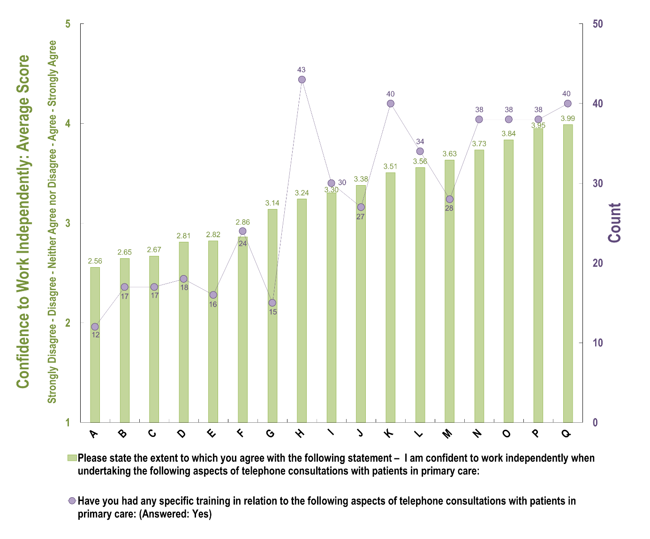

**Figure 2: Relationship between Percentage Training Received and the Confidence to Work Independently for Telephone Consultations**

**Figure 3: Reasons for Positive and Negative Experiences with Telephone Consultations from Questionnaire Data**

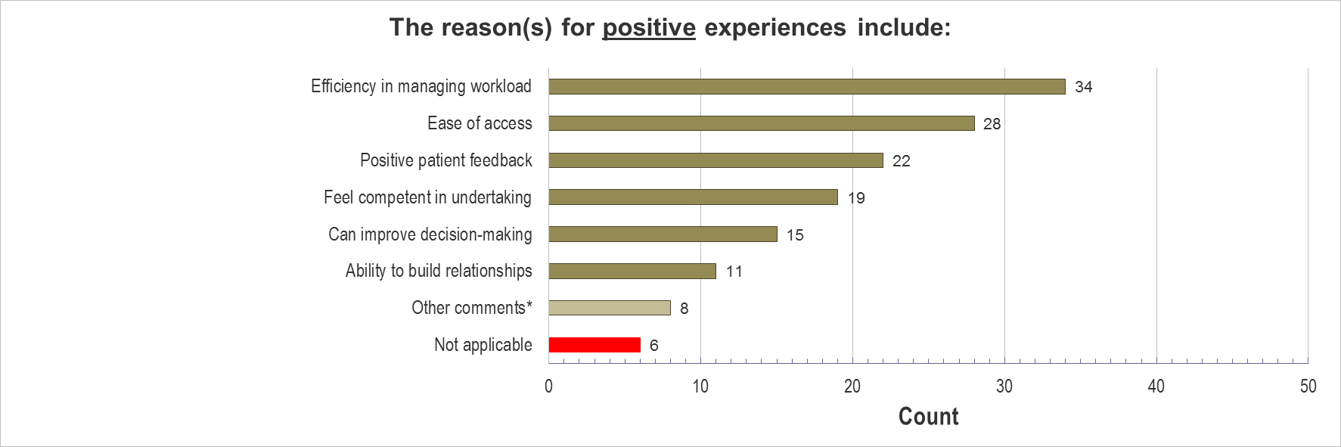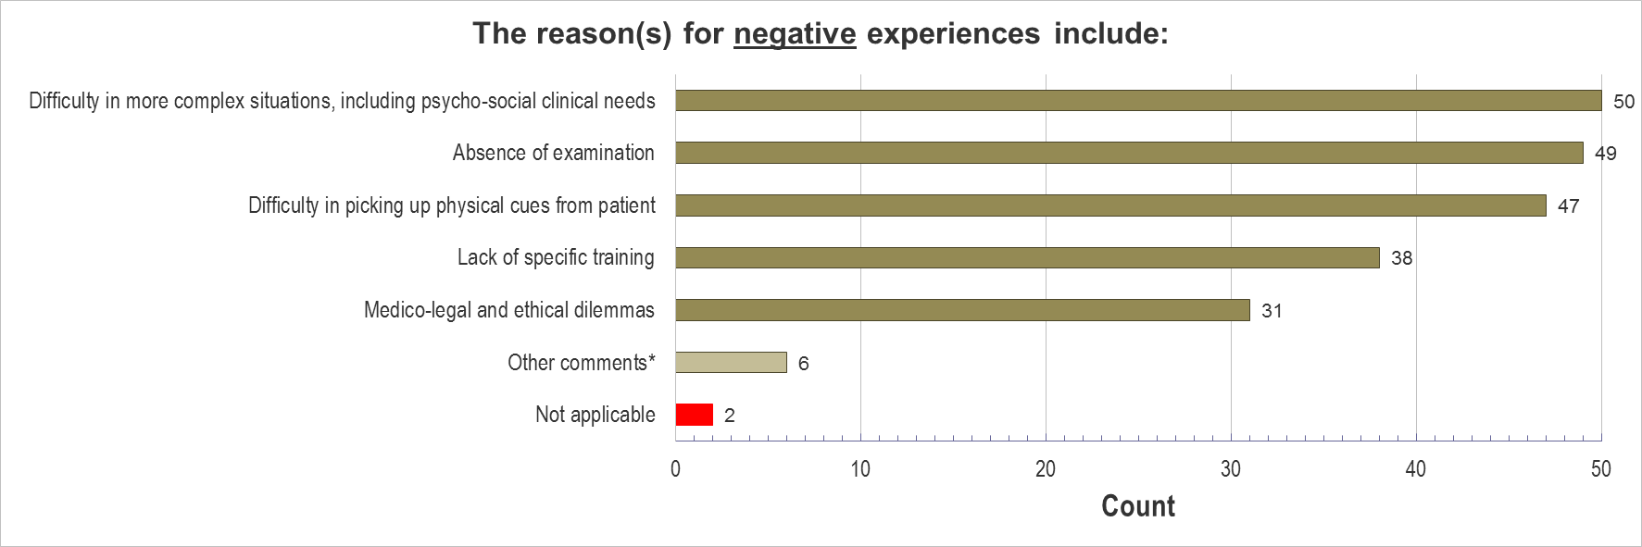

**\*Other comments provided for positive experiences included**: answer queries quickly; OOH training; communicate results; supportive supervisor; another form of communication; limited experience.

**\*Other comments provided for negative experiences included**: time pressures; increased workload; language-related issues; limited experience currently

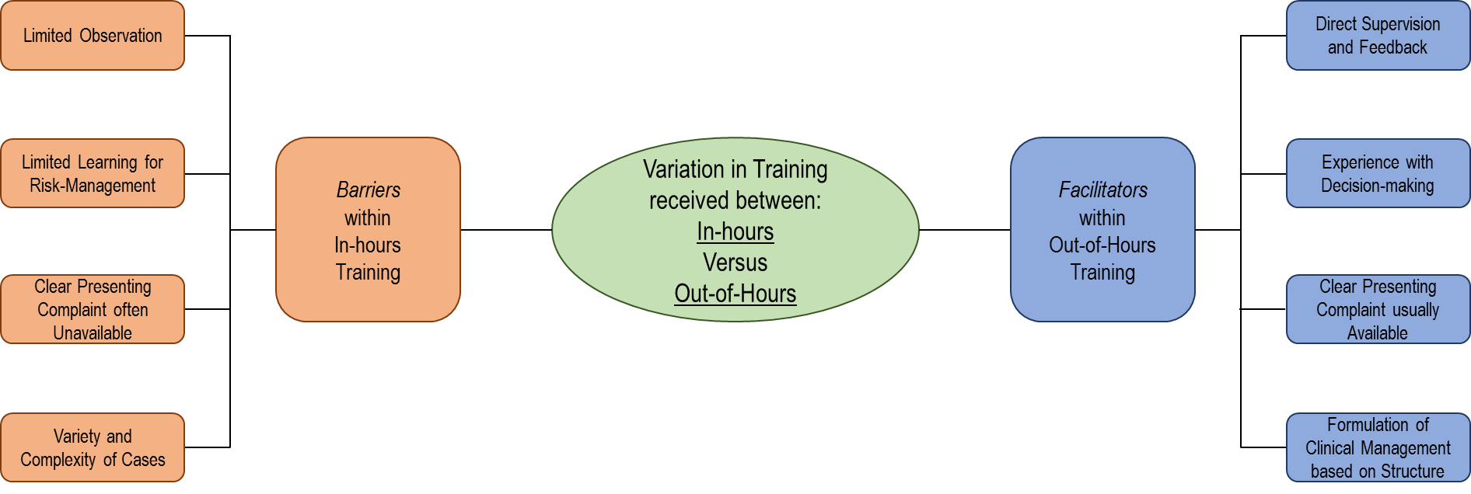**Figure 4:** **Factors shaping In-hours and Out-of-Hours Training – Barriers and Facilitators**