Supplementary Table 1: Patient characteristics at baseline (1/1/2010)
 |  | Patients included in main analysis |  | Patients excluded due to insufficient HbA1c measures
Characteristic |  | n | % | n | %
All |  | 58,832 | 100 | 23,660 | 100
Gender | Women | 26,295 | 44.7 | 10,553 | 44.6
 | Men | 32,537 | 55.3 | 13,107 | 55.4
Age (in 2008) | 40-49 | 3,756 | 6.4 | 2,939 | 12.4
 | 50-59 | 9,752 | 16.6 | 5,216 | 22.1
 | 60-69 | 17,400 | 29.6 | 6,469 | 27.3
 | 70-79 | 19,256 | 32.7 | 5,796 | 24.5
 | 80-89 | 8,668 | 14.7 | 3,240 | 13.7
Duration of | 0-5 years | 24,133 | 41.0 | 14,809 | 62.6
diabetes | 5-15 years | 28,136 | 47.8 | 7,278 | 30.8
 | >15 years | 6,563 | 11.2 | 1,573 | 6.7
IMD | 1 – Least | 11,494 | 19.5 | 4,562 | 19.3
Quintile§ | 2 | 13,761 | 23.4 | 5,371 | 22.7
 | 3 | 12,299 | 20.9 | 4,799 | 20.3
 | 4 | 12,271 | 20.9 | 5,177 | 21.9
 | 5 – Most | 8,969 | 15.3 | 3,733 | 15.8
Smoking | Never | 21,257 | 36.1 | 8,708 | 36.8
Status | Ex | 30,968 | 52.6 | 11,065 | 46.8
 | Current | 6,607 | 11.2 | 3,872 | 16.4
BMI§ | 10-20 | 877 | 1.5 | 482 | 2.0
 | 20-25 | 8,914 | 15.2 | 3,477 | 14.7
 | 25-30 | 20,942 | 35.6 | 7,906 | 33.4
 | 30-40 | 23,540 | 40.1 | 9,479 | 40.1
 | 40+ | 4,491 | 7.6 | 2,139 | 9.0
QOF Morbidity | 1 | 40,545 | 68.9 | 16,612 | 70.2
Score* | 2-3 | 10,118 | 17.2 | 3,784 | 16.0
 | 4+ | 8,169 | 13.9 | 3,264 | 13.8
History of | No | 56,879 | 96.7 | 23,201 | 98.1
Hypoglycaemia | Yes | 1,953 | 3.3 | 459 | 1.9
Number of HbA1c | 0 to 3 | _ | _ | 8,153 | 34.5
Measurements | 4 to 6 | 18,509 | 31.5 | 12,038 | 50.9
Recorded | 7 to 10 | 31,783 | 54.0 | 3,315 | 14.0
(2006-09) | >10 | 8,540 | 14.5 | 154 | 0.7
DM Medication | Any Insulin | 11,874 | 20.2 | 2,768 | 11.7
(2006-09) | Biguanides only | 13,628 | 23.2 | 6,967 | 29.5
 | Any Sulfonylureas† | 22,385 | 38.0 | 6,750 | 28.5
 | Other combination‡ | 2,841 | 4.8 | 801 | 3.4
 | None | 8,104 | 13.8 | 6,374 | 26.9
* - Mortality score derived from Diabetes (+1) and Atrial Fibrillation (+1), Metastatic Cancer (+3), COPD (+2), Dementia (+3), Epilepsy (+2), Heart Failure (+2), Psychosis, schizophrenia or bipolar affective disorder (+2), Stroke or TIA (+1).
† - Sulfonylureas with no Insulin
‡ - No Insulin or Sulfonylureas e.g. Other Diabetes medication with or without Biguanides
§ - Note: n=38 (0.06%) have no IMD recorded, n=68 (0.12%) have no BMI recorded

Supplementary Table 2: Pairwise adjusted HR’s for mortality by HbA1c average, trajectory and variability
HbA1c Summary | Category | Average  + Trajectory | Average  + Variability | Trajectory  + Variability
 |  | HR (95% CI) | HR (95% CI) | HR (95% CI)
Average* | 3.63 to 6.09% | 1.13 (1.04-1.22) | 1.14 (1.05-1.24) | _
 | >6.09 to 6.58% | 1 | 1 | _
 | >6.58 to 7.16% | 0.96 (0.90-1.03) | 0.93 (0.87-0.99) | _
 | >7.16 to 7.91% | 1.03 (0.97-1.10) | 0.95 (0.88-1.02) | _
 | >7.91 to 8.88% | 1.20 (1.11-1.29) | 1.06 (0.98-1.15) | _
 | >8.88% | 1.55 (1.43-1.68) | 1.36 (1.25-1.48) | _
Trajectory† | ≤-0.48%/y | 1.49 (1.38-1.61) | _ | 1.09 (1.01-1.19)
 | >-0.48 to -0.20%/y | 1.19 (1.11-1.27) | _ | 0.99 (0.92-1.06)
 | >-0.20 to 0.01%/y | 1 | _ | 1
 | >0.01 to 0.19%/y | 0.97 (0.92-1.03) | _ | 0.99 (0.92-1.06)
 | >0.19 to 0.43%/y | 1.12 (1.04-1.21) | _ | 1.00 (0.94-1.06)
 | > 0.43%/y | 1.36 (1.26-1.48) | _ | 1.06 (0.97-1.15)
CoV‡ | 0 to 3.14 | _ | 1 | 1
 | >3.14 to 4.71 | _ | 1.03 (0.95-1.12) | 1.01 (0.93-1.10)
 | >4.71 to 7.33 | _ | 1.31 (1.21-1.43) | 1.28 (1.18-1.39)
 | >7.33 to 11.40 | _ | 1.51 (1.39-1.65) | 1.49 (1.37-1.63)
 | >11.40 to 16.64 | _ | 1.75 (1.58-1.94) | 1.72 (1.55-1.91)
 | >16.64 | _ | 2.02 (1.82-2.23) | 2.00 (1.80-2.22)
Note: All models mutually adjust for two of the HbA1c measures (as indicated) plus age, age², sex, duration of diabetes, index of multiple deprivation, smoking and body mass index.
* – Average of the previous 4 annual means (2006, 2007, 2008, 2009). † – Mean annual slope from the linear regression of all measurements in the previous 4 years. ‡ – Coefficient of variation derived from the mean and standard deviation of all measurements in the previous 4 years. Note that all cut-offs correspond to the following percentiles: 10th, 25th, 50th, 75th and 90th.

Supplementary Table 3: Adjusted HR’s for mortality by HbA1c average, trajectory and variability, with further adjustment for co-morbidity and treatment
HbA1c Summary | Category | All HbA1c Measures  (Table 2) | All  + Co-morbidity | All  + DM Treatment
 |  | HR (95% CI) | HR (95% CI) | HR (95% CI)
Average* | 3.63 to 6.09% | 1.14 (1.05-1.24) | 1.12 (1.03-1.22) | 1.17 (1.07-1.27)
 | >6.09 to 6.58% | 1 | 1 | 1
 | >6.58 to 7.16% | 0.93 (0.87-0.99) | 0.94 (0.88-1.01) | 0.89 (0.83-0.96)
 | >7.16 to 7.91% | 0.95 (0.88-1.02) | 0.97 (0.91-1.04) | 0.83 (0.77-0.90)
 | >7.91 to 8.88% | 1.06 (0.98-1.14) | 1.09 (1.01-1.17) | 0.83 (0.76-0.90)
 | >8.88% | 1.35 (1.24-1.47) | 1.37 (1.26-1.50) | 0.99 (0.90-1.09)
Trajectory† | ≤-0.48%/y | 1.08 (1.00-1.18) | 1.11 (1.02-1.20) | 1.10 (1.01-1.19)
 | >-0.48 to -0.20%/y | 0.99 (0.93-1.05) | 1.00 (0.93-1.07) | 0.99 (0.93-1.07)
 | >-0.20 to 0.01%/y | 1 | 1 | 1
 | >0.01 to 0.19%/y | 0.99 (0.94-1.05) | 1.00 (0.93-1.07) | 1.00 (0.94-1.06)
 | >0.19 to 0.43%/y | 0.98 (0.91-1.06) | 0.98 (0.92-1.04) | 1.00 (0.93-1.08)
 | > 0.43%/y | 1.03 (0.95-1.12) | 1.03 (0.94-1.12) | 1.06 (0.97-1.16)
CoV‡ | 0 to 3.14 | 1 | 1 | 1
 | >3.14 to 4.71 | 1.03 (0.95-1.12) | 1.03 (0.95-1.11) | 1.01 (0.93-1.09)
 | >4.71 to 7.33 | 1.32 (1.21-1.44) | 1.26 (1.16-1.37) | 1.25 (1.15-1.36)
 | >7.33 to 11.40 | 1.51 (1.38-1.66) | 1.40 (1.28-1.53) | 1.39 (1.26-1.53)
 | >11.40 to 16.64 | 1.71 (1.53-1.91) | 1.53 (1.37-1.71) | 1.55 (1.39-1.74)
 | >16.64 | 1.93 (1.72-2.16) | 1.71 (1.53-1.91) | 1.79 (1.59-2.01)
Co-morbidity | 2-3 vs. 1 | _ | 1.85 (1.76-1.95) | _
Score§ | 4+ vs. 1 | _ | 2.56 (2.43-2.70) | _
DM Medication | Any Insulin | _ | _ | 1.74 (1.60-1.90)
 | Biguanides only | _ | _ | 1.00 (0.93-1.07)
 | Any Sulfonylureas¶ | _ | _ | 1.24 (1.15-1.33)
 | Other combination# | _ | _ | 0.93 (0.82-1.06)
 | None | _ | _ | 1
Note: All models mutually adjust for HbA1c measures plus age, age², sex, duration of diabetes, index of multiple deprivation, smoking and body mass index. * – Average of the previous 4 annual means (2006, 2007, 2008, 2009). † – Mean annual slope from the linear regression of all measurements in the previous 4 years. ‡ – Coefficient of variation derived from the mean and standard deviation of all measurements in the previous 4 years. Note that all cut-offs correspond to the following percentiles: 10th, 25th, 50th, 75th and 90th. § - Mortality score derived from Diabetes (+1) and Atrial Fibrillation (+1), Metastatic Cancer (+3), COPD (+2), Dementia (+3), Epilepsy (+2), Heart Failure (+2), Psychosis, schizophrenia or bipolar affective disorder (+2), Stroke or TIA (+1). ¶ - Sulfonylureas with no Insulin. # - No Insulin or Sulfonylureas e.g. Other Diabetes medication with or without Biguanides.

Supplementary Table 4: Adjusted HR’s for mortality by HbA1c average, trajectory and variability among those with 2-year survival from baseline only
HbA1c Summary | Category | All N=58,832  (Table 2) | Only among those with 2-year survival from baseline, N=47,130
 |  | HR (95% CI) | HR (95% CI)
Average* | 3.63 to 6.09% | 1.14 (1.05-1.24) | 1.10 (0.99-1.22)
 | >6.09 to 6.58% | 1 | 1
 | >6.58 to 7.16% | 0.93 (0.87-0.99) | 0.92 (0.84-1.01)
 | >7.16 to 7.91% | 0.95 (0.88-1.02) | 0.97 (0.89-1.06)
 | >7.91 to 8.88% | 1.06 (0.98-1.14) | 1.08 (0.97-1.20)
 | >8.88% | 1.35 (1.24-1.47) | 1.42 (1.27-1.59)
Trajectory† | ≤-0.48%/y | 1.08 (1.00-1.18) | 1.01 (0.90-1.13)
 | >-0.48 to -0.20%/y | 0.99 (0.93-1.05) | 1.00 (0.93-1.08)
 | >-0.20 to 0.01%/y | 1 | 1
 | >0.01 to 0.19%/y | 0.99 (0.94-1.05) | 1.00 (0.91-1.10)
 | >0.19 to 0.43%/y | 0.98 (0.91-1.06) | 1.00 (0.91-1.10)
 | > 0.43%/y | 1.03 (0.95-1.12) | 0.99 (0.88-1.10)
CoV‡ | 0 to 3.14 | 1 | 1
 | >3.14 to 4.71 | 1.03 (0.95-1.12) | 0.95 (0.86-1.05)
 | >4.71 to 7.33 | 1.32 (1.21-1.44) | 1.23 (1.10-1.36)
 | >7.33 to 11.40 | 1.51 (1.38-1.66) | 1.37 (1.23-1.53)
 | >11.40 to 16.64 | 1.71 (1.53-1.91) | 1.48 (1.29-1.69)
 | >16.64 | 1.93 (1.72-2.16) | 1.82 (1.58-2.09)
All models mutually adjust for HbA1c measures plus age, age², sex, duration of diabetes, index of multiple deprivation, smoking and body mass index. There were 5,901 deaths during 2012-5 (12.5% of eligible patients). * – Average of the previous 4 annual means (2006, 2007, 2008, 2009). † – Mean annual slope from the linear regression of all measurements in the previous 4 years. ‡ – Coefficient of variation derived from the mean and standard deviation of all measurements in the previous 4 years. Note that all cut-offs correspond to the following percentiles: 10th, 25th, 50th, 75th and 90th.

Supplementary Table 5: Adjusted HR’s for mortality by HbA1c average, trajectory and variability among all patients with a minimum of 4 HbA1c measurements at any time during 2006-9
HbA1c Summary | Category | All  (Min 1 measure/yr) N=58,832  (Table 2) | All  (Min 4 total measures)  N=74,339
 |  | HR (95% CI) | HR (95% CI)
Average* | 3.63 to 6.09% | 1.14 (1.05-1.24) | 1.16 (1.08-1.24)
 | >6.09 to 6.58% | 1 | 1
 | >6.58 to 7.16% | 0.93 (0.87-0.99) | 0.95 (0.89-1.00)
 | >7.16 to 7.91% | 0.95 (0.88-1.02) | 0.93 (0.87-0.99)
 | >7.91 to 8.88% | 1.06 (0.98-1.14) | 1.01 (0.94-1.09)
 | >8.88% | 1.35 (1.24-1.47) | 1.38 (1.28-1.49)
Trajectory† | ≤-0.48%/y | 1.08 (1.00-1.18) | 1.04 (0.97-1.12)
 | >-0.48 to -0.20%/y | 0.99 (0.93-1.05) | 0.98 (0.92-1.04)
 | >-0.20 to 0.01%/y | 1 | 1
 | >0.01 to 0.19%/y | 0.99 (0.94-1.05) | 0.97 (0.92-1.02)
 | >0.19 to 0.43%/y | 0.98 (0.91-1.06) | 0.97 (0.91-1.04)
 | > 0.43%/y | 1.03 (0.95-1.12) | 1.06 (0.98-1.14)
CoV‡ | 0 to 3.14 | 1 | 1
 | >3.14 to 4.71 | 1.03 (0.95-1.12) | 1.06 (0.99-1.14)
 | >4.71 to 7.33 | 1.32 (1.21-1.44) | 1.34 (1.25-1.45)
 | >7.33 to 11.40 | 1.51 (1.38-1.66) | 1.55 (1.43-1.69)
 | >11.40 to 16.64 | 1.71 (1.53-1.91) | 1.72 (1.56-1.90)
 | >16.64 | 1.93 (1.72-2.16) | 1.91 (1.73-2.10)
All models mutually adjust for HbA1c measures plus age, age², sex, duration of diabetes, index of multiple deprivation, smoking and body mass index. There were 5,901 deaths during 2012-5 (12.5% of eligible patients). * – Average of the previous 4 annual means (2006, 2007, 2008, 2009) OR Mean of all measurements (4 minimum). † – Mean annual slope from the linear regression of all measurements in the previous 4 years. ‡ – Coefficient of variation derived from the mean and standard deviation of all measurements in the previous 4 years. Note that all cut-offs correspond to the following percentiles: 10th, 25th, 50th, 75th and 90th.

Supplementary Table 6: Adjusted models for mortality stratified by highest and lowest quartiles of HbA1c average and variability
HbA1c Summary | Category | Variability among patients with lowest 25% average (n=14,703) | Variability among patients with highest 25% average (n=14,737) | Average among patients with lowest 25% variability (n=14,706) | Average among patients with highest 25% variability (n=14,707)
 |  | HR (95% CI) | HR (95% CI) | HR (95% CI) | HR (95% CI)
Average* | 3.63 to 6.09% | 1.16 (1.06-1.25) | _ | 1.17 (1.04-1.32) | 1.00 (0.78-1.28)
 | >6.09 to 6.58% | 1 | _ | 1 | 1
 | >6.58 to 7.16% | _ | _ | 0.95 (0.85-1.07) | 0.96 (0.80-1.14)
 | >7.16 to 7.91% | _ | _ | 1.07 (0.93-1.23) | 0.96 (0.82-1.13)
 | >7.91 to 8.88% | _ | 1 | 1.15 (0.88-1.50) | 1.08 (0.92-1.28)
 | >8.88% | _ | 1.28 (1.18-1.38) | 1.49 (1.06-2.11) | 1.31 (1.11-1.54)
Trajectory† | ≤-0.48%/y | 1.47 (1.13-1.90) | 1.09 (0.94-1.25) | _ | 1.15 (1.00-1.33)
 | >-0.48 to -0.20%/y | 1.06 (0.93-1.22) | 1.03 (0.87-1.23) | 0.97 (0.71-1.33) | 1.01 (0.85-1.21)
 | >-0.20 to 0.01%/y | 1 | 1 | 1 | 1
 | >0.01 to 0.19%/y | 0.95 (0.87-1.03) | 1.04 (0.88-1.22) | 0.96 (0.88-1.05) | 1.08 (0.87-1.34)
 | >0.19 to 0.43%/y | 0.90 (0.78-1.04) | 1.10 (0.94-1.29) | 0.89 (0.66-1.21) | 1.20 (1.00-1.46)
 | > 0.43%/y | 1.01 (0.76-1.35) | 1.08 (0.92-1.26) | _ | 1.11 (0.94-1.29)
CoV‡ | 0 to 3.14 | 1 | 1 | 1 | _
 | >3.14 to 4.71 | 1.09 (0.97-1.22) | 1.30 (0.76-2.20) | 1.01 (0.93-1.11) | _
 | >4.71 to 7.33 | 1.45 (1.28-1.64) | 1.50 (0.92-2.45) | _ | _
 | >7.33 to 11.40 | 1.54 (1.32-1.80) | 1.60 (0.99-2.60) | _ | _
 | >11.40 to 16.64 | 1.52 (1.22-1.89) | 1.91 (1.18-3.10) | _ | 1
 | >16.64 | 1.40 (1.06-1.85) | 2.14 (1.32-3.47) | _ | 1.14 (1.05-1.23)
All models mutually adjust for HbA1c measures (unless indicated) plus age, age², sex, duration of diabetes, index of multiple deprivation, smoking and body mass index.
* – Average of the previous 4 annual means (2006, 2007, 2008, 2009). † – Mean annual slope from the linear regression of all measurements in the previous 4 years. ‡ – Coefficient of variation derived from the mean and standard deviation of all measurements in the previous 4 years. Note that all cut-offs correspond to the following percentiles: 10th, 25th, 50th, 75th and 90th.

Supplementary Table 7: Adjusted HR’s for mortality by time-updated HbA1c average, trajectory and variability based on previous 4 years measurements
HbA1c Summary | Category | Average only | Average  + Trajectory | Average  + Variability | Trajectory  + Variability | All | All  + Hypo-glycaemia
 |  | HR (95% CI) | HR (95% CI) | HR (95% CI) | HR (95% CI) | HR (95% CI) | HR (95% CI)
Average* | 3.63 to 6.09% | 1.12 (1.03-1.22) | 1.14 (1.05-1.25) | 1.16 (1.05-1.27) | _ | 1.15 (1.05-1.27) | 1.16 (1.05-1.27)
 | >6.09 to 6.58% | 1 | 1 | 1 | _ | 1 | 1
 | >6.58 to 7.16% | 0.92 (0.86-0.99) | 0.89 (0.83-0.95) | 0.83 (0.77-0.90) | _ | 0.83 (0.77-0.90) | 0.83 (0.77-0.89)
 | >7.16 to 7.91% | 1.04 (0.97-1.11) | 0.95 (0.88-1.01) | 0.81 (0.76-0.88) | _ | 0.82 (0.76-0.88) | 0.81 (0.75-0.87)
 | >7.91 to 8.88% | 1.26 (1.17-1.35) | 1.06 (0.98-1.14) | 0.86 (0.79-0.93) | _ | 0.86 (0.79-0.93) | 0.85 (0.78-0.92)
 | >8.88% | 1.66 (1.53-1.81) | 1.32 (1.20-1.45) | 1.05 (0.95-1.15) | _ | 1.05 (0.95-1.16) | 1.03 (0.93-1.13)
Trajectory† | ≤-0.48%/y | _ | 1.70 (1.57-1.85) | _ | 1.04 (0.94-1.15) | 1.04 (0.95-1.15) | 1.04 (0.95-1.15)
 | >-0.48 to -0.20%/y | _ | 1.37 (1.27-1.46) | _ | 1.04 (0.97-1.12) | 1.04 (0.96-1.12) | 1.04 (0.96-1.12)
 | >-0.20 to 0.01%/y | _ | 1 | _ | 1 | 1 | 1
 | >0.01 to 0.19%/y | _ | 0.93 (0.87-0.99) | _ | 0.95 (0.89-1.01) | 0.94 (0.88-1.01) | 0.94 (0.88-1.01)
 | >0.19 to 0.43%/y | _ | 1.07 (0.99-1.16) | _ | 0.85 (0.79-0.92) | 0.85 (0.79-0.92) | 0.85 (0.79-0.92)
 | > 0.43%/y | _ | 1.50 (1.39-1.62) | _ | 0.94 (0.86-1.03) | 0.94 (0.86-1.03) | 0.94 (0.86-1.03)
CoV‡ | 0 to 3.14 | _ | _ | 1 | 1 | 1 | 1
 | >3.14 to 4.71 | _ | _ | 1.25 (1.13-1.37) | 1.19 (1.08-1.31) | 1.25 (1.14-1.38) | 1.25 (1.13-1.37)
 | >4.71 to 7.33 | _ | _ | 1.61 (1.48-1.77) | 1.51 (1.39-1.65) | 1.64 (1.49-1.80) | 1.62 (1.48-1.78)
 | >7.33 to 11.40 |  |  | 2.02 (1.83-2.22) | 1.85 (1.68-2.04) | 2.03 (1.83-2.26) | 2.01 (1.80-2.23)
 | >11.40 to 16.64 |  |  | 2.59 (2.32-2.90) | 2.38 (2.14-2.66) | 2.58 (2.28-2.91) | 2.53 (2.24-2.86)
 | >16.64 | _ | _ | 3.00 (2.69-3.36) | 2.79 (2.48-3.15) | 2.97 (2.60-3.38) | 2.91 (2.55-3.32)
History of hypoglycaemia§ | Yes vs. No | _ | _ | _ | _ | _ | 1.90 (1.68-2.15)
Note: All models mutually adjust for HbA1c measures (unless indicated) plus age, age², sex, duration of diabetes, index of multiple deprivation, smoking and body mass index which are fixed at baseline. HbA1c measures and hypoglycaemia are updated on January 1st at the beginning of each year (2010-2015). * – Average of the previous 4 annual means (2006, 2007, 2008, 2009). † – Mean annual slope from the linear regression of all measurements in the previous 4 years. ‡ – Coefficient of variation derived from the mean and standard deviation of all measurements in the previous 4 years. Note that all cut-offs correspond to the following percentiles: 10th, 25th, 50th, 75th and 90th. § - History of any hypoglycaemic event recorded prior to each year.
Supplementary Table 8: Adjusted HR’s for cardiovascular and non-cardiovascular mortality by HbA1c average, trajectory and variability
HbA1c Summary | Category | All  (Table 2) | Coronary Artery Disease or Ischaemic Stroke deaths only | All Other Causes
 |  | HR (95% CI) | HR (95% CI) | HR (95% CI)
Average* | 3.63 to 6.09% | 1.14 (1.05-1.24) | 1.04 (0.88-1.22) | 1.16 (1.06-1.27)
 | >6.09 to 6.58% | 1 | 1 | 1
 | >6.58 to 7.16% | 0.93 (0.87-0.99) | 0.92 (0.80-1.05) | 0.93 (0.86-1.00)
 | >7.16 to 7.91% | 0.95 (0.88-1.02) | 1.02 (0.89-1.16) | 0.92 (0.85-1.00)
 | >7.91 to 8.88% | 1.06 (0.98-1.14) | 1.25 (1.08-1.45) | 0.98 (0.90-1.07)
 | >8.88% | 1.35 (1.24-1.47) | 1.88 (1.60-2.21) | 1.12 (1.02-1.24)
Trajectory† | ≤-0.48%/y | 1.08 (1.00-1.18) | 1.30 (1.10-1.55) | 0.99 (0.90-1.09)
 | >-0.48 to -0.20%/y | 0.99 (0.93-1.05) | 1.11 (0.97-1.27) | 0.95 (0.88-1.03)
 | >-0.20 to 0.01%/y | 1 | 1 | 1
 | >0.01 to 0.19%/y | 0.99 (0.94-1.05) | 1.07 (0.94-1.21) | 0.96 (0.90-1.03)
 | >0.19 to 0.43%/y | 0.98 (0.91-1.06) | 1.14 (0.99-1.31) | 0.93 (0.85-1.01)
 | > 0.43%/y | 1.03 (0.95-1.12) | 1.14 (0.95-1.37) | 0.99 (0.93-1.11)
CoV‡ | 0 to 3.14 | 1 | 1 | 1
 | >3.14 to 4.71 | 1.03 (0.95-1.12) | 1.06 (0.88-1.27) | 1.02 (0.93-1.11)
 | >4.71 to 7.33 | 1.32 (1.21-1.44) | 1.25 (1.04-1.49) | 1.31 (1.19-1.41)
 | >7.33 to 11.40 | 1.51 (1.38-1.66) | 1.40 (1.16-1.67) | 1.48 (1.33-1.64)
 | >11.40 to 16.64 | 1.71 (1.53-1.91) | 1.45 (1.19-1.77) | 1.72 (1.52-1.93)
 | >16.64 | 1.93 (1.72-2.16) | 1.54 (1.23-1.93) | 1.97 (1.74-2.22)
Estimates for Coronary Artery Disease or Ischaemic Stroke mortality (n=2,375 deaths) and all other causes mortality (n=7,198 deaths) derived from Fine-Gray Cox models for competing risks. All models mutually adjust for HbA1c measures plus age, age², sex, duration of diabetes, index of multiple deprivation, smoking and body mass index. There were 3,443 cardiovascular deaths and 6,310 non-cardiovascular deaths. * – Average of the previous 4 annual means (2006, 2007, 2008, 2009). † – Mean annual slope from the linear regression of all measurements in the previous 4 years. ‡ – Coefficient of variation derived from the mean and standard deviation of all measurements in the previous 4 years. Note that all cut-offs correspond to the following percentiles: 10th, 25th, 50th, 75th and 90th.
Supplementary Figure 1: Study schematic overview
Must have HbA1c recorded in each calendar year
(i) Average HbA1c, (ii) Mean Slope (iii) Coefficient of Variation
1/1/2008
Follow-Up
N=96,630
Type 2 Diabetes patients aged 40-89 years with recorded diabetes as of 1/1/2008
N=14,138
No longer eligible* by 1/1/2010 (n=5,869 die, n=5,109 transfer out, n=3,160 practice leaves CPRD)
Outcomes recorded during 2010-15
(i) Mortality (All Cause, Cardiovascular)
(Ii) Emergency hospitalisation (All, Infections)
N=82,492
Still actively registered in participating CPRD practice as of 1/1/2010
1/1/2006
1/1/2010
31/12/2015
N=58,832
With eligible HbA1c measurements 2006-9
2006
2007
2008
2009
N=23,660
Insufficient HbA1c measurements 2006-9

Supplementary Figure 2: Distribution of HbA1c average, variability and trajectory during 2006-9
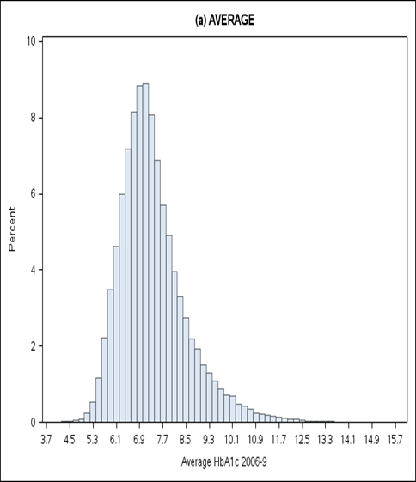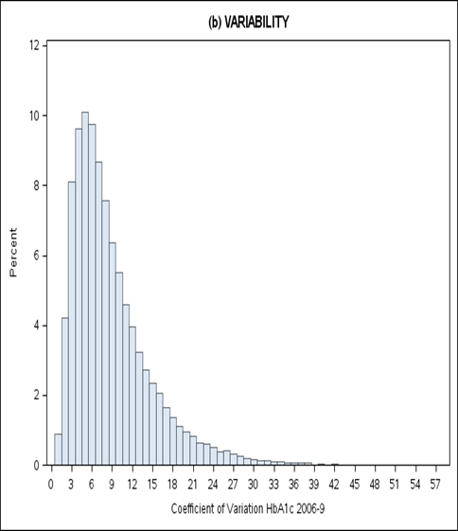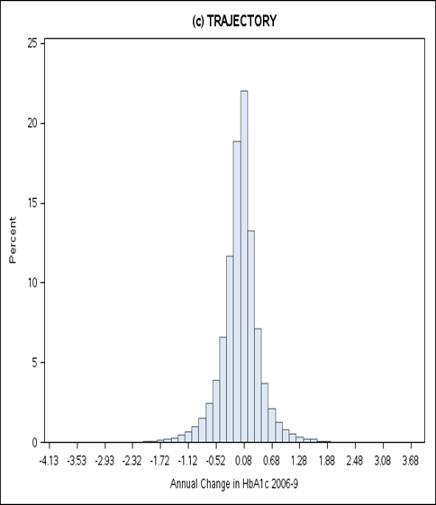
Top 10%
Top 10%
Bottom 10%
Bottom 10%
Bottom 10%
Top 10%

Note: Means (SD) for the above HbA1c summaries were: Average=7.36 (1.17), Variability=8.89 (5.95), Trajectory=-0.01 (0.43). Correlations were: Average and Variability==0.40, Average and Trajectory=-0.002, Variability and Trajectory=-0.12.

Supplementary Figure 3: Distribution of HbA1c average, variability and trajectory percentile groups by sex, age, BMI, time since diagnosis and diabetes medication
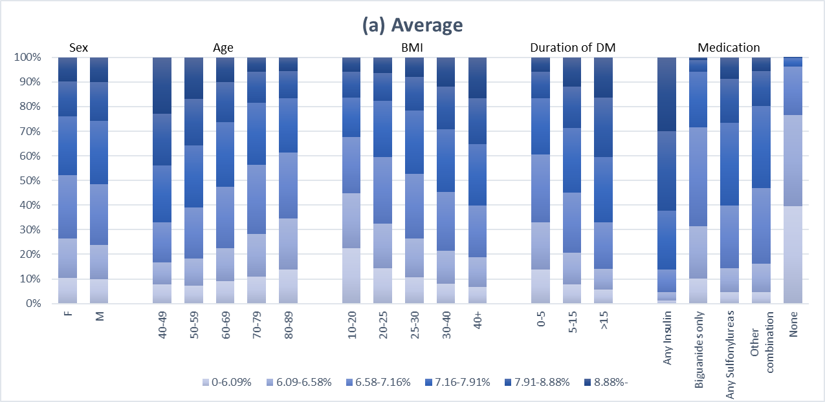
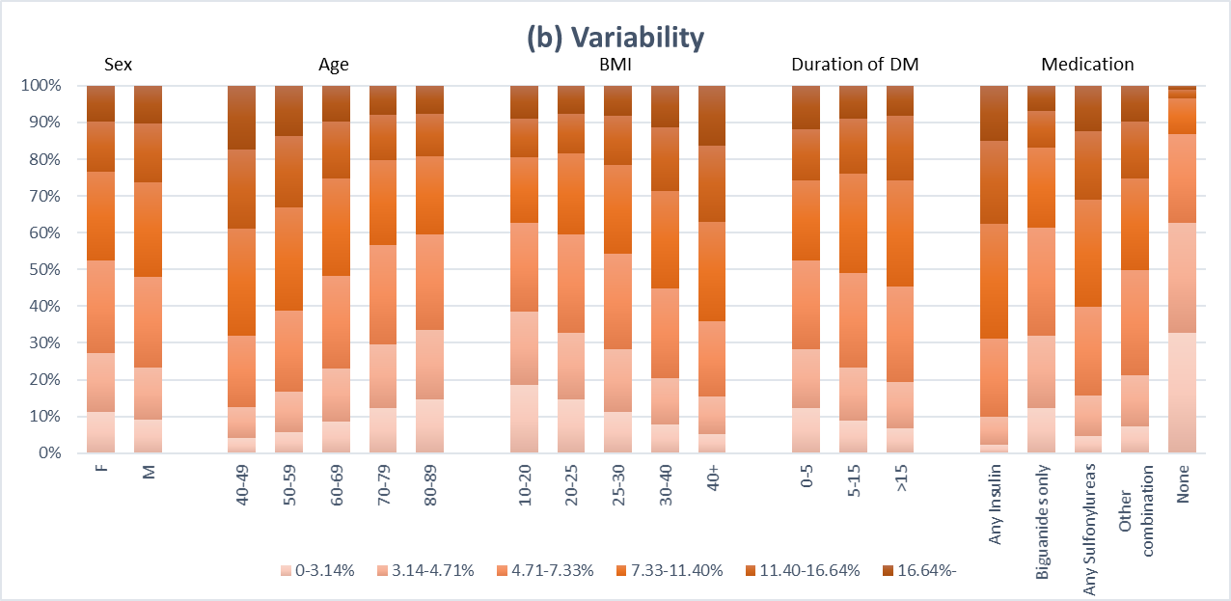
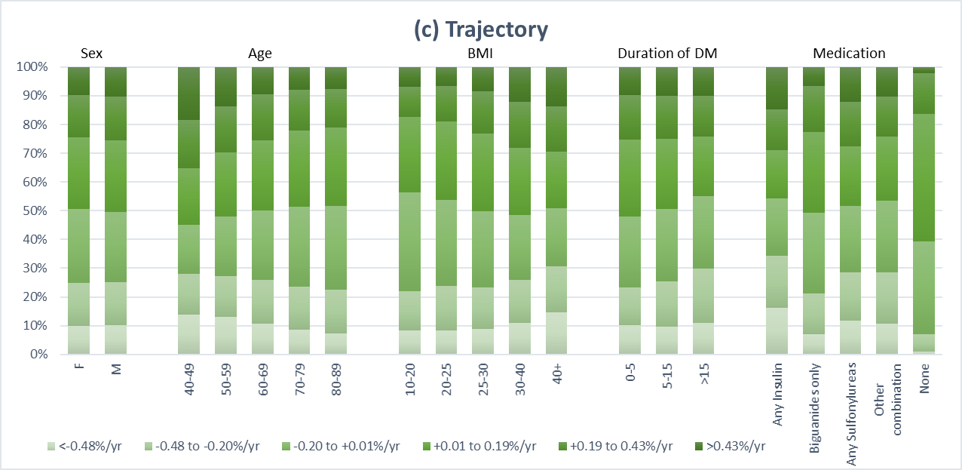

Supplementary Figure 4: Distribution of HbA1c average, variability and trajectory during 2006-9 by diabetes medication
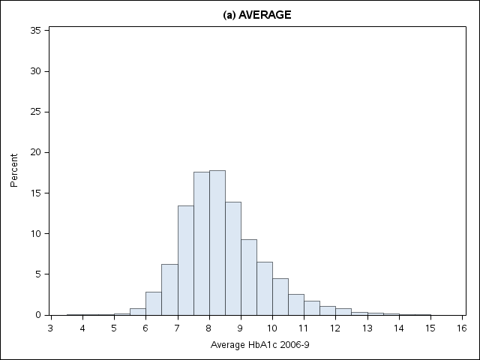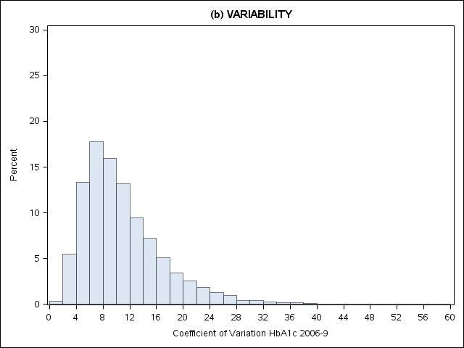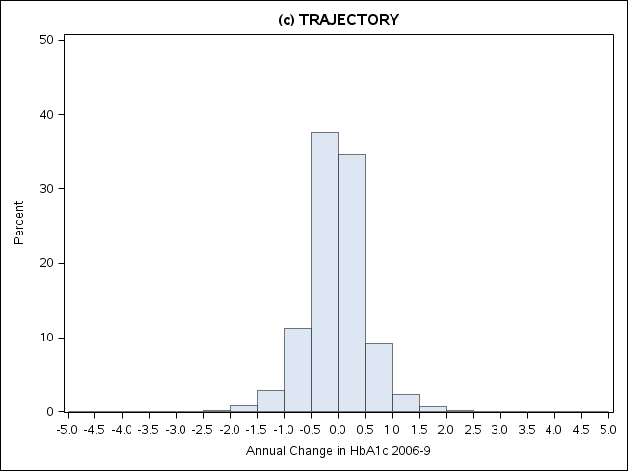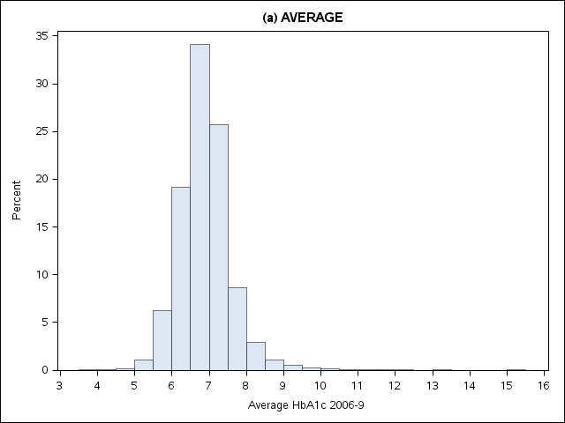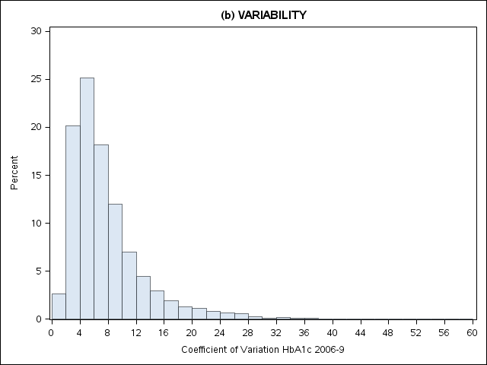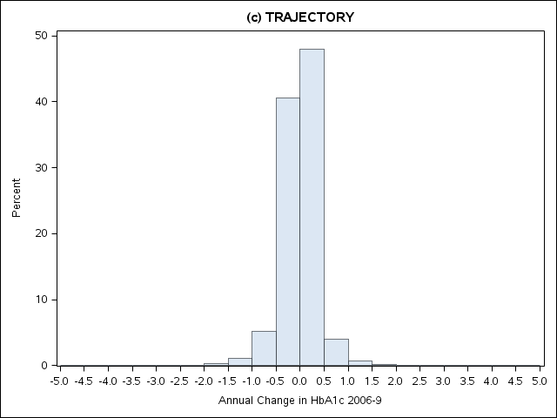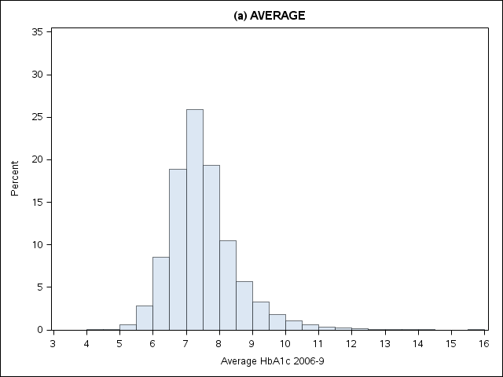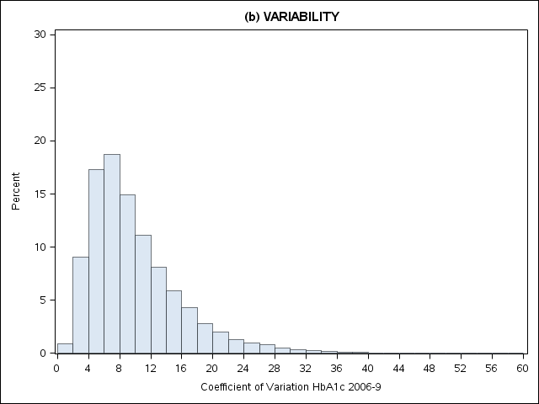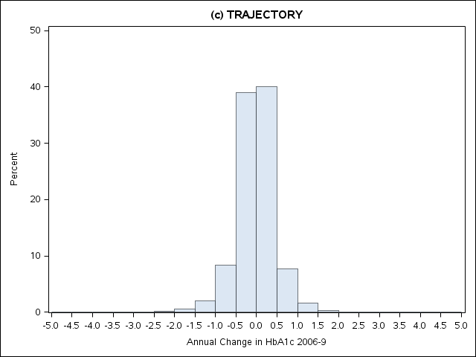
Any Sulfonylureas INSULIN
Biguanides only INSULIN
Insulin only

Supplementary Figure 5: HR’s from age-stratified models for mortality by HbA1c average and variability
