The International Society for Plastination. http://isp.plastination.org
Rafael Latorre¹, Robert Henry ², Philip J. Adds ³, Carlos Baptista ⁴.
¹Department of Anatomy and Comparative Pathological Anatomy, University of Murcia, Spain.
²College of Veterinary Medicine, Lincoln Memorial University, Harrogate, TN, USA.
³ Institute of Medical and Biomedical Education (Anatomy), St George's, University of London, London, UK.
⁴ Department of Medical Education, College of Medicine, University of Toledo, Ohio, USA.

Summary:

The International Society for Plastination (ISP) was conceived as a means of defining plastination as an area of professional activity and serving as an agency for disseminating information relative to the art and science of plastination. In this paper we present the purpose of the ISP, the Journal of Plastination, the Plastination Index and the different international meetings organized by the ISP.

Number of Figures and Tables: 12 figures, 0 tables
Keywords: Plastination, Journal of Plastination, Plastination Conferences, Plastination Index.
Main Text:
The International Society for Plastination (ISP) is a multidisciplinary organization that brings together people interested in the use of plastination techniques as a method of conservation of biological material. The main application of plastination techniques in academic forums is their use as a teaching resource, and this is why a majority of members have expressed interest in the ISP. On the other hand, some partners, increasingly numerous, are interested in the application of plastination techniques as a tool in research, especially related to the field of anatomy.
The purpose
Article III of the bylaws of our society points out the purpose of the ISP http://isp.plastination.org/about-us/bylaws/
- to provide for and maintain an International Association for individuals and institutions who perform plastination techniques, or are interested in plastination preservation methods;
- to serve as a forum for the exchange of information about plastination;
- to define plastination as a specialty area of professional activity, to encourage other institutions to adopt plastination preservation methods, and to invite individuals to learn and practice plastination as a career in the sciences;
- to publish the Journal of the International Society for Plastination on a regular basis;
- to hold regular meetings, workshops and conferences to promote and teach the techniques of plastination;
- to maintain a record of member institutions and individuals performing plastination, their particular specialty, and others interested in plastination.

The ISP (Fig. 1) was founded by Harmon Bickley in 1986, during the Third International Conference on Plastination, held in San Antonio, Texas, USA (Fig. 2). During this meeting, The Journal of the International Society for Plastination was created. In January 1987, Issue 1, Volume 1 of the journal was launched (Fig.3).

During the past 32 years, the ISP has had three Presidents from the USA (Prof. Harmon Bickley, Macon, Georgia, 1986-1995; Prof. Robert Henry, Knoxville, Tennessee, 1996; and Prof. Carlos Baptista, Toledo, Ohio, 2008-2016), and three Presidents from Europe (Prof. Andreas H. Weiglein, Graz, Austria, 1997-2003; Prof. Mircea-Constantin Sora, Vienna, Austria, 2004-2008; and Prof. Rafael Latorre, Murcia, Spain, 2016-present) http://isp.plastination.org/about-us/governance/.
The Society has four classes of membership: Regular Members, Associate Members, Distinguished Members and Emeritus Members.
To apply for membership in the ISP, one should fill out a form on the ISP website http://isp.plastination.org/membership/membership-application/. On the form, general information is requested, as well as previous experience in plastination techniques. Membership fees are $75.00, or equivalent, every two years.

The members of the ISP have access to the ISP-Listserve http://isp.plastination.org/membership/listserve/ to consult about any problems, as well as to receive direct information from other plastination laboratories around the world. This mailing list of the ISP serves as a discussion group, where members of the Society exchange ideas about techniques, and facts related to plastination.
Members also receive discounts and priority to attend the ISP biennial International Conference, or the workshops organized by the ISP in the Interim Meetings. Members of the ISP also receive information and direct access to the different papers published in each new issue of the Journal of Plastination.
The organizing committee of the ISP invites all its members to participate actively, not only in the activities organized by the ISP, but also in the positions of government (President, Vice-President, Secretary, Treasurer and Counselors).

We must make special mention of the four Distinguished Members of the ISP http://isp.plastination.org/awards/distinguished-members-awards/:
1994: Prof. Harmon Bickley (Fig. 2); and Prof. Gunther von Hagens (Fig.4) 2002: Prof. Robert Henry (Fig.5); 2012: Prof. Andreas H. Weiglein (Fig.6); and 2016: Prof. Carlos Baptista (Fig.7). Their work and efforts have made it possible for the ISP to be the active and prestigious society that it is today.

The Journal of Plastination
The Journal of Plastination (ISSN 2311-7761/printed) and (ISSN 2311-777X online) http://journal.plastination.org/index.html, the official publication of the International Society for Plastination, was first published in 1987 as ‘The Journal of the International Society for Plastination” (Fig. 3). The shorter title was adopted in 2009. The stated aims of the journal are “to provide a medium for the publication of scientific papers dealing with all aspects of plastination and preservation of biological specimens.” The broad aims of the journal mean that papers on a wide variety of topics are published, including technical articles on the process of plastination in all its forms, original research using plastinated specimens, or research into novel techniques or applications of plastination, and historical articles on significant figures or techniques from the past (Adds, 2018).
In both guises, the journal has been in continuous publication since its launch, with the exception of a hiatus from 2009-2011, during which time, for a number of reasons, the journal did not appear. A combined issue was published in 2012, covering the years 2009-2012. The first two years of publication saw two issue per volume, each containing 5 or 6 contributions. The journal appeared annually as a single issue for the next nine years, then Volumes 12-14 each contained two issues, before reverting to single-issue volumes for the next ten years (2000-2008). There was then a gap in publication until the single-issue volume 24 appeared in 2012. The new-look, relaunched Journal of Plastination, has been published bi-annually since then, with the exception of the single-issue Volume 28 (2016.)
The average number of original articles per issue (either research, technical, or historical) in the 39 issues published to date, is 5.7, (range 0-10) - omitting letters, abstracts, and meeting reports; the average number of pages per issue is just over 40. It has to be said, however, that the layout and pagination have changed considerably over the years, so it difficult to draw conclusions from the data. In comparison with a survey carried out in 1999 on the first 17 issues, however, it appears that these figures have remained remarkably constant throughout the lifetime of the Journal. Olry (1999) reported that the average number of pages per issue was 39.6 (31-49), and the average number of full-length publications per issue was 6.7 (5-11).
The earlier issues of the Journal were dominated by articles on the practicalities of plastination. These are listed as ‘Original Articles’ in the published journal, however, the majority of submissions to the earlier issues were what would now be classified as “Technical Brief Notes”.
The “Guidelines for authors” did not appear in print until Volume 20, in 2005, and specified the following categories of submissions: “Original Research - describes plastination techniques developed by the authors; Education - developments and applications utilizing plastinated specimens; Reviews - by invitation of the editor and editorial board only and will cover topics agreed upon by the author and editor.”
With the re-launch of the journal in 2012, the category list was widened and refined:
- Original Research – Plastination
- Original Research – Preservation
- Education
- Case reports
- Technical brief notes
- Review - by invitation only
- Legacy - institutions and people
- Correspondence
- Editorial

Analysis of papers published in the journal from Volume 1 (1987) to Volume 30(1) (2018) shows that original research and technical reports form the great majority of published articles (Fig. 8).

The Journal of Plastination has a truly global readership. In the last two years, submissions have been received from authors in the USA, UK, China, Spain, Saudi Arabia, India, Brazil, Germany, Sudan, and Austria. The journal is currently listed in SCOPUS, and an application for listing on PubMed by the United States National Library of Medicine is being pursued.

Plastination Index:
The plastination index is a cumulative index that includes publications on plastination, from the first paper published on the subject. This plastination index is available through the ISP website (http://www.plastination.org/isp/plastinationindex/) and it has also two paper editions, the first was published in 1996, and the second in 2000. This cumulative index is the creation of Mr. Gilles Grondin from the University of Quebec at Trois-Rivières. He made a great work with this index during many years, even after he had retired from the university.
This index lists not only the plastination papers or research published in the Journal of Plastination, but also papers in any other journals, and abstracts from any international conferences. It has eight languages available to do a search. The most frequent searches are always by keywords or topics, but the index offers the opportunity to search also by authors, journals, dates and citations
http://www.plastination.org/isp/plastinationindex/english.html

Meetings
International Conferences are one of the most important activities organized by the ISP. It is included in article V of the bylaws ( http://isp.plastination.org/about-us/bylaws/):
“The Society membership shall regularly meet at the Biennial International Conference, or at such other time and place as designated by the President. A meeting of officers and a Biennial General Meeting shall be held to conduct the business of the Society”.
The first two plastination meetings were held in the United States. They were informal gatherings of people interested in plastination. The First Conference on Plastination meeting was organized by Harmon Bickley in 1982 at the University of Texas Health Sciences, in San Antonio (Fig. 2). This meeting was attended by 8 individuals - all from the United States. The Second Conference on Plastination meeting was attended by approximately 100 people. While most attendees were from the United States, there were also participants from other countries. The second event truly made it an international event.
From 1982 until now, 19 international ISP conferences have been celebrated, 6 in the USA, 7 in Europe (2 in Germany, 2 in Austria, and one each in France, Spain and Russia), 2 in Canada (Kingston and Quebec), 2 in China (Beijing and Dalian), and one in Australia (Brisbane) and Puerto Rico.
http://isp.plastination.org/annual-meetings/previous-international-conferences/
- University of Texas Health Science Center, San Antonio, Texas, USA. April 1982
- University of Texas Health Science Center, San Antonio, Texas, USA. April 1984
- University of Texas Health Science Center, San Antonio, Texas, USA. April 1986
- Mercer University School of Medicine Macon, Georgia, USA. March 1988
- Faculty of Medicine University of Heidelberg, Heidelberg, Germany. July 1990.
This 5th International Conference was the first meeting held outside the United States. It was a return to the birthplace of Plastination. It was organized by Dr. von Hagens as a conference, and also a practical demonstration of the plastination technique. It was during this conference that the first plastinated full body was revealed to the public (Fig. 9).
- Department of Pathology, Queen's University, Kingston, Canada. July 1992
- Anatomisches Institut, Karl-Franzens-University, Graz, Austria. July 1994
- University of Queensland, Brisbane, Australia. July 1996.
This was the first far east meeting (Fig.10)
- Universite du Quebec, Trois-Rivieres, Quebec, Canada. July 1998
- Jean Monnet University, St. Etienne, France. July 2000
- Medical Sciences, San Juan, Puerto Rico. July 2002
First Caribbean Conference (Fig. 11)
- Universidad de Murcia, Spain, July 2004
- Anatomical Institute, Medical University of Vienna, Vienna, Austria, July 2006
- Heidelberg and Guben, Germany, July 2008
In order to commemorate the 30th anniversary of the creation of Plastination, the ISP conference returned to Heidelberg, Germany. A special post-conference tour was organized by Dr. von Hagens, which took the attendees to the city of Guben, Germany. Participants had the opportunity to visit the PLASTINARIUM museum in Guben/Brandenburg (Fig.12).
- University of Hawaii, College of Medicine, Hawaii, USA, July 2010
The ISP and the American Association of Clinical Anatomists (AACA) joined forces to host the first joint meeting (Fig.13).
- Beijing and Dalian, China, July 2012
First international conference in Asia (Fig. 14)
- Saint Petersburg, Russia, July 2014
- Toledo, Ohio, USA, June 2016
- Dalian, China, July 2018
The next international conference of the ISP will be hosted by Universidad de la Frontera, Temuco, Chile in 2020 (https://www.plastinacion.com/copia-de-workshop).

By 1989, interest in plastination had grown substantially. In order to provide training for those novices on the technique, Dr. Robert Henry created the 1st Interim Meeting on Plastination. This meeting was different, since it provided hands-on training in a workshop-style meeting. The 1st Interim meeting was held in College of Veterinary Medicine, University of Tennessee, Knoxville, TN, USA, in November 1989 (Fig. 15). This meeting would alternate biennially with the biennial International Conference of the society.
Thus, for twelve years the ISP has organized Interim Meetings in different places: USA, China, Macedonia, Brazil and South Africa: http://isp.plastination.org/annual-meetings/previous-interim-meetings/
- University of Tennessee, Knoxville, TN, USA. November 1989
- Chaffey College, Rancho Cucamonga, California, USA, August 1991
- University of South Alabama, Mobile, Alabama, USA. August 1993
- Ohio State University, Columbus, Ohio, USA. July 1995
- University of Tennessee, Knoxville, TN, USA. June/July 1997
- University of Rochester Medical Center, Rochester, New York, USA. July 1999
- Shanghai, China and Su Yi Plastination Factory, Najing, China, June 2001
- University of St "Cyril and Methodius" Macedonia. July 2005
- University of Michigan Medical School, Ann Arbor, Michigan, USA. July 2007
- College of Medicine, University of Toledo, Toledo, Ohio, USA, July 2011
- Universidade Federal do Espirito Santo, Vitoria, Brazil, July 2015
This was the first Interim meeting on plastination held in Latin America (Fig. 16).
- University of KwaZulu Natal - Durban, South Africa - July 2017
This was the first meeting of the ISP held in Africa.

Parallel to the Interim Meetings, several plastination laboratories began to conduct workshops supervised by experts in plastination. In these courses, concrete techniques are learned in small groups of participants. The University of Murcia, Spain, was one of the first to teach these courses, starting in 2000, and since then has run 18 courses https://www.um.es/web/anatvet/plastination/cursos-plastinacion. Other examples are the University of Toledo, Ohio, USA, which started in 2011 http://www.utoledo.edu/med/depts/medical-education/plastination/, Universidad de la Frontera, Chile, which started its courses in 2017 https://www.plastinacion.com/workshop, Federal University of Espirito Santo, Brazil, http://www.plastination.org/isp/InterimVitoria15/index.html, and the University of Dalian, China, which began in 2016 .
Nowadays there is still a great interest in plastination workshops, especially those focused on advanced topics such as vascular injection, plastination of hollow and flexible organs, brains, clinical applications, and the research potential of plastination. Other topics suggested by ISP members are: different methods of sectioning and casting in sheet plastination, brain reconstruction with P40 slices, staining of ultrathin epoxy slices, typical mistakes in plastination, and plastination for educational purposes.

Conclusion
The International Society for Plastination is a scientific society that brings together the motivations of many groups of academics and technical staff from around the world. However, it needs to involve more members in the activities of the Society. There is a need for defining a strategy aimed at improving the bonding of the active plastinators with the ISP. Plastination is quite well consolidated, not only in anatomical fields, but also in archaeological museums and zoology labs, and there is an important potential for workshops focused on advanced topics in plastination.

The International Society for Plastination has been an important partner in the advancement of plastination in the world. With recent major changes in education, the reduction of resources and dedicated time within the foundation science curricula necessitates the use of prosected material for experiential learning. In light of this development, there will be an increased demand for plastinated materials. The ISP will be in a position to become a very important resource for expanding the use of plastination around the world.

References

Adds PJ. 2018. Remembering the Past While Looking to the Future: The First Ten Years of the Journal of Plastination. J Plastination 30(2) (in press)

Olry R. 1999. The Journal of the International Society for Plastination: Assessment and Future Prospects. J Int Soc Plastination 14(1) pp 25-27

Acknowledgements:

Conflict of Interest:

Authors have not conflict of interest.
Figure legends:
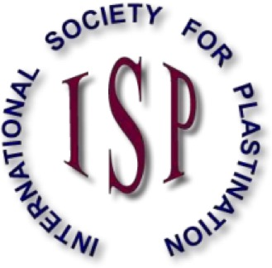
Fig. 1: International Society for Plastination.
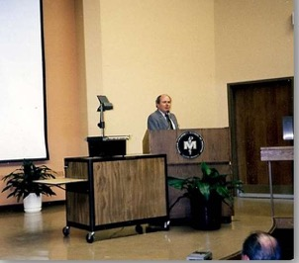
Fig. 2: Harmon Bickley in 1986, during the Third International Conference on Plastination, held in San Antonio, Texas, USA.
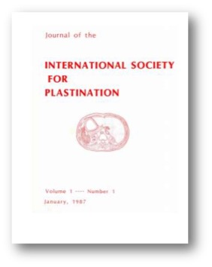
Fig.3: The Journal of the International Society for Plastination was created. In January 1987, Issue 1, Volume 1 of the journal was published.
Fig.4: Prof. Gunther von Hagens.
Fig.5: Prof. Robert Henry.
Fig.6: Prof. Andreas H. Weiglein.
Fig.7: Prof. Carlos Baptista.
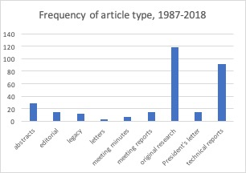
Fig.8: Frequency of article type published in the Journal of Plastination 1987 – 2018.
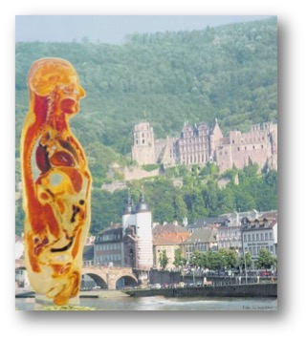
Fig. 9: 5th International ISP Conference, Faculty of Medicine University of Heidelberg, Heidelberg, Germany. July 1990.
Fig.10: 8th International ISP Conference University of Queensland, Brisbane, Australia. July 1996.
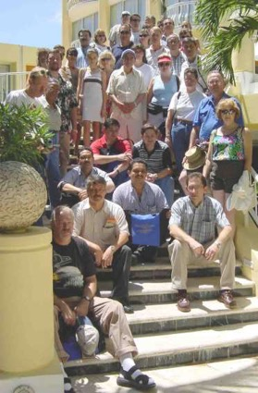
Fig. 11:11th International ISP Conference, San Juan, Puerto Rico, July 2002.
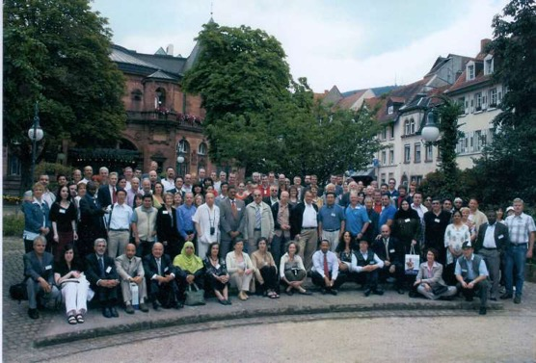

Fig. 12: 14th International ISP Conference. Heidelberg and Guben, Germany, July 2008.

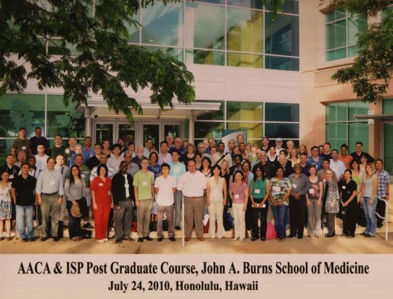
Fig. 13: 15th International ISP Conference. University of Hawaii, College of Medicine, Hawaii, USA, July 2010.
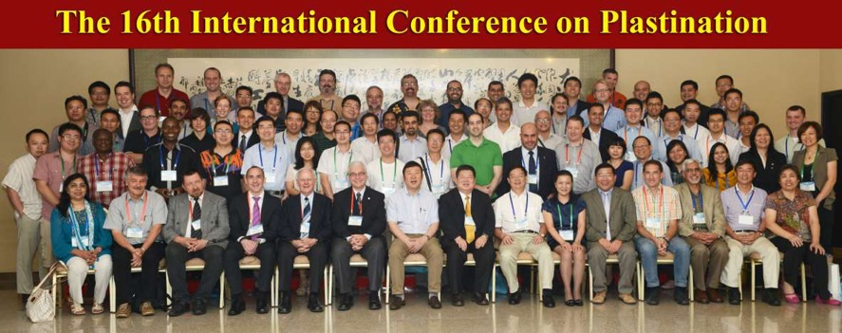
Fig. 14: 16th International ISP Conference. Beijing and Dalian, China, July 2012.
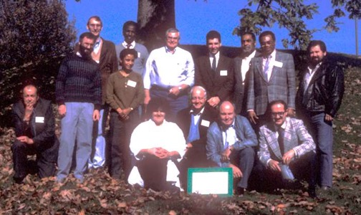
Fig. 15: 1st ISP Interim Meeting, College of Veterinary Medicine, University of Tennessee, Knoxville, TN, USA, in November 1989.
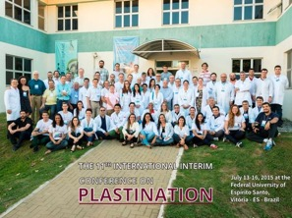
Fig. 16: 11th ISP Interim Meeting, Universidade Federal do Espirito Santo, Vitoria, Brazil, July 2015

