Figures
Figure 1: Smoking status at and following the time of Ulcerative Colitis diagnosis.
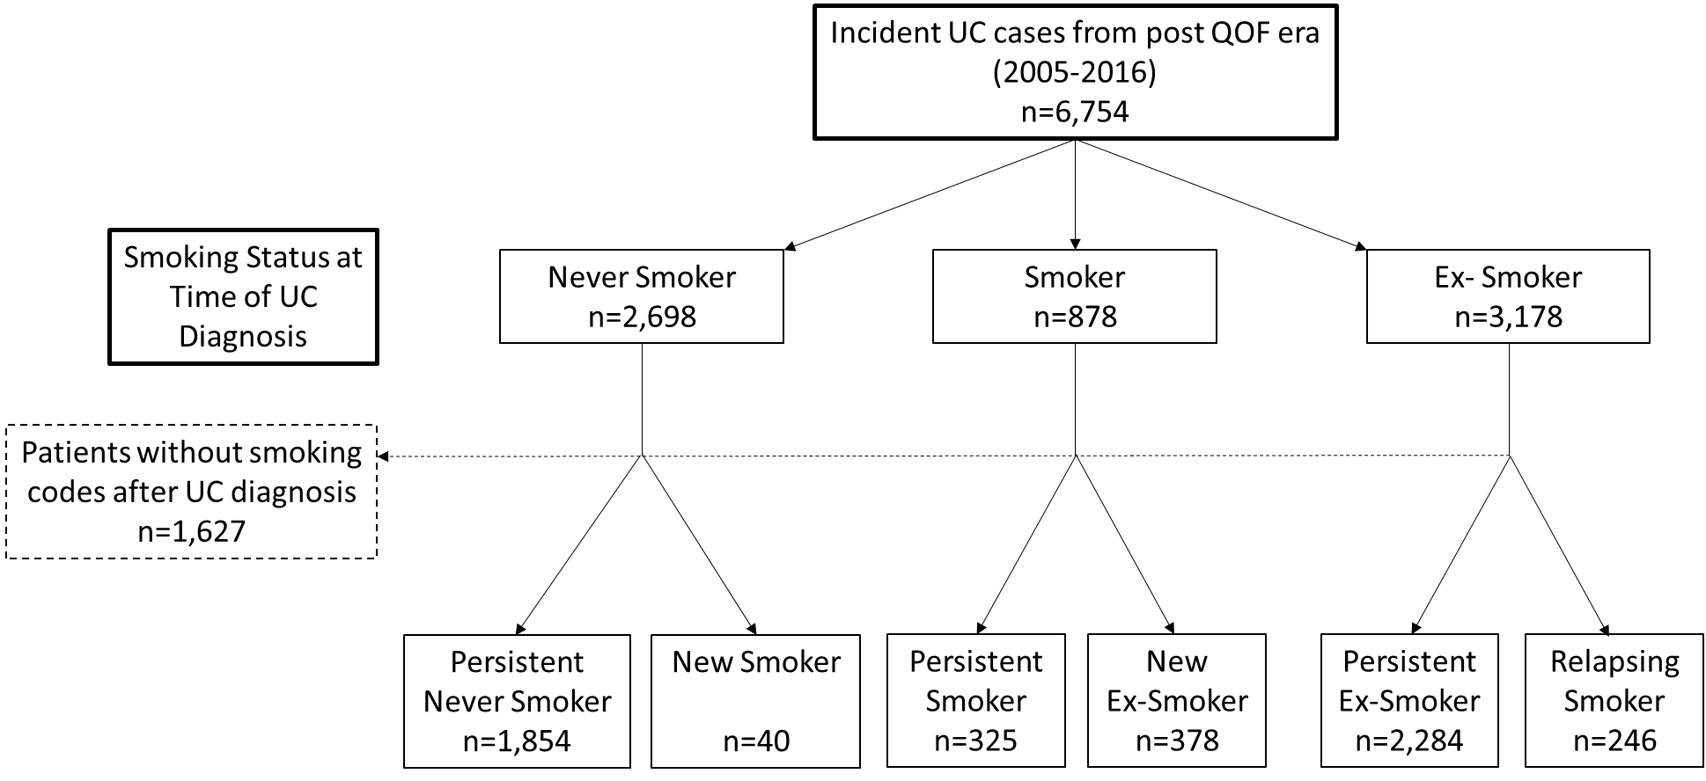
UC – Ulcerative Colitis
QOF – UK Quality Outcomes and Framework introduced to GPs in 2004
IBD – Inflammatory Bowel Disease

Figure 2: KM curves showing probability of oral CS exposure in patients with Ulcerative Colitis given smoking status at diagnosis
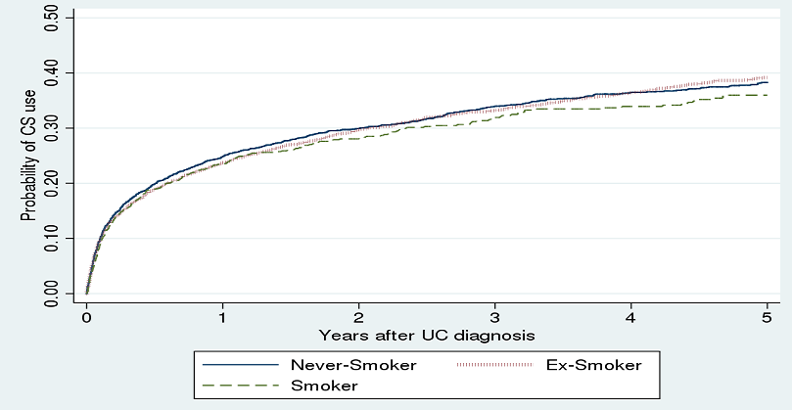
Log rank test for trend: p=0.53
CS - corticosteroid UC – Ulcerative Colitis

Figure 3: KM curves showing probability of colectomy in patients with Ulcerative Colitis by smoking status at diagnosis
Log rank test for trend: p=0.24
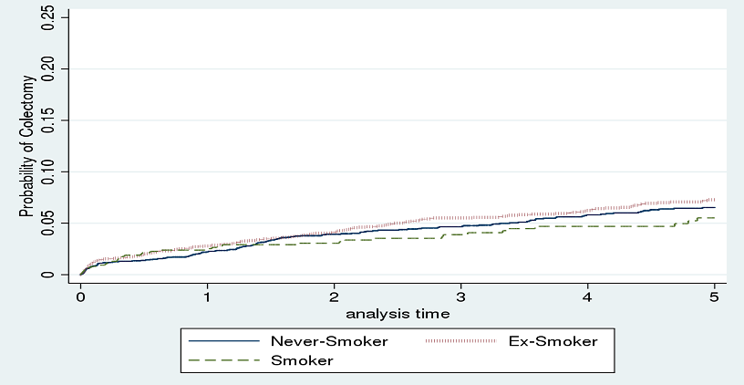
Log rank test for trend: p=0.24
UC – Ulcerative Colitis
Never-Smoker – UC patients who were non-smokers at the time of UC diagnosis with no previous Read codes indicating they were ex-smokers
Smoker – UC patients who were smokers at diagnosis
Ex-Smoker – UC patients who were non-smokers at the time of UC diagnosis with Read codes indicating previous smoking

Tables
Table 1: baseline characteristics of cohort
 | Never-Smoker at UC diagnosis  (n=2,698) | Ex-Smoker at UC diagnosis  (n=3,178) | Smoker at UC diagnosis  (n=878) | p-value
Sex  % male | 46.2 | 57.7 | 53.3 | <0.001
Age at diagnosisª (%)  A1  A2  A3 | 1.7  37.8  60.5 | 0.1  20.8  79.2 | 0  42.9  57.1 | <0.001
BMI category at diagnosis^{b} (%)  Underweight  Normal  Overweight  Obese | 3.5  43.8  35.5  17.2 | 1.2  34.0  44.2  20.7 | 4.2  44.8  36.2  14.7 | <0.001
Social deprivation^{c} (%)  IMD 1  IMD 2  IMD 3  IMD 4  IMD 5 | 26.5  25.1  17.7  19.1  11.6 | 25.8  24.9  19.5  17.9  11.8 | 18.9  23.8  19.8  20.6  17.0 | 0.006
Comorbidities (%)  IBS^{d}  Depression^{e} | 13.6  6.3 | 13.1  9.3 | 16.4  11.4 | 0.038  <0.001
a - Age at diagnosis categories as per Montreal classification (A1 <17 years, A2 17-40, A3 >40 years)
b - BMI (Body Mass index) - calculated as the closest BMI recording within one year of UC diagnosis. Data available for 88% of patients
c - IMD (Index of Multiple Deprivation). Data available for 58% of patients.
d - IBS (Irritable Bowel Syndrome) - co-diagnosis considered as any patient with a defined Read code for IBS in records
e - Premorbid depression considered if patient had any Read code for depressive illness in CPRD record before UC diagnosis

Table 2: Simple and multiple regression analysis for risk of corticosteroid dependency* in patients with Ulcerative Colitis
 | simple logistic regression  n=6714 |  |  | multiple logistic regression  n=3,558
 | OR | 95% CI | p value | OR | 95% CI | p value
Smoking status at diagnosis  Never-Smoker  Smoker  Ex-Smoker | 1  0.75  0.89 | -  0.60-0.93  0.78-1.02 | -  0.009  0.10 | 1  0.85  0.90 | -  0.61-1.18  0.73-1.11 | -  0.34  0.32
Sex  (ref to female) | 1.15 | 1.01-1.31 | 0.033 | 1.51 | 1.24-1.85 | <0.001
Age at IBD  diagnosisª  A1  A2  A3 | 3.40  1  0.77 | 2.12-5.47  -  0.67-0.88 | <0.001  -  <0.001 | 2.91  1  0.99 | 1.06-7.98  -  0.97-1.23 | 0.038  -  0.14
Era of IBD diagnosis^{b}  Era 1  Era 2  Era 3  Era 4  Era 5  Era 6 | 1  1.06  0.95  0.96  0.87  0.84 | -  0.87-1.29  0.78-1.17  0.78-1.20  0.69-1.09  0.62-1.14 | -  0.57  0.63  0.74  0.23  0.26 | 1  0.91  0.83  0.88  0.98  0.79 | -  0.68-1.22  0.61-1.11  0.63-1.21  0.70-1.37  0.47-1.34 | -  0.53  0.21  0.43  0.91  0.39
BMI category^{c}  Underweight  Normal  Overweight  Obese | 1.39  1  0.82  0.85 | 0.95-2.04  -  0.71-0.96  0.70-1.03 | 0.80  -  0.014  0.09 | 1.64  1  0.84  0.92 | 0.96-2.81  -  0.67-1.04  0.70-1.22 | 0.07  -  0.11  0.57
Social deprivation^{d}  IMD lower | 0.96 | 0.79-1.17 | 0.68 | 0.97 | 0.79-1.19 | 0.79
Co-morbidities^{e}  IBS  Depression | 0.96  0.83 | 0.79-1.16  0.64-1.07 | 0.65  0.15 | 1.16  0.98 | 0.89-1.52  0.67-1.43 | 0.28  0.91
Oral 5-ASA^{f} | 6.95 | 5.47-8.83 | <0.001 | 6.04 | 4.34-8.40 | <0.001
Multiple regression includes all covariates of simple regression. Significant odds ratios shown in bold.
OR – Odds Ratio CI - Confidence Interval IBD - Inflammatory Bowel Disease BMI - Body Mass Index IMD - index of multiple deprivation IBS - irritable bowel syndrome 5-ASA - 5-aminosalicylates
a- Age categories as per Montreal classification (A1 <17 years, A2 17-40, A3 >40 years)
b - Era 1: 2005-06, Era 2: 2007-08, Era 3: 2009-10, Era 4: 2011-12, Era 5: 2013-14, Era 6: 2015-04/2016
c – calculated as the closest recorded BMI to date of IBD diagnosis, one year either side of IBD diagnosis, data available for 88% of patients
d – IMD upper includes IMD categories 1 and 2 (versus IMD category 3,4 and 5), data available for 58% of patients
e – IBS co-diagnosis defined as any patient with a Read code for IBS before or after IBD diagnosis. Depression defined as any patient with a Read code for depression before IBD diagnosis
f – exposure of oral 5-ASA defined as any patients with at least one or more prescription for oral 5-ASA after IBD diagnosis
* steroid dependency calculated as any patient with a repeat steroid prescription within 3 months of the end of a previous steroid prescription or patients with steroid prescriptions for greater than 3 consecutive months

Table 3: Simple and multiple Cox regression analysis for risk of thiopurine use in patients with Ulcerative Colitis
 | simple Cox regression  n=6664 |  |  | multiple Cox regression  n=3545
 | HR | 95% CI | p value | HR | 95% CI | p value
Smoking status at diagnosis  Never-Smoker  Ex-Smoker  Smoker | 1  0.92  0.90 | -  0.80-1.05  0.60-0.93 | -  0.22  0.009 | 1  1.03  0.92 | -  0.84-1.27  0.67-1.25 | -  0.76  0.60
Sex  (ref to female) | 1.16 | 1.02-1.32 | 0.023 | 1.41 | 1.16-1.72 | 0.001
Age at IBD diagnosisª  A1  A2  A3 | 2.40  1  0.49 | 1.48-3.90  -  0.43-0.56 | <0.001  -  <0.001 | 0.96  1  0.54 | 0.30-3.07  -  0.44-0.66 | 0.95  -  >0.001
Era of IBD diagnosis^{b}  Era 1  Era 2  Era 3  Era 4  Era 5  Era 6 | 1  1.12  1.17  1.43  1.33  1.34 | -  0.91-1.39  0.95-1.45  1.15-1.78  1.06-1.68  1.01-1.79 | -  0.28  0.14  0.001  0.014  0.044 | 1  0.90  0.95  1.14  1.11  1.22 | -  0.67-1.22  0.70-1.29  0.83-1.56  0.79-1.55  0.77-1.94 | -  0.50  0.75  0.43  0.55  0.39
BMI category^{c}  Underweight  Normal  Overweight  Obese | 1.51  1  0.80  0.82 | 1.04-2.18  -  0.69-0.93  0.68-0.99 | 0.031  -  0.005  0.046 | 1.06  1  0.85  0.91 | 0.60-1.87  -  0.68-1.06  0.69-1.20 | 0.85  -  0.15  0.50
Social deprivation^{d}  IMD lower | 1.14 | 0.95-1.38 | 0.15 | 1.23 | 1.02-1.51 | 0.035
Co-morbidities^{e}  IBS  Depression | 0.80  0.70 | 0.65-0.97  0.54-0.92 | 0.024  0.010 | 0.76  0.82 | 0.56-1.02  0.56-1.22 | 0.066  0.34
IBD medication^{f}  Oral 5-ASA | 13.96 | 10.13-19.23 | <0.001 | 9.84 | 6.16-15.72 | <0.001
Early CS^{g} | 2.81 | 2.46-3.20 | <0.001 | 1.91 | 1.57-2.33 | <0.001
Multiple regression includes all covariates of simple regression. Significant hazard ratios shown in bold.
HR – Hazard Ratio CI - Confidence Interval IBD - Inflammatory Bowel Disease BMI - Body Mass Index IMD - index of multiple deprivation IBS - irritable bowel syndrome 5-ASA - 5-aminosalicylates CS - Corticosteroid
a – Age categories as per Montreal classification (A1 <17 years, A2 17-40, A3 >40 years)
b – Era 1: 2005-06, Era 2: 2007-08, Era 3: 2009-10, Era 4: 2011-12, Era 5: 2013-14, Era 6: 2015-04/2016
c – calculated as the closest recorded BMI to date of IBD diagnosis, one year either side of IBD diagnosis
d – IMD lower includes IMD categories 4 and 5 (versus IMD category 1, 2 and 3), data available for 58% of patients
e – IBS co-diagnosis defined as any patient with a Read code for IBS before or after IBD diagnosis. Depression defined as any patient with a Read code for depression before IBD diagnosis
f – exposure of oral 5-ASA defined as any patients with at least one or more prescription for oral 5-ASA after IBD diagnosis
g – corticosteroid prescription within 30 days of diagnosis with UC

Table 4: Simple and multiple Cox regression analysis for risk of first hospitalization in patients with Ulcerative Colitis
 | simple Cox regression  n=3633 |  |  | multiple Cox regression  n=3327
 | HR | 95% CI | p value | HR | 95% CI | p value
Smoking status at diagnosis  Never-Smoker  Ex-Smoker  Smoker | 1  0.82  0.91 | -  0.70-0.97  0.71-1.17 | -  0.017  0.46 | 1  0.87  0.92 | -  0.73-1.03  0.70-1.20 | -  0.11  0.54
Sex  (ref to female) | 0.91 | 0.78-1.06 | 0.23 | 1.01 | 0.86-1.19 | 0.90
Age at IBD diagnosisª  A1  A2  A3 | 2.36  1  0.72 | 1.12-5.02  -  0.61-0.84 | >0.001  -  0.025 | 1.26  1  0.85 | 0.31-5.14  -  0.71-1.02 | 0.74  -  0.086
Era of IBD diagnosis^{b}  Era 1  Era 2  Era 3  Era 4  Era 5  Era 6 | 1  1.13  1.12  1.17  1.37  1.44 | -  0.90-1.42  0.88-1.43  0.89-1.52  1.04-1.81  0.99-2.11 | -  0.30  0.36  0.26  0.026  0.058 | 1  1.17  1.18  1.18  1.33  1.75 | -  0.9-1.50  0.91-1.53  0.89-1.58  0.98-1.80  1.17-2.61 | -  0.20  0.20  0.25  0.066  0.006
BMI category^{c}  Underweight  Normal  Overweight  Obese | 1.29  1  0.84  1.01 | 0.77-2.17  -  0.70-1.10  0.81-1.25 | 0.34  -  0.052  0.95 | 1.11  1  0.86  1.03 | 0.66-1.88  -  0.72-1.04  0.82-1.29 | 0.70  -  0.12  0.79
Social deprivation^{d}  IMD lower | 1.38 | 1.18-1.62 | >0.001 | 1.41 | 1.19-1.66 | <0.001
Co-morbidities^{e}  IBS  Depression | 1.01  1.23 | 0.81-1.25  0.94-1.61 | 0.95  0.13 | 0.98  1.24 | 0.78-1.23  0.94-1.65 | 0.87  0.13
IBD medication^{f}  Oral 5-ASA | 1.96 | 1.64-2.35 | 0.006 | 1.94 | 1.59-2.38 | <0.001
Early CS^{g} | 1.26 | 1.09-1.47 | 0.003 | 1.01 | 0.87-1.19 | 0.95
Multiple regression includes all covariates of simple regression. Significant hazard ratios shown in bold.
HR – Hazard Ratio CI - Confidence Interval IBD - Inflammatory Bowel Disease BMI - Body Mass Index IMD - index of multiple deprivation IBS - irritable bowel syndrome 5-ASA - 5-aminosalicylates TP – Thiopurine CS - Corticosteroid
a – Age categories as per Montreal classification (A1 <17 years, A2 17-40, A3 >40 years)
b – Era 1: 2005-06, Era 2: 2007-08, Era 3: 2009-10, Era 4: 2011-12, Era 5: 2013-14, Era 6: 2015-04/2016
c – calculated as the closest recorded BMI to date of IBD diagnosis, one year either side of IBD diagnosis, data available for 88% of patients
d – IMD lower includes IMD categories 4 and 5 (versus IMD category 1, 2 and 3), data available for 58% of patients
e – IBS co-diagnosis defined as any patient with a Read code for IBS before or after IBD diagnosis. Depression defined as any patient with a Read code for depression before or after IBD diagnosis
f – exposure of oral 5-ASA defined as any patients with at least one or more prescription for oral 5-ASA after IBD diagnosis
g – corticosteroid prescription within 30 days of diagnosis with UC

Table 5: Simple and multiple Cox regression analysis for risk of colectomy in patients with Ulcerative Colitis
 | simple Cox regression  n=4069 |  |  | multiple Cox regression  n=3483
 | HR | 95% CI | p value | HR | 95% CI | p value
Smoking status at diagnosis  Never-Smoker  Ex-Smoker  Smoker | 1  1.12  0.76 | -  0.91-1.37  0.53-1.07 | -  0.29  0.12 | 1  1.06  0.89 | -  0.80-1.41  0.56-1.40 | -  0.70  0.60
Sex  (ref to female) | 1.12 | 0.92-1.36 | 0.25 | 1.35 | 1.03-1.77 | 0.031
Age at IBD diagnosisª  A1  A2  A3 | 2.18  1  0.82 | 0.96-4.94  -  0.67-1.01 | 0.061  -  0.062 | 3.84  1  0.94 | 1.18-12.50  -  0.69-1.27 | 0.026  -  0.68
Era of IBD diagnosis^{b}  Era 1  Era 2  Era 3  Era 4  Era 5  Era 6 | 1  1.06  0.91  0.96  0.89  0.80 | -  0.80-1.40  0.67-1.23  0.70-1.34  0.60-1.23  0.48-1.32 | -  0.71  0.55  0.85  0.41  0.37 | 1  1.08  0.96  1.11  0.95  0.63 | -  0.74-1.58  0.64-1.45  0.72-1.74  0.57-1.56  0.27-1.50 | -  0.69  0.84  0.63  0.83  0.30
BMI category^{c}  Underweight  Normal  Overweight  Obese | 0.50  1  0.77  0.75 | 0.20-1.21  -  0.61-0.96  0.56-1.00 | 0.12  -  0.022  0.053 | 0.53  1  0.70  0.68 | 0.17-1.67  -  0.52-0.94  0.46-0.99 | 0.28  -  0.018  0.049
Social deprivation^{d}  IMD lower | 1.02 | 0.78-1.33 | 0.90 | 1.04 | 0.79-1.38 | 0.76
Co-morbidities^{e}  IBS  Depression | 0.87  0.99 | 0.65-1.16  0.70-1.42 | 0.35  0.99 | 0.57  1.45 | 0.37-0.90  0.92-2.30 | 0.016  0.11
IBD medication^{f}  Oral 5-ASA | 1.36 | 1.09-1.69 | 0.006 | 1.18 | 0.87-1.62 | 0.29
Early CS^{g} | 1.39 | 1.14-1.68 | 0.001 | 1.25 | 0.94-1.66 | 0.12
Multiple regression includes all covariates of simple regression. Significant hazard ratios shown in bold.
HR – Hazard Ratio CI - Confidence Interval IBD - Inflammatory Bowel Disease BMI - Body Mass Index IMD - index of multiple deprivation IBS - irritable bowel syndrome 5-ASA - 5-aminosalicylates CS - Corticosteroid
a – Age categories as per Montreal classification (A1 <17 years, A2 17-40, A3 >40 years)
b – Era 1: 2005-06, Era 2: 2007-08, Era 3: 2009-10, Era 4: 2011-12, Era 5: 2013-14, Era 6: 2015-04/2016
c – calculated as the closest recorded BMI to date of IBD diagnosis, one year either side of IBD diagnosis, data available for 88% of patients
d – IMD lower includes IMD categories 4 and 5 (versus IMD category 1, 2 and 3), data available for 58% of patients
e – IBS co-diagnosis defined as any patient with a Read code for IBS before or after IBD diagnosis. Depression defined as any patient with a Read code for depression before or after IBD diagnosis
f – exposure of oral 5-ASA defined as any patients with at least one or more prescription for oral 5-ASA after IBD diagnosis
g – corticosteroid prescription within 30 days of diagnosis with UC

