Comparison of Ajmaline and Procainamide Provocation Tests in the Diagnosis of Brugada Syndrome

Short Title: Sodium Channel Blockers in Suspected Brugada

AUTHORS:
Christopher C. Cheung, MD¹, Greg Mellor, MD, MRCP², Marc W Deyell, MD, MSc(Epi), FHRS¹, Bode Ensam, MBBS, MRCP², Velislav Batchvarov, MD, MRCP², Michael Papadakis, MD, MRCP², Jason D. Roberts, MD, MAS, FRCPC³, Richard Leather, MD, FRCPC⁴, Shubhayan Sanatani, MD, FRCPC, FHRS⁵, Jeffrey S. Healey, MD, FRCPC⁶, Vijay S. Chauhan, MD, FRCPC⁷, David H. Birnie, MB, ChB, MRCP⁸, Jean Champagne, MD, FRCPC⁹, Paul Angaran, MD, FRCPC¹⁰, George J. Klein, MD, FRCPC, FHRS³, Raymond Yee, MD, FRCPC, FHRS³, Christopher S. Simpson, MD, FRCPC¹¹, Mario Talajic, MD, FRCPC, FACC¹², Martin Gardner, MD, FRCPC¹³, John Yeung, MD, FRCPC¹, Santabhanu Chakrabarti, MD, FRCPC¹, Zachary W. Laksman, MD, MSc, FRCPC¹, Sanjay Sharma, MD, FRCP, FESC², Elijah R. Behr, MD, FRCP, FESC², Andrew D. Krahn, MD, FRCPC, FHRS¹

AFFILIATIONS:
¹Division of Cardiology, University of British Columbia, Vancouver, BC
²Cardiology Clinical Academic Group, St. George’s University Hospitals NHS Foundation Trust, London, UK and Institute of Molecular and Clinical Sciences, St George’s University of London, London, UK
³Section of Cardiac Electrophysiology, Division of Cardiology, Western University, London, ON
⁴Division of Cardiology, Royal Jubilee Hospital, Victoria, BC
⁵Children’s Heart Centre, Department of Pediatrics, University of British Columbia, Vancouver, BC
⁶Division of Cardiology, McMaster University, Hamilton, ON
⁷Toronto General Research Institute, University Health Network, Toronto, ON
⁸University of Ottawa Heart Institute, University of Ottawa, Ottawa, ON
⁹Institut Universitaire de Cardiologie et Pneumologie de Québec, Université Laval, Québec City, QC
¹⁰Division of Cardiology, St. Michael’s Hospital, University of Toronto, Toronto, ON
¹¹Division of Cardiology, Queen’s University, Kingston, ON
¹²Institut de Cardiologie de Montréal, Département of Médecine, Université de Montréal, Montréal, QC
¹³Division of Cardiology, Dalhousie University, Halifax, NS (M.G.)

CORRESPONDING AUTHOR:
Dr. Andrew Krahn
Heart Rhythm Vancouver
211-1033 Davie Street
Vancouver, BC V6E 1M7
(e): akrahn@mail.ubc.ca
(p): (604) 682-2344 ext.63260

Conflicts of Interests: None

Word Count: 4402 words (out of 4500 words; includes all text, references, and figure legends, excluding tables and figures)

Tables and Figures: 5
Supplemental Tables: 2
References: 20
Subject Terms: Sudden Cardiac Death; Electrophysiology; Electrocardiology; Brugada syndrome; Sodium channel blocker

STRUCTURED ABSTRACT

BACKGROUND: A Type 1 Brugada ECG pattern precipitated by a sodium channel blocker (SCB) challenge confers a diagnosis of Brugada Syndrome.

OBJECTIVES: We studied the response rates and relative sensitivity of the most common agents used in the SCB challenge.

METHODS: Patients undergoing an SCB challenge were prospectively enrolled across Canada and the United Kingdom. Patients with no prior cardiac arrest and a family history of sudden cardiac death or Brugada Syndrome were included.

RESULTS: 425 individuals underwent SCB challenge (ajmaline n=331, 78%; procainamide n=94, 22%), with a mean age of 39±15 years (54% male). Baseline non-type 1 Brugada ST-segment elevation (STE) was present in 10%. 154 patients (36%) had a signal-averaged ECG (SAECG), with 41% having late potentials. A positive test occurred more often with ajmaline infusions than procainamide (26% vs. 4%, p<0.001).

On multivariable analysis, baseline non-type 1 Brugada STE (OR 6.92, 95% CI 3.15-15.2, p<0.001) and ajmaline use (OR 8.76, 95% CI 2.62-29.2, p<0.001) were independent predictors of a positive SCB challenge. In the SAECG subgroup, non-type 1 Brugada STE (OR 9.28, 95% CI 2.22-38.8, p=0.002), late potentials on SAECG (OR 4.32, 95% CI 1.50-12.5, p=0.007), and ajmaline use (OR 12.0, 95% CI 2.45-59.1, p=0.002) were strong predictors of SCB outcome.

CONCLUSIONS: The outcome of the SCB challenge was significantly affected by the drug used, with ajmaline more likely to provoke a Type 1 Brugada ECG pattern compared to procainamide. Patients undergoing SCB challenge may have contrasting results depending on the drug used, with potential clinical, psychosocial, and socio-economic implications.

Keywords: Brugada syndrome; sodium channels; cardiac arrest; sudden cardiac death; arrhythmia

Abstract Word Count: 250 words (out of 250)

CONDENSED ABSTRACT

A Type 1 Brugada ECG pattern precipitated by a sodium channel blocker (SCB) challenge confers a diagnosis of Brugada Syndrome. Patients undergoing an SCB challenge were prospectively enrolled across Canada and the United Kingdom. 425 individuals underwent SCB challenge with ajmaline (78%) and procainamide (22%). A positive test occurred more often with ajmaline infusions than procainamide (26% vs. 4%, p<0.001). Ajmaline use was an independent predictor of a positive SCB challenge (OR 8.76, 95% CI 2.62-29.2, p<0.001). Patients undergoing SCB challenge may have contrasting results depending on the drug used, with potential clinical, psychosocial, and socio-economic implications.

Abstract Word Count: 97 words (out of 100)

ABBREVIATIONS:
ECG: electrocardiogram;
SAECG: signal-average electrocardiogram;
HLECG: high precordial lead electrocardiogram;
STE: ST-segment elevation
BrS: Brugada syndrome
SCB: sodium channel blocker
CASPER: cardiac arrest survivors with preserved ejection fraction
SADS: sudden arrhythmic death syndrome
RMS: root-mean-square
INTRODUCTION
Brugada Syndrome (BrS) is diagnosed in patients with a spontaneous Type 1 Brugada ECG pattern, defined as coved-type ST-segment elevation (STE) with ≥2 mm in ≥1 lead among the right precordial leads in standard and high lead positions (i.e. V₁ and V₂ positioned in 4th, 3rd, or 2nd intercostal spaces).(1) In patients with a non-diagnostic baseline ECG, a drug provocation challenge using a sodium channel blocker (SCB) may be used to provoke a Type 1 Brugada pattern.(1) In previous guidelines, a provoked Type 1 Brugada pattern unmasked through SCB challenge (i.e. drug-induced Type 1) was considered diagnostic for BrS, and thus, patients should receive appropriate risk stratification and management similar to that of a spontaneous Type 1 Brugada pattern.(1) However, a recent consensus statement has placed less emphasis on a drug-induced Type 1 Brugada pattern, advocating the use of the proposed Shanghai score.(2)

While a spontaneous Brugada ECG pattern confers the greatest risk of sudden cardiac death (SCD), a provoked Brugada pattern (i.e. fever, drug provocation) is sufficient for diagnosis, and may confer an increased risk of SCD as well.(1) Furthermore, a diagnosis of BrS may lead to significant changes in clinical care and/or sequelae (including ICD implantation), and may also have a psychosocial and socio-economic impact on those diagnosed.(3) Multiple class I anti-arrhythmic drugs are used internationally for the purpose of SCB challenge (i.e. ajmaline, flecainide, pilsicainide, procainamide), but the relative potencies of each drug for provoking a Type 1 Brugada ECG are unclear. Previous small studies have compared intravenous flecainide and ajmaline demonstrating greater response to ajmaline.(4,5) Further comparison of agents is hampered by a lack of availability of all agents in any single country, and commonly only a single intravenous form is available in most countries. A differential response to SCB challenge may affect diagnostic rates and in turn, impact the subsequent management for patients with suspected BrS and their families. Our objective was to compare the relative yield of ajmaline and procainamide, the most commonly used agents in Europe and North America respectively, in provoking a Type 1 Brugada ECG pattern.

METHODS
Patient Enrollment
Patients were identified from several prospective registries. Firstly, the Cardiac Arrest Survivors with Preserved Ejection Fraction (CASPER) registry enrolls patients and families with a history of sudden unexplained death or cardiac arrest from across Canada.(6,7) Secondly, local inherited arrhythmia registries from Vancouver, British Columbia and London, Ontario routinely enroll families referred for suspected inherited arrhythmias or BrS. In this combined Canadian cohort, the SCB challenge (using procainamide) was conducted in keeping with the CASPER diagnostic algorithm or at the discretion of the local investigator based on the index of suspicion from the context of event, family history and related diagnoses.(6) The second cohort was a prospective institutional registry at St. George’s, University of London (London, United Kingdom) comprised of patients undergoing SCB challenge (with ajmaline) as part of a comprehensive evaluation for a family history of Sudden Arrhythmic Death Syndrome (SADS; sudden unexplained death with a normal post-mortem) as previously described.(8) All individuals had a transthoracic echocardiogram to exclude structural heart disease. To account for differences between cohorts, patients were matched for a positive family history of SCD, SADS, or BrS, but no personal history of cardiac arrest. All patients were required to have at least one 12-lead ECG, high precordial lead ECG (HLECG), and SCB challenge to be enrolled in this study. Patients with a spontaneous Type 1 Brugada ECG pattern at baseline were excluded. The Research Ethics Board at each institution approved the protocol.

Data Collection
Data collection consisted of demographics and clinical history, and cardiac investigations, including 12-lead ECG, HLECG (V₁ and V₂ in 2nd and 3rd intercostal spaces), signal-averaged ECG (SAECG), and SCB challenge.(7) Baseline ECG and HLECG were classified as normal, or non-Type 1 Brugada STE if either Type 2 or 3 Brugada ECG patterns were present. Standard definitions of Brugada ECG types 1-3 were used.(9) The SCB challenge was considered positive with the precipitation of a Type 1 Brugada ECG pattern in ≥1 lead in either standard or high-lead positions (Figure 1).(1) The SAECG was considered abnormal if one or more positive parameters were present (i.e. filtered QRS duration (fQRS) >114 ms, low-amplitude signal duration (LAS₄₀) >38 ms, terminal QRS root mean square voltage (RMS₄₀) <20 uV).

Sodium Channel Blocker Challenge
All Canadian sites used a standard SCB challenge protocol(7). Procainamide was infused through a peripheral intravenous line with continuous ECG monitoring at doses of 15 mg/kg (maximum 1000 mg) at 50 mg/min. In contrast to previous reports in which a dose of 10 mg/kg was administered at 100 mg/min, the infusion protocol was adapted to comply with the product monograph in Canada, and by doing so, a higher total dose was administered at a slower rate, thereby enhancing sensitivity.(7) Standard 12-lead ECGs and HLECGs were performed at baseline and were repeated at 10-minute intervals during the infusion and at 30-minute intervals for 1 hour following completion of the infusion.

The UK site administered ajmaline intravenously at 1 mg/kg (maximum 100 mg) over 5 minutes with continuous ECG recordings from baseline until the ECG normalized with simultaneous 15-lead ECG recordings including high precordial leads as previously described.(10) For both protocols, the infusion was terminated if a Type 1 Brugada ECG pattern was provoked, the QRS duration increased ≥130% from baseline, premature ventricular complexes or ventricular arrhythmias developed, or if any significant side effects were noted.

Statistical Analysis
Statistical analysis was performed using StataIC 15.0 Institutional Software (College Station, TX). Comparisons were performed using Chi-square and univariate logistic regression analyses. Variables demonstrating significant association on univariate analysis (p<0.05) were included in a multivariable logistic regression. Patients with an SAECG were included in a secondary, subgroup analysis. The dependent outcome for all univariate and multivariable analyses was the response to SCB challenge.

RESULTS
Baseline Clinical Characteristics of Full Cohort
425 patients (age 39±15 years, 54% male) were enrolled and received all pre-requisite investigations. Clinical characteristics including age, sex and ethnicity, history of syncope, indications for testing, and baseline ECG findings are presented in Table 1. There were 42 patients (10%) with baseline non-Type 1 Brugada STE in standard (5%) or high (9%) precordial leads. The procainamide and ajmaline groups were of similar age (38.3±15.6 years vs. 39.4±14.8 years, p=0.562), with the procainamide group having a higher proportion of non-Caucasian patients (52% vs. 6%, p<0.001) and patients with baseline non-Type 1 Brugada STE (16% vs. 8%, p=0.031).

SAECG Subgroup
154 patients (36%) underwent an SAECG as part of their assessment (Table 1). SAECG patients were similar with respect to baseline clinical characteristics (Supplemental Table 1). Late potentials (≥1 abnormal parameter) were present in 63 patients in the combined cohort (41%). Thirty-seven patients (24%) had ≥2 abnormal parameters. An abnormal SAECG was more frequent in the procainamide group than the ajmaline group (53% vs. 34%, p=0.028).

Sodium Channel Blocker Challenge
425 patients underwent the SCB challenge, with either ajmaline (331 patients, 78%) or procainamide (94 patients, 22%). In the combined cohort, 89 patients (21%) had a positive SCB challenge, with ajmaline patients more likely to have a positive SCB compared to procainamide (26% vs. 4%, p<0.001). In the SAECG subgroup (154 patients), 21 patients (14%) had a positive SCB challenge, with ajmaline patients again more likely to have a positive challenge (19% vs. 5%, p=0.027).

Predictors of Positive Sodium Channel Blocker Challenge
Univariate and multivariable analyses were performed to identify predictors of a positive SCB challenge (Table 2). In the combined cohort, increasing age, ethnicity, non-Type 1 Brugada STE at baseline, and ajmaline use were associated with a positive challenge on univariate analysis. On multivariable analysis, non-Type 1 Brugada STE (OR 6.92, 95% CI 3.15-15.2, p<0.001) and ajmaline use (OR 8.76, 95% CI 2.62-29.2, p<0.001) independently associated with a positive SCB challenge (Figure 2). Patients with a positive SCB provoked with ajmaline or procainamide were similar with respect to baseline clinical characteristics, but ajmaline-positive patients were less likely to have non-type 1 Brugada STE at baseline compared to procainamide-positive patients (standard leads: p=0.002; any leads: p=0.034; Supplemental Table 2).

In the SAECG subgroup (n=154), non-type 1 Brugada STE, late potentials on SAECG, and ajmaline use, were associated with a positive SCB challenge on univariate analysis (Table 3). These variables remained associated with a positive challenge on multivariable analysis, with ajmaline use demonstrating the strongest association (OR 12.0, 95% CI 2.45-59.1, p=0.002).

DISCUSSION
In a cohort of 425 individuals with a family history of sudden death/SADS/BrS who underwent a SCB challenge for the diagnosis of BrS, there was a marked difference in the likelihood of a positive result with the use of ajmaline compared to procainamide. After adjustment for other predictors, including male sex, ethnicity, familial clustering, baseline ST-segment elevation and late potentials on SAECG, ajmaline provocation was the strongest predictor of a positive SCB challenge. These results suggest ajmaline is significantly more potent than procainamide for precipitating a type 1 ECG pattern, and raises concern about diagnostic accuracy. This is further compounded by a lack of a clear gold standard for the diagnosis of Brugada syndrome, limiting interpretation of sensitivity or specificity for either drug. It is not possible to decide whether ajmaline has more false positive results, or if procainamide has more false negative results. To our knowledge, this is the largest study comparing two SCBs for the diagnosis of BrS, using a matched cohort across two countries.

A more ‘sensitive’ test may be seen as favorable as more individuals at potential risk from sudden death will be identified, in whom preventative measures may be instituted. Indeed, sudden death victims with familial Brugada syndrome may not show a spontaneous type 1 ECG pattern prior to death, and cardiac arrest survivors with Brugada syndrome may not show a spontaneous pattern without provocation.(7) However, a higher ‘sensitivity’ test may also lead to over-diagnosis, particularly when patients do not have baseline STE.(11) A diagnosis of BrS leads to significant clinical and psychological sequelae, which can often be complicated by imperfect risk stratification and a lack of effective medical therapies (apart from quinidine in select high-risk patients).(12) As such, in the absence of symptoms, patients with a drug-induced ECG pattern will not have sufficiently elevated risk of SCD to warrant specific therapy and ‘specificity’ may be preferred to ‘sensitivity’.(11) Importantly, these findings do not identify the correct drug of choice in the assessment of BrS- only that there is a significant difference between procainamide and ajmaline. Determining the drug of choice will likely depend on circumstance, and a correlation of outcomes such as major arrhythmic events.

Ajmaline is a potent inhibitor of the cardiac sodium channel and may be associated with precipitation of a type-1 pattern in the context of conditions other than BrS. In a study of patients with atrioventricular nodal reentrant tachycardia (AVNRT), 27% of patients and 4.5% of healthy controls had a type 1 ECG pattern when treated with ajmaline.(13) Genetic testing revealed mutations or rare variants in up to 77%, although a large proportion of variants were subsequently classified as benign or non-damaging.(13) The authors hypothesized that loss-of-function sodium channel (I_{Na}) mutations may simultaneously lead to BrS and AVNRT through a preferential block of one of the AV nodal pathways, although this remains unproven.(11) Peters et al. also identified a positive ajmaline test in 16% of patients with a diagnosis of arrhythmogenic right ventricular cardiomyopathy.(14) In a large study of family members with documented SCN5A mutations, ajmaline provocation was positive in 5.6% of genotype negative individuals (i.e. false-positives).(15) In a recent study of 637 individuals evaluated for unexplained cardiac arrest or sudden cardiac death, 8% of families had a positive ajmaline response that was identified to be a confounder in the context of an alternative genetic diagnosis or noncosegregation of the ajmaline response and arrhythmia.(16) Conversely, we have shown that 28% of systematically evaluated families of autopsy negative SCD (SADS) victims yield a positive ajmaline response.(17) In another study of SCB agents administered to 672 relatives with clear familial Brugada syndrome, Therasse et al. reported 54% as ajmaline positive compared to 37% with flecainide, suggesting a tendency towards over-diagnosis with ajmaline and under-diagnosis with flecainide.(18)

Current guidelines state BrS is diagnosed in the presence of a type-1 ECG pattern either spontaneously or after a positive SCB provocation regardless of symptomatic status.(1) In the recent J-wave Syndromes Expert Consensus Conference Report, the authors have recommended removing the label of Brugada syndrome among patients whose only type 1 Brugada pattern was drug induced, unless there is a symptom or family history that accompanies the finding, largely in response to concerns about a poor ‘specificity’ of ajmaline.(2) In the proposed ‘Shanghai Score’, a drug-induced Type 1 ECG pattern is assigned fewer points than a spontaneous or fever-induced Brugada pattern.(2) The results of our study suggest further complexity in the interpretation of a drug-induced ECG pattern, with the drug choice significantly affecting ‘sensitivity’. Arguably clinical context should primarily inform the use of any test, and the context of a SADS death in an immediate relative is important for the a priori likelihood of Brugada syndrome being present.

In the group where SAECG was performed, late potentials were also independently associated with a positive SCB. This is in keeping with recent evidence suggestive of conduction abnormalities and myocardial fibrosis in BrS.(19) Furthermore, a direct correlation between SAECG abnormalities and a positive SCB challenge has been suggested.(20) Cumulatively, the presence of late potentials and baseline STE may be useful in counseling patients regarding undergoing SCB testing, but their absence does not eliminate the need for SCB provocation when clinical suspicion remains.

Limitations
There were differences in the clinical characteristics of the ajmaline and procainamide groups, reflecting demographic differences in the practices of the two recruiting groups. Although we matched patients for family history of Brugada syndrome or sudden cardiac death, there remained significant differences in the clinical characteristics between the two groups, with the possibility of residual confounding despite our multivariable analysis. Notably, there were significant differences in baseline ethnicities between the ajmaline and procainamide cohort, which were included in our multivariable analysis. Without direct comparison of the effect of each drug in the same patient and clinical follow-up to identify differences in clinical events between the groups, it is not possible to recommend one drug over the other. Similarly, in the absence of a gold standard, it is impossible to determine whether the Type 1 Brugada pattern reflects a drug-induced and/or dose-dependent effect of the SCB, and whether ajmaline has more false positive results, or if procainamide has more false negative results. Future studies should perform head to head comparisons and include long-term follow-up to fully understand the clinical implications of an ajmaline versus procainamide-provoked Type 1 Brugada pattern. Unfortunately, this was not possible due to the lack of universal access to sodium channel blockers in Canada and the UK. In our cohort, genetic testing was performed based on clinician access and discretion in a small proportion of patients after the SCB challenge. Given the low rate of pathogenic mutations and retrospective interpretation (SCB challenge generally before genetic testing), we did not evaluate genetic results or incorporate this into our multivariable analysis. With a relatively heterogenous population of family members with no prior cardiac arrest, we also did not report outcomes due to the low rate of clinical events in follow-up (insufficient numbers for comparison).

CONCLUSIONS
The outcome of the sodium channel blocker provocation test for Brugada syndrome was significantly affected by the agent used, with ajmaline more substantially more likely to provoke a Type 1 Brugada ECG pattern than procainamide. These results have significant implications for the ‘sensitivity’ and ‘specificity’ of the test in patients suspected of Brugada Syndrome, albeit in the absence of a gold standard. Ajmaline provocation is a more potent test than procainamide provocation, raising concerns about over-diagnosis and under-diagnosis of Brugada syndrome, respectively. Large cohort head-to-head comparisons are needed to identify the optimal testing strategy in suspected Brugada Syndrome.

PERSPECTIVES
Competency in Medical Knowledge: Multiple class I anti-arrhythmic drugs are used internationally in the sodium channel blocker (SCB) challenge (i.e. ajmaline, flecainide, pilsicainide, procainamide), but the relative potencies of each drug in provoking a Type 1 Brugada ECG are unclear. While a spontaneous Type 1 Brugada ECG pattern confers the greatest risk of sudden cardiac death, a provoked Type 1 Brugada pattern is sufficient for diagnosis, and may confer an increased risk of sudden cardiac death as well. A diagnosis of Brugada syndrome may lead to significant changes in clinical care and/or sequelae, including ICD implantation.

Translational Outlook: After adjustment for factors associated with positive SCB challenge, the outcome of the SCB challenge was significantly affected by the drug used.

Translational Outlook 2: Ajmaline was much more likely to provoke a Type 1 Brugada pattern, compared to procainamide. It is not possible to determine if ajmaline has more false positive results, or if procainamide has more false negative results.

Translational Outlook 3: Varying sensitivities and specificities depending on the agent used in the SCB challenge may have potential clinical, psychosocial, and socio-economic implications.

ACKNOWLEDGEMENTS
We would like to thank the Heart and Stroke Foundation of Canada, the UK Charity Cardiac Risk in the Young and McColl’s RG Ltd. for their generous funding and continued support. We would like to thank Dr. Kathy Li for her statistical support in preparing this manuscript.

FUNDING SOURCES
The study was supported by the Heart and Stroke Foundation of Canada (G-13-0002775 and G-14-0005732), Cardiac Risk in the Young and the Robert Lancaster Memorial fund sponsored by
McColl’s RG Ltd.

DISCLOSURES
The authors have no relevant disclosures or conflicts of interest.

REFERENCES:
1. Priori SG, Wilde AA, Horie M et al. Executive summary: HRS/EHRA/APHRS expert consensus statement on the diagnosis and management of patients with inherited primary arrhythmia syndromes. Europace 2013;15:1389-406.
2. Antzelevitch C, Yan GX, Ackerman MJ et al. J-Wave syndromes expert consensus conference report: Emerging concepts and gaps in knowledge. J Arrhythm 2016;32:315-339.
3. Mohammed S, Lim Z, Dean PH et al. Genetic Insurance Discrimination in Sudden Arrhythmia Death Syndromes: Empirical Evidence From a Cross-Sectional Survey in North America. Circ Cardiovas Genet 2017;10.
4. Wolpert C, Echternach C, Veltmann C et al. Intravenous drug challenge using flecainide and ajmaline in patients with Brugada syndrome. Heart Rhythm 2005;2:254-60.
5. Conte G, Sieira J, Sarkozy A et al. Life-threatening ventricular arrhythmias during ajmaline challenge in patients with Brugada syndrome: incidence, clinical features, and prognosis. Heart Rhythm 2013;10:1869-74.
6. Krahn AD, Healey JS, Chauhan V et al. Systematic assessment of patients with unexplained cardiac arrest: Cardiac Arrest Survivors With Preserved Ejection Fraction Registry (CASPER). Circulation 2009;120:278-85.
7. Somani R, Krahn AD, Healey JS et al. Procainamide infusion in the evaluation of unexplained cardiac arrest: from the Cardiac Arrest Survivors with Preserved Ejection Fraction Registry (CASPER). Heart Rhythm 2014;11:1047-54.
8. Behr ER, Dalageorgou C, Christiansen M et al. Sudden arrhythmic death syndrome: familial evaluation identifies inheritable heart disease in the majority of families. Eur Heart J 2008;29:1670-80.
9. Antzelevitch C, Brugada P, Borggrefe M et al. Brugada syndrome: report of the second consensus conference: endorsed by the Heart Rhythm Society and the European Heart Rhythm Association. Circulation 2005;111:659-70.
10. Govindan M, Batchvarov VN, Raju H et al. Utility of high and standard right precordial leads during ajmaline testing for the diagnosis of Brugada syndrome. Heart 2010;96:1904-8.
11. Viskin S, Rosso R, Friedensohn L, Havakuk O, Wilde AA. Everybody has Brugada syndrome until proven otherwise? Heart Rhythm 2015;12:1595-8.
12. Belhassen B, Glick A, Viskin S. Efficacy of quinidine in high-risk patients with Brugada syndrome. Circulation 2004;110:1731-7.
13. Hasdemir C, Payzin S, Kocabas U et al. High prevalence of concealed Brugada syndrome in patients with atrioventricular nodal reentrant tachycardia. Heart Rhythm 2015;12:1584-94.
14. Peters S, Trummel M, Denecke S, Koehler B. Results of ajmaline testing in patients with arrhythmogenic right ventricular dysplasia-cardiomyopathy. Int J Cardiol 2004;95:207-10.
15. Hong K, Brugada J, Oliva A et al. Value of electrocardiographic parameters and ajmaline test in the diagnosis of Brugada syndrome caused by SCN5A mutations. Circulation 2004;110:3023-7.
16. Tadros R, Nannenberg EA, Lieve KV et al. Yield and Pitfalls of Ajmaline Testing in the Evaluation of Unexplained Cardiac Arrest and Sudden Unexplained Death: Single-Center Experience With 482 Families. JACC Clin Electrophysiol 2017;3:1400-1408.
17. Papadakis M, Papatheodorou E, Mellor G et al. The Diagnostic Yield of Brugada Syndrome After Sudden Death With Normal Autopsy. J Am Coll Cardiol 2018;71:1204-1214.
18. Therasse D, Sacher F, Petit B et al. Sodium-channel blocker challenge in the familial screening of Brugada syndrome: Safety and predictors of positivity. Heart Rhythm 2017;14:1442-1448.
19. Nademanee K, Raju H, de Noronha SV et al. Fibrosis, Connexin-43, and Conduction Abnormalities in the Brugada Syndrome. J Am Coll Cardiol 2015;66:1976-86.
20. Duthoit G, Fressart V, Hidden-Lucet F et al. Brugada ECG pattern: a physiopathological prospective study based on clinical, electrophysiological, angiographic, and genetic findings. Front Physiol 2012;3:474.
TABLES AND FIGURES
Table 1. Clinical Characteristics of the Combined Cohort
Table 2. Factors Associated with Positive SCB Challenge in Combined Cohort
Table 3. Factors Associated with Positive SCB Challenge in SAECG Cohort
Figure 1. Example of Positive SCB Challenge
Figure Legend. Sequential ECGs (standard and high precordial lead positions) during a sodium channel blocker challenge. The baseline ECG demonstrates a non-Type 1 Brugada ST elevation, followed by the induction of a Type 1 Brugada pattern during the drug challenge, and resolution with isoproterenol infusion.
Figure 2. Factors Associated with Positive SCB Challenge
Figure Legend. Representative Figure (combined cohort). Forest Plot of Predictors of Sodium Channel Blocker (SCB) Challenge in Combined Cohort (n=425) and SAECG Subgroup (n=154) on Multivariable Analysis. In the Combined Cohort, independent predictors of a positive SCB included Non-Type 1 Brugada STE (OR 6.92) and Ajmaline use (OR 8.76). In the SAECG Subgroup, independent predictors included Non-Type 1 Brugada STE (OR 9.28), late potentials on SAECG (OR 4.32), and Ajmaline use (OR 12.0).

Table 1. Clinical Characteristics of the Combined Cohort
Variable | Combined  Cohort | Ajmaline  Cohort | Procainamide  Cohort | p-value
Patients | 425 | 331 | 94
Age (years) | 39.1 ± 15.0 | 39.4 ± 14.8 | 38.3 ± 15.6 | 0.562
Sex (male) | 231 (54%) | 185 (56%) | 46 (49%) | 0.243
Ethnicity  Caucasian  Asian  Other | 357 (84%)  37 (9%)  31 (7%) | 312 (94%)  17 (5%)  2 (1%) | 45 (48%)  20 (21%)  29 (31%) | <0.001  <0.001  <0.001
Family history of Brugada, SCD or UCA  Brugada or IA syndrome  SCD or UCA | 425 (100%)  49 (12%)  376 (88%) | 331 (100%)  0 (0%)  331 (100%) | 94 (100%)  49 (52%)  45 (48%) | 1.00  <0.001  <0.001
Syncope | 29 (7%) | 21 (6%) | 8 (9%) | 0.488
Baseline ECG  Non-Type 1 Brugada STE (standard leads)  Non-Type 1 Brugada STE (high leads)  Non-Type 1 Brugada STE (any leads) | 20 (5%)  37 (9%)  42 (10%) | 8 (2%)  27 (8%)  27 (8%) | 12 (13%)  10 (11%)  15 (16%) | <0.001  0.533  0.031
Signal-Averaged ECG  Filtered QRS duration (ms)  Low-amplitude signal duration (ms)  Terminal QRS RMS voltage (uV) | 154 (36%)  112 ± 13  33.8 ± 11.2  35.5 ± 19.8 | 97 (29%)  110 ± 10  32.8 ± 9.0  36.6 ± 19.6 | 57 (61%)  115 ± 17  35.6 ± 14.0  33.7 ± 20.1 | <0.001  0.028  0.135  0.377
Late Potentials on SAECG  0 out of 3 abnormal parameters  1 out of 3 abnormal parameters  2 out of 3 abnormal parameters  3 out of 3 abnormal parameters | 91 (59%)  26 (17%)  12 (8%)  25 (16%) | 64 (66%)  12 (12%)  8 (8%)  13 (13%) | 27 (47%)  14 (25%)  4 (7%)  12 (21%) | 0.028  0.074  1.00  0.260
Positive SCB Challenge  Combined Cohort  SAECG Subgroup | 89 (21%)  21 (14%) | 85 (26%)  18 (19%) | 4 (4%)  3 (5%) | <0.001  0.027

Abbreviations: SCD=sudden cardiac death, UCA=unexplained cardiac arrest, IA=inherited arrhythmia, STE=ST elevation, RMS=root mean square, SAECG=signal averaged ECG.

Table 2. Factors Associated with Positive SCB Challenge in Combined Cohort
Variable (n=425) | Positive SCB, n (%) | Negative SCB, n (%) | Univariate |  | Multivariable
 |  |  | OR (95% CI) | p-value | OR (95% CI) | p-value
Age  <26 years  26-50 years  >50 years  Continuous | 16 (4)  45 (11)  28 (7)  n/a | 78 (18)  173 (41)  84 (20)  n/a | 1.00 (reference)  1.28 (0.68-2.41)  1.65 (0.83-3.27)  1.02 (1.00-1.03) | n/a  0.436  0.155  0.053 | 1.02 (1.00-1.03) | 0.067
Sex (male) | 47 (11) | 184 (43) | 0.92 (0.58-1.48) | 0.742
Ethnicity  Caucasian  Asian  Other or Unspecified | 84 (20)  4 (1)  1 (0) | 273 (64)  33 (8)  30 (7) | 1.00 (reference)  0.39 (0.14-1.14)  0.11 (0.01-0.81) | n/a  0.087  0.030 | 1.00 (reference)  0.78 (0.24-2.48)  0.39 (0.04-3.64) | n/a  0.668  0.408
Non-Type 1 Brugada STE | 20 (5) | 22 (5) | 4.14 (2.14-8.00) | <0.001 | 6.92 (3.15-15.2) | <0.001
Sodium-channel Blocker  Procainamide  Ajmaline | 4 (1)  85 (20) | 90 (21)  246 (58) | 1.00 (reference)  7.77 (2.77-21.8) | n/a  <0.001 | 1.00 (reference)  8.76 (2.62-29.2) | n/a  <0.001

Abbreviations: STE=ST-elevation, SAECG=signal-averaged ECG.

Table 3. Factors Associated with Positive SCB Challenge in SAECG Cohort
Variable (n=154) | Positive SCB, n (%) | Negative SCB, n (%) | Univariate |  | Multivariable
 |  |  | OR (95% CI) | p-value | OR (95% CI) | p-value
Ag  <26 years  26-50 years  >50 years  Continuous | 7 (5)  11 (7)  3 (2)  n/a | 36 (23)  66 (42)  31 (20)  n/a | 1.00 (reference)  0.86 (0.31-2.40)  0.50 (0.12-2.09)  1.00 (0.97-1.03) | 0.769  0.341  0.761
Sex (male) | 13 (8) | 66 (43) | 1.65 (0.64-4.24) | 0.299
Ethnicity  Caucasian  Asian  Other or Unspecified | 18 (12)  2 (1)  1 (1) | 102 (66)  9 (6)  22 (14) | 1.00 (reference)  1.26 (0.25-6.31)  0.26 (0.03-2.03) | n/a  0.779  0.198
Non-Type 1 Brugada STE | 6 (4) | 14 (9) | 3.40 (1.14-10.2) | 0.029 | 9.28 (2.22-38.8) | 0.002
SAECG  ≥1 abnormal parameter  ≥2 abnormal parameters  3 abnormal parameters  Per late potential | 13 (8)  8 (5)  6 (4)  n/a | 50 (32)  29 (19)  19 (12)  n/a | 2.70 (1.05-6.96)  2.21 (0.83-5.83)  2.40 (0.83-6.96)  1.46 (1.01-2.12) | 0.040  0.111  0.107  0.044 | 4.32 (1.50-12.5) | 0.007
Sodium-channel blocker  Procainamide  Ajmaline | 3 (2)  18 (12) | 54 (35)  79 (51) | 1.00 (reference)  4.10 (1.15-14.6) | n/a  0.029 | 1.00 (reference)  12.0 (2.45-59.1) | n/a  0.002

Abbreviations: STE=ST-elevation, SAECG=signal-averaged ECG.

Figure 1. Example of Positive SCB Challenge
 | Baseline | Procainamide | Isoproterenol
Standard  12-Lead ECG | 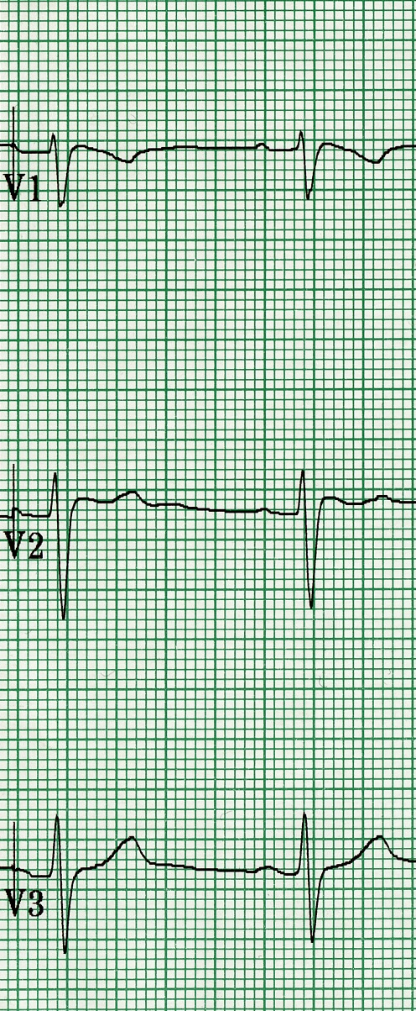 | 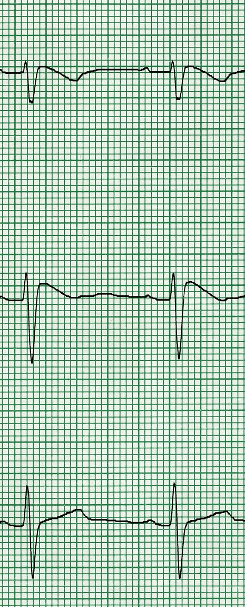 | 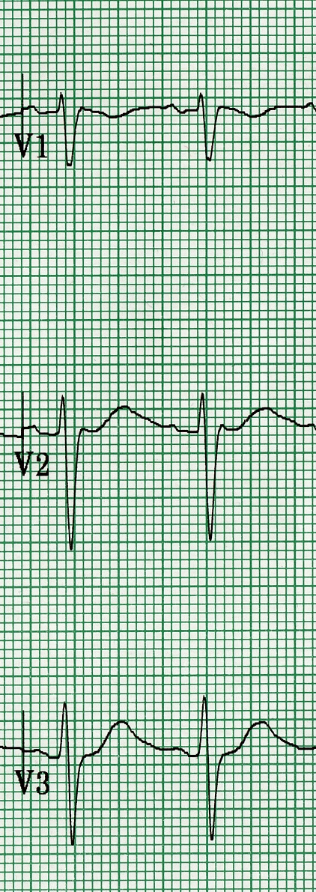
High Lead  ECG | 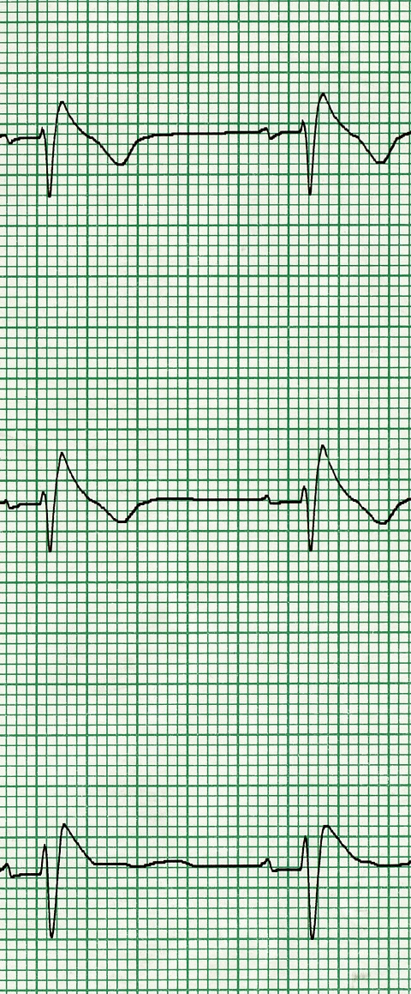 | 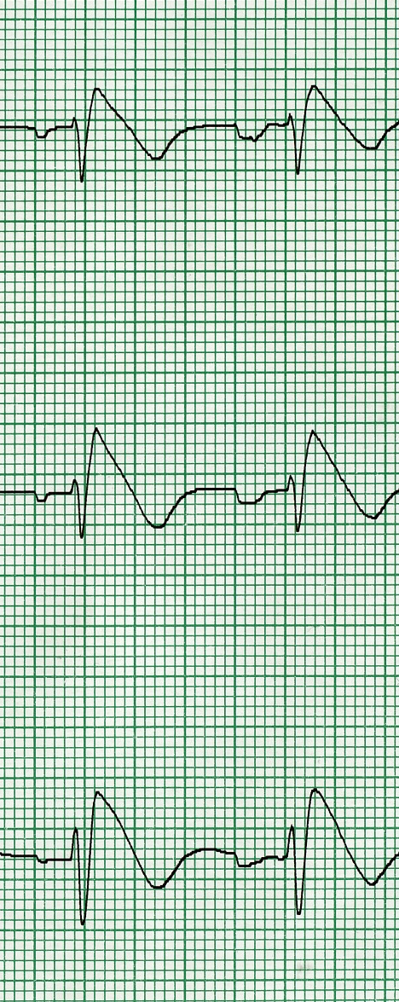 | 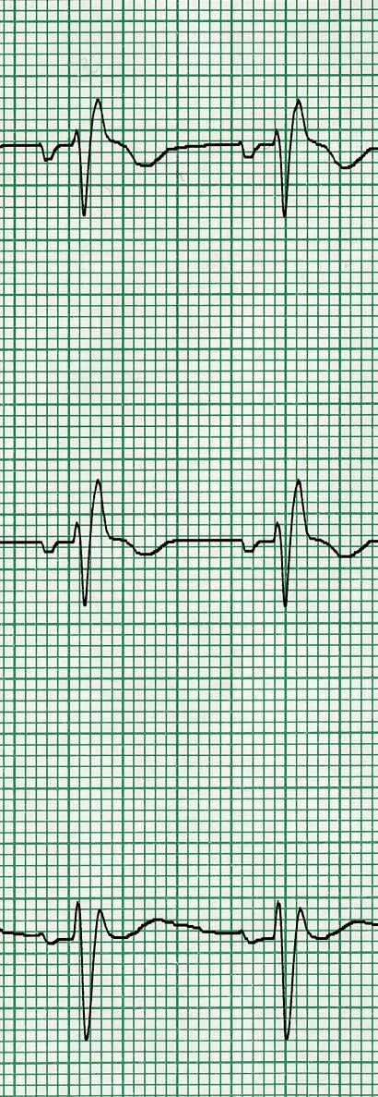

Figure Legend. Sequential ECGs (standard and high precordial lead positions) during a sodium channel blocker challenge. The baseline ECG demonstrates a non-Type 1 Brugada ST elevation, followed by the induction of a Type 1 Brugada pattern during the drug challenge, and resolution with isoproterenol infusion.

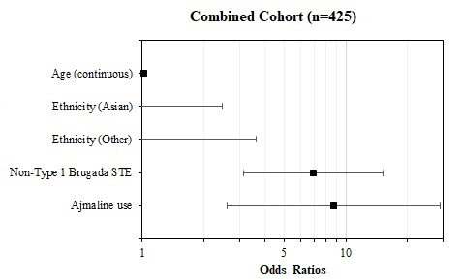
Figure 2. Factors Associated with Positive SCB Challenge

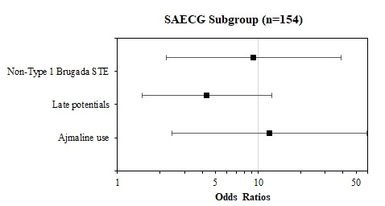

Figure Legend. Representative Figure (combined cohort). Forest Plot of Predictors of Sodium Channel Blocker (SCB) Challenge in Combined Cohort (n=425) and SAECG Subgroup (n=154) on Multivariable Analysis. In the Combined Cohort, independent predictors of a positive SCB included Non-Type 1 Brugada STE (OR 6.92) and Ajmaline use (OR 8.76). In the SAECG Subgroup, independent predictors included Non-Type 1 Brugada STE (OR 9.28), late potentials on SAECG (OR 4.32), and Ajmaline use (OR 12.0).

