**Appendices**

**Table of Contents**

Appendix 1 Site locations for TANDEM study 2

Appendix 2 TANDEM TB diagnosis algorithm 9

Appendix 3. Figures showing individual agreement between POC and laboratory HbA1c in the TANDEM study 10

# Appendix 1 Site locations for TANDEM study

**Summary - Study site locations**

In Bandung, Indonesia, suspected TB patients were recruited in 44 community health centres (CHCs) and from a district and a referral hospital. In Lima, Peru, patients were recruited at three primary health facilities and one secondary level hospital. In Romania, patients with TB were recruited from two secondary level hospitals, in two counties (Gorj and Dolj). In South Africa, patients were recruited at six community health care clinics in the northern Cape Town metropolitan area.

**Country and site selection**

For the TANDEM study, it was important to select countries from different geographic regions so that diverse cultural, health system structures and population demographics could be represented. The burden of TB and DM also needed to be sufficiently high so that there would be sufficient TB-DM burden within the populations to be able to detect a causal effect. The countries also needed to be typical of settings where economic improvement and changes in lifestyles would be likely to increase the risk of DM substantially. During the TANDEM proposal development in 2011, current data indicated that Peru and Romania had some of the highest TB incidence rates in the South American and European regions respectively (106 and 159 per 100,000 population respectively) and an expected increase of DM between 90% and 160% (WHO, 2010a). With a TB incidence of 189 per 100,000 population (WHO, 2010a), Indonesia’s burden was well above the recommended screening threshold for TB in people with DM of 100 per 100,000, as recommended by the WHO/Union Framework (The Union and WHO, 2011), even though it was not one of the highest in the South-East Asia region at that time.

The feasibility of conducting the studies was also an important criterion in the country selection and this was largely informed by long-term pre-existing research relationships between the TANDEM project principal investigators and research institutions within the countries as well as the collaborators’ capacity to recruit, test and treat patients for TB and DM and their access to potential participants. Given these considerations, Indonesia, Peru, Romania, and South Africa each with a high burden of TB and an increasing prevalence of DM, were selected.

The research team based in the Universitas Padjadjaran (UNPAD) in Bandung, Indonesia has a pre-existing research relationship with the main public tertiary teaching Hospital (RSHS), thus the DOTS and Endocrinology clinics at RSHS were selected for recruitment of people with TB and DM, respectively. The CHCs with the greatest number of patients with TB in Bandung were contacted and asked to participate in the TANDEM study, with the permission and endorsement of the City Health Office. Patients with TB were recruited from those facilities along with the 14 additional satellite CHCs. Recruitment of patients with TB was lower than expected, particularly from CHCs in the east. Therefore, the second hospital, Ujung Berung District Hospital, was later added so that patients with suspected TB at CHCs in east Bandung could be sent to Ujung Berung hospital for confirmation and enrolment in TANDEM.

In Peru, TANDEM made a request to the Ministry of Health to get permission and access to health facilities in Lima to conduct the studies in WP1 and WP2. The Ministry of Health then provided a list of facilities with sufficient patient volume to meet the Peru recruitment targets and that were not already involved in another research project, conducted by any other local or international institution. HAMA, the reference hospital for almost one million people in South Lima, was chosen for recruitment of people with DM since the Endocrinology Department and the daily DM clinic are the most accessed DM services in the area, particularly by uninsured people with DM. To recruit people with TB, four health facilities with a high or medium prevalence of TB in the Metropolitan area of Lima were chosen.

In Romania, sites were also purposively selected based on pre-existing research collaborations with the country principal investigator in Dolj and Gorj counties as well as a high volume of patients with TB at the Victor Babes Hospital and the Runcu Hospital, and patients with DM at the two general hospitals.

In South Africa, all clinical sites used for recruitment were located in the northern part of the Cape Town metropolitan area.  The facilities were selected because they are relatively close to Stellenbosch University's Faculty of Medicine and Health Sciences and cater for people with low- to lower-middle income for whom interventions are most needed. The areas have previously been reported to have a high prevalence of TB and diabetes, and the study team have a longstanding relationship with the personnel due to previous research activities. Diabetes patients were recruited from 3 Community Health Centres, under the management of Western Cape Provincial Health Department. Tuberculosis patients were recruited from 6 Primary Health Centres, under the management of City of Cape Town Health Department.

**TANDEM – GLOBAL LOCATIONS (See tandem-fp7.eu)**

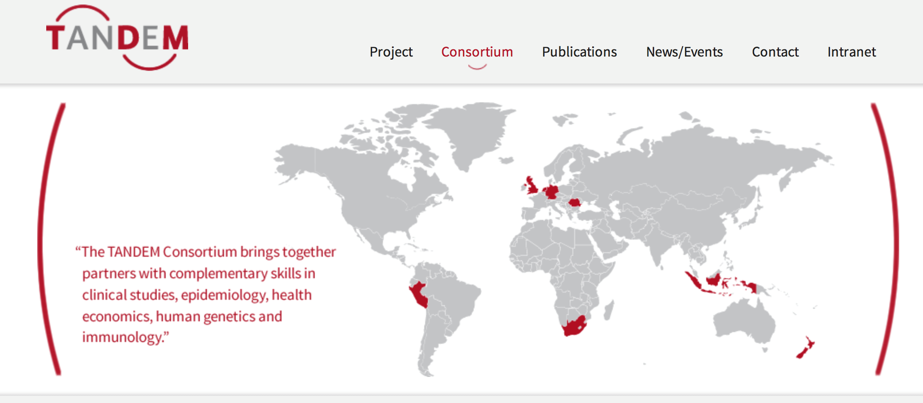

**TANDEM - SITES IN BANDUNG, INDONESIA**

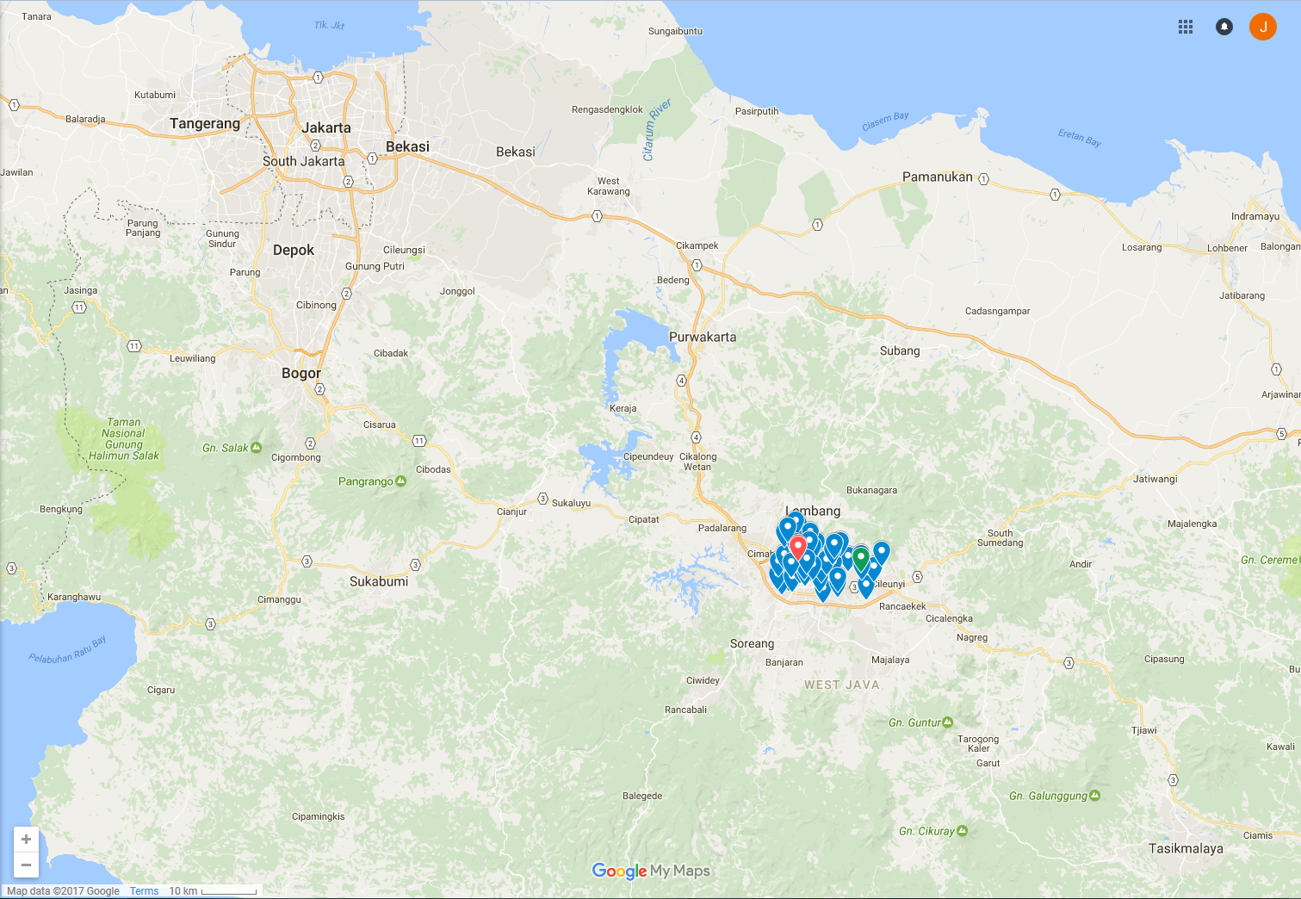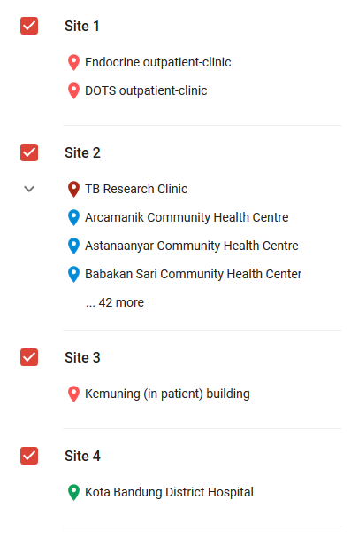

**TANDEM - SITES IN LIMA, PERU** 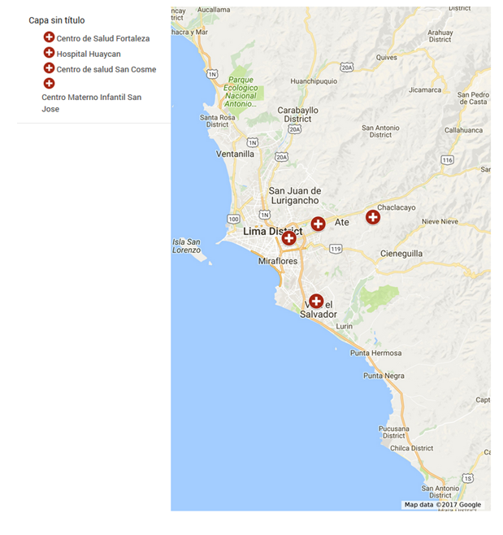

**TANDEM – SITES IN CRAIOVA ROMANIA**

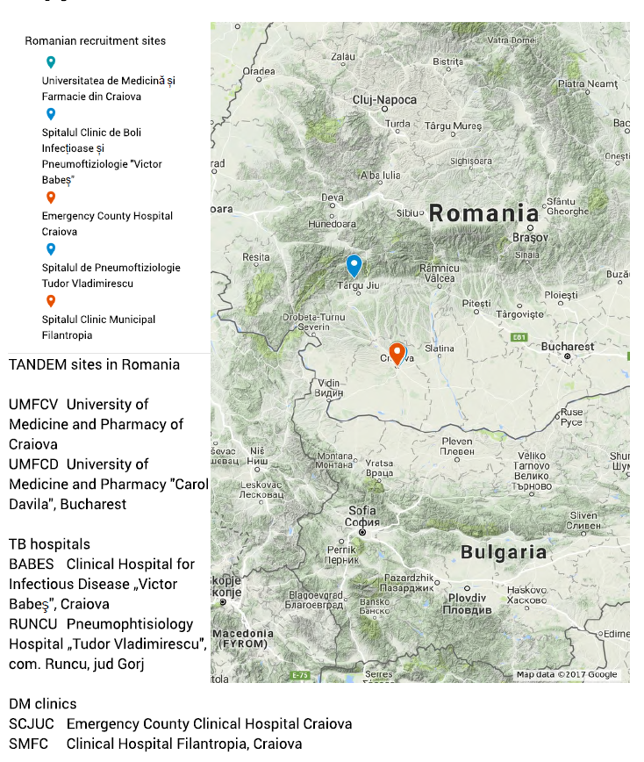

**TANDEM - SITES IN STELLENBOSCH, SOUTH AFRICA**

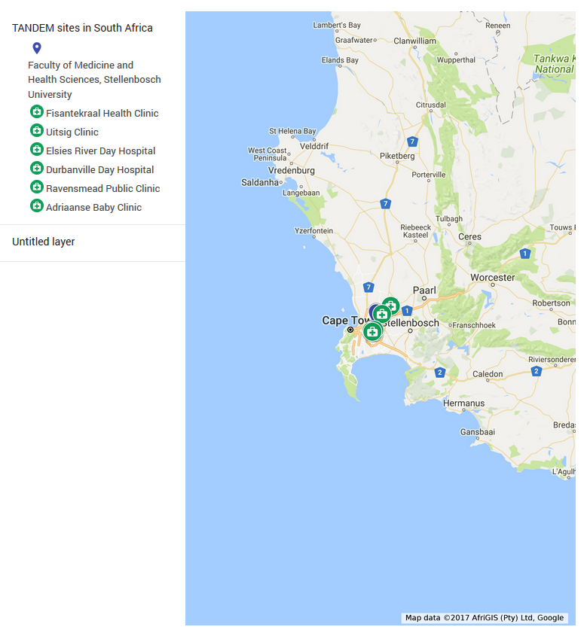

# Appendix 2 TANDEM TB diagnosis algorithm

|  |  |  |
| --- | --- | --- |
| **Case Definition** | **Criteria** | |
| Definite TB | Culture or GeneXpert positive | With or without:  Suggestive TB on X-ray  Possible TB on X-ray  TB symptoms |
| Probable TB | Smear Positive | And either:  Suggestive TB on X-ray  Possible TB on X-ray and TB Symptoms |
| Possible TB | Smear Positive | And either:  Possible TB on X-ray  TB symptoms |
| TB Symptoms | And either:  Suggestive TB on X-ray  Possible TB on X-ray |
| No TB | Does not fulfil any of the above criteria | |

In Indonesia and Peru, in order to obtain a positive result using the microscopic observation drug susceptibility assay (MODS) two colony forming units must be observed. Negative results require no growth. Indeterminate results occur when only one colony forming unit is observed, but is insufficient for bacterial confirmation. Indeterminate results are ignored by the case definition algorithm and are by default treated as negative1.

1 Moore DA, Mendoza D, et al. Microscopic observation drug susceptibility assay, a rapid, reliable diagnostic test for multidrug-resistant tuberculosis suitable for use in resource-poor settings. J Clin Microbiol. 2004;42:4432–4437.

# Appendix 3. Figures showing individual agreement between POC and laboratory HbA1c in the TANDEM study



**Total sample HbA1c difference**

POC was 0.14% (95%: 0.11, 0.18) greater than lab values (P<0.001)

**By study country:**



**Among Indonesian sample**

POC was 0.26% (95%: 0.21, 0.31) greater than lab values (P<0.001)



**Among Peruvian sample**

POC was 0.55% (95%: 0.47, 0.64) greater than lab values (P<0.001)



**Among Romanian sample**

Lab HbA1c was -0.37% (95%: -0.42, -0.31) greater than POC values (P<0.001)



**Among South African sample**

Lab HbA1c was -0.23% (95%: -0.32, -0.13) greater than POC values (P<0.001)

**By sex:**



**Among women only**

POC value was statistically greater than lab values by 0.21 (95%CI: 0.15, 0.27)



**Among men only**

POC value was statistically greater than lab values by 0.10 (95%CI: 0.05, 0.15)

**By BMI groups:**



**Among underweight group only**

POC values were significantly greater than lab values by 0.12 (0.07, 0.18)



**Among normal weight group**

POC values were significantly greater than lab values by 0.14 (0.09, 0.20)



**Among overweight group (143 people)**

POC values were significantly greater than lab values by 0.25 (0.10, 0.40)



**Among obese group (25 people)**

There is no statistical difference between POC and lab values 0.16 (-0.09, 0.40)

**By age groups:**



**Among <30 years**

POC values were significantly greater than lab values by 0.19 (0.13, 0.24)



**Among 30-39 years**

POC values were significantly greater than lab values by 0.27 (0.17, 0.36)



**Among 40-49 years (375 people)**

There is no statistical difference between POC and lab values -0.001 (-0.08, 0.08).



**Among 50-59 years (251 people)**

There is no statistical difference between POC and lab values 0.02 (-0.07, 0.11)



**Among >60 years (188 people)**

Borderline significant: 0.13 (-0.01, 0.27) P=0.06

**By anaemia status:**



**Among non-anaemic group**

POC was significantly greater than lab values by 0.12 (0.06, 0.17).



**Among mild anaemic group**

POC values were significantly greater than the lab values by 0.11 (0.04, 0.18)



**Among moderate anaemic group (352 people)**

POC values were significantly greater than lab values by 0.20 (0.12, 0.29)



**Among severe anaemic group (27 people)**

POC values were significantly greater than lab values by 1.07 (0.67, 1.46), P<0.001

**By HIV status:**



**Among HIV- group (1652 people)**

POC values were significantly greater than lab values by 0.15 (0.11, 0.19), P<0.001



**Among HIV+ group (72 people)**

POC values were significantly greater than lab values by 0.30 (0.10, 0.49), P=0.003