Exercise Recommendations in Patients with Valvular Heart Disease
Authors: Sabiha Gati, BSc (Hons), MRCP (UK), PhD¹ ; Aneil Malhotra, BA (Hons), MRCP (UK), PhD²; Sanjay Sharma, BSc (Hons), MRCP (UK), MD²

¹ Department of Cardiology, East & North Hertfordshire NHS Trust

² Cardiology Clinical Academic Group, St. George’s, University, London

Corresponding author:

Dr Sabiha Gati

Consultant Cardiologist

Lister Hospital,

East & North Hertfordshire NHS Trust

Corey Mills Lane, Stevenage

SG1 4AB

Email: sabiha.gati@nhs.net

Key Words: Exercise, Valves, Athlete’s Heart

Abstract word count 250.

Manuscript Word Count: 2723

Figures 4; Tables: 1

References: 30

Abstract
Valvular heart disease affects 1-2% of young individuals, many of whom aspire to partake in competitive sport or high intensity recreational exercise. There are limited reports on the impact of intensive physical activity on the progression of valvular heart disease, therefore, current recommendations are based on consensus opinion. The management of exercising individuals with valvular heart disease requires a structured approach which incorporates several key factors including symptomatic status, functional capacity, type and nature of the valvular lesion, impact on ventricular structure and function and effect on pulmonary artery pressure. Asymptomatic individuals with minor valvular abnormalities may engage in all forms of competitive sport whereas those with lesions of moderate severity may exercise intensively if an exercise stress test tailored to the type of physical exercise engaged reveals good functional capacity without myocardial ischaemia, haemodynamic disturbances or arrhythmia. Symptomatic athlete and those with severe valvular heart disease, impaired ventricular function, pulmonary hypertension and arrhythmias should refrain from most competitive sports. Athletes with a bicuspid aortic valve and aortic root diameter > 40 mm should avoid sport with a strong isometric component even with minimal valvular dysfunction. There is an association between mitral valve prolapse and sudden cardiac death in the general population, however there is limited evidence of increased risk with competitive sport. Athletes undergoing corrective surgery may return to exercise after 3 months if ventricular function and exercise capacity are preserved. Individuals anticoagulated for mechanical bioprosthetic valves should avoid contact or collision sport to minimise the risk of bleeding.

Introduction
Exercise is associated with multiple cardiovascular benefits and all individuals with cardiovascular disease should be encouraged to engage in some form of physical activity to maintain a healthy lifestyle. In the Western world, valvular heart disease is predominantly secondary to a degenerative process and generally prevalent from the sixth decade onward¹ but may also affect young and middle age individuals who are interested in participating in athletic activities.² Congenital defects are most common cause of valvular heart disease among young individuals. Indeed, the prevalence of congenital valvular heart disease compatible with daily life activities in the general population is in the range of 1-2% and a significant proportion of such individuals aspire to engage in intensive physical training including competitive sport.^{3,4} There are no prospective studies examining the impact of regular exercise on the progression of valvular heart disease. In the absence of such data, general guidance is based on consensus opinions and long-term follow-up studies from assessment of non-athletic individuals with these conditions.^{5–7} In general, asymptomatic athletes with mild valvular disease, normal ventricular function and good functional capacity can engage in all competitive sport. Right sided valvular abnormalities are better tolerated than left sided valvular abnormalities and regurgitant lesions are better tolerated than stenotic lesions. This review will focus on the potential pathophysiological mechanisms of exercise related valvular degeneration and provide a pragmatic approach in the management of competitive athletes and leisure sports persons with valvular heart disease.
Potential Effects of Exercise on Valvular Abnormalities
Although there is very limited data on the effects of intensive exercise on valvular heart disease, it is possible that the accompanying adrenergic surges and increased haemodynamic load on the heart may have several potential consequences in affected individuals (Figure 1). The mechanical effects of a vigorous stroke volume and repetitive increases in chronotropic response could cause functional deterioration of valve function. Experience from the general population with progressive valvular disease suggests that the ensuing valvular regurgitation or stenosis is associated with compensatory ventricular enlargement, hypertrophy and dysfunction. The main clinical consequences include reduced functional capacity, syncope, myocardial ischaemia, a predilection to atrial and/or ventricular arrhythmias and sudden death. Individuals with advanced left sided valvular lesions will have elevated left atrial pressure and may eventually develop pulmonary hypertension. Given that patients with bicuspid aortic valve may have accompanying aortopathy, the stress on the aortic wall from increased stroke volume and raised aortic pressure during high intensity exercise may theoretically accelerate the risk of dilatation or dissection of the aortic root or ascending aorta.

Valve Diseases Considered Safe for Intensive Exercise
Eligibility for competitive sports participation for individuals with valve disease is determined by several factors including symptomatic status, functional capacity, type and severity of valve disease, alterations in myocardial structure and function, pulmonary artery pressure and risk of arrhythmia. According to the American Heart Association (AHA) and American College of Cardiology (ACC) scientific statement², symptomatic individuals should not participate in competitive sport irrespective of the severity of valvular disease. Among asymptomatic individuals, lesions considered safe and compatible with exercise include the mild stenotic and mild regurgitant lesions (Table 1). Competitive exercise is also possible in individuals with moderate regurgitant lesions in the presence of good functional capacity and normal haemodynamic response to exercise or exercise induced arrhythmias. In this regard, it is essential to perform an exercise stress test to ensure that an individual with valve disease can tolerate the level of exertion expected from the specific type of physical activity wished to be engaged in without symptoms, haemodynamic compromise, inducible myocardial ischaemia or arrhythmias.
Individuals who exercise intensively for ≥4 hours per week develop a 10% increase in ventricular cavity size. The magnitude of the absolute LV cavity size is influenced by several demographic factors including age, sex, size and sporting discipline.⁸ As many as 14% of male athletes reveal a LV end-diastolic dimension >60mm.⁹ The current recommendations account for the physiological effects of intensive physical training on cardiac chamber size and provide upper limits of LV dimensions to facilitate decision making in athletes with moderate aortic or mitral regurgitation.² Among sedentary individuals, such dimensions would be an indication for surgical intervention despite the absence of symptoms. Specifically, individuals with moderate aortic regurgitation may compete in all sporting disciplines provided the left ventricular end-systolic dimension is <50mm in males and <40 mm in females or, <25mm/m² (either sex) and LV function is preserved if a maximal exercise stress test is normal. Similarly, individuals with moderate mitral regurgitation may compete in all sport if LVEDD < 60 mm (or < 35.3 mm/m² in men and < 40 mm/m² in women) with preserved LV function, PAP < 30 mm Hg and good functional capacity. Even these dimensions may be considered conservative especially in adult male endurance athletes with a body surface area ≥2m² and a tailored approach is recommended which accounts for these demographics before imposing restriction.
Individuals with moderate aortic stenosis may participate in low and moderate dynamic and static sports such as cricket, volleyball, running and rugby in the absence of ST-changes consistent with ischaemia, tachyarrhythmias and a blunted BP response to exercise. Individuals with severe stenotic valvular lesions particularly aortic stenosis should be advised to abstain from participation in any competitive or leisure sport/exercise other than light activities.
With increasing globalisation of elite sport, cardiologists in the Western world may encounter athletes from the developing world with rheumatic mitral stenosis. Most athletes with severe mitral stenosis are unable to participate in competitive sport involving moderate or high intensity exercise, however athletes with mild or moderate mitral stenosis may be asymptomatic. There is a theoretical risk that increased left ventricular filling during exercise may precipitate acute pulmonary oedema in the short term or cause atrial fibrillation in the long term. In general athletes with a mitral valve area <1.1cm² should not participate in competitive sport with exception of low intensity sport. Athletes with a mitral valve area >2.0cm² and in sinus rhythm can participate in all sport pending demonstration of good functional capacity on exercise tolerance test. Athletes who are in atrial fibrillation should be anticoagulated and avoid contact/collision sport.

Mitral Valve Prolapse
Mitral valve prolapse (MVP) is a common condition that has a genetic predisposition, resulting in myxomatous changes of the mitral valve leaflets. The estimated incidence of MVP is between 0.2 – 0.4% per year in the general population.¹⁰ Thickening and redundancy of the valve leaflets and chords results in prolapse of the leaflets in to the left atrium in systole with the potential for progressive mitral regurgitation from loss of leaflet apposition. The natural history of MVP is generally benign with a 10 year mortality risk of 5%,¹¹ however, MVP is the main cause for surgical intervention for severe mitral regurgitation in developed countries.¹² Chronic mitral regurgitation may be associated with pulmonary hypertension with subsequent right heart failure, increased risk of arrhythmias including atrial fibrillation^{13,14} with subsequent thromboembolic events and infective endocarditis.
Mitral valve prolapse has been associated with an increased predisposition to arrhythmogenic sudden cardiac death,¹⁵ which is the most feared complication of the disorder. A systematically maintained Italian cardiac pathological registry of 650 sudden cardiac deaths in young adults aged ≤40 years demonstrated that 7% (n=43) of all deaths were from MVP. Such deaths were more common in women (n=26; 60%) where MVP was the most common structural cardiac abnormality identified following SCD.¹⁶ Most decedents with a pre-mortem diagnosis of MVP did not have severe mitral regurgitation, therefore risk stratification for SCD is challenging. Certain electrical and structural abnormalities may identify high-risk patients. Amongst 12 individuals with MVP with an available ECG, 10 (83%) revealed inverted T-waves in inferior leads and ventricular extrasystoles of right bundle branch block ventricular morphology. These electrical anomalies suggest that the mechanical effects of MVP create an arrhythmogenic milieu that may cause sustained and potentially life threatening arrhythmias in some patients. An autopsy series has previously shown increased scarring in the infero-basal wall and the papillary muscles in almost 90% of decedents with MVP. Bi-leaflet MVP was identified in 70% of this population. The authors postulated that excessive stretch by the flail leaflets causes myocardial scarring and promotes arrhythmogenesis. In a more recent study the same group of researchers examined 36 living patients with arrhythmic MVP and confirmed the presence of infero-basal and papillary muscle fibrosis on cardiovascular magnetic resonance in 93% cases compared to those without arrhythmia where late scarring was noted in only 14% cases.¹⁷ The authors also noted longer mitral valve annulus disjunction, also presumably due to stretch among patients with MVP and ventricular arrhythmias compared to those without arrhythmia.

Whether MVP exacerbates risk of SCD in athletes is unclear. In another Italian study of young competitive athletes MVP was identified in 2.9% of 7449 athletes. During the follow-up period of 8±2 years, there were no reported sudden cardiac deaths. Adverse events occurred at a rate of 0.5% per annum and included flail leaflets, incident dyspnoea, progressive mitral regurgitation with LV dilatation, ischaemic stroke and atrial fibrillation requiring hospitalisation.¹⁸ Such events occurred in older athletes who also showed mitral valve disjunction and ventricular arrhythmias at baseline evaluation. Athletes with isolated MVP or mild mitral regurgitation had no adverse events.
In general, most physically active people with MVP that have mild to moderate regurgitation can engage in all competitive sport, however, based on the Italian studies there are several markers that may signify increased risk of SCD including T-wave inversion in the inferior leads on the 12-lead ECG, ventricular arrhythmias on Holter ECG, severe mitral regurgitation, left ventricular systolic dysfunction, family history of SCD and myocardial fibrosis in the left ventricular inferolateral basal region (figure 2). The current AHA/ACC² consensus panel do not make any specific recommendations with the exception that in the presence of LV systolic dysfunction, arrhythmias on Holter recording or a family history of SCD, exercise in individuals with MVP should be restricted to low-intensity competitive sport.

Bicuspid Aortic Valve
Bicuspid aortic valve (BAV) is the most common congenital heart defect and affects 1-2% of the general population.¹⁹ The prevalence of BAV in athletes is similar to that in the general population. There appears to be a higher male preponderance with a 3:1 ratio. Bicuspid aortic valve disease also has a genetic component similar to MVP, although a specific gene mutation has yet to be identified. Clinical studies demonstrate that one-third of families of individuals with BAV may have more than one affected member²⁰ Asymptomatic adults with BAV generally have a good prognosis with survival rates similar to those in the general population.²¹ Over one-third of individuals with BAV may develop serious complications including aortic stenosis or aortic regurgitation from the 5th decade onwards (figure 3). Individuals with fusion of the right and non coronary leaflets have a higher risk and rapid progression of aortic stenosis and regurgitation.²² In contrast, patients with fusion of right and left coronary leaflets exhibit a greater degree of aortic wall degeneration and is also associated with coarctation of the aorta.²³ Bicuspid aortic valve is a marker of connective tissue abnormalities and may be associated with an aortopathy.
The metabolic and haemodynamic effects of diverse sports including cycling, swimming, rugby and field athletics individuals with BAV do not appear to have a negative impact on left ventricular structure and function in the medium term. In a 5-year follow-up study on 292 subjects with BAV (210 athletes, 23 ex-athletes and 59 controls) there was no significant change in LV morphology and function among the diverse BAV patterns.²⁴
Almost 50% of individuals with a bicuspid aortic valve are at increased risk of aortopathy. The risk of developing increased risk of aortic root and/or ascending aortic aneurysm, dissection or rupture is approximately 0.1% per annum.^{21,25} Although it is unknown whether restriction of physical activity limits the rate or risk of aortic dilatation or dissection, there is a theoretical concern that haemodynamic effects of exercise training may accelerate aortopathy in athletes with BAV disease. Data derived from athletic cohorts suggest that most haemodynamically intense endurance disciplines are associated with the greatest increases in aortic dimensions.^{26,27} Based on existing cross sectional studies in athletic cohorts , the 99th percentile value of aortic root diameter in males and in females are 40mm and 34mm respectively.²⁶ Consensus opinion recommends that individuals with an aortic root diameter > 40mm should not engage in sporting activities that are associated with increased loading conditions on the aorta such as power lifting and isometric exercises. Our own experience of 20 professional male soccer players with BAV (mean age 24±81 years) compared with 24 male non-athletes with BAV (mean age 30±8.2 years) and 22 healthy athletes with normal tricuspid aortic valve (mean age 26±7.2years) diagnosed on routine echocardiography did not show a significant change in aortic dimensions over a follow-up period of 5±2 years.²⁸ Our findings do not suggest that exercise alone contributes to aortic dilatation in young athletes with BAV over a modest period of observation. It is likely that several factors such as genetic predisposition, maladaptive cell-matrix remodelling processes, haemodynamic and biomechanical perturbations may account for the natural history of aortopathy associated with BAV disease.²⁹

Management of Athletes With Valvular Disease
Based on personal experience, the majority of individuals with valve disease of a mild to moderate nature will remain asymptomatic without exercise limitation until late in the course of the disease. We recommend 1-2 yearly assessment with echocardiography and exercise stress testing to assess progression of valvular disease. Individuals with symptoms, severe valvular dysfunction, impaired ventricular function, pulmonary hypertension and arrhythmias should be advised to abstain from competitive sport and should be considered for corrective surgery.
Most individuals requiring surgical intervention will undergo valve replacement with a mechanical prosthesis which will be associated with a transvalvular gradient and the need for anticoagulation. In the absence of data on the natural history of a valve replacement or repair in individuals who exercise intensively, the current consensus recommendations are relatively conservative. Apart from avoiding contact sports or sports associated with trauma (such as competitive cycling, hiking, wind surfing etc) in those who are anticoagulated, our practice is to apply the same recommendations as native valve disease of moderate severity (Table 1). Recovering individuals should be rehabilitated with a gradually increasing exercise programme over 12 weeks and may start exercising more vigorously after this time period when the sternal wound has recovered completely.
Compared to native valves, the haemodynamic changes associated with prosthetic valve are sub-optimal and may impact on the athlete’s performance and therefore, exercise testing to evaluate haemodynamic response at the level of exertion expected for the sporting discipline is particularly helpful in such individuals.
Patients with valvular disease particularly MVP and BAV are at higher risk of infective endocarditis than the general population. In this regard, athletes with valvular heart disease should also be advised to abstain from having tattoos and body piercings. Athletes with atrial fibrillation should be anticoagulated and advised to avoid contact or collision sports (Figure 4).

Advice for Symptomatic Patients
The main focus of the review was on competitive or high intensity recreational exercise in asymptomatic patients, however, there are a significant proportion of individuals with mildly symptomatic or moderate valvular disease who aspire to exercise for pleasure and health benefits. Although there are no scientifically based recommendations, it is our practice to encourage gentle walking or cycling for 20-30 minutes 5 times per week with a heart rate correlating with their ventilatory anaerobic threshold assessed by cardio-pulmonary exercise testing or at 80% of the maximum age predicted heart rate for age (60-70% for individuals taking beta-blockers). Static muscle strengthening exercises improve mitochondrial function and retards sarcopenia. We recommend 3-6 repetitions on weights up to 20% of the body weight on upper limbs and 50% of the body weight on the lower limbs.³⁰ Exceptions to strength training include individuals with severe aortic stenosis or pulmonary stenosis. Patients must be advised to stop exercising immediately in the event of angina, palpitations or dizziness.
Conclusion
There is limited data on the impact of intensive exercise on the progression of valvular heart disease. Mild to moderate valvular disease is compatible with intensive exercise in most individuals. Individuals with symptoms and severe valvular dysfunction should abstain from competitive sport with view to reassessment after corrective surgery.

Figure Legends
Figure 1: The potential effects of adrenergic surges and increased haemodynamic load associated with exercise in individuals with valvular heart disease.
Figure 2: Specific markers of increased risk of sudden cardiac death in individuals with mitral valve prolapse.
LV: left ventricle; MR: mitral regurgitation; SCD: sudden cardiac death; TWI: T-wave inversion.
Figure 3: Complications of bicuspid aortic valve include a) mechanical obstruction from aortic stenosis; b) aortic root and ascending aortic dilatation; c) aortic dissection; d) unrecognised aortic coarctation.
Figure 4: General advice for all patient patients with valvular disease.

Table 1: Recommendations for participation in competitive sport in relation to type and severity of valve disease in asymptomatic individuals.
Valve Lesion | Recommendation for Sports Participation
Mitral Regurgitation* | Mild | Moderate | Severe
 | All sport | All sports if LVEDD < 60 mm (or < 35.3 mm/m² in men and < 40 mm/m² in women) if good LV function, PAP < 30 mm Hg and good functional capacity. | May compete in all sports after detailed discussion with physician if LVEDD < 60 mm (or < 35.3 mm/m² in men and < 40 mm/m² in women) if good LV function, PAP < 30 mm Hg and good functional capacity
Mitral Stenosis* | All sport if MVA >2.0cm² and good functional capacity. No collision or body contact sport if anticoagulated for AF. | Low dynamic/static sport if MVA <2.0cm² - >1.5cm² and good function capacity. | No competitive sport (except sport with low dynamic and/or static component) if MVA < 1.5 cm²
Aortic Regurgitation* | All sport | All sports if, LVESD < 50 mm (male) or < 40 mm (female) and good LV systolic function and functional capacity. | May compete in all sport after discussion with physician if LVESD < 50 mm (male) or < 40 mm (female) and good LV systolic function and functional capacity.
Aortic Stenosis* | All sports if AVA > 1.5 cm² or jet velocity < 3m/sec. | Low intensity sport if AVA 1-1.5 cm² or jet velocity 3-4 m/sec provided good functional capacity and no evidence and no evidence of myocardial ischaemia, arrhythmias or flat blood pressure response. | No competitive sport (except low intensity) if AVA < 1cm² or valve jet > 4m/sec.
*For mixed valvular disease, the recommendation for the predominant valve lesion should be followed.

Figure 1:
Figure 2:
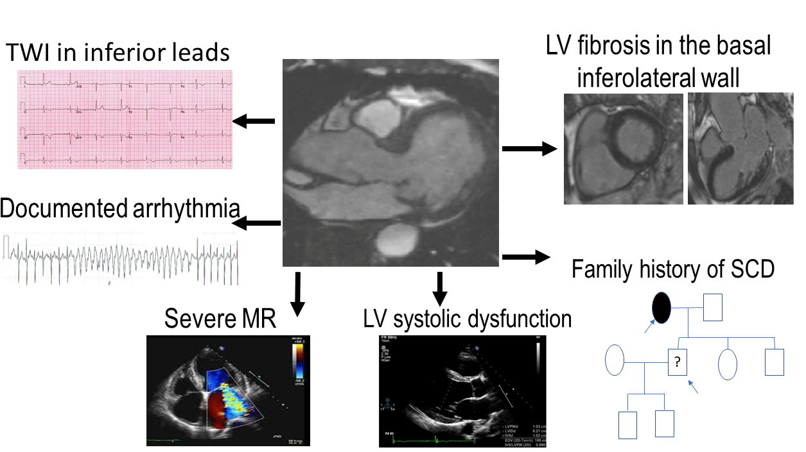
Figure 3:
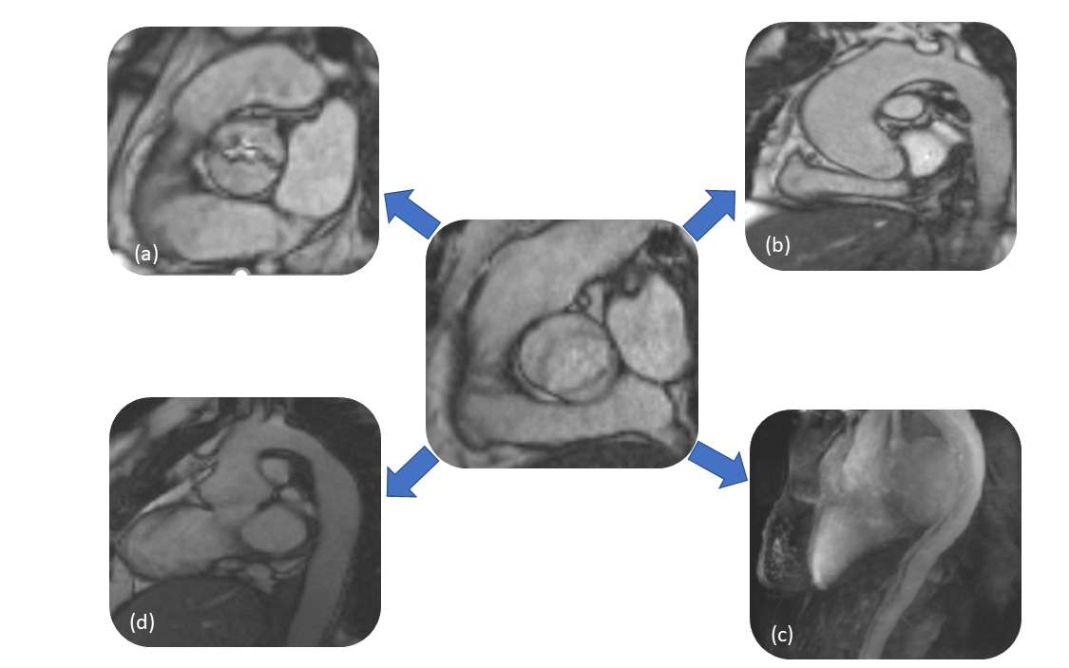
Figure 4:
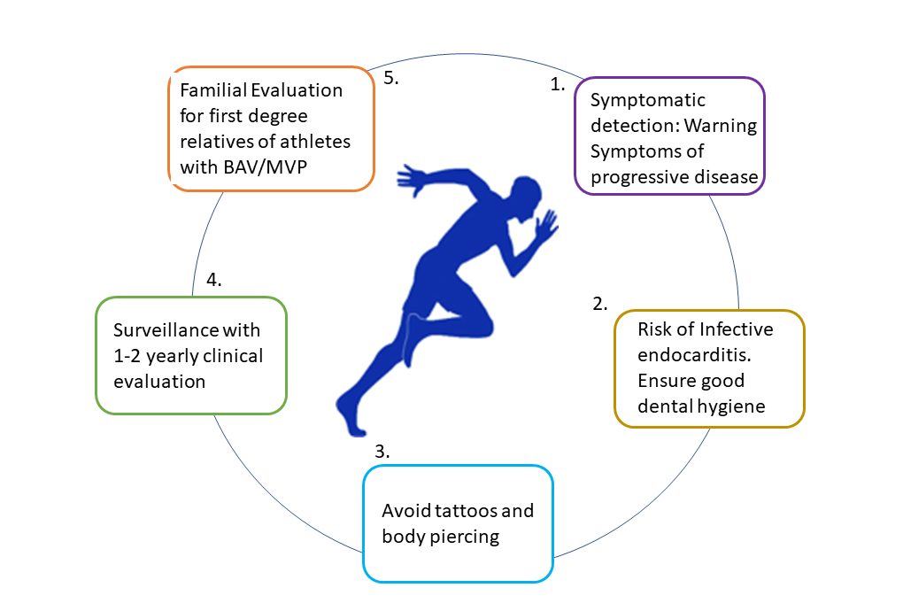

References
1. Maron BJ, Doerer JJ, Haas TS, Tierney DM, Mueller FO. Sudden deaths in young competitive athletes analysis of 1866 deaths in the united states, 1980-2006. Circulation. 2009;119(8):1085-1092.
2. Bonow RO, Nishimura RA, Thompson PD, Udelson JE. Eligibility and Disqualification Recommendations for Competitive Athletes with Cardiovascular Abnormalities: Task Force 5: Valvular Heart Disease: A Scientific Statement from the American Heart Association and American College of Cardiology. Circulation. 2015;132(22):e292-e297.
3. Nishimura RA, McGoon MD, Shub C, Miller FFA, Ilstrup DM, Jamil Tajik A. Echocardiographically documented mitral-valve prolapse. Long-term follow-up of 237 patients. N Engl J Med. 1985;313(21):1305-1309.
4. Williams DS. Bicuspid aortic valve. J Insur Med. 2006;38(1):72-74.
5. Genereux P, Stone GW, O’Gara PT, et al. Natural History, Diagnostic Approaches, and Therapeutic Strategies for Patients With Asymptomatic Severe Aortic Stenosis. J Am Coll Cardiol. 2016;67(19):2263-2288.
6. Masri A, Svensson LG, Griffin BP, Desai MY. Contemporary natural history of bicuspid aortic valve disease: a systematic review. Heart. 2017;103(17):1323-1330.
7. Desai MY, Grigioni F, Di Eusanio M, et al. Outcomes in Degenerative Mitral Regurgitation: Current State-of-the Art and Future Directions. Prog Cardiovasc Dis. 2017;60(3):370-385.
8. Zaidi A, Sharma S. Exercise and heart disease: from athletes and arrhythmias to hypertrophic cardiomyopathy and congenital heart disease. Future Cardiol. 2012;9(1):119-136.
9. Pelliccia A, Culasso F, Di Paolo FM, Maron BJ. Physiologic left ventricular cavity dilatation in elite athletes. Ann Intern Med. 1999;130(1):23-31.
10. Delling FN, Vasan RS. Epidemiology and Pathophysiology of Mitral Valve Prolapse. Circulation. 2014;129(21):2158 LP-2170.
11. Avierinos J-F, Gersh BJ, Melton LJ 3rd, et al. Natural history of asymptomatic mitral valve prolapse in the community. Circulation. 2002;106(11):1355-1361.
12. Luxereau P, Dorent R, De Gevigney G, Bruneval P, Chomette G, Delahaye G. Aetiology of surgically treated mitral regurgitation. Eur Heart J. 1991;12 Suppl B:2-4.
13. Winkle RA, Lopes MG, Fitzgerald JW, Goodman DJ, Schroeder JS, Harrison DC. Arrhythmias in patients with mitral valve prolapse. Circulation. 1975;52(1):73 LP-81..
14. Zuppiroli A, Mori F, Favilli S, et al. Arrhythmias in mitral valve prolapse: relation to anterior mitral leaflet thickening, clinical variables, and color Doppler echocardiographic parameters. Am Heart J. 1994;128(5):919-927.
15. Chesler E, King RA, Edwards JE. The myxomatous mitral valve and sudden death. Circulation. 1983;67(3):632-639.
16. Basso C, Perazzolo Marra M, Rizzo S, et al. Arrhythmic Mitral Valve Prolapse and Sudden Cardiac Death. Circulation. 2015;132(7):556-566.
17. Perazzolo Marra M, Basso C, De Lazzari M, et al. Morphofunctional Abnormalities of Mitral Annulus and Arrhythmic Mitral Valve Prolapse. Circ Cardiovasc Imaging. 2016;9(8):e005030.
18. Caselli S, Mango F, Clark J, et al. Prevalence and Clinical Outcome of Athletes With Mitral Valve Prolapse. Circulation. 2018;137(19):2080-2082.
19. Tzemos N. Outcomes in adults with bicuspid aortic valves. JAMA. 2008;300(11):1317-1325.
20. Cripe L, Andelfinger G, Martin LJ, Shooner K, Benson DW. Bicuspid aortic valve is heritable. J Am Coll Cardiol. 2004;44(1):138-143.
21. Tzemos N, Therrien J, Yip J, et al. Outcomes in adults with bicuspid aortic valves. JAMA. 2008;300(11):1317-1325.
22. Fernandes SM, Khairy P, Sanders SP, Colan SD. Bicuspid Aortic Valve Morphology and Interventions in the Young. J Am Coll Cardiol. 2007;49(22):2211-2214.
23. Fernandes SM, Sanders SP, Khairy P, et al. Morphology of bicuspid aortic valve in children and adolescents. J Am Coll Cardiol. 2004;44(8):1648-1651.
24. Stefani L, Galanti G, Innocenti G, Mercuri R, Maffulli N. Exercise training in athletes with bicuspid aortic valve does not result in increased dimensions and impaired performance of the left ventricle. Cardiol Res Pract. 2014;2014.
25. Michelena HI, Khanna AD, Mahoney D, et al. Incidence of aortic complications in patients with bicuspid aortic valves. JAMA. 2011;306(10):1104-1112.
26. Pelliccia A, Di Paolo FM, Quattrini FM. Aortic Root Dilatation in Athletic Population. Prog Cardiovasc Dis. 2012;54(5):432-437.
27. Boraita A, Heras M-E, Morales F, et al. Reference Values of Aortic Root in Male and Female White Elite Athletes According to Sport. Circ Cardiovasc Imaging. 2016;9(10)..
28. Malhotra, A. Yeo,T.J., Dhutia, H, Prakash K, Keteepe-Arachi,T, D’Silva, A, Finnichiaro G, Steriotis A, Papatheodorou S, Millar L, Dassanayake S, Ensam B, Papadakis M, Tome M SS. The effect of exercise on the aortic root diameter in young elite athletes with bicuspid aortic valve disease. Eur Heart J. 2016;37(Abstract Supplement):24-25.
29. Siu SC, Silversides CK. Bicuspid Aortic Valve Disease. J Am Coll Cardiol. 2010;55(25):2789-2800.
30. D’Silva A, Sharma S. Management of young competitive athletes with cardiovascular conditions. Heart. 2017;103(6):463-473.

