12-Lead ECG Monitoring in Athletes: Positive Strides on the Master Athlete’s Track

Sanjay Sharma BSc (Hons), MD, FESC, Efstathios Papatheodorou MD
Cardiology clinical academic group. St George’s, University of London

Conflict Of interest: None
Disclosures: None

Address for correspondence:
Professor Sanjay Sharma
Cardiology clinical academic group
St George’s, University of London
Cranmer Terrace. London. SW17 ORE. UK
E mail sasharma@sgul.ac.uk
Word count 1176
Premature ventricular beats (PVBs) are common in the general population and are reported in 40-75% of individuals. Complex ventricular arrhythmias (VA), specifically multi-focal PVBs, couplets, triplets and non-sustained ventricular tachycardia (NSVT), are detected in up to 4% of healthy subjects during continuous ambulatory ECG recording. However, such arrhythmias are rarely associated with an increased risk of sudden cardiac death in individuals without underlying structural disease or coronary artery disease.
Early reports in young athletes showed that only athletes with a high burden of PVBs were at risk of cardiac disease and adverse events. In a large study of 15,889 asymptomatic young Italian athletes, 355 (2.2%) athletes revealed ≥ 3PVBs on a resting ECG. Among these, 71 athletes (20%) revealed a high burden of PVBs (≥2000 PVBs per 24 hours) which was associated with structural heart disease in almost one three cases and 1 athlete died from cardiomyopathy. In contrast only 1.7% of athletes with a 24-hour PVB burden < 2000 showed structural disease which was confined to those with a 24-hour PVB burden of 100-2000 (1). The same authors reported the effect of detraining for almost 20 weeks in 70 of the 71 athletes with a high burden of PVBs and showed an 80% reduction the number of PVBs and couplets and a 90% reduction in the prevalence of NSVT. This effect was equally observed in athletes with and without structural disease. Forty athletes (excluding those with cardiomyopathy) continued to compete without adverse events (2). These findings led the investigators to conclude that PVBs, particularly when the burden is < 2000 per day, are benign features of the athlete’s heart in asymptomatic individuals. It should be emphasized that the origin of the PVBs in these studies was ascertained from the 12-lead ECG and 3 lead 24-hour Holter.
The potential pro-arrhythmic effect of multi-decadal participation in intensive physical activity has been a long-standing debate. There is increasing recognition that atrial fibrillation is more common in life long middle aged male endurance athletes (3) compared with the age matched general population but the jury is still out on the prevalence and significance of VA in ostensibly healthy middle aged and older athletes who represent the most rapidly growing cohort of sports participants in the Western world. Several observational studies have reported increased coronary artery calcification (4) and myocardial fibrosis (5), therefore a higher prevalence of VAs may be expected in this athlete cohort.
In this edition, Zorzi and colleagues (6) report the prevalence and morphology of VAs in predominantly male (83%) middle aged (mean age 43 years old) endurance athletes by performing 12-lead 24-hour ECGs in 134 middle aged endurance athletes and 134 age matched controls. All participants were apparently healthy and had a structurally normal heart at echocardiography. Athletes exercised for 9 hours per week for a mean duration of 13 years whereas controls did not exceed > 2 hours exercise per week.
The investigators found no difference in the prevalence of simple or complex VAs between athletes and controls. The prevalence of > 10 isolated PVBs between athletes and controls was 26% v 23%; 10 (7%) athletes and 6 (5%) controls had > 500 PVBs over 24 hours and 4 athletes and 3 controls showed NSVT. Athletes with > 10 isolated PVBs were older than athletes with less frequent PVBs (48 vs 44 years). The 12-lead facility of the 24-hour ECG enabled identification of the origin of the VAs. Furthermore, athletes were encouraged to exercise intensively during the monitoring period to assess the impact of adrenergic surges and loading conditions on the prevalence of VAs.
Approximately 40% of athletes and controls with VAs, showed PVBs arising from the right or left outflow tract (infundibular) or the distal left fascicle which are known to result from enhanced automaticity. Arrhythmias with these morphologies were most prevalent in athletes with frequent (> 500) PVBs. However, the remaining 60% of athletes with ventricular arrhythmias showed PVBs with wide RBBB, LBBB with an intermediate or superior axis or polymorphic PVBs, all of which have been implicated in potentially serious structural heart disease including isolated myocardial fibrosis in young athletes (7). This concern is also reflected in the most recent ECG interpretation recommendations in young athletes where extensive evaluation is recommended even in the presence of a single PVB with LBBB morphology and superior axis (8). Assuming that all athletes with PVBs of these specific morphologies were investigated and only 1 showed evidence of fibrosis on CMR, it could be inferred they may be of less prognostic significance in older athletes than younger counterparts.
Zorzi et al. provide important information about the prevalence, burden and morphology of VAs (predominantly PVBs) in middle aged athletes in their fifth decade. The take home message is that there is no difference in the prevalence of VAs and their morphological patterns in this age group of endurance athletes who have exercised for a mean period of 13 years compared with sedentary individuals of similar age. Readers may infer that long standing endurance exercise does not promote VAs and the authors themselves claim that their findings do not support this hypothesis. The conclusions are based on a relatively small number of individuals with frequent or complex PVBs (13 v 12), therefore, our position is to err on the side of caution until more data is available. The prevalence of VAs in athletes is influenced by several factors including age, subclinical disease, the intensity and longevity of exercise and the use of performance enhancing agents (Figure 1). Studies in apparently healthy older asymptomatic athletes in their sixth decade who have exercised for a mean period of 31 years have revealed a higher prevalence of very high coronary artery calcium scores, coronary plaques, subclinical myocardial infarction and NSVT compared with healthy controls with similarly low Framingham risk scores (4). In this study (6) the reader is not provided with precise information about the intensity and volume of exercise in these athletes yet there are several reports in young individuals participating in high volume intensive competitive cycling programmes who have presented with a high prevalence of symptomatic complex VAs and subsequently succumbed to a disorder identical to arrhythmogenic right ventricular cardiomyopathy in the absence pathogenic genetic variants for the disorder (9). Just as these authors have tried to disprove that VAs may be promoted by long term endurance exercise, others have postulated that exercise may promote cardiomyopathy and the onset of fatal arrhythmias, therefore the debate goes on. The authors have made positive strides on the master athlete’s track, but the finish line is still not within sight.
It is unlikely for an asymptomatic athlete to be subject to a 24-hour ECG as first line investigation, however an abnormal result may prompt further investigation and clinical surveillance. We propose a preliminary guide for investigating master athletes with VAs (Figure 1) which is based on information from cross sectional studies in relatively small cohorts. Much larger multicenter prospective studies are required on this intriguing cohort of athletes to provide a better understanding of the link between exercise, VAs and subsequent prognosis.

Figure 1
Title: Ventricular arrhythmias in middle aged athletes
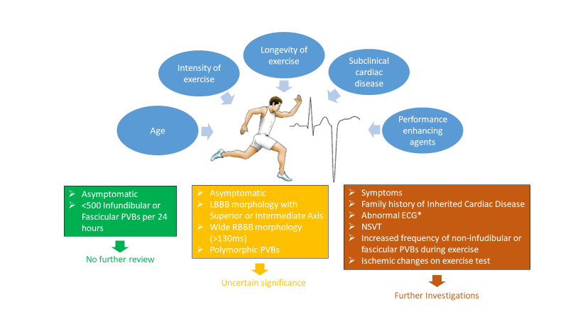
Figure Legend
*2017 International ECG Recommendations(8) with the addition of small complexes (<0.5mv) in the limb leads, PVBs = Premature Ventricular Beats, LBBB = Left Bundle Branch Block, RBBB = Right Bundle Branch Block, NSVT = Non-sustained ventricular tachycardia

References
1. Biffi A, Pelliccia A, Verdile L, et al. Long-Term Clinical Significance of Frequent and Complex Ventricular Tachyarrhythmias in Trained Athletes. 2002.
2. Biffi A, Maron BJ, Verdile L, et al. Impact of physical deconditioning on ventricular tachyarrhythmias in trained athletes. J. Am. Coll. Cardiol. 2004;44:1053–1058.
3. Guasch E, Mont L. Diagnosis, pathophysiology and management of exercise-induced arrhythmias. Nat. Rev. Cardiol. 2017;14:88–101.
4. Merghani A, Maestrini V, Rosmini S, et al. Prevalence of Subclinical Coronary Artery Disease in Masters Endurance Athletes with a Low Atherosclerotic Risk Profile. Circulation 2017:CIRCULATIONAHA.116.026964.
5. Breuckmann F, Möhlenkamp S, Nassenstein K, et al. Myocardial Late Gadolinium Enhancement: Prevalence, Pattern, and Prognostic Relevance in Marathon Runners. Radiology 2009;251:50–57.
6. Zorzi A, Mastella G, Cipriani A, et al. Burden of ventricular arrhythmias at 12-lead 24-hour ambulatory ECG monitoring in middle-aged endurance athletes versus sedentary controls. Eur. J. Prev. Cardiol. 2018:204748731879739.
7. Zorzi A, Perazzolo Marra M, Rigato I, et al. Nonischemic Left Ventricular Scar as a Substrate of Life-Threatening Ventricular Arrhythmias and Sudden Cardiac Death in Competitive Athletes. Circ. Arrhythmia Electrophysiol. 2016;9:e004229.
8. Sharma S, Drezner JA, Baggish A, et al. International recommendations for electrocardiographic interpretation in athletes. Eur. Heart J. 2018;39:1466–1480.
9. Heidbüchel H, Hoogsteen J, Fagard R, et al. High prevalence of right ventricular involvement in endurance athletes with ventricular arrhythmias. Role of an electrophysiologic study in risk stratification. Eur. Heart J. 2003;24:1473–80.

