Supplemental Material

Genome-wide association analyses of >200,000 subject identifies 42 novel genetic loci for chronic inflammation and highlights causal pathways that link inflammation and complex disorders

Table of Content
Figure S1. QQ-plot of the HapMap genome-wide association analysis of C-reactive protein. 7
Figure S2. Manhatton plot of the HapMap genome-wide association analysis of C-reactive protein. 8
Figure S3. QQ-plot of the 1KG genome-wide association analysis of C-reactive protein. 9
Figure S4. Manhattan plot of the 1KG genome-wide association analysis of C-reactive protein. 10
Figure S5. QQ-plots of the 1KG genome-wide association analysis of C-reactive protein, adjusted for body mass index. 11
Figure S6. Manhattan plot of the 1KG genome-wide association analysis of C-reactive protein. 12
Figure S7. Forrest plots of the Mendelian randomization analysis for the nine clinical outcomes. 13
Figure S7a. Alzheimer´s disease. 13
Figure S7b. Bipolar disorder. 14
Figure S7c. Coronary heart disease. 15
Figure S7d. Crohn´s disease. 16
Figure S7e. Diastolic blood pressure. 17
Figure S7f. Inflammatory bowel disease. 18
Figure S7g. Rheumatoid arthritis. 19
Figure S7h. Schizophrenia. 20
Figure S7i. Systolic blood pressure. 21
Figure S8. Scatter plots of the four Mendelian randomization analyses applied to nine a priori selected clinical outcomes. 22
Figure S8a. Alzheimer´s disease. 22
Figure S8b. Bipolar disorder 23
Figure S8c. Coronary artery disease. 24
Figure S8d. Crohn´s disease. 25
Figure S8e. Diastolic blood pressure. 26
Figure S8f. Inflammatory bowel disease. 27
Figure S8g. Rheumatoid arthritis. 28
Figure S8h. Schizophrenia. 29
Figure S8i. Systolic blood pressure. 30
Figure S9. Funnel plots of the CRP_{GWAS} IV Mendelian randomization analysis for the a priori selected nine clinical outcomes. 31
Figure S9a. Alzheimer´s disease. 31
Figure S9b. Bipolar disorder. 32
Figure S9c. Coronary artery disease. 33
Figure S9d. Crohn´s disease. 34
Figure S9e. Diastolic blood pressure. 35
Figure S9f. Inflammatory bowel disease. 36
Figure S9g. Rheumatoid arthritis. 37
Figure S9h. Schizophrenia. 38
Figure S9i. Systolic blood pressure. 39
Figure S10. Leave-one-out analysis of the Mendelian randomization analyses applied to nine a priori selected clinical outcomes. 40
Figure S10a. Alzheimer´s disease. 40
Figure S10b. Bipolar disorder. 41
Figure S10c. Coronary artery disease. 42
Figure S10d. Crohn´s disease. 43
Figure S10e. Diastolic blood pressure. 44
Figure S10f. Inflammatory bowel disease. 45
Figure S10g. Rheumatoid arthritis. 46
Figure S10h. Schizophrenia. 47
Figure S10i. Systolic blood pressure. 48
1. Mendelian Randomization (MR) methods 49
2. Study Descriptives and Acknowledgments 51
Age, Gene/Environment Susceptibility Reykjavik Study (AGES) 51
Avon Longitudinal Study of Parents and their Children (ALSPAC) 52
Amish Heredity and Phenotype Intervention (HAPI) Heart Study 53
The Atherosclerosis Risk in Communities (ARIC) study 54
Austrian Stroke Prevention Study (ASPS) 55
British 1958 birth cohort (B58C) 56
Bogalusa Heart Study (BHS) 57
BioMe 58
Baltimore Longitudinal Study of Aging (BLSA) 58
Busselton Health Study 59
Coronary Artery Risk Development in Young Adults (CARDIA) study 60
The Chicago Health and Aging Project (CHAP) 61
Center for Health Discovery and Well Being (CDHWB) 62
Cardiovascular Health Study (CHS) 63
Cilento study 65
Cohorte Lausannoise (CoLaus) 65
Corogene study 66
CROATIA-Vis study 67
Epidemiologic data on the syndrome of insulin resistance (DESIR) 67
Danish National Birth Cohort – Preterm Birth study (DNBC-PTB) 68
Estonian Genome Center at the University of Tartu (EGCUT) 69
European Prospective Investigation into Cancer and Nutrition (EPIC) Norfolk 69
Family Heart Study (FamHS) 70
Fenland Study 71
Framingham Heart Study (FHS) 72
FINRISK study 73
Friuli Venezia Giulia (FVG) 73
Genes and Blood-Clotting (GABC) study 74
Genetics, Arthrosis, and Progression study (GARP) 75
Genetic Study of Atherosclerosis Risk (GeneSTAR) 75
Genetics of Lipid Lowering Drugs and Diet Network (GOLDN) 76
Gutenberg Health Study (GHS) 77
Life-style factors on the development of the Immune System and Allergies in East and West Germany PLUS the influence of traffic emissions and genetics (LISAplus) Study / German Infant study on the influence of Nutrition Intervention PLUS environmental and genetic influences on allergy development (GINIplus) 78
Gothenburg Osteoporosis and Obesity Determinants (GOOD) study 80
Genetics of Overweight Young Adults (GOYA) 80
Health Aging and Body Composition Study (Health ABC) 81
Helsinki Birth Cohort Study (HBCS) 82
Hunter Community Study (HCS) 83
InCHIANTI study 83
INCIPE 84
Monitoring of Trends and Determinants in Cardiovascular Disease (MONICA)/ Cooperative Health Research in the Region of Augsburg (KORA) F3/F4 study 85
CROATIA-Korcula study 87
Lothian Birth Cohorts (LBC) 87
LifeLines cohort study 88
Leiden Longevity Study (LLS) 89
London Life Sciences Prospective Population Study (LOLIPOP) 90
Ludwigshafen Risk and Cardiovascular Health (LURIC) Study 91
Multi-Ethnic Study of Atherosclerosis (MESA) 92
METabolic Syndrome In Men (METSIM) 93
Microisolates in South Tyrol (MICROS) 93
The Osteoporotic Fractures in Men (MrOS) Sweden (MrOS Sweden) study 94
Netherlands Study of Depression and Anxiety (NESDA) Study 95
The Northern Finland Birth Cohort 1966 (NFBC66) 96
Nurses’ health study (NHS) 98
Health professionals’ follow-up study (HPFS) 99
Netherlands Twin Register (NTR) 99
Ogliastra Genetic Park -Talana (OGP-Talana) 101
Orkney Complex Disease Study (ORCADES) 102
Australian twin-family study of alcohol use disorder (OZALC) 102
Pharmacogenomics and Risk of Cardiovascular Disease study (PARC) 103
Prospective Investigation of the Vasculature in Uppsala Seniors (PIVUS) 104
Prevention of Renal and Vascular Endstage Disease (PREVEND) 105
Precocious Coronary Artery Disease Study (PROCARDIS) 106
PROspective Study of Pravastatin in the Elderly at Risk (PROSPER) 107
The Western Australian Pregnancy Cohort (Raine) Study 108
Rotterdam Study 109
SardiNIA study 110
Study of Health in Pomerania (SHIP) 111
TRacking Adolescents' Individual Lives Survey (TRAILS) 112
TwinGene 113
TwinsUK 114
Uppsala Longitudinal Study of Adult Men (ULSAM) 115
Vitamin Intervention Stroke Prevention (VISP) 115
Women’s Genome Health Study (WGHS) 117
Women Health Initiative (WHI) study 118
Young Finnish Study (YFS) 119
3. References 121

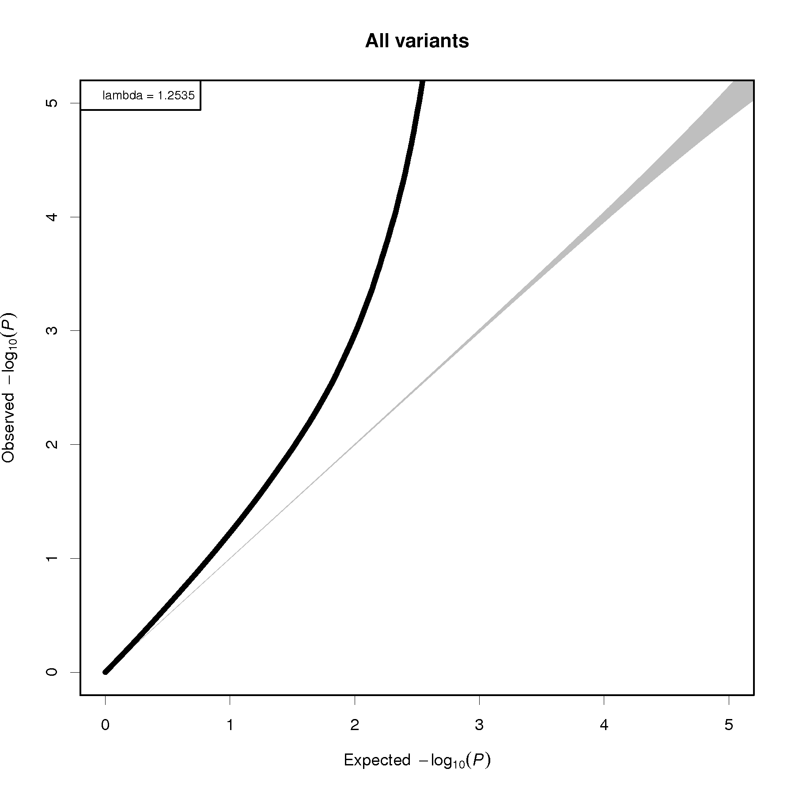

Figure S1. QQ-plot of the HapMap genome-wide association analysis of C-reactive protein.

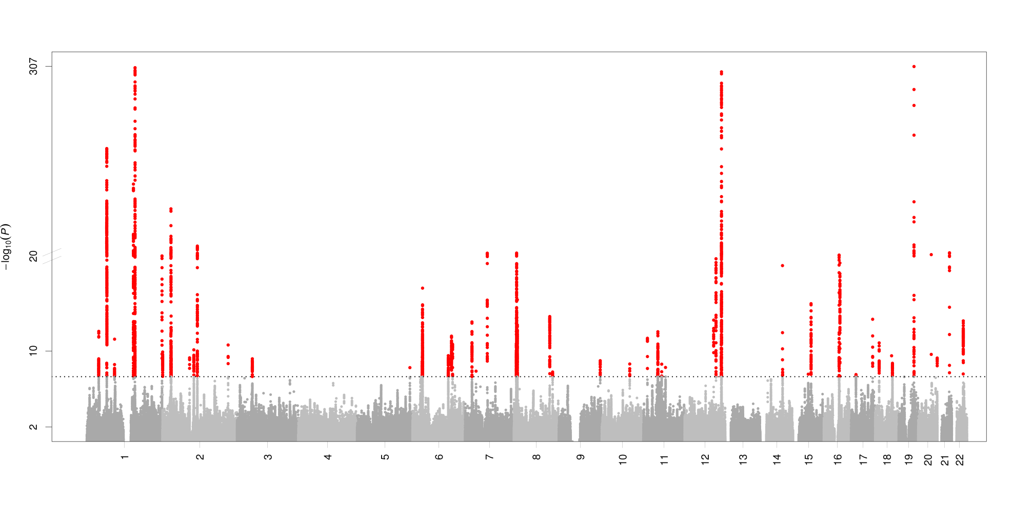

Figure S2. Manhatton plot of the HapMap genome-wide association analysis of C-reactive protein.
This figure presents 48 distinct genome-wide significant loci associated to serum CRP levels. The effective sample size was 204,402, including 78 Caucasian cohorts. The number on x-axis presents the chromosome number. The y-axis presents –log10 (P-value) for the association with natural log-transformed CRP.

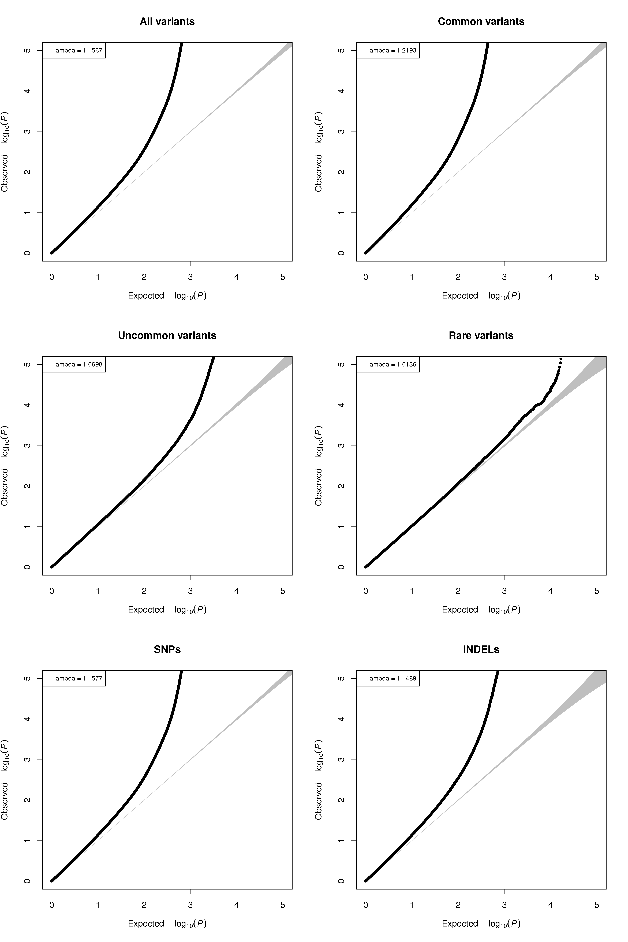

Figure S3. QQ-plot of the 1KG genome-wide association analysis of C-reactive protein.

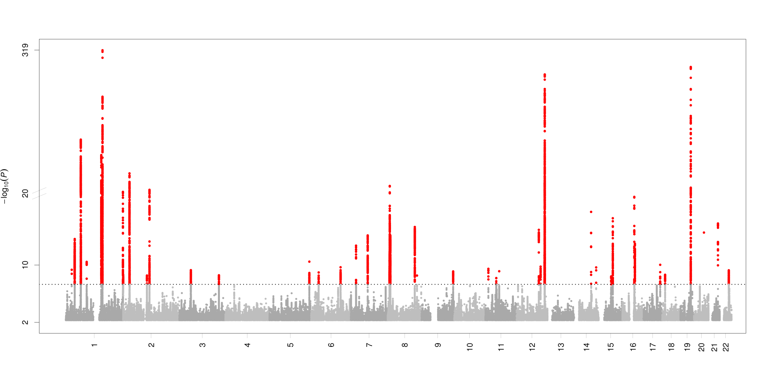

Figure S4. Manhattan plot of the 1KG genome-wide association analysis of C-reactive protein.
This figure presents 48 distinct genome-wide significant loci associated to serum levels of CRP. The effective sample size was 148,164 including 49 Caucasian cohorts. The number on the x-axis presents the chromosome number, and the y-axis presents the -log₁₀ (P-value) for the association with natural log-transformed CRP.

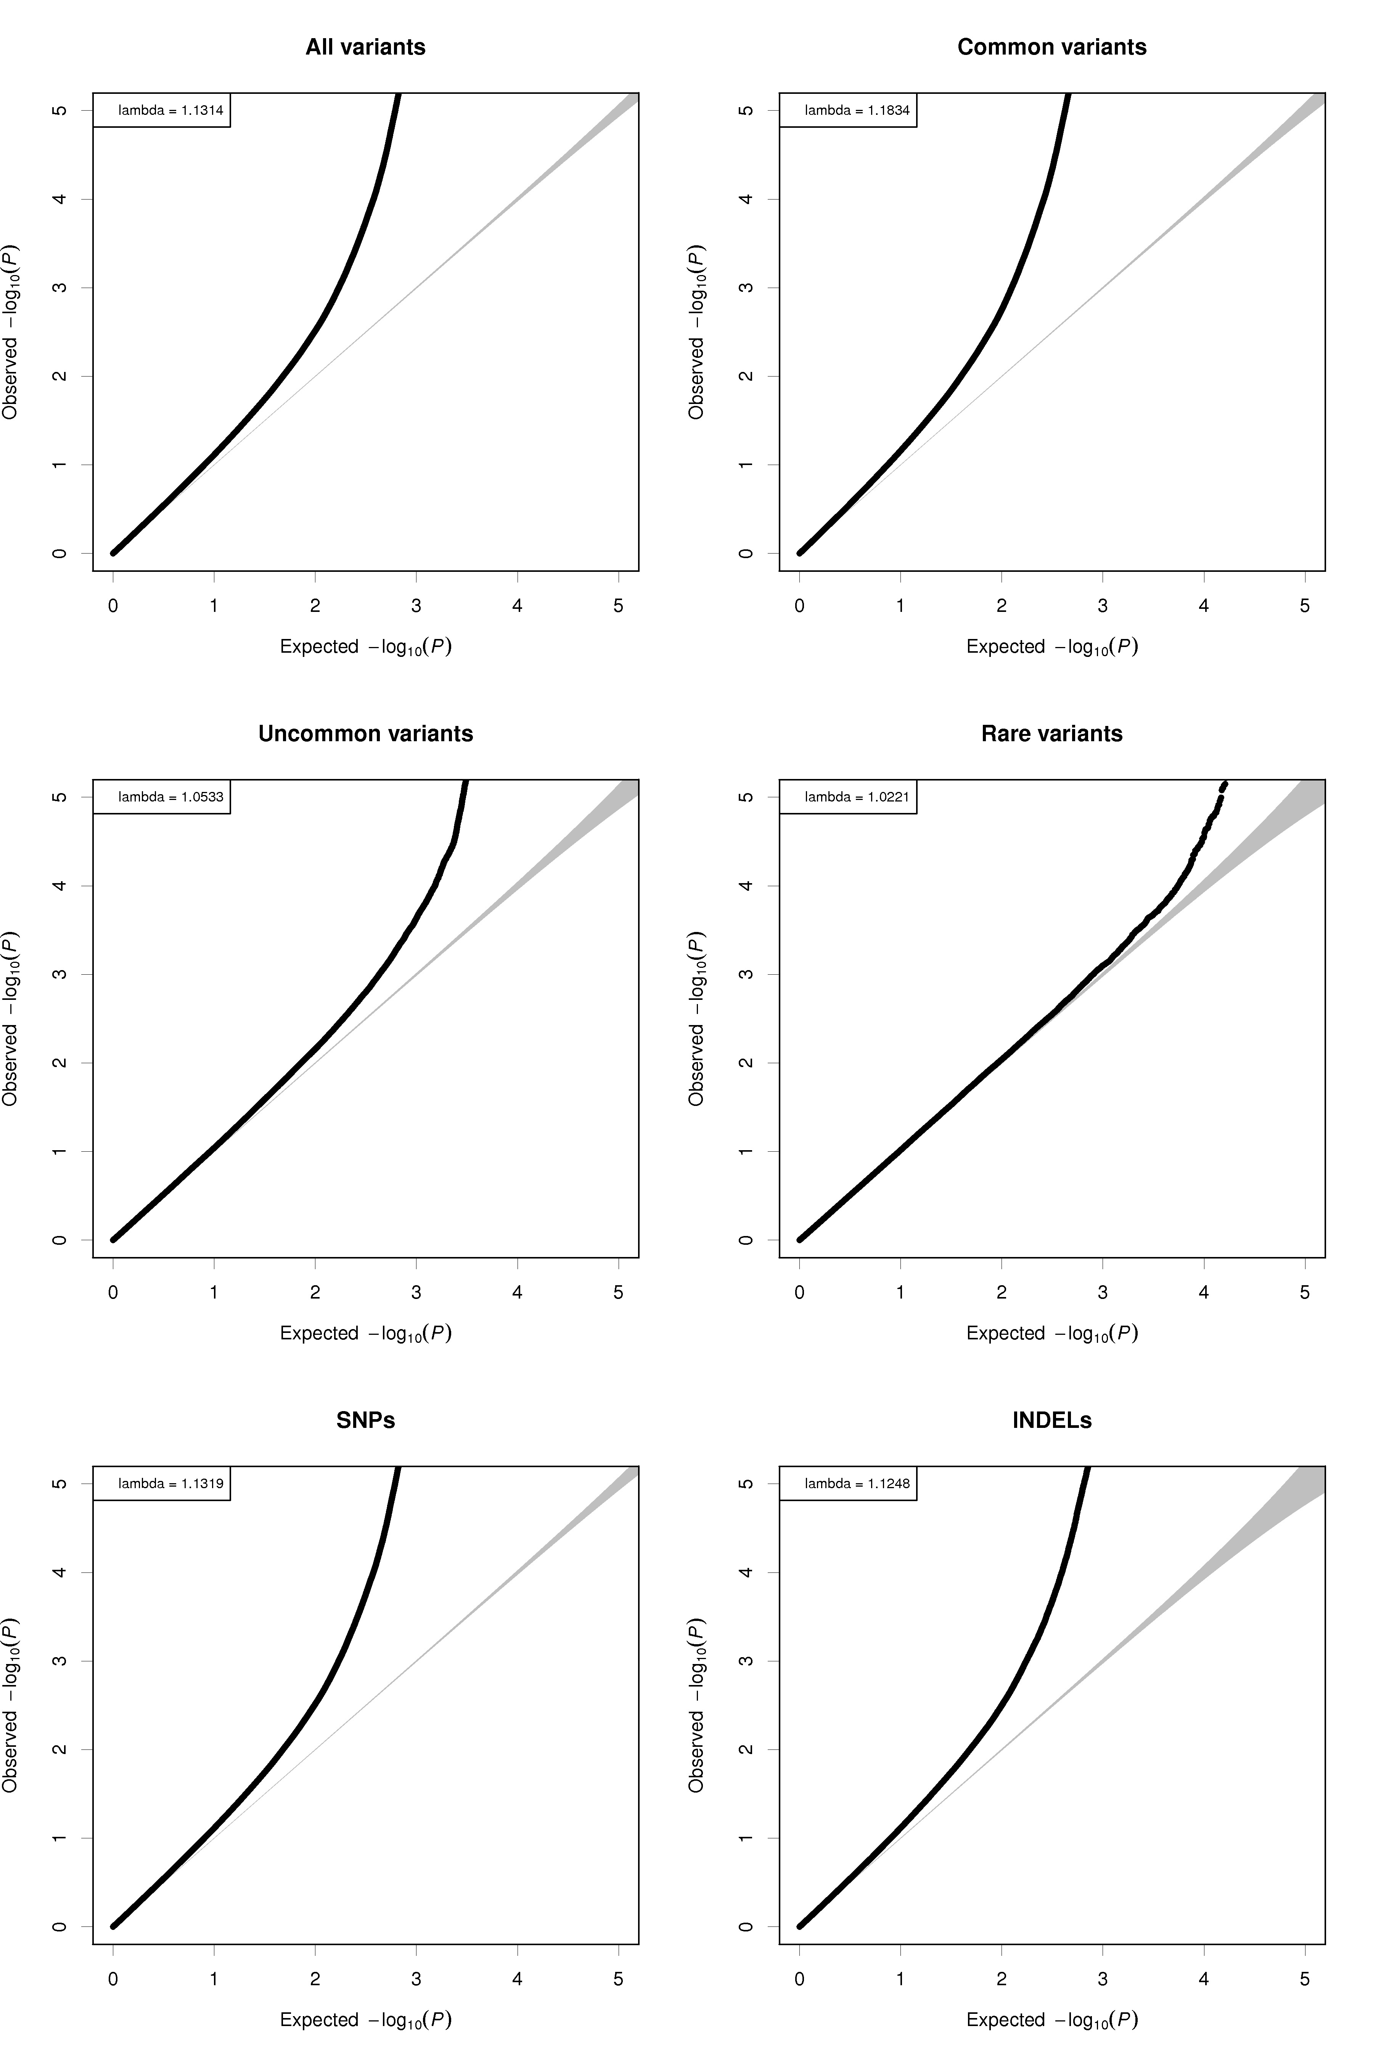

Figure S5. QQ-plots of the 1KG genome-wide association analysis of C-reactive protein, adjusted for body mass index.

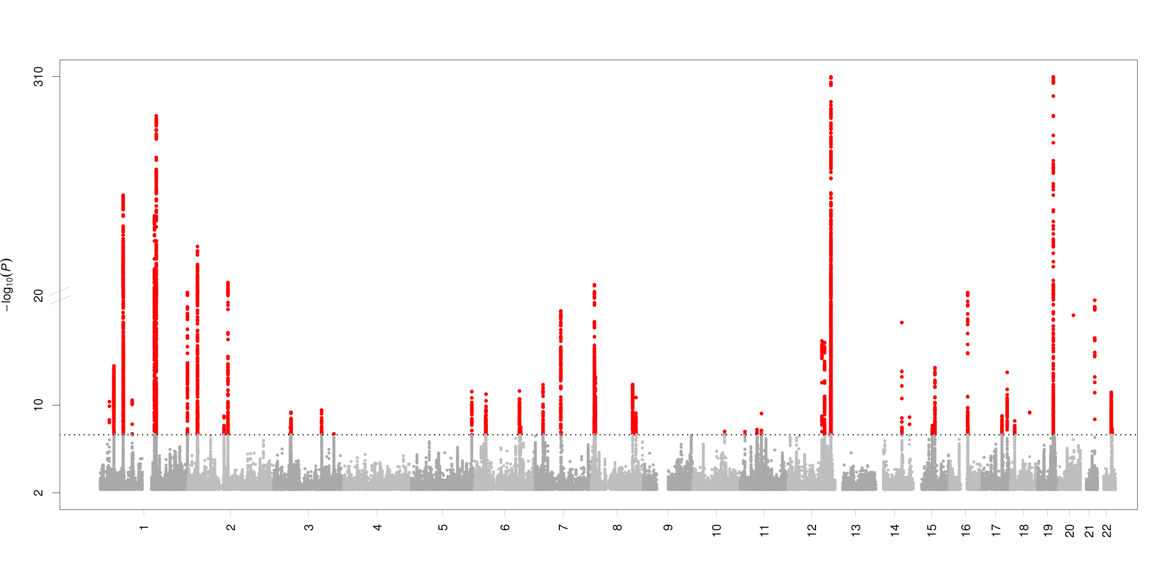

Figure S6. Manhattan plot of the 1KG genome-wide association analysis of C-reactive protein.
This figure presents 46 distinct genome-wide significant loci associated to serum CRP levels. The effective sample size was 148,164 including 49 Caucasian cohorts. The number on the x-axis presents the chromosome number, and the y-axis presents the -log₁₀ (P-value) for the association with natural log-transformed CRP.

Figure S7. Forrest plots of the Mendelian randomization analysis for the nine clinical outcomes.
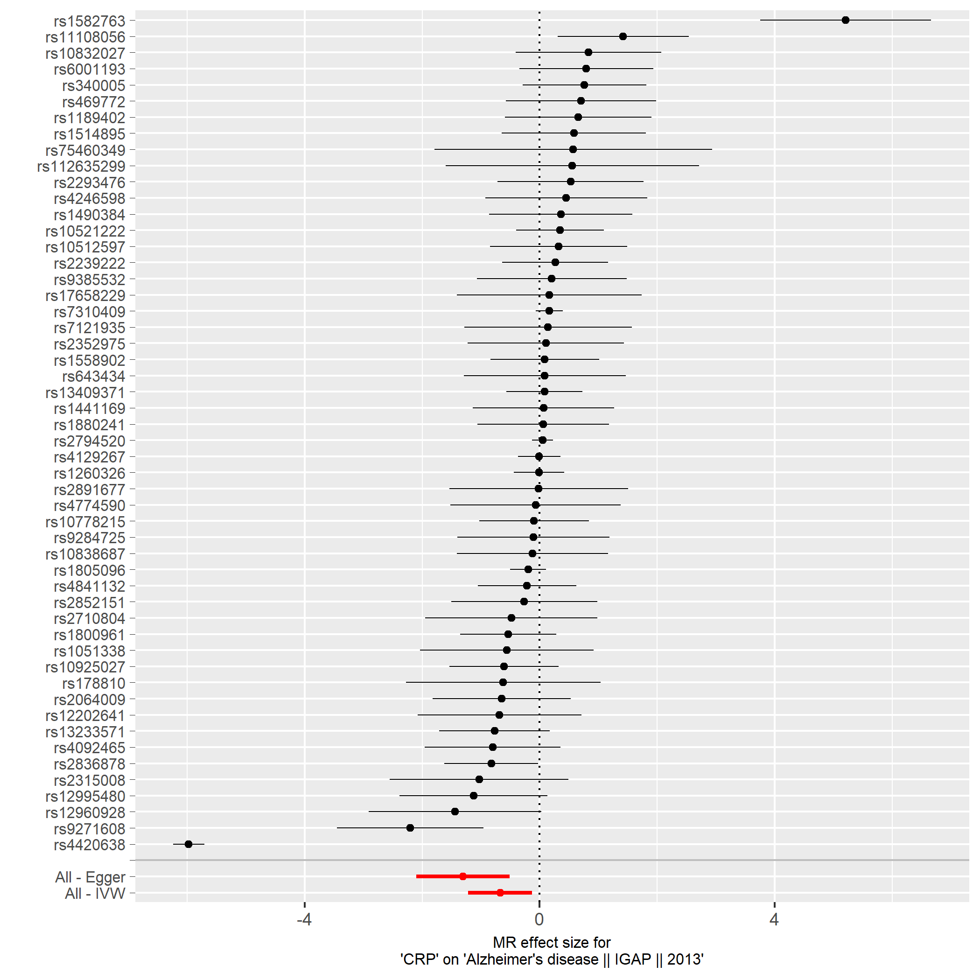

Figure S7a. Alzheimer´s disease.

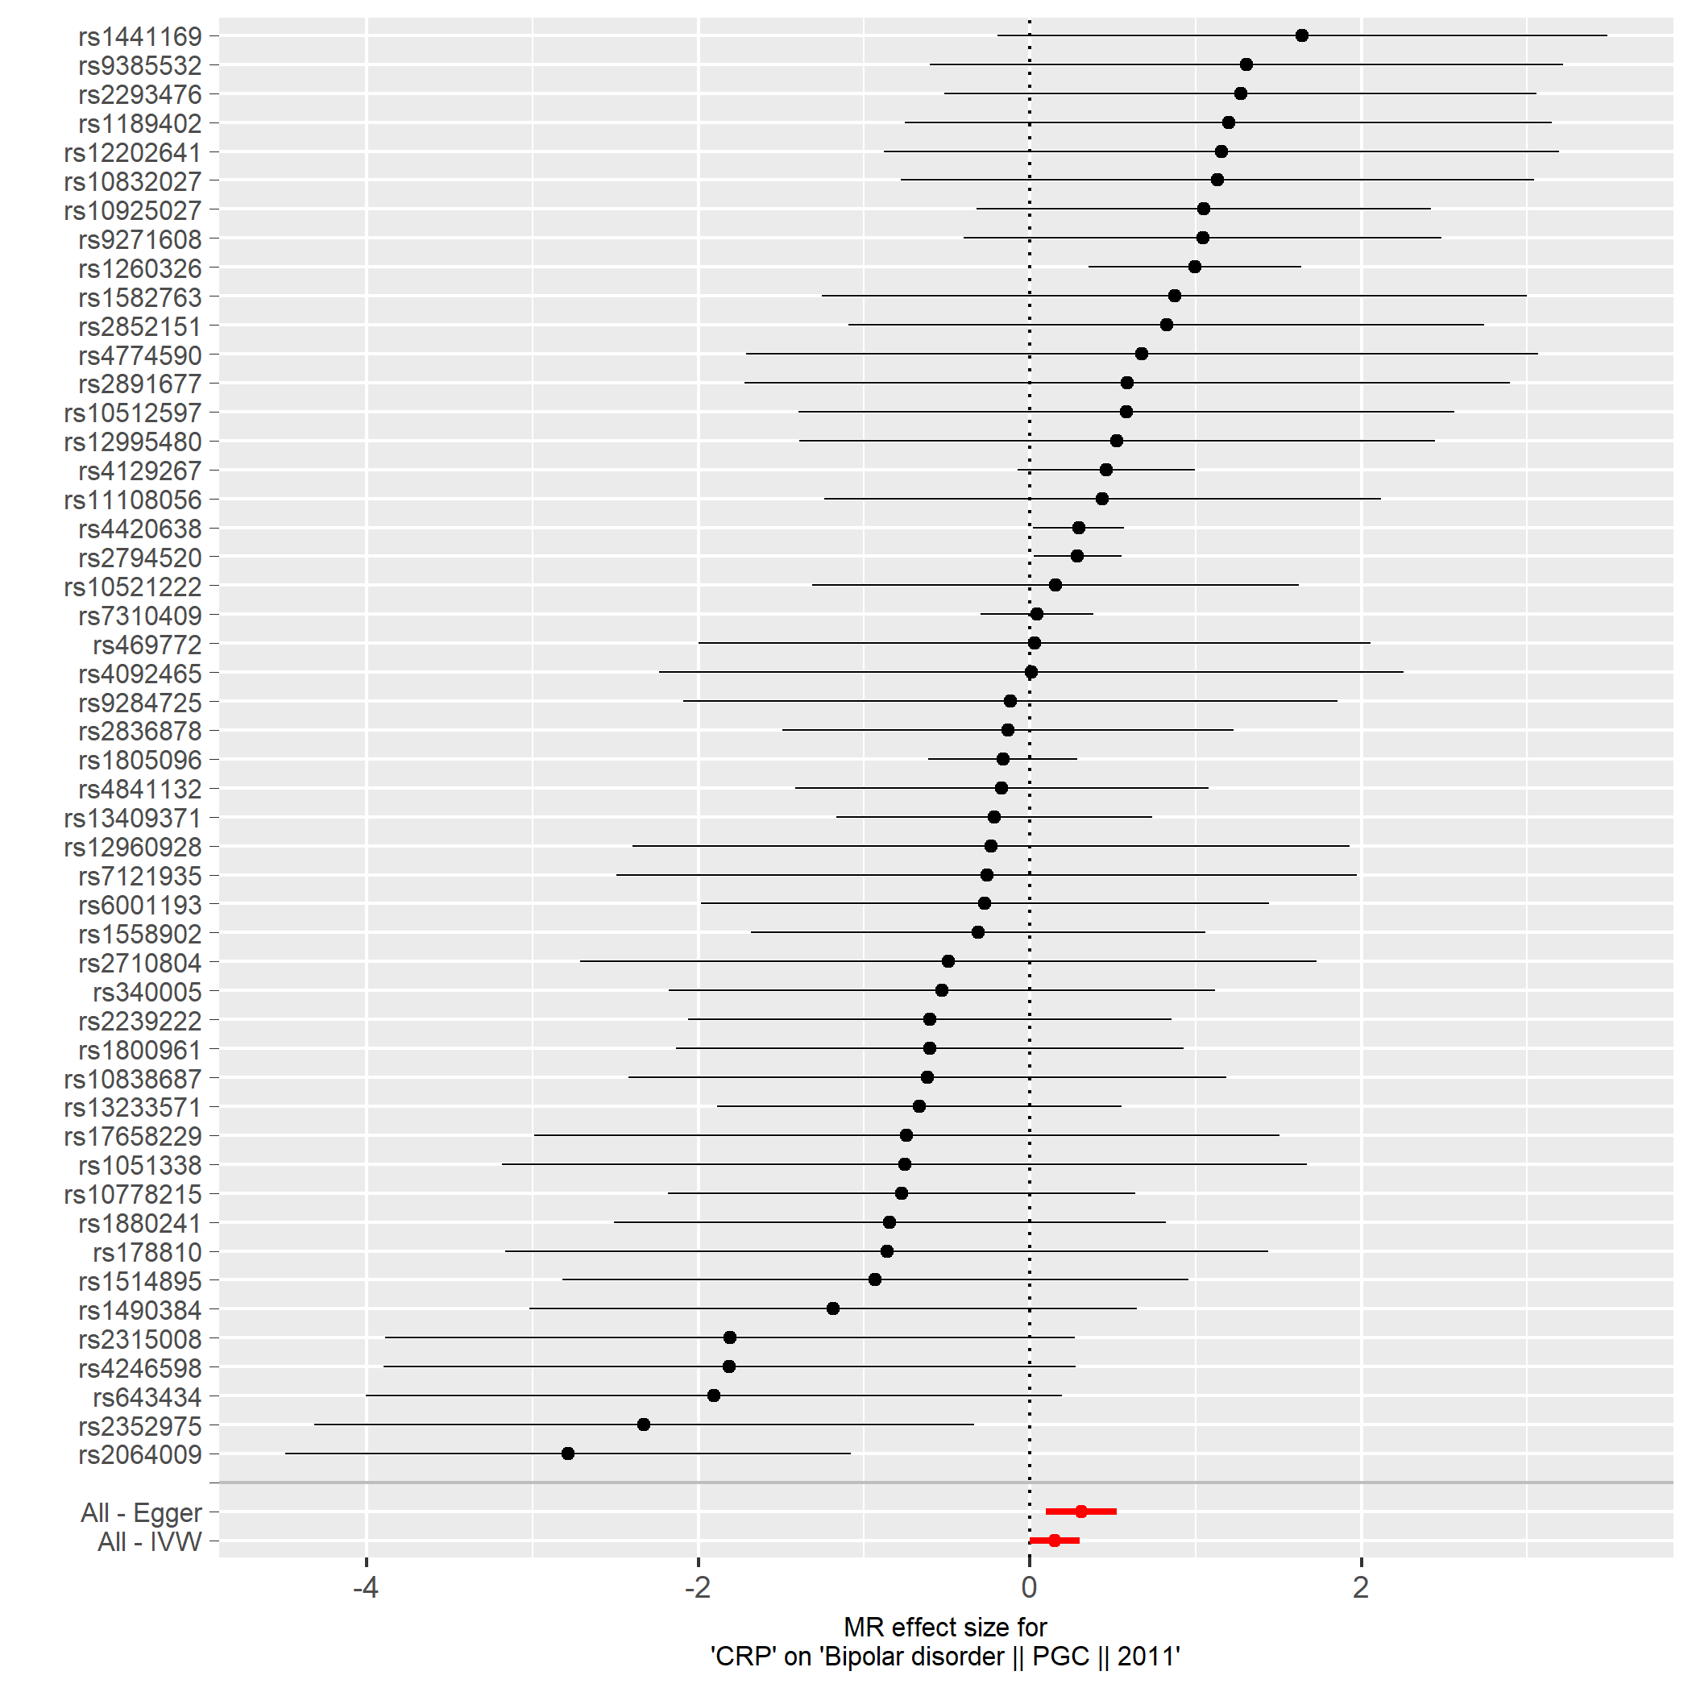

Figure S7b. Bipolar disorder.

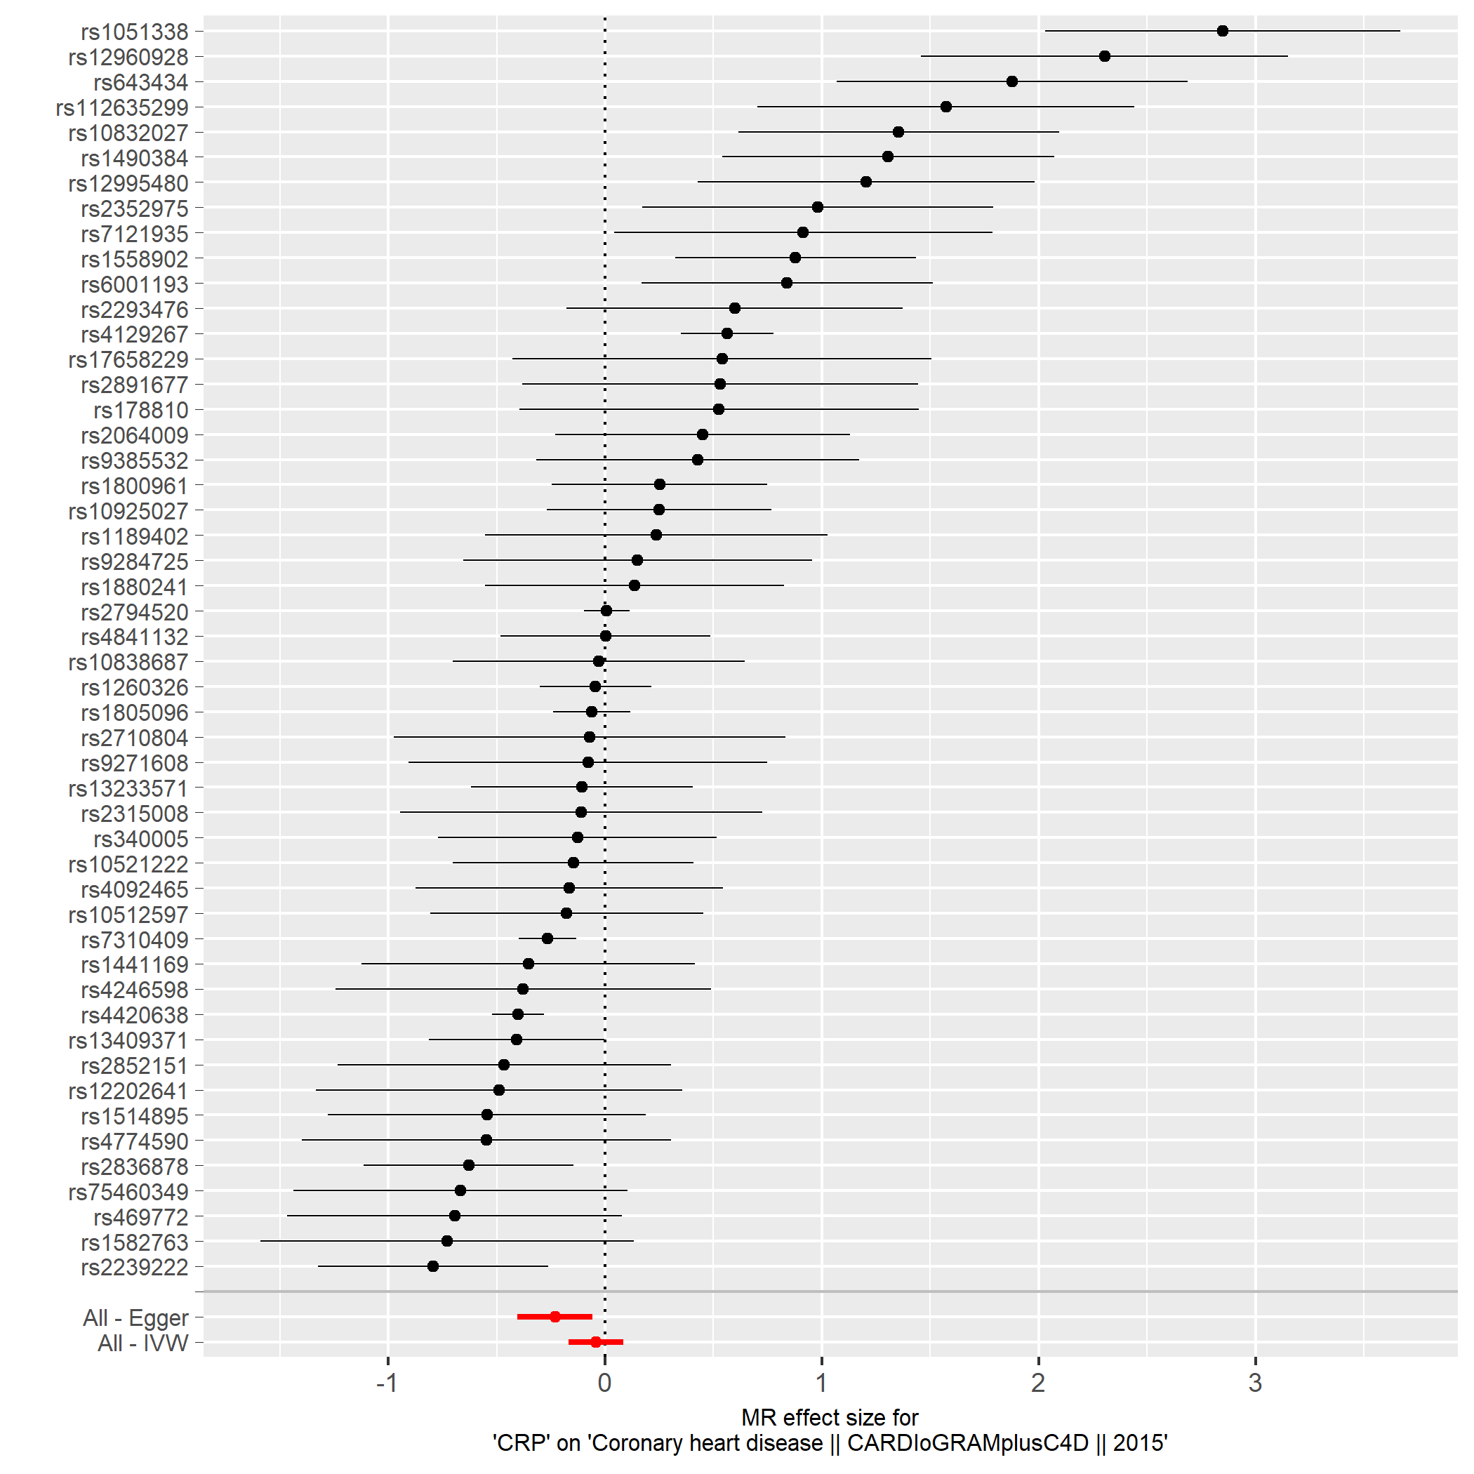

Figure S7c. Coronary heart disease.

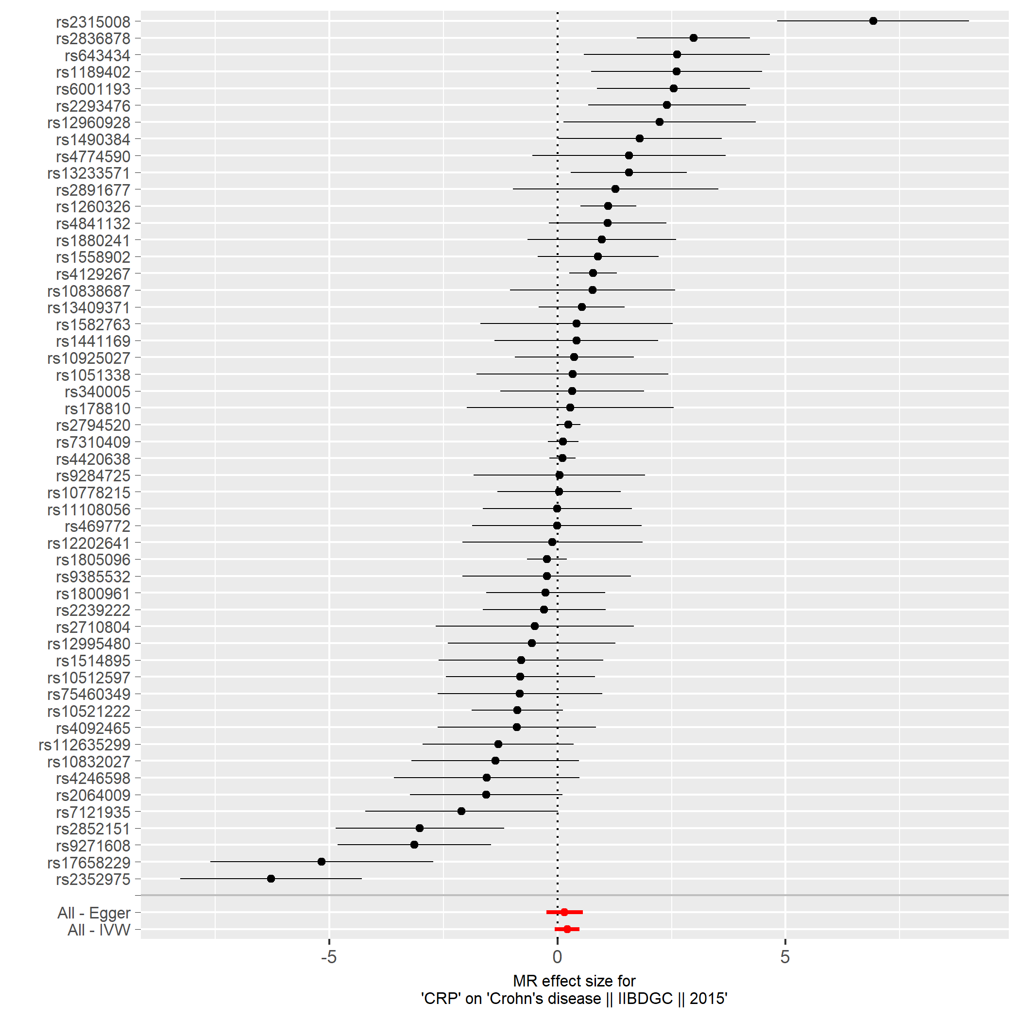

Figure S7d. Crohn´s disease.

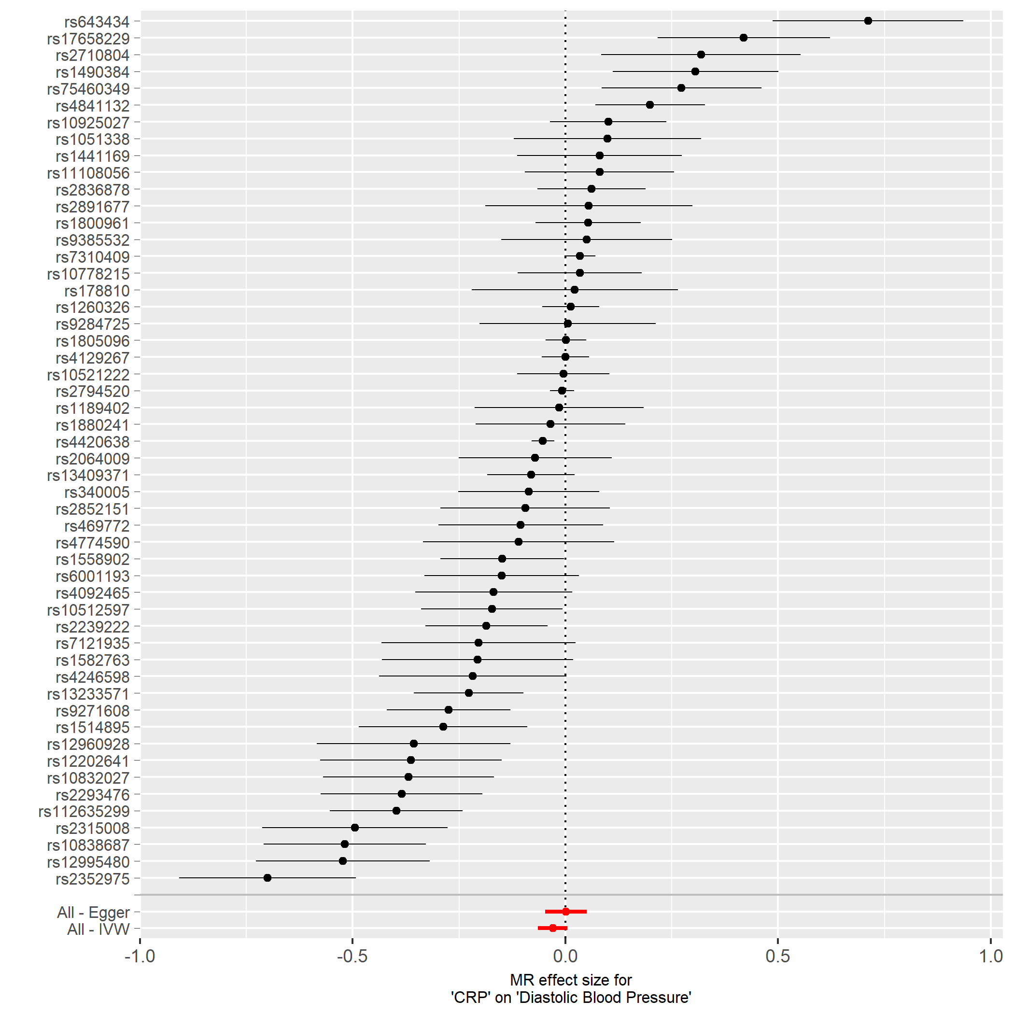

Figure S7e. Diastolic blood pressure.

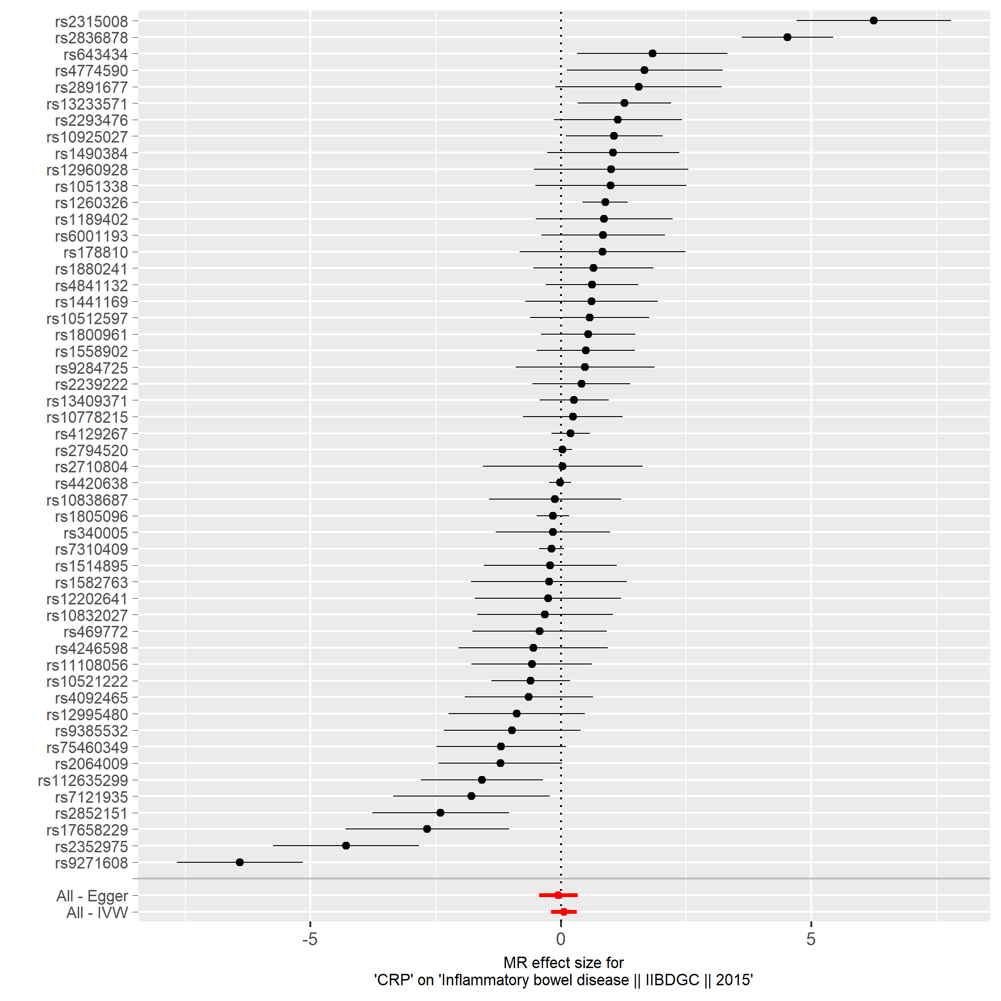

Figure S7f. Inflammatory bowel disease.

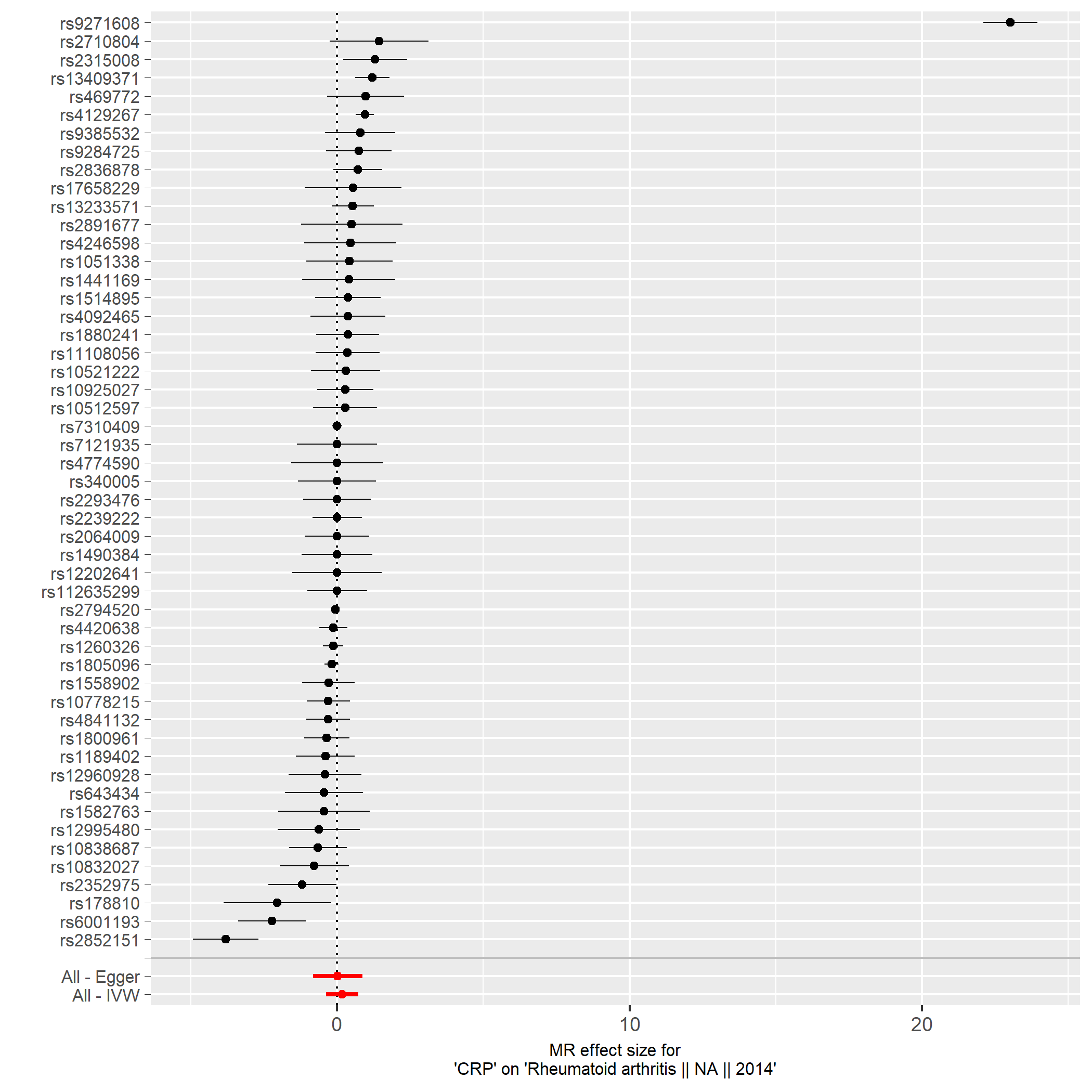

Figure S7g. Rheumatoid arthritis.

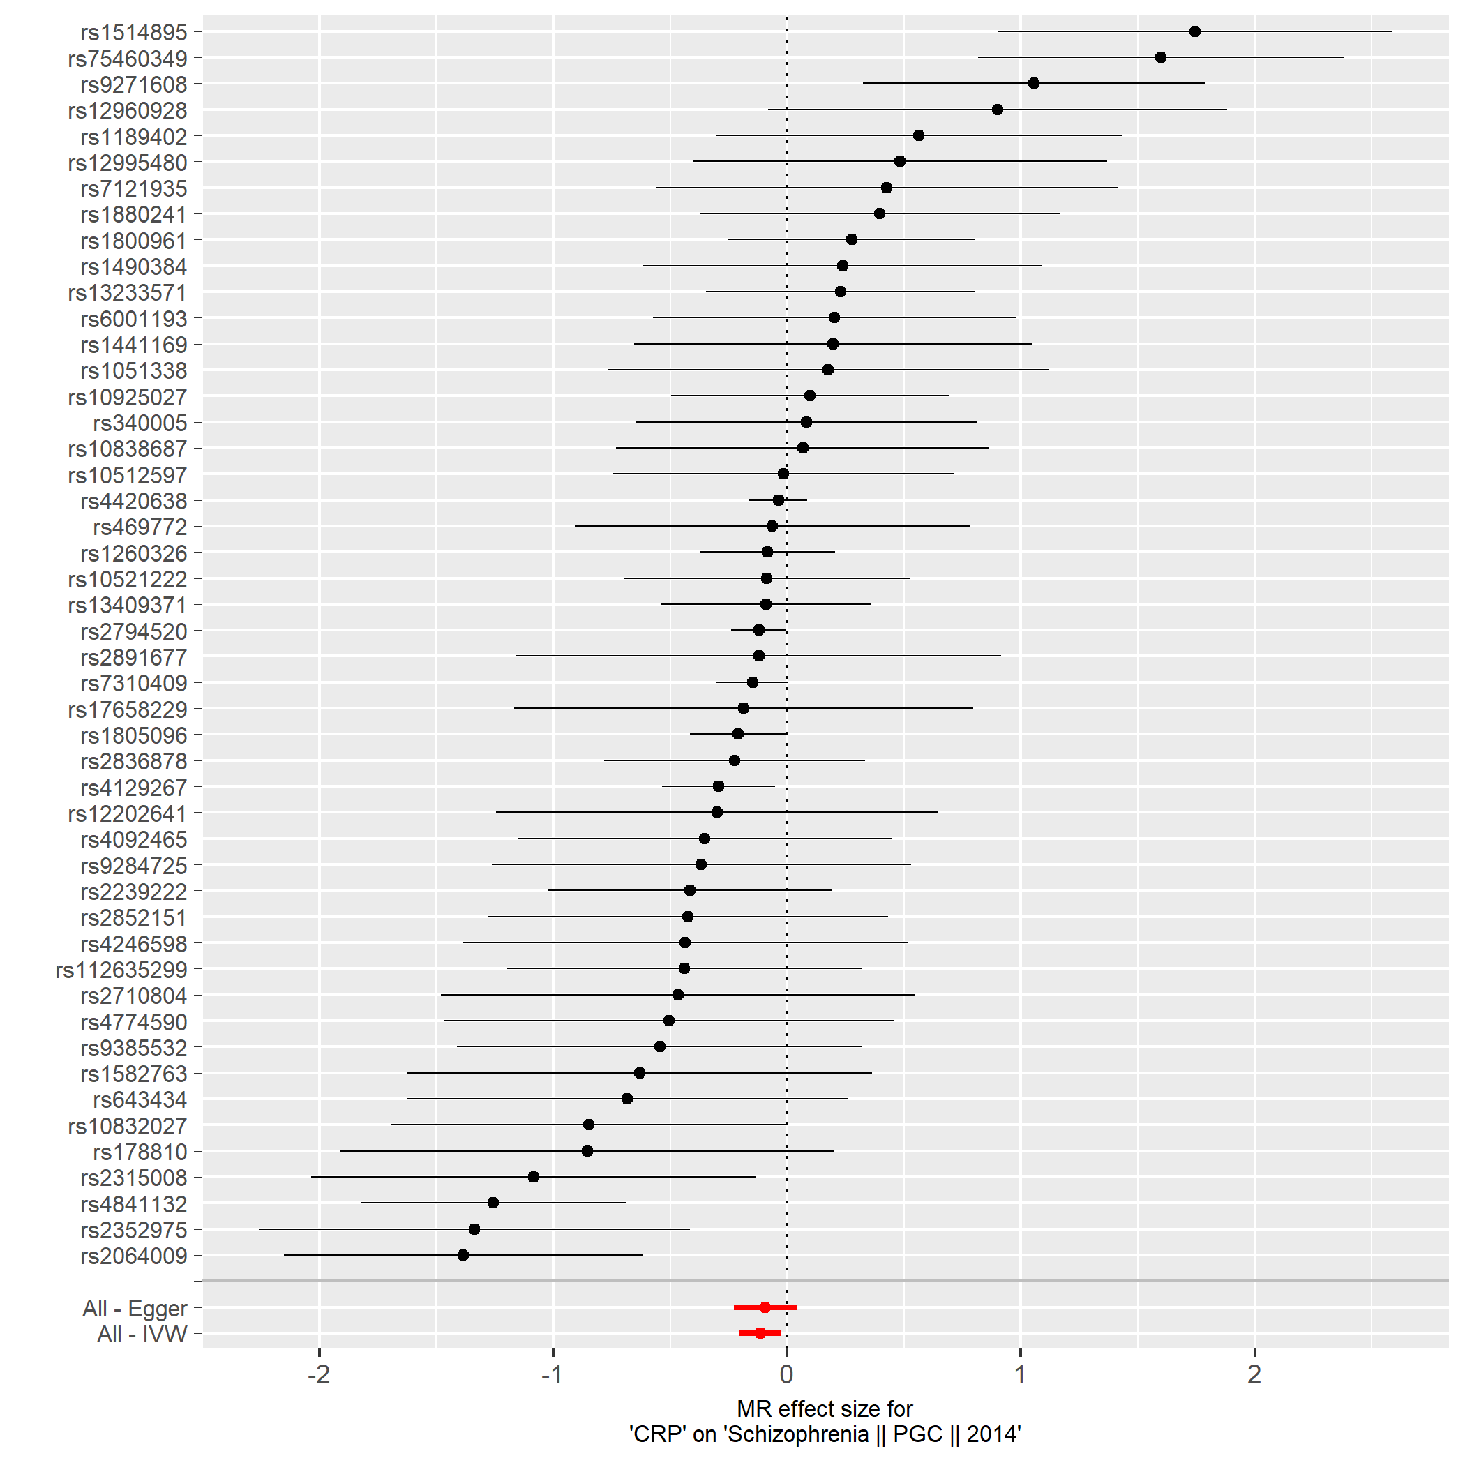

Figure S7h. Schizophrenia.

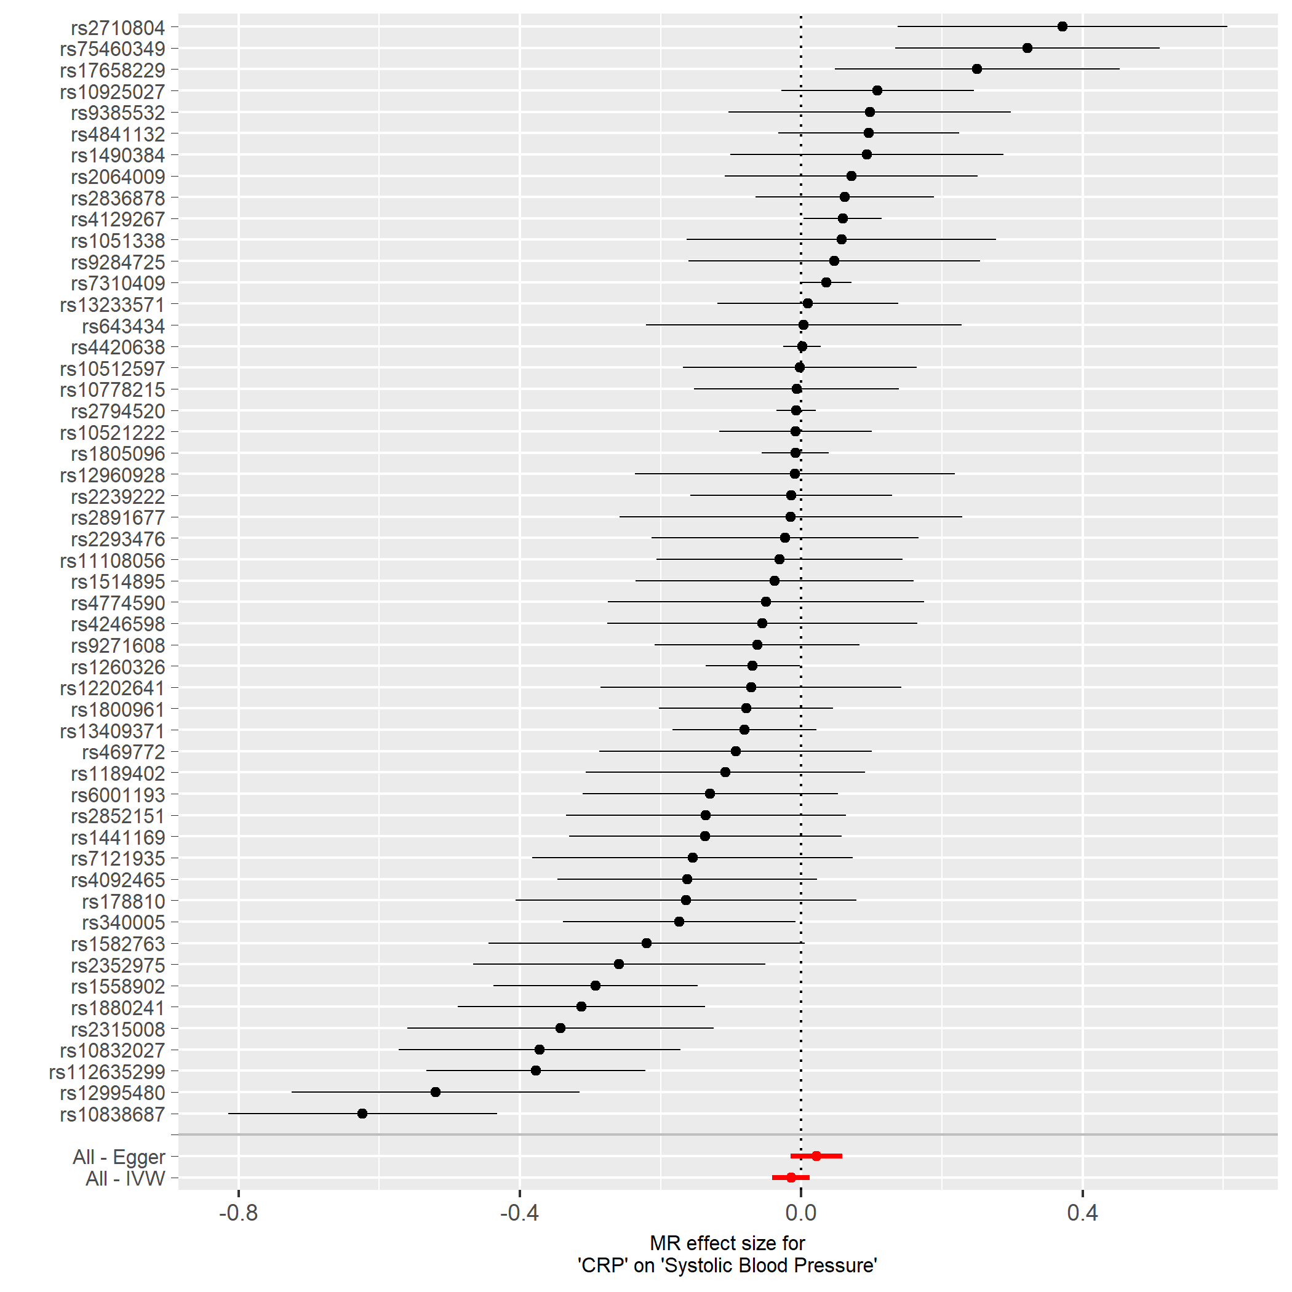

Figure S7i. Systolic blood pressure.

Figure S8. Scatter plots of the four Mendelian randomization analyses applied to nine a priori selected clinical outcomes.
The Y axis present the effect size of a given CRP associated SNP on the outcome of interest, the X-axis present the effect size of the same SNPs on the CRP levels derived from the HapMap GWAS meta-analysis.
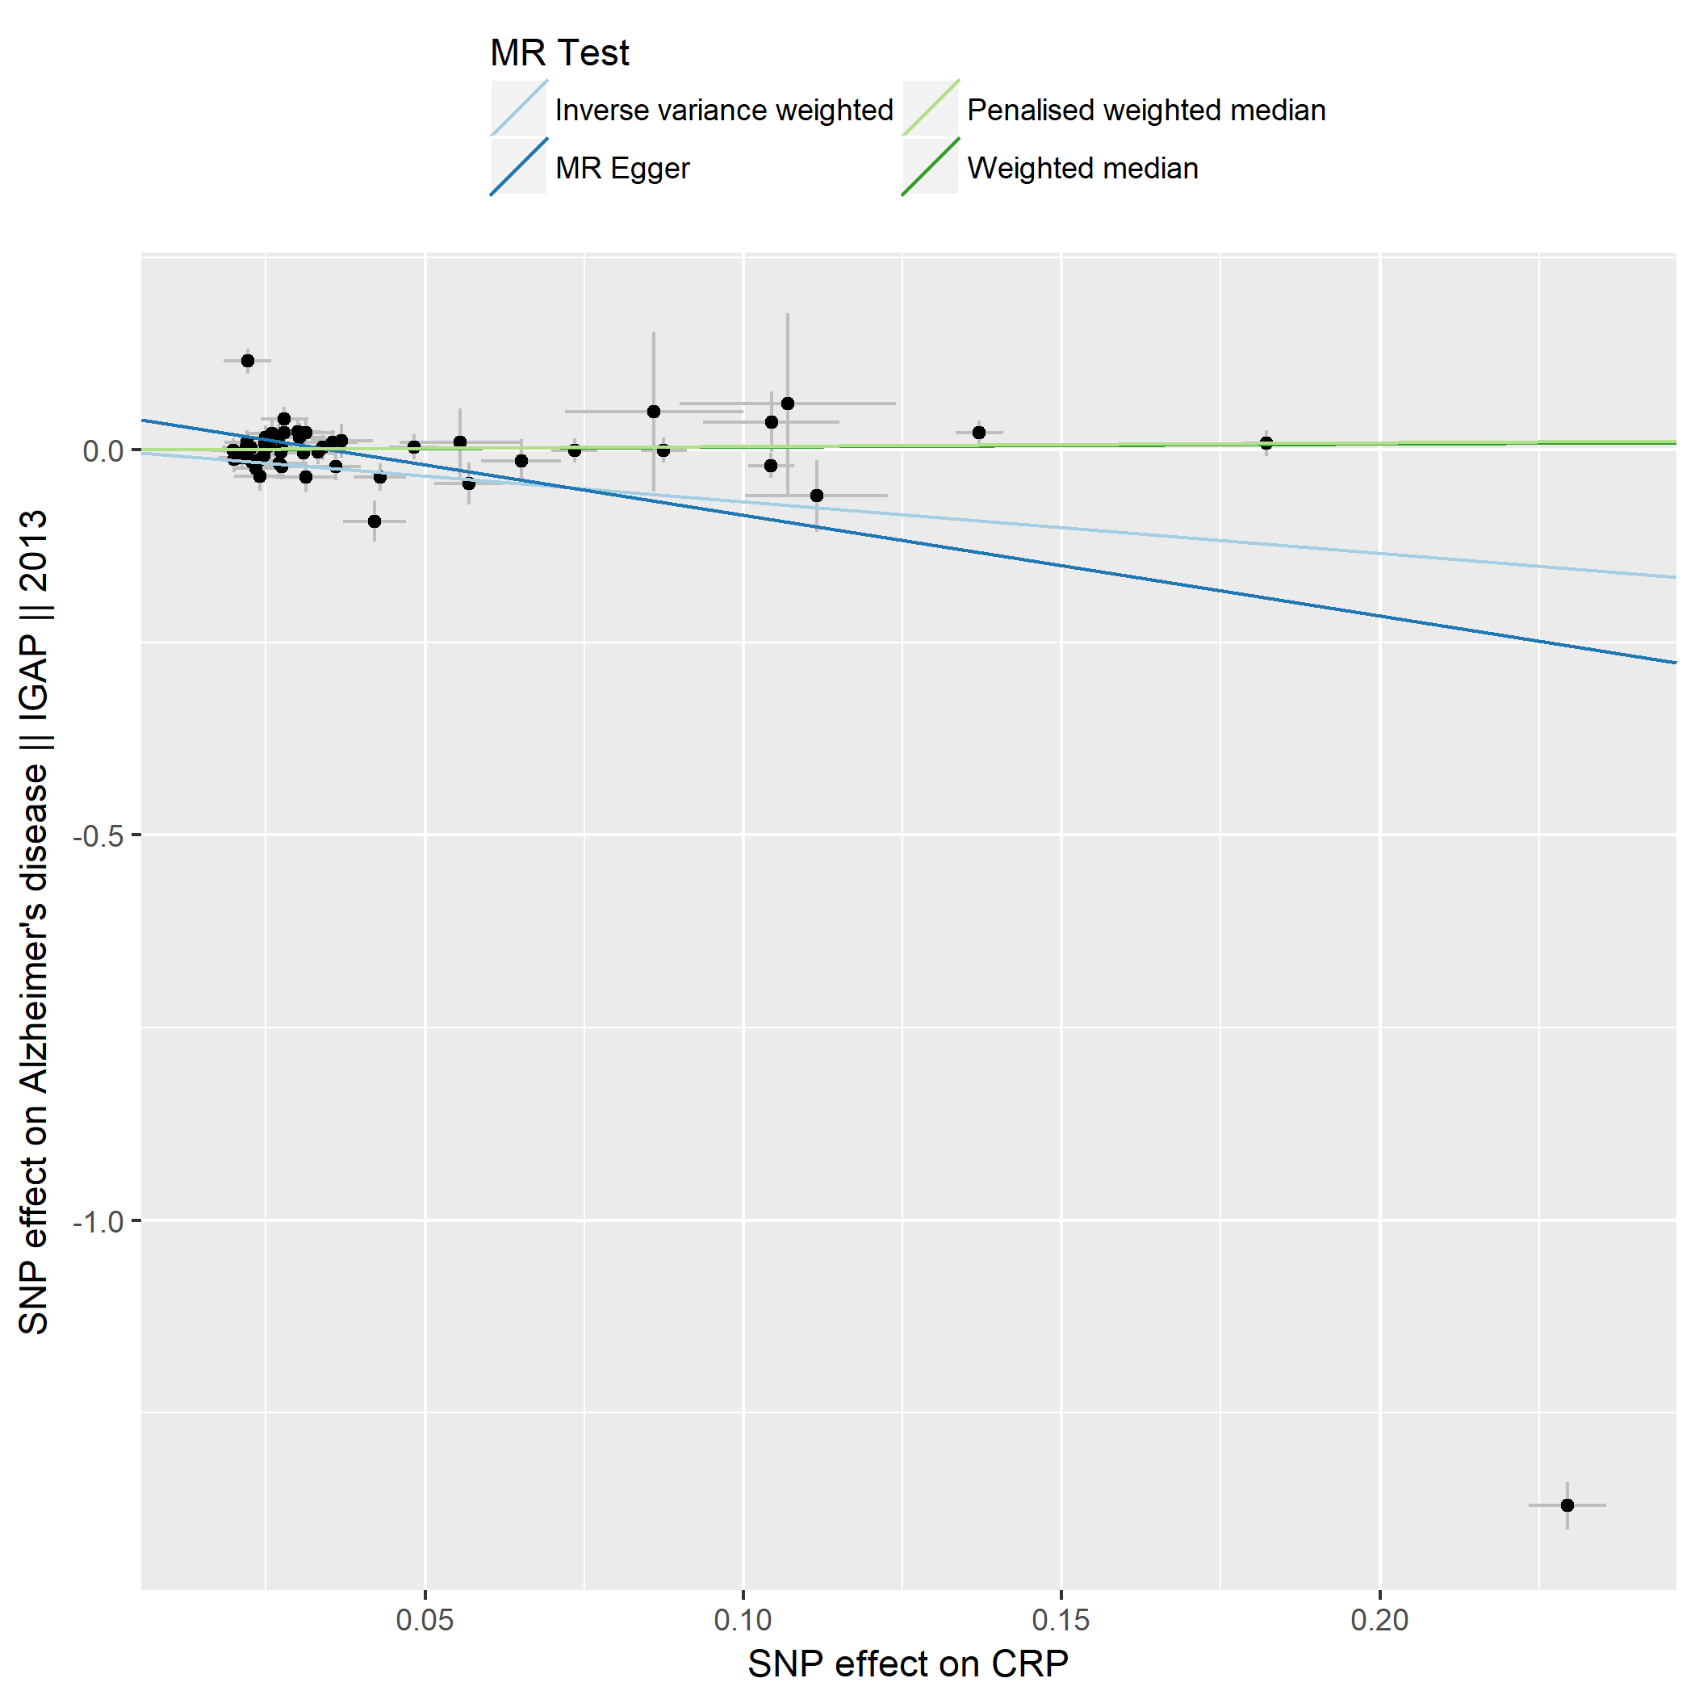

Figure S8a. Alzheimer´s disease.

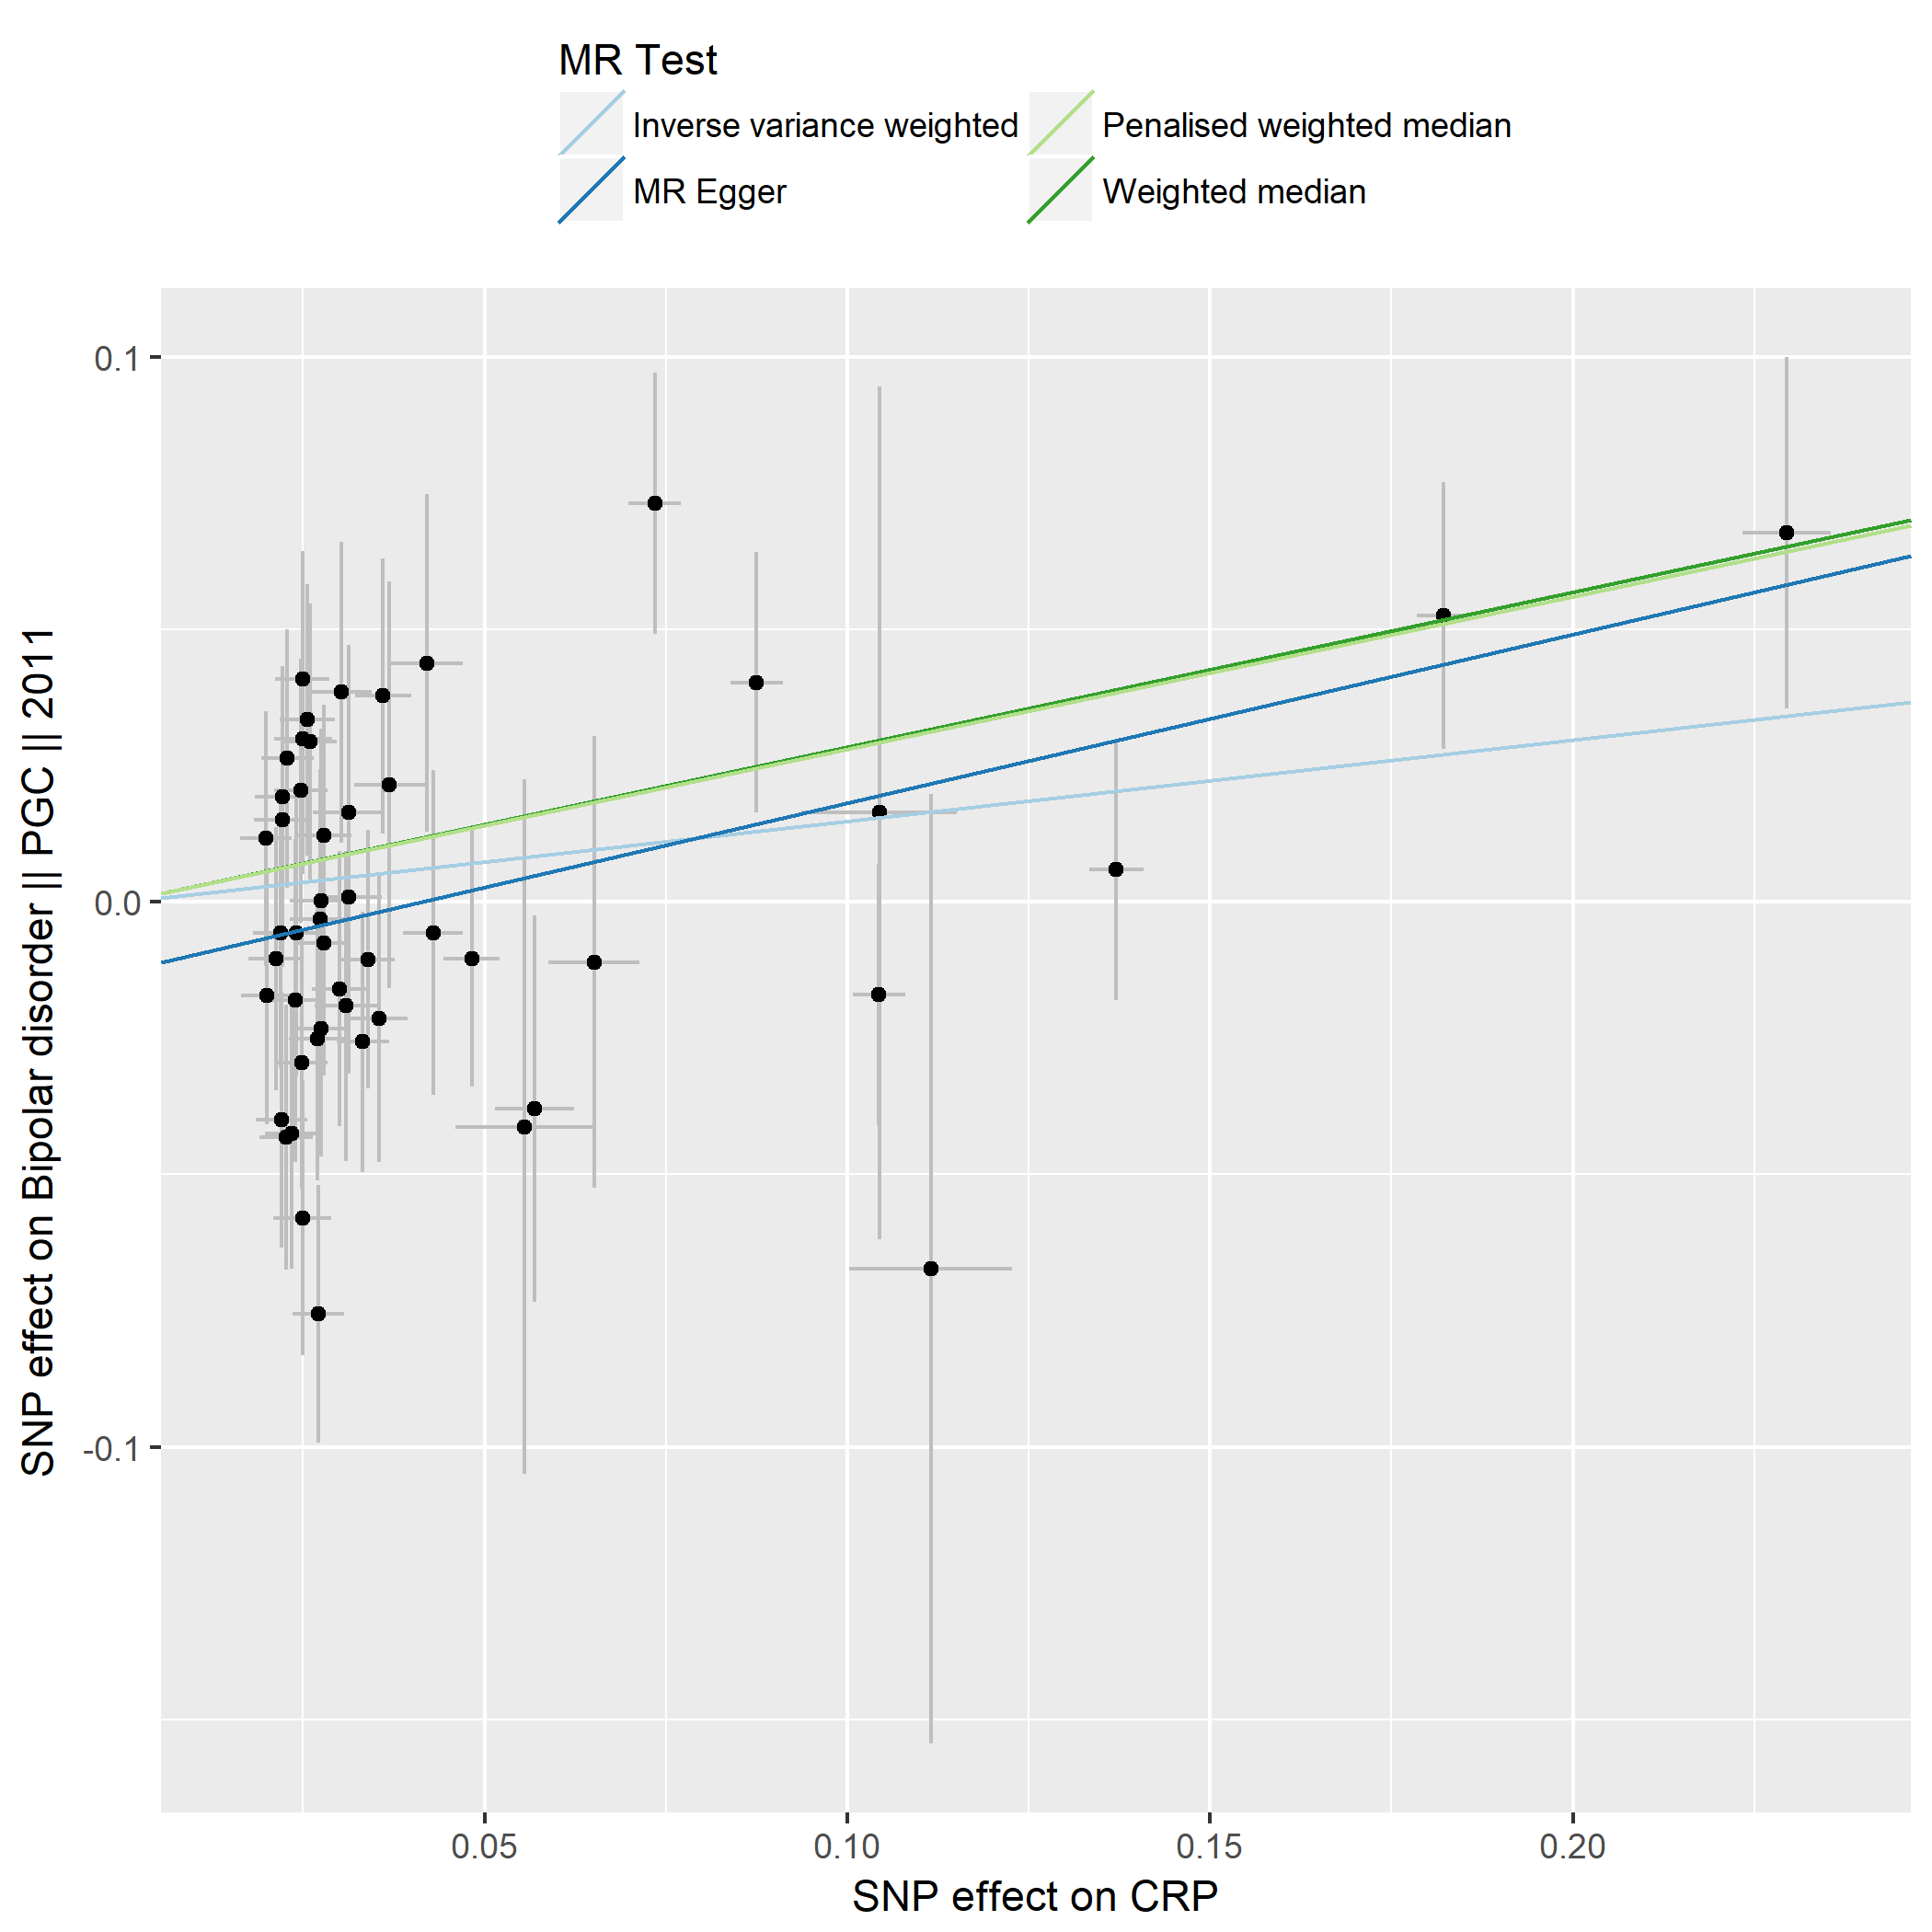

Figure S8b. Bipolar disorder

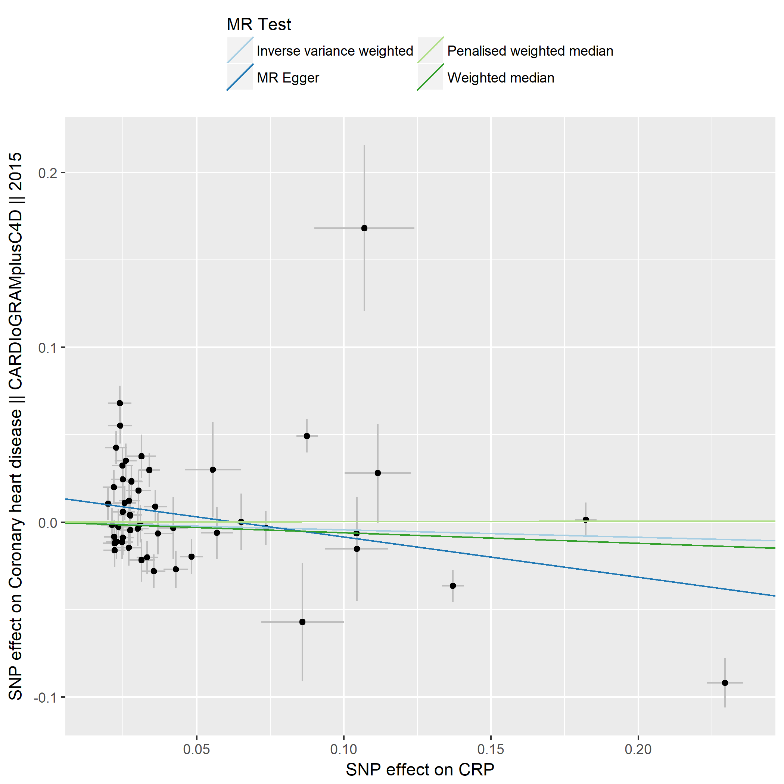

Figure S8c. Coronary artery disease.

Figure S8d. Crohn´s disease.

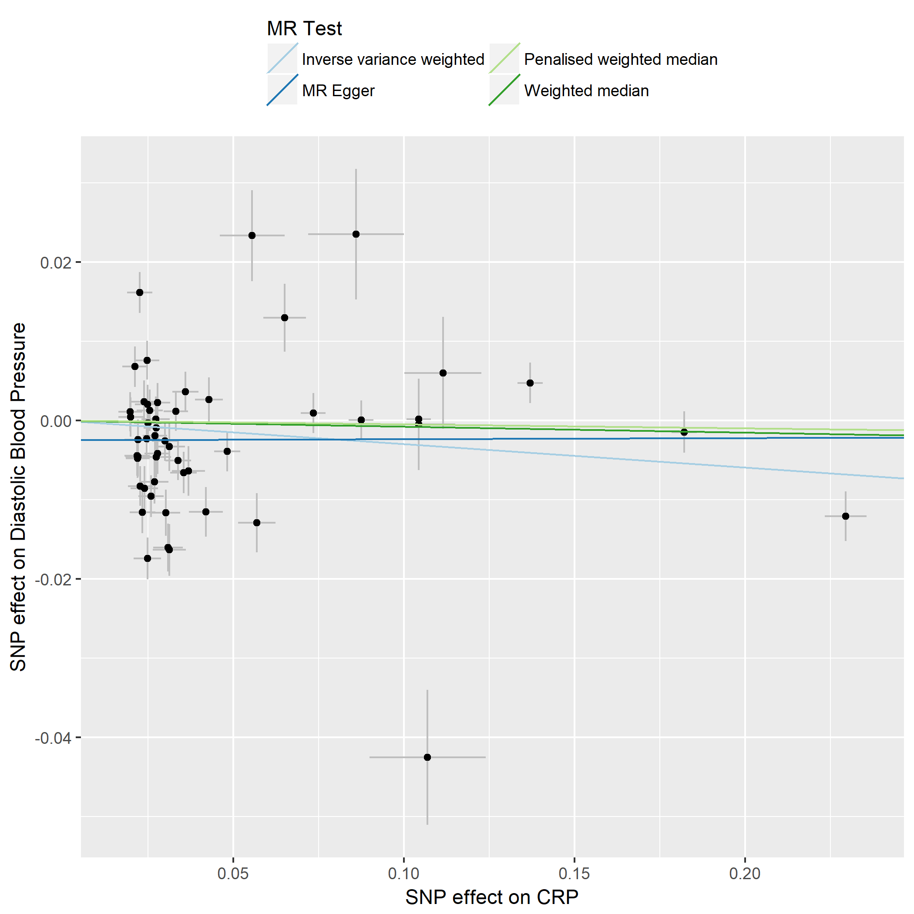

Figure S8e. Diastolic blood pressure.

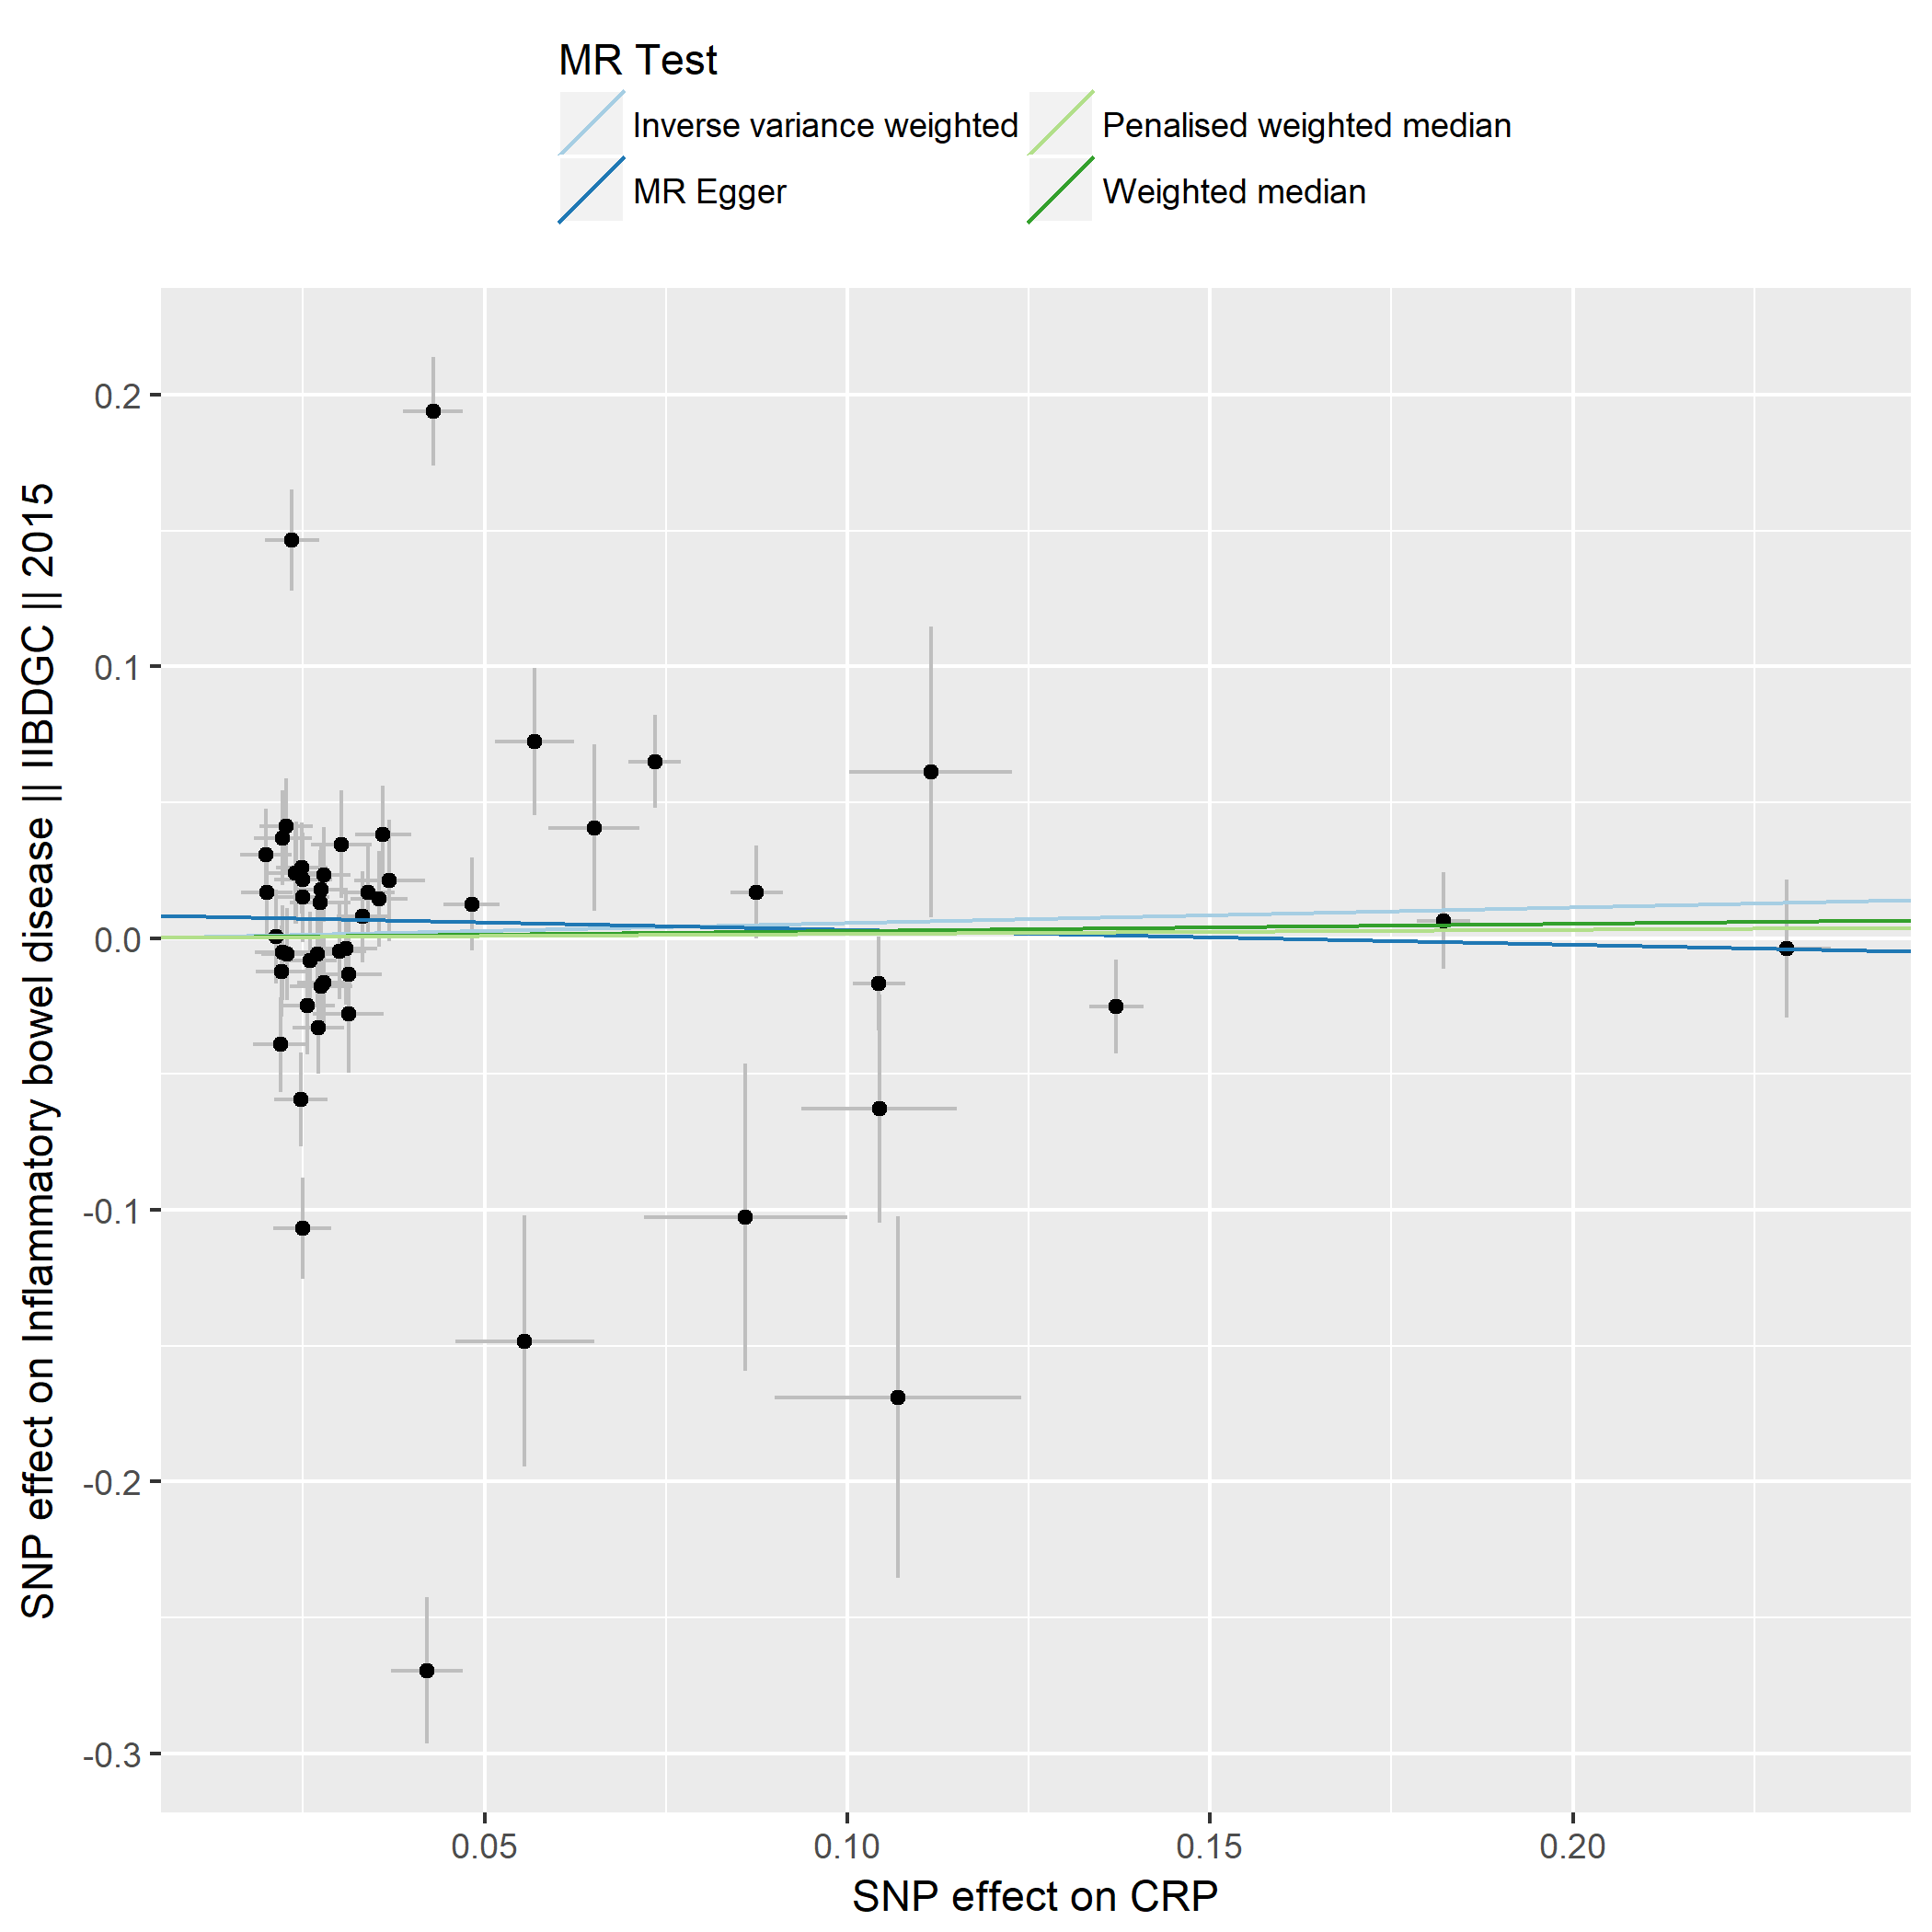

Figure S8f. Inflammatory bowel disease.

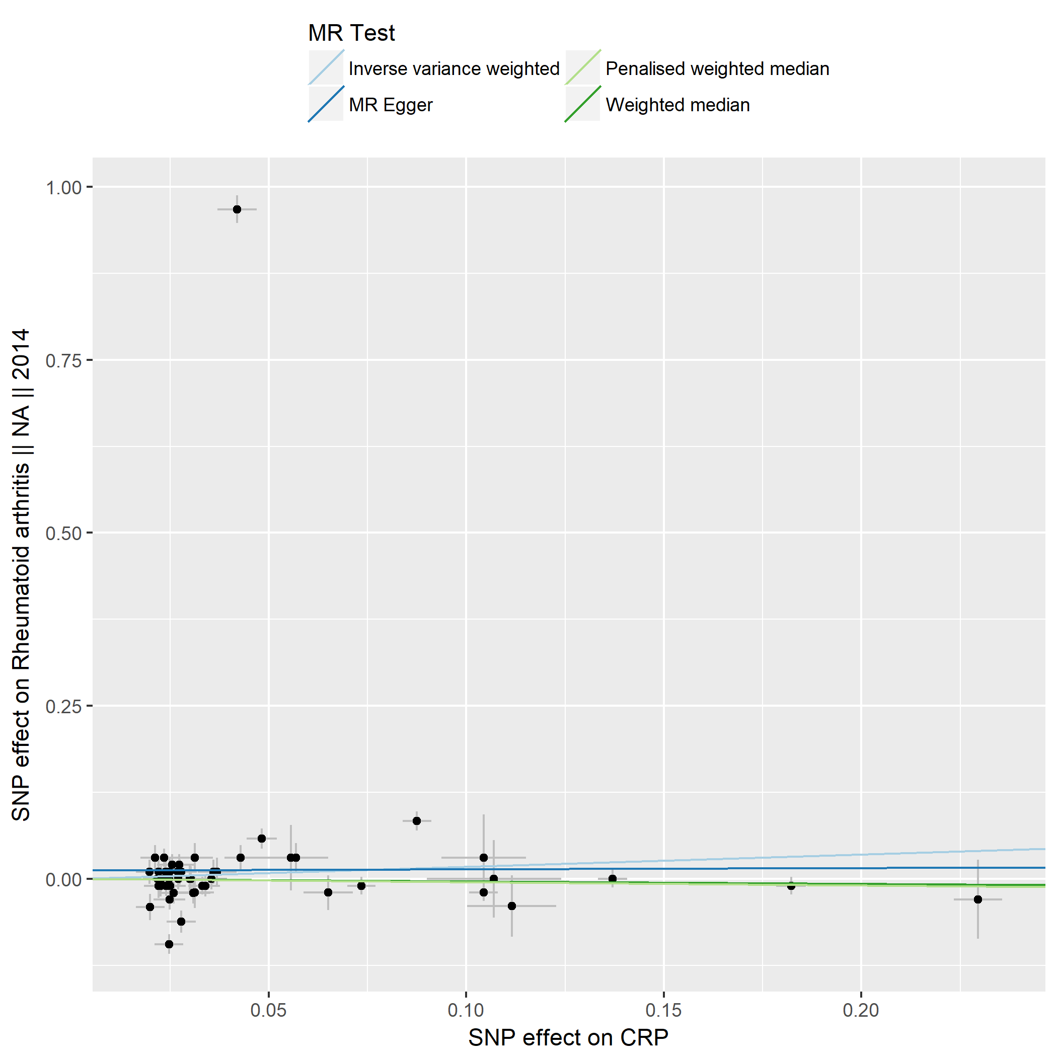

Figure S8g. Rheumatoid arthritis.

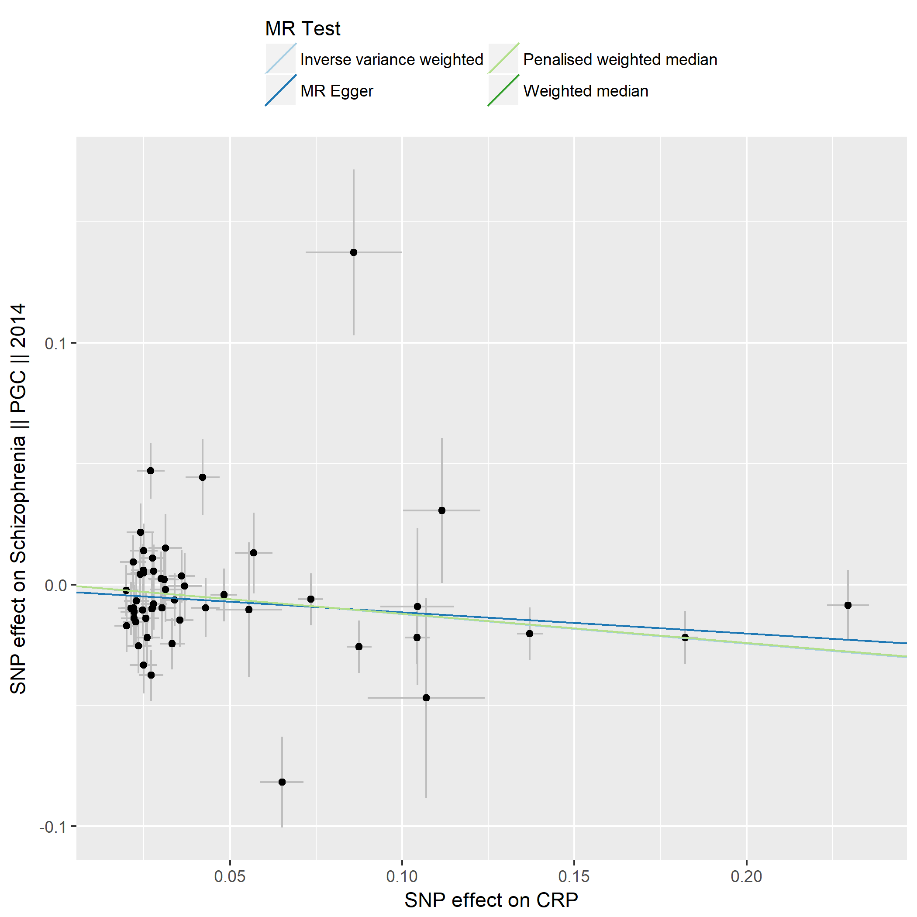

Figure S8h. Schizophrenia.

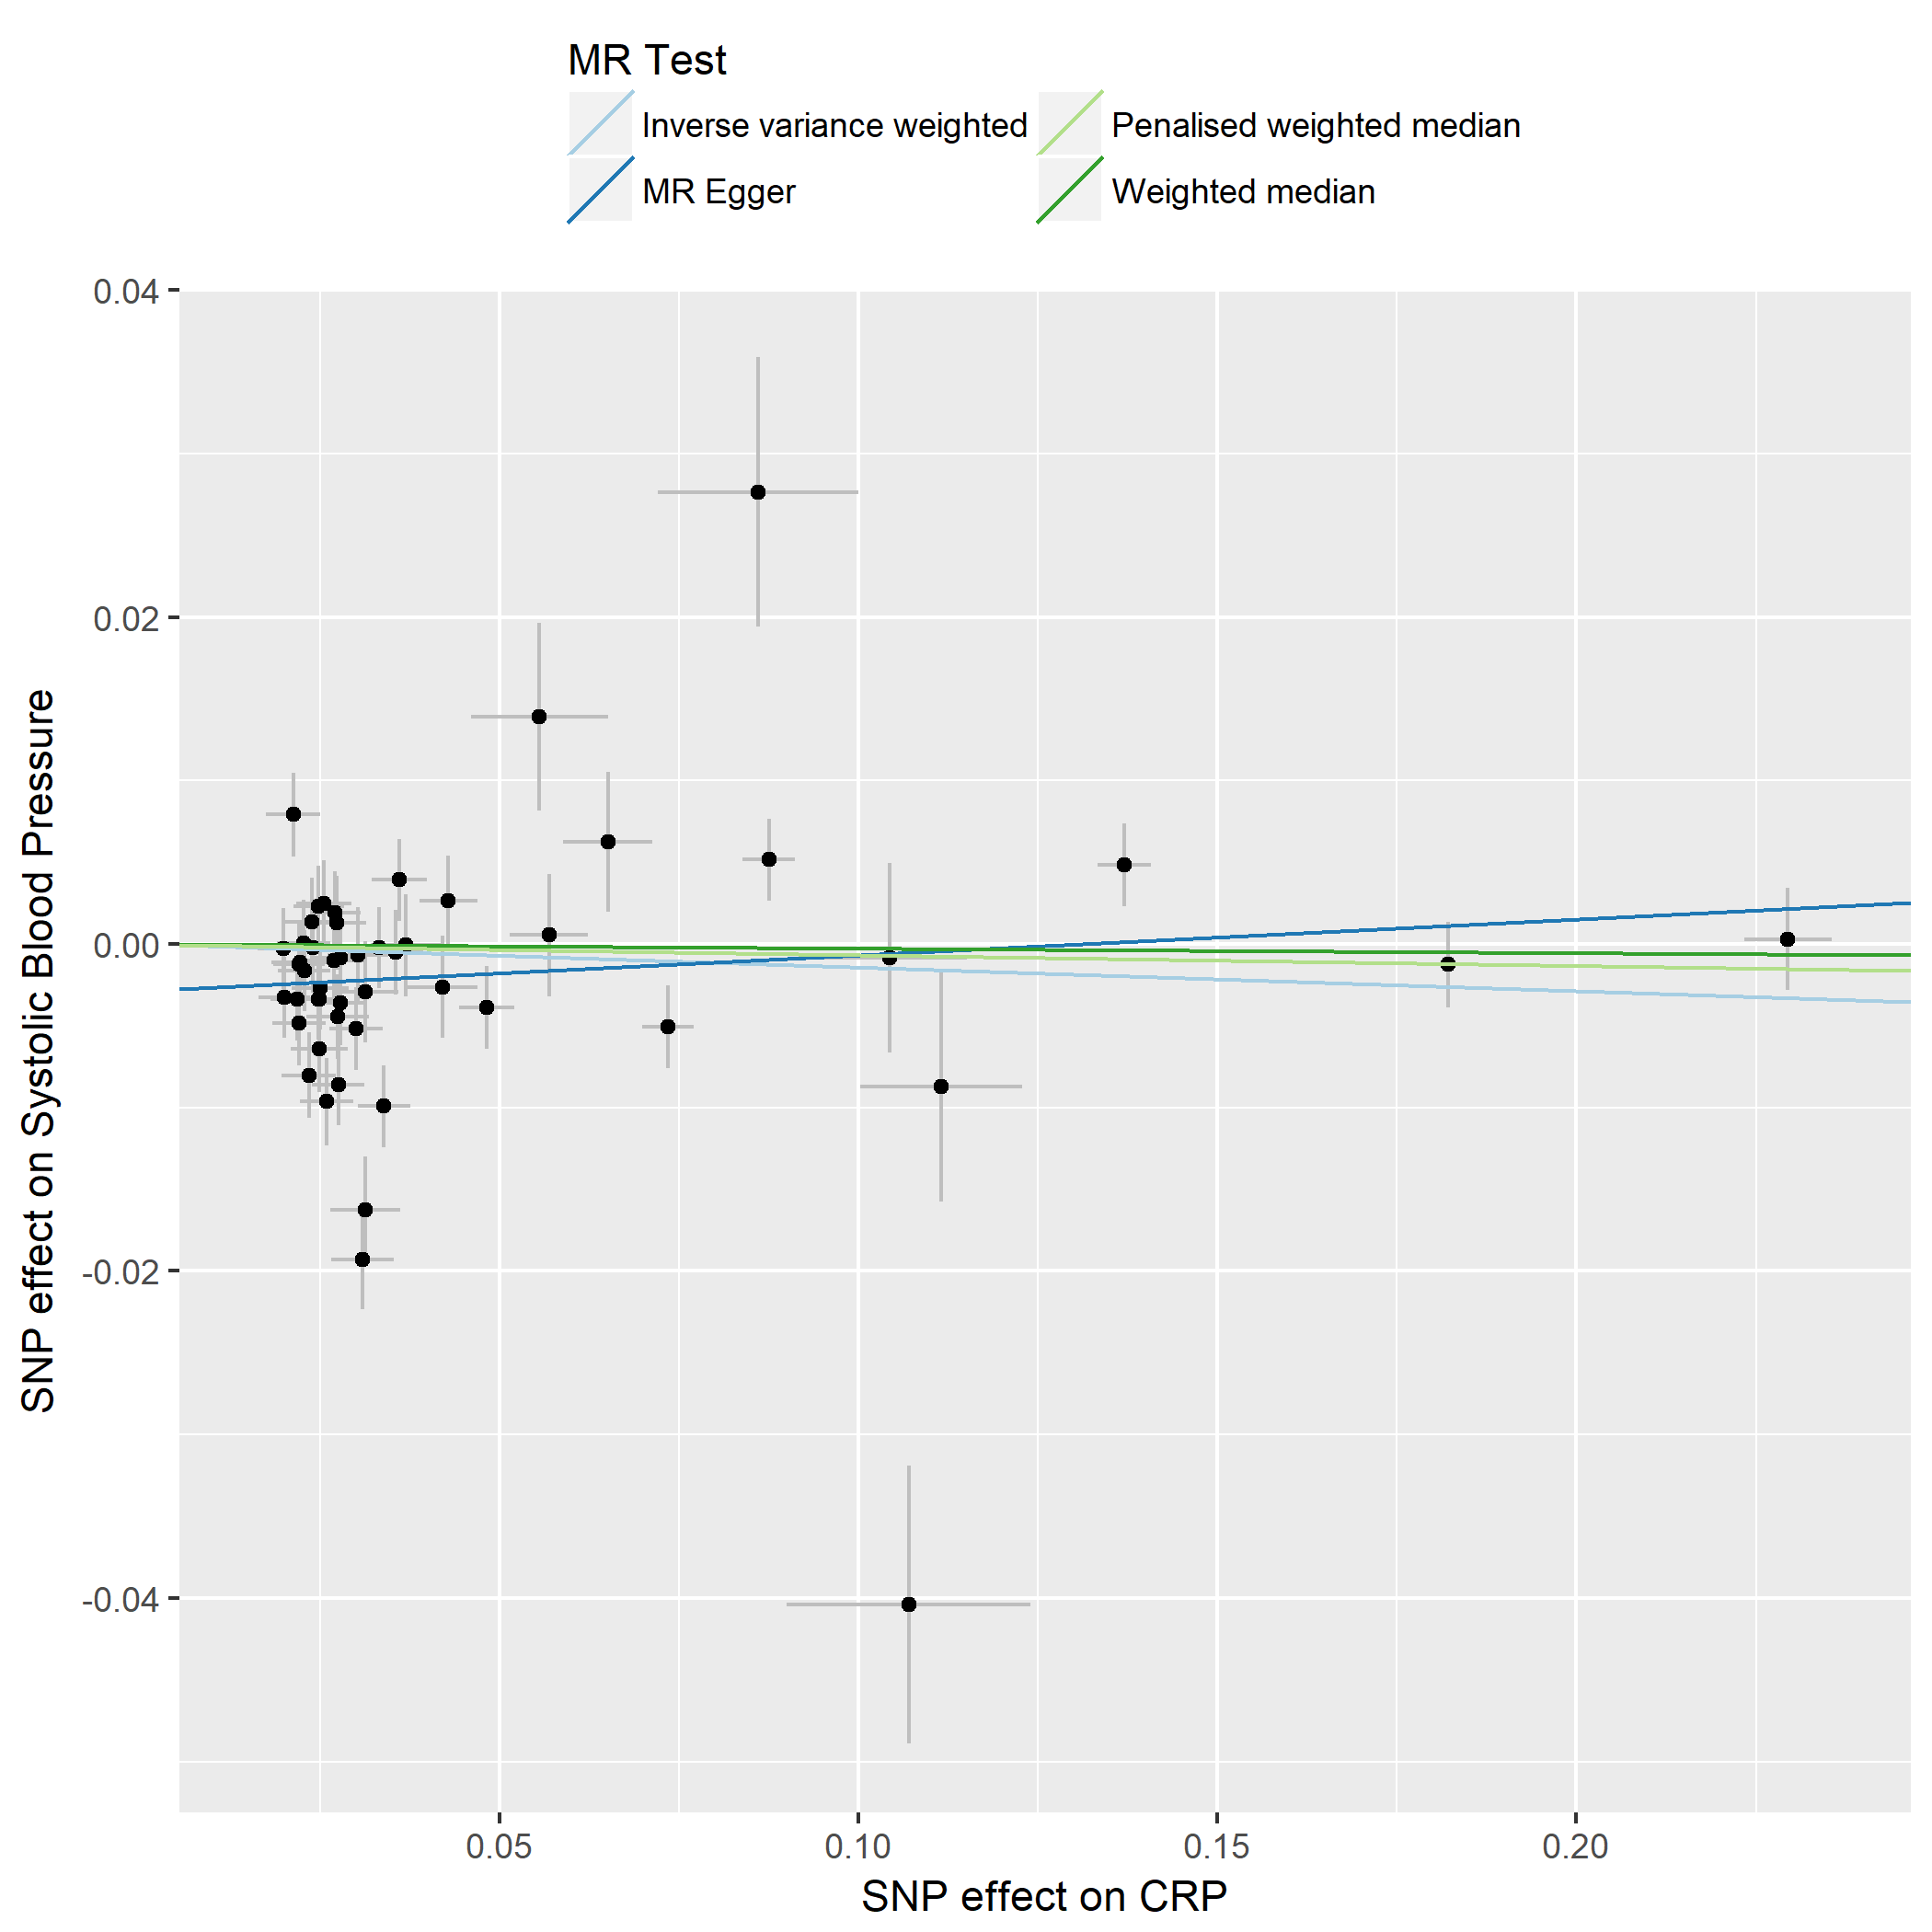

Figure S8i. Systolic blood pressure.

Figure S9. Funnel plots of the CRP_{GWAS} IV Mendelian randomization analysis for the a priori selected nine clinical outcomes.
Funnel plots aim to evaluate the presence of possible heterogeneity across the IV estimates, which is an indicator for presence of pleiotropic SNPs. The figure presents the observed causal effect of each of the 52 instrumental variables by dots, and the averaged causal effect of all IVs combined (β_{IV}) using inverse variance weighted (light blue line) and MR-Egger (dark blue line) method on x-axis. Y axis presents the inverse standard error of the estimated causal effect for each of the SNPs (IVs). Given the study size is the same for each of the IVs, the inverse SE of the IVs effect are expected to scatter on the bottom of the plot, aliened around the same horizontal (Y) line, surrounding the left and right side of the observed causal effect (B_{IV}). The potentially pleiotropic SNPs are expected to have a lower precision, and hence a larger SE, and thus move towards the top of funnel plot while their effect size may also pretend to be disproportional to the observed average effect estimates and to those of other SNPs with a similar effective allele frequency.
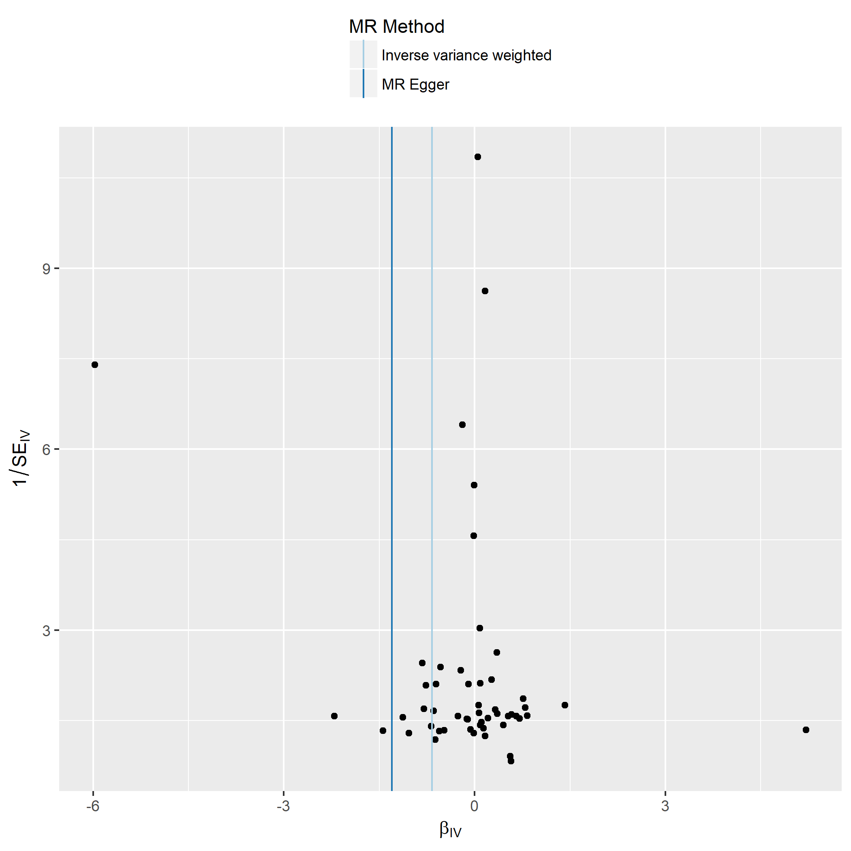

Figure S9a. Alzheimer´s disease.

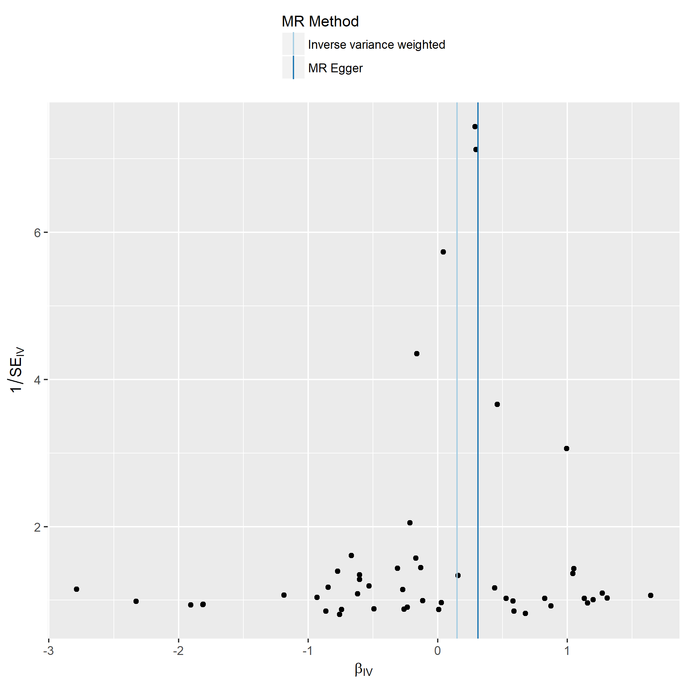

Figure S9b. Bipolar disorder.

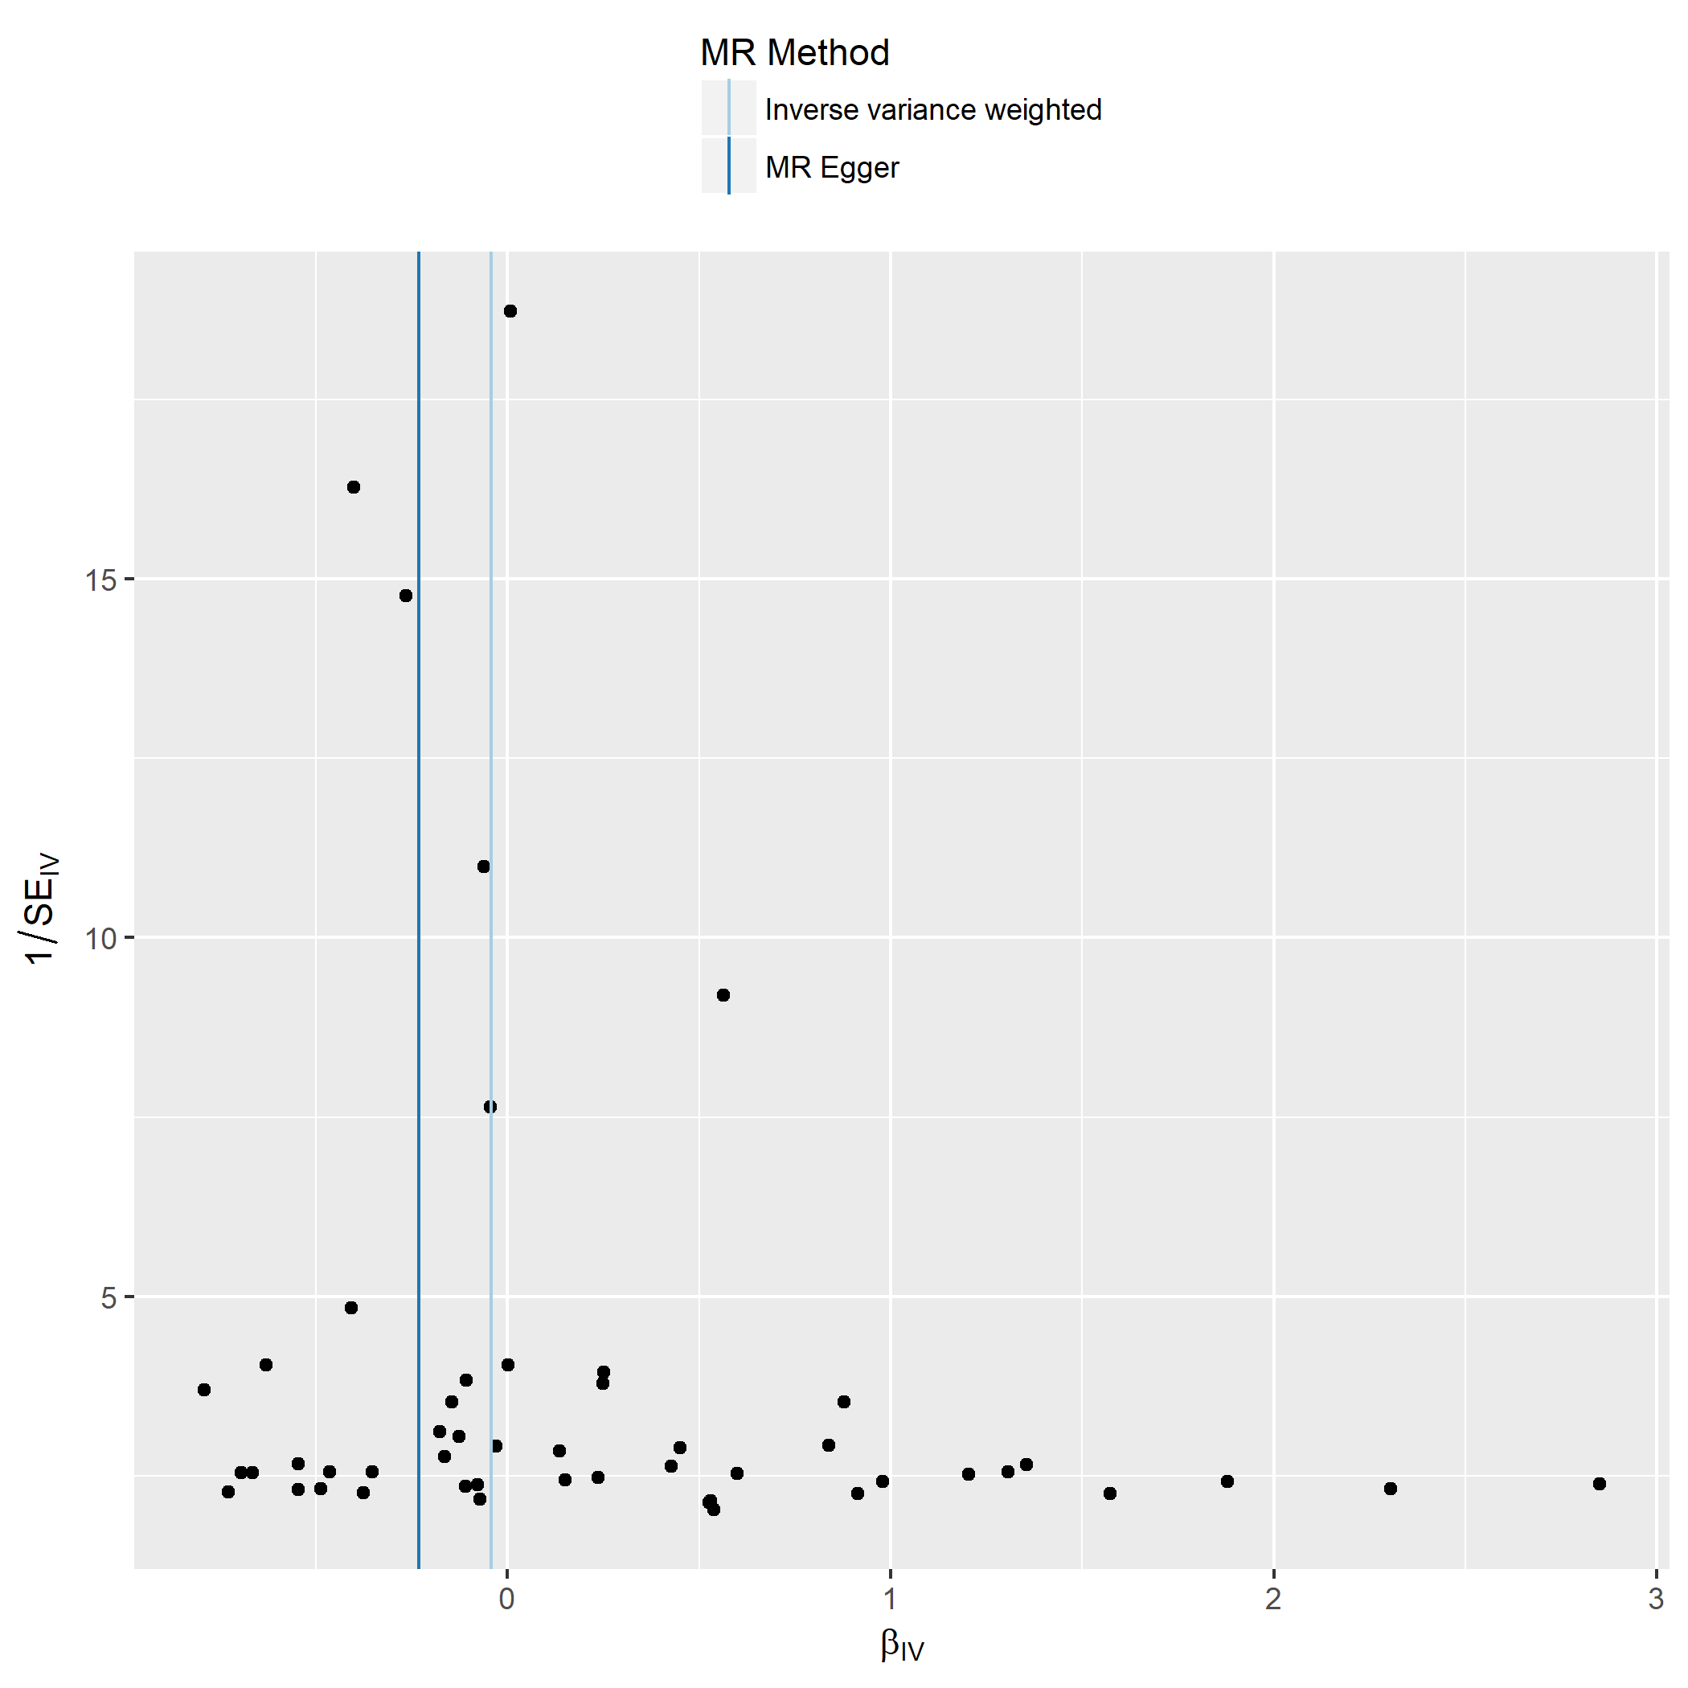

Figure S9c. Coronary artery disease.

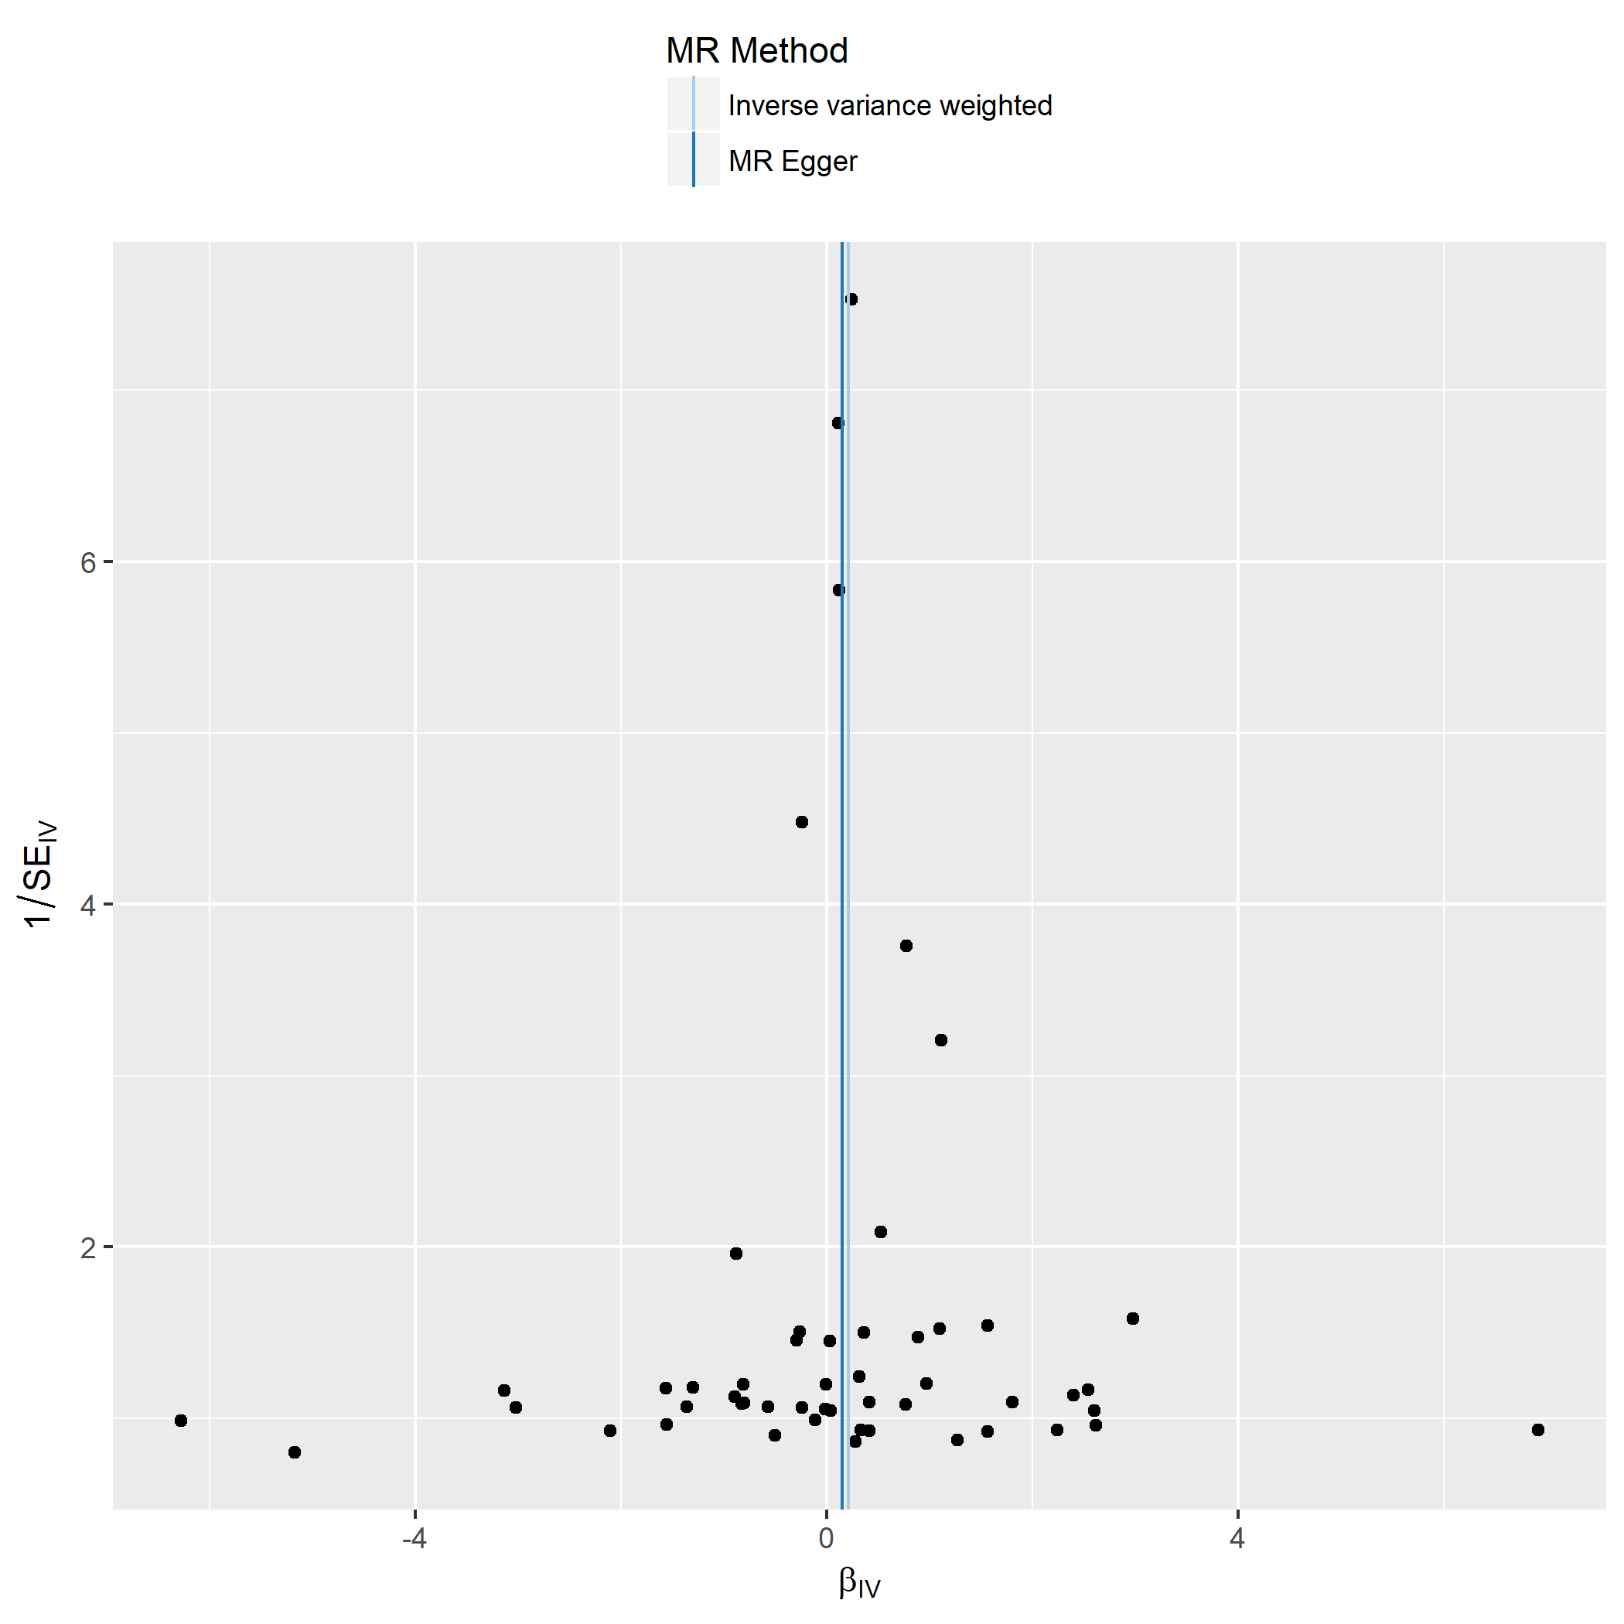

Figure S9d. Crohn´s disease.

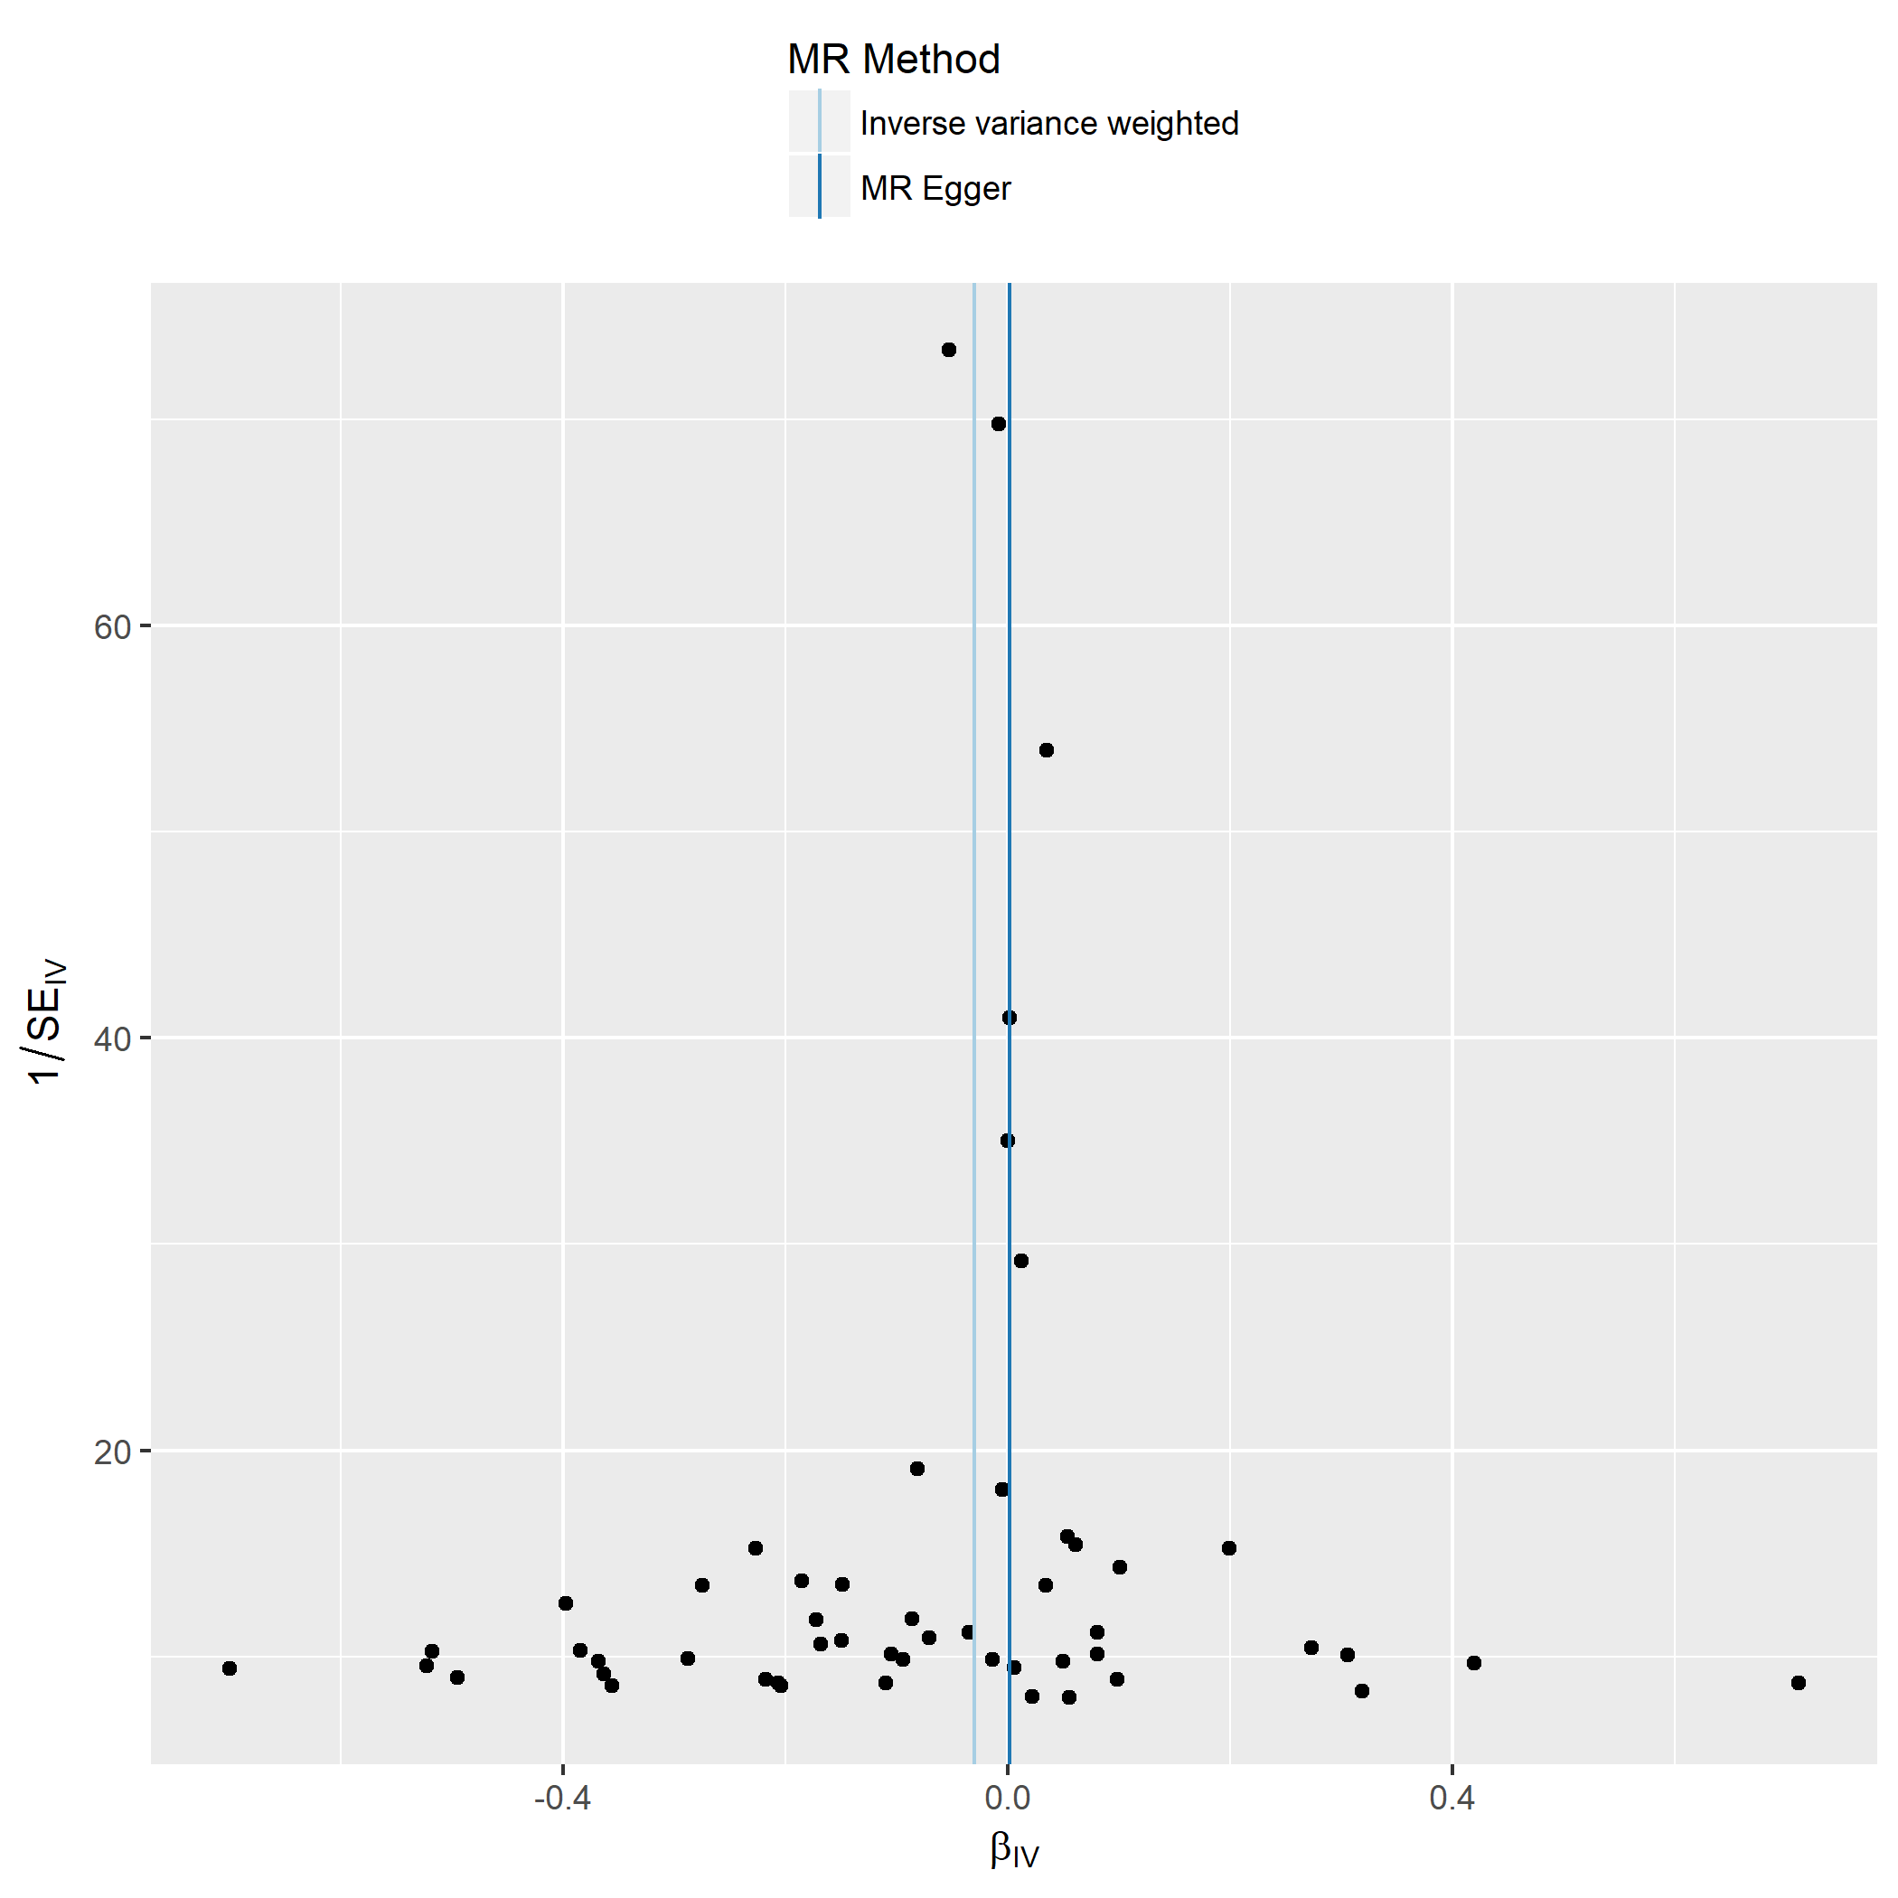

Figure S9e. Diastolic blood pressure.

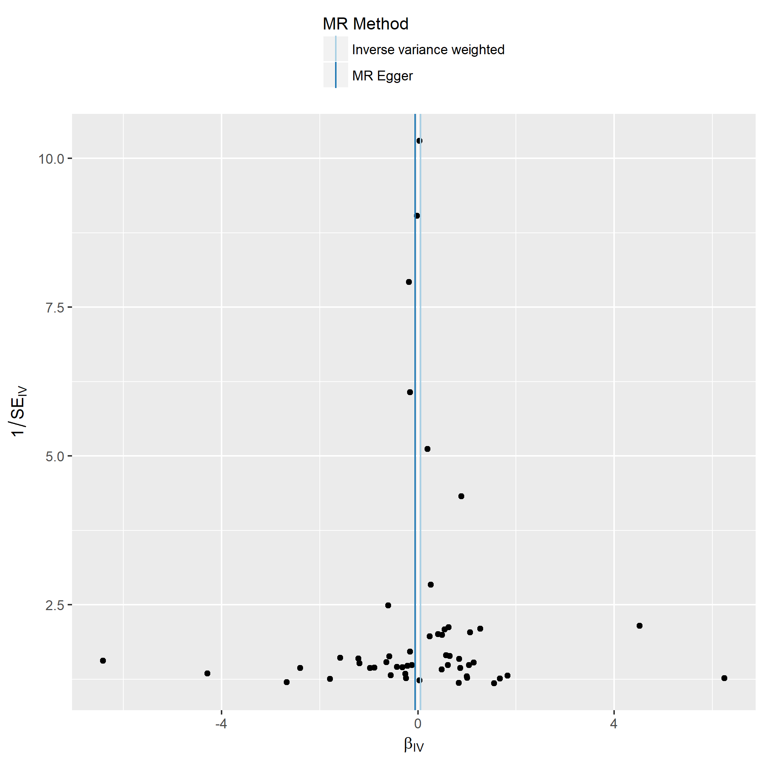

Figure S9f. Inflammatory bowel disease.

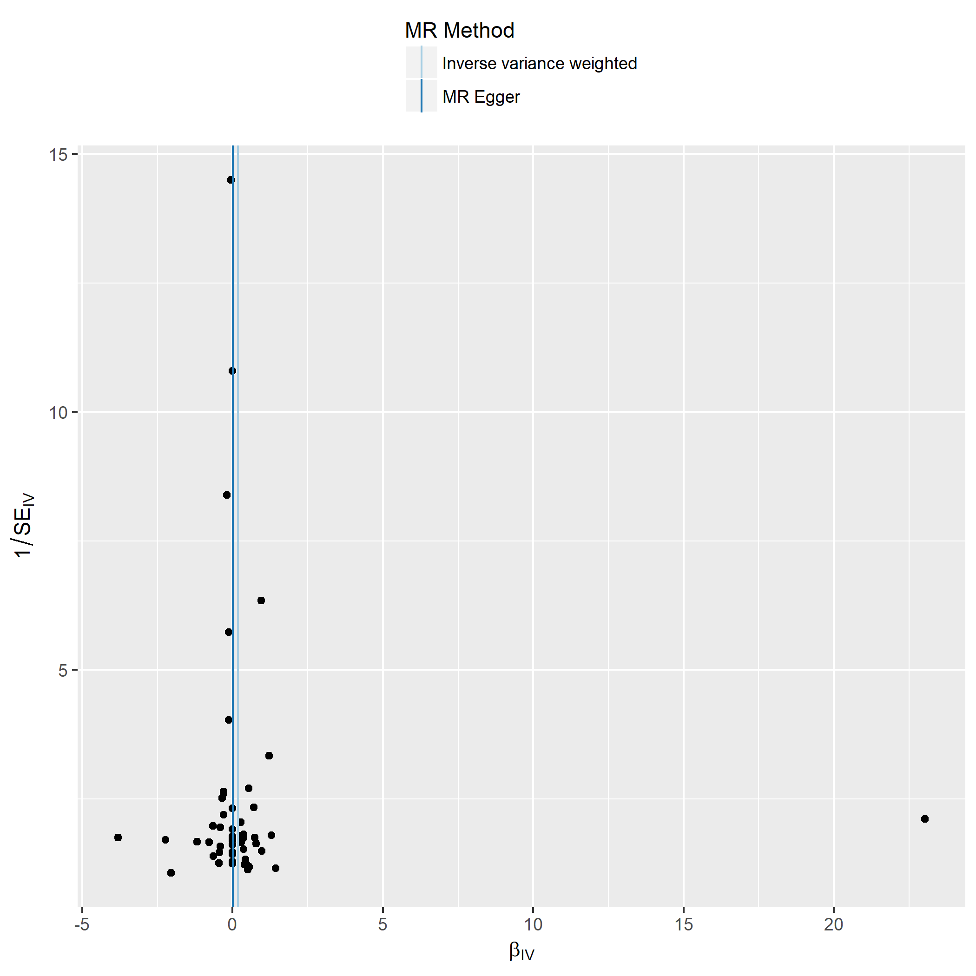

Figure S9g. Rheumatoid arthritis.

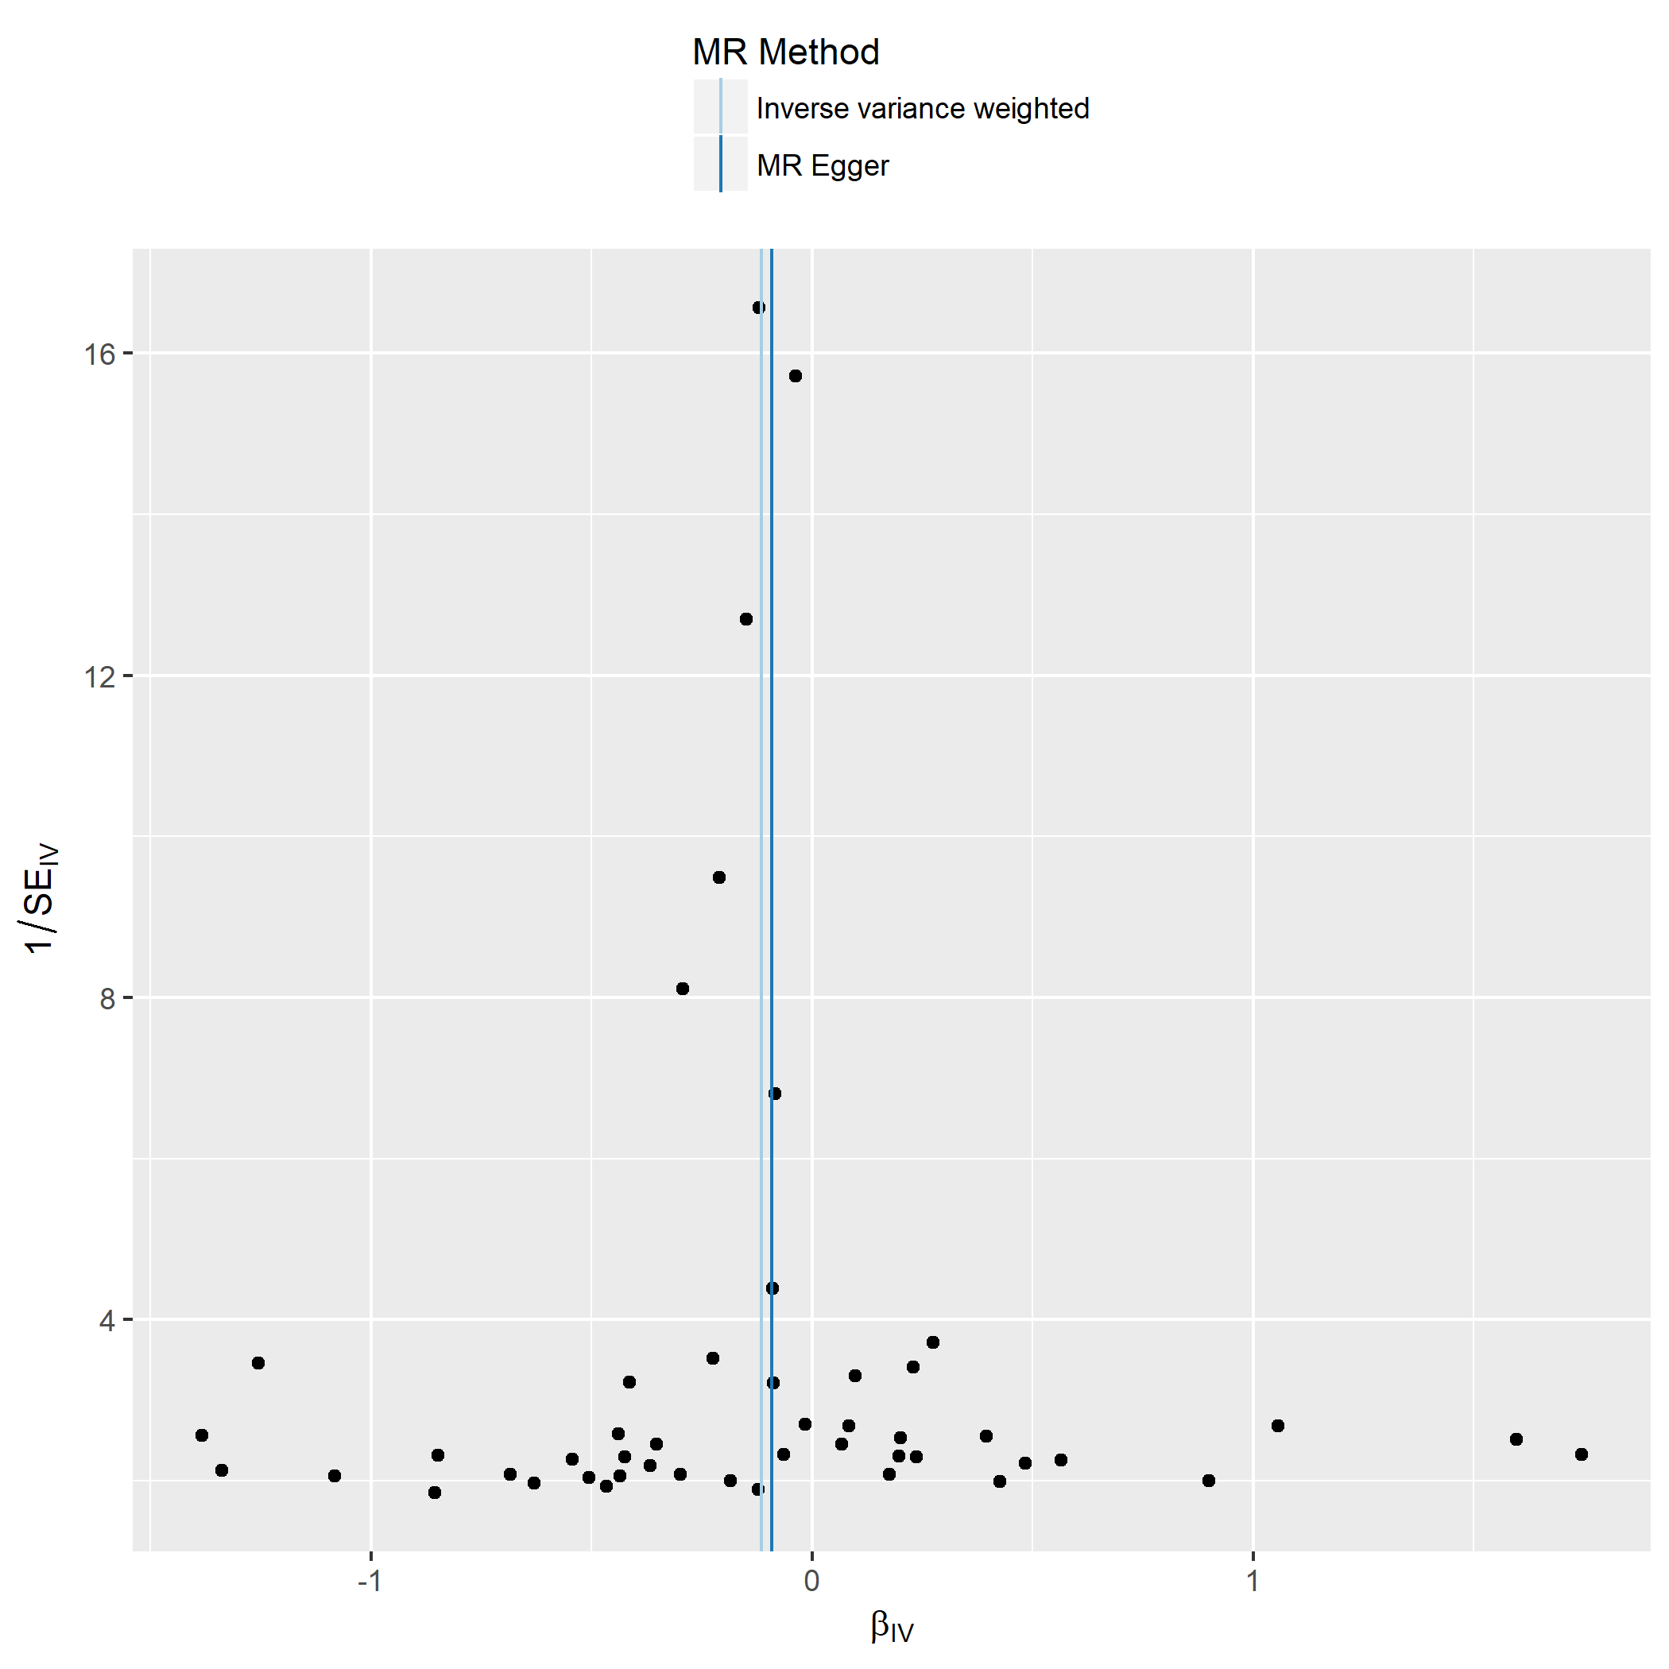

Figure S9h. Schizophrenia.

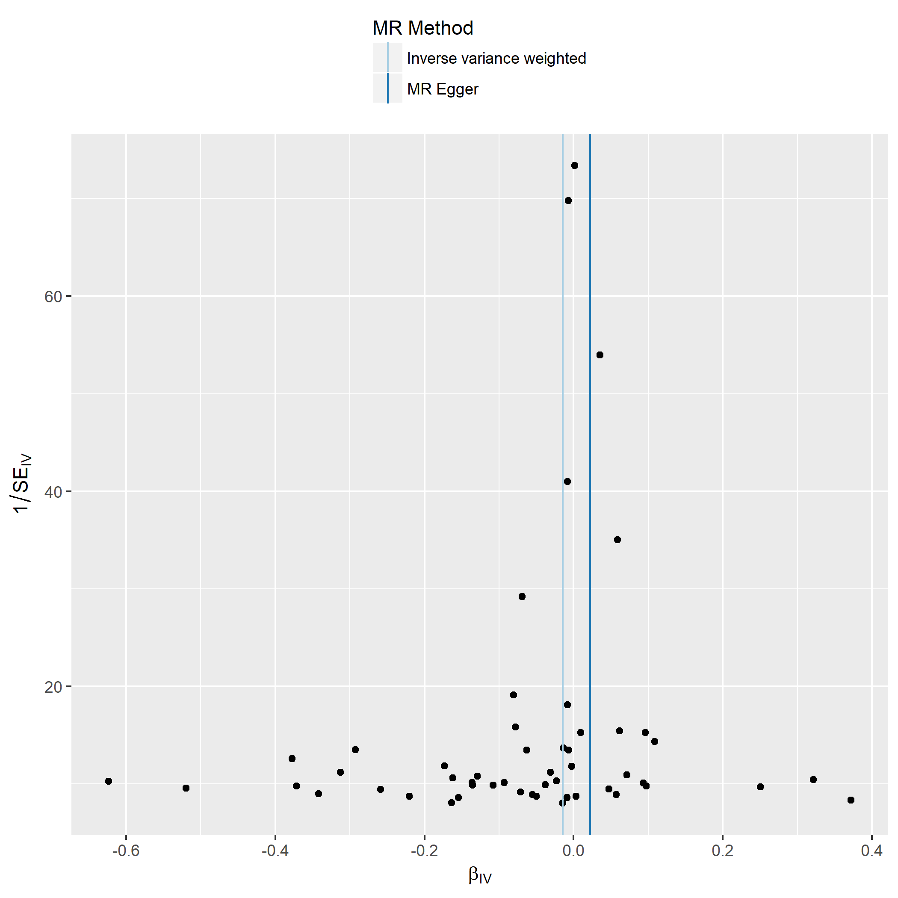

Figure S9i. Systolic blood pressure.

Figure S10. Leave-one-out analysis of the Mendelian randomization analyses applied to nine a priori selected clinical outcomes.
In the leave-one-out analysis, the MR is performed leaving out each SNP in turn. This to identify if a single SNP is driving the causal association. The SNP on the y-axis denotes the SNP that is removed from the corresponding MR analysis estimate.
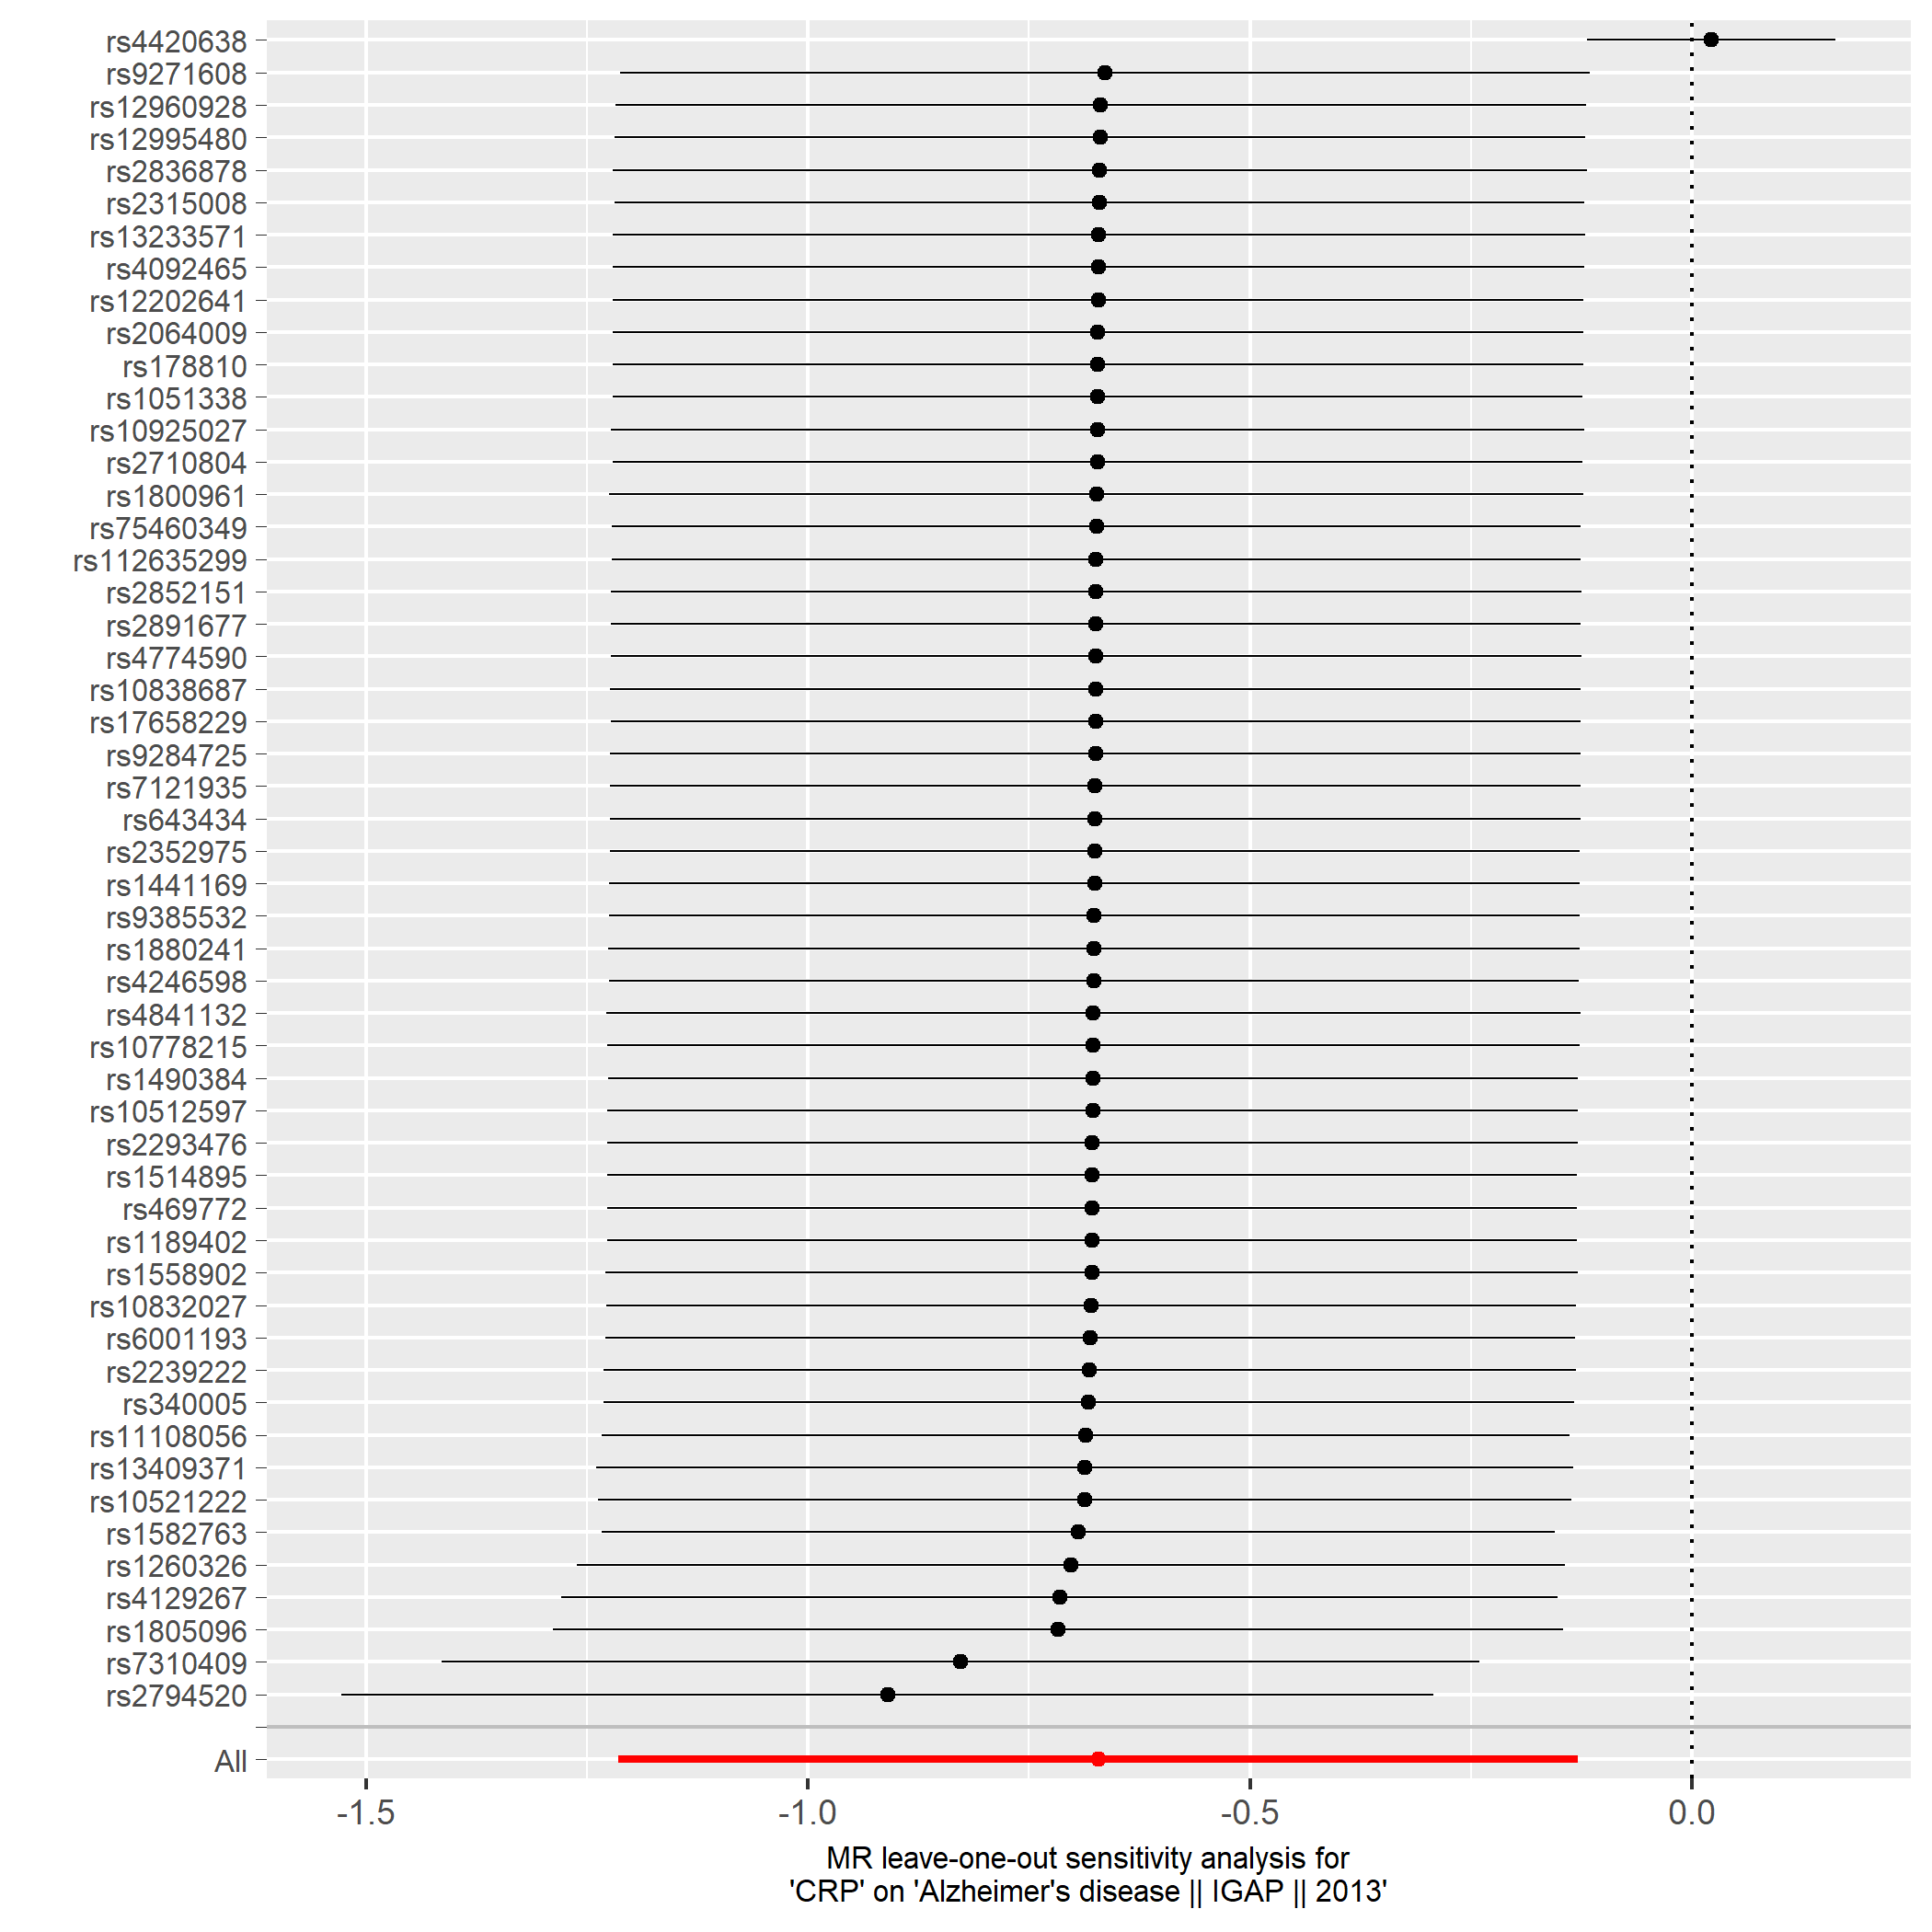

Figure S10a. Alzheimer´s disease.

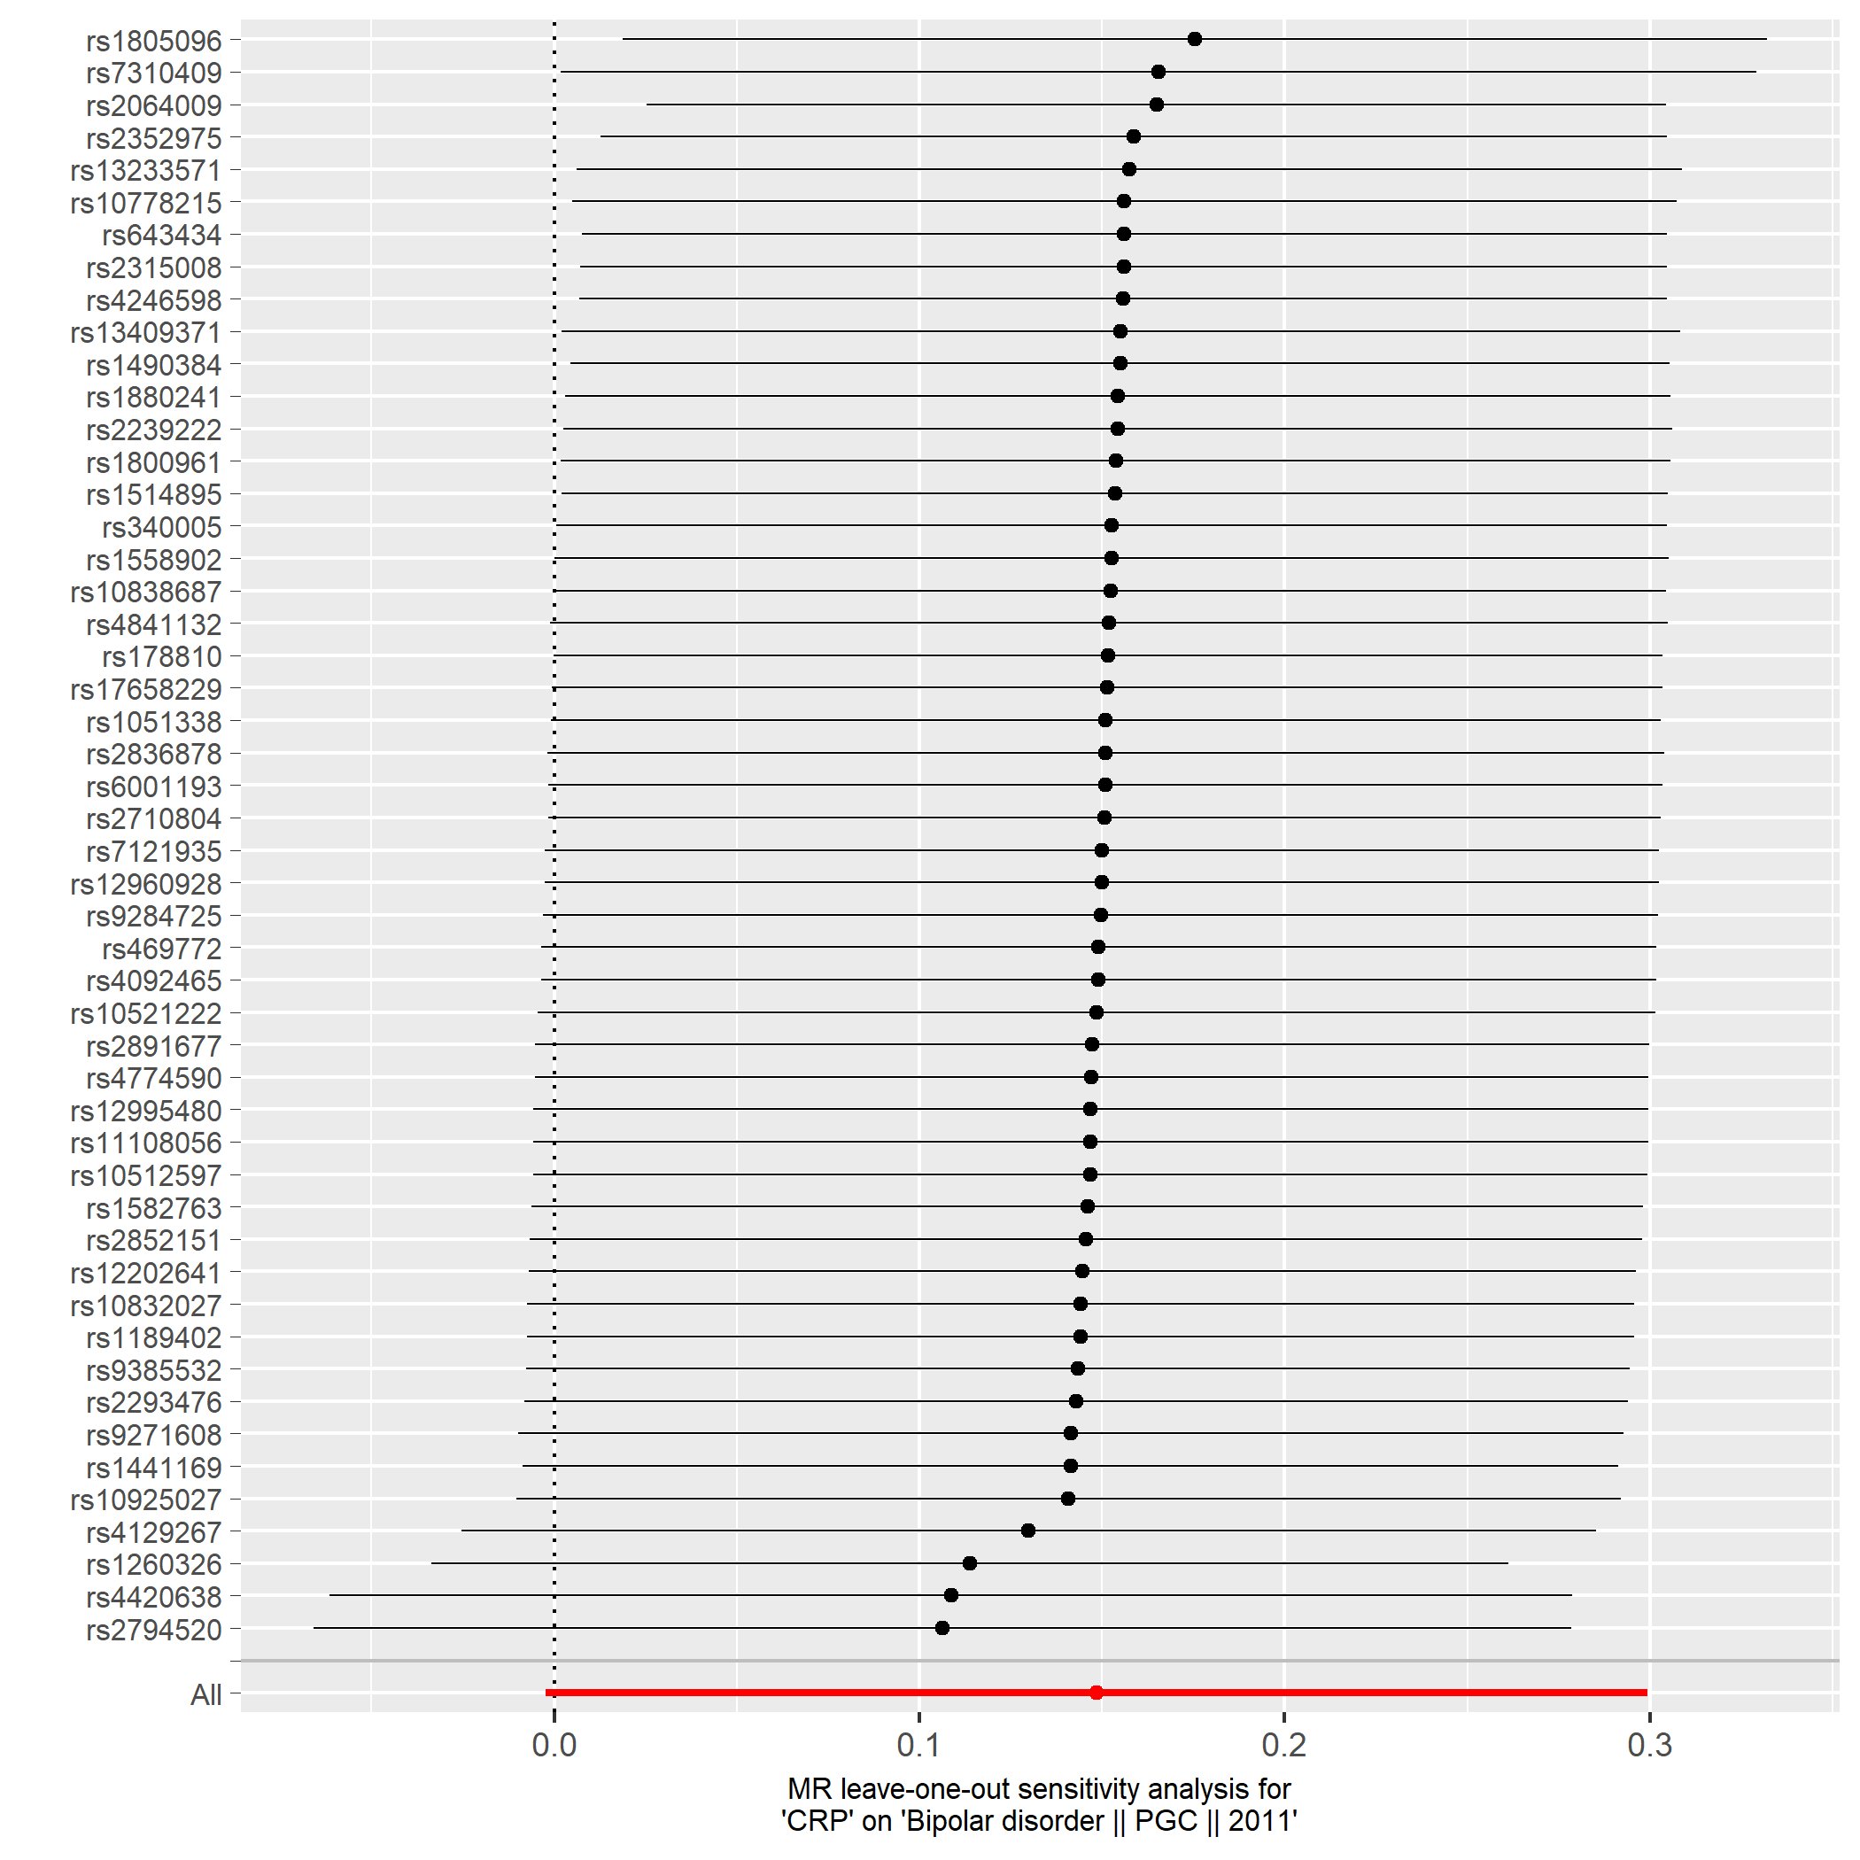

Figure S10b. Bipolar disorder.

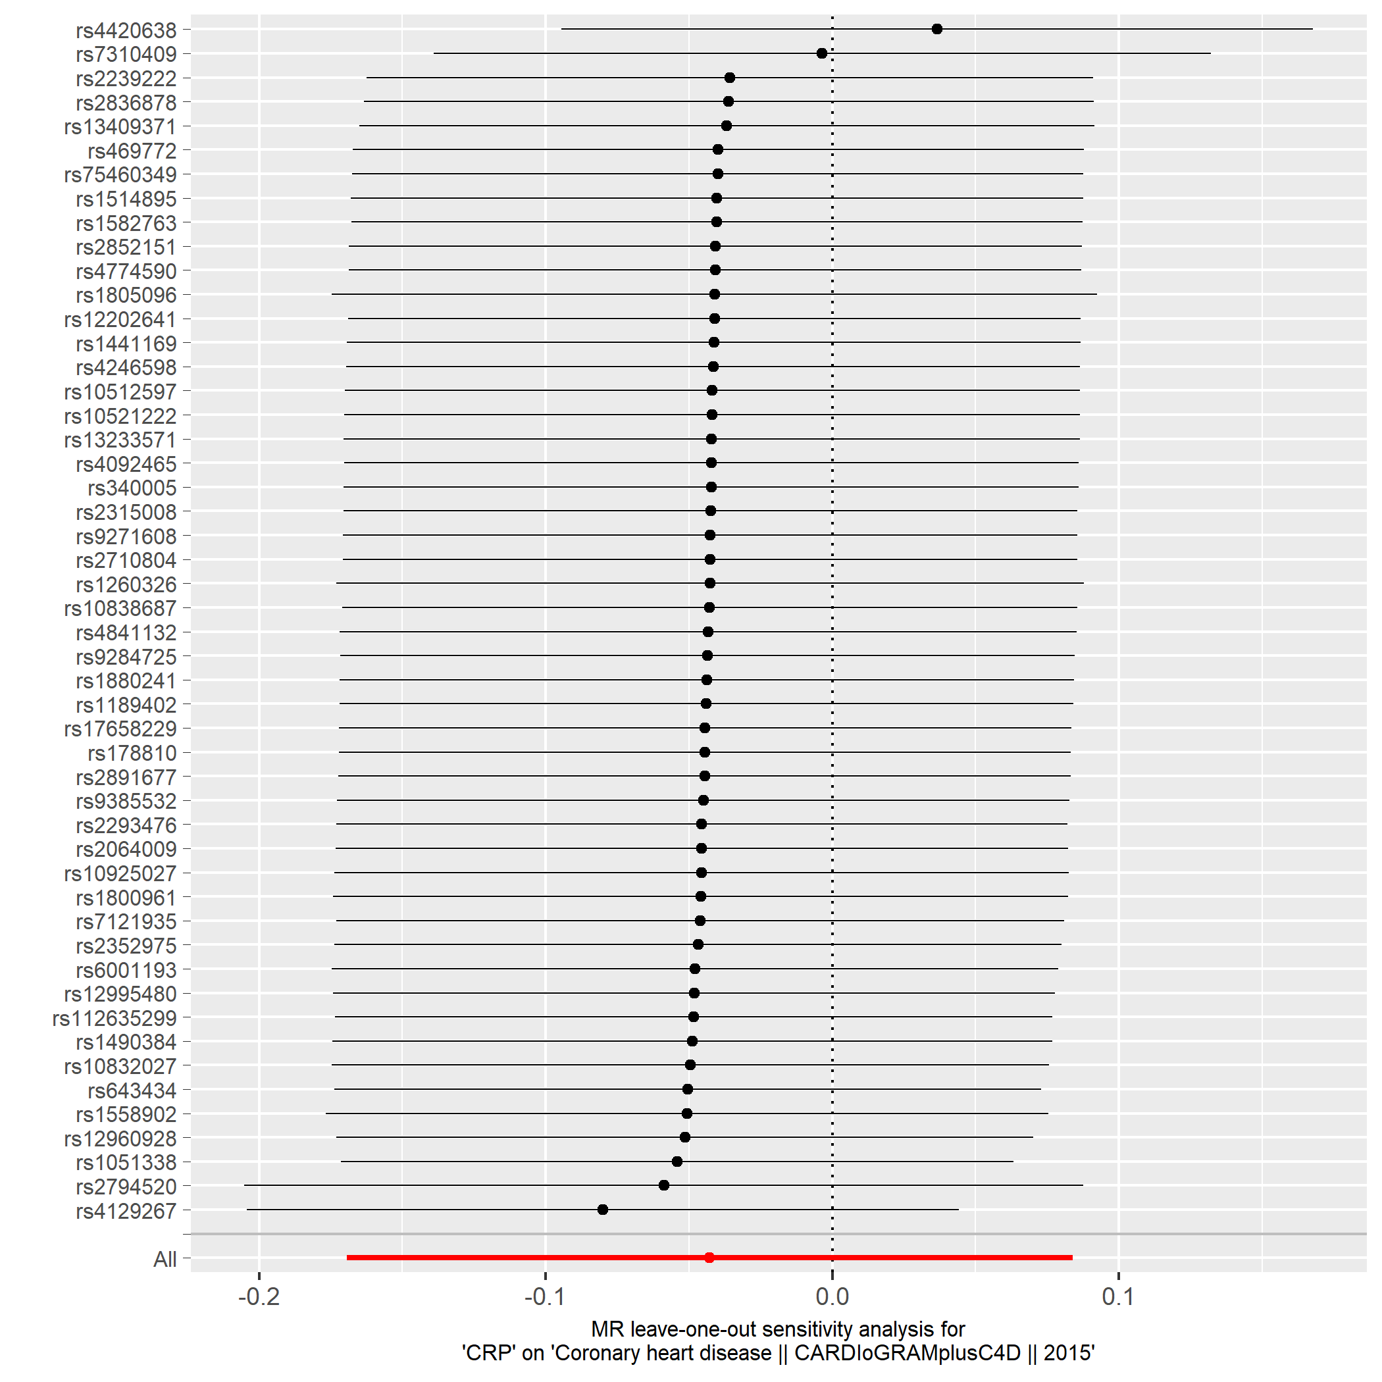

Figure S10c. Coronary artery disease.

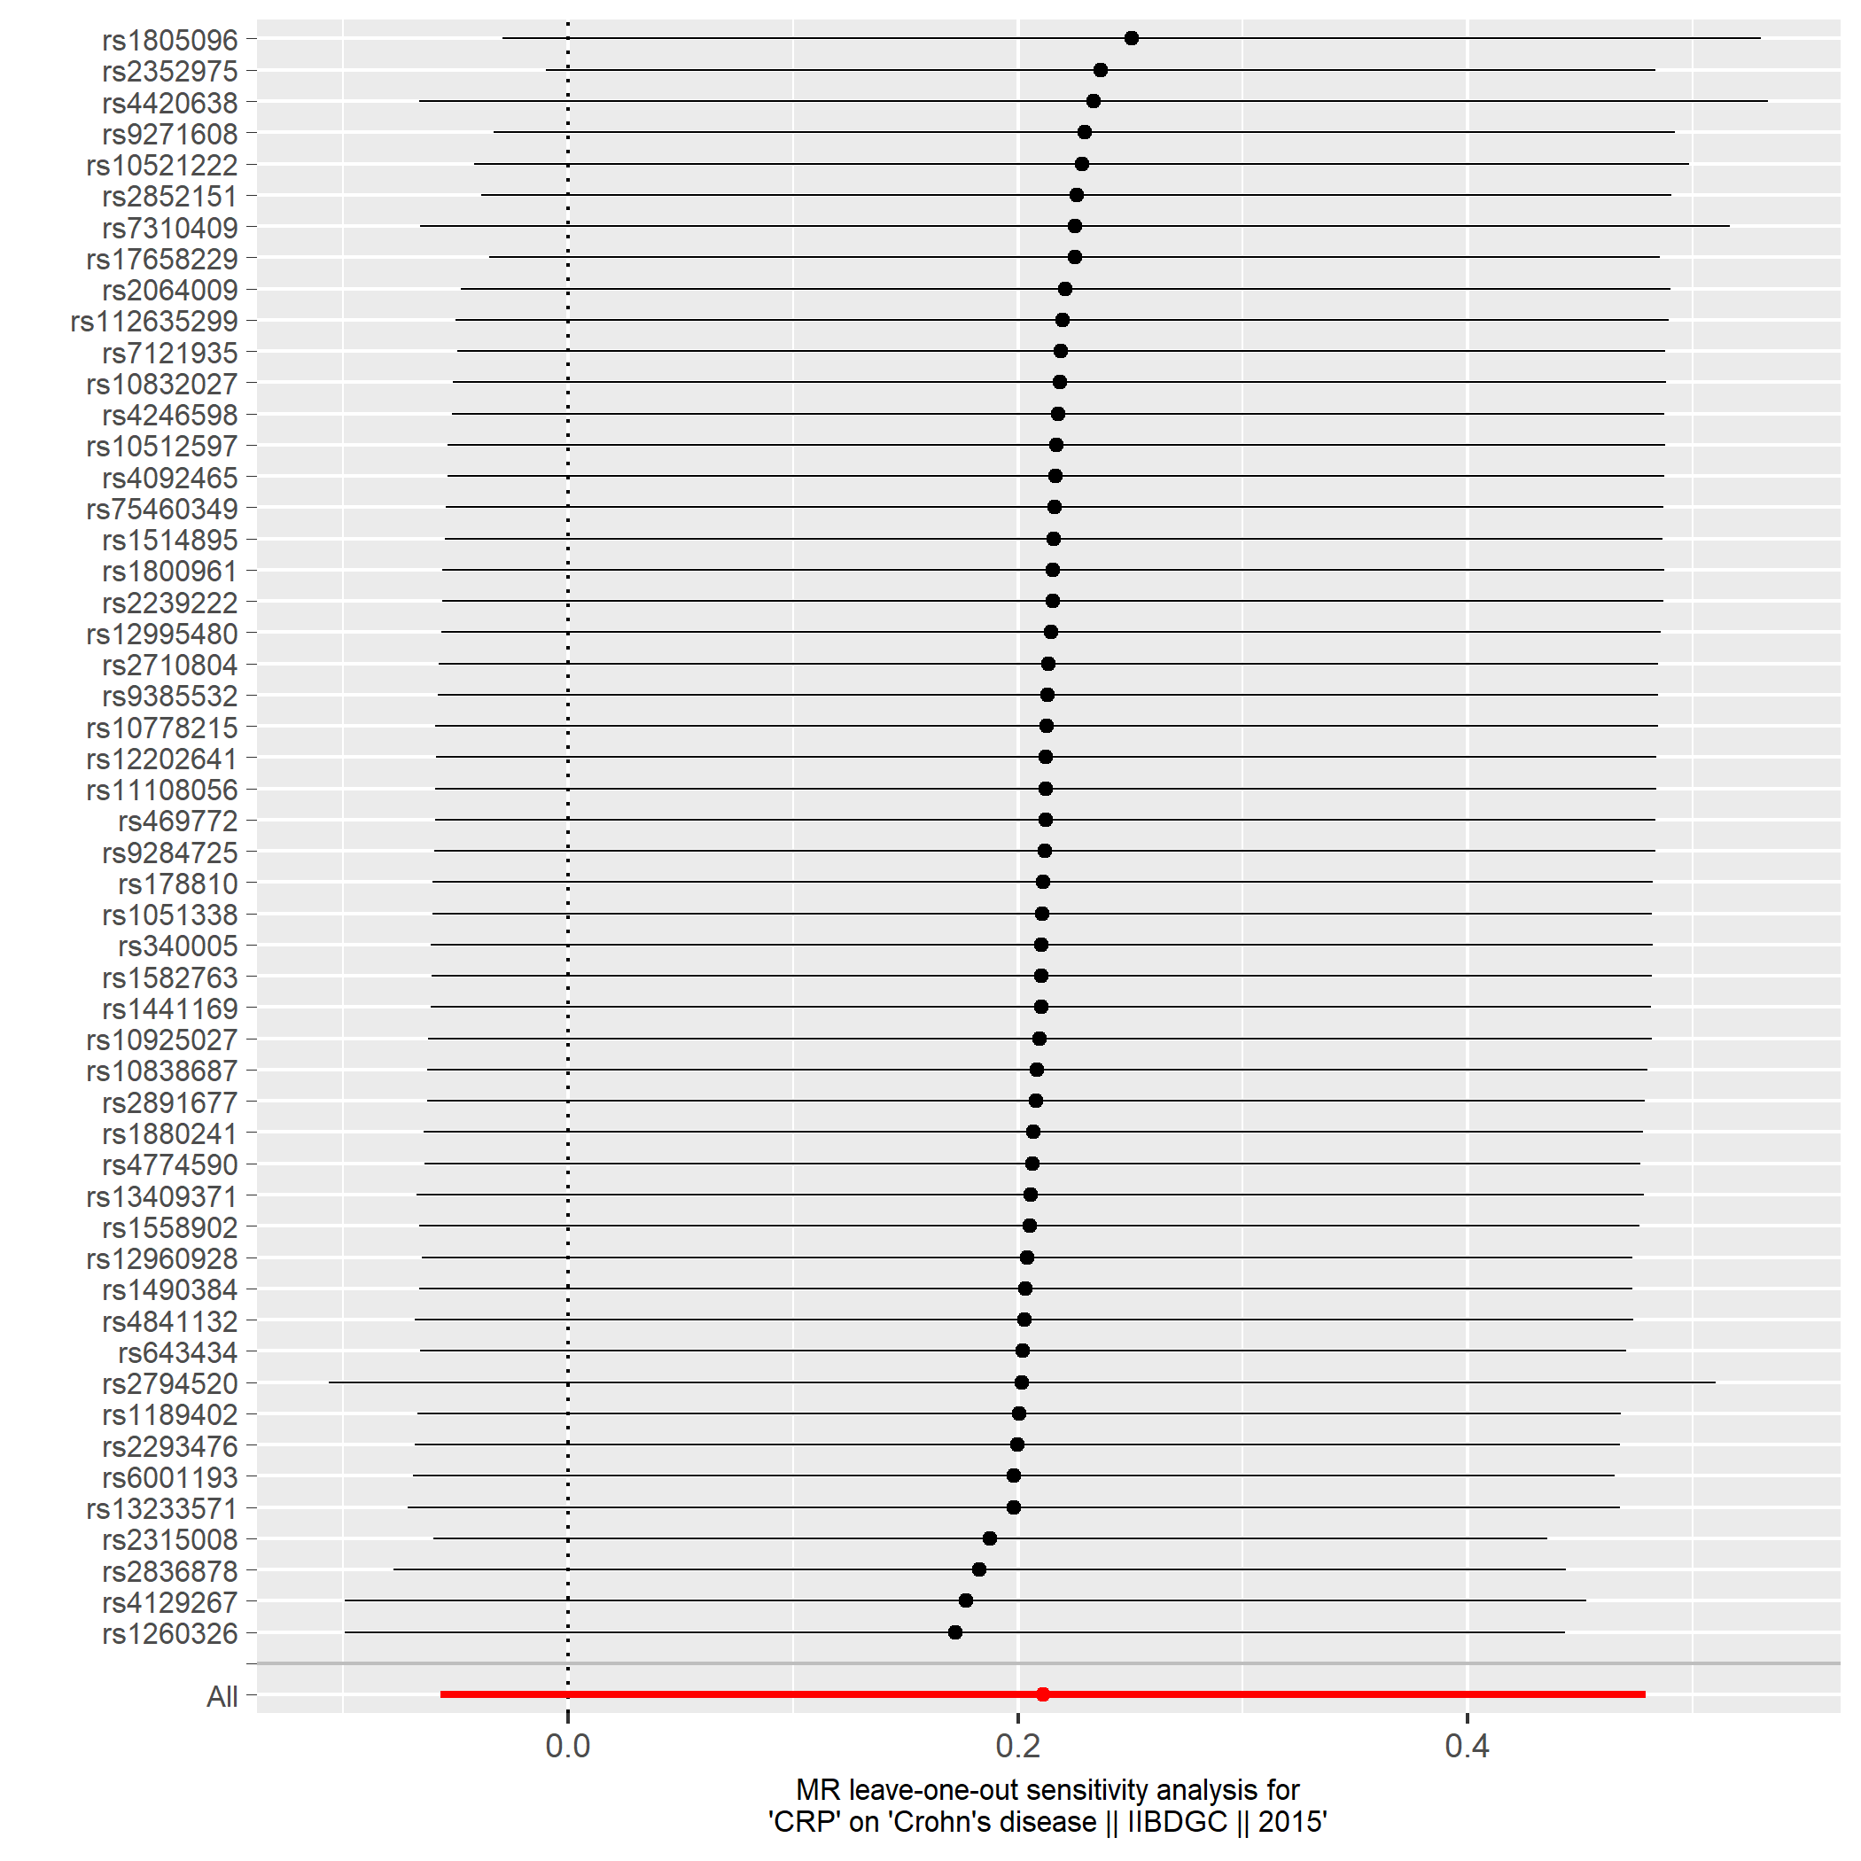

Figure S10d. Crohn´s disease.

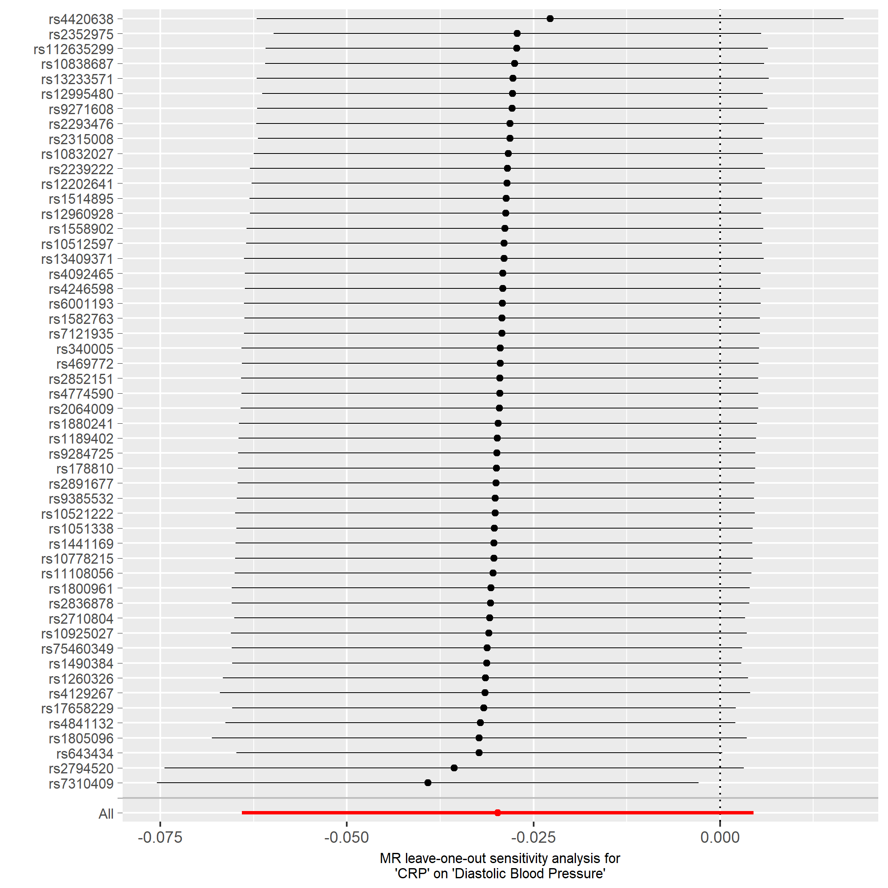

Figure S10e. Diastolic blood pressure.

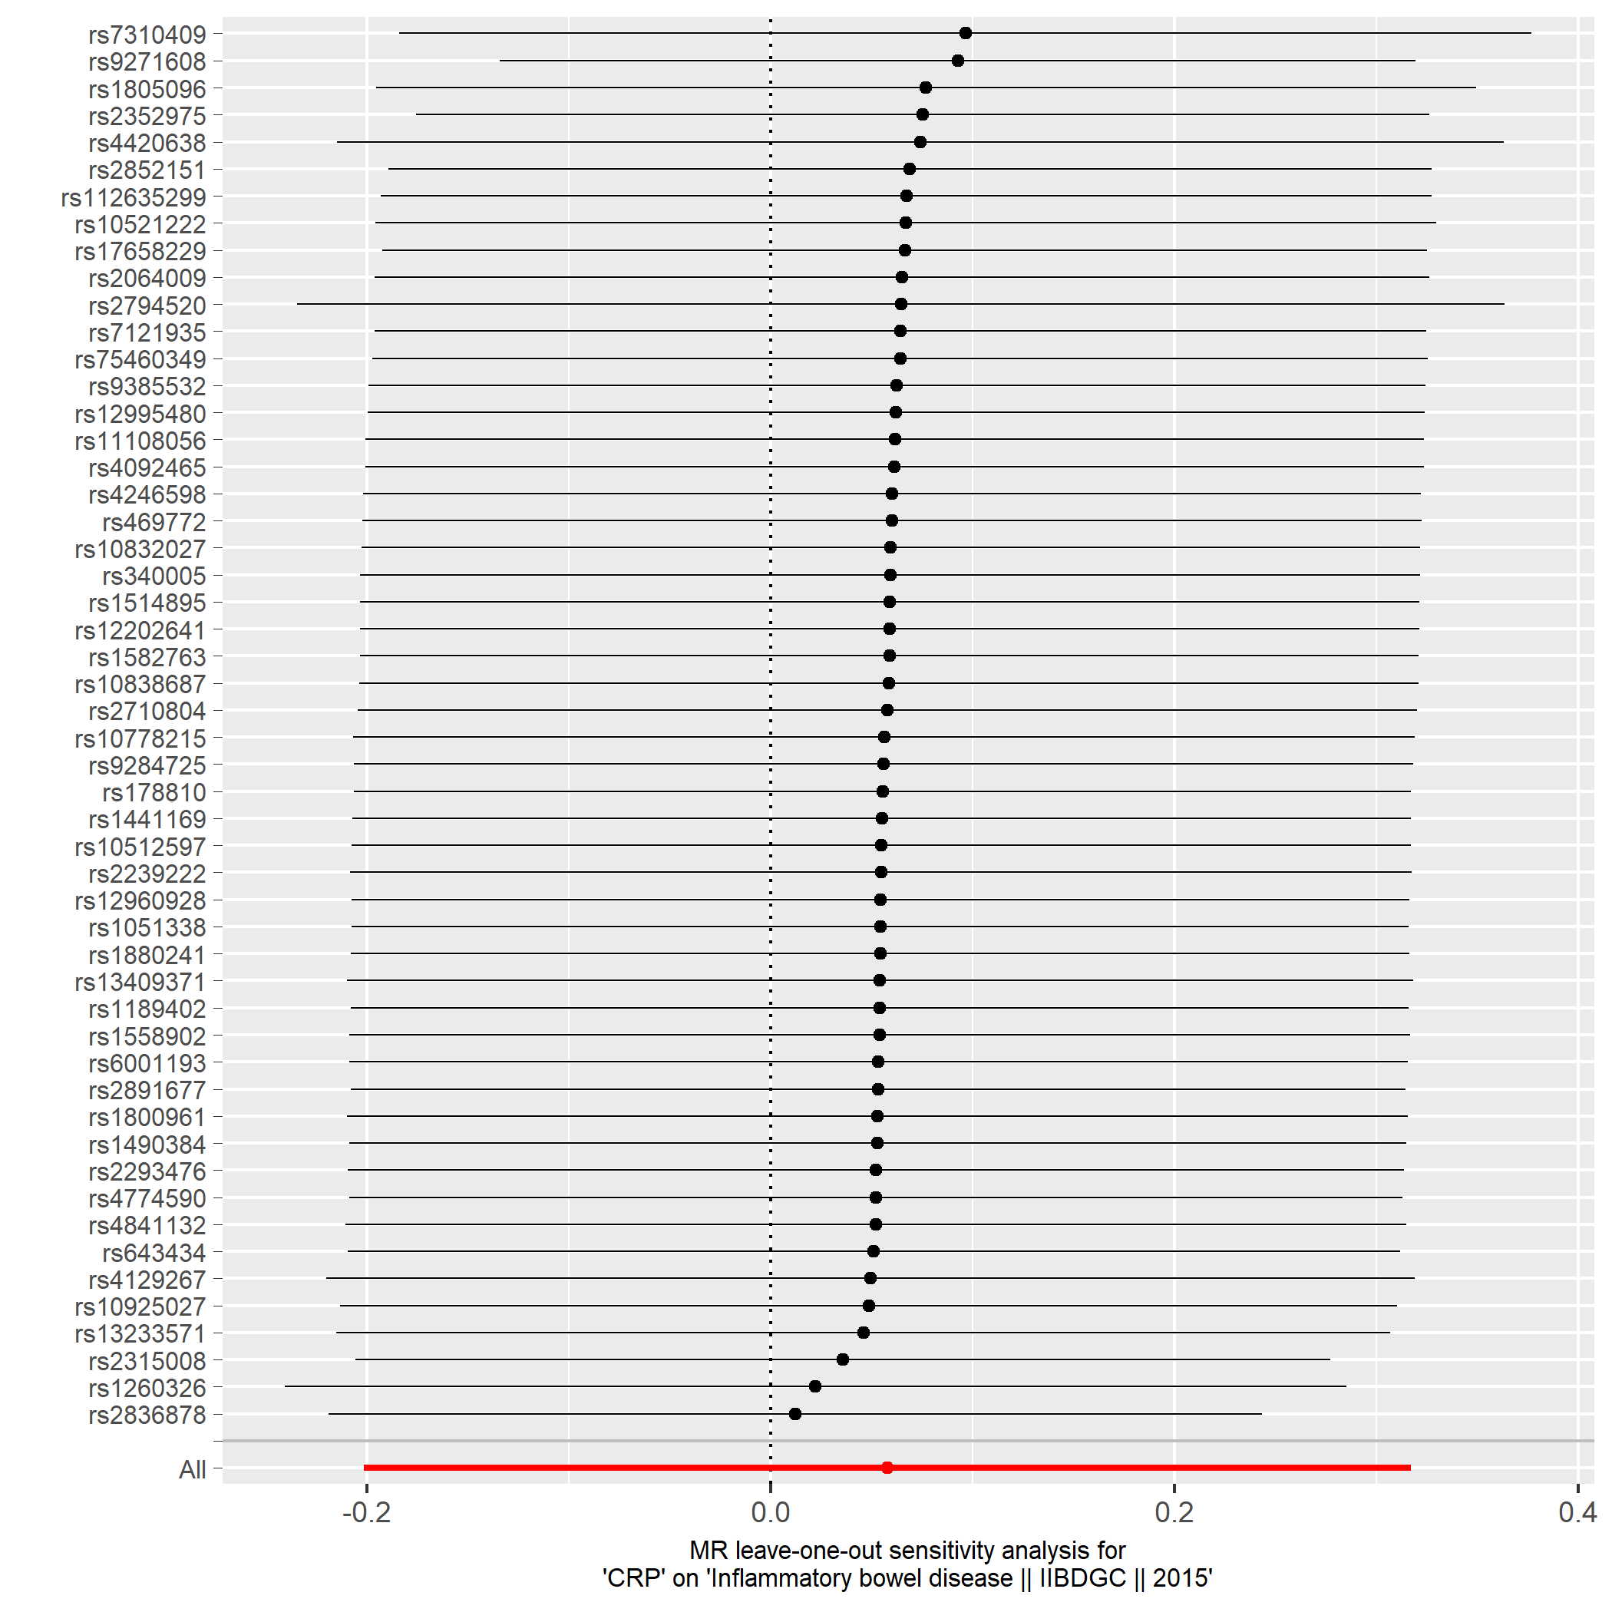

Figure S10f. Inflammatory bowel disease.

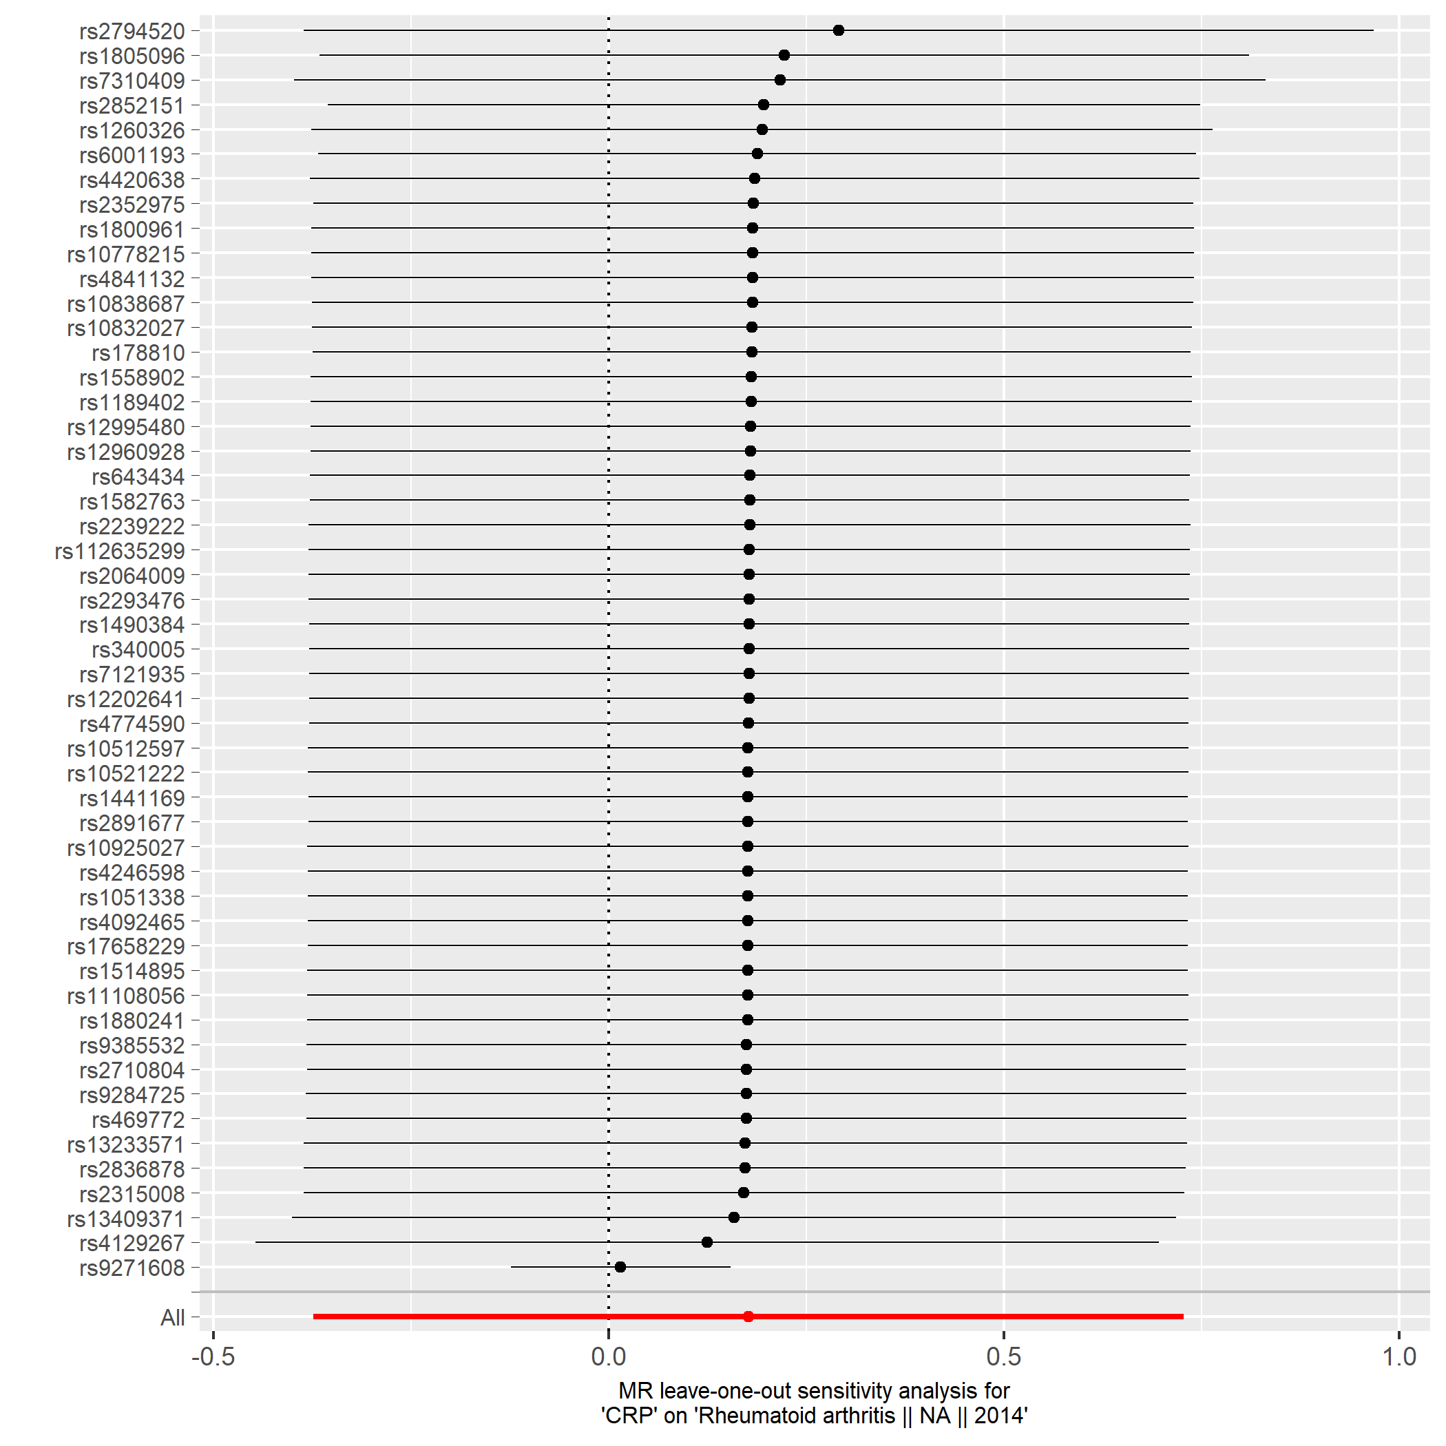

Figure S10g. Rheumatoid arthritis.

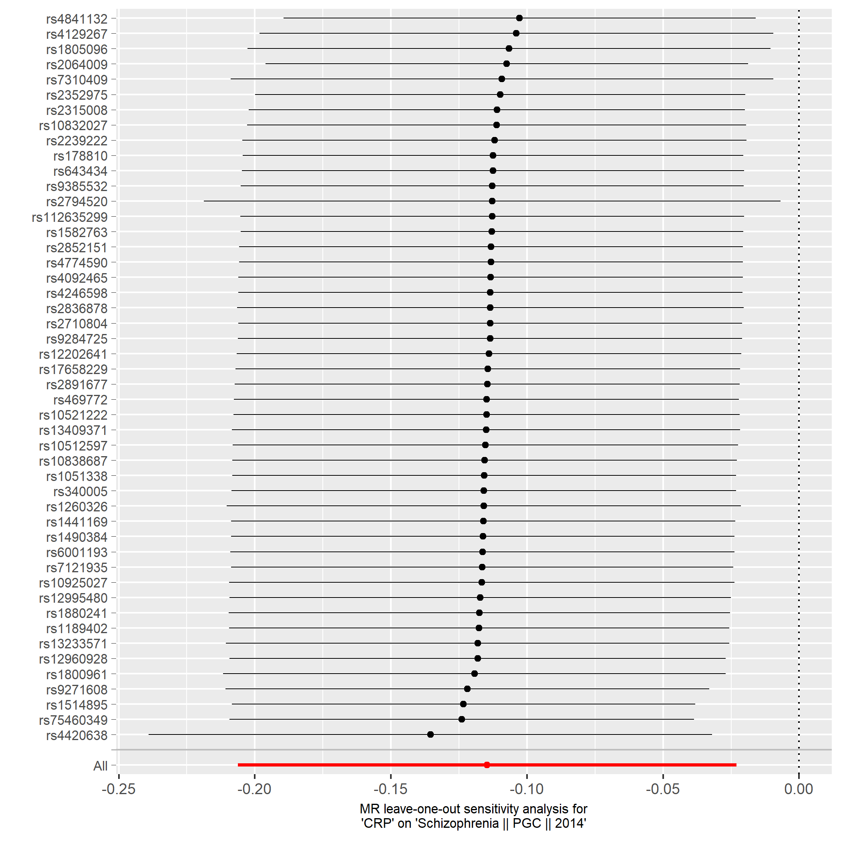

Figure S10h. Schizophrenia.

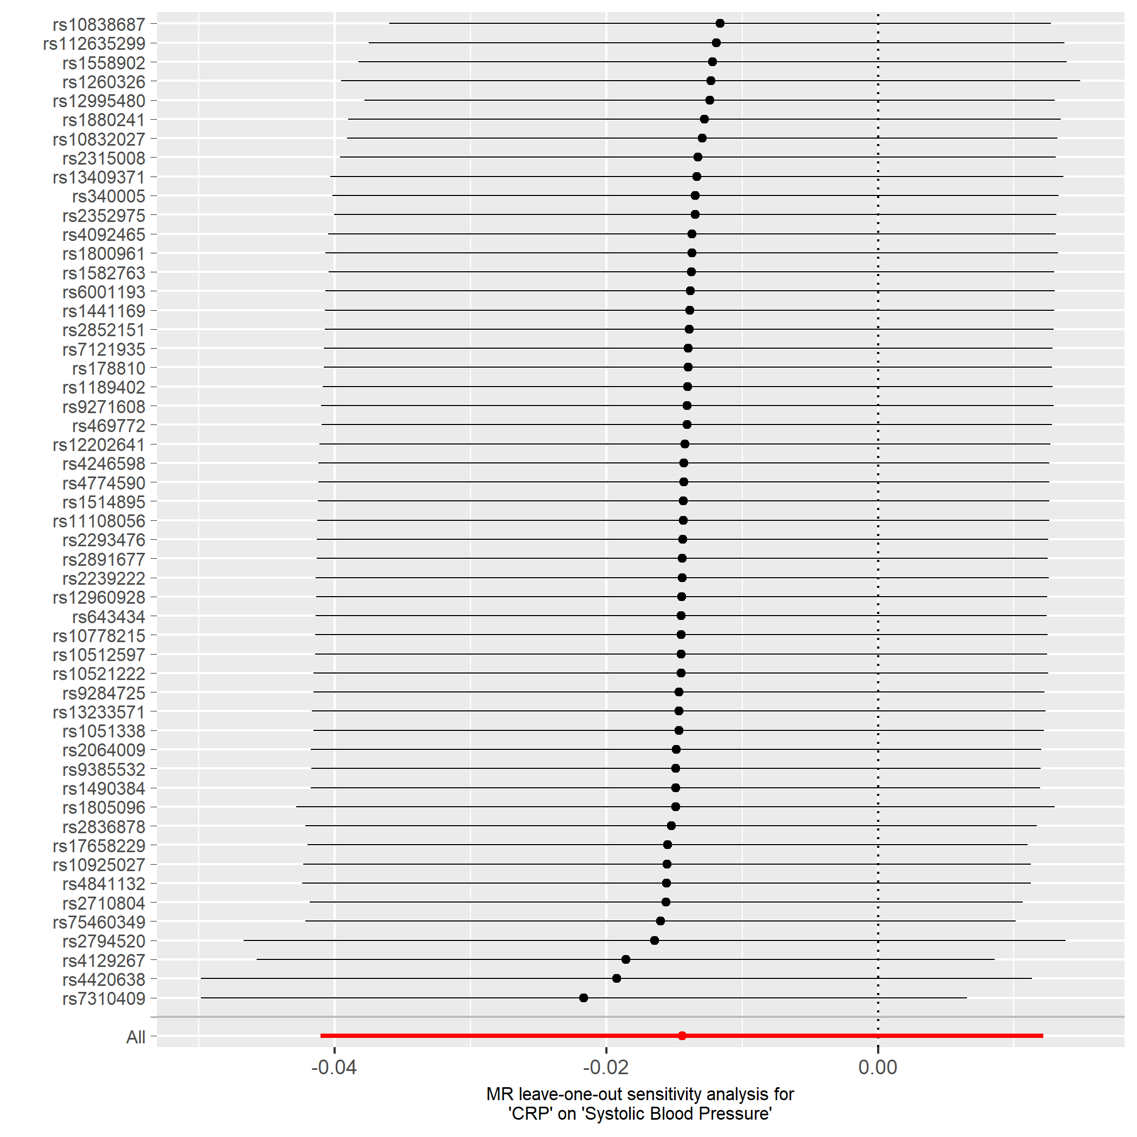

Figure S10i. Systolic blood pressure.

1. Mendelian Randomization (MR) methods
A two-sample MR was performed to estimate the causal effect of genetically determined variance in CRP and the risk of nine clinical outcomes. The effect estimates of the 48 lead SNPs found to be associated with CRP in the HapMap CRP GWAS, and the effect estimates of the four SNPs that were additionally found to be associated with CRP in the 1KG CRP GWAS were used in a multiple instrument approach for the MR analyses (n=52 SNPs). Furthermore, the causal effect of only the SNP rs2794520 at the CRP locus was used for MR, this to minimize the probability of horizontal pleiotropy that may be introduced in a multiple instrument approach. We tested the statistical significance of the association between the instrument and CRP using the formula:
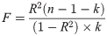
R² is the variance explained of CRP by the genetic instrument (0.014 for the rs2794520 SNP and 0.065 for the 52-SNP score), n is the number of individuals included in the CRP GWAS, and k the number of variants included in the genetic score. The F statistic for the 52-SNP score was 273, and for the rs2794520 SNP 2,902, indicating that both instruments were strong.
For the clinical outcomes, summary statistics from the most recent meta-analysis of GWA studies were used. For diastolic and systolic blood pressure, data from the UK Biobank were used. The table below summarizes the details of the outcome studies.
Outcome | Sample size | N cases | N controls | Consortium | Year | PMID
Alzheimer´s disease | 54,162 | 17,008 | 37,451 | IGAP | 2013 | 24162737
Bipolar disorder | 16,731 | 7,481 | 9,250 | PGC | 2011 | 21926972
Coronary heart disease | 184,305 | 60,601 | 123,504 | CARDIoGRAMplusC4D | 2015 | 26343387
Crohn´s disease | 20,883 | 5,956 | 14,927 | IIBDGC | 2015 | 26192919
Diastolic blood pressure | 317,756 | - | - | UK Biobank | 2017 | 28135244
Inflammatory bowel disease | 34,652 | 12,882 | 21,770 | IIBDGC | 2015 | 26192919
Rheumatoid Arthritis | 58,284 | 19,234 | 61,565 | - | 2014 | 24390342
Schizophrenia | 82,315 | 35,476 | 46,839 | PGC | 2014 | 25056061
Systolic blood pressure | 317,754 | - | - | UK Biobank | 2017 | 28135244

We implemented four different methods of MR analysis: Inverse-variance weighted method (IVW), MR-Egger, Weighted median (WM), and Penalized weighted median (PWM). The “TwoSampleMR” package in R was used for the MR analyses¹. The MR methods are described briefly below.
Inverse-variance weighted (IVW): The causal estimate is obtained by regressing the SNP associations with the outcome on the SNP associations with the risk factor, with the intercept set to zero and weights being the inverse-variances of the SNP associations with the outcome. With a single genetic variant, the estimate is the ratio of coefficients betaY/betaX and the standard error is the first term of the delta method approximation betaYse/betaX. When all CRP-SNPs are valid IVs, the IVW estimates converge to the true causal effect. When one or more invalids IVs are present, (ie. one SNP has effect on outcome through a different pathway than CRP), the IVW estimate deviates from the true causal effect.
MR-Egger: We used MR-Egger to account for potential unbalanced pleiotropy in the multiple variant instrument². When unbalanced pleiotropy is present, an alternative effect (positive or negative) is present between the SNP and the outcome that may bias the estimate of the causal association. The MR-Egger method is similar to the IVW analysis, but does not force the intercept to pass through the origin. The slope of the MR-Egger regression provides the estimate of the causal association between CRP and the clinical outcome. An MR-Egger intercept that is significantly different from zero suggests directional pleiotropic effects that may bias uncorrected estimates of the causal effect. MR-Egger regression depends on the InSIDE (Instrument Strength Independent of Direct Effect) assumption, that states that the strengths of the effect of the SNP on the outcome is uncorrelated with the direct pleiotropic effect of the SNP on the outcome.
Weighted median (WM) and penalized Weighted Median (PWM): We applied the median based method to provide robust estimates of causal association even in the presence of horizontal pleiotropy when up to 50% of the information contributed by the genetic variants is invalid³. In PWM analysis the effect of each variants is weighted by a factor that corresponds to the Q statistics (heterogeneity test) of the SNP; this means that most variants will not be affected by this correction, but the causal effect of the outlying variants, which are most likely to be invalid IVs, will be down-weighted.
The individual SNP causal effect estimates and corresponding 95% confidence intervals were displayed in a forest plot. To assess whether one of the variants used in the genetic score had disproportionate effects, we performed “leave-one-out” analyses where one SNP at a time is removed from the score. The relationship between the SNP effect on CRP and the SNP effect on the clinical outcomes were depicted in a scatter plot. In a funnel plot, the individual SNP effect were plotted against the inverse of their standard error. When unbalanced pleiotropy is absent, the causal effect estimates of the individual should center around the meta-analysis estimate in the funnel plot.
The proportion of variance in CRP explained by the genetic instruments (0.014 for the rs2794520 SNP and 0.065 for the 52-SNP score) was used to perform power calculations for each outcome using the online tool http://cnsgenomics.com/shiny/mRnd/⁴. The power to detect a relative 5%, 10%, 15%, and 20% difference in outcome risk were calculated. For example, a 10% difference refers to an OR of at least 0.90 or 1.10 in outcome risk.

2. Study Descriptives and Acknowledgments

Age, Gene/Environment Susceptibility Reykjavik Study (AGES)
The Reykjavik Study cohort originally comprised a random sample of 30,795 men and women born in 1907-1935 and living in Reykjavik in 1967. A total of 19,381 people attended, resulting in 71% recruitment rate. The study sample was divided into six groups by birth year and birth date within month. One group was designated for longitudinal follow up and was examined in all stages. One group was designated a control group and was not included in examinations until 1991. Other groups were invited to participate in specific stages of the study. Between 2002 and 2006, the AGES-Reykjavik study re-examined 5764 survivors of the original cohort who had participated before in the Reykjavik Study. Participants came in a fasting state to the clinic. The AGES Reykjavik Study GWAS was approved by the National Bioethics Committee (VSN: 00-063) and the Data Protection Authority.
High sensitivity CRP was measured in serum on a Hitachi 912, using a particle-enhanced immunoturbidimetric assay with reagents from Roche Diagnostics and following the manufacturer’s instructions. Both within- and between- assay quality control procedures were used and the coefficient of variation of the method was 1.3% to 3.4%, respectively, through the period of data collection. The assay could detect a minimal CRP concentration of 0.1 mg/L and values below this level were classified as undetectable. All participants in this study had detectable CRP levels.
The Age, Gene/Environment Susceptibility Reykjavik Study is funded by NIH contract N01-AG-12100, the NIA Intramural Research Program, Hjartavernd (the Icelandic Heart Association), and the Althingi (the Icelandic Parliament).

Avon Longitudinal Study of Parents and their Children (ALSPAC)
The Avon Longitudinal Study of Parents and their Children (ALSPAC) is a longitudinal population-based birth cohort that recruited pregnant women residing in Avon, UK, with an expected delivery date between 1st April 1991 and 31st December 1992. “Ethical approval for the study was obtained from the ALSPAC Ethics and Law Committee and the Local Research Ethics Committees.” This cohort is described in detail on the website (http://www.alspac.bris.ac.uk) and elsewhere⁵.
Blood samples were collected from participants who gave consent for venipuncture during clinical assessment at age 9 focus group clinic. Participants fasted overnight before attending the clinic if seen in the morning, or at least for 6 h if seen in the afternoon. Venous blood was centrifuged and plasma was frozen at -20C and later transferred to -80C, and were analysed within 3–9 months of blood sampling with no freeze-thaw cycles in between. High sensitivity CRP was measured by automated particle-enhanced immunoturbidimetric assay (Roche UK, Welwyn Garden City, UK). Intra- and inter-assay variation coefficients were 5% and 10% respectively. A valid measure of serum CRP (> 0.1mg/L) was obtained from 4099 participants that ranged from 0.1 to 34.39 mg/L.
We are extremely grateful to all the families who took part in this study, the midwives for their help in recruiting them, and the whole ALSPAC team, which includes interviewers, computer and laboratory technicians, clerical workers, research scientists, volunteers, managers, receptionists, and nurses. GWAS data was generated by Sample Logistics and Genotyping Facilities at the Wellcome Trust Sanger Institute and LabCorp (Laboratory Corporation of America) using support from 23andMe. The UK Medical Research Council and the Wellcome Trust (Grant ref: 102215/2/13/2) and the University of Bristol provide core support for ALSPAC. This work is supported by a Medical Research Council program grant (MC_UU_12013/4 to D.M.E). D.M.E is supported by an Australian Research Council Future Fellowship (FT130101709).

Amish Heredity and Phenotype Intervention (HAPI) Heart Study
The Heredity and Phenotype Intervention (HAPI) Heart Study was initiated in 2002 to measure the cardiovascular response to 4 short-term interventions affecting cardiovascular risk factors and to identify the genetic and environmental determinants of these responses. The interventions were carried out in 868 relatively healthy Amish adults aged 20 years and older who were recruited between 2003 and 2006. Fasting blood samples were collected for measurement of blood chemistries and isolation of DNA for genetic analysis. Serum CRP was measured in 840 of these subjects by End Point Nephelometry, assayed by Quest Diagnostics (Horsham, PA, inter-assay CV = 4.8%).
The Heredity and Phenotype Intervention (HAPI) Heart Study was initiated in 2002 to measure the cardiovascular response to 4 short-term interventions affecting cardiovascular risk factors and to identify the genetic and environmental determinants of these responses. The interventions were carried out in 868 relatively healthy Amish adults aged 20 years and older who were recruited between 2003 and 2006. Fasting blood samples were collected for measurement of blood chemistries and isolation of DNA for genetic analysis. Serum CRP was measured in 840 of these subjects by End Point Nephelometry, assayed by Quest Diagnostics (Horsham, PA, inter-assay CV = 4.8%).

The Atherosclerosis Risk in Communities (ARIC) study
The Atherosclerosis Risk in Communities (ARIC) study is a prospective epidemiological study designed to investigate the etiology and predictors of cardiovascular disease. It enrolled 15,792 individuals aged 45–64 years from four US communities (Forsyth County, NC; Jackson, MS; suburbs of Minneapolis, MN; and Washington County, MD) in 1987–89 and followed them for four completed visits in 1990–92, 1993–95, 1996–98, and 2011–13. A detailed description of the ARIC study design and methods is published elsewhere⁶. For this study, the analysis was restricted to subjects of European descent. Affymetrix 6.0 array genotypes were obtained in 8,861 self-identified whites: 734 individuals were excluded for the following reasons: 1) discordant with previous genotype data, 2) genotypic sex did not match phenotypic sex, 3) suspected first-degree relative of an included individual based on genome-wide genotype data, 4) genetic outlier (as assessed by average Identity by State (IBS) using PLINK and >8 standard deviations along any of first 10 principal components in EIGENSTRAT after 5 iterations. SNPs without chromosomal location, monomorphic SNPs, SNPs whose genotype frequencies between two freezes differed by p<10-6, SNPs with HWE p<10-6 or call rate <90% were excluded from analysis. Imputation of ~2.5 million autosomal SNPs in HapMap with reference to release 22 of the CEU sample was conducted using the algorithm implemented in MACH.
CRP was assessed in exam 4 (1996-1998) using the immunoturbidimetric CRP-Latex (II) high-sensitivity assay from Denka Seiken (Tokyo, Japan). This assay, which has been validated against the Dade Behring method (Deerfield, Ill)⁷, was performed according to the manufacturer’s protocol and using a BN2 analyzer (Dade Behring (Deerfield, Il). To assess repeatability of measurements, 421 blinded replicates were measured on different dates. The reliability coefficient was 0.99.
The ARIC study is carried out as a collaborative study supported by National Heart, Lung, and Blood Institute contracts (HHSN268201100005C, HHSN268201100006C, HHSN268201100007C, HHSN268201100008C, HHSN268201100009C, HHSN268201100010C, HHSN268201100011C, and HHSN268201100012C), R01HL087641, R01HL59367 and R01HL086694; National Human Genome Research Institute contract U01HG004402; and National Institutes of Health contract HHSN268200625226C. The authors thank the staff and participants of the ARIC study for their important contributions. Infrastructure was partly supported by Grant Number UL1RR025005, a component of the National Institutes of Health and NIH Roadmap for Medical Research.

Austrian Stroke Prevention Study (ASPS)
The ASPS study is a single centre prospective follow-up study on the effects of vascular risk factors on brain structure and function in the normal elderly population of the city of Graz, Austria. The procedure of recruitment and diagnostic work-up of study participants has been described previously^{8,9}. A total of 2007 participants were randomly selected from the official community register stratified by gender and 5 year age groups. Individuals were excluded from the study if they had a history of neuropsychiatric disease, including previous stroke, transient ischemic attacks, and dementia, or an abnormal neurologic examination determined on the basis of a structured clinical interview and a physical and neurologic examination. During 2 study periods between September 1991 and March 1994 and between January 1999 and December 2003 an extended diagnostic work-up including neuropsychological testing was done in 1076 individuals aged 45 to 85 years randomly selected from the entire cohort: 509 from the first period and 567 from the second. In 1992, blood was drawn from all study participants for DNA extraction. They were all European Caucasians. Genotyping was performed in 996 participants, and those 499 who passed genotyping quality control and had CRP measurements were available for these analyses. Non-fasting blood samples were taken from the study participants at the baseline examination and centrifuged at 3000g for 10 minutes, then plasma was separated and stored at -70°C until measurement of CRP. High sensitivity CRP was measured with a particle-enhanced immunoturbidimetric assay (Tina-quant CRP latex ultrasensitive assay, Roche Diagnostic) performed on a Hitachi 717 automated analyzer. This system measures concentrations from 0.1 to 240 mg/l. The between-assay coefficient of variation was 2.6% at 4.65 mg/l CRP¹⁰.
The research reported in this article was funded by the Austrian Science Fond (FWF) grant number P20545-P05 and P13180. The Medical University of Graz supports the databank of the ASPS. The authors thank the staff and the participants of the ASPS for their valuable contributions. We thank Birgit Reinhart for her long-term administrative commitment and Ing Johann Semmler for the technical assistance at creating the DNA-bank.

British 1958 birth cohort (B58C)
The British 1958 birth cohort is a national population sample followed periodically from birth. At age 44-45 years, 9377 cohort members were examined by a research nurse in the home as described previously ¹¹ and non-fasting blood samples were collected with permission for DNA extraction and creation of immortalised cell cultures. Ethical approvals for the 2002-2004 fieldwork, including consent procedures, and for this within-cohort genotype-phenotype analysis were obtained from the Southeast England Multicentre Research Ethics Committee.
Details of the blood collection, C-reactive protein (CRP) measurement and covariate adjustment have been described elsewhere ¹². In brief, CRP antigen levels were measured by high-sensitivity nephelometric assay using latex particles coated with monoclonal antibodies to human CRP in the BN ProSpec protein analyser (Dade Behring, Marburg, Germany). Levels were adjusted for sex, laboratory batch, time of day, month of examination, and postal delay. Adjustment for age was not required as all subjects were aged 44-45 years. Valid CRP measurements were available for 6092 (93.9%) of the 6491 subjects with genome-wide genotype data derived from three non-overlapping subsets, generated by the Wellcome Trust Case-Control Consortium, the Type 1 Diabetes Genetics Consortium, and the GABRIEL Asthma Genetics Consortium.
We acknowledge use of phenotype and genotype data from the British 1958 Birth Cohort DNA collection, funded by the Medical Research Council grant G0000934 and the Wellcome Trust grant 068545/Z/02. Genotyping for the B58C-WTCCC subset was funded by the Wellcome Trust grant 076113/B/04/Z. The B58C-T1DGC genotyping utilized resources provided by the Type 1 Diabetes Genetics Consortium, a collaborative clinical study sponsored by the National Institute of Diabetes and Digestive and Kidney Diseases (NIDDK), National Institute of Allergy and Infectious Diseases (NIAID), National Human Genome Research Institute (NHGRI), National Institute of Child Health and Human Development (NICHD), and Juvenile Diabetes Research Foundation International (JDRF) and supported by U01 DK062418. B58C-T1DGC GWAS data were deposited by the Diabetes and Inflammation Laboratory, Cambridge Institute for Medical Research (CIMR), University of Cambridge, which is funded by Juvenile Diabetes Research Foundation International, the Wellcome Trust and the National Institute for Health Research Cambridge Biomedical Research Centre; the CIMR is in receipt of a Wellcome Trust Strategic Award (079895). The B58C-GABRIEL genotyping was supported by a contract from the European Commission Framework Programme 6 (018996) and grants from the French Ministry of Research.

Bogalusa Heart Study (BHS)
The Bogalusa Heart Study is a biracial, community-based investigation of cardiovascular disease. Between 1973 and 2008, nine cross-sectional surveys of children aged 4-17 years and 10 cross-sectional surveys of adults aged 18-48 years, who had been examined as children, were conducted for cardiovascular disease risk factor examinations in Bogalusa, Louisiana¹³. During the 2001-2002 survey, plasma high-sensitivity C-reactive protein (hsCRP) was measured by latex particle-enhanced immunoturbidimetric assay on Hitachi 902 Automatic Analyzer¹⁴. There were 1,202 Caucasian and African American participants who have been examined on multiple occasions from childhood to adulthood with DNA available for genotyping¹⁵. After exclusions, 479 Caucasian participants with genotype and phenotype data were included in this analysis. Study protocols were approved by the Institutional Review Board of the Tulane University Medical Center. Informed Consent was obtained from all participants.
ENS and SSM are supported in part by NIH/NCRR Grant Number UL1 RR025774. The BHS was supported by grants HD-061437 and HD-062783 from the National Institute of Child Health and Human Development, and AG-16592 from the National Institute on Aging.

BioMe
The BioMe Biobank Program is an ongoing, prospective, hospital- and outpatient- based population research program operated by The Charles Bronfman Institute for Personalized Medicine (IPM) at Mount Sinai. BioMe has enrolled over 27,500 participants between September 2007 and April 2014. BioMe is an Electronic Medical Record (EMR)-linked biobank that integrates research data and clinical care information for consented patients at The Mount Sinai Medical Center, which serves diverse local communities of upper Manhattan with broad health disparities. IPM BioMe populations include 25% of African American ancestry (AA), 36% of Hispanic Latino ancestry (HL), 30% of white European ancestry (EA), and 9% of other ancestry. The IPM BioMe disease burden is reflective of health disparities in the local communities. BioMe operations are fully integrated in clinical care processes, including direct recruitment from clinical sites waiting areas and phlebotomy stations by dedicated BioMe recruiters independent of clinical care providers, prior to or following a clinician standard of care visit. Recruitment currently occurs at a broad spectrum of over 30 clinical care sites.
Information on anthropometrics, demographics, C - reactive protein values and use of antihypertensive medication was derived from participants EMR. For the current analyses, genotype and phenotype data was available on 386 BioMe participants of European American ancestry. Single SNP regression analyses were carried out using the score test option in SNPTEST.
The Mount Sinai IPM Biobank Program is supported by The Andrea and Charles Bronfman Philanthropies.

Baltimore Longitudinal Study of Aging (BLSA)
The Baltimore longitudinal study on Aging (BLSA)¹⁶ study is a population-based study aimed to evaluate contributors of healthy aging in the older population residing predominantly in the Baltimore-Washington DC area1. Starting in 1958, participants are examined every one to four years depending on their age. Currently there are approximately 1100 active participants enrolled in the study. Blood samples were collected for DNA extraction, and genome-wide genotyping was completed for 1231 subjects using Illumina 550K. The BLSA has continuing approval from the Institutional Review Board (IRB) of Medstar Research Institute.
The analysis was restricted to subjects with European ancestry and each analysis was further adjusted for the top two principal components derived from an EIGENSTRAT analysis utilizing ~10,000 randomly selected SNPs from the 550K SNP panel 2¹⁷. Genotyping was completed for 478 participants of European ancestry using a call rate of >98.5% without sex discrepancy based on homozygosity rates and with CRP data. 501,704 autosomal SNPs passed quality control (completeness>99%, MAF >1%, HWE >10-4) were used to for imputation. Imputation of ~39M SNPs was conducted using the 1000G Phase I Integrated Release Version 3 Haplotypes as reference with minimac3¹⁸.
Serum CRP was measured using the BNII nephelometer from Dade Behring utilizing a particle enhanced immunonepholometric assay. Polystyrene particles are coated with monoclonal antibodies to CRP, which, in the presence of antigen (CRP) agglutinate to cause an increase in the intensity of scattered light. The increase in scattered light is proportional to the amount of CRP in the sample. The assay range is 0.16 – 1100 ug/mL.
The BLSA was supported in part by the Intramural Research Program of the NIH, National Institute on Aging.

Busselton Health Study
The Busselton Health Study (BHS) (www.busseltonhealthstudy.com) is a longitudinal cohort study sampled from the general population. The BHS was established in 1966 as a framework for population sampling, community participation, and longitudinal, familial and cross-sectional studies of environmental and genetic factors associated with disease and health. The Shire of Busselton is a coastal community in the South-West of Western Australia with a stable population of predominantly European descent. Eight cross-sectional surveys of adults listed on the electoral roll in the Shire of Busselton were undertaken from 1966 to 2007, with participation rates ranging from 64 to 91%. In 1994/95, a follow-up survey was conducted of all surviving participants previously surveyed (n~5,700). A subsample of the follow-up participants were genotyped using the Illumina Human 610 quad array.
The BHS was approved by the Human Research Ethics Committee of the Sir Charles Gairdner Hospital in Perth, Western Australia. Written informed consent was obtained from all participants. This study included only participants who reported themselves to be of European ancestry, who had GWAS data available, and who had C-reactive protein measured in 1994/95 (n=1259).
Blood was collected after an overnight fast and serum was frozen at -80° C until CRP measurement. CRP was measured using a particle-enhanced immunoturbidimetric assay on a Modular analyzer (Roche Diagnostics, Germany) enabling detection of lower CRP levels (i.e., 3 mg/L). Interassay precision was 3.9% at 1.6 mg/L and 1.6% at 5 mg/L.

Coronary Artery Risk Development in Young Adults (CARDIA) study
The Coronary Artery Risk Development in Young Adults (CARDIA)¹⁹ study is a population-based study, initiated in 1985, to investigate the evolution of cardiovascular risk factors in a large, biracial cohort of young adults (Friedman et al. 1988). Participants aged 18–30 years were recruited from four geographic locations by community-based sampling (Birmingham, AL; Chicago; and Minneapolis) and through the membership of a large prepaid health plan (Oakland). In 1985–1986, baseline examinations of 5,115 participants, or 51% of the eligible persons contacted, were performed. The initial study population was approximately balanced with respect to age (45% were aged 18–24 years; 55% were aged 25–30 years), sex (46% men; 54% women), race (52% AA; 48% EA), and education (40% had completed ⩽12 years of education; 60% had completed >12 years). The CARDIA database includes repeated measures of lifestyle, physiologic, and metabolic risk factors, including smoking, obesity, and physical activity. Participants eligible for the current study included self-identified whites who had genome-wide genotyping data and plasma CRP measured at the year 7 examination. Plasma CRP levels were assayed using BNII immunonephelometry (BNII Nephelometer 100 Analyzer [Dade Behring]) on plasma, stored at year 7. Written informed consent was obtained from all participants. The CARDIA Study samples were genotyped using the Affymetrix Genome-Wide Human SNP Array 6.0 (Santa Clara, California); only participants of European descent were included in the analyses. A total of 578,568 SNPs passed quality control (MAF ≥ 2%, call rate ≥ 95%, HWE ≥ 10-4) and were used for imputation. Imputation was performed using the BEAGLE algorithm and software with the Hapmap2 CEU as the reference population.
The CARDIA study is funded by contracts N01-HC-95095, N01-HC-48047, N01-HC-48048, N01-HC-48049, N01-HC-48050, N01-HC-45134, N01-HC-05187, N01-HC-45205, and N01-HC-45204 and the CARDIA Women’s study by R01-HL065611 from the National Heart, Lung, and Blood Institute to the CARDIA investigators. Genotyping of the CARDIA participants was supported by grants U01-HG-004729, U01-HG-004446, and U01-HG-004424 from the National Human Genome Research Institute. Statistical analyses were supported by grants U01-HG-004729 and R01-HL-084099 to MF.

The Chicago Health and Aging Project (CHAP)
The Chicago Health and Aging Project (CHAP) study is a prospective population-based epidemiologic study that began in 1993 to study the epidemiology of Alzheimer’s disease and related disorders and common chronic health conditions in adults over the age of 65. The entire CHAP cohort consisted of 10,801 participants, of whom 3,659 participants have been genotyped. Of these participants, 1,335 were European Americans and the remaining 2,324 participants were African Americans. Of the 1,335 European Americans genotyped, 543 provided serum samples for CRP and were included in this analysis. The Rush University Institutional Review Board approved the CHAP study, and all participants provided written informed consent to participate in the CHAP study.
In the CHAP study, CRP was measured on serum using the BNII nephelometer from Siemens Healthcare Diagnostics utilizing a particle enhanced immunonepholometric assay. Polystyrene particles are coated with monoclonal antibodies to CRP, which, in the presence of antigen (CRP) agglutinate to cause an increase in the intensity of scattered light. The increase in scattered light is proportional to the amount of CRP in the sample. Suitable specimens for this assay are serum, heparin, or EDTA plasma. The assay range is 0.16 – 1100 ug/mL. Expected values for CRP in normal, healthy individuals are 3 mg/L. Inter-assay CVs range from 2.1 – 5.7%.
The parent CHAP study was supported by R01-AG11101 (PI: Denis Evans) and CRP assay was supported by R01 ES-010902 (PI: Carlos Mendes de Leon). The NIH grant R01- AG030146 (PI: Denis Evans) supported genotyping, while the GWAS imputation and analysis pipelines were created by support from NIH grant R01-AG051635 (PI: Kumar Rajan). The authors are grateful to the study participants from the South Side of Chicago, and the staff from the CHAP study.

Center for Health Discovery and Well Being (CDHWB)
The CHDWB Study is a longitudinal population-based cohort study started in 2008 as part of the Emory-Georgia Tech Predictive Health Institute, to study whether health partner intervention can maintain wellness in generally healthy adults. The cohort enrolled 700 employees of Emory University in Atlanta, Georgia, USA, each of whom has or is projected to undertake 5 approximately annual visits to the CHDWB. Participants were recruited at random from the University records, and are of mixed ancestry and socioeconomic status, based on their self-report. At each of the visits prior to 2013, participants were evaluated for a range of cardiometabolic traits, numerous blood parameters, and took surveys designed to assess mental and physical aspects of well-being. They then discussed these sub-clinical results with a health partner and set objectives for modified health behaviors. Modest but significant improvements in many health parameters have been published. Whole genome genotypes and microarray-based gene expression profiles for approximately 500 participants at baseline have also been generated. The CHDWB Study has been approved by the medical ethics committees of Emory University as well as the Georgia Institute of Technology, where all genetic analyses were conducted. Written informed consent was obtained from all participants.
Fasting serum samples were collected at each center visit, approximately at 12 month intervals. The samples were immediately put on ice, after which they were kept frozen at -20 °C until the measurement of CRP at Quest Diagnostic Laboratories in Atlanta, GA as described at http://www.questdiagnostics.com/testcenter/BUOrderInfo.action?tc=4420&labCode=DAL.
The generation of GWAS genotype data for the CHDWB Study was performed using Illumina OmniQuad genotyping arrays, at Expression Analysis Inc, Durham NC, with funding from the Georgia Tech Research Corporation (start-up award to G. Gibson). Genotypes were imputed onto the 1000G using Impute2 October 2014 release. We thank Cathy Laurie and Sarah Nelson at the University of Washington Department if Biostatistics for their help in imputation, and Dalia Arafat at Georgia Tech for sample extraction and data handling. The CHDWB founding Director was Dr Kenneth Brigham, whose enthusiastic support is acknowledged, as is the support of Dr Gregory Martin and the staff of the CHDWB, and the participation of the cohort members. Greg Gibson and Jing Zhao were partially supported by NIH grant P01- GM0996568 Project 3 to GG, and we thank Bruce Weir (University of Washington) for his support of the overall program. The CHDWB was supported by Emory University and the Atlanta Clinical and Translational Science Institute (ACTSI).

Cardiovascular Health Study (CHS)
The CHS is a population-based cohort study of risk factors for CHD and stroke in adults ≥65 years conducted across four field centers²⁰. The original predominantly Caucasian cohort of 5,201 persons was recruited in 1989-1990 from random samples of the Medicare eligibility lists; subsequently, an additional predominantly African-American cohort of 687 persons were enrolled for a total sample of 5,888.
Blood samples were drawn from all participants at their baseline examination and DNA was subsequently extracted from available samples. Genotyping was performed at the General Clinical Research Center’s Phenotyping/Genotyping Laboratory at Cedars-Sinai among CHS participants who consented to genetic testing and had DNA available using the Illumina 370CNV BeadChip system (for European ancestry participants, in 2007) or the Illumina HumanOmni1-Quad_v1 BeadChip system (for African-American participants, in 2010).
European ancestry participants were excluded from the GWAS study sample due to the presence at study baseline of coronary heart disease, congestive heart failure, peripheral vascular disease, valvular heart disease, stroke or transient ischemic attack or lack of available DNA. Beyond laboratory genotyping failures, participants were excluded if they had a call rate<=95% or if their genotype was discordant with known sex or prior genotyping (to identify possible sample swaps).
Blood was drawn in the morning after an overnight fast. Samples were promptly centrifuged at 3000g for 10 minutes at 4°C. Aliquots of plasma were stored in a central laboratory at –70°C. CRP was measured in all stored baseline plasma samples by a high- sensitivity immunoassay, with an inter-assay coefficient of variation of 6.25%²¹.
CHS was approved by institutional review committees at each field center and individuals in the present analysis had available DNA and gave informed consent including consent to use of genetic information for the study of cardiovascular disease. This CHS research was supported by NHLBI contracts HHSN268201200036C, HHSN268200800007C, N01HC55222, N01HC85079, N01HC85080, N01HC85081, N01HC85082, N01HC85083, N01HC85086, and HHSN268200960009C; and NHLBI grants U01HL080295, R01HL087652, R01HL105756, R01HL103612, HL130114, and R01HL120393 with additional contribution from the National Institute of Neurological Disorders and Stroke (NINDS). Additional support was provided through R01AG023629 from the National Institute on Aging (NIA). A full list of principal CHS investigators and institutions can be found at CHS-NHLBI.org.
The provision of genotyping data was supported in part by the National Center for Advancing Translational Sciences, CTSI grant UL1TR000124, and the National Institute of Diabetes and Digestive and Kidney Disease Diabetes Research Center (DRC) grant DK063491 to the Southern California Diabetes Endocrinology Research Center. The content is solely the responsibility of the authors and does not necessarily represent the official views of the National Institutes of Health.

Cilento study
The Cilento study includes 2,137 individuals recruited through a population-based sampling strategy in three isolated villages (Campora, Cardile, and Gioi) located in the area of the National Park of Cilento e Vallo di Diano (South Italy). For each village a deep genealogy (15-17 generations) including the majority of current inhabitants was also reconstructed. The study aims to identify genetic risk factors for complex traits and diseases. The study design was approved by the ethics committee of Azienda Sanitaria Locale Napoli 1. The study was conducted according to the criteria set by the declaration of Helsinki and each subject signed an informed consent before participating to the study.
Blood samples were collected in the morning after at least 12 hours fasting. Plasma samples were prepared using EDTA as anticoagulant buffer, and were immediately stored at -80°C. High sensitivity CRP was measured by use of an immunoturbidimetric assay on the Cobas Integra 800 analyzer(Roche Diagnostics, Mannheim, Germany).
The Cilento study was supported by the Italian Ministry of Education Universities and Research (Interomics Flagship Project, PON03PE_00060_7), FP6 (Vasoplus-037254), the Assessorato Ricerca Regione Campania, the Fondazione con il SUD (2011-PDR-13), and the Istituto Banco di Napoli - Fondazione to MC. We address special thanks to the populations of Cilento for their participation in the study.

Cohorte Lausannoise (CoLaus)
This prospective population cohort includes 6,188 Caucasians aged 35-75 years and randomly selected from the general population in Lausanne, Switzerland. These individuals underwent a detailed phenotypic assessment, and were genotyped using the Affymetrix Mapping 500K array. 5’612 samples passed genotyping quality control. Recruitment took place between June 2003 and May 2006. The institutional review boards of the University of Lausanne approved this study, and written consent was obtained from all participants. High sensitivity CRP concentration was measured by immunoturbidimetry.
The CoLaus study was supported by research grants from GlaxoSmithKline, the Faculty of Biology and Medicine of the University of Lausanne, Switzerland, and the Swiss National Science Foundation (grants 33CSCO-122661, 33CS30-139468 and 33CS30-148401). The authors would like to express their gratitude to the participants in the Lausanne CoLaus study, to the investigators who have contributed to the recruitment, in particular Yolande Barreau, Anne-Lise Bastian, Binasa Ramic, Martine Moranville, Martine Baumer, Marcy Sagette, Jeanne Ecoffey and Sylvie Mermoud for data collection, and to Allen Roses, Lefkos T. Middleton and Paul Matthews for their support.

Corogene study
The Corogene-study was enrolled between July 2006 and March 2008, and consecutive patients (N = 5,809) were assigned for coronary angiography in the Helsinki University Central Hospital. Of all 5,295 patients 91.2% gave informed consent and were included in the study. Data collected for our prospective register included comprehensive information gathered from all patient records and a 2-page patient questionnaire, incorporating medical history, current condition, cardiovascular risk factors, medications, ECG, echocardiography and coronary angiogram results. This material included 1,201 patients without coronary artery disease, 1,799 with coronary artery disease, 2,090 with acute coronary syndrome, and 204 with other ischemic heart events (type 2 myocardial infarction). The distribution of diagnoses among these acute coronary syndrome patients was as follows: unstable angina pectoris 11% (N = 227), non–ST elevation myocardial infarction 54.3% (N = 1,134) and ST elevation myocardial infarction 34.7% (N = 729). Of the Corogene cohort, 2,500 patients with either acute coronary syndrome or previous myocardial infarction have been genotyped with the Illumina 610K genotyping chip. The follow up information incudes medication usage based on the Finnish Prescription Register maintained by the Social Insurance Institution of Finland (SII). This register covers all the patients’ medication purchases, medication dispense date from January 1 st 2005 up to date. Blood samples were drawn to EDTA, citrate plasma and serum vacuum tubes. The blood samples were handled according to the laboratory standards of the Helsinki University Central Hospital (accredited laboratory), and stored at -80 C° until analyzed. High sensitivity C-reactive protein (hsCRP, photometric, immunochemic, accredited method, Orion Diagnostica, Espoo, Finland) was analyzed from serum samples.
The Corogene study was supported by grants from Aarno Koskelo Foundation, Helsinki University Central Hospital special government funds (EVO #TYH7215, #TKK2012005, #TYH2012209, #TYH2014312), and Finnish Foundation for Cardiovascular research.

CROATIA-Vis study
The CROATIA-Vis study, is a family-based, cross-sectional study in the isolated island of Vis that included 1,056 examinees aged 18-93. Blood samples were collected in 2003 and 2004 along with many clinical and biochemical measures and lifestyle and health questionnaires.
Fasting EDTA plasma was collected and processed within 30 minutes of collection. After which aliquots were stored at -70C until measurement of CRP A high sensitivity ELISA (R&D systems) was used for all assays. This system measures 0.15-1000 mg/l with a within run precision of <5.5% and a total precision of<6%.
The CROATIA-Vis study was funded by grants from the Medical Research Council (UK) and Republic of Croatia Ministry of Science, Education and Sports research grants to I.R. (108-1080315-0302). We would like to acknowledge the staff of several institutions in Croatia that supported the field work, including but not limited to The University of Split and Zagreb Medical Schools, the Institute for Anthropological Research in Zagreb and Croatian Institute for Public Health.The SNP genotyping for the CROATIA-Vis cohort was performed in the core genotyping laboratory of the Wellcome Trust Clinical Research Facility at the Western General Hospital, Edinburgh, Scotland.

Epidemiologic data on the syndrome of insulin resistance (DESIR)
The aim of the cohort DESIR is to study the status of individuals before the incidence of diseases (diabetes, hypertension, dyslipidaemia, obesity, cardiovascular diseases) caused by insulin resistance. The initial ascertainment was performed between 1994 and 1996 in Examination Centers located in Center-West of France (Calvados, Eure-et-Loir, Indre, Indre-et-Loire, Loir-et-Cher, Loiret, Maine-et-Loire, Orne, Sarthe). Then clinical data were collected again every 3 years during 9 years.
The generation and management of GWAS genotype data for the DESIR cohort was supported by grants from the ‘‘Agence Nationale de la Recherche,’’ the ‘‘Conseil Régional Nord-Pas de Calais/Fonds européens de développement économique et régional’’. We thank the subjects and families who participated in this study. We thank F. Allegaert, M. Deweirder and Stephane Lobbens for their technical support in DNA extraction, distribution and genotyping.

Danish National Birth Cohort – Preterm Birth study (DNBC-PTB)
The Danish National Birth Cohort (DNBC) is a population-based cohort of more than 100,000 pregnancies, recruited in the years 1996-2002²². Extensive phenotype information is available for the DNBC mothers and children based on computer-assisted telephone interviews, questionnaire-based follow-up surveys and data from Danish population and health registers. The DNBC-PTB participants come from a GWAS of preterm birth conducted within the GENEVA consortium with samples from the DNBC. Approximately half of the women delivered a preterm baby (case mothers in the GENEVA preterm birth study). Samples were taken at the pregnant woman's visit to her GP (around week 12 or week 26 of pregnancy). Samples were taken in EDTA tubes in closed circuit systems and forwarded to the Siemens Healthcare directly with original barcode labels. In case immediate shipment was not possible, samples were kept at 4 degrees Celsius until shipped. High sensitivity CRP was measured at the University of Iowa with a particle enhanced immuno-turbidimetric assay (Cardiac C-Reactive Protein (Latex) High Sensitive²³ using the Roche Cobas c 111 Analyzer. All women participating in the DNBC provided written informed consent. The study protocol was approved by the Danish Scientific Ethical Committee and the Danish Data Protection Agency.
We are very grateful to the women taking part in the Danish National Birth Cohort (DNBC). Funding support for the DNBC was provided by the Danish National Research Foundation, the Danish Pharmacists’ Fund, the Egmont Foundation, the March of Dimes Birth Defects Foundation, the Augustinus Foundation and the Health Fund of the Danish Health Insurance Societies. The generation of GWAS genotype data for the DNBC samples was carried out within the GENEVA consortium with funding provided through the NIH Genes, Environment and Health Initiative (GEI) (U01HG004423). Assistance with phenotype harmonization and genotype cleaning, as well as with general study coordination, was provided by the GENEVA Coordinating Center (U01HG004446). Genotyping was performed at Johns Hopkins University Center for Inherited Disease Research, with support from the NIH GEI (U01HG004438). The CRP measurements were conducted in Jeff Murray’s laboratory at the University of Iowa and we thank Dr. Murray and Bruce Bedell for their help in generating the data. Bjarke Feenstra is supported by an Oak Foundation Fellowship.

Estonian Genome Center at the University of Tartu (EGCUT)
The EGCUT (Estonian Biobank from Estonian Genome Center, University of Tartu) is a prospective, volunteer-based sample of the Estonian resident adult population (aged ≥ 18 years). The current number of participants is close to 52,000, which represents about 5% of the Estonian adult population. General practitioners and medical personnel in the special recruitment offices recruited adult volunteers throughout the country in period of 2002 – 2010. At baseline, the general practitioners performed the standardized health examination of the participants, who also donated blood samples, where DNA, plasma, serum, and white blood cells were immediately isolated²⁴.
EGCUT analysis were funded by EU H2020 grant 692145, Estonian Research Council Grant IUT20-60, IUT24-6, and European Union through the European Regional Development Fund Project No. 2014-2020.4.01.15-0012GENTRANSMED.

European Prospective Investigation into Cancer and Nutrition (EPIC) Norfolk
The European Prospective Investigation into Cancer and Nutrition (EPIC) Norfolk study is part of a Europe-wide programme primarily looking at the connection between diet, lifestyle factors and cancer, but was broadened from the outset to include other conditions. The Norfolk residents were an ethnically homogenous European population from which 25,663 EPIC-Norfolk participants, who were men and women aged between 40 and 79 and who lived in Norwich and the surrounding towns and rural areas, were recruited from general practice registers between 1993 and 1997 for a first health examination. Information was collected on diet, lifestyle and health through questionnaires and health checks over two decades. Trained nurses collected blood sample, spot urine sample, data on respiratory function, anthropometry (data on height, weight etc.), and blood pressure, at the health examination. A Health and Lifestyle questionnaire was completed before the health check. More details on the study design of EPIC-Norfolk studies have been reported^{25,26}. Volunteers provided informed consent, and ethical approval was granted by the local research ethics committee.
Plasma concentrations of CRP were measured on thawed frozen plasma using a validated assay.
The EPIC Norfolk Study is funded by program grants from the Medical Research Council UK and Cancer Research UK and with additional support from the European Union, Stroke Association, British Heart Foundation, Department of Health, Food Standards Agency and the Wellcome Trust.

Family Heart Study (FamHS)
The Family Heart Study (FamHS; https://dsgweb.wustl.edu/PROJECTS/MP1.html ) is a longitudinal and population-based family study designed to investigate the determinants of cardiovascular disease and coronary heart disease (CHD)²⁷. Approximately 6,000 European ancestry (EA) subjects were selected at random (588 families) or ascertained for family history of CHD (656 families) using information collected in the parent studies—Framingham Heart Study (Framingham, MA, USA), the Utah Health Family Tree Study (Salt Lake City, UT, USA) or the Atherosclerosis Risk in Communities Study (Minneapolis Suburbs, MN, USA and Forsyth County, NC, USA). In the first clinical visit (in 1992), a broad range of phenotypes were assessed in the general domains of CHD, including atherosclerosis, lipids, glucose metabolism, blood pressure, and adipose and anthropometry, inflammation. Approximately 8 years later, study participants belonging to the largest pedigrees were invited for a second clinical visit (2002-2004). A total of 2,756 subjects in 510 extended families were studied. Measurements of the most important CHD risk factors were assessed, and also CT images were read for coronary and aortic calcification, liver attenuation and abdominal visceral and subcutaneous fat. C-reactive protein (hsCRP) was measured using the BNII nephelometer from Dade Behring utilizing a particle enhanced immunonepholometric assay. Polystyrene particles were coated with monoclonal antibodies to hCRP. The lowest detection limit for hCRP was 0.15. We took the mid-point between 0 and 0.15, namely 0.075 as the value for all cases that were below the detection limit. The FamHS genotype data included three genotype platforms, Illumina 550K, Illumina 610k, and Illumina 1M. For imputation process, we used Phase II CEU HapMap population (release 22, build 36) http://hapmap.ncbi.nlm.nih.gov/downloads/phasing/2007-08_rel22/phased/ ). A total of 2,224 EA subjects, from the first clinic visit were included in the current study.
The FamHS is funded by a NIDDK grant, R01DK089256.

Fenland Study
The Fenland study is a population-based cohort study that uses objective measures of disease exposure, such as accurate methods of body composition and energy expenditure, to study the interactions between genetic and lifestyle factors that cause obesity and diabetes. The volunteers are recruited from general practice lists in and around Cambridgeshire (Cambridge, Ely, and Wisbech) in the United Kingdom from birth cohorts from 1950–1975.
The Fenland Study is funded by the Wellcome Trust and the Medical Research Council (MC_U106179471). We are grateful to all the volunteers for their time and help, and to the General Practitioners and practice staff for assistance with recruitment. We thank the Fenland Study Investigators, Fenland Study Co-ordination team and the Epidemiology Field, Data and Laboratory teams. We further acknowledge support from the Medical research council (MC_UU_12015/1).

Framingham Heart Study (FHS)
The Framingham Offspring Study is a community-based observational study initiated in 1948²⁸. Three generations of participants have been enrolled and followed at 2-8 year intervals. The Original Cohort consists of 5209 men and women. The Offspring Cohort was recruited in 1971, and consists of 5124 participants. They are the children of the Original Cohort and their spouses²⁹. The Third Generation cohort was recruited in 2002, and consists of 4095 participants who are mostly children of the Offspring Cohort³⁰. All study participants have given informed consent, and the study protocol was approved by the Boston University Medical Center Review Board. CRP was measured in the seventh examination for the Offspring Cohort and the first examination for the Third Generation Cohort. Fasting serum samples was collected from participants after fasting for more than eight hours. The CRP concentration was measured using particle enhanced immunonephelometry on a BN ProSpec protein analyzer (Dade Behring, Marburg, Germany) according to the manufacturers’ protocols. The measures were run in duplicate and the means of both measures were used. Testing was repeated if there is >5% discrepancy between replicates.
The Framingham Heart Study of the National Heart, Lung and Blood Institute (NHLBI) of the US National Institutes of Health (NIH) and Boston University School of Medicine is supported by the NIH/NHLBI contract N01-HC-25195 and HHSN268201500001I. The analyses reflect intellectual input and resource development from the Framingham Heart Study investigators participating in the SNP Health Association Resource project. This work was partly supported by a contract with Affymetrix Inc for genotyping services (Contract No N02-HL-6-4278). A portion of this research used the Linux Cluster for Genetic Analysis, which is funded by the Robert Dawson Evans Endowment of the Department of Medicine at Boston University School of Medicine and Boston Medical Center. The Framingham Heart Study inflammation projects were funded by 1RO1 HL64753; R01 HL076784; 1 R01 AG028321.

FINRISK study
The FINRISK study is a series of population-based cardiovascular risk factor surveys carried out every five years in five (or six in 2002) geographical areas of Finland, including North Karelia, Northern Savo (former Kuopio), Southwestern Finland, Oulu Province, Lapland province (in 2002 only) and the region of Helsinki and Vantaa³¹. A stratified random sample was drawn for each survey from the national population register; the age-range was 25-74 years. All individuals enrolled in the study received a physical examination, a self-administered questionnaire, and a blood sample was drawn. The Coordinating Ethical Committee of the Helsinki and Uusimaa Hospital District has approved the FINRISK surveys, which followed the declaration of Helsinki. For this analysis, healthy controls for COROGENE patients, chosen from FINRISK rounds 1997, 2002 and 2007 were used. Measurement of highly sensitive C-reactive protein (CRP) was carried out from frozen serum samples (-70°C) using a latex immunoassay (Sentinel diagnostics, Milan, Italy) on Architect c8000 analyzer (Abbott Laboratories, Abbott Park, IL, USA) at the Disease Risk Unit in the National Institute for Health and Welfare.
The FINRISK Study was supported by the Academy of Finland (grant number 139635) and the Finnish Foundation for Cardiovascular Research.

Friuli Venezia Giulia (FVG)
The INGI-FVG cohort consists of 1700 subjects drawn from the project “Genetic Park of Friuli Venezia Giulia”. This study examined 6 isolated villages located in North Eastern Italy, sampled between 2008 and 2011. Ethics approval was obtained from the Ethics Committee of the “Burlo Garofolo children hospital” in Trieste (ITALY). Written informed consent was obtained from every participant of the study. A questionnaire to obtain socio-demographic information, as well as data on physical activity, lifestyle, clinical examinations (psychological, neurological, cardiological, etc), clinical chemistry, drugs, diseases and other information regarding the health status (body mass index, bone density, blood pressure, etc) have been collected for each subject.
We are very grateful to the municipal administrators for their collaboration on the project and for logistic support. We would like to thank all participants to this study. We thank Anna Morgan and Angela D’Eustacchio for technical support. Fondo Trieste (2008) and Regione FVG (L.26.2008).

Genes and Blood-Clotting (GABC) study
Details of study recruitment, demographics sample storage have been previously published^{32,33}. A cohort of 1,189 healthy individuals representing 507 sibships between 14 and 35 years old was collected between 06/26/2006 and 01/30/2009 at the University of Michigan, Ann Arbor. Subjects with acute or chronic disease or those who were pregnant were excluded. Study participants agreed to an online informed consent. Blood was collected from subjects into 10% acid-citrate-dextrose solution (Sigma, St. Louis) for anti-coagulation and plasma was obtained by centrifugation of blood at 2000 x G for 10 minutes at room temperature prior to snap freezing in liquid nitrogen and storage. Levels of human C-reactive protein (CRP) were measured by ELISA kits purchased from the R&D Systems (Minneapolis, MN, USA) according to the manufacture instruction. The minimal detectable dose of human CRP of this ELISA system ranged from 0.005-0.022 ng/ml with a mean of 0.010 ng/ml. This system measures CRP concentrations ranged from 0.78 to 50 ng/ml with an intra-assay precision of 5.5%, inter-assay precision of 6.5%, and a reliability coefficient >0.997.
SNP genotyping was conducted at the Broad Institute of MIT and Harvard (Cambridge, MA), using Illumina HumanOmni1-Quad_v1-0_B array. The final cleaned dataset contained 763,195 SNPs and 1,152 subjects representing 489 sibships. The imputation was carried out using BEAGLE v3.3.1 on a set of 767,243 genotyped SNPs and 1,146 individuals as determined by their composite quality and pre-imputation filters, and a "cosmopolitan" 1000 Genomes reference panel (December 2010 interim data release). The final dataset included ~ 7.50 million SNPs. We then removed SNPs with low imputation quality (R-squared <0.3) and low allele frequency (MAF <2%), resulting in ~ 5.95 million SNPs. GABC phenotype and genotype data have been posted to dbGaP³⁴.
We would like to recognize the contributions of the participants of the Genes and Blood Clotting Study. GABC was supported by grants from the National Institutes of Health, R37HL039693 (K.C.D.) and R01HL112642 (J.Z.L., A.B.O. and K.C.D).

Genetics, Arthrosis, and Progression study (GARP)
The GARP study has been described in detail previously³⁵. It aimed at identifying determinants of osteoarthritis and the progression of this disease. The study is based on sibships of white Dutch ancestry with clinical- and radiographically-confirmed osteoarthritis at two or more joint sites of the hand, spine (cervical or lumbar), knee or hip. In the current analyses we included 359 subjects from whom we had genome wide scan data and HsCRP levels³⁶ available. Serum high sensitive C-reactive protein (S-HsCRP) was assayed using an ultrasensitive immunonephelometry method (N Latex CRP mono, Behringwerke AG, Marburg, Germany) on a BNA Behring nephelometer. The intra and inter assay variations are lower than 5% and the detection limit is of 0.2 mg/Lon non-hydrolysed samples by high performance liquid chromatography.
The Leiden University Medical Centre, the Dutch Arthritis Association and Pfizer Inc., Groton, CT, USA support the GARP study, whilst genotypic work was supported by the Netherlands Organization of Scientific Research (MW 904-61-095, 911-03-016, 917 66344 and 911-03-012), Leiden University Medical Centre, and by the “Centre of Medical System Biology” and the “Netherlands Consortium of Healthy Aging” in the framework of the Netherlands Genomics Initiative (NGI). Furthermore, the research leading to these results has received funding from the Dutch Arthritis Association (DAA 2010_017) and the European Union's Seventh Framework Programme (FP7/2007-2011) under grant 259679.

Genetic Study of Atherosclerosis Risk (GeneSTAR)
The Genetic Study of Atherosclerosis Risk (GeneSTAR) is a longitudinal study of coronary, stroke, and other vascular diseases in European- and African-American families. Probands were identified with documented early-onset coronary disease prior to age 60 in one of ten Baltimore, Maryland, USA area hospitals. Their initially healthy siblings who were younger than age 60 were recruited and completed baseline screening from 1983-2006, and the offspring of either the probands or healthy siblings as well as the co-parents of the offspring who were between the ages of 21 and 80 were recruited and completed baseline screening from 2003-2006. Participants are followed approximately every five years for incident coronary disease and stroke. GeneSTAR was approved by the Johns Hopkins Medicine Institutional Review Board, and written informed consent was obtained from all participants. This study included only participants who reported themselves to be European American and who had c-reactive protein measured at any study visit.
Blood was collected after an overnight fast and serum was frozen at -80° C until CRP measurement. High sensitivity CRP was measured in batches using antibody pair ELISA using biotin-streptavidin-peroxidase detection with the Immunology Consultants Laboratory Inc (Portland, Oregon, USA) Human CRP ELISA kit (E-80CRP) at the Cytokine Core Laboratory at the University of Maryland, Baltimore, Maryland, USA. For each batch, 30 samples were randomly chosen and run in duplicate. The lower detection limit for this system is 0.1 ug/L. The inter-assay CV was 2.5%, and the intra-assay CV was 1.4%.
GeneSTAR was supported by the United States National Institutes of Health (NIH)/National Heart, Lung, and Blood Institute (NHLBI) through the PROGENI (HL72518) and STAMPEED (HL087698) consortia as well as grants HL49762, HL59684, HL071025 and HL092165. Additional support was provided by grants from the NIH/National Institute of Nursing Research (NR0224103), the NIH/National Institute of Neurological Disorders and Stroke (NS062059), and the NIH/National Center for Research Resources (M01-RR000052) to the Johns Hopkins General Clinical Research Center.

Genetics of Lipid Lowering Drugs and Diet Network (GOLDN)
The National Heart, Lung, and Blood Institute GOLDN study was designed to identify genetic determinants to lipid-raising (ingesting a high-fat milkshake) and lipid-lowering (daily treatment with 160mg of fenofibrate for 3 weeks) interventions³⁷. The study included families of European descent with at least 2 siblings, who were recruited from the genetically homogeneous Minneapolis and Salt Lake City centers of the National Heart, Lung, and Blood Institute Family Heart study. Participants discontinued the use of lipid-lowering agents for at least 4 weeks, fasted for at least 8 hours, and abstained from alcohol for at least 24 hours prior to study visits. The study protocol was approved by Institutional Review Boards at the University of Minnesota, University of Utah, and Tufts University/New England Medical Center. Of the original 1327 participants, 821 had both genotype and C-reactive phenotype measurements and were included in the analysis.
High-sensitivity C-reactive protein was measured at baseline (before either intervention) using a latex particle enhanced immunoturbidimetric assay (Kamiya Biomedical Company, Seattle, WA) on the Hitachi 911. Reliability coefficient was estimated at 0.99³⁸.
This work has been funded by the NHLBI grant U01HL072524-04 from the National Institutes of Health.

Gutenberg Health Study (GHS)
The Gutenberg Health Study (GHS) is a population-based, prospective, observational, single-center cohort study, including residents of the City of Mainz and the County Mainz-Bingen from Western Germany. Briefly, individuals between 35 and 74 years of age were randomly selected from the local registration offices. The sample was stratified 1:1 for sex and present residence (urban/rural) with equal strata for decades of age. Exclusion criteria were insufficient knowledge of the German language and physical or mental inability to participate in the examinations. The study followed the recommendations of the Declaration of Helsinki and was approved by the ethics committee of the Chamber of Physicians of Rhineland-Palatinate, Germany (reference no. 837.020.07). Written informed consent was obtained from all participants. The present analysis is based on baseline data of 3,688 GHS-participants with genotype data and CRP measurements available.
Venous blood was drawn under standardized conditions from all study participants after an overnight fasting period and stored at -80°C. CRP concentration was measured in plasma by latex-enhanced immunoturbidimetric assay on Architect c8000 analyzer (Abbott Laboratories, Abbott Park, Illinois). The limit of detection was ≤0.1 mg/L for the ultrasensitive calibrator and ≤0.2 mg/L for the wide-range calibrator.
The GHS is funded through the government of Rhineland-Palatinate („Stiftung Rheinland-Pfalz für Innovation“, contract AZ 961-386261/733), the research programs “Wissen schafft Zukunft”, and its contract with Boehringer Ingelheim and PHILIPS Medical Systems, including an unrestricted grant for the Gutenberg Health Study.

Life-style factors on the development of the Immune System and Allergies in East and West Germany PLUS the influence of traffic emissions and genetics (LISAplus) Study / German Infant study on the influence of Nutrition Intervention PLUS environmental and genetic influences on allergy development (GINIplus)
The influence of Life-style factors on the development of the Immune System and Allergies in East and West Germany PLUS the influence of traffic emissions and genetics (LISAplus) Study is a population based birth cohort study. A total of 3094 healthy, full-term neonates were recruited between 1997 and 1999 in Munich, Leipzig, Wesel and Bad Honnef. The participants were not pre-selected based on family history of allergic diseases¹.
A total of 5991 mothers and their newborns were recruited into the German Infant study on the influence of Nutrition Intervention PLUS environmental and genetic influences on allergy development (GINIplus) between September 1995 and June 1998 in Munich and Wesel. Infants with at least one allergic parent and/or sibling were allocated to the interventional study arm investigating the effect of different hydrolysed formulas for allergy prevention in the first year of life³⁹. All children without a family history of allergic diseases and children whose parents did not give consent for the intervention were allocated to the non-interventional arm. Detailed descriptions of the LISAplus and GINIplus studies have been published elsewhere^{40,41}. DNA was collected at the age 6 and 10 years. For both studies, approval by the local Ethics Committees and written consent from participant’s families were obtained.
For both cohorts, levels of high sensitivity CRP were measured from blood samples taken at the age of 10 years by use of the Tina-quant C-reactive protein (latex) high sensitive assay (Roche/Hitachi Modular P, Roche Diagnostics, Mannheim, Germany).
The authors thank all the families for their participation in the GINIplus and LISAplus studies. Furthermore, we thank all members of the GINIplus and LISAplus Study Groups for their excellent work. The LISAplus Study Group consists of the following: The study team wishes to acknowledge the following: Helmholtz Zentrum Muenchen - German Research Center for Environment and Health, Institute of Epidemiology I, Neuherberg (Heinrich J, Wichmann HE, Sausenthaler S, Chen C-M); University of Leipzig, Department of Pediatrics (Borte M), Department of Environmental Medicine and Hygiene (Herbarth O); Department of Pediatrics, Marien-Hospital, Wesel (von Berg A); Bad Honnef (Schaaf B); UFZ-Centre for Environmental Research Leipzig-Halle, Department of Environmental Immunology (Lehmann I); IUF – Leibniz Research Institute for Environmental Medicine, Düsseldorf (Krämer U); Department of Pediatrics, Technical University, Munich (Bauer CP, Hoffman U); Centre for Allergy and Environment, Technical University, Munich (Behrendt H).
The GINIplus Study Group consists of the following: The study team wishes to acknowledge the following: Helmholtz Zentrum Muenchen - German Research Center for Environmental Health, Institute of Epidemiology I, Munich (Heinrich J, Wichmann HE, Sausenthaler S, Chen C-M, Thiering E, Tiesler C, Standl M, Schnappinger M, Rzehak P); Department of Pediatrics, Marien-Hospital, Wesel (Berdel D, von Berg A, Beckmann C, Groß I); Department of Pediatrics, Ludwig Maximilians University, Munich (Koletzko S, Reinhardt D, Krauss-Etschmann S); Department of Pediatrics, Technical University, Munich (Bauer CP, Brockow I, Grübl A, Hoffmann U); IUF – Leibniz Research Institute for Environmental Medicine, Düsseldorf (Krämer U, Link E, Cramer C); Centre for Allergy and Environment, Technical University, Munich (Behrendt H).

Gothenburg Osteoporosis and Obesity Determinants (GOOD) study
The Gothenburg Osteoporosis and Obesity Determinants (GOOD) study was initiated to determine both environmental and genetic factors involved in the regulation of bone and fat mass. Male study subjects were randomly identified in the greater Gothenburg area in Sweden using national population registers, contacted by telephone, and invited to participate. To be enrolled in the GOOD study, subjects had to be between 18 and 20 years of age. There were no other exclusion criteria, and 49% of the study candidates agreed to participate (n = 1068). Only subjects with full information on both genotypes and phenotypes were included in the present study. The study was approved by the ethics committee at the University of Gothenburg. Written and oral informed consent was obtained from all study participants.
CRP was measured by an ultrasensitive particle‐enhanced immunoturbidimetric assay (Orion Diagnostica, Espoo, Finland). The analyses were performed on a Konelab 20 autoanalyzer (Thermo Fisher Scientiﬁc Inc, Waltham, MA, USA), with a sensitivity of 0.1 mg/L. Inter-assay CV for the Konelab analyses was below 5%.
GOOD was funded by the Swedish Research Council, the Swedish Foundation for Strategic Research, the ALF/LUA research grant in Gothenburg, the Lundberg Foundation, the Torsten and Ragnar Söderberg's Foundation and the Novo Nordisk Foundation.

Genetics of Overweight Young Adults (GOYA)
The GOYA (Male) cohort is a longitudinal case-cohort (obese, non-obese) study comprising a randomly (1%) selected control group and all extremely overweight men identified among 362,200 Caucasian men examined at the mean age of 20 years at the draft boards in Copenhagen and its surrounding areas during 1943–1977. Obesity was defined as 35% overweight relative to a local standard in use at the time (mid 1970’s), corresponding to a BMI ≥31.0 kg/m², which proved to be above the 99th percentile. All of the obese and 50% of the random sampled controls, who were still living in the region, were invited to a follow-up survey in 1992–94 at the mean age of 46 years, at which time the blood samples were taken and genotyping were performed for a total of 673 extremely overweight and 792 controls⁴² With a sampling fraction of 0.5% (50% of 1%), the controls represent about 158,000 men among whom the case group was the most obese.
A subset of the GOYA (males) was followed up, that formed part of the ADIGEN (acronym for ADIposity GENetics) study where they were deeply phenotyped with additional biochemistry measures including hs-CRP. Blood samples were obtained in the morning after an overnight 12-hour fast, and hs-CRP was measured in plasma by high sensitivity enzyme-linked immunosorbent assay (ELISA), with a lower detection limit of 0.005 µg/dL⁴³.
This study was conducted as part of the activities of the Gene-diet Interactions in Obesity project (GENDINOB, www.gendinob.dk) and the MRC centre for Causal Analyses in Translational Epidemiology (MRC CAiTE). We thank all the participants of the study. TSA received his Post-Doctoral Research Grant from the GENDINOB project and acknowledges the same. L Paternoster was funded by an MRC Population Heath Fellowship (MR/J012165/1) and works in an MRC funded unit (MC_UU_12013/4).

Health Aging and Body Composition Study (Health ABC)
The Health ABC study is a prospective cohort study investigating the associations between body composition, weight-related health conditions, and incident functional limitation in older adults. Health ABC enrolled well-functioning, community-dwelling black (n=1281) and white (n=1794) men and women aged 70-79 years between April 1997 and June 1998. Participants were recruited from a random sample of all white and black Medicare eligible residents in the Pittsburgh, PA, and Memphis, TN, metropolitan areas. Of 3,075 participants at baseline, 1661 Caucasians had both genotype and phenotype data available for analysis.
Genomic DNA was extracted from buffy coat collected using PUREGENE® DNA Purification Kit during the baseline exam. Genotyping was performed by the Center for Inherited Disease Research (CIDR) using the Illumina Human1M-Duo BeadChip system. Samples were excluded from the dataset for the reasons of sample failure, genotypic sex mismatch, and first-degree relative of an included individual based on genotype data. Genotyping was successful for 1,151,215 SNPs in 2,802 unrelated individuals (1663 Caucasians and 1139 African Americans). Imputation was done for the autosomes using the MACH software version 1.0.16. SNPs with minor allele frequency ≥ 1%, call rate ≥97% and HWE p≥10-6 were used for imputation. HapMap II phased haplotypes were used as reference panels. For EAs, genotypes were available on 914,263 high quality SNPs for imputation based on the HapMap CEPH reference panel (release 22, build 36). For AAs, genotypes were available on 1,007,948 high quality SNPS for imputation based on a 1:1 mixture of the CEPH:Yoruban (YRI) reference panel (release 21, build 36). A total of 2,543,887 in EAs and 1,958,375 SNPs in AAs are available for analysis.
The Health Aging and Body Composition Study (Health ABC) was funded by the National Institutes of Aging. This research was supported by NIA contracts N01AG62101, N01AG62103, and N01AG62106. The genome-wide association study was funded by NIA grant 1R01AG032098-01A1 to Wake Forest University Health Sciences and genotyping services were provided by the Center for Inherited Disease Research (CIDR). CIDR is fully funded through a federal contract from the National Institutes of Health to The Johns Hopkins University, contract number HHSN268200782096C. This research was supported in part by the Intramural Research Program of the NIH, National Institute on Aging.

Helsinki Birth Cohort Study (HBCS)
The Helsinki Birth Cohort Study (HBCS) includes 8,760 individuals born between the years 1934-44 at the Women’s Hospital of the Helsinki University Central Hospital. Between 2001 and 2004, a randomly selected sample of 928 males and 1,075 females participated in a clinical follow-up study with a focus on cardiovascular, metabolic and reproductive health, cognitive function and depressive symptoms. During this visit blood was drawn for the CRP measurement. Venous blood was centrifuged after coagulation and serum was frozen immediately at -20C and after about one month at -70C until measurement. High sensitivity CRP was measured by use of immunoturbidimetric assay (CRP Vario, Sentinel Diagnostics, Milano, Italy).
There were 1,716 women and men (43% men) with valid genotype and phenotype data. The mean age of the participants was 61.5 years (SD=2.9). Detailed information on the selection of the HBCS participants and on the study design can be found elsewhere⁴⁴⁻⁴⁶. Research plan of the HBCS was approved by the Institutional Review Board of the National Public Health Institute and all participants have signed an informed consent.
We thank all study participants as well as everybody involved in the Helsinki Birth Cohort Study. Helsinki Birth Cohort Study has been supported by grants from the Academy of Finland, the Finnish Diabetes Research Society, Folkhälsan Research Foundation, Novo Nordisk Foundation, Finska Läkaresällskapet, Signe and Ane Gyllenberg Foundation, University of Helsinki, Ministry of Education, Ahokas Foundation, Emil Aaltonen Foundation.

Hunter Community Study (HCS)
The Hunter Community Study (HCS) is a population-based prospective cohort study of community-dwelling men and women aged 55–85 years of age who reside in Newcastle, New South Wales (NSW), Australia. The cohort comprises 3253 participants that were randomly selected from the NSW State electoral roll between 2004 and 2007⁴⁷. 12 h fasting blood was collected (95% were collected in the morning). Samples were centrifuged at 4 °C and 3000 g for 10 min, and serum was stored at −80 °C until analysis, 3-6 years later. High sensitivity CRP was analysed via CRP Flex System on Dimension Vista System immunonephelometry (Siemens Healthcare Diagnostics, Newark, DE, USA). The limit of detection was 0.16 mg/L and coefficient of variation was 4.8%.
The authors would like to thank the men and women participating in the HCS as well as The University of Newcastle, Vincent Fairfax Family Foundation and The Hunter Medical Research Institute.

InCHIANTI study
The InCHIANTI study is a population-based epidemiological study aimed at evaluating the factors that influence mobility in the older population living in the Chianti region in Tuscany, Italy. The details of the study have been previously reported⁴⁸. Briefly, 1616 residents were selected from the population registry of Greve in Chianti (a rural area: 11,709 residents with 19.3% of the population greater than 65 years of age), and Bagno a Ripoli (Antella village near Florence; 4,704 inhabitants, with 20.3% greater than 65 years of age). The participation rate was 90% (n=1453), and the subjects ranged between 21-102 years of age. Overnight fasted blood samples were for genomic DNA extraction, and measurement of CRP. Illumina Infinium HumanHap 550K SNP arrays were used for genotyping⁴⁹. The study protocol was approved by the Italian National Institute of Research and Care of Aging Institutional Review and Medstar Research Institute (Baltimore, MD).
The analysis was conducted on 1202 subjects that passed quality control with a sample call rate >97%, heterozygosity rates > 0.3 and correct sex specification and with CRP data. 495,343 autosomal SNPs that passed quality control (MAF>1%, completeness >99%, HWE > 10-4) were used for imputation. Imputation of ~39M SNPs was conducted using the 1000G Phase I Integrated Release Version 3 Haplotypes as reference with minimac3.
Serum CRP was measured using ELISA and colorimetric competitive immunoassay (Roche Diagnostics, GmbH, Mannheim, Germany). Intra-assay and inter-assay CV was 5%.
The InCHIANTI study baseline (1998-2000) was supported as a "targeted project" (ICS110.1/RF97.71) by the Italian Ministry of Health and in part by the U.S. National Institute on Aging (Contracts: 263 MD 9164 and 263 MD 821336).

INCIPE
For the INCIPE study, 6200 randomly chosen individuals, all Caucasians and at least 40 years of age as of 1 January 2006, received a letter inviting them to participate in the study. A total of 3870 subjects (62%) accepted and were enrolled⁵⁰. Two studies were included in the analysis:
1. INCIPE1: Individuals genotyped on HumanOmniExpress-12v1-Multi_B
2. INCIPE2: Individuals genotyped on HumanCoreExome-12v1
The ethics committees of the involved institutions approved the study protocol. The hsCRP assay
IMMAGE® Immunochemistry System for High Sensitivity C-Reactive Protein (CRPH) (Beckman Coulter) was used. The study was sponsored by CARIVR Foundation, Verona, Italy and University of Verona, Verona, Italy.

Monitoring of Trends and Determinants in Cardiovascular Disease (MONICA)/ Cooperative Health Research in the Region of Augsburg (KORA) F3/F4 study
The MONICA/KORA Augsburg Study consisted of a series of independent population-based epidemiological surveys of participants living in the region of Augsburg, Southern Germany. All survey participants are residents of German nationality identified through the registration office. The study was approved by the ethics committee of the Bavarian Medical Association, and informed written consent was obtained from all participants.
The presented data with HapMap data were derived from the third and fourth population-based Monitoring of Trends and Determinants in Cardiovascular Disease (MONICA)/ Cooperative Health Research in the Region of Augsburg (KORA) surveys S3 and S4. These cross-sectional surveys covering the city of Augsburg (Germany) and two adjacent counties were conducted in 1994/95 (S3) and 1999/2001 (S4) with 4,856 (S3) and 4,261 (S4) individuals aged 25 to 74 years. S3 was part of the WHO MONICA study. In a follow-up examination of S3 conducted in 2004/05 (MONICA/KORA F3) and of S4 conducted in 2006/08 (MONICA/KORA F4), a number of 3,006 (F3) and 3,080 (F4) subjects participated. All participants underwent standardized examinations including blood withdrawals for plasma and DNA. For the MONICA/KORA genome-wide association study, a number of 1,644 and 1,814 subjects were selected from F3 and F4 samples. After excluding subjects with no CRP measurements available or CRP extreme values, the final populations for the MONICA/KORA data sets comprised 1,587 (S3/F3) and 1,810 (S4/F4) subjects. For the 1000G part of the study, we included 2,721 subjects of the KORA F4 study⁵¹.
Genotyping for F3 was performed using Affymetrix 500K Array Set consisting of two chips (Sty I and Nsp I). The F4 samples were genotyped with the Affymetrix Human SNP Array 6.0. Hybridisation of genomic DNA was done in accordance with the manufacturer’s standard recommendations. Genotypes were determined using BRLMM clustering algorithm (Affymetrix 500K Array Set) or Birdseed2 clustering algorithm (Affymetrix Array 6.0). For quality control purposes, we applied a positive control and a negative control DNA every 48 samples (F3) or 96 samples (F4). On chip level only subjects with overall genotyping efficiencies of at least 93% were included. In addition the called gender had to agree with the gender in the MONICA/KORA study database. SNPs were excluded from analysis when monomorphic (MAF < 0.01). Imputation of genotypes was performed using maximum likelihood method with the software MACH v1.0.9.
Blood was collected in fasting subjects without stasis and kept at 4°C until centrifugation. Plasma concentrations of CRP were assessed by a high-sensitivity, latex-enhanced immunonephelometric assay on a BNII analyzer (Dade Behring, Marburg, Germany).
The authors are grateful to all members of the Helmholtz Zentrum München, the field staff in Augsburg, and the Augsburg registry team who were involved in the planning, organization, and conduct of the KORA studies as well as to Mrs Gerlinde Trischler from the Biomarker Laboratory of the Department of Internal Medicine II at the University of Ulm Medical Center for expert technical assistance. Finally, the authors express their appreciation to all study participants. The KORA study was initiated and financed by the Helmholtz Zentrum München – German Research Center for Environmental Health, which is funded by the German Federal Ministry of Education and Research (BMBF) and by the State of Bavaria. Furthermore, KORA research was supported within the Munich Center of Health Sciences (MC-Health), Ludwig-Maximilians-Universität, as part of LMUinnovativ. The research leading to these results has received funding from the Helmholtz Association (Helmholtz-Russia Joint Research Group 310), the European Union’s Seventh Framework Programme (FP7/2007-2013) under grant agreements n° 261433 (BioSHaRE-EU), n°603288 (SysVasc) and HEALTH-F2-2013-602736 (PAIN-OMICS), as well as the European Union's Seventh Framework Programme (FP7-Health-F5-2012) under grant agreement No 305280 (MIMOmics) and BMBF e:Med project: e:AtheroSysMed - Systems medicine of myocardial infarction and stroke. In addition, part of this work was financed by a grant from the BMBF to the German Center for Diabetes Research (DZD), by the German National Genome Research Network (NGFNplus, project number 01GS0834), and through additional funds from the University of Ulm.

CROATIA-Korcula study
The CROATIA-Korcula study, is a family-based, cross-sectional study in the isolated island of Korcula that included 965 examinees aged 18-95. Blood samples were collected in 2007 along with many clinical and biochemical measures and lifestyle and health questionnaires
Fasting EDTA plasma was collected and processed within 30 minutes of collection. After which aliquots were stored at -70C until measurement of CRP A high sensitivity ELISA (R&D systems) was used for all assays. This system measures 0.15-1000 mg/l with a within run precision of <5.5% and a total precision of<6%.
The CROATIA-Korcula study was funded by grants from the Medical Research Council (UK), European Commission Framework 6 project EUROSPAN (Contract No. LSHG-CT-2006-018947) and Republic of Croatia Ministry of Science, Education and Sports research grants to I.R. (108-1080315-0302). We would like to acknowledge the invaluable contributions of the recruitment team in Korcula, the administrative teams in Croatia and Edinburgh and the people of Korcula. The SNP genotyping for the CROATIA-Korcula cohort was performed in Helmholtz Zentrum München, Neuherberg, Germany.

Lothian Birth Cohorts (LBC)
The Lothian Birth Cohorts of 1921 and 1936 are two longitudinal studies of ageing⁵²⁻⁵⁴. They derive from the Scottish Mental Surveys of 1932 and 1947, respectively, when nearly all 11 year old children in Scotland completed a test of general cognitive ability⁵⁴. Survivors living in the Lothian area of Scotland were recruited in late-life at mean age 79 for LBC1921 (n=550) and mean age 70 for LBC1936 (n=1,091). Follow-up has taken place at ages 70, 73, and 76 in LBC1936 and ages 79, 83, 87, and 90 in LBC1921. Collected data include genetic information, longitudinal epigenetic information, longitudinal brain imaging (LBC1936), and numerous blood biomarkers, anthropomorphic and lifestyle measures.
Ethics permission for the study was obtained from the Multi-Centre Research Ethics Committee for Scotland (MREC/01/0/56) and from Lothian Research Ethics Committee (LBC1936: LREC/2003/2/29 and LBC1921: LREC/1998/4/183). The research was carried out in compliance with the Helsinki Declaration. All subjects gave written, informed consent.
At the first LBC1936 visit and the third LBC1921 visit, non-fasting blood samples were collected. At LBC1936 wave 1, a CRP assay was performed using a dry slide immuno-rate method on the OrthoFusion 5.1 F.S analyzers. At wave 3 of LBC1921, CRP was measured using high-sensitivity ELISA kits (R&D Systems, Oxon, UK).
We thank the cohort participants and team members who contributed to these studies. Phenotype collection in the Lothian Birth Cohort 1921 was supported by the UK’s Biotechnology and Biological Sciences Research Council (BBSRC), The Royal Society and The Chief Scientist Office of the Scottish Government. Phenotype collection in the Lothian Birth Cohort 1936 was supported by Age UK (The Disconnected Mind project). REM, DL, JMS, and IJD are members of The University of Edinburgh Centre for Cognitive Ageing and Cognitive Epidemiology (CCACE). CCACE is supported by funding from the BBSRC and Medical Research Council (MRC) as part of the cross-council Lifelong Health and Wellbeing initiative (MR/K026992/1).

LifeLines cohort study
The LifeLines Cohort Study is a multi-disciplinary prospective population-based cohort study examining in a unique three-generation design the health and health-related behaviors of 165,000 persons living in the North East region of The Netherlands. It employs a broad range of investigative procedures in assessing the biomedical, socio-demographic, behavioral, physical and psychological factors which contribute to the health and disease of the general population, with a special focus on multi-morbidity. In addition, the LifeLines project comprises a number of cross-sectional sub-studies, which investigate specific age-related conditions. These include investigations into metabolic and hormonal diseases, including obesity, cardiovascular and renal diseases, pulmonary diseases and allergy, cognitive function and depression, and musculoskeletal conditions. Written informed consent was obtained from every participant. We included 13,385 subjects. All participants are between 18 and 90 years old at the time of enrolment. Blood was drawn in BD tubes anticoagulated with EDTA. Blood CRP measurements were performed using a immuno-turbidimetric assay (CRPL3, Roche Modular P, Mannheim, Germany).
The LifeLines Cohort Study, and generation and management of GWAS genotype data for the LifeLines Cohort Study is supported by the Netherlands Organization of Scientific Research NWO (grant 175.010.2007.006), the Economic Structure Enhancing Fund (FES) of the Dutch government, the Ministry of Economic Affairs, the Ministry of Education, Culture and Science, the Ministry for Health, Welfare and Sports, the Northern Netherlands Collaboration of Provinces (SNN), the Province of Groningen, University Medical Center Groningen, the University of Groningen, Dutch Kidney Foundation and Dutch Diabetes Research Foundation.
We thank Behrooz Z. Alizadeh, Annemieke Boesjes, Marcel Bruinenberg, Noortje Festen, Pim van der Harst, Ilja Nolte, Lude Franke, Mitra Valimohammadi for their help in creating the GWAS database, and Rob Bieringa, Joost Keers, René Oostergo, Rosalie Visser, Judith Vonk for their work related to data-collection and validation. The authors are grateful to the study participants, the staff from the LifeLines Cohort Study and the contributing research centers delivering data to LifeLines and the participating general practitioners and pharmacists.

Leiden Longevity Study (LLS)
For the Leiden Longevity Study, long-lived siblings of European descent were recruited together with their offspring and the partners of the offspring. Families were recruited if at least two long-lived siblings were alive and fulfilled the age criterion of 89 years or older for males and 91 years or older for females, representing less than 0.5% of the Dutch population in 2001^{55,56}. In total 944 long-lived siblings were included with a mean age of 94 years (range 89-104), 1671 offspring (61 years, 39-81) and 744 partners (60 years, 36-79).
For this GWAS consortium the joint samples of offspring and controls (Ntotal = 2415, of which 55% is female) were analyzed. We analyze the two groups as 1 cohort of middle aged people in which we have to account for sibling relatedness. Mean age is 59.19 years (SD=6.8), mean BMI =25.4 (SD=3.6).
We have GWAS data available on 1585 offspring (Illumina 660 Quad) and 735 controls (265 Illumina 660 Quad and 470 Illumina 770Omni). hsCRP measurements were performed using the Hitachi Modular P 800 from Roche, Almere, the Netherlands. CV was below 5%.
We thank all participants of the Leiden Longevity Study. The research leading to these results has received funding from the European Union's Seventh Framework Programme (FP7/2007-2011) under grant agreement no. 259679. This study was supported by a grant from the Innovation-Oriented Research Program on Genomics (SenterNovem IGE05007), the Centre for Medical Systems Biology, and the Netherlands Consortium for Healthy Ageing (grant 050-060-810), all in the framework of the Netherlands Genomics Initiative, Netherlands Organization for Scientific Research (NWO).

London Life Sciences Prospective Population Study (LOLIPOP)
LOLIPOP is a population based prospective study of 17,606 Indian Asian and 7,766 European men and women aged 35-75 years. Subjects were recruited from the lists of 58 General Practitioners in West London, United Kingdom between 2003 and 2008^{57,58}. Indian Asians had all four grandparents born on the Indian subcontinent (India, Pakistan, Sri Lanka, or Bangladesh), whilst Europeans were of self-reported white ancestry. The LOLIPOP study is approved by the local Research Ethics Committees and all participants provided written consent for genetic studies⁵⁷.
Participants were interviewed by trained research nurses based on a standardized protocol. An interviewer-administered questionnaire was utilized to collect data on demographic factors, life style, and personal and family medical history. Anthropometric measurements were recorded. Blood samples were collected after an 8 hour overnight fast for biochemical measurements. Aliquots of whole blood and serum were stored at -80C. Serum high-sensitivity C-reactive protein was measured by automated microparticle-enhanced turbidimetric immunoassay run on COBAS MIRA (Roche Diagnostics GMbH)⁵⁹.
The LOLIPOP study is supported by the National Institute for Health Research (NIHR) Comprehensive Biomedical Research Centre Imperial College Healthcare NHS Trust, the British Heart Foundation (SP/04/002), the Medical Research Council (G0601966, G0700931), the Wellcome Trust (084723/Z/08/Z), the NIHR (RP-PG-0407-10371), European Union FP7 (EpiMigrant, 279143) and Action on Hearing Loss (G51). The work was carried out in part at the NIHR/Wellcome Trust Imperial Clinical Research Facility. We thank the participants and research staff who made the study possible.

Ludwigshafen Risk and Cardiovascular Health (LURIC) Study
The LURIC study included 3,316 Caucasians hospitalized for coronary angiography between 1997 and 2000 at a tertiary care centre in south-western Germany. Clinical indications for angiography were chest pain or a positive non-invasive stress test suggestive of myocardial ischemia. To limit clinical heterogeneity, individuals suffering from acute illnesses other than acute coronary syndrome, chronic non-cardiac diseases and a history of malignancy within the five past years were excluded. The study was approved by the ethics committee at the "Landesärztekammer Rheinland-Pfalz" and was conducted in accordance with the "Declaration of Helsinki”. Informed written consent was obtained from all participants. Information on vital status was obtained from local registries. Death certificates and medical records of local hospitals and autopsy data were reviewed independently by two experienced clinicians who were blinded to patient characteristics and who classified the causes of death. In cases of disagreement or uncertainty concerning the coding of a specific cause of death the decision was made by a principal investigator (W.M.).
Fasting blood samples were obtained by venipuncture in the early morning. High sensitivity CRP was measured by a nephelometric assay (N LATEX CRP mono, Dade Behring GmbH Marburg, Germany) on a Behring nephelometer II.
LURIC was supported by the 7th Framework Program (integrated project AtheroRemo, grant agreement number 201668 and RiskyCAD, grant agreement number 305739) of the European Union and by the INTERREG IV Oberrhein Program (Project A28, Genetic mechanisms of cardiovascular diseases) with support from the European Regional Development Fund (ERDF) and the Wissenschaftsoffensive TMO. The authors extend their appreciation to the participants of the LURIC study and thank the LURIC study team who were either temporarily or permanently involved in patient recruitment as well as sample and data handling, in addition to the laboratory staff at the Ludwigshafen General Hospital and the Universities of Freiburg and Ulm, Germany.

Multi-Ethnic Study of Atherosclerosis (MESA)
The Multi-Ethnic Study of Atherosclerosis (MESA) is a study that investigate the prevalence, correlates, and progression of subclinical CVD and risk factors that predict progression to clinically overt CVD, and that predict progression of subclinical disease itself, in a population-based sample of 6,814 ethnically diverse men and women aged 45-84 years. The cohort was recruited from six Field Centers in the United States and characterized with respect to coronary calcification using computed tomography, ventricular mass and function using magnetic resonance imaging, and other measures at baseline.
In the baseline study, fasting morning blood samples were collected processed and stored at -70 degrees. CRP was measured using the BNII nephelometer (N High Sensitivity CRP; Dade Behring Inc., Deerfield, IL) at the Laboratory for Clinical Biochemistry Research (University of Vermont, Burlington, VT). The assay range is 0.175 – 1100 mg/L. Intra-assay CVs range from 2.3 – 4.4% and inter-assay CVs range from 2.1 – 5.7%.
We thank the other investigators, the staff, and the participants of the Multi-Ethnic Study of Atherosclerosis (MESA) study for their valuable contributions. A full list of participating MESA investigators and institutions can be found at http://www.mesa-nhlbi.org. MESA and the MESA SHARe project are conducted and supported by the National Heart, Lung, and Blood Institute (NHLBI) in collaboration with MESA investigators. Support for MESA is provided by contracts N01-HC-95159, N01-HC-95160, N01-HC-95161, N01-HC-95162, N01-HC-95163, N01-HC-95164, N01-HC-95165, N01-HC-95166, N01-HC-95167, N01-HC-95168, N01-HC-95169, UL1-TR-001079, UL1-TR-000040, and DK063491.

METabolic Syndrome In Men (METSIM)
METSIM is a population-based study including 10,197 Finnish men examined between 2005 and 2010 randomly selected from the population register of the town of Kuopio in Eastern Finland⁶⁰. The Ethics Committee of the University of Eastern Finland and Kuopio University Hospital approved the METSIM study, and this study was conducted in accordance with the Declaration of Helsinki. All study participants gave written informed consent. Data collection included drug treatment, cardiovascular disease risk factors, a questionnaire on the FINDRISC score⁶¹, and measurement of height, weight, waist, hip, blood pressure, and fat percentage. Laboratory studies include many measurements obtained after a minimum of 10 hours fasting, one of which is high sensitivity C-reactive protein (hs-CRP). Serum concentrations of hs-CRP were assayed by kinetic immunoturbidimetry (NIPIA; Immage Immunochemistry System, Beckman Coulter, Fullerton, CA, USA).
The METSIM study was supported by Academy of Finland grants 77299 and 124243 and 141226; the Finnish Heart Foundation; the Finnish Diabetes Foundation; the Finnish Funding Agency for Technology and Innovation (TEKES) contract 1510/31/06; the Juselius Foundation; the Commission of the European Community HEALTH-F2-2007-201681; and U.S. National Institutes of Health grants R01DK093757, R01DK072193, U01DK105561, R01DK062370, and National Human Genome Research Institute Division of Intramural Research project number Z01HG000024.

Microisolates in South Tyrol (MICROS)
The MICROS study is part of the genomic health care program 'GenNova' and was carried out in three villages of the Val Venosta, South Tyrol (Italy), in 2001-2003. It comprised members of the populations of Stelvio, Vallelunga and Martello. A detailed description of the MICROS study is available elsewhere⁶². Briefly, study participants were volunteers from three isolated villages located in the Italian Alps, in a German-speaking region bordering with Austria and Switzerland. Owing to geographical, historical and political reasons, the entire region experienced a prolonged period of isolation from surrounding populations. Information on the participant’s health status was collected through a standardized questionnaire. Laboratory data were obtained from standard blood analyses. The study participants are connected among each other in a unique genealogy for the three villages.
For the MICROS study, we thank the primary care practitioners Raffaela Stocker, Stefan Waldner, Toni Pizzecco, Josef Plangger, Ugo Marcadent, and the personnel of the Hospital of Silandro (Department of Laboratory Medicine) for their participation and collaboration in the research project. The MICROS study was supported by the Ministry of Health and Department of Educational Assistance, University and Research of the Autonomous Province of Bolzano, the South Tyrolean Sparkasse Foundation, and the European Union framework program 6 EUROSPAN project (contract no. LSHG-CT-2006-018947).

The Osteoporotic Fractures in Men (MrOS) Sweden (MrOS Sweden) study
The Osteoporotic Fractures in Men (MrOS) study is a multicenter, prospective study including older men in Sweden, Hong Kong, and the United States. The Swedish MrOS cohort (n= 3014) consists of three sub-cohorts from three different Swedish cities (n=1005 in Malmö, n=1010 in Gothenburg, and n=999 in Uppsala). In the present study, only subjects from Gothenburg were included. The study subjects (men 69–80 yr of age) were randomly identified using national population registers. A total of 45% of the subjects who were contacted participated in the study. All participants are of European ancestry. To be eligible for the study, the subjects had to be able to walk without aids. There were no other exclusion criteria. The study was approved by the ethics committee at the University of Gothenburg. Informed consent was obtained from all study participants.
CRP was measured by an ultrasensitive particle‐enhancedimmunoturbidimetric assay (Orion Diagnostica, Espoo, Finland).The analyses were performed on a Konelab 20 autoanalyzer(Thermo Fisher Scientiﬁc Inc, Waltham, MA, USA), with asensitivity of 0.1 mg/L. Interassay CV for the Konelab analyseswas below 5%.
MrOS Sweden was funded by the Swedish Research Council, the Swedish Foundation for Strategic Research, the ALF/LUA research grant in Gothenburg, the Lundberg Foundation, the Torsten and Ragnar Söderberg's Foundation and the Novo Nordisk Foundation.

Netherlands Study of Depression and Anxiety (NESDA) Study
The Netherlands Study of Depression and Anxiety (NESDA) is an ongoing cohort study into the long-term course and consequences of depressive and anxiety disorders. In 2004-2007 participants aged 18 to 65 years were recruited from the community (19%), general practice (54%) and secondary mental health care (27%), reflecting therefore various settings and developmental stages of psychopathology in order to obtain a full and generalizable picture of the course of psychiatric disorders. A total of 2,981 participants were included, consisting of persons with a current or past depressive and/or anxiety disorder and healthy controls. The research protocol was approved by the ethical committee of participating universities, and all respondents provided written informed consent.
Markers of inflammation were assessed at the baseline NESDA measurement. Fasting blood samples of NESDA participants were obtained in the morning around 0800 hours and kept frozen at -70 ○C. CRP was assayed at the Clinical Chemistry department of the VU
University Medical Center. High-sensitivity plasma levels of CRP were measured in duplicate by an in-house ELISA based on purified protein and polyclonal anti-CRP antibodies
(Dako, Glostrup, Denmark). Intra- and inter-assay coefficients of variation were 5% and 10%, respectively.
Funding was obtained from the Netherlands Organization for Scientific Research (Geestkracht program grant 10-000-1002); the Center for Medical Systems Biology (CSMB, NWO Genomics), Biobanking and Biomolecular Resources Research Infrastructure (BBMRI-NL), VU University’s Institutes for Health and Care Research (EMGO+) and Neuroscience Campus Amsterdam, University Medical Center Groningen, Leiden University Medical Center, National Institutes of Health (NIH, R01D0042157-01A, MH081802, Grand Opportunity grants 1RC2 MH089951 and 1RC2 MH089995). Part of the genotyping and analyses were funded by the Genetic Association Information Network (GAIN) of the Foundation for the National Institutes of Health.Computing was supported by BiG Grid, the Dutch e-Science Grid, which is financially supported by NWO.

The Northern Finland Birth Cohort 1966 (NFBC66)
The Northern Finland Birth Cohort 1966 (NFBC 1966) is a longitudinal research program which aims to promote health and well-being of the population (http://www.oulu.fi/nfbc/). The prospective data collected from the Northern Finland forms a unique resource, which allows the study of incidence of diseases and the role of genetic, biological, social and behavioral risk factors. The population is comprised of mothers living in the two northernmost provinces of Finland, Oulu and Lapland with expected dates of delivery between Jan 1st - Dec 31st, 1966 (12 068 mothers, 12 231 children, 96.3% of all births during 1966 in that area)
Mothers and their children have been followed since. Information about family history, social relationships, environment, mother’s health habits and clinical parameters (hemoglobin, weight, blood pressure) were collected from antenatal clinics, hospital registers and by postal questionnaires. Obstetric data was collected during the perinatal period in delivery hospitals and antenatal clinics (N = 12 231 / 11 924, 97.5%). Information on children's growth, health and development was collected from children's welfare clinics when the children were 1 year old (N = 10 821 / 11 870, 91.2%). Yearly growth information (weight and height) from 1y to 14y has been collected from antenatal clinics. Postal questionnaire at 14 years of age included items about growth, health, living habits, school performances and family situation (11 764 / 11 010, 93.6%). At the age of 31 years, both postal questionnaire and clinical health examination were performed. The former included items about social background, health related habits, sickness and symptoms (N = 8767 / 11322, 77%). Clinical health examination was performed for those who lived in provinces of Oulu and Lapland or in Helsinki area (n=6033 / 8497, 71.3%). The examination included measurement of blood pressure, weight, height, waist-hip ratio, physical performance (grip strength, back extensor muscle strength, step-test), skin allergy (prick-test), and spirometry. In addition, blood samples were taken and many hormones, cytokines and metabolic parameters markers have been analyzed. Also DNA were extracted from blood samples and genome-wide association (GWAS) analyses were performed with 324 000 single nucleotide polymorphism markers (SNP) together with statistically estimated markers a total of 3 855 963 SNPs, from 5402 individuals. In addition, HumanOmniExpressExomeChipv1.2 covering close to one million SNP markers on the protein coding regions on the genome are available for association studies for 1500 individuals. Concluded in 2014, at the age of 46 years, a large health examination included both questionnaire and clinical examination. Questionnaires included items about social background, workload and occupational health, economy, lifestyle habits (sleep, smoking, physical activity, and nutrition), medication, sickness, organ-specific symptoms (musculoskeletal, gastrointestinal, ophthalmological, dental, respiratory, neurological, dermal, and gynecological symptoms), psychiatric symptoms (depression and anxiety), personal traits, functioning, quality of life, use of health services, and family history of diseases. 6800 subjects answered postal questionnaires. Basic clinical health examinations for N = 5800. The examinations were blood pressure, 15-lead EGC, weight, height, bioimpedance (Inbody 720), waist-hip ratio, physical performance (4 min step-test, back muscle endurance strength test, grip strength test), hearth rate variability test, thermal perception threshold and thermal pain tolerance test, pressure pain threshold and tolerance test, skin allergy test (prick test), spirometry, 2-hours oral glucose tolerance test, cognitive test, and 2-week accelerometer measurement with diary.
Biological samples were taken from the whole population (blood, fecal, urine, saliva and hair) and already 30 basic parameters from blood have been analysed. DNA samples have also been collected at 46 y-of-age enabling for example the analyses of epigenetic changes in relation to changes in health/disease. White blood cells and whole blood RNA samples have also been collected and extraction and analysis will be done within next 5 years and some data will be available in future. In addition, data has been collected from national registers until the end of 2011 (hospitalizations, medications, death causes, cancers, infectious diseases, sick leaves, disability pensions, employment and investments).
NFBC1966 received financial support from the Academy of Finland (project grants 104781, 120315, 129269, 1114194, 24300796, Center of Excellence in Complex Disease Genetics and SALVE), University Hospital Oulu, Biocenter, University of Oulu, Finland (75617), NHLBI grant 5R01HL087679-02 through the STAMPEED program (1RL1MH083268-01), NIH/NIMH (5R01MH63706:02), ENGAGE project and grant agreement HEALTH-F4-2007-201413, EU FP7 EurHEALTHAgeing -277849, the Medical Research Council, UK (G0500539, G0600705, G1002319, PrevMetSyn/SALVE) and the MRC, Centenary Early Career Award. The program is currently being funded by the H2020-633595 DynaHEALTH action and academy of Finland EGEA-project (285547). The DNA extractions, sample quality controls, biobank up-keeping and aliquotting was performed in the National Public Health Institute, Biomedicum Helsinki, Finland and supported financially by the Academy of Finland and Biocentrum Helsinki. We thank the late Professor Paula Rantakallio (launch of NFBCs), and Ms Outi Tornwall and Ms Minttu Jussila (DNA biobanking). The authors would like to acknowledge the contribution of the late Academian of Science Leena Peltonen.

Nurses’ health study (NHS)
The study population was derived from the NHS, a prospective cohort of 121,700 female registered nurses between the ages of 30-55 years at enrollment in 1976. Since the inception of the NHS, data on lifestyle and medical history have been ascertained through a self-administered questionnaire, including a semi-quantitative FFQ every 2-4 years. From 1989-1990, a blood sample was requested from all participants in the NHS, and 32,826 women provided one. Participants who provided blood samples were similar to those who did not. Blood samples were collected in liquid sodium heparin tubes, placed on ice packs, stored in Styrofoam containers, returned to our laboratory by overnight courier, centrifuged, and divided into aliquots for storage in liquid-nitrogen freezers (-130°C or colder). CRP levels were quantified using an immunoturbidimetric technique on the Hitachi 911 analyzer, with a CV of 1.4%.
This study was supported by grants HL126024, HL034594, DK100383, DK091718, HL071981, HL073168, CA87969, CA49449, CA055075, HL34594, HL088521, U01HG004399, DK080140, P30DK46200, U01CA137088, U54CA155626, DK58845, DK098311, U01HG004728, EY015473, CA134958, DK70756 and DK46200 from the National Institutes of Health, with additional support for genotyping from Merck Research Laboratories, North Wales, PA. LQ is a recipient of the American Heart Association Scientist Development Award (0730094N). The funding sources had no role in the design or conduct of the study; collection, management, analysis, and interpretation of the data; or preparation, review, or approval of the manuscript. The authors are grateful to the study participants, the staff from the NHS and HPFS.

Health professionals’ follow-up study (HPFS)
The study population was derived from the HPFS, a prospective cohort of 51,529 male health care professionals between the ages of 40-75 years at enrollment in 1986. Since the inception of the study, data on lifestyle and medical history have been ascertained through a self-administered questionnaire, including a semi-quantitative FFQ every 4 years. Blood samples were collected in liquid sodium heparin tubes, placed on ice packs, stored in Styrofoam containers, returned to our laboratory by overnight courier, centrifuged, and divided into aliquots for storage in liquid-nitrogen freezers (-130°C or colder). CRP levels were quantified using an immunoturbidimetric technique on the Hitachi 911 analyzer, with a CV of 1.4%.

Netherlands Twin Register (NTR)
As part of a Netherlands Twin Register (NTR) biobank project, 9,530 participants from 3,477 families were visited at home between January 2004 and July 2008 for collection of blood samples. Visits were scheduled between 7:00 and 10:00 am and fertile women were bled on day 2–4 of the menstrual cycle, or in their pill-free week. Fertile women were bled on day 2–4 of the menstrual cycle, or in their pill-free week. Body composition was measured and information about physical health and lifestyle (e.g. smoking and drinking behavior, physical exercise, medication use) was obtained. For more detailed information about the methodology of the NTR Biobank study, see⁶³. The NTR studies were approved by the Central Ethics Committee on Research involving human subjects of the VU University Medical Center, Amsterdam, an Institutional Review Board certified by the US Office of Human Research Protections (IRB number IRB-2991 under Federal wide Assurance-3703; IRB/institute codes, NTR 03-180). All subjects provided written informed consent. Valid GWA data were available for 6560 individuals.
CRP was measured in a 9 ml lithium heparin tube that was stored in melting ice during transport and processed at the laboratory within 6 hours of transport. After centrifugation of the tube for 15 minutes at 1000*g at 4°C, heparin plasma was obtained and divided into 8 subsamples of 0.5 ml, snap-frozen and stored at –30°C. The processing of this heparin tube took place in a sterile flow cabinet.
The C-reactive protein (CRP) level was determined using the Immulite 1000 CRP assay (Diagnostic Product Corporation, USA).
Funding was obtained from the Netherlands Organization for Scientific Research (NWO) and MagW/ZonMW grants 904-61-090, 985-10-002, 904-61-193,480-04-004, 400-05-717, Addiction-31160008, Middelgroot-911-09-032, Spinozapremie 56-464-14192, Biobanking and Biomolecular Resources Research Infrastructure (BBMRI –NL, 184.021.007). VU University’s Institute for Health and Care Research (EMGO+) and Neuroscience Campus Amsterdam (NCA); the European Community's Seventh Framework Program (FP7/2007-2013), ENGAGE (HEALTH-F4-2007-201413); the European Science Council (ERC Advanced, 230374), Rutgers University Cell and DNA Repository (NIMH U24 MH068457-06), the Avera Institute, Sioux Falls, South Dakota (USA) and the National Institutes of Health (NIH, R01D0042157-01A, MH081802, Grand Opportunity grants 1RC2 MH089951). Part of the genotyping and analyses were funded by the Genetic Association Information Network (GAIN) of the Foundation for the National Institutes of Health. Computing was supported by BiG Grid, the Dutch e-Science Grid, which is financially supported by NWO.

Ogliastra Genetic Park -Talana (OGP-Talana)
The Ogliastra Project is a large genetic and epidemiologic population-based study aiming at dissecting complex diseases and carried out in ten isolated villages of Ogliastra region, in eastern Sardinia, Italy. Ogliastra consists of 23 small villages with a mean number of inhabitants of about 1500, and with characteristics of genetic isolates. Key features of its population are ancient origins, few founders, a centenarian geographical isolation, a slow demographical growth with scarce immigration, high endogamy and consanguinity. Phase I of the epidemiological survey took place between December 2001 and October 2008, collecting data on about 12,000 people. Cohort recruitment was accomplished through information campaigns and letters sent to every family. Enrolled people, ranging in age from 2 to 104 years, first gave a blood sample for DNA extraction and determination of about 50 serological and haematological parameters. Subsequently, they underwent an extensive evaluation comprehensive of anthropometrical and blood pressure measurements, bioelectrical impedance for body composition assessment, and quantitative ultrasonography for bone mass screening. A structured interview was administered by trained physicians in order to collect socio-demographic data, living habits, exposure to most common risk factors, medical and medication history and, information about familial disorders. The research adheres to the tenets of the Declaration of Helsinki and written informed consent was obtained from all participants. The review board of the Italian Ministry of University and Research, who financed the research project, has approved the study.
In the present analysis only data from one of the villages, Talana, were used. Fasting venous blood samples were collected in 2007, they were centrifuged at 3000 RPM for 10 minutes at room temperature within 30 minutes, divided into aliquots of 400 microliters and kept frozen at -80 °C until the measurement of CRP in 2011. High sensitivity CRP (hsC) was measured by use of Immulite® 2000 Systems (Siemens Healthcare Diagnostics Products, Llanberis, Gwynedd, United Kingdom) with a chemiluminescent immunometric assay reference range 0.2-100 mg/l, analytical sensitivity 0.1 mg/l, functional sensitivity 0.2 mg/l.
The Ogliastra Genetic Park study is funded by the Italian Ministry of University and Research: MIUR 5571/DSPAR/2002, FIRB D. M. no. 718/Ric/2005 and, MERIT RBNE08NKH7_007. We thank Teresa Manias and Pino Ledda for reconstructing the genealogies of all the villages, Massimiliano Cosso and Francesca Marras for creating the phenotypic and genetic database, Simona Vaccargiu and Debora Parracciani for managing biological samples and, Maria Pina Concas for the creation and analysis of imputed data. In addition we would like to express our gratitude to the population of Ogliastra for their collaboration, to the local administrations for economic and logistic support and to the staff (physicians, nurses and biologists) that helped carrying out the survey.

Orkney Complex Disease Study (ORCADES)
The Orkney Complex Disease Study (ORCADES) is a family-based study in the isolated Scottish archipelago of Orkney. Genetic diversity in this population is decreased compared to Mainland Scotland, consistent with the high levels of endogamy historically. Fasting blood samples were collected and over 300 health-related phenotypes and environmental exposures were measured in each individual. All participants gave informed consent and the study was approved by Research Ethics Committees in Orkney and Aberdeen.
ORCADES was supported by the Chief Scientist Office of the Scottish Government, the Royal Society, the MRC Human Genetics Unit, Arthritis Research UK and the European Union framework program 6 EUROSPAN project (contract no. LSHG-CT-2006-018947). DNA extractions were performed at the Wellcome Trust Clinical Research Facility in Edinburgh. We would like to acknowledge the invaluable contributions of Lorraine Anderson and the research nurses in Orkney, the administrative team in Edinburgh and the people of Orkney.

Australian twin-family study of alcohol use disorder (OZALC)
The OZALC study was designed to investigate genetic influences on alcohol and nicotine addiction, through genome-wide linkage and association methods within an extended-family structure⁶⁴. These studies were approved by the Queensland Institute of Medical Research and Washington University Ethics Review Committees and participants gave informed consent. Recruitment was from the general population and was based on twins who had participated in our earlier studies, their first-degree relatives (siblings, parents, or adult offspring) and their spouses or partners. Information was gathered by a structured telephone interview. Blood samples were collected for DNA extraction, for measurement of biomarkers of alcohol intake⁶⁵ and for association studies on markers of risk for other common diseases. BMI was calculated from height and weight measured at the time of blood collection. Serum was stored at -80°C until analysis, which was conducted on Roche 917 or Modular P analysers.
We appreciate the generous co-operation of all the participants in our study. We acknowledge the work of the staff in the Genetic Epidemiology and Molecular Epidemiology Units of the Queensland Institute of Medical Research (now QIMR Berghofer Medical Research Institute), Brisbane; and in the Biochemistry Department of Royal Prince Alfred Hospital, Sydney. Subject recruitment and interviews, and blood collection and processing, were supported by grants AA013321, AA013326, DA012854 and AA013320 from the US National Institutes of Health to ACH, NGM, PAFM, and the late Richard Todd, MD, PhD. Biomarker measurement was supported by AA014041 to JBW. GWM was supported by the National Health and Medical Research Council of Australia Fellowship Scheme.

Pharmacogenomics and Risk of Cardiovascular Disease study (PARC)
There were two parts of population consisting Pharmacogenomics and Risk of Cardiovascular Disease (PARC) study. The first one was from Cholesterol Atherosclerosis Pharmacogenetics (CAP) Study. CAP subjects were recruited from two clinical sites located in Los Angeles and San Francisco, California, respectively. Participants were Caucasians, aged 30 and above, who received open label 40 mg simvastatin daily for 6 weeks. They were recruited on the basis of having serum total cholesterol levels of 4.14-10.36 mmol/L (160-400 mg/dL). The other one was from the Pravastatin Inflammation CRP Evaluation (PRINCE). These subjects were enrolled from 1143 sites representing 49 states and the District of Columbia, with no single site enrolling more than 4 patients. Participants were Caucasians, aged 21 and older, who received 40 mg daily pravastatin for 12 weeks. They were recruited for having an LDL-cholesterol concentration ≥3.5 mmol/L (>135 mg/dL) or a history of myocardial infarction, stroke, or coronary revascularization regardless of their baseline LDL-cholesterol. Subjects were excluded for baseline use of statins or other lipid lowering agents, pregnancy, lactation, alcohol or drug abuse, liver disease, known statin intolerance, uncontrolled diabetes, uncontrolled thyroid disease or abnormal thyroid function, and <90% compliance with the study medication during a two-week run in period. High sensitivity CRP (hs-CRP) was measured by latex-enhanced immunoassay (Latex) on the BN II nephelometer (Dade Behring, Newark, DE). The run-to-run precision, at hs-CRP concentrations of 0.47, 10.5, and 54.9 mg/L, was 6.4%, 3.7%, and 2.9%, respectively. Human use approvals were obtained at all participating institutions and all participants signed statements of informed consent.
This research was supported by the National Institutes of Health: grant U19 HL069757 from the National Heart, Lung, and Blood Institute; and grant UL1TR000124 from the National Center for Advancing Translational Sciences.

Prospective Investigation of the Vasculature in Uppsala Seniors (PIVUS)
Details of the samples have been described previously⁶⁶. Participants were randomly sampled from all men and women aged 70 years living in Uppsala County in 2001 (www.medsci.uu.se/PIVUS). All samples were genotyped with the Illumina Metabochip and Illumina OmniExpress array. High sensitive CRP was measured in serum by an ultra sensitive particle enhanced immunoturbidimetric assay (Orion Diagnostica, Espoo, Finland) on a Konelab 20 autoanalyser (Thermo Clinical Labsystems, Espoo, Finland). The interassay coefficient of variation was 3·2%.
These projects were supported by Knut and Alice Wallenberg Foundation (Wallenberg Academy Fellow), European Research Council (ERC Starting Grant), Swedish Diabetes Foundation (2013-024), Swedish Research Council (2012-1397, 2012-1727, and 2012-2215), Marianne and Marcus Wallenberg Foundation, County Council of Dalarna, Dalarna University, and Swedish Heart-Lung Foundation (20120197). The computations were performed on resources provided by SNIC through Uppsala Multidisciplinary Center for Advanced Computational Science (UPPMAX) under Project b2011036. Genotyping was funded by the Wellcome Trust under award WT064890. Analysis of genetic data was funded by the Wellcome Trust under awards WT098017 and WT090532. We thank the SNP&SEQ Technology Platform in Uppsala (www.genotyping.se) for excellent genotyping. Andrew P Morris is a Wellcome Trust Senior Fellow in Basic Biomedical Science (award WT098017).

Prevention of Renal and Vascular Endstage Disease (PREVEND)
The PREVEND (Prevention of Renal and Vascular End Stage Disease) study is a prospective study designed to prospectively investigate the natural course of albuminuria and its relation to renal and cardiovascular disease in a large cohort drawn from the general population. Details of this study have been described elsewhere⁶⁷. In brief, in 1997 and 1998, all inhabitants of Groningen, the Netherlands aged 28-75 years, were sent a questionnaire and a vial to collect a first morning void urine sample. Pregnant women and subjects with type 1 diabetes mellitus were excluded. Urinary albumin concentration was assessed in 40,856 responders. Subjects with a urinary albumin concentration of ≥10 mg/L (n=7,768) were invited to participate, of whom 6,000 were enrolled. In addition, a randomly selected group with a urinary albumin concentration of <10 mg/L (n=3,394) was invited to participate in the cohort, of whom 2,592 were enrolled. These 8,592 individuals form the PREVEND cohort. After the baseline visit, additional examinations at the research center took place every 3-4 years. The PREVEND study has been approved by the medical ethics committee of the University Medical Center Groningen and is conducted in accordance with the guidelines of the Declaration of Helsinki. Written informed consent was obtained from all participants.
Participants underwent two visits to the outpatient research unit for the baseline examination⁶⁸. At the first visit, all participants completed a questionnaire on demographics, cardiovascular disease history, smoking habits, alcohol consumption, and medication use. Information on medication use was combined with information from a pharmacy-dispensing database, which has complete information on drug-use of approximately 95% of subjects in the PREVEND study. On the first visit, height and weight were measured, and a fasting blood sample was drawn and stored at -80°C. Blood pressure was assessed during both visits in supine position, every minute for 10 and 8 minutes respectively, with an automatic Dinamap XL Model 9300 series device (Johnson-Johnson Medical, Tampa, Florida). The mean of the last two recordings from each visit was used. In addition, subjects collected two 24h urines for two consecutive days, after thorough oral and written instruction. Urine samples were stored at -20°C.
High-sensitivity C-reactive protein was determined by nephelometry (BN II, Dade Behring, Marburg, Germany). The measurement threshold of this system is 0.175 mg/L and intra- and inter-assay coefficients of variation are 4.4 and 5.7% respectively.
The Dutch Kidney Foundation supported the infrastructure of the PREVEND program from 1997 to 2003 (Grant E.033). The University Medical Center Groningen supported the infrastructure from 2003 to 2006. Dade Behring, Ausam, Roche, and Abbott financed laboratory equipment and reagents by which various laboratory determinations could be performed. The Dutch Heart Foundation supported studies on lipid metabolism (Grant 2001-005). The sponsors did not participate in the design and conduct of the study; collection, management, analysis, and interpretation of the data.

Precocious Coronary Artery Disease Study (PROCARDIS)
The Precocious Coronary Artery Disease Study (PROCARDIS) consists of coronary artery disease (CAD) cases and controls from four European countries (UK, Italy, Sweden and Germany). CAD (defined as myocardial infarction, acute coronary syndrome, unstable or stable angina, or need for coronary artery bypass surgery or percutaneous coronary intervention) was diagnosed before 66 years of age and 80% of cases had a sibling fulfilling the same criteria for CAD. Subjects with self-reported non-European ancestry were excluded. 1552 PROCARDIS controls containing CRP and BMI information are included in the present study. Individuals with extreme CRP values (>4SD of lnCRP) and those taking hormone replacement therapy were excluded. CRP was measured in EDTA plasma samples using an immunonephelometric assay.
PROCARDIS was supported by the European Community Sixth Framework Program (LSHM-CT- 2007-037273), AstraZeneca, the British Heart Foundation, the Wellcome Trust (Contract No. 075491/Z/04), the Swedish Research Council, the Knut and Alice Wallenberg Foundation, the Swedish Heart-Lung Foundation, the Torsten and Ragnar Söderberg Foundation, the Strategic Cardiovascular and Diabetes Programs of Karolinska Institutet and Stockholm County Council, the Foundation for Strategic Research and the Stockholm County Council. MSL is partially supported by the Swedish Heart and Lung Foundation.

PROspective Study of Pravastatin in the Elderly at Risk (PROSPER)
PROSPER was a prospective multicenter randomized placebo-controlled trial to assess whether treatment with pravastatin diminishes the risk of major vascular events in elderly. Between December 1997 and May 1999, we screened and enrolled subjects in Scotland (Glasgow), Ireland (Cork), and the Netherlands (Leiden). Men and women aged 70-82 years were recruited if they had pre-existing vascular disease or increased risk of such disease because of smoking, hypertension, or diabetes. A total number of 5,804 subjects were randomly assigned to pravastatin or placebo. A large number of prospective tests were performed including Biobank tests and cognitive function measurements. All measurements were performed on previously unthawed baseline samples stored at -80°C. CRP was measured by automated particle-enhanced immunoturbidimetric assay (Roche, UK). The method has an inter- and intra-assay coefficient of variation of 3%. Our laboratory participates in a national external quality control for high sensitivity CRP. A whole genome wide screening has been performed in the sequential PHASE project with the use of the Illumina 660K BeadChip. Of 5,763 subjects DNA was available for genotyping. Genotyping was performed with the Illumina 660K BeadChip, after QC (call rate <95%) 5,244 subjects and 557,192 SNPs were left for analysis. These SNPs were imputed to 2.5 million SNPs based on the HAPMAP built 36 with MACH imputation software.
The PROSPER study was supported by an investigator initiated grant obtained from Bristol-Myers Squibb. Prof. Dr. J. W. Jukema is an Established Clinical Investigator of the Netherlands Heart Foundation (grant 2001 D 032). Support for genotyping was provided by the seventh framework program of the European commission (grant 223004) and by the Netherlands Genomics Initiative (Netherlands Consortium for Healthy Aging grant 050-060-810).

The Western Australian Pregnancy Cohort (Raine) Study
The Western Australian Pregnancy Cohort (Raine) Study is a prospective pregnancy cohort where 2,900 were recruited from King Edward Memorial Hospital between 1989 and 1991. Data were collected throughout pregnancy and the children have been followed-up at ages 1, 2, 3, 5, 8, 10, 14, 17, 18, 20, and 22. Ethics approval for this study was obtained from King Edward Memorial Hospital and Princess Margaret Hospital. Participants were consented to being involved in this study prior to each follow-up⁶⁹. Fasting blood samples were analysed, and CRP was assessed using a high-sensitive monoclonal antibody assay (Dade Behring Marburg, Marburg, Germany) with interassay precision of 2.1-2.6% for values 0.5-14mg/l⁷⁰.
This study was supported by the National Health and Medical Research Council of Australia [grant numbers 572613, 1021105, 403981, and 003209] and the Canadian Institutes of Health Research [grant number MOP-82893].
The authors are grateful to the Raine Study participants and their families, and to the Raine Study research staff for cohort coordination and data collection. The authors gratefully acknowledge the NH&MRC for their long term contribution to funding the study over the last 25 years and also the following Institutions for providing funding for Core Management of the Raine Study: The University of Western Australia (UWA), Raine Medical Research Foundation, UWA Faculty of Medicine, Dentistry and Health Sciences, Telethon Kids Institute and Women and Infants Research Foundation and Curtin University. The authors gratefully acknowledge the assistance of the Western Australian DNA Bank (National Health and Medical Research Council of Australia National Enabling Facility). This work was supported by resources provided by the Pawsey Supercomputing Centre with funding from the Australian Government and the Government of Western Australia.

Rotterdam Study
The Rotterdam Study is a prospective population-based cohort study started in 1990 to study determinants of common diseases⁷¹. The first cohort included 7,983 inhabitants aged 55 years and older that were living in the well-defined district Ommoord in Rotterdam, the Netherlands. The baseline examinations took place between 1990 and 1993, after which additional examinations at the research center took place every 3-4 years. In 2000, the Rotterdam study was extended with a second cohort of 3011 individuals who reached the age of 55 and persons 55 years or older that moved into the research area. The baseline examinations of the second cohort took place from begin 2000 until the end of 2001. The third cohort was initiated in 2006 and included 3932 individuals aged 45 years and older. Baseline examinations for the third cohort were finished end 2008. All participants are of European ancestry based on their self-report. The Rotterdam Study has been approved by the medical ethics committee according to the Population Study Act Rotterdam Study, executed by the Ministry of Health, Welfare and Sports of the Netherlands. A written informed consent was obtained from all participants.
For the first cohort, non-fasting serum samples were collected at the baseline center visit. The samples were immediately put on ice and were processed within 30 minutes, after which they were kept frozen at -20 °C until the measurement of CRP in 2003-2004. High sensitivity CRP was measured by use of Rate Near Infrared Particle Immunoassay (Immage® Immunochemistry System, Beckman Coulter, USA). This system measures concentrations from 0.2 to 1440 mg/l, with a within-run precision <5.0%, a total precision <7.5% and a reliability coefficient of 0.995. For the second and third cohort, serum samples were collected at baseline from the participants after an overnight fast. High sensitivity CRP was measured by use of Immunoturbidimetric assay (cobas®, Roche Diagnostics, Mannheim, Germany). This system measures concentrations from 0.3 to 350 mg/L, with a within-run precision <4.0%, a total precision <5.0% and a reliability coefficient of 0.987.
The generation and management of GWAS genotype data for the Rotterdam Study is supported by the Netherlands Organisation of Scientific Research NWO Investments (nr. 175.010.2005.011, 911-03-012). This study is funded by the Research Institute for Diseases in the Elderly (014-93-015; RIDE2), the Netherlands Genomics Initiative (NGI)/Netherlands Organisation for Scientific Research (NWO) project nr. 050-060-810. We thank Pascal Arp, Mila Jhamai, Marijn Verkerk, Lizbeth Herrera, Marjolein Peters and Carolina Medina-Gomez for their help in creating the GWAS database, and Karol Estrada and Carolina Medina-Gomez for the creation and analysis of imputed data. The Rotterdam Study is funded by Erasmus Medical Center and Erasmus University, Rotterdam, Netherlands Organization for the Health Research and Development (ZonMw), the Research Institute for Diseases in the Elderly (RIDE), the Ministry of Education, Culture and Science, the Ministry for Health, Welfare and Sports, the European Commission (DG XII), and the Municipality of Rotterdam. Abbas Dehghan is supported by NWO grant (veni, 916.12.154) and the EUR Fellowship. The authors are grateful to the study participants, the staff from the Rotterdam Study and the participating general practitioners and pharmacists.

SardiNIA study
The SardiNIA Study is a longitudinal population-based cohort study started in 2001 to study quantitative traits of biomedical relevance with a special emphasis on those influencing aging. The study, now in its 14th year and in its fourth phase, collected the longitudinal information on more than 1000 quantitative traits, including inflammatory markers and immuno-related traits. In a first survey, the project recruited individuals from four towns in the Lanusei Valley (east-central Sardinia) and assessed 98 quantitative traits including over 62% of the eligible population living in the region (age 14-102 years), and at least 96% of the initial cohort have all grandparents born in the same province. The initial group of 6,148 individuals included 4,933 phenotyped sib pairs, 4,266 phenotyped parent-child pairs, >4,069 phenotyped cousin pairs, and >6,459 phenotyped avuncular pairs. Recently, the study recruited 773 additional individuals, involving a total of 6,921 subjects. A written informed consent was obtained from all participants.
We thank all the volunteers who generously participated in this study and made this research possible. This research was supported by National Human Genome Research Institute grants HG005581, HG005552, HG006513, HG007022 and HG007089; by National Heart, Lung, and Blood Institute grant HL117626; by the Intramural Research Program of the US National Institutes of Health, National Institute on Aging, contracts N01-AG-1-2109 and HHSN271201100005C; by Sardinian Autonomous Region (L.R. 7/2009) grant cRP3-154; by the PB05 InterOmics MIUR Flagship Project; by grant FaReBio2011 ‘Farmaci e Reti Biotecnologiche di Qualità’.

Study of Health in Pomerania (SHIP)
The Study of Health in Pomerania (SHIP) is a population-based project in West Pomerania, the north-east area of Germany^{72,73}. A sample from the population aged 20 to 79 years was drawn from population registries. First, the three cities of the region (with 17,076 to 65,977 inhabitants) and the 12 towns (with 1,516 to 3,044 inhabitants) were selected, and then 17 out of 97 smaller towns (with less than 1,500 inhabitants), were drawn at random. Second, from each of the selected communities, subjects were drawn at random, proportional to the population size of each community and stratified by age and gender. Only individuals with German citizenship and main residency in the study area were included. Finally, 7,008 subjects were sampled, with 292 persons of each gender in each of the twelve five-year age strata. In order to minimize drop-outs by migration or death, subjects were selected in two waves. The net sample (without migrated or deceased persons) comprised 6,267 eligible subjects. Selected persons received a maximum of three written invitations. In case of non-response, letters were followed by a phone call or by home visits if contact by phone was not possible. The SHIP population finally comprised 4,308 participants (corresponding to a final response of 68.8%).
Blood samples were taken from the cubital vein of mostly non-fasting participants in the supine position. Serum aliquots were stored at − 80 °C. Hs-CRP concentrations were determined in serum using a Behring Nephelometer II (Dade Behring Instrumentation Eschborn, Germany). The coefficients of variation were 3.1% at low concentrations and 2.9% at high concentrations of control material. CRP concentrations were determined in serum using a particle enhanced turbidimetric immunoassay (Dimension RxL, Siemens Healthcare Diagnostics, Eschborn, Germany) with a functional sensitivity of 0.2 mg/dL.
SHIP is part of the Community Medicine Research net of the University of Greifswald, Germany, which is funded by the Federal Ministry of Education and Research (grants no. 01ZZ9603, 01ZZ0103, and 01ZZ0403), the Ministry of Cultural Affairs as well as the Social Ministry of the Federal State of Mecklenburg-West Pomerania, and the network ‘Greifswald Approach to Individualized Medicine (GANI_MED)’ funded by the Federal Ministry of Education and Research (grant 03IS2061A). Genome-wide data have been supported by the Federal Ministry of Education and Research (grant no. 03ZIK012) and a joint grant from Siemens Healthcare, Erlangen, Germany and the Federal State of Mecklenburg- West Pomerania. The University of Greifswald is a member of the ‘Center of Knowledge Interchange’ program of the Siemens AG and the Caché Campus program of the InterSystems GmbH.

TRacking Adolescents' Individual Lives Survey (TRAILS)
TRAILS (TRacking Adolescents' Individual Lives Survey) is a prospective cohort study of Dutch adolescents with bi- or triennial measurements from age 11 to up until adulthood, which consists of a general population and a clinical cohort⁷⁴. In the population cohort, five assessment waves have been completed to date, which ran from March 2001 to July 2002 (T1), September 2003 to December 2004 (T2), September 2005 to August 2007 (T3), October 2008 to September 2010 (T4), and January 2012 to December 2013 (T5). The TRAILS study protocol was approved by the Central Committee on Research Involving Human Subjects (CCMO), and executed in accordance with the Helsinki Declaration (2008). Data for the present study were collected during the third assessment wave. At T1, 2230 (pre)adolescents were enrolled in the study (response rate 76.0%, mean age 11.09, SD 0.55, 50.8% girls⁷⁵, of whom 81.4% (N = 1816, mean age 16.27, SD 0.73, 52.3% girls) participated at T3.
We obtained a blood sample after at least eight hours of fasting, which was transported to the laboratory within four hours. HsCRP was determined using a immunonephelometric method, BN2, CardioPhase® hsCRP, Siemens with a lower detection limit of 0.175 mg/L. Intra-assay coefficients of variance ranged from 2.1 to 4.4, and inter-assay coefficients of variation coefficients of variance ranged from 1.1 to 4.0. Genome-wide genotyping was done with the Illumina Cyto SNP12 v2 array. This data was imputed using IMPUTE2 and association analysis was performed with SNPTEST v2.2.0.
TRAILS (TRacking Adolescents’ Individual Lives Survey) is a collaborative project involving various departments of the University Medical Center and University of Groningen, the Erasmus University Medical Center Rotterdam, the University of Utrecht, the Radboud Medical Center Nijmegen, and the Parnassia Bavo group, all in the Netherlands. TRAILS has been financially supported by grants from the Netherlands Organization for Scientific Research NWO (Medical Research Council program grant GB-MW 940-38-011; ZonMW Brainpower grant 100-001-004; ZonMw Risk Behavior and Dependence grant 60-60600-97-118; ZonMw Culture and Health grant 261-98-710; Social Sciences Council medium-sized investment grants GB-MaGW 480-01-006 and GB-MaGW 480-07-001; Social Sciences Council project grants GB-MaGW 452-04-314 and GB-MaGW 452-06-004; NWO large-sized investment grant 175.010.2003.005; NWO Longitudinal Survey and Panel Funding 481-08-013); the Dutch Ministry of Justice (WODC), the European Science Foundation (EuroSTRESS project FP-006), Biobanking and Biomolecular Resources Research Infrastructure BBMRI-NL (CP 32), the participating universities, and Accare Center for Child and Adolescent Psychiatry. We are grateful to all adolescents, their parents and teachers who participated in this research and to everyone who worked on this project and made it possible. Statistical analyses were carried out on the Genetic Cluster Computer (http://www.geneticcluster.org), which is financially supported by the Netherlands Scientific Organization (NWO 480-05-003) along with a supplement from the Dutch Brain Foundation.

TwinGene
Between the years 2004 and 2008 population-wide collection of blood on 12,647 Swedish twins born 1958 or earlier was undertaken in a project called TwinGene⁷⁶. The study population was recruited among twins participating in the earlier Screening Across the Lifespan Twin Study (SALT) which was a telephone interview study conducted in 1998-2002. Other inclusion criteria were that both twins in the pair had to be alive and living in Sweden. Subjects were excluded from the study if they previously declined participation in future studies or if they had been enrolled in other STR DNA sampling projects.
Around 10 000 of the TwinGene study participants were genotyped using the Illumina HumanOmniExpress beadchip and imputation to the 1000 Genomes reference panel was performed using the minimac and mach software packages.
The study subjects were asked to make an appointment at their local health-care facility on the morning Monday to Thursday and not the day before a national holiday, this to ensure that the sample would reach the KI biobank the following morning by over-night mail. The subjects were instructed to fast from 20:00 the previous night. By venipuncture a total of 50 ml of blood was drawn from each subject. Tubes (10 ml gel tubes with yellow cap) were filled, inverted 5 times immediately, let stand for 30 minutes for coagulation in room temperature, centrifuged for 10-15 minutes at 3800 rpm and sent to Karolinska Hospital by over-night mail. High sensitive CRP was measured by the Synchron Lx Systems (Beckman Coulter) at the clinical blood lab facility of Karolinska Hospital.
The TwinGene study was supported by The Ministry for Higher Education; The Swedish Research Council (M-2005-1112); GenomEUtwin (EU/QLRT-2001-01254; QLG2-CT-2002-01254); NIH DK U01-066134; The Swedish Foundation for Strategic Research (SSF); Heart and Lung foundation no. 20070481.

TwinsUK
Twins UK comprises unselected, mostly female volunteers ascertained from the general population through national media campaigns in the UK. Means and ranges of quantitative phenotypes in Twins UK were similar to an age-matched singleton sample from the general population. Zygosity was determined by standardized questionnaire and confirmed by DNA fingerprinting. Written informed consent was obtained from all participants before they entered the studies, whic were approved by the local research ethics committee.
CRP concentrations from serum were measured with the Human Cardiovascular Disease (CVD) Panel 2 (acute-phase proteins) LINCOplex Kit (HCVD2-67BK) from Linco (Millipore) and with the Extracellular Protein Buffer Reagent Kit (LHB0001) from Invitrogen. CRP concentrations were expected to be very high and a dilution step was required prior to analysis. The optimal dilution which was not specified in the assay procedure was set at 1:2000. Sample analyses were performed according to the manufacturers’ protocol (Sensitivity: CRP 6 pg/mL; Intra-assay: 3.7-13.4%; Inter-assay: 16.9-21%; Accuracy: CRP 121.0%) and assayed in duplicate. Data was collected using the Luminex-100 system (Qiagen LiquiChip).

Uppsala Longitudinal Study of Adult Men (ULSAM)
All men born between 1920 and 1924 in Uppsala, Sweden were invited to participate at age 50 years in this longitudinal cohort study that was started in 1970. Participants were reinvestigated at ages 60, 70, 77, 82, and 88 years⁷⁷. All samples were genotyped with the Illumina Metabochip and Illumina HumanOmni2.5 array. High sensitivity CRP measurements were performed by latex enhanced reagent (Dade Behring, Deerfield, IL) using a Behring BN ProSpec analyzer (Dade Behring). The intraassay CV of the CRP method was 1.4 % at both 1.23 mg/L and 5.49 mg/L.

Vitamin Intervention Stroke Prevention (VISP)
The VISP trial (P.I. James Toole, MD, Wake Forest University School of Medicine (WFU); R01 NS34447) was a multi-center, double-blind, randomized, controlled clinical trial that enrolled patients aged 35 or older with Homocysteine levels above the 25th percentile at screening and a non-disabling cerebral infarction (NDCI) within 120 days of randomization^{78,79}. NDCI was defined as an ischemic brain infarction not due to embolism from a cardiac source, characterized by the sudden onset of a neurological deficit. The deficit must have persisted for at least 24 hours, or if not, an infarction in the part of the brain corresponding to the symptoms must have been demonstrated by CT or MRI imaging. The trial was designed to determine if daily intake of a multivitamin tablet with high dose folic acid, vitamin B6 and vitamin B12 reduced recurrent cerebral infarction (1° endpoint), and nonfatal myocardial infarction (MI) or mortality (2° endpoints). Subjects were randomly assigned to receive daily doses of the high-dose formulation (n=1,827), containing 25mg pyridoxine (B6), 0.4mg cobalamin (B12), and 2.5mg folic acid; or the low-dose formulation (n=1,853), containing 200µg pyridoxine, 6µg cobalamin and 20µg folic acid. Enrollment in VISP began in August 1997, and was completed in December 2001, with 3,680 participants enrolled, from 55 clinic sites across the US and Canada and one site in Scotland.
CRP levels assayed in EDTA plasma by ELISA (VIRGO CRP, Hemagen Diagnostics, Inc., Waltham MA) to increase sensitivity and reduce potential turbidometric interference sometimes encountered in nephelometric methods. This assay utilizes goat anti-human CRP for capture and sheep anti-human CRP coupled to HRP for detection. The standard curves are linear from 0.125 to 10.0 µg/ml and standards are calibrated to the W.H.O. Standard 86/506 (NIBSC, Hertfordshire UK). Inter-assay variability ranges from 9-13%. Quality control with positive controls supplied by the manufacturer and the normal plasma pool.
Vitamin Intervention Stroke Prevention (VISP) The GWAS component of the VISP study was supported by the United States National Human Genome Research Institute (NHGRI), Grant U01 HG005160 (PI Michèle Sale & Bradford Worrall), as part of the Genomics and Randomized Trials Network (GARNET). Genotyping services were provided by the Johns Hopkins University Center for Inherited Disease Research (CIDR), which is fully funded through a federal contract from the NIH to the Johns Hopkins University. Assistance with data cleaning was provided by the GARNET Coordinating Center (U01 HG005157; PI Bruce S Weir). Study recruitment and collection of datasets for the VISP clinical trial were supported by an investigator-initiated research grant (R01 NS34447; PI James Toole) from the United States Public Health Service, NINDS, Bethesda, Maryland. Control data for comparison with VISP stroke cases were from the dbGaP study High Density SNP Association Analysis of Melanoma: Case-Control and Outcomes Investigation (phs000187.v1.p1; R01CA100264, 3P50CA093459, 5P50CA097007, 5R01ES011740, 5R01CA133996, HHSN268200782096C; PIs Christopher Amos, Qingyi Wei, Jeffrey E. Lee).

Women’s Genome Health Study (WGHS)
The Women’s Genome Health Study (WGHS)⁸⁰ is a prospective cohort of initially healthy, female North American health care professionals at least 45 years old at baseline representing participants in the Women’s Health Study (WHS) who provided a blood sample at baseline and consent for blood-based analyses. The WHS was a 2x2 trial beginning in 1992-1994 of vitamin E and low dose aspirin in prevention of cancer and cardiovascular disease with about 10 years of follow-up. Since the end of the trial, follow-up has continued in observational mode. Additional information related to health and lifestyle were collected by questionnaire throughout the WHS trial and continuing observational follow-up. Genotyping in the WGHS sample was performed using the HumanHap300 Duo ‘‘+’’ chips or the combination of the HumanHap300 Duo and iSelect chips (Illumina, San Diego, CA) with the Infinium II protocol. In either case, the custom SNP content was the same; these custom SNPs were chosen without regard to minor allele frequency (MAF) to saturate candidate genes for cardiovascular disease as well as to increase coverage of SNPs with known or suspected biological function, e.g. disease association, non-synonymous changes, substitutions at splice sites, etc. For quality control, all samples were required to have successful genotyping using the BeadStudio v. 3.3 software (Illumina, San Diego, CA) for at least 98% of the SNPs. A subset of 23,294 individuals were identified with self-reported European ancestry that could be verified on the basis of multidimensional scaling analysis of identity by state using1443 ancestry informative markers in PLINK v. 1.06. In the final dataset of these individuals, a total of 339596 SNPs were retained with MAF >1%, successful genotyping in 90% of the subjects, and deviations from Hardy-Weinberg equilibrium not exceeding P=10-6 in significance. Among the final 23,294 individuals of verified European ancestry, genotypes for a total of 2,608,509 SNPs were imputed from the experimental genotypes for 340,349 SNPs and LD relationships implicit in the HapMap r. 22 CEU samples. Imputation was performed with MaCH 1.0.16. Analysis is typically performed with ProbABEL. Among these same 23,294 individuals of verified European ancestry, genotypes for a total of 30,052,423 (autosomes) + 1,264,493 (X) SNPs were imputed from the experimental genotypes and phase information from the 1000G phase I v.3 release (March 2012) ALL panel using MaCH (v. 1.0.16) and Minimac (release 5/29/2012). A total of 332,927 genotyped SNPs that were selected by HWE p-value > 10-6 but unrestricted by MAF could be reconciled with the 1000G ALL panel and were used for imputation.
The WGHS is supported by the National Heart, Lung, and Blood Institute (HL043851 and HL080467) and the National Cancer Institute (CA047988 and UM1CA182913), with collaborative scientific support and funding for genotyping provided by Amgen.

Women Health Initiative (WHI) study
Blood was collected from 27,347 study participants prior to entry into WHI randomized, placebo-controlled clinical trial of hormone therapy in post-menopausal women. The WHI hormone trial enrolled women aged 50-79 years between 1993-1998, primarily by population-based direct mail strategies, at 40 clinical centers in 24 states and the District of Columbia in the U.S. Details of the study design, recruitment, data collection methods, follow-up, intensive validation and tabulations of baseline data have been published in detail⁸¹. Certified staff obtained fasting blood samples at the baseline clinic visit by venipuncture and deposited these samples into tubes containing ethylenediaminetetraacetic acid. DNA was extracted by the Specimen Processing Laboratory at the Fred Hutchinson Cancer Research Center from specimens that were collected at the time of enrollment. All participants provided written informed consent as approved by local human subjects committees.
Genome-wide genotyping was performed as part of the NHGRI-funded Genomics and Randomized Clinical Network (GARNET) at the Broad Institute using the Human Omni 1M Quad v1_B SNP array. Samples were excluded from the dataset for the reasons of genotyping failure, genotypic sex mismatch, and first degree relative of an included individual based on genotype data. A total of 942,499 high-quality SNPs passed QC filters. Genotype imputation was performed at the GARNET Data Coordinating Center (University of Washington) using BEAGLE software and the European continental reference panels selected from the 1000 Genomes Project. Genotyping data were available on 666 white cases of incident coronary heart disease, stroke, venous thrombotic disease, and diabetes, and 578 ethnicity-matched controls with CRP measurements. High-sensitivity CRP was measured with the use of a latex-particle enhanced immunoturbidimetric assay. The assay coefficient of variation was 2.3%.
Genotyping was performed at the Broad Institute (Cambridge, MA) through the NHGRI-funded Genomics and Randomized Clinical Network (U01 HG005152) or GARNET. The WHI program is funded by the National Heart, Lung, and Blood Institute, National Institutes of Health, U.S. Department of Health and Human Services through contracts N01WH22110, 24152, 32100-2, 32105-6, 32108-9, 32111-13, 32115, 32118-32119, 32122, 42107-26, 42129-32, and 44221. The authors thank the WHI investigators and staff for their dedication, and the study participants for making the program possible. A listing of WHI investigators can be found at http://www.whiscience.org/publications/WHI_investigators_shortlist.pdf.

Young Finnish Study (YFS)
The YFS is a population-based follow up-study started in 1980. The main aim of the YFS is to determine the contribution made by childhood lifestyle, biological and psychological measures to the risk of cardiovascular diseases in adulthood. In 1980, over 3,500 children and adolescents all around Finland participated in the baseline study. The follow-up studies have been conducted mainly with 3-year intervals. The latest 27-year follow-up study was conducted in 2007 (ages 30-45 years) with 2,204 participants. The study was approved by the local ethics committees (University Hospitals of Helsinki, Turku, Tampere, Kuopio and Oulu) and was conducted following the guidelines of the Declaration of Helsinki. All participants gave their written informed consent.
Genomic DNA was extracted from peripheral blood leukocytes using a commercially available kit and Qiagen BioRobot M48 Workstation according to the manufacturer’s instructions (Qiagen, Hilden, Germany). Genotyping was done for 2,556 samples using custom build Illumina Human 670k BeadChip at Welcome Trust Sanger Institute. Genotypes were called using Illuminus clustering algorithm. Fifty-six samples failed Sanger genotyping pipeline QC criteria (i.e., duplicated samples, heterozygosity, low call rate, or Sequenom fingerprint discrepancy). From the remaining 2,500 samples one sample failed gender check, three was removed due to low genotyping call rate (< 0.95) and 54 samples for possible relatedness (pi-hat > 0.2) . 11,766 SNPs were excluded based on HWE test (p = 1e-06), 7,746 SNPs failed missingness test (call rate < 0.95) and 34,596 SNPs failed frequency test (MAF < 0.01). After quality control there were 2,443 samples and 546,677 genotyped SNPs available for further analysis. Genotype imputation to HapMap II reference was performed using MACH 1.0 and HapMap II CEU (release 22) samples as reference. Imputation to 1000 Genomes reference was performed using SHAPEIT v1 for haplotype phasing and IMPUTE2 and 1000 Genomes March 2012 haplotypes for genotype imputation.
The Young Finns Study has been financially supported by the Academy of Finland: grants 286284, 134309 (Eye), 126925, 121584, 124282, 129378 (Salve), 117787 (Gendi), and 41071 (Skidi); the Social Insurance Institution of Finland; Competitive State Research Financing of the Expert Responsibility area of Kuopio, Tampere and Turku University Hospitals (grant X51001); Juho Vainio Foundation; Paavo Nurmi Foundation; Finnish Foundation for Cardiovascular Research ; Finnish Cultural Foundation; Tampere Tuberculosis Foundation; Emil Aaltonen Foundation; Yrjö Jahnsson Foundation; Signe and Ane Gyllenberg Foundation; and Diabetes Research Foundation of Finnish Diabetes Association.
The expert technical assistance in the statistical analyses by Irina Lisinen is gratefully acknowledged.

3. References
1. Hemani, G. et al. MR-Base: a platform for systematic causal inference across the phenome using billions of genetic associations. bioRxiv, 078972 (2016).
2. Bowden, J., Davey Smith, G. & Burgess, S. Mendelian randomization with invalid instruments: effect estimation and bias detection through Egger regression. International journal of epidemiology 44, 512-525 (2015).
3. Bowden, J., Davey Smith, G., Haycock, P.C. & Burgess, S. Consistent estimation in Mendelian randomization with some invalid instruments using a weighted median estimator. Genetic epidemiology 40, 304-314 (2016).
4. Brion, M.-J.A., Shakhbazov, K. & Visscher, P.M. Calculating statistical power in Mendelian randomization studies. International journal of epidemiology 42, 1497-1501 (2012).
5. Boyd, A. et al. Cohort profile: the ‘children of the 90s’—the index offspring of the Avon Longitudinal Study of Parents and Children. International journal of epidemiology, dys064 (2012).
6. The Aric Investigators. The Atherosclerosis Risk in Communities (ARIC) study: design and objectives. American journal of epidemiology 129, 687-702 (1989).
7. Roberts, W.L. et al. Evaluation of nine automated high-sensitivity C-reactive protein methods: implications for clinical and epidemiological applications. Part 2. Clinical chemistry 47, 418-425 (2001).
8. Schmidt, R., Fazekas, F., Kapeller, P., Schmidt, H. & Hartung, H.P. MRI white matter hyperintensities: three-year follow-up of the Austrian Stroke Prevention Study. Neurology 53, 132-9 (1999).
9. Schmidt, R. et al. Assessment of cerebrovascular risk profiles in healthy persons: definition of research goals and the Austrian Stroke Prevention Study (ASPS). Neuroepidemiology 13, 308-13 (1994).
10. Khuseyinova, N. et al. Determination of C-reactive protein: comparison of three high-sensitivity immunoassays. Clin Chem 49, 1691-5 (2003).
11. Strachan, D.P. et al. Lifecourse influences on health among British adults: effects of region of residence in childhood and adulthood. Int J Epidemiol 36, 522-31 (2007).
12. Rudnicka, A.R., Rumley, A., Lowe, G.D. & Strachan, D.P. Diurnal, seasonal, and blood-processing patterns in levels of circulating fibrinogen, fibrin D-dimer, C-reactive protein, tissue plasminogen activator, and von Willebrand factor in a 45-year-old population. Circulation 115, 996-1003 (2007).
13. Berenson, G.S. Bogalusa Heart Study: a long-term community study of a rural biracial (black/white) population. The American journal of the medical sciences 322, 267-274 (2001).
14. Toprak, D. et al. Adiposity in childhood is related to C‐reactive protein and adiponectin in young adulthood: from the Bogalusa Heart Study. Obesity 19, 185-190 (2011).
15. Smith, E.N. et al. Longitudinal genome-wide association of cardiovascular disease risk factors in the Bogalusa heart study. PLoS Genet 6, e1001094 (2010).
16. Shock, N.W. et al. Normal Human Aging: The Baltimore Study of Aging. NIH Publications 84-2450(1984).
17. Price, A.L. et al. Principal components analysis corrects for stratification in genome-wide association studies. Nat Genet 38, 904-9 (2006).
18. Howie, B., Fuchsberger, C., Stephens, M., Marchini, J. & Abecasis, G.R. Fast and accurate genotype imputation in genome-wide association studies through pre-phasing. Nat Genet 44, 955-9 (2012).
19. Friedman, G.D. et al. CARDIA: study design, recruitment, and some characteristics of the examined subjects. J Clin Epidemiol 41, 1105-16 (1988).
20. Fried, L.P. et al. The Cardiovascular Health Study: design and rationale. Ann Epidemiol 1, 263-76 (1991).
21. Macy, E.M., Hayes, T.E. & Tracy, R.P. Variability in the measurement of C-reactive protein in healthy subjects: implications for reference intervals and epidemiological applications. Clin Chem 43, 52-8 (1997).
22. Olsen, J. et al. The Danish National Birth Cohort-its background, structure and aim. Scandinavian Journal of Social Medicine 29, 300-307 (2001).
23. Eda, S., Kaufmann, J., Roos, W. & Pohl, S. Development of a new microparticle-enhanced turbidimetric assay for C-reactive protein with superior features in analytical sensitivity and dynamic range. J Clin Lab Anal 12, 137-44 (1998).
24. Leitsalu, L., Alavere, H., Tammesoo, M.-L., Leego, E. & Metspalu, A. Linking a population biobank with national health registries—the Estonian experience. Journal of personalized medicine 5, 96-106 (2015).
25. Day, N. et al. EPIC-Norfolk: study design and characteristics of the cohort. (1999).
26. Harding, A.-H. et al. Dietary fat and the risk of clinical type 2 diabetes: the European prospective investigation of Cancer-Norfolk study. American journal of epidemiology 159, 73-82 (2004).
27. Higgins, M. et al. NHLBI Family Heart Study: objectives and design. Am J Epidemiol 143, 1219-28 (1996).
28. Dawber, T.R., Kannel, W.B. & Lyell, L.P. An approach to longitudinal studies in a community: the Framingham Study. Ann N Y Acad Sci 107, 539-56 (1963).
29. Feinleib, M., Kannel, W.B., Garrison, R.J., McNamara, P.M. & Castelli, W.P. The Framingham Offspring Study. Design and preliminary data. Prev Med 4, 518-25 (1975).
30. Splansky, G.L. et al. The Third Generation Cohort of the National Heart, Lung, and Blood Institute's Framingham Heart Study: design, recruitment, and initial examination. Am J Epidemiol 165, 1328-35 (2007).
31. Borodulin, K. et al. Forty-year trends in cardiovascular risk factors in Finland. Eur J Public Health 25, 539-46 (2015).
32. Desch, K. et al. Analysis of informed consent document utilization in a minimal-risk genetic study. Ann Intern Med 155, 316-22 (2011).
33. Desch, K.C. et al. Linkage analysis identifies a locus for plasma von Willebrand factor undetected by genome-wide association. Proc Natl Acad Sci U S A 110, 588-93 (2013).
34. Ginsburg D, Desch KC, Li JZ, C.T., Sharathkumar AA & D., S. dbGaP: The Genes and Blood Clotting Study. (http://www.ncbi.nlm.nih.gov/projects/gap/cgi-bin/study.cgi?study_id=phs000304.v2.p1, 2011).
35. Riyazi, N. et al. Evidence for familial aggregation of hand, hip, and spine but not knee osteoarthritis in siblings with multiple joint involvement: the GARP study. Ann Rheum Dis 64, 438-43 (2005).
36. Meulenbelt, I. et al. Clusters of biochemical markers are associated with radiographic subtypes of osteoarthritis (OA) in subject with familial OA at multiple sites. The GARP study. Osteoarthritis Cartilage 15, 379-85 (2007).
37. Corella, D. et al. The -256T>C polymorphism in the apolipoprotein A-II gene promoter is associated with body mass index and food intake in the genetics of lipid lowering drugs and diet network study. Clin Chem 53, 1144-52 (2007).
38. Kabagambe, E.K. et al. Smoking, inflammatory patterns and postprandial hypertriglyceridemia. Atherosclerosis 203, 633-9 (2009).
39. Berg, A. et al. Impact of early feeding on childhood eczema: development after nutritional intervention compared with the natural course - the GINIplus study up to the age of 6 years. Clin Exp Allergy 40, 627-36 (2010).
40. Berg, A. et al. Impact of early feeding on childhood eczema: development after nutritional intervention compared with the natural course - the GINIplus study up to the age of 6 years. Clin Exp Allergy 40, 627-36 (2010).
41. Heinrich, J. et al. Allergens and endotoxin on mothers' mattresses and total immunoglobulin E in cord blood of neonates. Eur Respir J 20, 617-23 (2002).
42. Paternoster, L. et al. Genome-wide population-based association study of extremely overweight young adults--the GOYA study. PLoS One 6, e24303 (2011).
43. Zimmermann, E. et al. Influences of the common FTO rs9939609 variant on inflammatory markers throughout a broad range of body mass index. PLoS One 6, e15958 (2011).
44. Barker, D.J., Osmond, C., Forsen, T.J., Kajantie, E. & Eriksson, J.G. Trajectories of growth among children who have coronary events as adults. N Engl J Med 353, 1802-9 (2005).
45. Eriksson, J.G., Osmond, C., Kajantie, E., Forsen, T.J. & Barker, D.J. Patterns of growth among children who later develop type 2 diabetes or its risk factors. Diabetologia 49, 2853-8 (2006).
46. Rikkonen, K. et al. Infant growth and hostility in adult life. Psychosom Med 70, 306-13 (2008).
47. McEvoy, M. et al. Cohort profile: The Hunter Community Study. Int J Epidemiol 39, 1452-63 (2010).
48. Ferrucci, L. et al. Subsystems contributing to the decline in ability to walk: bridging the gap between epidemiology and geriatric practice in the InCHIANTI study. J Am Geriatr Soc 48, 1618-25 (2000).
49. Melzer, D. et al. A genome-wide association study identifies protein quantitative trait loci (pQTLs). PLoS Genet 4, e1000072 (2008).
50. Gambaro, G. et al. Prevalence of CKD in northeastern Italy: results of the INCIPE study and comparison with NHANES. Clin J Am Soc Nephrol 5, 1946-53 (2010).
51. Wichmann, H.E. Genetic epidemiology in Germany--from biobanking to genetic statistics. Methods Inf Med 44, 584-9 (2005).
52. Deary, I.J., Gow, A.J., Pattie, A. & Starr, J.M. Cohort profile: the Lothian Birth Cohorts of 1921 and 1936. Int J Epidemiol 41, 1576-84 (2012).
53. Deary, I.J. et al. The Lothian Birth Cohort 1936: a study to examine influences on cognitive ageing from age 11 to age 70 and beyond. BMC Geriatr 7, 28 (2007).
54. Deary, I.J., Whiteman, M.C., Starr, J.M., Whalley, L.J. & Fox, H.C. The impact of childhood intelligence on later life: following up the Scottish mental surveys of 1932 and 1947. J Pers Soc Psychol 86, 130-47 (2004).
55. Schoenmaker, M. et al. Evidence of genetic enrichment for exceptional survival using a family approach: the Leiden Longevity Study. Eur J Hum Genet 14, 79-84 (2006).
56. Westendorp, R.G. et al. Nonagenarian siblings and their offspring display lower risk of mortality and morbidity than sporadic nonagenarians: The Leiden Longevity Study. J Am Geriatr Soc 57, 1634-7 (2009).
57. Chambers, J.C. et al. Common genetic variation near MC4R is associated with waist circumference and insulin resistance. Nat Genet 40, 716-8 (2008).
58. Chambers, J.C. et al. Common genetic variation near melatonin receptor MTNR1B contributes to raised plasma glucose and increased risk of type 2 diabetes among Indian Asians and European Caucasians. Diabetes 58, 2703-8 (2009).
59. Chambers, J.C. et al. C-reactive protein, insulin resistance, central obesity, and coronary heart disease risk in Indian Asians from the United Kingdom compared with European whites. Circulation 104, 145-50 (2001).
60. Laakso, M. et al. The Metabolic Syndrome in Men study: a resource for studies of metabolic and cardiovascular diseases. Journal of Lipid Research 58, 481-493 (2017).
61. Lindström, J. & Tuomilehto, J. The diabetes risk score. Diabetes care 26, 725-731 (2003).
62. Pattaro, C. et al. The genetic study of three population microisolates in South Tyrol (MICROS): study design and epidemiological perspectives. BMC Med Genet 8, 29 (2007).
63. Willemsen, G. et al. The Netherlands Twin Register biobank: a resource for genetic epidemiological studies. Twin Res Hum Genet 13, 231-45 (2010).
64. Heath, A.C. et al. A quantitative-trait genome-wide association study of alcoholism risk in the community: findings and implications. Biol Psychiatry 70, 513-8 (2011).
65. Whitfield, J.B. et al. Metabolic and biochemical effects of low-to-moderate alcohol consumption. Alcohol Clin Exp Res 37, 575-86 (2013).
66. Lind, L., Fors, N., Hall, J., Marttala, K. & Stenborg, A. A comparison of three different methods to evaluate endothelium-dependent vasodilation in the elderly: the Prospective Investigation of the Vasculature in Uppsala Seniors (PIVUS) study. Arterioscler Thromb Vasc Biol 25, 2368-75 (2005).
67. Hillege, H.L. et al. Microalbuminuria is common, also in a nondiabetic, nonhypertensive population, and an independent indicator of cardiovascular risk factors and cardiovascular morbidity. Journal of internal medicine 249, 519-526 (2001).
68. Halbesma, N. et al. Gender differences in predictors of the decline of renal function in the general population. Kidney international 74, 505-512 (2008).
69. Newnham, J.P., Evans, S.F., Michael, C.A., Stanley, F.J. & Landau, L.I. Effects of frequent ultrasound during pregnancy: a randomised controlled trial. The Lancet 342, 887-891 (1993).
70. Huang, R.-C. et al. Synergy between adiposity, insulin resistance, metabolic risk factors, and inflammation in adolescents. Diabetes Care 32, 695-701 (2009).
71. Hofman, A. et al. The Rotterdam Study: 2016 objectives and design update. European journal of epidemiology 30, 661-708 (2015).
72. John, U. et al. Study of Health In Pomerania (SHIP): a health examination survey in an east German region: objectives and design. Soz Praventivmed 46, 186-94 (2001).
73. Volzke, H. et al. Cohort profile: the study of health in Pomerania. Int J Epidemiol 40, 294-307 (2011).
74. Oldehinkel, A.J. et al. Cohort Profile Update: the TRacking Adolescents' Individual Lives Survey (TRAILS). Int J Epidemiol 44, 76-76n (2015).
75. de Winter, A.F. et al. Evaluation of non-response bias in mental health determinants and outcomes in a large sample of pre-adolescents. Eur J Epidemiol 20, 173-81 (2005).
76. Magnusson, P.K. et al. The Swedish Twin Registry: establishment of a biobank and other recent developments. Twin Res Hum Genet 16, 317-29 (2013).
77. Stefan, N., Fritsche, A. & Haring, H.U. Insulin resistance and congestive heart failure. Jama 294, 2578; author reply 2578 (2005).
78. Spence, J.D. et al. Vitamin Intervention for Stroke Prevention (VISP) trial: rationale and design. Neuroepidemiology 20, 16-25 (2001).
79. Toole, J.F. Vitamin intervention for stroke prevention. Journal of the neurological sciences 203, 121-124 (2002).
80. Ridker, P.M. et al. Rationale, design, and methodology of the Women's Genome Health Study: a genome-wide association study of more than 25,000 initially healthy american women. Clin Chem 54, 249-55 (2008).
81. Stefanick, M.L. et al. The Women's Health Initiative postmenopausal hormone trials: overview and baseline characteristics of participants. Ann Epidemiol 13, S78-86 (2003).

