Figures with Figure Legends:

Figure 1. Consort Diagram for Flow of Patients Through the Study
Of the 58 patients consented into study protocols, 42 successfully completed full protocols. No patients completed more than one protocol.
1. Cold air inhalation at rest: the effect of the presence or absence of an obstructive coronary artery stenosis on the hemodynamic response to a period of cold air inhalation at rest.
2. Exercise with and without cold air inhalation (in patients with obstructive coronary stenoses only): the additional effect of cold air inhalation during a period of exercise was assessed in the same variables, compared to exercise at room temperature as a control.

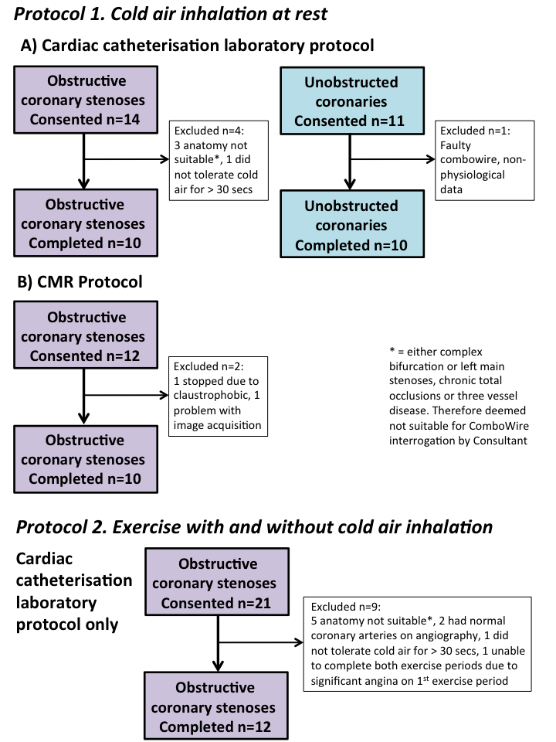

Figure 2. Cold Air Inhalation at Rest
Change from baseline in patients with and without obstructive coronary stenoses.

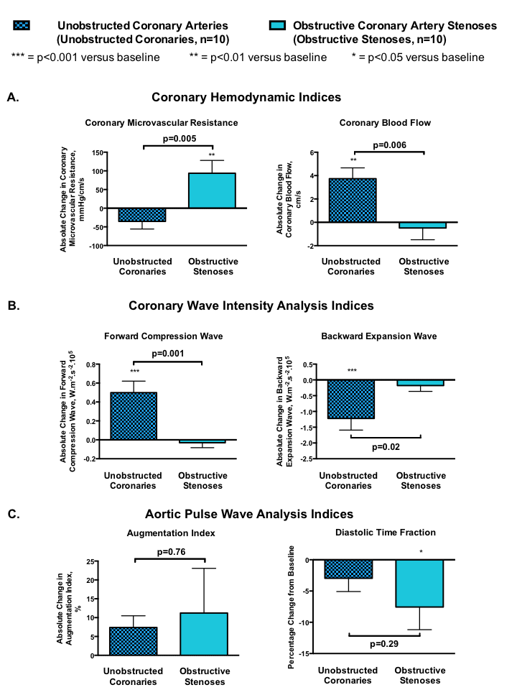

Figure 3. Exercise With and Without Cold Air Inhalation:
Change from baseline in patients with obstructive coronary stenoses.

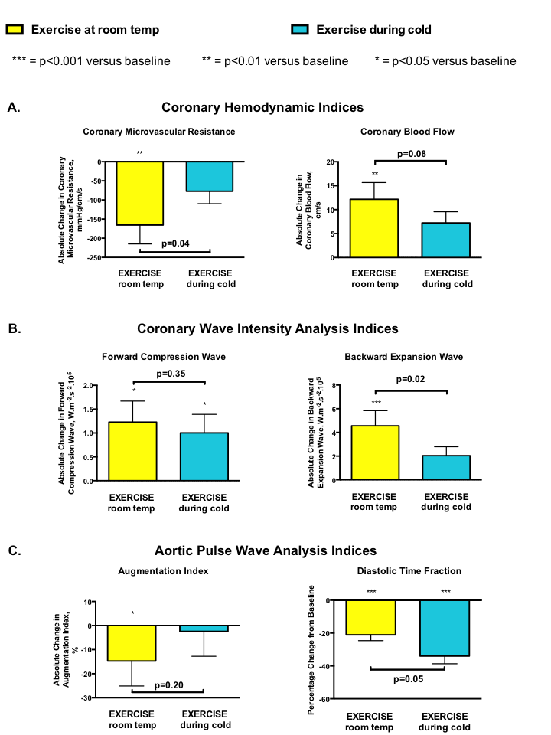

Figure 4. Pathological Effects of Cold Air During Exercise in 12 Patients with Obstructive Coronary Stenoses

Ao = aorta; CBF = coronary blood flow velocity; LV = left ventricle; MVR = microvascular resistance; PA = pulmonary artery.

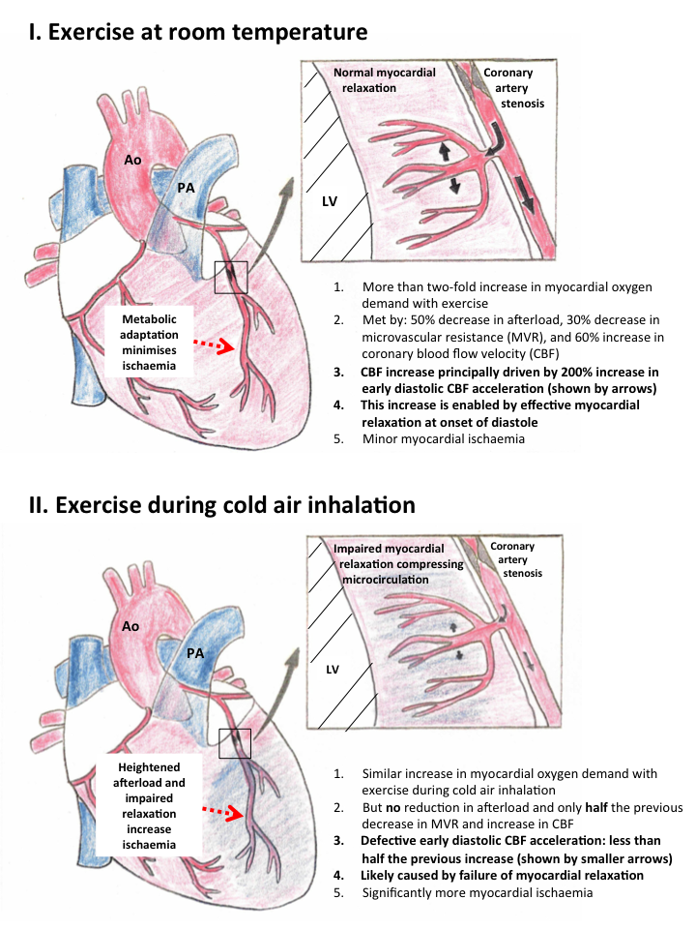

Figure 5. Individual Responses to Cold Air Inhalational at Rest
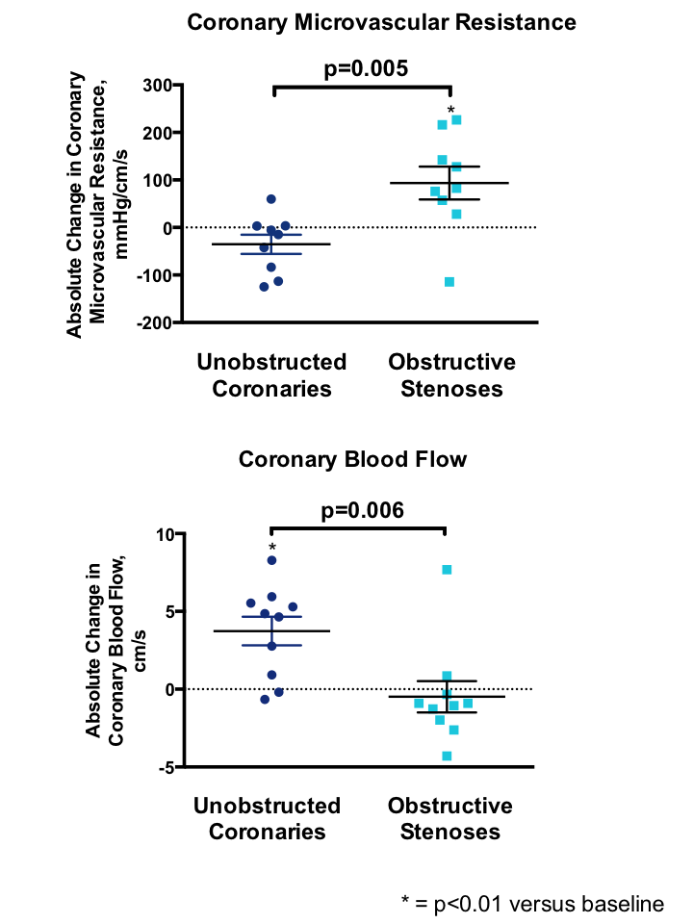
The individual responses to cold air inhalation at rest demonstrate reasonable homogeneity across both groups, with the exception of one patient in each group. On further scrutiny of these individual patients, age appears to be a significant confounder. The patient with normal coronaries with an increase in microvascular resistance was the oldest in the study cohort, aged 80 years. It is well established that diastolic dysfunction increases with age, and this was likely sufficient to provoke inefficient ventricular ejection and relaxation despite epicardial patency. The patient with an obstructive coronary stenosis who managed to reduce microvascular resistance was the youngest in the study cohort, aged 50 years. Hence despite a significant stenosis, better endothelial function combined with greater ventricular energetic reserve likely provided sufficient stimuli to maintain vasodilatation despite α-1 adrenoceptor-mediated vasoconstriction.

Figure 6. Coronary Wave Intensity (WIA) Profile at Rest.
This figure is a typical example of a WIA profile obtained at rest from a patient with unobstructed coronaries. The two shaded areas represent the forward compression and backward expansion wave intensities.
