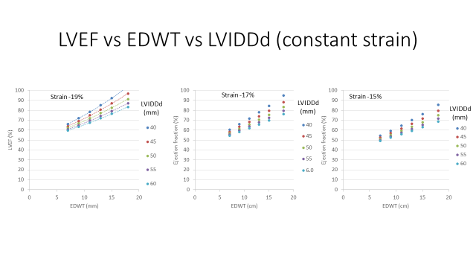
Figure 3: The mathematical relationship between LVEF, MWT and LVIDd and constant ɛ values

