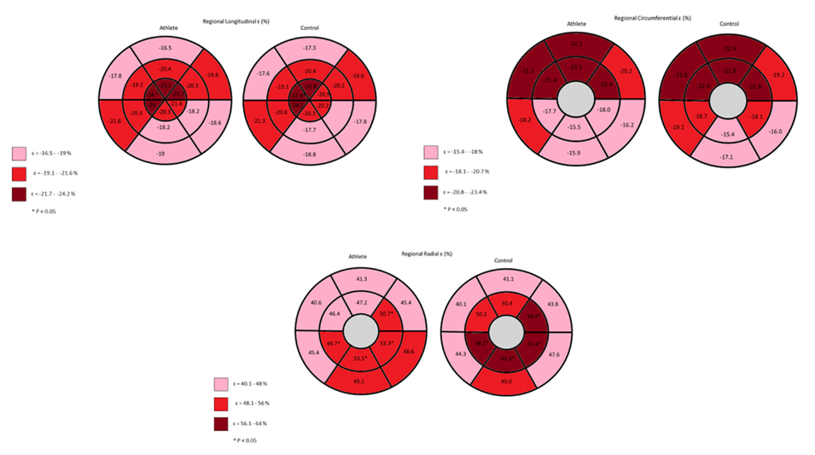

Figure 1A: Longitudinal, Circumferential and Radial ɛ

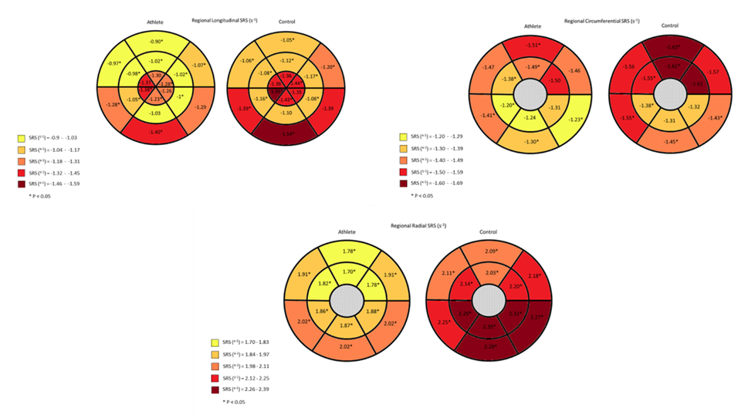

Figure 1B: Longitudinal, Circumferential and Radial SRS
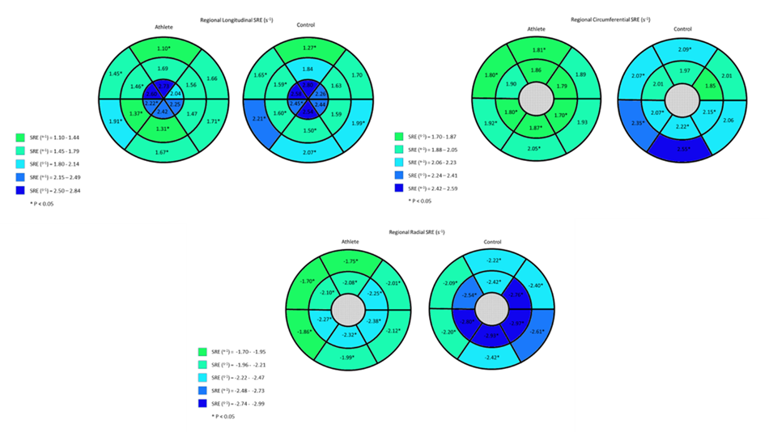

Figure 1C: Longitudinal, Circumferential and Radial SRE
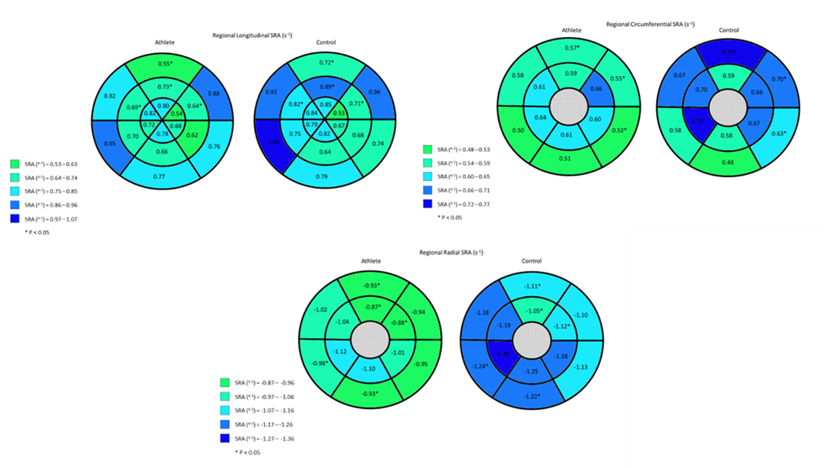
Figure 1D: Longitudinal, Circumferential and Radial SRA
Figure 1A-D: Athlete and Control regional ɛ and systolic and diastolic SR comparisons

