KEYSTONE

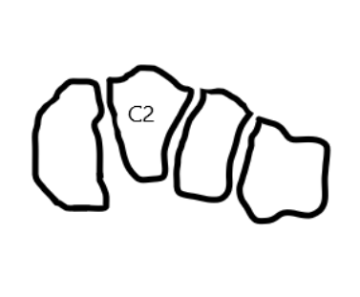

Figure 1: The Roman arch concept: the importance of the keystone in the mid foot represented by the articulation of the second metatarsal base with the middle cuneiform (C2)

