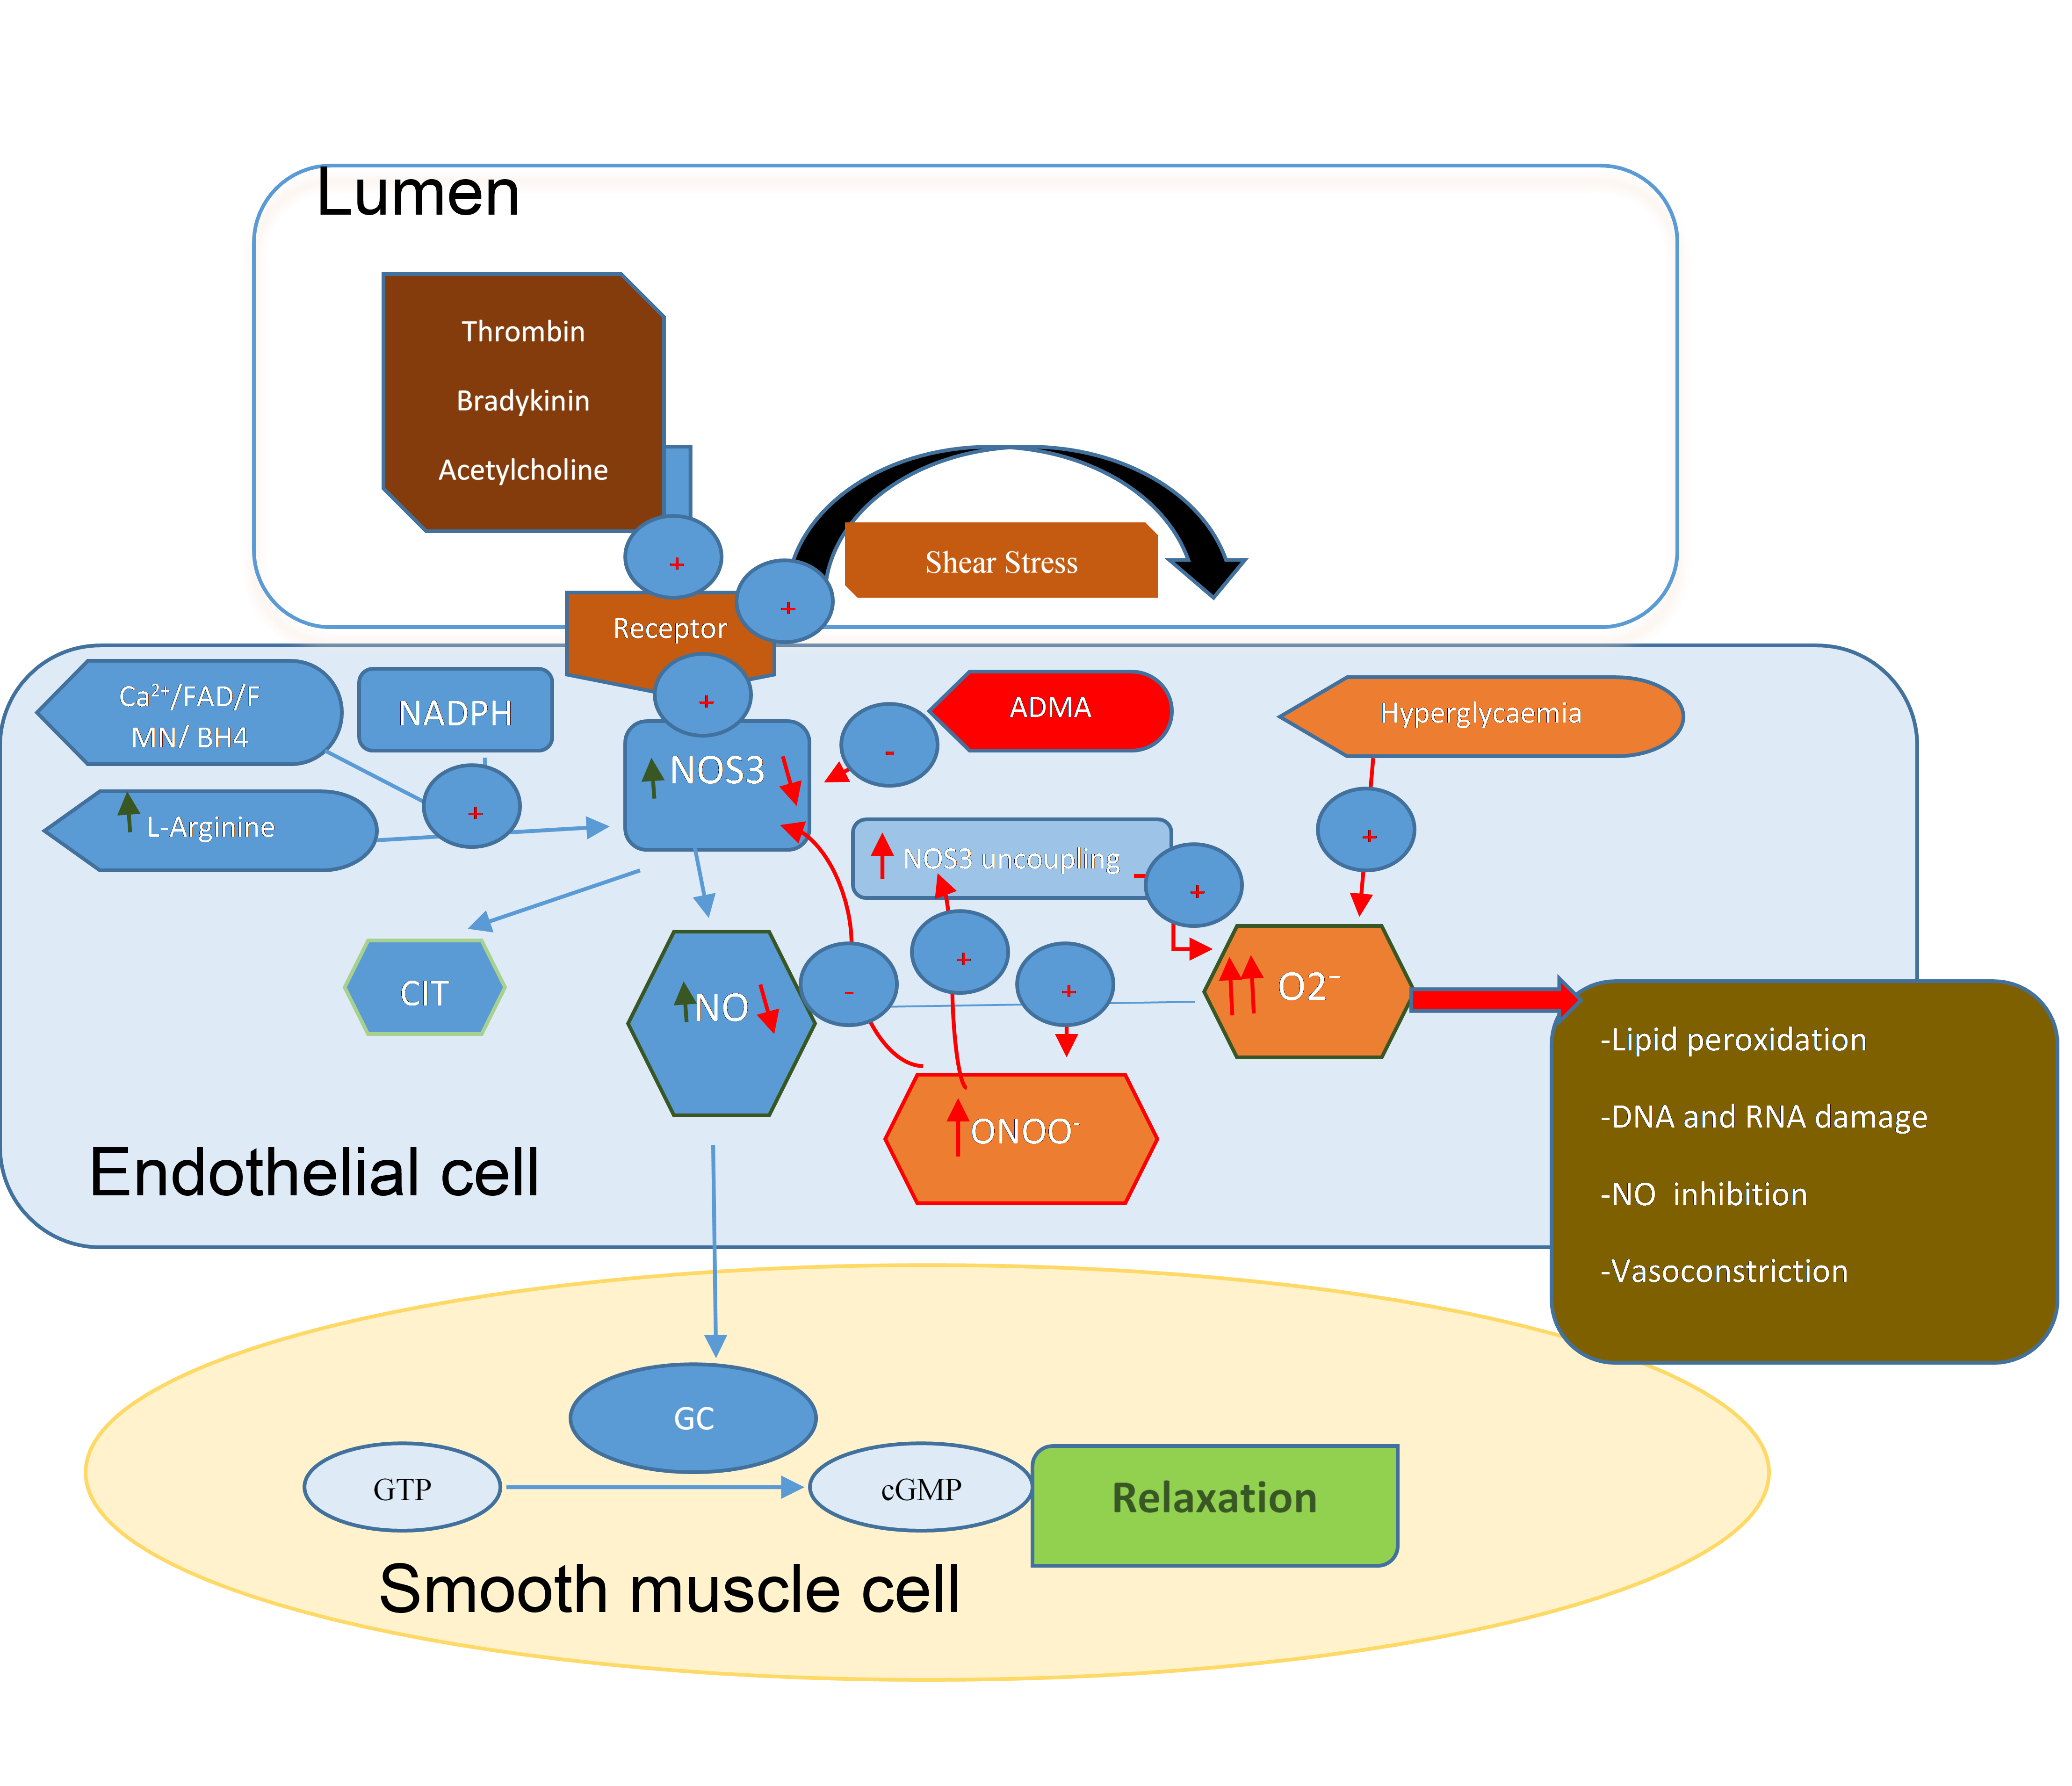

Figure2. Endothelial nitric oxide synthesis and inhibition. (→) Ideal conditions allow NO synthesis leading to vasodilation, while (→) flawed conditions cause inhibition of NO synthesis and inactivation preventing dilatation.

NO: nitric oxide; O2⁻: superoxide anion; ONOO⁻: peroxynitrite; GC: guanylyl cyclase; GTP: guanosine triphosphate; cGMP: cyclic guanosine-3’, 5-monophosphate; CIT: Citruline; FAD: flavin adenine dinucleotide; NADPH: Nicotinamide adenine dinucleotide phosphate ; FMN: Flavin mononucleotide; BH4: Tetrahydrobiopterin; NOS3: endothelial nitric oxide synthase; ADMA: asymmetric dimethylarginine.

