Impact of Pre-existent Prosthesis-Patient Mismatch on Survival Following Aortic Valve-in-Valve Procedures

Philippe Pibarot¹, DVM, PhD, Matheus Simonato², Marco Barbanti³, MD, Axel Linke⁴, MD, Ran Kornowski⁵, MD, Tanja Rudolph⁶, MD, Mark Spence⁷, MB, BCh, Neil Moat⁸, MBBS, MS, Gabriel Aldea⁹, MD, Marco Mennuni¹⁰, MD, Alessandro Iadanza¹¹, MD, Hafid Amrane¹², MD, Diego Gaia², MD, PhD, Won-Keun Kim¹³, MD, Massimo Napodano¹⁴, MD, Hardy Baumbach¹⁵, MD, Ariel Finkelstein¹⁶, MD, Junjiro Kobayashi¹⁷, MD, PhD, Stephen Brecker¹⁸, MD, Creighton Don⁹, MD, PhD, Alfredo Cerillo¹⁹, MD, Axel Unbehaun²⁰, MD, David Attias²¹, MD, Mohammed Nejjari²¹, MD, Noah Jones²², MD, Claudia Fiorina²³, MD, Didier Tchetche²⁴, MD, Raphael Philippart²⁴, MD, Konstantinos Spargias²⁵, MD, Jose-Maria Hernandez²⁶, MD, PhD, Azeem Latib²⁷, MD, Danny Dvir⁹, MD.
¹Institut Universitaire de Cardiologie et de Pneumologie de Québec, Quebec City, Canada; ²Escola Paulista de Medicina – UNIFESP, São Paulo, Brazil; ³Ferraroto Hospital, Catania, Italy; ⁴Universität Leipzig, Leipzig, Germany; ⁵Rabin Medical Center, Petah Tikva, Israel; ⁶Uniklinik Köln Herzzentrum, Cologne, Germany; ⁷Belfast Health and Social Care Trust, Belfast, Northern Ireland, United Kingdom; ⁸Royal Brompton & Harefield NHS Foundation Trust, London, England, United Kingdom; ⁹University of Washington, Seattle, WA, United States; ¹⁰Humanitas Hospital, Milan, Italy; ¹¹Azienda Ospedaliera Universitaria Senese, Siena, Italy; ¹²Medisch Centrum Leeuwarden, Leeuwarden, The Netherlands; ¹³Kerckhoff Klinik, Bad Nauheim, Germany; ¹⁴University of Padova, Padova, Italy; ¹⁵Robert-Bosch-Krankenhaus, Stuttgart, Germany; ¹⁶Tel Aviv Sourasky Medical Center, Tel Aviv, Israel; ¹⁷National Cerebral and Cardiovascular Center, Osaka, Japan; ¹⁸St. George’s, University of London, London, England, United Kingdom; ¹⁹Fondazione Toscana Gabriele Monasterio, Pisa, Italy; ²⁰Deutsches Herzzentrum Berlin, Berlin, Germany; ²¹Centre Cardiologique du Nord, Saint Denis, France; ²²Mount Carmel Columbus, Columbus, OH, United States; ²³Spedali Civili di Brescia, Brescia, Italy; ²⁴Clinique Pasteur, Toulouse, France; ²⁵Hygeia Hospital, Athens, Greece; ²⁶Hospital Universitario Virgen de la Victoria, Malaga, Spain; ²⁷Ospedale di San Raffaele, Milan, Italy.

Word count: 5101 words
Short Title: Impact of PPM on Aortic Valve-in-Valve Outcomes
Correspondence to:
Philippe Pibarot, Institut Universitaire de Cardiologie et de Pneumologie de Québec, 2725 Chemin Sainte-Foy, Québec, Canada, G1V-4G5
Email: philippe.pibarot@med.ulaval.ca
ABSTRACT
BACKGROUND: Transcatheter valve-in-valve (ViV) implantation is an alternative for the treatment of patients with degenerated bioprostheses. Small label size of the surgical valve was associated with increased mortality after ViV.

OBJECTIVES: To determine whether this association is, at least in part, related to pre-existent prosthesis-patient mismatch (PPM), i.e. a bioprosthesis that is too small in relation to the body size.

METHODS: Data of 1168 patients included in the VIVID registry were analyzed. Pre-existent PPM of the surgical valve was determined using a reference value of EOA for each given model and size of implanted prosthetic valve indexed for body surface. Severe PPM was defined according to the criteria proposed by VARC 2: indexed EOA <0.65 cm²/m² if body mass index (BMI) is <30 kg/m² or <0.6 cm²/m² if BMI is ≥30 kg/m². The primary study endpoint was 1-year mortality.

RESULTS: Among the 1168 patients included in the registry, 89 (7.6%) patients had pre-existent severe PPM. Patients with severe PPM had higher 30-day (10.3%; p=0.01) and 1-year (unadjusted: 28.6%, p<0.001; adjusted: 19.3%, p=0.03) mortality rates compared to patients with no severe PPM (4.3% and 11.9%, respectively). After adjusting for surgical valve label size, STS score, renal failure, diabetes, and stentless surgical valves, presence of pre-existent severe PPM was associated with increased risk of 1-year mortality (OR: 1.88; 95% CI: 1.07-3.28; p=0.03). Patients with severe PPM also more frequently harbored high post-procedural gradient (mean gradient ≥ 20 mmHg).

CONCLUSIONS: Pre-existent PPM of the failed surgical valve is strongly and independently associated with increased risk of mortality following ViV.

Keywords: Valve-in-valve; Prosthesis-patient-mismatch, Transcatheter aortic valve replacement
CONDENSED ABSTRACT

Transcatheter valve-in-valve (ViV) is an alternative treatment in patients with degenerated bioprostheses. Our objective was to examine the association between pre-existent prosthesis-patient mismatch (PPM) and increased ViV mortality, as well as to increased gradients. We determined pre-existent PPM based on reference surgical valve EOA values. Our 1168-patient study has found that individuals with severe pre-existent PPM had higher 30-day and 1-year mortality post-ViV, independent of label size, STS score, renal failure, diabetes, and stentless valves. Gradients were also higher in this group. We conclude that pre-existent PPM is an important predictor of mortality and worse hemodynamics after ViV.

Acknowledgements
Dr. Pibarot is the Canada Research Chair in Valvular Heart Disease. His research program is funded by Canadian Institutes of Health Research (FDN-143225).

Disclosures
Dr. Pibarot received research grant from Edwards Lifesciences and Medtronic for echocardiography core laboratory analyses in transcatheter heart valves. Dr. Dvir is a consultant for Edwards Lifesciences, Medtronic and St. Jude Medical. Dr Moat has received Consulting/speakers fees from Abbott, Edwards Lifesciences, Medtronic. Dr. Latib is consultant for Medtronic and received speaking honoraria from Abbott Vascular and research grants from Medtronic and Edwards Lifesciences. Dr. Kim is proctor for Symetis and St. Jude Medical. Dr. Linke is consultant for Medtronic, St. Jude Medical., Claret Medical, Boston Scientific, Edwards Lifesciences, Symetis and Bard, and he owns stock option from Claret Medical. Other authors have no disclosures.

Abbreviations
AVR: Aortic valve replacement
THV: Transcatheter heart valve
ViV: Valve-in-valve
PPM: Prosthesis-patient mismatch
VIVID: Valve-in-Valve International Data
EOA: Effective orifice area
VARC: Valve Academic Research Consortium
STS: Society of Thoracic Surgeons
INTRODUCTION
Currently, the vast majority of surgical aortic valve replacements (AVR) are performed with bioprosthetic valves, essentially because these valve substitutes are associated with less thrombotic and bleeding complications when compared to mechanical valves(1). However, the main limitation of bioprosthetic valves is that they have limited durability and commonly fail within 10-15 years(2, 3). Patients with failing surgical bioprosthetic valves are frequently at high surgical risk due to old age, comorbidities and the need for repeat cardiac surgery(4, 5). Transcatheter heart valve (THV) implantation within the failed aortic surgical bioprostheses (valve-in-valve, ViV) represents a valuable less-invasive alternative to surgery for patients considered to be at high risk of reoperation(6).

Surgical bioprostheses often have a small internal orifice diameter and a non-elastic stent, which predispose to THV under-expansion at the time of ViV(7). As a result, elevated post-procedural gradients are common following aortic ViV and have been associated with increased mortality(8, 9). In the VIVID registry, small label size of the surgical valve was found to be associated with increased mortality after ViV(9). However, it is unknown whether that association is, at least in part, related to pre-existent prosthesis-patient mismatch (PPM), i.e. PPM of the surgical bioprosthetic valve. PPM refers to a prosthetic valve with normal function that is too small in relation to the body size and thus for the cardiac output requirements of the patient. PPM is therefore defined with the use of the prosthetic valve EOA divided by the patient’s body surface area. The objective of this study was thus to examine the association between pre-existent PPM and the occurrence of high residual gradients and mortality after ViV.

METHODS

Registry Design
The Valve-in-Valve International Data (VIVID) registry is a multi-center international registry of ViV procedures, which includes different THV devices and valve positions(10). Since 2010, the registry prospectively collected data using a dedicated case report form from centers in Europe, North America, South America, Africa, Oceania and the Middle East. Inconsistencies were resolved directly with local investigators and on-site data monitoring. All patients gave written informed consent to a transcatheter ViV procedure. A local ethics committee approved the inclusion of patients in each center. In the present analysis, only cases performed in the aortic position were included.

Definitions
Conventional scores (STS [Society of Thoracic Surgeons] and EuroSCORE) were calculated to estimate operative mortality risk for surgical valve replacement. The mechanism of bioprosthetic valve failure (i.e. regurgitation, stenosis or mixed) was assessed using criteria proposed by the American Society of Echocardiography(11). Patients with at least a moderate degree of both stenosis and regurgitation were included in the mixed dysfunction group. Other patients were categorized according to the primary mechanism of failure, either stenosis or regurgitation. Body surface area was calculated using the Mosteller formula using the patient’s height and weight measured at the time of ViV.

Pre-existent PPM of the surgical valve was determined using the predicted effective orifice area (EOA), i.e. the normal reference value of EOA published in the literature for each given model and size of implanted bioprosthesis, divided by the patient’s body surface area(12). Severe PPM was defined according to the to the Valve Academic Research Consortium 2 (VARC 2) criteria(13): i.e. indexed EOA ≤ 0.65 cm²/m² for non-obese patients (body mass index < 30 kg/m²) and ≤ 0.60 cm²/m² for obese patients (body mass index ≥ 30 kg/m²).

The primary end-point for this study was 1-year all-cause mortality. The secondary end-points were: i) 30-day mortality and ii) the presence of elevated post-procedural gradient, which was defined as a mean transvalvular gradient ≥20 mmHg at either intra-procedural or first post-procedural echocardiogram(13). Major clinical endpoints were assessed according to the VARC 2 criteria(13).

Statistical analysis
Results are presented as mean ± standard deviation for continuous variables with normal distribution, median (interquartile range) for continuous variables without normal distribution, and number (percentage) for categorical data. Student’s t test was used to compare normally distributed continuous variables between the pre-existent severe PPM group versus the no/moderate PPM group. Mann-Whitney U-test was used for non-normally distributed variables. χ² and Fisher exact tests were used to compare categorical variables. A Cox proportional hazards analysis was used for univariable and multivariable analyses of factors associated with 1-year mortality. The variables entered in the multivariable model were those with a p value < 0.10 in the univariable analysis. A variable could also be included in the model if it was considered important for outcomes due to prior clinical knowledge. The results of the multivariable analysis are presented as hazard ratio (HR) with 95% confidence interval (CI). Survival curves derived from the Cox proportional hazards analysis were used to display adjusted cumulative hazard of death from any cause according to the presence or absence of pre-existent severe PPM. A 2-tailed p < 0.05 was considered statistically significant. Statistical analysis was performed using SPSS 22 statistical software (IBM SPSS Inc., Armonk, NY, United States).

RESULTS
Baseline and procedural characteristics according to pre-existent PPM
Among the 1,168 patients included in the registry, 89 (7.6%) had pre-existent severe PPM. Patients with severe PPM had significantly larger body surface area and body mass index and higher prevalence of obesity, diabetes, renal failure, and prior cerebrovascular events, and higher STS score (Table 1). All patients in the severe PPM group received a stented bioprosthetic valve at the time of the index surgical AVR, whereas in the no/moderate PPM group, 10.1% received a stentless bioprosthesis. The average size of the surgical bioprosthesis was smaller and the proportion of small (≤ 21 mm) valves was much larger in the severe PPM group than in the no/moderate PPM group (Table 1). As expected, the predicted EOA and indexed EOA were significantly smaller in the severe PPM group. There was no significant difference between the 2 groups with regards to the distribution of the mode of surgical valve failure. However, patients with severe PPM had smaller aortic valve area and indexed aortic valve area and lower prevalence of significant aortic regurgitation prior to the ViV procedure. The time from AVR to ViV was significantly shorter in the severe PPM group compared to no/moderate PPM group (Table 1).

With regards to the ViV procedural characteristics (Table 2), CoreValve / Evolut THV (Medtronic Inc., Fridley, MN, United States), transfemoral access, and conscious sedation were more frequently utilized in the group with pre-existent severe PPM than in that with no/moderate PPM. The average size of the THV was smaller in the pre-existent severe PPM group.

Association between pre-existent PPM and 30-day outcomes
Patients with pre-existent severe PPM harbored significantly higher early post-procedural gradients than those with no/moderate PPM (Table 3). The proportion of patients with high post-procedural gradients (mean gradient ≥ 20 mmHg) was greater in the severe PPM group: 47.6% vs. 29.5% (p=0.001) (Table 3, Figure 1). Patients with pre-existent severe PPM group had 2.4-fold higher 30-day mortality (10.3%) compared to those with no/moderate PPM group (4.3%) (p=0.01) (Figure 1). The rates of other 30-day morbidities were not statistically different between the two groups (Table 3).

Compared to balloon-expandable THVs (SAPIEN / SAPIEN XT / SAPIEN 3; Edwards Lifesciences, Irvine, CA, United States), the self-expanding THVs (CoreValve / Evolut) were associated with lower rates of high residual gradients early after ViV in the whole cohort as well as in the no/moderate PPM and severe PPM groups (Figure 2). This difference in the proportion of high gradients between self-expanding vs. balloon expandable THVs was particularly striking in the subset of patients with pre-existent severe PPM (34% vs. 78%, p<0.001).

Association between pre-existent PPM and 1-year mortality
Patients with pre-existent severe PPM had a 1.8-fold higher adjusted 1-year mortality rate compared to patients with no severe PPM (unadjusted: 28.6% vs. 11.9%; p<0.001, Figure 1; adjusted: 19.3% vs. 10.9%; p=0.03, Figure 3). The other factors associated with 1-year mortality in univariable analysis were: higher STS score (HR 1.05; 95% CI: 1.04-1.06; p<0.001), diabetes (HR 1.54; 95% CI: 1.05-2.26; p=0.026), renal failure (HR 1.71; CI 95%: 1.17-2.51; p=0.005), and smaller label size of the surgical valve (HR 0.86; 95% CI: 0.78-0.94; p=0.001). The mode of failure of the surgical valve as well as the other pre-procedural and procedural factors were not associated with mortality. Stentless surgical valves were not associated to mortality in univariate analysis (HR 1.39; 95% CI: 0.79-2.42; p=0.25), but we decided to force it in the model due to its potential importance in terms of likelihood of complications. Therefore, after adjusting for label valve size, STS score, renal failure, diabetes, and stentless surgical valves, presence of pre-existent severe PPM was independently associated with increased risk of 1-year mortality (HR 1.88; 95% CI: 1.07-3.28; p=0.03) (Figure 4).

DISCUSSION
The main findings of the study is that pre-existent severe PPM of the surgical bioprosthesis is associated with higher prevalence of elevated transaortic gradient after the ViV procedure and with 2.4 and 1.8-fold higher rates of 30-day and 1-year mortality, respectively. This is the first study to report an independent association between pre-existent PPM and mortality after ViV.

Most previous studies of ViV(8, 9, 14) did not assess the presence and impact on outcomes of pre-existent PPM of the surgical bioprosthesis. However, in the recent report from the CoreValve US Expanded Use Study including 233 patients(15), 13% had pre-existent severe PPM and of these patients, 77% had high residual gradient after ViV. In the present study, 7.6% of the patients had a pre-existent severe PPM, which appears lower that the prevalence in the CoreValve US registry(15). This difference may, at least in part, be related to the fact that, as recommended by VARC 2(13), we used lower cut-off values of indexed EOA to define PPM in obese patients. The utilization of the EOA indexed to body surface area may indeed result in an overestimation of the prevalence and severity of PPM in obese patients. The prevalence of pre-existent PPM in the present study is, however, consistent with the data reported in contemporary surgical AVR series(15–17). In a recent analysis of the STS database using similar PPM definition as the one used in our study(15), the prevalence of severe PPM was 15% in 2004 and dropped to 6% in 2014.

In the present study, the time from initial surgical AVR to bioprosthetic valve failure was substantially shorter in patients with pre-existent severe PPM compared to those with no/moderate PPM. These findings may be, at least in part, explained by the fact that PPM may accelerate the structural degeneration of bioprostheses(18, 19). Indeed, PPM increases the flow turbulence through the prosthetic valve orifice as well as the mechanical stress on the valve leaflets(18, 19). In turn, leaflet mechanical stress is an important factor contributing to the structural degeneration of bioprostheses(20). Furthermore, patients with pre-existent severe PPM already have significantly increased LV afterload at the outset of the index AVR and they may thus be less likely to tolerate the additional hemodynamic burden caused by a significant acquired dysfunction (stenosis and/or regurgitation).

In this study, patients with pre-existent severe PPM had worse hemodynamic and clinical outcomes following ViV. The ViV procedure generally improves the hemodynamic and clinical status of patients who have an acquired dysfunction resulting from structural valve degeneration. However, PPM is a non-structural “iatrogenic” complication that is characterized by a prosthetic valve with normal function but that is too small in relation to the body size and thus to the cardiac output requirements of the patient. Hence, given that the stent and internal orifice diameter of surgical bioprosthetic valves are generally not expansible, the ViV procedure cannot correct a pre-existent PPM and, in fact, this procedure may even worsen the PPM. Indeed, the implantation of a THV within a severely mismatched bioprosthetic valve may further reduce the already limited valve orifice area available for flow.

Patients with small surgical bioprostheses harbor a higher prevalence of severe PPM(17, 21). Hence, the association that was previously reported between small (≤21 mm) surgical valve label size and mortality after ViV may, at least in part, be related to the presence of unidentified pre-existent severe PPM(8, 9). As a matter of fact, in the present study, smaller label size was strongly associated with increased 1-year mortality in univariable analysis. However, this association was no longer significant in the multivariable model that also included pre-existent severe PPM (Figure 4).

Similarly, the previously reported association between stenosis as the failure mode of the surgical valve and mortality following ViV could be related to pre-existent PPM(9). Indeed, patients with high transprosthetic gradients prior to ViV were generally considered having a severe acquired prosthetic valve stenosis due to calcific degeneration of valve leaflets. However, it is likely that in a high proportion of these patients, the elevated gradient observed prior to ViV was, in large part, due to pre-existent PPM. In such patients, a ViV procedure would result in minimal to no reduction, or even an increase in gradient.

Clinical implications
The findings of this study provide a strong argument for the prevention of PPM at the time of initial surgical AVR. First, according to meta-analyses(16, 17), severe PPM is associated with a 1.8-fold increase in mortality and 1.6-fold increase in heart-failure rehospitalization after AVR. Second, severe PPM may increase the valve leaflet mechanical stress and flow turbulences, which may, in turn, accelerate the structural degeneration of bioprosthetic valves(18, 19, 22).
Hence, patients with severe PPM may require a ViV procedure earlier after the initial AVR. Furthermore, as demonstrated in the present study and in the previous CoreValve registry(15), the presence of pre-existent severe PPM negatively impacts the hemodynamic, functional, and clinical outcomes after ViV. The surgeons should thus make a particular effort to implant a bioprosthetic valve with the largest possible EOA in relation to patient’s body size in order to avoid PPM at the time of initial AVR. This goal may be achieved by using: i) new generations of stented bioprosthetic valves implanted in a supra-annular position; ii) stentless or sutureless bioprostheses; iii) aortic root enlargement to accommodate a larger bioprosthetic valve size. Given that transcatheter AVR is associated with less PPM compared to surgical AVR(23, 24), one may also consider performing a transcatheter rather than a surgical AVR at the time of initial AVR. Indeed, transcatheter AVR is associated with less severe PPM compared to surgical AVR, especially in patients with a small native aortic annulus(23, 24). Furthermore, ViV in a failed THV is generally associated with lower residual gradients compared to ViV in a failed surgical bioprosthesis.

The presence of pre-existent severe PPM should be systematically integrated in the pre-ViV risk stratification process. Knowing the exact model and size of surgical bioprosthesis, one can easily obtain the normal reference value of EOA(12) and calculate the predicted indexed EOA to determine the presence and severity of pre-existent PPM. The results of our study suggest that it is preferable to use self-expanding THVs with supra-annular design rather than balloon-expandable THVs for ViV procedure in patients with pre-existent severe PPM (Figure 2). The development of new surgical bioprostheses designs with an expandable stent may also help to improve outcomes following ViV in the future, especially in the patients with pre-existent severe PPM. For example, the INSPIRIS valve (Edwards Lifesciences), recently approved by the US Food and Drug Administration, has an expandable stent frame, as well as fluoroscopically visible size markers, which may facilitate and optimize a future ViV procedure. Pending the introduction of these new valves specifically adapted for ViV, one alternative in these patients would be to fracture the stent of the bioprosthesis by pre-dilation with an oversized non-compliant balloon. The procedure can be performed in small surgical bioprostheses to facilitate ViV with either balloon-expandable or self-expanding THVs, potentially resulting in reduced residual transvalvular gradients(25). The risk versus benefit ratio of this procedure should, however, be carefully assessed.

Limitations
We did not have systematic access to data after the initial surgical AVR that was performed at a median of almost a decade before the ViV. Therefore, to define PPM, we used the predicted indexed EOA, i.e. the normal reference value of EOA for the model and size of implanted bioprosthesis divided by the patient’s body surface area(12, 21) as commonly performed. Several studies and meta-analyses have shown that the predicted indexed EOA is a valid parameter to identify / quantify PPM and predict outcomes after AVR(16, 17, 26). In a recent study from the STS registry including >59,000 patients who underwent isolated surgical AVR, PPM defined on the basis of the predicted indexed EOA was found to be a powerful independent predictor of mortality and cardiac re-hospitalization(15). There were also several differences in the baseline characteristics between patients with vs. without pre-existent severe PPM. We used the height and weight measured at the time of the ViV procedure. The weight may have changed between the initial surgical AVR and the ViV procedure. However, this limitation is, in part, overcome by the fact that we used a definition of PPM that is adjusted for body mass index.

Conclusion
Pre-existent severe PPM of the failed surgical valve is strongly and independently associated with increased risk of 1-year mortality following aortic ViV. Furthermore, it is associated with high rates of 30-day mortality and of elevated post-procedural transaortic gradients. The findings of this study further emphasize the extreme importance of avoiding severe PPM at the time of the index surgical AVR. These findings also support the systematic integration of the assessment of pre-existent PPM in the risk stratification and decision making processes prior to ViV. This can easily be achieved by calculating the predicted indexed EOA.

FIGURE LEGEND

FIGURE 1: Rates of Elevated Post-Procedural Transvalvular Gradients, 30-Day and 1-Year Mortality According to Pre-existent Severe Prosthesis-Patient Mismatch (PPM)
Caption: Rates of elevated (≥ 20 mmHg) post-procedural gradients, 30-day mortality and unadjusted 1-year mortality according to presence or absence of pre-existent severe PPM.

FIGURE 2: Rates of Elevated Post-Procedural Transvalvular Gradient According to Pre-existent Severe Prosthesis-Patient Mismatch (PPM) and Type of Transcatheter Heart Valve used for ViV
Caption: Rates of elevated (≥ 20 mmHg) post-procedural gradients, 30-day mortality and 1-year mortality according to presence or absence of pre-existent severe PPM and to the type of transcatheter heart valve (i.e. self-expanding CoreValve/Evolut vs. balloon-expandable SAPIEN valves) used for ViV.

FIGURE 3: Adjusted One-Year Mortality Rate According to Pre-existent Severe Prosthesis-Patient Mismatch (PPM)
Caption: Cox proportional hazards regression curves showing the adjusted cumulative hazard of death from any cause according to the presence or absence of pre-existent severe PPM.

FIGURE 4: Multivariable Cox Regression Demonstrating Variables Associated with 1-Year Mortality
Caption: Multivariable regression demonstrates an independent association between pre-existent severe PPM of the surgical valve and increased 1-year mortality after aortic ViV.

FIGURE 1:
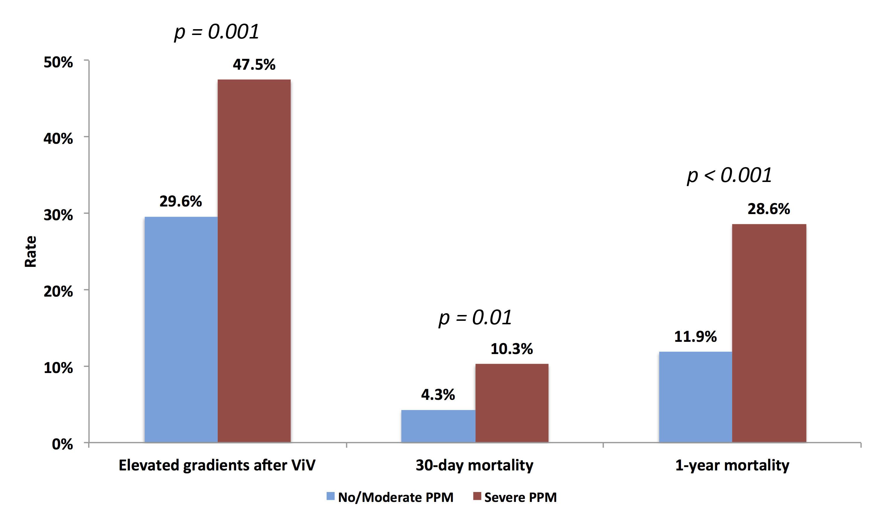

FIGURE 2:
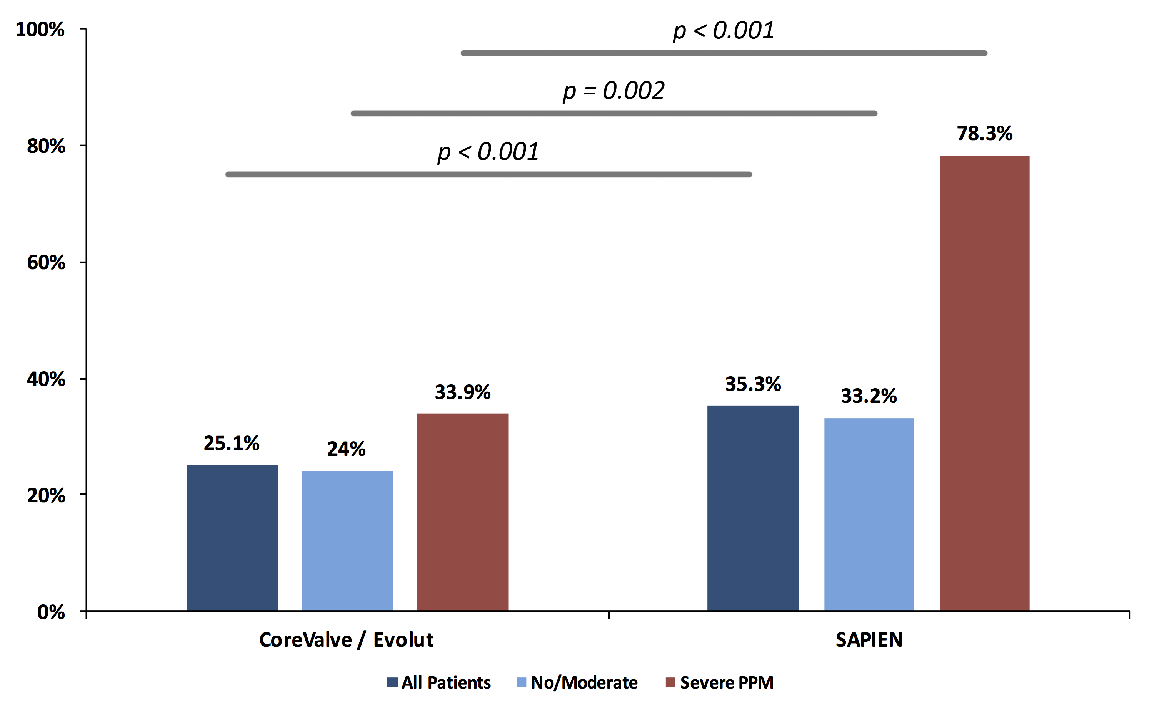

FIGURE 3:
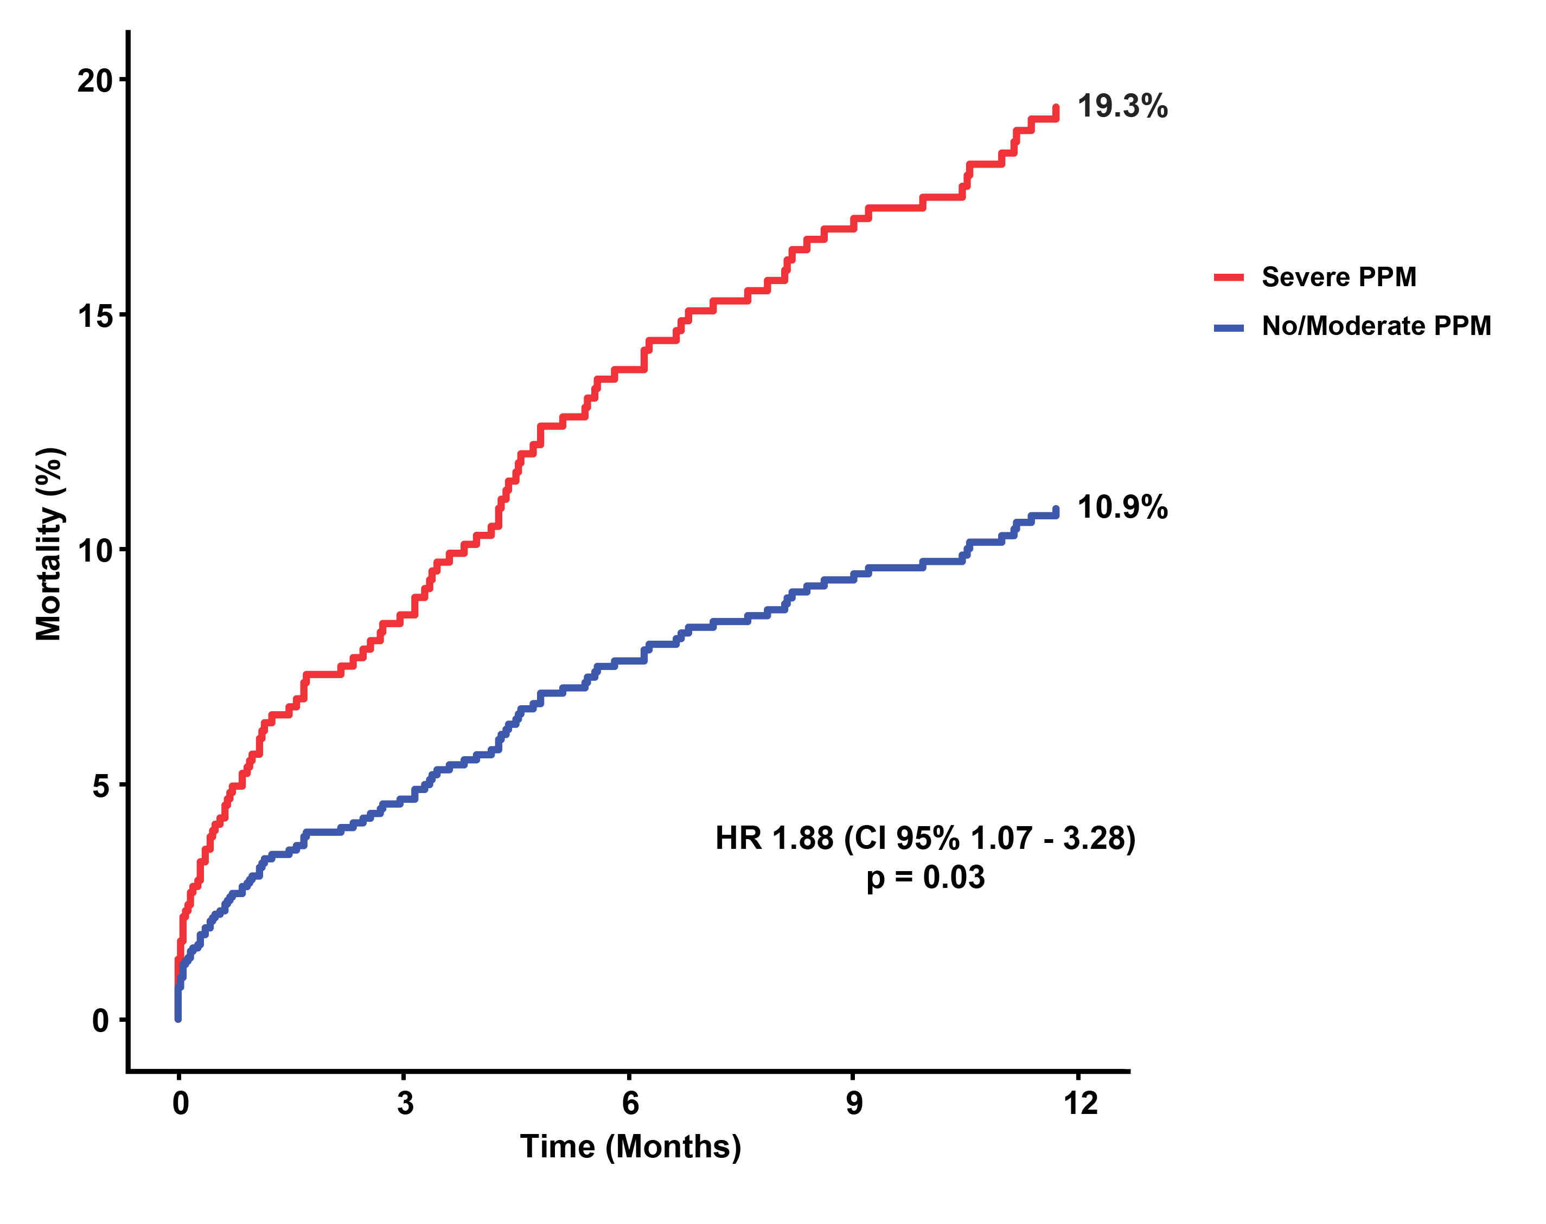
FIGURE 4:
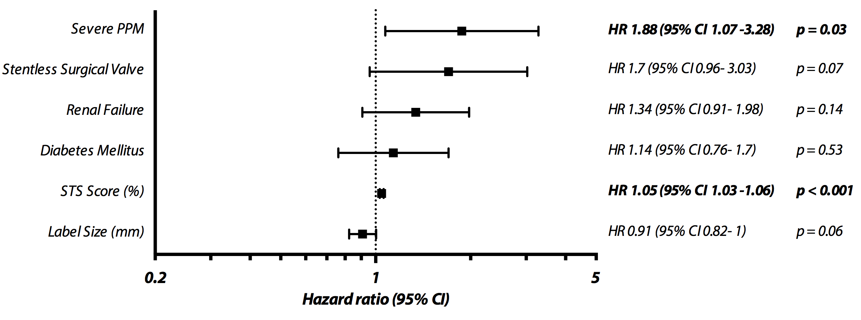

TABLE 1 - Baseline characteristics according to pre-existent PPM.
Baseline Characteristics | Severe PPM  (n = 89) | No/Moderate PPM  (n =1079) | p Value
Age, mean ± SD, years | 78 ± 7.6 | 78.6 ± 8.5 | 0.48
Male, n (%) | 51 (57.3%) | 604 (56.1%) | 0.82
Height, mean ± SD, cm | 171.3 ± 9.4 | 166.8 ± 9.5 | < 0.001
Weight, mean ± SD, kg | 87.7 ± 16.5 | 73.9 ± 15.5 | < 0.001
Body surface area, mean ± SD, m² | 2.00 ± 0.20 | 1.84 ± 0.20 | < 0.001
Body mass index, mean ± SD, kg/m² | 30 ± 5.7 | 26.6 ± 5.6 | < 0.001
Obesity, n (%) | 28 (31.5%) | 230 (21.3%) | 0.03
NYHA |  |  | 0.15
I, n (%) | 0 (0%) | 9 (0.9%)
II, n (%) | 5 (5.8%) | 106 (10.1%)
III, n (%) | 51 (59.3%) | 674 (63.9%)
IV, n (%) | 30 (34.9%) | 265 (25.1%)
STS Score, median (IQR), % | 9.9 (5-16.1) | 7.3 (4.6-11.5) | 0.002
Diabetes mellitus, n (%) | 38 (42.7%) | 267 (24.8%) | < 0.001
Peripheral vascular disease, n (%) | 16 (18.4%) | 232 (21.7%) | 0.47
Renal failure, n (%) | 53 (60.2%) | 528 (49.3%) | 0.049
Prior cerebrovascular event, n (%) | 19 (21.3%) | 145 (13.5%) | 0.04
Chronic lung disease, n (%) | 10 (16.9%) | 168 (22.9%) | 0.29
Previous permanent pacemaker, n (%) | 10 (12.7%) | 129 (13.7%) | 0.8
More than one cardiac surgery, n (%) | 15 (17.6%) | 128 (12.3%) | 0.15
Label size of surgical valve, mean ± SD, (mm) | 21 ± 1.5 | 23.3 ± 2 | < 0.001
Label size of surgical valve |  |  | < 0.001
≤ 21 mm, n (%) | 69 (77.5%) | 287 (26.6%)
> 21 mm and < 25 mm, n (%) | 18 (20.2%) | 429 (39.8%)
≥ 25 mm, n (%) | 2 (2.2%) | 363 (33.6%)
Predicted EOA, mean ± SD, cm² | 1.22 ± 0.11 | 1.51 ± 0.26 | < 0.001
Predicted indexed EOA, mean ± SD, cm²/m² | 0.60 ± 0.04 | 0.83 ± 0.14 | -
Time to surgical valve failure, median (IQR), years | 7 (5 – 9) | 9 (6.25 – 12) | < 0.001
Mechanism of surgical valve failure |  |  | 0.14
Regurgitation, N (%) | 15 (17.9%) | 247 (24.2%)
Stenosis, N (%) | 44 (52.4%) | 423 (41.4%)
Mixed, N (%) | 25 (29.8%) | 351 (34.4%)
Aortic valve area, mean ± SD, cm² | 0.78 ± 0.28 | 0.91 ± 0.46 | < 0.001
Indexed aortic valve area, mean ± SD, cm²/m² | 0.38 ± 0.14 | 0.5 ± 0.25 | < 0.001
Peak gradient, mean ± SD, mmHg | 66.5 ± 23.9 | 62.6 ± 27.2 | 0.21
Mean gradient, mean ± SD, mmHg | 40.2 ± 15.1 | 36.7 ± 17.6 | 0.09
Aortic regurgitation |  |  | < 0.001
None | 25 (30.5%) | 159 (15.4%)
Mild | 19 (23.2%) | 250 (24.2%)
Moderate | 10 (12.2%) | 149 (14.4%)
Moderately Severe | 20 (24.4%) | 224 (21.6%)
Severe | 8 (9.8%) | 253 (24.4%)
LVEF, mean ± SD, % | 51.6 ± 12.7 | 52.4 ± 13 | 0.61

Legend: EOA: effective orifice area; LVEF: left ventricular ejection fraction; NYHA: New York Heart Association; SD: Standard Deviation; STS: Society of Thoracic Surgeons;

TABLE 2 - ViV procedural characteristics according to pre-existent PPM.
Procedural Characteristics | Severe PPM | No/Moderate PPM | p Value
 | (n = 89) | (n =1079)
THV Type |  |  | < 0.001
CoreValve/Evolut, n (%) | 63 (70.8%) | 516 (47.8%)
SAPIEN/SXT/S3, n (%) | 25 (28.1%) | 507 (47%)
Others, n (%) | 1 (1.1%) | 56 (5.2%)
THV size, mean ± SD, (mm) | 24.0 ± 1.6 | 24.4 ± 1.9 | 0.04
THV Size |  |  | 0.15
20 mm, n (%) | 3 (3.4%) | 13 (1.2%)
23 mm, n (%) | 53 (59.6%) | 587 (55.6%)
25 mm, n (%) | 0 (0%) | 9 (0.9%)
26 mm, n (%) | 33 (37.1%) | 377 (35.7%)
27 mm, n (%) | 0 (0%) | 2 (0.2%)
29 mm, n (%) | 0 (0%) | 65 (6.2%)
31 mm, n (%) | 0 (0%) | 2 (0.2%)
Access |  |  | 0.02
Transfemoral, n (%) | 75 (84.3%) | 768 (71.2%)
Transapical, n (%) | 10 (11.2%) | 266 (24.7%)
Others, n (%) | 4 (4.5%) | 45 (4.2%)
General Anesthesia, n (%) | 44 (49.4%) | 704 (65.4%) | 0.003
Transesophageal echocardiogram, n (%) | 32 (36.4%) | 628 (58.5%) | < 0.001
Initial device malposition, n (%) | 9 (10.7%) | 70 (6.8%) | 0.18
Need for a second THV, n (%) | 6 (6.7%) | 40 (3.7%) | 0.16

Legend: THV: transcatheter heart valve. Other abbreviations as in Table 1. SXT: SAPIEN XT; S3: SAPIEN 3.

TABLE 3: 30-day hemodynamic and clinical outcomes according to pre-existent PPM.
 | 30-Day Hemodynamic and Clinical Outcomes |  | Severe PPM  (n = 89) | No/Moderate PPM  (n =1079) |  |  | p Value
 | Duration of hospital stay, median (IQR), days |  | 7 (5 – 10) | 7 (5 – 11) |  |  | 0.59
 | Vascular complications |  |  |  |  |  | 0.65
 | Minor, n (%) |  | 8 (9%) | 73 (6.8%)
 | Major, n (%) |  | 2 (2.2%) | 35 (3.2%)
 | Major bleeding, n (%) |  | 2 (2.4%) | 62 (5.9%) |  |  | 0.17
 | Major stroke, n (%) |  | 1 (1.2%) | 14 (1.3%) |  |  | 0.92
 | Acute kidney injury, n (%) |  | 6 (7.1%) | 65 (6.1%) |  |  | 0.74
 | Coronary obstruction, n (%) |  | 1 (1.1%) | 21 (2%) |  |  | 0.58
 | Pacemaker need, n (%) |  | 4 (5.1%) | 60 (6.4%) |  |  | 0.66
 | Death, n (%) |  | 9 (10.3%) | 45 (4.3%) |  |  | 0.01
 | Aortic valve area, mean ± SD, cm² |  | 1.47 ± 0.54 | 1.43 ± 0.44 |  |  | 0.43
Indexed aortic valve area, mean ± SD, cm²/m² |  | 0.72 ± 0.26 |  |  | 0.78 ± 0.25 | 0.07
 | Peak gradient, mean ± SD, mmHg |  | 34.4 ± 16.7 | 29.3 ± 14.3 |  |  | 0.003
 | Mean gradient, mean ± SD, mmHg |  | 19.5 ± 10 | 16.2 ± 8.7 |  |  | 0.001
 | Elevated (≥20 mmHg) post-procedural gradient, n (%) |  | 38 (47.5%) | 293 (29.6%) |  |  | 0.001
 | Aortic regurgitation |  |  |  |  |  | 0.80
 | None |  | 55 (69.6%) | 649 (64.6%)
 | Mild |  | 20 (25.3%) | 307 (30.6%)
 | Moderate |  | 4 (5.1%) | 41 (4.1%)
 | Moderately Severe |  | 0 (0%) | 5 (0.5%)
 | Severe |  | 0 (0%) | 2 (0.2%)
 | LVEF (%) |  | 53.9 ± 10.4 | 51.4 ± 12.1 |  |  | 0.049

Legend: Abbreviations as in Tables 1 and 2

CLINICAL PERSPECTIVES

What’s known?
The presence of severe PPM of the surgical valve (i.e. pre-existent PPM) is associated with worse outcomes after surgical aortic valve replacement, including increased mortality. It may also accelerate the structural degeneration of bioprosthetic valves.

What’s new?
Patients with pre-existent severe PPM of the surgical bioprosthesis have higher occurrence of high residual transaortic gradients and increased risk of mortality after aortic ViV procedure.

What’s next?

Pre-existent PPM of the surgical valve may compromise both hemodynamic and clinical outcomes after ViV. Particular attention should be paid to the prevention of PPM at the time of the index surgical AVR. We suggest the systematic inclusion of severe pre-existent PPM assessment in ViV risk stratification and decision making. Further research is needed to develop and validate new designs of surgical bioprosthetic valves with expansible/adjustable stents in order to optimize the hemodynamic and clinical outcomes of potential future ViV procedures.
REFERENCES
1. Lindman BR, Clavel M-A, Mathieu P, et al. Calcific aortic stenosis. Nat. Rev. Dis. Prim. 2016;2:16006.

2. Grunkemeier GL, Furnary AP, Wu Y, Wang L, Starr A. Durability of pericardial versus porcine bioprosthetic heart valves. J. Thorac. Cardiovasc. Surg. 2012;144:1381–6.

3. Bourguignon T, Bouquiaux-Stablo A-L, Candolfi P, et al. Very Long-Term Outcomes of the Carpentier-Edwards Perimount Valve in Aortic Position. Ann. Thorac. Surg. 2015;99:831–837.

4. Fukunaga N, Okada Y, Konishi Y, et al. Clinical outcomes of redo valvular operations: a 20-year experience. Ann. Thorac. Surg. 2012;94:2011–6.

5. Kaneko T, Vassileva CM, Englum B, et al. Contemporary Outcomes of Repeat Aortic Valve Replacement: A Benchmark for Transcatheter Valve-in-Valve Procedures. Ann. Thorac. Surg. 2015;100:1298–304; discussion 1304.

6. Nishimura RA, Otto CM, Bonow RO, et al. 2017 AHA/ACC Focused Update of the 2014 AHA/ACC Guideline for the Management of Patients With Valvular Heart Disease. J. Am. Coll. Cardiol. 2017;70:252–289.

7. Bapat VN, Attia R, Thomas M. Effect of Valve Design on the Stent Internal Diameter of a Bioprosthetic Valve: A Concept of True Internal Diameter and Its Implications for the Valve-in-Valve Procedure. JACC. Cardiovasc. Interv. 2014;7:115–127.

8. Dvir D, Webb J, Brecker S, et al. Transcatheter aortic valve replacement for degenerative bioprosthetic surgical valves: results from the global valve-in-valve registry. Circulation 2012;126:2335–44.

9. Dvir D, Webb JG, Bleiziffer S, et al. Transcatheter aortic valve implantation in failed bioprosthetic surgical valves. JAMA 2014;312:162–70.

10. Simonato M, Webb J, Kornowski R, et al. Transcatheter Replacement of Failed Bioprosthetic Valves: Large Multicenter Assessment of the Effect of Implantation Depth on Hemodynamics After Aortic Valve-in-Valve. Circ. Cardiovasc. Interv. 2016;9:e003651.

11. Zoghbi WA, Chambers JB, Dumesnil JG, et al. Recommendations for evaluation of prosthetic valves with echocardiography and doppler ultrasound: a report From the American Society of Echocardiography’s Guidelines and Standards Committee and the Task Force on Prosthetic Valves, developed in conjunction. J. Am. Soc. Echocardiogr. 2009;22:975-1014–4.

12. Lancellotti P, Pibarot P, Chambers J, et al. Recommendations for the imaging assessment of prosthetic heart valves: a report from the European Association of Cardiovascular Imaging endorsed by the Chinese Society of Echocardiography, the Inter-American Society of Echocardiography, and the Brazilian Department of Cardiovascular Imaging. Eur. Heart J. Cardiovasc. Imaging 2016;17:589–90.

13. Kappetein AP, Head SJ, Genereux P, et al. Updated standardized endpoint definitions for transcatheter aortic valve implantation: the Valve Academic Research Consortium-2 consensus document (VARC-2). Eur. J. Cardio-Thoracic Surg. 2012;42:S45–S60.

14. Webb JG, Mack MJ, White JM, et al. Transcatheter Aortic Valve Implantation Within Degenerated Aortic Surgical Bioprostheses: PARTNER 2 Valve-in-Valve Registry. J. Am. Coll. Cardiol. 2017;69:2253–2262.

15. Deeb GM, Chetcuti SJ, Reardon MJ, et al. 1-Year Results in Patients Undergoing Transcatheter Aortic Valve Replacement With Failed Surgical Bioprostheses. JACC Cardiovasc. Interv. 2017;10:1034–1044.

16. Head SJ, Mokhles MM, Osnabrugge RLJ, et al. The impact of prosthesis-patient mismatch on long-term survival after aortic valve replacement: a systematic review and meta-analysis of 34 observational studies comprising 27 186 patients with 133 141 patient-years. Eur. Heart J. 2012;33:1518–29.

17. Dayan V, Vignolo G, Soca G, Paganini JJ, Brusich D, Pibarot P. Predictors and Outcomes of Prosthesis-Patient Mismatch After Aortic Valve Replacement. JACC Cardiovasc. Imaging 2016;9:924–933.

18. Flameng W, Herregods M-C, Vercalsteren M, Herijgers P, Bogaerts K, Meuris B. Prosthesis-patient mismatch predicts structural valve degeneration in bioprosthetic heart valves. Circulation 2010;121:2123–9.

19. Mahjoub H, Mathieu P, Larose E, et al. Determinants of aortic bioprosthetic valve calcification assessed by multidetector CT. Heart 2015;101:472–7.

20. Thubrikar MJ, Deck JD, Aouad J, Nolan SP. Role of mechanical stress in calcification of aortic bioprosthetic valves. J. Thorac. Cardiovasc. Surg. 1983;86:115–25.

21. Pibarot P, Dumesnil JG. Prosthesis-patient mismatch: definition, clinical impact, and prevention. Heart 2006;92:1022–9.

22. Flameng W, Rega F, Vercalsteren M, Herijgers P, Meuris B. Antimineralization treatment and patient-prosthesis mismatch are major determinants of the onset and incidence of structural valve degeneration in bioprosthetic heart valves. J. Thorac. Cardiovasc. Surg. 2014;147:1219–24.

23. Pibarot P, Weissman NJ, Stewart WJ, et al. Incidence and Sequelae of Prosthesis-Patient Mismatch in Transcatheter Versus Surgical Valve Replacement in High-Risk Patients With Severe Aortic Stenosis. J. Am. Coll. Cardiol. 2014;64:1323–1334.

24. Zorn GL, Little SH, Tadros P, et al. Prosthesis-patient mismatch in high-risk patients with severe aortic stenosis: A randomized trial of a self-expanding prosthesis. J. Thorac. Cardiovasc. Surg. 2016;151:1014–22, 1023–3.

25. Chhatriwalla AK, Allen KB, Saxon JT, et al. Bioprosthetic Valve Fracture Improves the Hemodynamic Results of Valve-in-Valve Transcatheter Aortic Valve Replacement. Circ. Cardiovasc. Interv. 2017;10:e005216.

26. Pibarot P, Dumesnil JG, Cartier PC, Métras J, Lemieux MD. Patient-prosthesis mismatch can be predicted at the time of operation. Ann. Thorac. Surg. 2001;71:S265-8.

