Evaluating safety reporting in paediatric antibiotic trials 2000-2016: a systematic review and meta-analysis
Subheading: Safety reporting in paediatric antibiotic clinical trial 2000-2016
Drugs
^{1,2}Paola Pansa, MD; ¹Yingfen Hsia, PhD; ^{1,3}Julia Bielicki, MD; ⁴Irja Lutsar, MD; ⁵A. Sarah Walker, PhD; ¹Mike Sharland, MD; ¹*Laura Folgori, MD
¹ Paediatric Infectious Disease Research Group, Institute for Infection and Immunity, St George's University of London, Cranmer Terrace, London SW17 0RE, UK
² Department of Pediatrics, Sapienza University of Rome, Policlinico Umberto I, Viale Regina Elena 324, 00161 Rome, Italy
³ Paediatric Pharmacology, University Children’s Hospital Basel, Spitalstrasse 33 4056, Basel, Switzerland
⁴ Institute of Medical Microbiology, University of Tartu, Ravila 19, 50411 Tartu, Estonia
⁵ Nuffield Department of Clinical Medicine; NIHR Oxford Biomedical Research Centre, University of Oxford, Oxford OX1 3PA, UK

*Corresponding author: Laura Folgori
Mailing address: St George's University of London, Jenner Wing, Level 2, Room 2.215E, Cranmer Terrace, London, SW17 0RE, United Kingdom
E-mail address: lfolgori@sgul.ac.uk
Telephone number: +44 20 87254851
eFig. 1 Toxicity in Aminoglycosides: one daily dose (OD) versus multiple daily doses (MD) Meta-analysis (A: nephrotoxicity, B: ototoxicity)
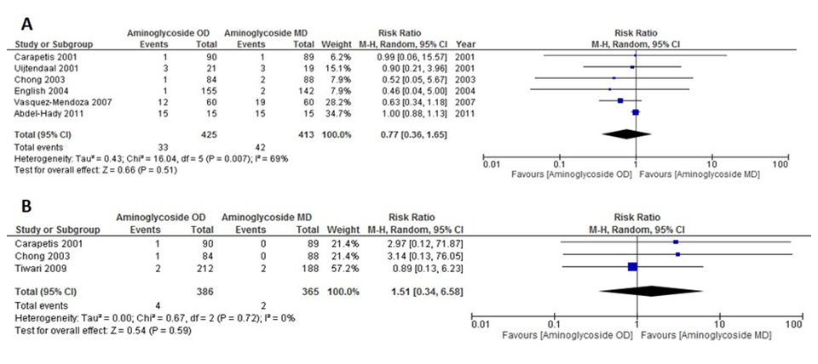
eFig. 2 Macrolides vs Penicillins (overall AEs): Meta-analysis
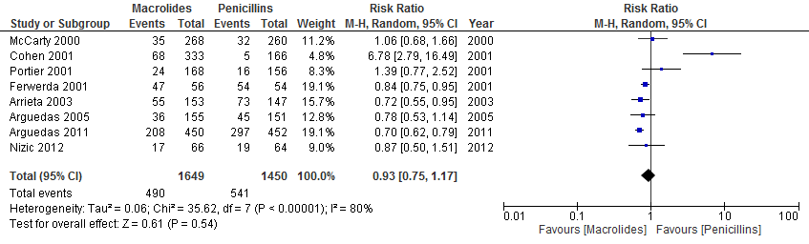

eFig. 3 Funnel plot of: A-B-C: diarrhoea in β-lactams (A: penicillins vs other beta-lactams; B: penicillins+beta lactamase inhibitor vs other beta-lactams; C: Cephalosporins vs other beta-lactams); D-E: Toxicity in one daily vs multiple doses of aminoglycosides (D: Nephrotoxicity; E: Ototoxicity); F: overall AEs in macrolides vs penicillins
