Rapid Rule-out of Myocardial Infarction with a High-sensitivity Cardiac Troponin T measurement below the limit of detection: A collaborative meta-analysis

Authors:

John W Pickering, PhD,^{1*}
Martin P Than, MBBS, ^{2*}
Louise Cullen, MBBS PhD ³
Sally Aldous, MBChB PhD ⁴
Ewoud ter Avest, MD PhD⁵
Richard Body, MBChB PhD⁶
Edward W Carlton, MBChB ⁷
Paul Collinson, MBBChir MD⁸
Anne Marie Dupuy, MD PhD⁹
Ulf Ekelund, MD, PhD¹⁰
Kai M Eggers, MD PhD¹¹
Christopher M Florkowski, MBBS MD¹²
Yonathan Freund, MD PhD¹³
Peter George, MBBS¹⁴
Steve Goodacre, MB ChB MSc PhD¹⁵
Jaimi H Greenslade, PhD¹⁶
Allan S Jaffe, MD¹⁷
Sarah J Lord, MBBS MSc¹⁸
Arash Mokhtari, MD¹⁹
Christian Mueller, MD²⁰

Andrew Munro, MBChB²¹
Sebbane Mustapha, MD PhD²²
William Parsonage, MBBS DM²³
W. Frank Peacock, MD²⁴
Christopher Pemberton, PhD²⁵
A. Mark Richards, MD PhD²⁶
Juan Sanchis, MD PhD²⁷
Lukas P Staub, MD PhD²⁸
Richard Troughton, MBChB PhD²⁹
Raphael Twerenbold, MD³⁰
Karin Wildi, MD³¹
Joanna Young, PhD³²
* Joint principal authors

Running title: Rapid rule-out of AMI using hs-TnT below the LoD

Abstract: 293

Text word count: 3551

Address for Correspondence:
Dr Martin Than, Emergency Department, Christchurch Hospital, Private Bag 4710, Christchurch, New Zealand Tel. +6433640270, Fax. +6433640286
martinthan@xtra.co.nz

Abstract
Background: High-sensitivity assays for cardiac troponin T (hs-cTnT) are sometimes used to rapidly rule-out acute myocardial infarction.
Purpose: To estimate the ability of a single hs-cTnT concentration below the limit of detection (<5ng/L) and non-ischemic ECG to rule-out myocardial infarction in adults presenting to the emergency department with chest pain.
Data sources Embase and Medline without language restrictions (1 January 2008 to 14 December 2016).
Study selection: Cohort studies involving adults presenting to the emergency department with possible acute coronary syndrome in whom ECG and hs-cTnT were measured and myocardial infarction outcomes adjudicated during initial hospitalization.
Data extraction: Investigators of cohort studies provided data on numbers of low-risk (no new ischemia on ECG and hs-cTnT measurements below 5ng/L) patients, and numbers of patients who had a myocardial infarction during hospital admission (main outcome), or a major adverse cardiac event (MACE) or death within 30 days (secondary outcomes), by risk classification (low-risk, not low-risk). Two independent epidemiologists rated risk of bias of the cohort studies.
Data synthesis: Of 9269 patients in 11 cohort studies 2825 (30.5%) were classified low-risk. Fourteen (0.5%) low-risk patients had a myocardial infarction. Sensitivity of the risk classification for myocardial infarction ranged from 87.5% to 100 in individual studies. The pooled estimated sensitivity was 98.7% (95%CI: 96.6 to 99.5). Sensitivity for 30-day MACE ranged from 87.9% to 100% while the pooled sensitivity was 97.9% (93.7 to 99.3). No low-risk patients died.
Limitations: Few studies; variation in timing and methods of reference standard troponin tests used to diagnose myocardial infarction; heterogeneity in risk and prevalence of infarction across studies.
Conclusion: A single hs-cTnT below the limit of detection in combination with a non-ischemic ECG may successfully rule-out myocardial infarction in patients presenting to emergency departments with possible emergency acute coronary syndrome.

Primary Funding Source: Emergency Care Foundation

Key words: Chest Pain, Acute Coronary Syndrome, Myocardial Infarction, Troponin, Emergency department, Emergency room

Introduction

Only 10-20% of patients who present to emergency departments (EDs) with suspected cardiac-related chest pain are finally diagnosed with an acute myocardial infarction (AMI).(1-3) Researchers have developed rule-out strategies to identify non-AMI chest pain patients for safe, early discharge to outpatient management.(1-3) A high sensitivity assay for cardiac troponin T (hs-cTnT) enables more reliable detection of very low concentrations of troponin T. A single hs-cTnT measurement below the limit of detection (LoD) or limit of blank (LoB) may rule-out AMI.

(4,5) These cut-offs have appeared as part of diagnostic pathways in European guidelines(6,7), yet the underpinning evidence presented was from a small number of studies some of which were affected by laboratory calibration errors resulting in lower than true hs-cTnT concentrations, including the largest study to advocate this approach to date.

(8,9) In that retrospective analysis of 14,636 chest pain patients, 61% of whom had an initial hs-cTnT measurement of <5ng/l (<LoD) and no ischemic ECG ST-segment changes. Of these 0.2% incurred an AMI within 30 days of their presentation at the emergency department. However, the retrospective design of this large study included a number of methodological compromises.(9) Two meta-analyses considered a single hs-cTn measurement below the LoD to rule-out AMI, however, one combined the results from two (3 ng/L and 5 ng/L) thresholds

(10)and the other combined studies of hs-cTnT with studies of hs-cTnI less the LoD.(11) Both these approaches are flawed and mean the resultant, pooled statistics cannot be used to evaluate an hs-cTnT<LoD rule-out strategy. For these reasons advocacy for rule-out of MI when hs-cTnT <LoD is premature. However, if findings can be validated across multiple studies free of these limitations, then this approach could enable safe discharge of many more patients than achieved by current practice.

Our objective was to test the utility of a single hs-cTnT measurement below the LoD combined with an ECG without evidence of acute ischemia to safely identify patients at low-risk of AMI on presentation to the ED.

Methods
We developed and followed a protocol (Supplementary material) and report according to the Preferred Reporting Items for Systematic Reviews and Meta-analyses (PRISMA).(12)

Data Sources and Searches
We searched MEDLINE and EMBASE without language restrictions from 1 January 2008 (when the hs-cTnT assay was first released) to 14 December 2016 using the terms: chest pain, chest discomfort, acute coronary syndrome, acute myocardial infarction, troponin, high sensitive/sensitivity, and emergency room/department (See Supplement).

Study Selection
Two reviewers (JWP and JY) independently screened titles and abstracts including conference abstracts and identified potential cohorts from the full-text articles. Where only conference abstracts were available, a further manual search was conducted based on author names for full-text articles. A third reviewer (MT) was used to confirm cohorts for exclusion or inclusion. Principal investigators and lead authors for each eligible cohort were contacted. We excluded cohorts if the investigators were unable to provide data.

Eligibility studies were prospective studies, published in peer review journals, recruited patients investigated in the ED for possible Acute Coronary Syndrome with ECG and hs-cTnT and reported on our primary endpoint. We excluded studies that did not: collect data prospectively, adjudicate for AMI using the Universal Definition (see Supplement), or address the calibration error of hs-cTnT batch numbers 157120, 160197, and 163704 (produced between October 2009 and April 2012 and with latest expiry date October 2012) by confirming no samples from affected batches were included in the original study, or by excluding samples from affected batches, or by new value assignment of the calibrator set applied to the original analyzer results (ie therefore providing exact, correct, results).

Data Synthesis and Analysis
The primary endpoint was index admission AMI according to the global taskforce definition requiring biochemical evidence of myocardial necrosis and clinical evidence of myocardial ischemia (ischemic symptoms, ECG changes, or imaging. evidence).(13) Patients with ST-Elevatetion Myocardial Infarction on initial ECG were excluded from analysis. There was no restriction on the troponin assay used for adjudication of AMI. There were two secondary endpoints: death in 30 days or a major adverse cardiac event (MACE) within 30 days after first presentation (including any during the initial hospital attendance). MACE included: death, cardiac arrest, emergency revascularization procedure, cardiogenic shock, ventricular arrhythmia or high-degree atrioventricular block needing intervention, and AMI.(14)

The index test was an ECG and hs-cTnT at ED presentation. Patients with a negative test defined as no new ischemic changes on ECG (ST segment changes or T wave inversion indicative of cardiac ischemia) and hs-cTnT concentration <LoD (5ng/L) of Roche Diagnostics hs-cTnT assay (also sometimes called the fifth generation troponin T assay. Table S1) were classified as low-risk for AMI and subsequent adverse events. The secondary index test utilized the LoB (3 ng/L) instead of the LoD.

We calculated the proportion of patients in each study classified as being at low risk for AMI using the index test. We validated the clinical performance of the index test by calculating the sensitivity (1-false negative rate) of non-low risk classification for AMI during the initial hospital attendance. The χ² test for equality of sensitivities (null hypothesis) was applied. We also report the Negative Predictive Value (NPV) as this has been used to assess biomarker performance in a number of troponin biomarker studies, but as this is prevalence-dependent we chose to use sensitivity for primary analysis. For completeness, we also reported test specificity and Positive Predictive Value (PPV), although we note that it is not currently intended that patients should be risk stratified as high-risk (rule-in) using the proposed strategy. For the secondary analysis, we assessed the clinical performance of the index test for prediction of MACE within 30 days of presentation by calculating the test sensitivity, NPV, specificity and PPV. Additional analyses were conducted using the LoB as the diagnostic threshold for hs-cTnT. The summary estimates of sensitivity (principal summary measure), specificity, NPV, PPV (and their 95% confidence interval reflecting the degree of heterogeneity between studies) were obtained using a random effects bivariate model.(15) A summary receiver operator characteristic curve was used to reflect the discriminative ability of the index test. We quantified heterogeneity with the I² statistic which reflects the proportion of variation in point estimates among studies beyond that expected by chance. I² <25%, 25% to <75%, and ≥75% were considered to represent low, moderate, and high heterogeneity respectively.(16)
We conducted all analyses using R version 3.2.2(17) (package ‘mada’ for meta-analysis of diagnostic accuracy).

Data extraction and quality assessment
Study investigators supplied summary 2x2 tables for each test with AMI, MACE and mortality outcomes along with a summary of cohort demographics.

Two independent epidemiologists (SJL & LKS) who had not participated in any of the included studies adjudicated study risk of bias and applicability for AMI. Assessments were made independently, followed by a meeting in which discrepancies were identified and resolved by discussion. Where required, questions were posed to study authors for further clarification before the final assessment. The evaluation was carried out using the QUADAS-2 (Quality Assessment of Diagnostic Accuracy Studies –version 2) tool.(18) Where available, information about the patient characteristics and AMI prevalence for excluded patients was also assessed to inform judgment of risk of bias.

Role of the Funding Source
The Emergency Care Foundation (ECF) administers a fellowship grant enabling JWP to undertake this and other work. The ECF had no role in design, conduct, or publication of this research. No specific grants or commercial funding were obtained for this study.

Results
The systematic search identified 596 citations from which 27 potential eligible cohorts were identified (Figure 1). Lead authors and primary investigators were contacted. A further 16 cohorts were excluded; Table S2.

Study populations
Eleven cohorts with a total of 9269 participants (range: 194 to 2831) were included (Table 1).

(4,19-27) Overall 63.9% of participants were male (cohort range 54.6% to 70.6%) with a mean age of 61.1 years (cohort range of mean age 54.5 to 70.6). AMI prevalence ranged from 7.0% to 23.3%. The overall prevalence of AMI for the pooled populations was 15.4%. Study inclusion criteria were reasonably consistent, however there were some differences in exclusion: renal failure requiring dialysis was specified in three studies

(4,19,25), one study excluded atypical presentations like fatigue or dizziness

(26)(Table S3).

Study methods and risk of bias
All studies prospectively recruited patients presenting to the EDs with symptoms suggestive of acute coronary syndrome. Three studies enrolled a consecutive sample of patients with all eligible patients included in the present analysis, and appropriate exclusions (Table S4).

(23-25) Four other cohorts enrolled consecutive patients during set times of the day.

(19,20,27) Two studies did not perform a second troponin on some low-risk patients

(25,26) Overall, nine cohorts were classified as high or unclear risk of bias for patient selection and/or study flow.

(4,20-23,25-27) Of these, three studies reported additional information on patient characteristics and outcomes in eligible patients not-enrolled or not included in the analysis; with each study reporting similar or lower AMI/ACS rates in excluded patients.

(21,26-28) One study reported on the proportion of index troponin tests that were indeterminate due to haemolysed samples (11/1167=0.9%).

(27) All studies performed the index test (hs-cTnT and ECG) and reference standard performed according to a pre-specified protocol for data collection and reported data to allow classification at the pre-specified LoD and LoB cut-points.

All studies followed global taskforce recommendations to define AMI and 10 studies used independent adjudication to verify endpoints. Second blood samples for clinical care purposes and later outcome adjudication were drawn at six or more hours after symptom onset except in the two studies where no second blood draw was made for some low risk patients

(25,26) and in one study where some low-risk patients were discharged after a second blood sample 2-hours after the first.(22) Six cohorts used hs-cTnT clinically and therefore also for adjudication purposes

(19,22-24,26,27) one of which had been re-adjudicated after the initial study.

(19,29).

Other cohorts used a variety of clinical troponins and those adjudicating outcomes were blinded to hs-cTnT concentrations (Table S3). If the clinical troponin concentration was elevated, but a rise or fall was not recorded, then other causes of a raised troponin concentration were considered by the adjudicators. If no clear alternative cause of the troponin rise was evident, and if the clinical presentation was suggestive of an acute coronary syndrome, an adjudicated diagnosis of AMI was made. In all studies with the exception of Nelson(22), experienced clinical researchers who were blinded to the study protocol adjudicated for the outcomes. In the Nelson cohort adjudication was not blinded to the study protocol, but one of two cardiologists assessed the outcome and, where necessary, an independent cardiologist assessed unclear assessments (Table S3). Six studies received supporting grants or reagents from Roche.

(4,19,20,23,25)

Primary Outcome
The index test classified 30.6% (range: 3.8% to 73.5%) of patients as being at low-risk of AMI (Table S5). Overall, there were 14 patients with a negative test who had an AMI (i.e. false negative cases). In 7 of these cases the time between symptom onset and blood sampling was <3 hours (4 <2 hours). The pooled estimate sensitivity of this test was 98.7% (95%CI: 96.6 to 99.5), with sensitivities of individual cohorts between 87.5% and 100% (Figure 2; test for equality of sensitivities p <0.001). The heterogeneity was high (I²=90.3%). The pooled NPV was 99.3% (97.3 to 99.8) and varied from 96.5% to 100% (Figure 3). The pooled negative likelihood ratio was 0.04 (0.02 to 0.08). The cohort with the lowest sensitivity (RATPAC) had greatest proportion of patients classified as low-risk (73.5%; Table S5). The range of specificities was broad (Figure S2; See also summary receiver operator characteristic curve, Figure S1).

Secondary Outcomes
Eight cohorts (total n= 8059) provided data on MACE within 30 days. There were 20 MACE events (including index admission AMI) following a negative index test including index admission AMI. The pooled estimate sensitivity for MACE was 98.0% (94.7 to 99.3), with sensitivities of individual cohorts ranging from 87.9% to 100% (Figure S4).

126 (1.3%) patients died within the 30-day follow-up period, none of whom had been classified as low-risk by the primary index test (Table S5).

Sensitivity Analysis
Nine cohorts provided data on index AMI outcomes with the LoB as the threshold for hs-cTnT. 19.6% of patients were classified as low risk (hs-TnT<LoB and no ischemic changes on ECG) with a pooled sensitivity of 99.1% (97.4 to 99.7) and NPV of 99.0% (93.7 to 99.9) for index admission AMI. (Figure S5; Table S6).

The pooled sensitivity for AMI for the index test among the cohorts

(19,22-24) which used hs-cTnT for adjudication of AMI was marginally greater (99.0% (95.5% to 99.8%)) than that for other the cohorts which used other troponin assays (98.4% (94.7 to 99.5)).

Discussion
In this collaborative meta-analysis, a non-ischemic ECG plus hs-cTnT <5ng/L classified a substantial proportion of chest pain patients as being at low-risk of AMI in EDs in a diverse sample of international locations. Integrating such an early screening approach into existing investigative strategies may enable patients to be safely discharged to outpatient follow-up earlier than in current practice.

Nine included studies were classified as high risk of bias due to reported non-consecutive, non-random patient selection or exclusions due to missing data. Recruitment 24 hours a day, 7 days a week is extremely challenging in the ED setting and it is almost inevitable that some patients are excluded if only because of lack of available staff. In such situations, it would be of value if studies characterized excluded populations.

The prevalence of AMI and the proportion of patients identified as low-risk varied between studies, allowing us to explore the clinical performance of this strategy in populations with different baseline risks. This is important because as this strategy does not include a formal assessment of risk factors or types of symptoms, decisions to override the strategy, or not, may vary considerably across sites and between attending physicians. In this study the pooled sensitivity and NPV of this strategy was high, nevertheless two sites had much lower sensitivities (<90%) than did the rest, the statistical heterogeneity was high, and the lower 95% confidence interval of the point estimate for sensitivity (96.6%) was less than the consensus goal of 99%(30), could mean the strategy is not universally safe. Therefore, while the pooled estimates of sensitivity and NPV were good, it is not possible for us to make an unequivocal recommendation.

The RATPAC cohort (sensitivity 89.6%) had a notably high proportion low-risk, was younger and with less co-morbidities than other cohorts and had low prevalence of AMI (8.0%). The Montpellier cohort was the smallest of the studies (n=194) and the low sensitivity (92.3%) was due to just 4 false negatives. While these two cohorts may be considered statistical outliers and it may be possible to identify differences between these and other studies, we do not believe that it is justifiable to ignore them. It is likely that other settings will also have differences that result in low sensitivity. We recommend implementation be audited to ensure adequate safety.

Since troponin may not be immediately detectable in the circulation following myocardial injury, some patients with AMI that present very early after onset of pain may not have detectable troponin. For this reason guidelines recommend a second sample approximately 3h after symptom onset in these patients.(6) As we observed 50% of false negatives had symptom onset within 3h of symptom onset, we recommend a cautious approach to implementation namely to exclude patients presenting soon after symptom onset. There is insufficient data to establish a minimum safe duration below 3h at this time.

Using our search strategies we identified additional studies that have reported the use of ‘undetectable’ hs-cTnT to rule out AMI in patients presenting with chest pain but were otherwise ineligible for inclusion in this meta-analysis. The largest was the registry study of Bandstein et al that reported of 8907 patients with initial hs-cTnT<5ng/L (61% of the cohort) only 15 (0.17%) had an MI within 30 days where no ischemic changes had been noted on initial presentation

(8) Other studies defined detectability thresholds using either the limit of blank (LoB; hs-cTnT <3 ng/l) or the limit of detection (LoD; hs-cTnT<5 ng/l). The studies by Aldous and colleagues report a sensitivity of hs-cTnT <LoB of 96%, inadequate for clinical use.

(31,32) Other studies report sensitivities between 98.2% and 100% for of hs-cTnT <LoD.

(4,5,8,33-37).

Recent guidelines from the National Institute for Health Care and Excellence (NICE) and the European Society of Cardiology (ESC) have included diagnostic pathways where the first step is to rule out patients if the first measured hs-cTnT was less than the LoB(7)(NICE) or LoD(6). A multi-centre analysis of the ESC pathway noted that hs-cTnT<LoD was not responsible for any of the false negatives recorded.

(38) In the systematic review that informed the NICE guidelines(7), five studies used LoB or LoD diagnostic thresholds. These studies were published near the time of the release of a technical bulletin (No: 12–023) by Roche Diagnostics which recommended recalibration of the hs-cTnT assay results from production batches 157120, 160197, and 163704 from 2009 to 2012.(39) Consequently, some hs-cTnT results from the affected batches were incorrectly reported as lower than the true value (in the absence of recalibration). Wildi and colleagues compared results from the faulty assays to re-measured samples with an unaffected batch in 867 patients and demonstrated that the incorrect results negatively impacted on rule-out strategies using low concentrations of hs-cTnT.

(40) Only one

(41) of these studies addressed this issue directly and one other(4) reported to us that the batches were not affected.

The absence of recalibration information in the cohort described by Bandstein et al.

(8) may explain the large number of patients categorized as low-risk and why (with the exception of the low prevalence RATPAC cohort) the proportion of patients identified as low-risk of AMI in our analysis is much smaller. This is because samples with reported concentrations in the range of 3-8 ng/L, may be as much as 7 ng/L higher when correctly calibrated.(39,42) Importantly, the reported hs-cTnT result can easily change from below the LoD (pre-correction) to above the LoD after correction or re-measurement. Following correction the number of values that were below the LoD decreased from 71.0% to 33.8%.(42) This present meta-analysis has carefully accounted for recalibration requirements before performing any data analysis. No data from mis-calibrated batches were included in our meta-analysis.

The specificity of detectable hs-cTnT was, not surprisingly, poor, as to rule-in AMI is not the purpose of the proposed threshold, nor should it be used to identify patients at high-risk of AMI. Several hs-cTnT algorithms have been proposed and evaluated which include a separate rule-in hs-cTnT threshold.

(38,43,44)

The LoD or LoB are assay specific and future troponin T assays may have different values, therefore it is important to recognize that this analysis applies for a specific assay and not to the use of LoD or LoB of all assays. Also, the analytical reliability of the LoD as a cut-off is vulnerable to manufacturer batch variation. Furthermore, variation in set-up, calibration and operation of analyzers in laboratories at individual sites means that in practice it is optimistic to expect these assays to universally perform well and consistently at such low values.

Limitations to this study included inter-cohorts variation in troponin assays used to adjudicate outcomes. There were also methodological differences for outcome adjudication between the studies including variation in the timing of late (second) reference troponin samples (Table S3). There was considerable heterogeneity which we were unable to assess by patient level meta-regression because patient specific data could not be shared. Seven studies identified as possibly meeting inclusion criteria declined to participate or did not respond to the invitation. Based on the apparent timing of hs-cTnT measurement, four of those studies may have used assay batches affected by the calibration error.

Future research should include an assessment of the current strategy in combination with a validated diagnostic strategy which accounts for risk factors and symptoms on presentation such as found in the History ECG Age Risk Troponin (HEART)(45), ADAPT(46) or Emergency Department Assessment of Chest pain Score (EDACS) pathways

(47). NICE have recently recommended this approach in conjunction with an LoD strategy.(48) The incorporation of risk and symptoms may reassure physicians of the safety of the early rule-out strategy, although possibly at the risk of lower efficacy. Second, further research on hs-cTnT kinetics is needed to establish the minimum safe duration post symptom onset for the first blood sample. Third, a pragmatic implementation trial to assess the strategy performance in a “real-life” emergency department setting is required. This may include assessments of the cost-efficacy and cost-benefit of the strategy.

Conclusion
This meta-analysis of eleven clinically and geographically diverse cohorts using hs-cTnT results assessed the safety of an early rule-out strategy for AMI. In most, but not all settings, patients investigated for Acute Coronary Syndrome with hs-cTnT<LoD and a non-ischemic ECG had very low risk of AMI or 30-day MACE. The point estimate for sensitivity was 98.7% (96.6% to 99.5%). AMI may be ruled out in a substantial proportion of patients after only one blood draw. We do not recommend at this time a single blood draw strategy be used in those presenting within 3 hours of symptom onset. Moreover, because the strategy had considerable heterogeneity in sensitivity between sites this strategy should not be used without careful additional clinical assessment to identify those patients at high likelihood of underlying critical coronary stenosis. Local audits of implementation should take place to ensure safety and efficacy.

Acknowledgements
We thank Dr Joanne Deely of JMD Writing Consultants for helping write and edit the manuscript and the Emergency Care Foundation for helping fund the manuscript development.

Grants, Contracts, other forms of Financial Support: MT was supported by a Clinical Practitioners Research Fellowship from the Health Research Council of New Zealand. JWP was supported by a Senior Research Fellowship from the Canterbury Medical Research Foundation, Emergency Care Foundation, and Canterbury District Health Board. LC was supported by a Research fellowship from the Queensland Emergency Medicine Research Foundation.

Relationships with industry:
No commercial organization funded or was involved in this study. Funding by Roche Diagnostics was provided for some of the cohorts included in this meta-analysis (see Table S3).

Reproducible Research Statement:
Study protocol: Supplementary material. Data code: not available. Data set: All data needed to reproduce the statistics in the text or supplement.

References

1. Six AJ, Backus BE, Kelder JC. Chest pain in the emergency room: value of the HEART score. Neth Heart J. 2008 Jun;16(6):191–6.
2. Hess EP, Brison RJ, Perry JJ, Calder LA, Thiruganasambandamoorthy V, Agarwal D, et al. Development of a Clinical Prediction Rule for 30-Day Cardiac Events in Emergency Department Patients With Chest Pain and Possible Acute Coronary Syndrome. Annals of Emergency Medicine. 2012 Feb;59(2):115–125.e1.
3. Than MP, Flaws D, Sanders S, Doust J, Glasziou P, Kline J, et al. Development and validation of the Emergency Department Assessment of Chest pain Score and 2 h accelerated diagnostic protocol. Emerg Med Australas. 2014 Feb;26(1):34–44.
4. Body R, Carley S, McDowell G, Jaffe AS, France M, Cruickshank K, et al. Rapid exclusion of acute myocardial infarction in patients with undetectable troponin using a high-sensitivity assay. JACC. 2011 Sep 20;58(13):1332–9.
5. Rubini Gimenez M, Hoeller R, Reichlin T, Zellweger C, Twerenbold R, Reiter M, et al. Rapid rule out of acute myocardial infarction using undetectable levels of high-sensitivity cardiac troponin. Int J Cardiol. 2013 Oct 9;168(4):3896–901.
6. Roffi M, Patrono C, Collet J-P, Mueller C, Valgimigli M, Andreotti F, et al. 2015 ESC Guidelines for the management of acute coronary syndromes in patients presenting without persistent ST-segment elevation: Task Force for the Management of Acute Coronary Syndromes in Patients Presenting without Persistent ST-Segment Elevation of the European Society of Cardiology (ESC). Eur Heart J. 2016 Jan 14;37(3):267–315.
7. Myocardial infarction (acute): Early rule out using high-sensitivity troponin tests (Elecsys Troponin T high-sensitive, ARCHITECT STAT High Sensitive Troponin-I and AccuTnI+3 assays)(DG15) [Internet]. National Institute for Health and Care Excellence; 2015 Apr pp. 1–51. Available from: http://nice.org.uk/guidance/dg15. Last accessed 15 February 2017.
8. Bandstein N, Ljung R, Johansson M, Holzmann MJ. Undetectable High-Sensitivity Cardiac Troponin T Level in the Emergency Department and Risk of Myocardial Infarction. JACC. United States; 2014 Jun 16;63(23):2569–78.
9. Cullen L, Than MP, Peacock WF. Undetectable hs-cTnT in the Emergency Department and Risk of Myocardial Infarction. JACC. 2014;64(6):632–3.
10. Zhelev Z, Hyde C, Youngman E, Rogers M, Fleming S, Slade T, et al. Diagnostic accuracy of single baseline measurement of Elecsys Troponin T high-sensitive assay for diagnosis of acute myocardial infarction in emergency department: systematic review and meta-analysis. BMJ. 2015 Jan 20;350:h15.
11. Sethi A, Bajaj A, Malhotra G, Arora RR, Khosla S. Diagnostic accuracy of sensitive or high-sensitive troponin on presentation for myocardial infarction: a meta-analysis and systematic review. Vasc Health Risk Manag. 2014;10:435–50.
12. Liberati A, Altman DG, Tetzlaff J, Mulrow C, Gøtzsche PC, Ioannidis JPA, et al. The PRISMA statement for reporting systematic reviews and meta-analyses of studies that evaluate health care interventions: explanation and elaboration. Plos Med. 2009 Jul 21;6(7):e1000100.
13. Thygesen K, Alpert JS, White HD, on behalf of the Joint ESC/ACCF/AHA/WHF Task Force for the Redefinition of Myocardial Infarction. Universal definition of myocardial infarction. Circulation. 2007 Nov 27;116(22):2634–53.
14. Cullen L, Than MP, Brown AFT, Richards M, Parsonage WA, Flaws D, et al. Comprehensive standardized data definitions for acute coronary syndrome research in emergency departments in Australasia. Emerg Med Australas. 2010 Feb;22(1):35–55.
15. Reitsma JB, Glas AS, Rutjes AWS, Scholten RJPM, Bossuyt PM, Zwinderman AH. Bivariate analysis of sensitivity and specificity produces informative summary measures in diagnostic reviews. J Clin Epidemiol. 2005 Oct;58(10):982–90.
16. Higgins JPT, Thompson SG, Spiegelhalter DJ. A re-evaluation of random-effects meta-analysis. J R Stat Soc Ser A Stat Soc. 2009 Jan;172(1):137–59.
17. R Core Team. R: A language and environment for statistical computing [Internet]. Vienna, Austria: R Foundation for Statistical Computing. Available from: http://www.R-project.org/ Last accessed 27 February 2017
18. Whiting PF, Rutjes AWS, Westwood ME, Mallett S, Deeks JJ, Reitsma JB, et al. QUADAS-2: a revised tool for the quality assessment of diagnostic accuracy studies. Ann Intern Med. 2011 Oct 18;155(8):529–36.
19. Reichlin T, Hochholzer W, Bassetti S, Steuer S, Stelzig C, Hartwiger S, et al. Early diagnosis of myocardial infarction with sensitive cardiac troponin assays. N Engl J Med. United States; 2009 Aug 27;361(9):858–67.
20. Than MP, Cullen L, Aldous S, Parsonage WA, Reid CM, Greenslade J, et al. 2-Hour accelerated diagnostic protocol to assess patients with chest pain symptoms using contemporary troponins as the only biomarker: the ADAPT trial. JACC. 2012 Jun 5;59(23):2091–8.
21. Goodacre SW, Bradburn M, Cross E, Collinson P, Gray A, Hall AS, et al. The Randomised Assessment of Treatment using Panel Assay of Cardiac Markers (RATPAC) trial: a randomised controlled trial of point-of-care cardiac markers in the emergency department. Heart. 2010 Dec 28;97(3):190–6.
22. Munro A, Jerram T, Morton T, Hamilton S. Use of an Accelerated Diagnostic Pathway allows rapid and safe discharge of 70% of chest pain patients from the Emergency Department. NZ Med J. 2015 Feb 1;128:62–71.
23. Sebbane M, Lefebvre S, Kuster N, Jreige R, Jacques E, Badiou S, et al. Early rule out of acute myocardial infarction in ED patients: value of combined high-sensitivity cardiac troponin T and ultrasensitive copeptin assays at admission. Am J Emerg Med. United States; 2013 Sep;31(9):1302–8.
24. Biener M, Mueller M, Vafaie M, Katus HA, Giannitsis E. Impact of Leading Presenting Symptoms on the Diagnostic Performance of High-Sensitivity Cardiac Troponin T and on Outcomes in Patients with Suspected Acute Coronary Syndrome. Clinical Chemistry. United States; 2015 Apr 28;61(5):744–51.
25. Freund Y, Chenevier-Gobeaux C, Bonnet P, Claessens Y-E, Allo J-C, Doumenc B, et al. High-sensitivity versus conventional troponin in the emergency department for the diagnosis of acute myocardial infarction. Crit Care. United Kingdom; 2011;15(3):R147.
26. Avest Ter E, Visser A, Reitsma B, Breedveld R, Wolthuis A. Point-of-care troponin T is inferior to high-sensitivity troponin T for ruling out acute myocardial infarction in the emergency department. Eur J Emerg Med. 2016 Apr;23(2):95–101.
27. Mokhtari A, Lindahl B, Smith JG, Holzmann MJ, Khoshnood A, Ekelund U. Diagnostic Accuracy of High-Sensitivity Cardiac Troponin T at Presentation Combined With History and ECG for Ruling Out Major Adverse Cardiac Events. Annals of Emergency Medicine. 2016 Dec;68(6):649–658.e3.
28. Collinson P, Goodacre S, Gaze D, Gray A, RATPAC Research Team. Very early diagnosis of chest pain by point-of-care testing: comparison of the diagnostic efficiency of a panel of cardiac biomarkers compared with troponin measurement alone in the RATPAC trial. Heart. 2012 Feb;98(4):312–8.
29. Rubini Gimenez M, Twerenbold R, Reichlin T, Wildi K, Haaf P, Schaefer M, et al. Direct comparison of high-sensitivity-cardiac troponin I vs. T for the early diagnosis of acute myocardial infarction. Eur Heart J. England; 2014 May 19;35(34):2303–11.
30. Than MP, Herbert M, Flaws D, Cullen L, Hess E, Hollander JE, et al. What is an acceptable risk of major adverse cardiac event in chest pain patients soon after discharge from the Emergency Department?: a clinical survey. Int J Cardiol. 2013 Jul 1;166(3):752–4.
31. Aldous SJ, Florkowski CM, Crozier IG, Elliott J, George P, Lainchbury JG, et al. Comparison of high sensitivity and contemporary troponin assays for the early detection of acute myocardial infarction in the emergency department. Ann Clin Biochem. United Kingdom; 2011 May;48(Pt 3):241–8.
32. Aldous SJ, Richards M, Cullen L, Troughton R, Than MP. Diagnostic and prognostic utility of early measurement with high-sensitivity troponin T assay in patients presenting with chest pain. CMAJ. 2012 Mar 20;184(5):E260–8.
33. Hammerer-Lercher A, Ploner T, Neururer S, Schratzberger P, Griesmacher A, Pachinger O, et al. High-sensitivity cardiac troponin T compared with standard troponin T testing on emergency department admission: how much does it add in everyday clinical practice? Journal of the American Heart Association. 2013 Jun 4;2(3):e000204.
34. Christ M, Popp S, Pohlmann H, Poravas M, Umarov D, Bach R, et al. Implementation of high sensitivity cardiac troponin T measurement in the emergency department. Am J Med. 2010 Nov 30;123(12):1134–42.
35. Carlton EW, Cullen L, Than MP, Gamble J, Khattab A, Greaves K. A novel diagnostic protocol to identify patients suitable for discharge after a single high-sensitivity troponin. Heart. United Kingdom; 2015 Jul 1;101(13):1041–6.
36. Sanchis J, García-Blas S, Mainar L, Mollar A, Abellán L, Ventura S, et al. High-sensitivity versus conventional troponin for management and prognosis assessment of patients with acute chest pain. Heart. 2014 Sep 30;100(20):1591–6.
37. Thelin J, Melander O, Öhlin B. Early rule-out of acute coronary syndrome using undetectable levels of high sensitivity troponin T. European Heart Journal: Acute Cardiovascular Care. 2015 Oct;4(5):403–9.
38. Pickering JW, Greenslade JH, Cullen L, Flaws D, Parsonage WA, Aldous S, et al. Assessment of the European Society of Cardiology 0 Hour/1 Hour Algorithm to Rule Out and Rule In Acute Myocardial Infarction. Circulation. 2016 Oct 17;134(20):1532–41.
39. Apple FS, Jaffe AS. Clinical implications of a recent adjustment to the high-sensitivity cardiac troponin T assay: user beware. Clinical Chemistry. 2012 Nov;58(11):1599–600.
40. Wildi K, Twerenbold R, Jaeger C, Rubini Gimenez M, Reichlin T, Stoll M, et al. Clinical impact of the 2010-2012 low-end shift of high-sensitivity cardiac troponin T. European Heart Journal: Acute Cardiovascular Care. 2016 Oct 13;5(6):399–408.
41. Hoeller R, Rubini Gimenez M, Reichlin T, Twerenbold R, Zellweger C, Moehring B, et al. Normal presenting levels of high-sensitivity troponin and myocardial infarction. Heart. 2013 Nov;99(21):1567–72.
42. Parsonage WA, Tate JR, Greenslade JH, Hammett CJ, Ungerer JPJ, Pretorius CJ, et al. Effect of recalibration of the hs-TnT assay on diagnostic performance. Clin Chem Lab Med. 2014 Feb;52(2):e25–7.
43. Reichlin T, Schindler C, Drexler B, Twerenbold R, Reiter M, Zellweger C, et al. One-hour rule-out and rule-in of acute myocardial infarction using high-sensitivity cardiac troponin T. Arch Intern Med. 2012 Sep 10;172(16):1211–8.
44. Parsonage WA, Mueller C, Greenslade JH, Wildi K, Pickering JW, Than MP, et al. Validation of NICE diagnostic guidance for rule out of myocardial infarction using high-sensitivity troponin tests. Heart. 2016 Aug 15;102(16):1279–86.
45. Mahler SA, Riley RF, Hiestand BC, Russell GB, Hoekstra JW, Lefebvre CW, et al. The HEART Pathway Randomized Trial: Identifying Emergency Department Patients With Acute Chest Pain for Early Discharge. Circ Cardiovasc Qual Outcomes. 2015 Mar;8(2):195–203.
46. Than MP, Aldous S, Lord SJ, Goodacre S, Frampton CMA, Troughton R, et al. A 2-hour diagnostic protocol for possible cardiac chest pain in the emergency department: a randomized clinical trial. JAMA Intern Med. 2014 Jan;174(1):51–8.
47. Than MP, Pickering JW, Aldous SJ, Cullen L, Frampton CMA, Peacock WF, et al. Effectiveness of EDACS Versus ADAPT Accelerated Diagnostic Pathways for Chest Pain: A Pragmatic Randomized Controlled Trial Embedded Within Practice. Annals of Emergency Medicine. 2016 Jul;68(1):93–102.e1.
48. Chest pain of recent onset: assessment and diagnosis or recent onset chest painor discomfort of suspected cardiat origin (update) (CG95 [Internet]. National Institute for Health and Care Excellence; 2016 Dec pp. 1–34. Available from: https://www.nice.org.uk/guidance/cg95/evidence/full-guideline-245282221 Last accessed 21 February 2017
Figures legends

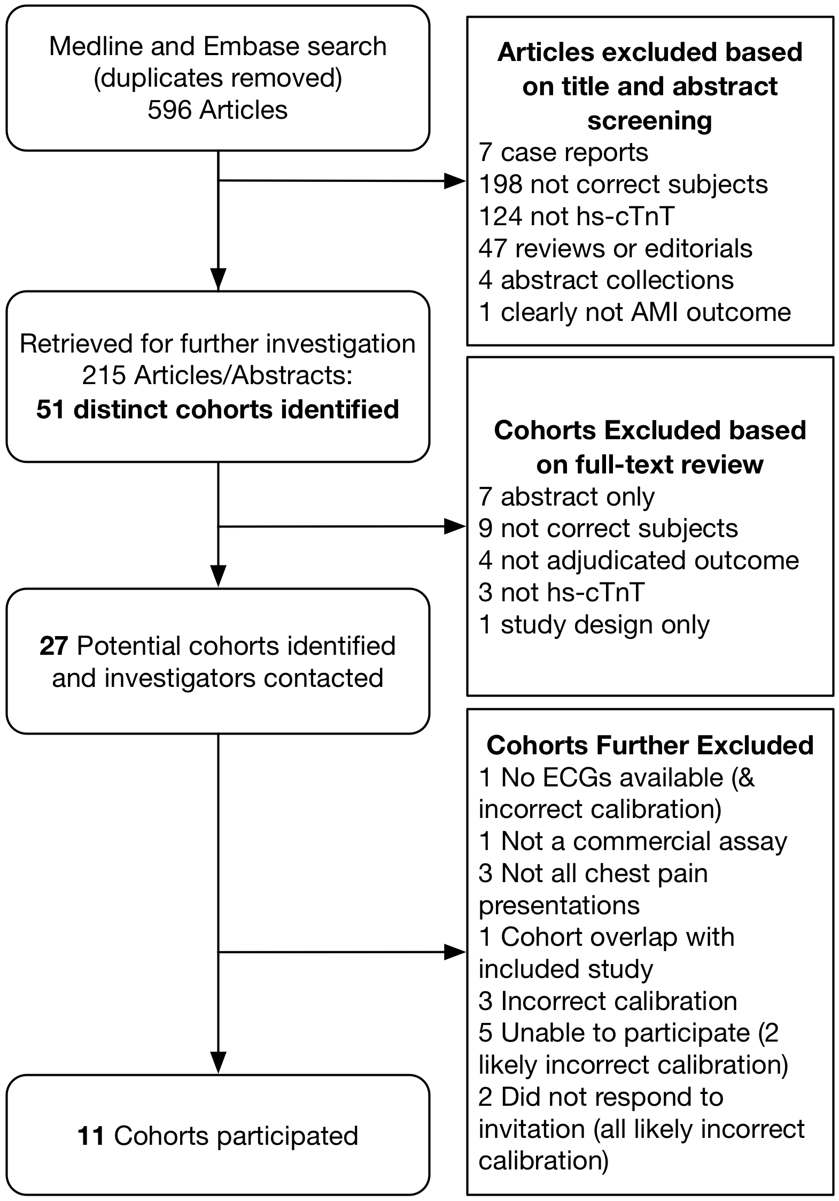
Figure 1: CONSORT diagram. Flow diagram describing the process to identify cohorts. ECG: Electrocardiogram. Hs-cTnT: High sensitivity cardiac troponin T

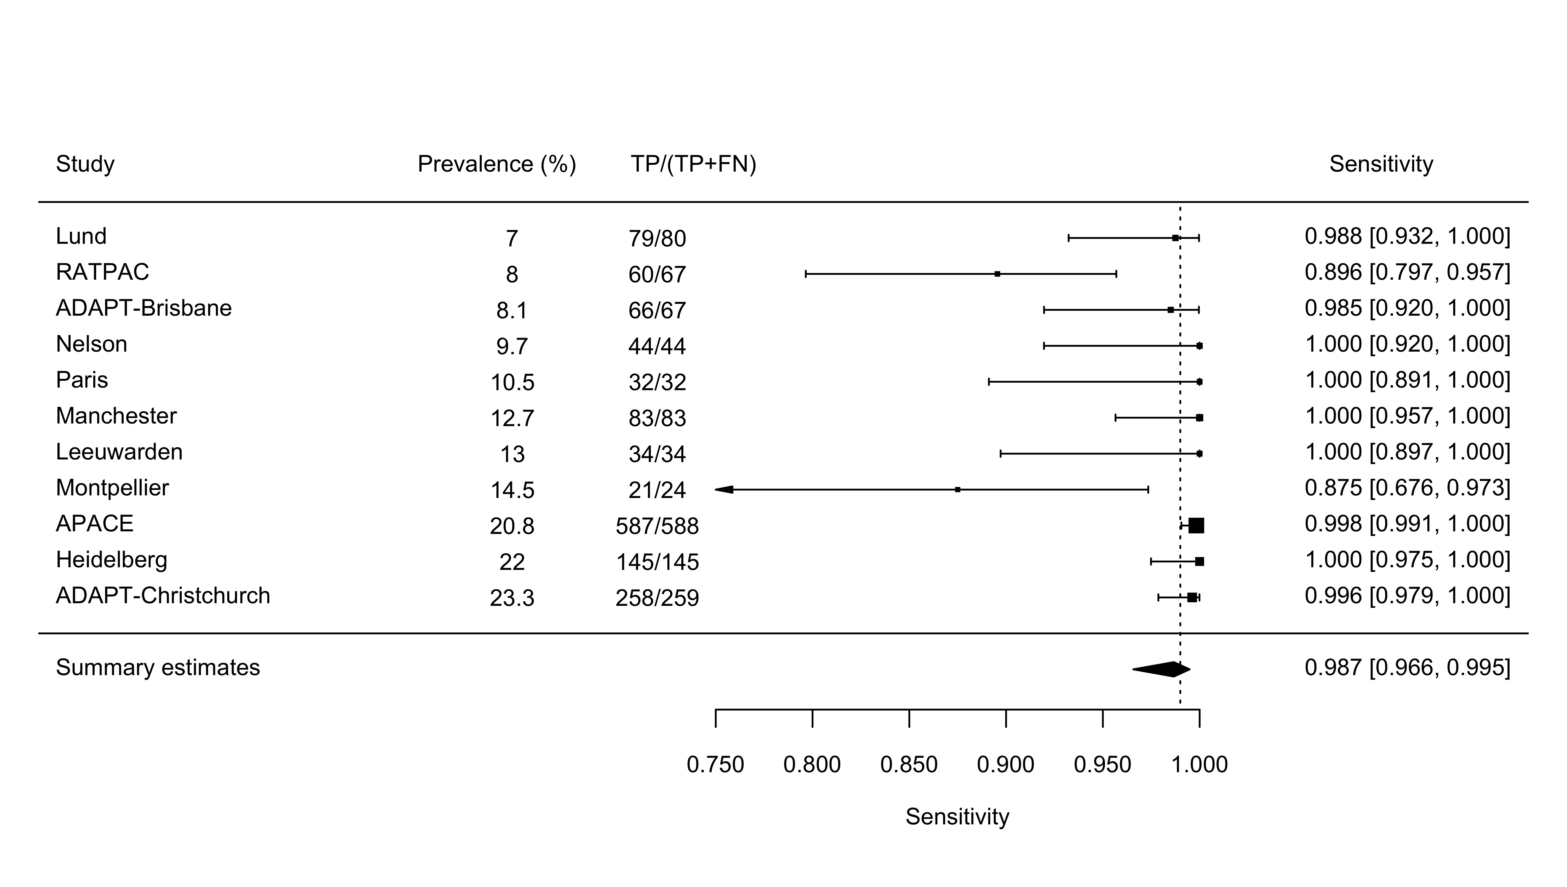
Figure 2: Forest plots for AMI or the summary estimates for Sensitivity. APACE: Advantageous Predictors of Acute Coronary Syndromes Evaluation. ADAPT: 2h Accelerated Diagnostic protocol to Assess Patients with chest pain symptoms using contemporary Troponins as the only biomarker study. RATPAC: Randomised Assessment of Treatment using Panel Assay of Cardiac Markers
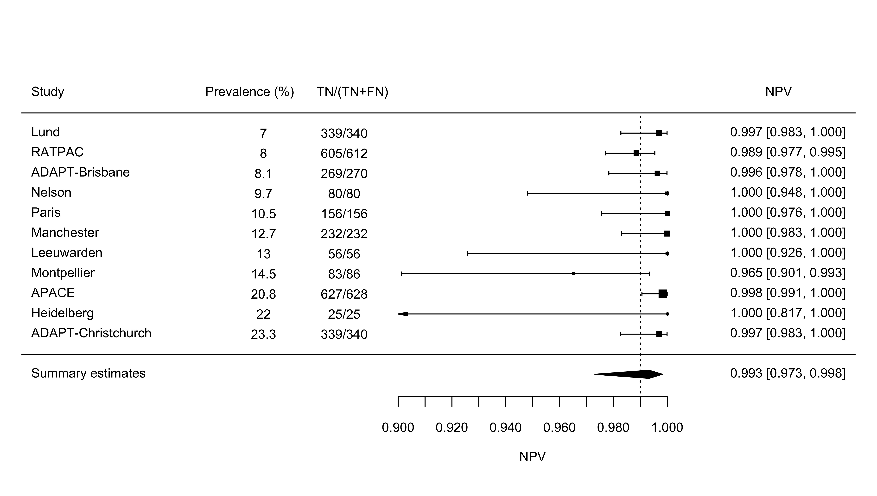
Figure 3: Forest plots for AMI or the summary estimates for Negative Predictive Value. APACE: Advantageous Predictors of Acute Coronary Syndromes Evaluation. ADAPT: 2h Accelerated Diagnostic protocol to Assess Patients with chest pain symptoms using contemporary Troponins as the only biomarker study. RATPAC: Randomised Assessment of Treatment using Panel Assay of Cardiac Markers

Table 1: Cohort Characteristics
 | Lund (28) | RATPAC (21) | ADAPT-Brisbane (20) | Nelson (22) | Paris  (25) | Manchester(4) | Leeuwarden (27) | APACE  (19) | Heidelberg  (24) | ADAPT-Christchurch(20) | Montpellier  (23)
Country | Sweden | United Kingdom | Australia | New Zealand | France | United Kingdom | Netherlands | Switerzland; Spain; Italy | Germany | New Zealand | France
n | 1138 | 833 | 832 | 452 | 304 | 653 | 261 | 2831 | 658 | 1113 | 194
Age (years) | 60.6 ± 17.5 | 54.8 ± 13.8 | 54.5 (45-65) | 63 ± 14.5 | 57 ± 17 | 58.6 ± 14.3 | 62 | 62 (49-74) | 70.6 ± 12.7 | 65.3 ± 13 | 60.5 ± 17.5
Male (%) | 54.6 | 59.8 | 61.2 | 60 | 64.1 | 61.2 | 61 | 70.6 | 64 | 65.2 | 63.4
eGFR (ml/min/1.73m²) | 84 ± 26 | NA | 85 (70-90) | NA | 80 ± 29 | 80.8 ± 21.5 | NA | 85 (69-101) | 66.6 ± 29.1 | 71 (57-84) | 91 ± 32.5
Creatinine (umol/l) | 85 ± 48 | 82.4 ± 24 | 84.0 ± 44.1 | NA | 89 ± 44 | 84.5 ± 28.4 | NA | 82 ± 35 | NA | 96 ± 41 | 86 ± 80
Diabetes | 13.9 | 8.2 | 13 | NA | 13.5 | 17.8 | NA | 18 | 33.6 | 17.8 | 14.4
Hypertension | 43.5 | 35.2 | 43.5 | NA | 36.8 | 48.8 | NA | 63.9 | 83.2 | 67.8 | 34.0
Dyslipidemia | 22.6 | 23.6 | 42.7 | NA | 36.5 | 48.2 | NA | 51.9 | 59.5 | 63.5 | 34.0
Family history of IHD | 22.6 | 31.8 | 46.2 | NA | 31.9 | 48.1 | NA | 33.4 | 21.4 | 67.2 | NA
Smoker | 13.0 | 28.6 | 27.8 | NA | 40.1 | 30.7 | NA | 64.1 | 12.0 | 42.8 | 34.0
Prior MI | 19.9 | 5.8 | 17.1 | NA | 26.0 | 23.8 | NA | 24.4 | NA | 33.3 | 4.1
Prior Stroke | 9.0 | NA | 9.3 | NA | NA | 10.1 | NA | 5.6 | 7.4 | NA | NA
Prior hospitalisation for CHF | NA | NA | 4.8 | NA | NA | NA | NA | NA | 20.5 | NA | NA
Aspirin use | 28.6 | 18.7 | 26.1 | NA | NA | 42.7 | NA | 37.7 | NA | 62 | NA
COPD | 7.4 | NA | NA | NA | NA | NA | NA | 10.9 | 15.7 | NA | NA
Beta-blocker | 30.4 | NA | 19.6 | NA | NA | 24.2 | NA | 35.6 | NA | 47.2 | 23.2
ACE/ARB | 30.8 | NA | 18.3 | NA | NA | 23.5 | NA | 40.4 | NA | 35 | 23.2
Statins | 29.8 | NA | 27.3 | NA | NA | 44.2 | NA | 36.8 | NA | 50.2 | NA
Length of stay (days) | NA | NA | 1.1 (0.4-3.0) | NA | NA | 2 (2 - 6) | NA | 1 (0-5) | NA | 2 (1-5) | NA

Data presented as percentage, mean ± standard deviation or median (lower quartile-upper quartile range)
eGF: estimated Glomerular Filtration Rate, MI = Myocardial Infarction; COPD: Chronic Obstructive Pulmonary Disease; ACE/ARB: Angiotensin Converting Enzyme inhibitors/Angiotensin II Receptor Blockers; CHF: Chronic Heart Failure; IHD: Ischemic Heart Disease
APACE: Advantageous Predictors of Acute Coronary Syndromes Evaluation. ADAPT: 2h Accelerated Diagnostic protocol to Assess Patients with chest pain symptoms using contemporary Troponins as the only biomarker study. RATPAC: Randomised Assessment of Treatment using Panel Assay of Cardiac Marker

Author affiliations:
- JWP: Associate Professor and Senior Research Fellow in Acute Care, Emergency Department, Christchurch Hospital, and Department of Medicine, University of Otago Christchurch, PO Box 4345, Christchurch 8140, New Zealand. John.pickering@otago.ac.nz
- MPT: Emergency consultant, Emergency Department, Christchurch Hospital, Private Bag 4710, Christchurch 8140, New Zealand. marththan@xtra.co.nz
- LC: Emergency consultant and Associate Professor, Queensland University of Technology, and Department of Emergency Medicine, Royal Brisbane and Women’s Hospital, Butterfield Street, Herston, QLD 4029, Australia. Louise.Cullen@health.qld.gov.au
- SA: Cardiologist, Cardiology Department, Christchurch Hospital, Private Bag 4710, Christchurch 8140, New Zealand. Sally.aldous@cdhb.health.nz
- EtA: Emergency Consultant, Department of Emergency Medicine, Medical Centre Leeuwarden, Postbus 888, 8901 BR Leeuwarden, The Netherlands. Ewoud.ter.Avest@ZNB.NL
- RB: Emergency consultant, Central Manchester University Hospitals NHS Foundation Trust and the University of Manchester, Oxford Road, Manchester M13 9PL, UK. richard.body@manchester.ac.uk
- EWC: Emergency consultant, Emergency Department, Southmead Hospital, North Bristol NHS Trust, Southmead Road, Bristol BS10 5NB, UK. eddcarlton@gmail.com
- PC: Consultant Chemical Pathologist and Professor of Cardiovascular Biomarkers, Departments of Clinical Blood Sciences and Cardiology, St George’s University Hospitals NHS Foundation Trust, Blackshaw Road, Tooting, London SW17 0QT and St George’s University of London. Paul.Collinson@stgeorges.nhs.uk
- AMD: Physician and biologist, Hôpital Lapeyronie, Laboratoire de Biochimie et d’Hormonologie 371 Avenue du Doyen Gaston Giraud 34295 MONTPELLIER cédex 5, FRANCE. am-dupuy@chu-montpellier.fr
- UE: Emergency Consultant, Department of Emergency and Internal Medicine, Skåne University Hospital, Klinikgatan 15, 221 85 Lund, Sweden. ulf.ekelund@med.lu.se
- KME: Cardiologist, Department of Medical Sciences, Uppsala University, Box 256, 751 05 Uppsala, Sweden. kai.eggers@ucr.uu.se
- CMF: Clinical Biochemist and Associate Professor Department of Pathology, University of Otago Christchurch, PO Box 4345, Christchurch 8140, New Zealand. Chris.Florkowski@cdhb.health.nz
- YF: Sorbonne Université, UPMC univ Paris 06 and emergency department, hopital pitie-salpetriere, Assistance Publique- Hopitaux de Paris, Paris, France. yonathan.freund@aphp.fr
- PG: Clinical Biochemist and Professor Department of Pathology, University of Otago Christchurch, PO Box 4345, Christchurch 8140, New Zealand. Peter.george@cdhb.health.nz
- SG: Professor of Emergency Medicine, School of Health and Related Research, University of Sheffield, Sheffield, England Regent Court, Regent Street, Sheffield, S1 4DA, United Kingdom. s.goodacre@sheffield.ac.uk
- JHG: Research Officer and Associate Professor, Queensland University of Technology, and Department of Emergency Medicine, Royal Brisbane and Women’s Hospital, Butterfield Street, Herston, QLD 4029, Australia. Jaimi.Greenslade@health.qld.gov.au
- ASJ: Professor of Cardiology and Professor of Laboratory Medicine and Pathology, Mayo Clinic, 200 First St SW, Rochester, Minnesota, MN 55905, USA. Jaffe.Allan@mayo.edu
- SJL: Epidemiologist, Head of Epidemiology and Medical Statistics School of Medicine The University of Notre Dame Australia 160 Oxford Street Darlinghurst NSW 2010, Australia. sally.lord@nd.edu.au
- AM: Physician, Department of Emergency and Internal Medicine, Skåne University Hospital, Klinikgatan 15, 221 85 Lund, Sweden. arash.mokhtari.0561@med.lu.se
- CM: Cardiologist and Professor, Universitätsspital Basel, Kardiologie, Petersgraben 4, 4031 Basel, Schweiz. Christian.Mueller@usb.ch
- AM: Emergency Physician, Emergency Department, Private Bag 18, Nelson Hospital, Nelson 7042, New Zealand. Andrew.Munro@nmdhb.govt.nz
- SM: Emergency consultant, Emergency Department, Hôpital Lapeyronie, Laboratoire de Biochimie et d’Hormonologie 371 Avenue du Doyen Gaston Giraud 34295 MONTPELLIER cédex 5, FRANCE. m-sebbane@chu-montpellier.fr
- WP: Cardiologist, Cardiology Department, Royal Brisbane and Women’s Hospital, Butterfield Street, Herston, QLD 4029, Australia. w.parsonage@me.com
- WFP: Emergency Physician and Professor Baylor College of Medicine, One Baylor Plaza, Houston, Texas TX 77030, USA. frankpeacock@gmail.com
- CP: Biochemist and Associate Professor, Christchurch Heart Institute, Department of Medicine University of Otago Christchurch, PO Box 4345, Christchurch 8140, New Zealand. Chris.pemberton@otago.ac.nz
- AMR: Cardiologist and Professor, Christchurch Heart Institute, Department of Medicine University of Otago Christchurch, PO Box 4345, Christchurch 8140, New Zealand, and Director Cardiovascular Research Institute, National University of Singapore, Singapore. Mark.Richards@cdhb.health.nz
- JS: Cardiologist and Professor of Cardiology, Catedrático de Medicina (Cardiología). Universidad de Valencia, Jefe de la Unidad de Hemodinámica y Cardiología intervencionista, Hospital Clínico Universitario, 46010 Valencia, Spain. sanchis_juafor@gva.es
- LPS: Epidemiologist, NHMRC Clinical Trials Centre, University of Sydney, Locked Bag 77, Camperdown NSW 1450, Australia. lukas.staub@ctc.usyd.edu.au
- RT: Cardiologist and Professor, Christchurch Heart Institute, Department of Medicine University of Otago Christchurch, PO Box 4345, Christchurch 8140, New Zealand. Richard.troughton@otago.ac.nz
- RT: Cardiologist Department of Cardiology and Cardiovascular Research Institute Basel (CRIB), Universitätsspital Basel, Kardiologie, Petersgraben 4, 4031 Basel, Schweiz. Raphael.Twerenbold@usb.ch
- Senior Physician, anaesthesiology and surgical intensive care unit, Universitätsspital Basel, Kardiologie, Petersgraben 4, 4031 Basel, Schweiz. Karin.Wildi@usb.ch
- JY: Research Scientist, Emergency Department, Christchurch Hospital, Private Bag 4710, Christchurch 8140, New Zealand. Jo.young@cdhb.health.nz

