Persistence of immunity following immunisation with a capsular group B meningococcal vaccine in three different toddler schedules: follow-on of a previous randomized-controlled trial
Manish Sadarangani BM BCh DPhil¹*†, Tim Sell MBChB¹*, Mildred A Iro MBBS PgDip¹, Matthew D Snape MBBS MD¹^, Merryn Voysey M Biostat^{1,2}, Adam Finn MA BM BCh PhD ³, Paul T Heath MB BS⁴, Gianni Bona MD⁵, Susanna Esposito MD⁶, Javier Diez- Domingo MD PhD ⁷, Roman Prymula MD PhD⁸, Adefowope Odueyungbo PhD^{9§}, Daniela Toneatto MD¹⁰, Andrew J Pollard MBBS PhD¹, for the European MenB Vaccine Study Group**

*These authors contributed equally to this manuscript

Authors’ Affiliations
¹Oxford Vaccine Group, Department of Paediatrics, University of Oxford, and the NIHR Oxford Biomedical Research Centre, Oxford, UK
²Nuffield Department of Primary Care Health Sciences, University of Oxford, Oxford, UK
³Bristol Children’s Vaccine Centre, School of Clinical Sciences, University of Bristol, Bristol, UK
⁴St George’s Vaccine Institute, University of London, London, UK
⁵Azienda Ospedaliero-Universitaria Maggiore della Carità, Clinica Pediatrica, Novara, Italy
⁶Pediatric Highly Intensive Care Unit, Università degli Studi di Milano, Fondazione IRCCS Ca' Granda Ospedale Maggiore Policlinico, Milan, Italy
⁷Vaccine Research Area, Fundación para el Fomento de la Investigación Sanitaria y Biomédica (FISABIO),Valencia, Spain
⁸Charles University Prague, School of Medicine, Department of Social Sciences, Hradec Kralove, Czech Republic
⁹Novartis Vaccines and Diagnostics Inc., Cambridge, MA, USA
¹⁰GSK, Siena, Italy
† Current affiliation: Vaccine Evaluation Center, BC Children’s Hospital Research Institute, University of British Columbia, Vancouver BC, Canada
§ Current affiliation: Hoffmann - La Roche Limited, Mississauga, Canada.
^Author for correspondence
Dr Matthew Snape; Email: matthew.snape@paediatrics.ox.ac.uk

**The European Men B Vaccine Study Group
UK: University of Oxford, Department of Paediatrics, Oxford Vaccine Group: Sarah Kelly RN, Danielle Campbell RN; Bristol Children’s Vaccine Centre: Sandra Dymond RN; University of London, St George’s Vaccine Institute: Alison Kent MD; Italy: University of Florence, Department of Health Sciences, Anna Meyer Children's University Hospital: Maurizio De Martino MD, Leila Bianchi MD, Carlotta Montagnani MD; University of Padua, Department of Pediatrics: Carlo Giaquinto MD; GSK (formerly known as Novartis Vaccines and Diagnostics Srl, Siena): Benedetta Ghezzi, Igor Kohl, Simone Inzillo, Linda Kasim, Lucie Hlavata, Laura Lulli, Harry Wisse, Sheena Gomez, Vasundhara Dindore; Azienda Ospedaliero-Universitaria Maggiore della Carità - Clinica Pediatrica, Novara: Erika Pozzi MD, Silvia Parlamento MD; Università degli Studi di Milano, Fondazione IRCCS Cà Granda Ospedale Maggiore Policlinico, Milan: Valentina Montinaro; Spain: Centro de Salud Catarroja: Miguel Tortajada-Girbés MD; Hospital Clinico Universitario de Santiago de Compostela: Federico Martinón-Torres MD, Lorenzo Redondo Collazo MD; Czech Republic: Hradec Kralove: University of Defense, Faculty of Military Health Sciences, Vaccination Center: Roman Chlíbek MD PHD; Jindrichuv Hradec: Samostatna ordinace praktickeho lekare pro deti a dorost: Daniel Dražan MD.
Contributors´ statement
M D Snape, D Toneatto and A J Pollard were involved in conception and study design; T Sell, M A Iro, M D Snape, A Finn, P T Heath, G Bona, S Esposito, J Diez-Domingo, R Prymula conducted the study and were involved in data acquisition; D Toneatto, M A Iro, M D Snape, A J Pollard, T Sell, M Sadarangani, M Voysey, A Odueyungbo analyzed and interpreted the data. M Sadarangani and T Sell drafted the manuscript and all authors revised it critically. All authors approved the final version to be published and agree to be accountable for all aspects of the work.
Funding statement
This study was sponsored by Novartis Vaccines Division, on 2 March 2015 Novartis non-influenza Vaccines Business was acquired by the GlaxoSmithKline group of companies. With the lead investigators, the Sponsor was involved in the design of the study as well as analysis of the data, review and comment on the manuscript. Data collection was undertaken by the study investigators’ teams. Editorial control of the manuscript was assigned to the University of Oxford. The Sponsor conducted the primary analysis of the data prior to being independently validated with full access to all data at the University of Oxford by M Voysey.

Competing Interests
M Sadarangani has been an investigator on investigator-initiated research studies funded by Pfizer and his institution received research grants from GlaxoSmithKline Biologicals SA. M D Snape, A Finn, P T Heath, G Bona, S Esposito, J Diez-Domingo, R Prymula act as investigators for clinical vaccine studies from both non-commercial funding bodies and commercial sponsors (i.e. some or all of Novartis Vaccines and Diagnostics S.r.l. [now a member of the GSK group of companies], GlaxoSmithKline Biologicals SA, Janssen, Sanofi-Aventis, Sanofi-Pasteur MSD, MedImmune, Pfizer Vaccines, Alios Bio Pharma and Ablynx NV) conducted on behalf of their institutions as listed in the affiliations. M D Snape participates in advisory boards and speaking engagements for vaccine manufacturers; all payments received are paid to his institution. G Bona declares being paid by Novartis Vaccines and Diagnostics through his institution for lectures. Before October 2014, A Finn undertook paid consultancy and speaking engagements for vaccine manufacturers, all income was paid to his employers. Owing to his membership of the UK Department of Health’s (DH) Joint Committee on Vaccination and Immunization (JCVI), A Finn no longer gives talks or undertakes advisory work for industry, either paid or unpaid. R Prymula, J Diez-Domingo, and S Esposito also undertake consultancy and advisory work and receive speaking honoraria, travel and accommodation reimbursements for several commercial sponsors (i.e. some or all of GlaxoSmithKline Biologicals SA, Pfizer, Novartis Vaccines and Diagnostics, MedImmune). M A Iro has received travel grants from GlaxoSmithKline Biologicals SA for attendance at conferences. The NIHR Oxford Biomedical Research Centre provides salary support for M D Snape, who is a Jenner Investigator. A J Pollard is a Jenner Investigator and James Martin Senior Fellow and has previously conducted research on behalf of Oxford University funded by vaccine manufacturers (including manufacturers of group B meningococcal vaccines; GSK, Novartis Vaccines and Diagnostics, Pfizer, ) and his department has received unrestricted educational grants from vaccine manufacturers for an infectious diseases course for paediatric trainees. A J Pollard, P T Heath and A Finn do not receive any personal remuneration from vaccine manufacturers. A J Pollard is chair of the UK Department of Health’s (DH) Joint Committee on Vaccination and Immunization (JCVI); the views presented in this manuscript do not necessarily represent the views of DH or JCVI. A Odueyungbo is former employee of Novartis Vaccines and Diagnostics; D Toneatto declares she is employed and holds shares in the GSK group of companies. T Sell and M Voysey declare no competing interests.

Wordcount: abstract (250/250); text (2493/2500)
Abstract
Background: One schedule for the capsular group B meningococcal vaccine, 4CMenB, is two doses two months apart for children 12-23 months of age, with a booster dose 12-24 months later. This study provides the first data on persistence of human serum bactericidal antibody (hSBA) titres up to 4 years of age after initial doses at 12-24 months, and immunogenicity of a booster dose at 48 months of age compared with vaccine-naïve children.
Methods: Children previously immunised with two doses of 4CMenB at 12-24 months of age received a booster at four years of age. Vaccine-naïve age-matched toddlers received two doses of 4CMenB. hSBA titres against reference strains H44/76, 5/99, NZ98/254 and M10713 were evaluated before and after 4CMenB in 4-year old children.
Results: Of 332 children in the study, 123 had previously received 4CMenB and 209 were vaccine-naïve controls. Prior to the booster, the proportions of participants (comparing previously vaccinated groups with controls) with hSBA titres ≥1:5 were 9-11% vs 1% (H44/76), 84-100% vs 4% (5/99), 0-18% vs 0% (NZ98/254) and 59-60% vs 60% (M10713). After one dose of 4CMenB in previously immunised children the proportions achieving hSBA titres ≥1:5 were 100% (H44/76 and 5/99), 70-100% (NZ98/254) and 90-100% (M10713).
Interpretation: Waning of hSBA titres by 4 years of age occurs following two doses of 4CMenB administered at 12-24 months, and doses at 12-24 months have a priming effect on the immune system. A booster might then be necessary to maintain hSBA titres ≥1:5 among those with increased disease risk.
Trial registration: ClinicalTrials.gov (NCT01717638)
Funding: Novartis Vaccines Division

Introduction
Neisseria meningitidis causes meningitis and septicaemia¹, with rapid disease onset, high case-fatality rate^{2,3} and increased rates of long-term neurological and non-neurological sequelae⁴⁻¹¹. Over the last 15 years conjugate vaccines have resulted in near elimination of endemic disease in countries with high coverage group C vaccine programmes¹² and marked impact of group A vaccines in Africa¹³. The majority of disease in many countries is now caused by capsular group B N. meningitidis (MenB)¹⁴. This is the leading cause of meningococcal disease in Canada, with a peak incidence of 6.16/100,000/year in children aged <1 year¹⁵. A recently licensed vaccine (4CMenB) designed primarily to prevent MenB infection was introduced into the routine infant immunisation schedule in the UK in September 2015¹⁶ and has been used in a response to hyperendemic MenB disease in Quebec, Canada¹⁷. While routine use of the vaccine is intended for infant immunisation, the vaccine may be considered in older children for catch-up campaigns or outbreaks. Information on duration of protection is therefore needed.

One recommended schedule for 4CMenB is two doses at least two months apart for children aged 12-23 months, followed by a booster dose 12-23 months thereafter because a single dose does not result in sufficient production and persistence of protective antibodies¹⁸. Different dosing schedules are used at different ages. Infants require additional doses¹⁸ and shorter intervals have been used in outbreak settings¹⁹. At present there are no data on the persistence of bactericidal antibodies (on which the correlate of protection is based) through to the pre-school period following vaccination of toddlers.

The aims of this follow-on study were to assess: (i) the persistence of human serum bactericidal antibody (hSBA) titres at 4 years of age in children previously immunised with two doses of 4CMenB in the second year of life, compared with age-matched vaccine-naïve children; (ii) the percentage of children with hSBA titres ≥1:5 following a booster dose of 4CMenB at 4 years of age; (iii) the proportion of vaccine-naïve 4-year old children achieving hSBA titres ≥1:5 following two doses of 4CMenB; (iv) adverse reactions after 4CMenB in 4-year old children.

Methods
Locations
This study (NCT01717638) was an open label, multi-centre extension to a randomised controlled trial conducted at 31 centres in the Czech Republic, Italy, Spain and the UK between November 2012 and October 2013 (Supplementary Table 1).

Participants
This study was part of a larger study, of which the primary outcome was persistence of hSBA titres in infants given 3 priming doses of 4CMenB as infants and a booster dose at 12, 18 or 24 months, reported elsewhere²⁰.

Participants involved in a previous follow-on study were invited to take part in this study via an invitation letter. In the previous study three cohorts received two doses of 4CMenB at 12 and 14 months (n=239), 18 and 20 months (n=51), or 24 and 26 months (n=55)²¹. Of these, 123 were enrolled as the follow-on cohort for this study. A further 209 vaccine-naïve participants were recruited as age-matched controls (Figure 1). Inclusion criteria: healthy child aged 48-59 months; previous receipt of two doses of 4CMenB in the previous study (‘follow-on’ participants) or no doses of 4CMenB (‘vaccine-naive’ participants). Exclusion criteria: previously ascertained or suspected disease caused by N. meningitidis; household contact and/or intimate exposure to an individual with laboratory-confirmed N. meningitidis; previous allergic reaction to any vaccine component; serious chronic or progressive disease; known/suspected immunosuppression; participation in another clinical trial within 90 days pre-enrolment or during the study; family member of research staff.

Vaccine
The investigational vaccine was 4CMenB (Bexsero™, GSK). It contains 50μg each of three proteins - Neisseria heparin binding antigen (NHBA), Neisserial adhesin A (NadA) and factor H binding protein (fHbp) - and 25μg of outer membrane vesicle (OMV) from N. meningitidis strain NZ98/254, plus aluminum hydroxide¹⁸. The vaccine was administered as 0.5ml intramuscularly.

Procedures
Follow-on participants received one dose of 4CMenB and had blood samples obtained prior to and 30 days post-vaccination. Vaccine-naïve participants received two doses of 4CMenB, two months apart, and had blood samples taken before the first immunisation and one month after each dose.

For 7 days post-vaccination parents recorded adverse events (AEs) and graded their severity. Solicited local AEs were injection site pain/erythema/induration/swelling. Solicited systemic AEs were fever (axillary temperature ≥38°C), change in eating habit, sleepiness, vomiting, diarrhoea, irritability, arthralgia, headache and rash. AEs requiring a physician’s visit and use of antipyretics and/or analgesia were recorded. The relationship of AEs to the study vaccine was determined by the study investigators, considering temporal relationship and biological plausibility.

Serum bactericidal antibody
Immunogenicity was assessed by measuring hSBA titres, using human serum as the source of exogenous complement²². Assays were performed at Novartis Vaccines and Diagnostics (GmbH, Marburg, Germany). The fHbp response was assessed with strain H44/76, NadA with strain 5/99, PorA with NZ98/254 and NHBA with M10713.

Statistical analysis
The percentage of children at each blood sampling time point with hSBA titres ≥1:5 and associated 2-sided 95% exact Clopper-Pearson confidence intervals (CIs) were calculated for each indicator strain. An interpolated SBA titre ≥1:5 represented 95% confidence that participants achieving this titre had an hSBA titre ≥1:4. A post-vaccine hSBA titre of ≥1:4 is currently accepted as the presumed protective threshold against meningococcal disease²³. hSBA geometric mean titres (GMTs) were calculated and geometric mean ratios (GMRs) by comparison of post-immunisation and pre-immunisation values. GMT and GMR with associated 95% CIs were computed by taking anti-logs. Sample size for the follow-on participants was determined by the number of participants in the previous study whose parents were willing to take part. Though the primary aim was descriptive, the secondary aim in the vaccine-naïve cohort was to demonstrate a “sufficient” immune response following two doses of the vaccine, pre-defined as >70% of participants with hSBA ≥1:5. Power calculations assumed the actual percentage would be 80%, so 162 participants were required in the vaccine-naïve cohort for 79% power (5% alpha) to demonstrate a sufficient immune response against NZ98/254, providing >99.9% power for strains H44/76 and 5/99. Assuming 15% drop-out, enrolment of 190 participants in the vaccine-naïve control group was required.

Ethics
Written, informed consent was obtained from parents or legal guardians of participants. Ethical approval was obtained from independent review committees at all study centres.

Results
Study population
Of 304 children invited, 123 were recruited into the follow-on cohort; 100 received their first dose of 4CMenB at 12 months (group 1), 11 at 18 months (group 2) and 12 at 24 months (group 3) – 122/123 (99%) completed the study (Figure 1). The vaccine-naïve cohort (group 4) included 209 children, of whom 190 (91%) completed the study. The demographics of the groups were broadly similar (Table 1).

Immunogenicity
Persistence of hSBA titre ≥1:5 at 4 years of age in the follow-on cohort (represented by the ‘pre-vaccine’ category) was 9-11% against H44/76, 84-100% against 5/99, 0-18% against NZ98/254 and 59-60% against M10713 (Figure 2). hSBA GMTs were <5 in all groups for H44/76 and NZ98/254, but were ≥5 for 5/99 and M10713 (Figure 3). After the third dose of 4CMenB at 4 years of age, 70-100% of participants had an hSBA titre ≥1:5, depending on the target strain (Figure 2). hSBA GMTs post-third dose were similar to or higher than the GMTs achieved 1 month after the second dose (Figure 3). The GMRs comparing pre- to post-booster vaccine responses were highest for strain H44/76 (67-133) and lowest for strain M10713 (5.24-7.35) (Table 2).

In the vaccine-naïve cohort, 0-5% had hSBA titres ≥1:5 against H44/76, 5/99 and NZ98/254 pre-vaccination, and 60% against M10713 (Figure 2). After two doses in these previously unvaccinated children 91-100% achieved an hSBA titre ≥1:5, with a 4-fold rise from baseline in 51-100% of participants, depending on the target strain (Supplementary Figure 1). GMTs after two doses were lower or similar to the post-booster dose values in the follow-on groups (Figure 3). GMRs were similar or higher after two doses compared with post-booster in the follow-on groups, with highest GMRs observed with strain 5/99 (GMR=299) and lowest with M10713 (GMR=5.12).

Reactogenicity
The most commonly reported local AE was injection site pain, occurring in 114/121 (94%) of the follow-on cohort overall after the booster dose, and in 185/205 (90%) of the vaccine-naïve cohort after the first dose and 157/194 (81%) after the second dose (Table 3). Sleepiness and irritability were the most common systemic AEs overall, occurring after 200/519 (39%) and 188/518 (36%) doses, respectively (Table 3). Fever ≥38.0°C occurred in 25/121 (21%) of the follow-on cohort after a single dose, and in 20/204 (10%) of the vaccine-naïve cohort after the first dose and 16/189 (8%) after the second dose (Table 3). Fever treatment was given after 73/518 (14%) vaccine doses overall, preventive therapy before 49/517 (9%) doses and medical attention for fever was sought in 9/517 (2%) cases (Table 3).

There were three reported serious AEs, all resulting in hospitalisation and occurring in the vaccine-naïve cohort. None were considered vaccine-related. One child developed croup 60 days after the first dose; another child had a head injury with concussion, contusion and periorbital haematoma 23 days after the first dose; a third child required intravenous fluids for gastroenteritis and dehydration three days after the second dose of vaccine. There was one withdrawal (parental decision) due to an AE – a child in the vaccine-naïve cohort with moderate injection site pain after the first vaccination.

Interpretation
This is the first study to describe waning of bactericidal antibodies in children two years or more following immunisation with 4CMenB in the second year of life, suggesting additional booster doses may be needed if protection is required beyond 4 years of age. A single booster dose at 4 years of age was sufficient to boost hSBA titres to protective levels in the majority of previously vaccinated children, and two doses in vaccine-naïve children provided similar protection, supporting the currently licensed schedule in this age group. Although hSBA titre is accepted as the correlate of protection against meningococcal disease, and used for vaccine licensure, vaccine effectiveness at a population level can only be assessed following vaccine use. In the UK, introduction of 4CMenB into the infant schedule resulted in 83% effectiveness, with prior in vitro immunogenicity data predicting coverage of 73-88%²⁴.

One previous study in Europe found variable waning of bactericidal antibodies in the first 12 months after two doses of 4CMenB given at 12 and 14 months or 13 and 15 months²⁵. After 12 months, 56-75% had hSBA titres ≥1:5 against H44/76, 94-97% against 5/99 and 6-18% against NZ98/254. With our data this suggests that waning of bactericidal antibody against fHbp most commonly occurs >12 months post-vaccination, whereas waning of anti-PorA antibodies occurs almost entirely within 12 months in this age group. Little waning of anti-NadA antibodies was seen up to 26 months post-vaccination. This was unlikely due to ongoing boosting by natural exposure, since only 4% of 4 year old vaccine-naive children had hSBA ≥1:5 against strain 5/99. Persistence of the vaccine-induced anti-NHBA response was poor as similar proportions of the vaccine-naïve and follow-on cohorts had bactericidal antibodies against strain M10713 in this study. The reason for high levels of pre-existing bactericidal antibodies against M10713 in the vaccine-naïve cohort is unknown, but does not appear to significantly impair the vaccine response, with similar post-vaccine SBA GMTs compared with NZ98/254. In the only other published study of antibody persistence in this age group, hSBA titres ≥1:4 occurred in 0-38% (depending on target strain) of three-year old UK children after one dose of 4CMenB at 12 months of age – confirming the need for two doses in this age group²⁶. Similar patterns of antigen-dependent differential waning of bactericidal antibodies have been reported after two doses of 4CMenB at 40 months of age^{27,28}. Presence of bactericidal antibodies against one of the vaccine antigens may be sufficient to ensure protection if the protein is expressed at sufficient levels on the bacterial surface. The Meningococcal Antigen Typing System has been designed to assess this and aims to predict vaccine coverage based on circulating strains²⁹.

Similar persistence of antibodies at four years of age has been described in children after three infant doses and a booster in the second year of life²⁰. This suggests that three doses in infants plus a booster is broadly equivalent to two doses in the second year of life with respect to antibody persistence to four years. However, this latter regime provides no protection to young infants who have the highest incidence of disease³⁰. While further doses after four years may be required in individuals at elevated risk of disease, incidence rates in immunocompetent children aged ≥5 years remain very low, until a small increase in adolescence in some populations³⁰.

Two doses in 11-17-year-old adolescents resulted in persistence of SBA ≥1:4 in ≥75% of individuals against all vaccine antigens 18-24 months post-vaccination with three doses³¹. A similar study of a bivalent fHbp MenB vaccine (rLP2086) in 11-18-year-olds reported hSBA titres ≥1:4 up to 4 years after three doses in >50% of participants for three of four target strains³².

Our data suggest that antibody persistence following two doses at 24 months is similar to immunisation at 12 or 18 months, although the numbers were small. Previous studies have reported significant waning of bactericidal antibodies by 5 years of age following vaccination at 3 years^{27,28}, suggesting children receiving two doses of 4CMenB at 2-3 years of age might require further boosters if ongoing protection is required (for example, children with splenic dysfunction or complement disorders). Persistence data are needed for 4-10 year-old children in larger studies.

The most common local AE in this study was injection site pain, with rates similar to those found in previous studies of 4CMenB in 3-year and 5-year old children²⁶⁻²⁸. The rate of post-immunisation fever was also similar to previous data²⁶.
The major limitation was the low proportion of participants in the follow-on cohort from those who completed the previous study (42% in group 1, 22% in group 2, and 24% in group 3). There is therefore the potential for selection bias as participants who tolerated the previous vaccinations better are more likely to take part. The group sizes for those receiving priming doses at 18 and 24 months of age were small, making comparisons between the follow-on groups difficult – within this limitation, there were no significant differences between the groups. Further studies would be required to explore differences between schedules in the second year of life.
Two doses of 4CMenB given at 12-24 months prime the immune system against the vaccine antigens so that there is a booster effect following a single dose 2 years later. The rates at which serum antibody titres to the different vaccine antigens wane vary widely, although the implications of this for vaccine effectiveness are yet to be established. Children receiving their first doses at 2-3 years of age may require further booster doses if ongoing direct protection beyond 4-5 years is required, as may be the case for those in high risk groups, although further data in larger cohorts are required to confirm this.

Bexsero is a trademark of the GSK group of companies.

Acknowledgements
The authors thank all of the participants, their families and the study staff at the research centres in the different participating countries for contributing to this study. The authors also thank Iudit-Hajnal Filip (XPE Pharma & Science, Wavre, Belgium c/o GSK) for publication coordination.

References
1. Cartwright KA, Stuart JM, Jones DM, Noah ND. The Stonehouse survey: nasopharyngeal carriage of meningococci and Neisseria lactamica. Epidemiol Infect. 1987;99:591-601.
2. Brandtzaeg P, van Deuren M. Classification and pathogenesis of meningococcal infections. Methods Mol Biol. 2012;799:21-35.
3. Ovstebo R, Hellerud BC, Coureuil M, Nassif X, Brandtzaeg P. Pathogenesis of invasive disease. In: Feavers I, Pollard AJ, Sadarangani M, eds. Handbook of Meningococcal Disease Management. Switzerland: Springer; 2016:25-43.
4. Pace D, Pollard AJ. Meningococcal disease: clinical presentation and sequelae. Vaccine. 2012;30 Suppl 2:B3-9.
5. Buysse CM, Oranje AP, Zuidema E, et al. Long-term skin scarring and orthopaedic sequelae in survivors of meningococcal septic shock. Archives of disease in childhood. 2009;94:381-6.
6. Buysse CM, Raat H, Hazelzet JA, Hop WC, Maliepaard M, Joosten KF. Surviving meningococcal septic shock: health consequences and quality of life in children and their parents up to 2 years after pediatric intensive care unit discharge. Crit Care Med. 2008;36:596-602.
7. Buysse CM, Vermunt LC, Raat H, et al. Surviving meningococcal septic shock in childhood: long-term overall outcome and the effect on health-related quality of life. Crit Care. 2010;14:R124.
8. Stein-Zamir C, Shoob H, Sokolov I, Kunbar A, Abramson N, Zimmerman D. The Clinical Features and Long Term Sequelae of Invasive Meningococcal Disease in Children. Pediatr Infect Dis J. 2014 Jul;33(7):777-9.
9. Borg J, Christie D, Coen PG, Booy R, Viner RM. Outcomes of meningococcal disease in adolescence: prospective, matched-cohort study. Pediatrics. 2009;123:e502-9.
10. Judge D, Nadel S, Vergnaud S, Garralda ME. Psychiatric adjustment following meningococcal disease treated on a PICU. Intensive Care Med. 2002;28:648-50.
11. Sander J, Bay D, Gedde-Dahl TW, et al. Late sequelae after meningococcal disease. A controlled study in young men. NIPH Ann. 1984;7:3-11.
12. Borrow R, Abad R, Trotter C, van der Klis FR, Vazquez JA. Effectiveness of meningococcal serogroup C vaccine programmes. Vaccine. 2013;31:4477-86.
13. MenAfriCar c. The Diversity of Meningococcal Carriage Across the African Meningitis Belt and the Impact of Vaccination With a Group A Meningococcal Conjugate Vaccine. J Infect Dis. 2015;212:1298-307.
14. Halperin SA, Bettinger JA, Greenwood B, et al. The changing and dynamic epidemiology of meningococcal disease. Vaccine. 2012;30 Suppl 2:B26-36.
15. Bettinger JA, Scheifele DW, Le Saux N, et al. The disease burden of invasive meningococcal serogroup B disease in Canada. Pediatr Infect Dis J. 2013;32:e20-5.
16. Drysdale SB, Pollard AJ. Group B meningococcal vaccine science and policy. J Infect. 2015;71 Suppl 1:S15-20.
17. Turner D. Clinical experience with the meningococcal B vaccine, Bexsero. 33rd Annual Meeting of the European Society for Paediatric Infectious Diseases. Leipzig, Germany2015:ESPID-0546. Available from: http://espid2015.kenes.com/submit-an-abstract/scientific-programe. Accessed on 08 Oct 2016.
18. European Medicines Agency. Bexsero. European Public Assessment Report (http://www.ema.europa.eu/docs/en_GB/document_library/EPAR_-_Product_Information/human/002333/WC500137881.pdf, accessed 14th February 2016)2012.
19. Basta NE, Mahmoud AA, Wolfson J, et al. Immunogenicity of a Meningococcal B Vaccine during a University Outbreak. N Engl J Med. 2016;375:220-8.
20. Iro MA, Snape MD, Voysey M, et al. Persistence of bactericidal antibodies following booster vaccination with 4CMenB at 12, 18 or 24months and immunogenicity of a fifth dose administered at 4years of age-a phase 3 extension to a randomised controlled trial. Vaccine. 2017;35:395-402.
21. Snape MD, Voysey M, Biostat M, et al. Persistence of Bactericidal Antibodies Following Infant Serogroup B Meningococcal Immunization and Booster Dose Response at 12, 18 or 24 Months of Age. Pediatr Infect Dis J. 2016; 35(4):e113-123.
22. Snape MD, Dawson T, Oster P, et al. Immunogenicity of two investigational serogroup B meningococcal vaccines in the first year of life: a randomized comparative trial. Pediatr Infect Dis J. 2010;29:e71-9.
23. Frasch CE, Borrow R, Donnelly J. Bactericidal antibody is the immunologic surrogate of protection against meningococcal disease. Vaccine. 2009;27 Suppl 2:B112-6.
24. Parikh SR, Andrews NJ, Beebeejaun K, et al. Effectiveness and impact of a reduced infant schedule of 4CMenB vaccine against group B meningococcal disease in England: a national observational cohort study. Lancet. 2016;388:2775-82.
25. Vesikari T, Prymula R, Merrall E, Kohl I, Toneatto D, Dull PM. Meningococcal serogroup B vaccine (4CMenB): Booster dose in previously vaccinated infants and primary vaccination in toddlers and two-year-old children. Vaccine. 2015;33:3850-8.
26. Snape MD, Saroey P, John TM, et al. Persistence of bactericidal antibodies following early infant vaccination with a serogroup B meningococcal vaccine and immunogenicity of a preschool booster dose. CMAJ. 2013;185:E715-24.
27. McQuaid F, Snape MD, John TM, et al. Persistence of bactericidal antibodies to 5 years of age after immunization with serogroup B meningococcal vaccines at 6, 8, 12 and 40 months of age. Pediatr Infect Dis J. 2014;33:760-6.
28. McQuaid F, Snape MD, John TM, et al. Persistence of specific bactericidal antibodies at 5 years of age after vaccination against serogroup B meningococcus in infancy and at 40 months. CMAJ. 2015;187:E215-23.
29. Vogel U, Taha MK, Vazquez JA, et al. Predicted strain coverage of a meningococcal multicomponent vaccine (4CMenB) in Europe: a qualitative and quantitative assessment. Lancet Infect Dis. 2013;13:416-25.
30. Ciaravino G, Högberg LD, Ködmön C, Whittaker R, Zucs P, Celentano LP. ECDC Surveillance Report. Surveillance of invasive bacterial diseases in Europe, 2012. Invasive pneumococcal disease, invasive Haemophilus influenzae disease and invasive meningococcal disease. Stockholm, Sweden: European Centre for Disease Prevention and Control;2015. Available at: http://ecdc.europa.eu/en/publications/Publications/Surveillance%20of%20IBD%20in%20Europe%202012.pdf. Accessed on 08 Oct 2016.
31. Santolaya ME, O'Ryan M, Valenzuela MT, et al. Persistence of antibodies in adolescents 18-24 months after immunization with one, two, or three doses of 4CMenB meningococcal serogroup B vaccine. Hum Vaccin Immunother. 2013;9:2304-10.
32. Marshall HS, Richmond PC, Beeslaar J, et al. Meningococcal serogroup B-specific responses after vaccination with bivalent rLP2086: 4 year follow-up of a randomised, single-blind, placebo-controlled, phase 2 trial. Lancet Infect Dis. 2017;17:58-67.

Figures
Figure 1. Participant flow diagram
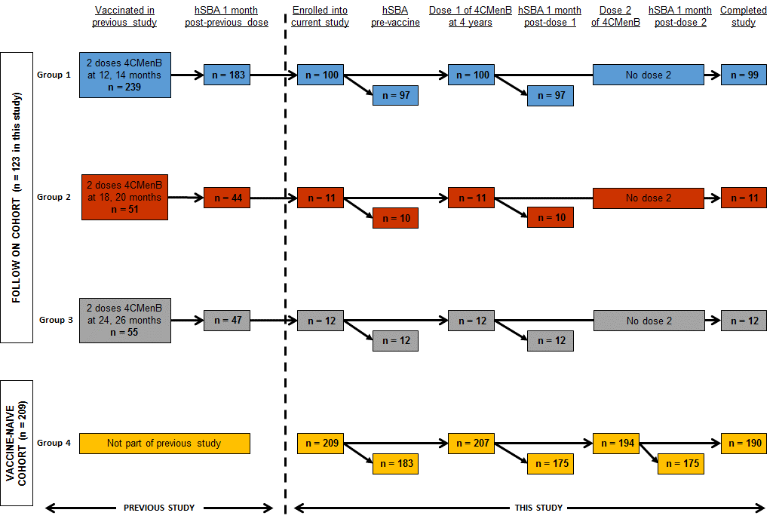
The follow-on cohort all received two previous doses of 4CMenB at 12 and 14 months (Group 1), 18 and 20 months (Group 2) or 24 and 26 months (Group 3) in a previous study²¹. The vaccine naïve cohort had not previously received any 4CMenB doses. All children received one dose at 4 years of age, the vaccine naïve cohort were given an additional dose two months later. Blood for persistence analysis was taken prior to any doses at four years of age (pre-vaccine timepoint) and for booster analysis 30 days after each dose. Safety data were collected after each dose. The flowchart shows the number of participants at each stage of the study. Timepoints where blood was taken for measurement of hSBA are shown slightly offset from the pain participant flow because inability to measure SBA did not preclude ongoing involvement of the participant in the study (i.e. this did not result in withdrawal or loss to follow-up). n, number of participants; hSBA, human serum bactericidal antibody; 4CMenB, multicomponent meningococcal serogroup B vaccine.
Figure 2. Proportion of participants with human serum bactericidal antibody (hSBA) titre ≥1:5 at each time point against each strain
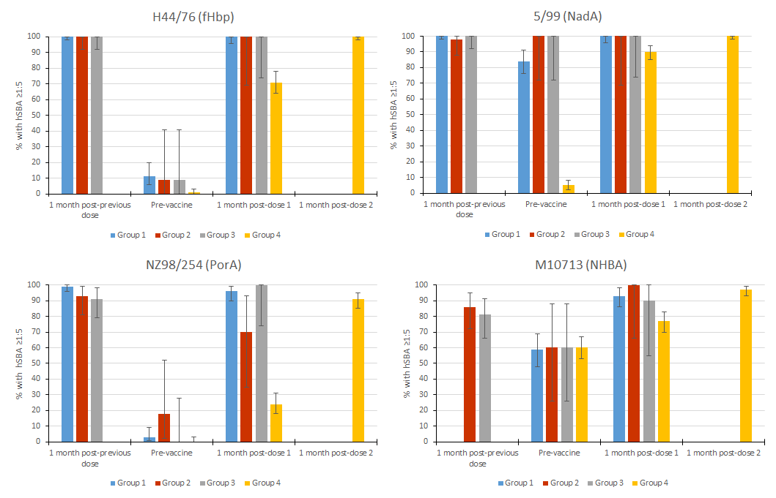
Proportion of participants with hSBA titre ≥1:5 at 1 month post-previous dose (Groups 1, 2 and 3 only) based on data from Snape et al.²¹ Time points from this study include pre-vaccine (before first dose, all groups), 1 month post-dose 1 (all groups) and 1 month post-dose 2 (Group 4 only). The pre-vaccine category for Groups 1, 2 and 3 represents persistence of hSBA following the vaccine doses at 12, 18 or 24 months. Group 1 were not tested for M10713 strains at 1 month following the previous dose in the prior study because the strain was not available. Bars represent overall percentage of participants achieving an hSBA titre ≥1:5, with error bars representing 95% confidence intervals. Data shown separately for the four indicator strains H44/76 (fHbp response), 5/99 (NadA response), NZ98/254 (PorA response) and M10713 (NHBA response). hSBA, human serum bactericidal antibody.
Figure 3. hSBA geometric mean titre (GMT) at each time point against each strain
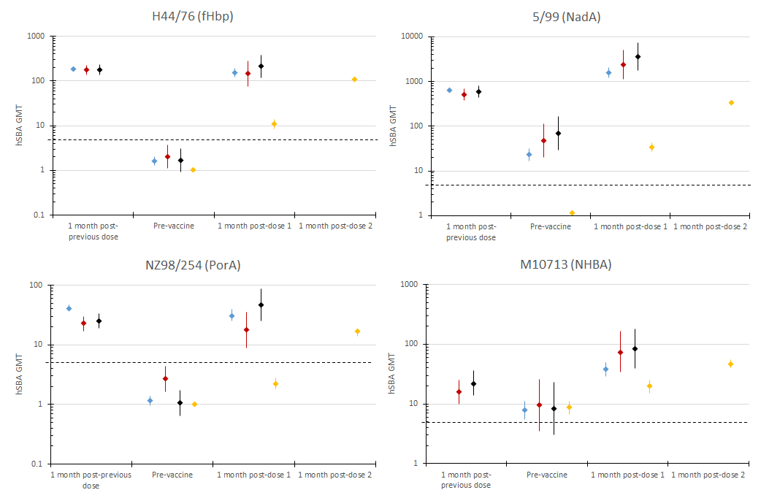
hSBA GMT at 1 month post-previous dose (Groups 1, 2 and 3 only) based on data from Snape et al.²¹. Time points from this study include pre-vaccine (before first dose, all groups), 1 month post-dose 1 (all groups) and 1 month post-dose 2 (Group 4 only). Group 1 were not tested for M10713 strains at 1 month following the previous dose in the prior study because the strain was not available. Points represent overall GMT, with error bars representing 95% confidence intervals. Data shown separately for the four indicator strains H44/76 (fHbp response), 5/99 (NadA response), NZ98/254 (PorA response) and M10713 (NHBA response). hSBA titre of 1:5 shown as horizontal dashed line on each graph to enable comparison as different y-axis scale on each graph. hSBA, human serum bactericidal antibody; GMT, geometric mean titre.
Tables

Table 1. Participant demographics
 | Follow-on cohort |  |  | Vaccine-naïve cohort
 | Group 1 | Group 2 | Group 3 | Group 4
n | 100 | 11 | 12 | 209
Ages at previous 4CMenB doses (months) | 12, 14 | 18, 20 | 24, 26 | None
Number of doses in this study | 1 | 1 | 1 | 2 (2 months apart)
Age at first dose in this study (months), mean ± SD | 51.7 ± 3.3 | 53.4 ± 4.3 | 56.8 ± 1.5 | 53.7 ± 3.6
Male sex, n (%) | 50 (50) | 5 (45) | 8 (67) | 110 (53)
Caucasian, n (%) | 97 (97) | 8 (73) | 7 (58) | 193 (92)
Weight (kg), mean ± SD | 18.1 ± 2.4ª | 18.7 ± 2.4^{b} | 18.8 ± 1.8^{c} | 18.1 ± 2.5^{d}
Height (cm), mean ± SD | 106 ± 4 | 107 ± 4 | 108 ± 6 | 107 ± 5e
a: n=91; b: n=9; c: n=11; d: n=189; e: n=205
n, number of participants; hSBA, human serum bactericidal antibody; SD, standard deviation.

Table 2. Geometric mean ratios (GMRs) of serum bactericidal antibody titres pre-vaccine compared with post-vaccine

 | Follow-on cohort |  |  | Vaccine-naïve cohort
Strain | Group 1 | Group 2 | Group 3 | Group 4 – Dose 1 | Group 4 – Dose 2
H44/76, GMR (95% CI) | 99 (79, 125)  n=95 | 67 (34, 135)  n=10 | 133 (68, 258)  n=11 | 10 (8.2, 13)  n=175 | 105 (94, 116)  n=175
5/99, GMR (95% CI) | 70 (57, 86)  n=92 | 51 (27, 95)  n=10 | 55 (30, 99)  n=11 | 29 (23, 37)  n=168 | 299 (256, 350)  n=172
NZ98/254, GMR (95% CI) | 27 (21, 36)  n=93 | 5.96 (2.7, 13)  n=10 | 38 (18, 81)  n=11 | 2.25 (1.84, 2.75)  n=173 | 17 (14, 19)  n=174
M10713, GMR (95% CI) | 5.24 (3.91, 7.02)  n=88 | 7.06 (2.92, 17)  n=9 | 7.35 (3.03, 18)  n=9 | 2 (1.62, 2.46)  n=158 | 5.12 (3.95, 6.65)  n=161
GMR represents the ratio of geometric mean titre (GMT) post-immunisation to pre-immunisation. Post-immunisation GMT was measured 1 month after each dose of vaccine and pre-immunisation GMT prior to any doses given in this study. 95% confidence intervals (CIs) were computed by taking the anti-log of the mean and the lower and upper limits of the 95% CI. Data shown separately for the four indicator strains H44/76 (fHbp response), 5/99 (NadA response), NZ98/254 (PorA response) and M10713 (NHBA response). GMR, geometric mean ratios; n, participants with available results.
Table 3. Number and percentage of participants with solicited local and systemic adverse events up to day 7 post-vaccination for each dose (day of vaccination = day 1)
 | Follow-on cohort |  |  | Vaccine-naïve cohort – Group 4
 | Group 1 | Group 2 | Group 3 | Dose 1 | Dose 2
Local symptoms
Pain – any  Severe¹ | 94/99 (95%)  19/99 (19%) | 9/10 (90%)  1/10 (10%) | 11/12 (92%)  1/12 (8%) | 185/205 (90%)  27/205 (13%) | 157/194 (81%)  21/194 (11%)
Erythema²  ≥25mm  >50mm  >100mm | 21/99 (21%)  9/99 (9%)  2/99 (2%) | 3/10 (30%)  1/10 (10%)  0/10 | 0/12  0/12  0/12 | 43/204 (21%)  9/204 (4%)  1/204 (<1%) | 34/194 (18%)  19/194 (10%)  0/194
Induration²  ≥25mm  >50mm  >100mm | 9/99 (9%)  1/99 (1%)  1/99 (1%) | 1/10 (10%)  0/10  0/10 | 0/12  0/12  0/12 | 26/204 (13%)  3/204 (1%)  0/204 | 20/194 (10%)  4/194 (2%)  0/194
Swelling²  ≥25mm  >50mm  >100mm | 20/99 (20%)  2/99 (2%)  0/99 | 2/10 (20%)  0/10  0/10 | 4/12 (33%)  1/12 (8%)  0/12 | 30/204 (15%)  4/204 (2%)  1/204 (<1%) | 24/194 (12%)  4/194 (2%)  0/194
Systemic symptoms
Change in eating habits – any  Severe³ | 42/99 (42%)  2/99 (2%) | 0/10  0/10 | 3/12 (25%)  1/12 (8%) | 49/203 (24%)  3/203 (1%) | 43/194 (22%)  2/194 (1%)
Sleepiness – any  Severe¹ | 52/99 (53%)  3/99 (3%) | 3/10 (30%)  0/10 | 3/12 (25%)  0/12 | 74/205 (36%)⁷  5/205 (2%) | 67/193 (35%)  2/193 (1%)
Vomiting – any  Severe⁴ | 6/99 (6%)  0/99 | 2/10 (20%)  0/10 | 1/12 (8%)  0/12 | 8/205 (4%)  0/205 | 6/194 (3%)  0/194
Diarrhoea – any  Severe⁵ | 5/99 (5%)  0/99 | 0/10  0/10 | 2/12 (17%)  0/12 | 11/204 (5%)  1/204 (<1%) | 8/193 (4%)  0/193
Irritability – any  Severe¹ | 53/99 (54%)  6/99 (6%) | 4/10 (40%)  0/10 | 5/12 (42%)  0/12 | 67/204 (33%)  8/204 (4%) | 58/193 (30%)⁷  5/193 (3%)
Headache – any  Severe¹ | 20/99 (20%)  1/99 (1%) | 2/10 (20%)  0/10 | 4/12 (33%)  0/12 | 25/204 (12%)  1/204 (<1%) | 24/194 (12%)  1/194 (1%)
Arthralgia – any  Severe¹ | 28/99 (28%)  10/99 (10%) | 1/10 (10%)  0/10 | 6/12 (50%)  1/12 (8%) | 45/203 (22%)  6/203 (3%) | 40/192 (21%)  2/192 (1%)
Rash | 13/99 (13%) | 0/10 | 0/12 | 15/201 (7%) | 10/192 (5%)
 | Follow-on cohort |  |  | Vaccine-naïve cohort – Group 4
 | Group 1 | Group 2 | Group 3 | Dose 1 | Dose 2
Fever  ≥38.0°C⁶  ≥39.0°C  ≥40.0°C | 16/99 (16%)  0/99  0/99 | 4/10 (40%)  0/10  0/10 | 5/12 (42%)  2/12 (17%)  0/12 | 20/204 (10%)  3/204 (1%)  2/204 (1%) | 16/189 (8%)  3/189 (2%)  0/189
Fever management  Treatment given  Preventive therapy given  Medical attention sought | 18/99 (18%)  5/99 (5%)  2/99 (2%) | 4/10 (40%)  2/10 (20%)  1/10 (10%) | 5/12 (42%)  2/12 (17%)  0/12 | 22/204 (11%)  17/204 (8%)  2/204 (1%) | 24/193 (12%)  23/192 (12%)  4/192 (2%)
¹unable to perform daily activity; ²severe erythema, swelling or induration defined as ≥50mm; ³no meals all day; ⁴requires intravenous hydration; ⁵6 or more watery stools per day or requires intravenous hydration; ⁶axillary temperature; ⁷Two additional systemic non-severe adverse events occurred within 30 minutes after vaccination – 1 episode of sleepiness and 1 episode of irritability.

Supplementary Information
Supplementary Results
Against H44/76, 5/99 and NZ98/254, ≥90% of participants in all follow-on groups (with the exception of group 2 [primary doses at 18 and 20 months of age] against strain NZ98/254) had ≥4-fold rise in human serum bactericidal antibody (hSBA) titre after a single booster dose (Supplementary Figure 1). For strain M10713, 56%-% and 67% had a 4-fold rise in hSBA titre after the booster.

After one dose in the vaccine-naïve cohort, 24-90% reached hSBA ≥1:5, depending on the target strain (Figure 2), and a 4-fold rise in hSBA titre occurred in 63% against H44/76, 86% against 5/99, 17% against NZ98/254 and 21% against M10713. hSBA geometric meant titres (GMTs) in the vaccine-naïve cohort before the first dose were similar to the follow-on cohorts at the same time point, except strain 5/99 (1.15 vs 23-69) (Figure 3).
Supplementary Table 1. List of study sites
Country | Study Site
United Kingdom | Oxford Vaccine Group, University of Oxford  Vaccine Institute, St George’s, University of London  Bristol Children’s Vaccine Centre, University of Bristol  South West Medicine, Cornwall
Italy | Fondazione IRCCS Policlinico Mangiagalli e Regina Elena  Ospedale Maggiore della Carita  A.O.U. Meyer Dip Scienze per la Salute della Donna e Bambino  Azienda Osp Padova Dip AIS per la salute Donna e Bambino
Spain | Centro Superior de Investigacion en Salud Publica  Hospital Universitario Dr Peset de Valencia Servicio de Ped  Hospital Clinico Universitario de Santiago  Hospital Xeral Cies
Czech Republic | Ordinace praktickeho lekare - Csukasova  Ordinace praktickeho lekare – Tyce  Ordinace praktickeho lekare – Eimerova  Samostatna ordinace praktickeho lekare - Drazan  Ordinace praktickeho lekare - Hrunka  Samostatna ordinace praktickeho lekare - Slavik  Samostatna ordinace praktickeho lekare - Karlova  Ordinace praktickeho lekare - Dvorakova  Ordinace praktickeho lekare - Machytka  Ordinace praktickeho lekare - Machytkova  Ordinace praktickeho lekare - Horakova  Ordinace praktickeho lekare - Brandova  Ordinace praktickeho lekare - Hanzl  Ordinace praktickeho lekare - Semerakova  Ordinace praktickeho lekare - Machackova  Ordinace praktickeho lekare - Kavalkova  Ordinace praktickeho lekare - Striteska  Samostatna ordinace praktickeho lekare - Verdanova  Samostatna ordinace praktickeho lekare - Zizkova

Supplementary Figure 1. Proportion of participants with ≥4-fold rise in hSBA titre from pre-vaccine time-point after one and/or two doses of 4CMenB
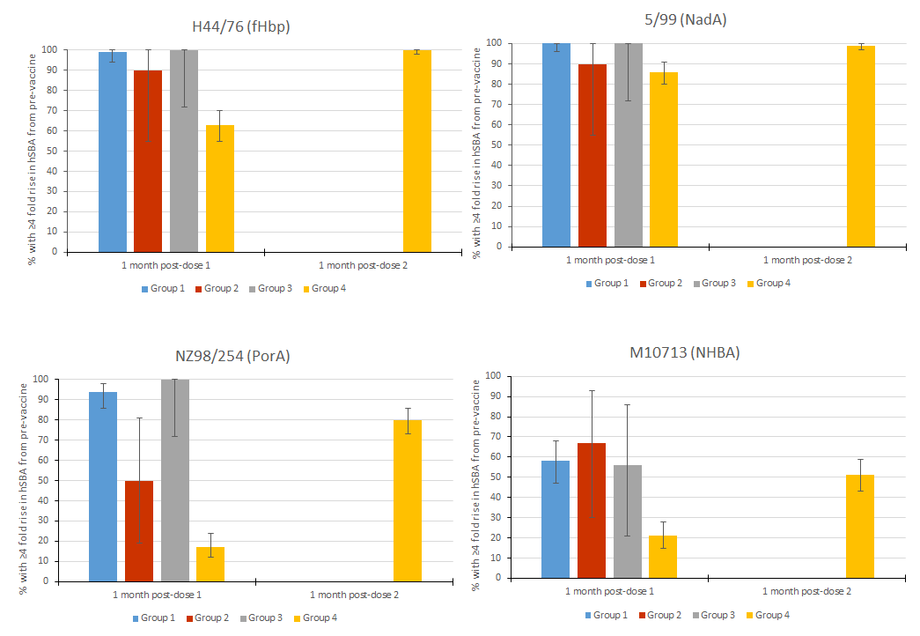
Proportion of participants with ≥4-fold rise in hSBA titre from pre-vaccine to 1 month post-dose 1 (all groups) and 1 month post-dose 2 (Group 4 only). Bars represent overall percentage of participants achieving ≥4-fold rise in hSBA titre, with error bars representing 95% confidence intervals. Data shown separately for the four indicator strains H44/76 (fHbp response), 5/99 (NadA response), NZ98/254 (PorA response) and M10713 (NHBA response). hSBA, human serum bactericidal antibody; 4CMenB, capsular group B meningococcal vaccine.

