Figure 1: CORE CRT Fidelity Scale concept mapping: chosen 4-cluster solution
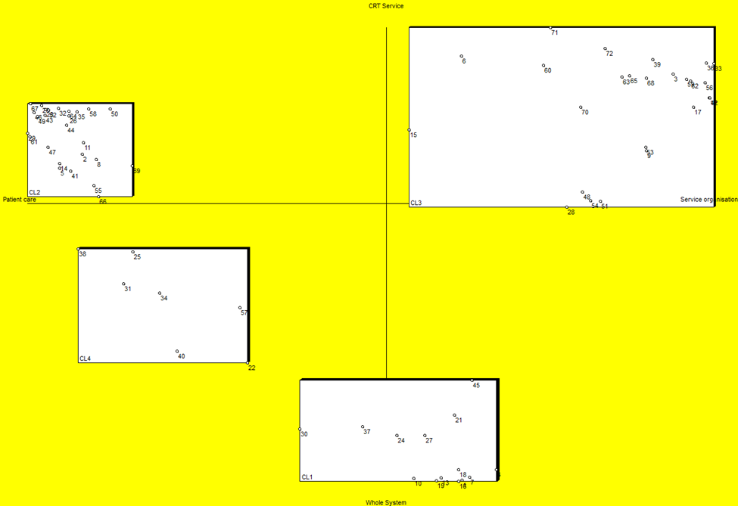
Access and referrals
Timing and location of care

Content and delivery of care
Staffing and team procedures

