Supplementary Materials: A meta-analysis of 120,246 individuals identifies 18 new loci for fibrinogen concentration

Supplementary methods

HapMap proxy search
LD estimation
Micro RNA binding site annotation
Study descriptions

Supplementary tables (in separate excel file)

Supplementary Table 1: Genotyping and quality control methods in the participating studies.
Supplementary Table 2: Imputation and analysis methods in the participating studies.
Supplementary Table 3: Characteristics of the participating studies and their participants.
Supplementary Table 4: Genomic inflation factors by study and analysis.
Supplementary Table 5: Heterogeneity I2 and P-values for lead variants and jointly significant variants.
Supplementary Table 6: Known associations of fibrinogen loci with other traits and diseases.
Supplementary Table 7: Blood eQTL Analysis of lead variants or their closest HapMap proxies.
Supplementary Table 8: Functional annotation of lead SNPs and correlated SNPs (R2 > 0.9).

Supplementary figures

Supplementary Figure 1: Quantile-Quantile (QQ) plots of autosomal variants
Supplementary Figure 2: Manhattan plot of autosomal variants
Supplementary Figure 3: Manhattan plot of uncommon autosomal variants (MAF < 5%).
Supplementary Figure 4: Regional plots of loci associated with circulating fibrinogen concentration.
Supplementary Figure 5: Forest plots of lead variants at loci associated with circulating fibrinogen concentration.
Supplementary Figure 6: Forest plots of additional variants at loci associated with plasma fibrinogen concentration.
Supplementary Figure 7: Quantile-Quantile (QQ) plots of variants on the X chromosome
Supplementary Figure 8: Manhattan plots of variants on the X chromosome

Supplementary methods
HapMap Proxy Search
Publicly available databases can contain only HapMap SNPs rather than all variants found in the 1000G project. For this purpose we identified proxies for our lead variants. For lead variants present in the 1000G pilot 1 dataset, we used the proxy search function in SNAP.(1) For lead variants not present in the 1000G pilot 1 dataset, we used the --ld-snp function in PLINK on the 1000G phase I version 3 EA panel.(2)
LD estimation
For some variants, we estimated the degree of LD with other nearby variants known from the literature. We did this using the --ld function in PLINK on the 1000G phase I version 3 EA panel.(2)
Micro RNA binding site annotation
We used the TargetScan, miRTarBase, and miRecords databases to obtain a comprehensive list of predicted micro RNA (miRNA) target genes.(3-5) We then identified 409,853 SNPs located in predicted miRNA binding sites on the 3’UTR of these genes using the PolymiRTS, Patrocles, miRdSNP, and microSNiPer databases.(6-9) These methods have been described in more detail previously.(10) We used this catalog of variants in miRNA binding sites to further annotate lead variants and variants correlated to lead variants (R2 > 0.9).
Study descriptions
The Atherosclerosis Risk in Communities (ARIC) study recruited 15,792 adults aged 45 to 64 years in 1987 through 1989 by probability sampling from Forsyth County, North Carolina; Jackson, Mississippi; suburbs of Minneapolis, Minnesota; and Washington County, Maryland.(11) The Jackson sample comprised African Americans only; the other three samples represent the ethnic mix of their communities. Extensive information was collected at baseline on cardiovascular risk factors. The ARIC study was approved by the institutional review board of each field center institutes and participants gave informed consent including consent for genetic testing. In this study we included only European American participants.
Fibrinogen was measured at baseline in the entire ARIC cohort after an 8-hour fasting period. Circulating plasma fibrinogen was measured by the Clauss clotting rate method.(12) Participants whose fibrinogen measurement was off 6SD from the mean were also excluded.
The British 1958 birth cohort (B58C) is a national population sample followed periodically from birth. At age 44-45 years, 9377 cohort members were examined by a research nurse in the home as described previously and non-fasting blood samples were collected with permission for DNA extraction and creation of immortalised cell cultures.(13) DNA samples from unrelated subjects of white ethnicity, with nationwide geographic coverage, were genotyped either by the Wellcome Trust Case Control Consortium (WTCCC), the Type 1 Diabetes Genetics Consortium, or the GABRIEL consortium.(14-16)
Details of the blood collection, fibrinogen measurement and covariate adjustment have been described elsewhere(17). In brief, fibrinogen was measured by the Clauss method using an MDA 180 coagulometer (Biomerieux, Basingstoke, UK) and adjusted for sex, laboratory batch, time of day, month of examination, and postal delay.(12) Adjustment for age was not required as all subjects were aged 44-45 years. Use of anticoagulant therapy was a contraindication to blood sampling. Valid fibrinogen measurements were available for 6085 (93.7%) of the 6491 subjects with imputed genotypes.
The Blue Mountains Eye Study (BMES) is a population-based cohort study of eye diseases and other health outcomes in an urban population aged 49 years or older. In 1992-4, 3654 residents (82.4% of those eligible) aged 49+ years, living in two postcode areas near Sydney, Australia, participated; 2335 (75.1% of survivors) were re-examined after 5 years in 1997-9, and 1952 (76% of survivors) were re-examined after 10 years in 2002-4. The study was approved by the University of Sydney and the Sydney West Area Health Service Human Research Ethics Committees, and written, informed consent was obtained.(18, 19)
At baseline, eight-hour fasting blood samples were drawn from 3222 (88%) of 3654 participants for hematology and clinical biochemistry assessments. Blood samples were centrifuged into serum and plasma components and an aliquot of plasma sample was tested for fibrinogen within the same day as sample collection in the Institute of Clinical Pathology and Medical Research (ICPMR) at Westmead Hospital, west of Sydney. Plasma fibrinogen was measured by the Von Clauss assay using an ACL 300 coagulometer (IL-Coulter, Sydney), with a sensitivity of 50 mg/dL and an inter-assay CV of 10% at 200mg/dL.
The Cardiovascular Health Study (CHS) is a population-based cohort study of risk factors for CHD and stroke in adults ≥65 years conducted across 4 field centers.(20) The original predominantly Caucasian cohort of 5,201 persons was recruited in 1989-1990 from random samples of the Medicare eligibility lists; subsequently, an additional predominantly African-American cohort of 687 persons was enrolled for a total sample of 5,888. DNA was extracted from blood samples drawn on all participants at their baseline examination in 1989-90. In this study we included only European American participants.
After an 8-12-h fast, CHS participants underwent phlebotomy by atraumatic venipuncture with a 21-gauge butterfly needle connected to a Vacutainer (Becton Dickinson, Rutherford, NJ) outlet via a Luer adaptor.(21) For fibrinogen determination, an additional citrate-containing tube was processed at 4°C. The study measured fibrinogen levels using the Clauss methods.
The CROATIA-Split study is a population-based, cross-sectional study in the Dalmatian City of Split in Croatia that includes 1000 examinees aged 18-95. Blood samples were collected in 2009 and 2010 along with many clinical and biochemical measures and lifestyle and health questionnaires. A detailed description of the study has been published elsewhere.(22)
The CROATIA-Korcula study is a family-based, cross-sectional study in the isolated island of Korcula in Croatia that included 965 examinees aged 18-95. Blood samples were collected in 2007 along with many clinical and biochemical measures and lifestyle and health questionnaires. A detailed description of the study has been published elsewhere.(23)
The CROATIA-Vis study is a family-based, cross-sectional study in the isolated island of Vis in Croatia that included 1,056 examinees aged 18-93. Blood samples were collected in 2003 and 2004 along with many clinical and biochemical measures and lifestyle and health questionnaires. A detailed description of the study has been published elsewhere.(24)
All 3 CROATIA studies used the Clauss method for measuring plasma fibrinogen.(12)
The European Prospective Investigation in Cancer (EPIC) Norfolk Study (EPIC-Norfolk) The EPIC-Norfolk GWAS consists of 1,284 obese individuals and 2,566 random subcohort in a case-cohort design randomly selected from the EPIC Norfolk Study, a population‐based cohort study of 25,663 men and women of European descent aged 39‐79 years recruited in Norfolk, UK between 1993 and 1995.(25) Height and weight were measured using standard anthropometric techniques. After quality controls, 3,552 individuals remained in the final sample. The Norwich Local Research Ethics Committee granted ethical approval for the study. All participants gave written informed consent.
Fibrinogen concentration in g/L: A non-fasting blood sample (42 mL) was collected at baseline health check in 1993-1997. Samples later used for fibrinogen analyses were collected in citrated bottles, stored in refrigerator at 4°C overnight and transferred the following morning to the EPIC laboratory for processing. Plasma not required for immediate analysis was frozen in aliquots in liquid nitrogen at -196°C. Between 2000 and 2002 aliquots of plasma were retrieved from liquid nitrogen and thawed for fibrinogen analysis. Fibrinogen was measured by a functional assay based on the method of Clauss using the commercial kit Fibriquik (bioMerieux, Lyon, France) on an MDA180 automated analyser (bioMerieux).(12, 26)
The Framingham Heart Study (FHS) was started in 1948 with 5,209 randomly ascertained participants from Framingham, Massachusetts, US, who had undergone biannual examinations to investigate cardiovascular disease and its risk factors. In 1971, the Offspring cohort (comprising 5,124 children of the original cohort and the children's spouses) and in 2002, the Third Generation (consisting of 4,095 children of the Offspring cohort) were recruited. FHS participants in this study are of European ancestry. The methods of recruitment and data collection for the Offspring and Third Generation cohorts have been described.(27)
Fibrinogen levels were measured using the Clauss method in the offspring and the third-generation subjects,(12) and a modified method of Ratnoff and Menzie in the original cohort subjects.(28)
GeneSTAR (Genetic Study of Atherosclerosis Risk) is an ongoing prospective family study begun in 1983 to determine environmental, phenotypic, and genetic causes of premature cardiovascular disease.(29) Briefly, probands with a premature coronary disease event prior to 60 years of age were identified at the time of hospitalization in any of 10 Baltimore area hospitals. Their apparently healthy 30-59 year old siblings without known CAD were recruited and underwent phenotypic measurement and characterization between 1983 and 2006; offspring of the siblings and probands, as well as the co-parent of these offspring, were recruited and assessed between 2003 and 2006. Participants are followed for coronary artery disease events at regular intervals. In this study, only European American participants were included.
Blood was obtained from venipuncture and collected into vacutainer tubes containing 3.2% sodium citrate. Plasma fibrinogen was measured using a modified Clauss method on an automated optical clot detection device (Dade-Behring, Newark, DE). Excess thrombin was added to citrated plasma, and the time needed for clot formation was recorded. This clotting time was then compared with that of a standardized fibrinogen preparation.
The Genetic Epidemiology Network of Arteriopathy (GENOA) study is one of four networks in the NHLBI Family-Blood Pressure Program (FBPP).(30) GENOA's long-term objective is to elucidate the genetics of target organ complications of hypertension, including both atherosclerotic and arteriolosclerotic complications involving the heart, brain, kidneys, and peripheral arteries. The longitudinal GENOA Study recruited European-American and African-American sibships with at least two individuals with clinically diagnosed essential hypertension before age 60 years. All other members of the sibship were invited to participate regardless of their hypertension status. Exclusion criteria were secondary hypertension, alcoholism or drug abuse, pregnancy, insulin-dependent diabetes mellitus, or active malignancy. The current study was limited to European Americans recruited at the Mayo Clinic in Rochester, MN. Fibrinogen levels and GWAS data were available for 1,117 participants. Study protocols were approved by the University of Michigan and Mayo Clinic Institutional Review Boards and participants gave written informed consent.
Blood was drawn after an overnight fast. Fibrinogen was measured from citrated blood by the Clauss (clotting time-based) method.(12)

The Gutenberg Health Study (GHS) is designed as a population-based, prospective, observational single-center cohort study in the Rhein-Main-Region in western Mid-Germany to evaluate and improve cardiovascular risk stratification.(31) The sample was drawn randomly from the governmental local registry offices in the city of Mainz and the district of Mainz-Bingen. The sample was stratified 1:1 for gender and for urban and rural residence with equal strata for decades of age. Individuals between 35 and 74 years of age were enrolled. In, total 15,010 study participants were included. A large variety of non-invasive cardiovascular phenotypes have been assessed and blood samples were drawn for biomarker measurements and genetic analyses. The study protocol and the sampling design were approved by the local ethics committee, and by the local and federal data safety commissioners. All participants gave written informed consent. Further, microarray-based analyses were performed in 3,891 individuals (SNP 6.0, Affymetrix, Santa Clara, CA). The analyses were subdivided into two batches, i.e. the microarray analyses of 1) 2,743 individuals were performed in 2008 (GHS I) and 2) of 1,148 individuals in 2009 (GHS II).
Fibrinogen was performed in citrated human plasma of 4,674 GHS participants. The analyses were done on the automated coagulation analyser BCS II (Siemens Diagnostics, Marburg, Germany) using reagents supplied by the manufacturer of the instrument. Assay plasma was brought to coagulation by a large excess of thrombin using the Multifibren U reagent (modification of the Clauss method).
The GOYA (Male) cohort is a longitudinal case-cohort (obese, non-obese) study comprising a randomly (1%) selected control group and all extremely overweight men identified among 362,200 Caucasian men examined at the mean age of 20 years at the draft boards in Copenhagen and its surrounding areas during 1943–1977. Obesity was defined as 35% overweight relative to a local standard in use at the time (mid 1970’s), corresponding to a BMI ≥31.0 kg/m2, which proved to be above the 99th percentile. All of the obese and 50% of the random sampled controls, who were still living in the region, were invited to a follow-up survey in 1992–94 at the mean age of 46 years, at which time the blood samples were taken and genotyping were performed for a total of 673 extremely overweight and 792 controls.(32) With a sampling fraction of 0.5% (50% of 1%), the controls represent about 158,000 men among whom the case group was the most obese.
A functional photometric assay was employed to estimate fibrinogen concentration. The sample is mixed with a snake venom enzyme (Batroxobin) and fibrin formation is recorded turbidimetrically at 334 nm. Reaction conditions are such that a linear increase in absorbance is obtained over a concentration range of fibrinogen from 80-700 mg/dl. Higher or lower ranges can be measured by adjusting the sample volume. Calibration is performed with a single standard.(33)
The Helsinki Birth Cohort Study (HBCS) is composed of 8 760 individuals born between the years 1934-44 in one of the two main maternity hospitals in Helsinki, Finland. Between 2001 and 2003, a randomly selected sample of 928 males and 1 075 females participated in a clinical follow-up study with a focus on cardiovascular, metabolic and reproductive health, cognitive function and depressive symptoms. Detailed information on the selection of the HBCS participants and on the study design can be found elsewhere.(34-36) Research plan of the HBCS was approved by the Institutional Review Board of the National Public Health Insitute and all participants have signed an informed consent.
Fibrinogen levels were measured using the Clauss method with an electrical impedance end point.(12) Plasma fibrinogen was measured in g/L and was natural log transformed to attain normality. After excluding subjects with anticoagulant medication (n=308), there were 1,314 subjects with both valid phenotype and genotype data (40.6% men). The mean age of the subjects was 61.4 (SD=2.9).
The Hunter Community Study (HCS) is a population-based prospective cohort study of community-dwelling men and women aged 55–85 years of age who reside in Newcastle, New South Wales (NSW), Australia. The cohort comprises 3253 participants that were randomly selected from the NSW State electoral roll between 2004 and 2007: details of recruitment have been published previously.(37)
Citrated plasma was used for the fibrinogen assay, which was performed on a STAGO Evolution Expert Series platform using a Clauss technique. This was performed at baseline before the samples had been aliquoted for long term freezer storage.
The Aging in the Chianti Area (InCHIANTI) study is a population-based epidemiological study aimed at evaluating the factors that influence mobility in the older population living in the Chianti region in Tuscany, Italy. The details of the study have been previously reported.(38) Briefly, 1616 residents were selected from the population registry of Greve in Chianti (a rural area: 11,709 residents with 19.3% of the population greater than 65 years of age), and Bagno a Ripoli (Antella village near Florence; 4,704 inhabitants, with 20.3% greater than 65 years of age). The participation rate was 90% (n=1453).
Overnight fasted blood samples were used for genomic DNA extraction, and measurement of fibrinogen. Plasma fibrinogen concentrations were measured by the Clauss method using STA fibrinogen assay (Diagnostic Stago, Roche Diagnostics, France)(12). The intra- and inter-assay CV was 4.1%.
The Monitoring of Trends and Determinants in Cardiovascular Disease/Cooperative Health Research in the Region of Augsburg Study (KORA) consisted of a series of independent population-based epidemiological surveys of participants living in the region of Augsburg, Southern Germany.(39, 40) All survey participants are residents of German nationality identified through the registration office and underwent standardized examinations including blood withdrawals for plasma and DNA. The presented data were derived from the KORA surveys S4 (conducted in 1999-2001) and F4 (conducted in 2006-2008) and comprised 3,720 participants with available fibrinogen and DNA information.
Fibrinogen was determined by an immunonephelometric method (Dade Behring Marburg GmbH, Marburg, Germany) on a Behring Nephelometer II analyzer.
The Lothian Birth Cohort (LBC) studies, LBC1936 & LBC1921, were ascertained as follows.
The LBC1936 consists of 1,091 relatively healthy individuals assessed on cognitive and medical traits at 70 years of age. They were born in 1936, most took part in the Scottish Mental Survey of 1947, and almost all lived independently in the Lothian region of Scotland (Edinburgh City and surrounding area). A full description of participant recruitment and testing can be found elsewhere.(41, 42) The LBC1921 cohort consists of 550 relatively healthy individuals, 316 females and 234 males, assessed on cognitive and medical traits at 79 years of age. They were born in 1921, most took part in the Scottish Mental Survey of 1932, and almost all lived independently in the Lothian region in Scotland. A full description of participant recruitment and testing can be found elsewhere.(41, 43) Ethics permission for the study was obtained from the Multi-Centre Research Ethics Committee for Scotland (MREC/01/0/56) and from Lothian Research Ethics Committee (LBC1936: LREC/2003/2/29 and LBC1921: LREC/1998/4/183). The research was carried out in compliance with the Helsinki Declaration. All subjects gave written, informed consent.
Fibrinogen levels were measured using HemosILTM based on the Clauss method. No exclusions were applied. Outliers were removed (>3.3SD). Plasma fibrinogen was in g/L, natural log transformed.
The Ludwigshafen Risk and Cardiovascular Health (LURIC) study is an ongoing prospective study of more than 3,300 individuals of German ancestry in whom cardiovascular and metabolic phenotypes (CAD, MI, dyslipidemia, hypertension, metabolic syndrome and diabetes mellitus) have been defined or ruled out using standardized methodologies in all study participants. Inclusion criteria for LURIC were: German ancestry (limitation of genetic heterogeneity), clinical stability (except for acute coronary syndromes) and availability of a coronary angiogram. Exclusion criteria were: any acute illness other than acute coronary syndromes, any chronic disease where non-cardiac disease predominated and a history of malignancy within the last five years. Genome-wide analyses using the Affymetrix 6.0 have been completed in all participants. A 10-year clinical follow-up for total and cause specific mortality has been completed.
Fasting blood samples were collected at baseline in the morning before angiography. Fibrinogen was measured in citrate plasma using the Clauss method (STA fibrinogen/STA Stago, Stago Diagnostica/Roche Mannheim, Germany) at the Haemostaseology Laboratory of the Ludwigshafen hospital on a daily basis.
The MARseille THrombosis Association (MARTHA) project has been previously described(44). Briefly, MARTHA consist in two independent samples of VT patients, named MARTHA08 (N=1,006) and MARTHA10 (N=586). MARTHA patients are unrelated subjects of European origin, with the majority being of French ancestry, consecutively recruited at the Thrombophilia center of La Timone hospital (Marseille, France) between January 1994 and October 2005. All patients had a documented history of VT and free of well characterized genetic risk factors including AT, PC, or PS deficiency, homozygosity for FV Leiden or FII 20210A, and lupus anticoagulant. They were interviewed by a physician on their medical history, which emphasized manifestations of deep vein thrombosis and pulmonary embolism using a standardized questionnaire. The thrombotic events were confirmed by venography, Doppler ultrasound, spiral computed tomographic scanning angiography, and/or ventilation/perfusion lung scan.
Blood samples were collected by antecubital venipuncture into Vacutainer® tubes 0.105 M trisodium citrate (ratio 9:1, Becton Dickinson) for the coagulation test and the thrombin generation assay. Platelet-poor plasma (PPP) was obtained after double centrifugation of citrated blood (3000 g for 10 min at 25°C) and kept frozen at -80°C until analysis. Fibrinogen levels were measured using the Clauss method on STAR automatic coagulomater.(12)
The Multi-Ethnic Study of Atherosclerosis (MESA) is a cohort study designed to investigate the characteristics of subclinical cardiovascular disease and the risk factors that predict progression to clinically overt cardiovascular disease or progression of the subclinical disease. MESA comprises a diverse, population-based sample of 6,814 asymptomatic men and women aged 45-84. Thirty-eight percent of the recruited participants are Caucasian, 28 percent African-American, 22 percent Hispanic, and 12 percent Asian, predominantly of Chinese descent.(45) Participants were recruited from six field centers across the United States: Wake Forest University, Columbia University, Johns Hopkins University, University of Minnesota, Northwestern University and University of California - Los Angeles. In this study we included only European American participants.
Fasting blood samples were collected, processed, and stored using standardized procedures. Fibrinogen antigen was measured using the BNII nephelometer (N Antiserum to Human Fibrinogen; Dade Behring Inc., Deerfield, IL). The assay was performed at the Laboratory for Clinical Biochemistry Research (University of Vermont, Burlington, VT). Intra- and inter-assay analytical coefficients of variation were 2.7% and 2.6%, respectively.
As part of a Netherlands Twin Registry (NTR) biobank project, 9,530 participants from 3,477 families were visited at home between January 2004 and July 2008 for collection of blood samples. Visits were scheduled between 7:00 and 10:00 am and fertile women were bled on day 2–4 of the menstrual cycle, or in their pill-free week. Fertile women were bled on day 2–4 of the menstrual cycle, or in their pill-free week. Body composition was measured and information about physical health and lifestyle (e.g. smoking and drinking behavior, physical exercise, medication use) was obtained. For more detailed information about the methodology of the NTR Biobank study, see.(46) The NTR studies were approved by the Central Ethics Committee on Research involving human subjects of the VU University Medical Center, Amsterdam, an Institutional Review Board certified by the US Office of Human Research Protections (IRB number IRB-2991 under Federal wide Assurance-3703; IRB/institute codes, NTR 03-180). All subjects provided written informed consent. Valid GWA data were available for 6171 individuals.
Fibrinogen was measured in a 4.5 ml CTAD tube that was stored during transport in melting ice and upon arrival at the laboratory, centrifuged for 20 minutes at 2000x g at 4° C, after which citrated plasma was harvested, aliquoted (0.5 ml), snapfrozen in dry ice, and stored at –30° C. Fibrinogen levels were determined on a STA Compact Analyzer Diagnostica Stago, France), using STA Fibrinogen (Diagnostica Stago, France).
The Orkney Complex Disease Study (ORCADES) recruited 2078 volunteers in the Scottish archipelago of Orkney between 2005 and 2011. Participants were aged from 18 to 100 years (mean age 53). Fasting blood samples were collected and over 300 health-related phenotypes and environmental exposures were measured in each individual. A detailed description of the study has been published elsewhere.(47)
Citrated blood samples were collected before 9.30 am after an overnight fast and processed immediately after venipuncture. Plasma fibrinogen was measured using the Clauss method.(12)
The Precocious Coronary Artery Disease Study (PROCARDIS) consists of coronary artery disease (CAD) cases and controls from four European countries (UK, Italy, Sweden and Germany). CAD (defined as myocardial infarction, acute coronary syndrome, unstable or stable angina, or need for coronary artery bypass surgery or percutaneous coronary intervention) was diagnosed before 66 years of age and 80% of cases had a sibling fulfilling the same criteria for CAD. Subjects with self-reported non-European ancestry were excluded. Among the “genetically-enriched” CAD cases, 70% had suffered myocardial infarction (MI).
Plasma fibrinogen concentrations for the Procardis-clauss sub-sample were measured in fasting citrate plasma samples by the Clauss method using the IL Test Fibrinogen C kit and IL Test Calibration Plasma, on the ACL-9000 coagulometer (all from Instrumentation Laboratory Spa, Milan, Italy).(12) The inter-assay CV was 7% (n=106). For the Procardis-immunonephelometric, fibrinogen was measured in EDTA plasma samples using Dade Behring reagents on the Dade-Behring Nephelometer II analyzer (Dade-Behring, Marburg, Germany). The inter-assay CV was 5.5%.
PROspective Study of Pravastatin in the Elderly at Risk (PROSPER-PHASE) was a prospective multicenter randomized placebo-controlled trial to assess whether treatment with pravastatin diminishes the risk of major vascular events in elderly. Between December 1997 and May 1999, we screened and enrolled subjects in Scotland (Glasgow), Ireland (Cork), and the Netherlands (Leiden). Men and women aged 70-82 years were recruited if they had pre-existing vascular disease or increased risk of such disease because of smoking, hypertension, or diabetes. A total number of 5804 subjects were randomly assigned to pravastatin or placebo. A large number of prospective tests were performed including Biobank tests and cognitive function measurements. A detailed description of the study has been published elsewhere.(48, 49)
Fibrinogen levels were measured by the Clauss method using aMDA180 coagulometer (Trinity Biotech; calibrant 9th British standard National Institute for Biological Standards and Control).(12)
The Rotterdam Study (RS-I and RS-II) is a prospective, population-based cohort study of determinants of several chronic diseases in older adults.(50) RS-I comprised 7,983 inhabitants of Ommoord, a district of Rotterdam in the Netherlands, who were 55 years or over. The baseline examination took place between 1990 and 1993. In 1999, the cohort was extended to include 3011 inhabitants who reached the age of 55 years after the baseline examination and persons aged 55 years or older who migrated into the research area (RS-II). Subjects are of European ancestry based on their self-report.
In RS-I, fibrinogen levels were derived at baseline (RS-I-1) from the clotting curve of the prothrombin time assay using Thromborel S as a reagent on an automated coagulation laboratory 300 (ACL 300, Instrumentation Laboratory, Zaventem, Belgium). At the second follow up of RS-I (RS-I-3) and the baseline visit of RS-II, fibrinogen levels were derived from the clotting curve of the prothrombin time assay using Thromborel S (Behringwerke, Marburg, Germany) as a reagent on an automated coagulation analyzer (Sysmex CA-500 Series Systems, Siemens, Breda, the Netherlands).
The SardiNIA study has been previously described.(51) Briefly, it is a large population-based study which consists of 6,921 individuals, males and females, ages 14-102 y, and representing >60% of the adult population of four villages in the Lanusei Valley of Sardinia. Samples have been characterized for several quantitative traits and medical conditions, including fibrinogen.
Fibrinogen levels were measured using the Clauss method.(12)
The Study of Health in Pomerania (SHIP) is a longitudinal cohort study in West Pomerania, the north-east area of Germany and has been described previously.(52, 53) From the entire study population of 212,157 inhabitants living in the area, a sample was selected from the population registration offices, where all German inhabitants are registered. Only individuals with German citizenship and main residency in the study area were included. A two-stage cluster sampling method was adopted from the WHO MONICA Project Augsburg, Germany. In a first step, the three cities of the region (with 17,076 to 65,977 inhabitants) and the 12 towns (with 1,516 to 3,044 inhabitants) were selected. Further 17 out of 97 smaller towns (with less than 1,500 inhabitants) were drawn at random. In a second step, from each of the selected communities, subjects were drawn at random, proportional to the population size of each community and stratified by age and gender. Finally, 7,008 subjects aged 20 to 79 years were sampled, with 292 persons of each gender in each of the twelve five-year age strata. In order to minimize drop-outs by migration or death, subjects were selected in two waves. The net sample (without migrated or deceased persons) comprised 6,267 eligible subjects. The SHIP population finally comprised 4,308 participants at baseline (corresponding to a final response of 68.8%).
A non-fasting blood sample was drawn from the antecubital vein in the supine position and immediately analyzed or stored at -80°C. Plasma fibrinogen concentrations were assayed according to Clauss using an Electra 1600 analyzer (Instrumentation Laboratory, Barcelona, Spain).(12) Coagulation time is measured and transferred into the result in g/L by applying a reference curve calculated in the laboratory. The assay proves linearity between 0.7 – 7 g/L. The analytical sensitivity of the assay was 0.7 g/L. Internal quality control measures were performed daily using two levels of manufacturers’ control materials. External quality control measures were performed on a regular basis by participating in analysis programs. The inter-assay coefficients of variation were 4.61 % at low levels (mean value = 0.95 g/L) and 1.82% at high levels (mean value = 3.22 g/L) of control material.
The TwinsUK cohort was derived from the UK adult twin registry based at King’s College London (www.twinsUK.ac.uk). These unselected twins have been recruited from the general population through national media campaigns in the United Kingdom and shown to be comparable to age-matched population singletons in terms of disease-related and lifestyle characteristics.(54) Informed consent was obtained from all participants and the study was approved by the St. Thomas' Hospital Ethics Committee.
Fasting blood samples was taken from samples into 0.13 trisodium citrate containers (Becton Dickinson, Oxford, United Kingdom) at room temperature, centrifuged at 2560g for 20 minutes to obtain platelet-poor plasma within 1 hour of collection and stored at –40°C until analysis. Fibrinogen levels were determined using the Clauss method.(12, 55)
The Women’s Genome Health Study (WGHS) is a prospective cohort of initially healthy, female North American health care professionals at least 45 years old at baseline representing participants in the Women’s Health Study (WHS) who provided a blood sample at baseline and consent for blood-based analyses.(56) The WHS was a 2x2 trial beginning in 1992-1994 of vitamin E and low dose aspirin in prevention of cancer and cardiovascular disease with about 10 years of follow-up. Since the end of the trial, follow-up has continued in observational mode. Additional information related to health and lifestyle were collected by questionnaire throughout the WHS trial and continuing observational follow-up.
Fibrinogen in plasma from the baseline blood sample was measured by a mass-based immunoturbidimetric assay (DiaSorin) with reproducibility of 5.20% and 3.99% at concentrations of 0.99 and 2.74 g/L respectively.
The Women’s Health Initiative (WHI) is one of the largest (n=161,808) studies of women's health ever undertaken in the U.S.(57) There are two major components of WHI: (1) a Clinical Trial (CT) that enrolled and randomized 68,132 women ages 50 – 79 into at least one of three placebo-control clinical trials (hormone therapy, dietary modification, and calcium/vitamin D); and (2) an Observational Study (OS) that enrolled 93,676 women of the same age range into a parallel prospective cohort study. DNA was extracted by the Specimen Processing Laboratory at the Fred Hutchinson Cancer research Center (FHCRC) using specimens that were collected at the time of enrollment. Only Caucasian participants with fibrinogen measured at baseline were included in this analysis.

Supplementary Figures
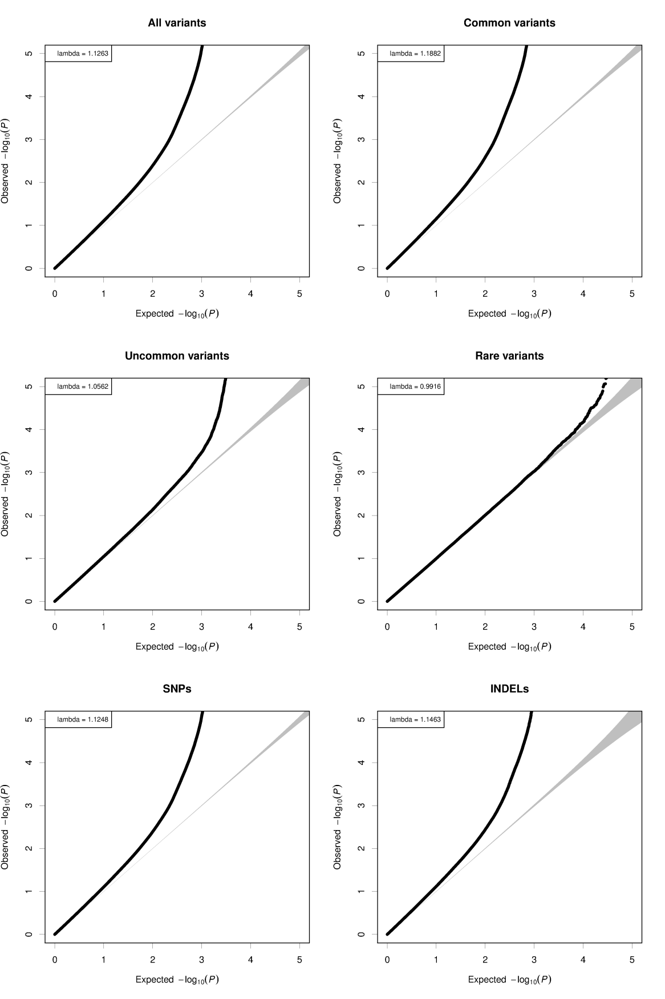
Supplementary Figure 1: Quantile-Quantile (QQ) plots of autosomal variants*.

*Shown separately for common variants (minor allele frequency > 5%), uncommon variants (minor allele frequency ≤ 5% & minor allele frequency > 1%), rare variants (minor allele frequency ≤ 1%), SNPs, and indels.

Supplementary Figure 2: Manhattan plot of autosomal variants
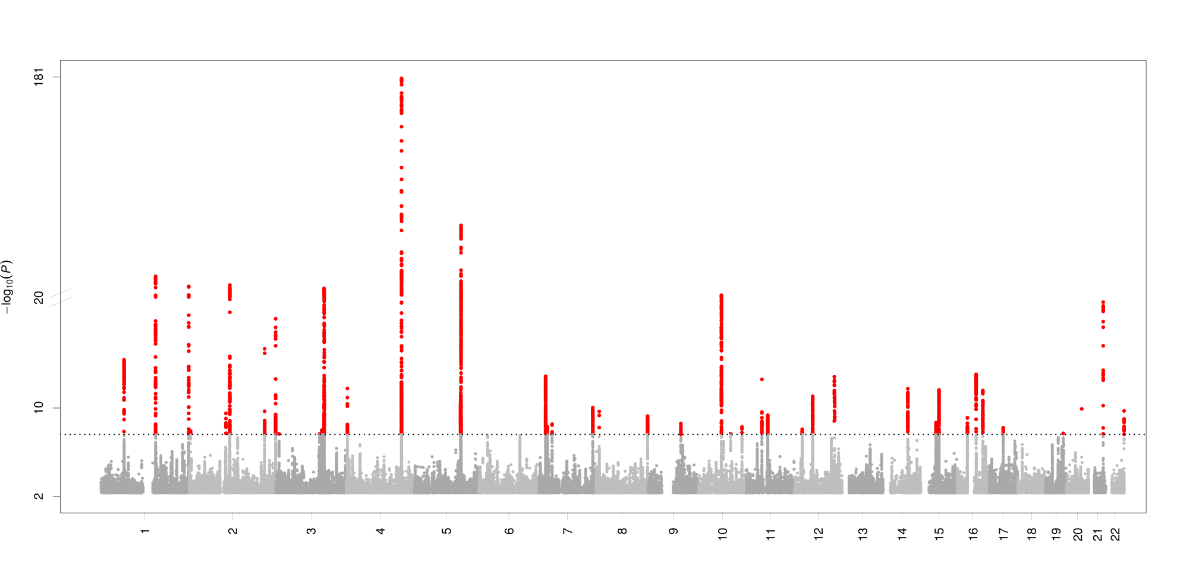
Supplementary Figure 3: Manhattan plot of uncommon and rare autosomal variants (minor allele frequency ≤ 5%).

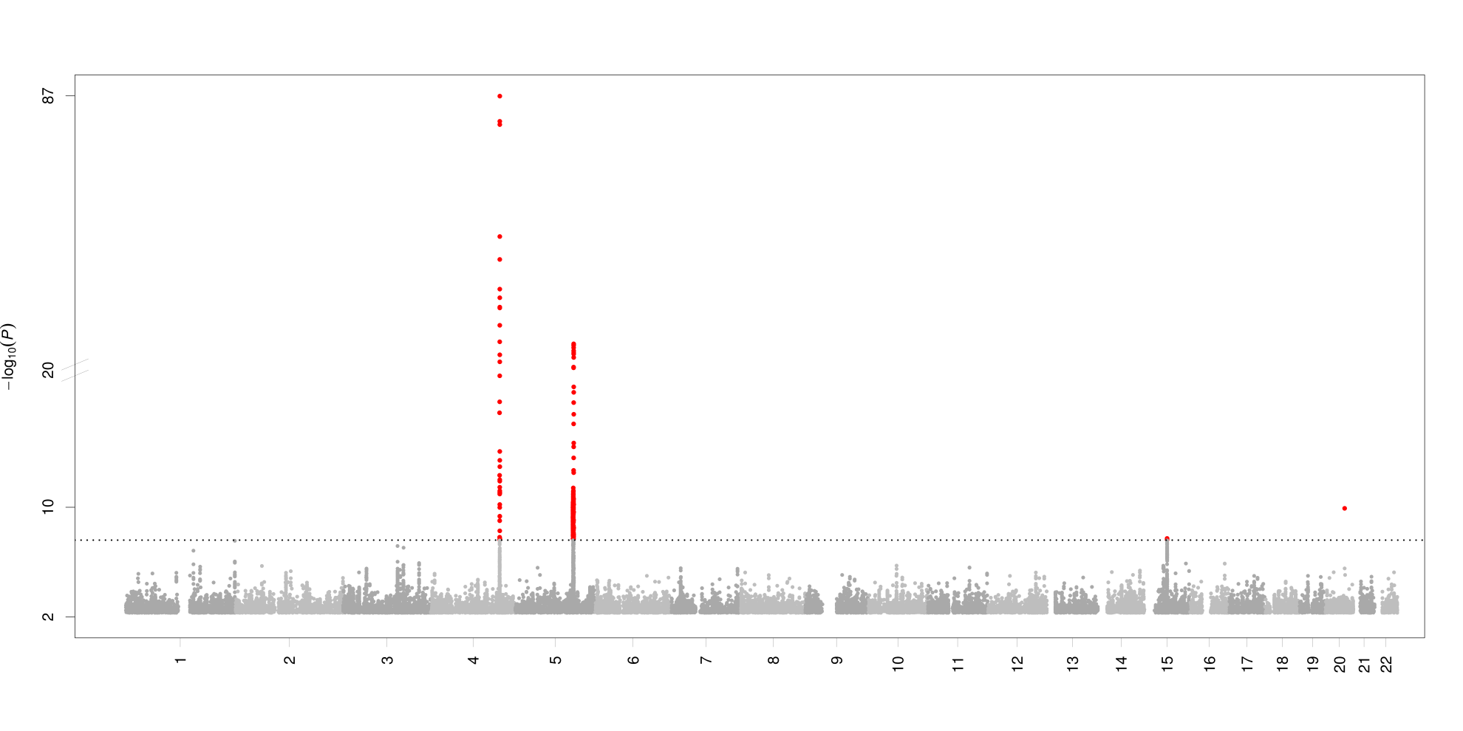
Supplementary Figure 4: Regional plots of loci associated with circulating fibrinogen concentration.
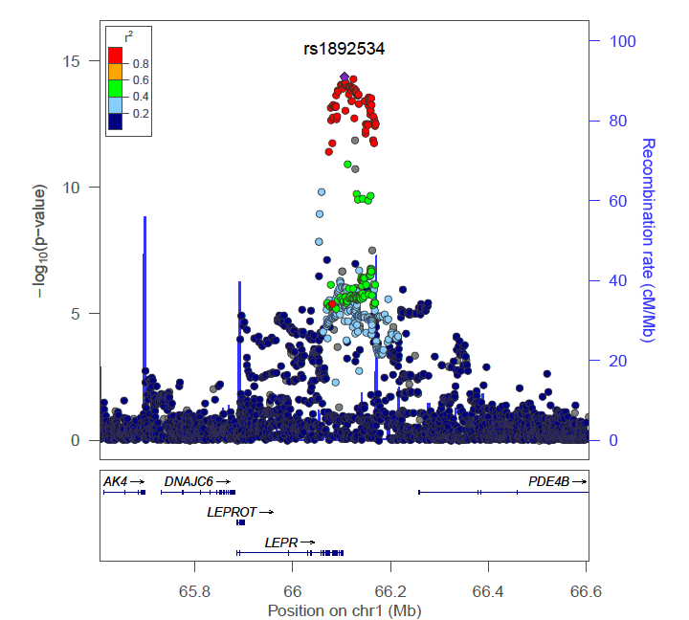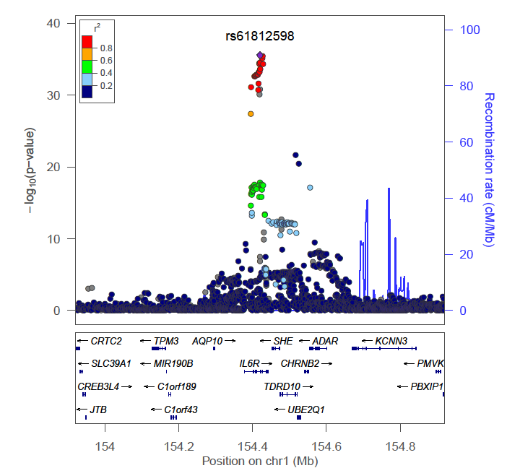

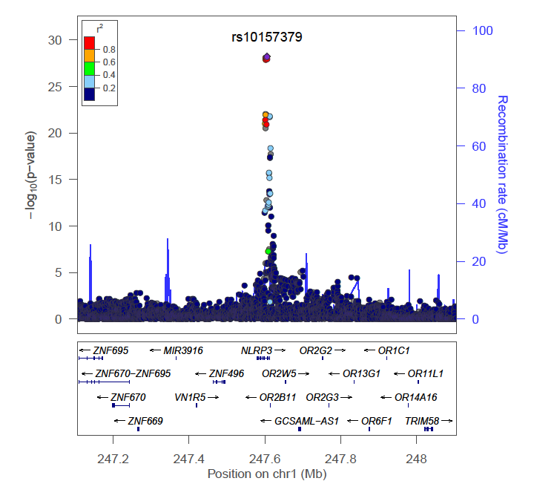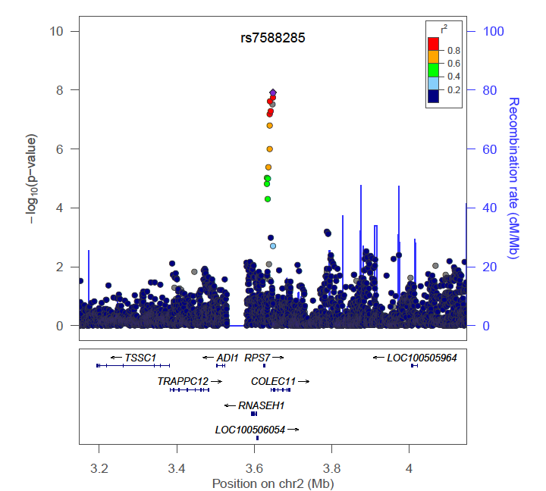
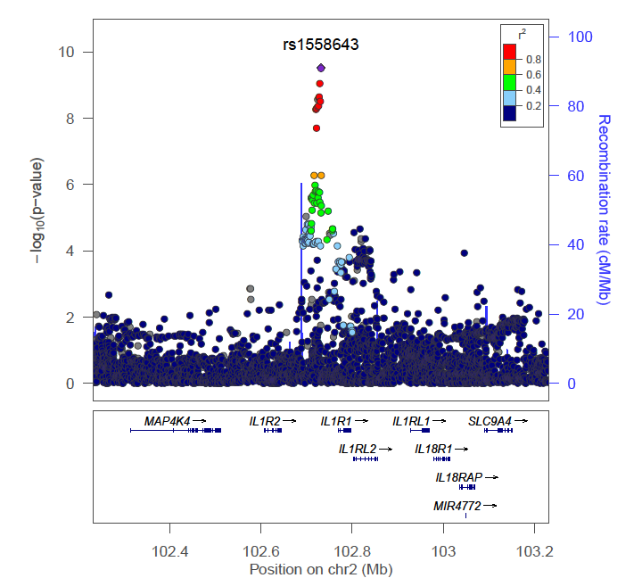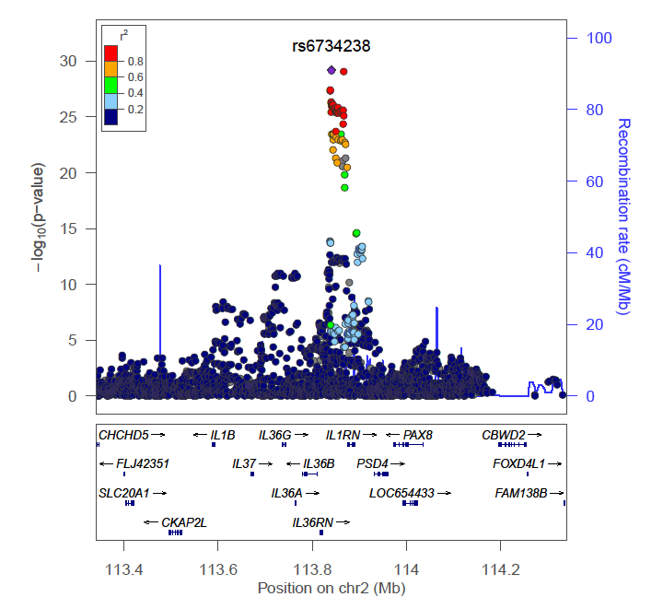

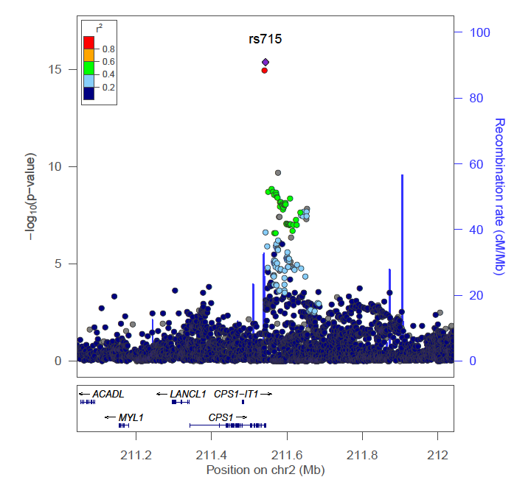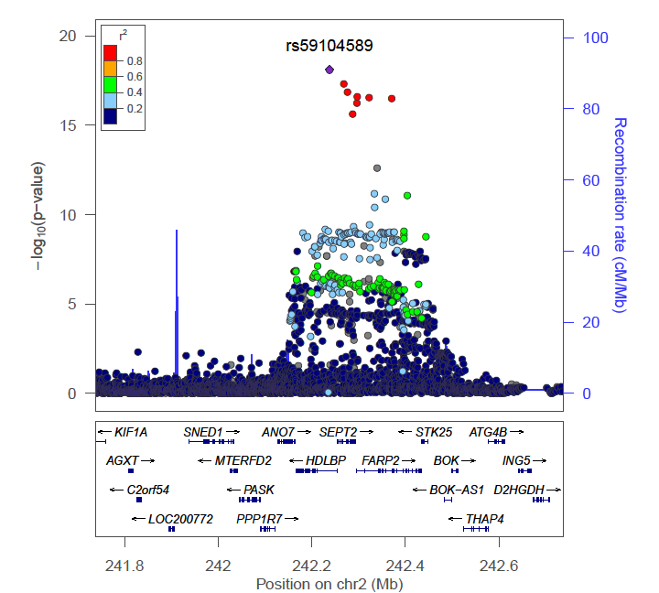
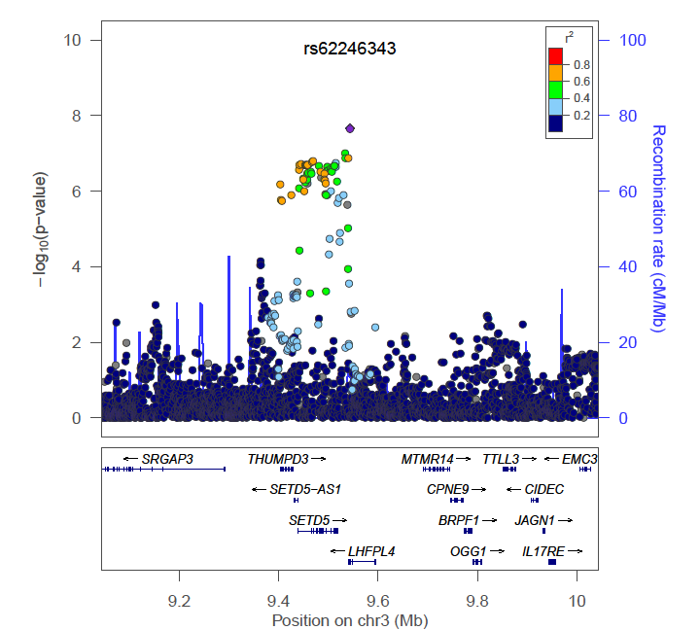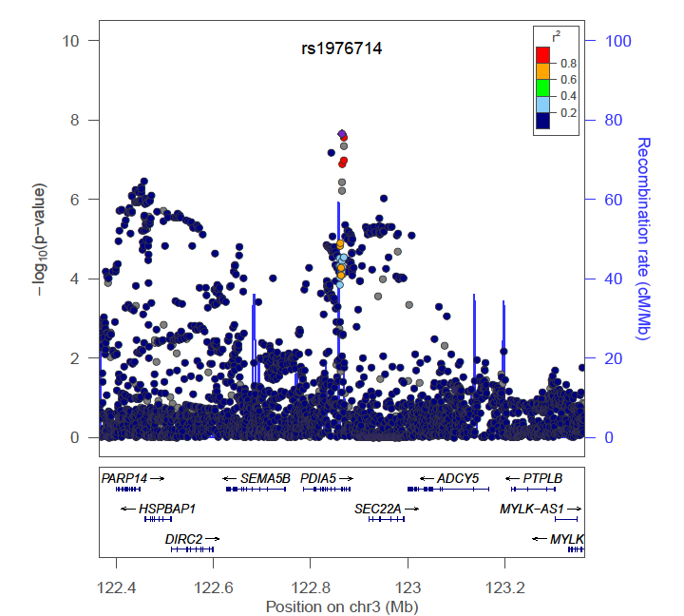
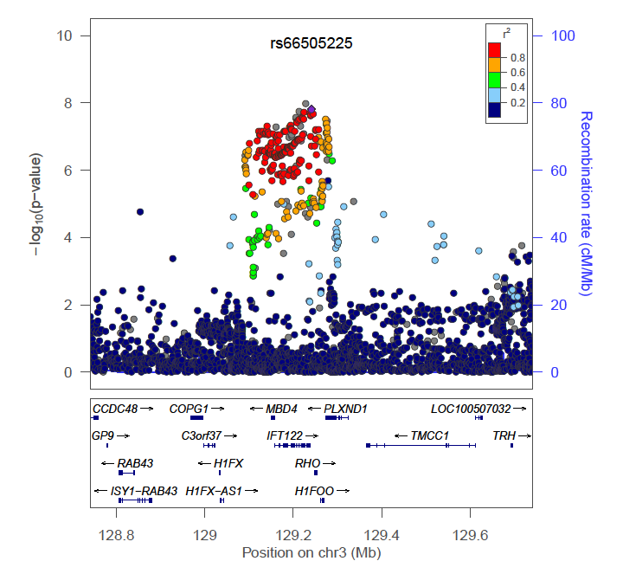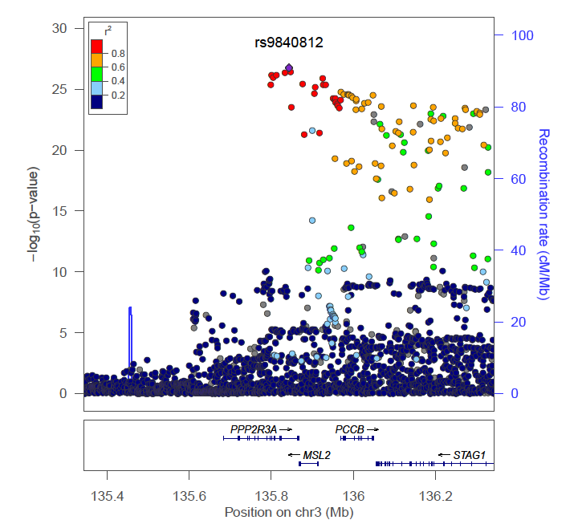

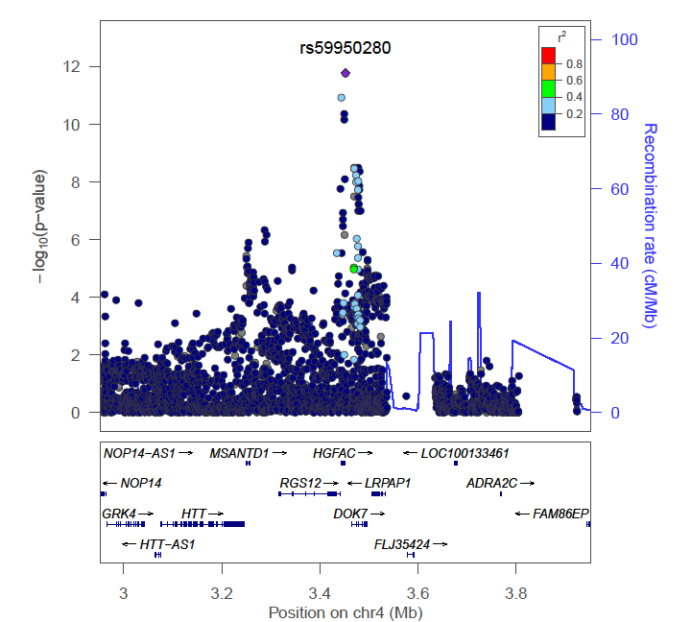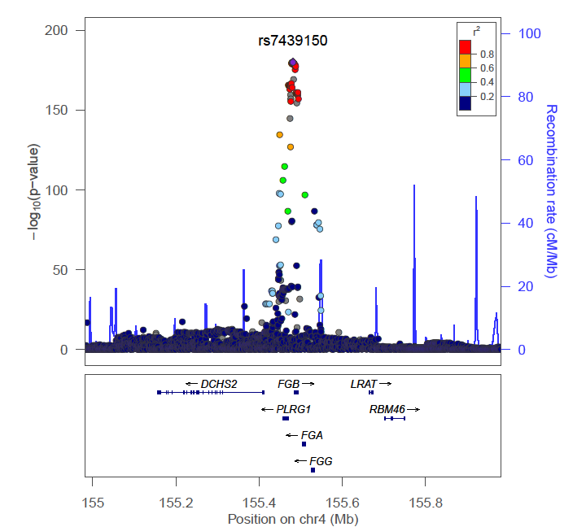
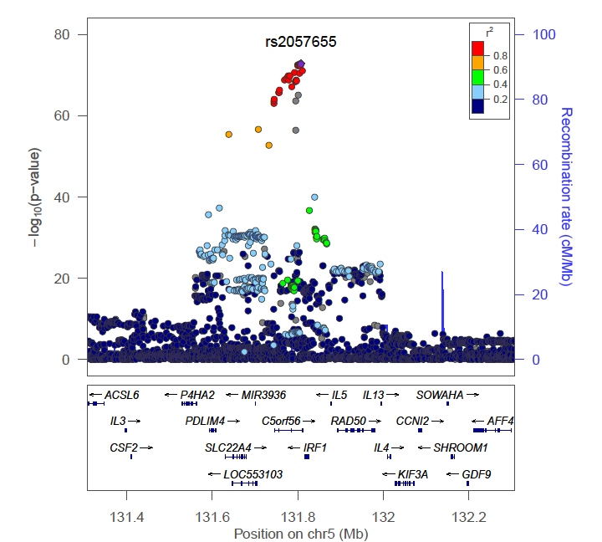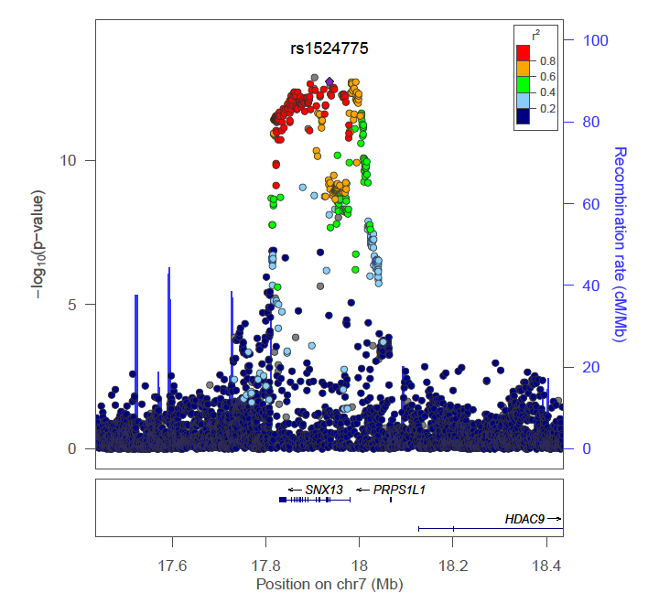
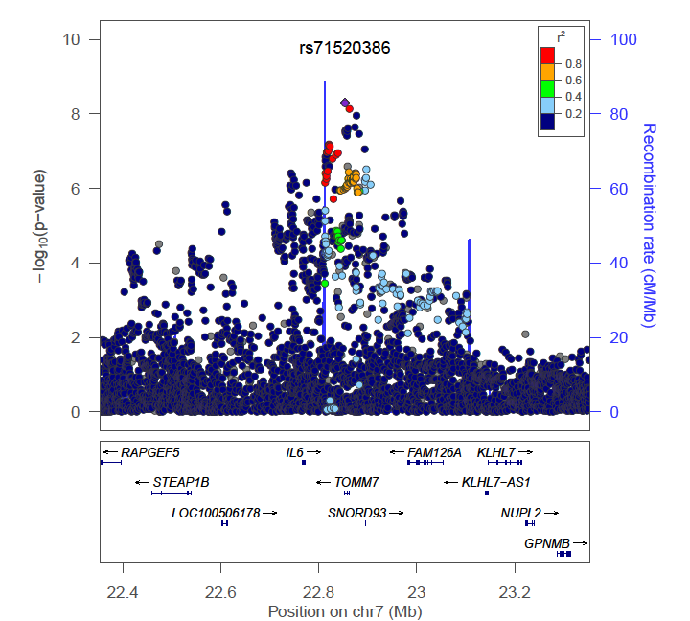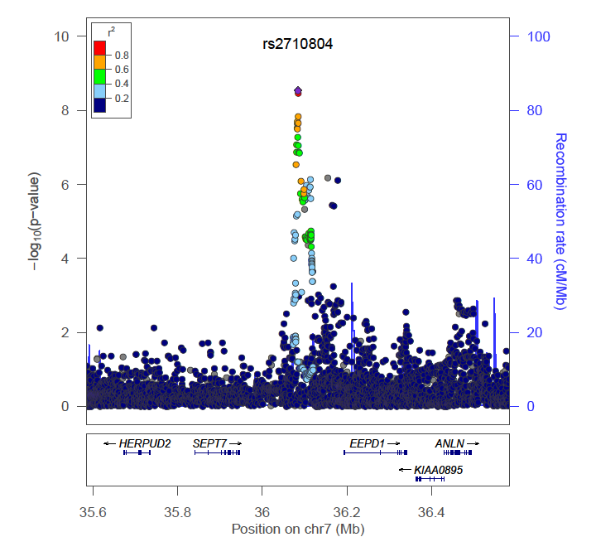

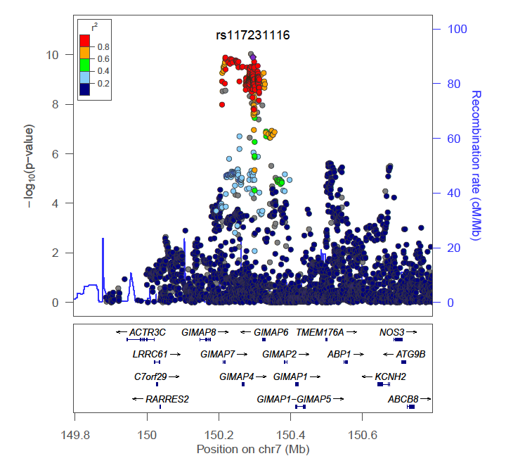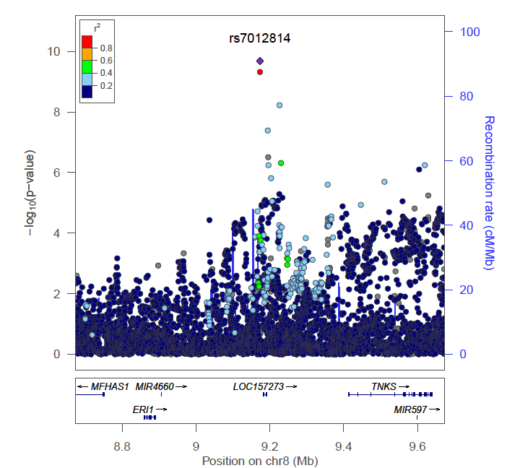
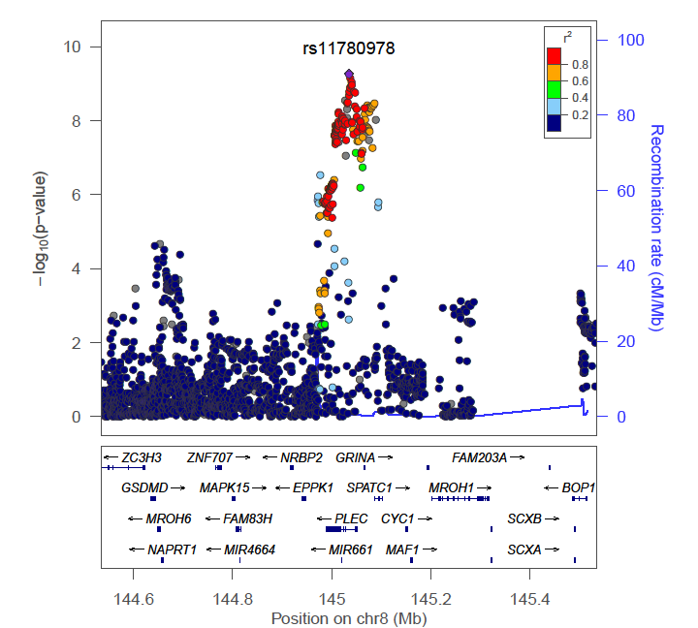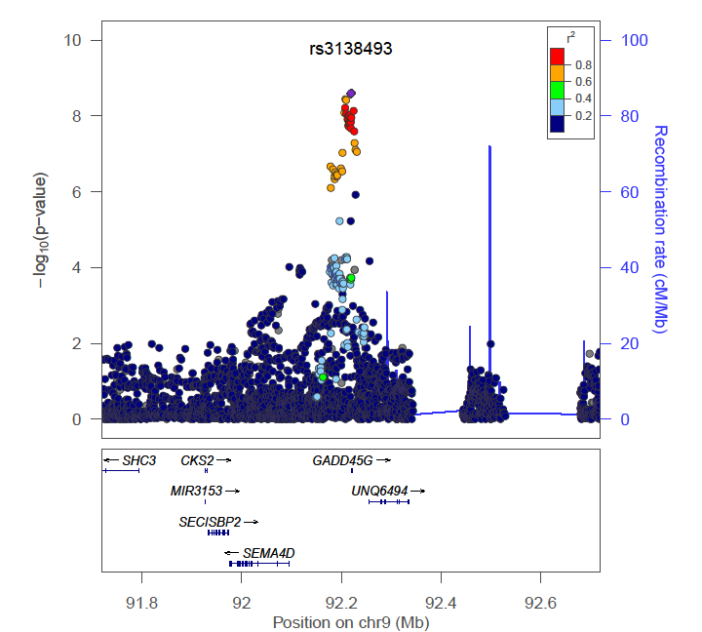
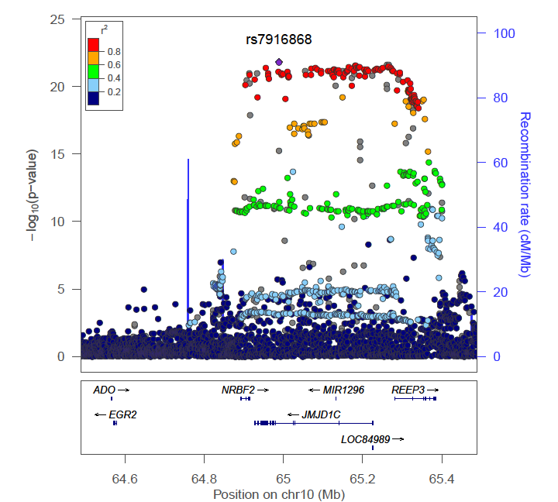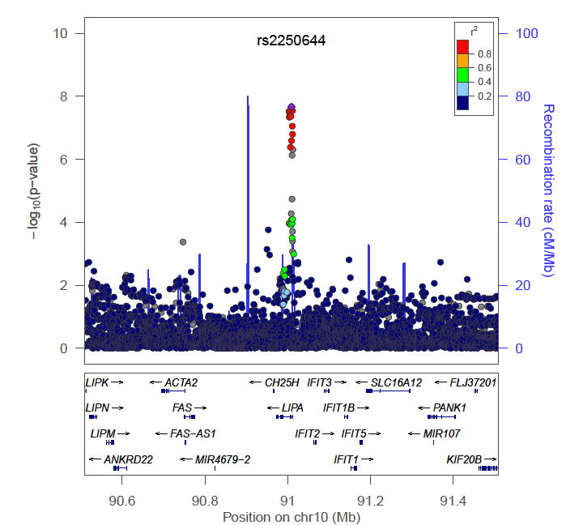

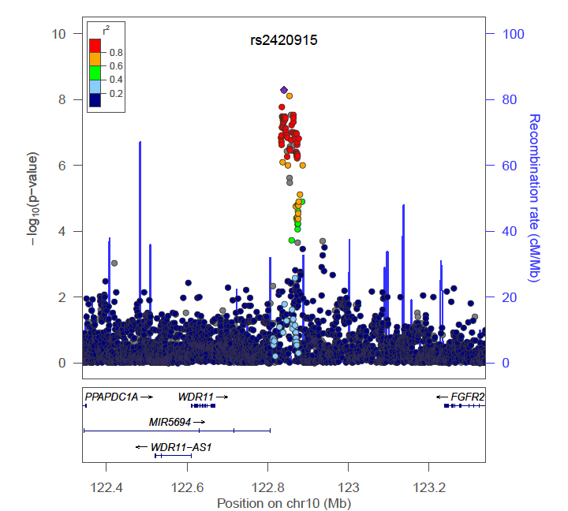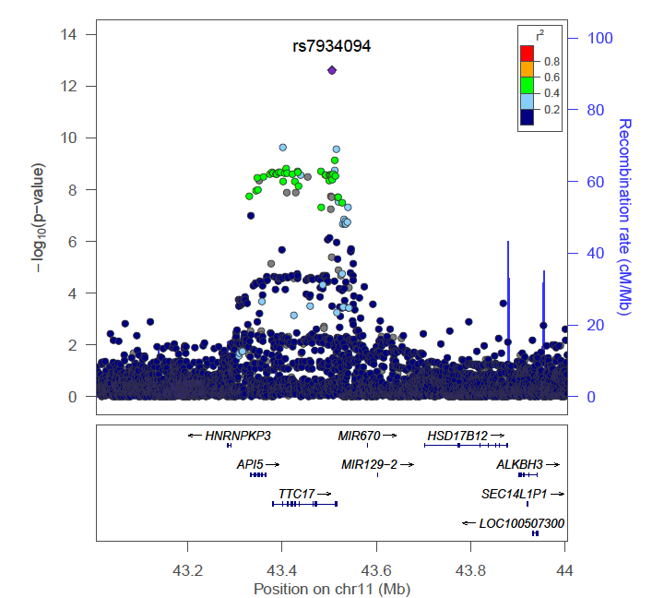
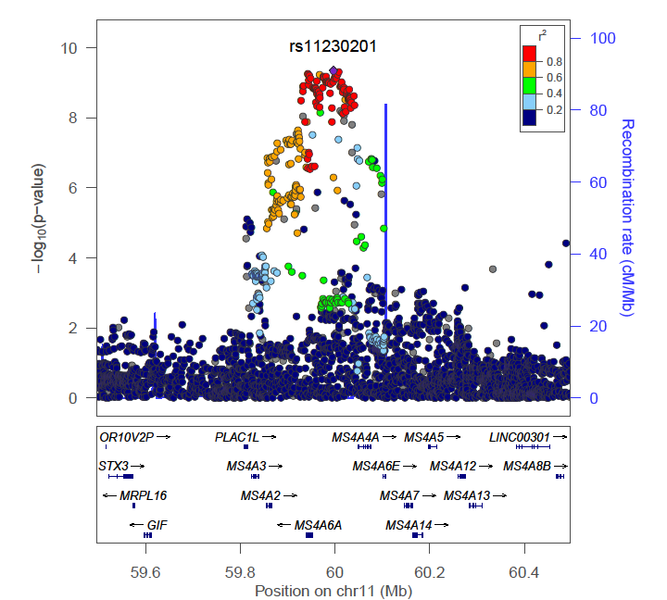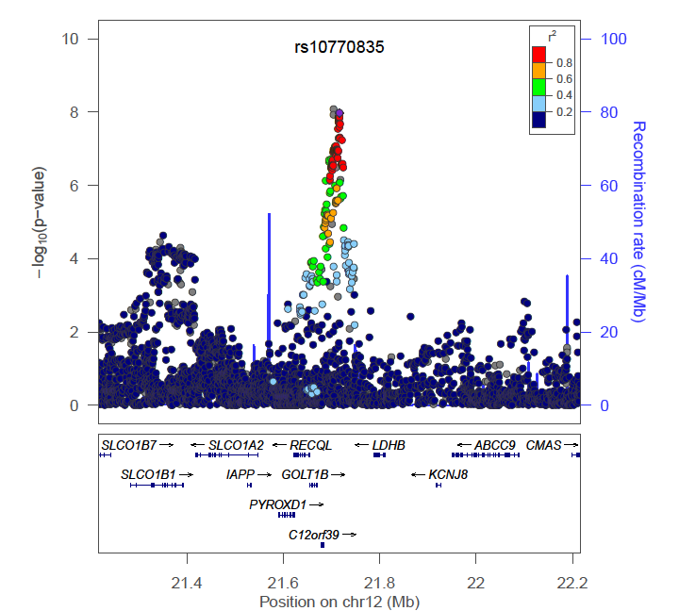
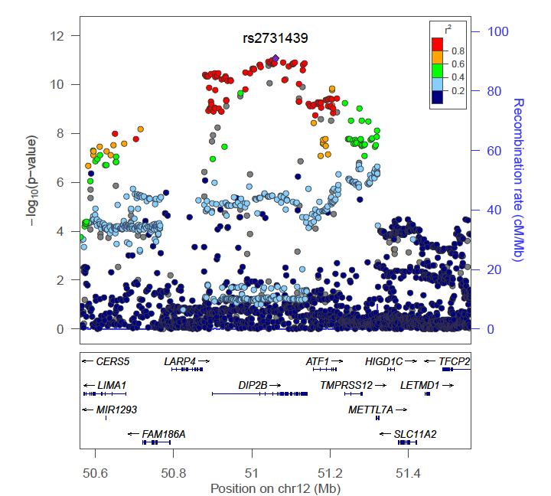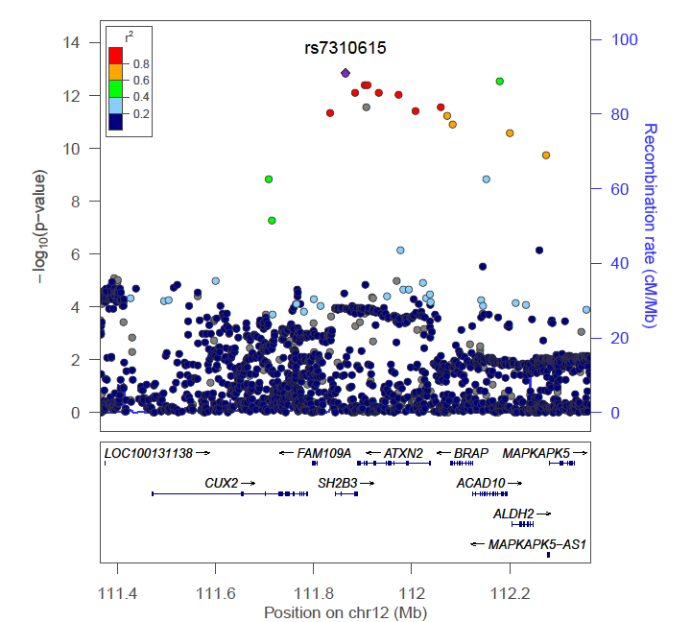

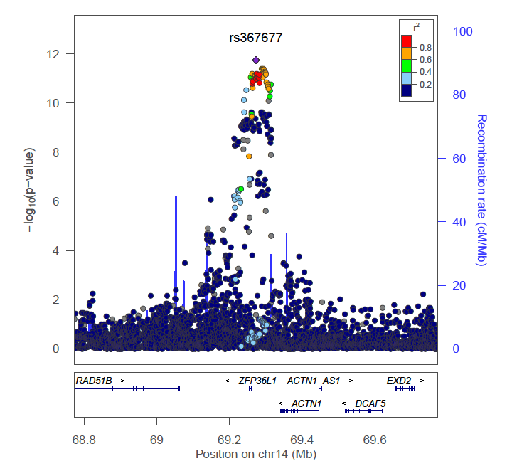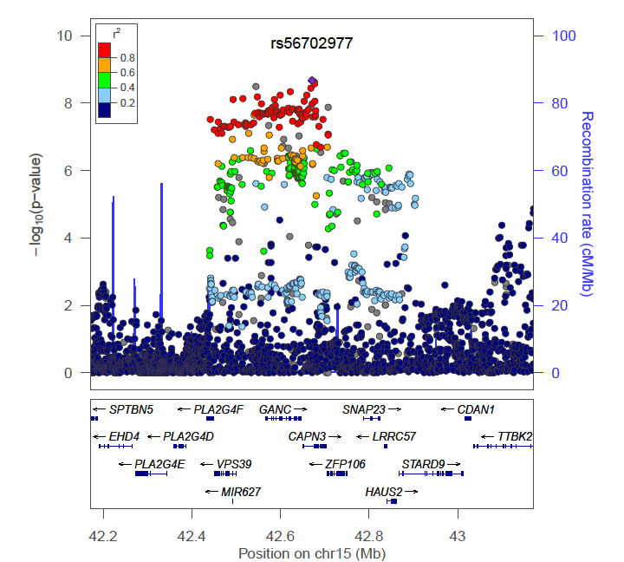
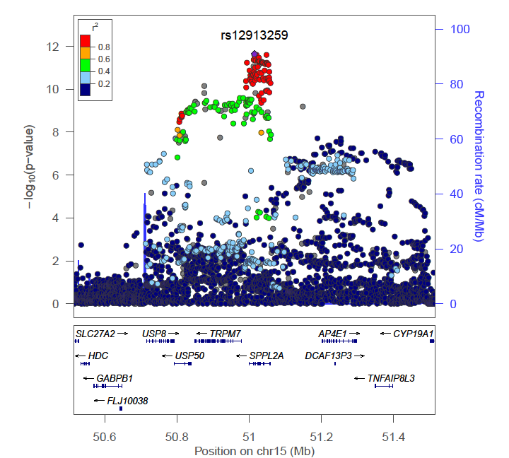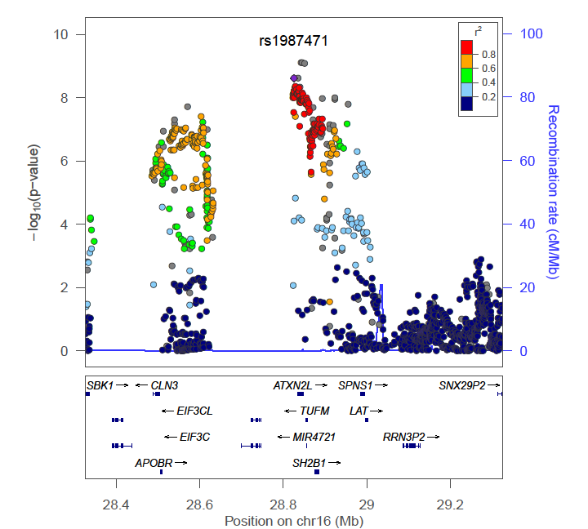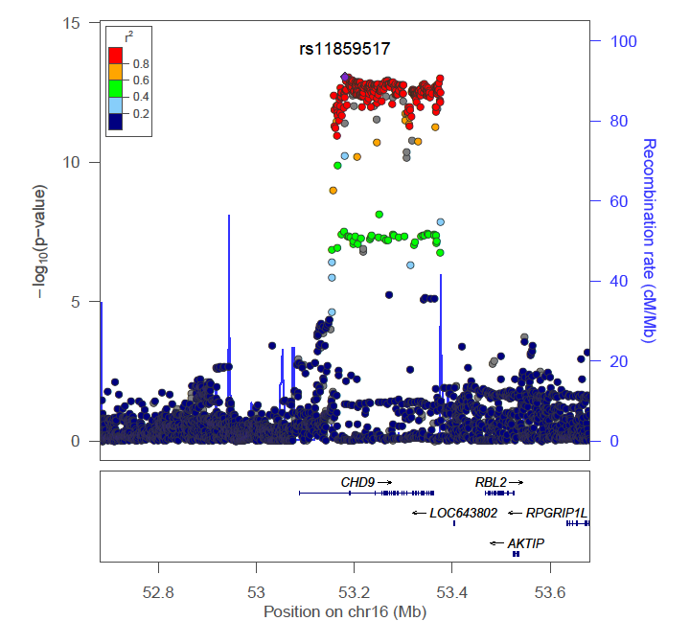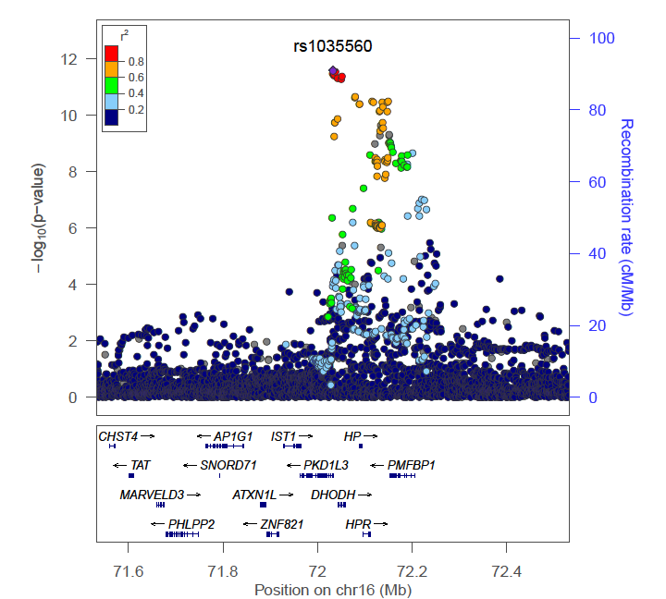

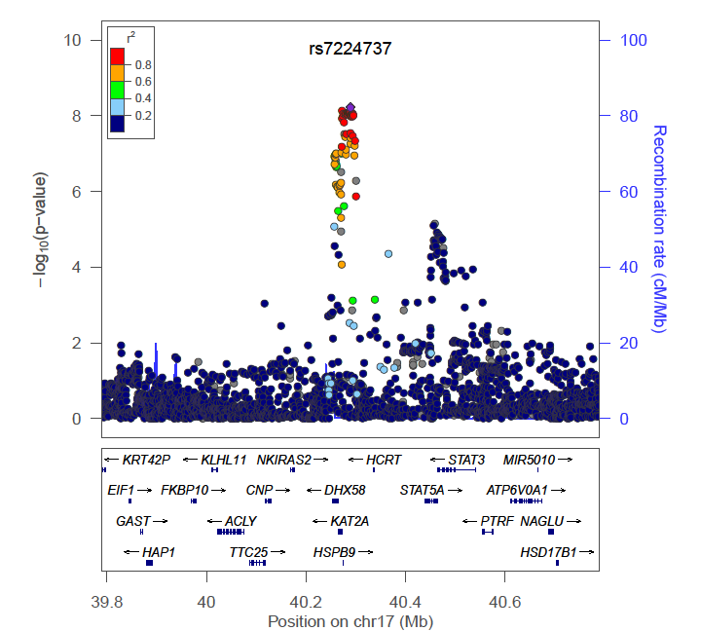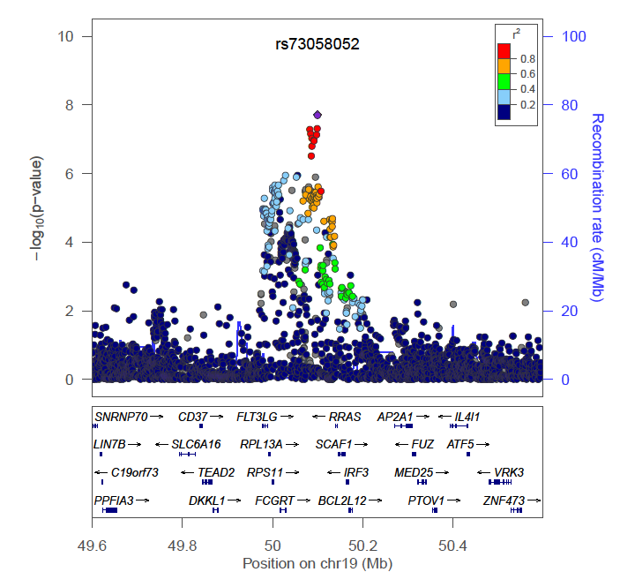
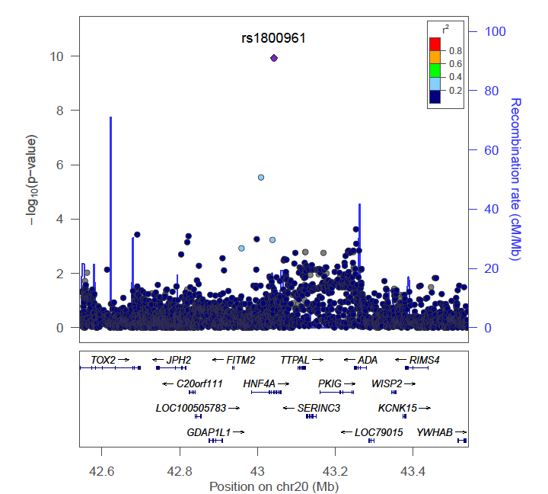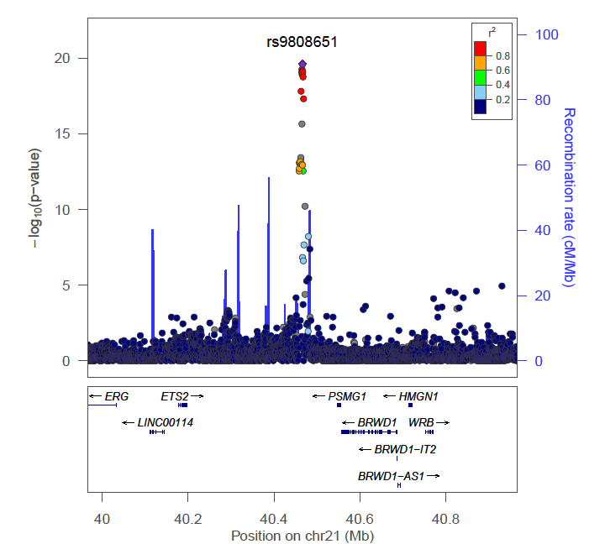
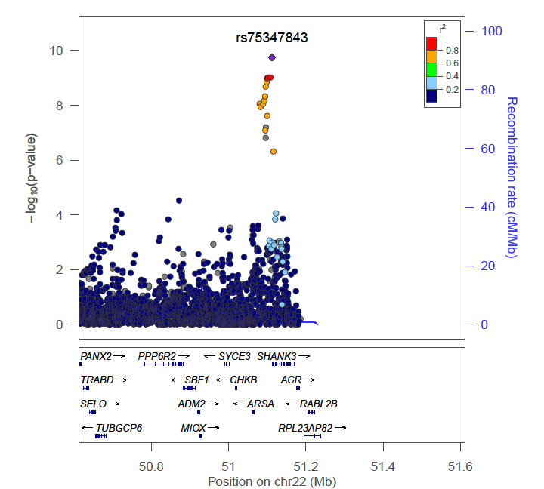

Supplementary Figure 5: Forest plots of lead variants at loci associated with circulating fibrinogen concentration. 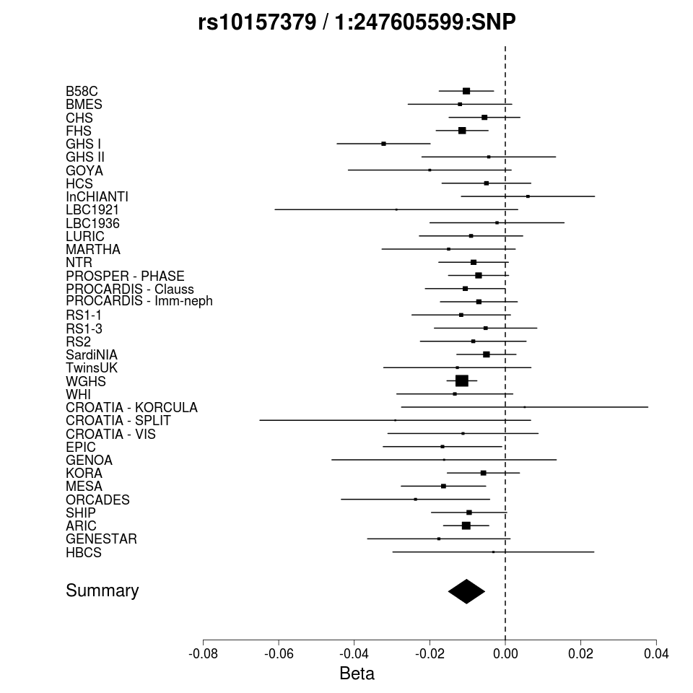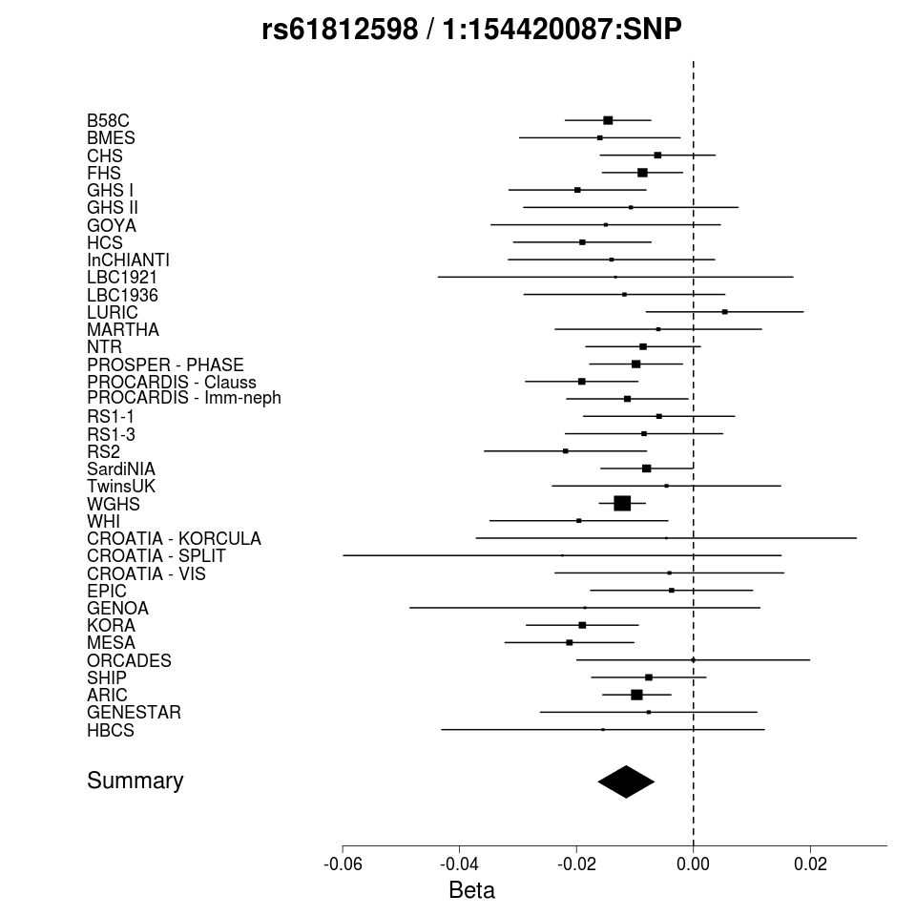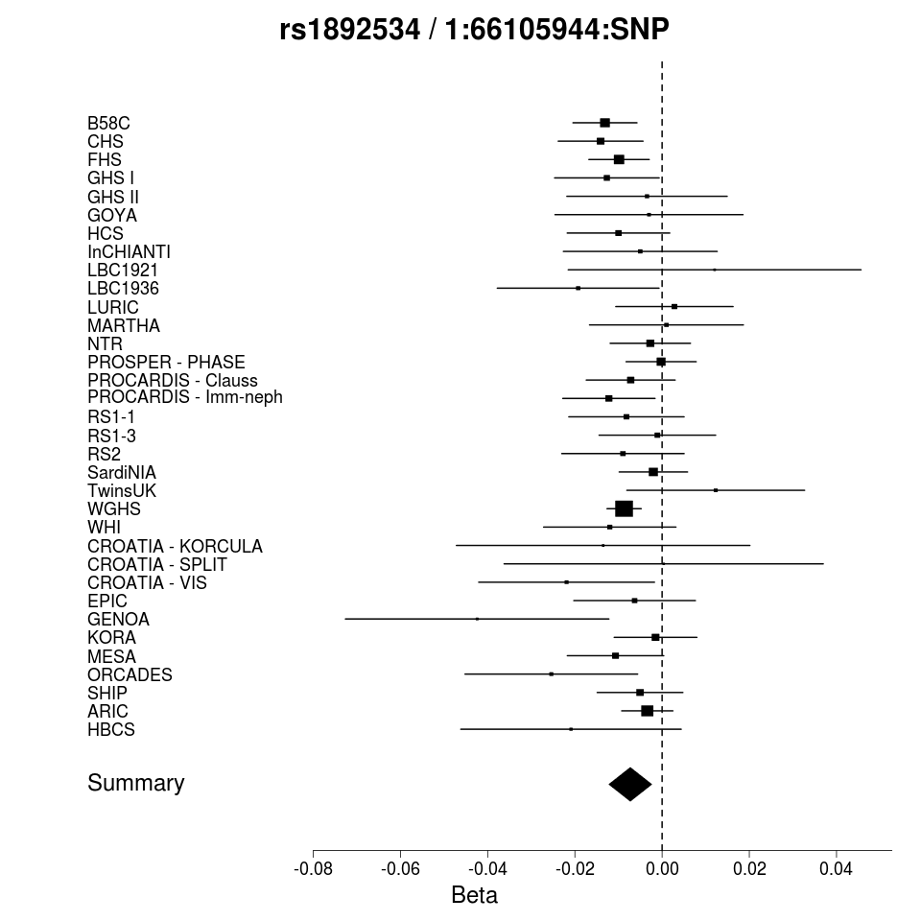 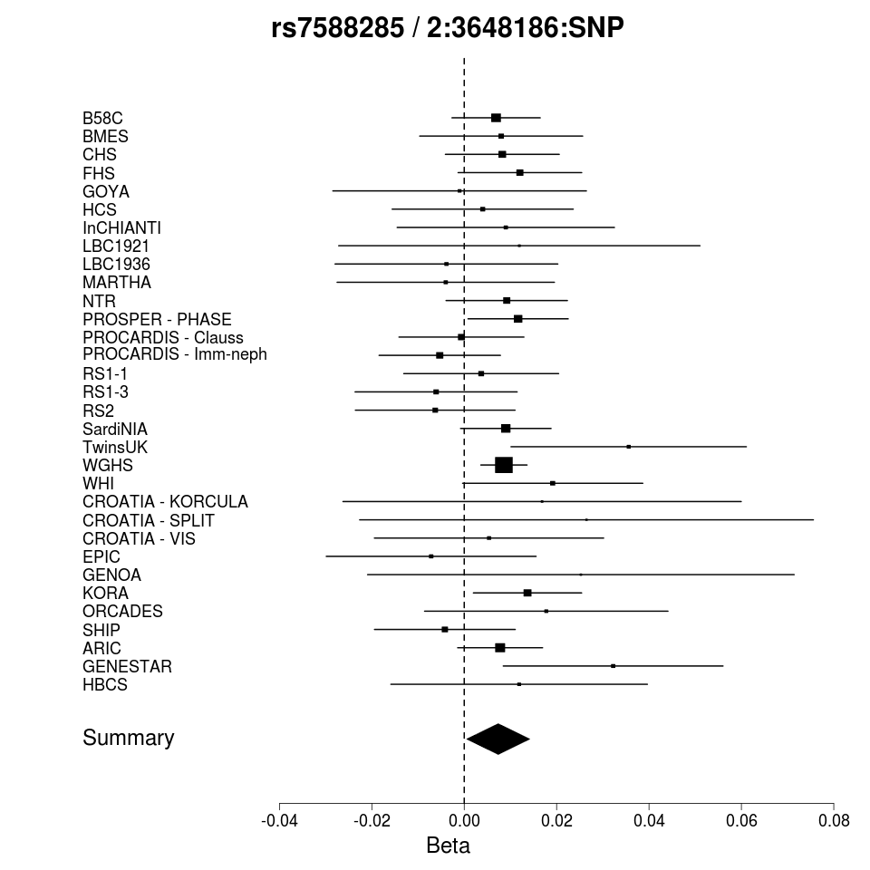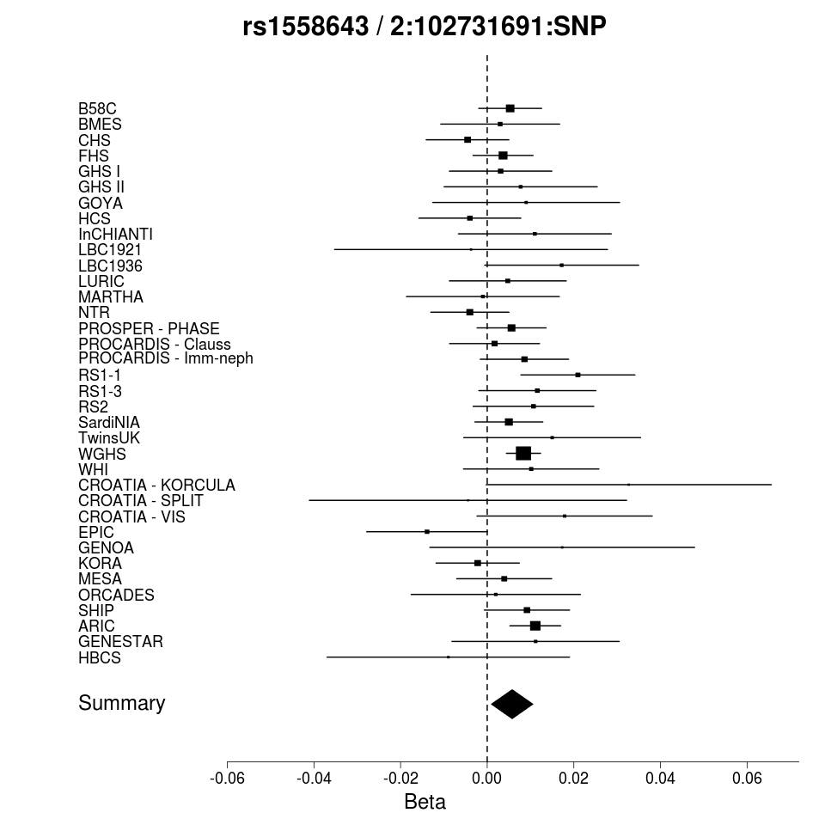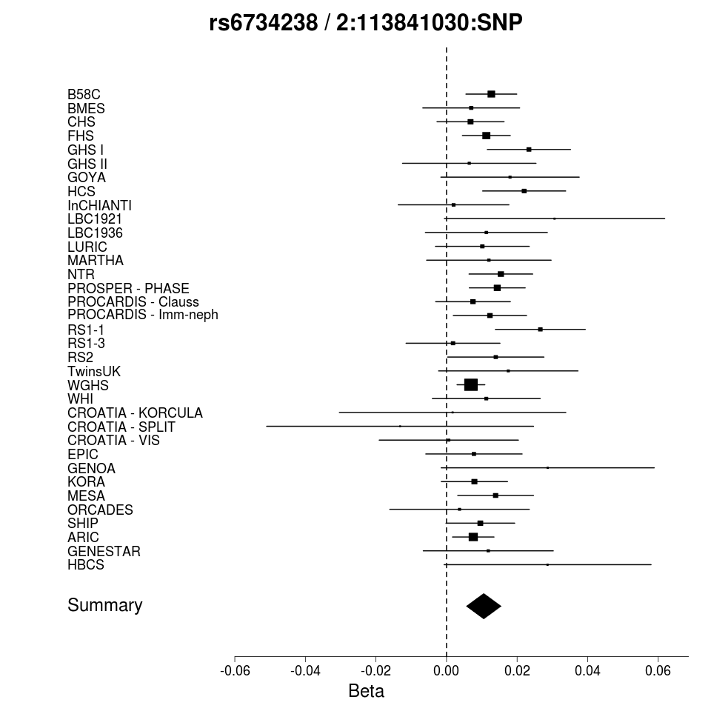

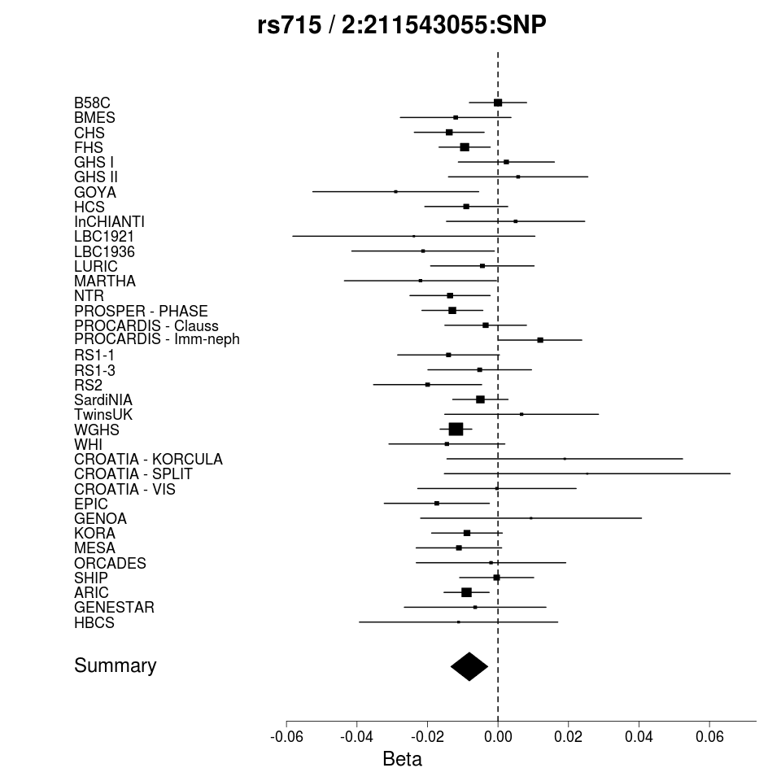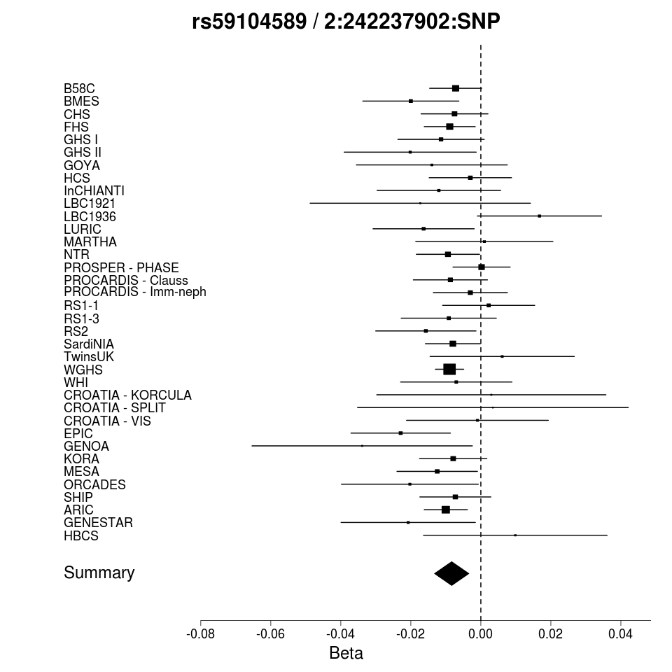
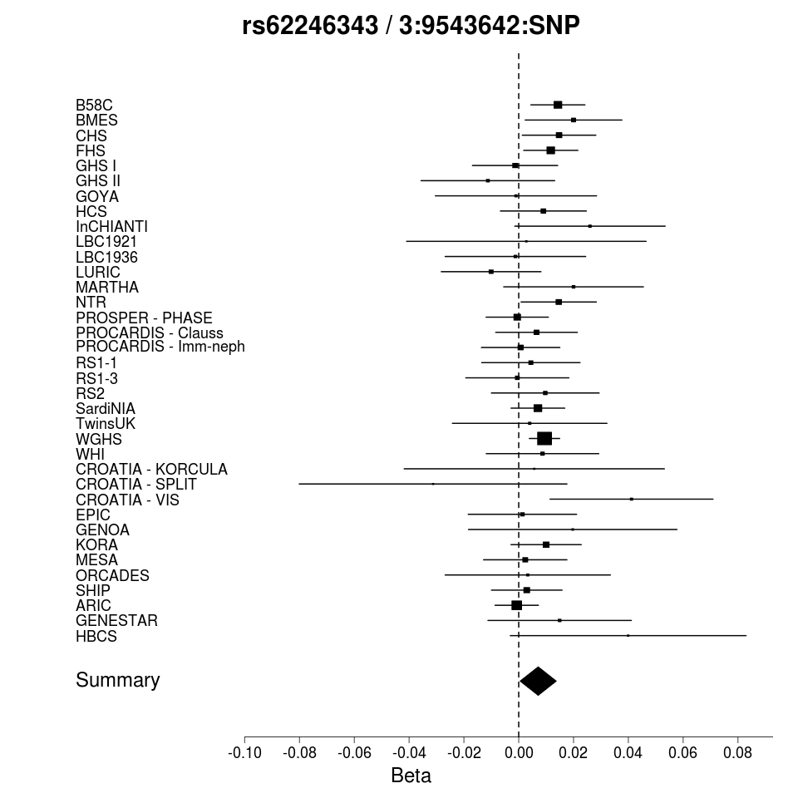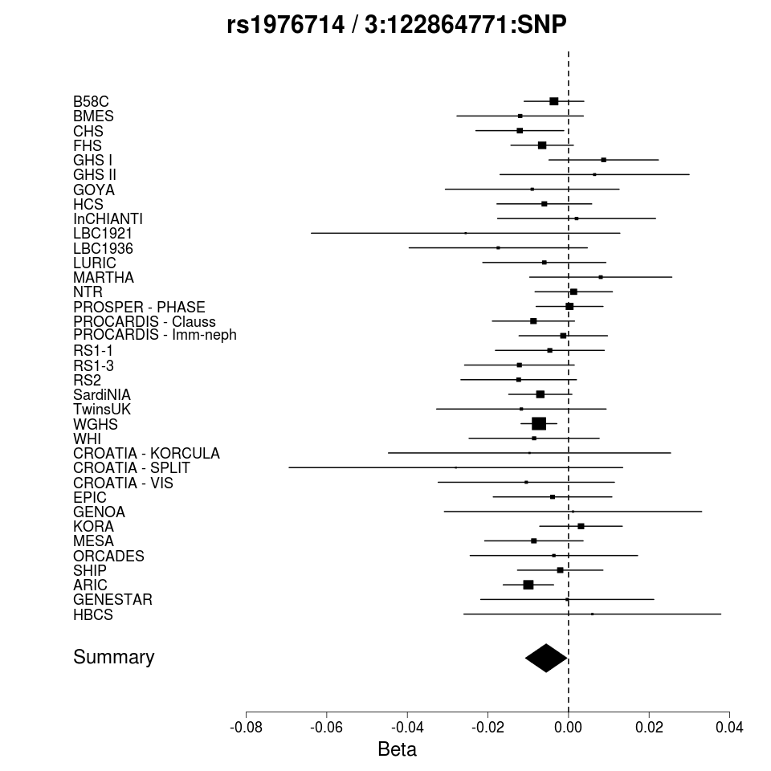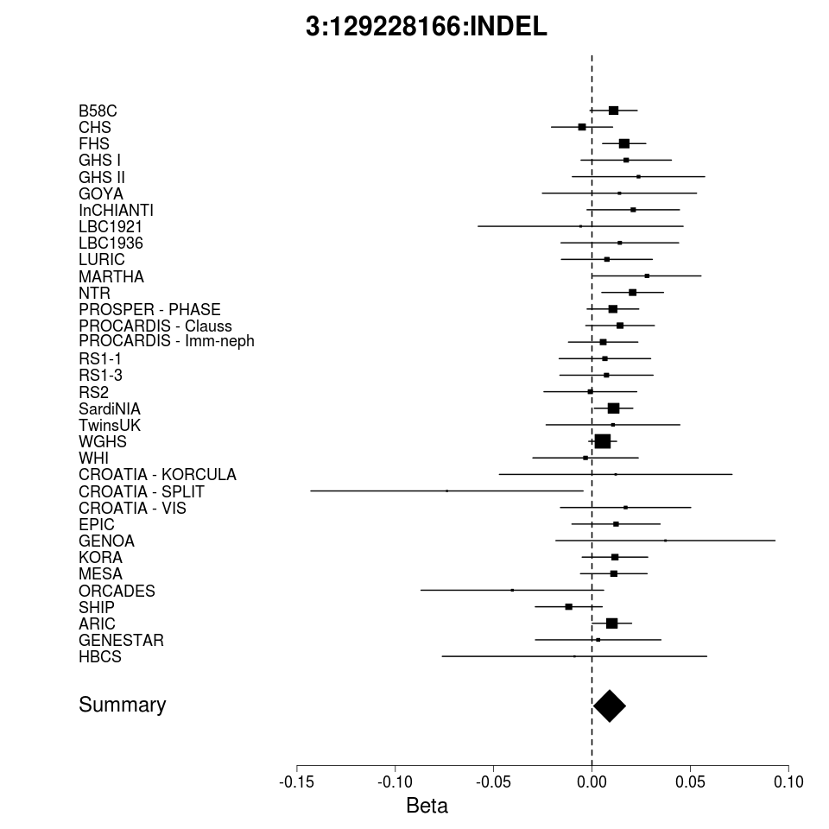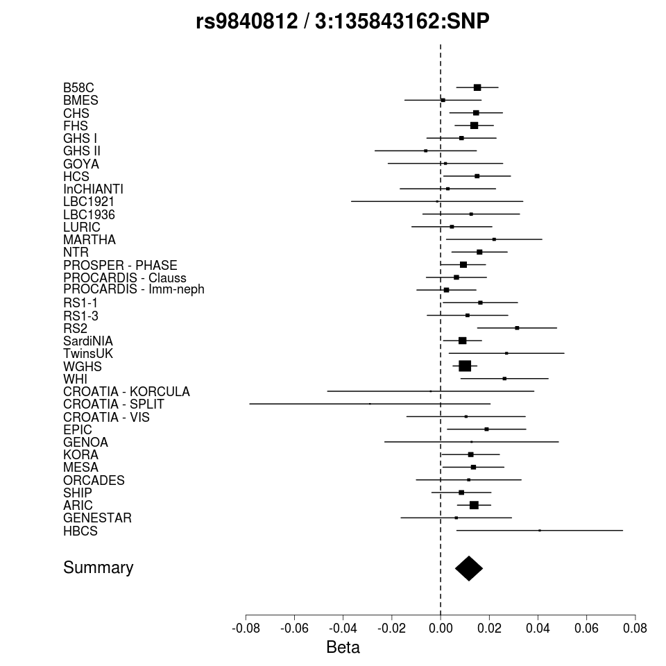

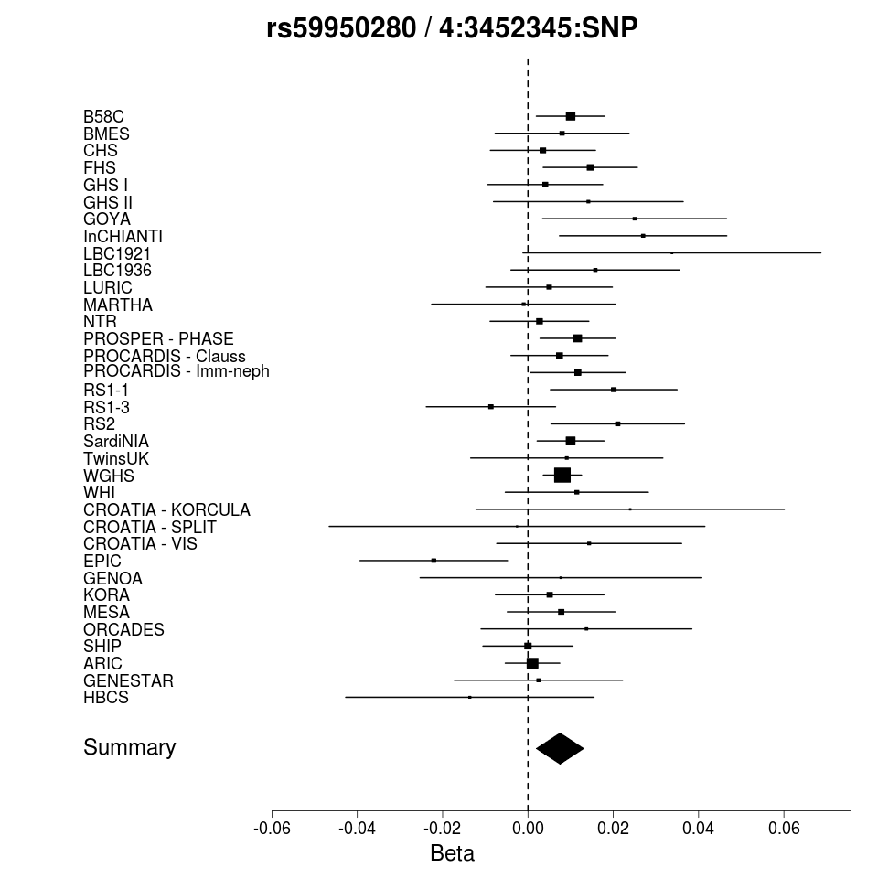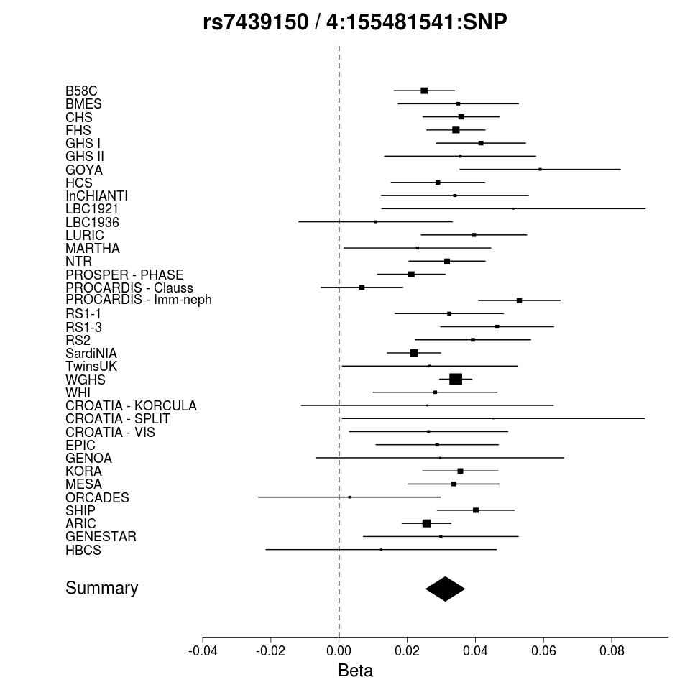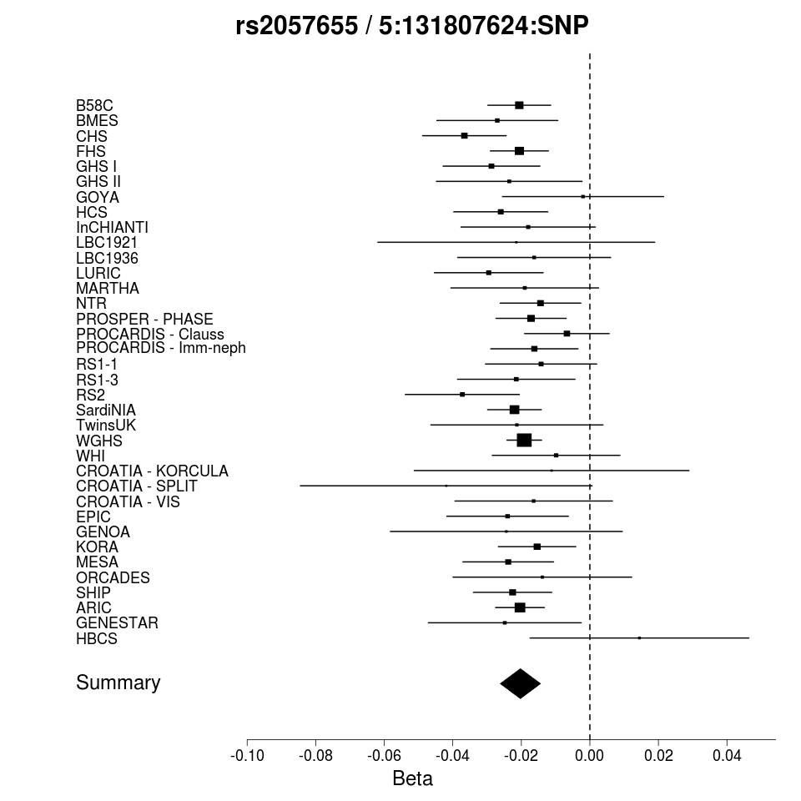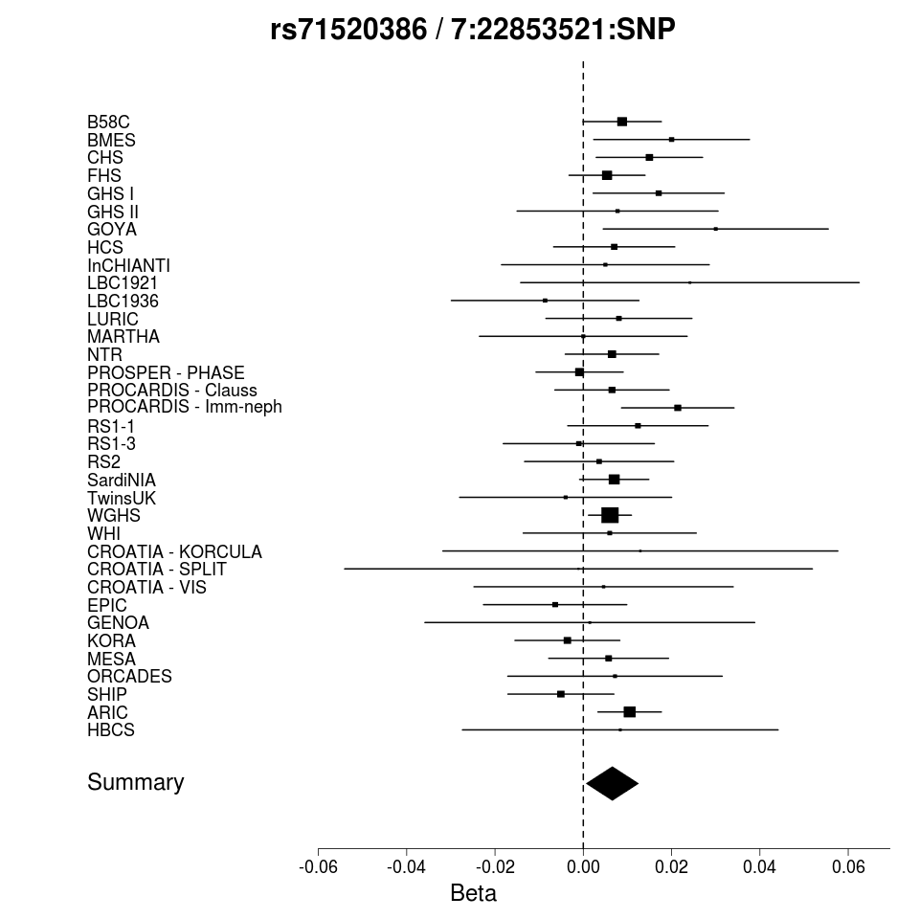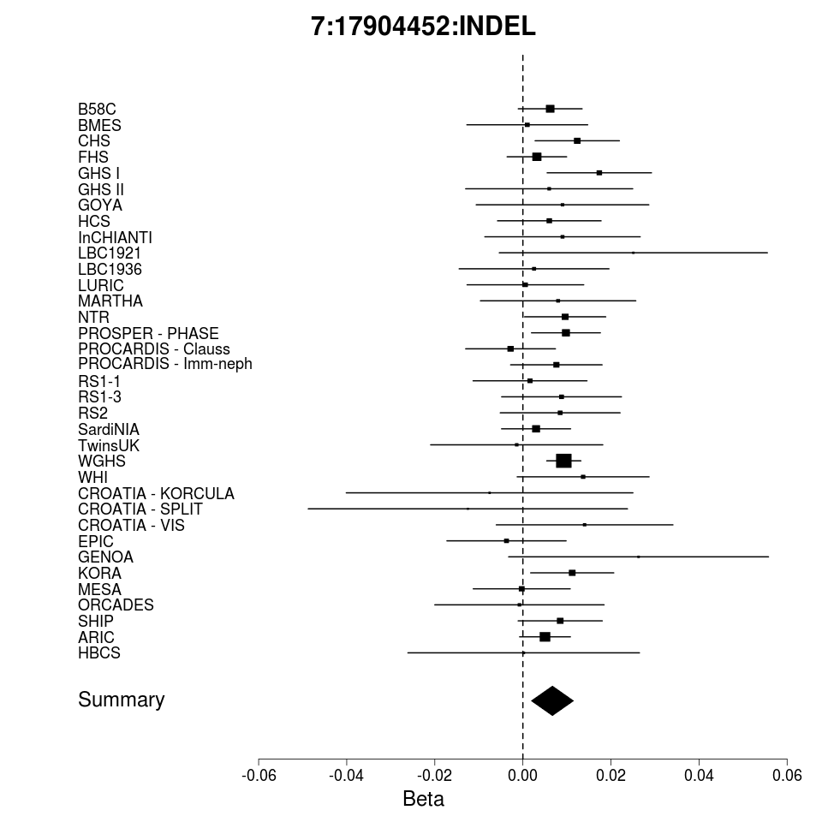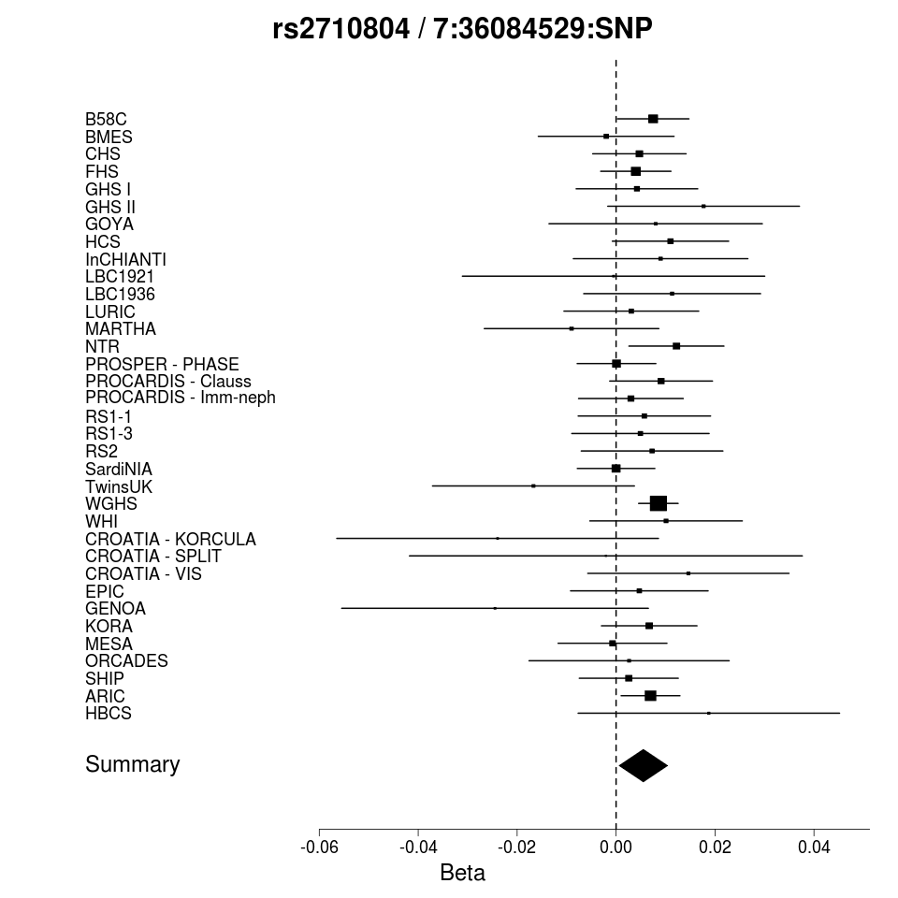

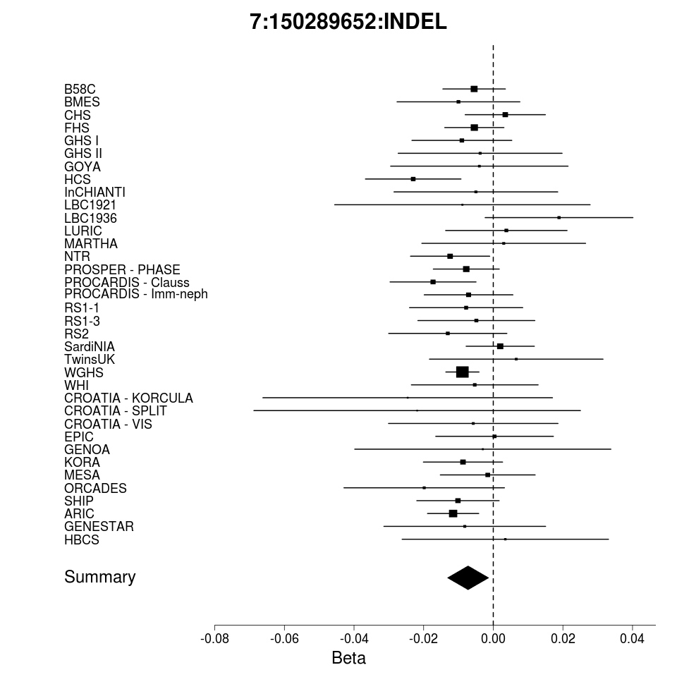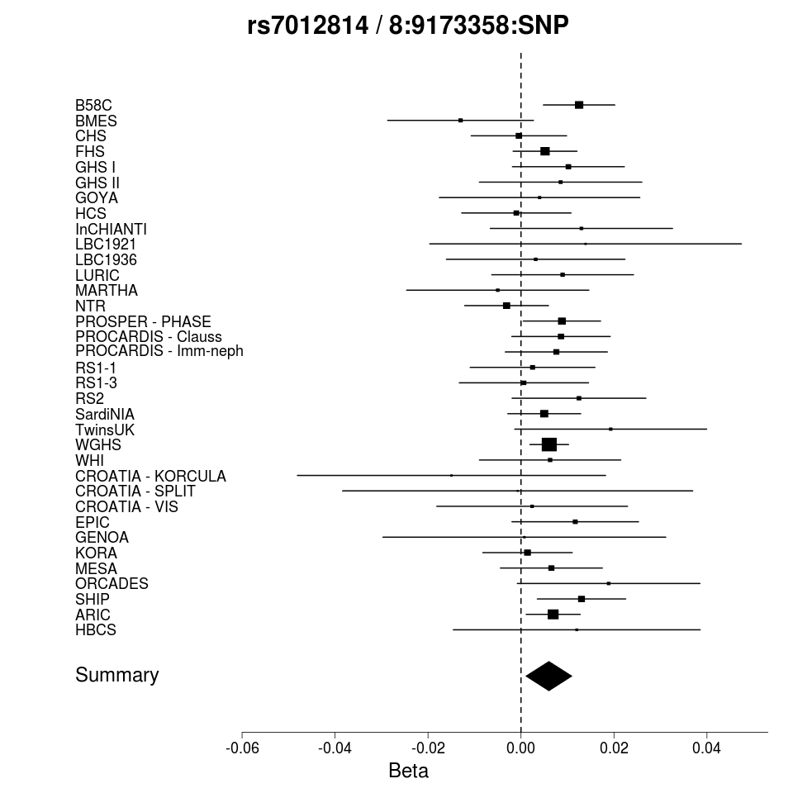
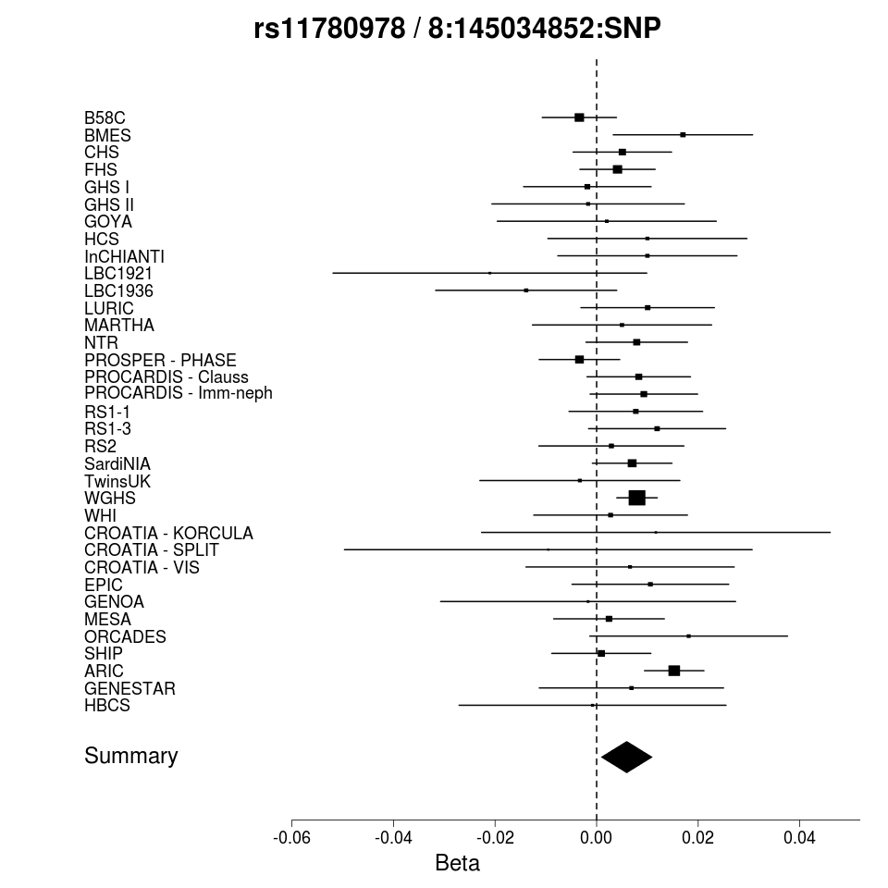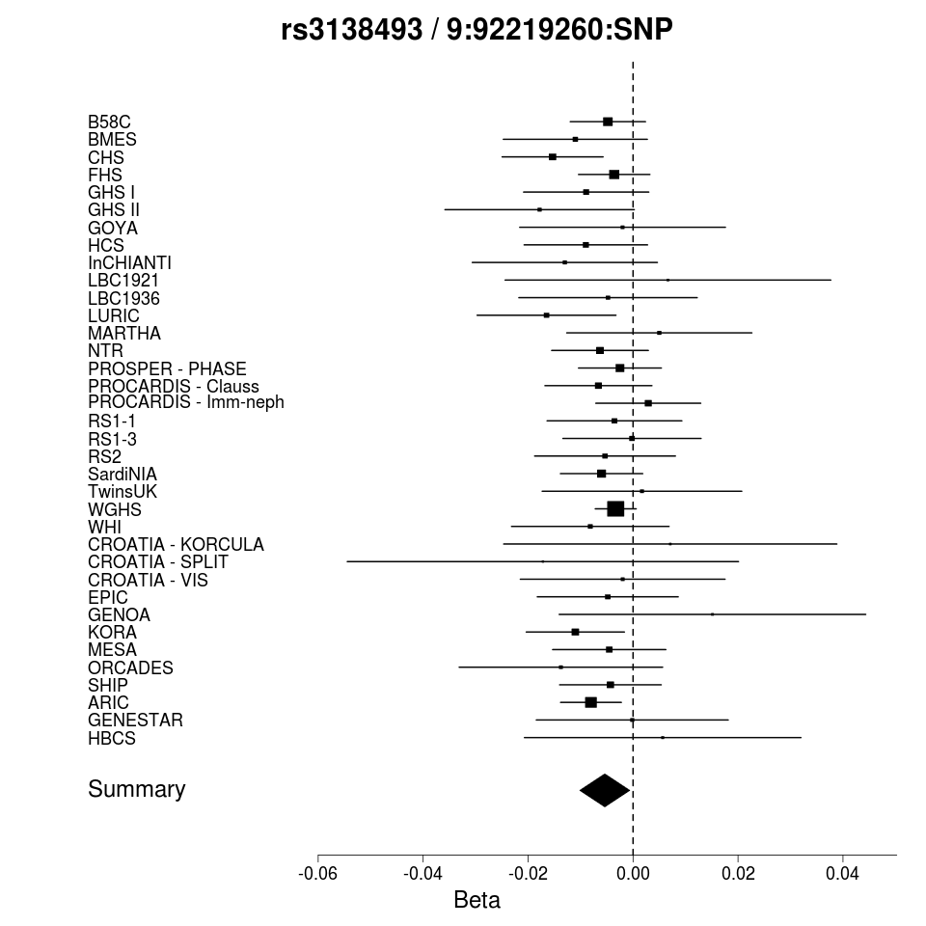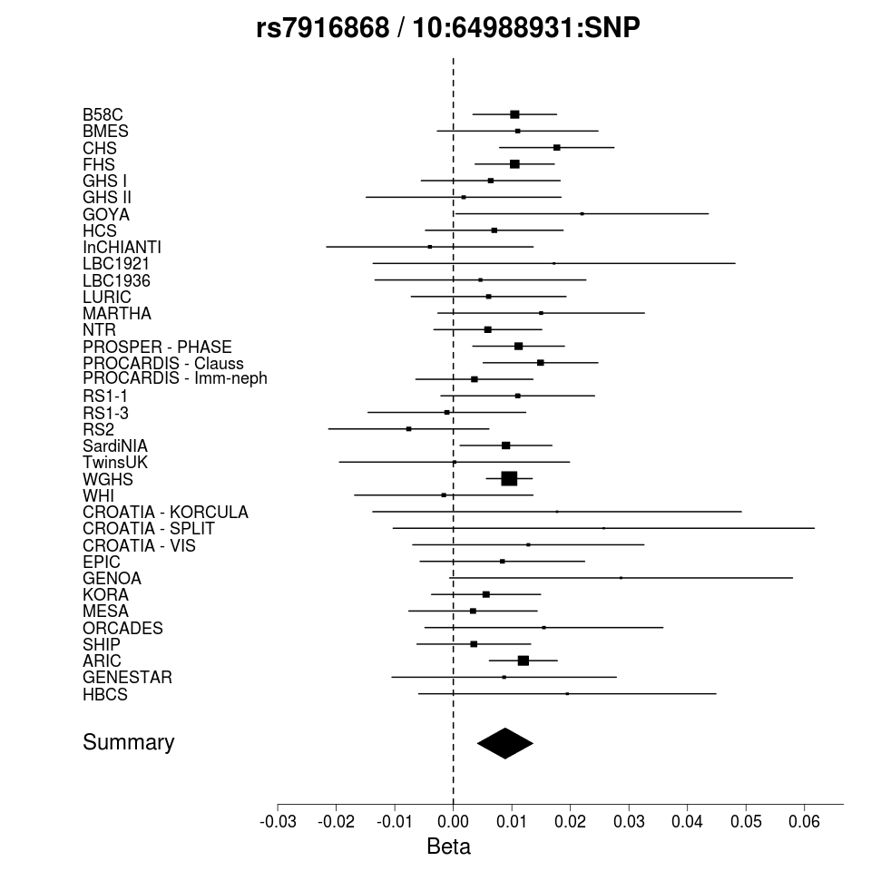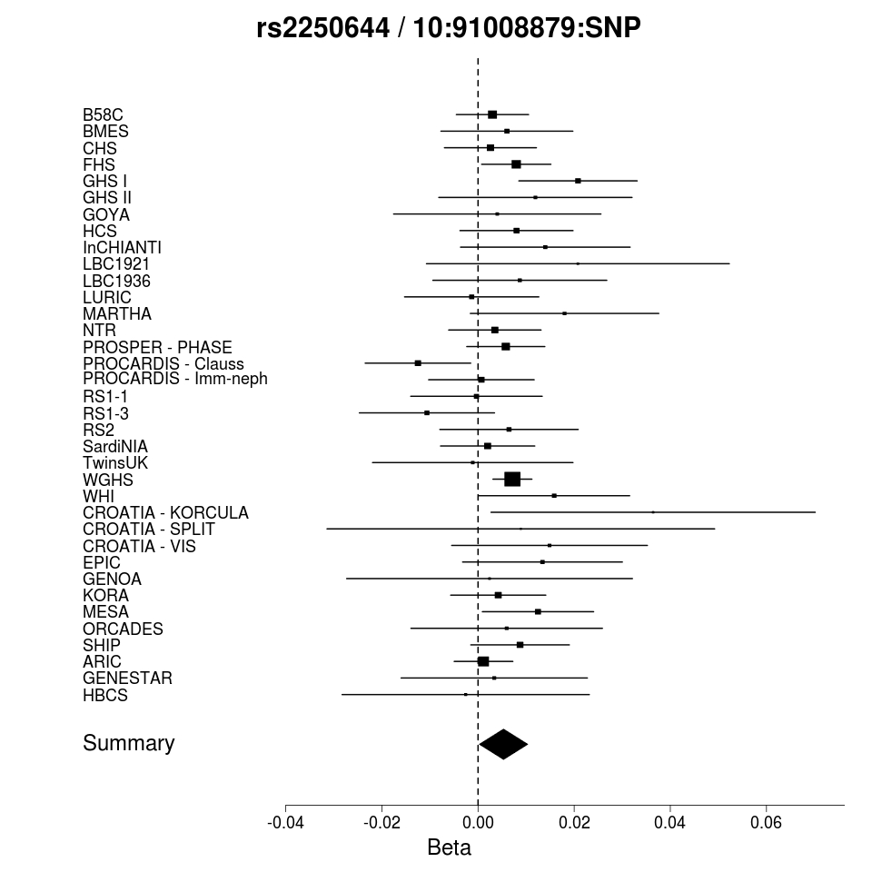

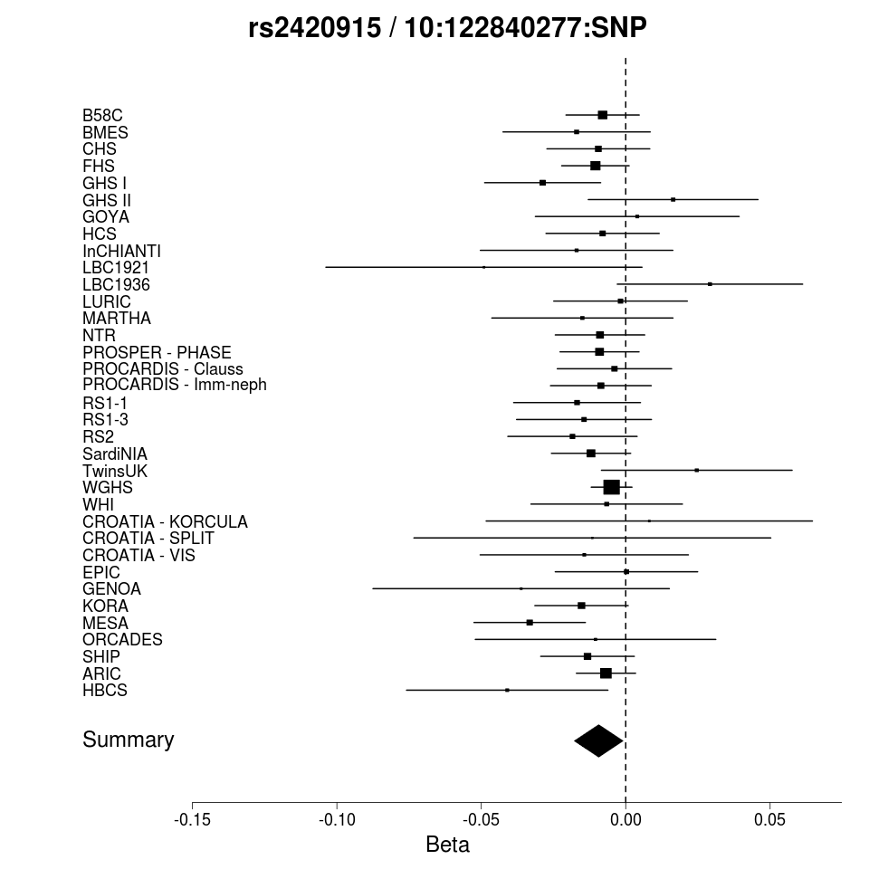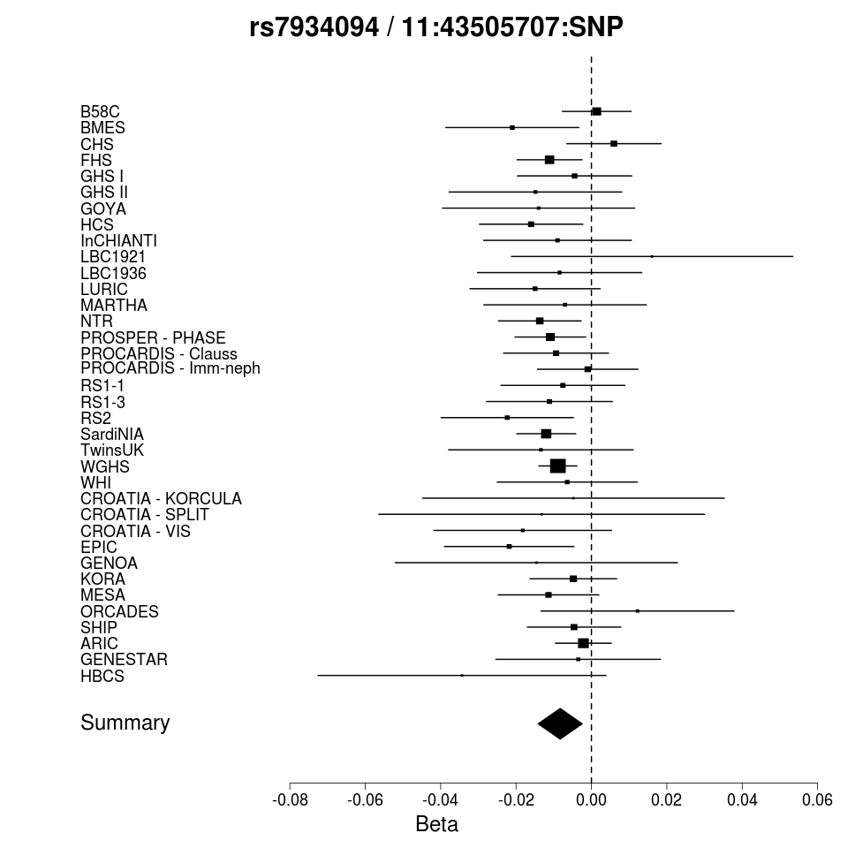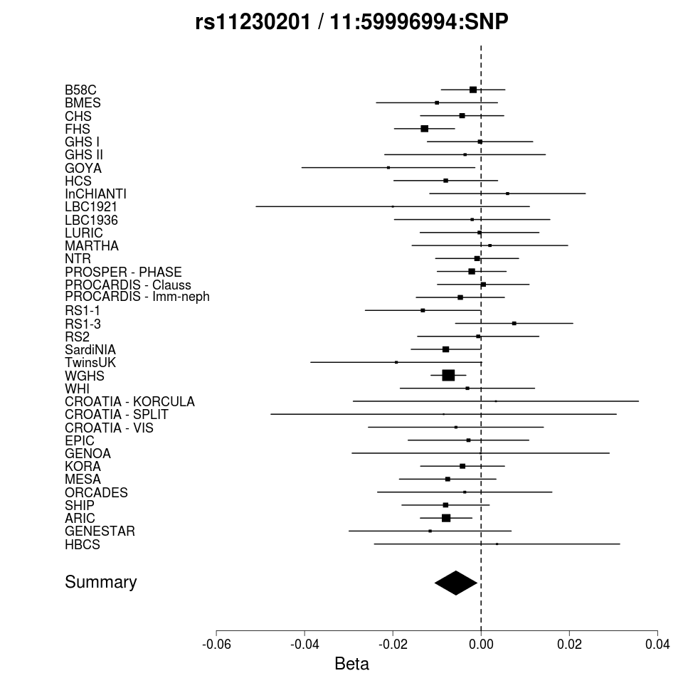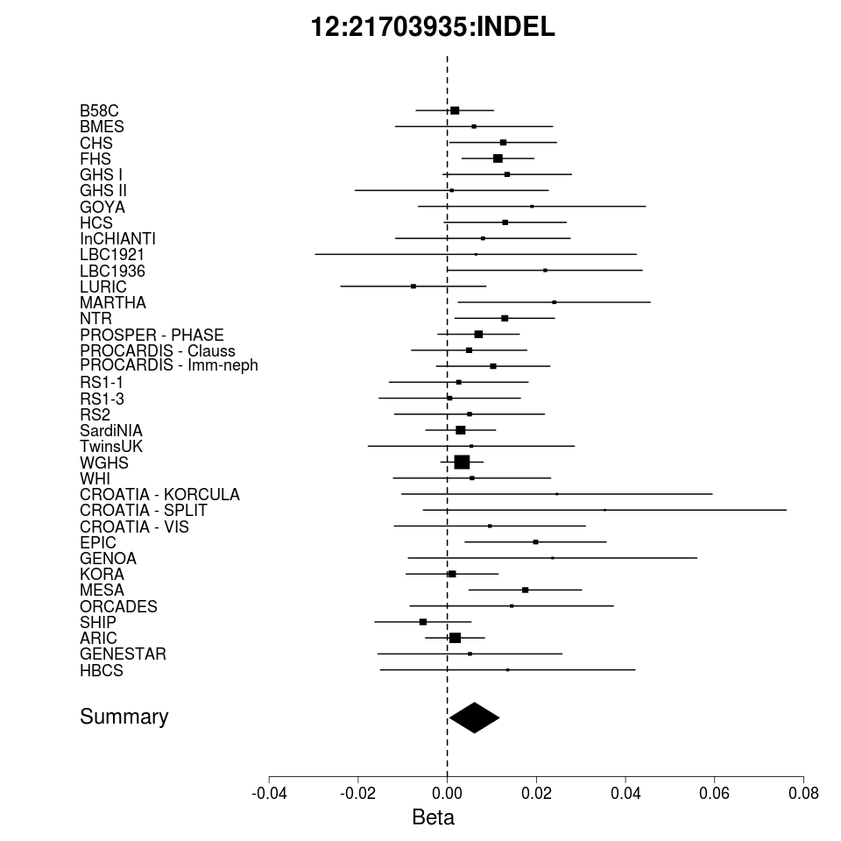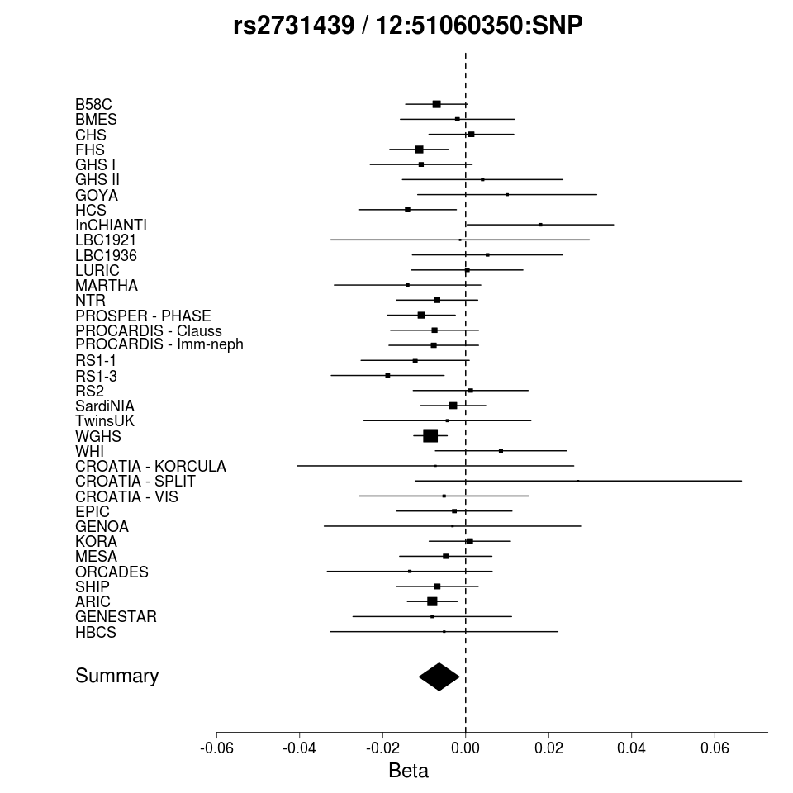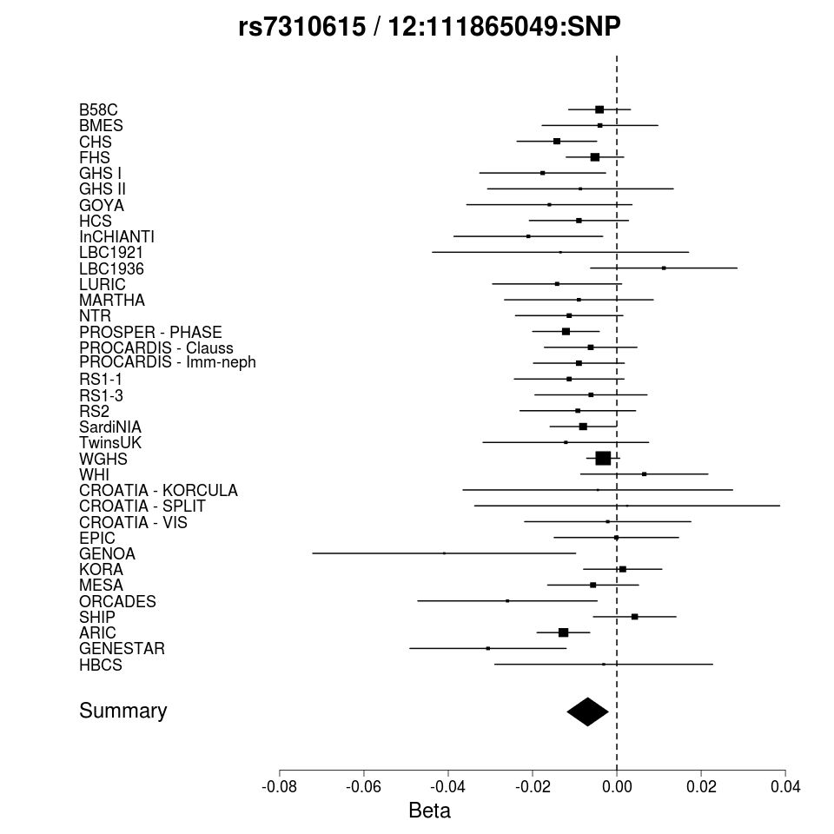
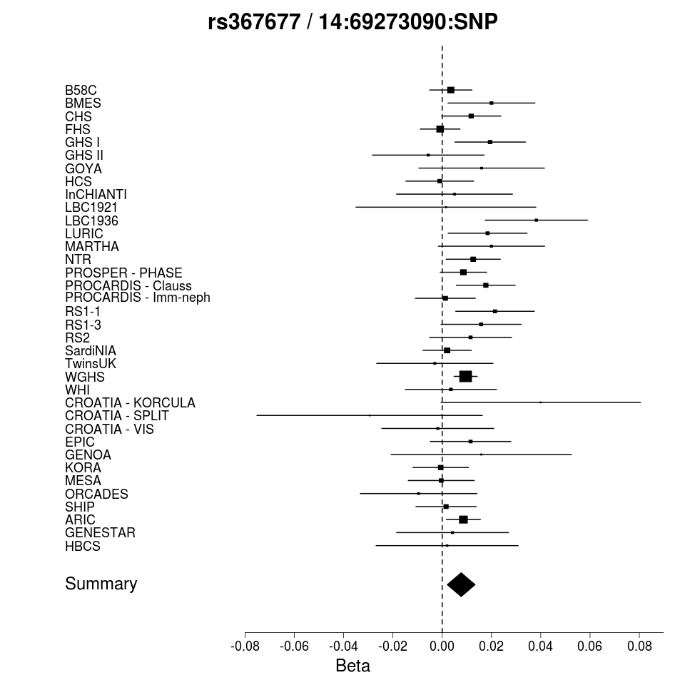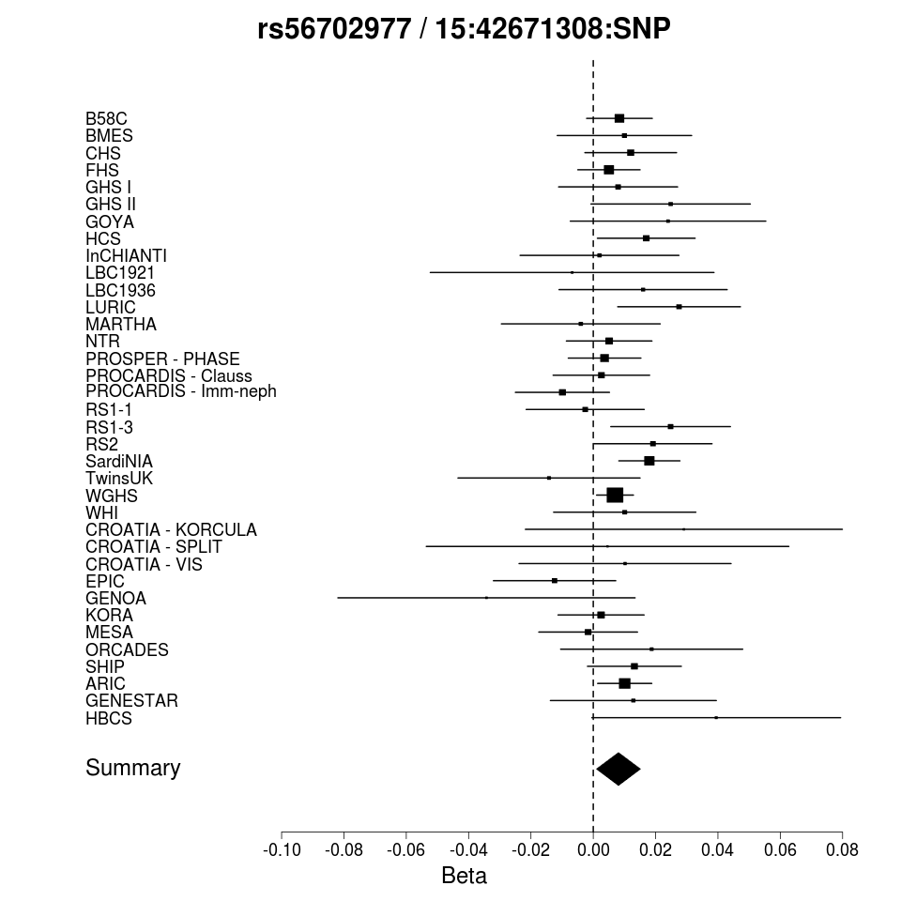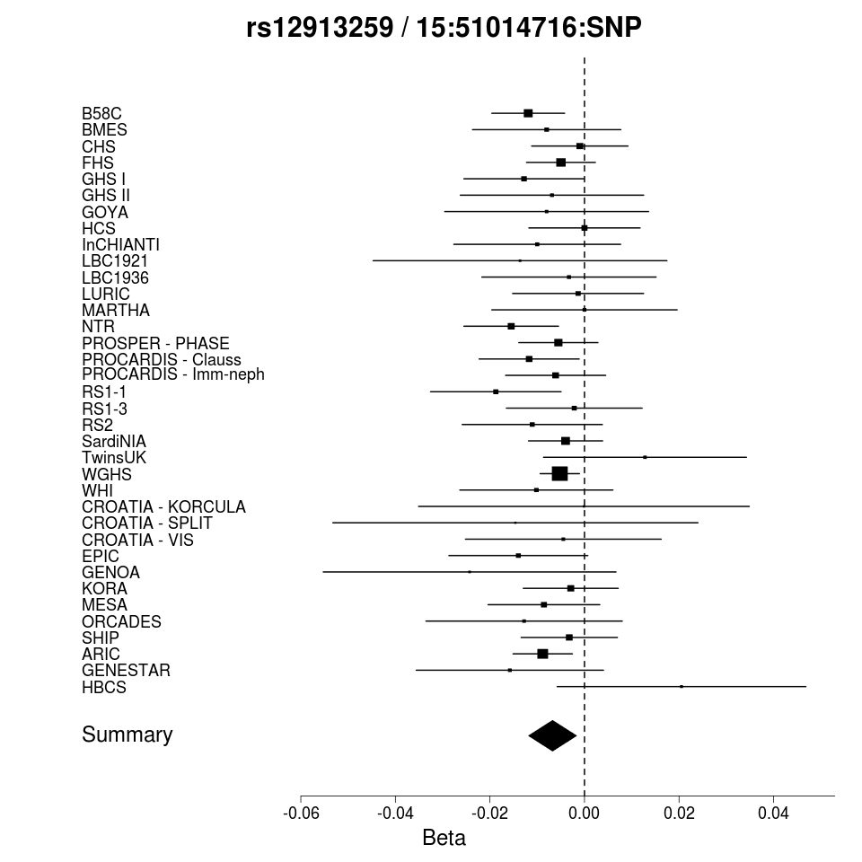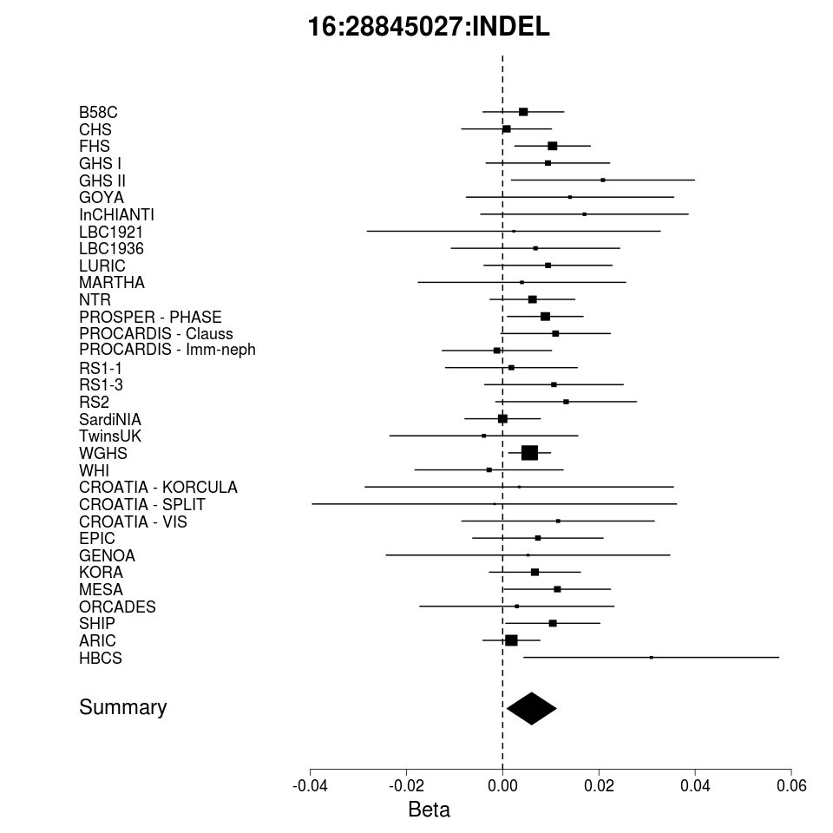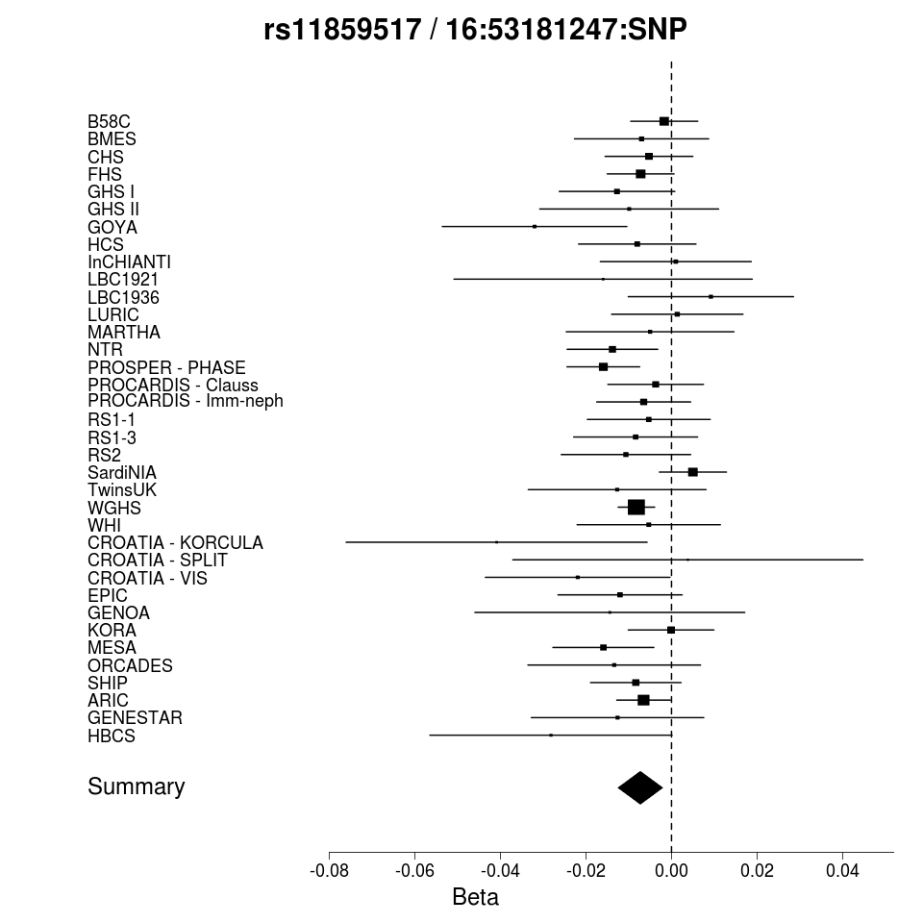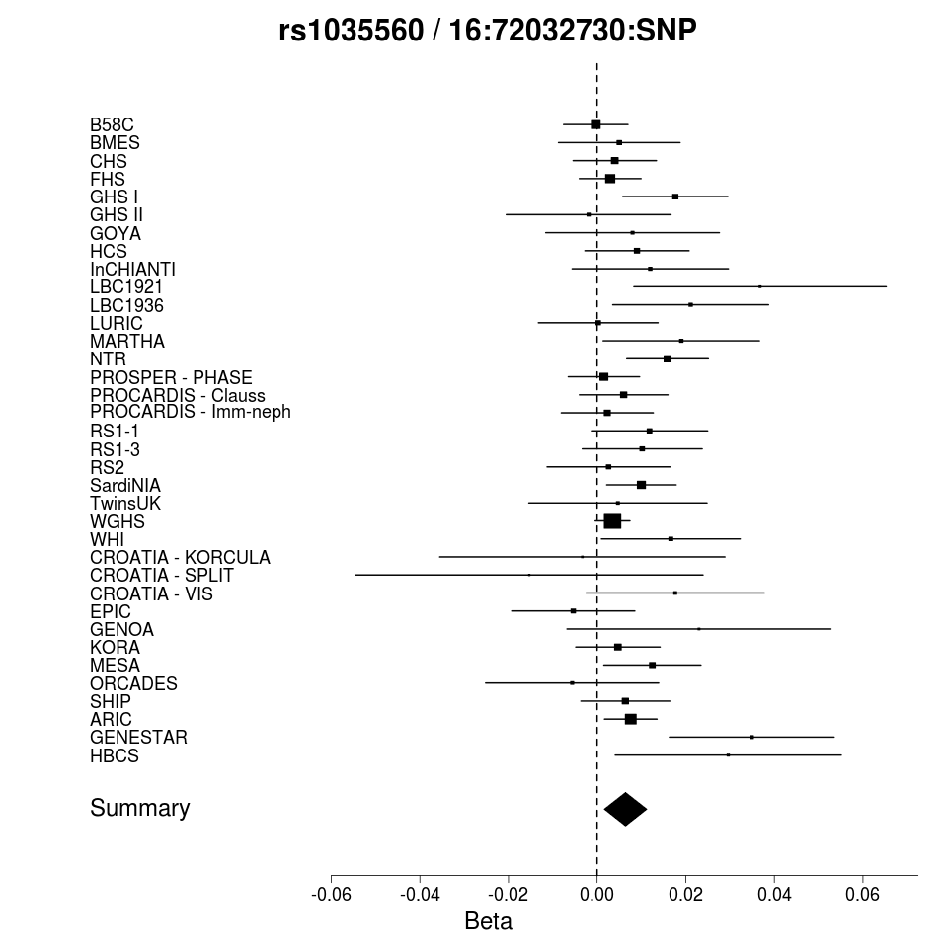

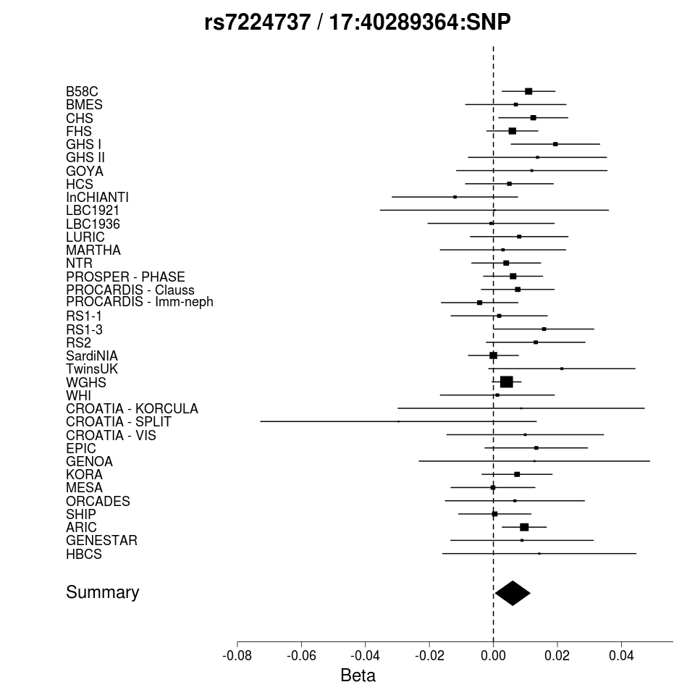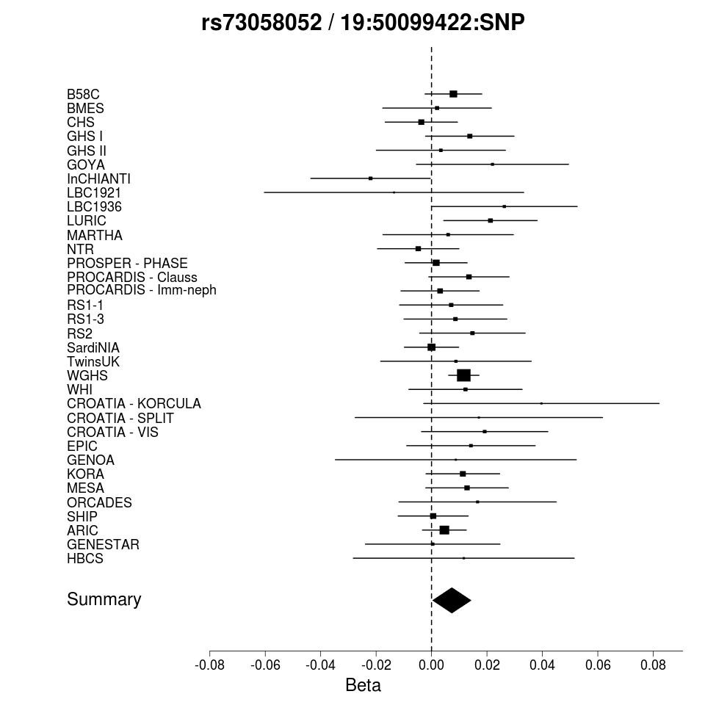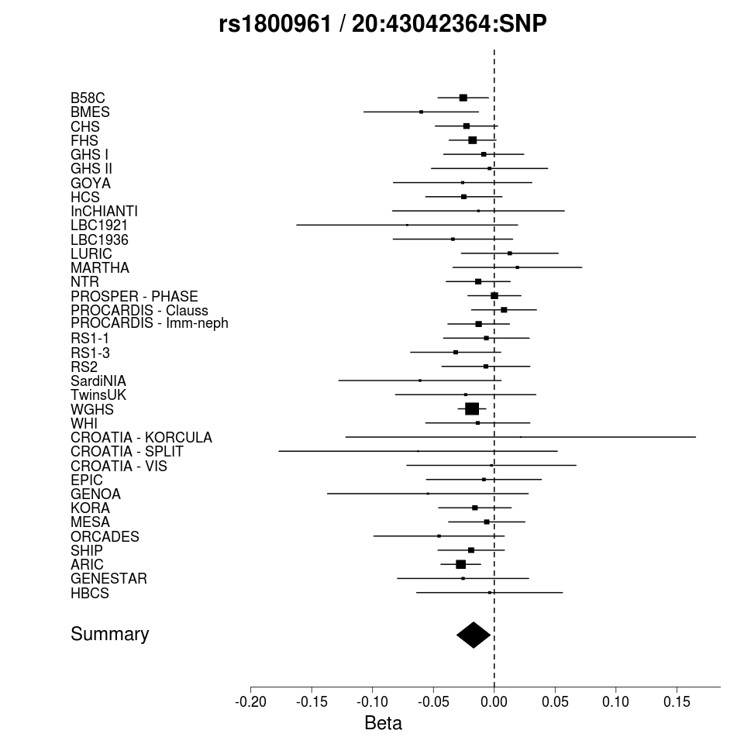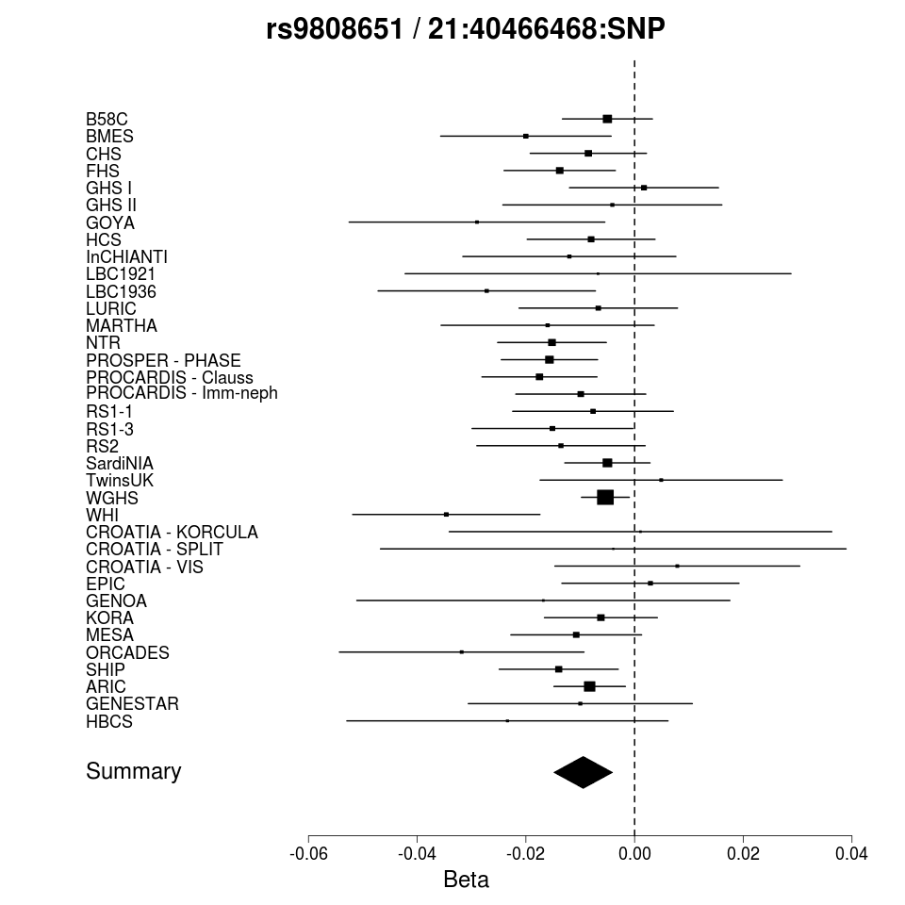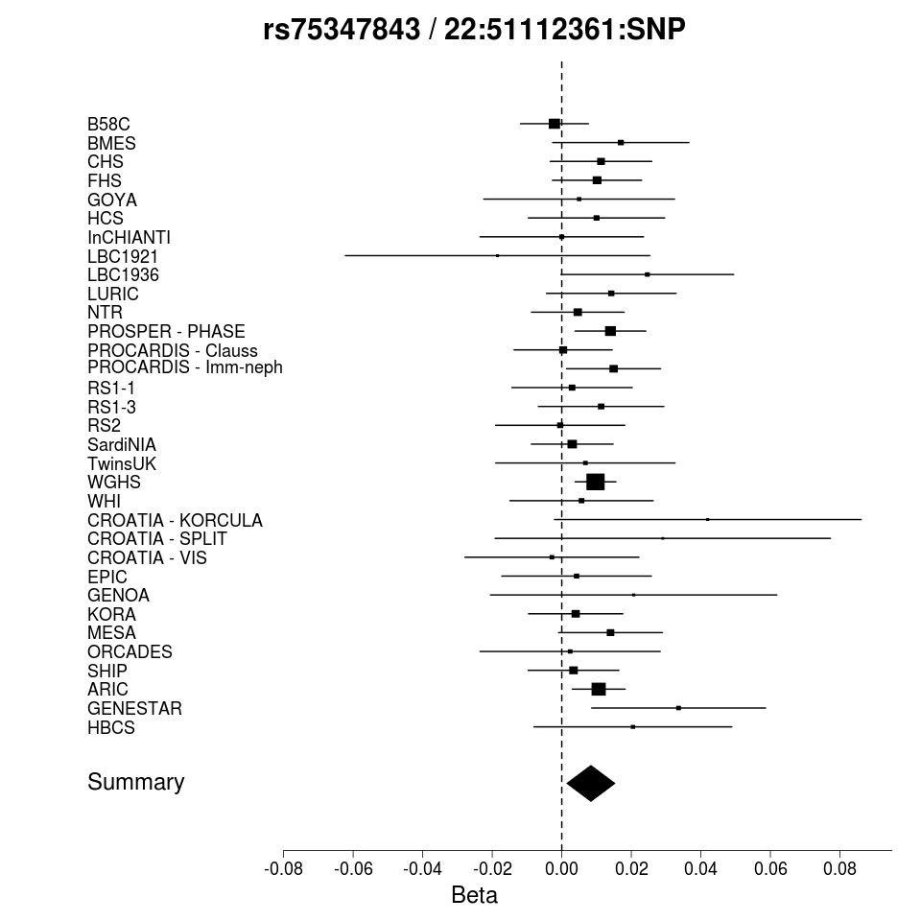
Supplementary Figure 6: Forest plots of additional variants at loci associated with plasma fibrinogen concentration.
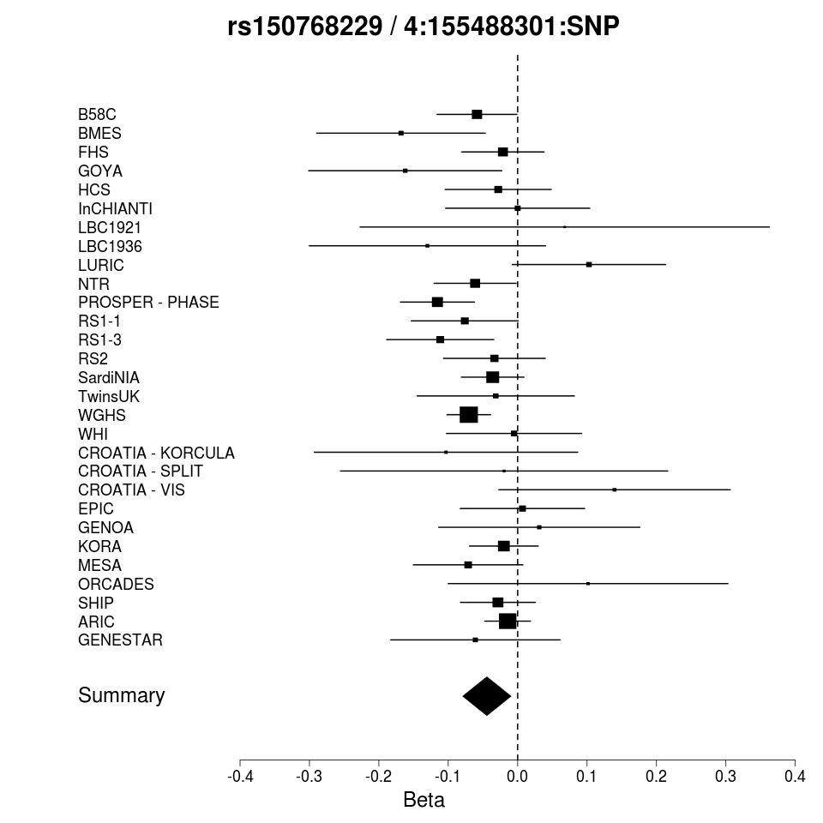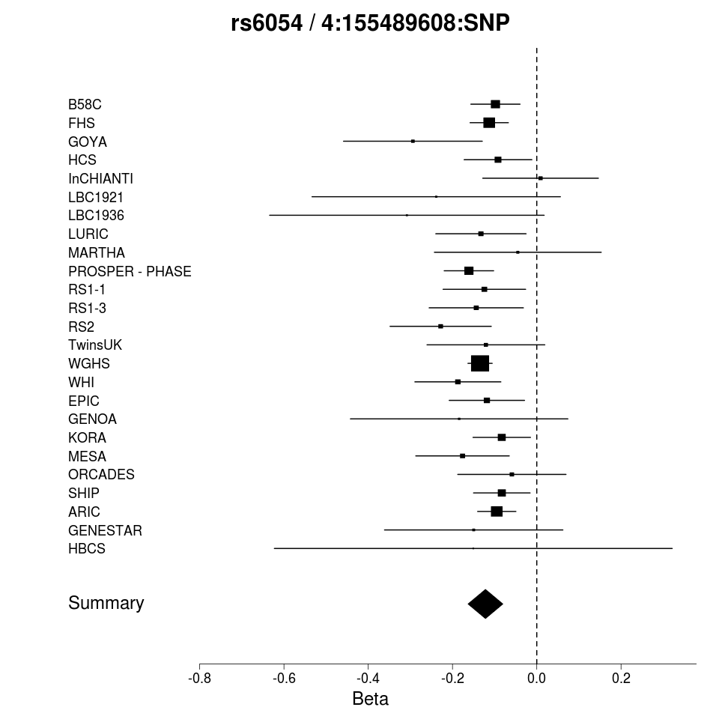
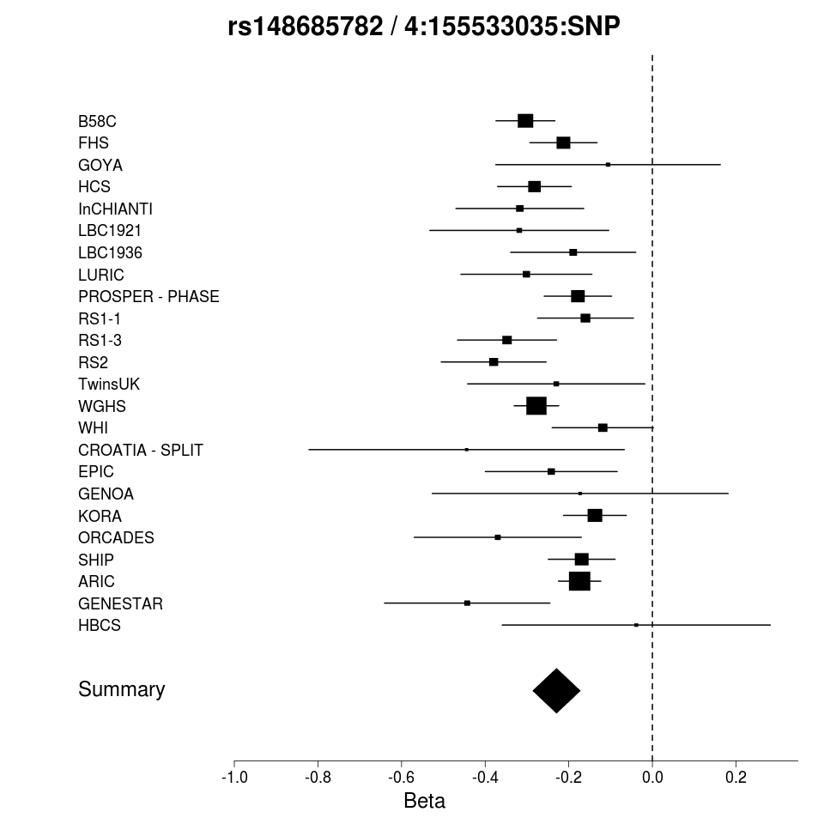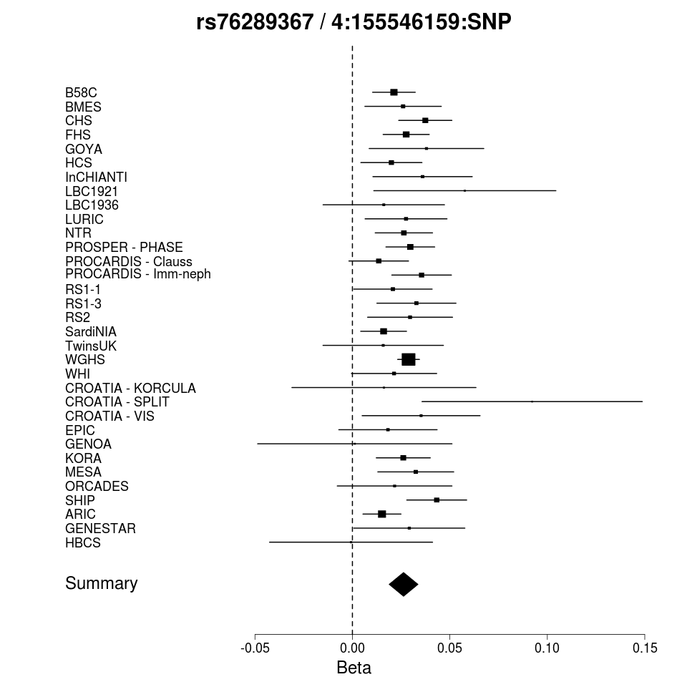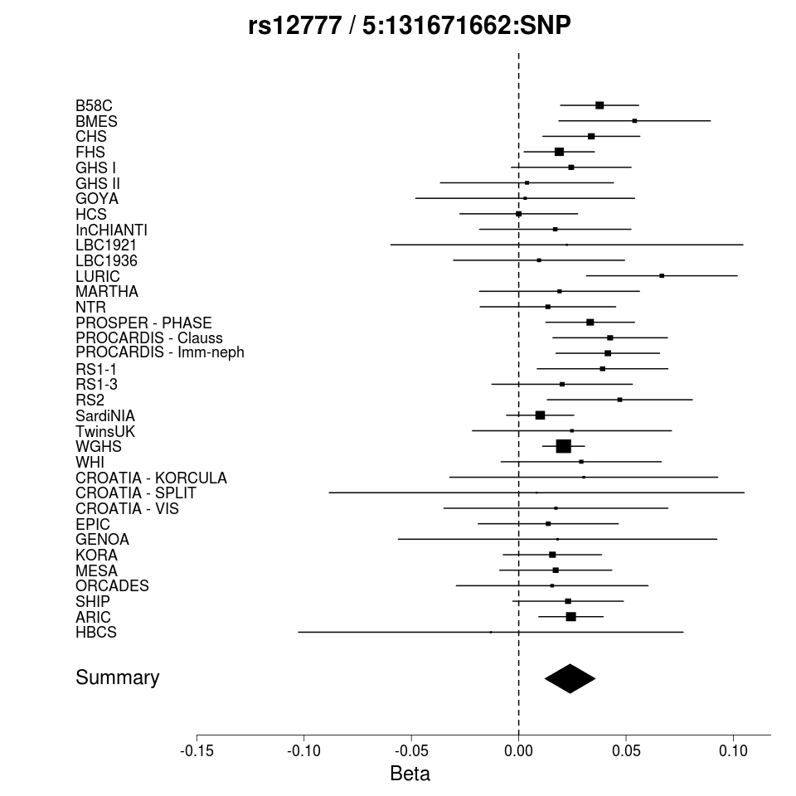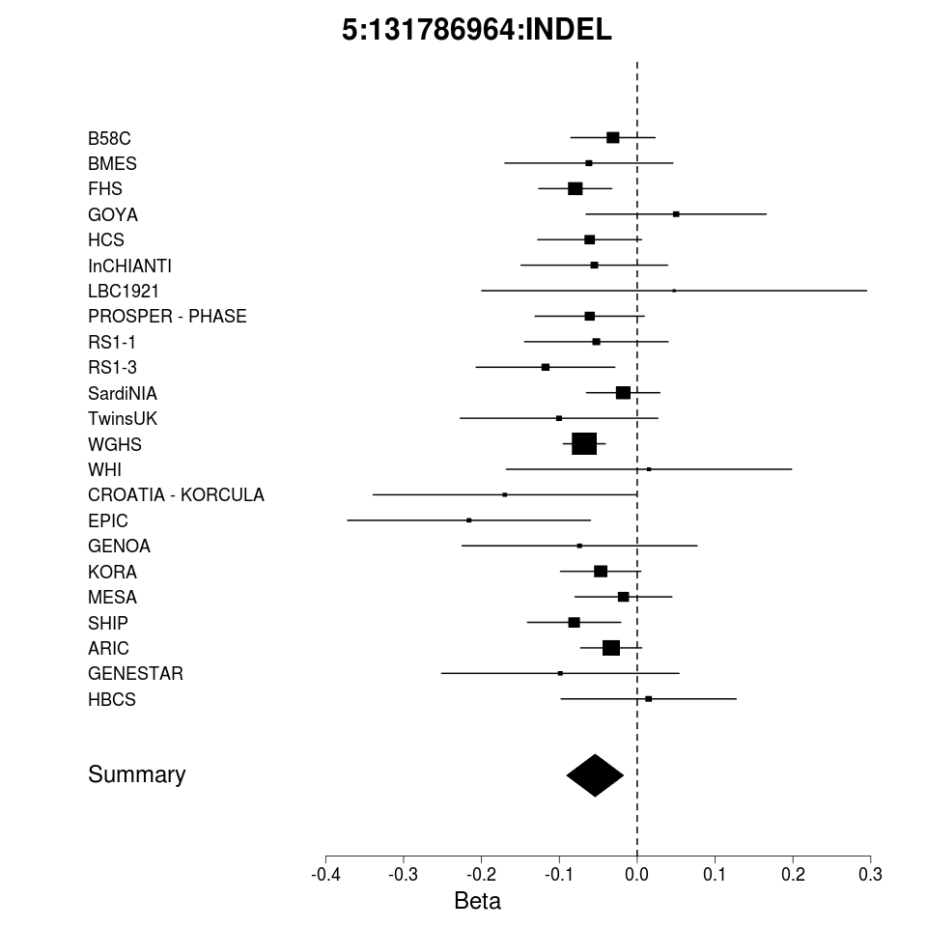
Supplementary Figure 7: Quantile-Quantile (QQ) plots of variants on the X chromosome

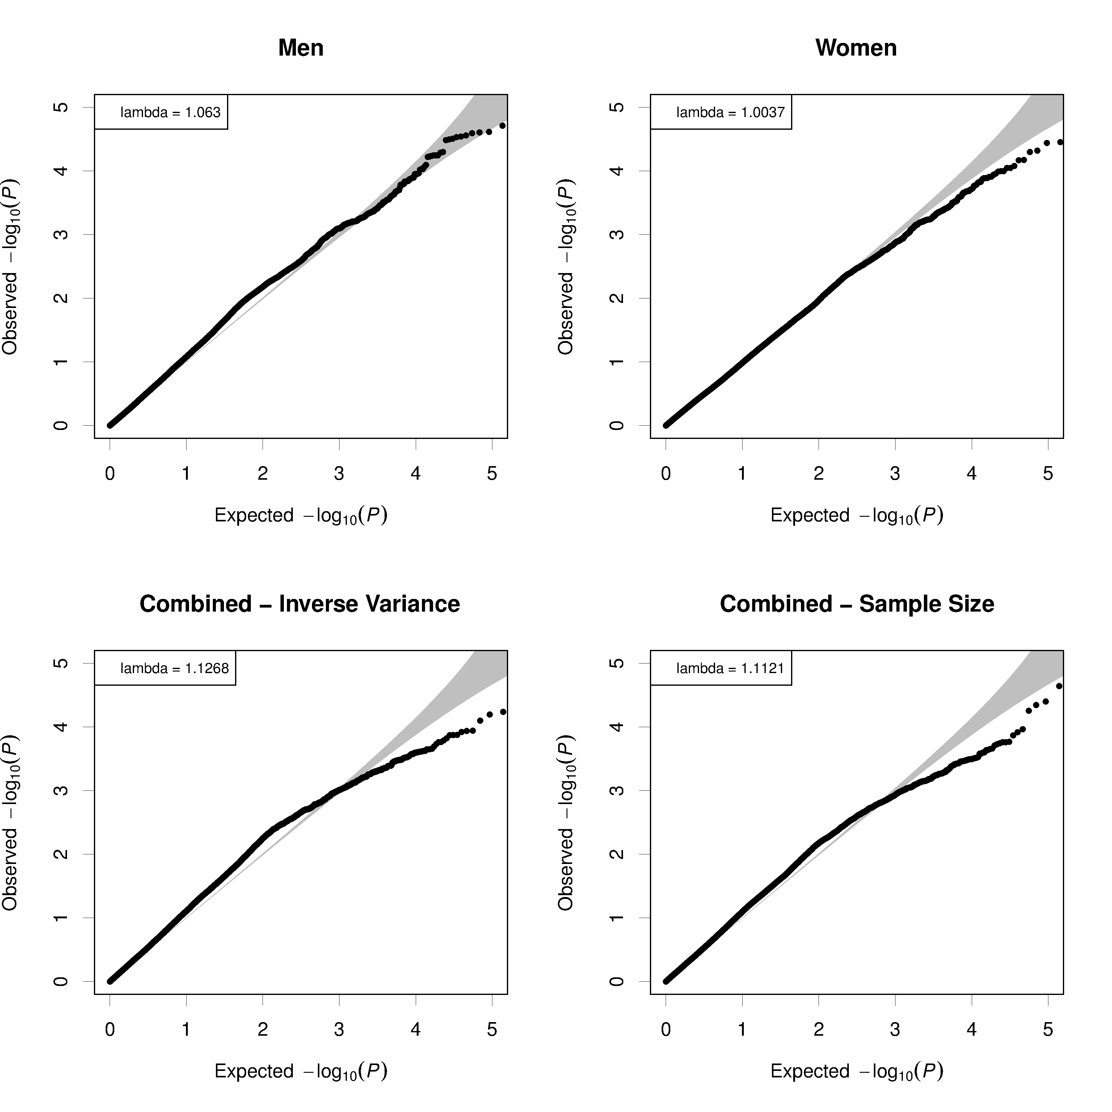
Supplementary Figure 8: Manhattan plots of variants on the X chromosome.
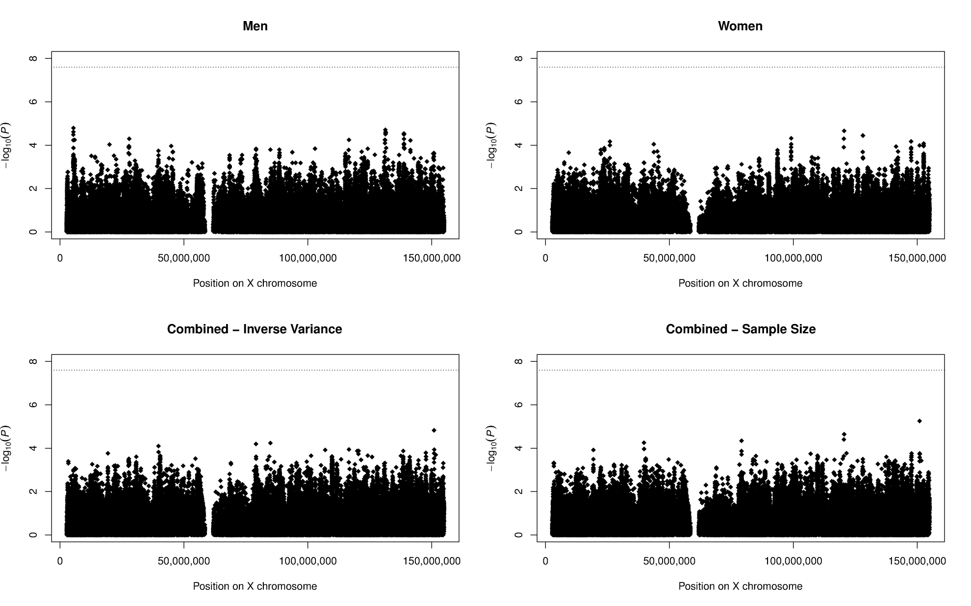

References
1. Johnson, A.D., Handsaker, R.E., Pulit, S.L., Nizzari, M.M., O'Donnell, C.J. and de Bakker, P.I. (2008) SNAP: a web-based tool for identification and annotation of proxy SNPs using HapMap. Bioinformatics, 24, 2938-2939.
2. Purcell, S., Neale, B., Todd-Brown, K., Thomas, L., Ferreira, M.A., Bender, D., Maller, J., Sklar, P., de Bakker, P.I., Daly, M.J. et al. (2007) PLINK: a tool set for whole-genome association and population-based linkage analyses. Am J Hum Genet, 81, 559-575.
3. Grimson, A., Farh, K.K., Johnston, W.K., Garrett-Engele, P., Lim, L.P. and Bartel, D.P. (2007) MicroRNA targeting specificity in mammals: determinants beyond seed pairing. Mol. Cell, 27, 91-105.
4. Hsu, S.D., Tseng, Y.T., Shrestha, S., Lin, Y.L., Khaleel, A., Chou, C.H., Chu, C.F., Huang, H.Y., Lin, C.M., Ho, S.Y. et al. (2014) miRTarBase update 2014: an information resource for experimentally validated miRNA-target interactions. Nucleic Acids Res, 42, D78-85.
5. Xiao, F., Zuo, Z., Cai, G., Kang, S., Gao, X. and Li, T. (2009) miRecords: an integrated resource for microRNA-target interactions. Nucleic Acids Res, 37, D105-110.
6. Bhattacharya, A., Ziebarth, J.D. and Cui, Y. (2014) PolymiRTS Database 3.0: linking polymorphisms in microRNAs and their target sites with human diseases and biological pathways. Nucleic Acids Res, 42, D86-91.
7. Hiard, S., Charlier, C., Coppieters, W., Georges, M. and Baurain, D. (2010) Patrocles: a database of polymorphic miRNA-mediated gene regulation in vertebrates. Nucleic Acids Res, 38, D640-651.
8. Gong, J., Tong, Y., Zhang, H.M., Wang, K., Hu, T., Shan, G., Sun, J. and Guo, A.Y. (2012) Genome-wide identification of SNPs in microRNA genes and the SNP effects on microRNA target binding and biogenesis. Hum. Mutat., 33, 254-263.
9. Barenboim, M., Zoltick, B.J., Guo, Y. and Weinberger, D.R. (2010) MicroSNiPer: a web tool for prediction of SNP effects on putative microRNA targets. Hum. Mutat., 31, 1223-1232.
10. Ghanbari, M., de Vries, P.S., de Looper, H., Peters, M.J., Schurmann, C., Yaghootkar, H., Dorr, M., Frayling, T.M., Uitterlinden, A.G., Hofman, A. et al. (2014) A genetic variant in the seed region of miR-4513 shows pleiotropic effects on lipid and glucose homeostasis, blood pressure, and coronary artery disease. Hum. Mutat., 35, 1524-1531.
11. ARIC (1989) The Atherosclerosis Risk in Communities (ARIC) Study: design and objectives. The ARIC investigators. Am J Epidemiol, 129, 687-702.
12. Clauss, A. (1957) [Rapid physiological coagulation method in determination of fibrinogen]
Gerinnungsphysiologische Schnellmethode zur Bestimmung des Fibrinogens. Acta Haematol., 17, 237-246.
13. Strachan, D.P., Rudnicka, A.R., Power, C., Shepherd, P., Fuller, E., Davis, A., Gibb, I., Kumari, M., Rumley, A., Macfarlane, G.J. et al. (2007) Lifecourse influences on health among British adults: effects of region of residence in childhood and adulthood. Int. J. Epidemiol., 36, 522-531.
14. Barrett, J.C., Clayton, D.G., Concannon, P., Akolkar, B., Cooper, J.D., Erlich, H.A., Julier, C., Morahan, G., Nerup, J., Nierras, C. et al. (2009) Genome-wide association study and meta-analysis find that over 40 loci affect risk of type 1 diabetes. Nat. Genet., 41, 703-707.
15. Moffatt, M.F., Gut, I.G., Demenais, F., Strachan, D.P., Bouzigon, E., Heath, S., von Mutius, E., Farrall, M., Lathrop, M., Cookson, W.O. et al. (2010) A large-scale, consortium-based genomewide association study of asthma. N. Engl. J. Med., 363, 1211-1221.
16. WTCCC (2007) Genome-wide association study of 14,000 cases of seven common diseases and 3,000 shared controls. Nature, 447, 661-678.
17. Rudnicka, A.R., Rumley, A., Lowe, G.D. and Strachan, D.P. (2007) Diurnal, seasonal, and blood-processing patterns in levels of circulating fibrinogen, fibrin D-dimer, C-reactive protein, tissue plasminogen activator, and von Willebrand factor in a 45-year-old population. Circulation, 115, 996-1003.
18. Attebo, K., Mitchell, P. and Smith, W. (1996) Visual acuity and the causes of visual loss in Australia. The Blue Mountains Eye Study. Ophthalmology, 103, 357-364.
19. Mitchell, P., Smith, W., Attebo, K. and Wang, J.J. (1995) Prevalence of age-related maculopathy in Australia. The Blue Mountains Eye Study. Ophthalmology, 102, 1450-1460.
20. Fried, L.P., Borhani, N.O., Enright, P., Furberg, C.D., Gardin, J.M., Kronmal, R.A., Kuller, L.H., Manolio, T.A., Mittelmark, M.B., Newman, A. et al. (1991) The Cardiovascular Health Study: design and rationale. Ann. Epidemiol., 1, 263-276.
21. Cushman, M., Cornell, E.S., Howard, P.R., Bovill, E.G. and Tracy, R.P. (1995) Laboratory methods and quality assurance in the Cardiovascular Health Study. Clin. Chem., 41, 264-270.
22. Rudan, I., Marusic, A., Jankovic, S., Rotim, K., Boban, M., Lauc, G., Grkovic, I., Dogas, Z., Zemunik, T., Vatavuk, Z. et al. (2009) "10001 Dalmatians:" Croatia launches its national biobank. Croat. Med. J., 50, 4-6.
23. Zemunik, T., Boban, M., Lauc, G., Jankovic, S., Rotim, K., Vatavuk, Z., Bencic, G., Dogas, Z., Boraska, V., Torlak, V. et al. (2009) Genome-wide association study of biochemical traits in Korcula Island, Croatia. Croat. Med. J., 50, 23-33.
24. Vitart, V., Rudan, I., Hayward, C., Gray, N.K., Floyd, J., Palmer, C.N., Knott, S.A., Kolcic, I., Polasek, O., Graessler, J. et al. (2008) SLC2A9 is a newly identified urate transporter influencing serum urate concentration, urate excretion and gout. Nat. Genet., 40, 437-442.
25. Day, N., Oakes, S., Luben, R., Khaw, K.T., Bingham, S., Welch, A. and Wareham, N. (1999) EPIC-Norfolk: study design and characteristics of the cohort. European Prospective Investigation of Cancer. Br. J. Cancer, 80 Suppl 1, 95-103.
26. Myint, P.K., Luben, R.N., Wareham, N.J., Welch, A.A., Bingham, S.A. and Khaw, K.T. (2008) Physical activity and fibrinogen concentrations in 23,201 men and women in the EPIC-Norfolk population-based study. Atherosclerosis, 198, 419-425.
27. Feinleib, M., Kannel, W.B., Garrison, R.J., McNamara, P.M. and Castelli, W.P. (1975) The Framingham Offspring Study. Design and preliminary data. Prev. Med., 4, 518-525.
28. Kannel, W.B., Wolf, P.A., Castelli, W.P. and D'Agostino, R.B. (1987) Fibrinogen and risk of cardiovascular disease. The Framingham Study. JAMA, 258, 1183-1186.
29. Vaidya, D., Yanek, L.R., Moy, T.F., Pearson, T.A., Becker, L.C. and Becker, D.M. (2007) Incidence of coronary artery disease in siblings of patients with premature coronary artery disease: 10 years of follow-up. Am. J. Cardiol., 100, 1410-1415.
30. FBPP Investigators (2002) Multi-center genetic study of hypertension: The Family Blood Pressure Program (FBPP). Hypertension, 39, 3-9.
31. Wild, P.S., Zeller, T., Beutel, M., Blettner, M., Dugi, K.A., Lackner, K.J., Pfeiffer, N., Munzel, T. and Blankenberg, S. (2012) [The Gutenberg Health Study]
Die Gutenberg Gesundheitsstudie. Bundesgesundheitsblatt Gesundheitsforschung Gesundheitsschutz, 55, 824-829.
32. Paternoster, L., Evans, D.M., Nohr, E.A., Holst, C., Gaborieau, V., Brennan, P., Gjesing, A.P., Grarup, N., Witte, D.R., Jorgensen, T. et al. (2011) Genome-wide population-based association study of extremely overweight young adults--the GOYA study. PLoS One, 6, e24303.
33. Becker, U., Bartl, K. and Wahlefeld, A.W. (1984) A functional photometric assay for plasma fibrinogen. Thromb. Res., 35, 475-484.
34. Barker, D.J., Osmond, C., Forsen, T.J., Kajantie, E. and Eriksson, J.G. (2005) Trajectories of growth among children who have coronary events as adults. N. Engl. J. Med., 353, 1802-1809.
35. Eriksson, J.G., Osmond, C., Kajantie, E., Forsen, T.J. and Barker, D.J. (2006) Patterns of growth among children who later develop type 2 diabetes or its risk factors. Diabetologia, 49, 2853-2858.
36. Räikkönen, K., Pesonen, A.K., Heinonen, K., Lahti, J., Kajantie, E., Forsen, T., Osmond, C., Barker, D.J. and Eriksson, J.G. (2008) Infant growth and hostility in adult life. Psychosom. Med., 70, 306-313.
37. McEvoy, M., Smith, W., D'Este, C., Duke, J., Peel, R., Schofield, P., Scott, R., Byles, J., Henry, D., Ewald, B. et al. (2010) Cohort profile: The Hunter Community Study. Int. J. Epidemiol., 39, 1452-1463.
38. Ferrucci, L., Bandinelli, S., Benvenuti, E., Di Iorio, A., Macchi, C., Harris, T.B. and Guralnik, J.M. (2000) Subsystems contributing to the decline in ability to walk: bridging the gap between epidemiology and geriatric practice in the InCHIANTI study. J. Am. Geriatr. Soc., 48, 1618-1625.
39. Holle, R., Happich, M., Lowel, H., Wichmann, H.E. and Group, M.K.S. (2005) KORA--a research platform for population based health research. Gesundheitswesen, 67 Suppl 1, S19-25.
40. Wichmann, H.E., Gieger, C., Illig, T. and Group, M.K.S. (2005) KORA-gen--resource for population genetics, controls and a broad spectrum of disease phenotypes. Gesundheitswesen, 67 Suppl 1, S26-30.
41. Deary, I.J., Gow, A.J., Pattie, A. and Starr, J.M. (2012) Cohort profile: the Lothian Birth Cohorts of 1921 and 1936. Int. J. Epidemiol., 41, 1576-1584.
42. Deary, I.J., Gow, A.J., Taylor, M.D., Corley, J., Brett, C., Wilson, V., Campbell, H., Whalley, L.J., Visscher, P.M., Porteous, D.J. et al. (2007) The Lothian Birth Cohort 1936: a study to examine influences on cognitive ageing from age 11 to age 70 and beyond. BMC Geriatr, 7, 28.
43. Deary, I.J., Whiteman, M.C., Starr, J.M., Whalley, L.J. and Fox, H.C. (2004) The impact of childhood intelligence on later life: following up the Scottish mental surveys of 1932 and 1947. J. Pers. Soc. Psychol., 86, 130-147.
44. Antoni, G., Oudot-Mellakh, T., Dimitromanolakis, A., Germain, M., Cohen, W., Wells, P., Lathrop, M., Gagnon, F., Morange, P.E. and Tregouet, D.A. (2011) Combined analysis of three genome-wide association studies on vWF and FVIII plasma levels. BMC Med Genet, 12, 102.
45. Bild, D.E., Bluemke, D.A., Burke, G.L., Detrano, R., Diez Roux, A.V., Folsom, A.R., Greenland, P., Jacob, D.R., Jr., Kronmal, R., Liu, K. et al. (2002) Multi-ethnic study of atherosclerosis: objectives and design. Am. J. Epidemiol., 156, 871-881.
46. Willemsen, G., de Geus, E.J., Bartels, M., van Beijsterveldt, C.E., Brooks, A.I., Estourgie-van Burk, G.F., Fugman, D.A., Hoekstra, C., Hottenga, J.J., Kluft, K. et al. (2010) The Netherlands Twin Register biobank: a resource for genetic epidemiological studies. Twin Res Hum Genet, 13, 231-245.
47. McQuillan, R., Leutenegger, A.L., Abdel-Rahman, R., Franklin, C.S., Pericic, M., Barac-Lauc, L., Smolej-Narancic, N., Janicijevic, B., Polasek, O., Tenesa, A. et al. (2008) Runs of homozygosity in European populations. Am J Hum Genet, 83, 359-372.
48. Shepherd, J., Blauw, G.J., Murphy, M.B., Bollen, E.L., Buckley, B.M., Cobbe, S.M., Ford, I., Gaw, A., Hyland, M., Jukema, J.W. et al. (2002) Pravastatin in elderly individuals at risk of vascular disease (PROSPER): a randomised controlled trial. Lancet, 360, 1623-1630.
49. Shepherd, J., Blauw, G.J., Murphy, M.B., Cobbe, S.M., Bollen, E.L., Buckley, B.M., Ford, I., Jukema, J.W., Hyland, M., Gaw, A. et al. (1999) The design of a prospective study of Pravastatin in the Elderly at Risk (PROSPER). PROSPER Study Group. PROspective Study of Pravastatin in the Elderly at Risk. Am. J. Cardiol., 84, 1192-1197.
50. Hofman, A., Darwish Murad, S., van Duijn, C.M., Franco, O.H., Goedegebure, A., Ikram, M.A., Klaver, C.C., Nijsten, T.E., Peeters, R.P., Stricker, B.H. et al. (2013) The Rotterdam Study: 2014 objectives and design update. Eur. J. Epidemiol., 28, 889-926.
51. Pilia, G., Chen, W.M., Scuteri, A., Orru, M., Albai, G., Dei, M., Lai, S., Usala, G., Lai, M., Loi, P. et al. (2006) Heritability of cardiovascular and personality traits in 6,148 Sardinians. PLoS Genet, 2, e132.
52. John, U., Greiner, B., Hensel, E., Ludemann, J., Piek, M., Sauer, S., Adam, C., Born, G., Alte, D., Greiser, E. et al. (2001) Study of Health In Pomerania (SHIP): a health examination survey in an east German region: objectives and design. Soz. Praventivmed., 46, 186-194.
53. Volzke, H., Alte, D., Schmidt, C.O., Radke, D., Lorbeer, R., Friedrich, N., Aumann, N., Lau, K., Piontek, M., Born, G. et al. (2011) Cohort profile: the study of health in Pomerania. Int. J. Epidemiol., 40, 294-307.
54. Andrew, T., Hart, D.J., Snieder, H., de Lange, M., Spector, T.D. and MacGregor, A.J. (2001) Are twins and singletons comparable? A study of disease-related and lifestyle characteristics in adult women. Twin Res., 4, 464-477.
55. Dunn, E.J., Ariens, R.A., de Lange, M., Snieder, H., Turney, J.H., Spector, T.D. and Grant, P.J. (2004) Genetics of fibrin clot structure: a twin study. Blood, 103, 1735-1740.
56. Ridker, P.M., Chasman, D.I., Zee, R.Y., Parker, A., Rose, L., Cook, N.R., Buring, J.E. and Women's Genome Health Study Working, G. (2008) Rationale, design, and methodology of the Women's Genome Health Study: a genome-wide association study of more than 25,000 initially healthy american women. Clin. Chem., 54, 249-255.
57. The Women's Health Initiative Study Group (1998) Design of the Women's Health Initiative clinical trial and observational study. Control. Clin. Trials, 19, 61-109.

