Table 1. Mutants of Guy’s 13 heavy and light chain with substitutions proximal to the cleavage sites ‘AKTTP’ and ‘EIKRA’. The wild type Guy’s 13 heavy and light chain sequence is shown in bold with corresponding Kabat amino acid numbering. The location of the protease cleavage site is indicated by the arrow and the positions amino terminal (P1 to P6) and carboxyl terminal (P1’ to P6’) to the scissile bond are shown at the top of the table.
The amino acid sequences used in mutant heavy and light chains are shown below, with amino acid substitutions shown (unshaded). Grey shading represents an unchanged amino acid residue.

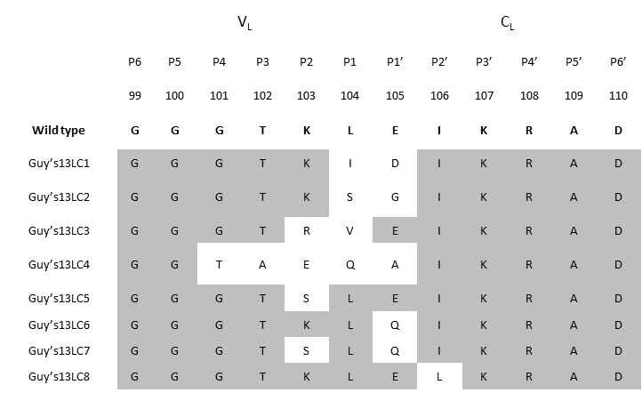
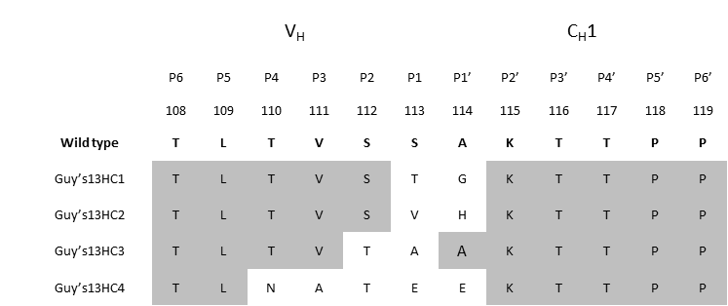
B
A

