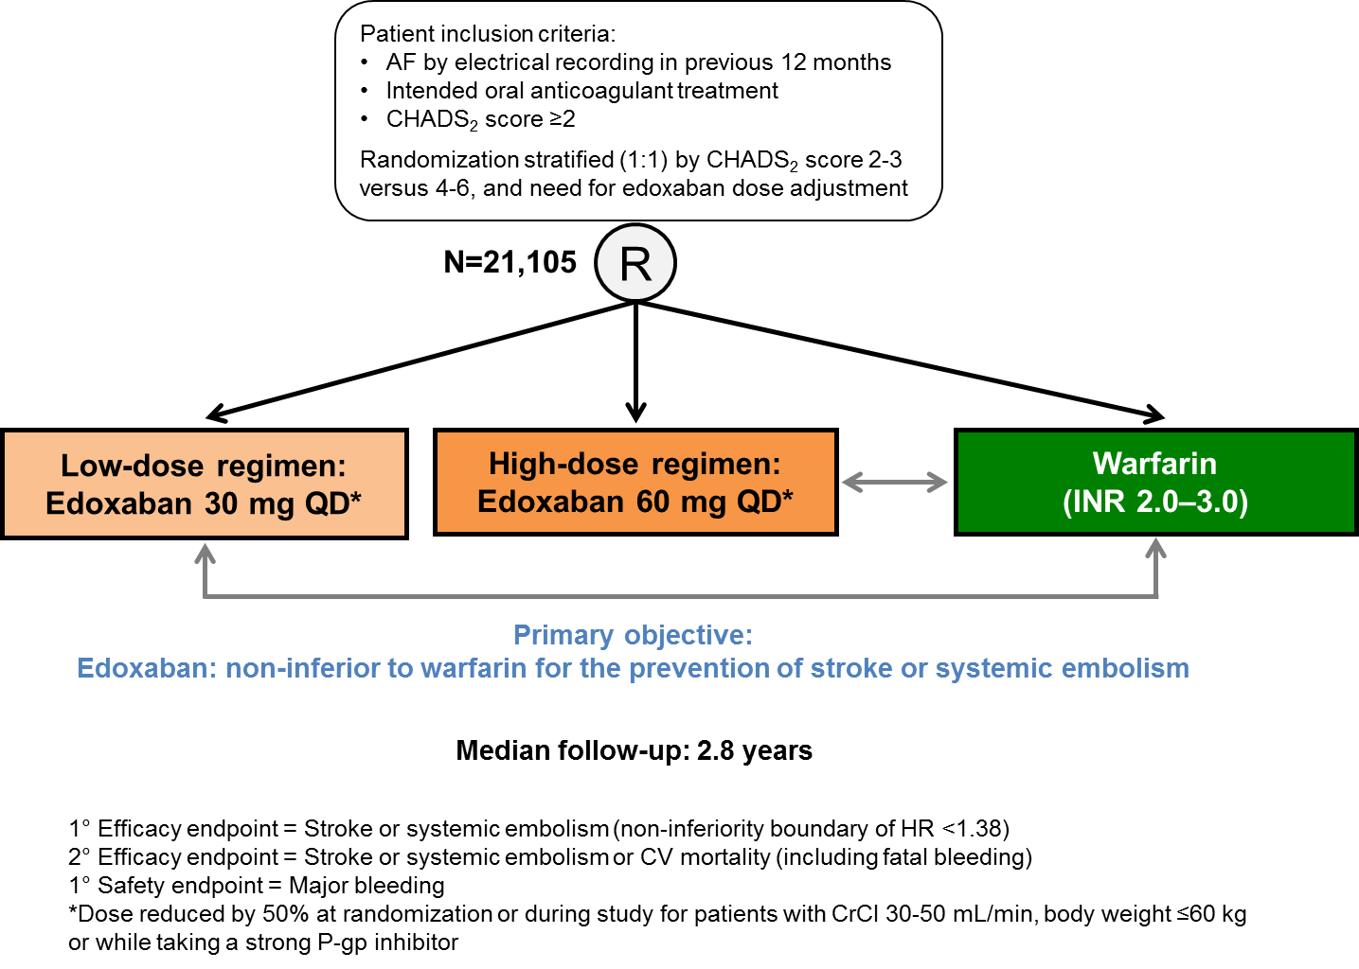
Supplementary Figure 1. Design of ENGAGE AF-TIMI 48 study. AF, atrial fibrillation; CrCl, creatinine clearance; CV, cardiovascular; HR, hazard ratio; INR, international normalization ratio; P-gp, P-glycoprotein; QD, once-daily; CHADS₂, Congestive heart failure or left ventricular dysfunction, Hypertension, Aged ≥75 years (doubled), Diabetes, Stroke/transient ischemic attach (doubled). Reproduced with permission from Ruff et al 2000.[40]

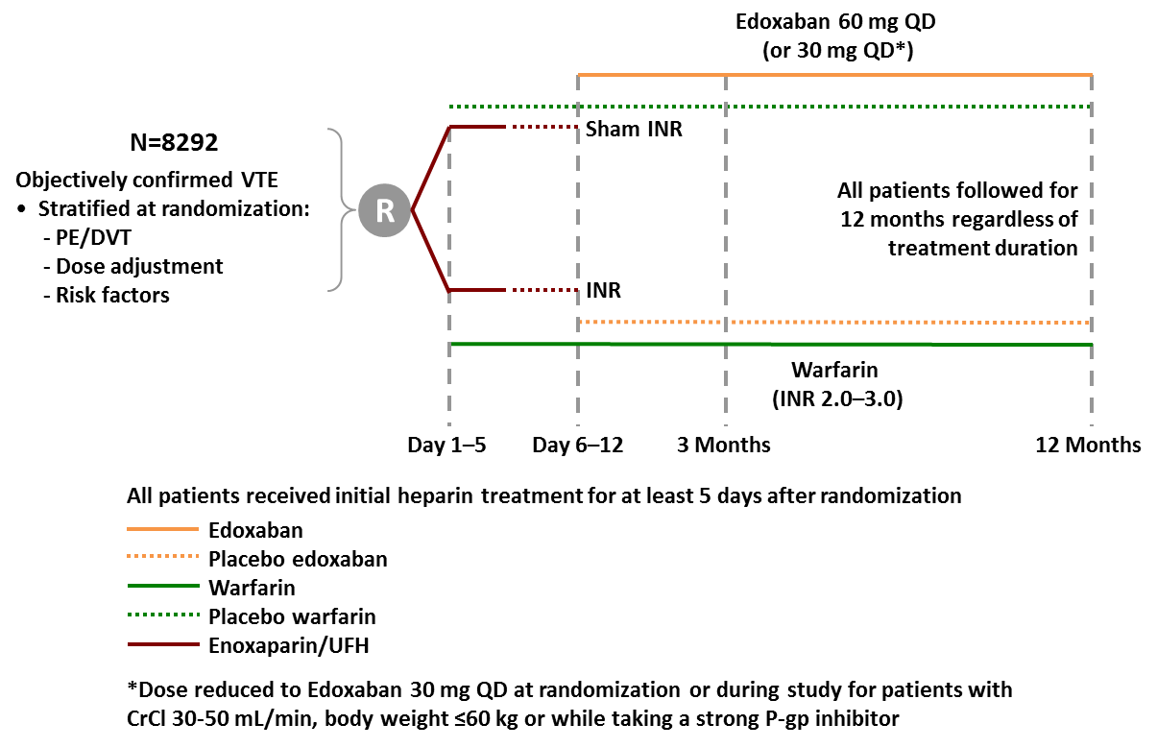
Supplementary Figure 2. Design of Hokusai-VTE. DVT, deep-vein thrombosis; INR, international normalization ratio; PE, pulmonary embolism; UFH, unfractionated heparin; VTE, venous thromboembolism. Reproduced with permission from Raskob et al 2013.[93]

