**Supplementary materials to:**

**Evaluation of the standard battery of *in vitro* genotoxicity tests for chemical hazard assessment through mathematical modelling: a report from the 8th International Workshop on Genotoxicity Testing (IWGT)**

Mirjam Luijten, Jan van Benthem, Takeshi Morita, Raffaella Corvi, Patricia A. Escobar, Yurika Fujita, Jennifer Hemmerich, Naveed Honarvar, David Kirkland, Naoki Koyama, David Lovell, Miriam Mathea, Andrew Williams, Stephen Dertinger, Stefan Pfuhler, Jeroen L.A. Pennings

**Contents**

Supplementary Table S1 2

Supplementary Table S3 3

Supplementary Figure S1 4

Supplementary Figure S2 5

References 6

## Supplementary Table S1

The database constructed for the analyses described can be freely accessed here at Zenodo: <https://zenodo.org/record/8363787>.

An R script containing the method described in this paper, as well as a data file with input data for the core set of 309 substances, are available at <https://github.com/jlapennings/iwgt_pwoe>.

## Supplementary Table S3

**Supplementary Table S3**. Combining test results when considering equivocal calls as positive test result.

|  |  |  |
| --- | --- | --- |
| Test result | Test result | Combined |
| + | + | + |
| + | - | + |
| + | E | + |
| - | - | - |
| - | E | + |
| E | E | + |

+: positive call

-: negative call

E: equivocal call

## Supplementary Figure S1

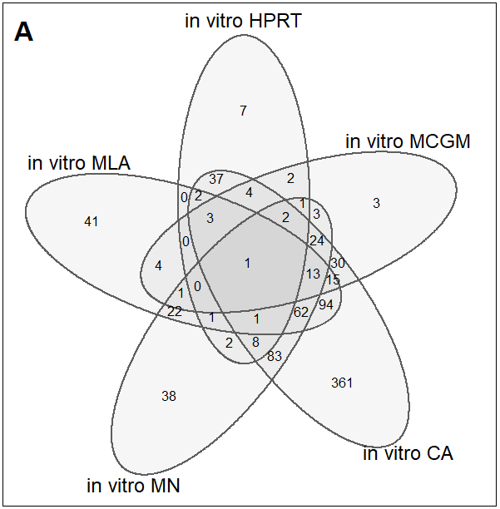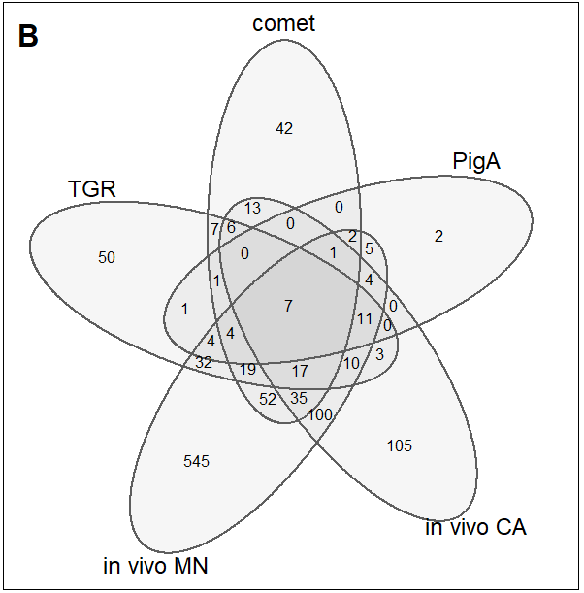

*Supplementary Figure S1. Distribution of the 1,078 substances with both in vitro and in vivo data for genotoxicity available in the database across (A) the mammalian in vitro genotoxicity tests studied: MLA, hprt, mammalian cell gene mutation test (MCGM, i.e. MLA and/or hprt, but not specified), in vitro MN and in vitro CA; and (B) the in vivo genotoxicity tests studied: in vivo MN, in vivo CA, TGR, comet and Pig-a. For 1,022 out of the 1,078 substances, Ames data are available.*

## Supplementary Figure S2

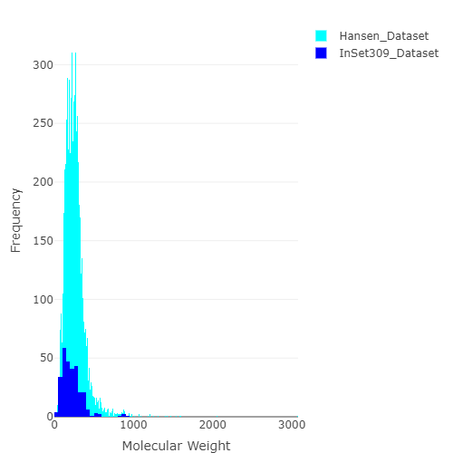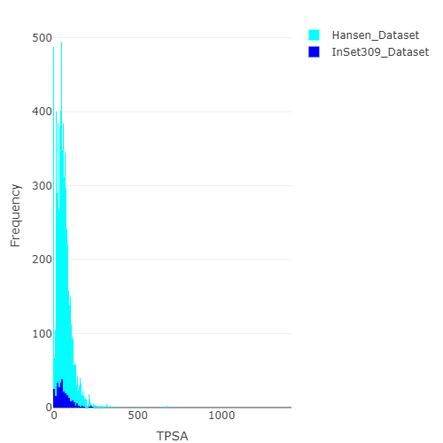

*Supplementary Figure S2. The molecular weight (left panel) and the topological polar surface area (TPSA; right panel) of the core set of 309 substances (dark blue) and a large benchmark dataset (light blue; [Hansen et al. 2009]), respectively.*

## References

Hansen K, Mika S, Schroeter T, Sutter A, ter Laak A, Steger-Hartmann T, Heinrich N, Muller KR. 2009. Benchmark data set for in silico prediction of ames mutagenicity. J Chem Inf Model 49: 2077-2081.