*Supporting information*

***Variability of ambient atmospheric ammonia in urban Europe (Finland, France, Italy, Spain, and the UK)***

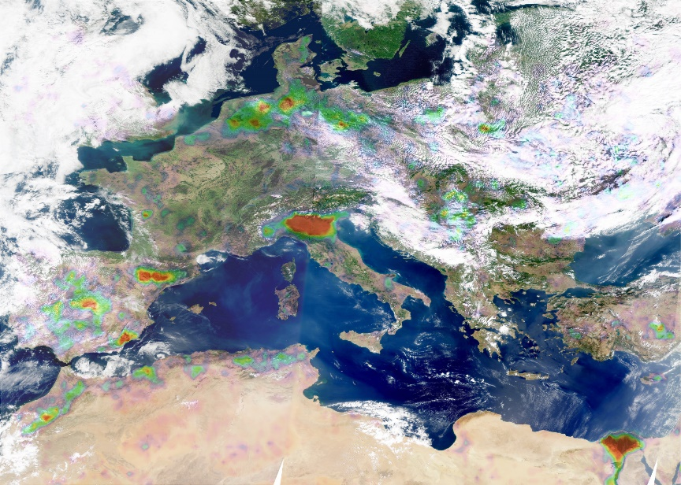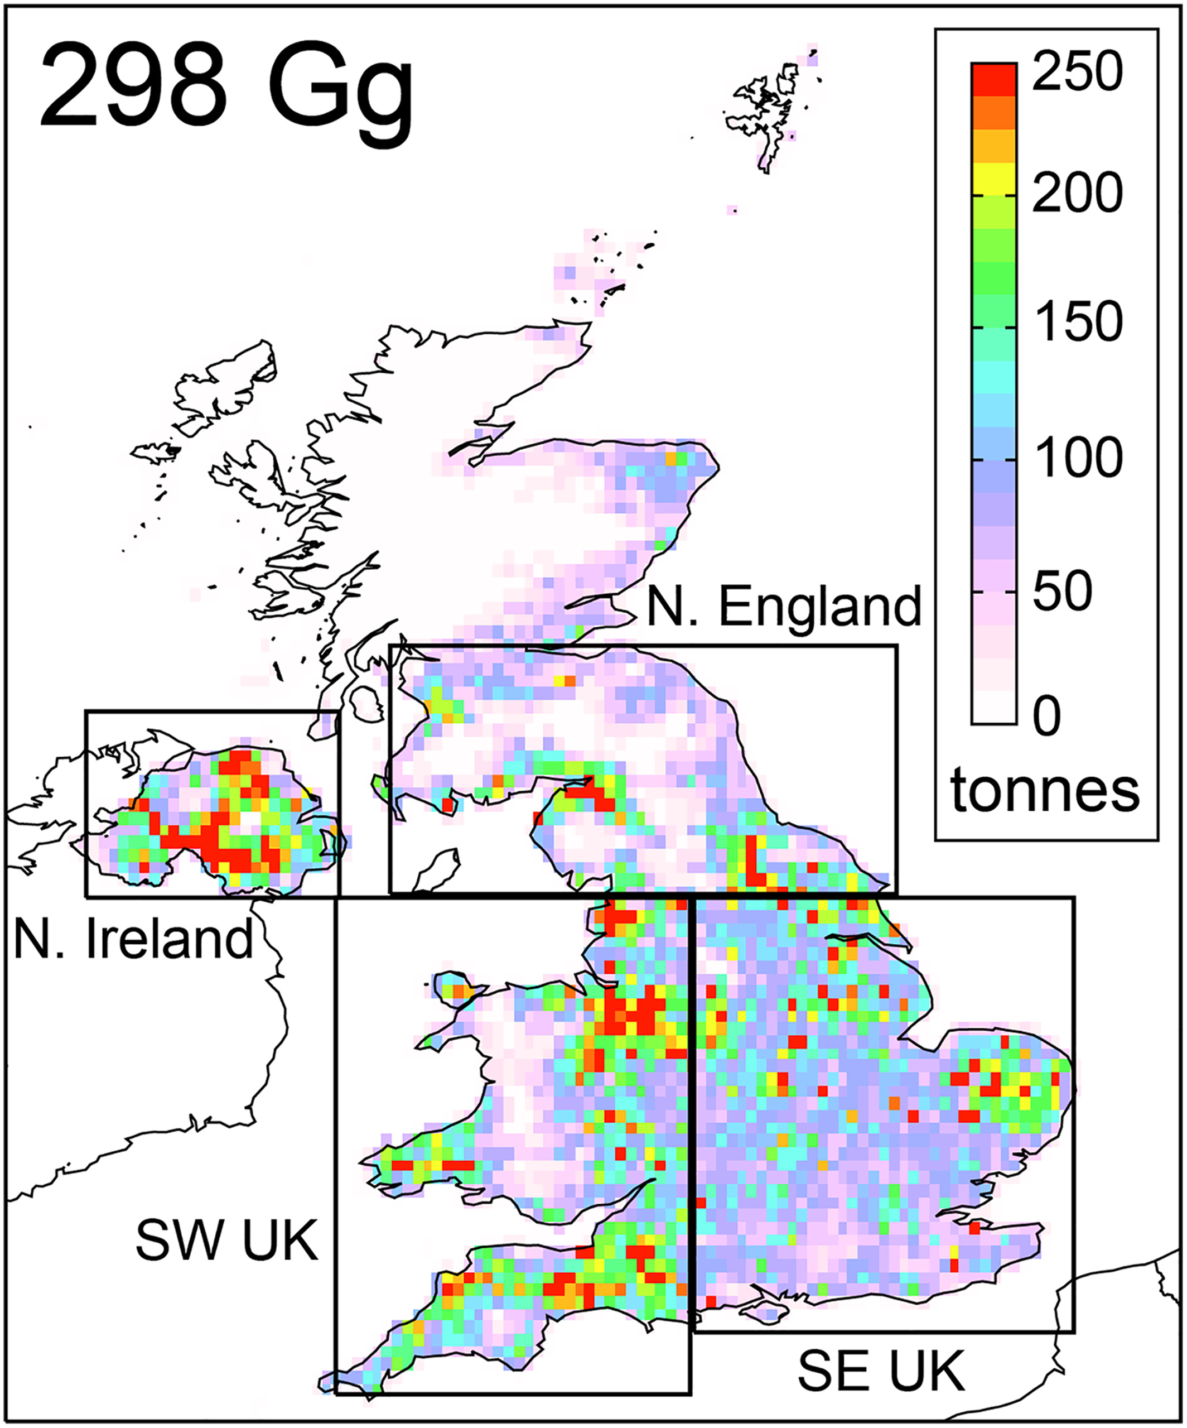

*Figure S1. The identifiable hotspots using remote data in France, Italy, Spain, and the UK. (Citation: Van Damme, et al. (2022).* [*https://www.nature.com/articles/s41598-022-15836-w*](https://www.nature.com/articles/s41598-022-15836-w)*; Marais, Eloise A., et al. (2021).*[*https://doi.org/10.1029/2021JD035237*](https://doi.org/10.1029/2021JD035237)*).*

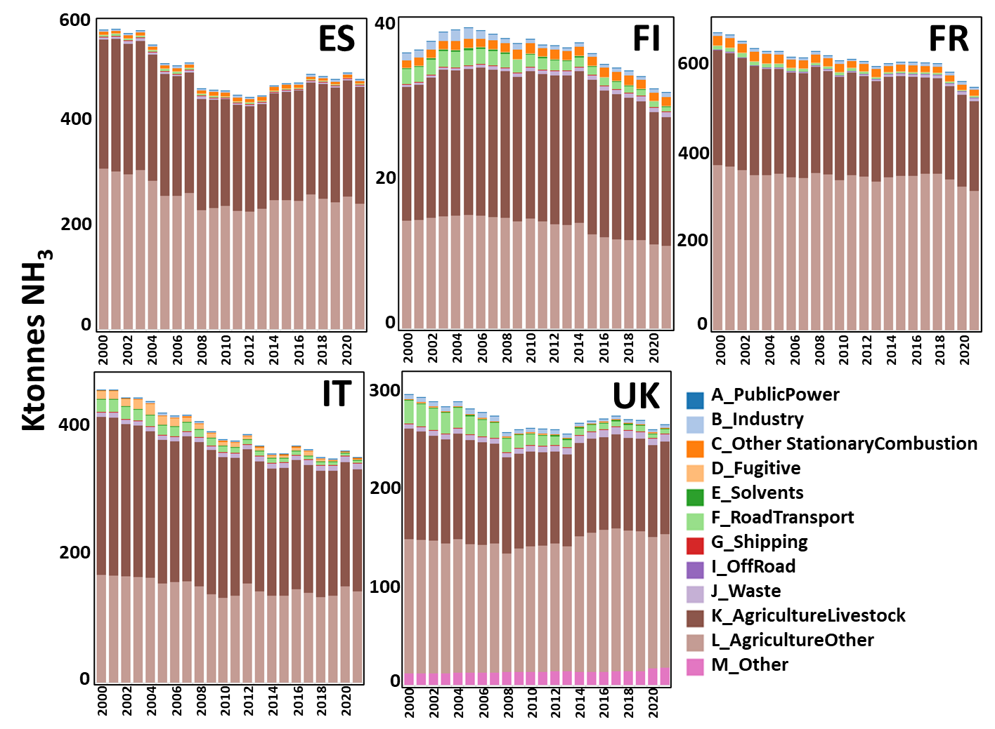

*Figure S2: Trends emission of NH3 in the five countries of Europe (ES, Spain; FI, Finland; FR, France; IT, Italy; and UK, United Kingdom) during 2000-2021 (https://www.ceip.at/data-viewer-2).*

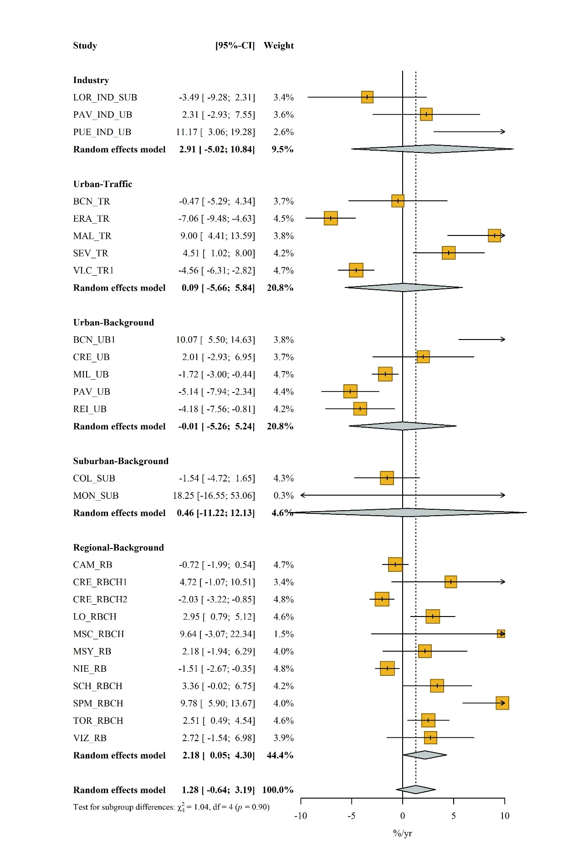

*Figure S3. Meta-analysis results for all long-term monitoring sites.*



*Figure S4. Seasonal variations of NH3 concentrations for 26 out of the 69 studied sites.*

*Table S1. List of air quality sites supplying NH3 datasets to this study with location and type of environment. IND, industry; UB, Urban Background; TR, Traffic; SUB, Suburban Background; RB, Regional Background.**RBCH, Regional Background closed hotspot.* ***Bold, farming/agricultural hotspots (FAHs).***

|  |  |  |  |  |  |
| --- | --- | --- | --- | --- | --- |
| City (Country) | Station type | Acronym | Latitude | Longitude | Altitude （m） |
| **Sannazzaro de' Burgondi (IT)** | **Urban-Industry** | **PAV_IND_UB** | **45.10** | **8.90** | **86** |
| **Puertollano (ES)** | **Urban-Industry** | **PUE_IND_UB** | **38.70** | **-4.09** | **708** |
| Coruña (A) (ES) | Suburban-Industry | COR_IND_SUB | 43.14 | -8.03 | 498 |
| Castellón (ES) | Suburban-industry | CS_IND_SUB | 39.97 | 0.01 | 0 |
| Lorca (ES) | Urban-Industry | LOR_IND_SUB | 37.68 | -1.69 | 327 |
| Barcelona (ES) | Urban-Traffic | BCN_TR | 41.39 | 2.15 | 70 |
| Bordeaux Gautier (FR) | Urban-Traffic | BOR_TR | 44.82 | -0.55 | 7 |
| **Valladolid (ES)** | **Urban-Traffic** | **EMB_TR** | **41.63** | **-4.72** | **691** |
| Erandio (ES) | Urban-Traffic | ERA_TR | 43.30 | -2.97 | 19 |
| Madrid (ES) | Urban-Traffic | MAD_TR | 40.42 | -3.71 | 637 |
| Málaga (ES) | Urban-Traffic | MAL_TR | 36.71 | -4.45 | 380 |
| **Murcia (región de) (ES)** | **Suburban-Traffic** | **MUR_TR_SUB** | **37.99** | **-1.14** | **40** |
| Paris (FR) | Urban-Traffic | PAR_TR | 48.84 | 2.41 | 44 |
| Poitiers-le nain (FR) | Urban-Traffic | POI_TR | 46.59 | 0.34 | 71 |
| Sevilla (ES) | Urban-Traffic | SEV_TR | 37.38 | -5.96 | 29 |
| Valencia (ES) | Urban-Traffic | VLC_TR1 | 39.47 | -0.38 | 8 |
| Valencia (ES) | Urban-Traffic | VLC_TR2 | 39.97 | 0.01 | 3 |
| **Argales (ES)** | **Urban-Background** | **ARG_UB** | **41.63** | **-4.23** | **741** |
| Barcelona (ES) | Urban-Background | BCN_UB1 | 41.39 | 2.11 | 64 |
| Barcelona (ES) | Urban-Background | BCN_UB2 | 41.39 | 2.12 | 68 |
| Barcelona (ES) | Urban-Background | BCN_UB3 | 41.37 | 2.17 | 30 |
| **Bergamo (IT)** | **Urban-Background** | **BER_UB** | **45.69** | **9.64** | **242** |
| Birmingham Tyburn (UK) | Urban-Background | BIR_UB | 52.51 | -1.83 | 92 |
| **Valladolid (ES** | **Urban-Background** | **CAB_UB** | **41.67** | **-4.72** | **691** |
| **Cremona (IT)** | **Urban-Background** | **CRE_UB** | **45.14** | **10.04** | **40** |
| Gonfreville l'Orcher (FR) | Urban-Background | GOR_UB | 49.50 | 0.23 | 72 |
| Helsinki (FI) | Urban-Background | HEL_UB | 60.12 | 24.58 | 26 |
| **Valladolid (ES)** | **Urban-Background** | **LAG_UB** | **41.59** | **-4.73** | **702** |
| London (Honor oak park) (UK) | Urban-Background | LND_UB | 51.45 | -0.04 | 31 |
| Málaga (ES) | Urban-Background | MAL_UB | 36.72 | -4.45 | 36 |
| Manchester (UK) | Urban-Background | MAN_UB | 53.4 | -2.24 | 36 |
| **Manlleu (ES)** | **Urban-Background** | **MANL_UB** | **42.01** | **2.28** | **460** |
| **Milano (IT)** | **Urban-Background** | **MIL_UB** | **45.48** | **9.24** | **116** |
| Niort Venise (FR) | Urban-Background | NIO_UB | 46.32 | -0.46 | 29 |
| **Valladolid (ES)** | **Urban-Background** | **OBR_UB** | **41.67** | **-4.73** | **691** |
| Paris (FR) | Urban-Background | PAR_UB | 48.86 | 2.34 | 35 |
| **Pavia (IT)** | **Urban-Background** | **PAV_UB** | **45.19** | **9.16** | **89** |
| **Valladolid (ES)** | **Urban-Background** | **PDR_UB** | **41.64** | **-4.76** | **747** |
| Rouen Petit Queuvilly (FR) | Urban-Background | PQUE_UB | 46.43 | 1.07 | 10 |
| Rouen, Quai de Paris (FR) | Urban-Background | QDP_UB | 49.44 | 1.10 | 4 |
| Reims (FR) | Urban-Background | REI_UB | 49.22 | 4.02 | 97 |
| Strasbourg (FR) | Urban-Background | STR_UB | 48.57 | 7.77 | 140 |
| Colico (IT) | Suburban-Background | COL_SUB | 46.14 | 9.38 | 229 |
| **Cremona (Piadena) (IT)** | **Suburban-Background** | **CRE_SUB** | **45.13** | **10.38** | **30** |
| **Valladolid (ES)** | **Suburban-Background** | **JAR_SUB** | **41.67** | **-4.72** | **692** |
| Málaga (ES) | Suburban-Background | MAL_SUB | 36.73 | -4.47 | 86 |
| **Milano (IT)** | **Suburban-Background** | **MIL_SUB** | **45.28** | **8.99** | **101** |
| **Monza (IT)** | **Suburban-Background** | **MON_SUB** | **45.60** | **9.28** | **237** |
| Paris (FR) | Suburban-Background | PAR_SUB1 | 48.71 | 2.21 | 156 |
| Paris (FR) | Suburban-Background | PAR_SUB2 | 48.71 | 2.21 | 156 |
| Paris (FR) | Suburban-Background | PAR_SUB3 | 48.71 | 2.21 | 156 |
| Poses (FR) | Suburban-Background | POSE_SUB | 49.30 | 1.24 | 10 |
| **Vic (ES)** | **Suburban-Background** | **VIC_SUB1** | **41.90** | **2.24** | **478** |
| **Vic (ES)** | **Suburban-Background** | **VIC_SUB2** | **41.90** | **2.24** | **478** |
| Auchencorth Moss (UK) | Rural-Background | ACTH_RB | 55.79 | -3.24 | 270 |
| Barcarrota (ES) | Rural-Background | BAR_RB | 38.47 | -6.92 | 377 |
| **Bujaraloz (ES)** | **Regional-Background** | **BUJ_RBCH** | **41.50** | **-0.15** | **327** |
| Campisábalos (ES) | Regional-Background | CAM_RB | 41.27 | -3.14 | 1368 |
| **Chilbolton (UK)** | **Regional-Background** | **CHIL_RBCH** | **51.10** | **1.44** | **90** |
| **Cremona (IT)** | **Regional-Background** | **CRE_RBCH1** | **45.11** | **10.07** | **35** |
| **Cremona (IT)** | **Regional-Background** | **CRE_RBCH2** | **45.28** | **10.01** | **60** |
| **Bertonico (IT)** | **Regional-Background** | **LO_RBCH** | **45.23** | **9.67** | **64** |
| **Montsec (ES)** | **Regional-Background** | **MSC_RBCH** | **42.00** | **0.73** | **1571** |
| **Montseny (ES)** | **Regional-Background** | **MSY_RB** | **41.70** | **2.36** | **720** |
| Niembro (ES) | Regional-Background | NIE_RB | 43.44 | -4.85 | 132 |
| **Schivenoglia (IT)** | **Regional-Background** | **SCH_RBCH** | **45.02** | **11.08** | **12** |
| San Pablo de los Montes (ES) | Regional-Background | SPM_RB | 39.55 | -4.35 | 923 |
| **Els Torms (ES)** | **Regional-Background** | **TOR_RBCH** | **41.39** | **0.73** | **488** |
| Víznar (ES) | Regional-Background | VIZ_RB | 37.24 | -3.55 | 1258 |

*Table S2. Summary of atmospheric NH3 monitoring results in various cities of the world.*

|  |  |  |  |  |  |
| --- | --- | --- | --- | --- | --- |
| City (Country) | Season | Types | Method | NH3 | Reference |
| Nanjing (CN) | 07/2013-08/2014 | Urban Traffic | portable ammonia gas detector | 6.7±1.1 | (Wang et al., 2016) |
| Shanghai (CN) | 04/2014-04/2015 | Urban | MARGA | 5.5±3.9 | (Chang *et al.*, 2016) |
| Beijing (CN) | 01/2019-06/2020 | Urban | Los Gatos Research | 15.7±8.9 | (Zhang *et al.*, 2021) |
| Seoul (ROK) | 03/2020-03/2021 | Urban Traffic | Radiello passive ammonia sampler | 18.2±4.6 | (Singh et al., 2021) |
| Toronto (CAN) | 07/2003-07/2014 | Urban | a PartisolModel 2300 | 1.8±0.8 | (Yao and Zhang, 2016) |
| 05/2006-04/2014 | 1.7±0.4 |
| 11/2007-10/2014 | 1.3±0.6 |
| 09/2003-08/2014 | 1.1±0.4 |
| Rochester (US) | 04/2016-10/2017 | Urban | chemiluminescence | 2.3±1.6 | (Zhou et al., 2019) |
| New York (US) | 06/2016-10/2017 | Urban | chemiluminescence | 2.0±1.3 |
| Delhi (IND) | 01/2011-12/2015 | Urban | chemiluminescence | 13.5±3.1 | (Saraswati et al., 2018) |

**References**

Chang, Y., Zou, Z., Deng, C., Huang, K., Collett, J.L., Lin, J., Zhuang, G., 2016. The importance of vehicle emissions as a source of atmospheric ammonia in the megacity of Shanghai. Atmos Chem Phys 16, 3577-3594.

Saraswati, Sharma, S.K., Mandal, T.K., 2018. Five-year measurements of ambient ammonia and its relationships with other trace gases at an urban site of Delhi, India. Meteorol Atmos Phys 130, 241-257.

Singh, R., Kim, K., Park, G., Kang, S., Park, T., Ban, J., Choi, S., Song, J., Yu, D., Woo, J., 2021. Seasonal and Spatial Variations of Atmospheric Ammonia in the Urban and Suburban Environments of Seoul, Korea. Atmosphere (Basel) 12, 1607.

Wang, W., Wang, S., Xu, J., Zhou, R., Shi, C., Zhou, B., 2016. Gas-phase ammonia and PM 2.5 ammonium in a busy traffic area of Nanjing, China. Environ Sci Pollut Res Int 23, 1691-1702.

Yao, X., Zhang, L., 2016. Trends in atmospheric ammonia at urban, rural, and remote sites across North America. Atmos Chem Phys 16, 11465-11475.

Zhang, X., Lin, W., Ma, Z., Xu, X., 2021. Indoor NH3 variation and its relationship with outdoor NH3 in urban Beijing. Indoor Air 31, 2130-2141.

Zhou, C., Zhou, H., Holsen, T.M., Hopke, P.K., Edgerton, E.S., Schwab, J.J., 2019. Ambient ammonia concentrations across New York state. Journal of Geophysical Research: Atmospheres 124, 8287-8302.