Recent advances in the diagnosis and management of Amoebiasis
Joseph Cooney^{1,2}, Spyros Siakavellas³, Peter L Chiodini^{4,5}, Ula Mahadeva⁶, Gauri Godbole⁴, Richard CG Pollok^{1,2}*¶, Philip J Smith⁷*
*PJS and RCGP are joint senior authors
Affiliations:
¹Department of Gastroenterology, St George’s Hospital NHS Foundation Trust, London, UK
²Division of Infection and Immunity, St George’s, University of London, UK
³Hepato-Gastroenterology Unit, Hippocration General Hospital of Athens, Greece
⁴The Hospital for Tropical Diseases, London, UK
⁵The London School of Hygiene & Tropical Medicine, UK
⁶Department of Histopathology, Guys and St Thomas’ NHS Foundation Trust, London, UK
⁷Department of Gastroenterology, Royal Liverpool Hospital, Liverpool University Hospitals NHS Foundation Trust, Liverpool, UK
Corresponding author:
¶Professor Richard CG Pollok, Department of Gastroenterology, St George’s Hospital NHS Foundation Trust, London, UK; Division of Infection and Immunity, St George’s, University of London, UK. Email: richard.pollok@nhs.net
ORCID iDs:
Joseph COONEY https://orcid.org/0000-0002-9295-1625
Spyros SIAKAVELLAS https://orcid.org/0000-0001-8217-8950
Peter L CHIODINI https://orcid.org/0000-0003-0317-7090
Ula MAHADEVA https://orcid.org/0000-0002-9459-3403
Gauri GODBOLE https://orcid.org/0000-0002-5846-8517
Richard CG POLLOK https://orcid.org/0000-0001-6452-6763
Philip J SMITH https://orcid.org/0000-0003-1568-3978
Conflicts of interest:
PJS is an Honorary Consultant Gastroenterologist at the Royal Liverpool University Hospital and Deputy Editor of Frontline Gastroenterology at the time of submission of this article. He has no other conflicts of interest in relation to this article.
JC, SS, PLC, UM, GG and RCGP declare no conflicts of interest in relation to this article.
Funding:
Not applicable
Author contributions:
Conception and design: JC, RCGP, PJS; Literature review: JC and SS; initial draft JC, SS, PC, GG, UM, PJS and RCGP. All authors contributed to critical revisions and final draft. PJS and RCGP are the guarantors.
Acknowledgements:
We are grateful to the Gastroenterology and Radiology Departments of St George’s Hospital NHS Trust for provision of images included in this article. We thank Guys and St Thomas’ NHS Foundation Trust Histopathology Department for allowing access to histopathology images. We thank CDC (Centers for Disease Control and Prevention, Atlanta, Georgia, USA) for use of their figure on Entamoeba histolytica life cycle which we have re-drawn and adapted (Figure 1). The original figure is available free of charge on their website – https://www.cdc.gov/dpdx/amebiasis/. Use of this material does not imply endorsement by CDC, ATSDR (Agency for Toxic Substances and Disease Registry, Atlanta, Georgia, USA), HHS (United States Department of Health and Human Services, Washington D.C., USA) or the United States Government.
Keywords: Amoebiasis, Entamoeba, Inflammatory bowel disease, colitis, dysentery, diarrhoea, liver abscess
Word count: 3982 (excluding abstract, figures and references)
Provenance: Commissioned
Social Media: @drjosephcooney @RichardPollok @PhilSmithIsBack

Abstract
With increasing international travel and migration, tropical and infectious diseases once largely confined to specialist institutes now present more widely. Amoebiasis is a potentially dangerous example, since it may closely mimic the presentation of inflammatory bowel disease. Misdiagnosis and treatment with immunosuppressants can result in fulminant amoebiasis and death. This review considers the epidemiology, pathogenesis, clinical features, diagnosis and treatment of intestinal and extraintestinal amoebiasis. It is written primarily for gastroenterologists, surgeons and acute physicians.

Background
Entamoeba histolytica is the only species of the protozoal genus Entamoeba known to cause the disease known as amoebiasis ¹. An estimated fifty million people worldwide are reported to be infected every year with E. histolytica and whilst approximately 90% may remain asymptomatic ² those that do develop symptoms will most commonly suffer bloody diarrhoea (amoebic colitis) and/or liver abscess ³, causing significant morbidity and mortality globally, with 2.2 million disability adjusted life years (DALY) lost and 55,000 deaths per year ^{4–8}. The majority of infections occur in low-income countries, in areas of contaminated water supply and poor sanitation, however, imported cases are increasingly identified in non-endemic regions such as the UK ⁹. Furthermore, symptoms and clinical features may mimic other conditions, such as inflammatory bowel disease, and in non-endemic regions particularly, misdiagnosis may lead to significant morbidity and in the worst-case scenario, mortality.
At least seven other species of the genus Entamoeba have been described: Entamoeba gingivalis in the buccal cavity, and six others in the intestine: Entamoeba coli, Entamoeba hartmanni, Entamoeba polecki, Entamoeba dispar, Entamoeba moshkovskii, and Entamoeba bangladeshi. The latter three are morphologically indistinguishable from E. histolytica by light microscopy ¹⁰. Brumpt first described the existence of both pathogenic and non-pathogenic species of Entamoeba, the most prevalent being E. dispar¹. Now molecular diagnostics can distinguish between E. histolytica and non-pathogenic amoebae, allowing precise diagnosis and are considered alongside other contemporary approaches to diagnosis and management of amoebiasis in this review ^{11–13}.
E. histolytica – life cycle and pathophysiology
E. histolytica is a single celled anaerobic eukaryote with a two-phase life cycle: infective cyst and invasive trophozoite. Infection begins by ingestion of cysts in food or water contaminated by human faeces. Transmission from animals to humans is thought to be rare ¹⁴. Cysts resist host defences by various mechanisms ^{4,15,16} and upon reaching the terminal ileum they release four trophozoites by the process of excystation ⁴. The galactose/N-acetylgalactosamine (Gal/GalNAc) specific lectin ^{17–19} allows trophozoites to adhere to the colonic epithelium and cause tissue injury by: the formation of amoebapores that rupture the host cell; release of cysteine proteases; and induction of an interleukin-1 and interleukin-8 mediated inflammatory response, leading to trophozoite invasion and the formation of pathognomonic flask shaped ulceration in the submucosa ^{4,15,16}. Access to the portal circulation via the gastrointestinal tract permits extra-intestinal dissemination, most commonly leading to liver abscess formation. Trophozoites multiply by binary fission and those in the intestinal lumen encyst again prior to excretion, after which they can survive for up to 90 days ²⁰. It is not known why only a minority develop invasive disease but there is emerging evidence for host genetic susceptibility ^{15,21}. Figure 1, provided by CDC (Centers for Disease Control and Prevention, Atlanta, Georgia, USA), outlines the life cycle of E. histolytica ²².

Figure 1: Entamoeba histolytica life cycle
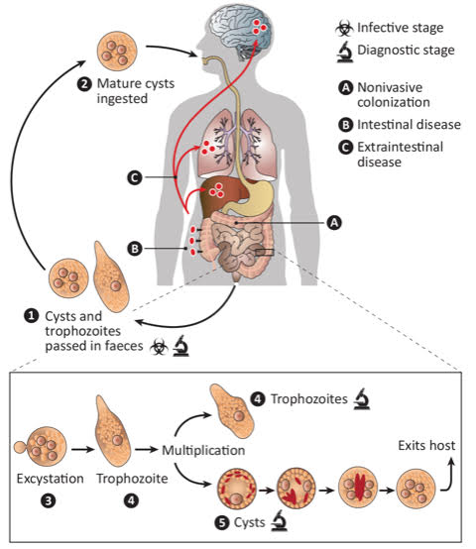
Cysts and trophozoites are passed in faeces . Cysts are typically found in formed stool, whereas trophozoites are typically found in diarrheal stool. Infection with Entamoeba histolytica (and E. dispar) occurs via ingestion of mature cysts from faecally contaminated food, water, or hands. Exposure to infectious cysts and trophozoites in faecal matter during sexual contact may also occur. Excystation occurs in the small intestine and trophozoites are released, which migrate to the large intestine. Trophozoites may remain confined to the intestinal lumen (A: non-invasive infection) with individuals continuing to pass cysts in their stool (asymptomatic carriers). Trophozoites can invade the intestinal mucosa (B: intestinal disease), or blood vessels, reaching extraintestinal sites such as the liver, brain, and lungs (C: extraintestinal disease). Trophozoites multiply by binary fission and produce cysts , and both stages are passed in the faeces . Cysts can survive days to weeks in the external environment and remain infectious in the environment due to the protection conferred by their walls. Trophozoites passed in the stool are rapidly destroyed once outside the body, and if ingested would not survive exposure to the gastric environment.
Source: CDC (Centers for Disease Control and Prevention, Atlanta, Georgia, USA): https://www.cdc.gov/dpdx/amebiasis/

Epidemiology and travel
The global prevalence of E. histolytica infection^{23,24} is likely an over estimate due regional endemicity, populations studied and the diagnostic capability to differentiate between non-pathogenic species³. Nonetheless, amoebiasis is a significant global health burden, responsible for 55,000 deaths per year⁵, predominantly in low income countries (LIC), and particularly in children under 5 years⁹, where it is a major contributor to parasitic infection-related death and morbidity ^{5,7}. Tropical and subtropical regions of Central and South America, Asia, and Africa are the most widely affected and amoebiasis is most prevalent in Bangladesh, India, Brazil, Colombia, Mexico, and China, and accounts for up to 20–40% reported cases of infectious diarrhoea in some areas of Mexico, Turkey, China, Saudi Arabia, Yemen, Egypt, and South Africa ^{5,6,23}.
Globally, morbidity due to amoebiasis, measured by disability-adjusted life years (DALY), has decreased over the past 30 years due to improved sanitation and medication. However, there has been an interesting trend in high-income countries (HIC), such as North America and Australia, where DALY lost to amoebiasis have increased. This rise is attributed to factors like migration and travel, which have introduced the disease into regions where it was previously uncommon ⁹. In the UK, E. histolytica infection is notifiable by laboratories under the Health Protection Regulations (2010) ²⁵, and approximately 100 infections are reported every year which likely underrepresents the true prevalence ²⁶. The GeoSentinel Surveillance Network data indicate that E. histolytica is the third most commonly isolated infection globally among returning tourists who suffer from gastrointestinal disorders, responsible for between 0.3-10% of cases of diarrhoea experienced by visitors ²⁷.
Travel to an endemic area most often precedes infection, with 50% of infections in USA occurring in migrants from Mexico, Central and South America, India and Pakistan ^{28–30}. Similarly in Spain, 46% of infections occurred in migrants and 56% had travelled to an endemic area, most often the Indian subcontinent, South or Central America and sub-Saharan Africa, with travel durations ranging from under 15 days to over 90 days, and symptoms commonly developing after, and not during, the travel period, sometimes developing months or years after exposure ³¹. Amoebic liver abscess cases have been reported over 20 years after the last visit to an endemic area, suggesting chronic asymptomatic carriage of E. histolytica or possibly acquisition in a non-endemic country ³².
Risk factors for E. histolytica infection
Acquisition in non-endemic countries is well recognised, with an Australian study finding that approximately 8% of infected individuals had no prior travel history ³³. Other means of transmission are rare but include transmission following abdominal surgery ³⁴, and after use of contaminated colonic irrigation equipment ^{35,36}. Sexual transmission can also occur. Epidemiological studies from HIC, including USA, Japan, Taiwan, Korea and Australia have shown increased prevalence of Entamoeba carriage amongst men who have sex with men (MSM) ^{37–44}. The effect of coexistent HIV infection has also been studied showing higher rates of E. histolytica infection in HIV positive MSM, but clinical outcomes appear similar, irrespective of CD4 count ^{4,29,45–48}. Importantly, carriage may occur via a sexual contact who has travelled to an endemic region, and not necessarily via travel by the symptomatic patient.
E. histolytica infection affects children and adults equally and can spread within families ⁴. Studies in adults show a male predominance, especially for amoebic liver abscesses, up to 72-76% of adult cases^{4,6,29,31,47,49}. The reason for this is not known; it may be due to higher alcohol consumption amongst males, with liver injury increasing susceptibility to abscess formation. Post-menopausal women are also at increased risk of liver abscesses; it is speculated hormonal factors in this group may be relevant ^{4,29}. The Monthly Infectious Diseases Surveillance Report produced by Public Health Ontario, Canada, found a peak incidence in men aged 40-49 years and a Japanese review reported a median age of infection of 61 years ^{29,47}. In the USA, amoebiasis related deaths were found to be most prevalent for men over the age of 75 years²⁹.
Immunosuppressive medication, particularly corticosteroids, have been shown to cause increased severity of infection, ^{50–52}. This is particularly concerning, since amoebic colitis may mimic the appearances of inflammatory bowel disease, both symptomatically and endoscopically. A systematic review of 24 cases of amoebic colitis reported that corticosteroid use resulted in rapid progression of disease; with increased rates of colonic perforation, amoeboma formation, rectovaginal fistula and extraintestinal dissemination, requiring more than half to undergo emergency surgery and a quarter resulting in death ⁵². Two thirds of patients in this case series also received other immunosuppressive mediation including azathioprine, methotrexate, tacrolimus and ciclosporin. Case reports also suggest that anti-tumour necrosis factor-alpha (anti TNF-a) treatment may lead to an increased risk of severe complications ⁵¹.
Clinical features
90% of patients with E. histolytica infection are asymptomatic, and this is likely due to a combination of factors, such as differences in microbiome profile, pro-inflammatory cytokine responses, and formation of antibodies to the parasite’s Gal/GalNAc attachment lectin that influence the host response and clinical disease manifestations ⁶. 10% of pathogenic cyst carriers develop invasive amoebiasis within 1 year ⁵³ and symptoms of infection will depend on the organ involved, of which the colon and liver are the most commonly affected. Patients with amoebic colitis typically present with a several week history of gradually worsening cramping abdominal pain, weight loss, and watery, mucoid or bloody diarrhoea, making the distinction from inflammatory bowel disease (IBD) especially challenging^{4,54}. Other infectious colitides, such as Shigella, Salmonella, Campylobacter and diarrhoeagenic E. coli usually have a shorter duration of illness. In a case series from the USA, the median duration of symptoms pre-diagnosis was 14 days, and up to 6 months ⁴⁶. Table 1 describes the symptoms of amoebic colitis.

Table 1: Symptoms of amoebic colitis²⁹
Symptoms | Prevalence
Diarrhoea – watery or bloody  ^{4,28,31,32,46,54–63} | Very common | >90%
Abdominal pain  ^{4,28,31,46,54–56,59,62,64–67} | Common | >60%
Fever  ^{4,46,55,60,63,68} | Less common | <40%
Weight loss  ^{4,31,54,59} | Uncommon | <25%
Rectal bleeding without diarrhoea  ^{46,56,68–75} | Rare
Abdominal mass (amoeboma)  ^{29,76} | Rare

Physical examination may be unremarkable, or may include abdominal tenderness (67%), distension (33%), and very rarely a palpable abdominal mass known as an amoeboma. This is a fibro-inflammatory mass representing chronic infection, typically in the caecum or ascending colon and palpated in the right iliac fossa and can resemble a phlegmon occurring in Crohn’s disease ⁴⁶. Progression of dysentery to a necrotising or fulminant colitis occurs in 0.5% ^{45,70,71,77–85}. These patients are typically very unwell with fever, bloody diarrhoea, vomiting, and abdominal pain with rebound tenderness ^{54,86}. Three quarters of patients with fulminant amoebic colitis will develop toxic megacolon or perforation ⁴, with a mortality rate of 40% ⁵⁴, and the risk is greatest in immunocompromised, alcoholic, diabetic or pregnant patients ⁸⁶.
There are over 50 case reports published in the last 10 years of atypical colonic presentations, which despite being extremely rare warrant awareness. These include amoebic appendicitis ^{87–93}, peristomal ulceration ⁷⁴, large bowel obstruction ^{33,66}, gallbladder infiltration ⁹⁴, perianal ulceration/fistulation ^{30,95,96}, enteric fistulae ^{95,97,98}, and infection residing within ^{56,75,89,99–101} or appearances mimicking colorectal adenocarcinoma ^{33,57,76,102–109}.
Amoebic liver abscess
Amoebic liver abscess (ALA) formation is the most common extra-intestinal manifestation of amoebiasis, affecting 1% of infected individuals ⁴. On reaching the liver, E. histolytica generates an inflammatory reaction which causes hepatocyte necrosis, characteristically leading to the formation of a single, well circumscribed abscess with a rim of connective tissue and containing brown so called “anchovy sauce” pus of dead hepatocytes, a few trophozoites and inflammatory cells ¹¹⁰.
There is significant variability in the onset of symptoms, which usually occur within 8-20 weeks (median 12 weeks) after travel to an endemic region ^{6,110,111}, although there have been case reports of ALA development after more than 20 years ^{112–114}, highlighting the importance of a obtaining a detailed travel history. Symptoms include fever and a dull or aching right upper quadrant pain, which may radiate to the epigastrium, chest, or shoulder ¹¹⁰. Cough and right sided pleural pain may be present when the abscess abuts the diaphragm; jaundice is uncommon and should raise suspicion of an alternative aetiology, particularly if multiple abscesses are present. Only 38% of patients report concomitant diarrhoea ¹¹⁰, and others may report a resolved dysenteric syndrome, but the majority will not have concurrent amoebic colitis with their ALA ¹¹⁵. Physical examination usually demonstrates tenderness over the liver and hepatomegaly in about 50% of cases ^{4,6,29,116}. A more chronic, subtle presentation has also been reported with symptoms of fever, weight loss and abdominal pain developing over months ¹¹⁰ and recurrence of the disease over many years, despite appropriate treatment, may rarely occur ¹¹⁷.
ALA was once a uniformly progressive and fatal disease, but the introduction of effective medical treatment has reduced its mortality rate to 1-3% in uncomplicated cases ⁴. Prognostic markers for increased mortality include the presence of encephalopathy, hyperbilirubinemia, hypoalbuminemia and increased abscess size ¹¹⁸. Other rare extra-intestinal manifestations may occur, as described in Table 2.
Table 2: Rare extra-intestinal manifestations of E. histolytica infection
Site | Risk | Clinical features | Prognosis
Pulmonary  ^{119–122} | - Accounts for 2-3% of extraintestinal manifestations  - More common when ALA, especially if ruptured  - Occurs by haematogenous or lymphatic spread | - Cough  - “Anchovy paste” sputum  - Haemoptysis  - Dyspnoea  - Pleuritic chest pain | - Radiology may show elevated right hemidiaphragm and consolidation.  - Mortality of >16%  - Most respond rapidly to treatment as per ALA
Pericardial  ^{123,124} | - Very rare  - More common when ALA in left hepatic lobe that ruptures | - Chest pain  - Pericardial effusion  - Acute/constrictive pericarditis  - Cardiac tamponade  - Congestive cardiac failure | - Left sided ALA drainage is recommended  - Pericardiocentesis is recommended
Neurological  ^{125–127} | - Very rare  - Always concomitant ALA  - Brain abscesses may be single or multiple | - Brain abscess  - Meningoencephalitis  - Headache  - Vomiting  - Impaired mental status  - Focal neurological signs | - Fatal if not diagnosed early  - CT findings non-specific  - Longer treatment durations required, up to 8 weeks  - Surgical evacuation may be required
Cutaneous  ^{30,128} | - Very rare  - May occur in isolation or with other organ  - Risk from poor perianal hygiene and sexual transmission | - Painful perianal ulceration  - Single or multiple erythematous ulcers with well demarcated elevated edges | - Trophozoites may be isolated from ulcer exudate or by scraping ulcer edge  - extensive spread may require reconstructive surgery
Genital  ^{37,42,43,129–132} | - Very rare  - risk factor anal sex | - Penile, vaginal and cervical ulcers  - Foul smelling vaginal discharge | - Treatment as per other forms  - Trace and treat sexual partner

Laboratory Diagnosis
Diagnostic methods comprise faecal microscopy, microscopy of rectal scrapes, serology, histopathology and nucleic acid detection, in support of clinical history, endoscopic and radiological findings. Differentiating E. histolytica from the non-pathogenic E. dispar is essential for accurate diagnosis and initiation of appropriate treatment. See Table 3 for summary of diagnostic approaches.
Light microscopy of a fresh stool is widely available, inexpensive, quick, can visualise both cysts and trophozoites, and is in common use in LIC. Whilst cysts may be seen in both solid and loose stool, trophozoites will usually only be seen in a loose ‘hot stool’ (a stool which is examined as soon as its produced, ideally within 20 minutes). Staining of a fixed faecal smear, for example with iron haematoxylin, will enable more detailed demonstration of morphology, especially the nucleus. Microscopy may identify ingested erythrocytes within the trophozoite, confirming infection by E. histolytica. However, it is impossible for morphology to distinguish E. histolytica cysts from those of non-pathogenic species like E. dispar or E. moskovskii ¹¹⁵.
Differentiation between E. histolytica and E. dispar can be made by isoenzyme analysis by starch gel electrophoresis of cultured amoebic trophozoites. However, culture is time consuming, requiring up to 10 days’ incubation, and only successful 50-70% of the time, so these techniques are not used in routine clinical practice ¹¹⁵.
Antigen detection using ELISA (enzyme linked immunosorbent assay) is a simple and readily available technique, using a monoclonal antibody to E. histolytica Gal/GalNAc lectin in stool samples and liver abscess aspirate. There are several commercially available laboratory kits available, with reported sensitivities and specificities of over 80% ¹³³.
Molecular approaches are now at the forefront in diagnosis and include DNA amplification tests, using PCR (polymerase chain reaction) and LAMP (loop-mediated isothermal amplification) techniques. These are performed on stool samples or liver abscess aspirate and can accurately differentiate E. histolytica from non-pathogenic species. Available PCR techniques include conventional, nested, multiplex, and real-time, and target a range of specific genes, such as haemolysin gene (HLY6), which has up to 100% sensitivity and specificity on stool samples. Real-time multiplex stool PCR is now commonplace in HIC and although costly, has the major advantage of being able to detect a wide panel of intestinal pathogens. In the UK, stool PCR enteric panels do not always include E. histolytica, and therefore may require a specific request to use a dedicated E. histolytica stool PCR assay, which is not widely available in all labs and may need samples to be forwarded to regional laboratories.
Point of care stool testing potentially allows for rapid diagnosis and does not involve expensive laboratory equipment, so may be an option in LIC. There is a range of commercially available kits available, however they have lower sensitivity and specificity and cannot reliably differentiate Entamoeba species.
Antibody detection tests measure IgG antibody levels in response to trophozoite antigen and may yield positive results within 7-14 days of symptom onset for both intestinal disease and liver abscess. Various methods are employed, of which ELISA is most commonly available with sensitivity and specificity of over 95% for liver abscess and is useful in non-endemic regions where prior exposure is unlikely. Where available, the amoebic fluorescent antibody test (IFAT) with the cellulose acetate precipitin test (CAP) as a confirmatory assay, is an alternative. Importantly for gastroenterology practice, sensitivity of antibody detection is only around 60% in invasive intestinal amoebiasis. Amoebic serology can remain positive for several years after infection and thus is not suitable for use in endemic regions. Microscopy of liver abscess pus is unhelpful, showing cellular debris, and it is not a sensitive method for diagnosis since trophozoites are seen in less than 20% of cases. Molecular techniques such as PCR can also be performed on aspirated pus.
It is very important to rule out E. histolytica infection in all patients with a new or suspected diagnosis of IBD prior to starting immunosuppressive therapies. Where immunosuppression for IBD has to commence urgently and cannot be delayed, testing of a stool by amoebic PCR should be prioritised and treatment reviewed in the light of the result. The most reliable diagnostic test to rule out active infection is to test a single stool for E. histolytica using PCR, either as a standalone test or in a pan-enteric panel. Furthermore, a careful travel history should be obtained, since development of disease may post-date initial infection by years. Additional confirmation of the diagnosis can be done by examining the histology of intestinal biopsies (see section on Histopathology) in cases where PCR is not available.
Where available, a full exposure history (travel, sexual contact, clinical reason to suspect amoebic colitis or new diagnosis of IBD) should be provided with the faecal sample, which may otherwise risk rejection by the laboratory, and contact with the microbiology team is recommended to arrange a ‘hot stool’ examination if there is a strong index of suspicion.

Table 3: Laboratory Testing for E. histolytica
 | Specimen | Details | Sensitivity | Specificity | Pros | Cons
Light Microscopy | Stool | Can visualise cysts but cannot differentiate E. histolytica from non-pathogenic cysts.  May visualise trophozoites in ‘hot stool’ (stool examined as soon as its produced) | <60% ⁶ | 95% ¹³⁴ | Cheap  Widely available  Can screen for other parasites | Low sensitivity and specificity  Stool tests cannot diagnose extra-intestinal infection
Antigen testing ELISA | Stool or liver abscess aspirate | Test for E. histolytica specific antigens | Up to 88% ⁶ | >80% ⁶ | Can differentiate Entamoeba species  Widely available | Need fresh (not preserved) stool  Reduced sensitivity and specificity once therapy started and for carriers
PCR* | Stool and liver abscess aspirate | Test for E. histolytica specific genes  Gold standard for intestinal amoebiasis | 92-100% ⁶ | 89-100% ⁶ | Can differentiate Entamoeba species | Expensive  Requires laboratory skill  E. histolytica may not feature in routinely tested pathogen panels
Serology / antibody testing | Serum | Detects IgG to E. histolytica specific antigen | 65-92% ⁶ | >90% ⁶ | Useful for both intestinal and extra-intestinal infection | Lower sensitivity for intestinal amoebiasis (~ 60%) than ALA (~95%). Suitable for use in non-endemic regions  False positives in endemic countries  Positive within 7-14 days of symptoms  Can remain positive for years after resolution of infection
Point of Care antigen detection | Stool | Monoclonal antibody based | 28-100% ¹¹⁵ | 80-100% ¹¹⁵ | Cheap  Quick | Cannot differentiate Entamoeba species  Low sensitivity
Histopathology | Tissue | Light microscopy of formalin-fixed paraffin wax embedded histology specimens, such as colonic biopsies. Trophozoites visible on Haematoxylin & Eosin staining, highlighted by staining with Periodic Acid Schiff (PAS) | Insufficient data | Operator-dependent | Cheap  Routine practice – no requirement for pre-test suspicion  Can be used on tissue from any site, both biopsies and surgical resections can be reported urgently within 24 hrs | Tissue reaction pattern is not specific and can mimic Crohn’s disease. Trophozoites may be missed or misdiagnosed, and identification is operator-dependent

*UK Health Security Agency recommend PCR as the method of choice for diagnosis of E. histolytica in symptomatic and asymptomatic patients²⁶.

Colonoscopy
Although colonoscopy is not mandated for the diagnosis of amoebic colitis, patients with gastrointestinal symptoms, particularly if they are severe or chronic, are often evaluated endoscopically. Both symptoms and endoscopic appearances of amoebic colitis can mimic those seen in IBD in other forms of infectious colitis including intestinal tuberculosis ^{4,21,47,135}. Whilst endoscopic features may be indistinguishable between these conditions; characteristic features of amoebic colitis have been described ⁴⁷. Amoebic colitis often causes patchy inflammation with or without pale exudate and ulceration, with a predominance in the caecum and ascending colon, since this is likely the site of excystation and trophozoite release, and next most commonly in the rectum, likely due to stasis of stool ^{47,135,136}. Ulcers can range in size and character, from tiny erosions to larger ulcers (>2cm) and are most often multiple and discrete. Surrounding mucosa can appear normal or inflamed. A mucosal “bump” sign has been proposed as a pathognomonic endoscopic feature, consisting of a <1cm inflammatory nodule infiltrated by trophozoites ⁴⁷. Table 4 and Figure 2 describe the endoscopic features and appearances of amoebic colitis.
There are case reports describing the simultaneous diagnosis of colorectal adenocarcinoma with E. histolytica infection on mucosal biopsy ¹⁰¹. However, correlation does not necessarily imply causation.

Table 4: Endoscopic features of amoebic colitis
Feature | Site | Prevalence
Erythema/ inflammation  28,32,46,47,57,59,61,63,65,73,135–137 | Patchy and variable distribution – may be pan-colonic with predominance in caecum and ascending colon | Common (>50%)
Exudate  ^{32,135,136,138} |  | Common (>25%)
Ulceration  32,46,47,57,58,60–65,68,74,76,101,135–144 |  | Very common (>75%)
Nodule (“bump”)  ^{32,47,59,136,137} |  | Rare (5%)
Mass (amoeboma)  ^{57,67,76,101,136,145} | Most commonly caecum | Very rare (<5%)
Active bleeding  ⁶⁸ | At site of inflammation/ ulceration | Very rare (<1%)
Stricture  ^{66,141} | Very rare – case reports of transverse colon | Stricture (<1%)
Coexistent adenocarcinoma  ^{73,75,101} | Very rare | Very rare (<5%)

Figure 2: Endoscopic appearances of amoebic colitis
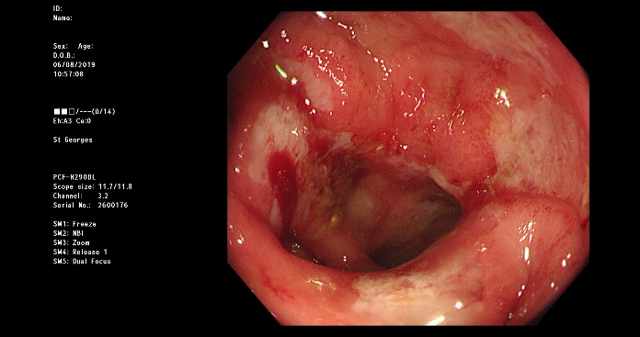 | 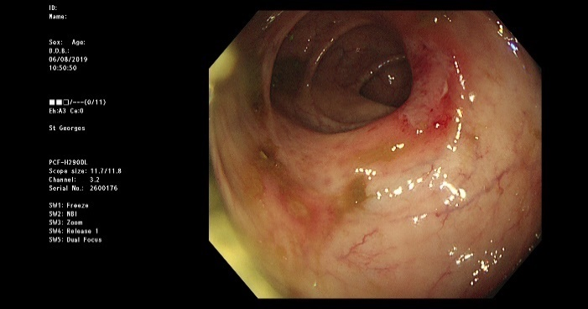 | 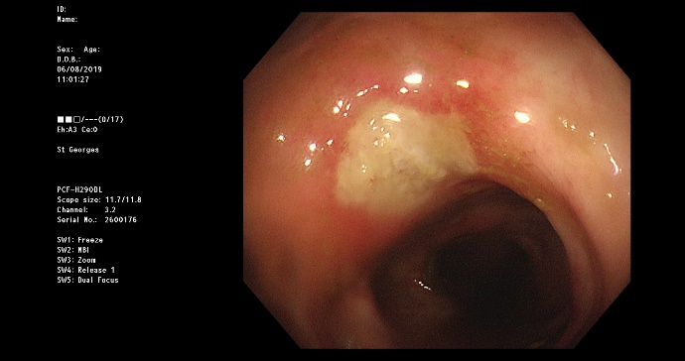
Caecum: mucosal erythema, ulceration, friability and contact bleeding | Transverse colon – superficial ulceration with normal surrounding mucosa | Splenic flexure – deeper ulceration raised edges
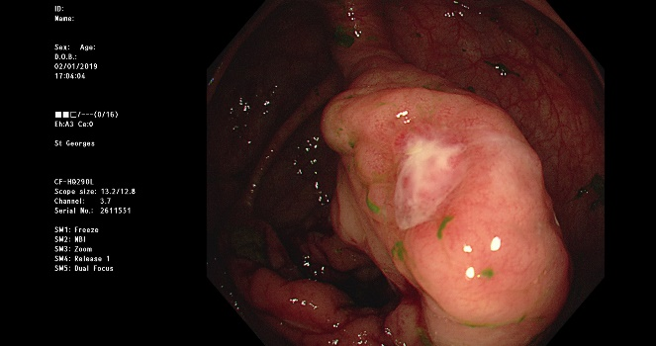 | 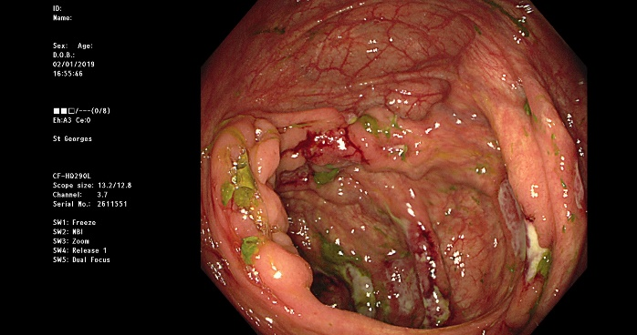 | 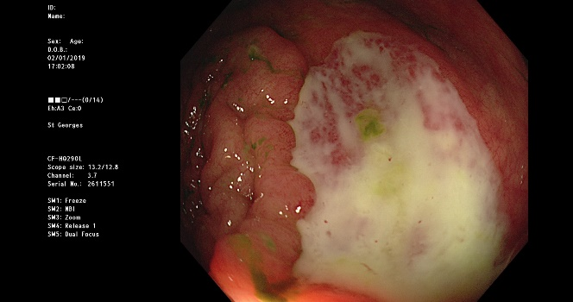
Caecum: ulcer overlying inflammatory “bump” | Caecum: scattered deep ulceration surrounded by normal mucosa | Caecum: deep ulceration with exudate

Histopathology
Figure 3: Histopathological findings in amoebic colitis
A 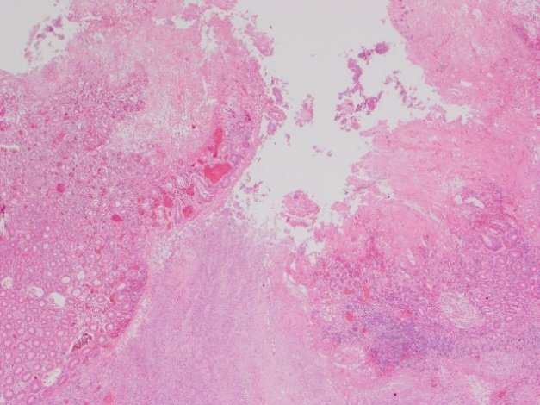 | Low magnification photomicrograph shows the edge of a typical flask-shaped, undermining ulcer in a colectomy specimen. In biopsies the main pitfall is misdiagnosis as IBD, particularly Crohn’s disease, because the ulceration may be patchy and features of chronicity, such as crypt architectural distortion and fibrosis, may be present. (Haematoxylin & Eosin x 12)
B 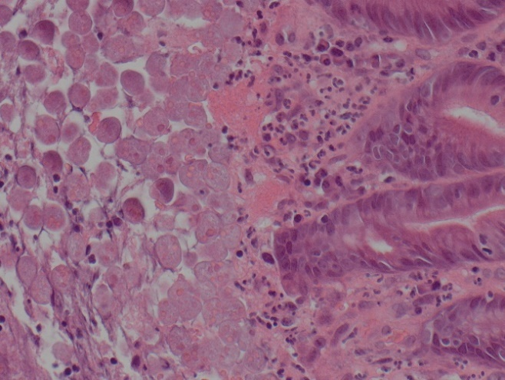 | High magnification photomicrograph showing E. histolytica trophozoites in ulcer slough on the surface of a colonic biopsy; the erythrophagocytosis is evident. The trophozoites may be mistaken for macrophages or sloughed enterocytes by the inexperienced. (Haematoxylin & Eosin x 200)
We thank Guys and St Thomas’ NHS Foundation Trust Histopathology Department for allowing access to histopathology images

Imaging
Imaging may be performed alongside laboratory tests to support diagnosis. Plain abdominal radiography may show non-specific features of colitis, with colonic wall thickening, gaseous distension and loss of haustral folds ²⁸. Computed tomography (CT) may help identify features of amoebic colitis, including deep ulceration, patchy distribution of colitis, and omental wrapping ²⁸. CT alone should not be made to diagnose amoebic colitis since features may be indistinguishable from IBD.
CT, magnetic resonance imaging (MRI) and ultrasonography (US) are good modalities to diagnose amoebic liver abscess. It is most commonly unilocular compared with pyogenic abscess, which is most commonly multilocular, but appearances may be indistinguishable. Amoebic liver abscess will appear on US as a cystic intrahepatic hypoechoic lesion with thick walls, often in the right hepatic lobe near the capsule, and by CT there will be a non-enhancing centre with an inflammatory ring following administration of contrast ^{6,146}. The right hemi-diaphragm may be elevated ¹⁴⁷. Figure 4 illustrates the typical radiological features of amoebic liver abscess.

Figure 4: Radiological features of amoebic liver abscess in a patient with right upper quadrant pain and weight loss
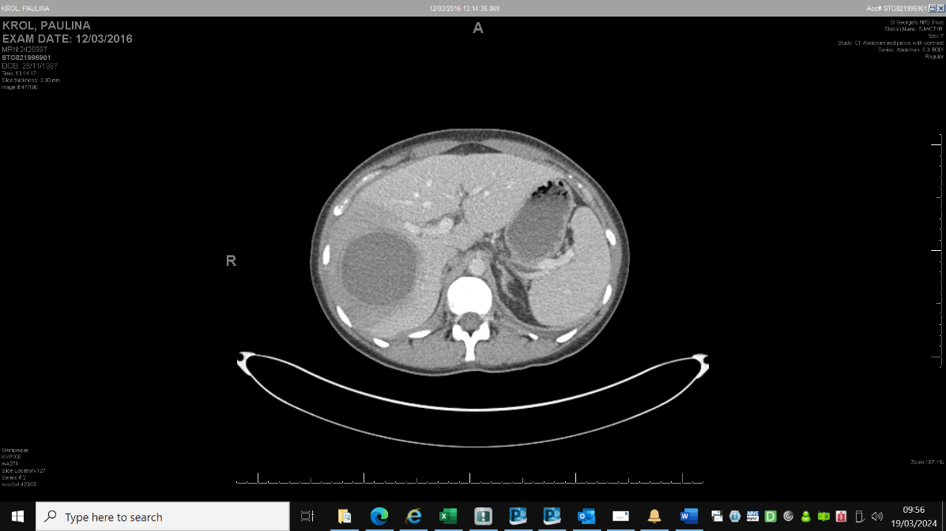 | 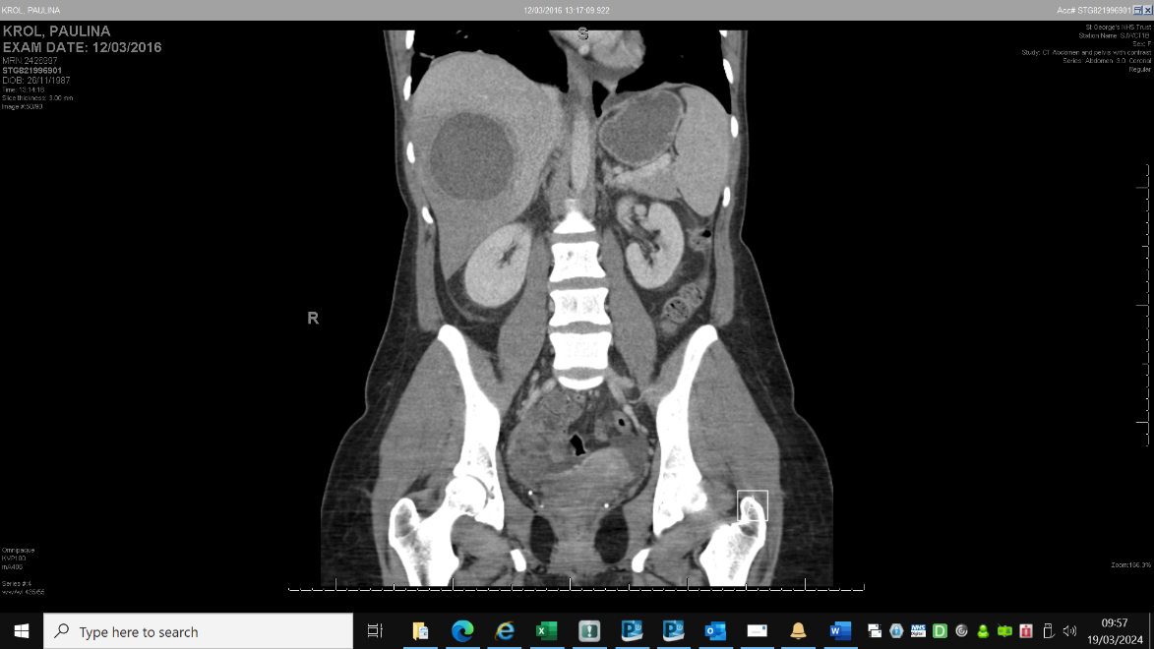 | 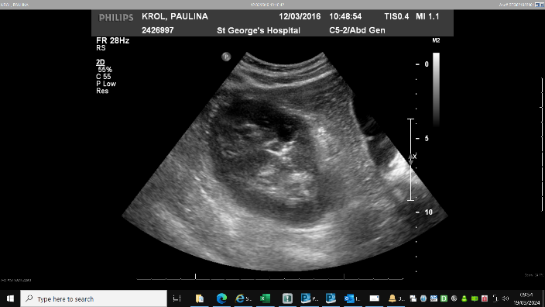
CT abdomen, axial (L) and coronal (R) planes: thick walled homogeneous 7.8cm diameter collection in the right lobe of the liver with surrounding hypo-enhancement and adjacent branch portal venous occlusion. |  | US liver: 7.5cmx7cm intrahepatic mass in the right lobe of the liver with mixed internal echogenic and hypoechoic appearances and peripheral blood flow and no internal blood flow. The surrounding liver parenchyma is echogenic, consistent with inflammation.

Treatment
All patients with E. histolytica infection should be treated, whether or not they have symptoms. The goal of therapy is to eliminate invading trophozoites and eradicate intestinal carriage. Treatment consists of two agents – a systemically absorbed tissue amoebicide ¹⁴⁸, and a luminal amoebicide, to eliminate cysts from the intestinal lumen. Tissue amoebicidal agents are nitroimidazole antibiotics, such as metronidazole and tinidazole, with a Cochrane review finding the latter more effective (metronidazole 5% failure rate vs tinidazole 1% failure rate) with fewer adverse events ²⁴, however tinidazole is no longer available in the UK ¹⁴⁹. Alcohol ingestion should be avoided during and for 4 days after metronidazole or tinidazole therapy due to unpleasant disulfiram like side effects. Luminal amoebicides include paromomycin, diloxanide furoate (no longer available in the UK), iodoquinol, and nitazoxanide. Paromomycin, an aminoglycoside which works by disrupting RNA translation, is the agent used in the UK ^{150,151}. Combination therapy has been shown to prevent disease recurrence, so whilst asymptomatic amoebic cyst passage is treated with a luminal amoebicide, treatment of symptomatic amoebiasis requires a tissue amoebicide followed by a luminal amoebicide ²⁴.
Previous national guidelines recommended giving tinidazole or metronidazole, followed by paromomycin ¹⁵¹ . Since 2021, tinidazole has not been available in the UK and therefore metronidazole is recommended ¹⁴⁹. Longer duration of treatment is recommended for extra-intestinal amoebiasis, including liver abscess (see Table 5) ^{6,110}. Amoebic liver abscesses do not routinely require percutaneous drainage, but it may be considered if clinical response is not seen after 3 or 4 days medical treatment, or when the abscess is >10cm (which carries an increased risk of abscess rupture) or if the abscess is in the left lobe, where rupture may involve the pericardium ⁶. The abscess may take many months to resolve fully on imaging, but this does not require extended periods of drug therapy⁶. Table 5 summarises the treatment for E. histolytica infection.
In patients with IBD for which there is a high index of suspicion for amoebiasis, it is reasonable to commence metronidazole therapy once a stool sample has been collected and confirmed to be sent for amoebic stool PCR testing.
Clinical care requires universal enteric precautions which can be discontinued 48 hours after resolution of diarrhoea ²⁶. Both symptomatic and asymptomatic household, co-traveller and sexual contacts (any sexual contact of the case following the suspected time of initial infection, (especially in men who have sex with men) should undergo stool PCR testing and treatment if positive ²⁶. Amoebic clearance should be checked with a stool PCR test at least 1 week following completion of treatment with both tissue and luminal amoebicides^{26,152}. This is done to demonstrate treatment success, although symptomatic relapses after an initial course of treatment are very rare. The literature suggests that asymptomatic carriage persists beyond 15 months after initial identification in untreated individuals ².
More than 90% of the patients with amoebiasis respond to nitroimidazoles, but parasite persistence is seen in 40-60% patients after nitroimidazole treatment (as they are tissue, not luminal, amoebicides). Luminal amoebicides like paromomycin have up to 85% cure rate in asymptomatic carriers². A Cochrane review showed reduction in parasitological failure by a third after completion of combination treatment over metronidazole alone (RR 0.36) ²⁴.
Additional, general supportive measures may be required, depending on the patient’s clinical needs and may include intravenous fluids, electrolyte replacement and nutritional supplementation ⁶. Prevention remains paramount, with personal hygienic measures, avoidance of contaminated food and water supplies, and education regarding sexual transmission ¹⁴⁹.
There are currently no licensed vaccines for amoebiasis but the Gal/GalNAc lectin has been the subject of research as a potential antigenic target ^{145,151}. Several novel drug targets involving different amoebic cellular processes have been suggested but these drugs are not yet in routine practice ¹⁴⁸. There have been shown to be alterations in the microbiome that may trigger amoebae to switch from commensal bystander to invasive pathogen, raising a theoretical role for probiotics as preventative or adjunctive treatment, but further research in this area is required ¹⁴⁵.
Conclusion
Misdiagnosis of intestinal amoebiasis as IBD in non-endemic regions can easily occur, be that clinically, endoscopically and histologically, leading to potential inadvertent treatment with steroids or immunosuppressants. This can lead to life-threatening complications and so Gastroenterologists, infectious diseases physicians and surgeons in particular need to have an awareness of it as a potential differential diagnosis. Establishing a detailed life-long travel history is essential, with the diagnosis of intestinal amoebiasis best achieved using stool E. histolytica PCR which must be requested specifically. Clinicians should consider routine stool PCR testing for E. histolytica in all new IBD cases, especially prior to commencing immunosuppression. Testing should be considered particularly in patients with established IBD who have travelled to endemic areas particularly in the context of a worsening acute colitis. Empirical treatment for amoebiasis should be offered once samples sent if there is a high index of suspicion. Routine colonic histopathology may be diagnostic if trophozoites are present, but sampling error or failure to recognise trophozoites may contribute to low sensitivity overall. If a patient treated for IBD with immunosuppressants fails to improve or deteriorates, it would be appropriate to request review of the histology, to search particularly for trophozoites, if necessary, by a specialist infectious disease histopathologist. Amoebic liver abscess will appear on ultrasound as a cystic intrahepatic hypoechoic lesion with thick walls and on CT there will be a non-enhancing centre with an inflammatory ring following administration of contrast. This should be suspected especially if patients have right upper quadrant pain, fever and deranged liver function tests. Treatment of intestinal amoebiasis should comprise both tissue and luminal amoebicides to avert disease recurrence.
Key points
- Clinical, endoscopic and histological misdiagnosis of intestinal amoebiasis as IBD in non-endemic regions can easily occur
- Inadvertent treatment with steroids or immunosuppressants can lead to life-threatening complications
- Diagnosis of intestinal amoebiasis is best achieved using stool E. histolytica PCR and needs to be requested specifically, giving full travel history
- Recommend stool PCR testing for E. histolytica in all new IBD cases regardless of previous travel history to an endemic area, especially prior to commencing immunosuppression. Testing should be performed in patients with established IBD who have had travel to endemic areas particularly with a worsening colitis. Empirical treatment for amoebiasis should be offered once samples sent if there is a high index of suspicion.
- Routine colonic histopathology may be diagnostic if trophozoites are present, but sampling error or failure to recognise trophozoites may contribute to low sensitivity
- Treatment should comprise both tissue AND luminal amoebicides to avert disease recurrence

Table Legends
Table 1: Symptoms of amoebic colitis
Table 2: Rare extra-intestinal manifestations of E. histolytica infection
Table 3: Laboratory Testing for E. histolytica
Table 4: Endoscopic features of amoebic colitis
Table 5: Treatment for E. histolytica infection
Figure Legends
Figure 1: Entamoeba histolytica life cycle
Figure 2: Endoscopic appearances of amoebic colitis
Figure 3: Histopathological findings in amoebic colitis
Figure 4: Radiological features of amoebic liver abscess in a patient with right upper quadrant pain and weight loss
Table 5: Treatment for E. histolytica infection
Amoebic colitis ¹⁵¹ | - Metronidazole 800mg TDS PO for 5 days  OR  Tinidazole 2g od for 3 days (no longer available in UK)  followed by a luminal amoebicide  - Paromomycin 25 - 35 mg/kg/day in three divided doses PO for 7 days  OR  - Diloxanide furoate for 10 days (no longer available in UK)
Amoebic liver abscess | - Metronidazole 800mg TDS PO for 5 to 10 days  OR  Tinidazole 2g od for 5 days (no longer available in UK)  followed by a luminal amoebicide  - Paromomycin 25 - 35 mg/kg/day in three divided doses PO for 7 days  OR  Diloxanide furoate for 10 days (no longer available in UK)  ONLY consider drainage of ALA, if:  - Imminent rupture  - No clinical response after 3 or 4 days of medical treatment  - Abscess diameter > 10cm  - ALA in left lobe of liver
Extra-intestinal/extra-hepatic amoebiasis | - Consult with Infectious Diseases team

References
1. WHO/PAHO/UNESCO report. A consultation with experts on amoebiasis. Mexico City, Mexico 28-29 January, 1997. Epidemiol Bull 18, 13–14 (1997).
2. Blessmann, J. et al. Longitudinal Study of Intestinal Entamoeba histolytica Infections in Asymptomatic Adult Carriers. J Clin Microbiol 41, 4745–4750 (2003).
3. El-Dib N.A. Entamoeba histolytica: an Overview. Curr. Trop. Med. Rep. 4, 11–20 (2017).
4. Stanley, S. L. Amoebiasis. The Lancet 361, 1025–1034 (2003).
5. Lozano, R. et al. Global and regional mortality from 235 causes of death for 20 age groups in 1990 and 2010: a systematic analysis for the Global Burden of Disease Study 2010. The Lancet 380, 2095–2128 (2012).
6. Shirley D.T., Farr L., Watanabe K., & Moonah S. A review of the global burden, new diagnostics, and current Therapeutics for amebiasis. Open Forum Infect. Dis. 5, ofy161 (2018).
7. Estimates of the global, regional, and national morbidity, mortality, and aetiologies of diarrhoea in 195 countries: a systematic analysis for the Global Burden of Disease Study 2016. The Lancet Infectious Diseases (2018).
8. Murray, C. J. L. et al. Disability-adjusted life years (DALYs) for 291 diseases and injuries in 21 regions, 1990–2010: a systematic analysis for the Global Burden of Disease Study 2010. The Lancet 380, 2197–2223 (2012).
9. Fu, X. et al. Global burden and trends of the Entamoeba infection-associated diseases from 1990 to 2019: An observational trend study. Acta Tropica 240, 106866 (2023).
10. Hooshyar, H., Rostamkhani, P. & Rezaeian, M. An Annotated Checklist of the Human and Animal Entamoeba (Amoebida: Endamoebidae) Species- A Review Article. Iran J Parasitol 10, 146–156 (2015).
11. Petithory, J. C., Brumpt, L. C. & Poujade, F. [Entamoeba histolytica (Schaudinn 1903) and Entamoeba dispar (E. Brumpt 1925) are 2 different species]. Bull Soc Pathol Exot 87, 231–237 (1994).
12. Sargeaunt, P. G., Williams, J. E. & Grene, J. D. The differentiation of invasive and non-invasive Entamoeba histolytica by isoenzyme electrophoresis. Transactions of the Royal Society of Tropical Medicine and Hygiene 72, 519–521 (1978).
13. Tannich, E., Horstmann, R. D., Knobloch, J. & Arnold, H. H. Genomic DNA differences between pathogenic and nonpathogenic Entamoeba histolytica. Proc Natl Acad Sci U S A 86, 5118–5122 (1989).
14. Junaidi, J. et al. Entamoeba histolytica Neglected Tropical Diseases (NTDs) Agents that Infect Humans and Some Other Mammals: A Review. E3S Web Conf. 151, 01019 (2020).
15. Moonah, S. N., Jiang, N. M. & Petri, W. A. Host Immune Response to Intestinal Amebiasis. PLoS Pathogens 9, (2013).
16. Debnath A., Rodriguez M.A., & Ankri S. Editorial: Recent progresses in amebiasis. Front. Cell. Infect. Microbiol. 9, 247 (2019).
17. Reed, S. L., Keene, W. E. & McKerrow, J. H. Thiol proteinase expression and pathogenicity of Entamoeba histolytica. J Clin Microbiol 27, 2772–2777 (1989).
18. Leippe, M. Amoebapores. Parasitol Today 13, 178–183 (1997).
19. Dodson, J. M. et al. Comparison of adherence, cytotoxicity, and Gal/GalNAc lectin gene structure in Entamoeba histolytica and Entamoeba dispar. Parasitology International 46, 225–235 (1997).
20. Marsden, P. D. Clinicai Parasitology, 9th Editon, Beaver, P.C., Jung, R C., Cupp, E. W. Lea and Febiger, Philadelphia, 1984. Rev. Soc. Bras. Med. Trop. 17, 219–219 (1984).
21. Pritt, B. S. & Clark, C. G. Amebiasis. Mayo Clinic Proceedings 83, 1154–1160 (2008).
22. Centers for Disease Control and Prevention (CDC). Amebiasis. https://www.cdc.gov/dpdx/amebiasis/.
23. Nasrallah, J. et al. Updates on the worldwide burden of amoebiasis: A case series and literature review. Journal of Infection and Public Health 15, 1134–1141 (2022).
24. Gonzales, M., Dans, L. & Sio‐Aguilar, J. Antiamoebic drugs for treating amoebic colitis. Cochrane Database of Systematic Reviews (2019) doi:10.1002/14651858.CD006085.pub3.
25. UK Health Security Agency. UK Health Protection (Notification) Regulations 2010, https://www.legislation.gov.uk/uksi/2010/659.
26. Public Health England. Interim Public Health Operational Guidelines for Amoebiasis v1.0. (2017).
27. Leder, K. GeoSentinel Surveillance of Illness in Returned Travelers, 2007–2011. Ann Intern Med 158, 456 (2013).
28. Kinoo, S. M., Ramkelawon, V. V., Maharajh, J. & Singh, B. Fulminant amoebic colitis in the era of computed tomography scan: A case report and review of the literature. Sa Journal of Radiology 22, a1354 (2018).
29. Kantor M. et al. Entamoeba Histolytica: Updates in Clinical Manifestation, Pathogenesis, and Vaccine Development. Can. J. Gastroenterol. Hepatol. 2018, 4601420 (2018).
30. Davis M.J., Templeton S.F., Dickensheets D.L., & Gross A.S. Massive perianal ulceration: Entamoeba histolytica and Candida albicans co-infection. JAAD Case Rep. 3, 553–555 (2017).
31. Roure S. et al. Approach to amoebic colitis: Epidemiological, clinical and diagnostic considerations in a non-endemic context (Barcelona, 2007-2017). PLoS ONE 14, e0212791 (2019).
32. Peixoto A., Silva M., Vilas-Boas F., & Macedo G. All that glitters is not gold. A different cause for an ‘ulcerative colitis’. Rev. Esp. Enferm. Dig. 109, 64 (2017).
33. Chahine E. et al. Complete resolution of obstructive colonic amebic pseudotumor with conservative treatment: A case report and literature review. Int. J. Surg. Case Rep. 59, 1–3 (2019).
34. Misra, S., Sakhuja, P., Agarwal, A. K. & Javed, A. Fulminant amebic colitis: An unusual postoperative complication of intraabdominal malignancy. J Postgrad Med 66, 99–101 (2020).
35. Istre, G. R. et al. An Outbreak of Amebiasis Spread by Colonic Irrigation at a Chiropractic Clinic. N Engl J Med 307, 339–342 (1982).
36. Markell, E. K. The 1933 Chicago outbreak of amebiasis. West J Med 144, 750 (1986).
37. Hung, C.-C., Chang, S.-Y. & Ji, D.-D. Entamoeba histolytica infection in men who have sex with men. The Lancet. Infectious diseases 12, 729–36 (2012).
38. Escolà-Vergé, L. et al. Outbreak of intestinal amoebiasis among men who have sex with men, Barcelona (Spain), October 2016 and January 2017. Euro surveillance : bulletin Europeen sur les maladies transmissibles = European communicable disease bulletin 22, (2017).
39. James, R., Barratt, J., Marriott, D., Harkness, J. & Stark, D. Seroprevalence of Entamoeba histolytica infection among men who have sex with men in Sydney, Australia. Am J Trop Med Hyg 83, 914–6 (2010).
40. Negata, N. et al. Risk Factors for Intestinal Invasive Amebiasis in Japan, 2003-2009. Emerging Infectious Diseases 18, 717–724 (2012).
41. Timsit B.L., Deroux A., Lugosi M., Colombe B., & Bouillet L. Amoebosis: May sexual transmission be an underestimated way of contamination? Rev. Med. Interne 39, 586–588 (2018).
42. Billet, A. C., Salmon Rousseau, A., Piroth, L. & Martins, C. An underestimated sexually transmitted infection: amoebiasis. (2019).
43. de Valdoleiros, S. R., Carvalho, J. A., Goncalves, C., Vasconcelos, O. & Sarmento-Castro, R. Nontravel-related invasive Entamoeba histolytica infection with probable heterosexual transmission. Idcases 18, e00592 (2019).
44. Gunther, J., Shafir, S., Bristow, B. & Sorvillo, F. Short Report: Amebiasis-Related Mortality among United States Residents, 1990-2007. American Journal of Tropical Medicine and Hygiene 85, 1038–1040 (2011).
45. Ishioka H., Umezawa M., & Hatakeyama S. Fulminant amebic colitis in an HIV-infected homosexual man. Intern. Med. 50, 2851–2854 (2011).
46. Fleming R. et al. Clinical manifestations and endoscopic findings of amebic colitis in a United States-Mexico border city: a case series. BMC Res Notes 8, 781 (2015).
47. Nagata, N. et al. Predictive value of endoscopic findings in the diagnosis of active intestinal amebiasis. Endoscopy 44, 425–428 (2012).
48. Samie, A. et al. Seroprevalence of Entamoeba histolytica in the context of HIV and AIDS: the case of Vhembe district, in South Africa’s Limpopo province. Annals of Tropical Medicine and Parasitology 104, 55–63 (2010).
49. Acuna-Soto, R., Maguire, J. H. & Wirth, D. F. Gender Distribution in Asymptomatic and Invasive Amebiasis. American Journal of Gastroenterology 95, 1277–1283 (2000).
50. Wang, H. & Kanthan, R. Multiple colonic and ileal perforations due to unsuspected intestinal amoebiasis-Case report and review. Pathology Research and Practice 216, 152608 (2020).
51. Verstockt, B., Vermeire, S., Van Assche, G. & Ferrante, M. When IBD is not IBD. Scandinavian Journal of Gastroenterology 53, 1085–1088 (2018).
52. Shirley, D.-A. & Moonah, S. Fulminant Amebic Colitis after Corticosteroid Therapy: A Systematic Review. PLoS Neglected Tropical Diseases 10, (2016).
53. Gathiram, V. & Jackson, T. F. A longitudinal study of asymptomatic carriers of pathogenic zymodemes of Entamoeba histolytica. S Afr Med J 72, 669–672 (1987).
54. Haque, R. Amebiasis. N Engl J Med 2003; 348:1565-1573 doi:10.1056/NEJMra022710.
55. Ana Domazetovska et al. A 12-Year Retrospective Study of Invasive Amoebiasis in Western Sydney: Evidence of Local Acquisition. (2018).
56. Cooper, C. J., Fleming, R., Boman, D. A. & Zuckerman, M. J. Varied Clinical Manifestations of Amebic Colitis. Southern medical journal 108, 676–81 (2015).
57. Bronswijk M. & Van Gool S. A case of amoebic colitis with amoeboma and simultaneous liver abscesses. A diagnosis by colonoscopy. Acta Gastro-Enterol. Belg. 82, 539–541 (2019).
58. Young C.A., Gracie D.J., Subramanian V., & Wyatt J.I. Amoebic colitis. Diagn. Histopathology 23, 563–565 (2017).
59. Mogensen, T. H., Christiansen, J. J., Eivindson, M. V., Larsen, C. S., & JOUR. Misdiagnosed amoebic colitis leading to severe dysentery and necrotizing colitis-Report of a case and review of the literature. (2014).
60. Upadhyay, R., Gupta, N., Gogia, P. & Chandra, S. Poached egg appearance in intestinal amebiasis. Gastrointestinal endoscopy 76, 189–90 (2012).
61. Den Y., Kinoshita J., Deshpande G.A., & Hiraoka E. Amoebiasis masquerading as inflammatory bowel disease. BMJ Case Rep. 2015, A1708 (2015).
62. Debourdeau, A., Boivineau, L. & Iltache, S. The Little Beast That Pretended to Be a Severe Crohn’s Disease. Gastroenterology 157, 1483–1484 (2019).
63. Kahn T., Locketz M., & Thomson S. The value of microscopy in the diagnosis of colitis. S. Afr. Gastroenterol. Rev. 17, 27–29 (2019).
64. Vinnamala S., Arasaradnam R., Malik A., S., S., & Mannath J. All caecal ulcers is not crohn’s: Think travel-think again. Acta Gastro-Enterol. Belg. 80, 83–84 (2017).
65. Li N., Wang H.-H., Zhao X.-J., & Sheng J.-Q. Amebic colitis: Colonoscopic appearance. Endoscopy 47, E145–E146 (2015).
66. Varshney V.K., Soni S.C., Yadav T., Puranik A., & Elhence P. Amebic colonic stricture: An unusual presentation. Trop. Parasitol. 8, 98–100 (2018).
67. Wang S.-Y. et al. Ameboma mimicking submucosal tumor of the colon in an elderly. Int. J. Gerontol. 5, 126–128 (2011).
68. Dogra V.K., Gupta D., Kashyap R., Nand L., & Sondhi S. Intestinal amebiasis presenting as life threatening lower GI bleed-A rare presentation. Ann. Trop. Med. Public Health 10, 244–246 (2017).
69. Madden G.R., Shirley D.-A., Townsend G., & Moonah S. Case report: Lower gastrointestinal bleeding due to Entamoeba histolytica detected early by multiplex PCR: Case report and review of the laboratory diagnosis of amebiasis. Am. J. Trop. Med. Hyg. 101, 1380–1383 (2019).
70. Atif Khan M., Verma G.R., & Lokesh H.M. Fulminant amebic colitis with lower GI bleed with liver abscess. Int. J. Colorectal Dis. 25, 535–537 (2010).
71. Chandnani, S. et al. Massive Lower Gastrointestinal Bleeding Due to Fulminant Necrotizing Amebic Colitis: A Diagnostic and Therapeutic Challenge. The Journal of the Association of Physicians of India 67, 79–81 (2019).
72. de Leijer J.H., Tan A.C.I.T.L., Mulder B., & Zomer S.F. Unexpected amebic colitis presenting with rectal bleeding and perforation after biopsy. Gastrointest. Endosc. 88, 565–566 (2018).
73. Ito S. et al. A case of a rectal adenocarcinoma mimicking a neuroendocrine tumor in the background mucosa of amoebic colitis. Clin. J. Gastroenterol. (2020) doi:10.1007/s12328-019-01088-1.
74. Sasaki, Y., Yoshida, T., Suzuki, J., Kobayashi, S. & Sato, T. [A Case of Peristomal Cutaneous Ulcer Following Amebic Colitis Caused by Entamoeba histolytica]. Kansenshogaku zasshi. The Journal of the Japanese Association for Infectious Diseases 90, 73–6 (2016).
75. Goel, P. et al. Entamoeba histolytica: A surprising coexistence with adenocarcinoma - Never brush aside brushings for biopsy. Journal of Laboratory Physicians 10, 251–254 (2018).
76. Li A.A., Cholankeril G., Berry G.J., & Fernandez-Becker N. An Unexpected Colonic Mass. Am. J. Gastroenterol. 114, 180–181 (2019).
77. Desai P. & Sivaramakrishnan N. Acute fulminant necrotizing amoebic colitis: A potentially fatal cause of diarrhoea on the Acute Medical Unit. Acute Med. 10, 145–148 (2011).
78. Ortiz-Castillo F. et al. Amoebic toxic colitis: Analysis of factors related to mortality. Pathog. Global Health 106, 245–248 (2012).
79. Wingfield, T. et al. Closing The Brief Case: A Rare Case of Invasive Amebiasis Requiring Emergency Subtotal Colectomy in an HIV-Positive Man. Journal of clinical microbiology 56, (2018).
80. Kenyon, C. & Otto, M. Bowel ‘infarction’ in a postpartum patient. Clin Infect Dis 53, 914–2 (2011).
81. Badyal R.K., Gupta R., & Vaiphei K. Diffuse perforated necrotising amoebic colitis with histoplasmosis in an immunocompetent individual presenting as an acute abdomen. BMJ Case Rep. 009059 (2013) doi:10.1136/bcr-2013-009059.
82. Kawazoe, A. & Nagata, N. Fulminant amebic colitis with an atypical clinical presentation successfully treated by metronidazole. Clin Gastroenterol Hepatol 10, e91 (2012).
83. Morris, P. D., Lee, D., Chung, K. K.-Y., Shin, J.-S. & Byrne, C. Fulminant amoebic colitis and septic shock in a returning traveller. ANZ J Surg 89, E50 (2019).
84. Arvind M., Nijhar J.S., & Ramasamy P. Fulminant necrotising amoebic colitis: A diagnostic conundrum. Med. J. Malays. 70, 365–366 (2015).
85. The Brief Case: A Rare Case of Invasive Amebiasis Requiring Emergency Subtotal Colectomy in an HIV-Positive Man. Journal of Clinical Microbiology 56, (2018).
86. Chaturvedi R., Gupte P.A., & Joshi A.S. Fulminant amoebic colitis: A clinicopathological study of 30 cases. Postgrad. Med. J. 91, 200–205 (2015).
87. Singh N.G., Rifat Mannan A.A.S., & Kahvic M. Acute amebic appendicitis: Report of a rare case. Indian J. Pathol. Microbiol. 53, 767–768 (2010).
88. Kishore M., Chauhan D.S., Rahar S., & Singh S. Acute amoebic appendicitis: A rare case report. J. Clin. Diagn. Res. 12, ED01–ED02 (2018).
89. Ito D. et al. Amebiasis presenting as acute appendicitis: Report of a case and review of Japanese literature. Int. J. Surg. Case Rep. 5, 1054–1057 (2014).
90. Herrera, G. C. et al. Amebiasis, a rare cause of acute appendicitis. Journal of Surgical Case Reports rjz076 (2019) doi:10.1093/jscr/rjz076.
91. Ichikawa H. et al. Amoebiasis presenting as acute appendicitis. Tokai J. Exp. Clin. Med. 41, 227–229 (2016).
92. Norwich, I. & JOUR. Amoebiasis presenting as acute appendicitis. (2019).
93. Taiichiro Kobayashi et al. Underestimated Amoebic Appendicitis among HIV-1-Infected Individuals in Japan. Journal of clinical microbiology 55, 313–320 (2016).
94. Ouadi, Y. et al. Amoeboma of the gallbladder mimicking a cholangiocarcinoma: A case report. International Journal of Surgery Case Reports 110, 108656 (2023).
95. Takahashi T. & Iwamoto A. Perianal fistula caused by intestinal invasive amebiasis in a male patient with AIDS. J. Exp. Clin. Med. 5, 237–238 (2013).
96. Agrawal V., Garg P.K., Jain B.K., Mishra K., & Mohanty D. Amoebic anal fistula: new insight into an old disease. Acta Med Indones 46, 131–133 (2014).
97. Jones, O. P., Murphy, J. A., Hamid, B. N. & Vimalachandran, D. Colocutaneous fistula secondary to amoebiasis. (2010).
98. Dinner, M. & JOUR. INTERNAL INTESTINAL FISTULAE CAUSED BY AMOEBIASIS. (2018).
99. Ayari, H. et al. [Colonic amoebiasis simulating a cecal tumor: case report]. Medecine et sante tropicales 23, 274–5 (2013).
100. Grosse, A. Diagnosis of colonic amebiasis and coexisting signet-ring cell carcinoma in intestinal biopsy. World Journal of Gastroenterology 22, 8234–8234 (2016).
101. Gupta, P., Sahay, A., Ramadwar, M. & Saklani, A. Entamoeba Histolytica Infesting Colonic Malignancy: First Series of Four Cases. (2018).
102. Al Rehily S., Kaki R., Al Ghamdi F., & El-Hossary D. Amoeboma in a Saudi resident: A case report. JMM Case Rep. 3, (2016).
103. Saha, K., Sengupta, M., Mitra, S. & Ray, S. Amoeboma of colon mimicking colonic carcinoma. Trop. parasitol. 4, 122–4 (2014).
104. Boopathy V., Alexander T., Balasubramanian P., & Phansalkar M. Amoeboma: Resurfacing of a vanishing illness. BMJ Case Rep. (2014) doi:10.1136/bcr-2013-202616.
105. Sinharay, R., Atkin, G., Mohamid, W. & Reay-Jones, N. Caecal amoebic colitis mimicking a colorectal cancer. J. surg. case rep. 2011, 1 (2011).
106. Mishra A. et al. Right abdominal mass: Keep an open mind. Libyan J. Med. 5, 1–3 (2010).
107. Rodrigues G. Simultaneous occurrence of amoebic liver abscess and cecal ameboma. J. Infect. Public Health 9, 356–357 (2016).
108. Takashima, M. et al. Synchronous tumor with diffuse large B-cell lymphoma and ameboma. J Clin Oncol 29, e769-71 (2011).
109. Higami, S. et al. The first case of huge amebic intra-abdominal tumor with asymptomatic amebic colitis. Surg Case Rep 1, 48 (2015).
110. Wuerz, T. et al. A review of amoebic liver abscess for clinicians in a nonendemic setting. Canadian Journal of Gastroenterology and Hepatology 26, 729–733 (2012).
111. Sinha, M. K. Amebic Liver Abscess: Varied Presentation and Management Update. International Journal of Scientific Study 4, 99–102 (2016).
112. Nespola, B. et al. First case of amebic liver abscess 22 years after the first occurrence. Parasite 22, 30 (2015).
113. Patel T.R., Grams D., Alrabaa S., & Sinnott J. Delayed Diagnosis of Amoebiasis. Clin. Microbiol. Newsl. 34, 106–107 (2012).
114. Lachish, T., Wieder-Finesod, A. & Schwartz, E. Amebic Liver Abscess in Israeli Travelers: A Retrospective Study. The American Journal of Tropical Medicine and Hygiene 94, 1015–1015 (2016).
115. Saidin, S., Othman, N. & Noordin, R. Update on laboratory diagnosis of amoebiasis. European journal of clinical microbiology & infectious diseases : official publication of the European Society of Clinical Microbiology 38, 15–38 (2019).
116. Banurekha, R. A Prospective Study on Incidence, Etiopathogenesis, Clinical Presentation, Management and Prognosis of Liver Abscess. (2013).
117. Singal, D. K., Mittal, A. & Prakash, A. Recurrent amebic liver abscess. Indian J Gastroenterol 31, 271–3 (2012).
118. Anesi, J. A. & Gluckman, S. Amebic liver abscess. Clinical Liver Disease 6, 41–41 (2015).
119. Shrestha M., Shah A., & Lettieri C. Dyspnea and dysentery: A case report of pleuropulmonary amebiasis. South. Med. J. 103, 165–168 (2010).
120. Talukdar A., Mukherjee K., Khanra D., & Saha M. An unusual cause of haemoptysis: A diagnostic challenge for clinicians. BMJ Case Rep. (2012) doi:10.1136/bcr-2012-006751.
121. Chang, H.-R., Lee, J.-J. & Lin, C.-B. Pleural Empyema Secondary to Rupture of Amoebic Liver Abscess. Internal Medicine 51, 471–474 (2012).
122. Sarkari, B., Hosseini, G., Motazedian, M. H., Fararouei, M. & Moshfe, A. Prevalence and risk factors of intestinal protozoan infections: a population-based study in rural areas of Boyer-Ahmad district, Southwestern Iran. BMC Infect Dis 16, 703 (2016).
123. Murali A., Balu K., Paari V., & Rajendiran G. Atrial flutter and pericarditis - A rare complication of right lobe amoebic liver abscess. Med. J. Malays. 66, 499–500 (2011).
124. Agarwal A. et al. Amoebic cardiac tamponade. QJM 112, 709–710 (2019).
125. Jindal, A. et al. Amoebic Cerebral Abscess: Still A Diagnostic Dilemma with Fatal Outcome. (2019).
126. Maldonado-Barrera C.A. et al. Clinical case of cerebral amebiasis caused by E. histolytica. Parasitol. Res. 110, 1291–1296 (2012).
127. Petri W.A. & Haque R. Entamoeba histolytica brain abscess. Handb. Clin. Neurol. 114, 147–152 (2013).
128. Verma G.K. et al. Amoebiasis cutis: Clinical suspicion is the key to early diagnosis. Australas. J. Dermatol. 51, 52–55 (2010).
129. Abdolrasouli, A. et al. Sexually transmitted penile amoebiasis in Iran: a case series. (2012).
130. Prasetyo, R. H. Scrotal abscess, a rare case of extra intestinal amoebiasis. Tropical biomedicine 32, 494–6 (2015).
131. Ahuja, N. K. et al. Esophageal distensibility measurement: impact on clinical management and procedure length. Diseases of the Esophagus 30, 1–8 (2017).
132. Mukherjee S., Nagarsenkar A., Chandra S., Sahasrabhojanee M., & Sawant D. Amoebic cervicitis mimicking posterior wall fibroid: A rare presentation. J. Microbiol. Immunol. Infect. 47, 354–357 (2014).
133. Haque, R. et al. Diagnosis of Amebic Liver Abscess and Intestinal Infection with the TechLab Entamoeba histolytica II Antigen Detection and Antibody Tests. Journal of Clinical Microbiology 38, 3235–3239 (2000).
134. Mohanty, S., Sharma, N. & Deb, M. Microscopy versus enzyme linked immunosorbent assay test for detection of Entamoeba histolytica infection in stool samples. Trop Parasitol 4, 136 (2014).
135. Horiki, N. et al. Endoscopic findings and lesion distribution in amebic colitis. Journal of Infection and Chemotherapy 21, 444–448 (2015).
136. Lee K.-C., Lu C.-C., Hu W.-H., Lin S.-E., & Chen H.-H. Colonoscopic diagnosis of amebiasis: a case series and systematic review. Int. J. Colorectal Dis. 30, 31–41 (2014).
137. Legris T. et al. Ameboma: An unusual cause of gastrointestinal bleeding during severe leptospirosis. BMC Infect. Dis. 14, 299 (2014).
138. Okamoto, M. et al. Amebic colitis in asymptomatic subjects with positive fecal occult blood test results: clinical features different from symptomatic cases. Am. J. Trop. Med. Hyg. 73, 934–935 (2005).
139. Singh, R., Balekuduru, A., Simon, E., Alexander, M. & Pulimood, A. The differentiation of amebic colitis from inflammatory bowel disease on endoscopic mucosal biopsies. Indian J Pathol Microbiol 58, 427 (2015).
140. Wu, N. & Freiman, J. S. Caecal ulceration in an asymptomatic man. Gut 66, 886 (2017).
141. Christopher Skappak et al. Invasive Amoebiasis: A Review of Entamoeba Infections Highlighted with Case Reports. (2014).
142. Yoon E.W.T. & Sumii M. Severe amoebic colitis in an HIV-infected male patient. BMJ Case Rep. 2016, 218570 (2016).
143. Watanabe, K. et al. Asymptomatic Intestinal Amebiasis in Japanese HIV-1–Infected Individuals. The American Journal of Tropical Medicine and Hygiene 91, 816–816 (2014).
144. Ng C.H., Lai L., Ng K.S., & Li K.K. Relapse of amoebic infection 10 years after the infection. Hong Kong Med. J. 17, 71–73 (2011).
145. Cacheux W. et al. Amoebic abscess diagnosed on fluorodeoxyglucose positron emission tomography scan in patient with recurrent oropharyngeal squamous cell carcinoma. J. Clin. Oncol. 29, e365–e366 (2011).
146. Pablo Rodríguez Carnero, Paula Hernández Mateo, Susana Martín-Garre, Ángela García Pérez, & Lourdes del Campo. Unexpected hosts: imaging parasitic diseases. (2017).
147. Jesrani, G., Kaur, J., Gupta, S., Cheema, Y. & Ahlawat, P. Mediastinal extension of amoebic liver abscess: A case report on the rare thoracic complication of Entamoeba histolytica. Turk J Emerg Med 23, 250 (2023).
148. Shrivastav, M. T., Malik, Z., & Somlata. Revisiting Drug Development Against the Neglected Tropical Disease, Amebiasis. Front. Cell. Infect. Microbiol. 10, 628257 (2021).
149. NICE. Trichomoniasis: Changes, Last revised in November 2023. National Institute of Clinical Exellence https://cks.nice.org.uk/topics/trichomoniasis/how-up-to-date-is-this-topic/changes/#:~:text=Recommendations%20relating%20to%20tinidazole%2C%20and,been%20discontinued%20in%20the%20UK. (2024).
150. Morán, P. et al. Amoebiasis: Advances in Diagnosis, Treatment, Immunology Features and the Interaction with the Intestinal Ecosystem. IJMS 24, 11755 (2023).
151. Richardson, D. et al. British Association of Sexual Health and HIV (BASHH) United Kingdom national guideline for the management of sexually transmitted enteric infections 2023. Int J STD AIDS 34, 588–602 (2023).
152. Public Health England. Principles and Practice Recommendations for the Public Health Management of Gastrointestinal Pathogens, A joint guidance from Public Health England and the Chartered Institute of Environmental Health. (2019).

