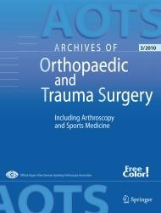 

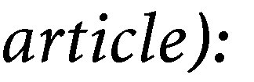

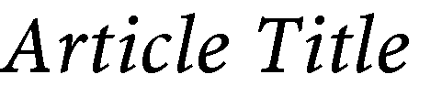

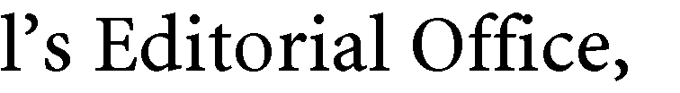

Maliha Ayoola, Diego Agustín Abelleyra Lastoria, Laura Casey, Sara Dardak, Roshan Rupra, Caroline Blanca Hing, Sarah Radcliffe, Catherine Kellett

Noise in operating theatres, is it safe?



None



Catherine Kellett



Drawing



17/06/2024





Diego Agustín Abelleyra Lastoria

17/06/2024



<http://www.springer.com/journal/402>

