Appendices

High-resolution spatial and spatiotemporal modelling of air pollution using fixed site and mobile monitoring in a Canadian city

Sierra Nicole Clark^{1,2}, Ryan Kulka², Stephane Buteau^{3,4} Eric Lavigne⁵, Joyce J.Y. Zhang², Christian Riel-Roberge⁶, Audrey Smargiassi^{3,4}, Scott Weichenthal^{2,7} Keith Van Ryswyk²

¹ Environmental and Social Epidemiology Section, Population Health Research Institute, St. George’s, University of London, London, UK
² Air Pollution Exposure Science Section, Water and Air Quality Bureau, Healthy Environments and Consumer Safety Branch, Health Canada, Ottawa, Ontario, Canada
³ Institut national de sante publique du Quebec (INSPQ), Quebec, Canada
⁴ École de santé publique, Département de santé environnementale et santé au travail, Université de Montréal, Québec, Canada
⁵ Populations Studies Division, Environmental Health Science and Research Bureau, Health Canada, Ottawa, Canada
6 Direction de santé publique, Centre intégré universitaire de santé et de services sociaux (CIUSSS) de la Capitale-Nationale ; Quebec City, Quebec, Canada
⁷ Department of Epidemiology, Biostatistics, and Occupational Health, McGill University, Montreal, Quebec, Canada

Corresponding Author
Keith Van Ryswyk; Mailing Address: Air Pollution Exposure Science Section, Water and Air Quality Bureau, Healthy Environments and Consumer Safety Branch, Health Canada, Government of Canada; Keith.VanRyswyk@hc-sc.gc.ca

Contents

Appendix 1. Air pollution measurement QA/QC and co-location with reference instruments 5
Figure A1.1. Comparison of PM_{2.5} study methods with regulatory MELCC station using least-squared regression analysis. 7
Figure A1.2. Comparison of PNC study methods with regulatory MELCC station using least squares regression analysis. 7
Figure A1.3. Comparison of BC study methods with regulatory MELCC station using least squares regression analysis. 8
Figure A1.4. Comparison of BrC study methods with regulatory MELCC station using least squares regression analysis. 8
Appendix 2. Candidate Predictor Variables, Variable Selection, and Generalized Additive Model Formulas 9
Appendix 3. Supplemental Figures 1
Appendix 4. Spatial Models for annual exposure of NO_{2,} O_{3,} PM_{2.5}, BC, BrC, PNC, particle size mode, and PNC for 13 particle sizes. 1
Table A4.1. Annual NO₂ (ppb) 1
Table A4.2. Annual O₃ (ppb) 2
Table A4.3. Annual PM_{2.5} (μg/m³) 3
Table A4.4. Annual Black Carbon (ng/m³) 4
Table A4.5. Annual Brown Carbon (ng/m³) 5
Table A4.6. Annual PNC (pts/cm³) 6
Table A4.7. Annual particle size mode (nm) 7
Table A4.8. Annual PNC for size fraction: 11.5nm (pts/cm³) 8
Table A4.9. Annual PNC for size fraction: 15.4nm (pts/cm³) 9
Table A4.10. Annual PNC for size fraction: 20.5nm (pts/cm³) 10
Table A4.11. Annual PNC for size fraction: 27.4nm (pts/cm³) 11
Table A4.12. Annual PNC for size fraction: 36.5nm (pts/cm³) 12
Table A4.13. Annual PNC for size fraction: 48.7nm (pts/cm³) 13
Table A4.14. Annual PNC for size fraction: 64.9nm (pts/cm³) 14
Table A4.15. Annual PNC for size fraction: 86.6nm (pts/cm³) 15
Table A4.16. Annual PNC for size fraction: 115.5nm (pts/cm³) 16
Table A4.17. Annual PNC for size fraction: 154.0nm (pts/cm³) 17
Table A4.18. Annual PNC for size fraction: 205.4nm (pts/cm³) 18
Table A4.19. Annual PNC for size fraction: 273.8nm (pts/cm³) 19
Table A4.20. Annual PNC for size fraction: 365.2nm (pts/cm³) 20
Appendix 5. Spatiotemporal Models for monthly exposure of PM_{2.5}, BC, BrC, and PNC. 23
Table A5.1. Monthly PM_{2.5} (μg/m³) 23
Table A5.2. Monthly BC (ng/m³) 24
Table A5.3: Monthly BrC (ng/m³) 25
Table A5.4. Monthly PNC (pts/cm³) 26
Appendix 6: Sensitivity analysis of the impact of the choice of ‘n visits’ on spatial model stability 28
Methods 28
Results 28
Figure A6.1. Ranges of adjusted R² values of 15 models for each category of ‘n visits’ for PM_{2.5}, PNC, particle size mode, BC, and BrC. Solid line represents adjusted R² of main model based on 40 visits. 29
Figure A6.2. Stability of PM_{2.5} model beta coefficients (estimate and 95% CI) within and across ’n visits’ groups. The blue line and shaded area represents the beta coefficients and 95%CI for the main 40-visit model. Estimates of beta coefficients for splined predictors do not represent the true relationship in models but this presentation does serve to demonstrate beta coefficient stability with increasing visits. 30
Figure A6.3. Stability of PNC model beta coefficients (estimate and 95% CI) within and across ’n visits’ groups. The blue line and shaded area represents the beta coefficients and 95%CI for the main 40-visit model. Estimates of beta coefficients for splined predictors do not represent the true relationship in models but this presentation does serve to demonstrate beta coefficient stability with increasing visits. 31
Figure A6.3 (continued). Stability of PNC model beta coefficients (estimate and 95% CI) within and across ’n visits’ groups. The blue line and shaded area represents the beta coefficients and 95%CI for the main 40-visit model. Estimates of beta coefficients for splined predictors do not represent the true relationship in models but this presentation does serve to demonstrate beta coefficient stability with increasing visits. 32
Figure A6.4. Stability of Particle size mode model beta coefficients (estimate and 95% CI) within and across ’n visits’ groups. The blue line and shaded area represents the beta coefficients and 95%CI for the main 40-visit model. Estimates of beta coefficients for splined predictors do not represent the true relationship in models but this presentation does serve to demonstrate beta coefficient stability with increasing visits. 33
Figure A6.4 (continued). Stability of Particle size mode model beta coefficients (estimate and 95% CI) within and across ’n visits’ groups. The blue line and shaded area represents the beta coefficients and 95%CI for the main 40-visit model. Estimates of beta coefficients for splined predictors do not represent the true relationship in models but this presentation does serve to demonstrate beta coefficient stability with increasing visits. 34
Figure A6.5. Stability of BC model beta coefficients (estimate and 95% CI) within and across ’n visits’ groups. The blue line and shaded area represents the beta coefficients and 95%CI for the main 40-visit model. Estimates of beta coefficients for splined predictors do not represent the true relationship in models but this presentation does serve to demonstrate beta coefficient stability with increasing visits. 35
Figure A6.5 (continued). Stability of BC model beta coefficients (estimate and 95% CI) within and across ’n visits’ groups. The blue line and shaded area represents the beta coefficients and 95%CI for the main 40-visit model. Estimates of beta coefficients for splined predictors do not represent the true relationship in models but this presentation does serve to demonstrate beta coefficient stability with increasing visits. 36
Figure A6.6. Stability of BrC model beta coefficients (estimate and 95% CI) within and across ’n visits’ groups. The blue line and shaded area represents the beta coefficients and 95%CI for the main 40-visit model. Estimates of beta coefficients for splined predictors do not represent the true relationship in models but this presentation does serve to demonstrate beta coefficient stability with increasing visits. 37
Figure A6.6 (continued). Stability of BrC model beta coefficients (estimate and 95% CI) within and across ’n visits’ groups. The blue line and shaded area represents the beta coefficients and 95%CI for the main 40-visit model. Estimates of beta coefficients for splined predictors do not represent the true relationship in models but this presentation does serve to demonstrate beta coefficient stability with increasing visits. 38
Figure A6.7. PM_{2.5} predictions for models with the min and max r² values of 15 models representing 8, 12, 16, 20, 24, 28, 32, and 36 visits (range 0(blue)-10(red) µg/m³). 39
Figure A6.7 (continued). PM_{2.5} predictions for models with the min and max r² values of 15 models representing 8, 12, 16, 20, 24, 28, 32, and 36 visits (range 0(blue)-10(red) µg/m³). 40
Figure A6.8. PNC predictions for models with the min and max r² values of 15 models representing 8, 12, 16, 20, 24, 28, 32, and 36 visits (range 3000(blue)-20000(red) pts/cm³). 41
Figure A6.8 (continued). PNC predictions for models with the min and max r² values of 15 models representing 8, 12, 16, 20, 24, 28, 32, and 36 visits (range 3000(blue)-20000(red) pts/cm³). 42
Figure A6.9. Particle size mode predictions for models with the min and max r² values of 15 models representing 8, 12, 16, 20, 24, 28, 32, and 36 visits (range 30(red)-65(blue) nm). 43
Figure A6.9 (continued). Particle size mode predictions for models with the min and max r² values of 15 models representing 8, 12, 16, 20, 24, 28, 32, and 36 visits (range 30(red)-65(blue) nm). 44
Figure A6.10. BC predictions for models with the min and max r² values of 15 models representing 8, 12, 16, 20, 24, 28, 32, and 36 visits (range 500(blue)-1800(red) ng/m³). 45
Figure A6.10 (continued). BC predictions for models with the min and max r² values of 15 models representing 8, 12, 16, 20, 24, 28, 32, and 36 visits (range 500(blue)-1800(red) ng/m³). 46
Figure A6.11. BrC predictions for models with the min and max r² values of 15 models representing 8, 12, 16, 20, 24, 28, 32, and 36 visits (range 300(blue)-1500(red) ng/m³). 47
Figure A6.11 (continued). BrC predictions for models with the min and max r2 values of 15 models representing 8, 12, 16, 20, 24, 28, 32, and 36 visits (range 300(blue)-1500(red) ng/m³). 48

Appendix 1. Air pollution measurement QA/QC and co-location with reference instruments

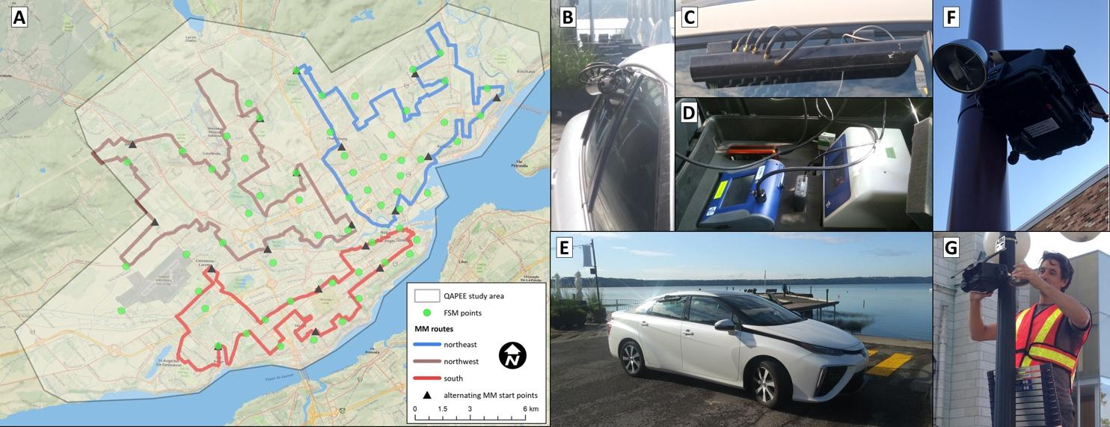
Figure A1. Quebec Air Pollution Exposure and Epidemiology (QAPEE) study area, FSS sites, and MM routes (A) and equipment set up for the MM (Frames B-E) and FSS (Frames F&G) campaigns.

NO₂ and O₃ Ogawa QA/QC

As >50% of the NO₂ and O₃ blanks were below detection, no blank corrections were applied. Based on duplicates (n=12, six/season), mean precision was 0.58 % and 0.38% for NO₂ and O₃, respectively, similar to past use of the Ogawa method for NO₂ and O₃ (Wheeler et al., 2011).

Measures of particle number counts (PNC) and particle size mode

The DiscMini (Testo; Lenzkirch, Germany) provided metrics on PNC and size mode for particles ranging from 10-700 nm. Measures of PNC for 13 size ranges for particles 10-450 nm were made with the Nanoscan (TSI, Inc.; Minnesota, USA). These metrics were represented as PNC with the particle size range median in subscript. These metrics and the particle size ranges they represented were PNC_{11.5} (10–13 nm), PNC_{15.4} (13–18 nm), PNC_{20.5} (18–24 nm), PNC_{27.4} (24–32 nm), PNC_{36.5} (32–42 nm), PNC_{48.7} (42–56 nm), PNC_{64.9} (56–75 nm), PNC_{86.6} (75–100 nm), PNC_{115.5} (100–133 nm), PNC_{154.0} (133–178 nm), PNC_{205.4} (178–237 nm), PNC_{273.8} (237–316 nm), and PNC_{365.2} (316–420 nm).

Air pollution measurement QA/QC and co-location with reference instruments

All monitors were calibrated by the manufacturer or vendor prior to the MM campaign. Time series data plots were inspected for technical issues on a weekly basis following each monitoring session. Erroneous data, characteristic of technical problems, were invalidated, and faulty instruments were replaced with calibrated spares and sent back to the lab for inspection and calibration. Temporal smoothing was considered as a data processing step, however not done on account of past work finding that this did not improve prediction (Hankey and Marshall, 2015). Both the 1-second BC and BrC underwent a noise-reduction data processing step (Hagler et al., 2011). A quality assurance and control program was set up in collaboration with the Ministère de l’Environnement, de la Lutte contre les changements climatiques de la Faune et des Parcs (MELCCFP). The MELCCFP site measures PNC with the ENVI-CPC from Palas (Karlsruhe, Germany), PM_{2.5} with the API T640 of Teledyne (California, USA) and black and brown carbon with the AE33 of Magee Scientific (California, USA). Over the study period, two 30-minute instrument co-location monitoring sessions per month were conducted at the MELCCFP stationary monitoring site (46.79462, -71.24681). Data for the comparisons were averaged over each ~30-minute intercomparisons session and compared with a least squares regression analysis. The number of sessions per pollutant varied from 20-23 depending on the available of data from the MELCCFP site.

Comparisons between the study’s MM measures and that of the regulatory MELCCFP station for PM_{2.5}, PNC, BC, and BrC are presented in Figures A1.1-4, respectively. Concentrations of PM_{2.5} measured at the MELCCFP station ranged from ~2-20 ug/m³ across the colocation sessions. The DustTrak 8530 of the MM campaign was shown to overpredict the Teledyne of the MELCCFP station by a factor of ~3. The slope of 0.35 and y-intercept of 1.61 was used to correct the PM_{2.5} of the MM campaign. The colocation sessions yielded PNC concentrations ranging up to 25,000 pts/cm³. The relationship between the PNC methods of the MELCCFP station and the study were close to unity (slope = 0.92). There was poor agreement between the methods of the study and MELCCFP station (R²=0.28). This may be due to low BC variability across sessions (<1 µg/m³). There was excellent agreement between these two units for BrC measures (R²=0.85, slope = 1.02).

Hagler, G. S. W., Yelverton, T. L. B., Vedantham, R., Hansen, A. D. A., & Turner, J. R. (2011). Post-processing method to reduce noise while preserving high time resolution in aethalometer real-time black carbon data. Aerosol and Air Quality Research, 11(5), 539–546. https://doi.org/10.4209/aaqr.2011.05.0055
Hankey, S., & Marshall, J. D. (2015). Land Use Regression Models of On-Road Particulate Air Pollution (Particle Number, Black Carbon, PM2.5, Particle Size) Using Mobile Monitoring. Environmental Science and Technology, 49(15), 9194–9202. https://doi.org/10.1021/acs.est.5b01209
Wheeler, A. J., Xu, X., Kulka, R., You, H., Wallace, L., Mallach, G., Ryswyk, K. Van, MacNeill, M., Kearney, J., Rasmussen, P. E., & others. (2011). Windsor, Ontario exposure assessment study: design and methods validation of personal, indoor, and outdoor air pollution monitoring. Journal of the Air & Waste Management Association, 61(3), 324–338. https://doi.org/https://doi.org/10.3155/1047-3289.61.2.142

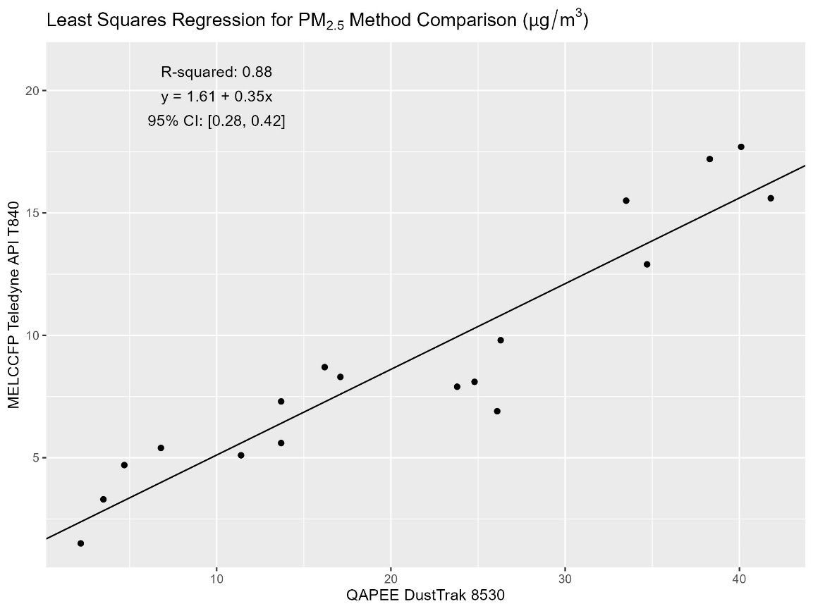

Figure A1.1. Comparison of PM_{2.5} study methods with regulatory MELCC station using least-squared regression analysis.

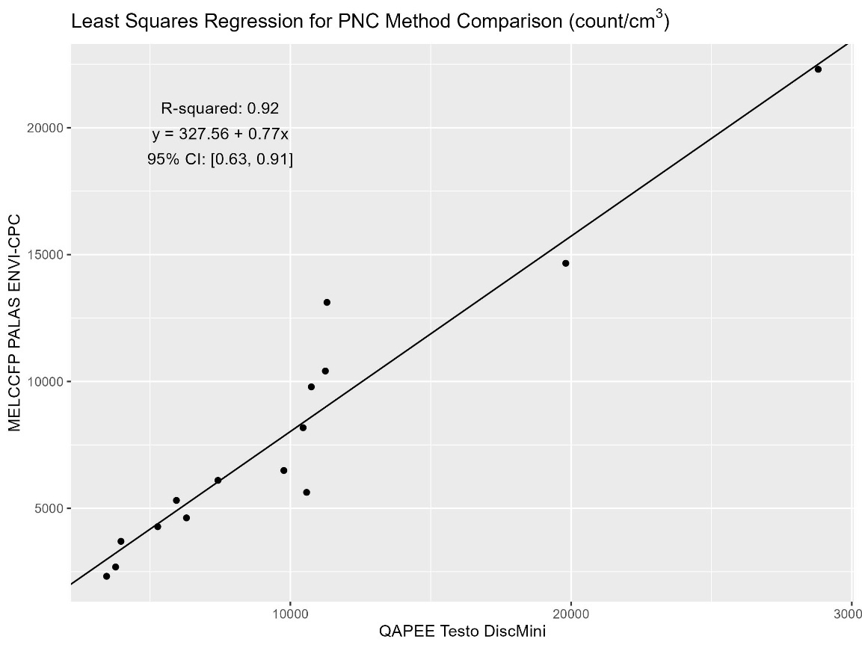

Figure A1.2. Comparison of PNC study methods with regulatory MELCC station using least squares regression analysis.
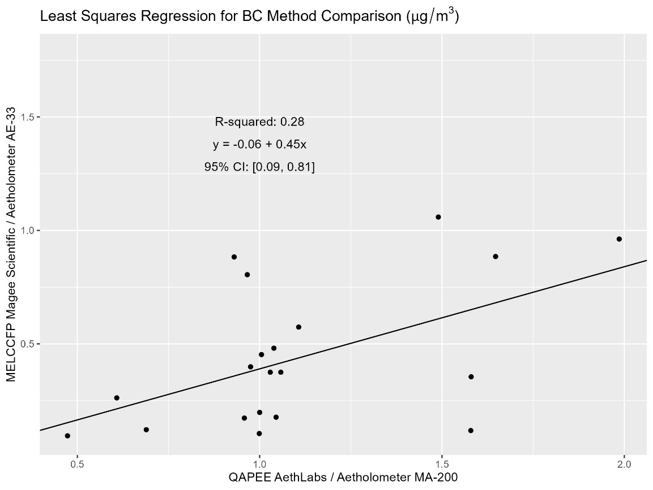

Figure A1.3. Comparison of BC study methods with regulatory MELCC station using least squares regression analysis.

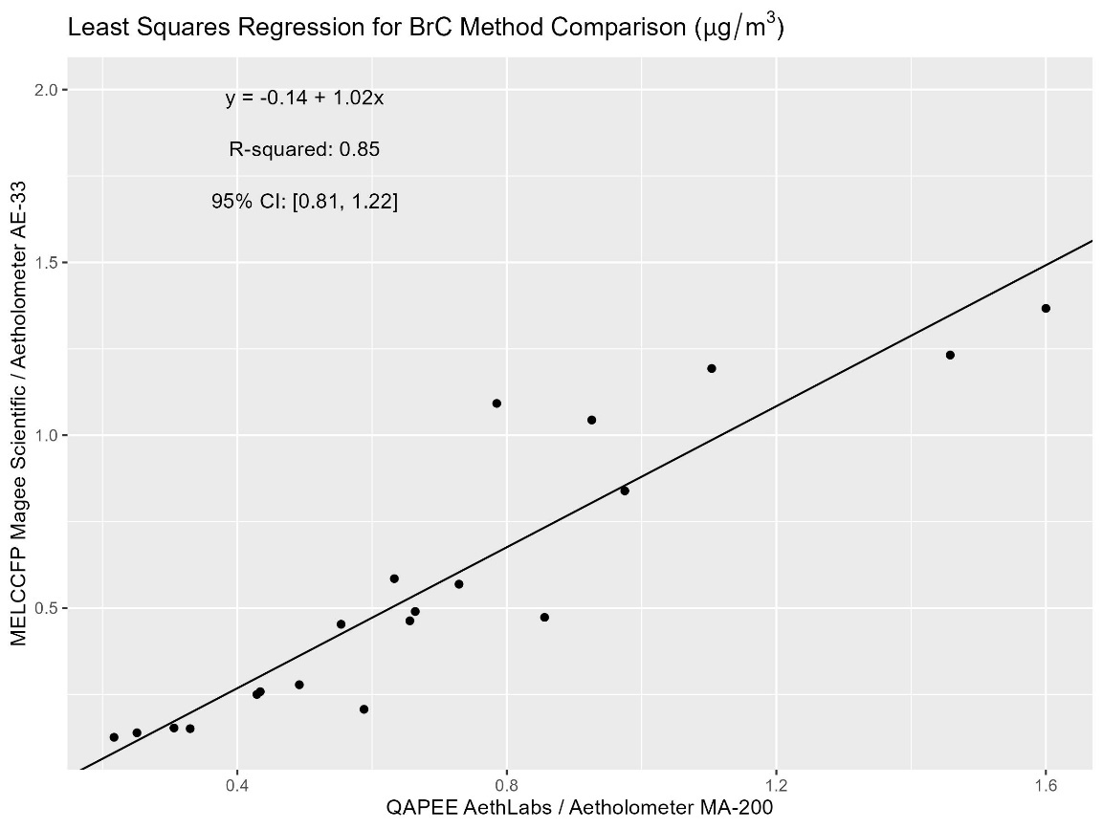

Figure A1.4. Comparison of BrC study methods with regulatory MELCC station using least squares regression analysis.

Appendix 2. Candidate Predictor Variables, Variable Selection, and Generalized Additive Model Formulas

Candidate Predictor Variables

Predictor variable type | Predictor variables** | GIS transformation
Locations of interest | Gas stations, restaurants, seaports, intersections, bus stops, railyards, airport, heliport, NPRI (all sites, cadmium sites, hexavalent chromium sites, lead sites, manganese sites, mercury sites, NO₂ sites, phenol sites, phosphorus sites, PM₁₀ sites, PM_{2.5} sites, selenium sites, SO₂ sites, total PM sites, zinc sites) | Count within buffer; Distance to nearest(m)
Road and rail mobile sources | Highways, major roads, local roads, rail-line, bus routes | Total length within buffer (m); Distance to nearest (m)
Aviation mobile sources** | Mean kerosene altitude (250m grid) (m), Mean avgas aircraft altitude (m), total kerosene fuel (250m grid) (kg), total avgas fuel (250m grid) (kg) | Average value within buffer
Geography and population | Elevation above sea-level (m), greenness (Normalized Difference Vegetation Index (NDVI)) *, population (n of people) | Average value within buffer
Land use | Residential areas, commercial areas, industrial areas, government or institutional areas, open areas, parks and recreational areas, | Area within buffer (m²); Distance to nearest (m)
Meteorology*** | Temperature (K), relative humidity (%, wind speed (km/h), atmospheric pressure (kPa) | --
Space and time | Latitude, longitude, month, season | --
* data sources; land use, roads, transit and rail, geography, and points of interest: DMTI Spatial Inc. and Ville de Québec Partenariat Données Québec. NPRI points: National Pollutant Release Inventory. Aviation data: NavCanada. Elevation and building height: Foret Ouverte (https://www.foretouverte.gouv.qc.ca). NDVI measures were based on Landsat 8 satellite imagery (USGS).
** For both kerosene and avgas aviation fuel, two metrics were calculated for each 250m grid cell; the sum of fuel consumed and the mean altitude at which it was consumed.
*** Predictors with monthly varying and annual average values. Meteorology data obtained from https://climate.weather.gc.ca/ https://climate.weather.gc.ca/.

Variable Selection

We initially identified a reduced set of predictor variables for each pollutant LUR model by several criteria used in previous work (Johnson et al., 2010; Mukerjee et al., 2009; Zhang et al., 2015). First, bivariate Least-squares Regression (LSR) analyses were run for each predictor with the pollutant as the dependent. Predictors with p-values <0.2 were retained. Further screening involved calculating Variance Inflation Factors (VIF) for the remaining variables. The VIF threshold was set at 2.5. Collinear pairs were identified and the predictor with the highest R² from the LSR bivariate (single independent variable) analyses was retained. Remaining predictors were ranked by LSR R² and the highest 12 were retained (which resulted in 4,017 to evaluate). Model predictive accuracy was maximized by running all combinations of models with 3-12 predictors (max = 4017 models). Where several combinations of predictor variables for an individual pollutant outcome had R²s within 0.01 decimal places of each other, we selected the models with the fewest number of predictors (for model parsimony) and lowest Root Mean Squared Error (RMSE). Finally, models were also screened for counterintuitive associations among predictor variables.

GAM models of annual average concentrations

$$Y_{i}= α+ \sum{β}X_{i}+\sum{f(}X_{i}) + ε_{i}$$

where Y_{i} represents the annual average pollutant concentration at location i. α is the intercept and β is the coefficient applied to each GIS predictor variable ($X_{i}$) estimated with linear functions. For the GIS predictor variables ($X_{i}$) modelled with non-linear functions, f (X_{i}) represents the smooth spline functions. $ε_{i}$is the random error term for each location i.

Spatial GAM models of annual average concentrations

$$Y_{i}= α+ \sum{β}X_{i}+\sum{f(}X_{i}) +f\left({Long}_{i} x {Lat}_{i}\right)+ ε_{i}$$

Spatial GAMs build on the base GAM models with an added smooth term applied to the interaction between the latitude and longitude $f\left({Long}_{i} x {Lat}_{i}\right)$ value for each location i.

Spatiotemporal GAM models of monthly average concentrations

$$Y_{ij}= α+ \sum{β}X_{i}+\sum{f(}X_{i}) +\sum{f(}X_{ij}) +\sum{β}T_{j}+\sum{f(}T_{j}) +f\left({Long}_{i} x {Lat}_{i} | {Season}_{s}\right)+ f({Month}_{j})+ ε_{ij}$$

where Y_{ij} represents the monthly averaged pollutant concentration at location i for month j; $\sum{β}X_{i}+\sum{f(}X_{i})$ represent the linear and non-linear spline functions applied to the purely spatial GIS predictor variables (X_{i}) for location i, while X_{ij} represents the spatial GIS predictor variables that have values that also vary by month j (i.e., NDVI levels); $\sum{β}T_{j}+\sum{f(}T_{j})$ represent the linear and non-linear spline functions applied to the purely temporal meteorological predictor variables (T_{j}) for month j; $f\left({Long}_{i} x {Lat}_{i} | {Season}_{s}\right)$ represents the spline function applied to the interaction between longitude and latitude at locations i, which is conditional on season s (s=4 defined seasons); $f\left({Month}_{j}\right)$ represents the non-linear spline function applied to the variable Month; and $ε_{ij}$is the random error term for each location i and month j.
References
Johnson, M., Isakov, V., Touma, J. S., Mukerjee, S., & Özkaynak, H. (2010). Evaluation of land-use regression models used to predict air quality concentrations in an urban area. Atmospheric Environment, 44(30), 3660–3668. https://doi.org/10.1016/J.ATMOSENV.2010.06.041
Mukerjee, S., Smith, L. A., Johnson, M. M., Neas, L. M., & Stallings, C. A. (2009). Spatial analysis and land use regression of VOCs and NO2 from school-based urban air monitoring in Detroit/Dearborn, USA. Science of the Total Environment, 407(16), 4642–4651. https://doi.org/10.1016/j.scitotenv.2009.04.030
Zhang, J. J. Y., Sun, L., Barrett, O., Bertazzon, S., Underwood, F. E., & Johnson, M. (2015). Development of land-use regression models for metals associated with airborne particulate matter in a North American city. Atmospheric Environment, 106, 165–177. https://doi.org/10.1016/j.atmosenv.2015.01.008

Appendix 3. Supplemental Figures

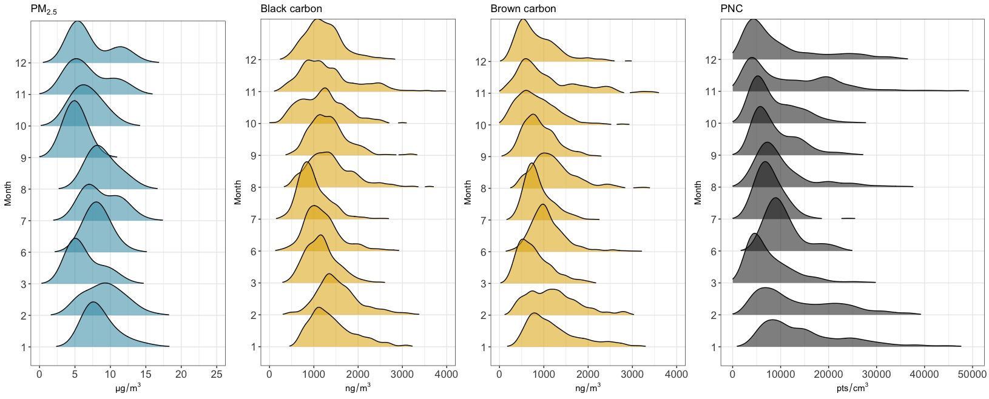
Figure A3.1. Density distribution plots of monthly median measured PM_{2.5} (corrected), PNC, BC, and BrC from the mobile monitoring campaign. Numbers on the Y axis refer to calendar monthly of the year with January = 1 and December = 12. April (4) and May (5) were not captured due to the start of the covid pandemic. Median monthly PM_{2.5} ranged between 4.8 to 9.1 ug/m³. Median monthly black carbon ranged from 922 – 1,476 ng/m³. Median monthly brown carbon ranged from 722- 1,148 ng/m³. Median monthly PNC ranged from 6,096 – 13,336 pts/cm³

Appendix 4. Spatial Models for annual exposure of NO_{2,} O_{3,} PM_{2.5}, BC, BrC, PNC, particle size mode, and PNC for 13 particle sizes.

Table A4.1. Annual NO₂ (ppb)
Predictors | Coefficients | 95% confidence interval | P-value
(Intercept) | 1.4756 | 1.1794 – 1.7718 | <0.001
Distance to nearest government or institutional land (m) | -0.0002 | -0.0003 – -0.0000 | 0.01
Mean monthly greenness within 50m buffer (NDVI) | -3.2969 | -5.5459 – -1.0479 | <0.001
Distance to nearest rail line (m) | -0.0000 | -0.0001 – 0.0001 | 0.63
Total length of bus routes within 50m buffer (m) | 0.0101 | 0.0021 – 0.0181 | 0.01
Smooth terms  Distance to Sainte-Foy railyard (m) |  |  | 0.03
Mean elevation within 50m buffer (m) |  |  | 0.15
latitude x longitude |  |  | <0.001
No. of observations | 60
R²  10-fold CV R²  10-fold CV RMSE | 0.84  0.76  1.06
10-fold CV: 10-fold cross-validation with 10% random sites; RMSE: Root mean squared error; NDVI: Normalized Difference Vegetation Index.

Table A4.2. Annual O₃ (ppb)
Predictors | Coefficients | 95% confidence interval | P-value
(Intercept) | 12.527 | 10.086 – 14.967 | <0.001
Mean avgas aircraft altitude within 1000m buffer (m) | -0.012 | -0.015 – -0.009 | <0.001
Total length of bus routes within 50m buffer (m) | -0.004 | -0.007 – -0.000 | 0.04
Mean elevation within 50m buffer (m) | 0.001 | -0.000 – 0.001 | 0.21
Smooth terms  Mean avgas aircraft altitude within 750m buffer (m) |  |  | <0.001
Distance to nearest residential (m²) |  |  | 0.06
Distance to the nearest highway (m) |  |  | 0.13
No. of Observations | 59
R²  10-fold CV R²  10-fold CV RMSE | 0.65  0.54  6.65
10- fold CV: 10-fold cross-validation with 10% random sites; RMSE: Root mean squared error.

Table A4.3. Annual PM_{2.5} (μg/m³)
Predictors | Coefficients | 95% confidence Interval | P-value
(Intercept) | 2.6964 | 1.0843 – 4.3086 | <0.001
Distance to Sainte-Foy railyard (m) | 0.0000 | -0.0001 – 0.0002 | 0.57
Distance to Quai 106 port (m) | -0.0001 | -0.0002 – 0.0001 | 0.32
Smooth terms  Distance to nearest highway (m) |  |  | <0.001
Distance to nearest rail line (m) |  |  | 0.67
longitude x latitude |  |  | <0.001
No. of observations | 355
R²  10-fold CV R²  10-fold CV RMSE | 0.87  0.86  1.25
10-fold CV: 10-fold cross validation with 10% random sites; RMSE: Root mean squared error.

Table A4.4. Annual Black Carbon (ng/m³)
Predictors | Coefficients | 95% confidence interval | P-value
(Intercept) | 7.9944 | 6.7275 – 9.2613 | <0.001
Distance to Quai 106 port (m) | -0.0001 | -0.0002 – -0.0000 | 0.04
Distance to Sainte-Foy railyard (m) | -0.0000 | -0.0001 – 0.0001 | 0.84
Total length of highway within 150m buffer (m) | 0.0026 | 0.0015 – 0.0037 | <0.001
Total length of bus routes within 50m buffer (m) | 0.0029 | 0.0009 – 0.0049 | <0.001
Smooth terms  Mean avgas aircraft altitude within 1000m buffer (m) |  |  | 0.54
Distance to nearest restaurant (m) |  |  | 0.24
Restaurant count within 300m buffer (n) |  |  | 0.19
longitude x latitude |  |  | <0.001
No. of observations | 355
R²  10-fold CV R²  10-fold CV RMSE | 0.57  0.50  186.52
10-fold CV: 10-fold cross validation with10% random sites; RMSE: Root mean squared error.

Table A4.5. Annual Brown Carbon (ng/m³)
Predictors | Coefficients | 95% confidence interval | P-value
(Intercept) | 6.8363 | 6.7233 – 6.9494 | <0.001
Distance to nearest rail line (m) | -0.0000 | -0.0001 – -0.0000 | 0.03
Mean elevation within 50m buffer (m) | -0.0002 | -0.0012 – 0.0008 | 0.69
Distance to nearest NPRI site (m) | -0.0000 | -0.0000 – 0.0000 | 0.55
Total length of bus routes within 50m buffer (m) | 0.0038 | 0.0013 – 0.0063 | <0.001
Smooth terms  Distance to Sainte-Foy railyard (m) |  |  | <0.001
Distance to nearest highway (m) |  |  | <0.001
Restaurant count within 300m buffer (n) |  |  | <0.001
Total length of highway within 150m buffer (m) |  |  | <0.001
longitude x latitude |  |  | <0.001
No. of observations | 355
R²  10-fold CV R²  10-fold CV RMSE | 0.61  0.54  192.92
10-fold CV: 10-fold cross validation with 10% random sites; RMSE: Root mean squared error; NDVI: Normalized Difference Vegetation Index; NPRI: National pollutant release inventory.

Table A4.6. Annual PNC (pts/cm³)
Predictors | Coefficients | 95% confidence interval | P-value
(Intercept) | 8.9108 | 7.2668 – 10.5549 | <0.001
Distance to Sainte-Foy railyard (m) | 0.0000 | -0.0001 – 0.0002 | 0.91
Mean elevation within 50m buffer (m) | 0.0000 | -0.0011 – 0.0012 | 0.93
Smooth terms  Mean monthly greenness within 50m buffer (NDVI) |  |  | <0.001
Distance to nearest highway (m) |  |  | <0.001
Restaurant count within 300m buffer (n) |  |  | 0.16
Distance to nearest NPRI site (m) |  |  | 0.48
longitude x latitude |  |  | <0.001
No. of observations | 355
R²  10-fold CV R²  10-fold CV RMSE | 0.88  0.81  1656.71
10-fold CV: 10-fold cross validation with 10% random sites; RMSE: Root mean squared error; NDVI: Normalized Difference Vegetation Index; NPRI: National pollutant release inventory.

Table A4.7. Annual particle size mode (nm)
Predictors | Coefficients | 95% confidence interval | P-value
(Intercept) | 3.6611 | 3.6560 – 3.6662 | <0.01
Smooth terms  Distance to nearest highway (m) |  |  | 0.04
Total length of highway within 750m buffer (m) |  |  | <0.01
Distance to nearest rail line (m) |  |  | 0.81
Distance to Baie de Beauport railyard (m) |  |  | 0.19
Distance to Sainte-Foy railyard (m) |  |  | 0.51
Gas station count within 1000m buffer (n) |  |  | <0.01
Distance to nearest resource and industrial area (m) |  |  | 0.04
latitude x longitude |  |  | <0.01
No. of observations | 355
R²  10-fold CV R²  10-fold CV RMSE | 0.81  0.78  2.01
** 10-fold CV: 10-fold cross-validation with 10% random sites; RMSE: Root mean squared error

Table A4.8. Annual PNC for size fraction: 11.5nm (pts/cm³)
Predictors | Coefficients | 95% confidence Interval | P-value
(Intercept) | 5.2647 | 4.9474 – 5.5820 | <0.001
Total length of bus routes within 500m buffer (m) | 0.0001 | -0.0001 – 0.0003 | 0.37
Mean avgas aircraft altitude within 50m buffer (m) | 0.0002 | -0.0002 – 0.0005 | 0.39
Distance to nearest gas station (m) | -0.0001 | -0.0001 – -0.0000 | 0.01
Mean monthly greenness within 50m buffer (NDVI) | -0.5415 | -1.0128 – -0.0701 | 0.02
Smooth terms  Distance to nearest highway (m) |  |  | <0.001
Distance to Sainte-Foy railyard (m) |  |  | 0.60
Distance to nearest NPRI site (m) |  |  | 0.45
longitude x latitude |  |  | <0.001
No. of observations | 353
R²  10-fold CV R²  10-fold CV RMSE | 0.78  0.67  78.24
10-fold CV: 10-fold cross validation with 10% random sites; RMSE: Root mean squared error; NDVI: Normalized Difference Vegetation Index; NPRI: National pollutant release inventory.

Table A4.9. Annual PNC for size fraction: 15.4nm (pts/cm³)
Predictors | Coefficients | 95% confidence interval | P-value
(Intercept) | 5.6780 | 3.3660 – 7.9900 | <0.001
Distance to Sainte-Foy railyard (m) | 0.0000 | -0.0002 – 0.0003 | 0.80
Mean monthly greenness within 50m buffer (NDVI) | -0.7509 | -1.1631 – -0.3386 | <0.001
Mean avgas aircraft altitude within 50m buffer (m) | 0.0002 | -0.0002 – 0.0005 | 0.37
Distance to nearest government or institutional (m) | -0.0000 | -0.0001 – 0.0001 | 0.71
Smooth terms  Distance to nearest highway (m) |  |  | <0.001
Total length of bus routes within 500m buffer (m) |  |  | 0.65
Distance to nearest NPRI site (m) |  |  | 0.46
longitude x latitude |  |  | <0.001
No. of observations | 353
R²  10-fold CV R²  10-fold CV RMSE | 0.82  0.74  130.98
10-fold CV: 10-fold cross validation with 10% random sites; RMSE: Root mean squared error; NDVI: Normalized Difference Vegetation Index; NPRI: National pollutant release inventory.

Table A4.10. Annual PNC for size fraction: 20.5nm (pts/cm³)
Predictors | Coefficients | 95% confidence Interval | p-value
(Intercept) | 5.8142 | 3.5761 – 8.0522 | <0.001
Mean elevation within 50m buffer (m) | -0.0012 | -0.0030 – 0.0006 | 0.20
Distance to nearest Sainte-Foy train station | 0.0000 | -0.0002 – 0.0002 | 0.91
Distance to nearest government or institutional (m) | -0.0000 | -0.0001 – 0.0001 | 0.85
Distance to nearest NPRI site (m) | 0.0000 | -0.0001 – 0.0001 | 0.76
Smooth terms  Distance to nearest highway (m) |  |  | <0.001
Total length of bus routes within 500m buffer (m) |  |  | 0.90
Restaurant count within 300m buffer (n) |  |  | 0.06
longitude x latitude |  |  | <0.001
No. of observations | 355
R²  10-fold CV R²  10-fold CV RMSE | 0.80  0.71  115.98
10-fold CV: 10-fold cross validation with 10% random sites; RMSE: Root mean squared error; NPRI: National pollutant release inventory.

Table A4.11. Annual PNC for size fraction: 27.4nm (pts/cm³)
Predictors | Coefficients | 95% confidence interval | P-value
(Intercept) | 6.2096 | 4.2257 – 8.1936 | <0.001
Mean elevation within 50m buffer (m) | -0.0015 | -0.0032 – 0.0002 | 0.08
Distance to Sainte-Foy railyard (m) | 0.0000 | -0.0002 – 0.0002 | 0.81
Distance to nearest NPRI site (m) | -0.0000 | -0.0001 – 0.0000 | 0.23
Distance to nearest government or institutional (m) | 0.0000 | -0.0001 – 0.0001 | 0.91
Distance to nearest rail line (m) | -0.0000 | -0.0001 – 0.0001 | 0.88
Smooth terms  Distance to nearest highway (m) |  |  | <0.001
Restaurant count within 300m buffer (n) |  |  | 0.03
Total rail within 1000m buffer (m) |  |  | 0.06
longitude x latitude |  |  | <0.001
No. of observations | 355
R²  10-fold CV R²  10-fold CV RMSE | 0.81  0.75  151.64
10-fold CV: 10-fold cross validation with 10% random sites; RMSE: Root mean squared error; NPRI: National pollutant release inventory.

Table A4.12. Annual PNC for size fraction: 36.5nm (pts/cm³)
Predictors | Coefficients | 95% Confidence interval | P-value
(Intercept) | 5.9213 | 3.6910 – 8.1517 | <0.001
Mean elevation within 50m buffer (m) | -0.0019 | -0.0035 – -0.0004 | 0.02
Distance to Sainte-Foy railyard (m) | 0.0001 | -0.0002 – 0.0003 | 0.62
Smooth terms  Distance to nearest highway (m) |  |  | <0.001
NPRI (all sites) count within 1000m buffer (n) |  |  | 0.58
Restaurant count within 300m buffer (n) |  |  | 0.07
Total government or institutional within 750m buffer (m²) |  |  | 0.81
longitude x latitude |  |  | <0.001
No. of observations | 355
R²  10-fold CV R²  10-fold CV RMSE | 0.82  0.73  151.99
10-fold CV: 10-fold cross validation with 105 random sites; RMSE: Root mean squared error; NPRI: National pollutant release inventory.

Table A4.13. Annual PNC for size fraction: 48.7nm (pts/cm³)
Predictors | Coefficients | 95% confidence interval | P-value
(Intercept) | 6.3879 | 6.2953 – 6.4804 | <0.001
Mean elevation within 50m buffer (m) | -0.0009 | -0.0021 – 0.0002 | 0.11
Smooth terms  Distance to Sainte-Foy railyard (m) |  |  | 0.85
Distance to nearest highway (m) |  |  | 0.05
Distance to nearest NPRI site (m) |  |  | 0.31
Restaurant count within 300m buffer (n) |  |  | 0.02
longitude x latitude |  |  | <0.001
No. of observations | 354
R²  10-fold CV R²  10-fold CV RMSE | 0.75  0.70  107.81
10-fold CV: 10-fold cross validation with 105 random sites; RMSE: Root mean squared error; NPRI: National pollutant release inventory.

Table A4.14. Annual PNC for size fraction: 64.9nm (pts/cm³)
Predictors | Coefficients | 95% confidence interval | P-value
(Intercept) | 6.7008 | 5.4934 – 7.9082 | <0.001
Distance to Sainte-Foy railyard (m) | -0.0000 | -0.0001 – 0.0001 | 0.57
Mean elevation within 50m buffer (m) | -0.0012 | -0.0025 – -0.0000 | 0.05
Smooth terms  Mean avgas aircraft altitude within 50m buffer (m) |  |  | 0.47
Restaurant count within 300m buffer (n) |  |  | 0.10
Distance to nearest NPRI site (m) |  |  | 0.32
Intersection count within 250m buffer (n) |  |  | 0.39
Total rail within 1000m buffer (m) |  |  | 0.40
longitude x latitude |  |  | <0.001
No. of observations | 355
R²  10-fold CV R²  10-fold CV RMSE | 0.63  0.56  105.23
10-fold CV: 10-fold cross validation with 105 random sites; RMSE: Root mean squared error; NPRI: National pollutant release inventory.

Table A4.15. Annual PNC for size fraction: 86.6nm (pts/cm³)
Predictors | Coefficients | 95% confidence interval | P-value
(Intercept) | 6.2306 | 6.0439 – 6.4174 | <0.001
Mean elevation within 50m buffer (m) | -0.0009 | -0.0019 – 0.0001 | 0.07
Mean avgas aircraft altitude within 50m buffer (m) | 0.0001 | -0.0002 – 0.0003 | 0.61
Total avgas fuel (250m grid) within 50m buffer (kg) | -0.0097 | -0.0209 – 0.0016 | 0.09
Distance to nearest rail line (m) | -0.0000 | -0.0000 – 0.0000 | 0.27
Distance to nearest NPRI NO₂ site (m) | -0.0000 | -0.0000 – 0.0000 | 0.94
Mean avgas aircraft altitude within 50m buffer (m) x Total avgas fuel (250m grid) within 50m buffer (kg) | 0.0000 | 0.0000 – 0.0001 | 0.04
Smooth terms  Distance to the neatest Sainte-Foy train station (m) |  |  | 0.53
Restaurant count within 300m buffer (n) |  |  | <0.001
longitude x latitude |  |  | 0.01
No. of observations | 355
R²  10- fold CV R²  10-fold CV RMSE | 0.45  0.38  111.20
10-fold CV: 10-fold cross validation with 10% random sites; RMSE: Root mean squared error; NPRI: National pollutant release inventory.

Table A4.16. Annual PNC for size fraction: 115.5nm (pts/cm³)
Predictors | Coefficients | 95% confidence interval | P-value
(Intercept) | 6.2402 | 6.1500 – 6.3304 | <0.001
Mean elevation within 50m buffer (m) | -0.0014 | -0.0023 – -0.0004 | 0.01
Distance to nearest rail line (m) | -0.0000 | -0.0000 – 0.0000 | 0.24
Smooth terms  Distance to Sainte-Foy railyard (m) |  |  | 0.83
Distance to nearest highway (m) |  |  | <0.001
Gas stations count within 500m buffer (n) |  |  | 0.11
longitude x latitude |  |  | <0.001
No. of observations | 355
R²  10-fold CV R²  10-fold CV RMSE | 0.46  0.44  90.89
10-fold CV: 10-fold cross validation with 10% random sites; RMSE: Root mean squared error; NPRI: National pollutant release inventory.

Table A4.17. Annual PNC for size fraction: 154.0nm (pts/cm³)
Predictors | Coefficients | 95% confidence interval | P-value
(Intercept) | 5.6243 | 5.5778 – 5.6708 | <0.001
Distance to nearest gas station (m) | -0.0001 | -0.0001 – -0.0000 | 0.01
Smooth terms  Mean elevation within 50m buffer (m) |  |  | 0.02
Distance to Sainte-Foy railyard (m) |  |  | 0.97
Distance to nearest highway (m) |  |  | <0.001
Total resource and industrial within 750m buffer (m2) |  |  | 0.04
longitude x latitude |  |  | 0.22
No. of observations | 355
R²  10-fold CV R²  10-fold CV RMSE | 0.32  0.29  62.43
10-fold CV: 10-fold cross validation with 10% random sites; RMSE: Root mean squared errors.

Table A4.18. Annual PNC for size fraction: 205.4nm (pts/cm³)
Predictors | Coefficients | 95% confidence interval | P-value
(Intercept) | 4.0742 | 4.0346 – 4.1139 | <0.001
Smooth terms  Mean avgas aircraft altitude within 50m buffer (m) |  |  | 0.50
Distance to nearest highway (m) |  |  | 0.12
Distance to nearest gas station (m) |  |  | 0.01
longitude x latitude |  |  | 0.17
No. of observations | 351
R²  10-fold CV R²  10-fold CV RMSE | 0.09  0.05  23.10

Table A4.19. Annual PNC for size fraction: 273.8nm (pts/cm³)
Predictors | Coefficients | 95% confidence interval | P-value
(Intercept) | 0.1781 | -0.0406 – 0.3968 | 0.11
Total length of highway within 150m buffer (m) | 0.0019 | 0.0007 – 0.0031 | <0.001
Meters to nearest intersection (m) | 0.0004 | 0.0002 – 0.0006 | <0.001
Total avgas fuel (250m grid) within 1000m buffer (kg) | -0.0002 | -0.0004 – 0.0000 | 0.08
Smooth term  longitude x latitude |  |  | 0.41
No. of observations | 355
R²  10-fold CV R²  10-fold CV RMSE | 0.07  0.00  0.68
10-fold CV: 10-fold cross validation with 10% random sites; RMSE: Root mean squared error.

Table A4.20. Annual PNC for size fraction: 365.2nm (pts/cm³)
Predictors | Coefficients | 95% confidence interval | P-value
(Intercept) | -0.0230 | -0.1852 – 0.1393 | 0.78
Total kerosene fuel (250m grid) within 250m buffer (kg) | 0.0000 | -0.0000 – 0.0000 | 0.48
Mean monthly greenness within 50m buffer (NDVI) | -0.1531 | -0.4199 – 0.1138 | 0.26
Smooth terms  Total length of highway within 150m buffer (m) |  |  | <0.001
Mean kerosene altitude (250m grid) within 1000m buffer (m) |  |  | <0.001
longitude x latitude |  |  | <0.001
No. of observations | 355
R²  10-fold CV R²  10-fold CV RMSE | 0.30  0.00  --
10-fold CV: 10-fold cross validation with 10% random sites; RMSE: Root mean squared error; NDVI: Normalized Difference Vegetation Index.

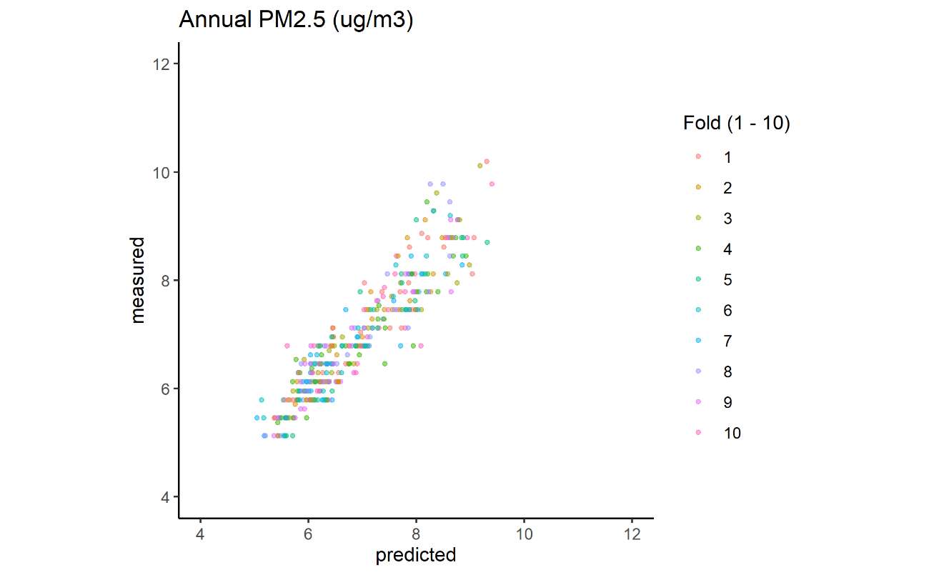
Figure A4.1 Measured and predicted PM2.5 concentrations based on 10-fold random sample cross validation.

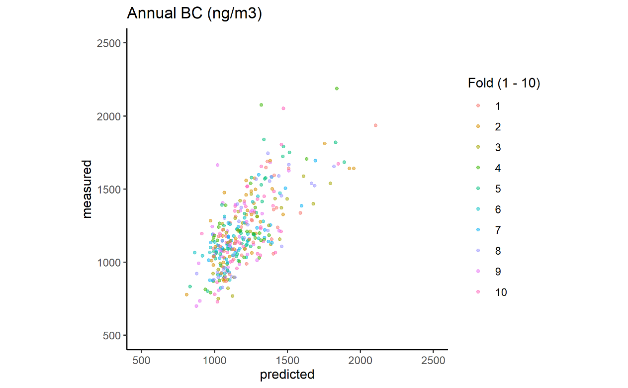
Figure A4.2 Measured and predicted Black Carbon concentrations based on 10-fold random sample cross validation.

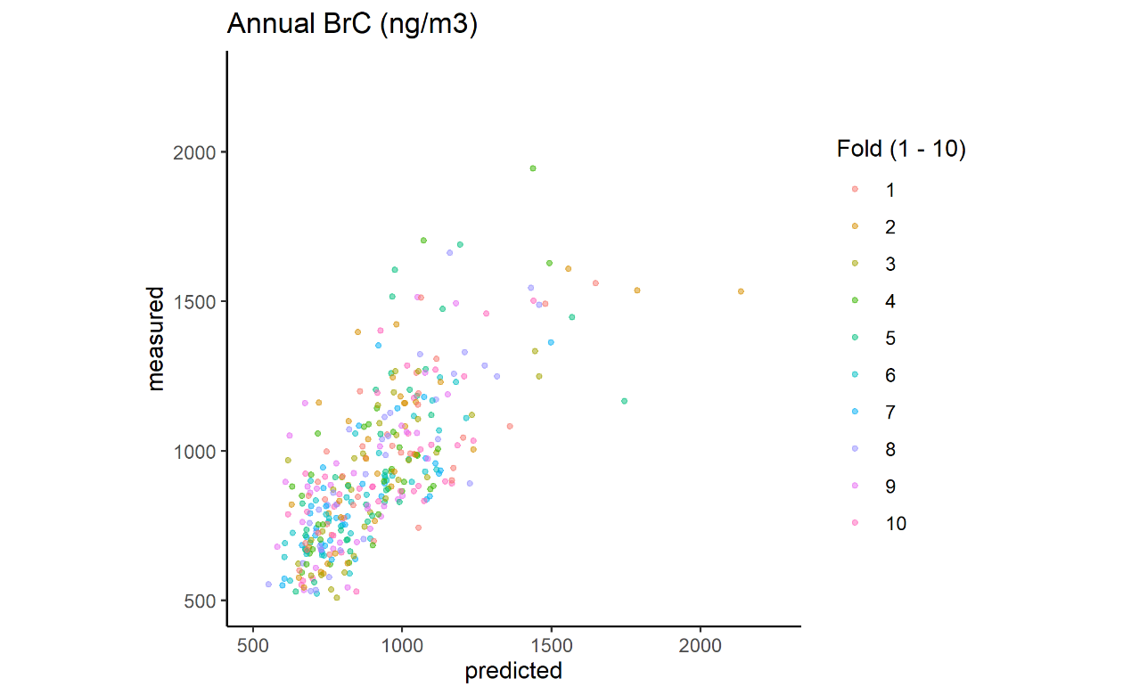Figure A4.3 Measured and predicted Brown Carbon concentrations based on 10-fold random sample cross validation.

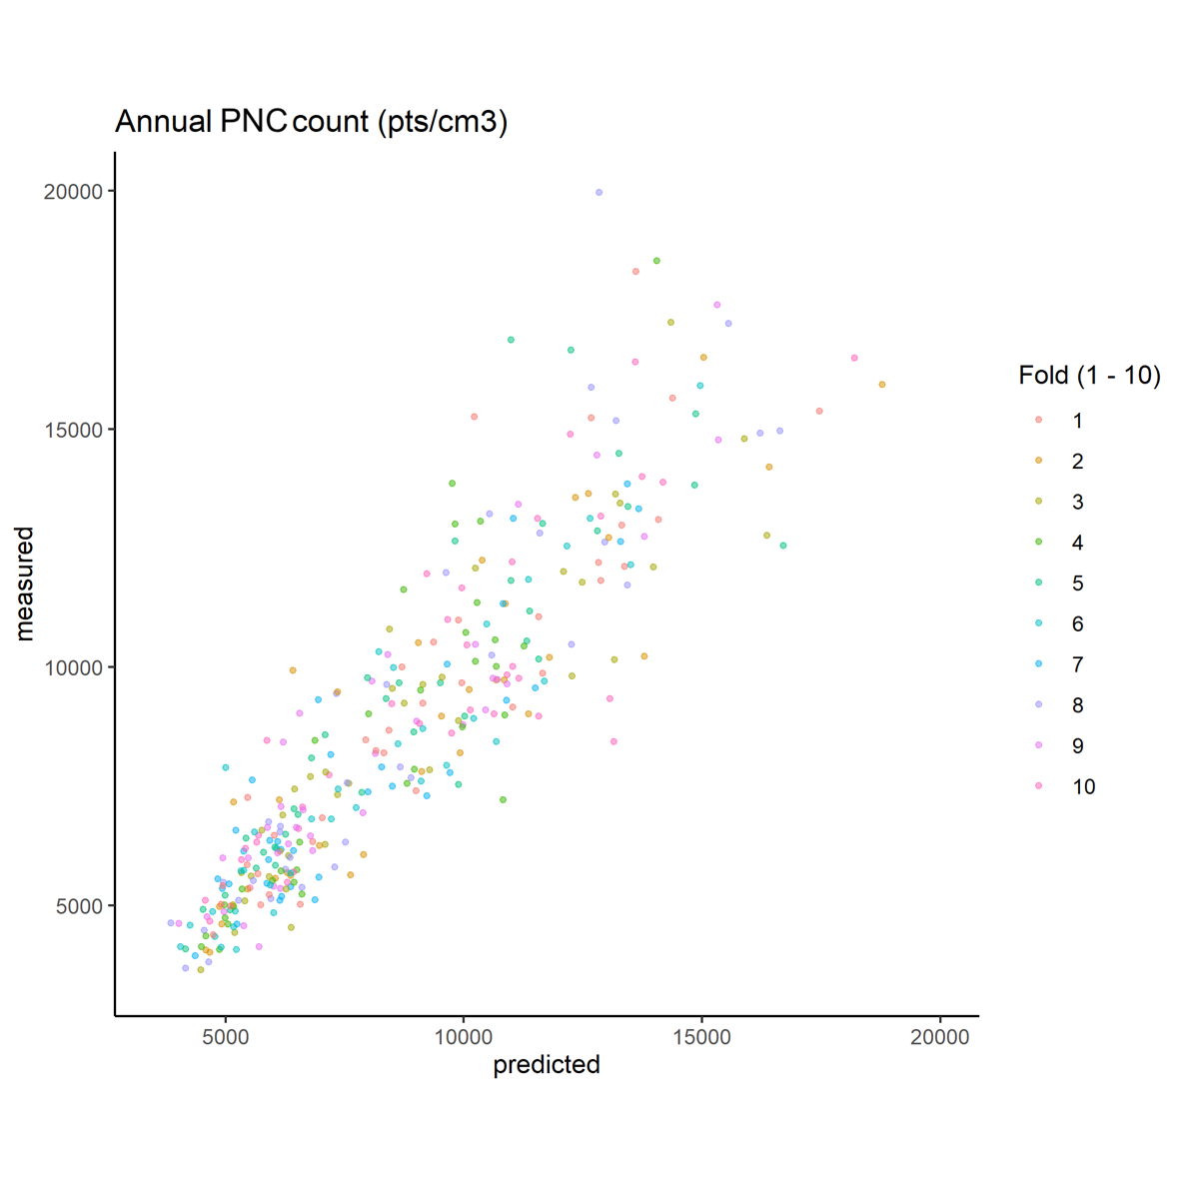
Figure A4.4 Measured and predicted PNC concentrations based on 10-fold random sample cross validation.

Appendix 5. Spatiotemporal Models for monthly exposure of PM_{2.5}, BC, BrC, and PNC.

Table A5.1. Monthly PM_{2.5} (μg/m³)
Predictors | Coefficients |  | 95% confidence interval | P-value
(Intercept) |  | 3.1191 | 2.2168 – 4.0215 | <0.001
Distance to Sainte-Foy railyard (m) |  | -0.0000 | -0.0001 – 0.0001 | 0.99
Distance to Quai 106 port (m) |  | -0.0001 | -0.0001 – 0.0000 | 0.08
Smooth term  Distance to nearest highway (m) |  |  |  | <0.001
Distance to nearest rail line (m) |  |  |  | 0.04
Month of the year |  |  |  | <0.001
Season 1 (longitude x latitude) |  |  |  | <0.001
Season 2 (longitude x latitude) |  |  |  | <0.001
Season 3 (longitude x latitude) |  |  |  | <0.001
Season 4 (longitude x latitude) |  |  |  | <0.001
Outdoor temp (K) |  |  |  | <0.001
Outdoor wind speed (Km/h) |  |  |  | <0.001
Atmospheric pressure (kPa) |  |  |  | <0.001
Outdoor RH (%) |  |  |  | <0.001
No. of observations |  | 3538
R²  10-fold CV R²  10-fold CV RMSE |  | 0.63  0.49  5.61
** 10-fold CV: 10-fold cross-validation with 10% random sites; RMSE: Root mean squared error.

Table A5.2. Monthly BC (ng/m³)
Predictors | Coefficients | 95% confidence interval | P-value
(Intercept) | 7.6861 | 6.9959 – 8.3763 | <0.001
Distance to Quai 106 port (m) | -0.0001 | -0.0001 – -0.0000 | 0.02
Distance to Sainte-Foy railyard (m) | -0.0000 | -0.0001 – 0.0000 | 0.75
Total length of highway within 150m buffer (m) | 0.0030 | 0.0022 – 0.0038 | <0.001
Total length of bus routes within 50m buffer (m) | 0.0035 | 0.0020 – 0.0051 | <0.001
Smooth terms  Mean avgas aircraft altitude within 1000m buffer (m) |  |  | <0.001
Distance to nearest restaurant (m) |  |  | 0.04
Restaurant count within 300m buffer (n) |  |  | <0.001
Outdoor temp (K) |  |  | <0.001
Outdoor RH (%) |  |  | 0.01
Outdoor wind speed (Km/h) |  |  | 0.12
Atmospheric pressure (kPa) |  |  | <0.001
Season 1 (longitude x latitude) |  |  | <0.001
Season 2 (longitude x latitude) |  |  | 0.11
Season 3 (longitude x latitude) |  |  | <0.001
Season 4 (longitude x latitude) |  |  | <0.001
Month of the year |  |  | <0.001
No. of observations | 3549
R² | 0.31
10-fold CV R²  10-fold CV RMSE | 0.27  450.10
** 10-fold CV: 10-fold cross-validation with 10% random sites; RMSE: Root mean squared error.

Table A5.3: Monthly BrC (ng/m³)
Predictors | Coefficients | 95% confidence interval | P-value
(Intercept) | 6.8533 | 6.7610 – 6.9456 | <0.001
Meters to nearest rail line (m) | -0.0000 | -0.0001 – -0.0000 | 0.03
Mean elevation within 50m buffer (m) | -0.0008 | -0.0016 – -0.0001 | 0.03
Meters to nearest NPRI site (m) | 0.0000 | -0.0000 – 0.0000 | 0.56
Total length of bus routes within 50m buffer (m) | 0.0034 | 0.0015 – 0.0053 | <0.001
Smooth term  Distance to Sainte-Foy railyard (m) |  |  | 0.77
Distance to nearest highway (m) |  |  | <0.001
Restaurant count within 300m (n) |  |  | <0.001
Total length of highway within 150m buffer (m) |  |  | <0.001
Outdoor temp (K) |  |  | <0.001
Outdoor wind speed (Km/h) |  |  | <0.001
Atmospheric pressure (kPa) |  |  | <0.001
Season 1 (longitude x latitude) |  |  | <0.001
Season 2 (longitude x latitude) |  |  | <0.001
Season 3 (longitude x latitude) |  |  | 0.05
Season 4 (longitude x latitude) |  |  | <0.001
Month of the year |  |  | <0.001
No. of observations | 3550
R²  10-fold CV R²  10-fold CV RMSE | 0.39  0.29  462.77
** 10-fold CV: 10-fold cross-validation with 10% random sites; RMSE: Root mean squared error.

Table A5.4. Monthly PNC (pts/cm³)
Predictors | Coefficients | 95% confidence interval | P-value
(Intercept) | 8.8890 | 7.7199 – 10.0580 | <0.001
Distance to Sainte-Foy railyard (m) | 0.0000 | -0.0001 – 0.0001 | 0.73
Mean elevation within 50m buffer (m) | -0.0004 | -0.0013 – 0.0006 | 0.44
Smooth term  Mean monthly urban greenness within 50m buffer (NDVI) |  |  | <0.001
Distance to the nearest highway (m) |  |  | <0.001
Restaurant count within 300m buffer (n) |  |  | <0.001
Meters to nearest NPRI site (all sites) (m) |  |  | 0.71
Month of the year |  |  | <0.001
Season 1 (longitude x latitude) |  |  | <0.001
Season 2 (longitude x latitude) |  |  | <0.001
Season 3 (longitude x latitude) |  |  | <0.001
Season 4 (longitude x latitude) |  |  | <0.001
Outdoor temp (K) |  |  | <0.001
Outdoor wind speed (Km/h) |  |  | <0.001
Atmospheric pressure (kPa) |  |  | <0.001
Outdoor RH (%) |  |  | 0.31
No. of observations | 3542
R²  10-fold CV R²  10-fold CV RMSE | 0.62  0.49  5245.79
** 10-fold CV: 10-fold cross-validation with 10% random sites; RMSE: Root mean squared error.

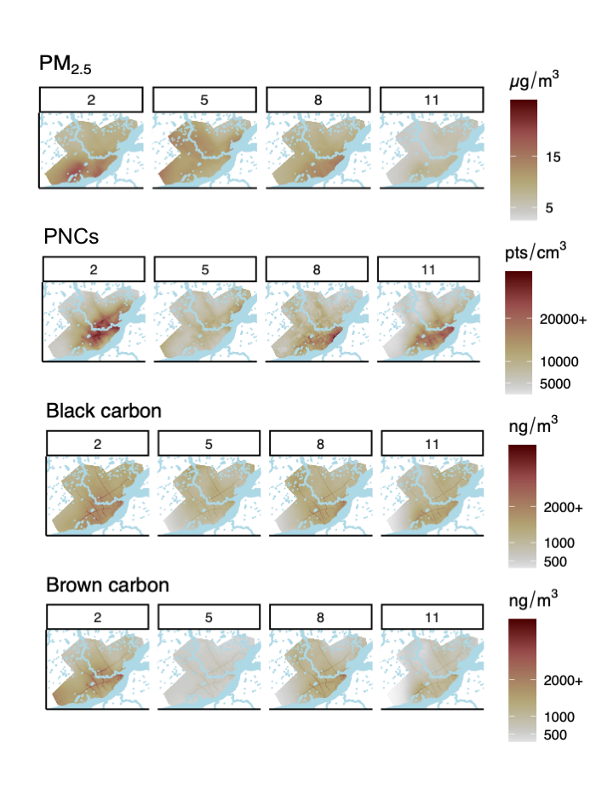
Figure A5.1 Monthly predictions of median ambient concentrations of PM_{2.5} (corrected), PNC, BC, and BrC for the months February (2), May (5), August (8), and November (11) in the Quebec City area. Light blue areas on the map indicate water.

Appendix 6: Sensitivity analysis of the impact of the choice of ‘n visits’ on spatial model stability

Methods

This intensive MM campaign involved 40 weekly ‘visits/laps’ of the MM network. In order to capture a spatial pattern representative of a year, these visits were collected over a 10-month period, covering each season. While this high frequency of visits was chosen to support the development of monthly spatiotemporal modelling, it also provided a rich dataset to explore the question of the number of visits required to produce a robust model of the spatial pattern of air pollution. This study provides the opportunity to explore this question for PM_{2.5}, PNC and particle size mode, BC and BrC in a seasonal city 372 km² in size.

The ’n visits’ sensitivity analysis was informed by similar work on MM-based UFP models conducted in Montreal, Canada (Hatzopoulou et al., 2017). For this sensitivity analysis, the spatial models for PM_{2.5}, PNC, particle size mode, BC, and BrC were rerun reflecting MM designs consisting of 8, 12, 16, 20, 24, 28, 32, and 36 visits (weekly MM sessions). For each ‘n visits’ category (n=8), 15 random samples from the total 40 visits were taken, totalling 120 models. Each random sample was constrained to an even number of visits across the four 10-week periods, roughly reflecting the four seasons covered in the study. This was done to preserve the annual representativeness of the median concentration value calculated for each 500m road segment (n=355).

For each pollutant, boxplots presenting the adjusted R² variability of the 15 models for each ‘n visits’ group were plotted to investigate the relationship between the number of visits on model prediction. As well, the model beta coefficients with confidence intervals were compared graphically to assess the trend of increasing beta coefficient stability with increasing ‘n visits’. Finally, for each ‘n visits’ group, the prediction surfaces for two of the 15 models were presented. These two models represented the highest and lowest adjusted R² values, providing an approximation of the range of prediction surfaces within each ‘n visits’ group. A similarity of these two surfaces was interpreted as the n visits group being capable of producing stable models. Pairs of these maps for all eight ‘n visits’ groups were presented together to facilitate the assessment of the number of visits required to achieve a robust model.

Results

In the sensitivity analysis, we investigated the number of visits (‘n visits’) required to attain robust spatial models for annual concentrations of PM_{2.5}, PNC, particle size mode, BC, and BrC. Within the context of this study, the term ‘n visits’ reflects the number of MM sessions or sampling weeks. Beta coefficients were re-estimated based on scenarios of MM designs reflecting 8, 12, 16, 20, 24, 28, 32, and 36 visits. The range of adjusted R² values by ‘n visits’ for each pollutant are presented in Figure A.6.1. For each of the five pollutants, the interquartile ranges of the adjusted R² values overlap with that of the 36-visit category at 16 visits or less, suggesting minimal improvement in model prediction with additional visits beyond 16. For PM_{2.5}, adjusted R² values were similar across each ‘n visits’ category, suggesting 8 visits to be sufficient. However, the subsequent examination of the impact of increasing visits on the stability of beta coefficients (Figures A6.2-6) and prediction surfaces (Figures A6.7-11) suggest more visits are required to achieve robust models. For PM_{2.5}, 32 visits were required for all predictors to achieve beta coefficients that were consistent across the 15 models and similar to those of the main 40-visit model (Figure A6.2). This is reflected in the examination of the worst and best prediction surfaces of each ‘n visits’ category (Figure A6.7). Only at 32 visits do the best (highest Adj-R²) and worst (lowest Adj-R²) predictive surfaces resemble each other, indicating that model robustness has been achieved. This same approach suggests that, to achieve stable models, where no further visits can add benefit, 32 visits were required for BC, 28 for PNC and BrC, and 24 for particle size mode.

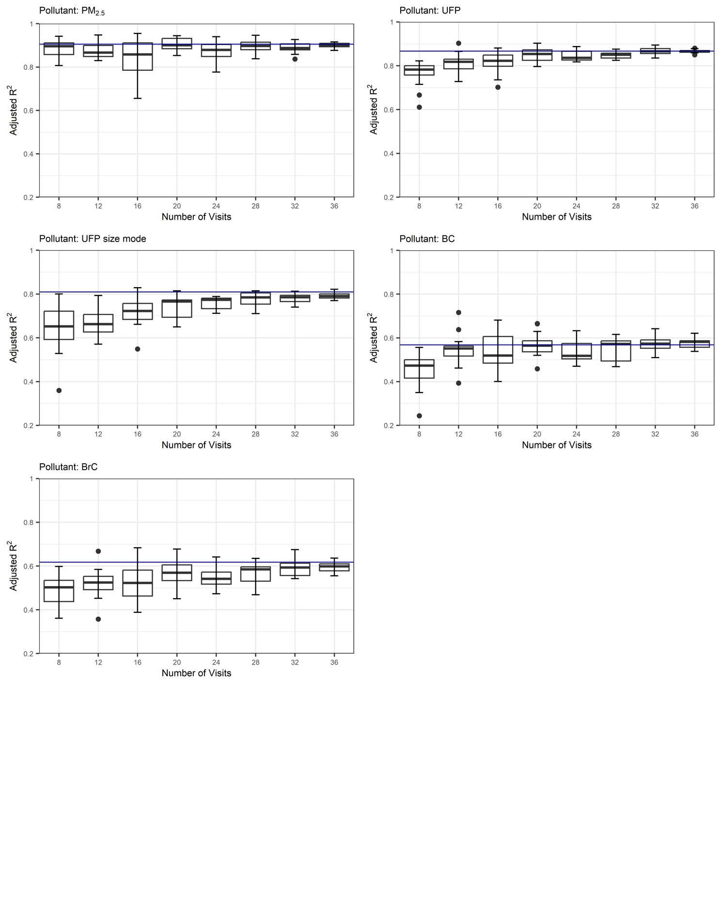

Figure A6.1. Ranges of adjusted R² values of 15 models for each category of ‘n visits’ for PM_{2.5}, PNC, particle size mode, BC, and BrC. Solid line represents adjusted R² of main model based on 40 visits.

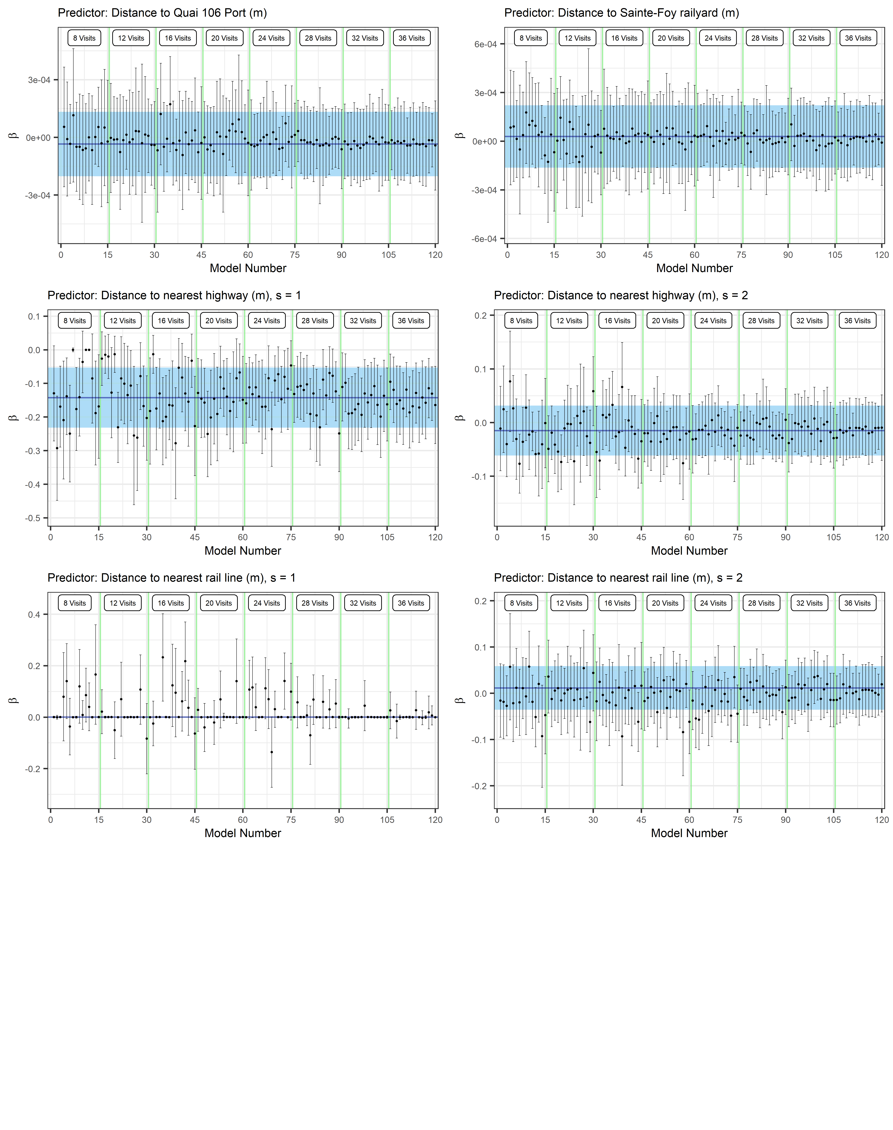

Figure A6.2. Stability of PM_{2.5} model beta coefficients (estimate and 95% CI) within and across ’n visits’ groups. The blue line and shaded area represents the beta coefficients and 95%CI for the main 40-visit model. Estimates of beta coefficients for splined predictors do not represent the true relationship in models but this presentation does serve to demonstrate beta coefficient stability with increasing visits.
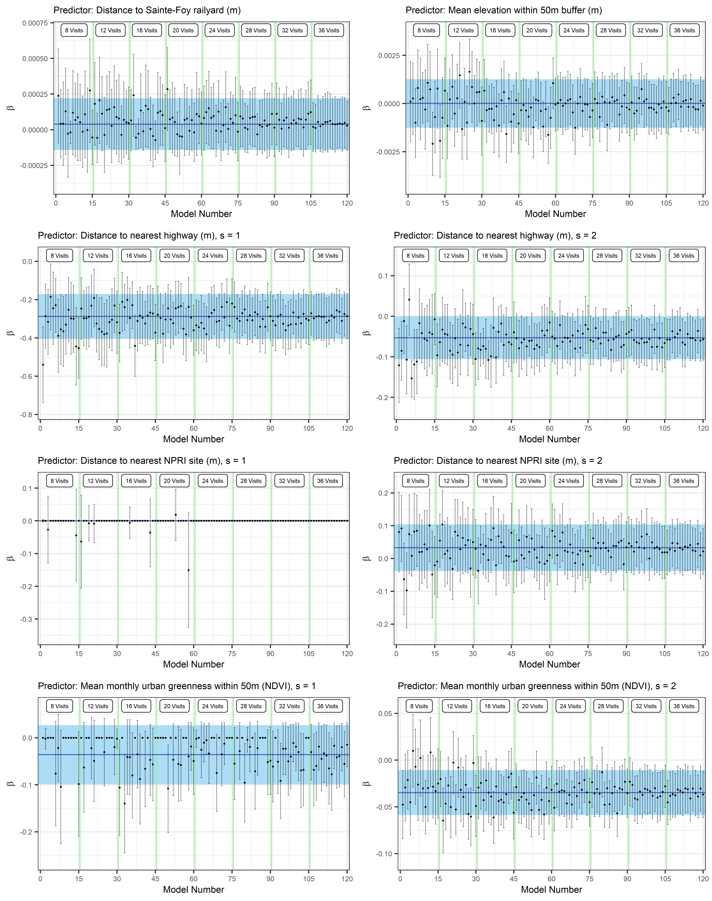

Figure A6.3. Stability of PNC model beta coefficients (estimate and 95% CI) within and across ’n visits’ groups. The blue line and shaded area represents the beta coefficients and 95%CI for the main 40-visit model. Estimates of beta coefficients for splined predictors do not represent the true relationship in models but this presentation does serve to demonstrate beta coefficient stability with increasing visits.

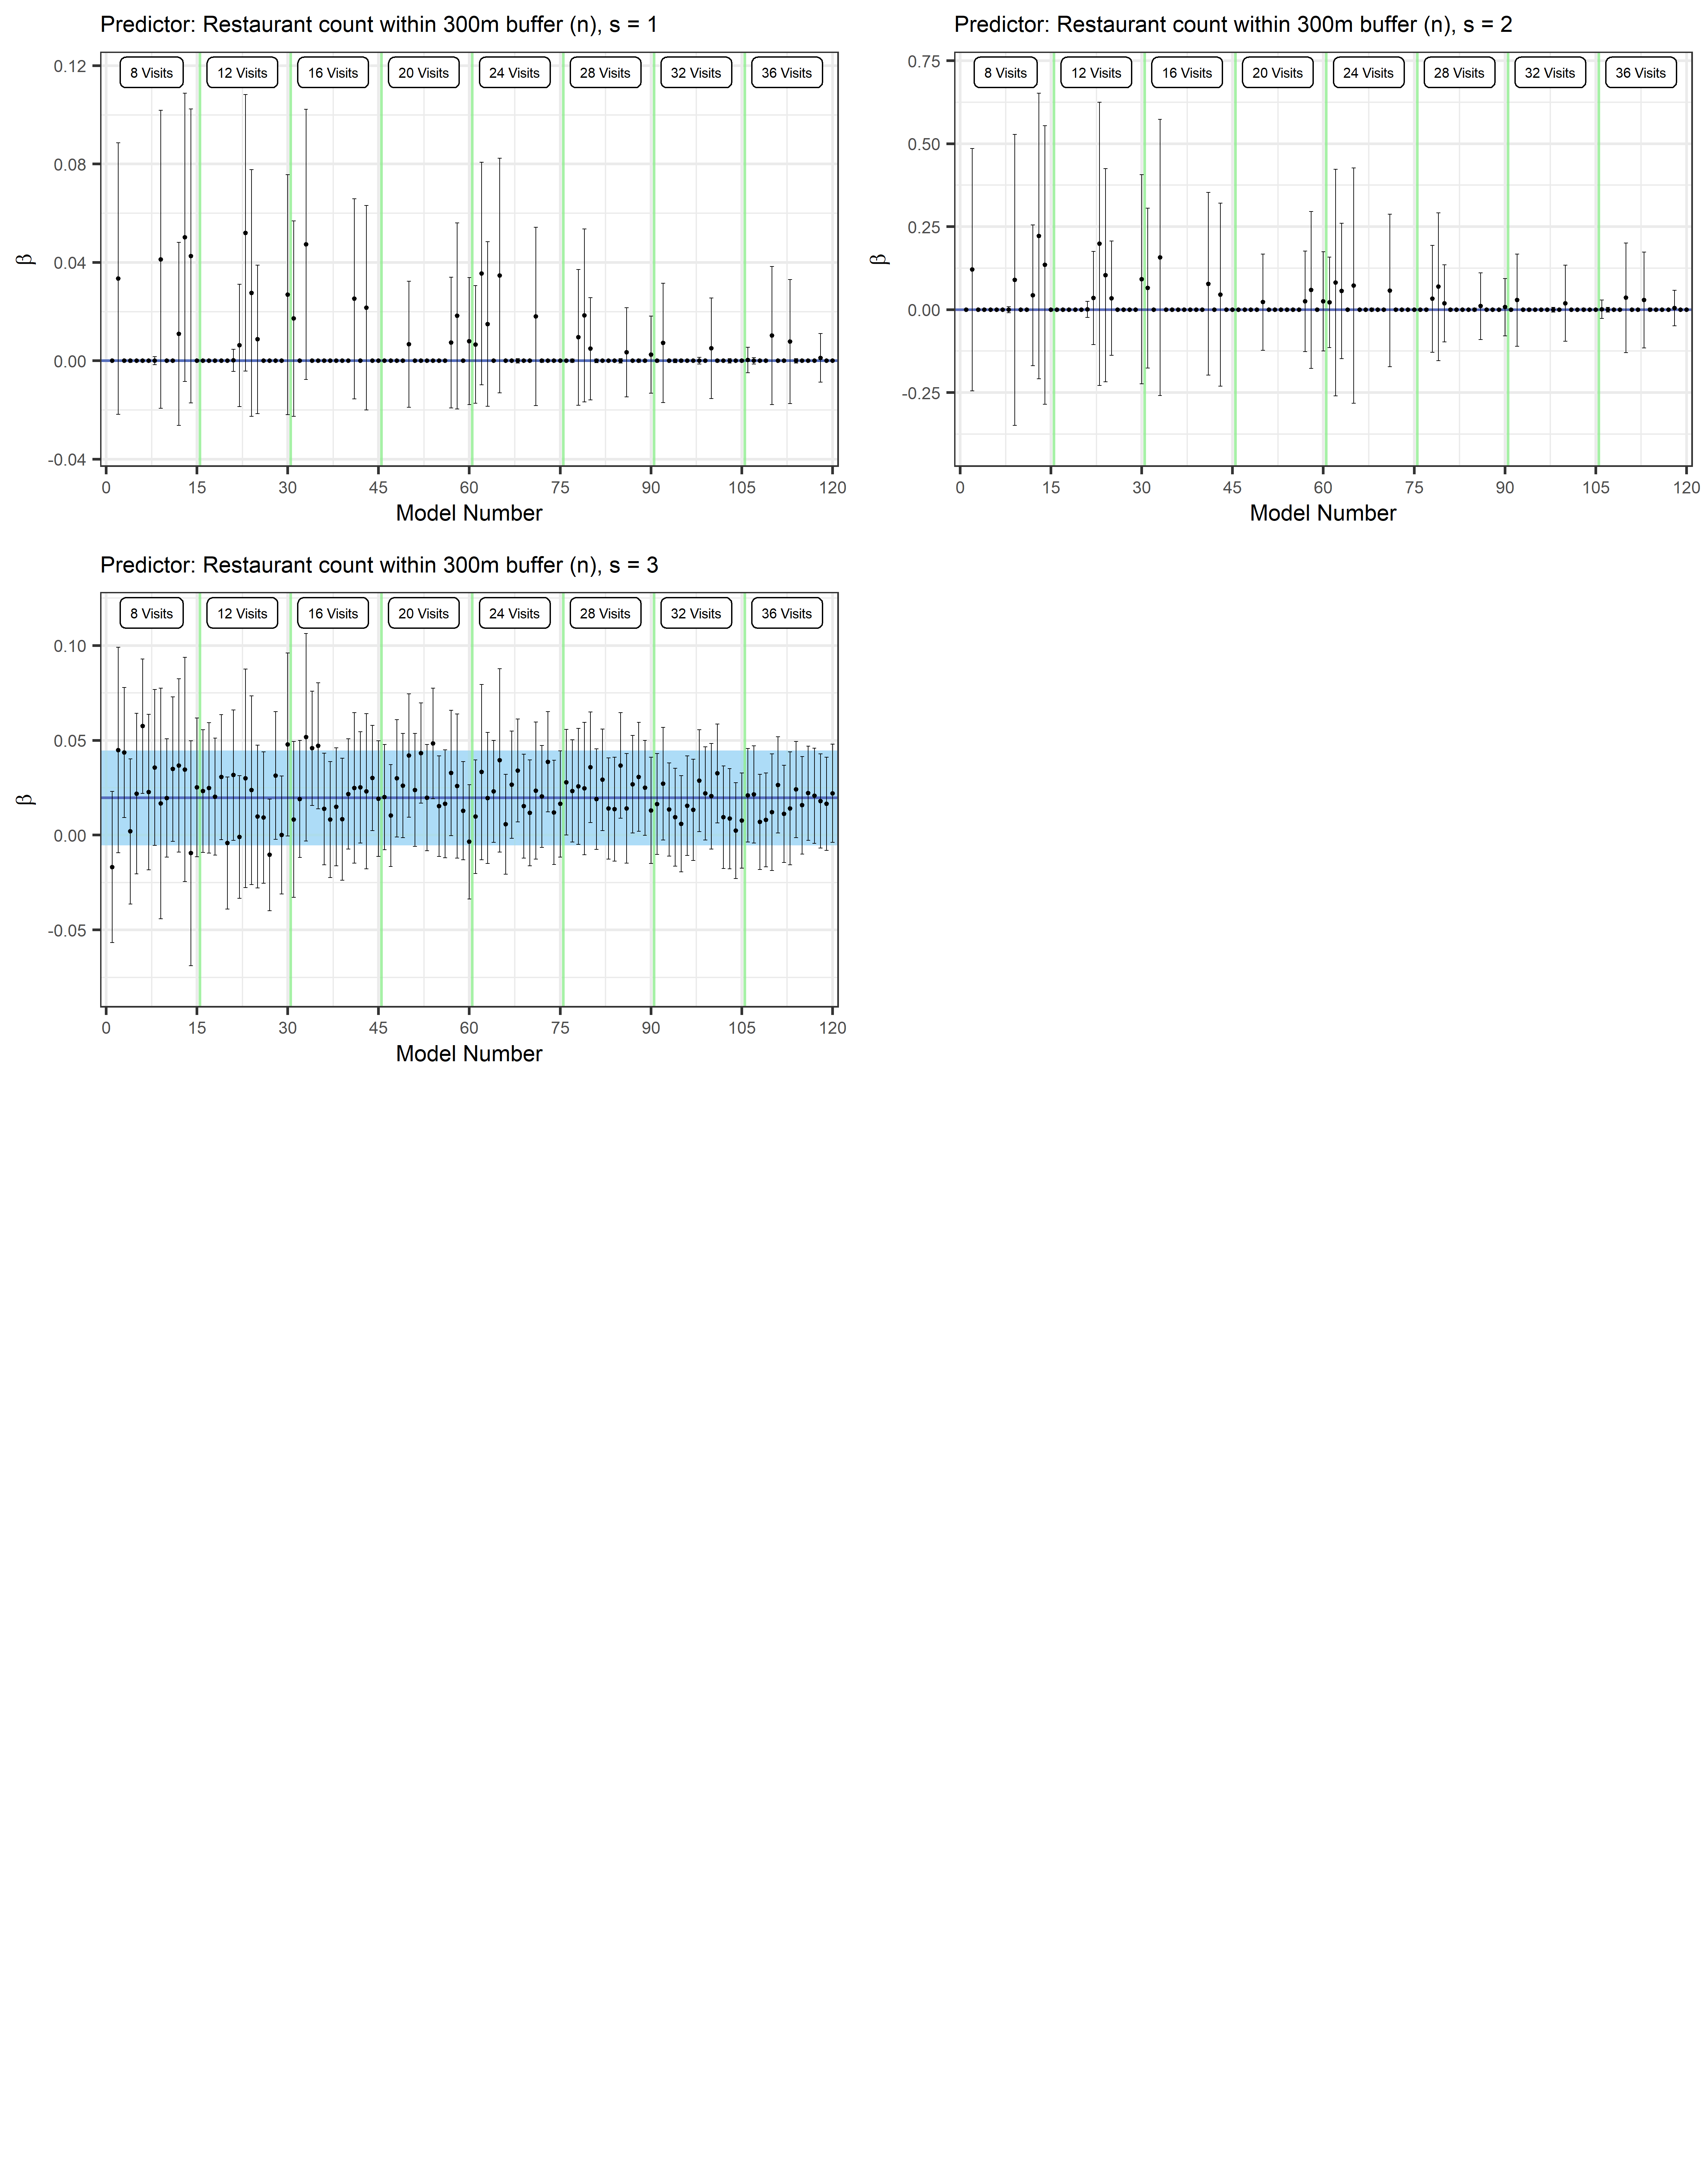

Figure A6.3 (continued). Stability of PNC model beta coefficients (estimate and 95% CI) within and across ’n visits’ groups. The blue line and shaded area represents the beta coefficients and 95%CI for the main 40-visit model. Estimates of beta coefficients for splined predictors do not represent the true relationship in models but this presentation does serve to demonstrate beta coefficient stability with increasing visits.

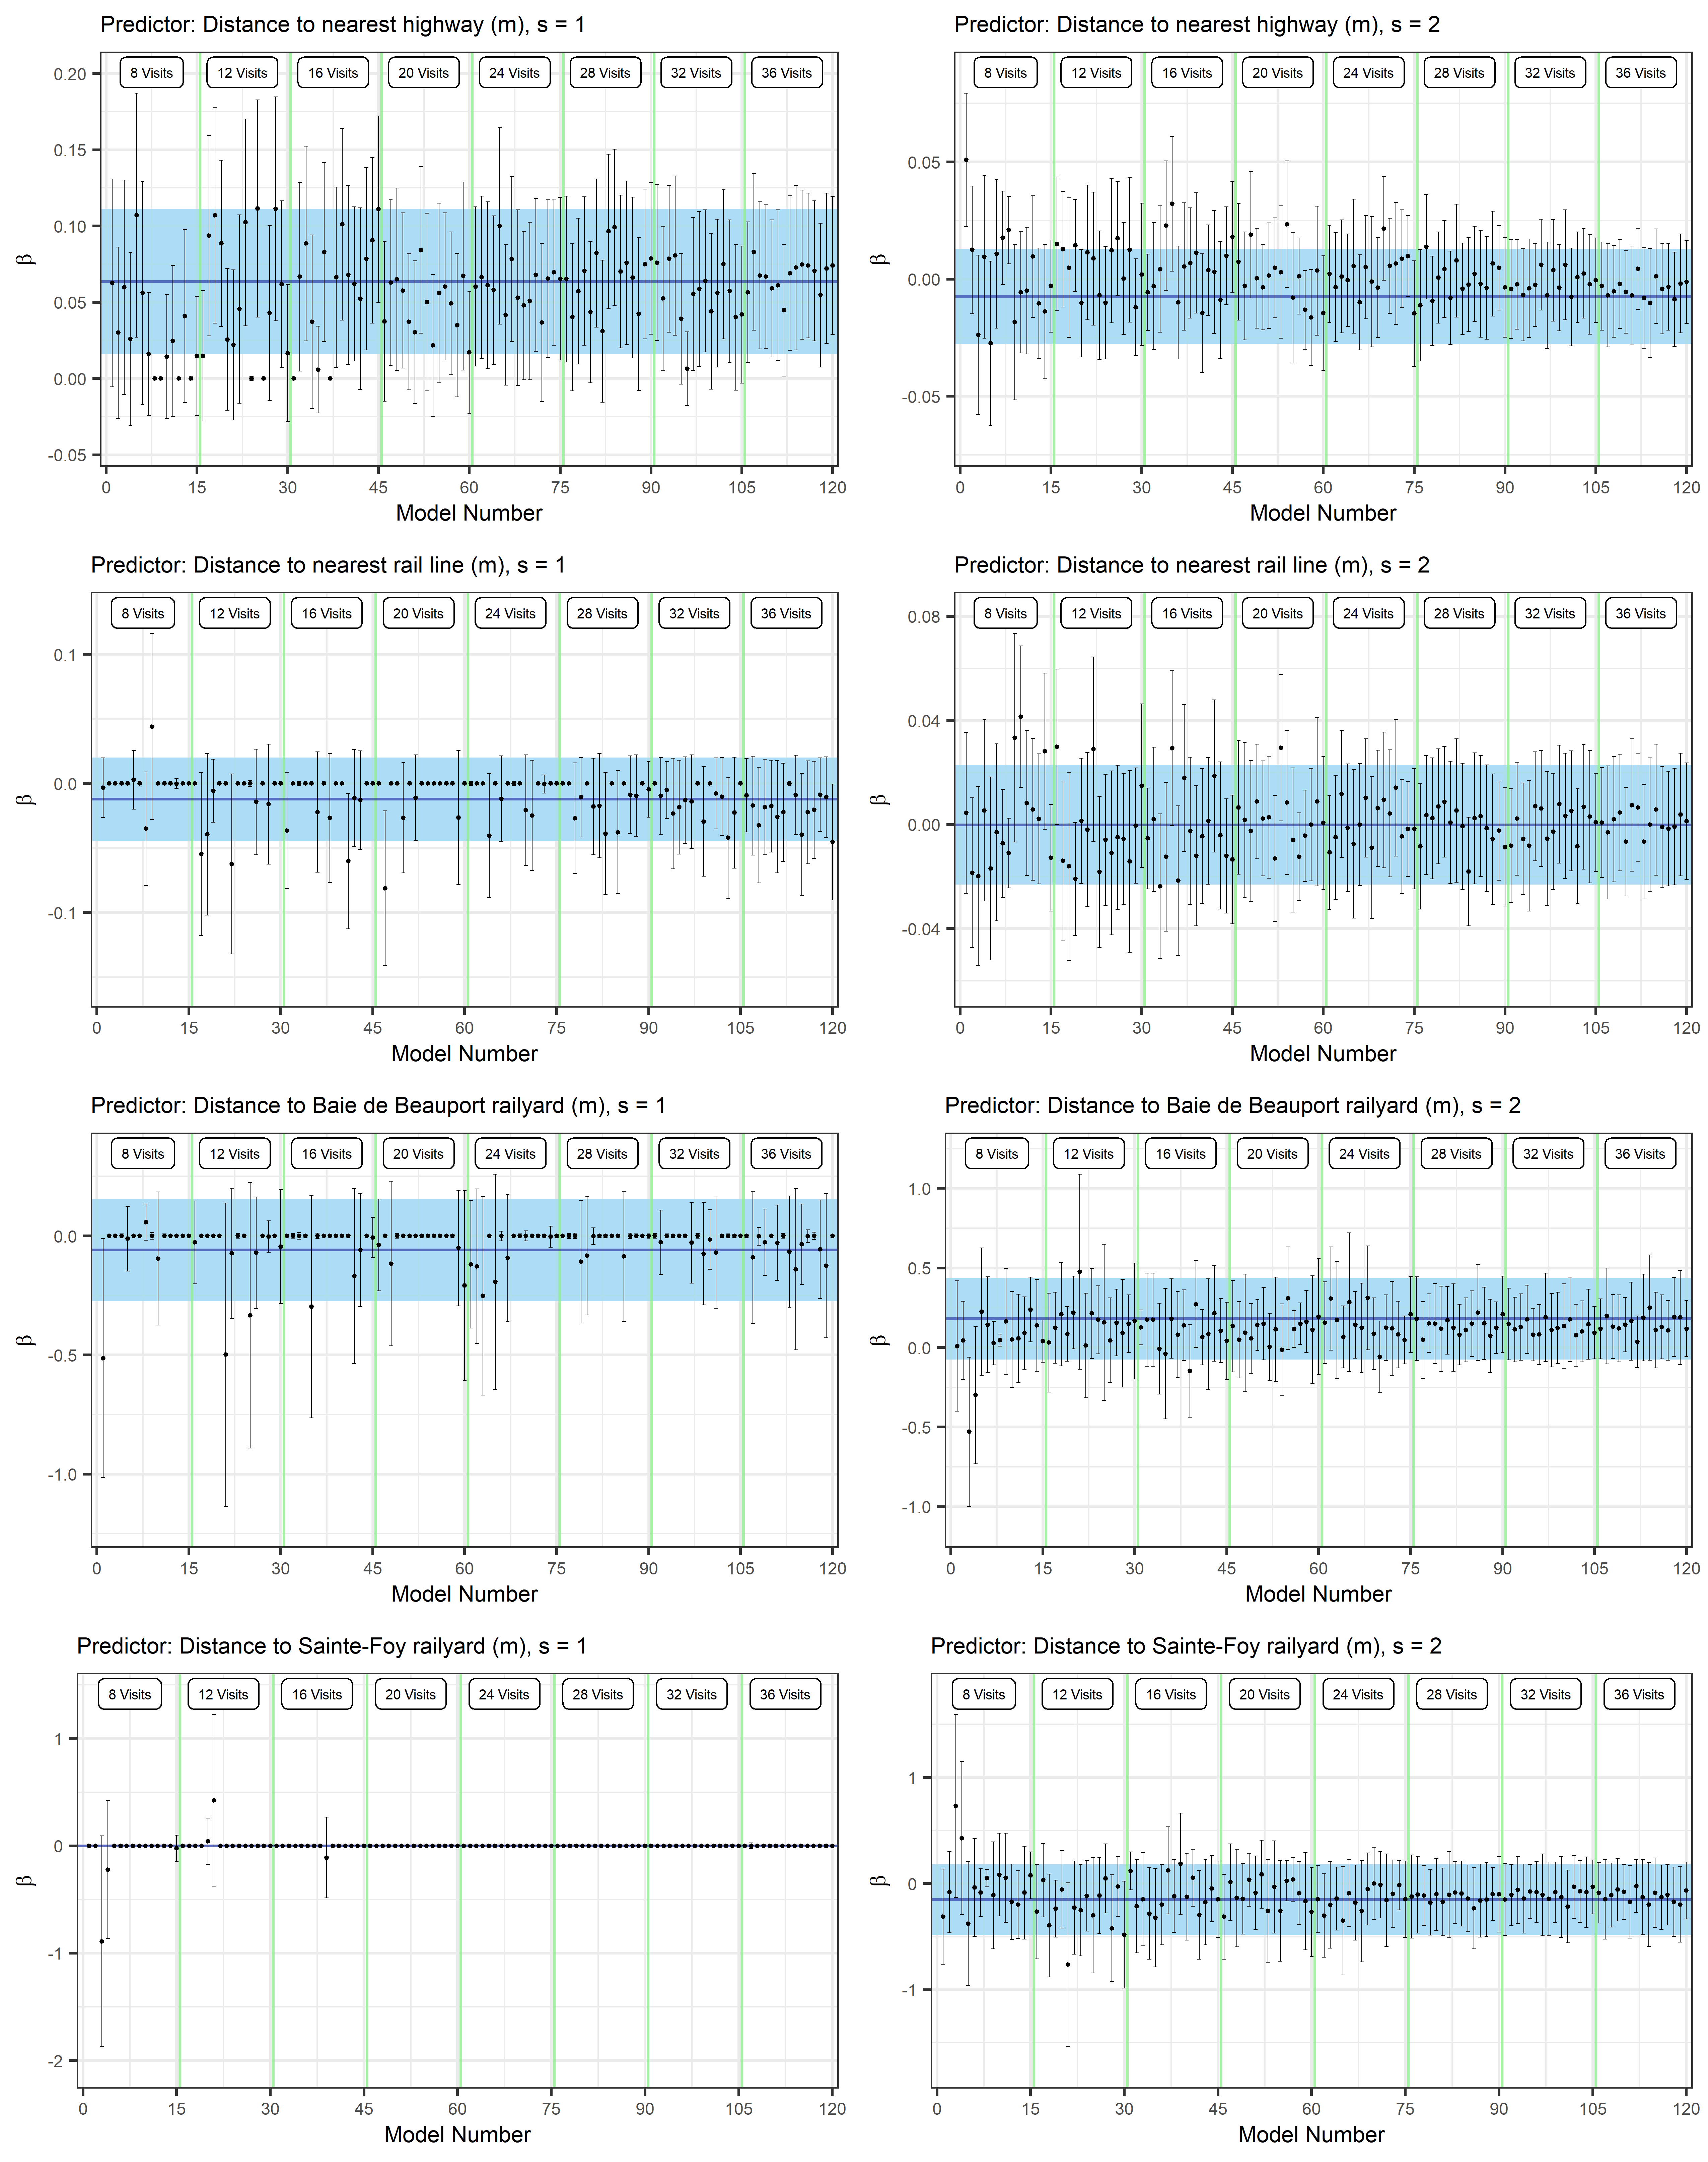

Figure A6.4. Stability of Particle size mode model beta coefficients (estimate and 95% CI) within and across ’n visits’ groups. The blue line and shaded area represents the beta coefficients and 95%CI for the main 40-visit model. Estimates of beta coefficients for splined predictors do not represent the true relationship in models but this presentation does serve to demonstrate beta coefficient stability with increasing visits.
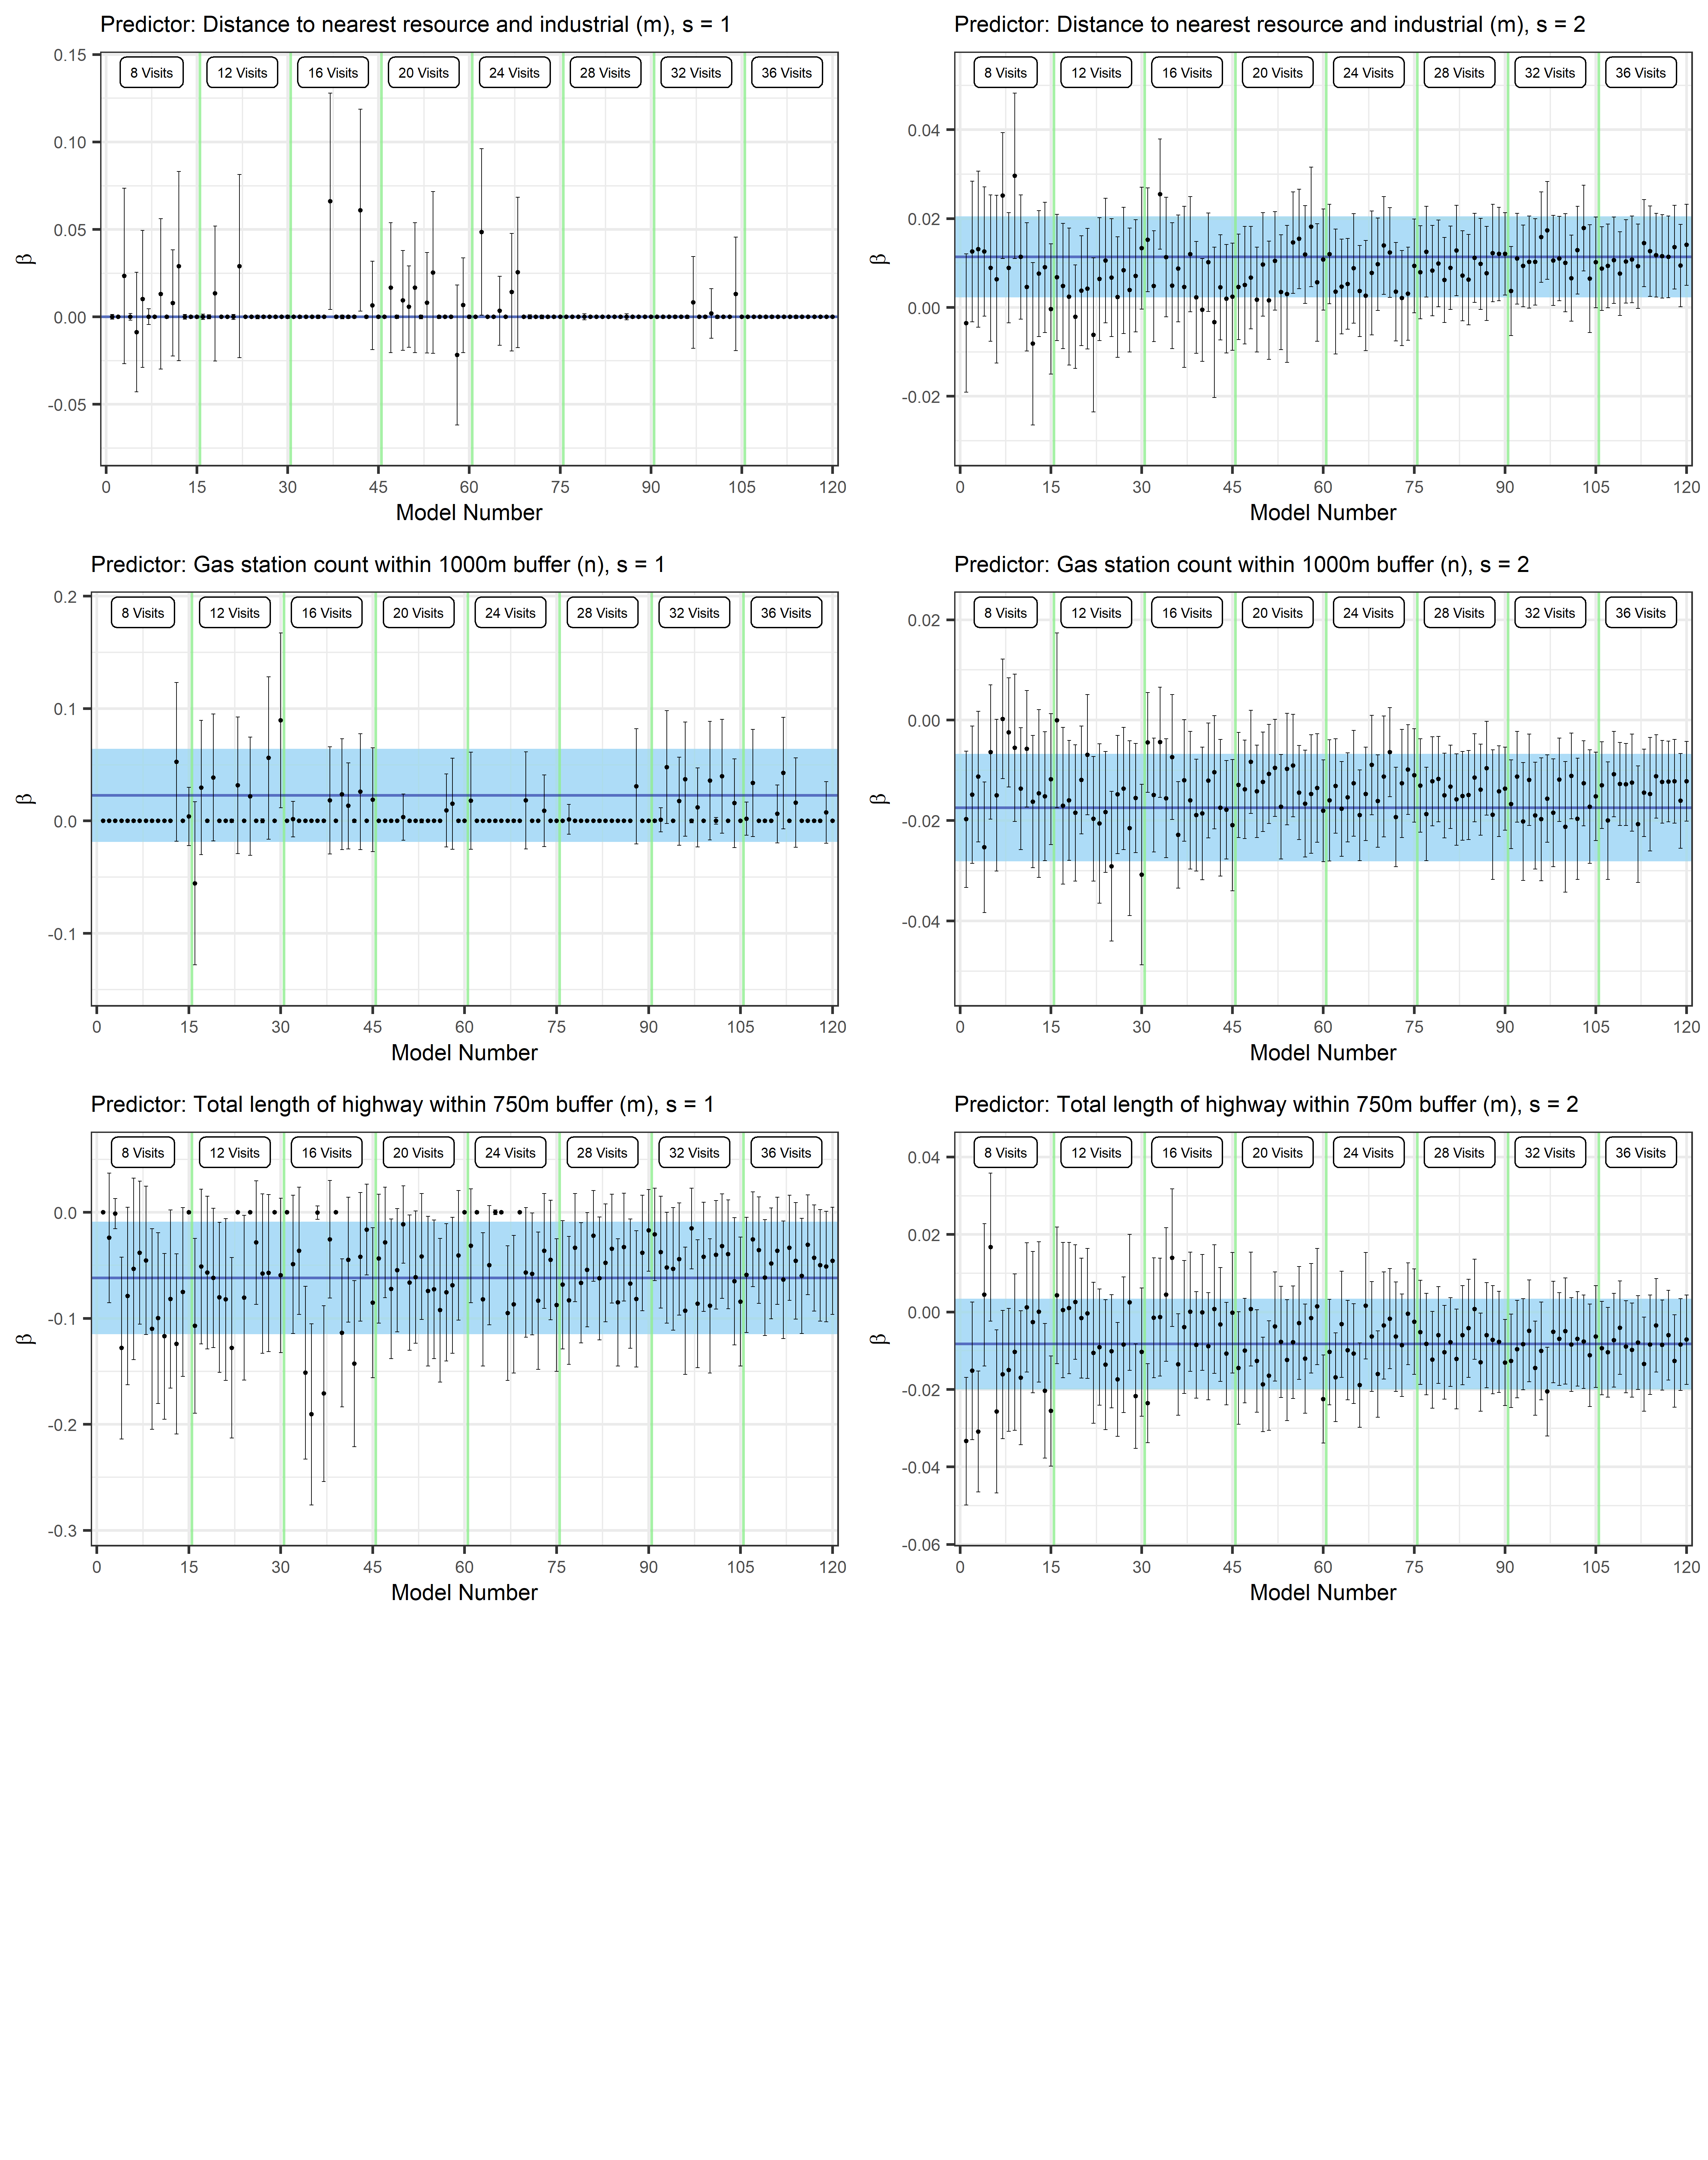

Figure A6.4 (continued). Stability of Particle size mode model beta coefficients (estimate and 95% CI) within and across ’n visits’ groups. The blue line and shaded area represents the beta coefficients and 95%CI for the main 40-visit model. Estimates of beta coefficients for splined predictors do not represent the true relationship in models but this presentation does serve to demonstrate beta coefficient stability with increasing visits.
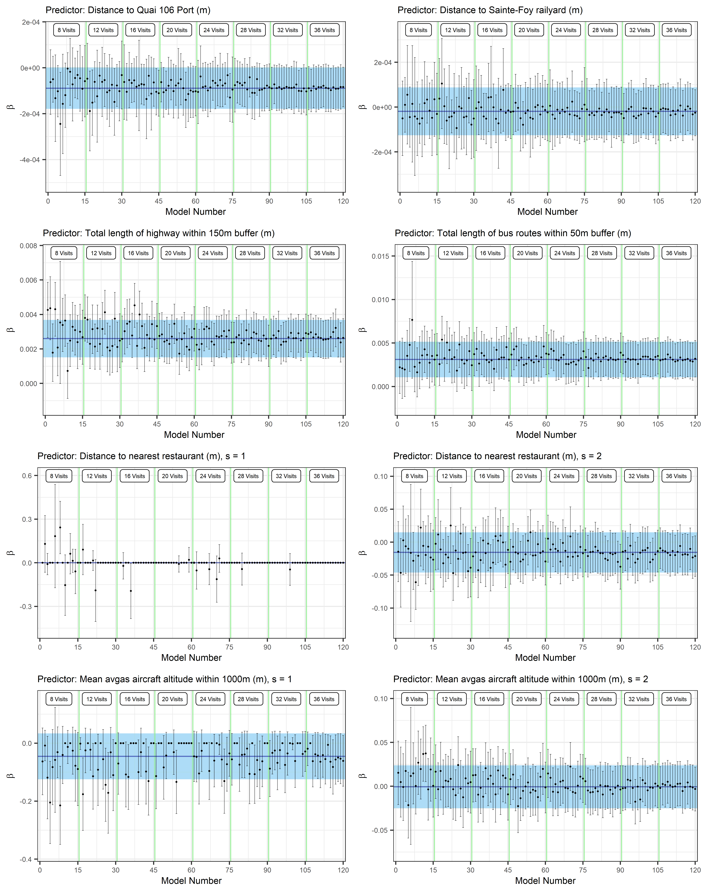

Figure A6.5. Stability of BC model beta coefficients (estimate and 95% CI) within and across ’n visits’ groups. The blue line and shaded area represents the beta coefficients and 95%CI for the main 40-visit model. Estimates of beta coefficients for splined predictors do not represent the true relationship in models but this presentation does serve to demonstrate beta coefficient stability with increasing visits.
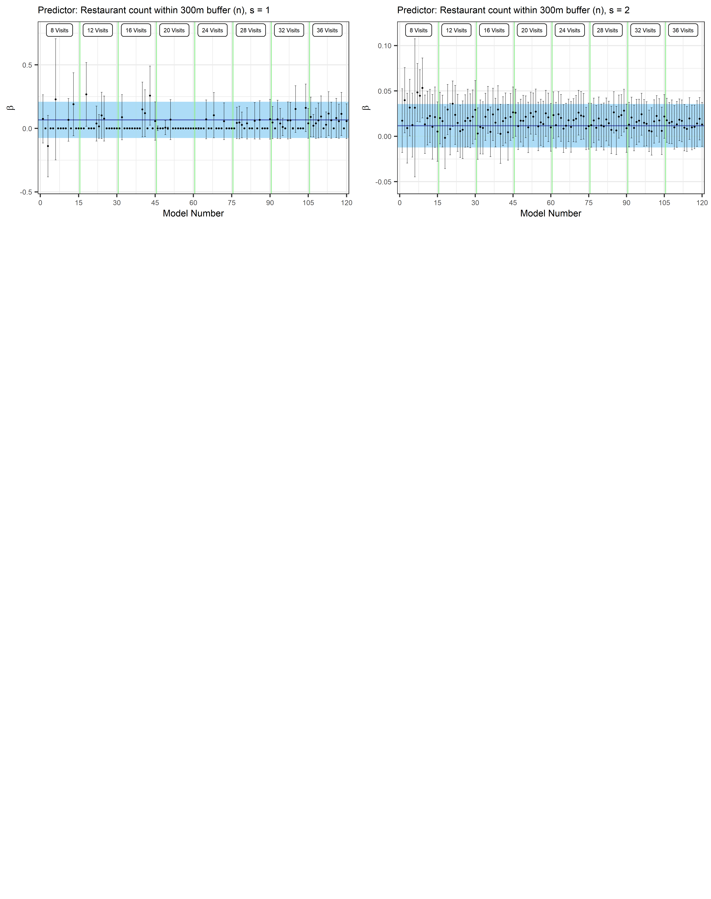

Figure A6.5 (continued). Stability of BC model beta coefficients (estimate and 95% CI) within and across ’n visits’ groups. The blue line and shaded area represents the beta coefficients and 95%CI for the main 40-visit model. Estimates of beta coefficients for splined predictors do not represent the true relationship in models but this presentation does serve to demonstrate beta coefficient stability with increasing visits.
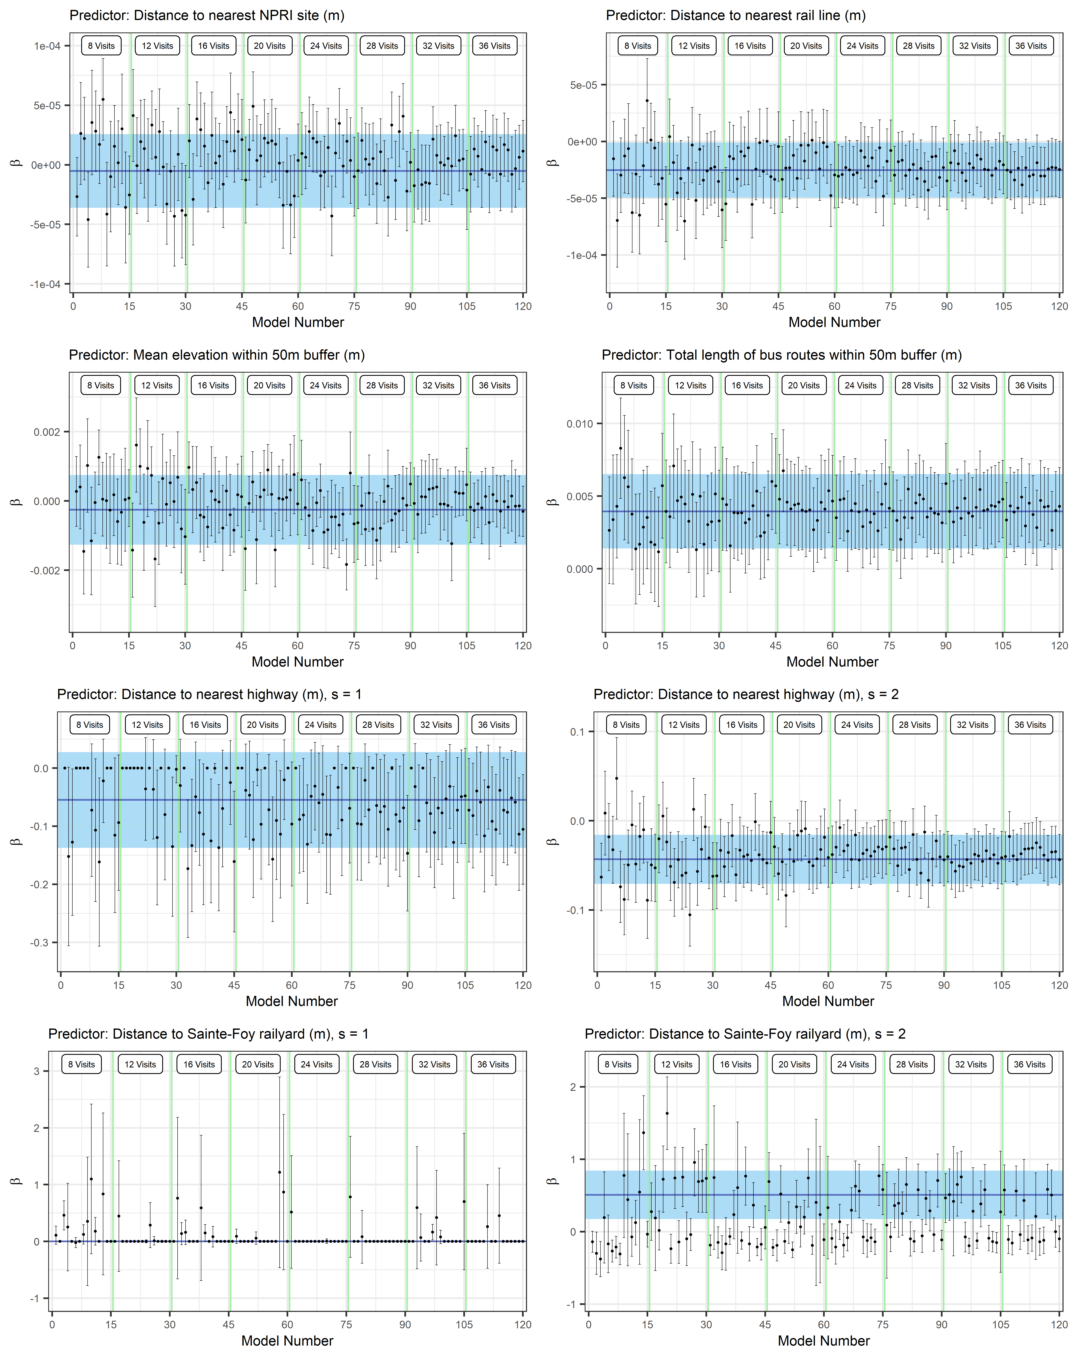

Figure A6.6. Stability of BrC model beta coefficients (estimate and 95% CI) within and across ’n visits’ groups. The blue line and shaded area represents the beta coefficients and 95%CI for the main 40-visit model. Estimates of beta coefficients for splined predictors do not represent the true relationship in models but this presentation does serve to demonstrate beta coefficient stability with increasing visits.
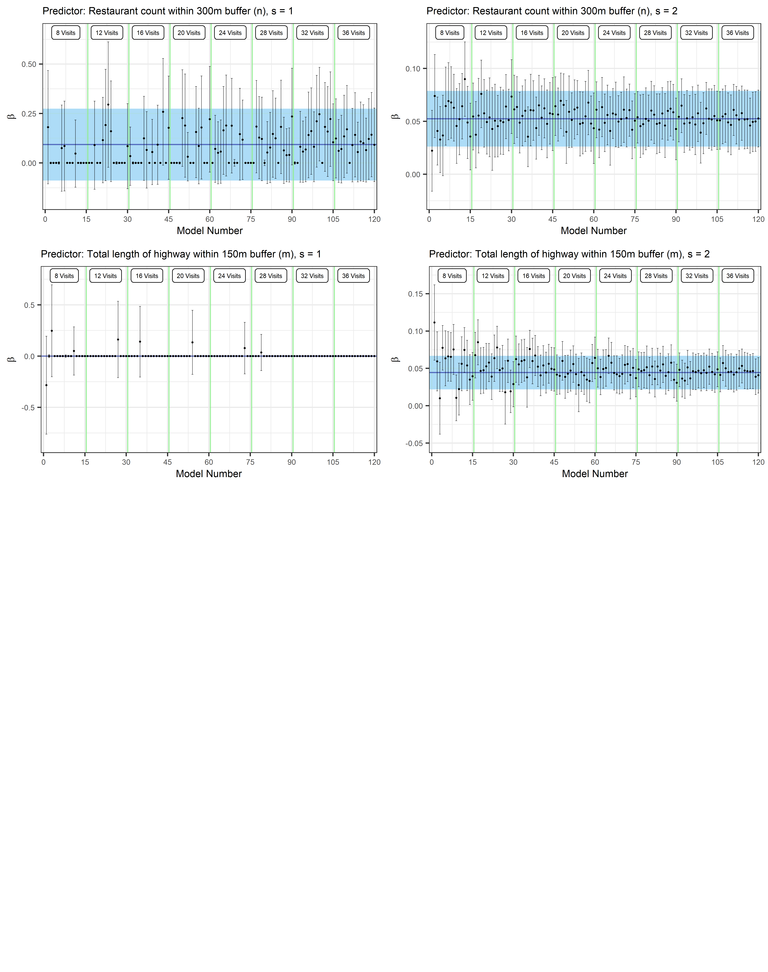

Figure A6.6 (continued). Stability of BrC model beta coefficients (estimate and 95% CI) within and across ’n visits’ groups. The blue line and shaded area represents the beta coefficients and 95%CI for the main 40-visit model. Estimates of beta coefficients for splined predictors do not represent the true relationship in models but this presentation does serve to demonstrate beta coefficient stability with increasing visits.

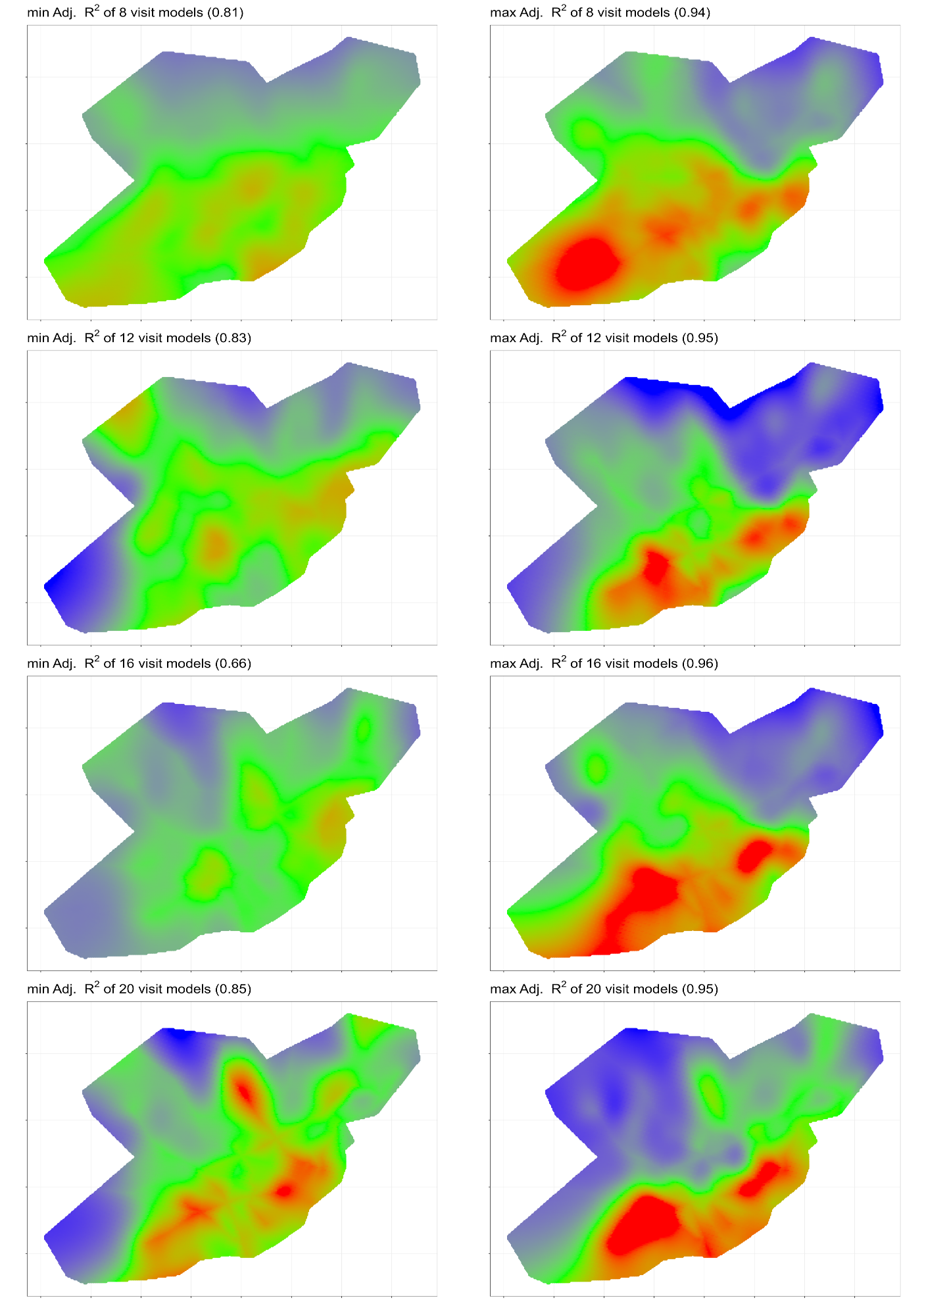

Figure A6.7. PM_{2.5} predictions for models with the min and max r² values of 15 models representing 8, 12, 16, 20, 24, 28, 32, and 36 visits (range 0(blue)-10(red) µg/m³).
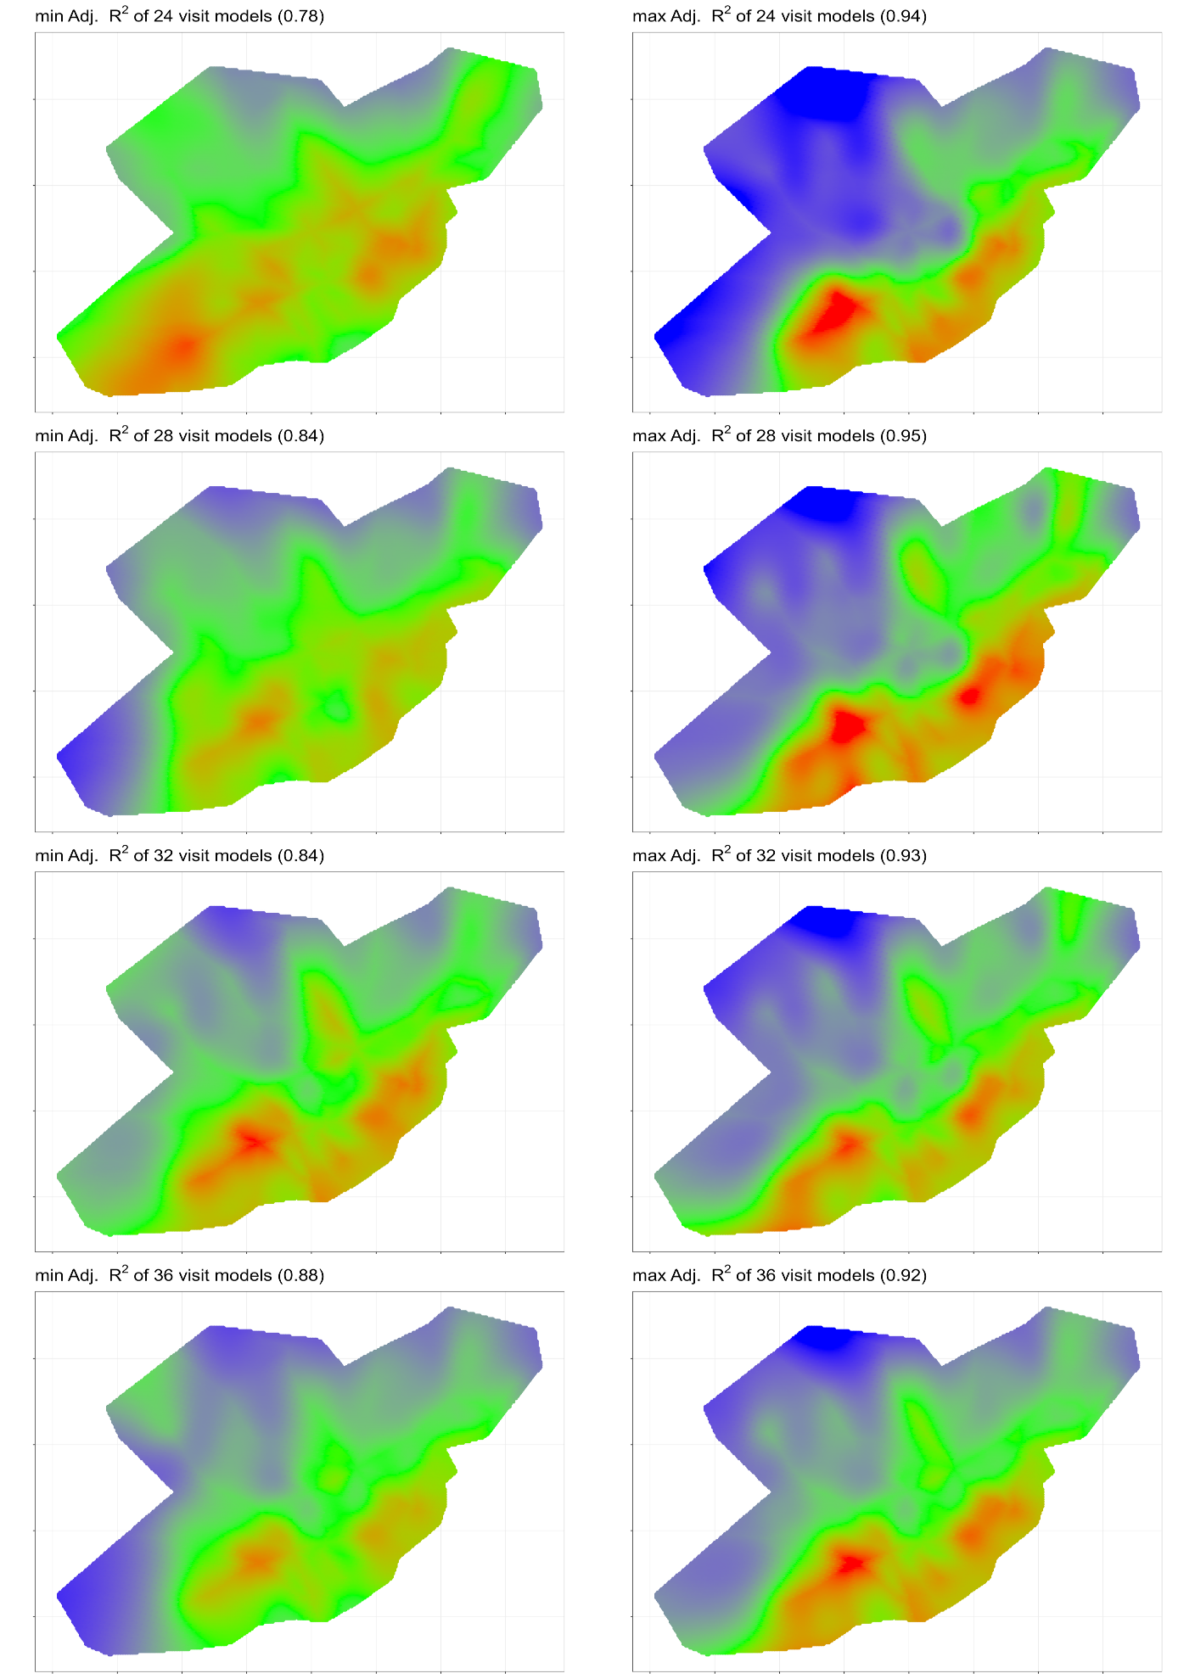

Figure A6.7 (continued). PM_{2.5} predictions for models with the min and max r² values of 15 models representing 8, 12, 16, 20, 24, 28, 32, and 36 visits (range 0(blue)-10(red) µg/m³).
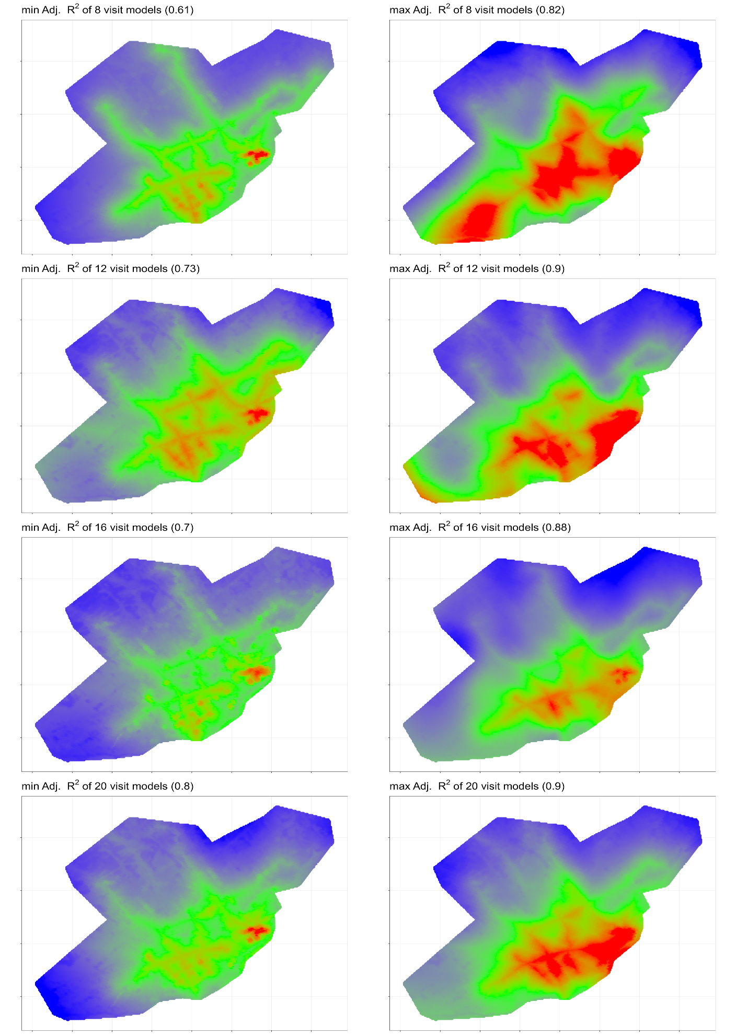

Figure A6.8. PNC predictions for models with the min and max r² values of 15 models representing 8, 12, 16, 20, 24, 28, 32, and 36 visits (range 3000(blue)-20000(red) pts/cm³).
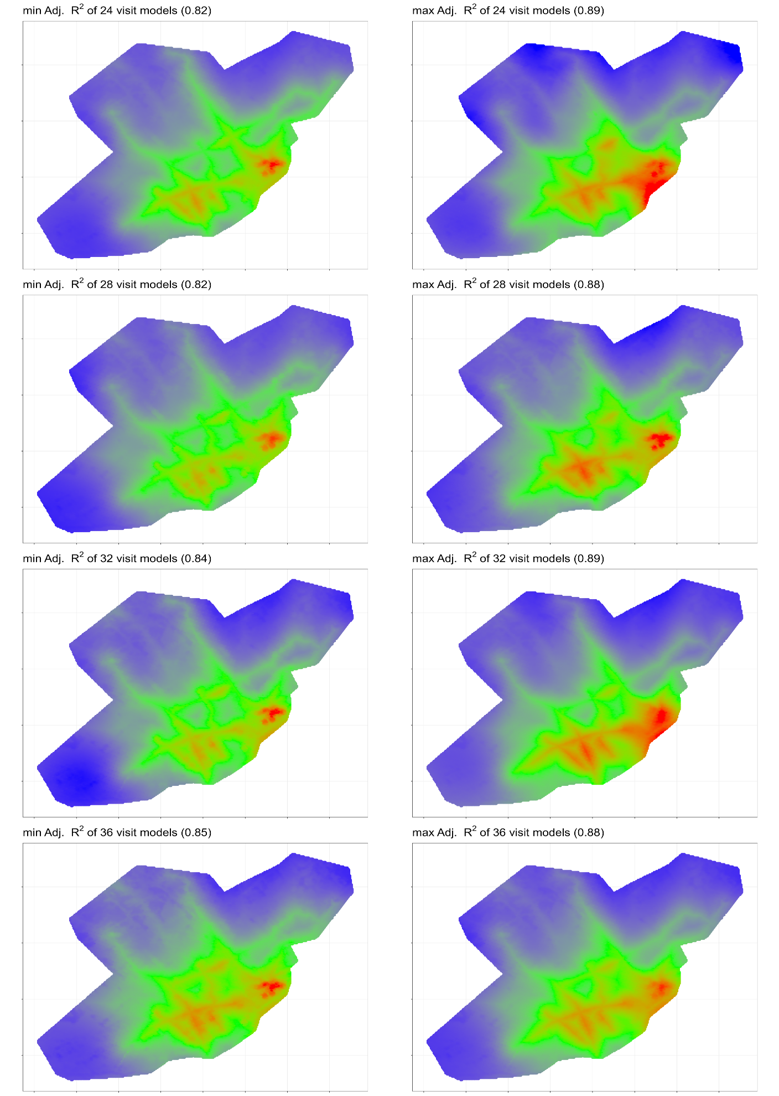

Figure A6.8 (continued). PNC predictions for models with the min and max r² values of 15 models representing 8, 12, 16, 20, 24, 28, 32, and 36 visits (range 3000(blue)-20000(red) pts/cm³).
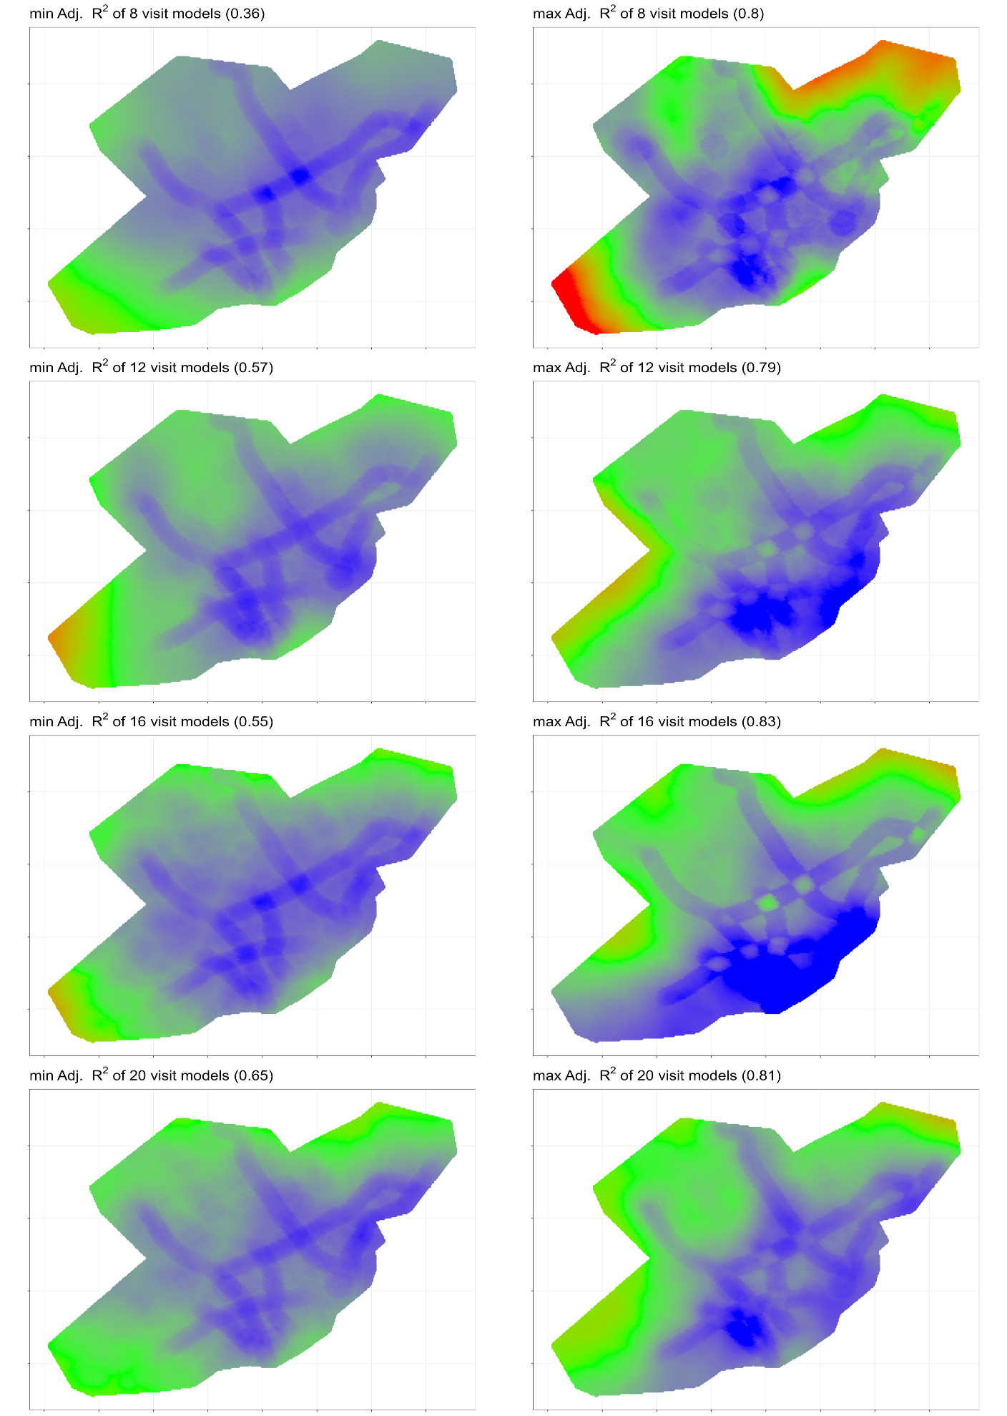

Figure A6.9. Particle size mode predictions for models with the min and max r² values of 15 models representing 8, 12, 16, 20, 24, 28, 32, and 36 visits (range 30(red)-65(blue) nm).
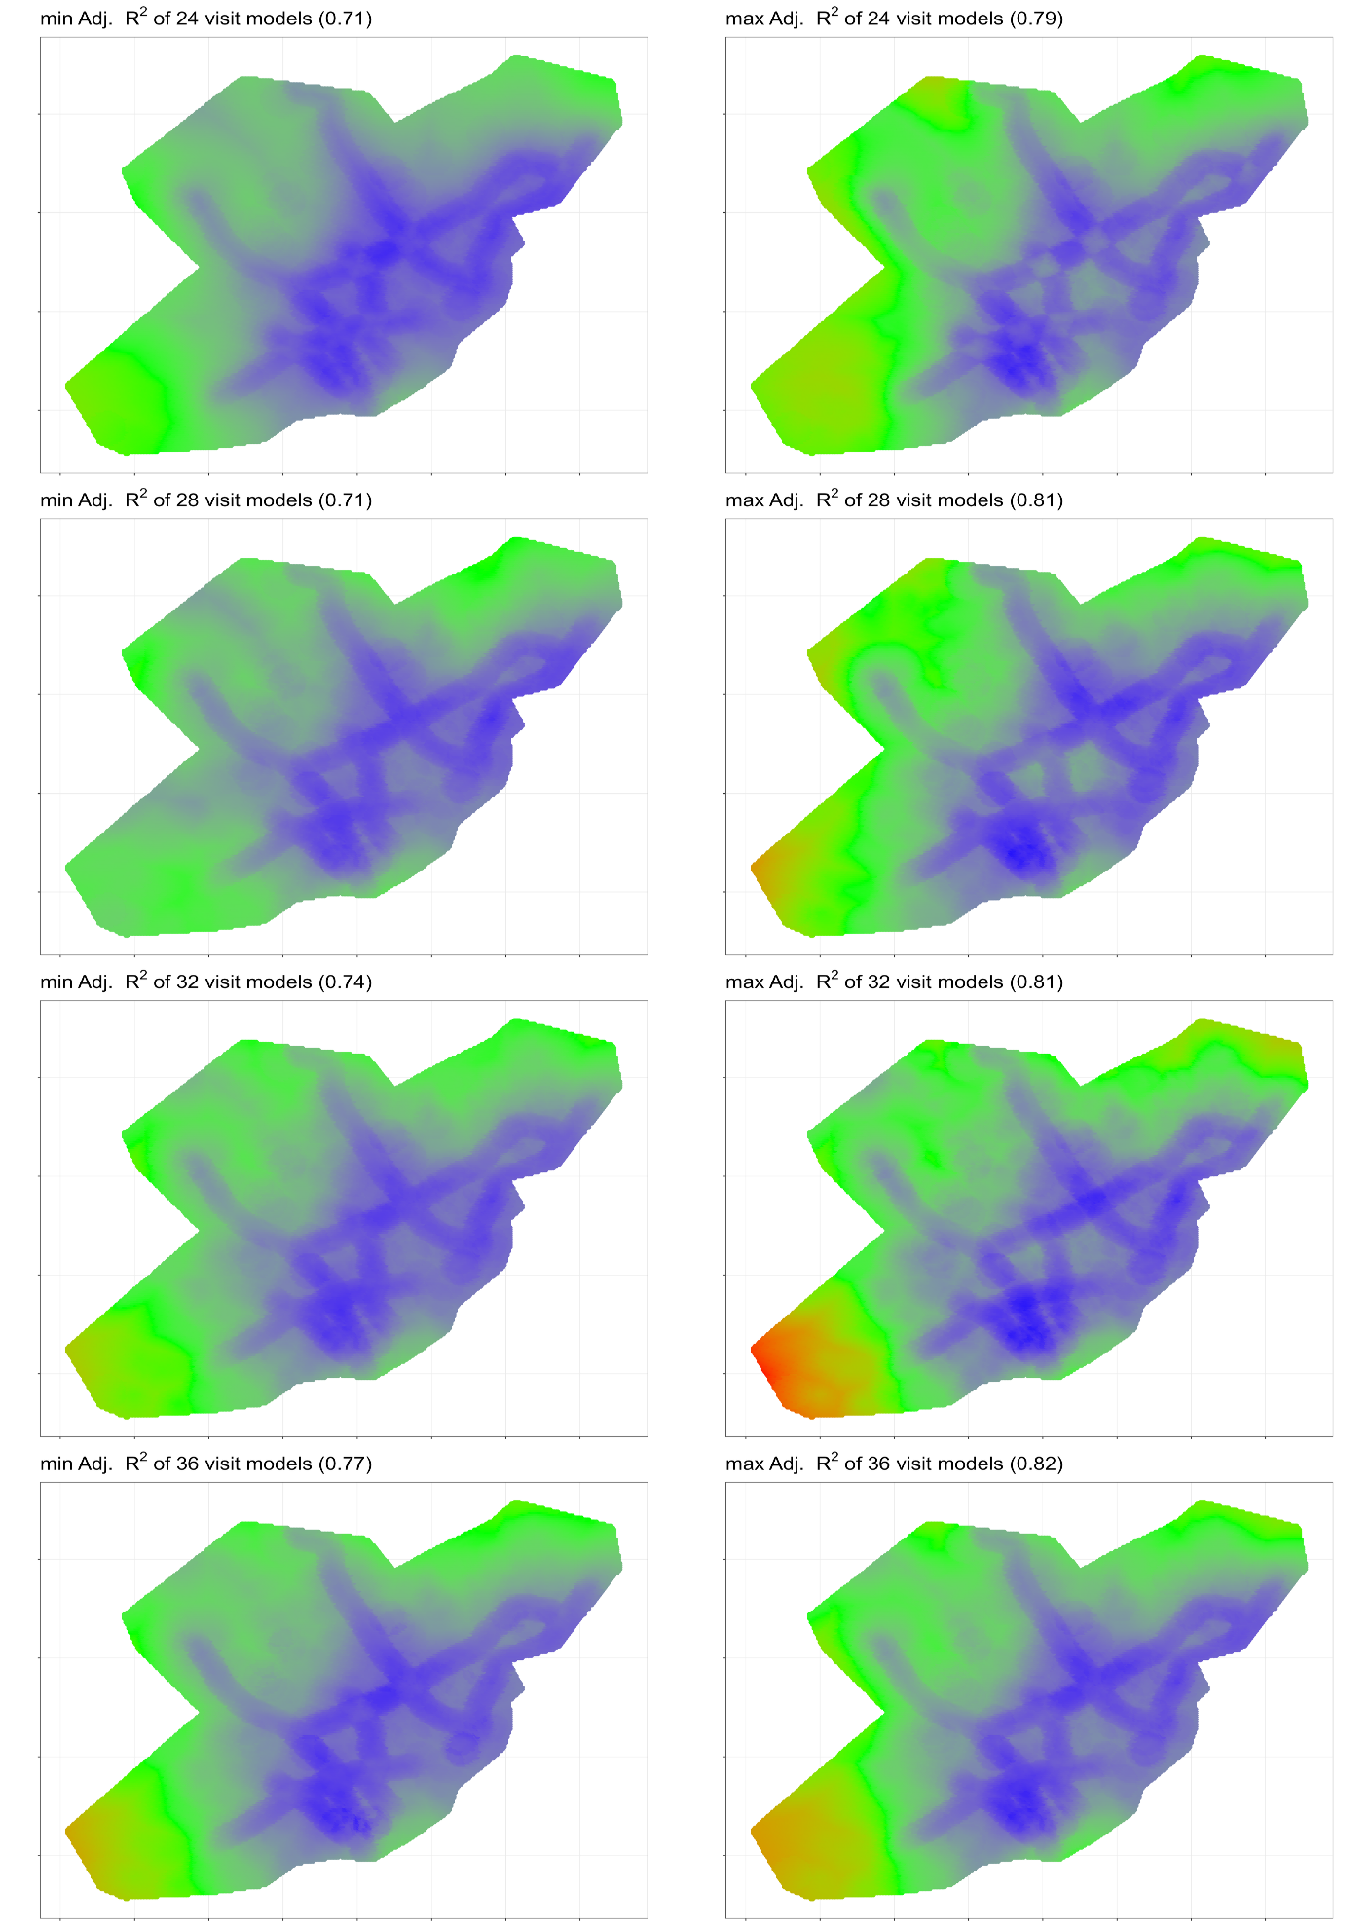

Figure A6.9 (continued). Particle size mode predictions for models with the min and max r² values of 15 models representing 8, 12, 16, 20, 24, 28, 32, and 36 visits (range 30(red)-65(blue) nm).
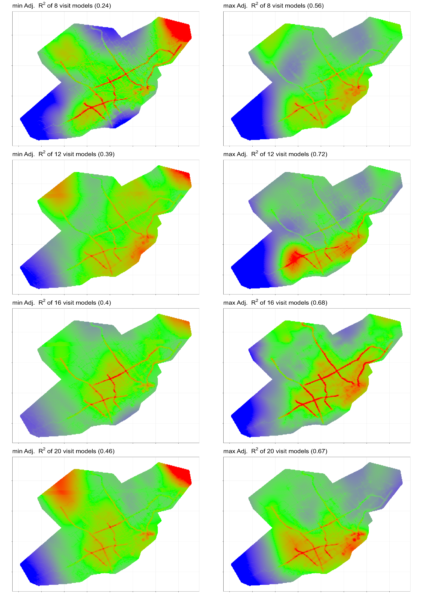

Figure A6.10. BC predictions for models with the min and max r² values of 15 models representing 8, 12, 16, 20, 24, 28, 32, and 36 visits (range 500(blue)-1800(red) ng/m³).
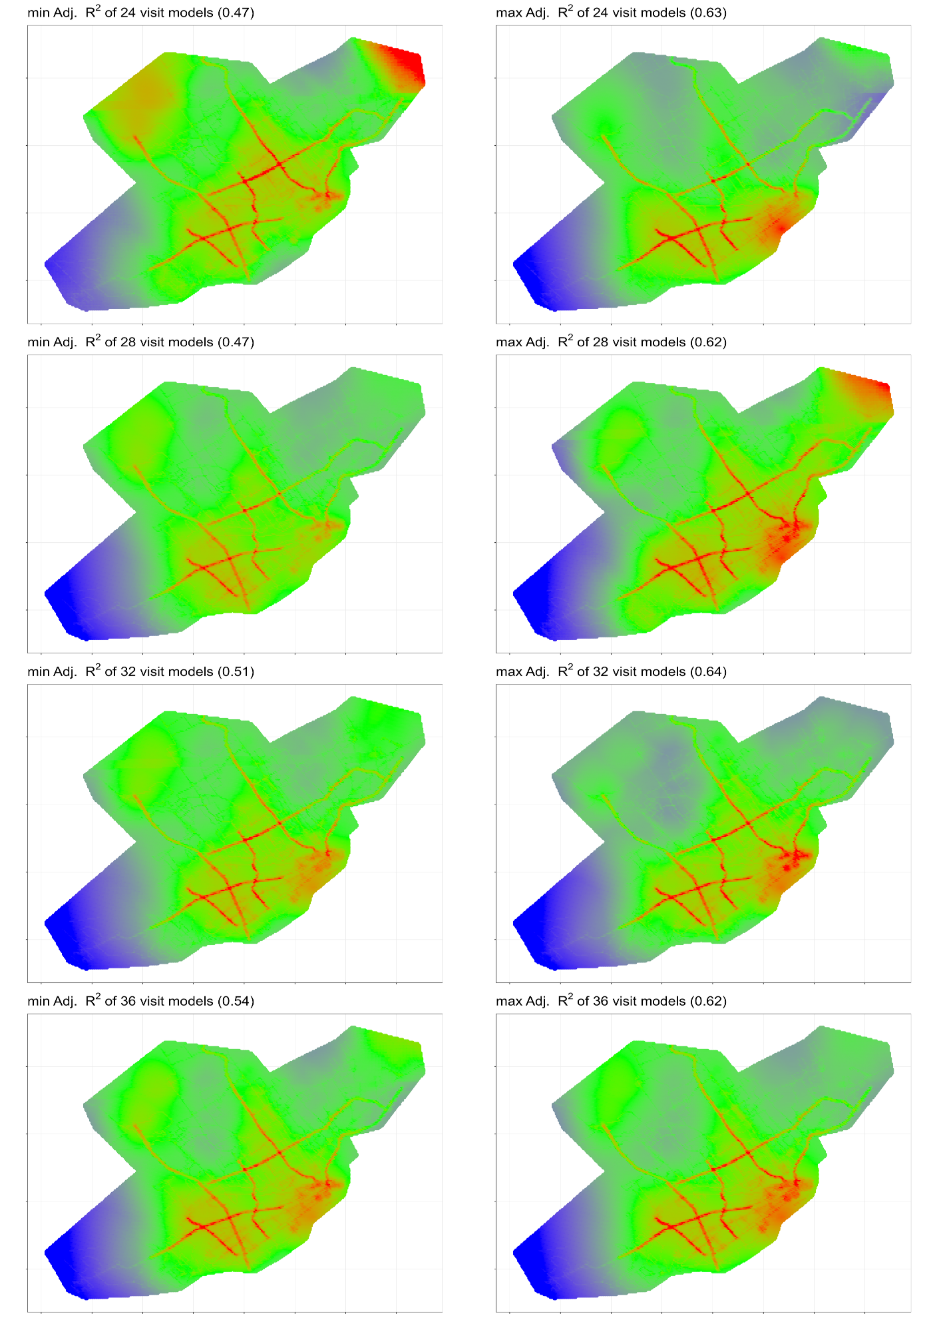

Figure A6.10 (continued). BC predictions for models with the min and max r² values of 15 models representing 8, 12, 16, 20, 24, 28, 32, and 36 visits (range 500(blue)-1800(red) ng/m³).
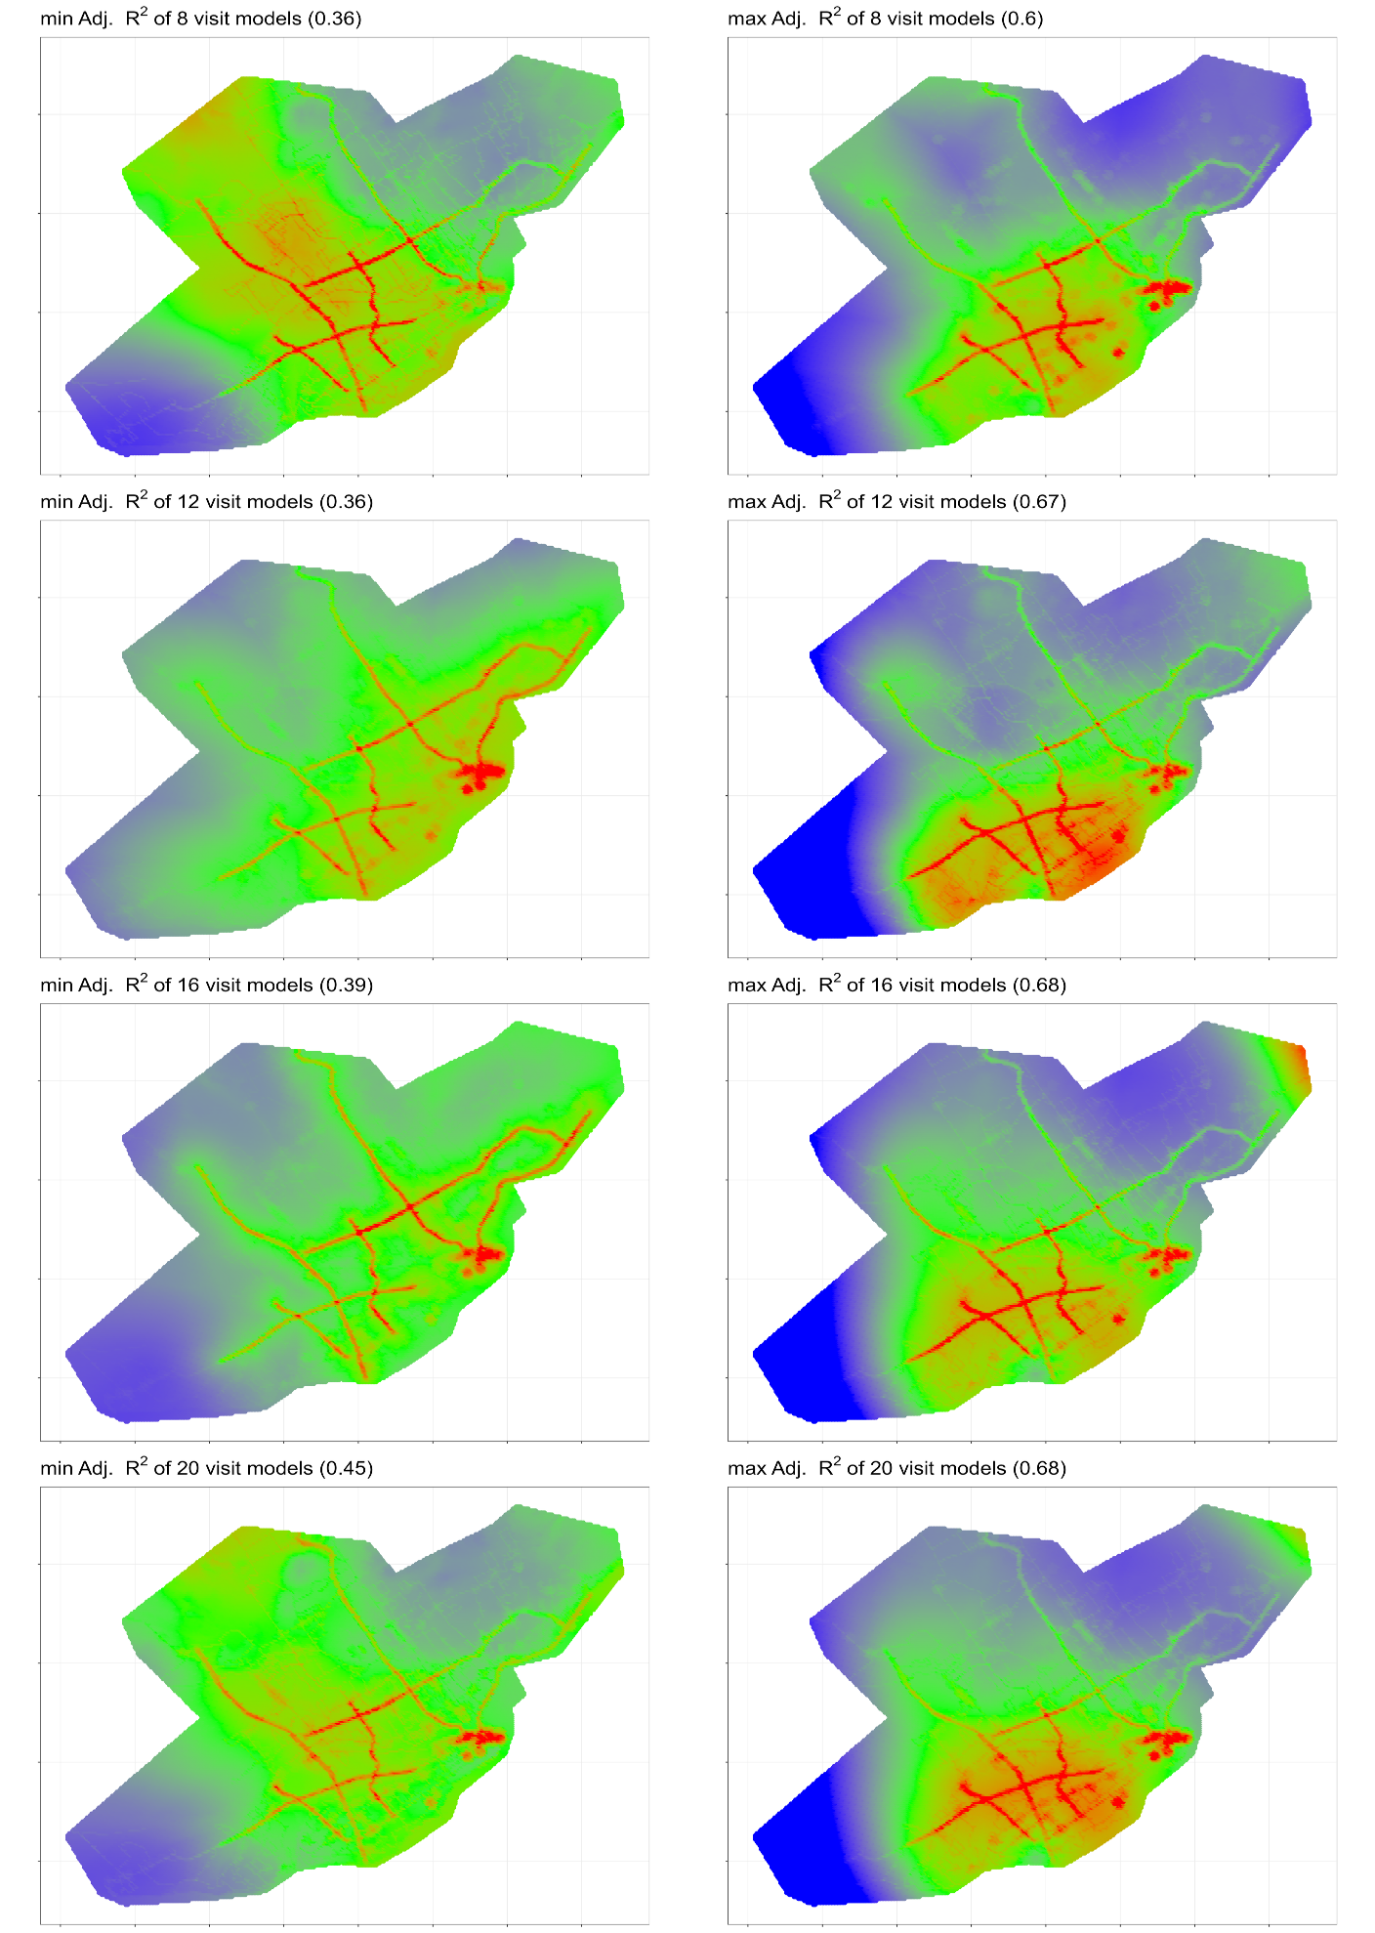

Figure A6.11. BrC predictions for models with the min and max r² values of 15 models representing 8, 12, 16, 20, 24, 28, 32, and 36 visits (range 300(blue)-1500(red) ng/m³).
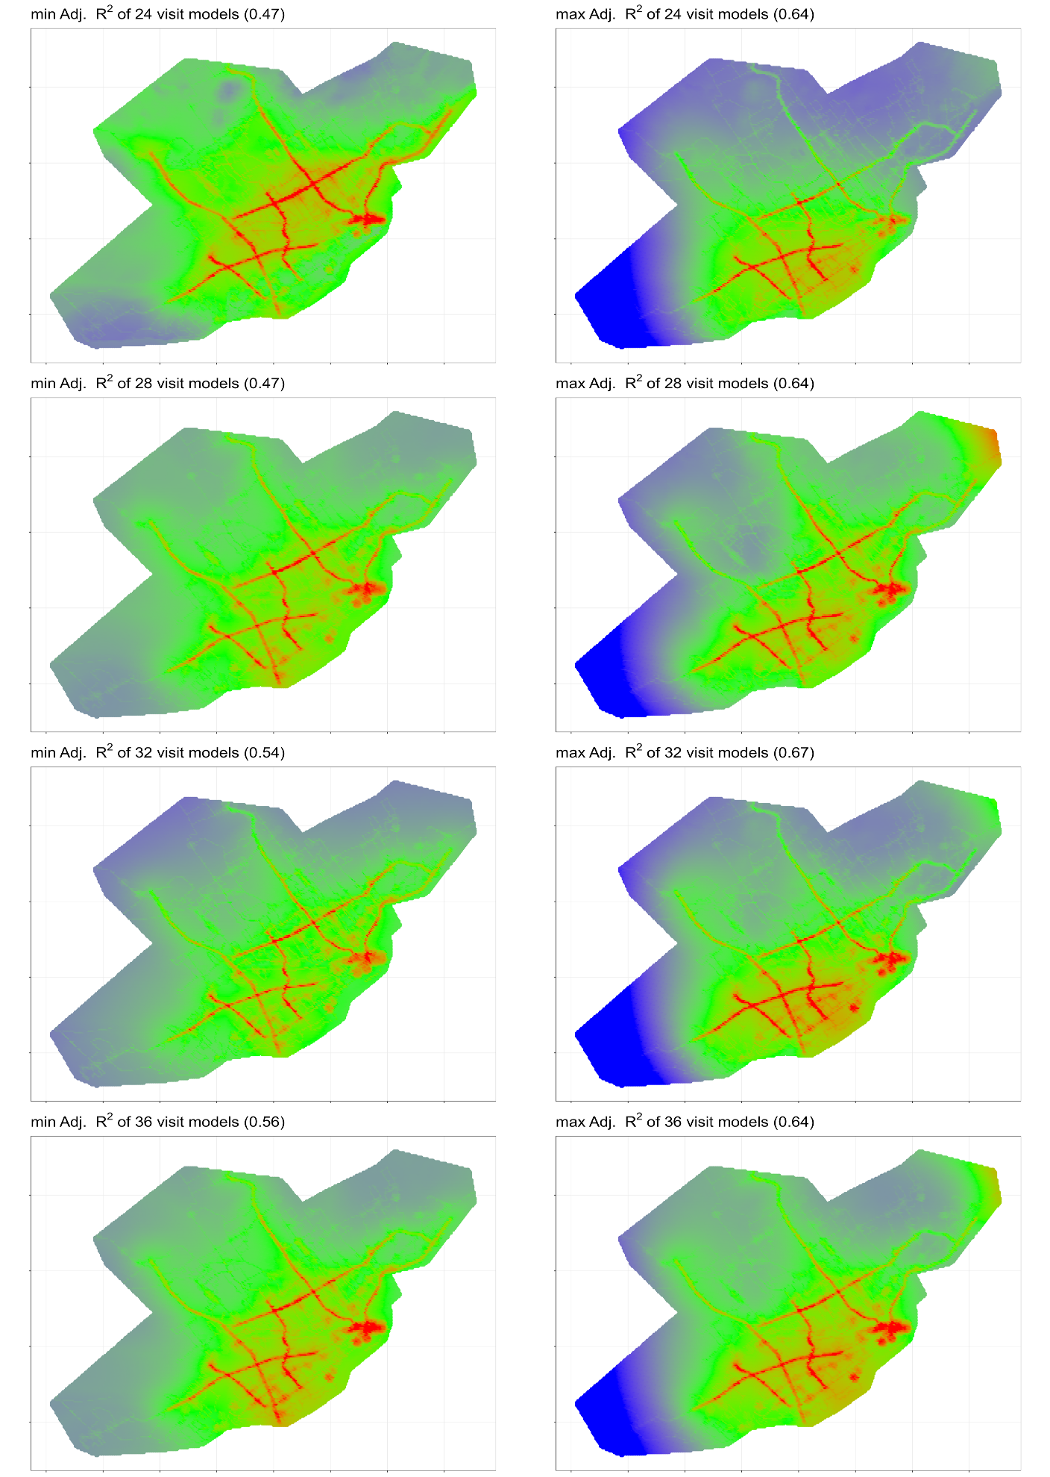

Figure A6.11 (continued). BrC predictions for models with the min and max r2 values of 15 models representing 8, 12, 16, 20, 24, 28, 32, and 36 visits (range 300(blue)-1500(red) ng/m³).

