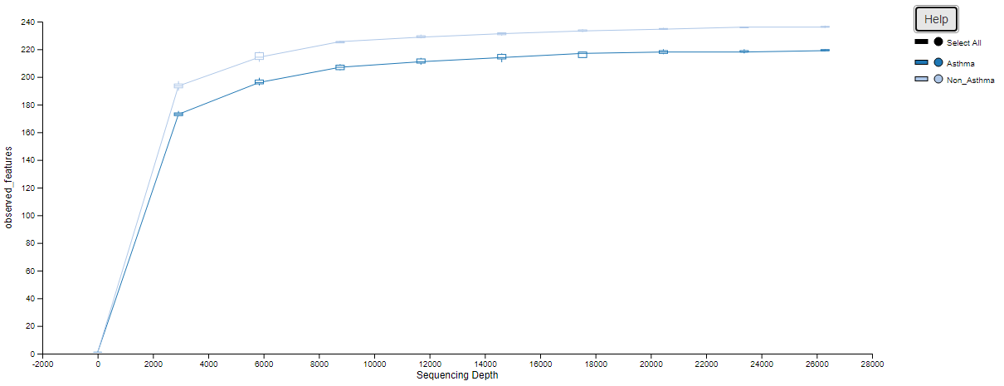
Figure S1. Alpha rarefaction curves for features

Figure S2. Relative abundance of predominant bacteria.
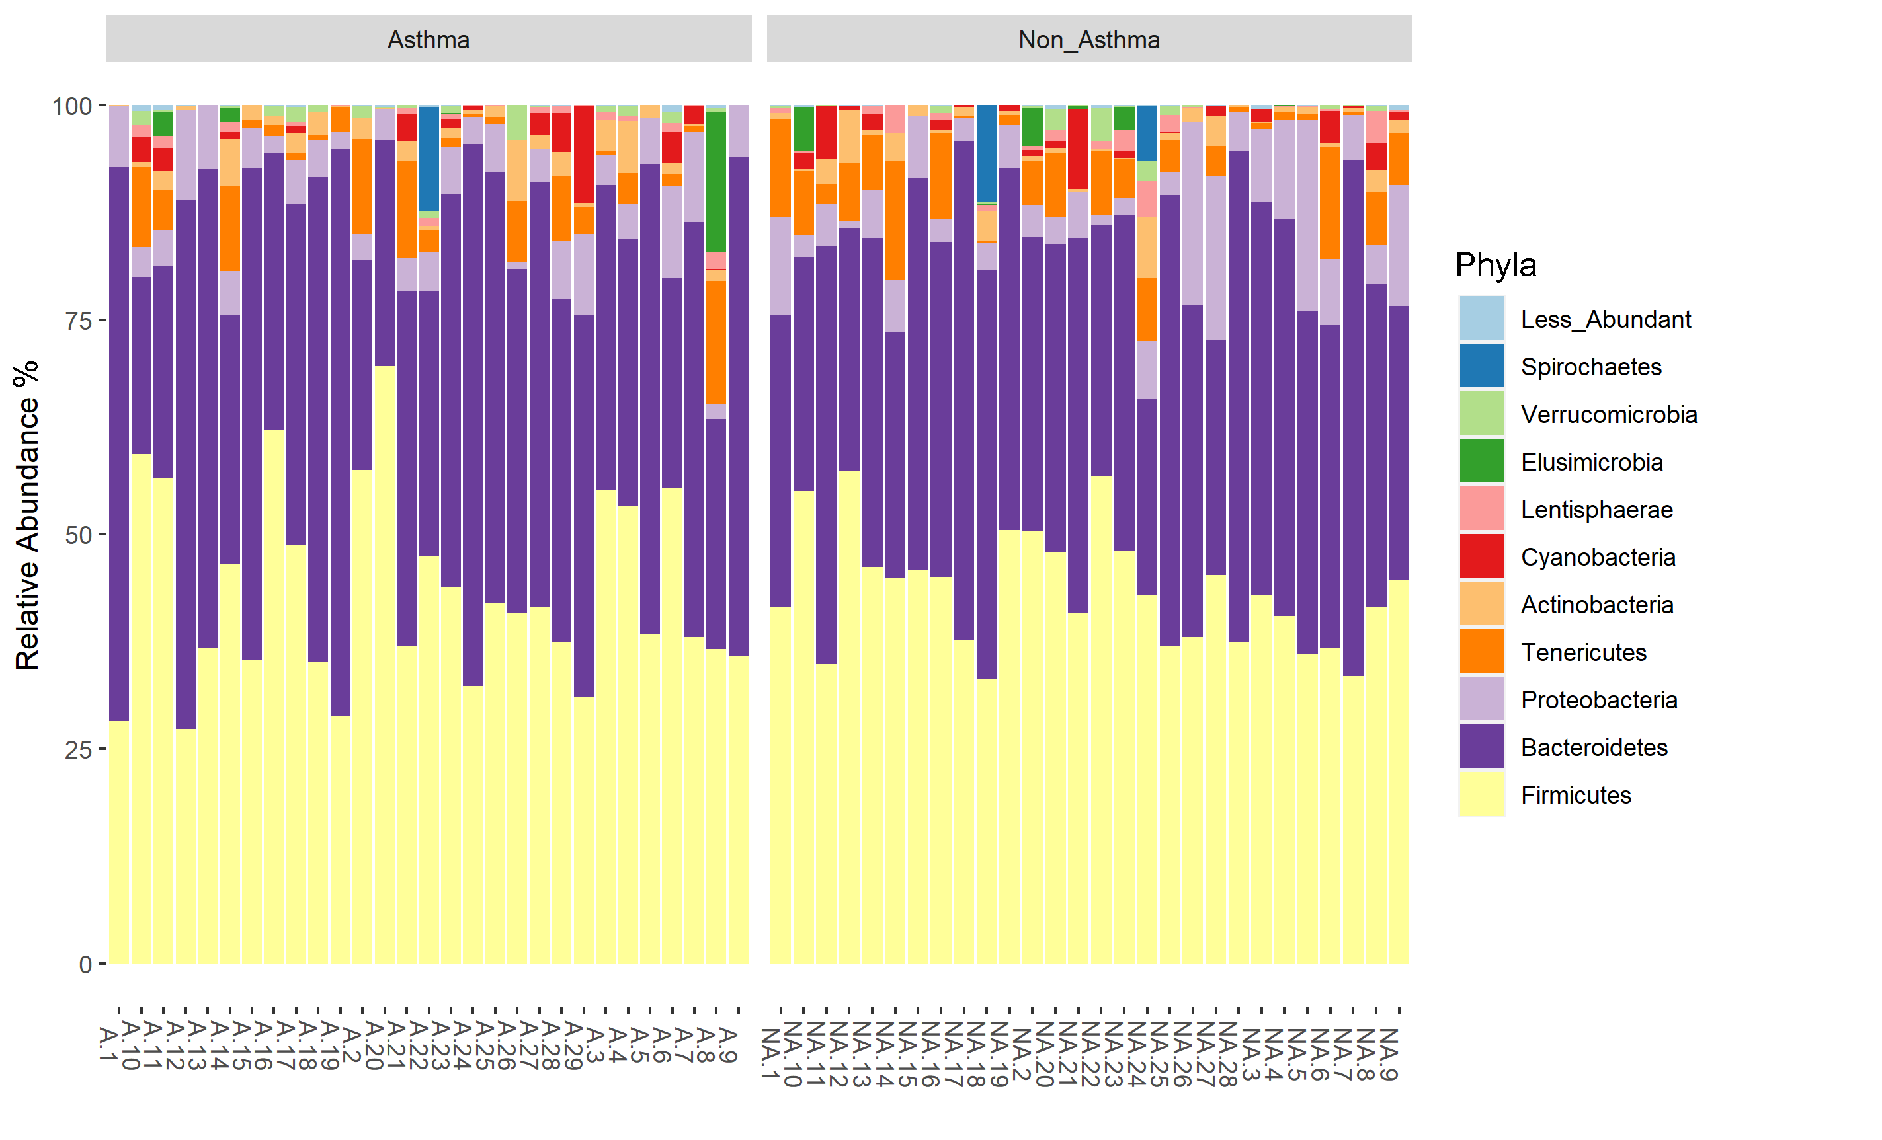

Figure S3. Diet profile based on weekly consumption.

