Pharmacokinetics-Based Pediatric Dose Evaluation and Optimization using Saliva – a Case Study
Supplementary Files
Marion Anliker-Ort, PhD¹, Frédérique Rodieux, MD^{1,2}, Victoria C. Ziesenitz, MD^{1,3}, Andrew Atkinson, PhD^{1,4}, Julia A Bielicki, MD, PhD^{1,5}, Thomas O. Erb, MD⁶, Nicolas Gürtler, MD⁷, Stefan Holland-Cunz, MD⁸, Urs Duthaler, PhD⁹, Deborah Rudin, PhD⁹, Manuel Haschke, MD¹⁰, John van den Anker, MD, PhD, FAAP, FCP¹, Marc Pfister, MD, PhD, FCP^{1*} and Verena Gotta, PhD^{1*}
¹ Pediatric Pharmacology and Pharmacometrics, University Children’s Hospital Basel (UKBB), University of Basel, Basel, Switzerland
² Division of Clinical Pharmacology and Toxicology, Department of Anesthesiology, Pharmacology, Intensive Care and Emergency Medicine, Geneva University Hospitals, Geneva, Switzerland
³ Pediatric and Congenital Cardiology, University Children’s Hospital Heidelberg, Heidelberg, Germany
⁴ Infectious Diseases Division, Washington University in St. Louis School of Medicine, St. Louis, MO, USA
⁵ Pediatric Infectious Diseases, University Children’s Hospital Basel (UKBB), University of Basel, Basel, Switzerland
⁶ Pediatric Anesthesiology, University Children’s Hospital Basel (UKBB), University of Basel, Basel, Switzerland
⁷ Department of Otolaryngology, Head and Neck Surgery, University Hospital Basel, University of Basel, Basel, Switzerland
⁸ Pediatric Surgery, University Children’s Hospital Basel (UKBB), University of Basel, Basel, Switzerland
⁹ Division of Clinical Pharmacology and Toxicology, Department of Biomedicine, University Hospital Basel and University of Basel, Basel, Switzerland
¹⁰ Clinical Pharmacology & Toxicology, Department of General Internal Medicine, University Hospital Bern, University of Bern, Bern, Switzerland

*shared last authorship
Corresponding author: Verena Gotta, verena.gotta@ukbb.ch

Supplementary Table S1: Pharmacokinetic (PK) parameters of metamizole metabolites in saliva and plasma after a single intravenous dose of 10 mg/kg in children from which at least 5 evaluable saliva samples were collected
 |  |  | 4-MAA |  | 4-AA |  | 4-FAA |  | 4-AAA
Parameter [unit] | Statistic |  | Saliva  (N = 7) | Plasma  (N = 6) | Saliva  (N = 7) | Plasma  (N = 6) | Saliva  (N = 7) | Plasma  (N = 6) | Saliva  (N = 7) | Plasma  (N = 6)
C_{max} [ng/mL] | Geometric mean |  | 2741 | 8055 | 398 | 683 | 1891 | 1340 | 1179 | 1087
 | 95% CI of geometric mean |  | 1414, 5315 | 6340, 10232 | 269, 590 | 435, 1072 | 1384, 2583 | 951, 1890 | 597, 2329 | 600, 1966
t_{max} [h] | Median |  | 1.0 | 1.0 | 2.0 | 2.0 | 4.1 | 4.9 | 5.8 | 5.9
 | Range |  | 1.0, 2.3 | 1.0, 1.2 | 1.0, 9.0 | 1.1, 6.0 | 1.0, 6.1 | 4.0, 6.0 | 2.0, 9.0 | 4.0, 9.0
AUC_{0–t} [ng·h/mL] | Geometric mean |  | 8252 | 26406 | 2781 | 4266 | 15412 | 11535 | 10375 | 8853
 | 95% CI of geometric mean |  | 4594, 14823 | 20225, 34475 | 1514, 5108 | 2121, 8578 | 9528, 24931 | 7536, 17655 | 5227, 20594 | 5291, 14814
AUC_{0–∞} [ng·h/mL]ª | Geometric mean |  | 8571 | 27962 | - | - | - | - | - | -
 | 95% CI of geometric mean |  | 4746, 15480 | 20076, 38946 | - | - | - | - | - | -
t_{½} [h]¹ | Geometric mean |  | 3.3 | 2.3 | - | - | - | - | - | -
 | 95% CI of geometric mean |  | 1.9, 5.6 | 1.7, 3.2 | - | - | - | - | - | -
Actual sampling times were used and all concentrations below lower limit of quantification were imputed with zero. C_{max} and t_{max} were derived from the individual measured concentrations. AUC_{0–t} was calculated with the linear trapezoidal rule. AUC_{0–∞} and t_{½} were determined based on the terminal elimination rate constant derived by log-linear regression analysis. PK parameters were summarized by geometric mean and 95% CI (except for median and range for t_{max}).
ª For 4-AA, 4-FAA, and 4-AAA, no t_{½} and, consequently, no AUC_{0–∞} were determined based on too few data points during the terminal elimination phase.
4-AA = 4-aminoantipyrine, 4-AAA = 4-acetyl-aminoantipyrine, 4-FAA = 4-formyl-aminoantipyrine, 4-MAA = 4-methylaminoantipyrine, AUC_{0–t} = Area under the saliva concentration-time curve from zero to the last measurement above the limit of quantification, AUC_{0–∞} = Area under the saliva concentration-time curve from zero to infinity, C_{max} = Maximum plasma concentration, t_{½} = Terminal half-life, t_{max} = Time to reach maximum plasma concentration. CI = Confidence interval.
Out of 27 children who were enrolled, 16 provided saliva samples. For a direct comparison, the plasma PK were calculated for the same subset of children providing saliva samples, except for 1 child, from whom only saliva samples were available.

Supplementary Table S2: Number of available plasma and saliva samples per sampling time point
 |  | Sampling time points (h)
Matrix | Metabolite | 1 | 2 | 4 | 6 | 8 | 10 | 24
Saliva | 4-MAA | 13 | 9 | 13 | 12 | - | 9 | 4
 | 4-AA | 13 | 9 | 13 | 12 | - | 9 | 4
 | 4-FAA | 13 | 9 | 13 | 12 | - | 9 | 4
 | 4-AAA | 13 | 9 | 13 | 12 | - | 9 | 4
Plasma | 4-MAA | 26 | 22 | 21 | 20 | 1 | 19 | 6
 | 4-AA | 26 | 22 | 21 | 20 | 1 | 19 | 6
 | 4-FAA | 26 | 22 | 21 | 20 | 1 | 19 | 6
 | 4-AAA | 26 | 22 | 21 | 20 | 1 | 19 | 6

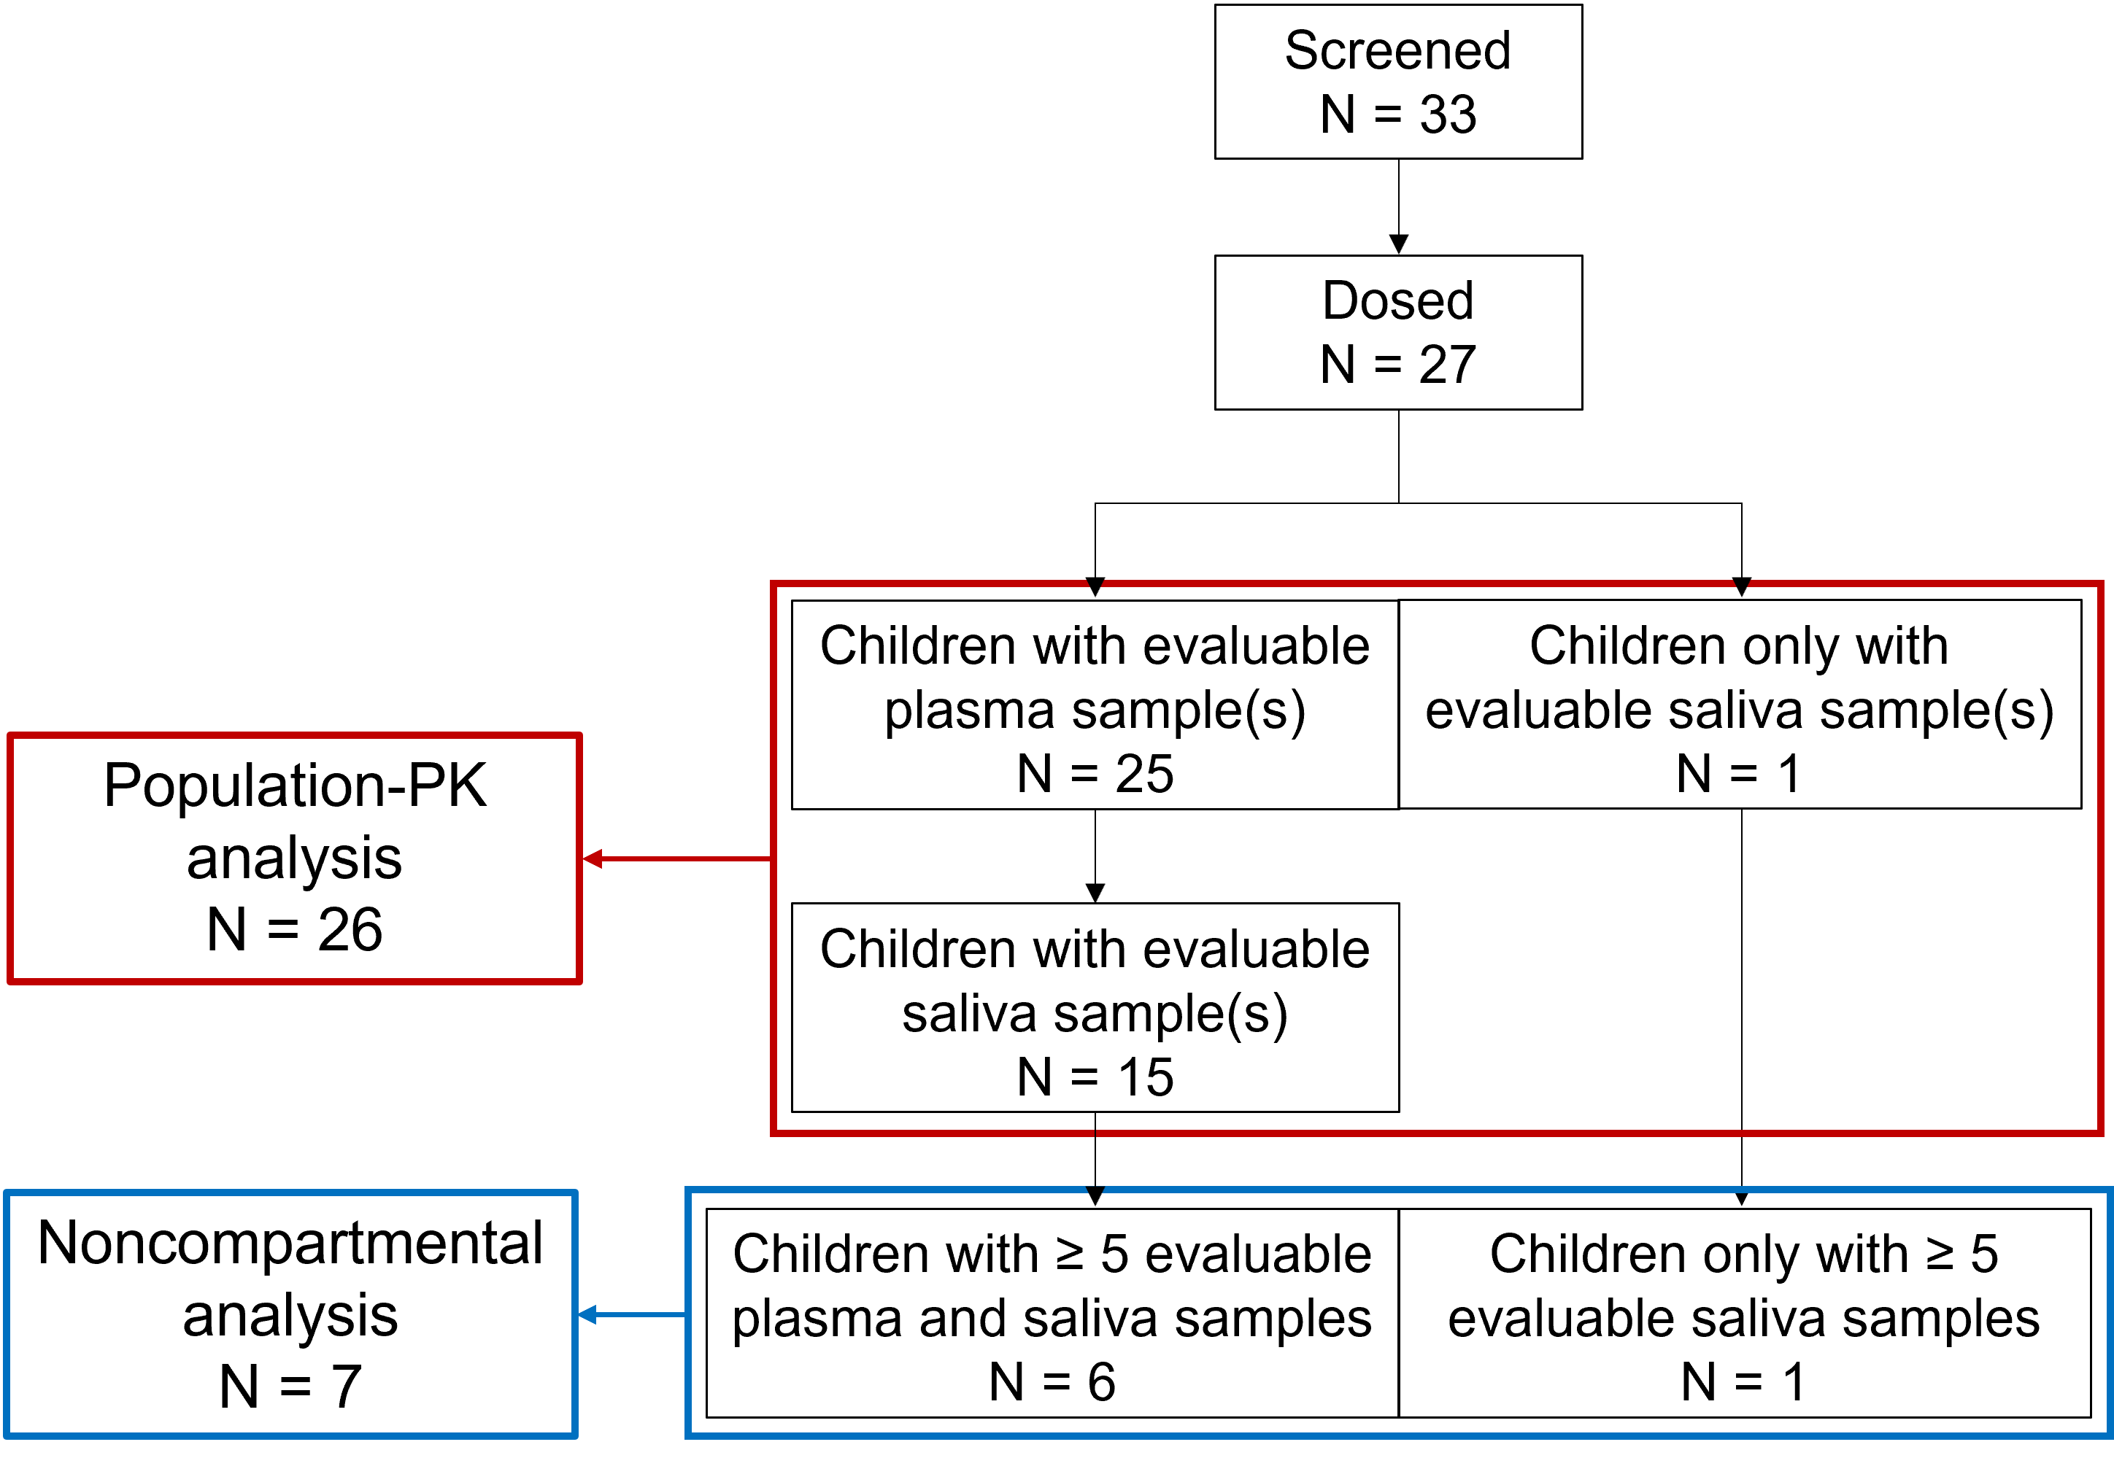
Supplementary Figure S1: Flow chart of enrolled and dosed children and number of children providing plasma and/or saliva samples
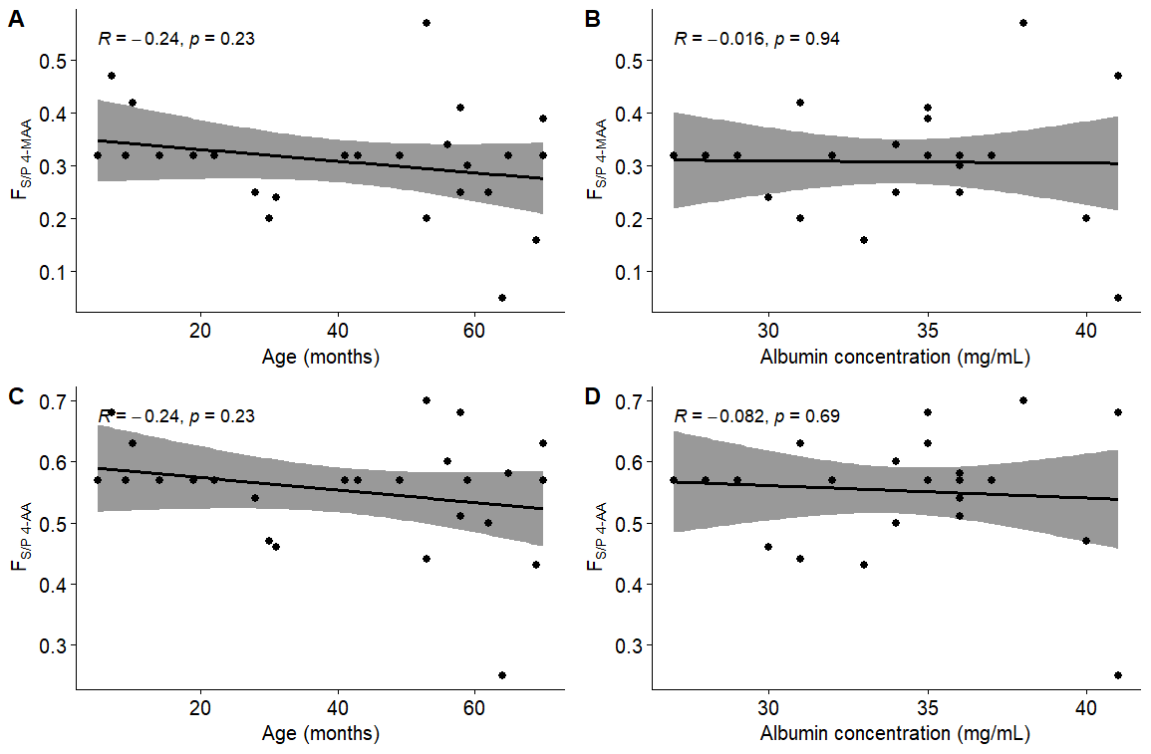
Supplementary Figure S2: Correlations between individual distribution fraction parameters saliva to plasma (F_{S/P}) for 4-MAA with [A] the children’s age and [B] albumin concentrations as well as F_{S/P} for 4-AA and [C] the children’s age and [D] albumin concentrations. Solid line = linear regression, grey-shaded area = 95% confidence interval
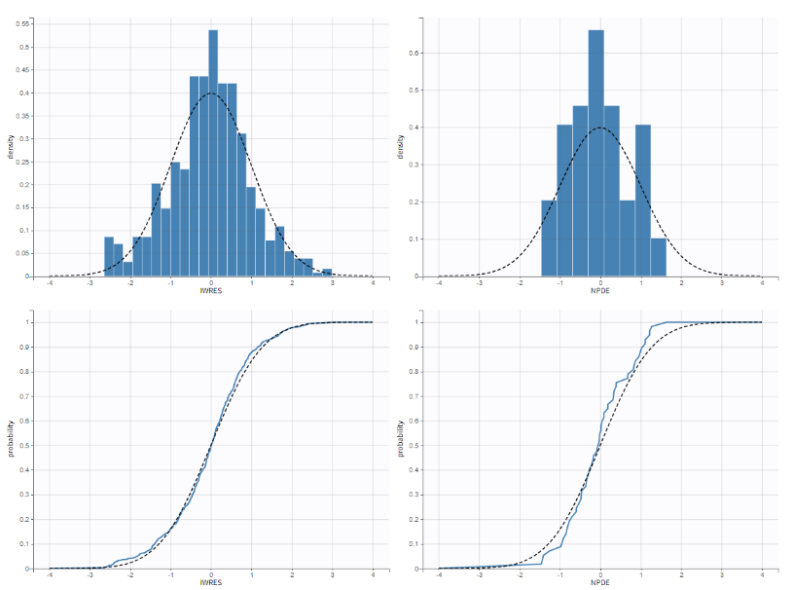
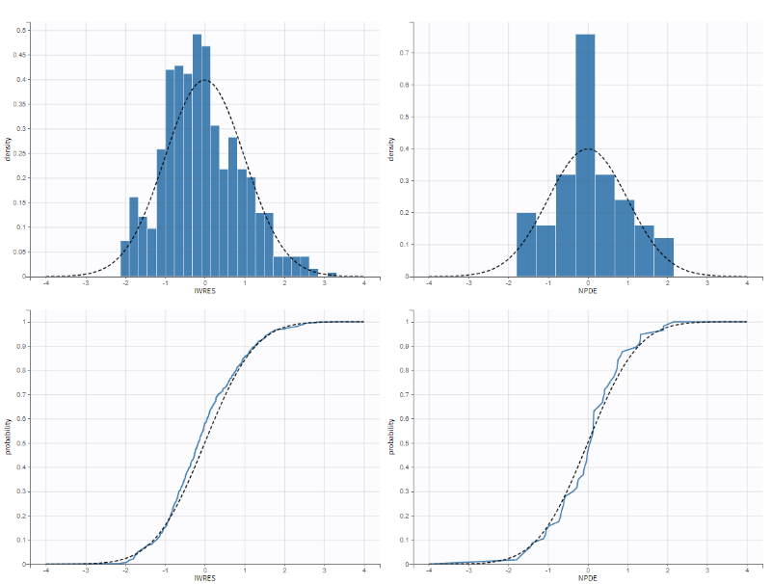
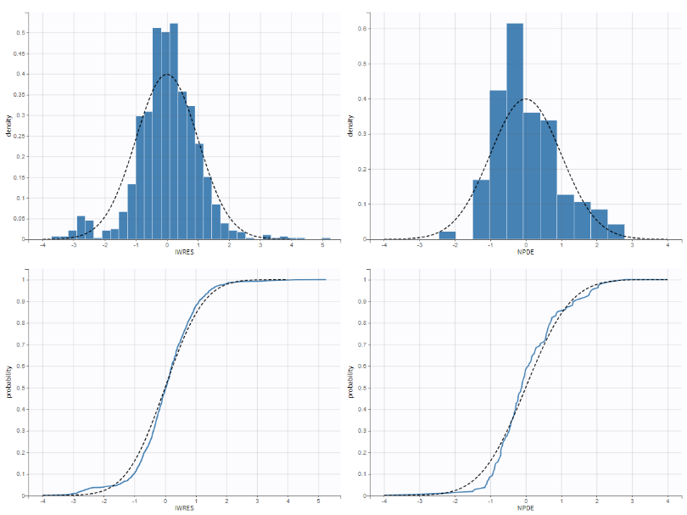
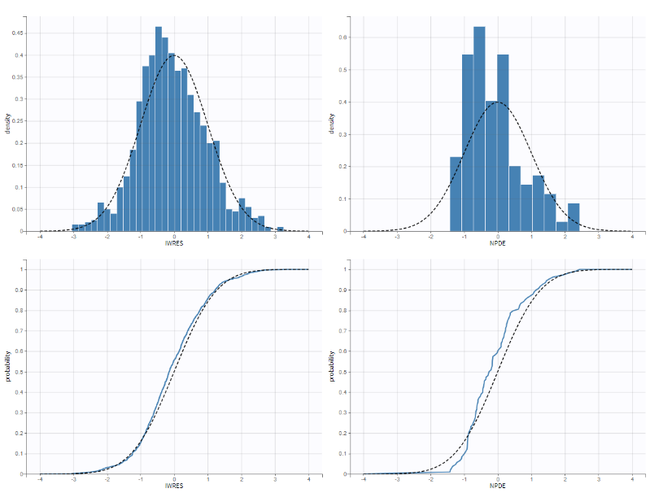
Supplementary Figure S3: Normalized Prediction Distribution Errors and individual weighted residuals plots for the final population PK model of 4-MAA and 4-AA in plasma and saliva
4-AA saliva
4-MAA saliva
4-MAA plasma
4-AA plasma

Supplementary Figure S4: [A] Visual predictive checks (points = observed concentration data over time, lines = median, 5th, and 95th percentile of observed data, shaded area = 90% prediction interval of median and 10th and 90th percentile of the simulations, linear scales) and [B] observation versus prediction plots for the final population PK model of 4-MAA and 4-AA in plasma and saliva (points = concentration, solid line = line of identity, logarithmic scales)
4-MAA plasma
4-MAA saliva
4-AA saliva
4-AA plasma
[A]
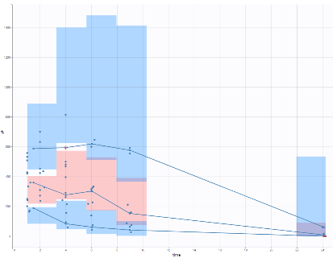
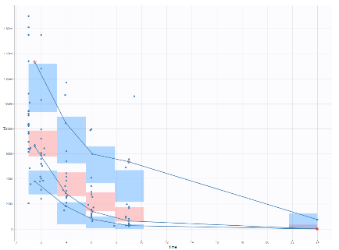
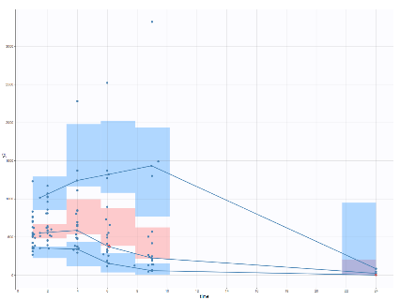
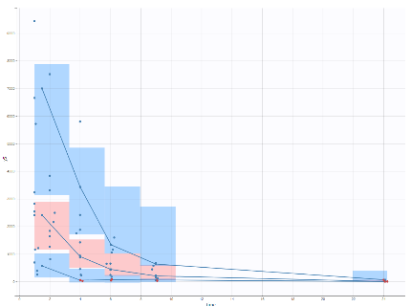
[B]
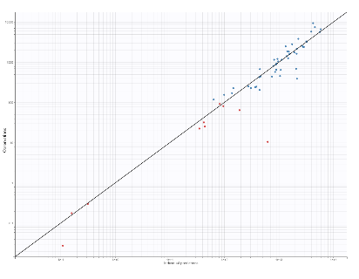
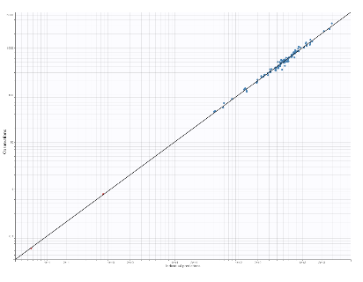
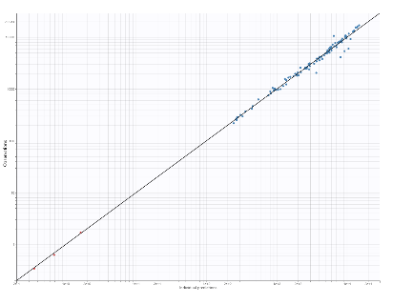
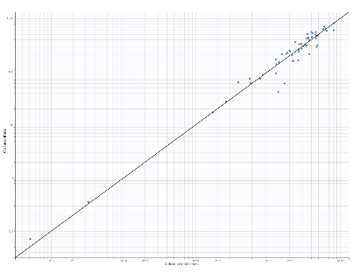
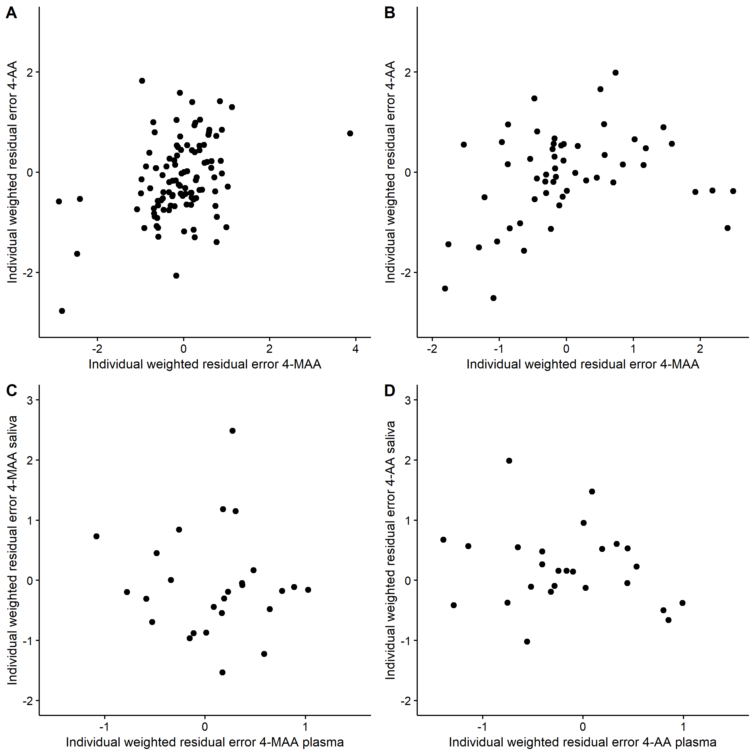
Supplementary Figure S5: Correlation between residual errors of 4-AA versus 4-MAA in [A] plasma and [B] saliva as well as residual errors of saliva versus plasma of [C] 4-MAA and [D] 4-AA. Suggested correlation was not considered in the model as it did not improve the fit

