Supplemental Material

Contents
Figure S1 – Overview of study design 2
Figure S2 – Overview of HbA1c variability score (HVS). 3
Table S1 – Comparison of HbA1c Variability Score (HVS) based on absolute and relative thresholds. 4
Figure S3 – Distribution of HbA1c variability score (HVS) cross-classified by average HbA1c level. 5
Figure S4 – Distribution of the direction of the percentage change in the last HbA1c measurement recorded before 2015 stratified by average HbA1c level. 6
Table S2 – Sensitivity analyses estimating adjusted incidence rate ratios for mean HbA1c and variability score for hospitalisation infections with different exclusion criteria. 7
Table S3 – Sensitivity analyses comparing estimated adjusted incidence rate ratios for hospitalisation infections for HbA1c variability scores based on relative versus absolute changes. 8
Table S4 – Sensitivity analyses comparing estimated adjusted incidence rate ratios for hospitalisation infections for HbA1c variability scores based on relative versus absolute changes in annual mean estimates for HbA1c between 2011-4. 9
Figure S5 – Adjusted Incidence Rate Ratios for hospitalisation infections for average HbA1c level by HbA1c variability score category. 10
Figure S6 – Adjusted Incidence Rate Ratios for hospitalisation infections by direction of percentage change on last measurement stratified by average HbA1c level. 11
Figure S7 – Distribution of HbA1c variability score (HVS) cross-classified by average HbA1c level by sex and age. 12
Figure S8 – Distribution of HbA1c variability score (HVS) cross-classified by average HbA1c level by ethnicity. 13
Table S5 – Adjusted incidence rate ratios for average HbA1c level and HbA1c variability score for hospitalisation infections by sex and age. 14
Table S6 – Adjusted incidence rate ratios for average HbA1c level and HbA1c variability score for hospitalisation infections by ethnicity. 15
Table S7 – Adjusted incidence rate ratios for average HbA1c level and HbA1c variability score for specific hospitalisation infections. 16

Figure S1 – Overview of study design
N=411,963
Patients with ≥4 HbA1c measurements during 2011-14
2011
2019
Hospitalisation related infections
- Admissions with infection as primary cause
- Acquired hospital infections
- Evidence of sepsis on hospital record.
N=527,151
All patients with Type 2 Diabetes aged 18-90 active and registered in CPRD on 1 January 2015
2015
H
H
H
H
H
Measurements minimum of 30 days apart
I
I
Same infection type minimum of 90 days apart
Note: A sensitivity analysis in Table S2 extends this minimum to 90 days but reduces the number of eligible patients to N=391,426

Figure S2 – Overview of HbA1c variability score (HVS).

Basic Formula
$$\text{HbA1c variability score (HVS)} =\frac{\text{Number of successive measurements that differ by X} }{\text{(Total number of HbA1c measurements }-\text{ 1 )}}$$
where X is pre-determined, usually set as 5.5 mmol/mol.

An Example
(a) HVS estimated using an absolute threshold of 5.5 mmol/mol to count significant fluctuations¹
HVS = 2/5 = 40%

(b) HVS estimated using relative threshold of 10% of prior value to count significant fluctuations²
HVS = 1/5 = 20%
Note: The final change of 70 to 64 mmol/mol is considered a significant fluctuation for (a) but not in (b) as it is less than 10% of the prior value (± 7 mmol/mol).

Categorisation of HVS
For the analysis, four summary categories were chosen (see table). The table shows how many significant fluctuations for different totals would result in these categories e.g., a patient with 5 total measurements, would need all 4 successive measurements to be significant fluctuations to be categorised as “80 to 100”.
Estimated HVS | Total Number of HbA1c Measurements
 | 3 | 4 | 5 | 6 | 7 | 8
0 to <20 | 0/2 | 0/3 | 0/4 | 0/5 | 0/6 or 1/6 | 0/7 or 1/7
20 to <50 | _ | 1/3 | 1/4 | 1/5 or 2/5 | 2/6 | 2/7 or 3/7
50 to <80 | 1/2 | 2/3 | 2/4 or 3/4 | 3/5 | 3/6 or 4/6 | 4/7 or 5/7
80 to 100 | 2/2 | 3/3 | 4/4 | 4/5 or 5/5 | 5/6 or 6/6 | 6/7 or 7/7
¹ - See Forbes et al. (2018) Lancet Diabetes & Endocrinology 6(6): 476-486.
² - See Monnier et al. (2023) Diabetes & Metabolism 49(1).

Table S1 – Comparison of HbA1c Variability Score (HVS) based on absolute and relative thresholds.
 |  | HVS based on counting absolute changes of 5.5mmol (0.5%) or more
HVS based on counting relative changes of 10% or more |  | 0 to <20 | 20 to <50 | 50 to <80 | 80 to 100 | All
0 to <20 | N  (% row) | 102,463 (92.9%) | 6,518  (5.9%) | 1,253  (1.1%) | 84  (0.1%) | 110,318  (100%)
 | Mean in mmol/mol (SD) | 49.0  (7.2) | 68.9  (13.5) | 84.6  (16.8) | 100.4  (19.1) | 50.6  (9.9)
20 to <50 | N  (% row) | 17,667 (12.3%) | 105,390 (73.2%) | 19,342 (13.4%) | 1,499  (1.0%) | 143,898  (100%)
 | Mean in mmol/mol (SD) | 44.9  (5.1) | 55.9  (10.1) | 73.8  (14.0) | 88.2  (16.0) | 57.3  (13.2)
50 to <80 | N  (% row) | 1,589  (1.3%) | 11,462 (9.2%) | 99,772 (79.6%) | 12,461 (10.0%) | 125,284  (100%)
 | Mean in mmol/mol (SD) | 42.0  (5.2) | 47.8  (6.2) | 63.1  (12.7) | 79.2  (14.7) | 63.0  (14.4)
80 to 100 | N  (% row) | 33  (0.1%) | 424  (1.3%) | 3,104  (9.6%) | 28,892 (89.0%) | 32,453  (100%)
 | Mean in mmol/mol (SD) | 38.0  (6.2) | 44.1  (6.6) | 52.6  (8.0) | 69.3  (13.8) | 67.3  (14.5)
All | N  (% row) | 121,752  (29.6%) | 123,794  (30.1%) | 123,471  (30.0%) | 42,936 (10.4%) | 411,953  (100%)
 | Mean in mmol/mol (SD) | 48.3  (7.1) | 55.8  (10.8) | 64.7  (13.7) | 72.9  (15.2) | 58.0  (14.0)
Shaded cell indicates agreement between categories.
Correlation coefficients (r) with mean HbA1c: HVS counting absolute changes +/- 5.5mmol (0.5%) = 0.60, HVS counting relative changes +/- 10% = 0.40.

Figure S3 – Distribution of HbA1c variability score (HVS) cross-classified by average HbA1c level.
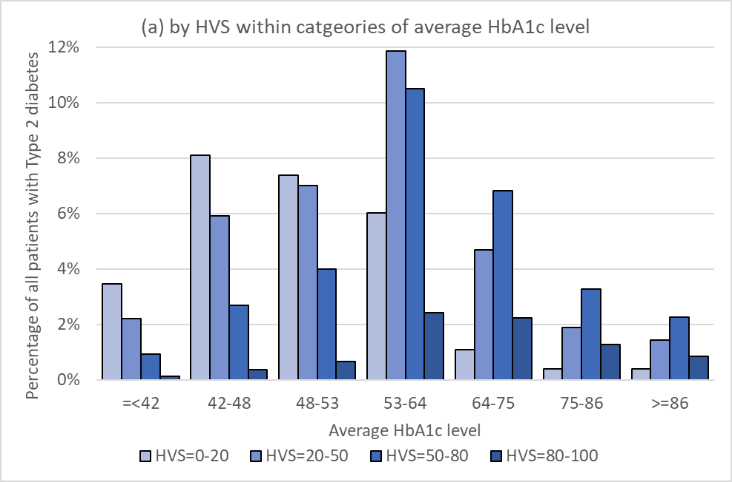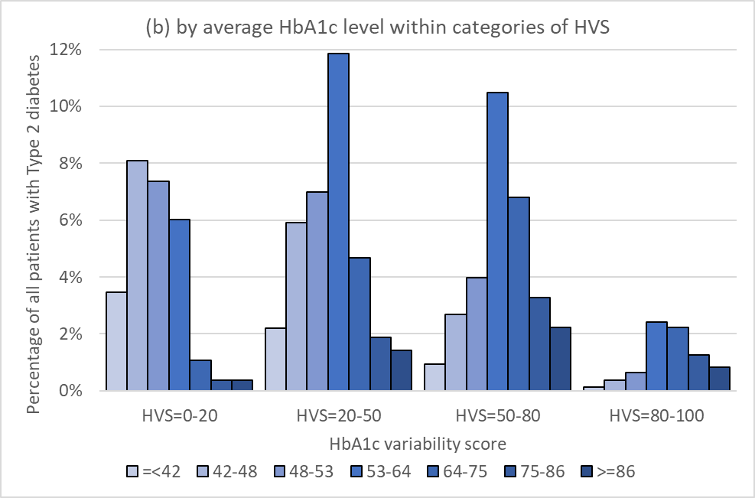

Figure S4 – Distribution of the direction of the percentage change in the last HbA1c measurement recorded before 2015 stratified by average HbA1c level.
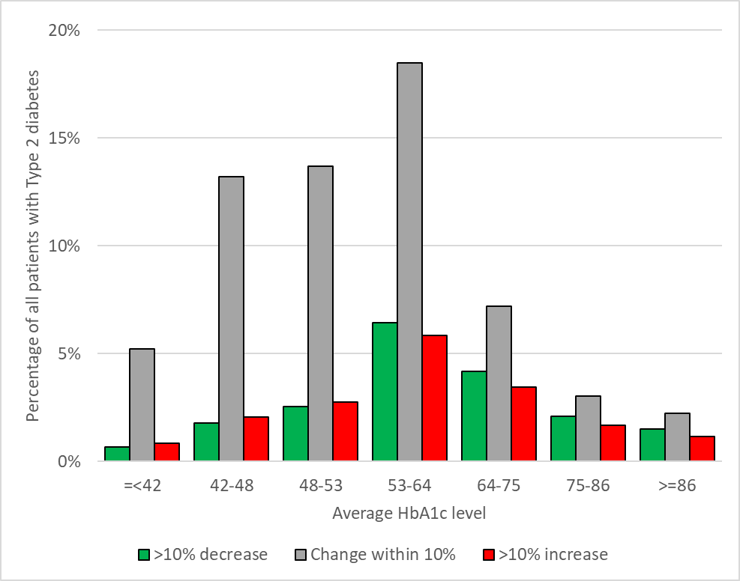
Note: Overall, n=79,105 (19.2%) had a recorded decrease of 10 percent of more of previous measurement, n=259,763 (63.1%) had a change recorded within 10 percent of previous measurement, n=73,085 (17.7%) had a recorded increase of 10 percent or more od previous measurement.

Table S2 – Sensitivity analyses estimating adjusted incidence rate ratios for mean HbA1c and variability score for hospitalisation infections with different exclusion criteria.
 | No history of hypoglycaemia (n=395,727) |  | HbA1c measures minimum >90 days apart  (n=391,426) |  | No hospitalisation for infection 2011-14 (n=364,535)
 | % | IRR (95% CI) | % | IRR (95% CI) | % | IRR (95% CI)
Average HbA1c
- <42 | 6.8% | 1.12 (1.09-1.15) | 6.8% | 1.12 (1.09-1.15) | 6.7% | 1.09 (1.06-1.13)
42 to <48 | 17.4% | 1 (Reference) | 17.1% | 1 (Reference) | 17.2% | 1 (Reference)
48 to <53 | 19.3% | 0.97 (0.95-0.99) | 19.0% | 0.97 (0.96-0.99) | 19.3% | 0.98 (0.96-1.00)
53 to <64 | 30.7% | 0.96 (0.94-0.98) | 31.1% | 0.96 (0.94-0.98) | 31.1% | 0.98 (0.96-1.01)
64 to <75 | 14.4% | 1.09 (1.07-1.12) | 14.6% | 1.08 (1.06-1.11) | 14.5% | 1.10 (1.07-1.13)
75 to <86 | 6.6% | 1.28 (1.24-1.31) | 6.7% | 1.26 (1.23-1.30) | 6.6% | 1.31 (1.26-1.35)
≥86 | 4.8% | 1.80 (1.75-1.85) | 4.8% | 1.81 (1.76-1.86) | 4.6% | 1.80 (1.74-1.86)
Attributable Fraction to average (%)* |  | 3.7% |  | 3.7% |  | 4.6%
HbA1c Variability Score (HVS)
0 to <20 | 27.1% | 1 (Reference) | 25.9% | 1 (Reference) | 27.8% | 1 (Reference)
20 to <50 | 34.9% | 1.20 (1.19-1.22) | 33.1% | 1.21 (1.19-1.23) | 35.0% | 1.15 (1.13-1.17)
50 to <80 | 30.1% | 1.38 (1.35-1.40) | 31.3% | 1.41 (1.39-1.44) | 29.7% | 1.28 (1.25-1.30)
80 to 100 | 7.8% | 1.52 (1.48-1.56) | 9.7% | 1.57 (1.53-1.61) | 7.5% | 1.37 (1.33-1.41)
Attributable Fraction to variability (%)* |  | 16.8% |  | 18.5% |  | 13.1%

 | Diagnosed in the last 5 years only  (n=113,787) |  | No anti-diabetic medication in 2014 (n=68,655) |  | All HbA1c measures between 42-64 mmol/mol  (n=143,495)
 | % | IRR (95% CI) | % | IRR (95% CI) | % | IRR (95% CI)
Average HbA1c
- <42 | 7.9% | 1.08 (1.03-1.14) | 23.5% | 1.12 (1.08-1.16) | _ | _
42 to <48 | 23.7% | 1 (Reference) | 42.1% | 1 (Reference) | 24.7% | 1 (Reference)
48 to <53 | 23.3% | 1.06 (1.02-1.10) | 23.9% | 1.01 (0.97-1.04) | 44.4% | 1.02 (1.00-1.05)
53 to <64 | 27.0% | 1.06 (1.03-1.10) | 9.0% | 1.03 (0.97-1.09) | 30.9% | 1.00 (0.97-1.03)
64 to <75 | 11.0% | 1.10 (1.05-1.16) | 1.0% | 1.00 (0.85-1.17) | _ | _
75 to <86 | 4.6% | 1.25 (1.17-1.34) | 0.3% | 0.96 (0.70-1.31) | _ | _
≥86 | 2.6% | 1.56 (1.44-1.69) | 0.3% | 1.60 (1.24-2.08) | _ | _
Attributable Fraction to average (%)* |  | 6.4% |  | 3.0% |  | 1.0%
HbA1c Variability Score (HVS)
0 to <20 | 28.0% | 1 (Reference) | 52.0% | 1 (Reference) | 49.3% | 1 (Reference)
20 to <50 | 34.1% | 1.19 (1.15-1.23) | 31.8% | 1.26 (1.22-1.30) | 35.7% | 1.15 (1.12-1.18)
50 to <80 | 29.4% | 1.37 (1.32-1.42) | 14.0% | 1.48 (1.41-1.54) | 13.6% | 1.29 (1.25-1.34)
80 to 100 | 8.5% | 1.46 (1.38-1.54) | 2.1% | 1.78 (1.62-1.96) | 1.4% | 1.38 (1.27-1.50)
Attributable Fraction to variability (%)* |  | 15.9% |  | 12.0% |  | 8.1%
IRR = Incidence rate ratio adjusts for age, sex, ethnicity, deprivation (IMD), co-morbidity count, smoking and BMI.
* - Attributable fractions estimates assume a casual association under which all patients are moved to reference category

Table S3 – Sensitivity analyses comparing estimated adjusted incidence rate ratios for hospitalisation infections for HbA1c variability scores based on relative versus absolute changes.
 | Variability based on relative changes only* | Average and variability based on relative changes* | Variability based on absolute changes only† | Average and variability based on absolute changes†
 | IRR (95% CI) | IRR (95% CI) | IRR (95% CI) | IRR (95% CI)
Average HbA1c
- <42 | _ | 1.12  (1.09-1.15) | _ | 1.15  (1.12-1.18)
42 to <48 | _ | 1  (Reference) | _ | 1  (Reference)
48 to <53 | _ | 0.97  (0.96-0.99) | _ | 0.95  (0.93-0.97)
53 to <64 | _ | 0.96  (0.94-0.98) | _ | 0.91  (0.90-0.93)
64 to <75 | _ | 1.08  (1.06-1.11) | _ | 1.01  (0.99-1.04)
75 to <86 | _ | 1.26  (1.23-1.30) | _ | 1.17  (1.14-1.20)
≥86 | _ | 1.81  (1.76-1.86) | _ | 1.62  (1.58-1.67)
Attributable Fraction to average (%)§ | _ | 4.1% | _ | 0.0%
HbA1c Variability Score (HVS)
0 to <20 | 1  (Reference) | 1  (Reference) | 1  (Reference) | 1  (Reference)
20 to <50 | 1.22  (1.21-1.24) | 1.21  (1.19-1.23) | 1.21  (1.19-1.23) | 1.24  (1.22-1.26)
50 to <80 | 1.45  (1.43-1.48) | 1.38  (1.36-1.41) | 1.46  (1.44-1.48) | 1.44  (1.41-1.47)
80 to 100 | 1.67  (1.63-1.70) | 1.53  (1.49-1.56) | 1.72  (1.69-1.76) | 1.56  (1.53-1.60)
Attributable Fraction to variability (%)§ | 19.1% | 17.1% | 19.1% | 18.8%
IRR = Incidence rate ratio adjusts for age, sex, ethnicity, deprivation (IMD), co-morbidity count, smoking and BMI.
* - As per Table 2, † - HVS now counts number of absolute changes of 5.5mmol/mol (0.5%), § - Attributable fractions estimates assume a casual association under which all patients are moved to reference category

Table S4 – Sensitivity analyses comparing estimated adjusted incidence rate ratios for hospitalisation infections for HbA1c variability scores based on relative versus absolute changes in annual mean estimates for HbA1c between 2011-4.
 | Variability based on relative changes only | Average and variability based on relative changes | Variability based on absolute changes only† | Average and variability based on absolute changes†
 | IRR (95% CI) | IRR (95% CI) | IRR (95% CI) | IRR (95% CI)
Average HbA1c
- <42  (6.6%) | _ | 1.09  (1.06-1.13) | _ | 1.12  (1.09-1.15)
42 to <48  (16.8%) | _ | 1  (Reference) | _ | 1  (Reference)
48 to <53  (19.3%) | _ | 0.95  (0.93-0.97) | _ | 0.93  (0.91-0.95)
53 to <64  (32.3%) | _ | 0.96  (0.94-0.98) | _ | 0.92  (0.90-0.94)
64 to <75  (14.4%) | _ | 1.11  (1.08-1.14) | _ | 1.03  (1.00-1.06)
75 to <86  (6.3%) | _ | 1.31  (1.23-1.30) | _ | 1.20  (1.16-1.24)
≥86  (4.4%) | _ | 1.84  (1.78-1.90) | _ | 1.66  (1.60-1.71)
Attributable Fraction to average (%)§ | _ | 3.2% | _ | -0.5%
HbA1c Variability Score (HVS)*
0  (31.8% relative 34.6% absolute) | 1  (Reference) | 1  (Reference) | 1  (Reference) | 1  (Reference)
33.3  (33.1% relative, 29.1% absolute) | 1.22  (1.20-1.24) | 1.20  (1.18-1.22) | 1.23  (1.21-1.26) | 1.25  (1.23-1.27)
66.7  (25.3% relative, 24.4% absolute) | 1.44  (1.41-1.47) | 1.38  (1.35-1.40) | 1.47  (1.44-1.50) | 1.43  (1.41-1.46)
100  (9.9% relative,  11.9% absolute) | 1.57  (1.53-1.61) | 1.45  (1.41-1.49) | 1.64  (1.61-1.68) | 1.50  (1.47-1.54)
Attributable Fraction to variability (%)§ | 17.2% | 15.4% | 18.0% | 17.2%
Note: Above analysis is now restricted to 300,120 patients with a HbA1c in each of the 4 years
IRR = Incidence rate ratio adjusts for age, sex, ethnicity, deprivation (IMD), co-morbidity count, smoking and BMI.
* - As all patients now have 4 total measurements, there are only 4 possible values for HVS, † - HVS now counts number of absolute changes of 5.5mmol/mol (0.5%). § - Attributable fractions estimates assume a casual association under which all patients are moved to reference category

Figure S5 – Adjusted Incidence Rate Ratios for hospitalisation infections for average HbA1c level by HbA1c variability score category.
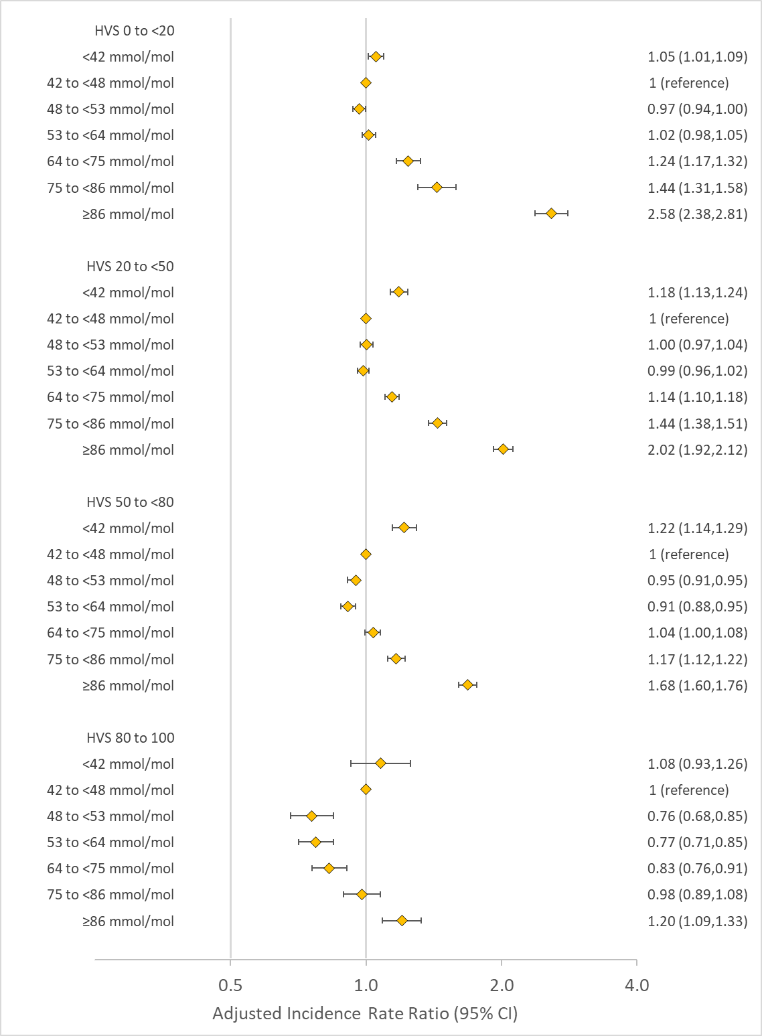

Figure S6 – Adjusted Incidence Rate Ratios for hospitalisation infections by direction of percentage change on last measurement stratified by average HbA1c level.
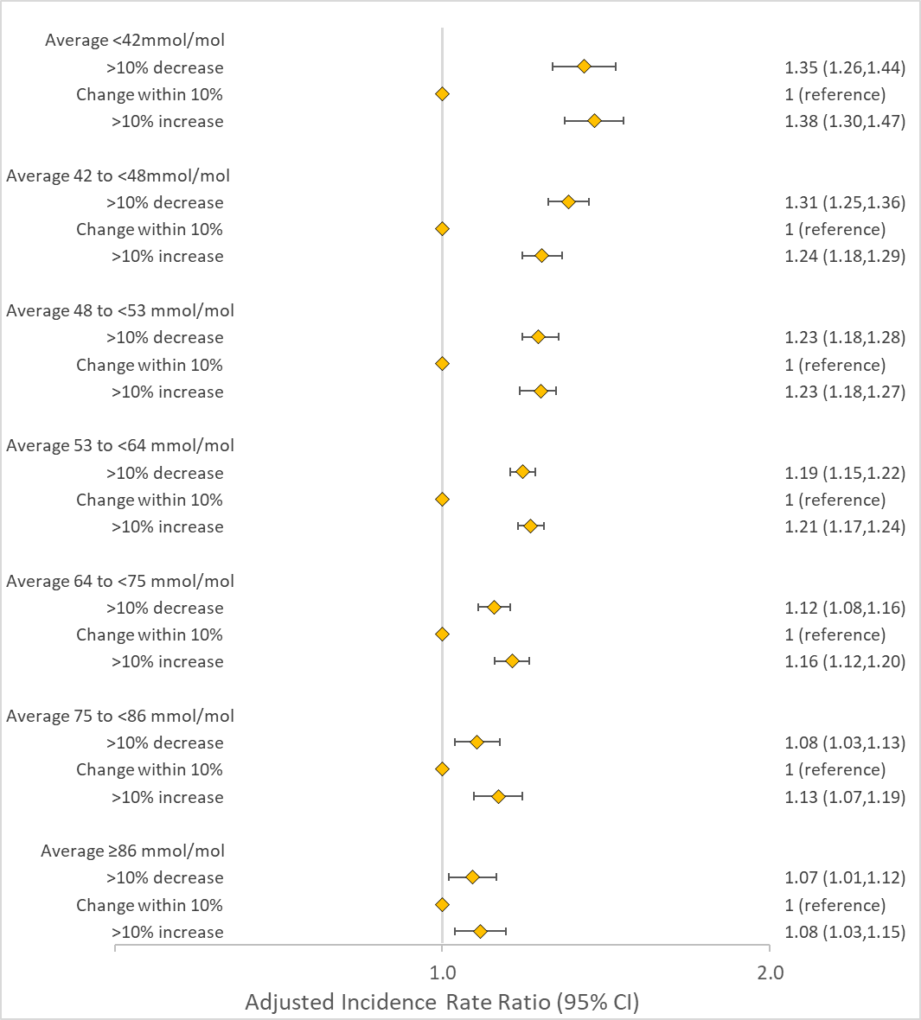

Figure S7 – Distribution of HbA1c variability score (HVS) cross-classified by average HbA1c level by sex and age.
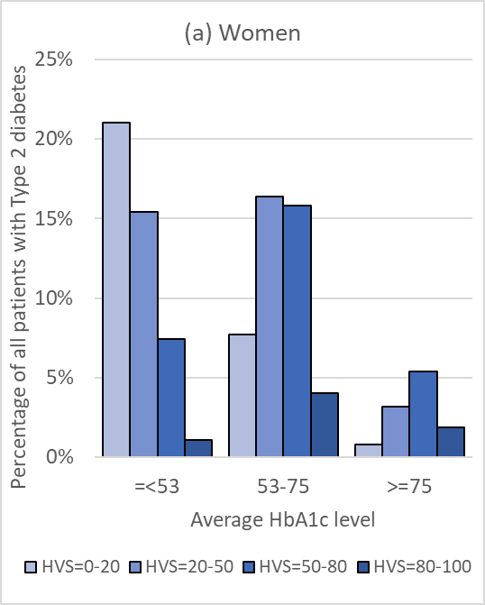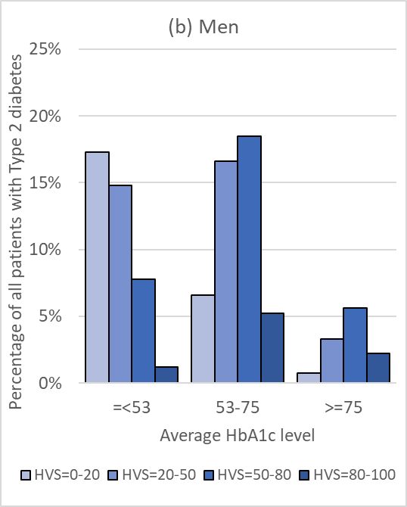
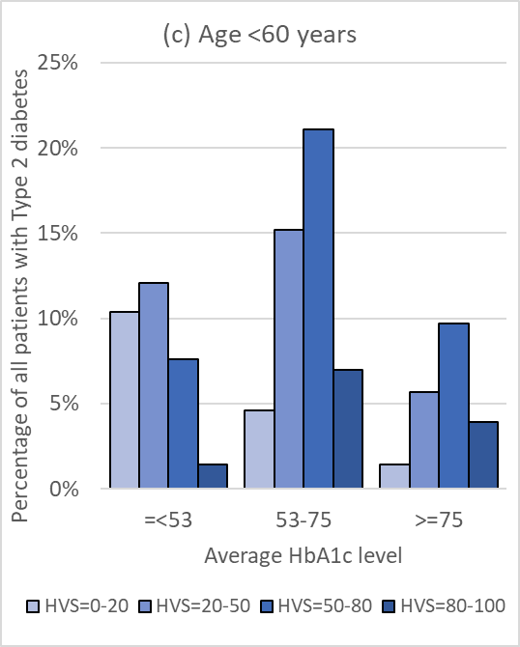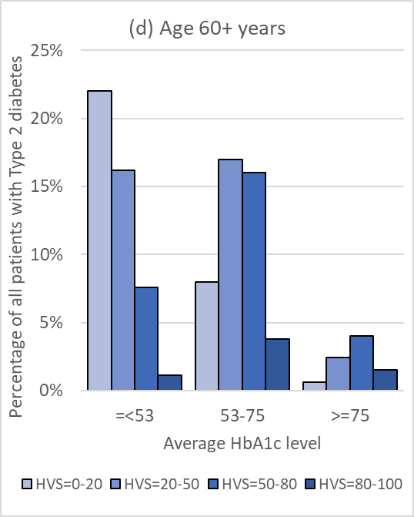

Figure S8 – Distribution of HbA1c variability score (HVS) cross-classified by average HbA1c level by ethnicity.
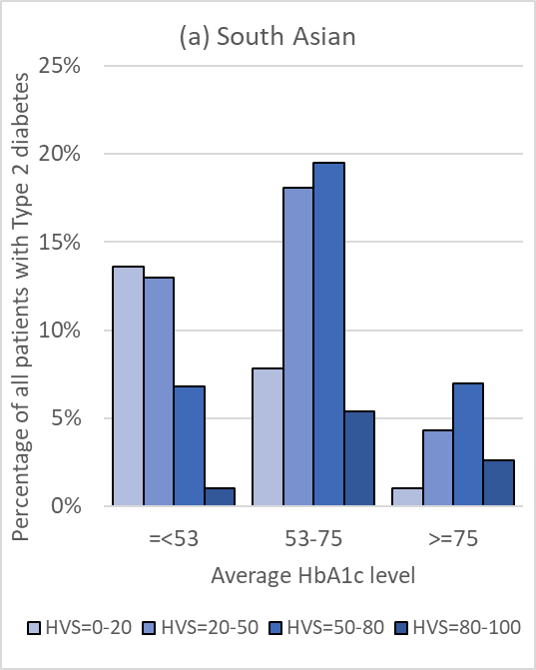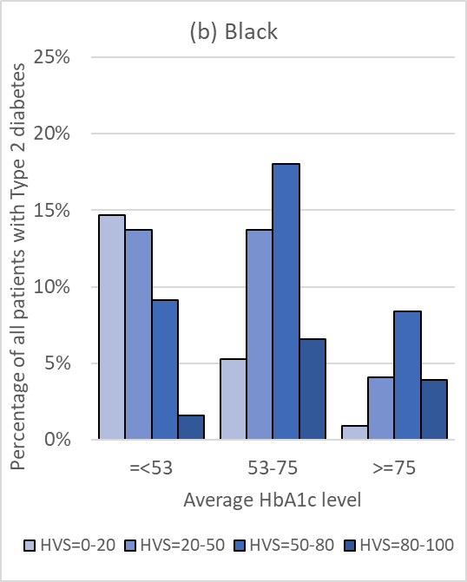
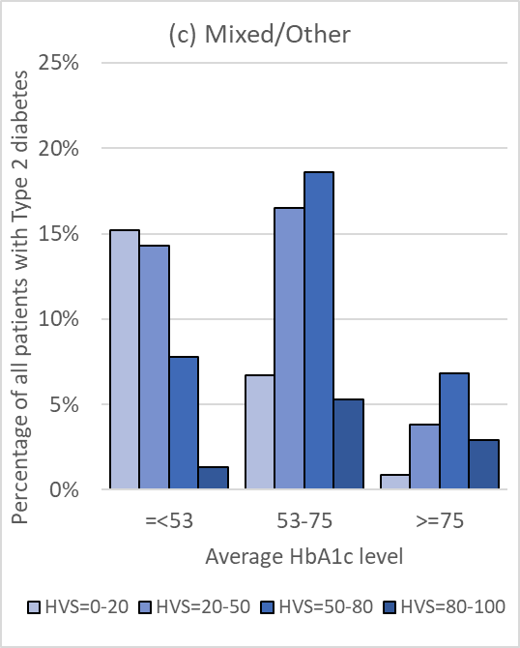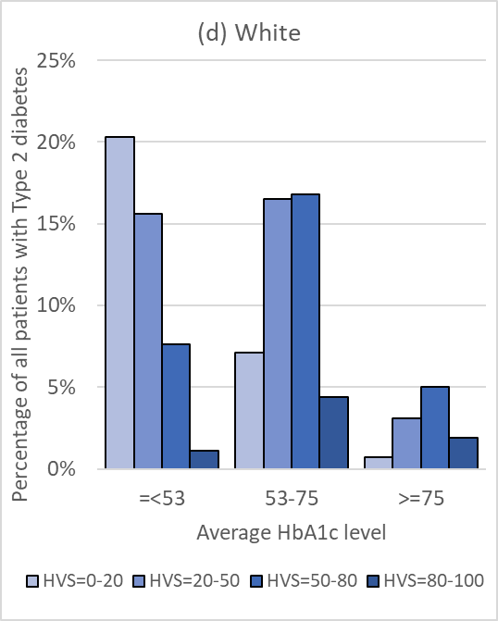

Table S5 – Adjusted incidence rate ratios for average HbA1c level and HbA1c variability score for hospitalisation infections by sex and age.
 | Women  (n=181,891) | Men  (n=230,062) | Age<60  (n=108,139) | Age 60+  (n=303,814)
 | IRR* (95% CI) | IRR* (95% CI) | IRR* (95% CI) | IRR* (95% CI)
Average HbA1c
- <42 | 1.15  (1.10-1.19) | 1.10  (1.06-1.14) | 1.15  (1.07-1.25) | 1.11  (1.08-1.14)
42 to <48 | 1  (Reference) | 1  (Reference) | 1  (Reference) | 1  (Reference)
48 to <53 | 0.98  (0.95-1.01) | 0.96  (0.94-0.99) | 0.91  (0.85-0.97) | 0.98  (0.96-1.00)
53 to <64 | 0.97  (0.95-1.00) | 0.96  (0.94-0.98) | 0.91  (0.85-0.96) | 0.97  (0.96-0.99)
64 to <75 | 1.10  (1.07-1.14) | 1.10  (1.06-1.13) | 1.02  (0.96-1.08) | 1.11  (1.09-1.14)
75 to <86 | 1.25  (1.20-1.30) | 1.32  (1.27-1.37) | 1.25  (1.17-1.33) | 1.29  (1.25-1.33)
≥86 | 1.76  (1.69-1.83) | 1.89  (1.82-1.96) | 1.98  (1.86-2.10) | 1.68  (1.63-1.74)
Attributable Fraction to average (%)* | 4.4% | 3.9% | 3.6% | 3.2%
HbA1c Variability Score (HVS)
0 to <20 | 1  (Reference) | 1  (Reference) | 1  (Reference) | 1  (Reference)
20 to <50 | 1.23  (1.20-1.26) | 1.19  (1.16-1.21) | 1.14  (1.09-1.20) | 1.21  (1.19-1.23)
50 to <80 | 1.44  (1.41-1.48) | 1.33  (1.30-1.36) | 1.24  (1.18-1.31) | 1.40  (1.38-1.43)
80 to 100 | 1.64  (1.58-1.70) | 1.44  (1.39-1.49) | 1.29  (1.22-1.37) | 1.59  (1.55-1.64)
Attributable Fraction to variability (%)* | 17.9% | 16.0% | 14.4% | 16.5%
IRR = Incidence rate ratio adjusts for age, sex, ethnicity, deprivation (IMD), co-morbidity count, smoking and BMI.
* - Attributable fractions estimates assume a casual association under which all patients are moved to reference category

Table S6 – Adjusted incidence rate ratios for average HbA1c level and HbA1c variability score for hospitalisation infections by ethnicity.
 | South Asian  (n=42,199) | Black  (n=16,663) | Mixed/Other  (n=23,219) | White  (n=293,279)
 | IRR* (95% CI) | IRR* (95% CI) | IRR* (95% CI) | IRR* (95% CI)
Average HbA1c
- <42 | 1.18  (1.04-1.33) | 1.21  (1.02-1.43) | 0.95  (0.82-1.11) | 1.12  (1.09-1.15)
42 to <48 | 1  (Reference) | 1  (Reference) | 1  (Reference) | 1  (Reference)
48 to <53 | 0.95  (0.88-1.03) | 1.03  (0.91-1.17) | 0.92  (0.83-1.02) | 0.98  (0.96-1.00)
53 to <64 | 0.96  (0.89-1.03) | 0.99  (0.87-1.11) | 0.91  (0.83-1.00) | 0.97  (0.95-0.99)
64 to <75 | 1.04  (0.96-1.13) | 1.20  (1.05-1.37) | 1.09  (0.98-1.21) | 1.10  (1.08-1.13)
75 to <86 | 1.17  (1.07-1.29) | 1.37  (1.18-1.61) | 1.20  (1.05-1.36) | 1.31  (1.27-1.35)
≥86 | 1.70  (1.55-1.87) | 1.89  (1.63-2.20) | 1.78  (1.57-2.01) | 1.87  (1.80-1.93)
Attributable Fraction to average (%)* | 2.7% | 10.2% | 0.6% | 3.3%
HbA1c Variability Score (HVS)
0 to <20 | 1  (Reference) | 1  (Reference) | 1  (Reference) | 1  (Reference)
20 to <50 | 1.18  (1.11-1.26) | 1.08  (0.98-1.20) | 1.14  (1.05-1.23) | 1.22  (1.20-1.25)
50 to <80 | 1.33  (1.25-1.42) | 1.15  (1.03-1.28) | 1.30  (1.19-1.41) | 1.40  (1.37-1.43)
80 to 100 | 1.54  (1.42-1.67) | 1.13  (0.98-1.30) | 1.28  (1.14-1.44) | 1.56  (1.51-1.60)
Attributable Fraction to variability (%)* | 17.0% | 8.5% | 13.9% | 13.1%
IRR = Incidence rate ratio adjusts for age, sex, ethnicity, deprivation (IMD), co-morbidity count, smoking and BMI.
* - Attributable fractions estimates assume a casual association under which all patients are moved to reference category

Table S7 – Adjusted incidence rate ratios for average HbA1c level and HbA1c variability score for specific hospitalisation infections.
 |  | Type of Infection
 |  | Bone & Joint | Gastro-Intestinal Tract | Genito-urinary | Lower Respiratory Tract | Sepsis | Skin
Annual Incidence Rate | Per 1000 | 1.9 | 10.2 | 14.4 | 28.7 | 15.4 | 7.3
Average HbA1c
- <42 | IRR  (95%CI) | 1.05  (0.86-1.28) | 1.08  (1.01-1.16) | 1.19  (1.12-1.25) | 1.14  (1.10-1.18) | 1.16  (1.10-1.27) | 1.10  (1.01-1.20)
42 to <48 | IRR  (95%CI) | 1 (Reference) | 1 (Reference) | 1 (Reference) | 1 (Reference) | 1 (Reference) | 1 (Reference)
48 to <53 | IRR  (95%CI) | 0.94  (0.81-1.09) | 0.98  (0.93-1.03) | 0.98  (0.94-1.03) | 0.98  (0.96-1.01) | 0.94  (0.90-0.98) | 0.97  (0.91-1.03)
53 to <64 | IRR  (95%CI) | 0.99  (0.86-1.13) | 1.00  (0.95-1.04) | 1.01  (0.97-1.05) | 0.96  (0.93-0.99) | 0.95  (0.91-0.99) | 0.95  (0.89-1.00)
64 to <75 | IRR  (95%CI) | 1.71  (1.48-1.97) | 1.05  (0.99-1.11) | 1.17  (1.12-1.23) | 1.08  (1.04-1.12) | 1.11  (1.06-1.16) | 1.14  (1.06-1.22)
75 to <86 | IRR  (95%CI) | 2.57  (2.20-2.99) | 1.18  (1.11-1.27) | 1.38  (1.30-1.46) | 1.24  (1.19-1.29) | 1.31  (1.24-1.38) | 1.45  (1.35-1.57)
≥86 | IRR  (95%CI) | 5.83  (5.04-6.75) | 1.55  (1.44-1.66) | 1.96  (1.85-2.09) | 1.67  (1.60-1.75) | 1.95  (1.84-2.07) | 2.57  (2.38-2.77)
Attributable Fraction to average (%)† | % | 12.9% | 3.5% | 7.3% | 3.6% | 3.5% | 5.1%
HbA1c Variability Score (HVS)
0 to <20 | IRR  (95%CI) | 1 (Reference) | 1 (Reference) | 1 (Reference) | 1 (Reference) | 1 (Reference) | 1 (Reference)
20 to <50 | IRR  (95%CI) | 1.31  (1.18-1.46) | 1.19  (1.14-1.24) | 1.21  (1.17-1.32) | 1.22  (1.19-1.25) | 1.26  (1.22-1.31) | 1.12  (1.07-1.18)
50 to <80 | IRR  (95%CI) | 1.41  (1.26-1.58) | 1.33  (1.28-1.39) | 1.47  (1.41-1.52) | 1.44  (1.40-1.48) | 1.51  (1.45-1.56) | 1.22  (1.16-1.29)
80 to 100 | IRR  (95%CI) | 1.54  (1.34-1.78) | 1.40  (1.32-1.49) | 1.69  (1.60-1.78) | 1.60  (1.54-1.66) | 1.75  (1.67-1.84) | 1.31  (1.21-1.40)
Attributable Fraction to variability (%)† | % | 19.9% | 15.5% | 19.0% | 18.6% | 20.9% | 11.2%
IRR = Incidence rate ratio adjusts for age, sex, ethnicity, deprivation (IMD), co-morbidity count, smoking and BMI.
* - Attributable fractions estimates assume a casual association under which all patients are moved to reference category

