SUPPLEMENTARY DATA

Table S1: Propensity Matching

Summary of Balance for Unmatched Data:
 | Means COVID | Means Control | Std. Mean Diff.
Age | 61.43 | 58.36 | 0.25
Sex | 0.83 | 0.48 | 0.95
Hypertension | 0.52 | 0.45 | 0.15
Type 2 Diabetes | 0.32 | 0.25 | 0.16
Smoker | 0.72 | 0.72 | 0.004
Summary of Balance for Matched Data:
 | Means COVID | Means Control | Std. Mean Diff.
Age | 61.43 | 58.91 | 0.21
Sex | 0.83 | 0.81 | 0.06
Hypertension | 0.52 | 0.47 | 0.11
Type 2 Diabetes | 0.32 | 0.29 | 0.07
Smoker | 0.72 | 0.70 | 0.05

Figure S1 CMR Protocol

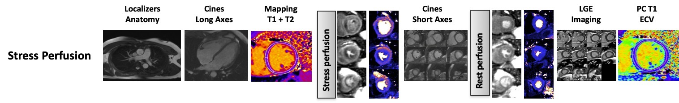

Figure S2 Perfusion Mapping Quality Assurance and Outputs

First-pass perfusion A. Raw data B. Motion corrected (MOCO) image C. Gadolinium corrected image
Graphical data D. Plot of RR intervals E. Arterial Input Function F. Respiratory motion
Stress perfusion maps G. Base H. Mid I. Apex
Bullseye plots J. Stress myocardial blood flow (MBF) K. Rest MBF L. Myocardial perfusion reserve (MPR)
Supplementary Figure 3 CONSORT diagram

Figure S3. CONSORT diagram describing the pathway from clinical CMR post-COVID to final number of patients who underwent stress CMR. Abbreviations - CMR (cardiac magnetic resonance imaging)

