Supplemental material

Electrocardiographic abnormalities in patients with cardiomyopathies

Alberto Aimo^{1,2}, Agnese Milandri³, Andrea Barison^{1,2}, Andrea Pezzato⁴, Paolo Morfino¹, Giuseppe Vergaro^{1,2}, Marco Merlo⁴, Alessia Argirò⁵, Iacopo Olivotto⁶, Michele Emdin^{1,2}, Gherardo Finocchiaro^{7,8}, Gianfranco Sinagra⁴, Perry Elliott⁹, Claudio Rapezzi^{9┼}

1. Interdisciplinary Center for Health Sciences, Scuola Superiore Sant’Anna, Pisa, Italy; 2. Cardiology Division, Fondazione Toscana Gabriele Monasterio, Pisa, Italy; 3. Cardiology Unit, Bentivoglio Hospital, Bologna, Italy; 4. Center for Diagnosis and Management of Cardiomyopathies; Cardiothoracovascular Department Azienda Sanitaria Universitaria Giuliano Isontina (ASUGI) and University of Trieste, Italy; 5. Careggi University Hospital, Florence, Italy; 6. Department of Experimental and Clinical Medicine, University of Florence, Meyer Children Hospital Florence, Italy; 7. Royal Brompton and Harefield Hospital, London, UK; 8. St George’s University of London, UK; 9. UCL Centre for Heart Muscle Disease and lead of the Inherited Cardiovascular Disease Unit, Bart's Heart Centre, London, UK; 10. Cardiology Centre, University of Ferrara, Italy. ┼ deceased.

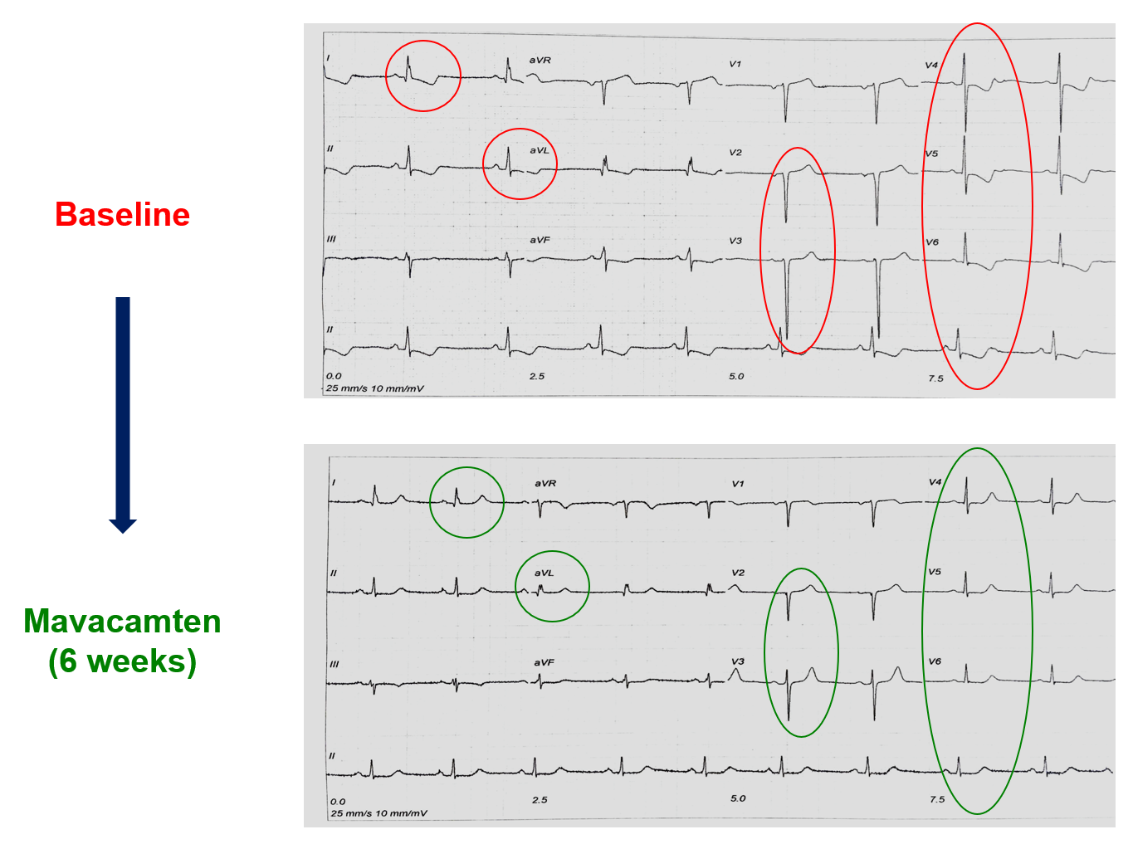
Supplemental Figure 1. Regression of electrocardiographic abnormalities in a 50-year-old patient with hypertrophic cardiomyopathy following therapy with mavacamten for 6 weeks.
Courtesy of Iacopo Olivotto.

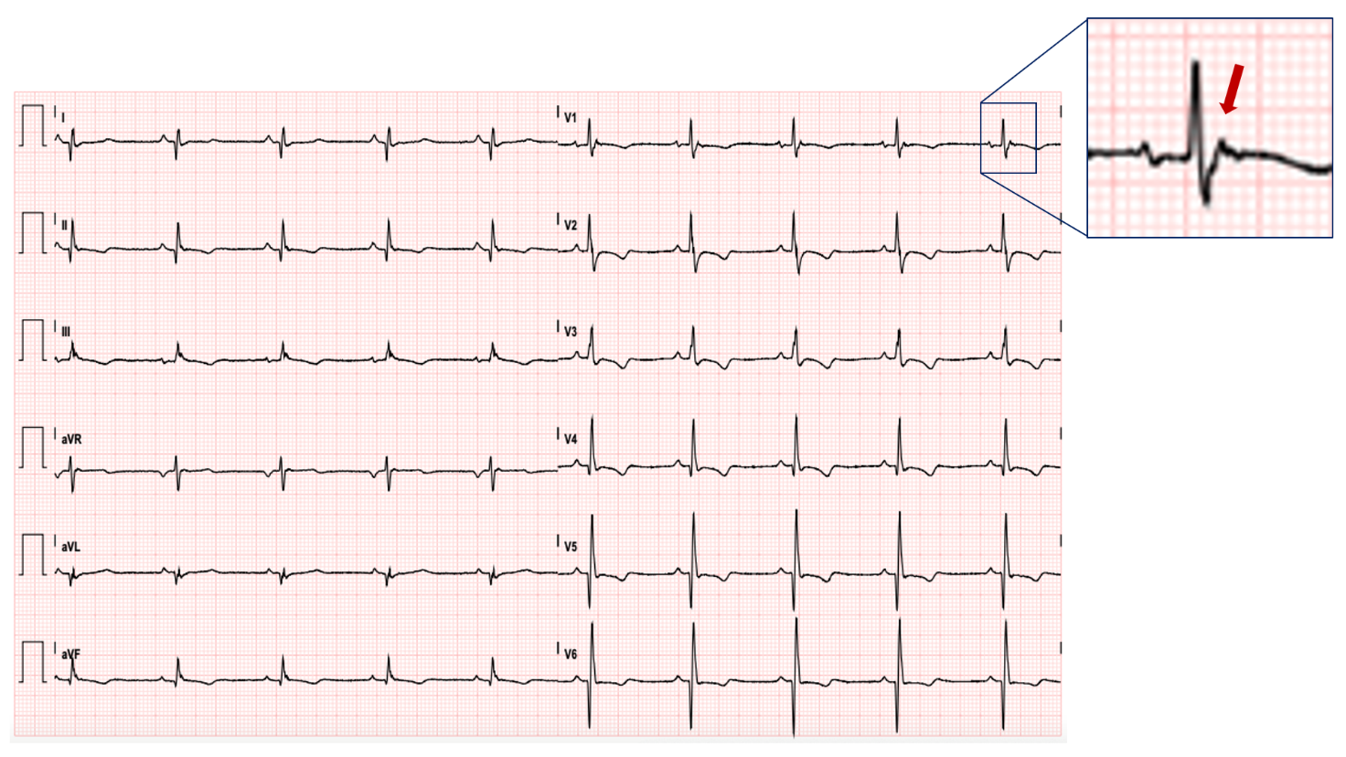
Supplemental Figure 2. The epsilon wave.

