Supplementary material

Supplementary methods

Prevalence meta-analysis
In the base case, prevalence was pooled from all studies combined, with prevalence values from individual studies examined in sensitivity analysis. Figure 1 shows the results of the meta-analysis for acute heart failure prevalence in those presenting to the ED with signs and symptoms of suspected heart failure. Given the heterogeneity across results (I²=0.98), the random effects model results were used in the base case (43.4%).
Figure 1: Forest plot of acute heart failure prevalence among those presenting with symptoms
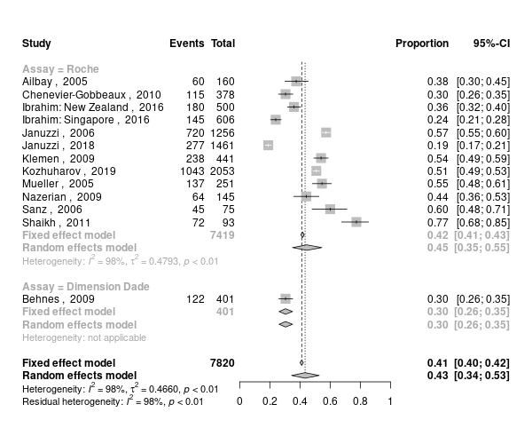
Abbreviations: CI, confidence interval.

Diagnostic test accuracy for NT-proBNP RO
For the NT-proBNP ‘rule-out’ strategy, studies were sourced from the NICE CG187 systematic review and updated with data from newer rule-in/rule-out studies. The new meta-analysis estimates are shown in Figure 2 and Figure 3. A bivariate meta-analysis as detailed by Reitsma 2005 (1), was conducted to calculate the sensitivity and specificity for the NT-proBNP rule-out thresholds and to account for any correlation between the two measures. One study, Behnes 2009 (2), used an NT-proBNP test not produced by Roche and therefore the meta-analysis was sub-grouped to include an overall diagnostic accuracy figure and a Roche only figure, with the Roche only figure being used in the base case. Overall, the central estimates were very similar to those reported in NICE CG187, that is, the new studies appear to have a similar proportion of positive and negative patients with NT-proBNP <300pg/ml to those in other cohorts.
Figure 2: Forest plot for diagnostic accuracy (sensitivity) of the NT-proBNP rule out threshold (300 pg/mL)
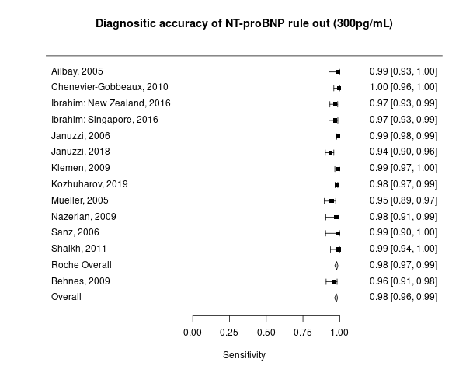
Abbreviations: NT-proBNP, N-terminal pro B-type natriuretic peptide.
Figure 3: Forest plot for diagnostic accuracy (specificity) of the NT-proBNP rule out threshold (300pg/mL)
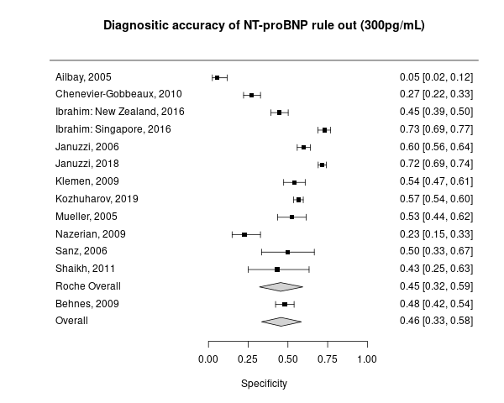
Abbreviations: NT-proBNP, N-terminal pro B-type natriuretic peptide.

Diagnostic test accuracy for NT-proBNP RI/RO
For the diagnostic test accuracy of the NT-proBNP RI/RO strategy, a meta-analysis in the usual sense could not be performed. A 2-step approach was undertaken instead, using the central estimates of sensitivity and specificity from the meta-analysis to quantify the proportion of patients with and without AHF falling below the 300 pg/mL threshold. This ensured that this number was consistent in both NT-proBNP arms of the model. For patients with and without AHF who were above the 300 pg/mL threshold, the proportion that were also above the age-specific thresholds was then obtained. While raw figures were available for Kozhuharov 2019 and Januzzi 2018 (3, 4), figures for Ibrahim 2017 (5) were inferred using sample size, number AHF positive and the sensitivity/specificity reported within the paper. Effectively, these are new univariate diagnostic test accuracy meta-analyses in patients above the 300 pg/mL threshold. Random effects models were selected due to statistical heterogeneity >50%. For the base case, data from the BASEL V study was used rather than the meta-analysis results because the age range was closest to the UK population, it was the largest study and the only one conducted in Europe (4). The meta-analysis results were used in scenario analysis.
Figure 4: Proportion of patients with AHF that are ruled in (TPs)
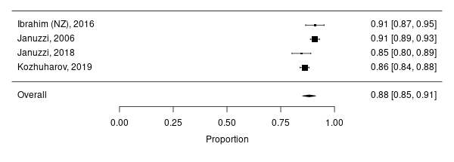
Abbreviations: AHF, acute heart failure; NZ, New Zealand; TP, true positive.
Figure 5: Proportion of patients without AHF that are ruled in (FPs)
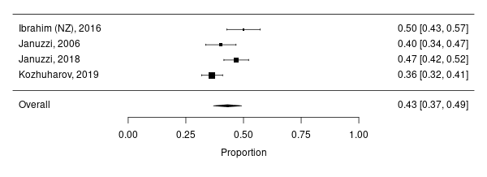
Abbreviations: AHF, acute heart failure; FP, false positive; NZ, New Zealand.

Grey zone analysis
A series of logistic regression models were fitted to the individual patient data for patients in the grey zone from ICON-RELOADED to try to quantify the predictive ability of decision making in the ED (3, 6). Assuming the important variables by which a clinician will make a referral to echocardiogram have been captured in the model, the true sensitivity and specificity of clinical decision in the grey zone should lie at a point on the model’s receiver operating characteristic (ROC) curve. This method of estimating the diagnostic test accuracy of clinical decision has previously been used by Siebert et al. (7). In their analysis the logistic regression was run on all patients to estimate clinical decision alone, while here the analysis was run specifically on grey zone patients.
A number of model specifications were attempted, which included using the original model’s beta-coefficients, re-fitting the original model, re-specifying the original model with alternate candidate variables and including NT-proBNP as a predictive variable within the grey zone. The NT-proBNP value was included as this would be available to the clinician when assessing grey zone patients. Figure 6 shows a summary of the results of all the models of interest compared on the same graph.
Figure 6: ROC curves for all models in the analysis
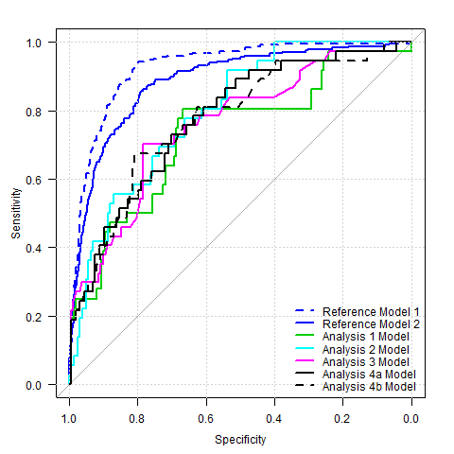
ROC: receiver operating characteristic.
Table 1: AUC statistics for all models in the analysis
 | AUC | 95% CI
Reference Model 1 | 0.926 | 0.908 ; 0.943
Reference Model 2 | 0.885 | 0.862 ; 0.909
Analysis 1 Model | 0.732 | 0.635 ; 0.829
Analysis 2 Model | 0.798 | 0.726 ; 0.870
Analysis 3 Model | 0.758 | 0.670 ; 0.847
Analysis 4a Model | 0.775 | 0.692 ; 0.858
Analysis 4b Model | 0.774 | 0.688 ; 0.859
AUC, area under the curve; CI, confidence interval.
The “Reference Models” here are those built on the whole patient dataset from ICON-RELOADED (N=1461). Reference Model 1 includes NT-proBNP and Reference Model 2 includes clinical variables alone. The “Analysis Models” are built on the grey zone dataset from ICON-RELOADED (N=196).
- Analysis Model 1: A logistic regression model with response variable ADHF and covariates as selected in model 2 is estimated on the grey zone dataset. Odds ratios based on the regression coefficients (e^{β}) are reported with according 95% confidence intervals.
In addition, scores obtained by a 10-fold cross-validated logistic regression model with the same response and covariates on the grey zone dataset are used to perform a ROC analysis. Resulting ROC curve and AUC value with corresponding 95% confidence intervals (10-fold cross-validation stratified by ADHF) are reported.
- Analysis Model 2: A logistic regression model with response variable ADHF and covariates as selected in model 2 is fitted on the full dataset and applied on the grey zone dataset to obtain regression scores, using 10-fold cross-validation stratified by ADHF. The resulting regression scores for the grey zone dataset are used to perform a ROC analysis. Resulting ROC curve and AUC value with corresponding 95% confidence intervals (10-fold cross-validation stratified by ADHF) are reported.
- Analysis Model 3: Variable selection based on logistic regression with lasso penalization with response variable ADHF and the same candidate covariates as in model 2 is performed on the grey zone dataset (lasso penalization parameter lambda selected by cross-validation criterion). Odds ratios based on the regression coefficients (e^{β}) of the final model with the covariates as selected in the variable selection step are reported with according 95% confidence intervals.
In addition, scores obtained by a 10-fold cross-validated logistic regression model with the same response and the covariates as selected by the variable selection step are used to perform a ROC analysis. Resulting ROC curve and AUC value with corresponding 95% confidence intervals (10-fold cross-validation stratified by ADHF) are reported.
- Analysis Model 4a: Variable selection based on logistic regression with lasso penalization with response variable ADHF and the same candidate covariates as in model 2, and additionally NT-proBNP (log_{e}-transformed, pg/mL), is performed on the grey zone dataset (lasso penalization parameter lambda selected by cross-validation criterion). Odds ratios derived by the regression coefficients of the final model with the covariates as selected by the variable selection step are reported with corresponding 95% confidence intervals.
In addition, scores obtained by a 10-fold cross-validated logistic regression model with the same response and the covariates as selected in the variable selection step are used to perform a ROC analysis. Resulting ROC curve and AUC value with corresponding 95% confidence intervals (10-fold cross-validation stratified by ADHF) are reported.
- Analysis Model 4b: Variable selection based on logistic regression with lasso penalization with response variable ADHF and the same candidate covariates as in model 2, and additionally binary variables “age>75 years”, “NT-proBNP>400 pg/mL”, and an interaction term of these two variables, is performed on the grey zone dataset (lasso penalization parameter lambda selected by cross-validation criterion). Odds ratios derived by the regression coefficients of the final model with the covariates as selected by the variable selection step are reported with corresponding 95% confidence intervals.
In addition, scores obtained by a 10-fold cross-validated logistic regression model with the same response and the covariates as selected in the variable selection step are used to perform a ROC analysis. Resulting ROC curve and AUC value with corresponding 95% confidence intervals (10-fold cross-validation stratified by ADHF) are reported.

Conclusions from the new analysis
- The analysis models show that the diagnostic accuracy of clinical decision alone is worse in the grey zone than in the overall population, which is understandable, given that NT-proBNP will correlate with clinical severity.
- The analysis models show that the diagnostic accuracy of clinical decision in the grey zone is still reasonably good in the grey zone, with sensitivity and specificity pairs far away from the central line and the lower CI of the AUC far from the 0.5 which represents randomness.
- The ROC curves are fairly consistent between the different approaches used. AUCs range from 0.73 to 0.8 (vs. 0.885 in the whole dataset) and curves overlap with each other significantly.
- Although the curves are fairly similar, the best prediction appears to be provided by Analysis Model 2, which uses the original variables and beta coefficients from the whole dataset. This suggests that clinical variables can be weighed in the same way for grey zone patients as for the cohort at large.
- NT-proBNP does not appear to improve or hinder prediction within the grey zone.
- Although these new data do not enable us to know the actual sensitivity and specificity of clinical decision in the grey zone, the ROC curve provides some guidance as to the range of plausible values that could be used within the economic model.
- The economic model should be updated with a sensitivity/specificity pair from one of the new grey zone ROC curves.

New economic model results
In the economic model based on ICON-RELOADED, the researchers consulted with a group of clinicians and selected a point on the shoulder of the ROC curve of Reference Model 2 that they felt best represented the central sensitivity and specificity of clinical decision alone (6). They chose the point at 80%/80%. The same approach was followed here to obtain a sensitivity/specificity pair to represent grey zone decision making within the economic model. For the base case a sensitivity/specificity pair sitting near the “shoulder” of the ROC around 80%/60% was assumed. Sensitivity/specific pairs on the ROC curve of 70%/70% and 60%/80% were explored in scenario analysis

Long-term survival
A Kaplan-Meier curve showing up to 5-year survival for patients with AHF first diagnosed in hospital in the UK in the period 2009-2014 was obtained from NICOR 2015 (8). This survival curve was digitised using graph digitisation software (WebPlotDigitizer, Version 4.4) and the resulting X,Y data were converted into synthetic individual patient survival times using the well validated Guyot algorithm (9). Survival analysis was undertaken on the synthetic individual patient data using the survfit and flexsurvreg functions in R, and appropriate parametric curves for use in base case and sensitivity analysis were selected based on visual inspection and Akaike’s Information Criterion (AIC) in line with NICE DSU recommended methods (10). Graphs showing visual fit of the parametric curves to the original Kaplan-Meier data, along with tables of AIC are presented in Figure 7. A one year Kaplan-Meier curve for patients with AHF discharged from hospital during 2017/18 obtained from the NICOR dataset (11), as well as dataset from an observational study by Taylor et al. 2019 (8) were used in sensitivity analysis.
The same methodology was applied to these alternative data. The survival curve within the Taylor paper relates to survival from date of diagnosis, as such, this does not exactly match the desired population of survival from discharge. The authors do highlight that as data is collected from GP registers, a proportion of in hospital AHF deaths are unlikely to have this diagnosis transferred to their GP records. As such, the population may closely match the modelled population of patients after discharge.
Of the fitted parametric curves the Weibull distribution had the second lowest AIC but a better visual fit, especially post year 3, versus the Gamma curve with the best AIC. The parameters of the Weibull curve were included within the PSA; the Gamma curve was included as a scenario analysis.
Figure 7: Parametric curves fitted to the NICOR Kaplan-Meier curves, with AIC and BIC.
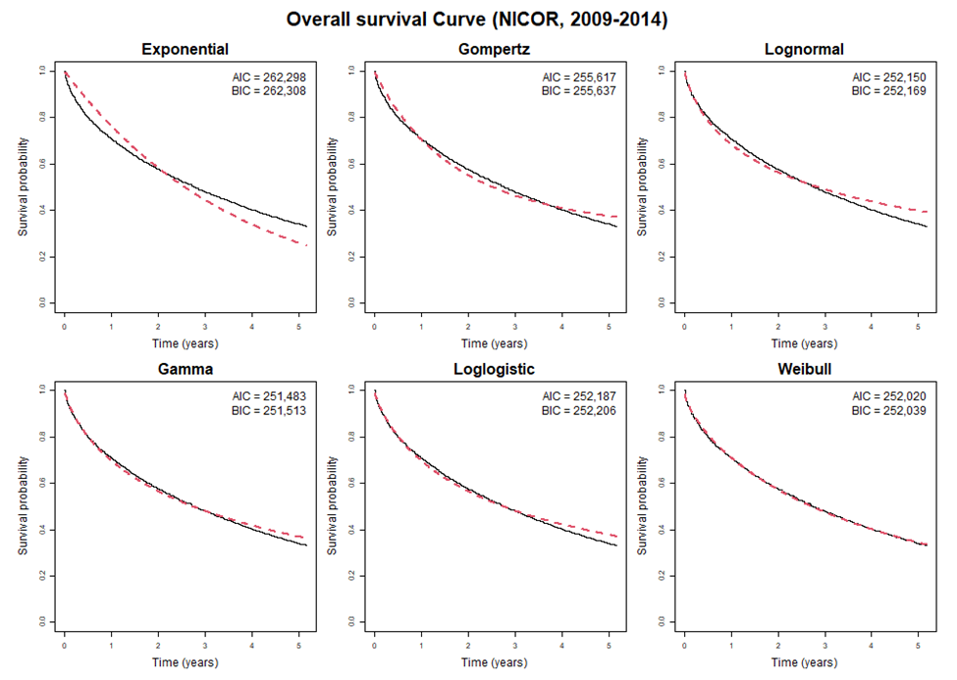
Abbreviations: AIC, Akaike's information criteria; BIC, Bayesian information criteria.
In keeping with the approach taken in CG187, the survival curve for FNs was calculated by applying weighted hazard ratios to the survival curve for TPs, since these patients also have AHF, but don’t benefit from disease modifying interventions. A multivariate cox proportional hazards model conducted on the patients included in the NICOR dataset showed that there were three treatment related factors that were independent predictors of survival: not receiving an angiotensin-converting enzyme inhibitor (ACEi) and/or an angiotensin receptor blocker (ARB), not receiving a beta-blocker, and not receiving cardiologist follow-up (Table 2).
The hazard ratio for being an FN versus a TP was down-weighted by the proportion of patients that received the respective interventions (Table 3). For example, if 75% of TPs received the intervention then the relevant log hazard ratio was weighted by 0.75 for the FN population. At the start of the longer-term model a proportion of TPs were assumed to start on each follow-up service, and the weighted hazard ratios were applied to the overall survival curve to model each population over time.
Although a proportion of patients in the model receive an aldosterone antagonist (AA), which modifies their risk of readmission, AAs were not included as a mortality modifier for unconverted FNs. This is because the multivariate cox model from NICOR did not include an AA variable and of this was introduced exogenously, this would bias the analysis as 57% of patients within the NICOR cox model were already taking AAs. Much of the benefit is likely accounted for if patients were taking AAs alongside beta-blockers and ACEi/ARBs. However, as the NICE model assumed a HR on mortality of 0.8 for AAs this assumption has been explored in scenario analysis (12).
The costs and benefits of sacubitril/valsartan were excluded from the model in the base case. This is firstly because the true incremental cost-effectiveness ratio (ICER) for sacubitril/valsartan was expected to be ~£20,000/QALY and the net benefit therefore ~zero (13). Secondly, no data on sacubitril/valsartan were available in NICOR or the Taylor observational study and the vast majority of the data in the Taylor study relate to a time period prior to sacubitril/valsartan’s approval. Thirdly, limited data were available on the proportion of patients receive sacubitril/valsartan. NHS digital published an estimate of tablet usage between 2018-2020, these figures suggest that 5% of registered heart failure patients are currently on sacubitril/valsartan and rising. Therefore in a conservative sensitivity analysis to account for future increases in use of sacubitril/valsartan, 10% of AHF positive patients were assumed to receive sacubitril/valsartan’s benefits and costs. These 10% of patients were modelled using an adjusted survival curve based on the all-cause mortality hazard ratio taken from the NICE technology appraisal for sacubitril/valsartan (14). The TP survival curve was the sum of the sacubitril/valsartan and non-sacubitril/valsartan population at any given time point.
The committee discussion in NICE TA388 indicates that some patients could be eligible for sacubitril/valsartan straight away; for example, if they were already taking ACEis for another condition or existing HF (13). Rather than attempting to account for a delay in treatment initiation with sacubitril/valsartan, the 10% was therefore applied as a blanket assumption to all positive and converted patients in all cycles of the model.
Patients entering the model were assumed to have a median age of 81 (11). Because of the asymptotic nature of parametric survival curves it is common for a small proportion of patients to remain alive in models to implausibly old ages. The curves were therefore tapered in a linear fashion from age 95 to ensure that all patients in the model had died by age 100.
Table 2: Mortality hazard ratios by follow-up intervention
Follow up service | Hazard ratio (95% CI) | Source
Cardiology follow-up | 0.68 (0.64, 0.73) | NICOR 2021
Beta-blockers | 0.83 (0.76, 0.86) | NICOR 2021
ACEi/ARBs | 0.69 (0.65, 0.74) | NICOR 2021
AAs (MRAs) | 0.80 (0.65,0.98) | NICE 2014
Sacubitril/valsartan | 0.84 (0.76, 0.93) | McMurray et al 2014 (14)
Abbreviations: AA, aldosterone antagonist; ACEi, angiotensin-converting enzyme inhibitors; ARB, angiotensin receptor blocker; CI, confidence interval; MRA, mineralocorticoid receptor antagonist; NICOR, The National Institute for Cardiovascular Outcomes Research.
Table 3: Proportion of TPs receiving follow-up interventions
Drug therapy | Proportion receiving therapy (SE) | Source
Cardiology follow-up | 0.46 | NICOR 2021
ACEi/ARBs | 0.84 (0.001) | NICOR 2021
Beta-blockers | 0.9 (0.001) | NICOR 2021
AAs (MRAs) | 0.57 (0.002) | NICOR 2021
Sacubitril/valsartan | 0.1 | Assumption
Abbreviations: AA, aldosterone antagonist; ACEi, angiotensin-converting enzyme inhibitors; ARB, angiotensin receptor blocker; MRA, mineralocorticoid receptor antagonist; NICOR, The National Institute for Cardiovascular Outcomes Research; SE, standard error; TP, true positive.

Readmission probabilities
Readmission probabilities for TPs were taken from the NICE CG187 economic model (Table 5), and were originally derived from a study of UK AHF patients followed up for four years after diagnosis in hospital. When extending the time horizon of the model beyond 4 years, it was assumed that the monthly proportion of admissions remained constant. As admission probability was very low at this point, any plausible variations in this assumption were not expected to substantially impact the results.
For FNs, admissions were adjusted by a relative risk, as they would not receive appropriate treatments (Table 4). As not all TPs would be expected to receive the benefits of the relevant treatments, relative risks were down-weighted by the proportion of patients receiving the interventions in the latest NICOR data. For example, if 75% of TP patients received the intervention then the relevant log relative risk was weighted by 0.75 for the FN population. The weighted relative risk was then weighted again by the proportion of patients who had converted to TPs at the start of each cycle. At the point that all FNs have converted to TPs, the overall relative risk becomes 1.
In the base case only AAs, ACEi/ARBs, and beta-blockers were applied to calculate the readmission probability for FNs as the study used to calculate the baseline probabilities would not have included any patients on Sacubitril/Valsartan. In the scenario where Sacubitril/Valsartan was explored, a similar method to the survival curve was used, where patients receiving Sacubitril/Valsartan had their readmission probability adjusted using the risk ratio in Table 4, and patients not receiving Sacubitril/Valsartan experienced the baseline readmission probability.
Table 4: Readmission relative risk ratios by follow-up drug therapy
Drug therapy | Risk ratio (95% CI) | Source
Aldosterone Agonists | 0.65 (0.54, 0.78) | CG187
ACEi/ARB | 0.8 (0.75, 0.86) | CG187
Beta-blocker | 0.77 (0.72, 0.84) | CG187
Sacubitril/Valsartan | 0.79 (0.71, 0.89) | McMurray et al 2014 (14)

Table 5: Probability of readmission for heart failure by patient status
Cycle of 3 months | Baseline probability of a HF readmission for TPs | Probability of readmission for unconverted FNs
Cycle 1 | 0.178 | 0.326
Cycle 2 | 0.081 | 0.149
Cycle 3 | 0.071 | 0.130
Cycle 4 | 0.058 | 0.106
Cycle 5 | 0.032 | 0.059
Cycle 6 | 0.057 | 0.105
Cycle 7 | 0.025 | 0.046
Cycle 8 | 0.06 | 0.110
Cycle 9 | 0.038 | 0.070
Cycle 10 | 0.036 | 0.066
Cycle 11 | 0.034 | 0.062
Cycle 12 | 0.033 | 0.061
Cycle 13 | 0.031 | 0.057
Cycle 14 | 0.03 | 0.055
Cycle 15 | 0.029 | 0.053
Cycle 16 | 0.028 | 0.051
Abbreviations: FN, false negative; HF, readmission; TP, true positive.

Additional model parameters

Follow-up care costs
Within the model, patients could receive cardiology follow-up and/or heart failure specialist nurse (HFSN) follow-up. The proportion of patients receiving each service was taken from the latest national heart failure audit, with 46% receiving cardiologist follow-up and 55% receiving HFSN follow-up (11) (Table 6). Per annum itemised resource use for each of these follow-up services was sourced from NICE CG187. Costs were sourced from NICE CG187 and updated to include the latest figures from either NHS Reference Costs or PSSRU Unit Costs (Table 7).
Table 6: Resource use for follow-up services
Follow-up service | Receiving service | Not receiving service
Cardiology
Outpatient visit (first year) | 2 | 0
Outpatient visit (subsequent years) | 1 | 0
NT-proBNP tests (first year) | 2 | 0
Blood tests (first year) | 2 | 0
HFSN follow-up
Community HFSN visit | 4 | 0
GP visit | 3 | 7
Abbreviations: GP, general practitioner; HFSN, heart failure specialist nurse; NT-proBNP, N-terminal pro B-type natriuretic peptide.
Table 7: Follow-on resource use cost
Follow-on service | Cost | Source
GP visit | £42.32 | PSSRU Unit Costs 2019/20: 11.7 minute consultation
Community HFSN visit | £49.25 | PSSRU Unit Costs 2019/20: Nurse Specialist (Community), 1 hour.
Hospital outpatient visit | £145 | NHS Reference Costs 2019/20: Cardiology outpatient visit.
Blood test | £2 | NHS Reference Costs 2018/19: Integrated blood services.
Abbreviations; HFSN, heart failure specialist nurse; NHS, National Health Service; PSSRU, Personal Social Services Research Unit.
In line with the methodology from the NICE CG187 model, average unit costs for each of the drug therapies were calculated using NHS tariff costs (15), with dosage taken from the British National Formulary (16), and then weighted by the proportion of each drug being prescribed in the 2020 prescription cost analysis (17) (Table 8). As was highlighted in the NICE guideline this includes all prescriptions of these drugs, and therefore may not be a perfect representation of the case mix for CHF-specific prescription.
Table 8: Weighted daily cost of follow up drug therapy
Drug class | Drugs | Weighted average cost
ACEi/ARB | Enalapril maleate, lisinopril, perindopril erbumine, ramipril/candesartan cilexetil, irbesartan, losartan potassium, valsartan | £0.11
Beta-blockers | Bisoprolol fumarate, carvedilol, nebivolol | £0.03
Aldosterone antagonist | Eplerenone, spironolactone | £0.08
Sacubitril/valsartan | Sacubitril, Valsartan | £3.27
Abbreviations: ACEi, angiotensin-converting enzyme inhibitors; ARB, angiotensin receptor blocker.

Inputs for the European scenario analyses
A summary of the alternative inputs for the European scenario analyses is provided in Table 9.
Due to lack of audit data for the European countries, it was assumed that 100% of TPs/FPs would receive echocardiograms, the same proportion of patients would receive cardiology follow-up as the UK, and all patients would visit a GP over a HF nurse. Given that ESC guidance for follow-up care is aligned with NICE guidance, contact time with consultants and GPs was assumed to be equal to the NICE CG187 model. Costs were sourced from national databases where possible, with currency conversion used where costs were not available.
For the Netherlands, the cost of an AHF admission was based on a weighted average of the Zorgproduct codes 99899024, 99899049, 99899050, 99899108. For non-AHF admissions, the weighted average cost of all codes relating to a nursing day or bed day (excluding heart failure) was used, in line with the UK methodology (18).
For Spain, the average cost of an AHF admission was sourced directly from GRP-APR code 194. For non-AHF admissions, the cost was assumed to be equal to the Spanish bed day cost multiplied by the average length of stay for non-AFH admissions for the UK. Although this is a pragmatic assumption, the ratio of cost between TP and TN was similar to the Netherlands.
Table 9: Alternative model parameters for European country scenario analyses
Variable group | Variable | The Netherlands |  | Spain
 |  | Input | Source | Input | Source
Costs | Discount rate | Costs: 4%  QALYs: 1.5% | ISPOR HEOR resources (19) | 3% | ISPOR HEOR resources (20)
 | Cost of an AHF admission (for TP patients | €4,919.99 | Dutch Healthcare Authority DIS (18) | €3,395.80 | Hospital costs - Analytical Accounting (21)
 | Cost of a non-AHF admission (for TN patients) | €3,269.45 | Dutch Healthcare Authority DIS (18) | €2,156.60 | Assumption: bed day cost multiplied by UK average length of stay for non-AHF admission
 | Cost of an excess bed day for admitted FP patients | €479 | Institute for Medical Technology Assessment (iMTA) (22) | €385.80 | Mainar et al. 2015 (23)
 | Cost of an excess bed day for admitted FN patients | €479 | Assumption: equivalent to FP patients | €385.80 | Assumption: equivalent to FP patients
 | Cost of echocardiogram | €117 | Treskes et al. 2022 (24) | €137 | Ciruelos et al. 2019 (25)
Follow-up costs | GP visit | €33 | Institute for Medical Technology Assessment (iMTA) (22) | € 78.45 | Leon-Justel et al. 2021 (26)
 | Hospital outpatient visit | €94 |  | € 97.83
Drug costs | ACEi/ARB | € 0.13 | Regulation on maximum prices for medicines (27) | € 0.09
 | Beta-blockers | €0.11 |  | €0.04
 | Aldosterone antagonist | €0.53 |  | €0.04
Resource use | Proportion or patients receiving echocardiogram | 1 | Assumption | 1 | Assumption
Mortality | Proportion of patients seeing a specialist | 0.46 | Assumed equal to UK | 0.46 | Assumed equal to UK
Currency conversion | GBP to EUR | 1.17 | Online currency converter (28) | 1.17 | Online currency converter (28)
Footnote: NHB = incremental gain in QALYs – (incremental cost / opportunity cost threshold). Opportunity cost threshold: UK £20,000; the Netherlands €50,000; Spain €30,000. ICER, incremental cost-effectiveness ratio; NA, not applicable; NHB, net health benefit; NT-proBNP, N-terminal pro B-type natriuretic peptide; QALY, quality-adjusted life year; RI, rule-in; RO, rule-out; UK, United Kingdom.
Table 10: Intermediate results for the Netherlands and Spain
Intermediate outcomes | Clinical decision alone | NT-proBNP RO strategy | NT-proBNP RI/RO strategy
Sensitivity | 78.0% | 98.0% | 95.3%
Specificity | 81.0% | 45.4% | 66.2%
PPV | 75.9% | 57.9% | 68.4%
NPV | 82.8% | 96.7% | 94.8%
HF deaths during the decision tree | 39.4 | 34.7 | 35.4
Initial admissions | 753 | 793 | 742
Total echocardiograms during initial admissions | 484.7 | 673.5 | 566.0
Readmissions | 339.1 | 346.3 | 345.3
Life years for AHF patients in the long-term model | 1956.6 | 2011.2 | 2003.6

Netherlands societal perspective scenario analysis
While the model was set up from a healthcare perspective, Dutch guidelines indicate that economic analyses should follow a societal perspective (19), considering productivity loss, informal care, and travel costs. Model parameters for these variables were sourced from Ramos et al. 2017 (29). Ramos et al. directly relates to heart failure patients and is therefore likely generalisable to this analysis. The estimated cost of informal care was €66 per month, inflated to €71 via the iMTA tool (22). This was applied only to TP/FNs as the model does not estimate the survival of non-AHF patients, nor is it assumed that there is an inpatient mortality for incorrect diagnosis of FP/TNs, and as such costs for FP/TNs would be equivalent across treatment strategies. Travel expenses of €5.07 (inflated from €4.73) were also assigned to each follow-up contact (GP or consultant).
Lastly, a single per patient productivity loss cost of €78 per day (inflated from €73) was assigned to each patient, calculated based on the age break down from Kozhuharov et al. (BASEL V) (4), and the age-specific costs from Ramos et al. This was conservatively applied to AHF and non-AHF patients for one month post-admission. Ramos et al. did not consider the productivity lost/gained due to differences in mortality. For the model, mortality was applied equally across the age groups using Kozhuharov et al., and the time between death and retirement was estimated as the age group mid-point up until a retirement age of 65.
The sensitivity analysis results show that the inclusion of societal costs do not materially alter the comparison between RO and RI/RO, due to the marginal differences in sensitivity. However, they do significantly alter the comparisons between NT-proBNP and clinical decision alone, resulting in both RO/RI and RO dominating clinical decision alone. The poor sensitivity of clinical decision alone means a larger proportion of patients die before retirement and are therefore associated with a productivity loss. However, there are some limitations to the conclusion. As the pragmatic approach to modelling productivity loss assumed equal mortality across age groups it likely overestimated productivity loss for less sensitive strategies. The true mortality rate in the working cohort (associated with the greatest productivity loss) is expected to be lower than modelled. While the impact on productivity may not be as dramatic as seen here, the direction of the impact would remain unchanged, thus favouring NT-proBNP strategies over clinical decision alone.
Table 11: Cost-effectiveness results for Netherlands societal perspective scenario analysis
Strategy | Costs | QALYs | ICER vs clinical decision alone | ICER vs RI/RO strategy
Clinical decision alone | €15,769,454 | 1,378.56 | - | -
NT-proBNP RI/RO | €15,252,111 | 1,401.14 | RI/RO dominates | -
NT-proBNP RO | €15,769,454 | 1,378.56 | RO dominates | €126,086
ICER, incremental cost-effectiveness ratio; NT-proBNP, N-terminal pro B-type natriuretic peptide; QALY, quality-adjusted life year; RI, rule-in; RO, rule-out.

Other scenario analysis results
Sensitivity and scenario analyses are presented in Table 12 in terms of NHB. In each scenario analysis, the strategy with the highest NHB is the most cost-effective.
Table 12: NHB for the three strategies in scenario analysis
Scenario |  | NT-proBNP RI/RO | Clinical decision alone | NT-proBNP RO
Sensitivity/specificity of clinical decision alone | IMPROVE (base case) | 1050.88 | 1029.75 | 1043.57
 | NICE/ICON | 1050.88 | 1029.91 | 1043.57
Admission probabilities for RO | Composite inclusive of grey zone (base case) | 1050.88 | 1029.75 | 1043.57
 | Aligned with non-grey zone RI/RO values | 1050.88 | 1029.75 | 1050.67
Mortality in the decision tree for non-admitted patients | Aligned with inpatient mortality for admitted patients (base case) | 1050.88 | 1029.75 | 1043.57
 | No mortality | 1060.06 | 1042.16 | 1052.11
Admission probabilities for clinical decision alone and RI/RO strategy non-grey zone NT-proBNP | ICON-RELOADED economic model (base case) | 1050.88 | 1029.75 | 1043.57
 | Siebert 2006 | 1043.78 | 1019.28 | 1038.67
Cardiology follow-up for FPs in the longer-term model | Included (base case) | 1050.88 | 1029.75 | 1043.57
 | Excluded | 1051.11 | 1029.83 | 1043.94
Prevalence of AHF | Meta-analysis (base case) | 1050.88 | 1029.75 | 1043.57
 | BNP study | 1146.00 | 1123.42 | 1139.60
 | ICON-RELOADED | 395.05 | 383.97 | 381.48
Rates of echocardiogram for FNs during admission (conversion to TPs) | 80% (base case) | 1050.88 | 1029.75 | 1043.57
 | 0% | 1047.72 | 1014.65 | 1042.23
 | 100% | 1051.67 | 1033.53 | 1043.90
Conversion of FPs to TNs in the longer-term model | After 1 cycle (base case) | 1050.88 | 1029.75 | 1043.57
 | Exp admissions curve | 1048.77 | 1020.27 | 1042.67
 | Median 0.25 yrs | 1049.91 | 1025.42 | 1043.16
 | Median 1 yr | 1047.38 | 1014.04 | 1042.09
 | Median 2 yrs | 1045.68 | 1006.39 | 1041.36
 | Never | 1041.47 | 987.49 | 1039.58
 | Exact cumulative admissions match | 1047.54 | 1014.77 | 1042.15
Sensitivity/specificity of NT-proBNP RO at 300 pg/mL threshold | Meta-analysis excluding Behnes 2009 (base case) | 1050.88 | 1029.75 | 1043.57
 | BASEL over 75s only | 1044.80 | 1029.75 | 1035.12
Probability that patients with AHF have an NT-proBNP result > age-specific rule-in threshold | BASEL (base case) | 1050.88 | 1029.75 | 1043.57
 | ICON | 1050.54 | 1029.75 | 1043.57
 | New Zealand | 1051.95 | 1029.75 | 1043.57
 | Singapore | 1052.09 | 1029.75 | 1043.57
 | Januzzi meta-analysis | 1051.95 | 1029.75 | 1043.57
 | Meta-analysis excl. Singapore | 1051.35 | 1029.75 | 1043.57
 | Meta-analysis all | 1051.47 | 1029.75 | 1043.57
 | Over 75s only | 1050.03 | 1029.75 | 1043.57
Probability that patients without AHF have an NT-proBNP result > age-specific rule-in threshold | BASEL (base case) | 1050.88 | 1029.75 | 1043.57
 | ICON | 1050.33 | 1029.75 | 1045.00
 | New Zealand | 1050.17 | 1029.75 | 1045.40
 | Singapore | 1050.08 | 1029.75 | 1045.60
 | Januzzi meta-analysis | 1050.68 | 1029.75 | 1044.11
 | Meta-analysis excl. Singapore | 1050.53 | 1029.75 | 1044.51
 | Meta-analysis all | 1050.45 | 1029.75 | 1044.70
 | Over 75s only | 1051.34 | 1029.75 | 1042.17
QALY penalty for FPs in the longer-term model | 0 (base case) | 1050.88 | 1029.75 | 1043.57
 | -0.01 | 1050.42 | 1029.60 | 1042.82
 | -0.05 | 1048.57 | 1029.00 | 1039.84
 | -0.1 | 1046.27 | 1028.25 | 1036.11
 | -0.2 | 1041.65 | 1026.74 | 1028.65
Survival curve tapering | Taper survival curve to 0 at age 100 (base case) | 1050.88 | 1029.75 | 1043.57
 | Do not taper survival curve | 1069.93 | 1048.49 | 1062.67
Parametric survival curve for TPs | NICOR 2014 Weibull (base case) | 1050.88 | 1029.75 | 1043.57
 | NICOR 2014 Gamma | 1053.75 | 1027.39 | 1407.31
 | Taylor 2019 Gamma | 1053.75 | 1027.39 | 1047.31
 | NICOR 2019 Gamma | 1390.18 | 1361.26 | 1384.14
 | NICOR 2019 Exp | 948.33 | 933.30 | 940.02
Specificity/sensitivity of grey zone clinical decision | 80/60% (base case) | 1050.88 | 1029.75 | 1043.57
 | 70%/70% (Analysis model 2 ROC) | 1049.57 | 1029.75 | 1043.10
 | 60%/80% (Analysis model 2 ROC) | 1048.26 | 1029.75 | 1042.96
 | Aligned with clinical decision alone | 1051.09 | 1029.75 | 1042.97
Cost of excess bed days for AHF and non-AHF patients | NHS reference costs (base case) | 1050.88 | 1029.75 | 1043.57
 | HRG reference data | 1046.72 | 1026.18 | 1037.10
 | NHS tariff costs | 1052.20 | 1031.05 | 1045.58
Proportion of TPs receiving sacubitril/valsartan | 0% (base case) | 1050.88 | 1029.75 | 1043.57
 | 10% | 1060.88 | 1040.81 | 1053.39
Probability of admission in the NT-proBNP RI/RO strategy grey zone | Empirically observed and adjusted for diagnostic classification (base case) | 1050.88 | 1029.75 | 1043.57
 | Aligned with clinical decision alone | 1051.24 | 1029.75 | 1043.81
 | Empirically observed but not changed by positive/negative status | 1051.27 | 1029.75 | 1047.51
 | Aligned with non-grey zone RI/RO NT-proBNP | 1057.20 | 1029.75 | 1050.67
Mortality hazard ratio for AA/MRA | HR = 0 (base case) | 1050.88 | 1029.75 | 1043.57
 | NICE assumption HR = 0.80 | 1050.21 | 1026.74 | 1043.28
Footnotes: Green indicates the most cost-effective strategy, orange indicates the second most cost-effective strategy, and red indicates the least cost-effective strategy.
Abbreviations: AHF, acute heart failure; FN, false negative; FP, false positive; HRG, healthcare resource group; NHS, National Health Service; NICE, National Institute of Health and Care Excellence; NICOR, National Institute for Cardiovascular Outcomes Research; NT-proBNP, N-terminal pro B-type natriuretic peptide; QALY, quality-adjusted life year; RI, rule-in; RO, rule-out; TP, true positive.

Structural sensitivity analysis
The results for the NICE inspired structural sensitivity analysis (assuming 100% admission from the ED) were similar to the base case, with both NT-proBNP strategies being comfortably cost-effective versus clinical decision alone (Table 13). While RO was still not cost-effective compared to RI/RO, the ICER was much lower, because the potential benefit of reduced admissions in the NT-proBNP RI/RO strategy comparted with the RO is not factored into this model.
Table 13: Cost-effectiveness results for NICE structural sensitivity analysis
NICE | Costs | QALYs | NHB | ICER vs clinical decision alone | ICER vs RI/RO strategy
Clinical decision alone | £5,365,787 | 1,257.39 | 989.10 | - | -
NT-proBNP RI/RO | £5,423,489 | 1,272.58 | 1,001.41 | £3,798/QALY | -
NT-proBNP RO | £5,505,227 | 1,274.98 | 999.72 | £7,928 /QALY | £34,122/QALY
Abbreviations: ICER, incremental cost-effectiveness ratio; NHB, net health benefit; NICE, National Institute of Health and Care Excellence; NT-proBNP, N-terminal pro B-type natriuretic peptide; QALY, quality-adjusted life year; RI, rule-in; RO, rule-out; TP, true positive.

References
1. Reitsma JB, Glas AS, Rutjes AW, Scholten RJ, Bossuyt PM, Zwinderman AH. Bivariate analysis of sensitivity and specificity produces informative summary measures in diagnostic reviews. Journal of clinical epidemiology. 2005;58(10):982-90.
2. Behnes M, Brueckmann M, Ahmad-Nejad P, Lang S, Wolpert C, Elmas E, et al. Diagnostic performance and cost effectiveness of measurements of plasma N-terminal pro brain natriuretic peptide in patients presenting with acute dyspnea or peripheral edema. International journal of cardiology. 2009;135(2):165-74.
3. Januzzi JL, Chen-Tournoux AA, Christenson RH, Doros G, Hollander JE, Levy PD, et al. N-terminal pro–B-type natriuretic peptide in the emergency department: the ICON-RELOADED study. Journal of the American College of Cardiology. 2018;71(11):1191-200.
4. Kozhuharov N, Sabti Z, Wussler D, Nowak A, Badertscher P, Twerenbold R, et al. Prospective validation of N‐terminal pro B‐type natriuretic peptide cut‐off concentrations for the diagnosis of acute heart failure. European journal of heart failure. 2019;21(6):813-5.
5. Ibrahim I, Kuan WS, Frampton C, Troughton R, Liew OW, Chong JPC, et al. Superior performance of N‐terminal pro brain natriuretic peptide for diagnosis of acute decompensated heart failure in an Asian compared with a Western setting. European journal of heart failure. 2017;19(2):209-17.
6. Siebert U, Milev S, Zou D, Litkiewicz M, Gaggin HK, Tirapelle L, et al. Economic Evaluation of an N-terminal Pro B-type Natriuretic Peptide-Supported Diagnostic Strategy Among Dyspneic Patients Suspected of Acute Heart Failure in the Emergency Department. The American Journal of Cardiology. 2021;147:61-9.
7. Siebert U, Milev S, Zou D, Litkiewicz M, Gaggom H, Tirapelle L, et al. PMU18 Economic evaluation of an NT-proBNP-supported diagnostic strategy among dyspneic patients suspected of acute heart failure in the emergency department. Value in Health. 2020;23:S236.
8. The National Institute for Cardiovascular Outcomes Research (NICOR). National Heart Failure Audit April 2013-March 2014. 2015. Available from: https://www.nicor.org.uk/wp-content/uploads/2019/02/hfannual13-14-updated.pdf. Accessed on: 8 July 2022
9. Guyot P, Ades A, Ouwens MJ, Welton NJ. Enhanced secondary analysis of survival data: reconstructing the data from published Kaplan-Meier survival curves. BMC medical research methodology. 2012;12(1):1-13.
10. Latimer N. NICE DSU technical support document 14: survival analysis for economic evaluations alongside clinical trials-extrapolation with patient-level data. 2011. Available from: http://nicedsu.org.uk/wp-content/uploads/2016/03/NICE-DSU-TSD-Survival-analysis.updated-March-2013.v2.pdf. Accessed on: 31 January 2022
11. The National Institute for Cardiovascular Outcomes Research (NICOR). National Cardiac Audit Programme National Heart Failure Audit (NHFA) 2021 Summary Report (2019/20 data). 2021. Available from: https://www.nicor.org.uk/wp-content/uploads/2021/10/NHFA-Domain-Report_2021_FINAL.pdf. Accessed on: 25 January 2022
12. National Institute for Health and Care Excellence (NICE). Acute heart failure: diagnosis and management (CG187). 2014. Available from: https://www.nice.org.uk/guidance/cg187. Accessed on: 25 January 2022
13. National institute for Health and Care Excellence (NICE). Sacubitril valsartan for treating symptomatic chronic heart failure with reduced ejection fraction (TA388). 2016. Available from: https://www.nice.org.uk/guidance/ta388. Accessed on: 31 January 2022
14. McMurray JJ, Packer M, Desai AS, Gong J, Lefkowitz MP, Rizkala AR, et al. Angiotensin–neprilysin inhibition versus enalapril in heart failure. N Engl J Med. 2014;371:993-1004.
15. NHS Business Services Authority. NHS Electronic Drug Tariff. 2021. Available from: http://www.drugtariff.nhsbsa.nhs.uk/#/00446515-DC_2/DC00446511/Home. Accessed on: 25 January 2022
16. British National Formulary (BNF). Available from: https://bnf.nice.org.uk/. Accessed on: 25 January 2022
17. NHS Business Services Authority. Prescription Cost Analysis - England 2020/21. 2020. Available from: https://www.nhsbsa.nhs.uk/statistical-collections/prescription-cost-analysis-england/prescription-cost-analysis-england-202021. Accessed on: 25 January 2022
18. Nederlandse Zorgautoriteit (NZa). DBC-Informatiesysteem. “Zorgactiviteiten per jaar, specialisme, diagnose, zorgproduct.”. Available from: https://www.opendisdata.nl/downloads. Accessed on: 22 June 2022
19. International Society for Pharmacoeconomics and Outcomes Research (ISPOR). Pharmacoeconomic Guidelines: The Netherlands. 2020. Available from: https://www.ispor.org/heor-resources/more-heor-resources/pharmacoeconomic-guidelines/pe-guideline-detail/the-netherlands. Accessed on: 29th June 2022
20. International Society for Pharmacoeconomics and Outcomes Research (ISPOR). Pharmacoeconomic Guidelines: Spain. 2020. Available from: https://www.ispor.org/heor-resources/more-heor-resources/pharmacoeconomic-guidelines/pe-guideline-detail/spain. Accessed on: 29th June 2022
21. Ministerio de Sanidad. Costes hospitalarios - Contabilidad Analítica. 2019. Available from: https://www.sanidad.gob.es/estadEstudios/estadisticas/inforRecopilaciones/anaDesarrolloGDR.htm. Accessed on: 29th June 2022
22. Institute for Medical Technology Assessment (iMTA). The iMTA Disease Burden Calculator (iDBC) for proportional shortfall and fair innings for The Netherlands. Available from: https://www.imta.nl/. Accessed on: 22 June 2022
23. Mainar AS, Artieda RN, Nolla JI. Economic impact of heart failure according to the effects of kidney failure. Revista Española de Cardiología (English Edition). 2015;68(1):39-46.
24. Treskes RW, van den Akker-van ME, van Winden L, van Keulen N, van der Velde ET, Beeres S, et al. The Box—eHealth in the Outpatient Clinic Follow-up of Patients With Acute Myocardial Infarction: Cost-Utility Analysis. Journal of Medical Internet Research. 2022;24(4):e30236.
25. Ciruelos E, Alba E, López R, Lluch A, Martín M, Arroyo I, et al. Contribution of trastuzumab to the prognostic improvement of HER2-positive early breast cancer in Spain: an estimation of life years and disease-free life years gained since its approval. Oncotarget. 2019;10(42):4321.
26. Leon-Justel A, Morgado Garcia-Polavieja JI, Alvarez-Rios AI, Caro Fernandez FJ, Merino PAP, Galvez Rios E, et al. Biomarkers-based personalized follow-up in chronic heart failure improves patient’s outcomes and reduces care associate cost. Health and quality of life outcomes. 2021;19(1):1-12.
27. De Minister van Volksgezondheid, Welzijn en Sport. Regeling maximumprijzen geneesmiddelen. Available from: https://wetten.overheid.nl/BWBR0008023/2015-07-01#Opschrift. Accessed on: 28th June 2022
28. Xe Currency Converter. 1 GBP to EUR. 2022. Available from: https://www.xe.com/currencyconverter/convert/?Amount=1&From=GBP&To=EUR Accessed on: 27th May 2022
29. Ramos IC, Versteegh MM, de Boer RA, Koenders JM, Linssen GC, Meeder JG, et al. Cost effectiveness of the angiotensin receptor neprilysin inhibitor sacubitril/valsartan for patients with chronic heart failure and reduced ejection fraction in the Netherlands: a country adaptation analysis under the former and current Dutch Pharmacoeconomic Guidelines. Value in Health. 2017;20(10):1260-9.

