This supplementary figure simulates several scenarios in which system level function (shown by contour maps) depends on two core parameters (that scale over the x- and y- axis). Each panel illustrates a potential repercussion of degeneracy; distinct diseases that lead to common system level function, system level function that is sensitive to certain parameters and insensitive to others, homeostatic dependencies that cannot be estimated if a single variable is interpreted in isolation.

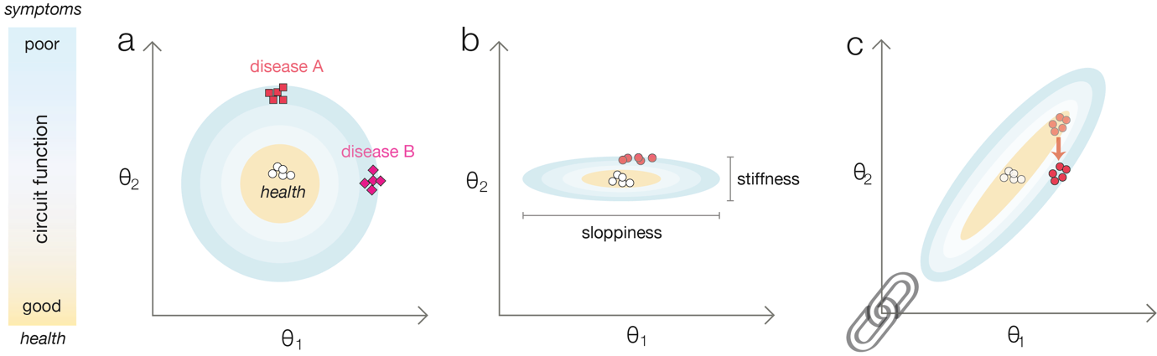
Supplementary Figure. Implications of degeneracy. Here, circuit level function such as phenotype is indicated by a graduated contour plot. Shifts in lower-level processes are simulated in a reduced two-dimensional parameter space ($θ_{1}$ and $θ_{2}$). Good health and function are located within tan areas, symptoms and dysfunction are indicated by increasing graduations of blue. a) Two diseases (A and B) are caused by different genetic mutations and two parameters are measured in patients ($θ_{1}$ and $θ_{2}$). In this example, even though the underlying genetic disorders are different, and underlying parameters are different, the system ends up on the same contour line. Correspondingly, circuit function is the same even though the lower-level configuration is different. b) Neural circuit behaviour may be inherently robust to perturbations of some parameters (‘sloppiness’) but highly sensitive to others (‘stiffness’).¹⁻⁴ Therefore, therapeutic interventions which seek to reduce a parameter that exhibits sloppiness may have little or no effect as circuit function is relatively insensitive to this. Conversely only small changes in other parameters that exhibit stiffness may be required for large circuit level shifts. c) Dynamic systems such as the brain have many dependences between parameters. ² Normal function of the simulated circuit requires jointly low or jointly high values of ${ θ}_{1}$ and $θ_{2}$ (within a certain range). Correspondingly, if one parameter (${ θ}_{1}$) changes in response to disease, another parameter ($θ_{2}$) will homeostatically mirror this change for circuit level function to be maintained. It is feasible that an inadvertent researcher could measure only the compensation ($θ_{2}$), without recognising it is a response to an upregulation of another parameter ($θ_{1}$). Any attempts to correct the ‘abnormality’ would make the phenotype worse as an effective homeostatic compensation would be blocked. Figure adapted with permission from Misuzaki and O’Donnell⁵.
References
1 Gonzalez, D. L., Giannerini, S. & Rosa, R. On the origin of degeneracy in the genetic code. Interface Focus 9, 20190038, doi:10.1098/rsfs.2019.0038 (2019).
2 Goldman, M. S., Golowasch, J., Marder, E. & Abbott, L. F. Global structure, robustness, and modulation of neuronal models. J Neurosci 21, 5229-5238 (2001).
3 Gutenkunst, R. N. et al. Universally sloppy parameter sensitivities in systems biology models. PLoS Comput Biol 3, 1871-1878, doi:10.1371/journal.pcbi.0030189 (2007).
4 Marder, E. & Goaillard, J. M. Variability, compensation and homeostasis in neuron and network function. Nat Rev Neurosci 7, 563-574, doi:10.1038/nrn1949 (2006).
5 Mizusaki, B. E. P. & O'Donnell, C. Neural circuit function redundancy in brain disorders. Curr Opin Neurobiol 70, 74-80, doi:10.1016/j.conb.2021.07.008 (2021).

