Supplementary Information

Table S1. Summary of relevant intravenous dosing recommendations from the British National Formulary for Children
(BNFC).¹

Drug | Indication | Postnatal age (PNA) | Intravenous dose | Recommended frequency
Amoxicillin | Susceptible infections | < 7 days | 30 mg/kg  (max 60mg/kg) | Twice daily, q12h.  Increased dose used in severe infection, CAP or salmonellosis
 |  | 7 - 28 days | 30 mg/kg  (max 60mg/kg) | Every eight hours, q8h  Increased dose used in severe infection, CAP or salmonellosis
 |  | > 1 month | 20–60 mg/kg  (max dose 500 mg) | Every eight hours, q8h.  Increased dose used in severe infection
 | Listeria meningitis | < 7 days | 50-100 mg/kg | Twice daily, q12h
 |  | 7 - 28 days | 50-100 mg/kg | Every eight hours, q8h
 |  | > 1 month | 50-100 mg/kg  (max dose 2g) | Every four – six hours, q4h – q6h.
Co-amoxiclav | Infections due to beta-lactamase-producing strains | < 28 days | 30 mg/kg | Twice daily, q12h
 |  | 1 – 2 months | 30 mg/kg | Twice daily, q12h
 |  | > 3 months | 30 mg/kg  (max dose 1.2g) | Every eight hours, q8h

(table continued)
Drug | Indication | PNA | Intravenous dose | Recommended frequency
Benzylpenicillin | Sepsis | < 7 days | 25 mg/kg | Every eight – twelve hours, q8h – q12h.  (increased frequency if required)
 |  | 7 - 28 days | 25 – 50 mg/kg | Every eight hours, q8h. Higher dose in severe infections
 |  | > 28 days | 25 – 50 mg/kg  (max dose 2.4 g) | Every four – six hours, q4h – q6h.  Higher dose and frequency used in severe infections.
 | Meningitis | < 7 days | 50 mg/kg | Twice daily, q12h.
 |  | 7 - 28 days | 50 mg/kg | Every eight hours, q8h.
 |  | > 28 days | 50 mg/kg  (max dose 2.4 g) | Every four – six hours, q4h – q6h.
Flucloxacillin | Infections due to  beta-lactamase-producing staphylococci | < 7 days | 25 - 50 mg/kg | Twice daily, q12h. Higher dose in severe infections
 |  | 7 - 20 days | 25 - 50 mg/kg | Every eight hours, q8h. Higher dose in severe infections
 |  | 21 – 28 days | 25 - 50 mg/kg | Every six hours, q6h. Higher dose in severe infections
 |  | > 1 month | 12.5 - 50 mg/kg  (max dose 2 g) | Every six hours, q6h.  Higher dose (25 – 50mg/kg) in severe infections
Piperacillin/  tazobactam | HAP, septicaemia,  complicated skin,  soft tissue or urinary  tract infections | Neonate | 90 mg/kg | Every eight hours, q8h.
 |  | 1 month – 11 years | 90 mg/kg  (max dose 4.5 g) | Every six – eight hours, q6h – q8h.
 |  | 12 – 17 years | 4.5 g | Every six – eight hours, q6h – q8h.
Abbreviations: HAP, hospital-acquired pneumonia; CAP, community-acquired pneumonia; h, hours.

Table S2. Recommended sampling windows

Patient group | Sample no. | 1 | 2 | 3
Children | Optimal time | 15 mins | 1 hr 40 mins | 3 hrs 30 mins
 | Sampling window | 10 mins – 30 mins | 1 hr 25 mins –  2 hrs 15 mins | 3 hrs – 4 hrs
Neonates | Optimal time | 15 mins | 2 hours | 5 hrs 50 mins
 | Sampling window | 10 mins – 30 mins | 1 hr 25 mins –  2 hrs 15 mins | 5 hrs 30 mins –  6 hrs

All times stated above are the time in minutes (or hours) post dose administration
Abbreviations: no., number; mins, minutes; hrs, hours.
Table S3 . Results of parameter estimates derived from modelling individual NAPPA penicillins separately (summary table adapted from results presented in CB’s PhD thesis, “The pharmacokinetics of penicillin antibiotics in neonates and children”, ISNI: 0000 0005 0665 2680).
Drug  Parameter | Amoxicillin | Benzylpenicillin | Flucloxacillin | Piperacillin
TVCL | 18.2 (6.8%) | 6.92 (14.6%) | 11 (12.1%) | 8.05 (6.6%)
TVV | 30.6 (7.5%) | 12.2 (9.7%) | 12.5 (15.9%) | 17 (11.6%)
TVQ | 6.84 (35.8%) | N/A | 14 (18.6%) | 1.95 (27.1%)
TVV2 | 14 (14.6%) | N/A | 9.17 (14.6%) | 5.5 (20.4%)
Apparent Vd* | 44.6 | 12.2 | 21.67 | 22.5
Var for IIV(1) | 0.156 (18.7%) | 0.23 (22%) | 0.223 (21.8%) | 0.227 (30.7%)
Var IIV (2) | N/A | N/A | N/A | 0.209 (45.4%)
Var prop RE | 0.096 (16.6%) | 0.251 (14.5%) | 0.164 (16.8%) | 0.142 (22.4%)
Var add RE | 0.013 (63.6%) | 0.012 (58.5%) | 0.003 (47.5%) | N/A
T50 | 54.2 (3.7%) | 47.7 (fixed) | 41.2 (17.2%) | 38.9 (fixed)
Hill | 3.14 (2.5%) | 3.76 (10.7%) | 2.29 (39.1%) | 3.65 (fixed)
Creat on CL | -0.342 (37.7%) | N/A | N/A | -0.422 (23.1%)

Parameter estimates presented with RSE (relative standard error) in % in brackets.
Abbreviations and units: TVCL, typical value of clearance in L/h/70kg; TVV, typical value of volume in L/70kg; TVQ, typical value of intercompartmental clearance in L/h/70kg; TVV2, typical value of peripheral volume in L/70kg; T50, maturation half time (postmenstrual age, PMA in weeks); Hill, Hill coefficient; Var, variance; Var IIV (1), variance of IIV on CL; prop RE, proportional residual error; s: shrinkage (%).
Apparent Vd: apparent volume of distribution, calculated from sum of TVV and TVV2 for 2 compartment models, and equivalent to TVV for 1 compartment model.
Table S4: Summary of simulated fT>MIC for each NAPPA penicillin by percentiles for high BNFC recommended dose (combining the simulated results of all age-groups together)
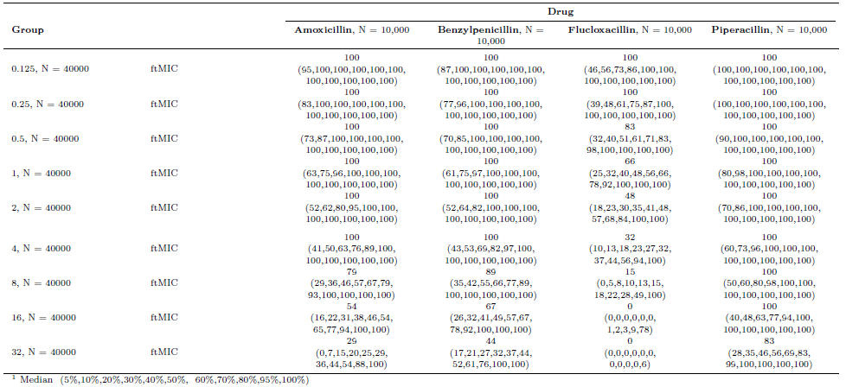
The first column, “Group”, shows the relevant MIC in mg/L.

Table S5: Summary of simulated fT>MIC for each NAPPA penicillin by percentiles for low BNFC recommended dose (combining the simulated results of all age-groups together). Note piperacillin has only one recommended dose.
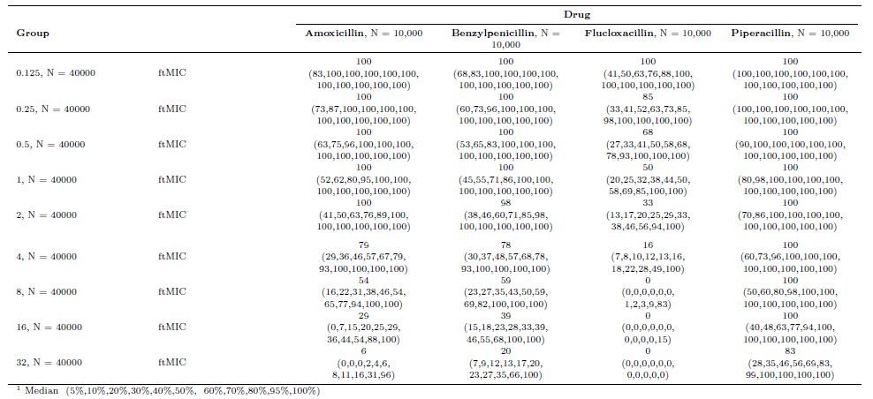
The first column, “Group”, shows the relevant MIC in mg/L.
Table S6: Summary of simulated fT>MIC for each NAPPA penicillin by percentiles for WHO recommended dose (combining the simulated results of all age-groups together)
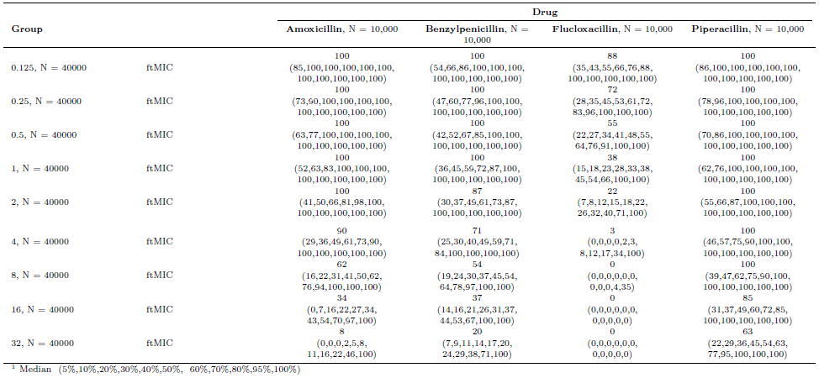
The first column, “Group”, shows the relevant MIC in mg/L.

Table S7. Demographics characteristics of patients included in joint IV/oral PK models for amoxicillin and flucloxacillin

Demographic characteristics | Co-amoxiclav & amoxicillin (n = 180) | Flucloxacillin  (n = 78)
Weight (kg) | 3.8 (0.580 - 70) | 3.645 (0.585 - 67)
Postnatal age (weeks) | 51.6 (1 - 5711) | 50.5 (1 - 5730)
Gestational age at birth (weeks) | 39 (22.9 - 41.9) | 38 (23 - 41.4)
Postmenstrual age (weeks) | 42.3 (23.6 - 855.9) | 43.7 (24.7 - 858.6)
Female sex | 42.2% | 52.6%
ICU or HDU level care | 90.0% | 74.4%
Ventilation support or oxygen therapy | 69.4% | 50%
Renal impairment | 3.9% | 5.10%
Therapeutic hypothermia | 5.0% | 0%
Liver impairment | 1.7% | 1.20%
Baseline creatinine (micromol/L) | 33 (2 - 102) | 38 (11 - 81)
Urea (mmol/L) | 3.3 (0.8 - 12.4) | 3.5 (0.6 - 17)
Bilirubin (micromol/L) | 22 (2 - 250) | 16.5 (2 - 255)
AST (IU/L) | 37 (12 - 4153) | 27.5 (11 - 166)
ALT (IU/L) | 19 (3 - 2212) | 17 (5 - 243)
ALP (IU/L) | 353.5 (47 - 2010) | 320 (23 - 1196)
Albumin (g/L) | 28 (17 - 50) | 29 (16 - 47)
Haematocrit | 0.340 (0.212 - 0.66) | 0.350 (0.250 - 0.637)
CRP (mg/L) | 18.5 (0.1 - 281) | 6.85 (1 - 146.4)
Contributed oral PK data | 3.9% (n = 7) | 11.5% (n = 9)
Median IV dose (mg/kg/dose) | 25.2 (9.7 – 112) | 25.1 (12.4 – 100)
Median oral dose (mg/kg/dose) | 23.6 (6.1 - 30) | 24.5 (9.9 – 48.1)

Continuous data are presented as median (range) and categorical data are presented with the number of subjects (% of total). Abbreviations: ICU, intensive care unit; HDU, high dependency unit; ALP, alkaline phosphatase; ALT, alanine transaminase; AST, aspartate transaminase; CRP, C-reactive protein.

Table S8: Clinical indications for antibiotic prescription for patients included in separate joint IV/oral PK models for amoxicillin and flucloxacillin

Indication for antibiotic therapy | Co-amoxiclav & amoxicillin  (n =180) | Flucloxacillin  (n =78)
Suspected or proven sepsis (including bacteraemia) | 83 (46.1%) | 34 (46.1%)
Surgical prophylaxis | 38 (21.1%) | 11 (21.1%)
LRTI (including CAP) | 19 (10.6%) | 5 (10.6%)
Intra-abdominal infection (including NEC) | 14 (7.8%) | 0 (7.8%)
Medical prophylaxis | 9 (5%) | 7 (5%)
Meningitis | 7 (3.9%) | 1 (3.9%)
Urinary tract infection | 3 (1.7%) | 0 (1.7%)
Hospital-acquired pneumonia | 2 (1.1%) | 0 (1.1%)
Ventilator associated HAP | 0 (0%) | 0 (0%)
Aspiration pneumonia | 0 (0%) | 0 (0%)
Pharyngitis | 1 (0.6%) | 0 (0.6%)
Skin or soft tissue infection | 1 (0.6%) | 19 (0.6%)
Septic arthritis or osteomyelitis | 1 (0.6%) | 4 (0.6%)
Febrile neutropaenia or neutropaenic sepsis | 1 (0.6%) | 1 (0.6%)
Endocarditis | 0 (0%) | 2 (0%)
Congenital pneumonia | 0 (0%) | 0 (0%)
Other | 16 (8.9%) | 2 (8.9%)
Abbreviations: LRTI, lower respiratory tract infection; CAP, community-acquired pneumonia, NEC, necrotising enterocolitis. Note some patients had more than one indication for antibiotic therapy recorded, hence the total number of indications is greater than the total number of subjects.

Table S9. Summary overview of amoxicillin/co-amoxiclav population pharmacokinetic studies including children or neonates

Study population | Amoxicillin dose (typical) | No. of subjects | Ave Wt (kg) | Sample no. for PK model | CL: popPK point estimate | Vd: popPK point estimate | Q (point estimate) | V2 (point estimate) | Elimination t_{1/2} (h) | Ref
VLBW neonates (<32 wks, <1500g) | 50 mg/kg (IV), every 12 h | 40 | 1.123 | 214 | 0.0805 L/h/kg  or if on gentamicin then  0.0610 L/h/kg | 0.678 L |  |  | 5.2 (without gentamicin)  6.9 (with gentamicin) | ³
Preterm and term neonates  (25-42 wks GA) | 50 - 100 mg/kg per dose | 150 | 2.29 | 674 | 0.096 L/kg/h | 0.65 L/kg |  |  | 5.2 | ⁴
Preterm and term infants (aged 10 to 52 days) | As above. | 32 | 2.27 | Not stated (mean 5.2 per infant) | 0.18 L/kg/h | 0.66 L/kg |  |  | 3.0 | ⁵
PICU  (age 1m to 15y) | 25 mg/kg/dose | 50 | 14.4 | 325 | 17.97 L/hr/70kg | 9.07 L/70kg | 35.88 L/hr/70kg | 5.43 L/70kg  11.24 L/70kg | Not stated | ⁶
NICU  (age 2 to 5 d,  GA 36 – 42 wk) | 91 mg/kg/day | 125 | 3.34 (mean BW) | 1280 | 2.92 L/h/70kg | 24.1 L/70kg | 7.93 L/h/70kg | 24.1 L/70kg | Not stated | ⁷
Neonates/infants  (Age 1 – 37 d,  GA 28–41 wk) | 24 mg/kg/dose | 187 | 3.21 | 224 | 0.81 L/h | 1.48 L | 0.17 L/h | 2.42 L | Not stated | ⁸
ABDose (ICU age 0.008–85)y) | 17.3 mg/kg/dose | 80 | 65.0 | 427 | 14.4 L/hr/70kg | 13.4 L/70kg | 9.2 L/hr/70kg | V2 12.1 L/70kg V3 9.7 L/70kg | Not stated | ⁹
Neonates/infants (age range: 0.09 to 2.0 years) | 32.6 mg/kg/dose | 47 | 7.2 | 62 | 0.31 L/h/kg | 0.32 L/kg | weight normalized Q not stated | 0.34 L/kg |  | ¹⁰
This study: NAPPA  (aged 1 – 5711 weeks) | 25.2 mg/kg/dose | 174 | 3.76 | 409 | 16.4 L/h/70kg | 46.2 L/70kg |  |  | Not stated

Abbreviations: CL, clearance; Vd, volume of distribution; Q, intercompartmental clearance; V2, peripheral volume; t_{1/2}, half-life; No., number; Ref. reference; h, hours; wk, weeks; m, months; y, years; GA, gestational age; BW, birth weight; med, median; VLBW, very low birth weight.
Table S10. Summary of benzylpenicillin population pharmacokinetic studies including neonates or infants
Study population | Typical Dose | No. of subjects | Ave. Weight (kg) | No. of PK samples for modelling | CL: popPK parameter point estimate | Vd: popPK parameter point estimate | Q (point estimate) | V2 (point estimate) | Elimination t_{1/2} (hours) | Ref
Preterm neonates  (<32 wk GA) | 50,000 U/kg  every 12 h | 20 | 1.195 (mean) | 167 | 0.103 L/h | 0.359 L | 0.774 L/h | 0.152 L | 3.9 | ¹¹
Term neonates (moderate hypothermia) | Various:  148,323 IU/kg/day q8h (mode) | 41 | 3.42 (BW) | 398 | 0.48 L/h | 0.62 L/kg |  |  |  | ¹²
 |  |  |  |  | Estimates for a typical patient with a GA of 40 weeks, BW of 3,000 g, PNA 2 days (Temp, 33.5°C), and normal UO (2 ml/kg/h)
Neonates (GA  32-34 wk) | 25,000 IU/kg or 50,000 IU/kg | 17 | 2.0 |  | 13.2 L/h/70kg  (Data from 2 studies combined and modelled) | 10.3 L/70kg | 55.6 L/h/70kg | 29.8 L/70kg | 3.5-4.2 | ¹³
Neonates  (GA  <28 wk) |  | 18 | 3.1 |  |  |  |  |  | 3.8-4.6 | ¹⁴
All ages  (from preterm neonates to adults) | 20 mg/kg | 19 | 62.5 | 94 | 24.6 L/h/70kg | 12.3 L/70kg | Q2: 2.8 L/h/70kg | V2: 10.1 L/70kg |  | ⁹
 |  |  |  |  |  |  | Q3: 44.2 L/h/70kg | V3: 14.1 L/70kg
This study:  (aged 0.1 - 685.1 weeks) | 25.4 mg/kg/dose | 64 | 2.83 | 147 | 7.17 L/h/70kg | 11.8 L/70kg |  |  | Not stated | ¹⁵
Note 25,000 IU/kg of benzylpenicillin sodium is equivalent to 15 mg/kg.
Abbreviations: CL, clearance; Vd, volume of distribution; Q, intercompartmental clearance; V2, peripheral volume; t_{1/2}, half-life; No., number; Ref. reference; wk, weeks; GA, gestational age; BW, birth weight; PNA, postnatal age; UO, urine output; med, median.

Table S11. Summary overview of flucloxacillin population pharmacokinetic studies including children or neonates
Study population | Dose  (typical) | No. of subjects | Ave Wt (kg) | Sample no. for PK model | CL: popPK point estimate | Vd: popPK point estimate | Q (point estimate) | V2 (point estimate) | Elimination t_{1/2} (h) | Ref
Preterm and term neonates (26-42 weeks GA) | 25–50 mg/kg | 55 | 1.49 | 235 | CL = 0.18 L/kg/h | Vd = 0.54 L/kg |  |  | 2.6 | ¹⁶
ABDose (ICU age 0.01y–71.7 y) | 21.0 mg/kg | 10 | 82.4 | 59 | 5.3 L/h/70kg | 10.0 L/70kg | 2.6 L/h/70kg | 5.1 L/70kg | Not stated | ⁹
This study  (aged 0.143 - 818.6 weeks) | 25.1 mg/kg/dose | 72 | 3.1 | 185 | 14.6 L/h/70kg | 23.3 L/70kg |  |  | Not stated

Abbreviations: CL, clearance; Vd, volume of distribution; Q, intercompartmental clearance; V2, peripheral volume; t_{1/2}, half-life; No., number; Ref. reference; h, hours; wk, weeks; m, months; y, years; GA, gestational age; BW, birth weight; med, median

Table S12. Summary of piperacillin population pharmacokinetic studies including children or neonates
Study population | Dose (typical) | No. of subjects | Ave Wt (kg) | Sample no. for PK model | CL: popPK point estimate | Vd: popPK point estimate | Q (point estimate) | V2 (point estimate) | Elimination t_{1/2} (h) | Ref
Preterm infants  (22-32 wk GA) | 88 mg/kg | 56 | 0.867 | 211 | 0.479 L/h/kg^{0.75} | 2.91 L/kg | - | - | 6.9 | ¹⁷
Neonates and infants (< 2 m) | 44.44/5.56 mg/kg | 71 | 2.76 | 207 | 0.133 L/h/kg | Central Vd = 0.742 L | 1.11 L/h | 0.269 L | Not stated | ¹⁸
Neonates  (23-40 wk GA) | 80 to 100 mg/kg | 32 | 1.439 | 128 | 0.080 L/h/kg | 0.42 L/kg | - | - | 3.5 | ¹⁹
Children  (9 m to 6 y) | 75 to 106 mg/kg, | 13 | 14.5 | 31 | 0.299 L/h/kg | Central Vd = 0.249 L/kg | K12 (/h)  6.663 | K21 (/h)  8.482 | 1.39 | ²⁰
Children  (3 y to 10 y) | 70 to 107 mg/kg, | 21 | 28.5 | 48 | 0.204 L/h/kg | Central Vd = 0.199 L/kg | K12 (/h)  0.897 | K21 (/h)  1.427 | 2.6 | ²¹
Children  (9 m to 11 y) | 80 to 100 mg/kg, | 12 | 17 | 72 | 0.22 L/h/kg | 0.43 L/kg | - | - | 1.4 | ²²
Children  (2 m to 15 y) | 75 mg/kg | 47 | 14 | 310 | 0.25 L/h/kg | 0.13 L/kg | 0.19 L/h/kg | 0.11 L/kg | Not stated | ²³
Children  (0.1 y – 18 y) | 75 mg/kg | 50 | 11.9 | 132 | 3 L/h  ≡12.6 L/h/70kg | 0.33 L/kg  ≡ 24.6 L/70kg | - | - | 0.9 | ²⁴
Children  (2m – 6y) | 80 mg/kg or  90 mg/kg  (2-5m /6m-6y) | 79 | 11.4 | 165 | 3.92 L/h | 4.87 L | 0.25 L/h | 0.49 L | Not stated | ²⁵
Children  (0.5 y – 18 y) | 100mg/kg (max 533mg) | 43 | 39.4 | 482 | 15.4 L/h/70kg | 16.0 L/70kg | 0.237 L/h/70kg | 3.4 L/70kg | Not stated | ²⁶
Children (3 m to 15 y) +/- CRRT | 88.9 mg/kg | 32 | 8.1 | 429 | Renal 1.3 L/h  Non-renal 0.5 L/h | 3.23 L | 0.51 L/h | 1.45 L |  | ²⁷
All ages  (0.02 y –87.5 y) | 66.7 mg/kg | 51 | 60 | 291 | 10.9 L/h/70kg | 17.9 L/70kg | 11.4 L/h/70kg | 8.95 L/70kg | Not stated | ⁹
This study  (aged 0.7 - 795 weeks) | 80 mg/kg/dose | 70 | 10.9 | 222 | 8.59 L/h/70kg | 18.6 L/70kg |  |  | Not stated

Abbreviations: CL, clearance; Vd, volume of distribution; Q, intercompartmental clearance; V2, peripheral volume; t_{1/2}, half-life; No., number; Ref. reference; h, hours; wk, weeks; m, months; y, years; GA, gestational age; BW, birth weight; med, median; CRRT, continuous renal replacement therapy

Table S13. Comparison of estimates of clearance and volume of distribution for each penicillin in the NAPPA and ABDose studies versus the Summary of Product Characteristics (SPC)
Comparison of estimates of the CL and V parameter values for each penicillin in the NAPPA and ABDose studies and the SPC
Drug | Amoxicillin |  |  | Benzylpenicillin |  |  | Flucloxacillin† |  | Piperacillin
Parameter | NAPPA | ABDose | SPC | NAPPA | ABDose | SPC | NAPPA | ABDose | NAPPA | ABDose | SPC‡
TVCL | 16.4 (7.1%) | 15.9 (6.7%) | 25 | 7.17 (13%) | 29.8 (16.2%) | Not reported | 14.6 (8.4%) | 7.7 (13.4%) | 8.59 (7.9%) | 12.0 (8.0%) | 23.7
TVV | 46.2 (4.8%) | V1: 11.5 (6.9%) | 24.5* | 11.8 (10.5%) | V1: 12.9 (20.5%) | 24.5* | 23.3 (8.5%) | V1: 9.9 (18.8%) | 18.6 (8.7%) | V1: 13.6 (12.6%) | 17.01
 |  | V2: 17.2 (15.1%) |  |  | V2: 17.9 (15.4%) |  |  | V2: 5.3 (18.0%) |  | V2: 7.0 (24.4%)

Parameter values presented are the point estimates of the final population PK model, followed by the % relative standard error. Units: TVCL, typical value of clearance, in L/h/70kg; TVV, typical value of volume of distribution, in L/70kg (ABDose results are presented as V1, volume of central compartment, and V2, volume of peripheral compartment: estimated Vd is calculated as the sum of V1 and V2).

Standard PK parameters reported in SPCs are typically calculated from PK studies in healthy volunteers and are usually presented with units of L/kg and L/hour – we have presumed this can be directly interpreted as scaled to 70kg for Vd comparisons, and we have scaled the CL parameter linearly to 70kg for comparison.

*For amoxicillin and benzylpenicillin, SPCs report Vd of 0.3-0.4 L/kg in adults (both drugs) and 0.785 L/kg in children (benzylpenicillin only). TVCL value shown in table calculated as 0.35 L/kg for 70kg adult for purposes of comparison to scaled estimates for NAPPA and ABDose.

†For flucloxacillin, no values for CL or Vd were reported in the SPCs reviewed on the Electronic Medicines Compendium (https://www.medicines.org.uk/).

‡Piperacillin SPC reports paediatric CL of 5.64 ml/min/kg as being similar to adult CL (which is not reported), and CL is described as 20% reduced in patients aged 2– 9 months old. CL value shown in table calculated for 70kg adult for comparison. Piperacillin mean half-life is reported to be 32% longer in the elderly (no CL value reported). Piperacillin Vd reported in SPC as 0.243 L/kg, independent of age.

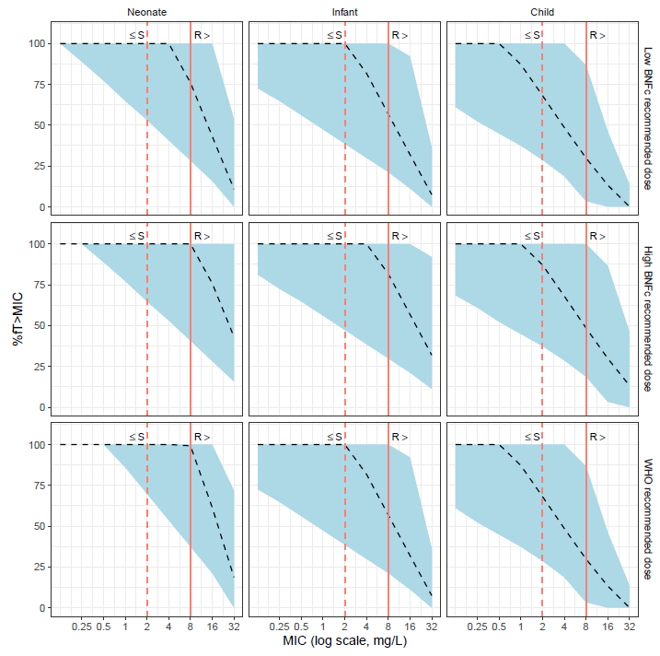

Figure S1. Results of the amoxicillin model-based simulations testing the probability of target attainment for the BNFC high and low dose regimens and the WHO recommended dosing. The panels each show the proportion of time the free drug concentration spent above a range of MICs over the first 24 hours of therapy for simulated patients (n=10,000). The dashed line represents the simulated median and the shaded area represents 95% of simulated patients’ fT>MIC. The solid vertical line indicates the EUCAST breakpoint MIC R (resistant). The dashed vertical line indicates the EUCAST MIC S (susceptible).

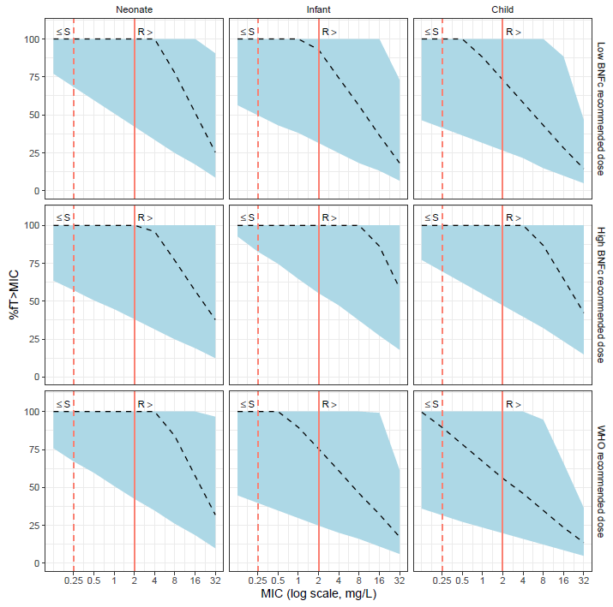
Figure S2. Results of the benzylpenicillin model-based simulations testing the probability of target attainment for the BNFC high and low dose regimens and the WHO recommended neonatal dosing (as there is no WHO recommendations for the older age-groups). The panels each show the proportion of time the free drug concentration spent above a range of MICs over the first 24 hours of therapy for simulated patients (n=10,000). The dashed line represents the simulated median and the shaded area represents 95% of simulated patients’ fT>MIC. The solid vertical line indicates the EUCAST breakpoint MIC R (resistant). The dashed vertical line indicates the EUCAST MIC S (susceptible).

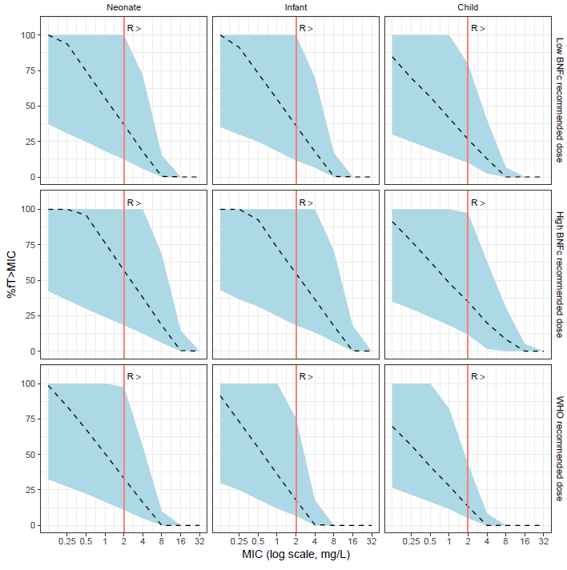
Figure S3. Results of the flucloxacillin model-based simulations testing the probability of target attainment for the BNFC high and low dose regimens and the WHO recommended dosing.² The panels each show the proportion of time the free drug concentration spent above a range of MICs over the first 24 hours of therapy for simulated patients (n=10,000). The dashed line represents the simulated median and the shaded area represents 95% of simulated patients’ fT>MIC. The solid vertical line indicates the EUCAST breakpoint MIC R (resistant).

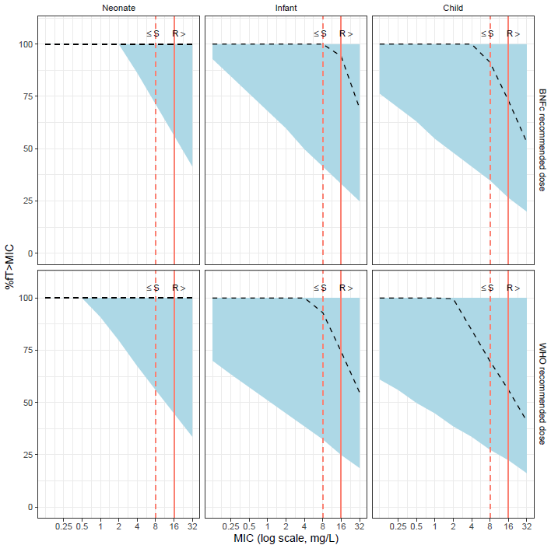
Figure S4. Results of the piperacillin model-based simulations testing the probability of target attainment for the BNFC regimen and the WHO recommended dosing. The panels each show the proportion of time the free drug concentration spent above a range of MICs over the first 24 hours of therapy for simulated patients (n=10,000). The dashed line represents the simulated median and the shaded area represents 95% of simulated patients’ fT>MIC. The solid vertical line indicates the EUCAST breakpoint MIC R (resistant). The dashed vertical line indicates the EUCAST MIC S (susceptible).

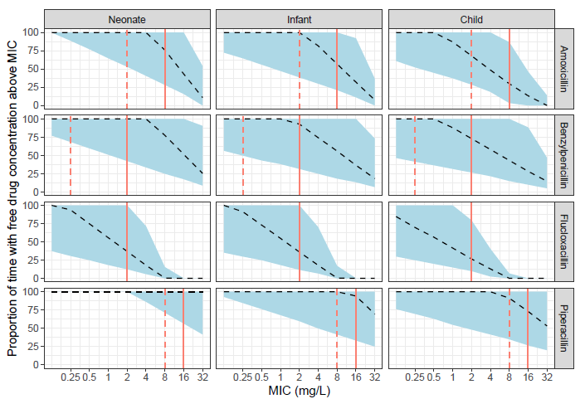
Figure S5. Results of the model-based simulations testing the probability of target attainment for the BNFC low dose regimens for all NAPPA penicillins. The panels each show the proportion of time above a range of MICs over the first 24 hours of therapy for simulated patients (n=10,000). The dashed line represents the simulated median and the shaded area represents 95% of simulated patients’ fT>MIC. The solid vertical lines indicate the EUCAST breakpoint MIC R (resistant). The dashed vertical lines indicate the EUCAST MIC S (susceptible).

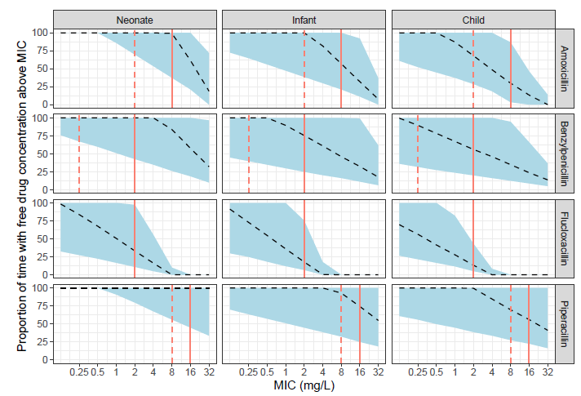
Figure S6. Results of the model-based simulations testing the probability of target attainment for the WHO dosing regimens for all NAPPA penicillins.² The panels each show the proportion of time above a range of MICs over the first 24 hours of therapy for simulated patients (n=10,000). The dashed line represents the simulated median and the shaded area represents 95% of simulated patients’ fT>MIC. The solid vertical lines indicate the EUCAST breakpoint MIC R (resistant). The dashed vertical lines indicate the EUCAST MIC S (susceptible).

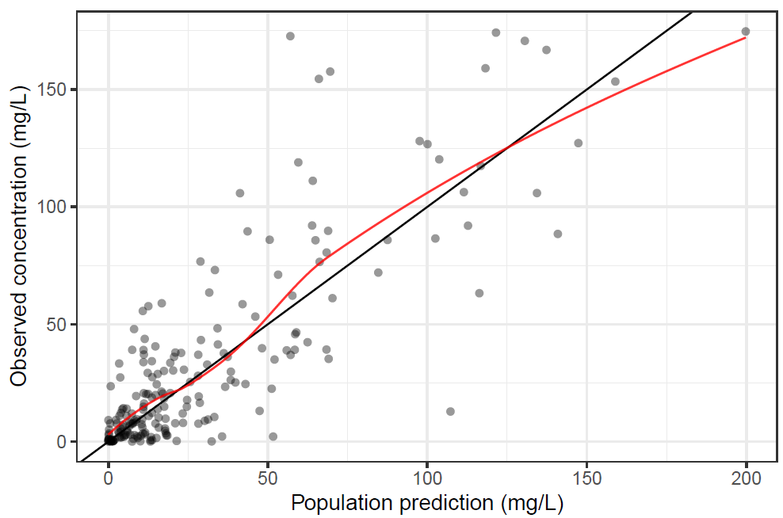

Figure S7. Goodness of fit plot for flucloxacillin model, combining IV and oral PK data: observed concentrations plotted against population predictions.

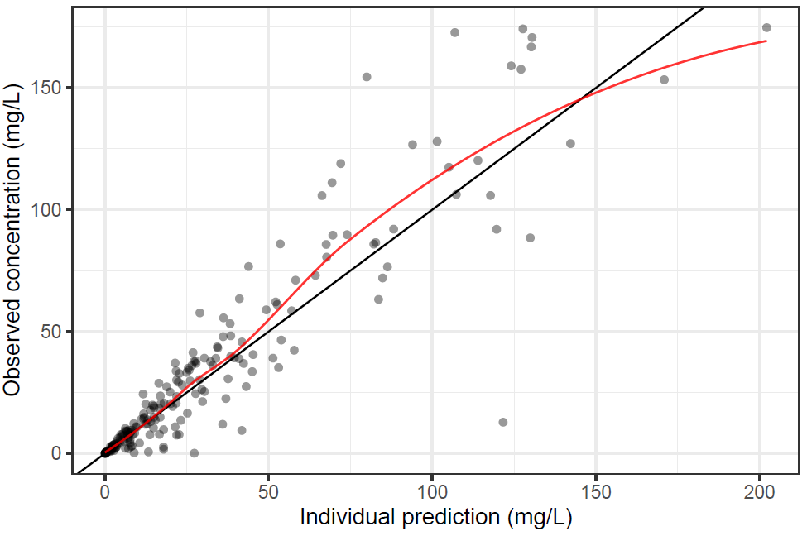

Figure S8. Goodness of fit plots for flucloxacillin model, combining IV and oral PK data: observed concentrations plotted against individual predictions.

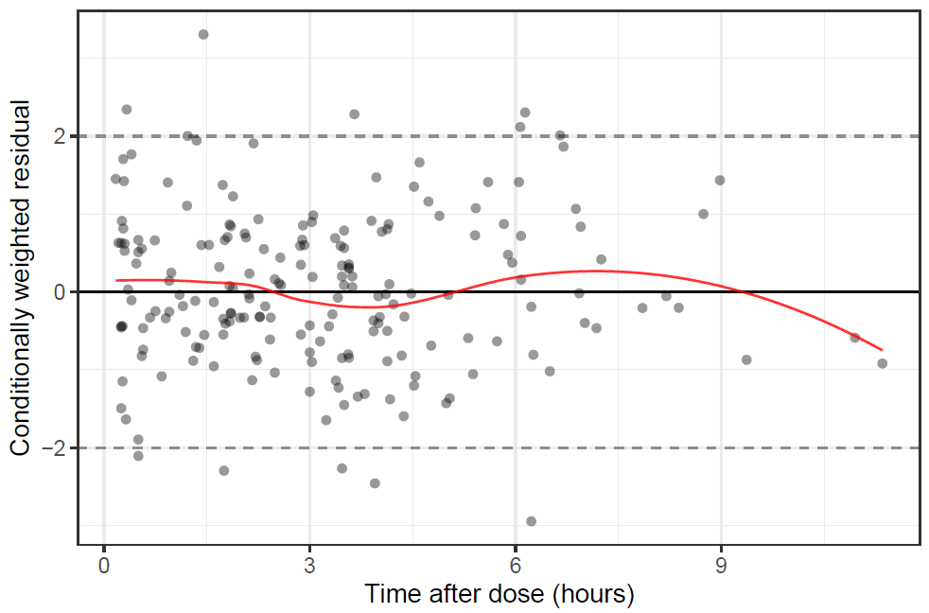

Figure S9. Goodness of fit plot for flucloxacillin model, combining IV and oral PK data: conditionally weighted residual errors plotted against time after dose (for 0-12 hours following the dose).

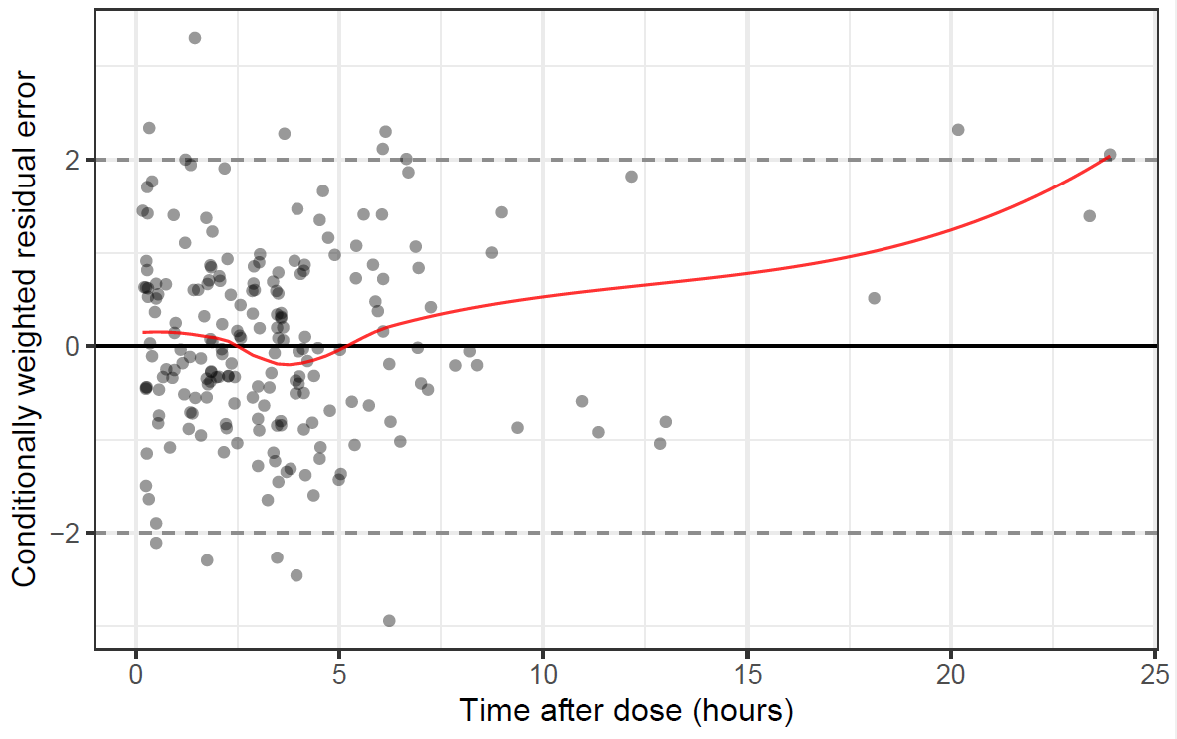

Figure S10. Goodness of fit plot for flucloxacillin model, combining IV and oral PK data: conditionally weighted residual errors plotted against time after dose (including later sampling time points: 0-24 hours following the previous dose).

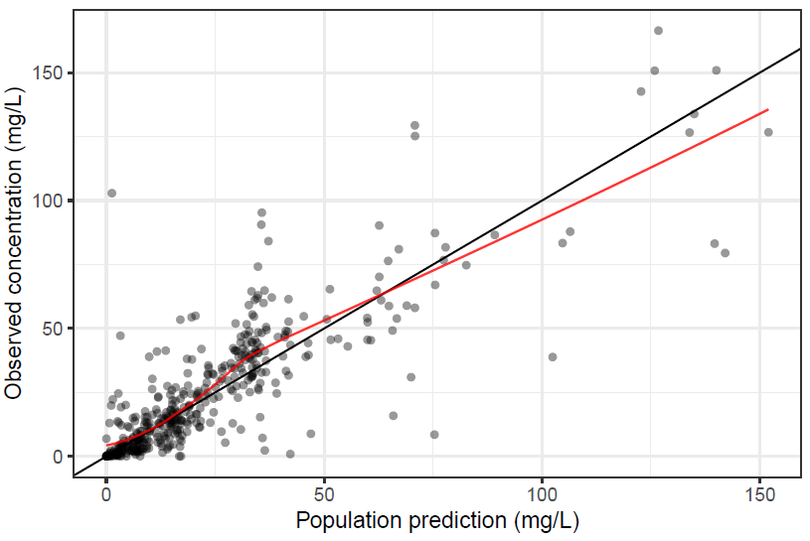

Figure S11. Goodness of fit plot for amoxicillin model, combining IV and oral PK data: observed concentrations plotted against population predictions.

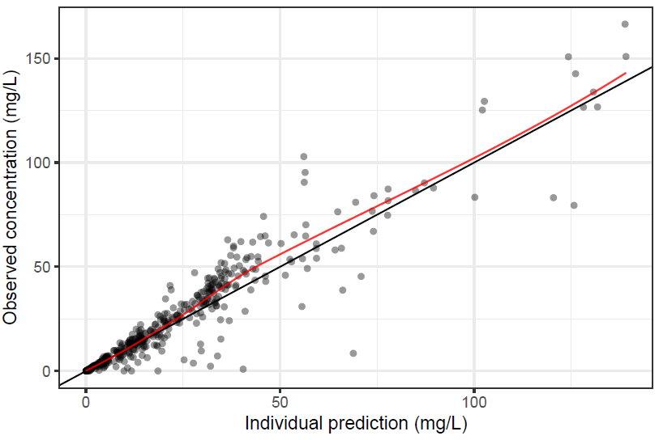

Figure S12. Goodness of fit plots for amoxicillin model, combining IV and oral PK data: observed concentrations plotted against individual predictions.

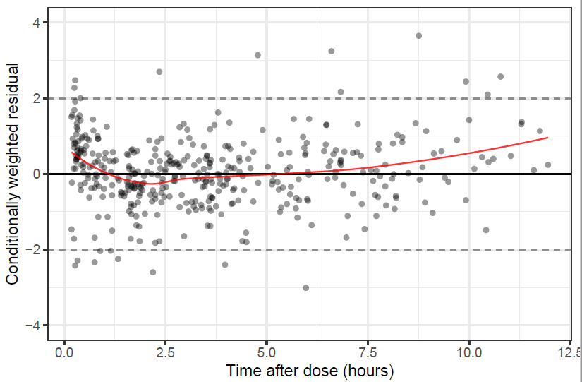

Figure S13. Goodness of fit plot for amoxicillin model, combining IV and oral PK data: conditionally weighted residual errors plotted against time after dose (for 0-12 hours following the dose).

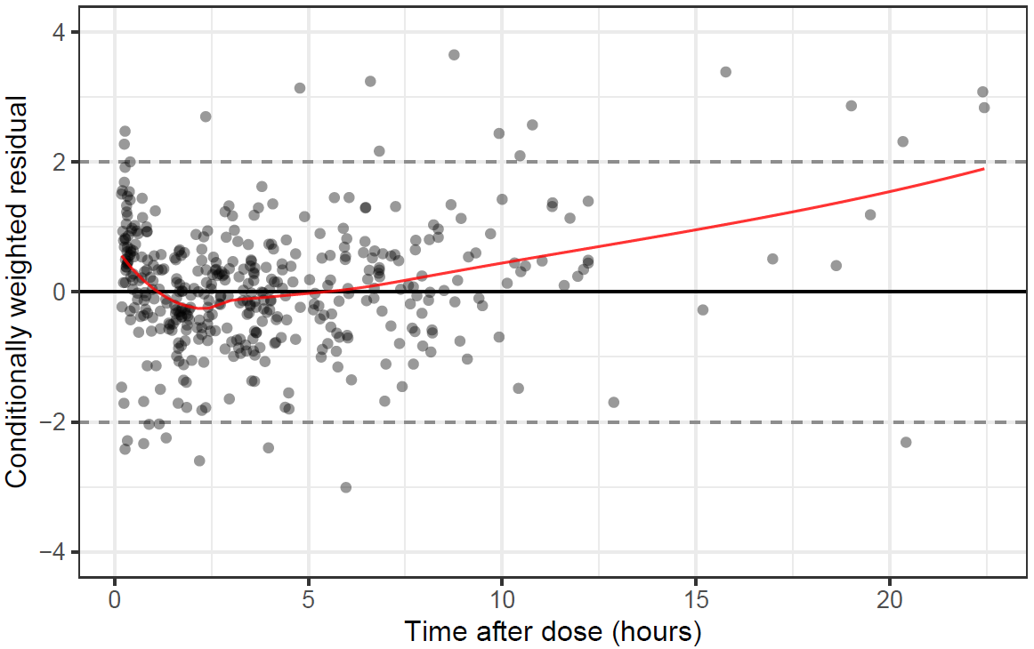

Figure S14. Goodness of fit plot for amoxicillin model, combining IV and oral PK data: conditionally weighted residual errors plotted against time after dose (including later sampling time points: 0-24 hours following the previous dose).

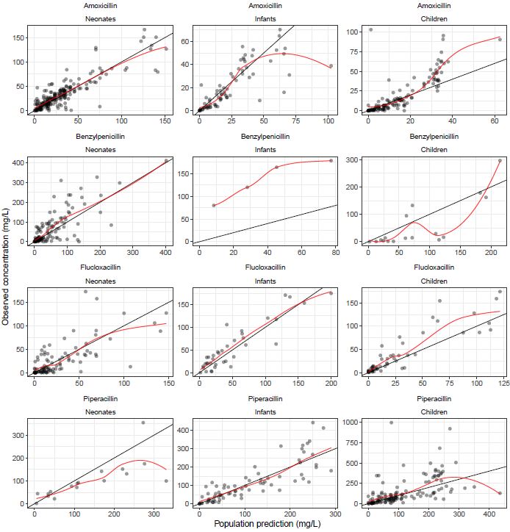
Figure S15. Additional goodness of fit plot for combined IV model stratified by drug and by age group (neonates, infants, and children): observed concentrations plotted against population predictions for amoxicillin, benzylpenicillin, flucloxacillin and piperacillin.

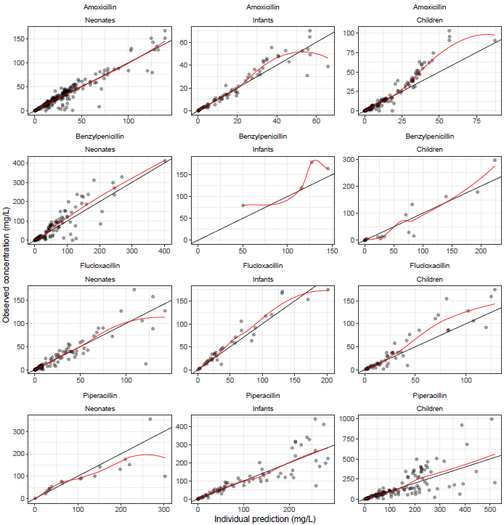
Figure S16. Additional goodness of fit plot for combined IV model stratified by drug and by age group (neonates, infants, and children): observed concentrations plotted against individual predictions for amoxicillin, benzylpenicillin, flucloxacillin and piperacillin.
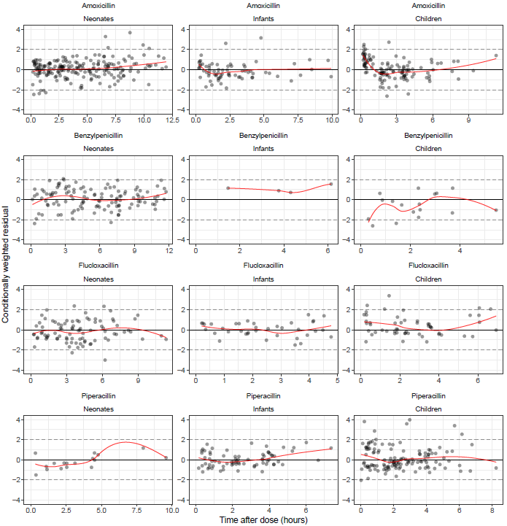

Figure S17. Additional goodness of fit plot for combined IV model, stratified by drug and by age group (neonates, infants, and children): conditionally weighted residual errors plotted against time after dose (for 0-12 hours following the IV dose) for amoxicillin, benzylpenicillin, flucloxacillin and piperacillin.
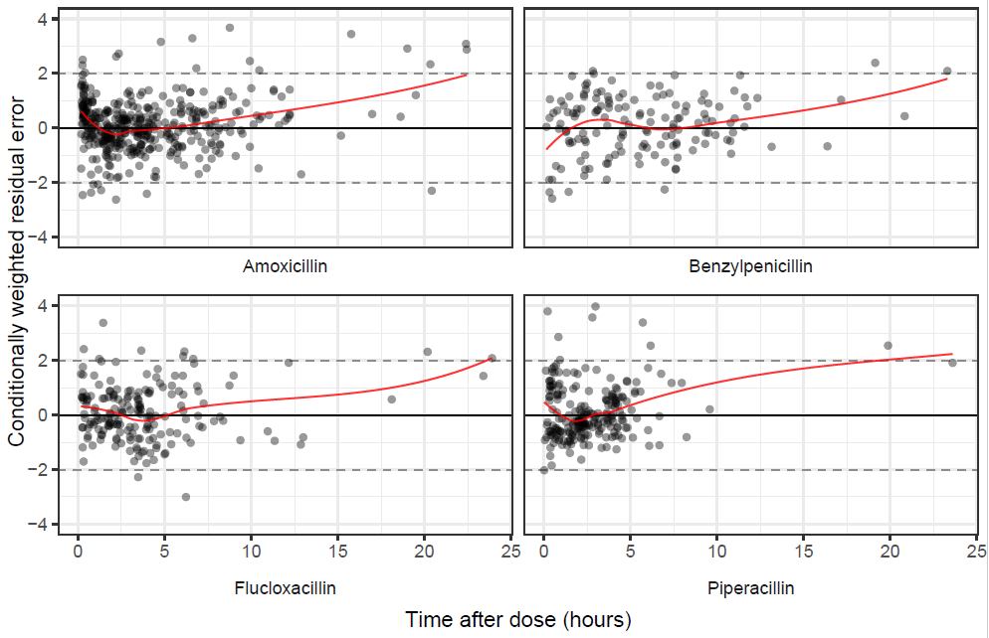

Figure S18. Additional goodness of fit plot for combined IV model: conditionally weighted residual errors plotted against time after dose (including later sampling time points: 0-24 hours following the previous dose).

Covariate Modelling: Supplementary Information
During the previous PK analysis of the data from the individual penicillins, additional covariate modelling was undertaken (results not shown).²⁸ After the inclusion of allometric weight scaling and the testing of serum creatinine on clearance (both as detailed in the main paper), further covariate analysis was undertaken using stepwise covariate model (SCM) building with a forward inclusion criterion of P<0.05 and backwards elimination criterion of P<0.01.

The covariates tested on clearance and volume in the SCM included: (i) baseline CRP and baseline albumin, both modelled as continuous covariates and (ii) sex, ITU/HDU level care, and ventilatory support (including supplemental oxygen), which were modelled as binary categorical covariates. The equations used in the SCM are shown below.

Supplementary Code for Equation 1: Linear function for a continuous covariate:
PARCOV= ( 1 + THETA(1)*(COV - median))
where PARCOV represents the covariation function, THETA represents the PK parameter on which it is being tested, and COV is the measured value of the covariate. The median is the study population median of the covariate being tested.

Supplementary Code for Equation 2: Linear function for a bivariate categorical covariate:
IF(COV.EQ.0) PARCOV = 1
IF(COV.EQ.1) PARCOV = ( 1 + THETA(1))
where PARCOV represents the covariation function and THETA represents the PK parameter on which it is being tested.

The covariates tested in the SCM were not significant when the IV PK data were analysed separately for amoxicillin (amoxicillin and co-amoxiclav PK data combined), benzlpenicillin, flucloxacillin, and piperacillin, so they were not retested in the joint model.
NONMEM code for final combined IV model

$DATA combnmwithpna.csv IGNORE=@
$SUBROUTINE ADVAN7 TRANS1
$MODEL COMP=(AMOX) COMP=(BENPEN) COMP=(FLUCLOX) COMP=(PIP)
;
$PK
; Covariate functions
WTCL = (WT/70)**0.75
WTV = (WT/70)
T50 = THETA(9)
HILL = THETA(10)
PMA_TV = GA + PNA/7 ; time varying PMA
MF = PMA_TV**HILL/(PMA_TV**HILL+T50**HILL) ;PMA in weeks
;PNA function on CL
CLPNA = THETA(11) + (1 - THETA(11)) * (1 - EXP(-PNA * THETA(12)))

;--- Mean expected creatinine for age---;
AGEY = ((PNA+0.001)/365.25) ; convert PNA in days to age in years
MSCR = -2.37330-12.91367*LOG(AGEY)+23.93581*AGEY**0.5 ; Mean SeCr, age
;
IF(AGEY.GT.15.AND.AGEY.LE.17)THEN
IF(GIRL==2)THEN
MSCR = 9.5471*AGEY-87.847
ELSE
MSCR = 4.7137*AGEY-15.347
ENDIF
ENDIF
SCOV = (CREAT/MSCR)**THETA(13)
;
TVCL1 = THETA(1)
TVVC1 = THETA(2)
TVCL2 = THETA(3)
TVVC2 = THETA(4)
TVCL3 = THETA(5)
TVVC3 = THETA(6)
TVCL4 = THETA(7)
TVVC4 = THETA(8)
;
CL1 = TVCL1*EXP(ETA(1))*WTCL*MF*CLPNA*SCOV
VC1 = TVVC1*EXP(ETA(2))*WTV
CL2 = TVCL2*EXP(ETA(3))*WTCL*MF*CLPNA*SCOV
VC2 = TVVC2*EXP(ETA(4))*WTV
CL3 = TVCL3*EXP(ETA(5))*WTCL*MF*CLPNA*SCOV
VC3 = TVVC3*EXP(ETA(6))*WTV
CL4 = TVCL4*EXP(ETA(7))*WTCL*MF*CLPNA*SCOV
VC4 = TVVC4*EXP(ETA(8))*WTV
;S1 = VC1
;S2 = VC2
;S3 = VC3
;S4 = VC4
;
;Rate constants
K10 = CL1/VC1
K20 = CL2/VC2
K30 = CL3/VC3
K40 = CL4/VC4
;
;TAD
IF(AMT>0) TDOS = TIME
IF(AMT>0) TAD = 0
IF(AMT==0) TAD = TIME-TDOS
;
$ERROR
IF(CMT==1) IPRED = A(1)/VC1
IF(CMT==2) IPRED = A(2)/VC2
IF(CMT==3) IPRED = A(3)/VC3
IF(CMT==4) IPRED = A(4)/VC4
IRES = DV-IPRED
W = IPRED
IWRES = IRES/W
IF(CMT==1) Y = IPRED*(1+EPS(1))+EPS(2)
IF(CMT==2) Y = IPRED*(1+EPS(3))+EPS(4)
IF(CMT==3) Y = IPRED*(1+EPS(5))+EPS(6)
IF(CMT==4) Y = IPRED*(1+EPS(7))+EPS(8)

TDV = DV
IF(TDV <= 0.01) TDV = 0.01

;
$THETA (0,16.4) ; 1. CL1
$THETA (0,46.2) ; 2. VC1
$THETA (0,7.17) ; 3. CL2
$THETA (0,11.8) ; 4. VC2
$THETA (0,14.6) ; 5. CL3
$THETA (0,23.3) ; 6. VC3
$THETA (0,8.59) ; 7. CL4
$THETA (0,18.6) ; 8. VC4
$THETA (0,42.6,100) ; 9. T50
$THETA (2,2.68,4.5) ; 10. HILL
$THETA (0,0.516,1) ; 11. M - fraction of clearance on day of birth
$THETA (0.01, 0.0202) ; 12. N - rate of maturation post birth
$THETA -0.302 ; 13. Creatinine coefficient
;
$OMEGA 0.167
$OMEGA 0.0454
$OMEGA 0.249
$OMEGA 0 FIX
$OMEGA 0.237
$OMEGA 0.0243
$OMEGA 0.225
$OMEGA 0 FIX
;
$SIGMA 0.135
$SIGMA 0 FIX
$SIGMA 0.241
$SIGMA 0.0122
$SIGMA 0.179
$SIGMA 0 FIX
$SIGMA 0.212
$SIGMA 0 FIX
;
$ESTIMATION METHOD=1 INTER MAXEVAL=9999 PRINT=1 ; calculation method
$COVARIANCE

NONMEM code for flucloxacillin model, including combined IV and oral data

$DATA combnmwithpnaflucloxonlyv3.csv IGNORE=@
$SUBROUTINE ADVAN2 TRANS2
;
$PK
; KA = ABSORPTION RATE CONSTANT
TVKA = THETA(8)
; Covariate functions
WTCL = (WT/70)**0.75
WTV = (WT/70)
T50 = THETA(3)
HILL = THETA(4)
PMA_TV = GA + PNA/7 ; time varying PMA
MF = PMA_TV**HILL/(PMA_TV**HILL+T50**HILL) ; PMA in weeks
;PNA function on CL
CLPNA = THETA(5) + (1 - THETA(5)) * (1 - EXP(-PNA * THETA(6)))

;--- Mean expected creatinine for age---;
AGEY = ((PNA+0.001)/365.25) ; convert PNA in days to age in years
MSCR = -2.37330-12.91367*LOG(AGEY)+23.93581*AGEY**0.5 ; Mean SeCr, age
;
IF(AGEY.GT.15.AND.AGEY.LE.17)THEN
IF(GIRL==2)THEN
MSCR = 9.5471*AGEY-87.847
ELSE
MSCR = 4.7137*AGEY-15.347
ENDIF
ENDIF
SCOV = (CREAT/MSCR)**THETA(7)
;
TVCL = THETA(1)
TVV = THETA(2)
;
CL = TVCL*EXP(ETA(1))*WTCL*MF*CLPNA*SCOV
V = TVV*EXP(ETA(2))*WTV
;
;Rate constants
KA = TVKA*EXP(ETA(3))
S1 = V
K=CL/V
;
F1=THETA(9)
;TAD
IF(AMT>0) TDOS = TIME
IF(AMT>0) TAD = 0
IF(AMT==0) TAD = TIME-TDOS;
;
$ERROR
;
IPRED = A(2)/V
IRES = DV-IPRED
W = IPRED
IWRES = IRES/W
Y = IPRED*(1+EPS(1))+EPS(2)
;
$THETA 14.6 FIX ; 1. TVCL
23.3 FIX ; 2. TVV
42.6 FIX ; 3. T50
2.68 FIX ; 4. HILL
0.516 FIX ; 5. M - fraction of clearance on day of birth
0.0202 FIX ; 6. N - rate of maturation post birth
-0.302 FIX ; 7. Creatinine coefficient
(0,1.16) ; 8. TVKA for flucloxacillin
(0,0.627,1) ; 9. F1 Bioavailability term for flucloxacillin
$OMEGA 0.237 FIX
$OMEGA 0.0243 FIX
$OMEGA 0 FIX
;
$SIGMA 0.195
$SIGMA 0 FIX
;
$ESTIMATION METHOD=1 INTER MAXEVAL=9999 PRINT=1 ; calculation method
$COVARIANCE

NONMEM code for amoxicillin model, including combined IV and oral data

$DATA combnmwithpnaamoxonlyv3.csv IGNORE=@
$SUBROUTINE ADVAN2 TRANS2
;
$PK
; KA = ABSORPTION RATE CONSTANT
TVKA = THETA(8)
; Covariate functions
WTCL = (WT/70)**0.75
WTV = (WT/70)
T50 = THETA(3)
HILL = THETA(4)
PMA_TV = GA + PNA/7 ; time varying PMA
MF = PMA_TV**HILL/(PMA_TV**HILL+T50**HILL) ; PMA in weeks
;PNA function on CL
CLPNA = THETA(5) + (1 - THETA(5)) * (1 - EXP(-PNA * THETA(6)))

;--- Mean expected creatinine for age---;
AGEY = ((PNA+0.001)/365.25) ; convert PNA in days to age in years
MSCR = -2.37330-12.91367*LOG(AGEY)+23.93581*AGEY**0.5 ; Mean SeCr, age
;
IF(AGEY.GT.15.AND.AGEY.LE.17)THEN
IF(GIRL==2)THEN
MSCR = 9.5471*AGEY-87.847
ELSE
MSCR = 4.7137*AGEY-15.347
ENDIF
ENDIF
SCOV = (CREAT/MSCR)**THETA(7)
;
TVCL = THETA(1)
TVV = THETA(2)
;
CL = TVCL*EXP(ETA(1))*WTCL*MF*CLPNA*SCOV
V = TVV*EXP(ETA(2))*WTV
;
;Rate constants
KA = TVKA*EXP(ETA(3))
S1 = V
K=CL/V
;
F1=THETA(9)
;TAD
IF(AMT>0) TDOS = TIME
IF(AMT>0) TAD = 0
IF(AMT==0) TAD = TIME-TDOS;
;
$ERROR
;
IPRED = A(2)/V
IRES = DV-IPRED
W = IPRED
IWRES = IRES/W
Y = IPRED*(1+EPS(1))+EPS(2)
;
$THETA 16.4 FIX ; 1. TVCL
46.2 FIX ; 2. TVV
42.6 FIX ; 3. T50
2.68 FIX ; 4. HILL
0.516 FIX ; 5. M - fraction of clearance on day of birth
0.0202 FIX ; 6. N - rate of maturation post birth
-0.302 FIX ; 7. Creatinine coefficient
(0,1.3) ; 8. TVKA for amoxicillin
(0,0.587,1) ; 9. F1 Bioavailability term for amoxicillin
;
$OMEGA 0.167 FIX
$OMEGA 0.0454 FIX
$OMEGA 0 FIX
;
$SIGMA 0.141
$SIGMA 0 FIX
;
$ESTIMATION METHOD=1 INTER MAXEVAL=9999 PRINT=1 ; calculation method
$COVARIANCE

References for supplementary information
1. Paediatric Formulary Committee. BNF for Children (online) London: BMJ Group, Pharmaceutical Press, and RCPCH Publications https://bnfc.nice.org.uk/ (last accessed 15 November 2022).
2. World Health Organization. The WHO Essential Medicines List Antibiotic Book: improving antibiotic AWaReness. Available at: https://www.who.int/publications/m/item/the-who-essential-medicines-list-antibiotic-book-improving-antibiotic-awareness (last accessed 15 November 2022).
3. Charles BG, Preechagoon Y, Lee TC et al. Population pharmacokinetics of intravenous amoxicillin in very low birth weight infants. Journal of pharmaceutical sciences 1997; 86: 1288-92.
4. Pullen J, Stolk LM, Nieman FH et al. Population pharmacokinetics and dosing of amoxicillin in (pre)term neonates. Therapeutic Drug Monitoring 2006; 28: 226-31.
5. Pullen J, Driessen M, Stolk LM et al. Amoxicillin pharmacokinetics in (preterm) infants aged 10 to 52 days: effect of postnatal age. Therapeutic Drug Monitoring 2007; 29: 376-80.
6. De Cock PA, Standing JF, Barker CI et al. Augmented renal clearance implies a need for increased amoxicillin/clavulanic acid dosing in critically ill children. Antimicrob Agents Chemother 2015.
7. Bijleveld YA, Mathot R, van der Lee JH et al. Population Pharmacokinetics of Amoxicillin in Term Neonates Undergoing Moderate Hypothermia. Clin Pharmacol Ther 2018; 103: 458-67.
8. Tang BH, Wu YE, Kou C et al. Population Pharmacokinetics and Dosing Optimization of Amoxicillin in Neonates and Young Infants. Antimicrob Agents Chemother 2019; 63.
9. Lonsdale. 2017. PhD Thesis: Antimicrobial pharmacokinetics and pharmacodynamics in critically ill patients.
10. Wu YE, Wang YK, Tang BH et al. Population Pharmacokinetics and Dosing Optimization of Amoxicillin in Chinese Infants. J Clin Pharmacol 2021; 61: 538-46.
11. Muller AE, DeJongh J, Bult Y et al. Pharmacokinetics of penicillin G in infants with a gestational age of less than 32 weeks. Antimicrob Agents Chemother 2007; 51: 3720-5.
12. Bijleveld YA, de Haan TR, van der Lee JH et al. Evaluation of a System-Specific Function To Describe the Pharmacokinetics of Benzylpenicillin in Term Neonates Undergoing Moderate Hypothermia. Antimicrob Agents Chemother 2018; 62.
13. Padari H, Metsvaht T, Germovsek E et al. Pharmacokinetics of Penicillin G in Preterm and Term Neonates. Antimicrob Agents Chemother 2018; 62.
14. Metsvaht T, Oselin K, Ilmoja ML et al. Pharmacokinetics of penicillin g in very-low-birth-weight neonates. Antimicrob Agents Chemother 2007; 51: 1995-2000.
15. NAPPA: Neonatal and Paediatric Pharmacokinetics of Antimicrobials Study: NCT01975493. EudraCT 2013-002366-40.
16. Pullen J, de Rozario L, Stolk LM et al. Population pharmacokinetics and dosing of flucloxacillin in preterm and term neonates. Therapeutic Drug Monitoring 2006; 28: 351-8.
17. Cohen-Wolkowiez M, Benjamin DK, Jr., Ross A et al. Population pharmacokinetics of piperacillin using scavenged samples from preterm infants. Therapeutic Drug Monitoring 2012; 34: 312-9.
18. Li Z, Chen Y, Li Q et al. Population pharmacokinetics of piperacillin/tazobactam in neonates and young infants. European journal of clinical pharmacology 2013; 69: 1223-33.
19. Cohen-Wolkowiez M, Watt KM, Zhou C et al. Developmental Pharmacokinetics of Piperacillin and Tazobactam Using Plasma and Dried Blood Spots from Infants. Antimicrobial Agents and Chemotherapy 2014; 58: 2856-65.
20. Cies JJ, Shankar V, Schlichting C et al. Population pharmacokinetics of piperacillin/tazobactam in critically ill young children. Pediatr Infect Dis J 2014; 33: 168-73.
21. Cies JJ, Jain J, Kuti JL. Population pharmacokinetics of the piperacillin component of piperacillin/tazobactam in pediatric oncology patients with fever and neutropenia. Pediatr Blood Cancer 2015; 62: 477-82.
22. Nichols K, Chung EK, Knoderer CA et al. Population Pharmacokinetics and Pharmacodynamics of Extended-Infusion Piperacillin and Tazobactam in Critically Ill Children. Antimicrob Agents Chemother 2016; 60: 522-31.
23. De Cock P, van Dijkman SC, de Jaeger A et al. Dose optimization of piperacillin/tazobactam in critically ill children. J Antimicrob Chemother 2017; 72: 2002-11.
24. Beranger A, Benaboud S, Urien S et al. Piperacillin Population Pharmacokinetics and Dosing Regimen Optimization in Critically Ill Children with Normal and Augmented Renal Clearance. Clin Pharmacokinet 2019; 58: 223-33.
25. Thibault C, Lavigne J, Litalien C et al. Population Pharmacokinetics and Safety of Piperacillin-Tazobactam Extended Infusions in Infants and Children. Antimicrob Agents Chemother 2019.
26. Thorsted A, Kristoffersson AN, Maarbjerg SF et al. Population pharmacokinetics of piperacillin in febrile children receiving cancer chemotherapy: the impact of body weight and target on an optimal dosing regimen. J Antimicrob Chemother 2019.
27. Butragueno-Laiseca L, Marco-Arino N, Troconiz IF et al. Population pharmacokinetics of piperacillin in critically ill children including those undergoing continuous kidney replacement therapy. Clin Microbiol Infect 2022.
28. Barker CIS. The pharmacokinetics of penicillin antibiotics in neonates and children. PhD Thesis. ISNI: 0000 0005 0665 2680. St George's, University of London, 2020.

