Prospective associations between diet quality, dietary components, and risk of cardiometabolic multimorbidity in older British men
European Journal of Nutrition
Qiaoye Wang^{1*}, Amand Floriaan Schmidt^{2,3}, Lucy T. Lennon¹, Olia Papacosta¹, Peter H. Whincup⁴, and S. Goya Wannamethee¹
¹ Department of Primary Care and Population Health, Institute of Epidemiology and Health Care, University College London, London NW3 2PF, UK
² Department of Population Science and Experimental Medicine, Institute of Cardiovascular Science, University College London, London WC1E 6DD, UK
³ Department of Cardiology, Amsterdam Cardiovascular Sciences, Amsterdam University Medical Centre, University of Amsterdam, Amsterdam, The Netherlands
⁴ Population Health Research Institute, St George’s University of London, London SW17 0RE, UK
* Corresponding author: Qiaoye Wang, email: qiaoye.wang.21@ucl.ac.uk

Supplementary Material

Table 1.
Elderly Dietary Index (EDI) components and scoring criteria
EDI Scoring
Component | Score = 1 | Score = 2 | Score = 3 | Score = 4
Fruits | <1 day/week | 1-2 days/week | 3-6 days/week | Daily
Vegetables | <1 day/week | 1-2 days/week | 3-6 days/week | Daily
Cereals | <1 day/week | 1-2 days/week | 3-6 days/week | Daily
Legumes | Never/rarely | <1 day/week | ≥3 days/week | 1-2 days/week
Meat | ≥3 days/week | Never/rarely | <1 day/week | 1-2 days/week
Fish/Seafood | Never/rarely | <1 day/week | ≥3 days/week | 1-2 days/week
Bread | None | White | White and whole grain | Whole grain
Olive oil ª | Never/Rarely | Tertile 1 of intake | Tertile 2 of intake | Tertile 3 of intake
Dairy | Full-fat milk and full-fat cheese | Semi-skimmed milk and full-fat cheese / full-fat milk and low-fat cheese | Skimmed milk and full-fat cheese | Skimmed/Semi-skimmed milk and low-fat cheese
ª Never/rarely consume olive oil is the lowest intake category. For participants who consume olive oil at least once a month, consumption “tertiles” were used to categorize participants into the upper three intake groups.

Fig 1.
Distribution of Elderly Dietary Index (EDI) scoring in British Regional Heart Study (BRHS) participants (1998-2000), n=2873.
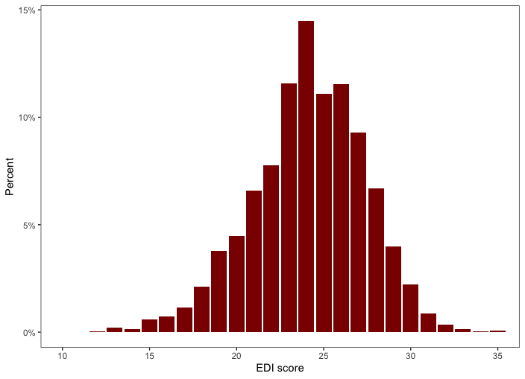

Fig 2.
Disease transition pattern from baseline (CMD-free) to first MI, first stroke, or first T2D, and to CMM and death.
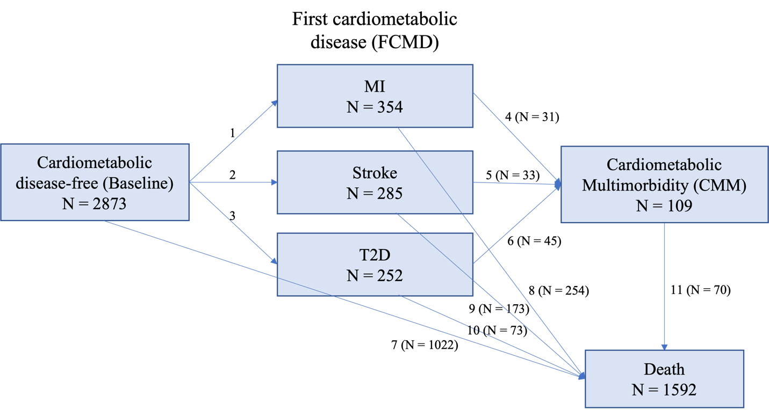
MI: Myocardial Infarction; T2D: Type 2 Diabetes

Table 2.
Comparison of complete cases and missing sample among BRHS participants free of prevalent cardiometabolic diseases at Q20 (n=3167).
Variable | Complete cases  (n = 2873) | Missing sample  (n = 294) | P value
CMM, n (%) | 109 (3.8) | 10 (3.4) | 0.7
Mean EDI score | 24.1 (3.3) | 23.5 (3.1), n = 62 | 0.1
Age at baseline, years | 68.2 (5.5) | 70.2 (5.6), n = 294 | < 0.01
Smoking status,  Current/recent smokers, % | 15.5 | N = 288  19.4 | < 0.01
Alcohol intake  Heavy alcohol drinkers, % | 2.7 | N = 294  6.1 | < 0.01
Physical activity,  Physically inactive, % | 8.6 | N = 294  11.9 | 0.02
Social class,  Manual social class, % | 45.3 | N = 294  59.2 | < 0.01
National IMD most deprived quintile, % | 14.7 | N = 291  26.8 | < 0.01
BMI, kg/m² | 26.7 (3.5) | 26.6 (3.9), n = 285 | 0.5
Waist Circumference, cm | 96.4 (10.1) | 96.8 (10.5), n = 278 | 0.4
Energy intake, kcal/day | 2147.9 (522.1) | 2012.3 (604.2), n = 173 | < 0.01
Family history of diabetes, % | 11.2 | 8.2, n = 294 | 0.2
Atrial Fibrilation based on ECG, % | 2.9 | 2.7, n = 293 | 0.8
Use of any lipid-lowering drugs, % | 3.5 | 3.7 | 0.3
Use of any blood pressure lowering drugs, % | 24.2 | 23.5 | 0.3
Systolic blood pressure, mm Hg | 149.3 | 149.1, n = 293 | > 0.9
Diastolic blood pressure, mm Hg | 85.8 (10.8) | 85.0 (12.0), n = 293 | 0.2
Total cholesterol, mmol/L | 6.1 (1.1) | 5.9 (1.0), n = 279 | < 0.01
Plasma HDL-C, mmol/L | 1.3 (0.3) | 1.4 (0.4), n = 277 | 0.3
Plasma LDL cholesterol, mmol/L | 4.0 (1.0) | 3.8 (0.9), n = 276 | < 0.01
Triglycerides, mmol/L | 1.8 (1.0) | 1.7 (1.2), n = 279 | 0.1
CMM, cardiometabolic multimorbidity; BMI, body mass index.
Values are presented as Mean (SD) or percentage unless stated otherwise.
Pearson’s chi-square test was used for all categorical variables.
Wilcoxon rank sum test was used for all continuous variables.

Table 3.
Prospective associations of baseline EDI dietary components with cardiometabolic multimorbidity in BRHS participants aged 60-79 years in 1998-2000 (n = 2873).
 |  |  | HRs (95% CI) of CMM
EDI Dietary Components | No. of events | Rate (per 1000 PY) | Model 1 ª | Model 2 ^{b} | Model 3 ^{c}
Fruits
< 1 day/week (n = 244) | 8 | 1.64 | Ref | Ref | Ref
1-2 days/week (n = 358) | 6 | 0.84 | 0.48 (0.17, 1.38) | 0.47 (0.16, 1.34) | 0.49 (0.17, 1.43)
3-6 days/week (n = 1152) | 46 | 2.00 | 1.03 (0.49, 2.18) | 0.94 (0.44, 2.00) | 1.20 (0.55, 2.62)
Daily (n = 1119) | 49 | 2.19 | 1.06 (0.50, 2.24) | 1.00 (0.47, 2.12) | 1.39 (0.63, 3.09)
P for trend |  |  | 0.30 | 0.35 | 0.07
Vegetables
< 1 day/week (n = 79) | 5 | 3.16 | Ref | Ref | Ref
1-2 days/week (n = 265) | 11 | 2.08 | 0.60 (0.21, 1.73) | 0.53 (0.18, 1.52) | 0.52 (0.18, 1.54)
3-6 days/week (n = 1723) | 60 | 1.74 | 0.47 (0.19, 1.16) | 0.44 (0.17, 1.08) | 0.46 (0.18, 1.19)
Daily (n = 806) | 33 | 2.05 | 0.51 (0.20, 1.29) | 0.49 (0.19, 1.26) | 0.55 (0.20, 1.50)
P for trend |  |  | 0.35 | 0.46 | 0.77
Cereals
< 1 day/week (n = 204) | 9 | 2.21 | Ref | Ref | Ref
1-2 days/week (n = 277) | 8 | 1.44 | 0.70 (0.27, 1.82) | 0.66 (0.25, 1.71) | 0.63 (0.24, 1.66)
3-6 days/week (n = 508) | 27 | 2.66 | 1.10 (0.51, 2.33) | 1.07 (0.50, 2.28) | 1.11 (0.51, 2.41)
Daily (n = 1884) | 65 | 1.73 | 0.68 (0.34, 1.36) | 0.72 (0.36, 1.44) | 0.77 (0.37, 1.61)
P for trend |  |  | 0.19 | 0.34 | 0.57
Legumes
Never/rarely (n = 324) | 14 | 2.16 | Ref | Ref | Ref
< 1 day/week (n = 297) | 15 | 2.53 | 1.11 (0.53, 2.30) | 1.19 (0.57, 2.48) | 1.30 (0.62, 2.74)
$≥$ 3 days/week (n = 813) | 36 | 2.21 | 0.97 (0.52, 1.80) | 1.06 (0.57, 1.97) | 1.12 (0.59, 2.13)
1-2 days/week (n = 1439) | 44 | 1.53 | 0.66 (0.36, 1.20) | 0.69 (0.38, 1.27) | 0.74 (0.40, 1.37)
P for trend |  |  | 0.06 | 0.07 | 0.10
Meat ^{d}
$≥$ 3 days/week (n = 2642) | 100 | 1.89 | Ref | Ref | Ref
< 1 day/week (n = 86) | 4 | 2.33 | 1.11 (0.41, 3.01) | 1.23 (0.45, 3.33) | 1.08 (0.38, 3.03)
1-2 days/week (n = 145) | 5 | 1.72 | 0.82 (0.34, 2.02) | 0.83 (0.34, 2.04) | 0.99 (0.39, 2.48)
P for trend |  |  | 0.74 | 0.80 | 0.98
Fish/Seafood ^{e}
< 1 day/week (n = 308) | 22 | 3.57 | Ref | Ref | Ref
$≥$ 3 days/week (n = 950) | 30 | 1.58 | 0.37 (0.21, 0.63) * | 0.38 (0.22, 0.67) * | 0.37 (0.20, 0.66) *
1-2 days/week (n = 1615) | 57 | 1.76 | 0.41 (0.25, 0.68) * | 0.44 (0.27, 0.72) * | 0.44 (0.26, 0.73) *
P for trend |  |  | 0.01 | 0.02 | 0.03
Bread ^{f}
None and white (n = 758) | 26 | 1.72 | Ref | Ref | Ref
White and whole grain (n = 1313) | 58 | 2.21 | 1.13 (0.71, 1.80) | 1.17 (0.74, 1.87) | 1.33 (0.82, 2.15)
Whole grain (n = 802) | 25 | 1.56 | 0.79 (0.46, 1.38) | 0.87 (0.50, 1.51) | 1.03 (0.58, 1.85)
P for trend |  |  | 0.39 | 0.61 | 0.91
Olive oil
Never/Rarely (n = 2033) | 74 | 1.82 | Ref | Ref | Ref
Tertile 1 of intake  (n = 315) | 18 | 2.86 | 1.40 (0.83, 2.35) | 1.46 (0.87, 2.46) | 1.86 (1.08, 3.20) *
Tertile 2 of intake  (n = 258) | 10 | 1.94 | 0.99 (0.51, 1.92) | 1.08 (0.56, 2.10) | 1.32 (0.67, 2.61)
Tertile 3 of intake  (n = 267) | 7 | 1.31 | 0.59 (0.27, 1.28) | 0.57 (0.26, 1.24) | 0.66 (0.30, 1.44)
P for trend |  |  | 0.36 | 0.39 | 0.79
Dairy
Full-fat milk and full-fat cheese (n = 669) | 22 | 1.64 | Ref | Ref | Ref
Semi-skimmed milk and full-fat cheese / full-fat milk and low-fat cheese  (n = 1572) | 57 | 1.81 | 1.08 (0.66, 1.77) | 1.06 (0.65, 1.74) | 1.18 (0.71, 1.97)
Skimmed milk and full-fat cheese (n = 281) | 17 | 3.02 | 1.85 (0.98, 3.51) | 1.88 (0.99, 3.56) | 2.29 (1.16, 4.49) *
Skimmed/Semi-skimmed milk and low-fat cheese  (n = 351) | 13 | 1.85 | 1.25 (0.63, 2.49) | 1.27 (0.64, 2.53) | 1.44 (0.70, 2.95)
P for trend |  |  | 0.20 | 0.18 | 0.10
CMM, cardiometabolic multimorbidity; EDI, Elderly dietary index.
ª Model 1: Adjusted for age.
^{b} Model 2: Adjusted for model 1 + BMI.
^{c} Model 3: Adjusted for model 2 + waist circumference, smoking status, alcohol intake, physical activity, social class, National IMD, energy intake, use of any lipid-lowering drugs, and modified EDI score without food group of interest.
^{d} Due to small case numbers, never/rarely and < 1 day/week were combined to < 1 day/week for meat intake.
^{e} Due to small case numbers, never/rarely and < 1 day/week were combined to < 1 day/week for fish/seafood intake
^{f} Due to small case numbers, none and white were combined to none/white for bread intake.
* p < 0.05

Table 4.
Prospective associations of EDI quartiles and fish/seafood consumption with cardiometabolic multimorbidity in BRHS participants aged 60-79 years in 1998-2000, excluding patients with prevalent heart failure at baseline (n = 2859)
Baseline EDI Quartiles | HRs (95% CI) of CMM
Q1 (EDI Score 9-22) | Ref
Q2 (EDI Score 23-24) | 0.71 (0.42, 1.21)
Q3 (EDI Score 25-26) | 0.94 (0.55, 1.60)
Q4 (EDI Score 27-35) | 0.89 (0.51, 1.55)
Baseline Fish/Seafood Consumption ª
< 1 day/week | Ref
$≥$ 3 days/week | 0.37 (0.21, 0.66) *
1-2 days/week | 0.43 (0.25, 0.72) *
CMM, cardiometabolic multimorbidity.
ª The two least adherence intake groups were combined (never/rarely and < 1 day/week) into < 1 day/week due to small case numbers in the “never/rarely” consumption group.
Model was adjusted for age, BMI, waist circumference, smoking status, alcohol intake, physical activity, social class, National IMD, energy intake, use of any lipid-lowering drugs. An additional covariate, modified EDI score without fish/seafood intake, was adjusted in the fish/seafood consumption model.

Table 5.
Prospective associations of EDI quartiles and fish/seafood consumption with cardiometabolic multimorbidity in BRHS participants aged 60-79 years in 1998-2000, after missing data imputation (n = 3167)
Baseline EDI Quartiles | HRs (95% CI) of CMM
Q1 (EDI Score 9-22) | Ref
Q2 (EDI Score 23-24) | 0.72 (0.42, 1.21)
Q3 (EDI Score 25-26) | 0.91 (0.54, 1.54)
Q4 (EDI Score 27-35) | 0.90 (0.53, 1.54)
Baseline Fish/Seafood Consumption ª
< 1 day/week | Ref
$≥$ 3 days/week | 0.39 (0.22, 0.70) *
1-2 days/week | 0.50 (0.31, 0.83) *
CMM, cardiometabolic multimorbidity.
ª The two least adherence intake groups were combined (never/rarely and < 1 day/week) into < 1 day/week due to small case numbers in the “never/rarely” consumption group.
Model was adjusted for age, BMI, waist circumference, smoking status, alcohol intake, physical activity, social class, National IMD, energy intake, use of any lipid-lowering drugs. An additional covariate, modified EDI score without fish/seafood intake, was adjusted in the fish/seafood consumption model.

Table 6.
Hazard Ratios (95% CI) for disease transitions from baseline (CMD-free) to FCMD, CMM, and death by quartiles of the Elderly Dietary Index (EDI) in BRHS participants aged 60-79 years in 1998-2000 (n = 2873)
 |  | Hazard Ratios (95% CI) for each disease transition
 |  | Baseline EDI Quartiles
Disease transition | No. of Events | Q1  (EDI Score 9-22, n = 793) | Q2  (EDI score 23-24, n = 749) | Q3  (EDI score 25-26, n = 651) | Q4  (EDI score 27-35, n = 680)
Baseline to FCMD | 891 | Ref | 0.97 (0.81, 1.16) | 0.93 (0.77, 1.13) | 0.87 (0.72, 1.07)
FCMD to CMM | 109 | Ref | 0.59 (0.34, 1.02) | 0.86 (0.49, 1.48) | 0.80 (0.45, 1.42)
Baseline to death | 1022 | Ref | 0.90 (0.76, 1.07) | 0.93 (0.78, 1.12) | 0.84 (0.70, 1.02)
FCMD to death | 500 | Ref | 0.55 (0.43, 0.70) * | 0.68 (0.53, 0.88) * | 0.47 (0.35, 0.63) *
CMM to death | 70 | Ref | 2.45 (0.99, 6.06) | 4.40 (1.66, 11.66) * | 2.58 (0.94, 7.04)
FCMD: First cardiometabolic disease; CMM: Cardiometabolic multimorbidity
Model adjusted for age, BMI, waist circumference, smoking status, alcohol intake, physical activity, social class, National IMD, energy intake, and use of any lipid-lowering drugs
* p < 0.05

Table 7.
Hazard Ratios (95% CI) for disease transitions from baseline (CMD-free) to first MI, Stroke, or T2D, CMM, and death by quartiles of the Elderly Dietary Index (EDI) in BRHS participants aged 60-79 years in 1998-2000 (n = 2873)
 |  | Hazard Ratios (95% CI) for each disease transition
 |  | Baseline EDI Quartiles
Disease transition | No. of Events | Q1  (EDI Score 9-22, n = 793) | Q2  (EDI score 23-24, n = 749) | Q3  (EDI score 25-26, n = 651) | Q4  (EDI score 27-35, n = 680)
Baseline to FCMD
Baseline to MI | 354 | Ref | 1.04 (0.79, 1.38) | 0.96 (0.71, 1.30) | 0.75 (0.54, 1.04)
Baseline to Stroke | 285 | Ref | 0.90 (0.64, 1.25) | 1.07 (0.76, 1.50) | 1.01 (0.71, 1.43)
Baseline to T2D | 252 | Ref | 1.01 (0.72, 1.40) | 0.84 (0.57, 1.22) | 0.96 (0.67, 1.38)
FCMD to CMM
MI to CMM | 31 | Ref | 0.85 (0.23, 3.07) | 4.21 (1.05, 16.71) * | 3.45 (0.83, 14.34)
Stroke to CMM | 33 | Ref | 0.28 (0.07, 1.15) | 0.38 (0.12, 1.26) | 1.25 (0.39, 3.96)
T2D to CMM | 45 | Ref | 0.77 (0.35, 1.72) | 0.67 (0.28, 1.60) | 0.38 (0.13, 1.13)
Baseline to death | 1022 | Ref | 0.91 (0.77, 1.08) | 0.94 (0.79, 1.13) | 0.85 (0.71, 1.03)
FCMD to death
MI to death | 254 | Ref | 0.73 (0.49, 1.07) | 1.04 (0.67, 1.59) | 0.68 (0.43, 1.07)
Stroke to death | 173 | Ref | 0.41 (0.25, 0.67) * | 0.63 (0.39, 0.99) * | 0.52 (0.30, 0.91) *
T2D to death | 73 | Ref | 0.45 (0.22, 0.91) * | 0.69 (0.34, 1.37) | 0.41 (0.19, 0.92) *
CMM to death | 70 | Ref | 2.19 (0.88, 5.43) | 4.24(1.49, 12.05) * | 1.58 (0.58, 4.34)
FCMD: First cardiometabolic disease; CMM: Cardiometabolic multimorbidity
Model adjusted for age, BMI, waist circumference, smoking status, alcohol intake, physical activity, social class, National IMD, energy intake, and use of any lipid-lowering drugs
* p < 0.05

Fig 3.
Disease transition probabilities from baseline to incident FCMD, CMM, and death with or without CMD and CMM for BRHS participants by baseline EDI quartiles.
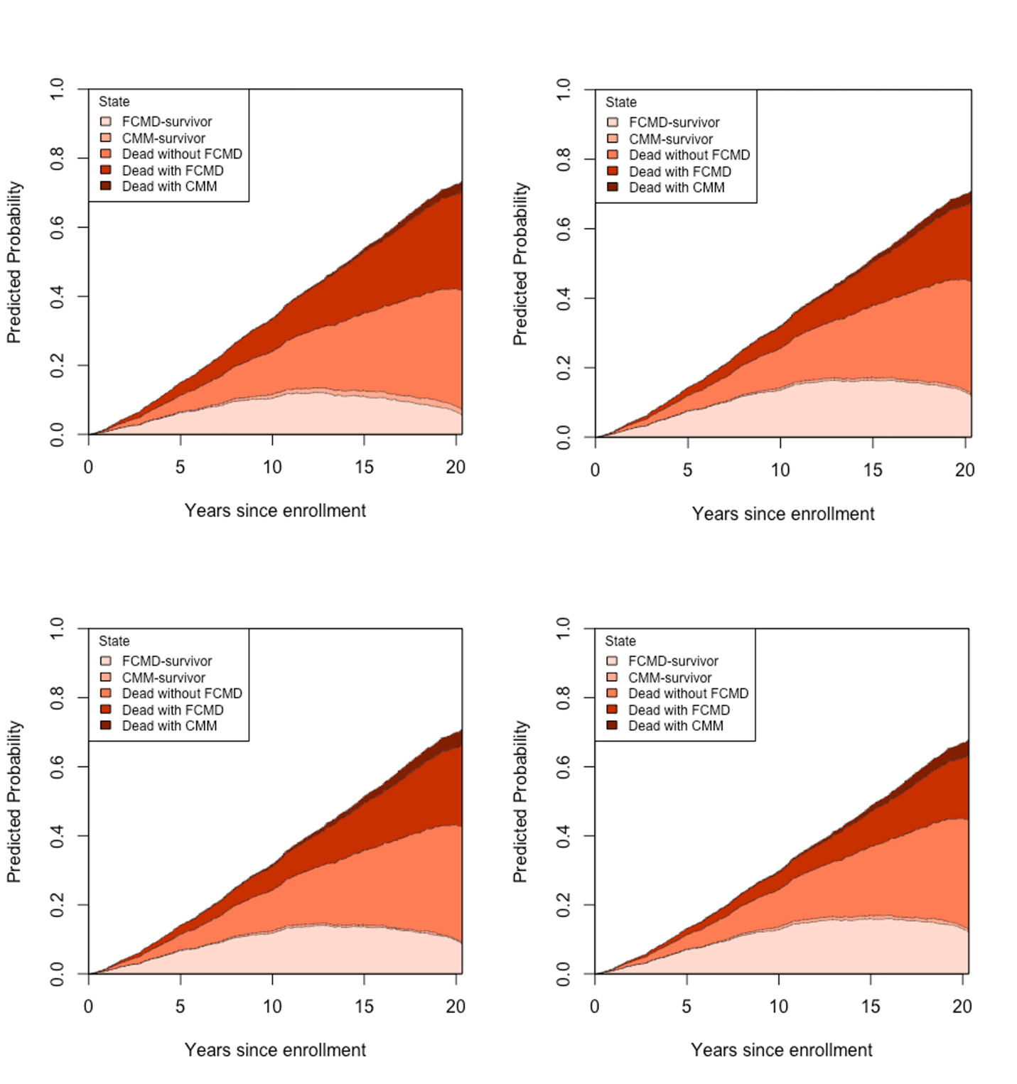
FCMD: First cardiometabolic disease; CMM: Cardiometabolic multimorbidity.
Disease transition probabilities were computed for participants with baseline EDI Q1 (top-left), baseline EDI Q2 (top-right), baseline EDI Q3 (bottom-left), and baseline EDI Q4 (bottom-right). All covariates were set to the average level or reference level of the BRHS population in the present analysis.

Table 8.
Hazard Ratios (95% CI) for disease transitions from baseline (CMD-free) to FCMD, CMM, and death by baseline fish/seafood consumption in BRHS participants aged 60-79 years in 1998-2000 (n = 2873)
 |  | Hazard Ratios (95% CI) for each disease transition
 |  | Baseline Fish/Seafood Consumption
Disease transition | No. of Events | < 1 day/week (n = 308) | $≥$ 3 days/week (n = 950) | 1-2 days/week (n = 1615)
Baseline to FCMD | 891 | Ref | 0.81 (0.64, 1.02) | 0.93 (0.75, 1.16)
FCMD to CMM | 109 | Ref | 0.43 (0.23, 0.77) * | 0.41 (0.24, 0.70) *
Baseline to death | 1022 | Ref | 0.81 (0.65, 1.01) | 0.81 (0.67, 1.00) *
FCMD to death | 500 | Ref | 1.09 (0.77, 1.52) | 0.82 (0.60, 1.11)
CMM to death | 70 | Ref | 1.58 (0.62, 4.03) | 0.53 (0.21, 1.30)
FCMD: First cardiometabolic disease; CMM: Cardiometabolic multimorbidity
Model adjusted for age, BMI, waist circumference, smoking status, alcohol intake, physical activity, social class, National IMD, energy intake, use of any lipid-lowering drugs, and modified EDI score without fish/seafood intake.

Fig 4.
Disease transition probabilities from baseline to incident FCMD, CMM, and death with or without CMD and CMM by baseline fish/seafood consumption frequencies
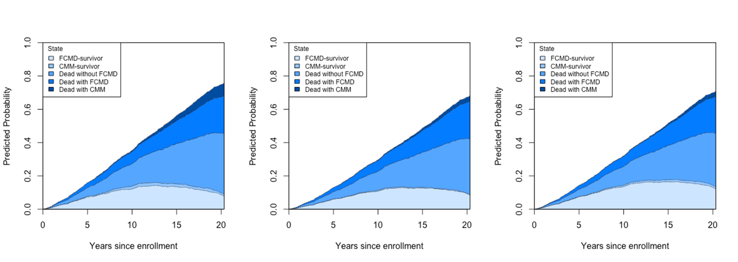
FCMD: First cardiometabolic disease; CMM: Cardiometabolic multimorbidity.
Disease transition probabilities were computed for participants with baseline fish/seafood consumption < 1 day/week (left), baseline fish/seafood consumption$≥$3 days/week (middle), and baseline fish/seafood consumption 1-2 days/week (right). All covariates were set to the average level or reference level of the BRHS population in the present analysis.

