SUPPLEMENTARY MATERIAL
Table S1 NHS England rapid fetal exome R21 pathway inclusion and exclusion criteria¹
Inclusion criteria
- *Ongoing pregnancies in fetuses with anomalies in two or more systems
- *Suspected skeletal dysplasias (fetal growth restriction excluded)
- *Large echogenic kidneys with a normal bladder
- *Major central nervous system abnormalities excluding neural tube defects)
- *Multiple contractures (excluding isolated bilateral talipes)
- Persistent nuchal translucency (NT) of greater than 6.5mm plus another anomaly with a normal array CGH
- Non-immune hydrops fetalis with a normal array CGH
*Persistent NT (>3.5mm) can only be considered in the presence of other structural abnormalities in two or more systems.
*Mild ventriculomegaly should only be considered as an abnormality if the posterior horn is persistently >11mm. Under these circumstances it is not considered a major CNS abnormality in isolation.
Exclusion criteria
- Confirmed aneuploidy or pathogenic copy number variant consistent with fetal anomalies detected by microarray
- Fetuses with confirmed thanatophoric dysplasia, achondroplasia or Apert syndrome on other relevant rapid tests (R23, R24, R25, R306 or R309) are excluded.
- Cases where familial causative variant(s) are known - targeted testing should be performed
- For cases where sonographic findings indicate a specific monogenic disorder, targeted testing should be applied where appropriate
- Where termination of pregnancy has already been decided or when fetal demise has occurred or is imminent then rapid exome sequencing will not be performed. Appropriate testing should be implemented postnatally using the R27 clinical indication (congenital malformation and dysmorphism syndromes – microarray and sequencing).
*Array comparative genomic hybridization (CGH) typically commenced in parallel to sequencing. Prenatal phenotypes included were those in ongoing pregnancies. NOTE: In Liverpool pES was commenced in March 2021 before formal commencement of the R21 pathway which started October 2021.

Table S2 Ultrasound phenotypes and assessment for Clause E termination of pregnancy based on ultrasound features alone of all cases in which termination of pregnancy was carried out
Case No. | Phenotype |  |  | Clause E criteria met independent of pES (gestational age) | Genetic Diagnosis | Gestational age at TOP  (weeks + days)
 | 1st trimester | 2nd trimester | 3rd trimester
E1 | Normal early Anatomy | HC < 3rd centile  enlarged CSP,  thickened corpus callosum  small thymus, bilateral duplex renal systems with hydronephrosis  MRI Fetal Brain- asymmetry of lateral ventricles, underdevelopment of sylvian fissure, prominent CSF space on one side, evolving cortical brain anomaly | NA | Yes (25+3) | Schinzel-Giedion syndrome OMIM 269150 | 26+6
E11 | Raised NT | Mild ventriculomegaly, bilateral talipes | Mild ventriculomegaly, bilateral talipes  MRI Fetal Brain - abnormality of  cortical formation, likely extensive bilateral polymicrogyria | Yes (29+6) | Zellweger syndrome OMIM 214100 | 30+6
E14 | Normal early anatomy | Double aortic arch, small thymus, cleft lip and palate | Double aortic arch, small thymus, brachycephaly/trigonocephaly, cleft lip and palate | No | Arboleda-Tham syndrome OMIM 616268 | 32+3
E16 | Raised NT | Microcephaly, hypoplastic cerebellum, raised NF, cardiomegaly, pericardial effusion  bilateral hydronephrosis with dysplastic cortex, unilateral talipes  MRI Fetal Brain- hypoplastic corpus callosum, poor sulcation of cerebral hemispheres | Microcephaly, hypoplastic cerebellum, raised NF, cardiomegaly, pericardial effusion  bilateral hydronephrosis with dysplastic cortex, unilateral talipes | Yes (26+4) | Renpenning syndrome OMIM 309500 | 28+5
E38 | Raised NT | SGA 3rd centile, prominent forehead, VSD, bilateral SVC | AGA, HC 3rd centile  Unilateral pelvic kidney, small contralateral kidney  Frontal brachycephaly possible bi-coronal craniosynostosis  MRI - normal intracranial anatomy | No | Kabuki syndrome OMIM 147920 | 29+4
E39 | Normal early anatomy | Unilateral renal pelvic dilatation | Moderate unilateral pleural effusion (progressed to hydrops fetalis), suspected bicuspid aortic valve | Yes (31+6) | Noonan syndrome OMIM 163950 | 32+6
E4 | Normal early anatomy | CHAOS, tracheal web visualised, possible TOF | Incomplete CHAOS (partial obstruction)  MRI fetal neck/thorax- possible obstruction in region of epiglottis, no diaphragm inversion. Follow-up MRI indicated narrowed upper trachea with small complete block above sternal notch | Yes (22+6) | pES negative | 34+6
E6 | Normal early anatomy | Mild ventriculomegaly (second recurrence) | NA | Yes (20+6) | pES negative | 23+6
E22 | Raised NT, suspected exomphalos | Micrognathia, restricted thorax, possible TOF, thoracic scoliosis, fixed flexion of arms and clenched hands, fixed flexion of feet | NA | Yes (26+2) | pES negative | 26+2
E25 | Normal early anatomy | Microcephaly, micrencephaly | Microcephaly, micrencephaly | Yes (28+2) | pES negative | 29+1
E32 | Normal early anatomy | Microcephaly, partial agenesis of corpus callosum, hypoplastic cerebellum | Microlissencephaly | Yes (28+5) | pES negative | 29+2
P16 | Normal early anatomy | Bilateral mild ventriculomegaly, club hands, both radii absent, suspected oesophageal atresia, SUA, large VSD and single overriding outflow vessel | NA | Yes (26+4) | Microarray normal | 26+4
P17 | Cystic Hygroma | Craniofacial malformation, severe ventriculomegaly, hypoplastic ventricle, single great vessel and left SVC, right CDH, bilateral duplex kidney, thoracolumbar scoliosis | NA | Yes (20+6) | Microarray normal | 21+4
P18 | Normal early anatomy | Hydrops Fetalis, short-long bones, placentomegaly | NA | Yes (26+3) | Microarray normal | 26+3
P19 | Raised NT | Hydrops fetalis, micrognathia, VSD, ectopic kidney, talipes | NA | Yes (12+6) | Microarray normal | 17+3
P20 | Raised NT | Macrocephaly, ventriculomegaly, restricted thorax, short long bones | NA | Yes (20+3) | Microarray- incidental X-linked ichtyosis | 20+3
P1 | Macrocephaly, enlarged posterior fossa, LV:RV disproportion | Macrocephaly, enlarged posterior fossa, LV:RV disproportion | NA | Yes (12+5) | Not tested | 12+5
P2 | Normal early anatomy | DCDA twins, discordant CHAOS, Hydrops Fetalis | NA | Yes (22+0) | pES negative (postmortem) | 23+0
P5 | Exomphalos | Suspected encephalocele, exomphalos, mediastinal shift | NA | Yes (12+5) | Trisomy 18 (postmortem) | 12+5
P7 | NA | Relative macrocephaly, restricted chest, short long bones | NA | Yes (24+3) | Not tested | 24+3
P8 | Exomphalos, bladder exstrophy, kyphosis | Restricted chest, possible CDH, exomphalos, bladder exstrophy, kyphoscoliosis, unilateral rocker bottom foot | NA | Yes (12+3) | Microarray normal (postmortem) | 17+3
P11 | Cystic Hygroma | Posterior fossa cyst, cleft lip and palette, LV:RV disproportion | NA | Yes (12+4) | Not tested | 13+4
P12 | Normal early anatomy | ACC, DORV, VSD, mitral dysplasia with unbalanced ventricles, ascites | NA | Yes (21+4) | Trisomy 9 (postmortem) | 23+3
P14 | Normal early anatomy | Alobar holoprosencephaly, bilateral proptosis, bilateral facial and palatal clefts | NA | Yes (21+5) | Microarray normal (postmortem) | 23+6
HC, head circumference; CSP, cavum septum pellucidum; NF, nuchal fold; NT, nuchal translucency; SGA, small for gestational age; VSD, ventriculoseptal defet; AGA, appropriately grown for gestational age; SVC, superior vena cava; CHAOS, congenital higher airway obstruction syndrome; TOF, tracheoesophageal fistula; SUA, single umbilical artery; CDH, congenital diaphragmatic hernia; LV:RV, left ventricular: right ventricular; DCDA, dichorionic, diamniotic; ACC, absent corpus callosum; DORV, double outlet right ventricle.
Table S3 Ultrasound phenotypes, assessment for Clause E termination of pregnancy based on ultrasound features and pregnancy outcome of all cases in which prenatal exome sequencing was uninformative
Case No. | Phenotype |  |  | Clause E criteria met independent of pES | Pregnancy Outcome
 | 1st trimester | 2nd trimester | 3rd trimester
E2 | Cystic hygroma, jugular lymphatic sacs, hypoplastic nasal bone, DV reversed A-wave, possible AVSD | Mitral atresia, small LV, VSD, pulmonary atresia, total anomalous pulmonary venous connection, possible isomerism, absent stomach | EFW on 10th centile, spleen not seen, liver in the midline with persistent right umbilical vein | Yes | LB
E3 | Normal early anatomy | Pulmonary sequestration, Bilateral pleural effusion, Generalised skin oedema | Pleural effusion resolved on the left, minimal effusion on the right | No
E4 | Normal early anatomy | CHAOS, tracheal web visualised, possible TOF | Incomplete CHAOS (partial obstruction)  MRI fetal neck/thorax- possible obstruction in region of epiglottis, no diaphragm inversion. Follow-up MRI indicated narrowed upper trachea with small complete block above sternal notch | Yes | TOP
E5 | NT 5.5mm | Cardiomegaly - 50% CT ratio  Umbilical vein draining into right atrium with total liver bypass  absent DV, absent portal system  Left multicystic kidney, normal right kidney and bladder, normal liquor, SUA | Cardiomegaly - 70% CT ratio, no change to other findings | Yes | NND
E6 | Normal early anatomy | Mild ventriculomegaly second recurrence, no WGS testing | NA | Yes | TOP
E7 | Normal early anatomy | Normal anatomy | Rhizomelia of upper and lower limbs, femur:foot ratio abnormal, ambiguous genitalia | No | LB
E8 | Normal early anatomy | Normal anatomy | All biometry <1st centile with normal Dopplers, normal thorax, possible bicornonal craniosynostosis, normal femur:foot ratio | No | LB
E9 | Normal early anatomy | RV not apex forming, smaller and hypertrophied, hypokinetic. Duplex right kidney, renal pelvic dilatation, ureteric dilatation and ureterocele. | RV not apex forming, smaller and hypertrophied, hypokinetic. Duplex right kidney, renal pelvic dilatation, ureteric dilatation and ureterocele. | Yes | LB
E10 | Normal early anatomy | HC <1st centile, cerebellum <1st centile, mild ventriculomegaly | Microcephaly, underdeveloped sylvian fissure  MRI - microcephaly and progressive ventriculomegaly | Yes | LB
E12 | Normal early anatomy | All long bones <1st centile, normal thorax and bone morphology and ossification, femur: foot ratio abnormal | Reduced growth velocity of long bones, long bones bowed with advancing gestation, hypoplastic scapulae and ribs, micrognathia, hypertelorism, hypoplastic nose  Mild fetal scalp oedema, normal HC and AC, TC<1st centile, bilateral hydronephrosis | Yes | NND
E13 | Exomphalos | Exomphalos major, cardiac axis deviated left, inlet VSD with overriding aorta, no PA/ductal arch visible, ascites, suspected anal atresia, thoracic hemivertebrae with mild kyphoscoliosis | Double outlet right ventricle with parallel great arteries, pulmonary valve restricted, slender pulmonary branch arteries  Small thorax, suspected anal atresia, VACTERL | Yes | LB (died at 45 days)
E15 | Normal early anatomy | Short long bones <1st centile, normal thorax, normal bone morphology and ossification, normal femur:foot ratio | HC normal range, AC and long bones <1st centile, UA AEDF suspected placental cause of FGR with normal genetic results | No | LB
E17 | Normal early anatomy | HC <3rd centile, hypoplastic cerebellum, raised nuchal fold, echogenic bowel, echogenic right kidney | MRI - microcephaly, micrencephaly, hyoplastic cerebellum and small brainstem, delayed sulcation/gyration | Yes | LB *
E18 | Normal early anatomy | Echogenic focus in the liver,  Hypercoiling of umbilical cord | All biometry, including long bones <1st centile, thorax hypoplastic, bell-shaped with rib crowding, hand brachydactyly | Yes | LB
E19 | DCDA twins, normal early anatomy | Discordant unilateral pleural effusion and mild ascites | Ascites resolved, increasing right sided pleural effusion with mediastinal shift and compression of the contralateral lung, pleuro-amniotic shunt inserted and effusion resolved | No | LB both twins
E22 | Raised NT, suspected exomphalos | Micrognathia, restricted thorax, possible TOF, thoracic scoliosis, fixed flexion of arms and clenched hands, fixed flexion of feet | NA | Yes | TOP
E23 | Cystic hygroma, generalised skin oedema | Bilateral periventricular echogenicity, suspicion of diffuse lower body oedema especially in thighs | Normal appearance | Yes | LB
E24 | Normal early anatomy | Severe bilateral ventriculomegaly, unilateral cleft lip and palate | NA | Yes | NND
E25 | Normal early anatomy | Microcephaly | Microcephaly, micrencephaly | Yes | TOP
E26 | Gastroschisis | Gastroschisis | SGA <3rd centile, gastroschisis, cardiac axis deviation, RV hypoplastic with hypertrophic wall, small PA | Yes | LB
E27 | Normal early anatomy | Severe left CDH, right kidney not visible | Severe left CDH, horseshoe kidney, severe FGR UA AEDF | Yes | NND
E28 | Normal early anatomy | Moderate left CDH, unilateral cleft lip, SUA | SGA <10th centile, moderate left CDH, cleft lip, suspected coarctation of aorta | Yes | NND
E29 | Normal early anatomy | Echogenic bowel, FGR with AEDF | Mild ventriculomegaly  MRI- confirmed isolated mild ventriculomegaly | No | LB
E30 | Possible kyphosis | Mild ventriculomegaly, suspected left lung hypoplasia, left kidney not visible, persistent right umbilical vein, left axis deviation, small left branch PA, hypoplastic aortic arch, VSD | FGR <3rd centile, mild ventriculomegaly, suspected left lung hypoplasia, left kidney not visible, persistent right umbilical vein, left axis deviation, small left branch PA, hypoplastic aortic arch, VSD | Yes | NND
E31
E32 | Normal early anatomy | Microcephaly, partial agenesis of corpus callosum, hypoplastic cerebellum | Microlissencephaly | Yes | TOP
E33 | Normal early anatomy | Normal anatomy | Bilateral pleural effusions, with some skin oedema, all resolved | No | LB
E34 | Normal early anatomy | HC and FL <1st centile, abnormal abdominal cord insertion suspected exomphalos, echogenic bowel | SGA <10th centile, normal cord insertion | No | LB
E35 | Raised NT | Raised NF, TCD <1st centile | Raised NF, TCD <1st centile  Bullet shaped 4th ventricle, Enlarged bilateral echogenic kidneys, oligohydramnios | Yes | NND
E36 | Normal early anatomy | Cardiomegaly, biventricular hypertrophy, increased cardiac echogenicity, hepatomegaly, ascites | Non-immune hydrops fetalis (bilateral pleural effusion, ascites  skin oedema), trigoncephaly and hypotelorism | Yes | IUFD
E37 | Normal early anatomy | Brachycephaly, cerebellar hypoplasia, ventriculomegaly  CSP/CC not visualised, low set ears, small thorax, short long bones, bilateral talipes, flexed knees, hypospadias | MRI 29/40 microcephaly, microencephaly, marked cortical loss, clefts on both cerebral hemispheres. Absence CSP, normal corpus callosum | Yes | LB
E40 | Normal early anatomy | Absent CSP, hypoplastic CC and pericallosal vessels not seen, dilated 3rd ventricle, bilateral severe ventriculomegaly, long bones <1st centile | SGA <3rd centile, UA AEDF  MRI confirmed scan findings, no additional findings | Yes | LB
E41 | Normal early anatomy | Normal anatomy | Severe unilateral ventriculomegaly, absent CSP  MRI - left hemimegaencephaly with cerebellar involvement | Yes | LB
E44 | Normal early anatomy | Possible cleft palate, thoracolumbar kyphoscoliosis  Thorax small and crowded  Unilateral multicystic dysplastic kidney, oligohydramnios | Restricted thorax, outlet VSD, straight ribs, thoracic hemivertebrae, sacral agenesis, kidneys appear normal, dilated rectum, anal sphincter not visualised, flexed lower limbs with bilateral talipes, suspected VACTERL | Yes | NND
E45 | Absent nasal bone, posterior fossa cyst, suspected Tetralogy of Fallot, SUA, hydronephrotic kidneys | Left-sided large polycystic kidney, abnormal posterior fossa with communication between the 4th  ventricle and CM | MRI 24/40  Dandy-Walker  spectrum disorder | Yes | LB
E47 | Normal early anatomy | Oligohydroamnios  Raised NF, limb reduction defect - Bones of the right lower leg short, unable to visualise the foot  Left leg appears normal, possible positional talipes | Oligohydroamnios  Raised NF, limb reduction defect - Bones of the right lower leg short, unable to visualise the foot  Left leg appears normal, possible positional talipes | No | LB
DV, ductus venosus; AVSD, atrioventriculoseptal defect; VSD, ventriculoseptal defect; LV, left ventricle; EFW, estimated fetal weight; CHAOS, congenital higher airway obstruction syndrome; TOF, tracheoesophageal fistula; NT, nuchal translucency; SUA, single umbilical artery; WGS, whole genome sequencing; HC, head circumference; AC, abdominal circumference; FL, femur length; VACTERL, vertebral, anal atresia, cardiac, tracheoesophageal fistula, renal, limb anomalies; CSP, cavum septum pellucidum; CC, corpus callosum; TCD, transcerebellar diameter; DCDA, dichorionic diamniotic; SGA, small for gestational age; UA, umbilical artery; AEDF, absent edn diastolic flow; RV, right ventricle; PA, pulmonary artery; FGR, fetal growth restriction; CM, cisterna magna; NF, nuchal fold.
Table S4 Cases with potentially significant variant of unknown significance on prenatal exome sequencing, absent from population databases and hypomorphic
Case No. | Prenatal phenotype | Variant | ACMG  Classification | Disease association | Outcome
E12 | Long bones <1st centile with bowing, bilateral hydronephrosis | TRIP11 (NM_000466.2): c.3082C>T p.(Arg1028Ter) pat and c.5334A>G p.Lys1778= mat | V/III | Achondrogenesis OMIM 200600 | CP, NND
E35 | Cerebellar hypoplasia, suspected molar tooth sign, microcephaly, enlarged bilateral echogenic kidneys and oligohydramnios. | PKD1 (NM_001009944.2): c.9484C>T p.(Arg3162Cys) het pat | III | Polycystic kidney disease 1  OMIM 173900 | CP, NND
CP, continued pregnancy; NND, neonatal death; mat, maternal; pat, paternal.

Table S5 Case with incidental findings on prenatal exome sequencing
Case No. | Prenatal phenotype | Variant | ACMG  Classification | Disease association | Outcome
E29 | FGR, moderate ventriculomegaly, echogenic bowel | EXT2 (LRG_494t1;NM_000401.3) mat | IV | Exostoses, multiple, type 2 OMIM 133701 | CP, LB
CP, continued pregnancy; FGR, fetal growth restriction; LB, livebirth; mat, maternal.

Appendix S1 Case 1 history, illustrating the impact of a prenatal exome sequencing result on decision-making
A 26-year-old primigravida was referred to the Fetal Medicine Unit at 21-weeks’ gestation with bilateral renal pelvic dilatation. The couple were non-consanguineous with no significant family history. At 21 weeks the fetus was found to have bilateral duplex kidneys, both with renal pelvic dilatation and duplex ureters. The fetal head circumference was below the third centile for gestational age with an unusual, thickened corpus callosum and abnormally wide cavum septum pellucidum. The fetus also had a small thymus (Figure S1). Amniocentesis was offered and accepted, and due to the anomalies present in two systems, trio prenatal exome sequencing (pES) was performed. MRI fetal brain at 23 weeks indicated a head circumference on the 5th centile, with a wide anterior cavum septum pellucidum, possible minor hypogenesis of corpus callosum with apparent communication between interhemispheric fissure and 3rd ventricle. The lateral ventricles were asymmetric with under-developed sylvian fissure and asymmetric prominent cerebrospinal fluid spaces. There was a suspected evolving cortical brain abnormality, such as polymicrogyria. Trio pES identified a heterozygous pathogenic variant in the SETBP1 gene consistent with Schinzel-Giedion syndrome. At 25 weeks the couple attended for joint Clinical Genetics and Fetal Medicine counselling and returned home to discuss options.
One week later the patient presented in threatened preterm labor and disclosed that she had decided for termination of pregnancy (TOP) and had Fetal Medicine review scheduled the next day where she had planned to request this. Support was sought from a senior colleague in Fetal Medicine, the option of emergency feticide was discussed, and a short period of assessment allowed, and it was agreed by two doctors that the grounds for Clause E of the abortion act were met. The patient was not in rapidly progressive preterm labor and certain of her decision. Feticide was subsequently carried out and she had an uncomplicated vaginal birth three hours later. The couple did not wish to have a postmortem examination.

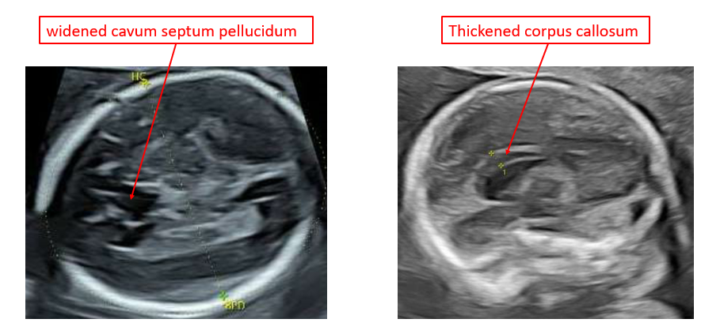
Figure S1: Ultrasound features identified in a fetus with a de novo heterozygous pathogenic variant in the SETBP1 gene consistent with Schinzel-Giedion syndrome.

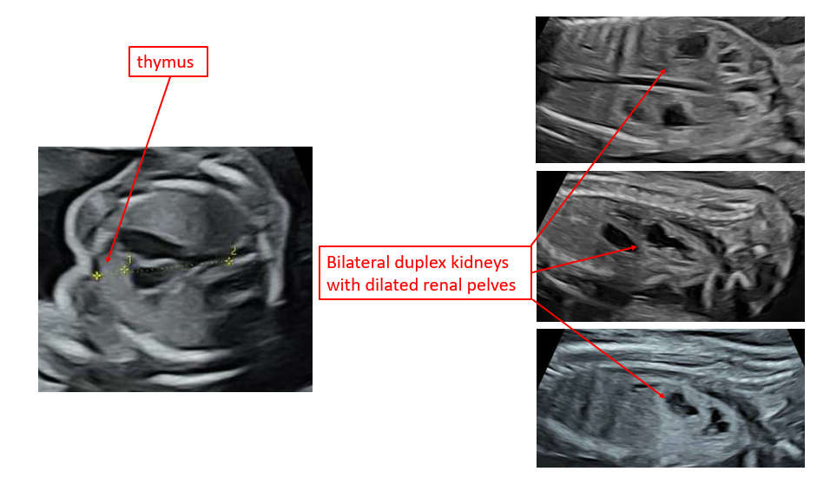
Appendix S2 Case 38 history, illustrating the impact of a prenatal exome sequencing result on decision-making A 26-year-old primigravida was referred to the Fetal Medicine Unit by her local unit with a nuchal translucency of 4mm at dating scan at 13- weeks’ gestation. The patient was in a non-consanguineous relationship with no significant family history. The remainder of the fetal anatomy appeared normal. An amniocentesis was performed at 16 weeks with no aneuploidy or causative copy number variants. Normal QF-PCR (trisomy 13, 18, 21) and microarray result were received.
At 23 weeks the fetal echocardiography identified a moderate inlet VSD with bilateral superior vena cavae. The fetus was small-for-gestational age on the third centile with a Fetal Medicine review one week later revealed a small for gestational age fetus (on the third customised centile) with a right pelvic kidney, small left kidney, frontal brachycephaly and suspected bi-coronal craniosynostosis [Figures 2a-e].
Subsequent MRI of the fetal brain at 25 weeks revealed normal intracranial anatomy and the couple felt committed to the pregnancy. They progressed with multidisciplinary planning for birth and beyond. Due to evolving fetal phenotype with multisystem anomalies a trio pES was performed (turnaround time of 22 days) and identified a heterozygous de novo variant in the KMT2D gene in keeping with Kabuki Syndrome. The patient received joint Clinical Genetic and Fetal Medicine counselling, with discussion of the association with neurodisability and significant learning issues. Knowledge of the fetal diagnosis had a significant impact on the couple and a decision for TOP was made. Post-mortem was not performed.

Figure S2: Ultrasound features identified in a de novo heterozygous variant in the KMT2D gene in keeping with Kabuki Syndrome.
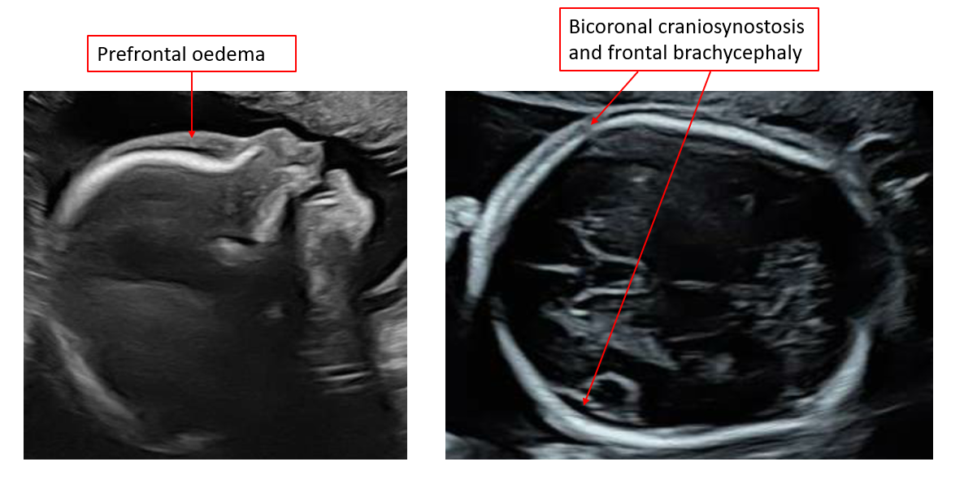

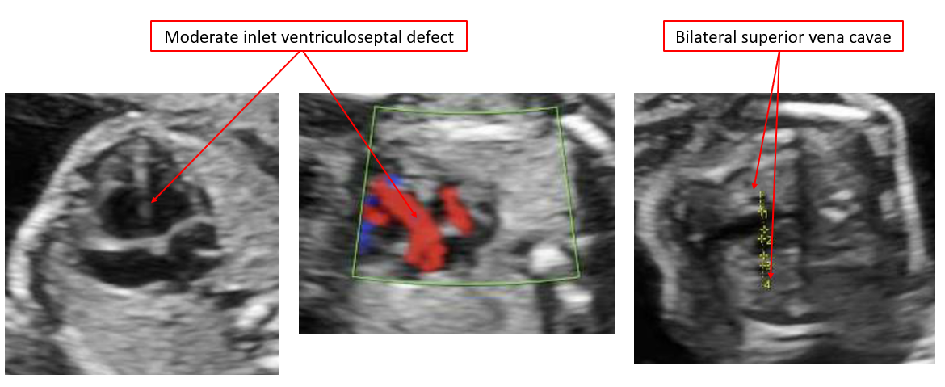
REFERENCES
- NHSE. Rapid exome sequencing service for fetal anomalies, 2021. https://www.england.nhs.uk/wp-content/uploads/2021/07/B0179_Guidance-rapid-exome-sequencing-service-for-fetal-anomalies_July21.pdf [Accessed 23 May 2022].

