Supplementary Figure 1 – CONSORT diagram

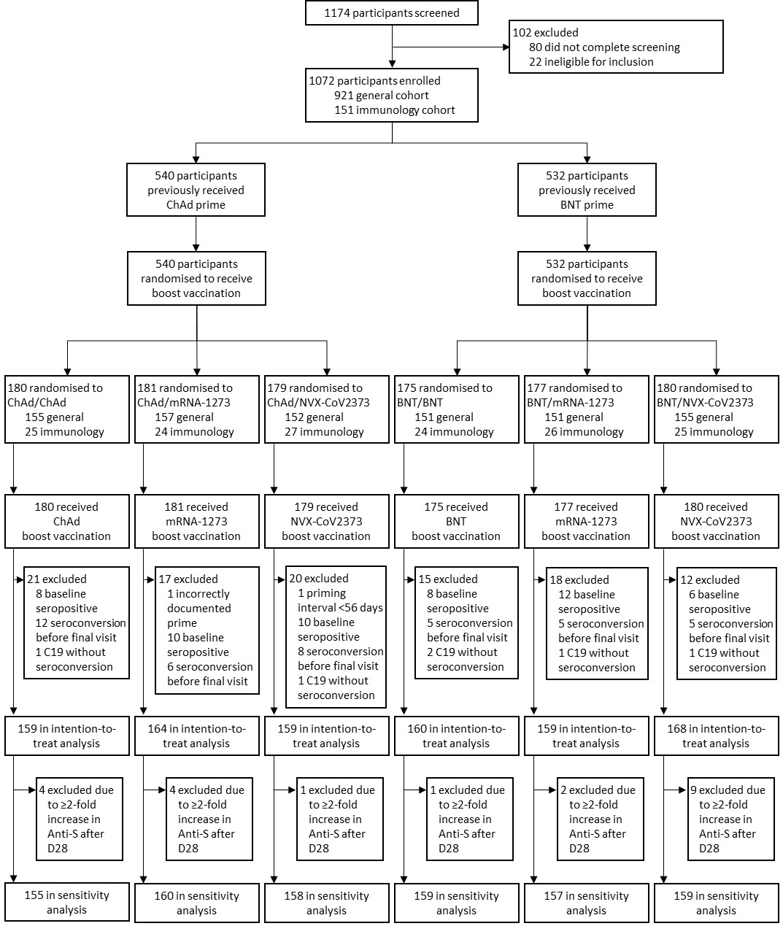
Supplementary Figure 2 – Sensitivity analysis: Forest plots comparing heterologous and homologous immunological outcomes per timepoint for Anti-spike IgG

Supplementary Figure 3 - Anti-spike IgG analysis in subgroup of samples which had neutralisation assays performed on them, only

Supplementary Figure 4 - Boxplots of raw, unadjusted anti-spike IgG data by subgroup of covariates in mixed effects model A) Age, B) Baseline, C) BMI, D) Comorbidity, E) Ethnicity, F) Interval, G) Sex
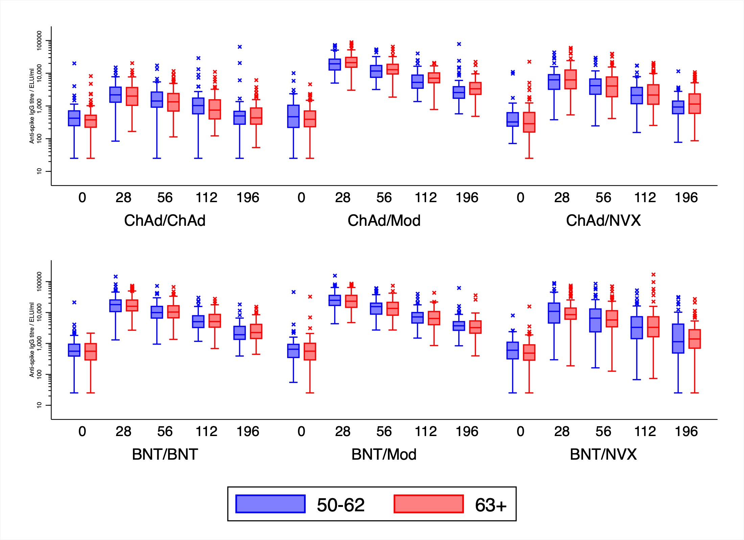
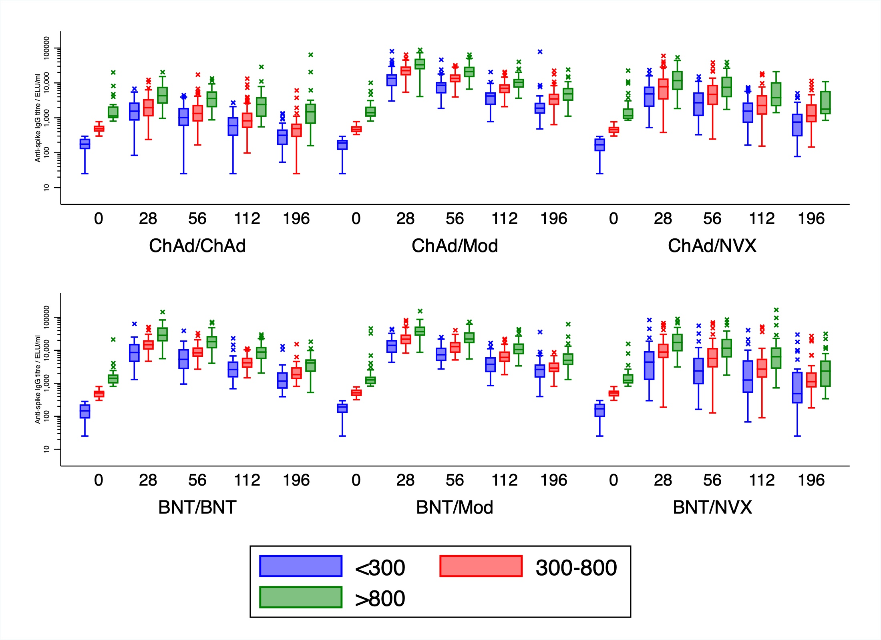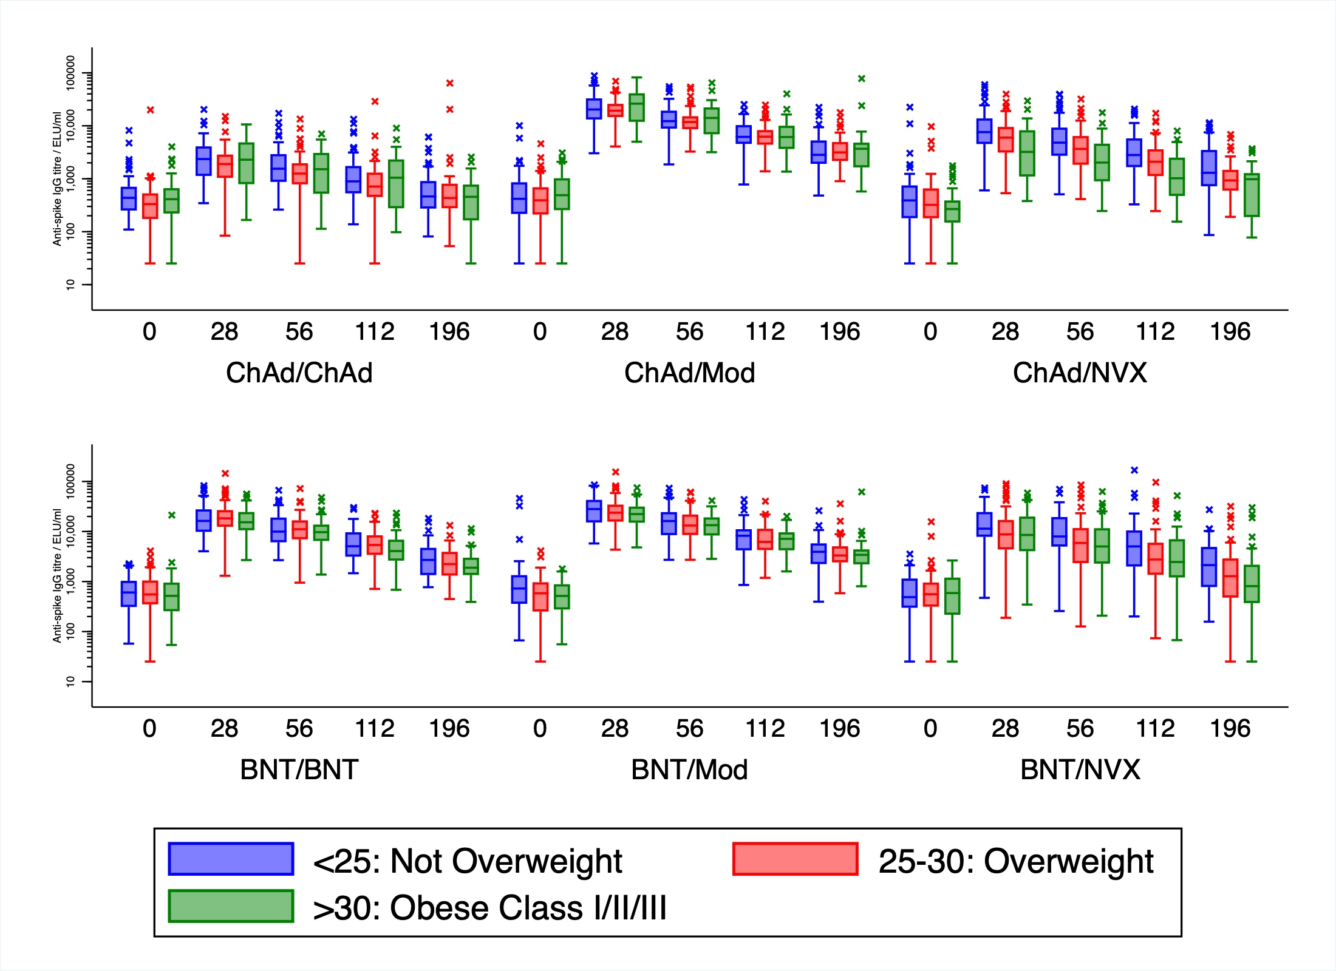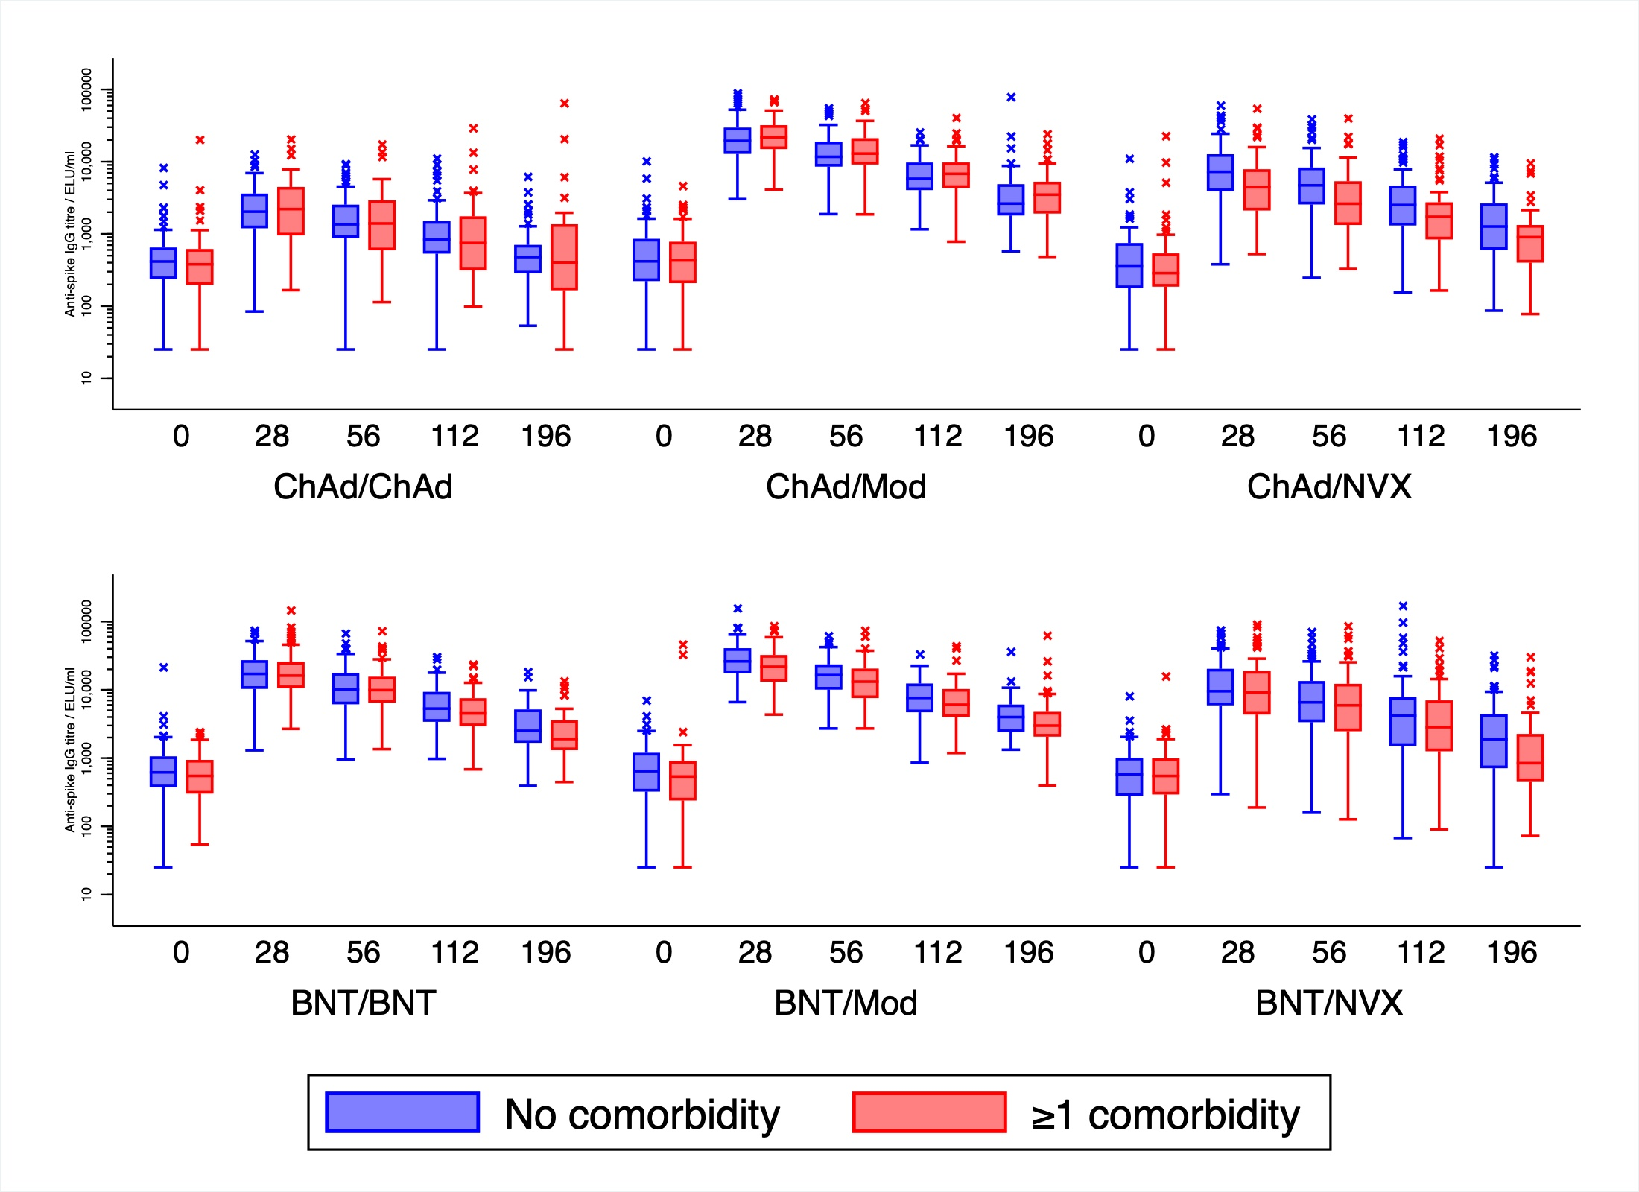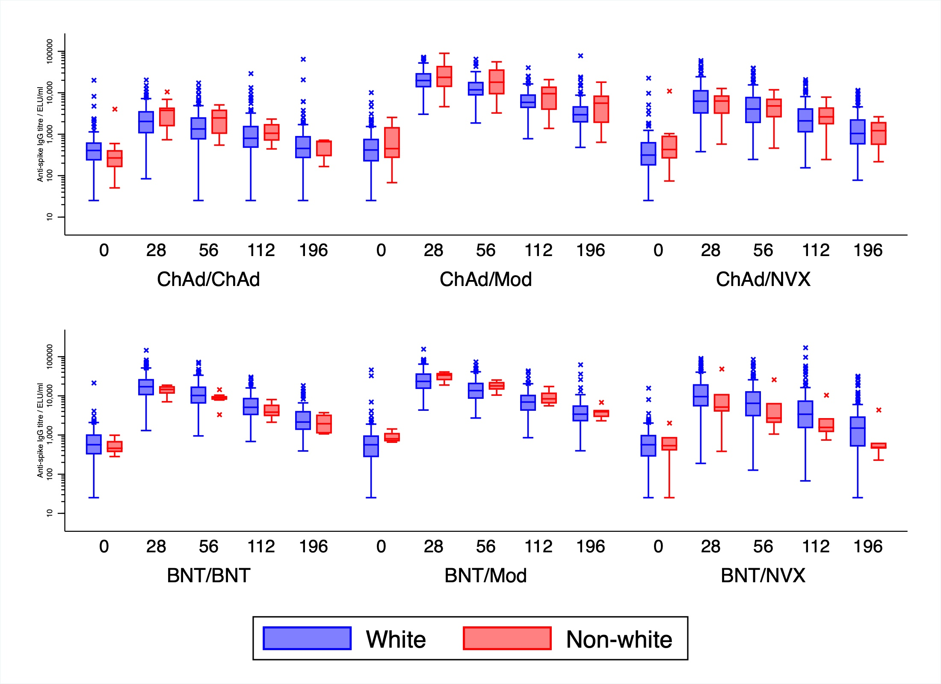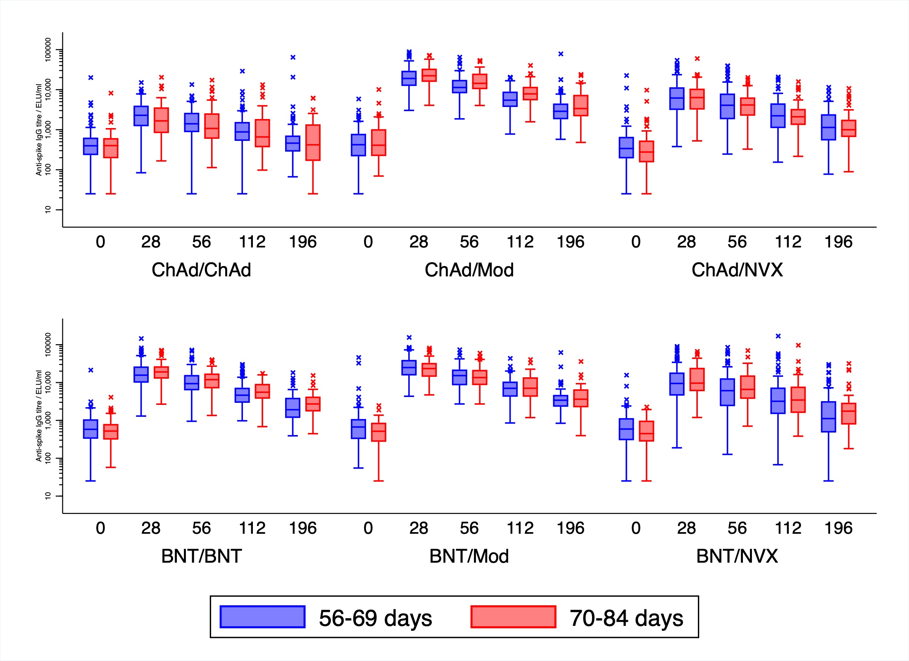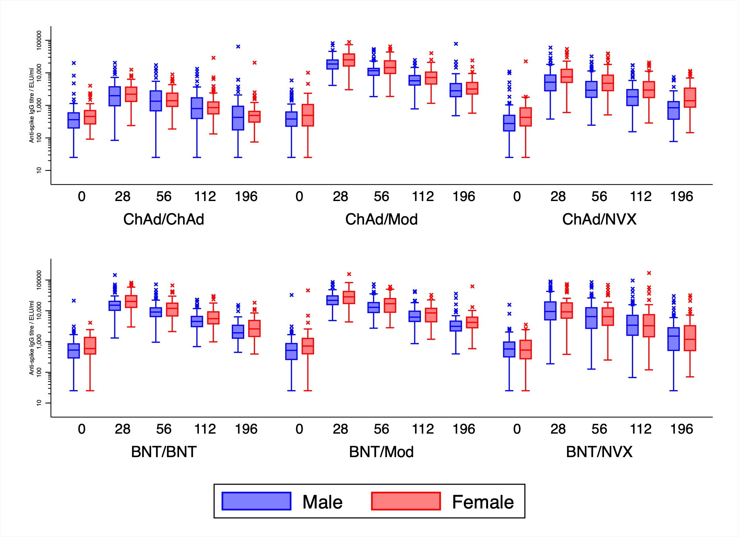
Supplementary Figure 5 - Forest plots comparing anti-spike IgG titres over time between heterologous and homologous schedules by subgroup of covariates in mixed effects model A) Age, B) Baseline, C) BMI, D) Comorbidity, E) Ethnicity, F) Interval, G) Sex
