Correspondence
Plant molecular farming in the wake of the closure of Medicago Inc.
Eugenio Benvenuto¹, Inge Broer², Marc-André D'Aoust³, Inga Hitzeroth⁴, Penny Hundleby⁵, , Rima Menassa⁶, Kirsi-Marja Oksman-Caldentey⁷, Hadrien Peyret⁵, Sancha Salgueiro⁸, Pooja Saxena⁹, Jennifer Stander¹⁰, Heribert Warzecha¹¹ and Julian Ma*¹²

1- Department for Sustainability, Biotechnology and Agroindustry Division, ENEA, Centro Ricerche Casaccia, Roma, Italy.
2 - Faculty of Agricultural and Environmental Sciences, University of Rostock, Rostock, Germany.
3 - Medicago R&D Québec City, Canada.
4 – BioPharming Research Unit, Dept. of Molecular and Cell Biology, University of Cape Town, South Africa
5 – John Innes Centre, Norfolk, England
6 – University of Western Ontario, London, Canada
7 - VTT Technical Research Centre of Finland, Espoo, Finland
8 - chart Biotechnology, Gilleleje, Denmark
9 - BlueRock Therapeutics, Toronto, Canada
10 - Cape Bio Pharms, Cape Town, South Africa
11 – Technical University of Darmstadt, Darmstadt, Germany
12 – St. George’s, University of London, UK

e-mail: Julian K-C. Ma jma@sgul.ac.uk

To the editor: Plant Molecular Farming (PMF), which includes the production of valuable recombinant proteins and small molecules using plant biotechnology, could provide a step change in improving health outcomes, particularly in developing countries,. This field was recently surprised by the announcement that the Canadian biotechnology company Medicago Inc. has ceased operations due to the termination of investment by its parent company. Medicago has been a pioneer and a leader in the commercial development of plant molecular farming, particularly vaccine production by transient expression in Nicotiana benthamiana (tobacco). A key contribution of Medicago to the COVID-19 pandemic response was the licensing in Canada, of a virus-like particle vaccine (Covifenz®) in under 24 months from initial design. While some may be concerned that the closure of this company will be a major step back for the entire field, the International Society for Plant Molecular Farming does not believe this closure to be a serious indictment of the technology, nor should it have a significant impact on future endeavours.
Medicago is one of many companies in the plant molecular farming arena — others are active with commercially successful products and full pipelines (Fig. 1). For example, Protalix Therapeutics in Israel has one marketed product, another that has completed phase-III development, and others at earlier stages. BioApp in Korea has an approved vaccine against classical swine fever, and KBio Inc. in the United States is developing a range of recombinant biologics, including a COVID-19 vaccine in phase-I/II trials. The German company Denka/Icon Genetics reported a successful phase-I trial of a norovirus vaccine and the University of Louisville has completed phase-I studies of an anti-viral lectin against HIV and coronaviruses. Germany’s Eleva GmbH has completed phase-I trials of a therapeutic enzyme produced in moss. Other companies are marketing plant-derived recombinant growth factors, cytokines, antibodies and blood components as diagnostics and research reagents, cosmetic ingredients or for laboratory-based meat. Examples include InVitria and ORF Genetics, which use transgenic cereal seeds as an expression system, and Agrenvec and Diamante, which, like Medicago, also use tobacco.
The plant molecular farming industry has always cited global access to health as one of its key targets, and this mantle has been taken up by companies in low- and middle-income countries, such as Thailand’s Baiya Phytopharm and South Africa’s Cape Bio Pharms. Baiya Phytopharm has taken two COVID-19 vaccine candidates into phase-I clinical trials, as well as another vaccine and four anti-cancer antibodies in pre-clinical development (manufactured at its cGMP facility in Bangkok). Cape Bio Pharms is currently marketing research reagents, including several related to COVID-19, but these products could also be developed as therapeutics if produced under GMP conditions. Both companies use the same basic technology as Medicago — transient expression in tobacco.

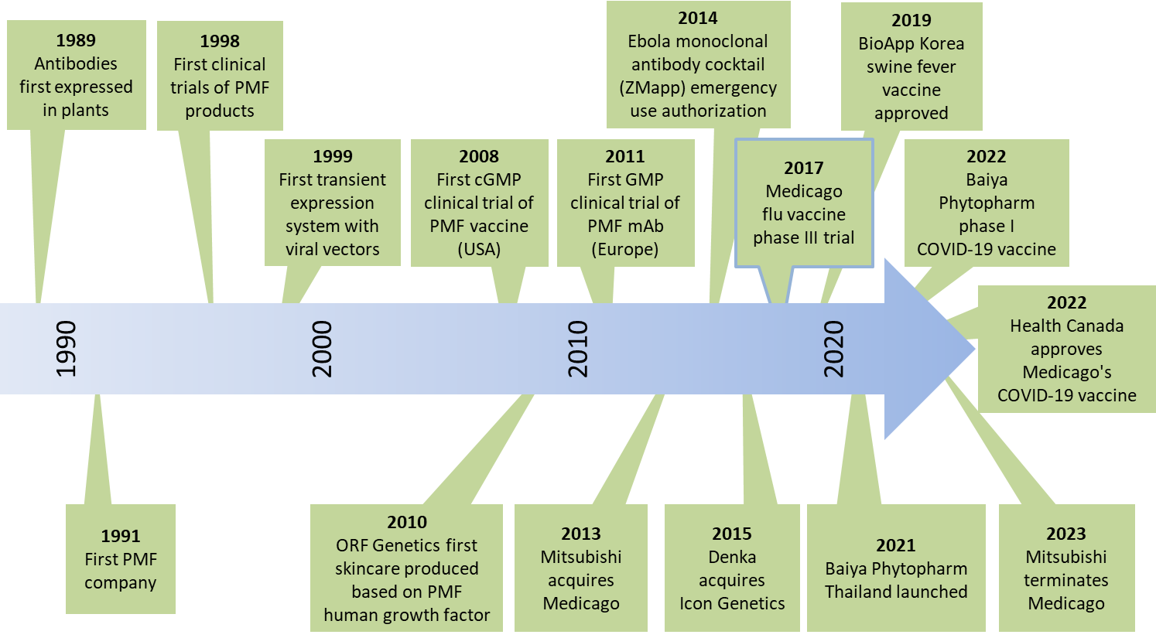
Fig. 1. Key landmarks in the development and commercialization of plant molecular farming.
The scientific, economic and social justifications for further investment in plant molecular farming remain compelling. More than 30 years of research and development since the first recombinant proteins were expressed in plants, have resulted in a robust technology and the original appeal of this manufacturing platform has not changed^{1,2} (Fig. 1). Advantages include low up-front costs that enable scalable manufacturing, a rapid manufacturing process via transient expression, the massive potential scalability of stable transgenic plant lines, the compatibility of plant-cell suspension cultures with manufacturing infrastructure designed for microbial and mammalian cells, and the potential for technology transfer to low- and middle-income countries, addressing global-health inequities. In the 2000’s, the Pharma-Planta Consortium delivered on this by producing an HIV monoclonal antibody in transgenic tobacco plants — from construct design to the completion of phase-I clinical trials — on the modest budget of an EU Framework Project,. This included full costing of upstream and downstream production, GMP-compliant manufacturing and a humanitarian declaration for cost-free technology transfer to developing countries.
The socioeconomic potential and commercial feasibility of plant molecular farming is further supported by robust evidence favoring a lower cost of goods compared to equivalents produced in traditional systems,. The upsurge in plant molecular farming has been helped by focusing on a small number of well-characterized expression systems (mainly tobacco) and the development of efficient downstream processing steps for plant material,.
Unmet market needs and product superiority are key to commercial success for any new product. But as noted by Yuri Gleba, CEO Nomad Biosciences, “Plant molecular farming has always faced a double jeopardy — the risk of a new product and the risk of a new platform”. Despite Medicago’s demise, the company undeniably de-risked plant molecular farming and in so doing validated the field.
In our opinion, consumers are starting to gain better awareness of current vaccine-production techniques, and plant-based solutions (as well as a move from egg production) are gaining interest. Consumer demand for more choice, ethical and sustainable production may sway investment decisions in this area. Furthermore, the techno-economic benefits of plant molecular farming should be recognized by governments and regulators as an efficient way to fast-track technology transfer to developing countries and regionalize pharmaceutical production facilities with low upfront costs and scalable production lines. This will allow production of biologics ‘in the region, for the region’, with the potential to target endemic diseases that are typically overlooked by Big Pharma, thus prioritizing products that give the greatest benefit for local populations.

Competing interests
This Correspondence is submitted by the 13 members of the Executive Committee of the International Society for Plant Molecular Farming. One member (Marc-André D'Aoust) is an employee of Medicago Inc., and one member (Jennifer Stander) is an employee of Cape Bio Pharms, two companies that are discussed in the Correspondence.

References
- Ma, J.K.C. et al. Nat. Rev. Genet. 4, 794–805 (2003).
- Tschofen, M. et al. Ann. Rev. Analyt. Chem. 9, 271–294 (2016).
- Mitsubishi Chemical Group. Overseas consolidated subsidiary, Medicago to cease operations (2023). https://www.mcgc.com/english/news_release/pdf/01468/01708.pdf
- Fischer, R. & Buyel, J.F. Biotechnol. Adv. 40, 107519 (2020).
- Mor, T.S. Biotechnol. Lett. 37, 2147–2150 (2015).
- ClinicalTrials.gov NCT04473690 (2020). https://clinicaltrials.gov/ct2/show/NCT04473690
- Leroux-Roels, I. et al. Front. Immunol. 13, 1021500 (2022).
- ClinicalTrials.gov NCT05122260 (2021). https://clinicaltrials.gov/ct2/show/NCT05122260
- Hennermann, J.B. et al. J. Inherit. Metab. Dis. 42, 527–533 (2019).
- Hiatt, A.H. et al. Nature 342, 76–78 (1989).
- Sijmons, P.C. et al. Biotechnology (NY) 8, 217–221 (1990).
- Ma, J.K.C. et al. Plant Biotechnol. J. 13, 1106–1120 (2015).
- Sack, M. et al. Plant Biotechnol. J. 13, 1094–1105 (2015).
- Nandi, S. et al. MAbs 8, 1456–1466 (2016).
- Tusé, D. et al. Biomed. Res. Int. 2014, 256135 (2014).
- Buyel, J.F. et al. Biotechnol. Adv. 33, 902–913 (2015).
- Buyel, J.F. et al. Biotechnol. Adv. 35, 458–665 (2017).

Ma, J.K.C., Drake, P.M.W. & Christou, P. Nat. Rev. Genet. 4, 794–805 (2003).
Tschofen, M., Knopp, D., Hood, E.E. & Stoger, E. Ann. Rev. Analyt. Chem. 9, 271–294 (2016).
Mitsubishi Chemical Group. Overseas consolidated subsidiary, Medicago to cease operations (2023). https://www.mcgc.com/english/news_release/pdf/01468/01708.pdf
Fischer, R. & Buyel, J.F. Biotechnol. Adv. 40, 107519 (2020).
Mor, T.S. Biotechnol. Lett. 37, 2147–2150 (2015).
ClinicalTrials.gov NCT04473690 (2020). https://clinicaltrials.gov/ct2/show/NCT04473690
Leroux-Roels, I., et al. Front. Immunol. 13, 1021500 (2022).
ClinicalTrials.gov NCT05122260 (2021). https://clinicaltrials.gov/ct2/show/NCT05122260
Hennermann, J.B. et al. J. Inherit. Metab. Dis. 42, 527–533 (2019).
Hiatt, A.H., Caffertey, R. & Bowdish, K. Nature 342, 76–78 (1989).
Sijmons, P.C., et al. Biotechnology (NY) 8, 217–221 (1990).
Ma, J.K.C., et al. Plant Biotechnol. J. 13, 1106–1120 (2015).
Sack, M., et al. Plant Biotechnol. J. 13, 1094–1105 (2015).
Nandi, S., et al. MAbs 8, 1456–1466 (2016).
Tusé, D., et al. Biomed. Res. Int. 2014, 256135 (2014).
Buyel, J.F., Fischer, R. & Twyman, R.M. Biotechnol. Adv. 33, 902–913 (2015).
Buyel, J.F., Twyman, R.M. & Fischer, R. Biotechnol. Adv. 35, 458–665 (2017).

