Supplementary information
Supplementary Table S1: Antibodies used in immunofluorescent staining
Antigen | Species (Isotype) | Label | Supplier | Cat. Nr. | Dilution
Von Willebrand factor propeptide | Rabbit | - | Prof. Tom Carter, SGUL | - | 1:500
Von Willebrand factor | Rabbit | - | DAKO | A0082 | 1:500
Von Willebrand factor | Mouse (IgG_{2b}) | - | Sanquin | CLB-RAg20 | 1:500
Alpha-tubulin | Mouse (IgG_{2b}) | - | Abcam | ab56676 | 1:500
Alpha-tubulin | Mouse (IgG₁) | - | Sigma | DM1A | 1:500
SPARC | Mouse (IgG₁) | - | SantaCruz | sc-73472 | 1:500
Fibrinogen | Rabbit | - | DAKO | A0080 | 1:500
CD62P | Mouse (IgG₁) | - | Bio-Rad | MCA796 | 1:500
Mouse IgG₁ | Goat | CF488A | Biotium | 20246 | 1:1000
Mouse IgG₁ | Goat | CF568 | Biotium | 20248 | 1:1000
Mouse IgG₁ | Goat | CF647 | Biotium | 20252 | 1:1000
Mouse IgG_{2b} | Goat | CF647 | Biotium | 20272 | 1:1000
Rabbit IgG (H+L) | Goat | CF488 | Biotium | 20012 | 1:1000
Rabbit IgG (H+L) | Donkey | AF 568 | ThermoFisher | A11042 | 1:400
Alpaca IgG | Goat | AF 488 | Jackson ImmunoResearch | 128-545-230 | 1:400

Supplemental Figure 1
Supplemental Figure 1: VWF and VWFpp localization in resting platelets. Full field of view of resting platelets segmented based on alpha-tubulin staining (magenta) and stained for VWF (red) and VWFpp (green) (A). Highlighted platelets are randomly selected and presented as single plane zoom-in images in (B). Scale bar represents 5 μM in (A) and 1 μM in (B).

Supplemental Figure 2
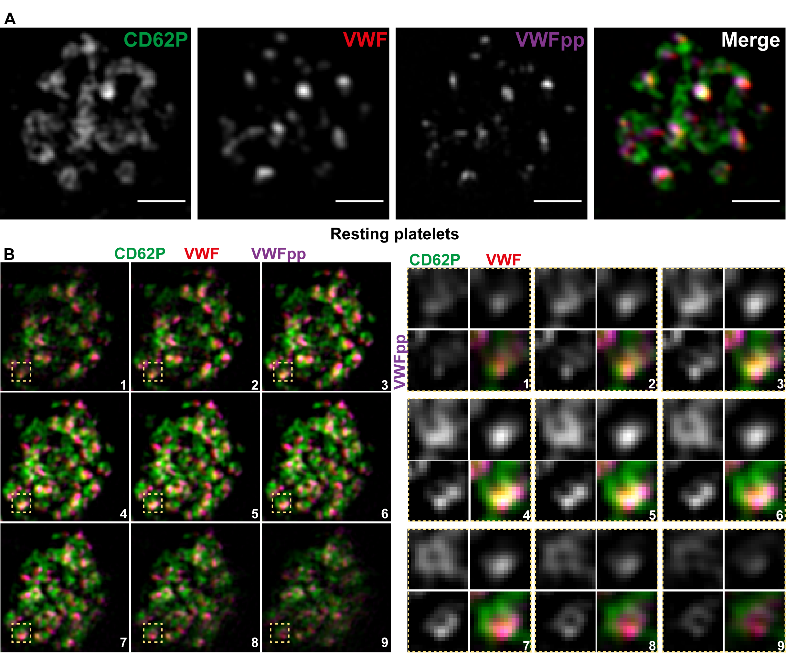
Supplemental Figure 2: 3D VWF and VWFpp localization in CD62P-defined alpha-granular structures. Resting platelets were stained for CD62P (green), VWF (red, CLB-RAg20) and VWFpp (magenta). Representative platelets are shown as single plane zoom-in image (A) or in serial planes of a zoom-in image (B) to illustrate 3D localization of the stained proteins. Single granule details of CD62P/VWF/VWFpp (yellow squares) are shown. Scale bar represents 1 µm.

Supplemental Figure 3
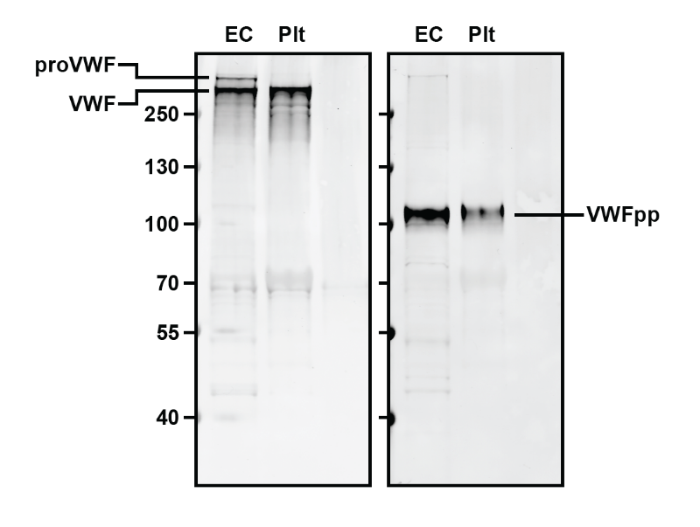
Supplemental Figure 3: VWF and VWFpp immunoblots of endothelial- and platelet lysates. Endothelial and platelet lysates were separated on a 4-12% Bis-Tris gel and probed for VWF (left, DAKO) or VWFpp (right). Bands corresponding to proVWF, mature VWF (VWF) and VWFpp are indicated.

Supplemental Figure 4

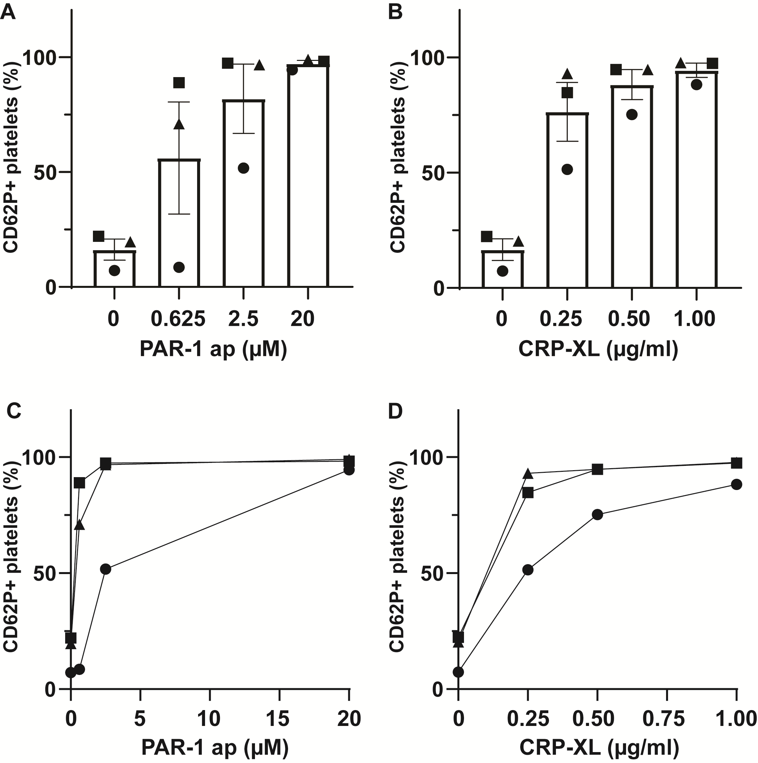

Supplemental Figure 4: Alpha-granule release assessed by FACS analysis of P-selectin exposure. Platelets were stimulated with increasing doses of PAR-1 ap (A) or CRP-XL (B) and quantified for CD62P+ cell surface exposure by flow cytometry. Symbols represent individual donors (n=3). Individual dose response curves are shown in C (PAR-1 ap) and D (CRP-XL) with symbols representing unique donors. Data presented as mean ± SD.

Supplemental Figure 5
Supplemental Figure 5: Compression of marginal band area in PAR1- and GPVI-activated platelets. Platelets were incubated with vehicle or increasing doses of PAR-1 ap or CRP-XL (B). Marginal band area was determined based on the delineation by the alpha-tubulin immunofluorescent staining of the ring structure in the middle Z-slice. Data shown are derived from platelets from 3 independent healthy control donors (PAR1 0 µM, n=208; PAR1 0.625 µM, n=166; PAR1 2.5 µM, n=157; PAR1 20 µM, n=128; CRP-XL 0 µg/mL, n=179; CRP-XL 0.25 µg/mL, n=137; CRP-XL 0.5 µg/mL, n=113; CRP-XL 1.0 µg/mL, n=139). Bars represent means and 95% confidence interval. *** p<0.001, **** p<0.0001 by 1-way ANOVA with Dunnett’s post hoc test for multiple comparison.

Supplemental Figure 6
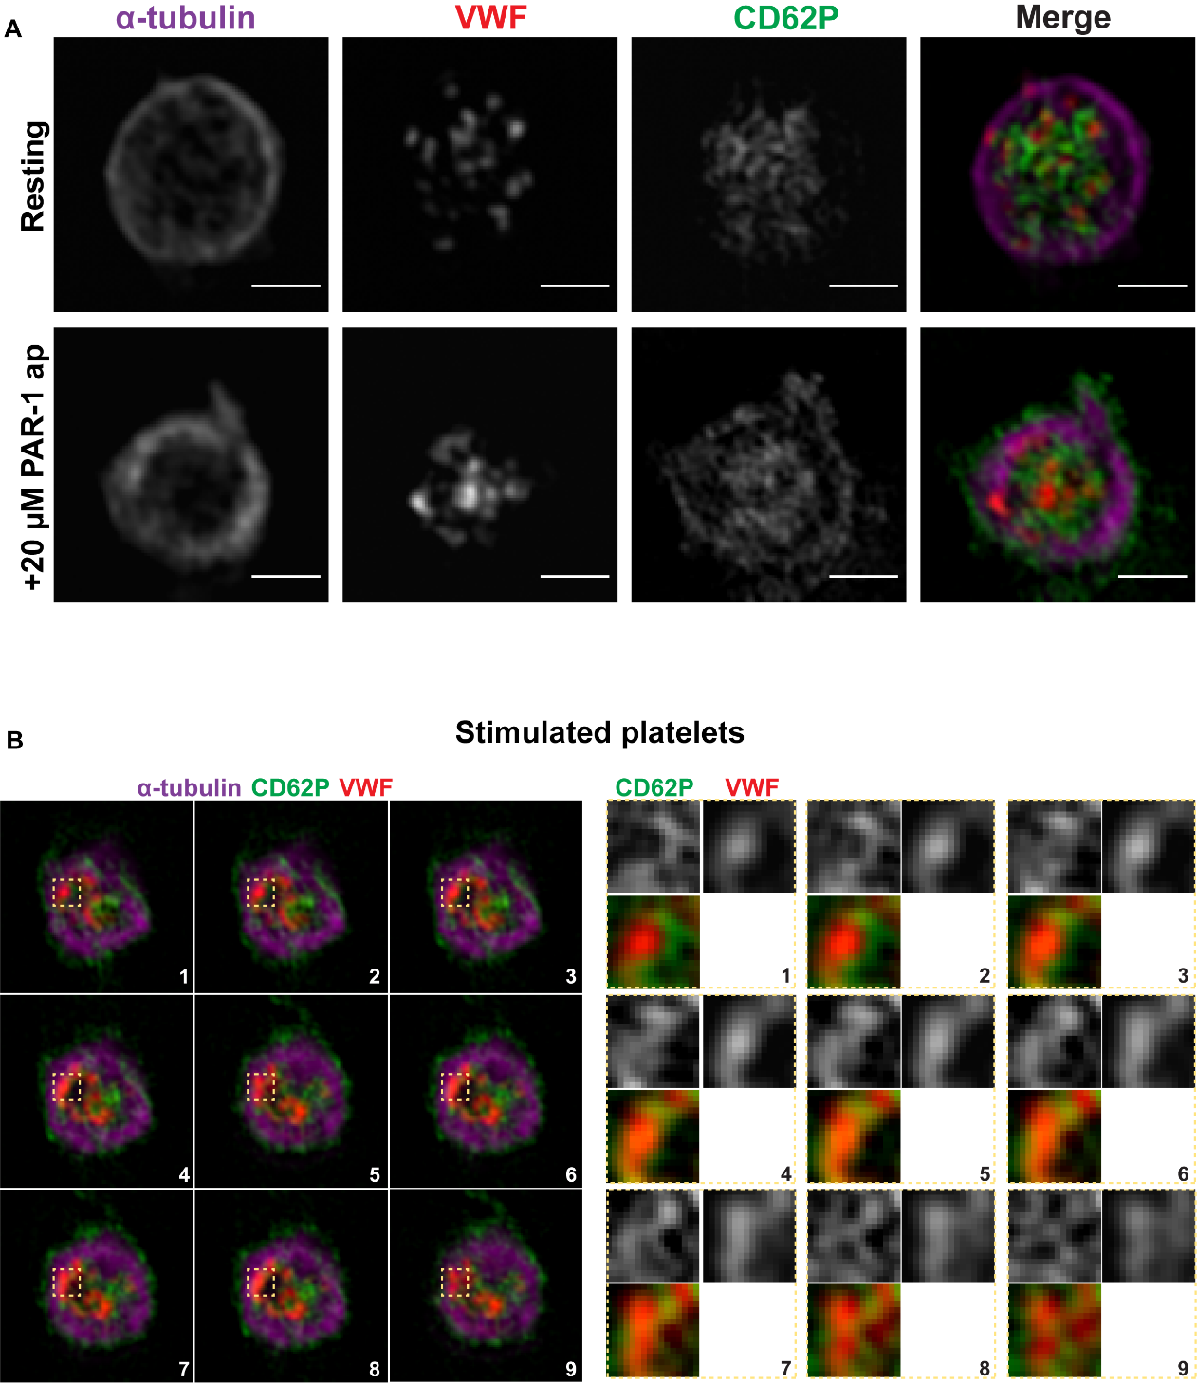
Supplemental Figure 6: 3D VWF localization in stimulated platelets. Platelets stimulated with 20 µM PAR-1 ap were stained for CD62P (green), VWF (red, DAKO) and α-tubulin (magenta) and compared to resting platelets (A). Serial planes of a zoom-in image are shown with granule details on the right (yellow squares) to illustrate 3D localization of CD62P and VWF (B). Scale bar represents 1 µm.

Supplemental Figure 7
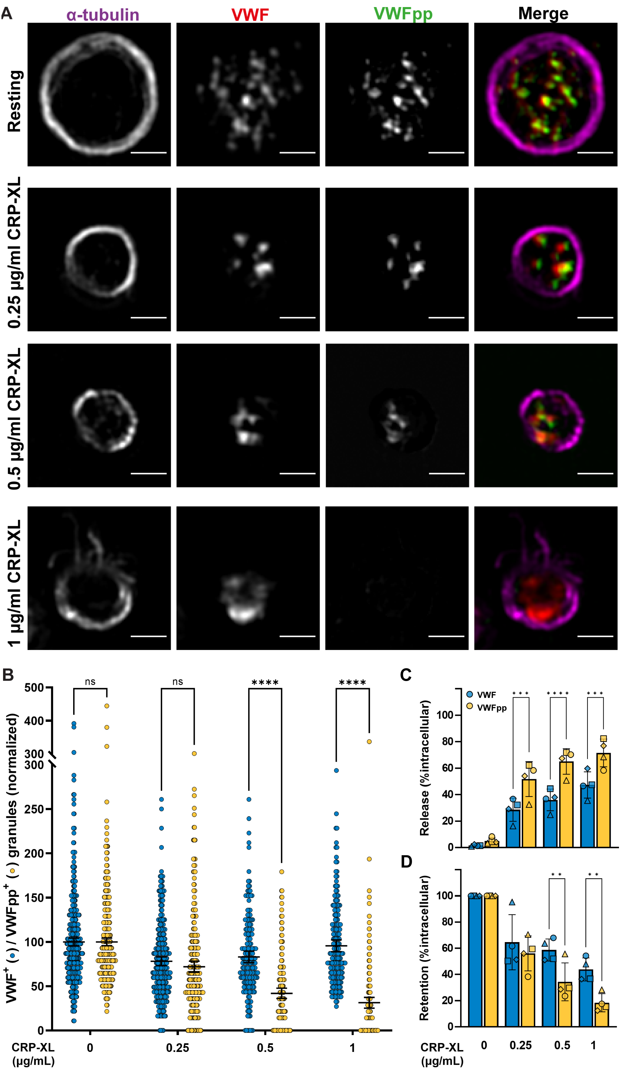
Supplemental Figure 7: Dose-response release of VWF and VWFpp. Platelets were stimulated with 0-1 µg/ml CRP-XL and stained for α-tubulin, VWF (CLB-RAg20) and VWFpp (A). Representative single plane zoom-in images are shown. Scale bar represents 1 µm. (B) VWF and VWFpp release were assessed by quantification of their residual levels in platelets normalized to resting platelets. N=498, 305, 187 and 191 respectively. Counts are pooled from 3 independent healthy donors. The release (C) and retention (D) of VWF and VWFpp in CRP-XL stimulated platelets was measured by ELISA and normalized to resting intracellular content. Symbols represent 4 healthy donors (N=4). Statistical analysis was two-way ANOVA with Sidak multiple comparisons test and significance levels of ** = p<0.01,*** = p<0.001, **** = p<0.0001. Data is presented as mean with 95% confidence interval.

Supplemental Figure 8
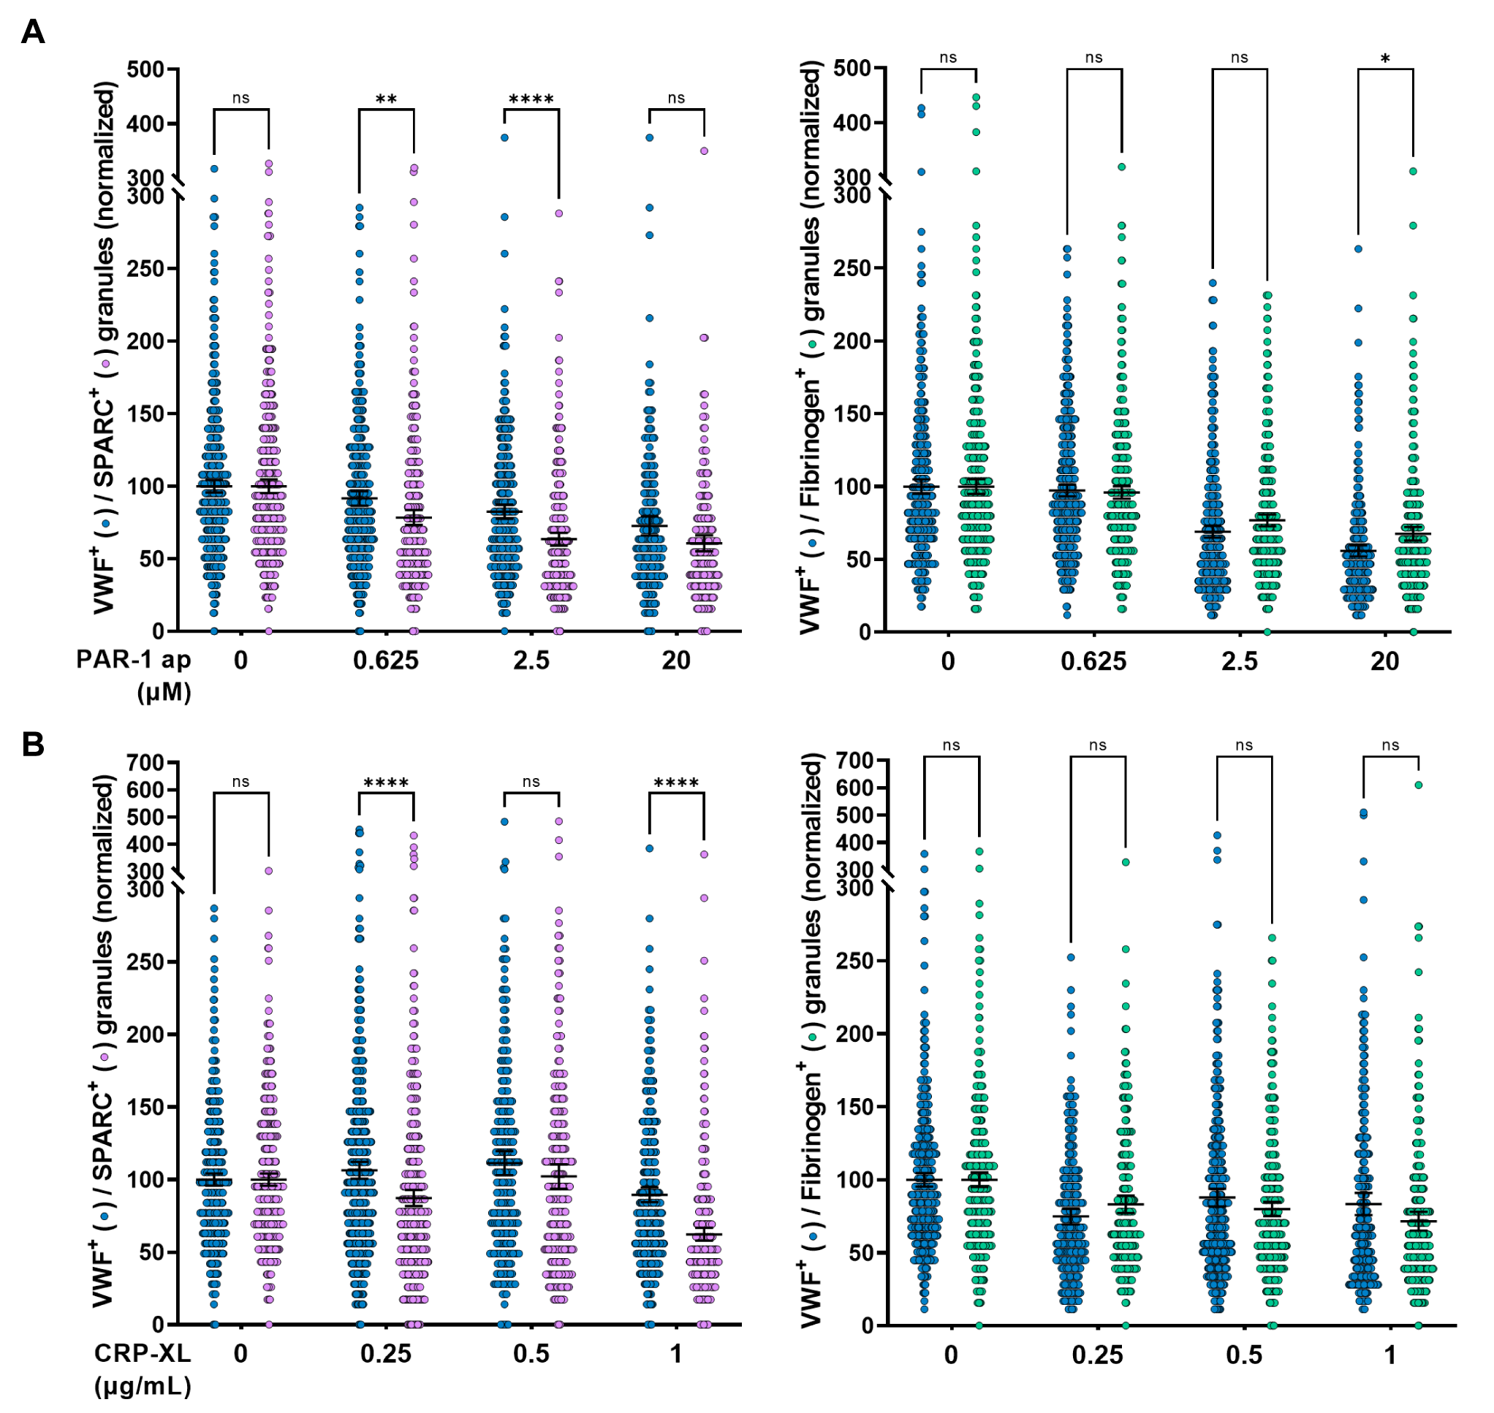
Supplemental Figure 8: Dose-response release of VWF compared to SPARC and Fibrinogen. Platelets were stimulated with 0-20 µM PAR-1 ap (A) or 0-1 µg/ml CRP-XL (B). VWF (blue), SPARC (pink) and fibrinogen (green) release was assessed by quantification of their residual levels in platelets normalized to resting platelets.
(SPARC PAR1 0 µM, n=512; PAR1 0.625 µM, n=376; PAR1 2.5 µM, n=355; PAR1 20 µM, n=218; CRP-XL 0 µg/mL, n=512; CRP-XL 0.25 µg/mL, n=480; CRP-XL 0.5 µg/mL, n=263; CRP-XL 1.0 µg/mL, n=401) (Fibrinogen PAR1 0 µM, n=549; PAR1 0.625 µM, n=499; PAR1 2.5 µM, n=437; PAR1 20 µM, n=342; CRP-XL 0 µg/mL, n=430; CRP-XL 0.25 µg/mL, n=255; CRP-XL 0.5 µg/mL, n=355; CRP-XL 1.0 µg/mL, n=292)
* = p<0.1, ** = p<0.01, **** = p<0.0001, as analyzed by two-way ANOVA with Sidak multiple comparison test. Data presented as mean with 95% confidence interval.
Supplemental Figure 9
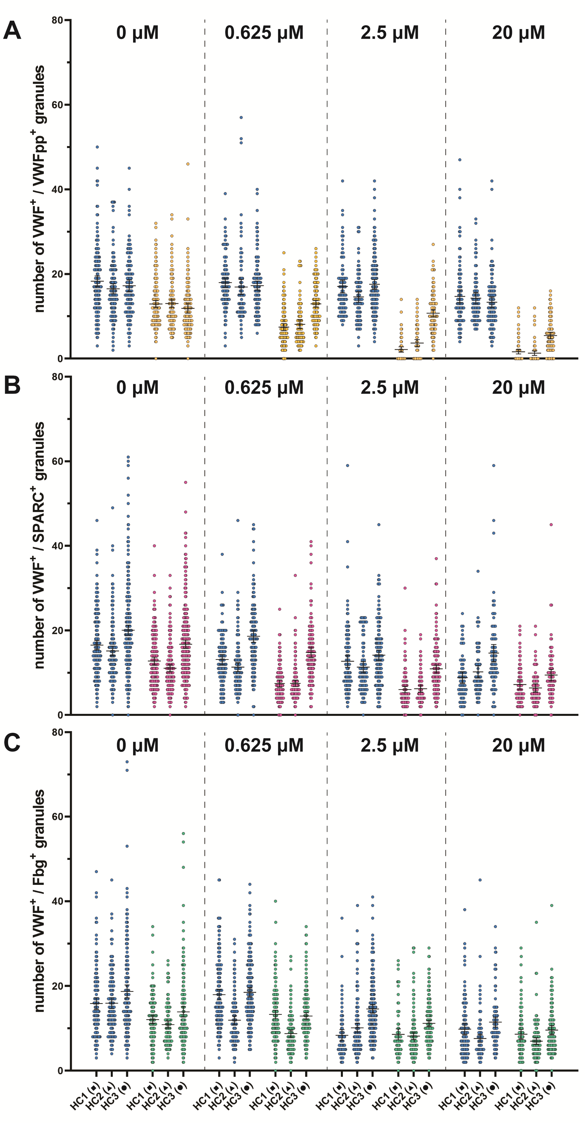
Supplemental Figure 9: Healthy donor variation in dose-response release. Platelets of healthy donors were stimulated with 0-20 μM PAR-1 ap and imaged by SIM. Absolute counts of VWF and VWFpp (A), SPARC (B) and fibrinogen (C) positive granules are shown per donor. The symbol for each individual donor corresponds to the one that is used in Supplemental Figure 4.

Supplemental Figure 10
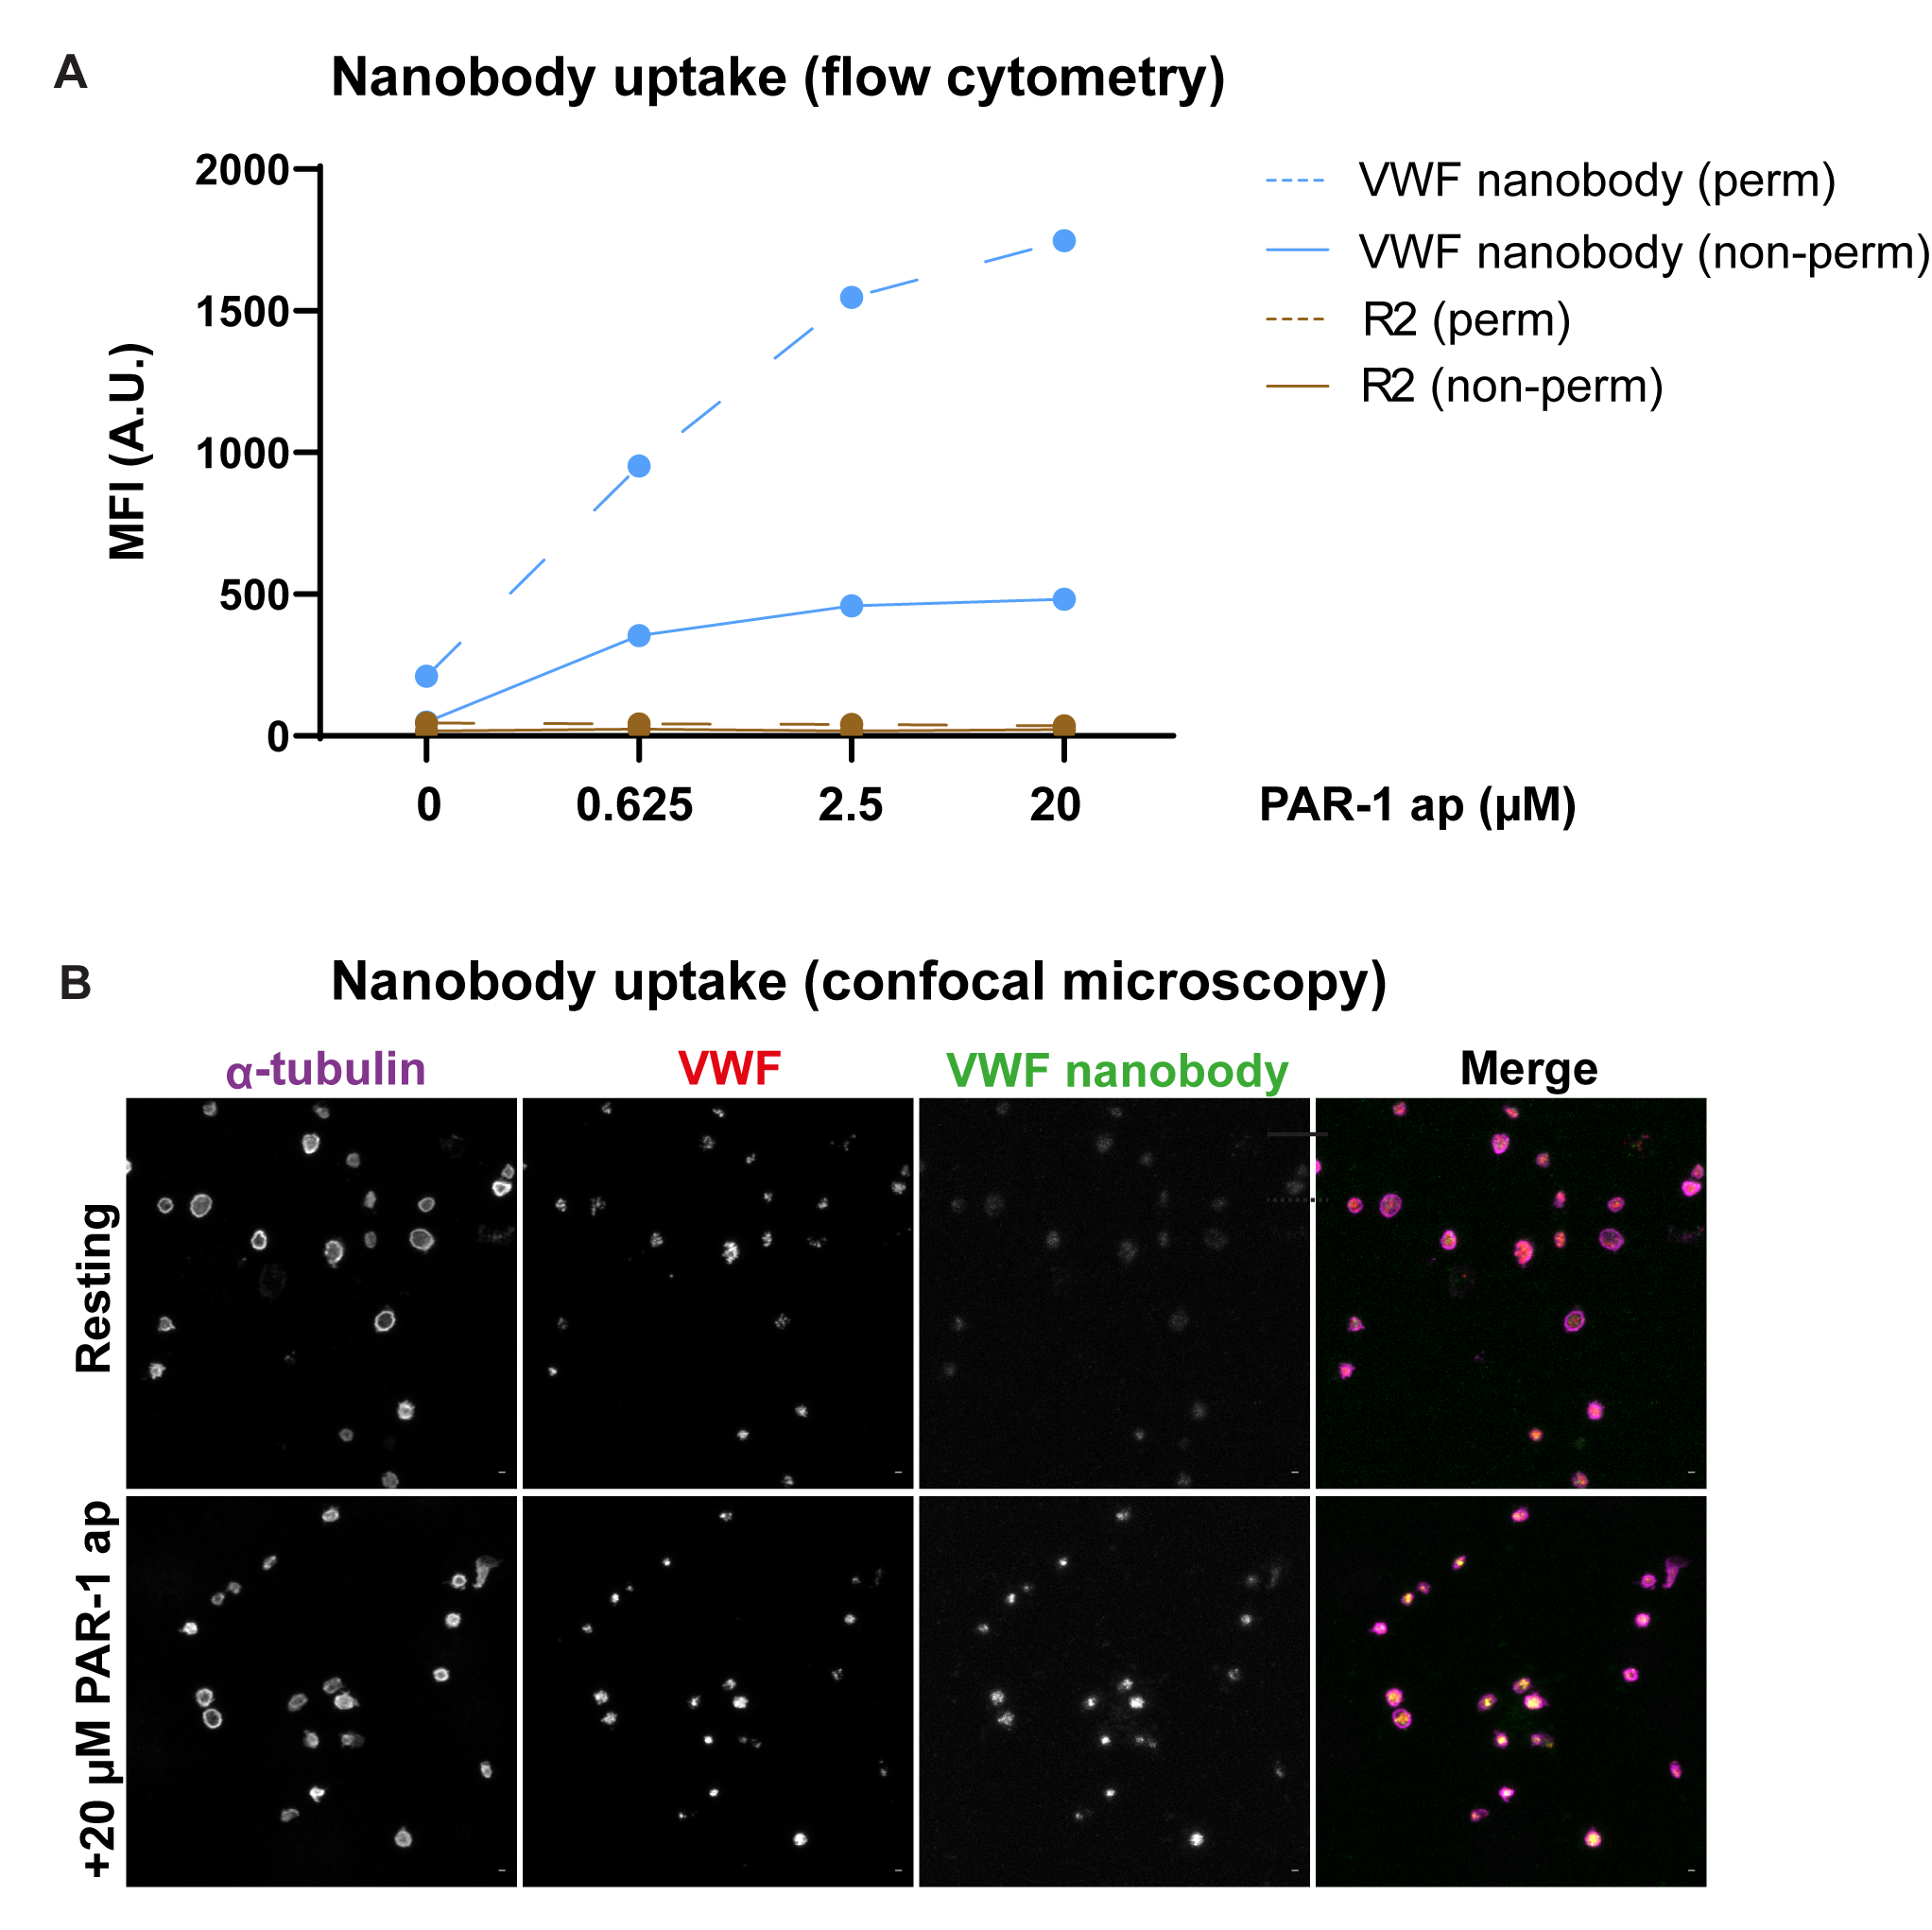

Supplemental Figure 10: VWF nanobody bulk uptake in platelets. Platelets were stimulated for 30 minutes with 0-20 µM PAR-1 in the presence of 1 µg/ml VWF nanobody or R2 control nanobody and were analyzed for nanobody uptake by flow cytometry (A) and confocal microscopy (B).

