Table S1. SPR experimental parameters for human Fcγ Receptor binding to IgG1AAG ICIs. CM5 chip coated with ~2000RU S. aureus Protein A (Sigma-Aldrich, USA) and HBS-EP+ (10 mM HEPES, pH 7.4, 150 mM NaCl, 3 mM EDTA and 0.05% surfactant P-20) was used as Running Buffer. Chip surfaces were regenerated with 2 pulses of 10 mM glycine-HCl, pH 1.5.

Receptor | Temperature | Ligand | Ligand flow rate | Rmax | Receptor concentration | Contact time | Dissociate time | Flow rate
FcγRI | 25ºC | Individual mAbs/ICIs | 20 μL min⁻¹ | 50 | 3.75 to 60 nM | 135 | 600 | 40
FcγRIIa  (R167) | 37ºC | Individual mAbs/ICIs | 25 μL min⁻¹ | 100 | 0.1875 to 1.5 uM | 30 | 60 | 45
FcγRIIb | 37ºC | Individual mAbs/ICIs | 25 μL min⁻¹ | 100 | 0.1875 to 1.5 uM | 30 | 60 | 45
FcγRIIIa  (V158) | 25ºC | Individual mAbs/ICIs | 20 μL min⁻¹ | 50 | 93.75 to 750 nM | 135 | 600 | 40

Table S2. Binding of IgG1AAG ICIs to hFcRn and human Fcγ receptors. (A) Binding of IgG1AAG- and IgG4P ICIs produced in plants with wild-type glycosylation (WT) or axylosylated and afucosylated glycans (NtFX-KO) to (A) hFcRn at pH 6.0; (B) hFcRn at pH 7.4; (C-F) Binding of IgG1AAG ICIs produced in mammalian cells or plants with wild-type glycosylation (WT) or axylosylated and afucosylated glycans (NtFX-KO) with (C) human FcγRI; (D) human FcγRIIa; (E) human FcγRIIb/c; (F) human FcγRIIIa. IgG1k with non-modified Fc region made in glycomodified plants (plant IgG1k) or IgG1k or IgG4k from human myeloma cells (IgG1k or IgG4k; Sigma, USA) were used as positive control. SPR experiments were conducted using parameters detailed in Table S1. Two biological repeats were conducted for each experiment.

A
hFcRn pH 6.0 (2-state reaction model)
Antibody/ICI |  |  |  |  | K_{D} |  | ka1 (1/Ms) |  |  |  | SE(ka1) |  |  |  |  | kd1 (1/s) |  |  |  |  | SE(kd1) |  |  |  | ka2 (1/s) |  |  | SE(ka2) |  | kd2 (1/s) |  | SE(kd2)
IgG1k MC |  |  |  |  | 2.55E-007 |  | 1.56E+006 |  |  |  | 3.10E+005 |  |  |  |  | 0.3963 |  |  |  |  | 8.80E-002 |  |  |  | 1.02E-007 |  |  | 6.40E-007 |  | 0.003093 |  | 4.50E-003
IgG1k NtFX-KO |  |  |  |  | 5.03E-008 |  | 1.00E+006 |  |  |  | 3.10E+004 |  |  |  |  | 0.1007 |  |  |  |  | 0.0044 |  |  |  | 0.01345 |  |  | 4.30E-004 |  | 1.19E-002 |  | 3.20E-004
IgG1AAG NtFX-KO (1) |  |  |  |  | 1.99E-007 |  | 3.16E+006 |  |  |  | 8.70E+005 |  |  |  |  | 0.8176 |  |  |  |  | 0.24 |  |  |  | 0.008097 |  |  | 2.90E-004 |  | 0.02672 |  | 6.50E-004
IgG1AAG NtFX-KO (2) |  |  |  |  | 1.13E-007 |  | 2.57E+006 |  |  |  | 1.60E+005 |  |  |  |  | 0.2916 |  |  |  |  | 0.018 |  |  |  | 1.13E-005 |  |  | 1.60E-005 |  | 0.002333 |  | 8.00E-004
IgG1AAG WT (1) |  |  |  |  | 7.76E-008 |  | 8.06E+005 |  |  |  | 1.70E+004 |  |  |  |  | 0.1169 |  |  |  |  | 0.003 |  |  |  | 0.01112 |  |  | 3.60E-004 |  | 0.0128 |  | 3.80E-004
IgG1AAG WT (2) |  |  |  |  | 9.17E-008 |  | 7.85E+005 |  |  |  | 1.90E+004 |  |  |  |  | 0.1436 |  |  |  |  | 0.0047 |  |  |  | 0.01371 |  |  | 4.20E-004 |  | 0.01379 |  | 3.40E-004
Table S2 (continued)

A

Antibody/ICI |  |  |  |  | Rmax (RU) |  |  | SE(Rmax) |  |  |  | tc |  |  |  |  | SE(tc) |  |  |  |  | chi2
IgG1k MC |  |  |  |  | 62.8 |  |  | 8.2 |  |  |  | 2.94E+007 |  |  |  |  | 9.30E+006 |  |  |  |  | 2.57
IgG1k NtFX-KO |  |  |  |  | 195 |  |  | 3.8 |  |  |  | 3.24E+013 |  |  |  |  | 3.60E+017 |  |  |  |  | 4.84
IgG1AAG NtFX-KO (1) |  |  |  |  | 78.7 |  |  | 2.8 |  |  |  | 2.84E+007 |  |  |  |  | 3.00E+006 |  |  |  |  | 0.139
IgG1AAG NtFX-KO (2) |  |  |  |  | 42.1 |  |  | 1.1 |  |  |  | 1.63E+007 |  |  |  |  | 9.80E+005 |  |  |  |  | 0.997
IgG1AAG WT (1) |  |  |  |  | 229.1 |  |  | 2.7 |  |  |  | 1.64E+015 |  |  |  |  | 1.10E+018 |  |  |  |  | 5.19
IgG1AAG WT (2) |  |  |  |  | 274.9 |  |  | 3.2 |  |  |  | 3.50E+008 |  |  |  |  | 4.00E+007 |  |  |  |  | 6.57
 |  | hFcRn pH 6.0 (2-state reaction model)
Antibody/ICI |  |  |  | K_{D} |  |  |  |  | Rmax (RU) |  |  |  | chi2
IgG1k MC |  |  |  | 3.101E-8 |  |  |  |  | 22.6 |  |  |  | 0.431
IgG1k NtFX-KO |  |  |  | 2.173E-8 |  |  |  |  | 37 |  |  |  | 1.73
IgG4k MC (1) |  |  |  | 1.085E-7 |  |  |  |  | 26.8 |  |  |  | 0.197
IgG4k MC (2) |  |  |  | 7.168E-8 |  |  |  |  | 17 |  |  |  | 0.328
IgG4P MC (1) |  |  |  | 8.931E-8 |  |  |  |  | 31.7 |  |  |  | 0.288
IgG4P MC (2) |  |  |  | 1.619E-8 |  |  |  |  | 22.8 |  |  |  | 0.976
IgG4P NtFX-KO (1) |  |  |  | 1.305E-8 |  |  |  |  | 20.6 |  |  |  | 1.31
IgG4P NtFX-KO (2) |  |  |  | 1.069E-7 |  |  |  |  | 26 |  |  |  | 2.51
IgG4P WT (1) |  |  |  | 1.143E-7 |  |  |  |  | 30.15 |  |  |  | 0.213
IgG4P WT (2) |  |  |  | 1.117E-8 |  |  |  |  | 23.4 |  |  |  | 1.45

Table S2 (continued)

B
hFcRn pH 7.4 (2-state reaction model)
Antibody/ICI | K_{D}
IgG1k MC | No binding
IgG1k NtFX-KO | No binding
IgG1AAG NtFX-KO (1) | No binding
IgG1AAG NtFX-KO (2) | No binding
IgG1AAG WT (1) | No binding
IgG1AAG WT (2) | No binding

Antibody/ICI | K_{D}
IgG4k MC (1) | No binding
IgG4k MC (2) | No binding
IgG4P NtFX-KO (1) | No binding
IgG4P NtFX-KO (2) | No binding
IgG4P WT (1) | No binding
IgG4P WT (2) | No binding

Table S2 (continued)
C
hFcγRI
1:1 langmuir model
Antibody/ICI | K_{D} | Rmax (RU) | ka (1/Ms) | kd (1/s) | tc | chi2 | U-value
IgG1k MC (1) | 1.22E-009 | 69.4 | 1.47E+005 | 1.79E-004 | 2.64E+015 | 1.39 | 7
IgG1k MC (2) | 7.27E-011 | 87.7 | 3.14E+006 | 2.28E-004 | 1.24E+008 | 2.19 | 2
IgG1k NtFX-KO (1) | 1.41E-010 | 50.63 | 2.10E+006 | 2.95E-004 | 7.05E+014 | 1.38 | 2
IgG1k NtFX-KO (2) | 1.63E-010 | 46.1 | 1.403E+006 | 2.280E-4 | 7.010E+21 | 0.228 | 1
IgG1AAG MC (1) | 5.44E-009 | 3.615 | 4.29E+005 | 0.002333 | 1.51E+007 | 0.121 | 9
IgG1AAG MC (2) | 1.94E-010 | 2.43 | 1.61E+006 | 3.13E-004 | 1.49E+018 | 0.316 | 26
IgG1AAG NtFX-KO (1) | 6.21E-009 | 6.39 | 4.55E+005 | 0.002822 | 7.27E+007 | 0.219 | 4
IgG1AAG NtFX-KO (2) | 4.75E-009 | 7.604 | 3.05E+006 | 1.45E-002 | 8.96E+005 | 0.247 | 26

2-state reaction model
Antibody/ICI | K_{D} | ka1 (1/Ms) | SE(ka1) | kd1 (1/s) | SE(kd1) | ka2 (1/s) | SE(ka2) | kd2 (1/s) | SE(kd2)
IgG1AAG WT (1) | 2.70E-007 | 4.83E+004 | 4.60E+003 | 0.05111 | 0.0018 | 0.004799 | 9.90E-005 | 0.001645 | 3.20E-005
IgG1AAG WT (2) | 5.53E-009 | 8.37E+005 | 7.60E+004 | 0.0146 | 0.0018 | 0.002759 | 2.50E-004 | 1.28E-003 | 1.80E-004

Antibody/ICI | Rmax (RU) | SE(Rmax) | tc | SE(tc) | chi2
IgG1AAG WT (1) | 164.5 | 15 | 5.10E+011 | 7.80E+010 | 0.139
IgG1AAG WT (2) | 9.4 | 0.32 | 4.74E+008 | 1.20E+010 | 0.901

Table S2 (continued)
D
hFcγRIIa (Steady state)
Antibody/ICI | K_{D} | Rmax (RU) | chi2
IgG1k MC (1) | 1.97E-007 | 84.86 | 0.466
IgG1k MC (2) | 4.21E-007 | 17.26 | 0.143
IgG1k NtFX-KO (1) | 6.29E-007 | 12.2 | 0.126
IgG1k NtFX-KO (2) | 1.23E-008 | 100.3 | 18
IgG1AAG MC (1) | No binding
IgG1AAG MC (2) | No binding
IgG1AAG NtFX-KO (1) | No binding
IgG1AAG NtFX-KO (2) | No binding
IgG1AAG WT (1) | No binding
IgG1AAG WT (2) | No binding

Table S2 (continued)
E
hFcγRIIb/c (2-state reaction model)
Antibody/ICI | K_{D} | Rmax (RU) | chi2
IgG1k MC (1) | 3.76E-006 | 60.88 | 0.0302
IgG1k MC (2) | 2.955E-006 | 216.1 | 3.53
IgG1k NtFX-KO (1) | 6.006E-006 | 374.2 | 0.0521
IgG1k NtFX-KO (2) | 1.72E-006 | 61.92 | 0.0334
IgG1AAG MC (1) | No binding
IgG1AAG MC (2) | No binding
IgG1AAG NtFX-KO (1) | No binding
IgG1AAG NtFX-KO (2) | No binding
IgG1AAG WT (1) | 2.25E-005 | n.a. | 3.84
IgG1AAG WT (2) | 9.03E-006 | 269.5 | 2.79

Table S2 (continued)
F
hFcγRIIIa (2-state reaction model)
Antibody/ICI | K_{D} | ka1 (1/Ms) |  | SE(ka1) |  | kd1 (1/s) |  | SE(kd1) |  |  | ka2 (1/s) | SE(ka2) | kd2 (1/s) | SE(kd2)
IgG1k MC (1) | 5.90E-007 | 2.60E+005 |  | 9.70E+003 |  | 0.1913 |  | 8.40E-003 |  |  | 0.009031 | 4.90E-004 | 0.03622 | 9.60E-004
IgG1k MC (2) | 2.44E-007 | 7.37E+005 |  | 9.30E+004 |  | 0.1888 |  | 2.90E-002 |  |  | 1.84E-004 | 3.10E-005 | 0.003529 | 7.10E-004
IgG1k NtFX-KO (1) | 2.12E-008 | 6.97E+005 |  | 5.60E+003 |  | 0.02007 |  | 2.80E-004 |  |  | 0.003937 | 1.30E-004 | 0.01107 | 1.30E-004
IgG1k NtFX-KO (2) | 3.98E-008 | 4.14E+005 |  | 3.10E+003 |  | 0.02323 |  | 2.90E-004 |  |  | 0.004554 | 9.90E-005 | 0.01111 | 9.20E-005
IgG1AAG MC (1) | 3.84E-006 | 2.24E+002 |  | 6.60E+000 |  | 0.00732 |  | 3.10E-004 |  |  | 6.20E-003 | 2.10E-004 | 8.27E-004 | 3.70E-005
IgG1AAG MC (2) | 6.66E-006 | 2.58E+002 |  | 1.00E+001 |  | 0.01043 |  | 6.30E-004 |  |  | 0.00826 | 3.50E-004 | 0.001631 | 5.10E-005
IgG1AAG NtFX-KO (1) | 1.91E-008 | 6.80E+005 |  | 1.30E+006 |  | 0.01331 |  | 7.60E-002 |  |  | 2.76E-004 | 7.90E-003 | 0.01037 | 1.50E-002
IgG1AAG NtFX-KO (2) | 1.29E-006 | 3.51E+002 |  | 3.90E+002 |  | 0.02998 |  | 0.026 |  |  | 0.01249 | 5.60E-003 | 1.92E-004 | 8.20E-004
IgG1AAG WT (1) | 2.38E-005 | 100.2 |  | 6.5 |  | 0.01745 |  | 5.80E-004 |  |  | 0.008288 | 1.30E-004 | 0.001309 | 1.80E-005
IgG1AAG WT (2) | 7.13E-007 | 3390 |  | 1.50E+002 |  | 0.01729 |  | 4.50E-004 |  |  | 0.006428 | 8.70E-005 | 0.001045 | 1.80E-005
Antibody/ICI | Rmax (RU) |  | SE(Rmax) |  | tc |  | SE(tc) |  | chi2
IgG1k MC (1) | 47.6 |  | 1.1 |  | 2.91E+007 |  | 9.80E+006 |  | 0.11
IgG1k MC (2) | 24 |  | 1.2 |  | 7.76E+006 |  | 2.10E+006 |  | 0.256
IgG1k NtFX-KO (1) | 56.3 |  | 0.11 |  | 1.72E+008 |  | 2.70E+007 |  | 0.237
IgG1k NtFX-KO (2) | 57.8 |  | 0.12 |  | 7.89E+007 |  | 8.40E+006 |  | 0.103
IgG1AAG MC (1) | 567.4 |  | 14 |  | 9.79E+007 |  | 2.10E+007 |  | 0.0436
IgG1AAG MC (2) | 529.8 |  | 16 |  | 9.41E+007 |  | 1.30E+007 |  | 0.0892
IgG1AAG NtFX-KO (1) | 0 |  | 0.0069 |  | 1.00E+008 |  | 6.20E+008 |  | 0.088
IgG1AAG NtFX-KO (2) | 3.2 |  | 3.3 |  | 1.00E+008 |  | 1.10E+008 |  | 0.147
IgG1AAG WT (1) | n.a. |  | 2.10E+002 |  | 1.47E+008 |  | 4.30E+007 |  | 0.0875
IgG1AAG WT (2) | n.a. |  | 4.1 |  | 2.66E+011 |  | 1.40E+013 |  | 0.0721

Table S3. Probability (p) values of Fcγ receptor binding differences of antibodies and ICIs. P-values indicating whether there were significant differences between binding of commercial IgG1k and IgG4k (Sigma, USA), IgG4P ICIs made in mammalian cells and wild-type (WT) or glycomodified (NtFX-KO) plants, as well as IgG1AAG ICIs made in WT or NtFX-KO plants to A) FcγRI, B) FcγRIIa, C) FcγRIIb/c and D) FcγRIIIa. Blank-subtracted binding of antibodies to Fcγ receptor (expressed as Response Units or RUs) were calculated as a percentage of IgG1k binding to the same receptor (IgG1k set as 1.0) and Mean ± SD were reported in Table 3B. Results in bold indicate p-values of p≤0.05. Results in asterisks (*) indicate p-values of 0.09>p>0.05. Three biological replicates were performed for each experiment.
A
hFcγRI
ICIs | IgG1 | IgG4 | IgG4P (MC) | IgG4P (NtFX-KO) | IgG4P (WT) | IgG1AAG (NtFX-KO) | IgG1 AAG (WT)
IgG1 | - | 0.7977 | 0.6909 | 0.2935 | 0.5103 | 0.0049 | 0.0049
IgG4 | - | - | 0.5419 | 0.2369 | 0.3948 | 0.0044 | 0.0044
IgG4P (MC) | - | - | - | 0.4561 | 0.7931 | 0.0092 | 0.0092
IgG4P (NtFX-KO) | - | - | - | - | 0.5978 | 0.0212 | 0.0211
IgG4P (WT) | - | - | - | - | - | 0.0110 | 0.0110
IgG1AAG (NtFX-KO) | - | - | - | - | - | - | 0.3868
IgG1 AAG (WT) | - | - | - | - | - | - | -

Table S3 (continued)
B
hFcγRIIa
ICIs | IgG1 | IgG4 | IgG4P (MC) | IgG4P (NtFX-KO) | IgG4P (WT) | IgG1AAG (NtFX-KO) | IgG1 AAG (WT)
IgG1 | - | 0.0013 | 0.0431 | 0.0128 | 0.0045 | 0.0049 | 0.0048
IgG4 | - | - | 0.1125 | 0.0189 | 0.3450 | 0.1075 | 0.1096
IgG4P (MC) | - | - | - | 0.7016 | *0.0836 | *0.0553 | *0.0558
IgG4P (NtFX-KO) | - | - | - | - | 0.0019 | 0.0037 | 0.0036
IgG4P (WT) | - | - | - | - | - | 0.0187 | 0.0175
IgG1AAG (NtFX-KO) | - | - | - | - | - | - | 0.4226
IgG1 AAG (WT) | - | - | - | - | - | - | -

Table S3 (continued)
C
hFcγRIIb/c
ICIs | IgG1 | IgG4 | IgG4P (MC) | IgG4P (NtFX-KO) | IgG4P (WT) | IgG1AAG (NtFX-KO) | IgG1 AAG (WT)
IgG1 | - | 0.1064 | *0.0754 | *0.0737 | 0.0157 | 0.0063 | 0.0063
IgG4 | - | - | 0.7318 | 0.8587 | *0.0585 | 0.0264 | 0.0264
IgG4P (MC) | - | - | - | 0.6493 | *0.0565 | 0.0014 | 0.0014
IgG4P (NtFX-KO) | - | - | - | - | *0.0683 | <0.0001 | <0.0001
IgG4P (WT) | - | - | - | - | - | 0.3750 | 0.3750
IgG1AAG (NtFX-KO) | - | - | - | - | - | - | >0.9999
IgG1 AAG (WT) | - | - | - | - | - | - | -

Table S3 (continued)
D
hFcγRIIIa
ICIs | IgG1 | IgG4 | IgG4P (MC) | IgG4P (NtFX-KO) | IgG4P (WT) | IgG1AAG (NtFX-KO) | IgG1 AAG (WT)
IgG1 | - | 0.0021 | 0.0008 | 0.0066 | 0.0009 | 0.0007 | 0.0032
IgG4 | - | - | 0.1191 | 0.0042 | 0.3786 | 0.2820 | 0.2114
IgG4P (MC) | - | - | - | 0.0255 | 0.3692 | 0.5610 | *0.0795
IgG4P (NtFX-KO) | - | - | - | - | 0.0215 | 0.0213 | 0.0243
IgG4P (WT) | - | - | - | - | - | 0.7584 | 0.1656
IgG1AAG (NtFX-KO) | - | - | - | - | - | - | 0.1461
IgG1 AAG (WT) | - | - | - | - | - | - | -

Table S4. Input parameter settings used for the calculation of production costs of plant-derived ICIs. Note (*) – the biomass per plant values were selected to span typical product recovery levels of N. benthamiana (~150 g) and N. tabacum (~350 g). Note (**) – a filter capacity of >1000 L m⁻² that was previously reported (Buyel et al., 2015) was not used because it relied on flocculants which have an unknown effect on the recovery of the ICI products investigated here. Note (***) – in addition to differences in environmental controls and thus accumulation differences, the calculation for the greenhouse scenario envisaged manual handling of plants, whereas a fully-automated setup was considered for the vertical farm scenario.

Parameter | Unit | Type | Value or Range
Product quantity | [kg] | Numeric | 2–20
Biomass per plant (*) | [kg] | Numeric | 0.15–0.35
Plant age at harvest | [d] | Numeric | 40–56
Product accumulation | [g kg⁻¹] | Numeric | 0.01–2.00
Filter capacity (**) | [L m⁻²] | Numeric | 50–300
Recovery | [-] | Numeric | 0.05–1.00
Safety factor | [-] | Numeric | 1.05
Plants per batch | [-] | Numeric | 2000
Expression strategy | [-] | Categoric | Transgenic; transient
Growth support | [-] | Categoric | Soil; stone wool
Growth environment (***) | [-] | Categoric | Greenhouse; vertical farm
Extraction method | [-] | Categoric | Blade-based; screw-press

Table S4 (continued)

Parameter | Unit | Type | Value or Range
Filter system | [-] | Categoric | 3-stage; 1-stage; integrated
Capture system | [-] | Categoric | Adsorber; packed-bed column
Polishing system | [-] | Categoric | Single-step; two-step
Labor cost | [€ h⁻¹] | Numeric | 10–80
Energy cost | [€ kWh⁻¹] | Numeric | 0.15
Fertilizer cost | [€ L⁻¹] | Numeric | 0.02
Fresh water cost | [€ L⁻¹] | Numeric | 0.005
Waste water cost | [€ L⁻¹] | Numeric | 0.115
Consumable cost | [€] | Numeric | diverse
Cost threshold CHO-derived ICIs | [€ g⁻¹] | Numeric | 2500–6000

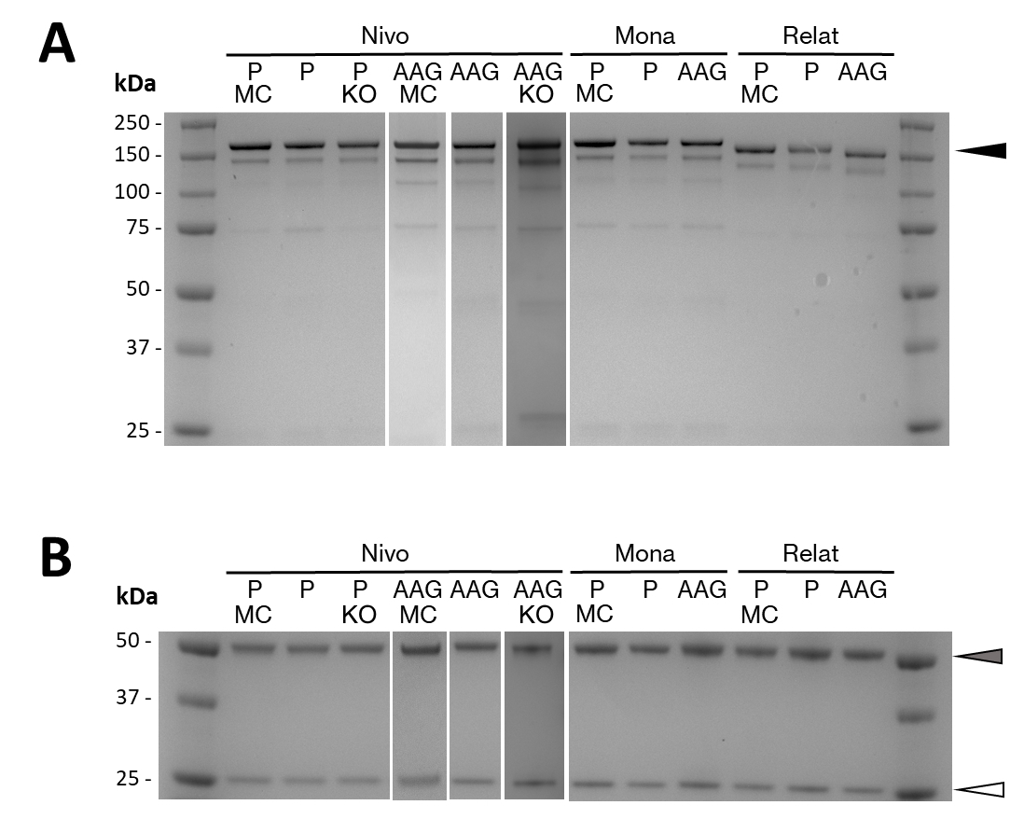
Figure S1. PAGE gel of purified ICIs. Purified ICIs Nivolumab (Nivo), Monalizumab (Mona) and Relatimab (Relat) with either IgG4 S228P (P) or IgG1 L324A/L325A/P329G (AAG) on a non-reducing (A) or reducing (B) PAGE gel. ICIs were produced in mammalian cells (MC), N. benthamiana with wild-type glycosylation, or afucosylated and axylosylated N. tabacum line (NtFX-KO; shortened to KO). Commercial mammalian-cell produced Nivolumab (Nivo MC; Absolute Antibody, USA) was used as positive control. Black arrow at 150 kDa indicate intact, correctly assembled ICIs. The grey arrow on the reducing gel indicate the heavy chain at 50 kDa, while the white arrow at 25 kDa indicate the light chain. 2 μg of purified ICIs were loaded onto the PAGE gels for non-reducing blots and 1 μg for reducing blots.

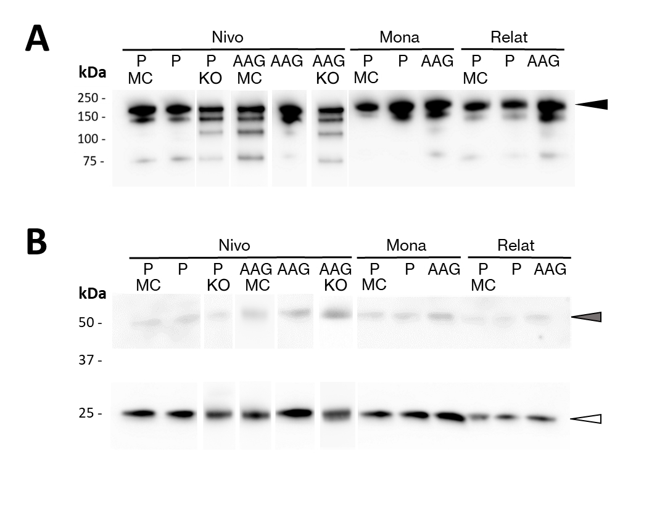
Figure S2. Western blot of purified ICIs. Purified ICIs Nivolumab (Nivo), Monalizumab (Mona) and Relatimab (Relat) with either IgG4 S228P (IgG4P) or IgG1 L324A/L325A/P329G (IgG1AAG) on a non-reducing (A) or reducing (B) Western blot. ICIs were produced in mammalian cells (MC), N. benthamiana with wild-type glycosylation, or afucosylated and axylosylated N. tabacum line (NtFX-KO; shortened to KO). Commercial mammalian-cell produced Nivolumab (Nivo MC; Absolute Antibody, USA) was used as positive control. Anti-human IgG gamma chain antiserum were used on the non-reducing and reducing Western blot to detect ICI heavy chain (black and grey arrows); while anti-kappa antisera was used to detect ICI light chain in reducing blot (white arrow). 50 ng of purified ICIs were loaded onto the blot.
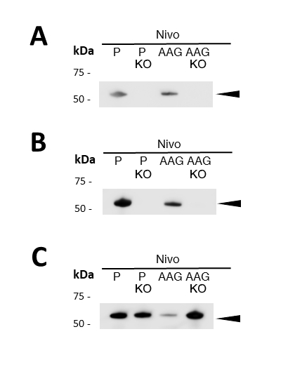
Figure S3. Glycosylation of ICIs. Nivolumab variants were presented as representatives of all ICIs. Western blot of IgG4 S228P (IgG4P) or IgG1 L324A/L325A/P329G (IgG1AAG) variants of Nivolumab produced in N. benthamiana with wild-type glycosylation or afucosylated and axylosylated N. tabacum line (NtFX-KO; shortened to KO). Anti-β1,2-xylose (A), anti-α1,3-fucose (B) and anti-human gamma (C) anti-sera were used to detect glycosylation on the heavy chain or the heavy chain itself. 50-100 ng of purified ICIs were loaded onto the blot.

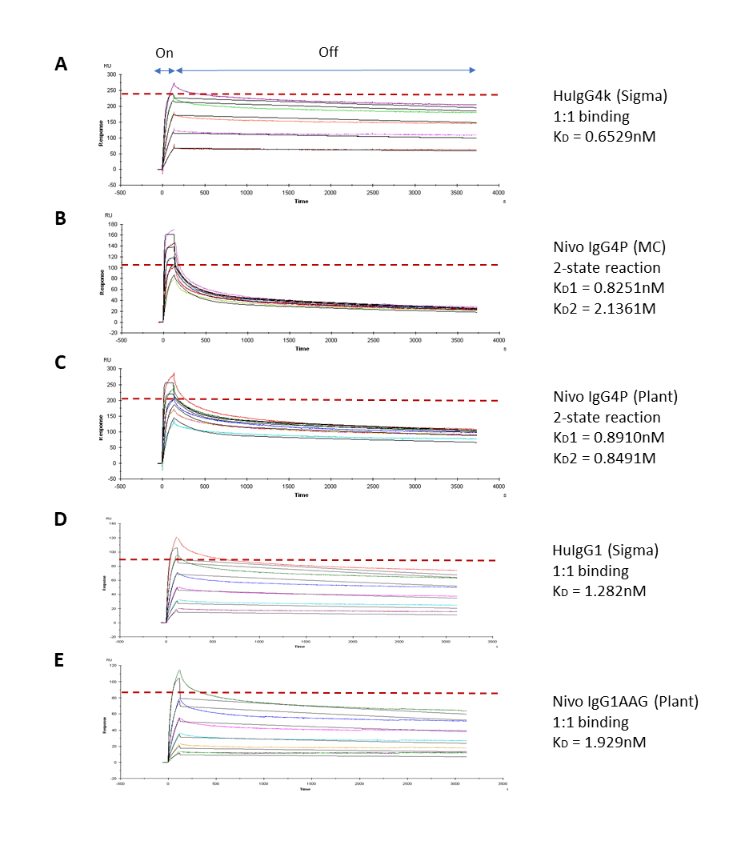
Figure S4. Binding of ICIs to S. aureus Protein A. Representative SPR sensorgrams showing the binding kinetics of S. aureus Protein A (Sigma, USA) to A) IgG4k from human myeloma plasma (Sigma, USA); B) mammalian-cell made Nivolumab IgG4P (Absolute Antibody, USA); C) plant-made Nivolumab IgG4P with wild-type glycosylation; D) IgG1k from human myeloma plasma (Sigma, USA); and E) plant-made Nivolumab IgG1AAG with wild-type glycosylation. Red dashed lines indicate R_{max}. On: Association; Off: Dissociation

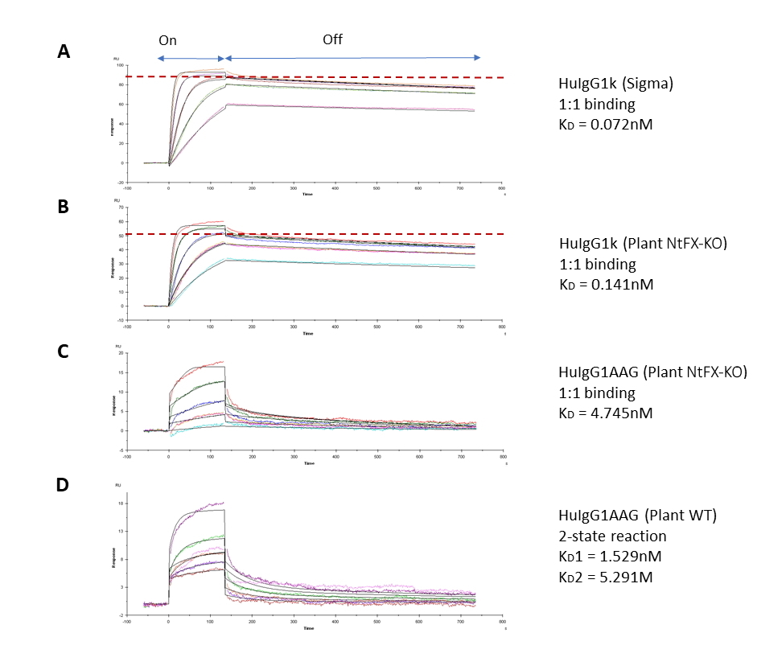
Figure S5. Binding of antibodies and ICIs to human FcγRI receptor. Representative SPR sensorgrams showing the binding kinetics of human FcγRI receptor (R&D Systems, USA) to A) commercial human IgGk1 from myeloma cells (Sigma, USA); B) non-related human IgG1k made in glycomodified N. tabacum plants (NtFX-KO); C) IgG1AAG ICI made in NtFX-KO plants; and D) IgG1AAG ICI made in plants with wild-type (WT) glycosylation. Red dashed lines if present indicate R_{max} of >50 RU has been reached. On: Association; Off: Dissociation.

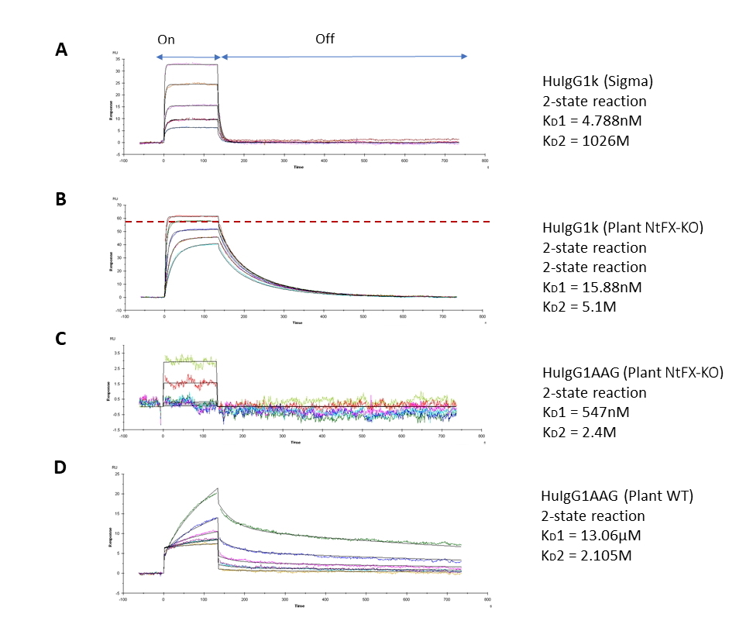
Figure S6. Binding of antibodies and ICIs to human FcγRIIIa receptor. Representative SPR sensorgrams showing the binding kinetics of human FcγRIIIa receptor (R&D Systems, USA) to A) commercial human IgGk1 from myeloma cells (Sigma, USA); B) non-related human IgG1k made in glycomodified N. tabacum plants (NtFX-KO); C) IgG1AAG ICI made in NtFX-KO plants; and D) IgG1AAG ICI made in plants with wild-type (WT) glycosylation. Red dashed lines if present indicate R_{max} of >50 RU has been reached. On: Association; Off: Dissociation.

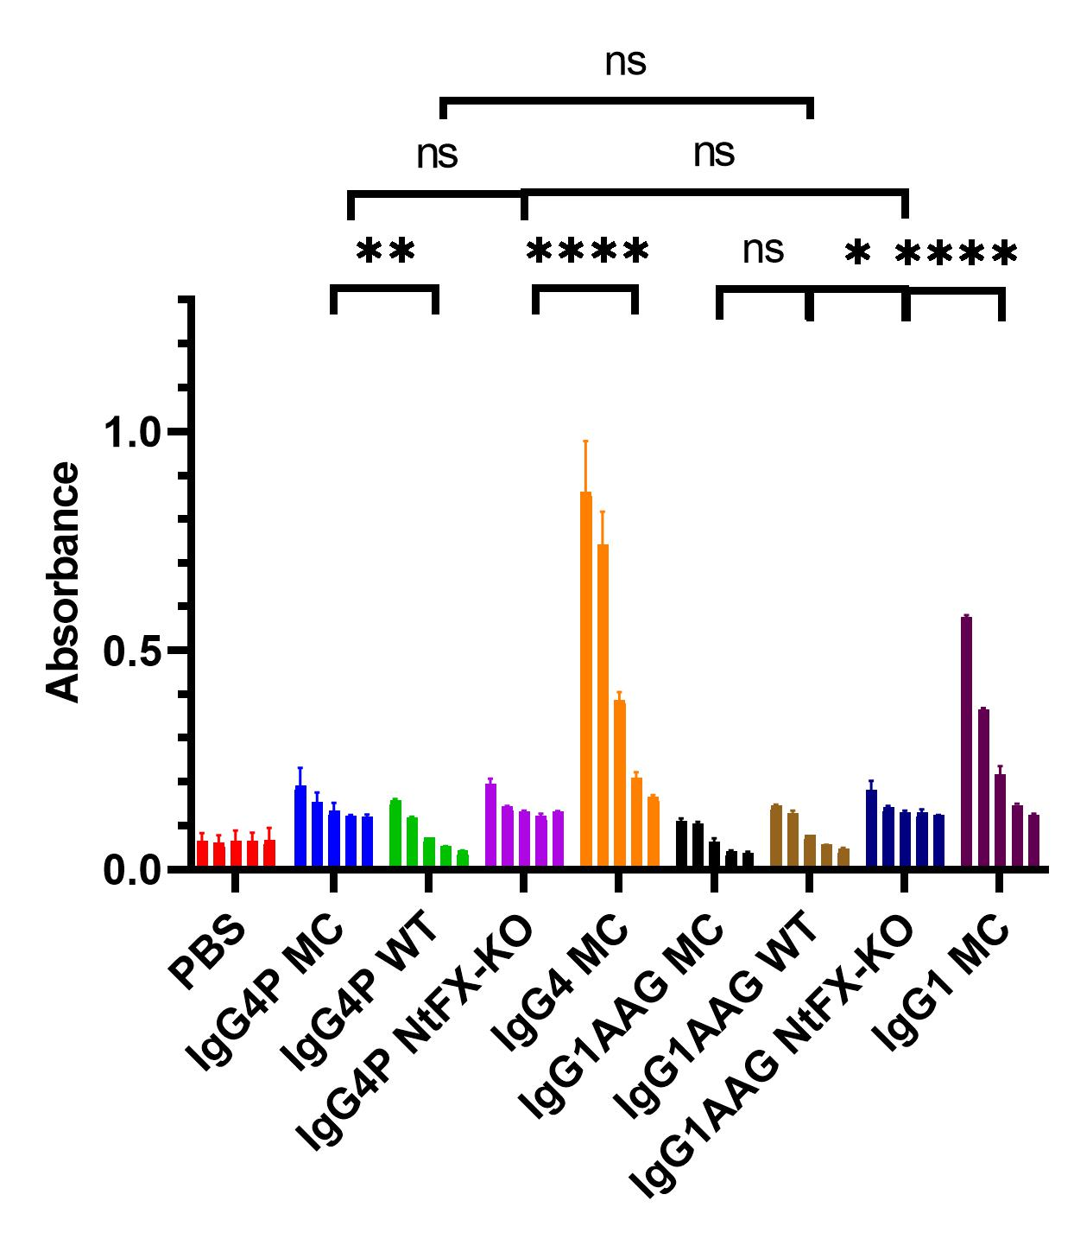

Figure S7. Binding of ICIs to hC1q. Binding of IgG4P- and IgG1AAG ICIs made in N. benthamiana plants with wild-type glycosylation (WT), or afucosylated and axylosylated N. tabacum (NtFX-KO), to human complement component C1q. PBS was used a negative controls and non-Fc modified IgG4 or IgG1 and Fc-modified IgG4P and IgG1AAG from mammalian cells were used as positive controls. Graph showing mean and standard deviation of three biological repeats.

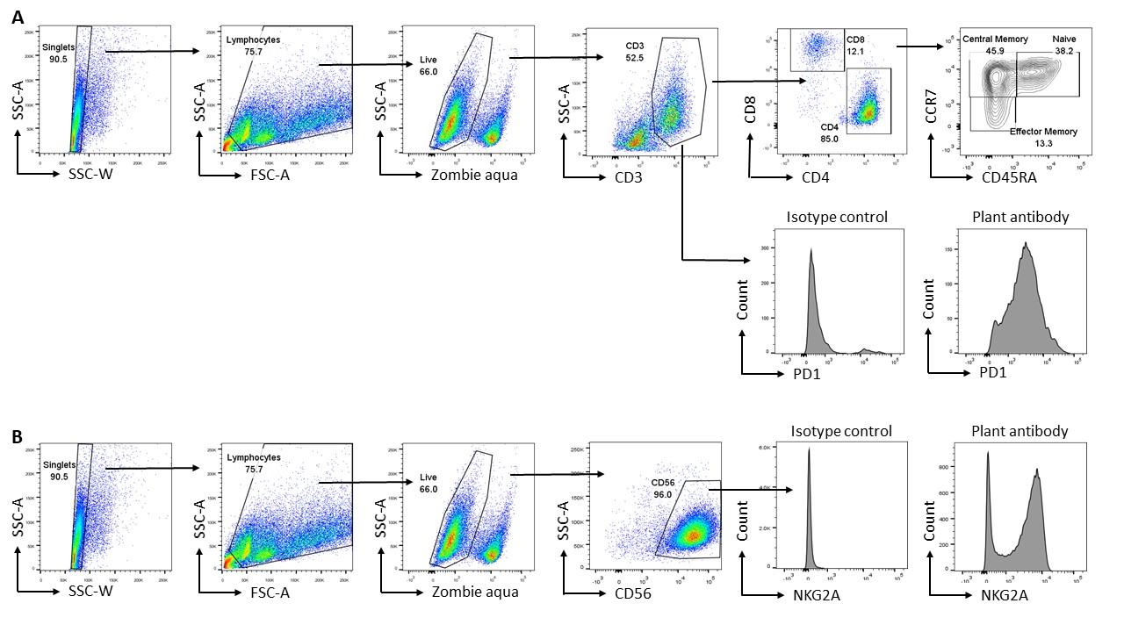
Figure S8. Gating strategy for PD-1, LAG-3, NKG2A expression. Doublets were excluded by SSC-A versus SSC-W and lymphocytes were gated based on SSC-A versus FSC-A. From this, live cells were gated based on negativity for zombie aqua staining. A) In isolated and activated T-cells CD3 positive cells were gated and from this population PD-1 and LAG-3 expression was examined. PD-1 and LAG-3 positivity was determined by gates set based on expression within IgG isotype controls. From CD3 positive cells both CD4 positive and CD8 positive cells were identified and T-cell sub-populations were gated based on CD45RA versus CCR7. Naïve cells were CD45RA+CCR7+, central memory cells were CD45RA-CCR7+ and effector memory cells were CD45RA-CCR7-. PD-1 and LAG-3 positive gates were then copied onto the relevant T-cell sub-populations. B) In isolated and activated NK cells CD56 positive cells were gated from the live cell gate and from this population NKG2A expression was assessed as histograms

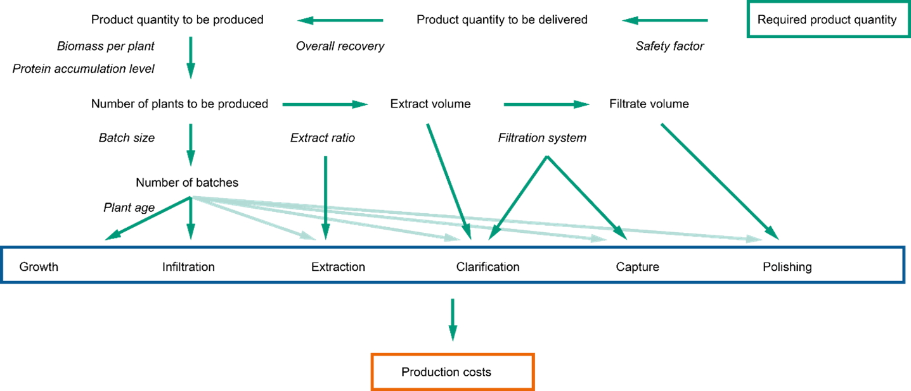

Figure S9. Top-down model workflow to calculate the production costs per gram of ICI. Starting from the product quantity to be delivered, losses were accounted for by a safety factor and process recovery resulting in the quantity of ICI to be produced. This value was converted into upstream production and downstream purification costs based on number of plants to be cultivated and biomass to be processed respectively. The dominant parameter determining both costs was the product accumulation level in the biomass. Parameter values and ranges used in the model are listed in Table S4.

References (Supplementary materials)
Buyel, J.F., Opdensteinen, P., and Fischer, R. (2015) Cellulose-based filter aids increase the capacity of depth filters during the
downstream processing of plant-derived biopharmaceutical proteins. Biotechnol. J., 10, 584–591.

