Additional File Table 1: TRIPOD checklist for prognostic model development and validation studies
Section/Topic | Item |  | Checklist Item | Page
Title and abstract
Title | 1 | D;V | Identify the study as developing and/or validating a multivariable prediction model, the target population, and the outcome to be predicted. | 1
Abstract | 2 | D;V | Provide a summary of objectives, study design, setting, participants, sample size, predictors, outcome, statistical analysis, results, and conclusions. | 2-3
Introduction
Background and objectives | 3a | D;V | Explain the medical context (including whether diagnostic or prognostic) and rationale for developing or validating the multivariable prediction model, including references to existing models. | 4-5
 | 3b | D;V | Specify the objectives, including whether the study describes the development or validation of the model or both. | 5
Methods
Source of data | 4a | D;V | Describe the study design or source of data (e.g., randomized trial, cohort, or registry data), separately for the development and validation data sets, if applicable. | 6
 | 4b | D;V | Specify the key study dates, including start of accrual; end of accrual; and, if applicable, end of follow-up. | 6
Participants | 5a | D;V | Specify key elements of the study setting (e.g., primary care, secondary care, general population) including number and location of centres. | 6
 | 5b | D;V | Describe eligibility criteria for participants. | 6
 | 5c | D;V | Give details of treatments received, if relevant. | N/A
Outcome | 6a | D;V | Clearly define the outcome that is predicted by the prediction model, including how and when assessed. | 7
 | 6b | D;V | Report any actions to blind assessment of the outcome to be predicted. | N/A
Predictors | 7a | D;V | Clearly define all predictors used in developing or validating the multivariable prediction model, including how and when they were measured. | 7-8
 | 7b | D;V | Report any actions to blind assessment of predictors for the outcome and other predictors. | N/A
Sample size | 8 | D;V | Explain how the study size was arrived at. | 8
Missing data | 9 | D;V | Describe how missing data were handled (e.g., complete-case analysis, single imputation, multiple imputation) with details of any imputation method. | 8
Statistical analysis methods | 10a | D | Describe how predictors were handled in the analyses. | 8-9
 | 10b | D | Specify type of model, all model-building procedures (including any predictor selection), and method for internal validation. | 9-10
 | 10c | V | For validation, describe how the predictions were calculated. | 9-10
 | 10d | D;V | Specify all measures used to assess model performance and, if relevant, to compare multiple models. | 9-10
 | 10e | V | Describe any model updating (e.g., recalibration) arising from the validation, if done. | 9
Risk groups | 11 | D;V | Provide details on how risk groups were created, if done. | N/A
Development vs. validation | 12 | V | For validation, identify any differences from the development data in setting, eligibility criteria, outcome, and predictors. | N/A
Results
Participants | 13a | D;V | Describe the flow of participants through the study, including the number of participants with and without the outcome and, if applicable, a summary of the follow-up time. A diagram may be helpful. | 10-11
 | 13b | D;V | Describe the characteristics of the participants (basic demographics, clinical features, available predictors), including the number of participants with missing data for predictors and outcome. | 10-11
 | 13c | V | For validation, show a comparison with the development data of the distribution of important variables (demographics, predictors and outcome). | N/A
Model development | 14a | D | Specify the number of participants and outcome events in each analysis. | 10-11
 | 14b | D | If done, report the unadjusted association between each candidate predictor and outcome. | 11
Model specification | 15a | D | Present the full prediction model to allow predictions for individuals (i.e., all regression coefficients, and model intercept or baseline survival at a given time point). | Supplement
 | 15b | D | Explain how to the use the prediction model. | 12
Model performance | 16 | D;V | Report performance measures (with CIs) for the prediction model. | 12
Model-updating | 17 | V | If done, report the results from any model updating (i.e., model specification, model performance). | 11-12
Discussion
Limitations | 18 | D;V | Discuss any limitations of the study (such as nonrepresentative sample, few events per predictor, missing data). | 14
Interpretation | 19a | V | For validation, discuss the results with reference to performance in the development data, and any other validation data. | N/A
 | 19b | D;V | Give an overall interpretation of the results, considering objectives, limitations, results from similar studies, and other relevant evidence. | 13-15
Implications | 20 | D;V | Discuss the potential clinical use of the model and implications for future research. | 15-16
Other information
Supplementary information | 21 | D;V | Provide information about the availability of supplementary resources, such as study protocol, Web calculator, and data sets. | Supplement
Funding | 22 | D;V | Give the source of funding and the role of the funders for the present study. | 17
*Items relevant only to the development of a prediction model are denoted by D, items relating solely to a validation of a prediction model are denoted by V, and items relating to both are denoted D;V.

Additional File Table 2: Final multivariable analysis developed model and optimism adjusted β coefficients
Variable | Developed model: coefficients | Final model coefficients after adjusting for overfitting
SARS-CoV-2 test result
Negative | 0.00000 | 0.00000
Positive | 1.03388 | 0.99847
Sex
Male | 0.00000 | 0.00000
Female | 0.36324 | 0.35080
Ethnicity
White | 0.00000 | 0.00000
Asian | 0.08161 | 0.07882
Black | 0.25060 | 0.24203
Mixed | 0.45300 | 0.43749
Other | 0.13034 | 0.12588
Prefer not to say | -0.58041 | -0.56053
Physical Health before testing
Very good | 0.00000 | 0.00000
Good | 0.31963 | 0.30868
Okay | 0.44983 | 0.43443
Very poor/Poor | 0.48992 | 0.47315
Mental Health before testing
Very good | 0.00000 | 0.00000
Good | 0.25949 | 0.25060
Okay | 0.39083 | 0.37745
Very poor/Poor | 0.45189 | 0.43641
Loneliness before testing
Never | 0.00000 | 0.00000
Hardly Ever | 0.46431 | 0.44841
Occasionally | 0.83599 | 0.80736
Some of the time | 0.86956 | 0.83978
Often/Always | 0.98939 | 0.95551
Looking after self before testing
No problem | 0.00000 | 0.00000
Some/a lot of problems | 0.99648 | 0.96235
Doing usual activities before testing
No problem | 0.00000 | 0.00000
Some/a lot of problems | 0.78959 | 0.76255
Having pain before testing
No problem | 0.00000 | 0.00000
Some/a lot of problems | 1.73252 | 1.67319
Feeling worried/sad before testing
No problem | 0.00000 | 0.00000
A bit | 0.63393 | 0.61222
Very worried/sad | 1.27242 | 1.22884
Age at time of testing#
(Age-14) | 0.02397 | 0.02315
(Age-14)² | -0.03524 | -0.03404
Number of symptoms at time of testing
((number of symptoms+1)/10)⁻² | 0.01773 | 0.01712
(number of symptoms+1) /10 | 2.32994 | 2.25015
Ethnicity*Positive SARS-CoV-2 test result
White | 0.00000 | 0.00000
Asian | -0.16281 | -0.15724
Black | -0.48247 | -0.46595
Mixed | -0.28892 | -0.27903
Other | -0.89708 | -0.86636
Prefer not to say | 1.27248 | 1.22891
Mental Health before testing*Positive SARS-CoV-2 test result
Very good | 0.00000 | 0.00000
Good | -0.12697 | -0.12262
Okay | -0.40864 | -0.39465
Very poor/Poor | 0.18387 | 0.17757
Loneliness before testing*Positive SARS-CoV-2 test result
Never | 0.00000 | 0.00000
Hardly Ever | -0.29911 | -0.28887
Occasionally | -0.40995 | -0.39591
Some of the time | -0.37543 | -0.36258
Often/Always | -0.65366 | -0.63128
Doing usual activities before testing*Positive SARS-CoV-2 test result
No problems | 0.00000 | 0.00000
Some/a lot of problems | -0.90103 | -0.87018
Age*Positive SARS-CoV-2 test result
(Age-14) | -0.01905 | -0.0184
(Age-14)² | 0.05130 | 0.04955
Constant* | -5.76129 | -5.6010
Outcome modelled is the ln-odds of long COVID 3 months after a PCR-test i.e. ln(P_{i}/(1-P_{i})) where “P_{i}” is the probability of long COVID 3 months after a PCR-test for person i and “ln” is natural logarithmic transformation
#Age was centered on 14 years i.e. (Age-14)
*Constant term was re-estimated after adjustment for optimism (shrinkage factor =0.96575) to uphold overall model calibration

Additional File Table 3: Model Performance Statistics based on internal validation
Measure | Apparent performance (95% CI) | Average optimism | Optimism corrected
Calibration slope* | 1.00000 (0.99998, 1.00001) | 0.03425 | 0.96575
Calibration in the large (CITL)** | 0.00000 (-0.00005, 0.00005) | -0.00620 | 0.00620
C Statistic*** | 0.83788 (0.82672, 0.84903) | 0.00658 | 0.83130
*A measure of calibration; Values closer to one indicate better calibration.
**A measure of calibration; values closer to zero indicate better calibration
***A measure of discrimination; values 0.7 and above indicate strong discrimination

Box 1: Final equation for experiencing long COVID 3 months after a PCR-test in children aged 11 to 17 years

Estimated risk of experiencing long COVID 3 months after a PCR-test = exp (Linear Predictor)/ (1+exp (Linear Predictor))

Where:
Linear Predictor = -5.60102 + 0.35080*[sex=Female] + 0.07881*[Ethnicity=Asian]*[SARS-CoV-2 test result=Negative]+ 0.24202*[Ethnicity=Black]*[SARS-CoV-2 test result=Negative] + 0.43749*[Ethnicity=Mixed]*[SARS-CoV-2 test result=Negative] +0.125878*[Ethnicity=Other]*[SARS-CoV-2 test result=Negative]- 0.56053*[Ethnicity=Prefer not to say]*[SARS-CoV-2 test result=Negative] + 0.47315*[Physical Health=Very poor/Poor] + 0.43443*[Physical Health=Okay] +0.30868*[Physical Health=Good] + 0.4364132*[Mental Health=Very poor/Poor]*[SARS-CoV-2 test result=Negative] + 0.37745*[Mental Health=Okay]*[SARS-CoV-2 test result=Negative] + 0.25060*[Mental Health=Good]*[SARS-CoV-2 test result=Negative] + 0.95551*[Loneliness=Often/Always]*[SARS-CoV-2 test result=Negative] + 0.83978*[Loneliness=Some of the time]*[SARS-CoV-2 test result=Negative]+ 0.80736*[Loneliness=Occasionally]*[SARS-CoV-2 test result=Negative] + 0.44841*[Loneliness=Hardly Ever]*[SARS-CoV-2 test result=Negative] + 0.962351*[EQ-5D-Y_look=Some/a lot of problems] + 0.76255*[EQ-5D-Y_usual=Some/a lot of problems]*[SARS-CoV-2 test result=Negative] + 1.67319*[EQ-5D-Y_pain=Some/a lot of problems] + 0.61222*[EQ-5D-Y_sad=A bit] + 1.22884*[EQ-5D-Y_sad=Very] + 0.02315*(Age-14)*[SARS-CoV-2 test result=Negative] + (-0.03404)*(Age-14)² *[SARS-CoV-2 test result=Negative] -0.07842 *[Ethnicity=Asian]*[SARS-CoV-2 test result=Positive] -0.22392*[Ethnicity=Black]*[SARS-CoV-2 test result=Positive] 0.15846*[Ethnicity=Mixed]*[SARS-CoV-2 test result=Positive] -0.740487 *[Ethnicity=Other]*[SARS-CoV-2 test result=Positive] 0.66838*[Ethnicity=Prefer not to say]*[SARS-CoV-2 test result=Positive] + 0.61398*[Mental Health=Very poor/Poor]*[SARS-CoV-2 test result=Positive] -0.0172*[Mental Health=Okay]*[SARS-CoV-2 test result=1]+0.12798*[Mental Health=Good]*[SARS-CoV-2 test result=Positive] + 0.32422*[Loneliness=Often/Always]*[SARS-CoV-2 test result=Positive] + 0.47720*[Loneliness=Some of the time]*[SARS-CoV-2 test result=Positive] + 0.41145*[Loneliness=Occasionally]*[SARS-CoV-2 test result=Positive] + 0.15954*[Loneliness=Hardly Ever]*[SARS-CoV-2 test result=Positive] -0.10763*[EQ-5D-Y_usual=Some problems]*[SARS-CoV-2 test result=Positive] + 0.99847*[SARS-CoV-2 test result=Positive] + 0.00475*(Age-14)*[SARS-CoV-2 test result=Positive] + 0.01551*(Age-14)² *[SARS-CoV-2 test result=Positive] + (0.01712)* ((Total number of symptoms+1)/10)² + (2.25015)*((Total number of symptoms+1)/10)

exp = exponential function

Note in above Linear Predictor:
- score 1 if sex is female indicated as [sex=Female]
- score 1 if ethnicity is Asian indicated as [Ethnicity=Asian]; similarly for Black, Mixed, Other, or Prefer not to say
- score 1 if physical health before testing was good indicated as [Physical Health=Good]; similarly for okay, or very poor/poor
- score 1 if mental health before testing was good indicated as [Mental Health=Good]; similarly for okay, or very poor/poor
- score 1 if felt lonely often/always before testing indicated as [Loneliness=Often/Always]; similarly for some of the time, occasionally, hardly ever
- score 1 if had some/a lot of problems looking after self before testing indicated as [EQ-5D-Y_look=Some/a lot of problems]; similarly for doing usual activities before testing (EQ-5D-Y_usual) and having pain before testing (EQ-5D-Y_pain)
- score 1 if was a bit sad indicated as [EQ-5D-Y_sad=A bit]; similarly for very worried/sad

See Table 4 (main test) for worked examples.

Additional File Figure 1: Probability of long COVID for each predictor (from the developed model), when all other predictive variables are at their reference value*
- Age (years) (b) Total symptoms
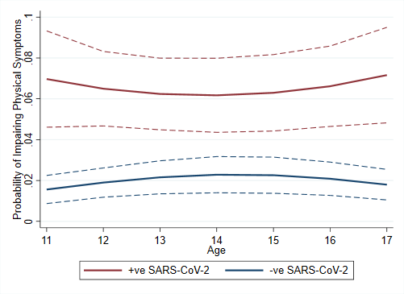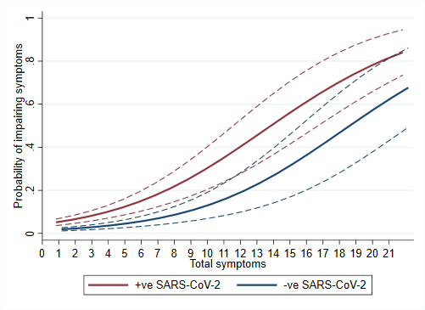
- Sex (d) Ethnicity
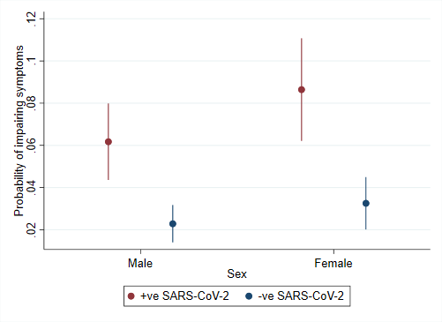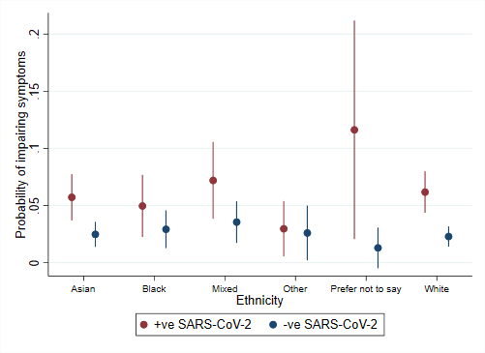
(e) Mental health (f) Physical Health
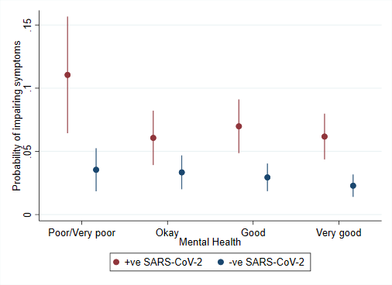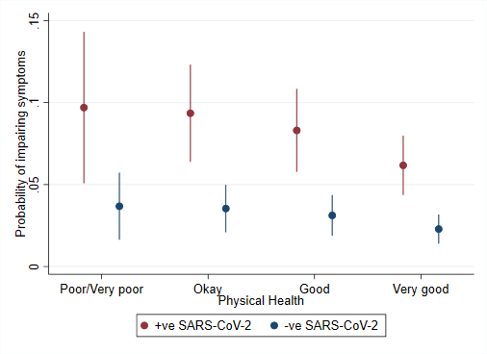
(g) Loneliness

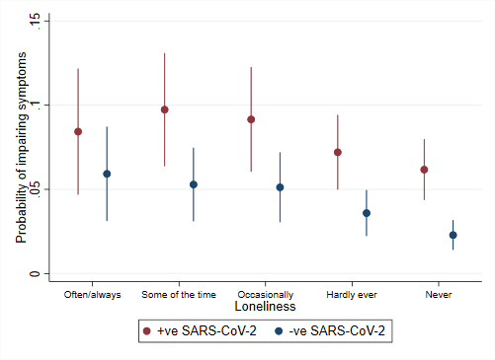
(h) EQ-5D-Y Looking after self (i) EQ-5D-Y Feeling sad/worried
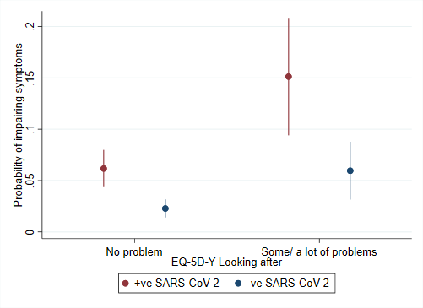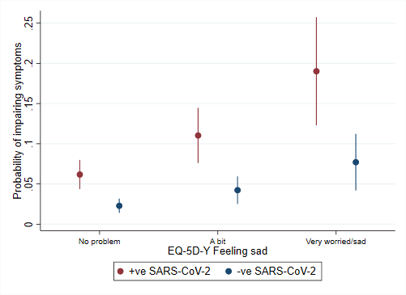
(j) EQ-5D-Y Having pain (k) EQ-5D-Y Doing usual activities
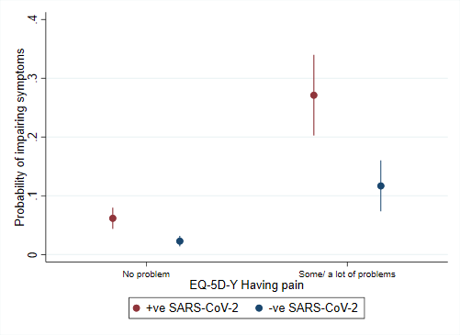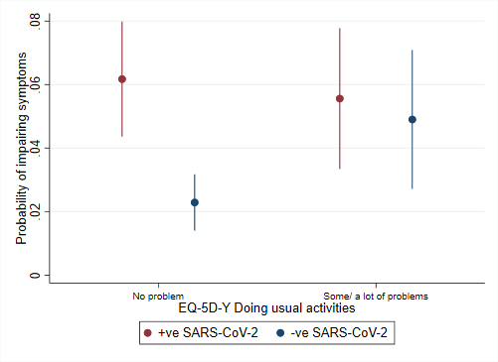
*Reference values are: 14 years, male, White ethnicity, zero symptoms, very good physical health, very good mental health, never feeling lonely and no problems on all included EQ-5D-Y items

