Supplementary Figure S1. Numerical reasons given by CCGs to justify the order of ATs in 41 rheumatoid arthritis pathways

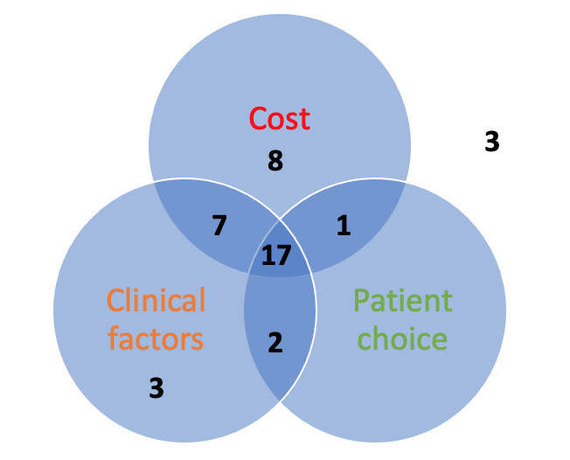
3
No reason

