Supplementary Material

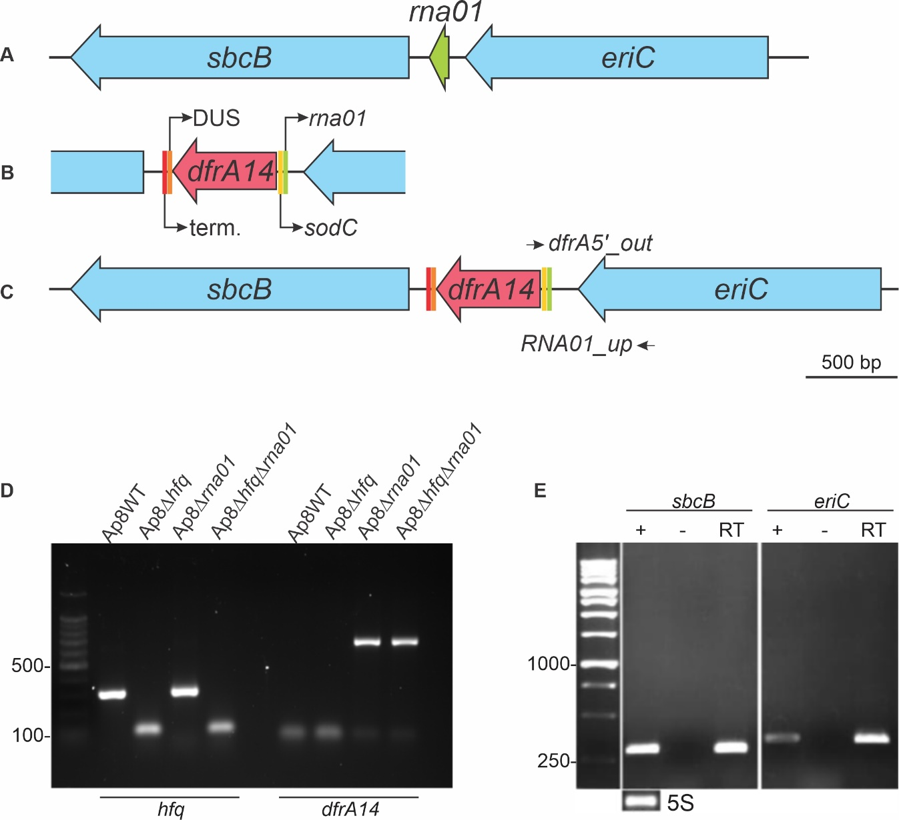
Supplementary Figure 1. Construction and confirmation of A. pleuropneumoniae Rna01 mutant strains. The original sequences of the rna01 gene in MIDG2331 (WT) and Ap8∆hfq strains (A) were replaced by a cassette containing the trimethoprim resistance gene dfrA14, controlled by the sodC promoter sequence, followed by a DNA uptake sequence (DUS) and a terminator (term.) (B), flanked by 500 bp of the genes scbB and eriC (C). The Rna01 and hfq single and double mutants were confirmed by PCR to detect the absence of hfq and presence of dfrA14, in the corresponding strains (D). The maintenance of expression of rna01’s flanking genes sbcB and eriC in the ∆rna01 strains (RT) was verified by RT-PCR (E) Total DNA free-RNA isolated from the WT strain subjected to cDNA synthesis of untreated were used as positive (+) and negative (-) controls.

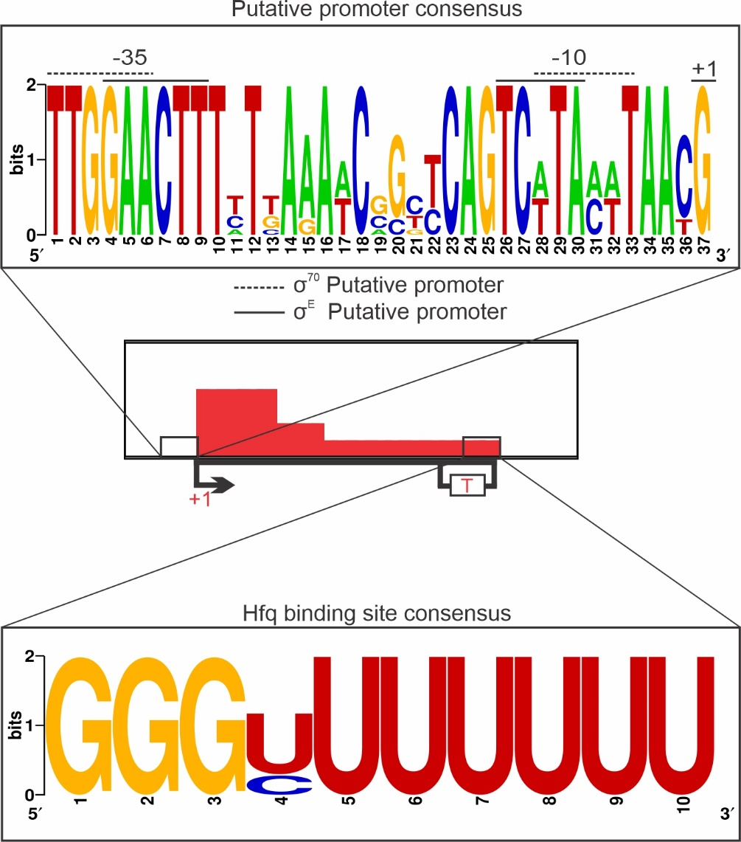
Supplementary Figure 2. Analysis of Rna01 homologues. (B) Conservation of Rna01’s putative Hfq-binding site and promoters regions.

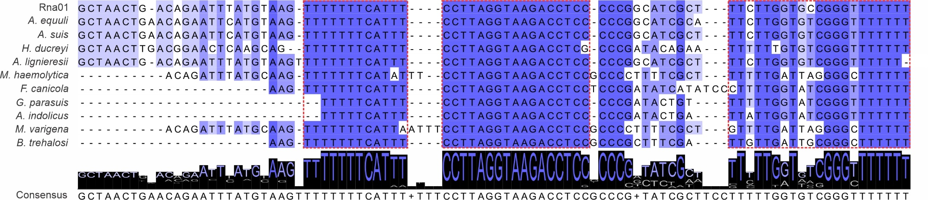
Supplementary Figure 3. Alignment of Rna01 homologues sequences. Alignment of homologues was developed using Jalview. Conserved regions are highlighted with red dotted lines and the consensus sequence is showed at bottom.
Supplementary Table 1. Potential mRNA targets of the Rna01 manually predicted in Actinobacillus pleuropneumoniae.
Target | Locus on MIDG2331 | Energy (kcal/mol) | Description
MIDG2331_00243 | MIDG2331_00243 | -10.78 | putative lipoprotein
nrfB | MIDG2331_00104 | -5.14 | nitrate reductase, cytochrome-C type protein
omlA | MIDG2331_01204 | -4.92 | outer membrane lipoprotein A precursor
comEA | MIDG2331_01571 | -6.16 | DNA uptake protein-binding protein
phoR_2 | MIDG2331_01297 | -6.24 | phosphate regulon sensor protein
phoB | MIDG2331_01298 | -7.63 | phosphate regulon transcriptional regulatory protein
rpoH | MIDG2331_02050 | -5.92 | RNA polymerase sigma-32 factor
MIDG2331_00952 | MIDG2331_00952 | -9.15 | TPR repeat-containing protein
exbD2 | MIDG2331_00080 | -5.99 | biopolymer transport protein
potD2 | MIDG2331_00385 | -7.97 | spermidine/putrescine-binding periplasmic protein
lsgD | MIDG2331_01068 | -7.79 | glycosyltransferase involved in LPS biosynthesis
lolB | MIDG2331_00799 | -5.47 | outer membrane lipoprotein LolB
acrA2 | MIDG2331_00863 | -6.2 | membrane-fusion protein
lpp | MIDG2331_00037 | -6.56 | outer membrane lipoprotein
MIDG2331_01099 | MIDG2331_01099 | -6.3 | NirD/YgiW/YdeI family stress tolerance protein
ompD | MIDG2331_00430 | -6.99 | outer membrane protein D-15
degP | MIDG2331_01359 | -6.91 | periplasmic serine protease
tadE | MIDG2331_00535 | -10.46 | tight adherence protein E
ompP2B | MIDG2331_00658 | -9,09 | outer membrane protein P2-like protein
MIDG2331_00918 | MIDG2331_00918 | -6.92 | YdgA family protein
lamB | MIDG2331_01276 | -8,96 | maltoporin
MIDG2331_01616 | MIDG2331_01616 | -9.41 | thioredoxin-like protein
fhuA | MIDG2331_02245 | -9,66 | outer membrane ferric hydroxamate receptor
ompW | MIDG2331_01124 | -12.55 | outer membrane protein ompW precursor
momP2 | MIDG2331_02079 | -6.98 | major outer membrane protein
rbsB1 | MIDG2331_01591 | -10.54 | periplasmic sugar-binding protein
dsbE2 | MIDG2331_01091 | -10.06 | putative thiol:disulfide interchange protein
cas1f | MIDG2331_00220 | -9.27 | CRISPR-associated protein
rbsD | MIDG2331_01859 | -10.57 | high affinity ribose transport protein
ompP2A2 | MIDG2331_00006 | -11.76 | outer membrane protein P2

Supplementary Table 2. Potential mRNA targets of the Rna01 predicted by TargetRNA2 and CopraRNA in Actinobacillus pleuropneumoniae.
TargetRNA2
Target | Locus on MIDG2331 | Energy | P-value | Description
lon | MIDG2331_RS01940 | -19.62 | 0.000 | Lon protease
rarD | MIDG2331_RS05305 | -13.5 | 0.003 | Thiosulfate sulfurtransferase
ppiB | MIDG2331_00946 | -10,77 | 0,016 | Peptidyl-prolyl cis-trans isomerase
murQ | MIDG2331_RS08355 | -10.41 | 0.019 | N-acetylmuramic acid 6-phosphate etherase
dppA2 | MIDG2331_00067 | -10,15 | 0,022 | ABC transporter substrate-binding protein
xseB | MIDG2331_RS04060 | -9.74 | 0.027 | Exodeoxyribonuclease 7 small subunit
fhuA | MIDG2331_02245 | -9,66 | 0,028 | TonB-dependent siderophore receptor
malK | MIDG2331_RS06255 | -9.58 | 0.029 | Maltose/maltodextrin import ATP-binding protein MalK
cysQ | MIDG2331_RS06740 | -9.57 | 0.029 | 3'(2'),5'-bisphosphate nucleotidase CysQ
cas1f | MIDG2331_RS01085 | -9.27 | 0.033 | CRISPR-associated endonuclease Cas1
exbB1 | MIDG2331_01754 | -9,13 | 0,035 | MotA/TolQ/ExbB proton channel family protein
ompP2B | MIDG2331_00658 | -9,09 | 0,036 | porin
tolR | MIDG2331_RS01555 | -9.05 | 0.036 | Tol-Pal system protein TolR
lamB | MIDG2331_01276 | -8,96 | 0,038 | maltoporin
rplR | MIDG2331_RS09745 | -8.89 | 0.039 | 50S ribosomal protein L18
ispC | MIDG2331_RS02090 | -8.79 | 0.041 | 1-deoxy-D-xylulose 5-phosphate reductoisomerase
purE | MIDG2331_RS03280 | -8.77 | 0.041 | N5-carboxyaminoimidazole ribonucleotide mutase
moeB | MIDG2331_RS01610 | -8.69 | 0.042 | Molybdopterin-synthase adenylyltransferase
CopraRNA
Target | Locus on MIDG2331 | Fdr | P-value | Description
malE | MIDG2331_RS06260 | 0,090615546 | 0,000183598 | maltose/maltodextrin ABC transporter substrate-binding protein MalE
bioB | MIDG2331_RS00605 | 0,090615546 | 0,000186356 | biotin synthase
accC | MIDG2331_RS10255 | 0,180388642 | 0,000463724 | acetyl-CoA carboxylase biotin carboxylase subunit
aroQ | MIDG2331_RS10240 | 0,186751572 | 0,000714664 | 3-dehydroquinate dehydratase
pssA | MIDG2331_RS00215 | 0,186751572 | 0,000779764 | phosphatidylserine synthase
hemD | MIDG2331_RS05130 | 0,186751572 | 0,000942524 | uroporphyrinogen-III synthase
yedF | MIDG2331_RS10805 | 0,186751572 | 0,001027049 | SirA-like protein
ubiD | MIDG2331_RS07875 | 0,186751572 | 0,001056179 | 4-hydroxy-3-polyprenylbenzoate decarboxylase
mtgA | MIDG2331_RS02450 | 0,273161438 | 0,001966201 | monofunctional biosynthetic peptidoglycan transglycosylase
asd | MIDG2331_RS00025 | 0,323193418 | 0,002658661 | aspartate-semialdehyde dehydrogenase
lctP | MIDG2331_RS02310 | 0,337316752 | 0,00295043 | L-lactate permease
plpB | MIDG2331_RS04595 | 0,337316752 | 0,003282774 | methionine ABC transporter substrate-binding protein MetQ
znuA | MIDG2331_RS07880 | 0,337316752 | 0,003295125 | zinc ABC transporter substrate-binding protein
sufE | MIDG2331_RS06570 | 0,368974332 | 0,004190709 | Derived by automated computational analysis using gene prediction method: Protein Homology.
argB | MIDG2331_RS01235 | 0,368974332 | 0,004363193 | acetylglutamate kinase
fdnI | MIDG2331_RS04515 | 0,409768106 | 0,005056264 | formate dehydrogenase subunit gamma
murF | MIDG2331_RS00070 | 0,455255302 | 0,006085674 | UDP-N-acetylmuramoyl-tripeptide--D-alanyl-D- alanine ligase
mltA | MIDG2331_RS04100 | 0,457230577 | 0,006379401 | murein transglycosylase A
hybE | MIDG2331_RS06855 | 0,457230577 | 0,006731636 | hydrogenase
sucD | MIDG2331_RS02330 | 0,457230577 | 0,006817319 | succinate--CoA ligase subunit alpha
pheT | MIDG2331_RS02930 | 0,492356498 | 0,008100466 | phenylalanine--tRNA ligase subunit beta

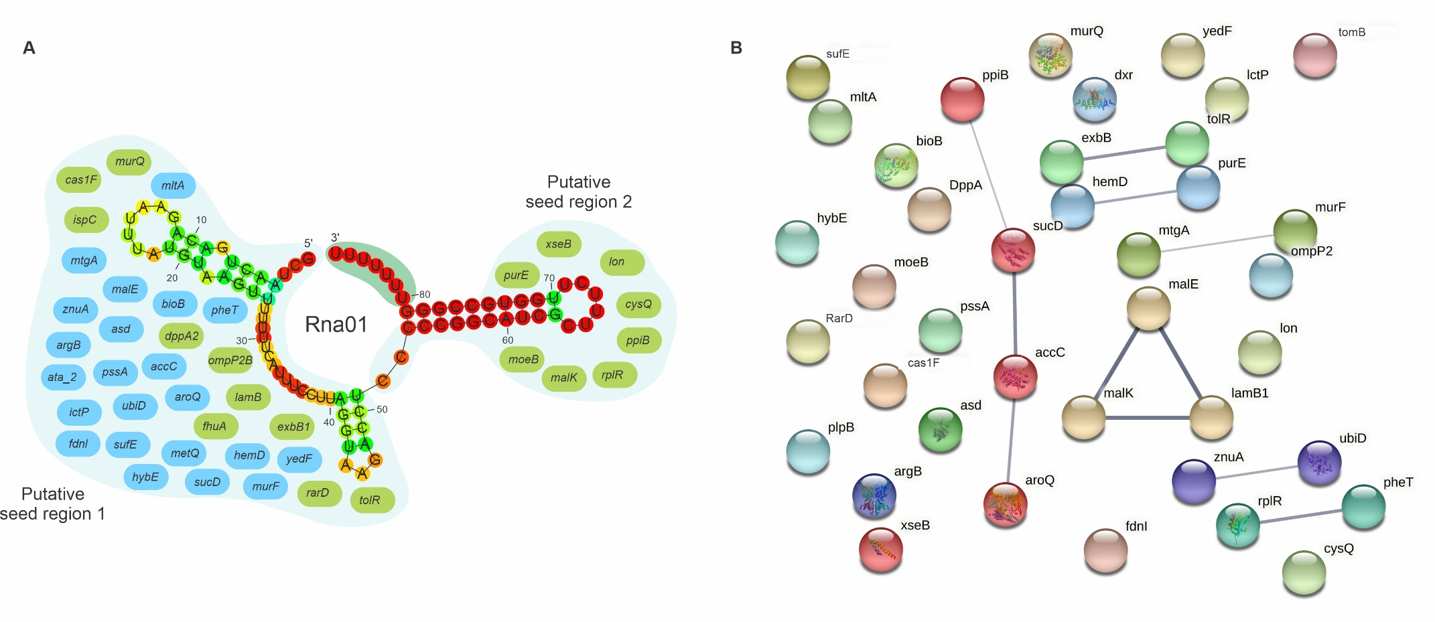
Supplementary Figure 4. Investigation of targets prediction for Rna01. (A) targets predicted for Rna01 using CopraRNA and TargetRNA2. Putative regions of interaction (seed regions 1 and 2) are showed in the figure. Targets predicted by TargetRNA2 are shown in green and targets predicted by CopraRNA, in blue. Nucleotides circled in dark green represent the Hfq binding site (B) protein-protein association of targets predicted for Rna01. Grey lines represent protein-protein associations, and their thickness indicates the strength of data support. Associations are meant to be specific and meaningful, for example, proteins that jointly contribute to a shared function. Genes were analyzed with a moderate confidence 0.400 and Markov clustering method (MCL) with inflation parameter 1.1. Associated proteins share color of the network.

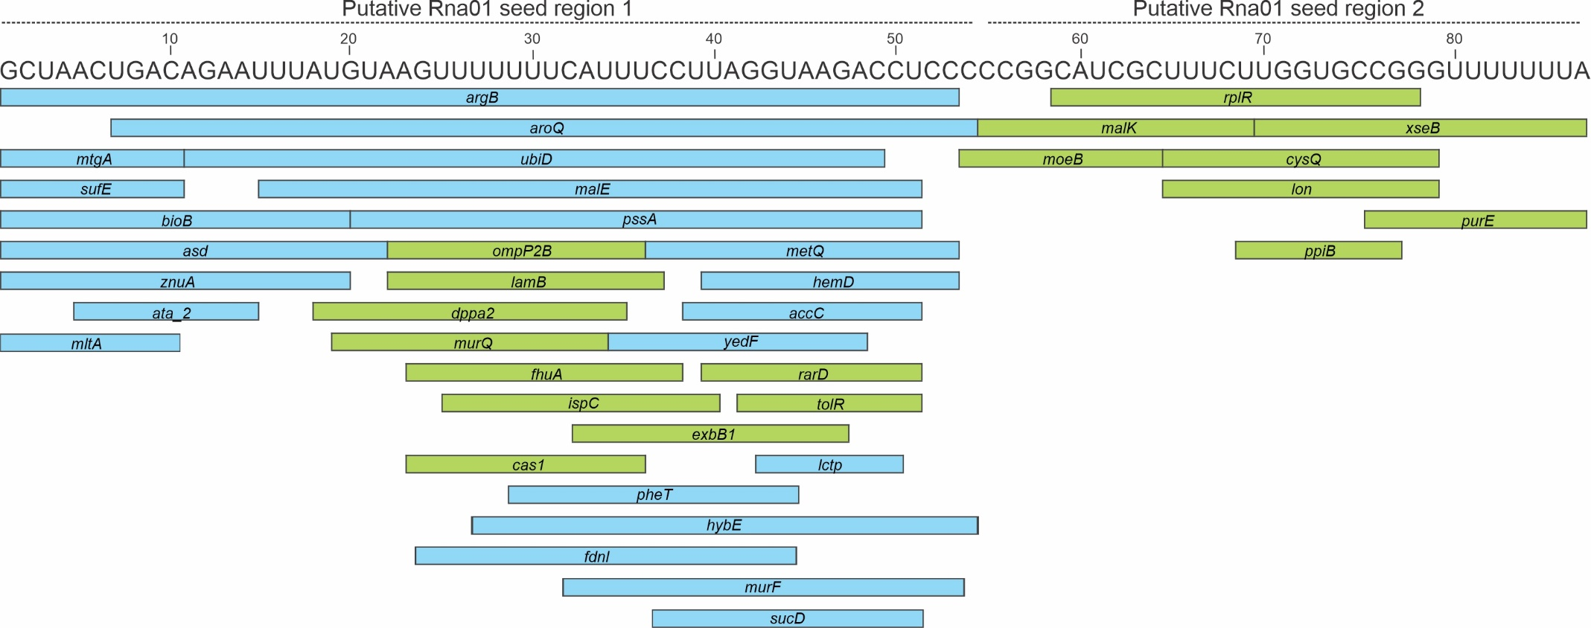
Supplementary Figure 5. Putative “seed” region of Rna01’ targets. Target prediction by TargetRNA2 and CopraRNA shows the putative region of interaction between Rna01 and its targets. Targets predicted by TargetRNA2 are shown in green and targets predicted by CopraRNA, in blue.
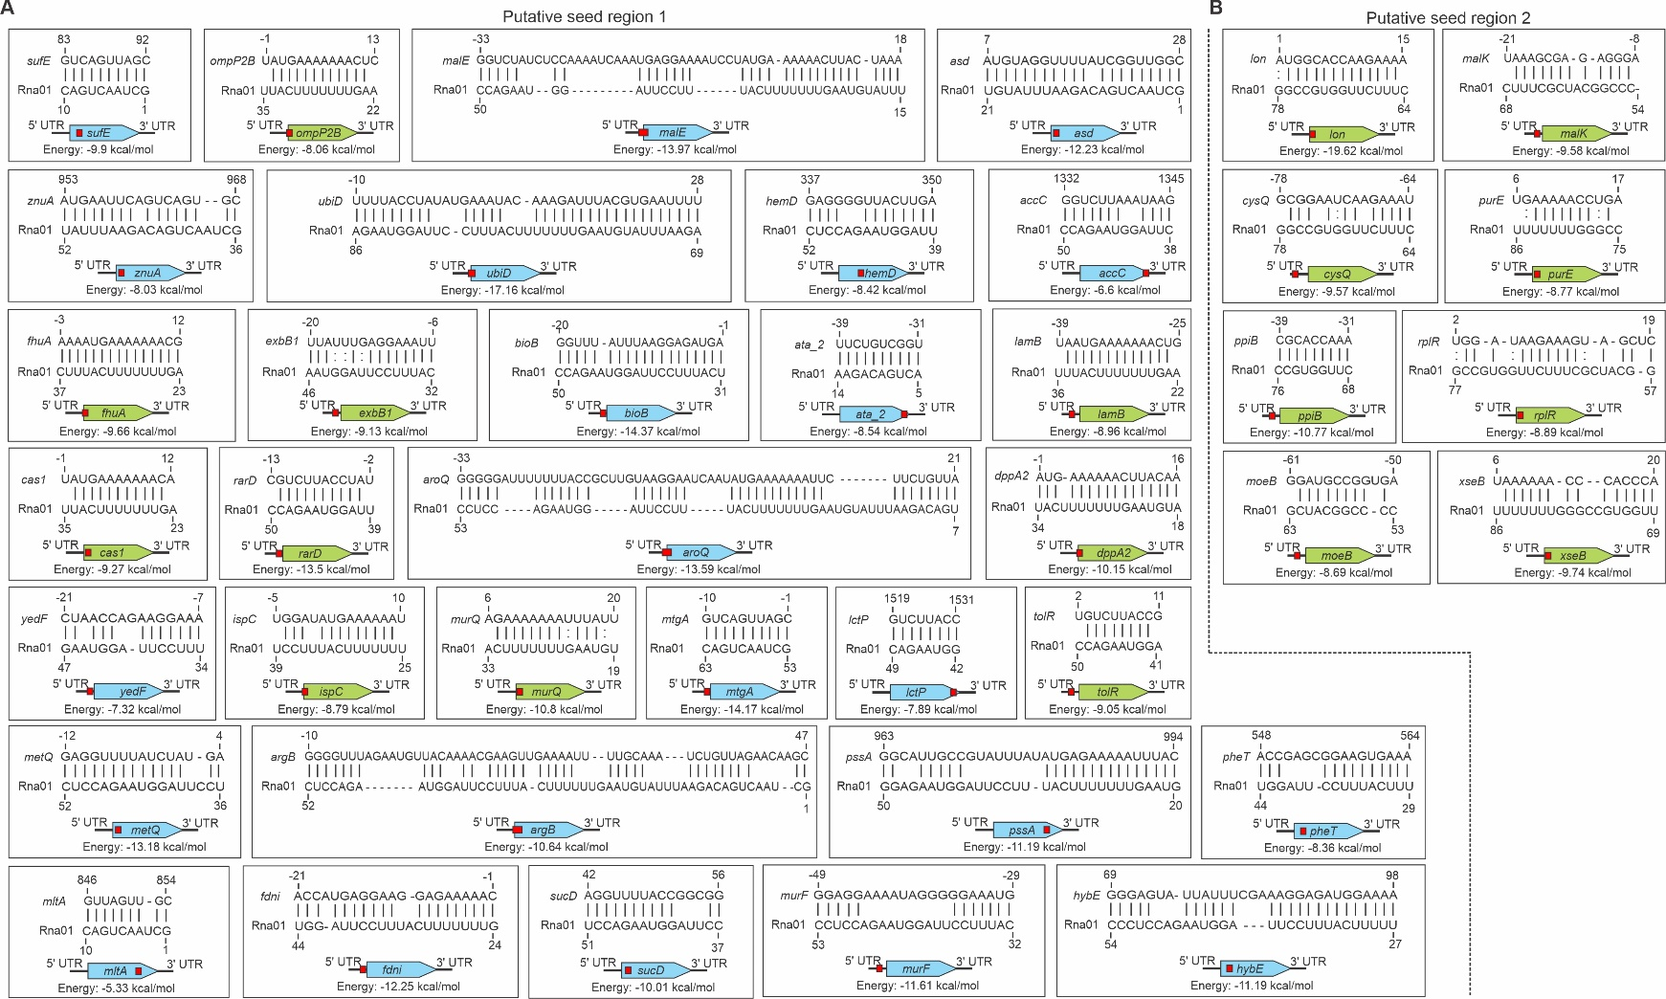
Supplementary Figure 6 | RNA-RNA interaction between Rna01 and respective targets. Putative region of interaction of the seed region 1 (A) and seed region 2 (B) of the Rna01 and the mRNAs targets. Targets predicted by TargetRNA2 are shown in green and targets predicted by CopraRNA, in blue.

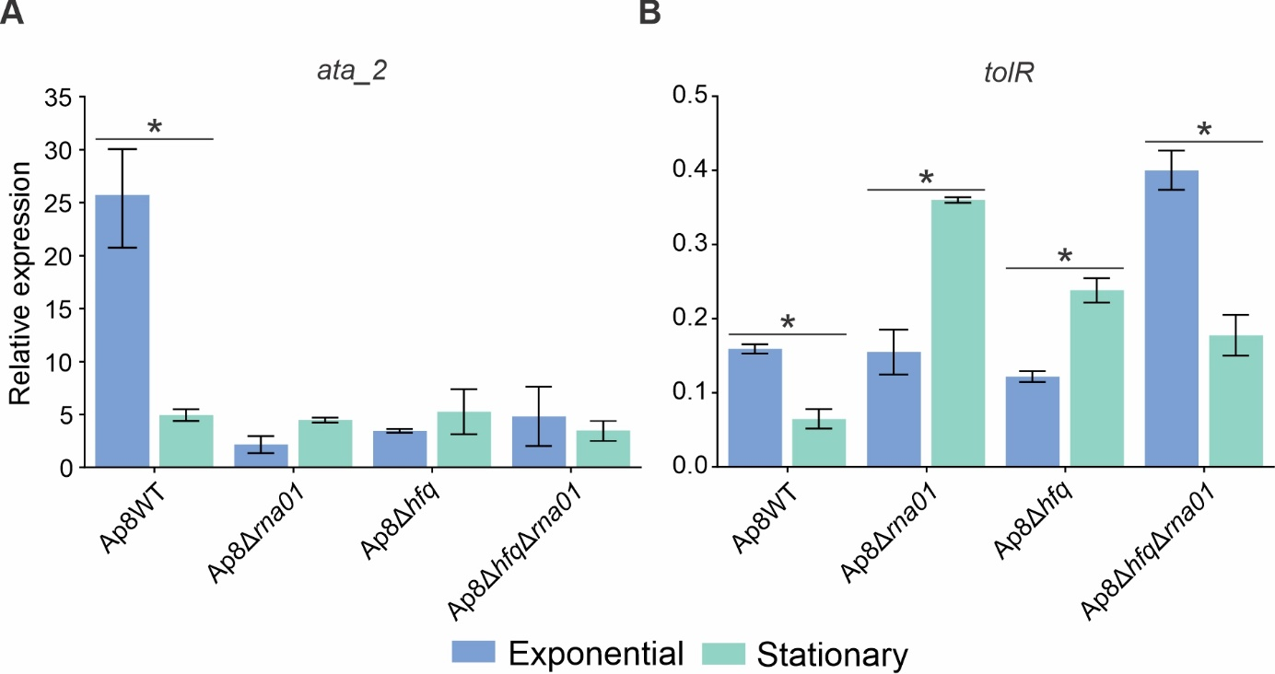
Supplementary Figure 7. Targets expression are affected by Rna01. qPCR of ata_2 (A) and tolR (B) targets in exponential and stationary phase among the strains. *Significative difference by t-test (p<0.1).
Supplementary Table 3. Pairwise comparisons of the log-hank test of G. mellonella infection assay with A. pleuropneumoniae strains
Comparisons | P-Value | Significant?
Ap8WT vs. PBS | 0,000000409 | Yes
Ap8WT vs. Ap8∆hfq | 0,00000409 | Yes
Ap8WT vs. Ap8∆hfq∆rna01 | 0,0000915 | Yes
Ap8WT vs. Ap8∆rna01 | 0,0136 | Yes
Ap8∆rna01 vs. PBS | 0,0153 | Yes
Ap8∆rna01 vs. Ap8∆hfq | 0,0667 | No
Ap8∆hfq∆rna01 vs. PBS | 0,277 | No
Ap8∆rna01 vs. Ap8∆hfq∆rna01 | 0,288 | No
Ap8∆hfq vs. Ap8∆hfq∆rna01 | 0,520 | No
Ap8∆hfq vs. PBS | 0,317 | No

Supplementary Table 4. Pairwise comparisons of the log-hank test of G. mellonella infection assay with EVs from A. pleuropneumoniae strains
Comparisons | P-Value | Significant?
Ap8∆rna01 vs. Ap8∆hfq | 0,00000495 | Yes
Ap8WT vs. Ap8∆rna01 | 0,0000175 | Yes
Ap8∆rna01 vs. Ap8∆hfq∆rna01 | 0,000305 | Yes
Ap8∆rna01 vs. PBS | 0,000839 | Yes
Ap8∆hfq∆rna01 vs. PBS | 0,619 | No
Ap8∆hfq vs. Ap8∆hfq∆rna01 | 0,592 | No
Ap8WT vs. PBS | 0,777 | No
Ap8WT vs. Ap8∆hfq∆rna01 | 0,765 | No
Ap8∆hfq vs. PBS | 0,729 | No
Ap8WT vs. Ap8∆hfq | 0,559 | No

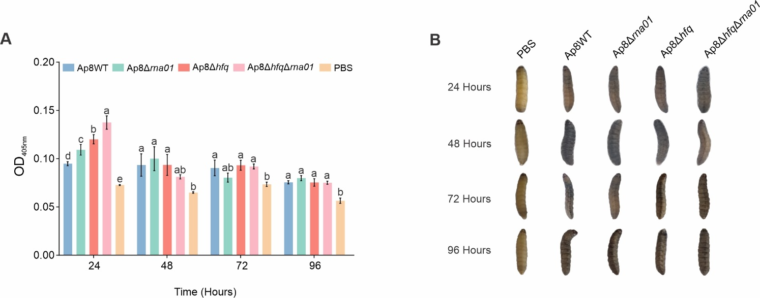
Supplementary Figure 8. Extracellular vesicles cause strong melanization in G. mellonella. (A) optical density of larval hemolymph post-infection. (B) visual observation of larval melanization through the course of the experiment. Means with different letters are significantly different by Tuckey’s test

