Arrhythmogenic Cardiomyopathy and Differential Diagnosis with Physiological Right Ventricular Remodelling in Athletes using Cardiovascular Magnetic Resonance.

Authors: Eleonora Moccia^{1,2} MD, Efstathios Papatheodorou¹ MD, Chris J Miles¹ MBBS, Ahmed Merghani¹ MBBS, MD, Aneil Malhotra¹ MBBS, MA, MSc, PhD, Harshil Dhutia¹ BSc, MBBS, Rachel Bastiaenen^{1,3} BSc, MRCP, PhD, Nabeel Sheikh^{1,3} BSc, PhD, Abbas Zaidi¹ BSc, MBBS, MD, Giuseppe Damiano Sanna² MD, PhD, Tessa Homfray¹ MD, Nicholas Bunce¹, MBBS, MD, Lisa J Anderson¹ BSc, MBChB, MD, Maite Tome¹ MD, PhD, Elijah Behr¹ MBBS, MA, MD, James Moon^{4,5} MBBS, MD, Sanjay Sharma¹ BSc, MBChB, MD, Gherardo Finocchiaro^{1,3} MD, PhD*, Michael Papadakis¹ MBBS, MD* * Equally contributed as senior authors

Institutions:

¹ Cardiology Clinical Academic Group, St George's University of London and St George’s University Hospital NHS Foundation Trust, London, United Kingdom
² Clinical and Interventional Cardiology, Sassari University Hospital, Sassari, Italy
³ Guy’s and St. Thomas’s Hospital, London, United Kingdom
⁴ Barts Heart Centre, St Bartholomew’s Hospital, London, UK

⁵ Institute of Cardiovascular Science, University College London, London, UK

Author for correspondence:

Eleonora Moccia, MD.

Clinical and Interventional Cardiology, Sassari University Hospital; Cardiology Clinical Academic Group, St. George’s University of London;

Via Enrico de Nicola 1, Sassari, Italy

E-mail: e.moccia@studenti.uniss.it

ORCID: 0000-0002-1999-1049

Acknowledgements: Cardiac Risk in The Young (CRY).

ABSTRACT

Purpose

To describe the overlap between structural abnormalities typical of arrhythmogenic right ventricular cardiomyopathy (ARVC) and physiological right ventricular adaptation to exercise and differentiate between pathologic and physiologic findings using CMR.

Methods

We compared CMR studies of 43 patients (mean age 49±17 years, 49% males, 32 genotyped) with a definitive diagnosis of ARVC with 97 (mean age 45±16 years, 61% males) healthy athletes.

Results

CMR was abnormal in 37 (86%) patients with ARVC, but only 23 (53%) fulfilled a major or minor CMR criterion according to the TFC. 7/20 patients who did not fulfil any CMR TFC showed pathological finding (RV RWMA and fibrosis in the LV or LV RWMA). RV was affected in isolation in 17 (39%) patients and 18 (42%) patients showed biventricular involvement. Common RV abnormalities included RWMA (n=34; 79%), RV dilatation (n=18; 42%), RV systolic dysfunction (≤45%) (n=17; 40%) and RV LGE (n=13; 30%). The predominant LV abnormality was LGE (n=20; 47%). 22/32 (69%) patients exhibited a pathogenic variant: PKP2 (n=17, 53%), DSP (n=4, 13%) and DSC2 (n=1, 3%). Sixteen (16%) athletes exceeded TFC cut-off values for RV volumes. None of the athletes exceeded a RV/LV end-diastolic volume ratio >1.2, nor fulfilled TFC for impaired RV ejection fraction.

Conclusions

The majority (86%) of ARVC patients demonstrate CMR abnormalities suggestive of cardiomyopathy but only 53% fulfil at least one of the CMR TFC. LV involvement is found in 50% cases. In athletes, an RV/LV end-diastolic volume ratio >1.2 and impaired RV function (RVEF≤45%) are strong predictors of pathology.

Abstract word count: 251 words

Keywords: arrhythmogenic cardiomyopathy, athlete’s heart, cardiac magnetic resonance.

INTRODUCTION
Arrhythmogenic right ventricular cardiomyopathy (ARVC) is an inherited condition that is characterized by progressive fibrofatty replacement of the myocardium and a predilection for fatal arrhythmias ^{[1–4]}. The diagnosis of ARVC is complex and based on the Task Force Criteria (TFC) which include a series of clinical, electrocardiographic and structural/functional traits ^{[5]}. Due to its ability to accurately assess regional wall motion abnormalities, chamber volume and systolic function, cardiac magnetic resonance (CMR) was incorporated in the revised 2010 TFC for the diagnosis of ARVC and is increasingly used in the diagnostic work-up of suspected cases ^{[6–8]}. Specifically, the combination of right ventricular (RV) regional wall motion abnormalities (RWMA) and RV chamber dilatation and/or RV systolic dysfunction constitute the major and minor TFC.
Since the publication of the TFC in 2010, it has become increasingly apparent that ARVC is a bi-ventricular disease in a considerable proportion of cases, including isolated left ventricular (LV) involvement in some cases. These observations have resulted in calls for revising the existing diagnostic criteria as well as the nomenclature of the condition ^{[9, 10]}. In addition, the TFC RV values indicative of a diagnosis of ARVC are based on data derived from 44 patients who were investigated at multiple centres against a control group of 462 ostensibly healthy individuals who were not matched for age or sex. As such, the accuracy of the proposed cut-off values remains unclear. Highly trained athletes are a prime example of this challenge, as they often reveal a physiological increase in RV size and mild reduction in RV fractional area during resting conditions which may result in an erroneous diagnosis of ARVC ^{[11–15]}.
The aims of our study were to characterize a cohort of patients with ARVC with CMR and to define the overlap in terms of structural cardiac changes between ARVC and healthy athletes through CMR parameters.

MATERIALS AND METHODS

Study population

Patients with ARVC

The patient cohort consisted of 43 consecutive patients with a diagnosis of ARVC who were investigated with CMR at the St George’s University Hospital inherited cardiac conditions (ICC) and sports cardiology clinic between 2008 and 2018. Only patients who fulfilled a definitive diagnosis of ARVC according to the 2010 TFC prior to undergo CMR scan, were included in the study (Figure 1). All patients were comprehensively evaluated with history, clinical examination, 12-lead ECG, signal-averaged ECG, transthoracic echocardiogram, exercise tolerance test and 24h Holter monitoring. Genetic testing was performed in 32 (74%) patients (30 probands). All patients remained under regular follow-up at the same centre.
Fig 1. Task Force criteria fulfilled by each study patient to allow a definite diagnosis of ARVC prior to CMR scan. Abbreviations: ECHO: echocardiography, Repolarization abn: repolarization abnormalities, depolarization abn: depolarization abnormalities.

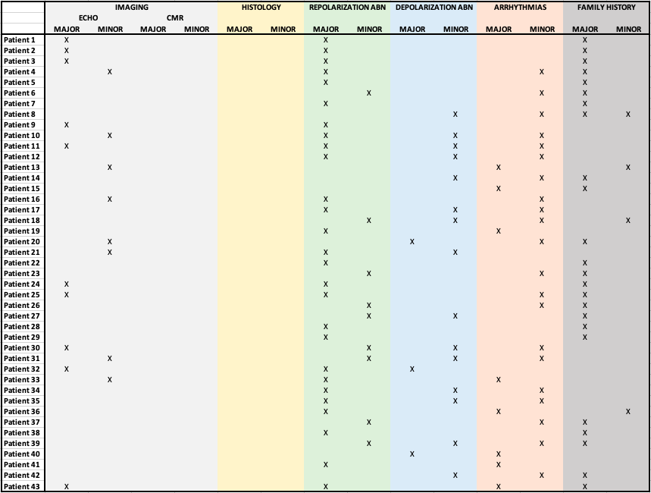

Athletes

The athlete cohort consisted of 97 ostensibly healthy athletes who were investigated with a CMR. A case-control study design was adopted where we attempted to match the ARVC and athletic cohorts for age, gender, and ethnicity. Athletes were recruited utilizing 2 different sources: 1) Thirty-one competitive athletes who were referred to the sports cardiology clinic for the investigation of possible cardiomyopathy between 2014 and 2018. Athletes participated in running (n=12, 31%), rugby (n=9, 23%), football (n=7, 22%), basketball (n=1, 2%) and rowing, (n=2, 6%), engaging at least 10 hours of exercise per week. The main reasons for referral were T wave inversion (TWI) in the anterior leads (n=20), cardiac symptoms (palpitations or chest pain where cardiac investigations did not reveal any pathological finding (n=9), and premature ventricular contractions on the baseline ECG (n=1). None of the athletes had a family history of premature sudden cardiac death or inherited cardiac conditions. Overt cardiac disease was excluded after comprehensive evaluation including 12-lead ECG, transthoracic echocardiogram, exercise tolerance test, 24h Holter monitoring and CMR.
2) Sixty-six healthy, asymptomatic veteran (> 40 years of age) endurance runners of whom 26% also participated in other sports such as cycling and/or swimming. All athletes engaged in at least 10 hours of exercise per week. The veteran athletes were prospectively enrolled in a study previously published ^{[16]} and the cohort comprised 152 athletes who were tested with several cardiac investigations including CMR. Of these, 68 showed LGE. For the present study, only athletes with RV insertion point LGE (24/68) were included, while the ones with other LGE patterns (subendocardial, subepicardial, mid-wall, patchy or involving papillary muscles) were excluded. This choice was motivated by the fact that while RV insertion point LGE is considered a normal finding^{[17]}, the clinical significance of other LGE patterns is not well defined in this context (possibly representing cardiac pathology) and the aim of the study was to select a cohort of healthy athletes where possible structural changes were due to physiological conditioning rather than a possible cardiac condition.
The investigation conforms with the principles outlined in the Declaration of Helsinki ^{[18]} and with the local legal requirements. For master athletes written consent was obtained from all participants, and ethical approval was granted by the National Research Ethics Service and the Southwest-Central Bristol committee.

Cardiac magnetic resonance
Cardiac magnetic resonance was performed with a Philips Achieva 3.0T TX (Amsterdam, The Netherlands) scanner and a 1.5T magnet (Avanto, Siemens Healthineers) scanner. For the assessment of LV and RV RWMA, ventricular volumes and mass, breath-hold steady-state, free precession (SSFP) cines images were used in short axis (from atrioventricular plane to the apex, 7-mm slice thickness, no gap) and in axial views (from diaphragm to the entire outflow tract, 5-mm slice thickness, no gap) ^{[19]}. Dedicated long axis views of RV were acquired. A stack of transverse slices covering the entire RV was obtained. Late gadolinium enhancement images were acquired ten minutes after intravenous bolus injection of 0.2 mmol/Kg gadoterate meglumine (Dotarem) or 0.1 mmol/Kg of Gadovist. Appropriate inversion times were set to null normal myocardium (range 250-300 msec, obtained from TI-scout sequences) and LGE images were phase swapped to exclude artefact when required. ECG gating was obtained for all patients. The scans were reported by a Cardiologist with level III accreditation from the European Society of Cardiology and revised blindly by two cardiologists with expertise in CMR. The presence of LGE was visually estimated. Volumes and function of both ventricles and LV mass were measured using standard techniques ^{[20]} and analysed using semi-automated cvi42 software (Circle Cardiovascular Imaging Inc, Calgary, Alberta, Canada). All volumes and masses were indexed for age and body surface area (BSA)^{[21]}. Right ventricular regional wall motion abnormalities (RWMA) were classified as akinesia, dyskinesia and aneurysm. To be reproducible, we considered 3 main myocardial regions: RV free wall, anterior wall/RVOT and apex. Based on the TFC, a CMR was considered to fulfil diagnostic criteria in the presence of RWMA and either a ratio of RV end-diastolic volume to BSA ≥110mL/m² for males and ≥100 mL/m² for females or RV ejection fraction ≤40% for major criterion, and either a ratio of RV end-diastolic volume to BSA ≥100 to <110 mL/m² (male) and ≥90 to <100 mL/m² (female) or RV ejection fraction >40% to ≤45% for minor criterion.
Statistical Analysis
Statistical analysis was performed using the PASW software (PASW 18.0 Inc, Chicago, IL) and the Medcalc software (version 17.4, Ostend, Belgium). Results are expressed as mean ± SD for continuous variables or as number of cases and percentage for categorical variables. Comparison between groups was performed using Student’s t-tests for continuous variables with adjustment for unequal variance if needed and chi-square tests or Fisher Exact Tests for categorical variables. Regression analysis was used to determine relations between continuous variables. For inter-observer variability, in cases where there was disagreement between the 2 operators regarding the qualitative assessment of the wall motion or the presence of LGE, the data were adjusted to the assessment of a third experienced (European Society of Cardiology level III accreditation) operator (GF). Cohen’s kappa (k) coefficient was used to calculate the overall inter-observer reliability in CMR measurements of RV and LV volumes.

RESULTS

Cardiac magnetic resonance in patients with ARVC
The characteristics of patients with ARVC are reported in Table 1.

Table 1. Demographics and CMR data of the ARVC patients. Abbreviations: BSA: body surface area; CMR: Cardiac magnetic resonance; LGE: late gadolinium enhancement, LV: left ventricle; LVEDV: left ventricular end-diastolic volume, LVEF: left ventricular ejection fraction, RV: right ventricle; RVEDV: right ventricular end-diastolic volume, RVEF: right ventricular ejection fraction, RVESV: right ventricular end-systolic volume, RVOT: right ventricular outflow tract, RWMA: regional wall motion abnormalities.
ARVC patients
(n=43)
Demographics
Age years | 49±17 [24-86]
Males n (%) | 21 (49%)
White n (%) | 35 (81%)
CMR features
LVEDV ml | 152±38 [67-238]
LVEDV/BSA ml/m² | 81±18 [45-125]
LVEF % | 61±9 [39-80]
RVEDV ml | 183±64 [102-405]
RVEDV/BSA ml/m² | 97±32 [19-168]
RVESV ml | 100±59 [33-320]
RVESV/BSA ml/m² | 53±31 [19-168]
CMR major volume criteria n (%) | 13 (30)
CMR minor volume criteria n (%) | 5 (12)
RVEF % | 48±13 [18-69]
CMR major function criteria n (%) | 10 (23)
CMR minor function criteria n (%) | 9 (21)
RV RWMA n (%)  RV apical n (%)  RV free wall n (%)  RV anterior wall/RVOT n (%) | 34 (79)  12 (23)  26 (60)  22 (51)
LGE n (%)  LGE RV only n (%)  LGE LV only n (%)  LGE biventricular n (%)  LGE LV inferolateral wall n (%)  LGE interventricular septum n (%)  LGE LV extensive/circumferential n (%)  LGE RV free wall n (%) | 28 (65)  8 (19)  15 (35)  5 (12)  10 (23)  6 (14)  6 (14)  13 (30)

The CMR was abnormal in 37 (86%) patients. The RV was affected, in isolation, in 17 (40%) patients. The LV was involved in 20 (47%) cases, with 18 (42%) patients exhibiting biventricular involvement and 2 (5%) patients showing isolated LV involvement (Figure 2).

Fig 2. study cohort. Fiftyfour percent of patients fulfilled at least one TF criterion. Seventeen patients (39%) had a right-dominant form of the disease, eighteen (42%) had biventricular involvement and two (5%) had LV involvement only. The CMR was normal in 6 patients. Percentages of patients harbouring genetic variants were calculated on total number of patients investigated with genetic test.
Major volume criterion: RVEDV/BSA ≥110 ml/m² in males or 100 ml/m² in females; minor volume criterion: RVEDV/BSA ≥100 ml/m² in males and ≥90ml/m² in females. Major function criterion: RVEF ≤40%; minor function criterion: RVEF >40% ≤45%.
Abbreviations: DSC2: desmocollin 2; DSP: desmoplakin; Gene –ve: gene negative, no genetic variants detected; PKP2: plakophillin 2; VUS: variance of unknown significance.

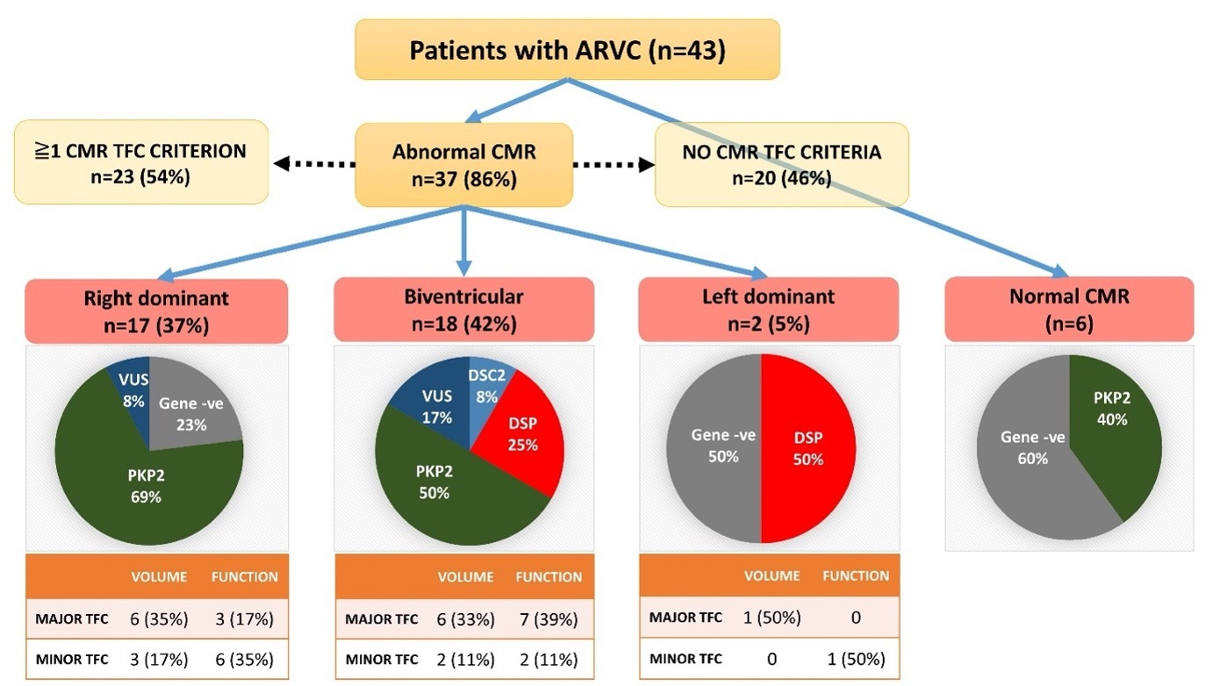

The most common RV abnormalities included RWMA (n=34; 79%), RV dilatation fulfilling a major or minor volume TFC (n=18; 42%), impaired RV systolic function (ejection fraction ≤45%: n=17; 40%) and LGE (n=13; 30%). Right ventricular RWMA predominantly affected the RV free wall and the anterior wall (n=26; 60%), the right ventricular outflow tract (RVOT) (n=22; 51%), and the RV apex (n=12; 28%).
The predominant LV abnormality was LGE (n=20; 47%), with a smaller proportion of patients
exhibiting RWMA (n=6; 14%) and impaired systolic function (LVEF <50%: n=6; 14%).
Left ventricular RWMA affected predominantly the inferolateral wall (3 out of 6).
For measurements of average LV and RV volumes the intraclass correlation coefficient was > 0.85. For qualitative parameters, such as RWMA and presence of LGE, the agreement between the two readers was 80%.
Cardiac magnetic resonance in healthy athletes
The characteristics of the athletes are reported in Table 2. Sixteen (16%) athletes exceeded the cut-off values for RV volumes used as a major (n=10; 10%) or a minor (n=6; 6%) TFC. None of the athletes fulfilled the TFC for impaired (≤45%) RV ejection fraction.

Table 2. Comparison between athletes and ARVC patients. Legends: abbreviations as per Table 1. LVSV: left ventricular stroke volume; RVSV: right ventricular stroke volume.

 | ARVC patients  (n=43) | Athletes  (n=97) | P
Age years | 49±17 [24-86] | 45±16 [16-73] | 0.14
Males n (%) | 21 (49) | 59 (61) | 0.18
White n (%) | 35 (81) | 71 (73) | 0.31
LVEDV ml | 152±38 [67-238] | 157±32 [94-248] | 0.49
LVEDV/BSA ml/m² | 81±18 [45-125] | 89±17 [57-147] | 0.02
LVESV ml/m² | 62 ± 26 [18-130] | 53 ± 18 [19-118] | 0.03
LVESV/BSA ml/m² | 33 ± 14 [11-71] | 30 ± 9 [12-64] | 0.15
LVEF % | 61±9 [39-80] | 67±6 [53-82] | <0.001
LVSV ml | 90 ± 21 | 104 ± 19 | <0.001
RVEDV ml | 183±64 [102-405] | 144±37 [79-256] | <0.001
RVEDV/BSA ml/m² | 97±32 [19-168] | 81±18 [44-128] | 0.005
RVESV ml | 100±59 [33-320] | 46±25 [11-134] | <0.001
RVESV/BSA ml/m² | 53±31 [19-168] | 26±13 [7-68] | <0.001
RVEF % | 48±13 [18-69] | 70±9 [48-88] | <0.001
RVEF≤40% n (%) | 10 (30) | 0 | 0.001
RVEF≤40% n (%) | 18 (42) | 0 | <0.001
RVSV ml | 83 ± 21 | 94 ± 21 | 0.005
RVEDV/LVEDV | 1.21±0.3 [0.67-1.77] | 0.91±0.1 [0.65-1.2] | <0.001
RVEDV/LVEDV>1.20 n (%) | 18 (42) | 0 | <0.001

Comparison of cardiac MRI features in patients with ARVC and in healthy athletes

A comparison between the demographic and CMR characteristics of patients with ARVC and athletes is reported in Table 2. The LV and the RV ejection fraction were significantly lower in patients with ARVC compared to athletes. None of the athletes revealed RV RWMA. Left ventricular end-diastolic volumes were higher in athletes, whereas RV end-diastolic volumes were considerably higher in patients with ARVC. This was reflected by a RV/LV end-diastolic volume ratio >1.2 in 42% of patients compared to none of the athletes. We observed an inverse relationship between RV volumes indexed for BSA and age in athletes (r= -0.41, p<0.001) (Figure 3). In contrast, there was no significant association between RV dimensions and age in patients with ARVC (r=-0.005, p=0.97). Twenty-eight (72%) patients with ARVC had impaired RV systolic function compared to none of the athletes.

Fig 3. Relationship between RV dimensions and age in healthy athletes.
Males: Blue circle; Females: Pink squares. Dashed blue line: threshold value for RV dilatation in males; dashed pink line: threshold value for RV dilatation in females (as per major ARVC criteria). Abbreviations: LV: left ventricular; RV: right ventricular; RWMA: regional wall motion abnormalities.

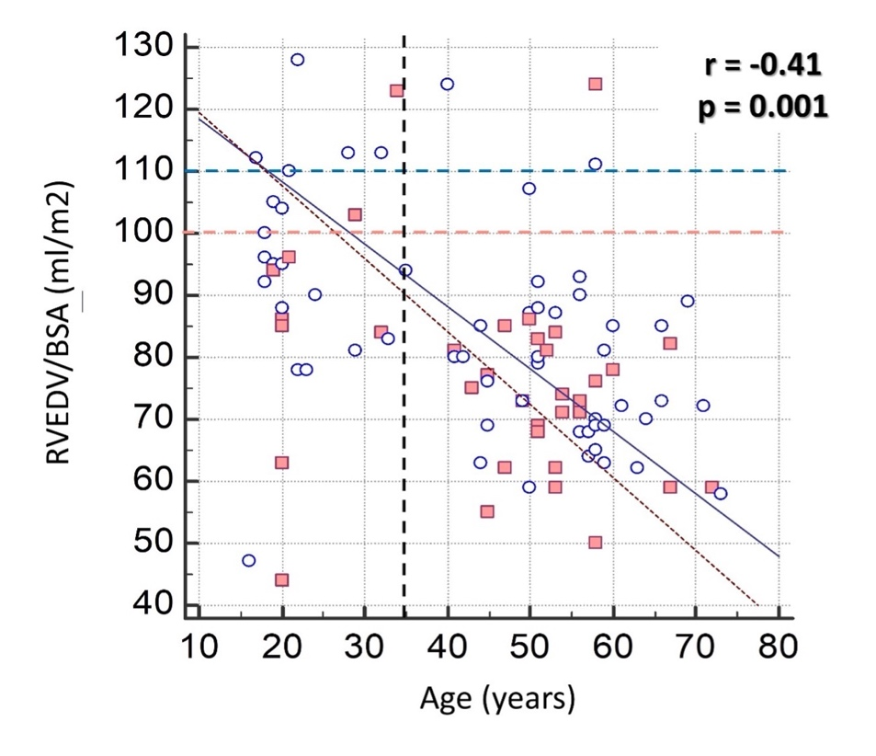

Performance of the revised TFC
Twenty-three (53%) ARVC patients fulfilled a major (n=14; 33%) or minor (n=9; 21%) CMR TFC (Figure 2). Of the 20 patients who did not fulfil the TFC, 7 (35%) showed a combination of RV RWMA and a non-ischaemic pattern of major focal fibrosis in the LV (47%) or LV regional wall motion abnormalities (14%) (Figure 4).
Fig 4. Venn diagram showing electrical, structural, and pathogenic variants in patients with ARVC who did not fulfil CMR TFC. Panel: CMR short axis and long axis views of the heart of a 54-year-old patient with a plakophillin2 (PKP2) mutation diagnosed with ARVC; RV volumes are within normal limits (RVEDV/BSA 84ml/m2), with an RVEDV/LVEDV ratio of 1.0, a small aneurysmal segment in the basal RV wall (gold arrow) is present, and LGE at the basal interventricular septum and lateral wall (yellow arrows). Abbreviations: RVEDV: right ventricular end-diastolic volume.

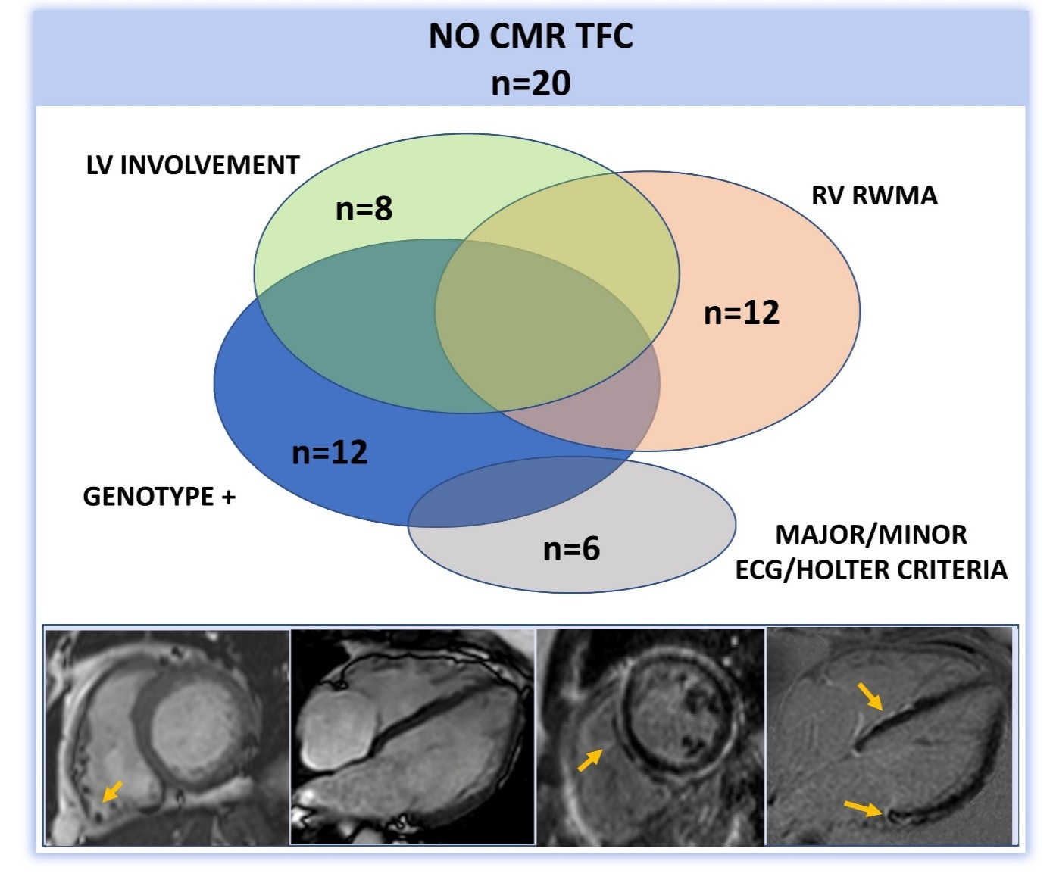
Eighteen (42%) patients exceeded the cut-off values for RV volumes used as a major (n=13; 30%) or a minor (n=5; 12%) TFC (Table 1, Figure 2). There was a trend for males to more frequently exceed the cut-off values for RV volumes compared to female patients (57% vs. 27%, p=0.07) (Table 1 in Supplementary Material). Applying the RV volume and systolic function TFC values to the entire study population, showed a sensitivity of 53%, a specificity of 83% and an accuracy of 0.68 in differentiating ARVC from physiological adaptation to exercise (Table 3).

Table 3. Performance of CMR volume and function Task Force Criteria for differentiating ARVC from healthy athletes of similar age and sex

MAJOR CRITERIA
- Regional RV akinesia or dyskinesia or dyssynchronous RV contraction
- and 1 of the following
- Ratio of RV end-diastolic volume to BSA ≥110mL/m² (male) or ≥100 mL/m² (female)
- or RV ejection fraction ≤40%
MINOR CRITERIA
- Regional RV akinesia or dyskinesia or dyssynchronous RV contraction
- and 1 of the following
- Ratio of RV end-diastolic volume to BSA ≥100 to <110 mL/m² (male) or ≥90 to <100 mL/m² (female)
- or RV ejection fraction >40% to ≤45%
ISOLATED MAJOR RV SIZE CRITERIA  Sensitivity  Specificity  Accuracy | 30% (17% to 46%)  90% (82% to 95%)  0.6 (0.51 to 0.68)
ISOLATED MINOR RV SIZE CRITERIA  Sensitivity  Specificity  Accuracy | 12% (4% to 25%)  94% (87% to 98%)  0.53 (0.44 to 0.61)
ISOLATED MAJOR RV FUNCTION CRITERIA  Sensitivity  Specificity  Accuracy | 23% (12% to 39%)  100% (96% to 100%)  0.62 (0.53 to 0.7)
ISOLATED MINOR RV FUNCTION CRITERIA  Sensitivity  Specificity  Accuracy | 21% (10% to 36%)  100% (96% to 100%)  0.6 (0.52 to 0.69)
MAJOR/MINOR RV SIZE/FUNCTION CRITERIA*  Sensitivity  Specificity  Accuracy | 53% (38% to 69%)  83% (75% to 90%)  0.68 (0.6 to 0.76)

* sensitivity/specificity/accuracy for at least one of size or function major or minor criterion.

Genetic yield by ventricular involvement

Twenty-two (69%) of the 32 patients (20 out of the 30 probands) investigated with genetic testing had a pathogenic variant in the following genes: plakophillin 2 (PKP2) (n=17, 53%), desmoplakin (DSP) (n=4, 13%) and desmocollin 2 (DSC2) (n=1, 3%) (Figure 2). Three (9%) patients revealed a variant of uncertain significance (VUS) and 7 (22%) did not harbour any variants. There was similar yield of pathogenic variants in desmosomal genes in patients with isolated RV involvement or biventricular involvement (69% vs 83%, p=0.44) (Figure 2). The correlation between imaging features and genetic status is shown in Table 2 in Supplementary Material.

DISCUSSION
Cardiovascular magnetic resonance is widely used in clinical practice for the evaluation of invdividuals with suspected ARVC ^{[22]}. Our study show that most patients with ARVC (86%) exhibited one or more CMR abnormalities that would raise suspicion of cardiomyopathy. Conversely, only 53% of patients with ARVC fulfilled any of the CMR TFC and interestingly, a significant proportion of the remaining 47%, exhibited LV abnormalities and specifically LGE. Abnormalities in the LV, often in the absence of significant RV dilatation or systolic dysfunction, but in the presence of RV RWMA are those that provide the most useful diagnostic information in individuals with suspected ARVC.

A diagnosis of ARVC has significant implications on athletes. Apart from strong recommendations against participating in competitive sports^{[23,24]}, recent data reveal that even exercise intensities exceeding 6 METS, may accelerate the disease process ^{[25]}. Our results reveal that almost one fifth of athletes exhibit RV volumes on CMR that may contribute to a diagnosis of ARVC according to the current TFC. In line with previous studies showing that RV physiological remodelling is common in young athletes, in our cohort athletes with RV enlargement were mainly young and there was an inverse relationship between RV size and age, with master athletes exhibiting normal RV dimensions even though they engaged in 3 decades of exercise. Importantly, we demonstrated that athletes have balanced RV enlargement with a RV/LV end diastolic volume ratio ≤1.2. Conversely, in patients with ARVC a RV/LV end diastolic volume ratio >1.2 was found in 42% of the cohort.

Cardiac MRI features in ARVC
Although ARVC was initially considered a disease of the RV, subsequent studies have suggested that LV involvement is common ^{[9,26–28]}. In our study, nearly half of the patients showed LV involvement. Regional wall motion abnormalities were present in the majority of patients and noted mostly at the level of the basal RV free wall, the RVOT and occasionally affecting the RV apical segments. Left ventricular RWMA affected predominantly the inferolateral wall. These findings are in keeping with data showing that the RV apex, which was traditionally thought to be frequently involved as part of the “triangle of dysplasia” (RV base, outflow tract and apex), is relatively spared, particularly in the early stages of the disease ^{[29,30]}.

Focal myocardial fibrosis detected with LGE was noted in 65% of patients. The RV was affected, in isolation, in 19% of patients, while LGE in the LV myocardium was reported in almost half (47%) of the cohort. Late gadolinium enhancement is not included in the current TFC due to concerns about several limitations. The assessment of LGE in the RV myocardium is often challenging due to the relatively thin walls and the highly trabeculated architecture which may result in “entrapment” of the gadolinium and over interpretation of abnormal appearances (5). In contrast, myocardial tissue characterisation of the LV with gadolinium is reliable and offers an opportunity to incorporate it in novel diagnostic criteria with a focus on bi-ventricular disease ^{[10]}.

The presence of biventricular involvement would have classified as abnormal 7 of the 20 CMRs which did not fulfil the TFC, thereby increasing the sensitivity of the CMR criteria from 53% to 70%. Therefore LV abnormalities such as non-ischaemic LGE or LV RWMA when present in combination with RV RWMA should be considered as part of the CMR diagnostic criteria for ARVC, even in the absence of significant RV dilatation or RV systolic dysfunction. Mimics of ARVC that may exhibit bi-ventricular involvement such as cardiac sarcoid and inflammatory cardiomyopathies should be excluded ^{[31,32]}.

Genetic correlations

The diagnostic yield of genetic testing was similar in right sided and biventricular disease.

Consistent with the literature, pathogenic or likely pathogenic variants in PKP2 represented the majority (17/22; 77%) of the positive genetic yield in the ARVC patients [^{22,33}. Interestingly, although PKP2 variants are traditionally described in predominant RV involvement ^{[28,34,35]} in our cohort these variants were frequently found in biventricular disease. This may simply reflect the ability of the CMR to detect RWMA and myocardial fibrosis, assigning more cases from right dominant to biventricular disease. As previously described, DSP pathogenic variants were reported mainly in left dominant cases^{[35]}.

Limitations
Our study has some limitations. The sample size was relatively small, but comparable to previous publications. Our institution is a national referral centre; therefore, it is possible that more complex cases of ARVC were referred, resulting in a possible bias towards a higher number of cases with biventricular involvement. On the other hand, use of the traditional ARVC TFC is likely to have excluded individuals with predominantly LV disease. In an attempt to compare patients with ARVC with healthy athletes, we considered athletes without evidence of significant LGE although recent studies have shown that LGE may be identified in a considerable proportion of male masters athletes, however, usually in the absence of any RV abnormalities ^{[36]}. The decision to exclude athletes exhibiting significant LGE was governed by the uncertainties surrounding the aetiology and long-term significance of this specific feature in athletes. Although myocarditis and subclinical infarction due to embolic plaques or demand ischaemia have been proposed as potential mechanisms, it is also possible that some athletes may have a genetic or acquired form of arrhythmogenic cardiomyopathy.
For qualitative parameters, such as RWMA, the agreement between the 2 experienced interpreters was 80% which reflects an intrinsic limitation of RV assessment, and which further strengthens the value of using the easier quantitative parameters such as RVEF and the RVEDV/LVEDV ratio. Furthermore, since the beginning of our study, some new CMR techniques have been developed (for example, feature tracking myocardial strain) which proved to have additional value in this setting, identifying even subclinical RV dysfunction ^{[37]}.
Finally, although all athletes underwent extensive evaluation to exclude a cardiomyopathy it is possible that some may express overt phenotype at a later age.

Conclusions

The majority (86%) of patients with ARVC demonstrate structural abnormalities suggestive of cardiomyopathy on CMR but only 53% fulfil at least one CMR Task Force criterion. The emergence of ARVC as a biventricular disease provides an opportunity to re-evaluate the diagnostic criteria and include LV involvement in conjunction with RV involvement to improve diagnostic accuracy. According to the CMR TFC for ARVC, 42% of patients with ARVC and 16% of athletes show RV enlargement. In athletes, an RV/LV end-diastolic volume ratio >1.2 and impaired RV function (RVEF≤45%) are strong predictors of pathology.

REFERENCES

1. Corrado D, Link MS, Calkins H. Arrhythmogenic Right Ventricular Cardiomyopathy. N Engl J Med. 2017;376(1):61-72. doi:10.1056/NEJMra1509267
2. Basso C, Corrado D, Bauce B, Thiene G. Arrhythmogenic right ventricular cardiomyopathy. Circulation: Arrhythmia and Electrophysiology. 2012;5(6):1233-1246. doi:10.1161/CIRCEP.111.962035
3. Wang W, James CA, Calkins H. Diagnostic and therapeutic strategies for arrhythmogenic right ventricular dysplasia / cardiomyopathy patient. 2018;(April):1-13. doi:10.1093/europace/euy063
4. Towbin JA, McKenna WJ, Abrams DJ, et al. 2019 HRS Expert Consensus Statement on Evaluation, Risk Stratification, and Management of Arrhythmogenic Cardiomyopathy. Heart Rhythm. Published online May 9, 2019. doi:10.1016/j.hrthm.2019.05.007
5. Marcus FI, Mckenna WJ, Sherrill D, et al. Diagnosis of Arrhythmogenic Right Ventricular Cardiomyopathy / Dysplasia. Published online 2010. doi:10.1161/CIRCULATIONAHA.108.840827
6. Tandri H, Saranathan M, Rodriguez ER, et al. Noninvasive detection of myocardial fibrosis in arrhythmogenic right ventricular cardiomyopathy using delayed-enhancement magnetic resonance imaging. J Am Coll Cardiol. 2005;45(1):98-103. doi:10.1016/j.jacc.2004.09.053
7. Te Riele ASJM, Tandri H, Bluemke DA. Arrhythmogenic right ventricular cardiomyopathy (ARVC): Cardiovascular magnetic resonance update. Journal of Cardiovascular Magnetic Resonance. 2014;16(1):1-15. doi:10.1186/s12968-014-0050-8
8. Haugaa KH, Basso C, Badano LP, et al. Comprehensive multi-modality imaging approach in arrhythmogenic cardiomyopathy—an expert consensus document of the European Association of Cardiovascular Imaging. European Heart Journal – Cardiovascular Imaging. 2017;(C):jew229. doi:10.1093/ehjci/jew229
9. Miles C, Finocchiaro G, Papadakis M, et al. Sudden Death and Left Ventricular Involvement in Arrhythmogenic Cardiomyopathy. Circulation. Published online January 31, 2019. doi:10.1161/CIRCULATIONAHA.118.037230
10. Corrado D, Perazzolo Marra M, Zorzi A, et al. Diagnosis of arrhythmogenic cardiomyopathy: The Padua criteria. International Journal of Cardiology. 2020;319:106-114. doi:10.1016/j.ijcard.2020.06.005
11. Utomi V, Oxborough D, Ashley E, et al. The impact of chronic endurance and resistance training upon the right ventricular phenotype in male athletes. European Journal of Applied Physiology. 2015;115(8):1673-1682. doi:10.1007/s00421-015-3147-3
12. Zaidi A, Sheikh N, Jongman JK, et al. Clinical Differentiation Between Physiological Remodeling and Arrhythmogenic Right Ventricular Cardiomyopathy in Athletes With Marked Electrocardiographic Repolarization Anomalies. J Am Coll Cardiol. 2015;65(25):2702-2711. doi:10.1016/j.jacc.2015.04.035
13. D’Ascenzi F, Pisicchio C, Caselli S, Di Paolo FM, Spataro A, Pelliccia A. RV Remodeling in Olympic Athletes. JACC: Cardiovascular Imaging. 2017;10(4):385-393. doi:10.1016/j.jcmg.2016.03.017
14. D’Ascenzi F, Solari M, Corrado D, Zorzi A, Mondillo S. Diagnostic Differentiation Between Arrhythmogenic Cardiomyopathy and Athlete’s Heart by Using Imaging. JACC Cardiovasc Imaging. 2018;11(9):1327-1339. doi:10.1016/j.jcmg.2018.04.031
15. Zaidi A, Ghani S, Sharma R, et al. Physiological right ventricular adaptation in elite athletes of African and Afro-Caribbean origin. Circulation. 2013;127(17):1783-1792. doi:10.1161/CIRCULATIONAHA.112.000270
16. Merghani A, Maestrini V, Rosmini S, et al. Prevalence of Subclinical Coronary Artery Disease in Masters Endurance Athletes With a Low Atherosclerotic Risk Profile. Circulation. 2017;136(2):126-137. doi:10.1161/CIRCULATIONAHA.116.026964
17. Andersen S, Nielsen-Kudsk JE, Vonk Noordegraaf A, de Man FS. Right Ventricular Fibrosis. Circulation. 2019;139(2):269-285. doi:10.1161/CIRCULATIONAHA.118.035326
18. Zghaib T, Ghasabeh MA, Assis FR, et al. Regional Strain by Cardiac Magnetic Resonance Imaging Improves Detection of Right Ventricular Scar Compared With Late Gadolinium Enhancement on a Multimodality Scar Evaluation in Patients With Arrhythmogenic Right Ventricular Cardiomyopathy. Circ Cardiovasc Imaging. 2018;11(9):e007546. doi:10.1161/CIRCIMAGING.118.007546
19. Kramer CM, Barkhausen J, Flamm SD, Kim RJ, Nagel E. Standardized cardiovascular magnetic resonance (CMR) protocols 2013 update. Journal of Cardiovascular Magnetic Resonance. 2013;15(1):1-10. doi:10.1186/1532-429X-15-91
20. Grothues F, Moon JC, Bellenger NG, Smith GS, Klein HU, Pennell DJ. Interstudy reproducibility of right ventricular volumes, function, and mass with cardiovascular magnetic resonance. American Heart Journal. 2004;147(2):218-223. doi:10.1016/j.ahj.2003.10.005
21. D DB. A formula to estimate the approximate surface area if height and weight be known. Nutrition. 1989;5(5):303-311.
22. Te Riele ASJM, Tandri H, Sanborn DM, Bluemke DA. Noninvasive Multimodality Imaging in ARVD/C. JACC Cardiovasc Imaging. 2015;8(5):597-611. doi:10.1016/j.jcmg.2015.02.007
23. Maron BJ, Udelson JE, Bonow RO, et al. Eligibility and Disqualification Recommendations for Competitive Athletes With Cardiovascular Abnormalities: Task Force 3: Hypertrophic Cardiomyopathy, Arrhythmogenic Right Ventricular Cardiomyopathy and Other Cardiomyopathies, and Myocarditis: A Scientif. Circulation. 2015;132(22):e273-80. doi:10.1161/CIR.0000000000000239
24. Pelliccia A, Solberg EE, Papadakis M, et al. Recommendations for participation in competitive and leisure time sport in athletes with cardiomyopathies, myocarditis, and pericarditis: position statement of the Sport Cardiology Section of the European Association of Preventive Cardiology (EAPC). Eur Heart J. 2019;40(1):19-33. doi:10.1093/eurheartj/ehy730
25. Lie ØH, Dejgaard LA, Saberniak J, et al. Harmful Effects of Exercise Intensity and Exercise Duration in Patients With Arrhythmogenic Cardiomyopathy. JACC Clin Electrophysiol. 2018;4(6):744-753. doi:10.1016/j.jacep.2018.01.010
26. Sen-Chowdhry S, Syrris P, Prasad SK, et al. Left-Dominant Arrhythmogenic Cardiomyopathy. An Under-Recognized Clinical Entity. J Am Coll Cardiol. 2008;52(25):2175-2187. doi:10.1016/j.jacc.2008.09.019
27. Rizzo S, Pilichou K, Thiene G, Basso C. The changing spectrum of arrhythmogenic (right ventricular) cardiomyopathy. Cell and Tissue Research. 2012;348(2):319-323. doi:10.1007/s00441-012-1402-z
28. DeWitt ES, Chandler SF, Hylind RJ, et al. Phenotypic Manifestations of Arrhythmogenic Cardiomyopathy in Children and Adolescents. J Am Coll Cardiol. 2019;74(3):346-358. doi:10.1016/j.jacc.2019.05.022
29. Marra MP, Leoni L, Bauce B, et al. Imaging study of ventricular scar in arrhythmogenic right ventricular cardiomyopathy comparison of 3d standard electroanatomical voltage mapping and contrast-enhanced cardiac magnetic resonance. Circulation: Arrhythmia and Electrophysiology. 2012;5(1):91-100. doi:10.1161/CIRCEP.111.964635
30. Te Riele ASJM, James CA, Philips B, et al. Mutation-positive arrhythmogenic right ventricular dysplasia/cardiomyopathy: the triangle of dysplasia displaced. J Cardiovasc Electrophysiol. 2013;24(12):1311-1320. doi:10.1111/jce.12222
31. Quarta G, Husain SI, Flett AS, et al. Arrhythmogenic right ventricular cardiomyopathy mimics: role of cardiovascular magnetic resonance. J Cardiovasc Magn Reson. 2013;15:16. doi:10.1186/1532-429X-15-16
32. Pieroni M, Dello Russo A, Marzo F, et al. High prevalence of myocarditis mimicking arrhythmogenic right ventricular cardiomyopathy differential diagnosis by electroanatomic mapping-guided endomyocardial biopsy. J Am Coll Cardiol. 2009;53(8):681-689. doi:10.1016/j.jacc.2008.11.017
33. Bhonsale A, Groeneweg JA, James CA, et al. Impact of genotype on clinical course in arrhythmogenic right ventricular dysplasia/cardiomyopathy-associated mutation carriers. Eur Heart J. 2015;36(14):847-855. doi:10.1093/eurheartj/ehu509
34. Cruz FM, Sanz-Rosa D, Roche-Molina M, et al. Exercise triggers ARVC phenotype in mice expressing a disease-causing mutated version of human plakophilin-2. J Am Coll Cardiol. 2015;65(14):1438-1450. doi:10.1016/j.jacc.2015.01.045
35. Towbin JA, McKenna WJ, Abrams DJ, et al. 2019 HRS expert consensus statement on evaluation, risk stratification, and management of arrhythmogenic cardiomyopathy. Heart Rhythm. Published online May 9, 2019. doi:10.1016/j.hrthm.2019.05.007
36. van de Schoor FR, Aengevaeren VL, Hopman MTE, et al. Myocardial Fibrosis in Athletes. Mayo Clin Proc. 2016;91(11):1617-1631. doi:10.1016/j.mayocp.2016.07.012
37. Czimbalmos C, Csecs I, Dohy Z, et al. Cardiac magnetic resonance based deformation imaging: role of feature tracking in athletes with suspected arrhythmogenic right ventricular cardiomyopathy. International Journal of Cardiovascular Imaging. 2019;35(3):529-538. doi:10.1007/s10554-018-1478-y

STATEMENTS AND DECLARATIONS

Funding: Gherardo Finocchiaro, Micheal Papadakis and Sanjay Sharma have received research grants from Cardiac Risk in the Young (CRY). Gherardo Finocchiaro has received a research grant from the Charles Wolfson Charitable Trust.

Competing interests: The authors have no relevant financial or non-financial interests to disclose.

Authors contributions: All authors contributed to the study conception and design. Material preparation, data collection and analysis were performed by Eleonora Moccia, Efstathios Papatheodorou and Gherardo Finocchiaro. The first draft of the manuscript was written by Eleonora Moccia, Gherardo Finocchiaro and Micheal Papadakis; all authors commented on previous versions of the manuscript. All authors read and approved the final manuscript.

Ethics approval: This study was performed in line with the principles of the Declaration of Helsinki. Approval was granted by the National Research Ethics Service and the Southwest-Central Bristol committee.

