Additional File 1:
Tables:
Table S1. PRISMA Checklist adapted from Moher et al.
Table S2. Database search strategy.
Table S3. Number of included studies and isolates
Table S4. Sensitivity analysis
Table S5. Azithromycin resistance in S. Typhi.
Table S6. Studies incuded in the systematic review

Figures:
Figure S1. Metaanalysis and median prevalence comparison
Figure S2. Sensitivity analysis
Figure S3. MDR S. Typi in sub-Saharan Africa
Figure S4. MDR S. Typhi in NAME
Figure S5. MDR S. Typhi in East Asia
Figure S6. FQNS S. Typhi in sub-Saharan Africa
Figure S7. FQNS S. Typhi in NAME
Figure S8. FQNS S. Typhi in East Asia
Figure S9. MDR S. Paratypi in South Asia
Figure S10. MDR S. Paratyphi in Southeast Asia
Figure S11. MDR S. Paratyphi in East Asia
Figure S12. FQNS S. Paratypi in South Asia
Figure S13. FQNS S. Paratyphi in Southeast Asia
Figure S14. FQNS S. Paratyphi in East Asia

Table S1. PRISMA Checklist: adapted from Moher et al.
Section/topic | # | Checklist item | Reported
TITLE
Title | 1 | Identify the report as a systematic review, meta-analysis, or both.
ABSTRACT
Structured summary | 2 | Provide a structured summary including, as applicable: background; objectives; data sources; study eligibility criteria, participants, and interventions; study appraisal and synthesis methods; results; limitations; conclusions and implications of key findings; systematic review registration number.
INTRODUCTION
Rationale | 3 | Describe the rationale for the review in the context of what is already known.
Objectives | 4 | Provide an explicit statement of questions being addressed with reference to participants, interventions, comparisons, outcomes, and study design (PICOS).
METHODS
Protocol and registration | 5 | Indicate if a review protocol exists, if and where it can be accessed (e.g., Web address), and, if available, provide registration information including registration number.
Eligibility criteria | 6 | Specify study characteristics (e.g., PICOS, length of follow-up) and report characteristics (e.g., years considered, language, publication status) used as criteria for eligibility, giving rationale.
Information sources | 7 | Describe all information sources (e.g., databases with dates of coverage, contact with study authors to identify additional studies) in the search and date last searched.
Search | 8 | Present full electronic search strategy for at least one database, including any limits used, such that it could be repeated.
Study selection | 9 | State the process for selecting studies (i.e., screening, eligibility, included in systematic review, and, if applicable, included in the meta-analysis).
Data collection process | 10 | Describe method of data extraction from reports (e.g., piloted forms, independently, in duplicate) and any processes for obtaining and confirming data from investigators.
Data items | 11 | List and define all variables for which data were sought (e.g., PICOS, funding sources) and any assumptions and simplifications made.
Risk of bias in individual studies | 12 | Describe methods used for assessing risk of bias of individual studies (including specification of whether this was done at the study or outcome level), and how this information is to be used in any data synthesis.
Summary measures | 13 | State the principal summary measures (e.g., risk ratio, difference in means).
Synthesis of results | 14 | Describe the methods of handling data and combining results of studies, if done, including measures of consistency (e.g., I²) for each meta-analysis.
Risk of bias across studies | 15 | Specify any assessment of risk of bias that may affect the cumulative evidence (e.g., publication bias, selective reporting within studies).
Additional analyses | 16 | Describe methods of additional analyses (e.g., sensitivity or subgroup analyses, meta-regression), if done, indicating which were pre-specified.
RESULTS
Study selection | 17 | Give numbers of studies screened, assessed for eligibility, and included in the review, with reasons for exclusions at each stage, ideally with a flow diagram.
Study characteristics | 18 | For each study, present characteristics for which data were extracted (e.g., study size, PICOS, follow-up period) and provide the citations.
Risk of bias within studies | 19 | Present data on risk of bias of each study and, if available, any outcome level assessment (see item 12).
Results of individual studies | 20 | For all outcomes considered (benefits or harms), present, for each study: (a) simple summary data for each intervention group (b) effect estimates and confidence intervals, ideally with a forest plot.
Synthesis of results | 21 | Present results of each meta-analysis done, including confidence intervals and measures of consistency.
Risk of bias across studies | 22 | Present results of any assessment of risk of bias across studies (see Item 15).
Additional analysis | 23 | Give results of additional analyses, if done (e.g., sensitivity or subgroup analyses, meta-regression [see Item 16]).
DISCUSSION
Summary of evidence | 24 | Summarize the main findings including the strength of evidence for each main outcome; consider their relevance to key groups (e.g., healthcare providers, users, and policy makers).
Limitations | 25 | Discuss limitations at study and outcome level (e.g., risk of bias), and at review-level (e.g., incomplete retrieval of identified research, reporting bias).
Conclusions | 26 | Provide a general interpretation of the results in the context of other evidence, and implications for future research.
FUNDING
Funding | 27 | Describe sources of funding for the systematic review and other support (e.g., supply of data); role of funders for the systematic review.

Table S2: Database search strategy. Strategy designed in Ovid MedLine and altered for other databases
Search number | Search term
1 | Typhoid Fever/ (11123)
2 | typhoid*.ti,ab. (12200)
3 | paratyphoid*.ti,ab. (1674)
4 | "enteric fever*".ti,ab. (1511)
5 | "salmonella typhi".ti,ab. (4311)
6 | "salmonella paratyphi".ti,ab. (821)
7 | paratyphoid fever/ (2380)
8 | 1 or 2 or 3 or 4 or 5 or 6 or 7(20567)
9 | exp Drug Resistance, Bacterial/ (78649)
10 | exp Microbial Sensitivity Tests/ (116858)
11 | "antibacterial resistan*".ti,ab. (617)
12 | "antibacterial drug resistan*".ti,ab. (33)
13 | "bacterial drug resistan*".ti,ab. (208)
14 | "antimicrobial resistan*".ti,ab. (14949)
15 | "antibiotic drug resistan*".ti,ab. (67)
16 | "bacterial resistan*".ti,ab. (5266)
17 | "antibiotics resistan*".ti,ab. (634)
18 | "bacterial surveillan*".ti,ab. (40)
19 | "antibiotic surveillan*".ti,ab. (36)
20 | "antibacterial surveillan*".ti,ab. (1)
21 | "antimicrobial surveillan*".ti,ab. (393)
22 | "antimicrobial susceptib*".ti,ab. (11401)
23 | exp Bacteremia/ (27328)
24 | bacteraemia*.ti,ab. (5772)
25 | bacteremia*.ti,ab. (21957)
26 | ("blood culture*" adj3 result*).ti,ab. (1319)
27 | (antibacter* adj3 surveillan*).ti,ab. (29)
28 | 9 or 10 or 11 or 12 or 13 or 14 or 15 or 16 or 17 or 18 or 19 or 20 or 21 or 22 or 23 or 24 or 25 or 26 or 27 (215387)
29 | 8 and 28 (2202)
30 | 29 (2202)
31 | limit 29 to yr="1990 -Current" (1930)

Table S3a: Total number of included studies and isolates. Displayed are the total number of studies and isolates included by GBD region and five-year time-period. *Some studies provide data on multiple sites and/or time periods therefore the total number of studies displayed here is higher than the total number of studies included in this review.
GBD Region | Number of studies (Number of isolates)
 | 1990-1994 | 1995-1999 | 2000-2004 | 2005-2009 | 2010-2014 | 2015-2018 | Total
Andean Latin America | 1(97) | 0(0) | 0(0) | 0(0) | 1(33) | 0(0) | 2(130)
Australasia | 0(0) | 0(0) | 0(0) | 0(0) | 0(0) | 0(0) | 0(0)
Caribbean | 0(0) | 0(0) | 0(0) | 0(0) | 0(0) | 0(0) | 0(0)
Central Asia | 0(0) | 1(34) | 1(41) | 1(123) | 0(0) | 0(0) | 3(198)
Central Europe | 0(0) | 0(0) | 0(0) | 0(0) | 0(0) | 0(0) | 0(0)
Central Latin America | 0(0) | 0(0) | 0(0) | 0(0) | 0(0) | 0(0) | 0(0)
Central Sub-Saharan Africa | 0(0) | 0(0) | 1(29) | 2(410) | 3(363) | 0(0) | 6(802)
East Asia | 0(0) | 0(0) | 7(4,916) | 4(443) | 2(463) | 0(0) | 13(5,822)
Eastern Europe | 0(0) | 0(0) | 0(0) | 0(0) | 0(0) | 0(0) | 0(0)
Eastern Sub-Saharan Africa | 2(62) | 3(357) | 2(345) | 6(2,504) | 4(254) | 0(0) | 17(3,522)
High-income Asia Pacific | 0(0) | 0(0) | 0(0) | 0(0) | 0(0) | 0(0) | 0(0)
High-income North America | 0(0) | 0(0) | 0(0) | 0(0) | 0(0) | 0(0) | 0(0)
North Africa & Middle East | 4(643) | 5(1,218) | 4(1,044) | 3(996) | 0(0) | 2(69) | 18(3,970)
Oceania | 0(0) | 0(0) | 0(0) | 0(0) | 0(0) | 0(0) | 0(0)
South Asia | 57(13,851) | 35(23,253) | 59(19,130) | 60(14,388) | 64(25,886) | 13(2,937) | 288(99,445)
Southeast Asia | 5(905) | 12(2,279) | 6(3,795) | 7(421) | 8(1,233) | 1(46) | 39(8,679)
Southern Latin America | 0(0) | 0(0) | 0(0) | 0(0) | 0(0) | 0(0) | 0(0)
Southern Sub-Saharan Africa | 0(0) | 0(0) | 0(0) | 0(0) | 0(0) | 0(0) | 0(0)
Tropical Latin America | 0(0) | 0(0) | 0(0) | 0(0) | 0(0) | 0(0) | 0(0)
Western Europe | 0(0) | 0(0) | 0(0) | 0(0) | 0(0) | 0(0) | 0(0)
Western Sub-Saharan Africa | 0(0) | 4(193) | 3(513) | 7(446) | 7(592) | 1(35) | 22(1,779)
Total | 69(15,558) | 60(27,334) | 83(29,813) | 90(19,731) | 89(28,824) | 17(3,087) | *408(124,347)

Table S3b: Number of included studies and isolates for S. Typhi. Displayed by GBD region and five-year time-period. *Some studies provide data on multiple sites and/or time periods therefore the total number of studies displayed here is higher than the total number of studies included in this review.
GBD Region | Number of studies (Number of isolates)
 | 1990-1994 | 1995-1999 | 2000-2004 | 2005-2009 | 2010-2014 | 2015-2018 | Total
Andean Latin America | 0(0) | 0(0) | 0(0) | 0(0) | 1(33) | 0(0) | 1(33)
Australasia | 0(0) | 0(0) | 0(0) | 0(0) | 0(0) | 0(0) | 0(0)
Caribbean | 0(0) | 0(0) | 0(0) | 0(0) | 0(0) | 0(0) | 0(0)
Central Asia | 0(0) | 1(34) | 1(41) | 1(123) | 0(0) | 0(0) | 3(198)
Central Europe | 0(0) | 0(0) | 0(0) | 0(0) | 0(0) | 0(0) | 0(0)
Central Latin America | 0(0) | 0(0) | 0(0) | 0(0) | 0(0) | 0(0) | 0(0)
Central Sub-Saharan Africa | 0(0) | 0(0) | 1(29) | 2(410) | 3(363) | 0(0) | 6(802)
East Asia | 0(0) | 0(0) | 5(618) | 2(164) | 0(0) | 0(0) | 7(782)
Eastern Europe | 0(0) | 0(0) | 0(0) | 0(0) | 0(0) | 0(0) | 0(0)
Eastern Sub-Saharan Africa | 2(62) | 3(357) | 2(345) | 6(2,504) | 4(254) | 0(0) | 17(3,522)
High-income Asia Pacific | 0(0) | 0(0) | 0(0) | 0(0) | 0(0) | 0(0) | 0(0)
High-income North America | 0(0) | 0(0) | 0(0) | 0(0) | 0(0) | 0(0) | 0(0)
North Africa & Middle East | 4(643) | 5(1,218) | 4(1,004) | 3(996) | 0(0) | 2(69) | 18(3,930)
Oceania | 0(0) | 0(0) | 0(0) | 0(0) | 0(0) | 0(0) | 0(0)
South Asia | 57(13,136) | 31(17,472) | 55(12,726) | 55(10,530) | 62(19,581) | 13(2,274) | 273(75,719)
Southeast Asia | 5(761) | 12(2,260) | 6(3,728) | 7(421) | 7(689) | 1(46) | 38(7,905)
Southern Latin America | 0(0) | 0(0) | 0(0) | 0(0) | 0(0) | 0(0) | 0(0)
Southern Sub-Saharan Africa | 0(0) | 0(0) | 0(0) | 0(0) | 0(0) | 0(0) | 0(0)
Tropical Latin America | 0(0) | 0(0) | 0(0) | 0(0) | 0(0) | 0(0) | 0(0)
Western Europe | 0(0) | 0(0) | 0(0) | 0(0) | 0(0) | 0(0) | 0(0)
Western Sub-Saharan Africa | 0(0) | 4(176) | 3(513) | 7(431) | 7(570) | 1(35) | 22(1,725)
Total | 68(14,602) | 56(21,517) | 77(19,004) | 83(15,579) | 84(21,490) | 17(2,424) | *385(94,616)

Table S3c: Number of included studies isolates for S. Paratyphi A. Displayed by GBD region and five-year time-period. *Some studies provide data on multiple sites and/or time periods therefore the total number of studies displayed here is higher than the total number of studies included in this review.
GBD Region | Number of studies (Number of isolates)
 | 1990-1994 | 1995-1999 | 2000-2004 | 2005-2009 | 2010-2014 | 2015-2018 | Total
Andean Latin America | 1(97) | 0(0) | 0(0) | 0(0) | 0(0) | 0(0) | 1(97)
Australasia | 0(0) | 0(0) | 0(0) | 0(0) | 0(0) | 0(0) | 0(0)
Caribbean | 0(0) | 0(0) | 0(0) | 0(0) | 0(0) | 0(0) | 0(0)
Central Asia | 0(0) | 0(0) | 0(0) | 0(0) | 0(0) | 0(0) | 0(0)
Central Europe | 0(0) | 0(0) | 0(0) | 0(0) | 0(0) | 0(0) | 0(0)
Central Latin America | 0(0) | 0(0) | 0(0) | 0(0) | 0(0) | 0(0) | 0(0)
Central Sub-Saharan Africa | 0(0) | 0(0) | 0(0) | 0(0) | 0(0) | 0(0) | 0(0)
East Asia | 0(0) | 0(0) | 2(4,298) | 4(279) | 2(463) | 0(0) | 8(5,040)
Eastern Europe | 0(0) | 0(0) | 0(0) | 0(0) | 0(0) | 0(0) | 0(0)
Eastern Sub-Saharan Africa | 0(0) | 0(0) | 0(0) | 0(0) | 0(0) | 0(0) | 0(0)
High-income Asia Pacific | 0(0) | 0(0) | 0(0) | 0(0) | 0(0) | 0(0) | 0(0)
High-income North America | 0(0) | 0(0) | 0(0) | 0(0) | 0(0) | 0(0) | 0(0)
North Africa & Middle East | 0(0) | 0(0) | 1(40) | 0(0) | 0(0) | 0(0) | 1(40)
Oceania | 0(0) | 0(0) | 0(0) | 0(0) | 0(0) | 0(0) | 0(0)
South Asia | 5(715) | 9(5,781) | 28(6,404) | 30(3,858) | 40(6,305) | 7(663) | 119(23,726)
Southeast Asia | 3(144) | 1(19) | 2(67) | 0(0) | 6(544) | 0(0) | 12(774)
Southern Latin America | 0(0) | 0(0) | 0(0) | 0(0) | 0(0) | 0(0) | 0(0)
Southern Sub-Saharan Africa | 0(0) | 0(0) | 0(0) | 0(0) | 0(0) | 0(0) | 0(0)
Tropical Latin America | 0(0) | 0(0) | 0(0) | 0(0) | 0(0) | 0(0) | 0(0)
Western Europe | 0(0) | 0(0) | 0(0) | 0(0) | 0(0) | 0(0) | 0(0)
Western Sub-Saharan Africa | 0(0) | 1(17) | 0(0) | 1(15) | 2(22) | 0(0) | 4(54)
Total | 9(956) | 11(5,817) | 33(10,809) | 35(4,152) | 50(7,334) | 7(663) | *145(29,731)

Table S4a. Sensitivity analysis: Random effects metaanalysis results for studies on MDR S. Typhi in South Asia, comparing results for all studies with only those reporting (a) AST methods used; (b) resistance breakpoints used; (c) internal control strain used and (d) those on over 50 isolates of S. Typhi.
Time Period | Studies (N) | I² (%) | Pooled prevalence [95% CI]
All studies
1990_1994 | 33 | 98% | 63% [54-71]
1995_1999 | 14 | 100% | 38% [24-52]
2000_2004 | 33 | 99% | 34% [24-44]
2005_2009 | 31 | 99% | 12% [6-20]
2010_2014 | 42 | 98% | 7% [4-12]
Studies reporting AST methods
1990-1994 | 25 | 99% | 61% [50-71]
1995-1999 | 12 | 100% | 36% [22-51]
2000-2004 | 27 | 99% | 32% [21-44]
2005-2009 | 31 | 99% | 12% [6-20]
2010-2014 | 39 | 98% | 6% [3-10]
Studies reporting resistance breakpoints*
1990-1994 | 5 | 100% | 67% [38-91]
1995-1999 | 7 | 100% | 29% [14-47]
2000-2004 | 20 | 99% | 27% [18-38]
2005-2009 | 25 | 99% | 13% [6-22]
2010-2014 | 38 | 98% | 6% [3-10]
Studies reporting internal quality control
1990-1994 | 33 | 98% | 63% [54-71]
1995-1999 | 14 | 100% | 37% [23-53]
2000-2004 | 33 | 99% | 34% [24-44]
2005-2009 | 31 | 99% | 12% [6-20]
2010-2014 | 42 | 98% | 7% [4-12]
Studies with over 50 isolates
1990-1994 | 23 | 98% | 61% [51-70]
1995-1999 | 14 | 100% | 38% [24-52]
2000-2004 | 22 | 99% | 34% [22-47]
2005-2009 | 27 | 99% | 10% [4-17]
2010-2014 | 30 | 99% | 8% [4-14]
* Testing standards including version or year

Table S4b. Sensitivity analysis: Random effects metaanalysis results for studies on FQNS S. Typhi in South Asia, comparing results for all studies with only those reporting (a) AST methods used; (b) resistance breakpoints used; (c) internal control strain used and (d) those on over 50 isolates of S. Typhi.
Time Period | Studies (N) | I² (%) | Pooled prevalence [95% CI]
All studies
1990_1994 | 6 | 93% | 2% [0-14]
1995_1999 | 8 | 98% | 49% [26-72]
2000_2004 | 29 | 99% | 62% [47-77]
2005_2009 | 38 | 97% | 76% [69-83]
2010_2014 | 50 | 99% | 82% [75-89]
Studies reporting AST methods
1990-1994 | 3 | 95% | 10% [0-46]
1995-1999 | 8 | 98% | 49% [26-72]
2000-2004 | 26 | 99% | 59% [42-74]
2005-2009 | 36 | 97% | 77% [70-84]
2010-2014 | 48 | 99% | 82% [74-89]
Studies reporting resistance breakpoints*
1990-1994 | 1 | 0% | 0% [0-0]
1995-1999 | 6 | 99% | 51% [21-81]
2000-2004 | 22 | 99% | 68% [53-82]
2005-2009 | 31 | 97% | 77% [69-84]
2010-2014 | 45 | 99% | 83% [74-90]
Studies with control strain stated
1990-1994 | 6 | 93% | 3% [0-15]
1995-1999 | 8 | 98% | 49% [26-72]
2000-2004 | 29 | 99% | 62% [47-77]
2005-2009 | 38 | 97% | 76% [69-83]
2010-2014 | 50 | 99% | 82% [75-89]
Studies with over 50 isolates
1990-1994 | 2 | 85% | 1% [0-4]
1995-1999 | 6 | 96% | 39% [23-55]
2000-2004 | 20 | 99% | 65% [48-80]
2005-2009 | 26 | 98% | 75% [66-83]
2010-2014 | 29 | 99% | 82% [72-91]
* Testing standards including version or year

Table S5: Azithromycin resistance in S. Typhi. Resistant isolates are defined as having an MIC >16μg/ml [EUCAST 2014, BSAC 2012] or by disk diffusion, a zone diameter ≤18mm [BSAC 2012]. Sensitive isolates have an MIC ≤16μg/ml or zone diameter ≥19mm.
Author (Year) | Country | Testing Method | Number examined (N) | Resistant, N (%)
Chinh (2000) | Viet Nam | Agar dilution | 86 | 0 (0)
Capoor (2009) | India | E-test | 149 | 1 (1)
Kasper (2010) | Cambodia | E-test | 41 | 0 (0)
Ngoun (2012) | Cambodia | E-test | 102 | 0 (0)
Rai (2012)ᵇ | India | E-test | 80 | 27 (34)
Vlieghe (2012) | Cambodia | E-test | 20 | 1 (5)
Garg (2013) | India | E-test | 17 | 3 (7)
Jain (2013) | India | Disk-diffusion | 266 | 17 (6)
Koirala (2013) | Nepal | E-test | 218 | 0 (0)
Venkatesh (2013) | India | E-test | 132 | 0 (0)
Dutta (2014) | India | E-test | 77 | 0 (0)
Maltha (2014) | Burkina Faso | E-test | 12 | 0 (0)
Phoba (2014) | DRC | E-test | 18 | 0 (0)
Srirangaraj (2014) | India | E-test | 16 | 2 (13)
Ikram (2015) | Pakistan | Disk-diffusion | 71 | 60 (85)
Chande (2016) | India | E-test | 108 | 0 (0)
Iyer (2017) | India | E-test | 217 | 0 (0)
Khanal (2017) | Nepal | Agar dilution | 74 | 0 (0)
Kuijpers (2017) | Cambodia | E-test | 64 | 0 (0)
Okanda (2018) | Bangladesh | Microdilution | 18 | 0 (0)
Sharma (2018) | India | E-test | 95 | 1 (1)
Joshi (2019) | India | E-test | 300 | 0 (0)

Table S6: Studies included in the systematic review
Author (Year) | Citation
Aatekah (2010) | Aatekah O, Shazia S, Umber Z, Arjumand R, Zaidi AKM. Incidence of typhoid bacteremia in infants and young children in southern coastal Pakistan. Pediatr Infect Dis J 2010; 29(11): 1035-9.
Abdel Wahab (1999) | Abdel Wahab MF, el-Gindy IM, Sultan Y, el-Naby HM. Comparative study on different recent diagnostic and therapeutic regimens in acute typhoid fever. J Egypt Public Health Assoc 1999; 74(1-2): 193-205.
Abdullah (2012) | Abdullah FE, Faryal H, Kanwal F, Saboohi I, Iqbal MS. Enteric fever in Karachi: current antibiotic susceptibility of Salmonellae isolates. J Coll Physicians Surg Pak 2012; 22(3): 147-50.
Abdullah (2013) | Abdullah MA, Adnan Z, Sattar NY. Susceptibility of Salmonella enterica serotype Typhi, to the usual line of antimicrobial treatment in Rawalpindi. Pakistan Journal of Public Health 2013; 3(2): 14-8.
Abdullahi (2015) | Abdullahi M, Olonitola SO, Umoh VJ, Inabo IH. Antibacterial resistance profile and PCR detection of antibiotic resistance genes in Salmonella serovars isolated from blood samples of hospitalized subjects in Kano, North-West, Nigeria. Br Microbiol Res J 2015; 5(3): 245-56.
Abucejo (2001) | Abucejo PE, Capeding MR, Lupisan SP, et al. Blood culture confirmed typhoid fever in a provincial hospital in the Philippines. Southeast Asian J Trop Med Public Health 2001; 32(3): 531-6.
Acharya (1995) | Acharya G, Butler T, Ho M, et al. Treatment of typhoid fever: randomized trial of a three-day course of ceftriaxone versus a fourteen-day course of chloramphenicol. Am J Trop Med Hyg 1995; 52(2): 162-5.
Acharya (2011) | Acharya D, Bhatta DR, Malla S, Dumre SP, Adhikari N, Kandel BP. Salmonella enterica serovar Paratyphi A: an emerging cause of febrile illness in Nepal. Nepal Med Coll J 2011; 13(2): 69-73.
Acharya (2012) | Acharya D, Trakulsomboon S, Madhup SK, Korbsrisate S. Antibiotic susceptibility pattern and the indicator of decreased ciprofloxacin susceptibility of Salmonella enterica serovar Typhi isolated from Dhulikhel Hospital, Nepal. Jpn J Infect Dis 2012; 65(3): 264-7.
Achla (2005) | Achla P, Grover SS, Bhatia R, Khare S. Sensitivity index of antimicrobial agents as a simple solution for multidrug resistance in Salmonella Typhi. Indian J Med Res 2005; 121(3): 185-93.
Adeshina (2009) | Adeshina GO, Osuagwu NO, Okeke CLE, Ehinmidu JO, Bolaji RO. Prevalence and susceptibility of Salmonella Typhi and Salmonella Paratyphi in Zaria, Nigeria. International Journal of Health Research 2009; 2(4): 355-60.
Adhikari (2012) | Adhikari D, Acharya D, Shrestha P, Amatya R. Ciprofloxacin susceptibility of Salmonella enteric serovar Typhi and Paratyphi A from blood samples of suspected enteric fever patients. International Journal of Infection and Microbiology 2012; 1(1): 9-13.
Afia (2005) | Afia Z, Ibrahim NG, Tanwir A, Zohair A, Zaidi A, Rumina H. Nalidixic acid screening test in detection of decreased fluoroquinolone susceptibility in Salmonella Typhi isolated from blood. J Coll Physicians Surg Pak 2005; 15(7): 413-7.
Afifi (2005) | Afifi S, Earhart K, Azab MA, et al. Hospital-based surveillance for acute febrile illness in Egypt: a focus on community-acquired bloodstream infections. Am J Trop Med Hyg 2005; 73(2): 392-9.
Afroze (2014) | Afroze SR, Rahim MA, Hasan MM, et al. Pattern of antibiotic sensitivity in enteric fever: A tertiary care hospital experience. Journal of Medicine (Bangladesh) 2014; 15(2): 122-4.
Afzal (2013) | Afzal A, Sarwar Y, Ali A, et al. Molecular evaluation of drug resistance in clinical isolates of Salmonella enterica serovar Typhi from Pakistan. J Infect Dev Ctries 2013; 7(12): 929-40.
Agarwal (1991) | Agarwal S, Madhu SV, Guleria JS, Talwar V. The problem of emerging chloramphenicol resistance in typhoid fever - A preliminary report. J Assoc Physicians India 1991; 39(6): 443-4.
Aggarwal (2007) | Aggarwal A, Vij AS, Oberoi A. A three-year retrospective study on the prevalence, drug susceptibility pattern, and phage types of Salmonella enterica subspecies Typhi and Paratyphi in Christian Medical College and Hospital, Ludhiana, Punjab. J Indian Acad Clin Med 2007; 8(1): 32-5.
Aggarwal (2011) | Aggarwal A, Ghosh A, Gomber S, Mitra M, Parikh AO. Efficacy and safety of azithromycin for uncomplicated typhoid fever: an open label non-comparative study. Indian Pediatr 2011; 48(7): 553-6.
Agyekum (2010) | Agyekum A. Prevalence of bacteria causing bacteraemia in children under five years in Agogo, Asante-Akyem and their antimicrobial susceptibility patterns: Kwame Nkrumha University of Science & Technology, Kumasi; 2010.
Ahmed (2017) | Ahmed D, Nahid MA, Sami AB, et al. Bacterial etiology of bloodstream infections and antimicrobial resistance in Dhaka, Bangladesh, 2005-2014. Antimicrob Resist Infect Control 2017; 6.
Akinyemi (2000) | Akinyemi KO, Coker AO, Olukoya DK, Oyefolu AO, Amorighoye EP, Omonigbehin EO. Prevalence of multi-drug resistant Salmonella Typhi among clinically diagnosed typhoid fever patients in Lagos, Nigeria. Z Naturforsch [C] 2000; 55(5-6): 489-93.
Akinyemi (2005) | Akinyemi KO, Smith SI, Bola Oyefolu AO, Coker AO. Multidrug resistance in Salmonella enterica serovar typhi isolated from patients with typhoid fever complications in Lagos, Nigeria. Public Health 2005; 119(4): 321-7.
Akinyemi (2015) | Akinyemi KO, Iwalokun BA, Alafe OO, Mudashiru SA, Fakorede C. Bla<inf>CTX-M-I</inf> group extended spectrum beta lactamase-producing Salmonella Typhi from hospitalized patients in Lagos, Nigeria. Infect Drug Resist 2015; 8: 99-106.
Akinyemi (2018) | Akinyemi KO, Oyefolu AOB, Mutiu WB, et al. Typhoid fever: tracking the trend in Nigeria. (Special Issue: Tackling typhoid - what do global and country trends teach us?).American Journal of Tropical Medicine and Hygiene 2018;99(3 Suppl):41-47
Al-Abbasy (2018) | Al-Abbasy AJ. Molecular study of antibiotic resistance gene in salmonella enterica serovar typhi isolates.International Journal of Pharmaceutical Research 2018;10(3):378-384
Alam (2011) | Alam MS, Pillai PK, Kapur P, Pillai KK. Resistant patterns of bacteria isolated from bloodstream infections at a university hospital in Delhi. J Pharm Bioallied Sci 2011; 3(4): 525-30.
Alaullah (2009) | Alaullah S, Bhuiyan MS, Farhana K, et al. Salmonella enterica serovar Typhi-specific immunoglobulin A antibody responses in plasma and antibody in lymphocyte supernatant specimens in Bangladeshi patients with suspected typhoid fever. Clin Vaccine Immunol 2009; 16(11): 1587-94.
Ali (2010) | Ali SQ, Ale Z, Naqvi BS, Shahjahan S, Rabia B. Resistance pattern of ciprofloxacin against different pathogens. Oman Med J 2010; 25(4): 294-8.
Ali (2016) | Ali MK, Sultana S. Antimicrobial sensitivity patterns of Salmonella Typhi in children. Bangladesh J Med Sci 2016; 15(3): 416-8.
Ali (2017) | Ali A, Ali HA, Shah FH, Zahid A, Aslam H, Javed B. Pattern of antimicrobial drug resistance of Salmonella Typhi and Paratyphi a in a teaching hospital in Islamabad. J Pak Med Assoc 2017; 67(3): 375-9.
Aliya (2010) | Aliya N, Ram PK, Brooks WA, et al. Burden of typhoid and paratyphoid fever in a densely populated urban community, Dhaka, Bangladesh. Int J Infect Dis 2010; 14(Suppl. 3): e93-e9.
Aljanaby (2017) | Aljanaby AAJ, Medhat AR. Prevalence of some antimicrobials resistance associated-genes in Salmonella Typhi isolated from patients infected with typhoid fever. J Bio Sci 2017; 17(4): 171-84.
Amatya (2007) | Amatya NM, Shrestha B, Lekhak B. Etiological agents of bacteraemia and antibiotic susceptibility pattern in Kathmandu Model Hospital. JNMA J Nepal Med Assoc 2007; 46(167): 112-8.
Amdani (1998) | Amdani SK. Antibiotic resistance pattern of pediatric typhoid fever patients at Harapan Kita Children and Maternity Hospital Jakarta, 1996. Med J Indones 1998; 7: 253-6.
Anand (1993) | Anand AC. The anatomy of an epidemic (the final report on an epidemic of multidrug resistant enteric fever in eastern India). Trop Gastroenterol 1993; 14(1): 21-7.
Andrews (2018) | Andrews JR, Qamar FN, Charles RC and Ryan ET. Extensively Drug-Resistant Typhoid - Are Conjugate Vaccines Arriving Just in Time?New England Journal of Medicine 2018;379(16):1493-1495
Anees (2015) | Anees A, Indu S, Fatima K, Anjum P. Multi-drug resistant Salmonella enterica subspecies enterica serotype Typhi: A diagnostic and therapeutic challenge. Int J Curr Microbiol Appl Sci 2015; 4(Special Issue 1): 19-25.
Anglaret (1997) | Anglaret X, Sylla-Koko F, Bonard D, et al. Susceptibilities to co-trimoxazole of pathogens isolated from blood and stool specimens in Abidjan, Ivory Coast, 1994 to 1996. J Clin Microbiol 1997; 35(7): 1915.
Anjum (2004) | Anjum P, Qureshi AH, Rafi S. Fluroquinolone resistance in typhoidal Salmonella and its detection by nalidixic acid disc diffusion. J Pak Med Assoc 2004; 54(6): 295-301.
Arjyal (2011) | Arjyal A, Basnyat B, Koirala S, et al. Gatifloxacin versus chloramphenicol for uncomplicated enteric fever: an open-label, randomised, controlled trial. Lancet Infect Dis 2011; 11(6): 445-54.
Arjyal (2016) | Arjyal A, Basnyat B, Nhan HT, et al. Gatifloxacin versus ceftriaxone for uncomplicated enteric fever in Nepal: an open-label, two-centre, randomised controlled trial. Lancet Infect Dis 2016; 16(5): 535-45.
ARSP Working Group (2013) | ARSP Working Group. A multi centre laboratory study of Gram negative bacterial blood stream infections in Sri Lanka. Ceylon Med J 2013; 58(2): 56-61.
Asna (2000) | Asna SMZH, Ashraful Haq J. Decrease of antibiotic resistance in Salmonella Typhi isolated from patients attending hospitals of Dhaka City over a 3 year period. Int J Antimicrob Agents 2000; 16(3): 249-51.
Bajracharya (2006) | Bajracharya BL, Baral MR, Shakya S, Tuladhar P, Paudel M, Acharya B. Clinical profile and antibiotics response in typhoid fever. Kathmandu Univ Med J (KUMJ) 2006; 4(1): 25-9.
Baliga (1999) | Baliga S, Shenoy S, Vidyalaxmi, Pereira P. Ciprofloxacin-resistant Salmonella Typhi. Natl Med J India 1999; 12(3): 138.
Bavdekar (1991) | Bavdekar A, Chaudhari M, Bhave S, Pandit A. Ciprofloxacin in typhoid fever. Indian J Pediatr 1991; 58(3): 335-9.
Beig (2009) | Beig FK, Ahmad F, Abqari S. Changing antibiotic sensitivity pattern and scope of chloramphenicol in the management of hospitalised patients of typhoid fever. J Indian Med Assoc 2009; 107(12): 862-5.
Bekur (2010) | Bekur R, Vandana KE, Shivashankara KN, Valsalan R, Sathyanarayanan V. Paratyphoid fever- Emerging problem in South India. Asian Pac J Trop Med 2010; 3(10): 815-7.
Bello (2018) | Bello N, Kudu ATD, Adetokun AB, et al. Characterization and Antimicrobial Susceptibility Profile of Bacteraemia Causing Pathogens Isolated from Febrile Children with and without Sickle Cell Disease in Kano, Nigeria.Mediterranean Journal of Hematology & Infectious Diseases 2018;10(1):e2018016
Bhaswati (2007) | Bhaswati S, Shanta D, Dipika S, et al. Phage typing, biotyping & antimicrobial resistance profile of Salmonella enterica serotype Typhi from Kolkata. Indian J Med Res 2007; 125(5): 685-8.
Bhat (1998) | Bhat KG, Andrade AT, Karadesai SG, Hemashettar BM, Patil CS. Antimicrobial susceptibility of Salmonella Typhi to quinolones & cephalosporins. Indian J Med Res 1998; 107: 247-51.
Bhat (1999) | Bhat KG, Suresh K. Ciprofloxacin-resistant Salmonella Typhi. Natl Med J India 1999; 12(2): 88.
Bhat (2009) | Bhat KG, Tripathy A, Rajagopal R, Ramachandran S. A simple broth-disk method to determine the minimum inhibitory concentration of ceftriaxone on Salmonella enterica serovar Typhi and Paratyphi. Indian J Pathol Microbiol 2009; 52(2): 189-90.
Bhatia (2007) | Bhatia JK, Mathur AD, Arora MM. Reemergence of chloramphenicol sensitivity in enteric fever. Med J Armed Forces India 2007; 63(3): 212-4.
Bhattacharya (1992) | Bhattacharya SK, Dutta D, Bhattacharya MK, et al. Multi-resistant typhoid fever. Natl Med J India 1992; 5(1): 41.
Bhattacharya (2003) | Bhattacharya SS, Das U. A steady decrease in occurrence of Salmonella Typhi infection in Rourkela, Orissa. Indian J Pathol Microbiol 2003; 46(3): 498-500.
Bhattacharya (2011) | Bhattacharya SS, Das U, Choudhury BK. Occurrence & antibiogram of Salmonella Typhi & S. Paratyphi A isolated from Rourkela, Orissa. Indian J Med Res 2011; 133: 431-3.
Bhetwal (2017) | Bhetwal A, Maharjan A, Khanal PR and Parajuli NP. Enteric Fever Caused by Salmonella enterica Serovars with Reduced Susceptibility of Fluoroquinolones at a Community Based Teaching Hospital of Nepal.International Journal of Microbiology 2017;2017(2869458
Bisso Andrade (1998) | Bisso Andrade A. Fiebre paratífica: estudio de 107 pacientes. Bol Soc Peru Med Interna 1998; 11(4): 162-9.
Blacksell (2007) | Blacksell SD, Sharma NP, Phumratanaprapin W, et al. Serological and blood culture investigations of Nepalese fever patients. Trans R Soc Trop Med Hyg 2007; 101(7): 686-90.
Bouzenoune (2011) | Bouzenoune F, Debbih KK, Boudersa F, Kouhil S, Nezzar N. Antibiotic susceptibility of Salmonella enterica serovar Typhi isolated from blood cultures at the Ain M'lila hospital (Algeria), between 2005 and 2008. [French]. Med Mal Infect 2011; 41(4): 181-5.
Breiman (2012) | Breiman RF, Cosmas L, Njuguna H, et al. Population-based incidence of typhoid fever in an urban informal settlement and a rural area in Kenya: implications for typhoid vaccine use in Africa. PLoS ONE 2012; 7(1): e29119.
Britto (2018) | Britto CD, Dyson ZA, Duchene S, et al. Laboratory and molecular surveillance of paediatric typhoidal Salmonella in Nepal: Antimicrobial resistance and implications for vaccine policy.PLoS Neglected Tropical Diseases [electronic resource] 2018;12(4):e0006408
Brooks (2005) | Brooks WA, Hossain A, Goswami D, et al. Bacteremic typhoid fever in children in an urban slum, Bangladesh. Emerg Infect Dis 2005; 11(2): 326-9.
Buch (1994) | Buch NA, Hassan MU, Kakroo DK. Enteric fever--a changing sensitivity pattern, clinical profile and outcome. Indian Pediatr 1994; 31(8): 981-5.
Butler (1993) | Butler T, Ho M, Acharya G, Tiwari M, Gallati H. Interleukin-6, gamma interferon, and tumor necrosis factor receptors in typhoid fever related to outcome of antimicrobial therapy. Antimicrob Agents Chemother 1993; 37(11): 2418-21.
Butt (2005) | Butt T, Ahmad RN, Salman M, Kazmi SY. Changing trends in drug resistance among typhoid Salmonellae in Rawalpindi, Pakistan. East Mediterr Health J 2005; 11(5-6): 1038-44.
Butt (2006) | Butt T, Khan MY, Ahmad RN, Salman M, Afzal RK. Validity of nalidixic acid screening in fluoroquinolone-resistant typhoid Salmonellae. J Coll Physicians Surg Pak 2006; 16(1): 31-4.
Capoor (2006) | Capoor MR, Nair D, Hasan AS, Aggarwal P, Gupta B. Typhoid fever: narrowing therapeutic options in India. Southeast Asian J Trop Med Public Health 2006; 37(6): 1170-4.
Capoor (2009) | Capoor MR, Deepthi N, Jitendra P, et al. Minimum inhibitory concentration of carbapenems and tigecycline against Salmonella spp. J Med Microbiol 2009; 58(3): 337-41.
Chakravorty (1993) | Chakravorty B, Jain N, Gupta B, Rajvanshi P, Sen MK, Krishna A. Chloramphenicol resistant enteric fever. J Indian Med Assoc 1993; 91(1): 10-3.
Chand (2014) | Chand HJ, Rijal KR, Neupane B, Sharma VK, Jha B. Re-emergence of susceptibility to conventional first line drugs in Salmonella isolates from enteric fever patients in Nepal. J Infect Dev Ctries 2014; 8(11): 1483-7.
Chandane (2017) | Chandane P, Gandhi A, Bowalekar S. Study of antibiotic susceptibility pattern of Salmonella Typhi in children suffering from enteric fever. Ann Trop Med Public Health 2017; 10(2): 440-3.
Chande (2002) | Chande C, Shrikhande S, Kapale S, Agrawal S, Fule RP. Change in antimicrobial resistance pattern of Salmonella Typhi in central India. Indian J Med Res 2002; 115: 248-50.
Chande (2016) | Chande CA, Chopdekar KA, Pradnya V, et al. Current trend of antibiotic sensitivity of Salmonella Typhi and other Salmonellae in Mumbai: A 5 years study. Indian J Med Microbiol 2016; 34(1): 115-6.
Chaudhary (2011) | Chaudhary R, Sijapati K, Singh SK. A study on nalidixic acid resistant Salmonella among the patients attending Shree Birendra Hospital. Med J Shree Birendra Hosp 2011; 10(2): 1-3.
Chheng (2013) | Chheng K, Carter MJ, Emary K, et al. A prospective study of the causes of febrile illness requiring hospitalization in children in Cambodia. PLoS ONE 2013; 8(4): e60634.
Chinh (1997) | Chinh NT, Solomon T, Thong MX, et al. Short courses of ofloxacin for the treatment of enteric fever. Trans R Soc Trop Med Hyg 1997; 91(3): 347-9.
Chinh (2000) | Chinh NT, Parry CM, Ly NT, et al. A randomized controlled comparison of azithromycin and ofloxacin for treatment of multidrug-resistant or nalidixic acid-resistant enteric fever. Antimicrob Agents Chemother 2000; 44(7): 1855-9.
Chowta (2005) | Chowta MN, Chowta NK. Study of clinical profile and antibiotic response in typhoid fever. Indian J Med Microbiol 2005; 23(2): 125-7.
Ciraj (1999) | Ciraj AM, Seetha KS, Gopalkrishna BK, Shivananda PG. Drug resistance pattern and phage types of Salmonella Typhi isolates in Manipal, South Karnataka. Indian J Med Sci 1999; 53(11): 486-9.
Ciraj (2000) | Ciraj AM, Mohammed M, Bhat KG, Shivananda PG. Copper resistance and its correlation to multiple drug resistance in Salmonella Typhi isolates from south Karnataka. Indian J Med Res 2000; 110(DEC.): 181-2.
Ciraj (2001) | Ciraj AM, Seema DS, Bhat GK, Shivananda PG. Nalidixic acid screening test for the detection of decreased susceptibility to ciprofloxacin in Salmonella Typhi. Indian J Pathol Microbiol 2001; 44(4): 407-8.
Crump (2011) | Crump JA, Ramadhani HO, Morrissey AB, et al. Invasive bacterial and fungal infections among hospitalized HIV-infected and HIV-uninfected adults and adolescents in northern Tanzania. Clin Infect Dis 2011; 52(3): 341-8.
Daga (1994) | Daga MK, Sarin K, Sarkar R. A study of culture positive multidrug resistant enteric fever--changing pattern and emerging resistance to ciprofloxacin. J Assoc Physicians India 1994; 42(8): 599-600.
Dar (1992) | Dar L, Gupta BL, Rattan A, Bhujwala RA, Shriniwas. Multidrug resistant Salmonella Typhi in Delhi. Indian J Pediatr 1992; 59(2): 221-4.
Das (2000) | Das U, Bhattacharya SS. Multidrug resistant Salmonella Typhi in Rourkela, Orissa. Indian J Pathol Microbiol 2000; 43(2): 135-8.
Das (2006) | Das U, Bhattacharya SS. Antibiogram, phage typing and biotyping of Salmonella Typhi and Salmonella Paratyphi A from Rourkela, Orissa. Indian J Med Res 2006; 124(1): 109-11.
Das (2016) | Das S, Samajpati S, Ray U, Roy I, Dutta S. Antimicrobial resistance and molecular subtypes of Salmonella enterica serovar Typhi isolates from Kolkata, India over a 15 years period 1998-2012. Int J Med Microbiol 2016; 25: 25.
Das (2017) | Das S, Samajpati S, Roy I, et al. Molecular Subtyping of Salmonella enterica Serovar Typhi by Pulsed-Field Gel Electrophoresis and Multiple-Locus Variable-Number Tandem-Repeat Analysis in India: Their Association with Antimicrobial Resistance Profiles. Jpn J Infect Dis 2017; 70(5): 536-43.
Dashti (2008) | Dashti AA, Jadaon MM, Habeeb F, West PW, Panigrahi D, Amyes SG. Salmonella enterica Serotype Typhi in Kuwait and its reduced susceptibility to ciprofloxacin. J Chemother 2008; 20(3): 297-302.
Dhanashree (2007) | Dhanashree B. Antibiotic susceptibility profile of Salmonella enterica serovars: trend over three years showing re-emergence of chloramphenicol sensitivity and rare serovars. Indian J Med Sci 2007; 61(10): 576-9.
Dhar (1993) | Dhar KL, Thomas MS, Abraham G. Changing trends in the treatment of Salmonella Typhi infections in north-western India. J Assoc Physicians India 1993; 41(9): 616-7.
Dheer (2013) | Dheer G, Kundra S, Goel A, Singh T, Berry V. Changing spectrum of antibiotic sensitivity in enteric fever- a six year retrospective study in north india. Res J Pharm Biol Chem Sci 2013; 4(4): 492-8.
Dilruba (2006) | Dilruba A, D'Costa LT, Khorshed A, Nair GB, Hossain MA. Multidrug-resistant Salmonella enterica serovar Typhi isolates with high-level resistance to ciprofloxacin in Dhaka, Bangladesh. Antimicrob Agents Chemother 2006; 50(10): 3516-7.
Dimitrov (2005) | Dimitrov TS, Panigrahi D, Emara M, Al-Nakkas A, Awni F, Passadilla R. Incidence of bloodstream infections in a speciality hospital in Kuwait: 8-Year experience. Med Princ Pract 2005; 14(6): 417-21.
Dimitrov (2010) | Dimitrov T, Dashti AA, Albaksami O, Jadaon MM. Detection of mutations in the gyrA gene in fluoroquinolone resistance Salmonella enterica serotypes Typhi and Paratyphi A isolated from the Infectious Diseases Hospital, Kuwait. J Clin Pathol 2010; 63(1): 83-7.
Dougle (1997) | Dougle M, Hendriks E, Sanders E, Dorigo-Zetsma JW. Laboratory investigations in the diagnosis of septicaemia and malaria. East Afr Med J 1997; 74(6): 353-6.
Duggal (2014) | Duggal S, Rongpharpi SR, Gur R, Nayar R, Arora VM. Etiology and susceptibility of blood stream infections in a Referral Hospital in north Delhi: A one year study. Res J Pharm Biol Chem Sci 2014; 5(2): 1859-64.
Duggal (2016) | Duggal S, Banerjee P, Chugh TD. Review of fifty culture proven salmonella cases. Indian J Med Sci 2016; 68(1): 67-72.
Dutta (2001)ᵃ | Dutta P, Mitra U, Dutta S, De A, Chatterjee MK, Bhattacharya SK. Ceftriaxone therapy in ciprofloxacin treatment failure typhoid fever in children. Indian J Med Res 2001a; 113: 210-3.
Dutta (2001)ᵇ | Dutta P, Mitra U, Datta S, et al. Ciprofloxacin susceptible Salmonella Typhi with treatment failure. J Trop Pediatr 2001b; 47(4): 252-3.
Dutta (2005) | Dutta S, Sur D, Manna B, Bhattacharya SK, Deen JL, Clemens JD. Rollback of Salmonella enterica serotype Typhi resistance to chloramphenicol and other antimicrobials in Kolkata, India. Antimicrob Agents Chemother 2005; 49(4): 1662-3.
Dutta (2014) | Dutta S, Das S, Mitra U, et al. Antimicrobial resistance, virulence profiles and molecular subtypes of Salmonella enterica serovars Typhi and Paratyphi A blood isolates from Kolkata, India during 2009-2013. PLoS ONE 2014; 9(8): e101347.
Eibach (2016) | Eibach D, Campos CB, Krumkamp R, et al. Extended spectrum beta-lactamase producing Enterobacteriaceae causing bloodstream infections in rural Ghana, 2007-2012. Int J Med Microbiol 2016; 306(4): 249-54.
Eibacha (2016) | Eibacha D, Al-Emrana HM, Dekker DM, et al. The emergence of reduced ciprofloxacin susceptibility in Salmonella enterica causing bloodstream infections in rural Ghana. Clin Infect Dis 2016; 62(Suppl. 1): S32-S6.
El-Din (1996) | El-Din SS, Haseeb NM, Hussein MM, Abdel Wahab MF, Helmy AZ, El-Sagheer M. Chloramphenicol drug failure in typhoid fever. J Egypt Public Health Assoc 1996; 71(1-2): 63-78.
Elumalai (2014) | Elumalai S, Muthu G, Selvam RE, Ramesh S. Detection of TEM-, SHV- and CTX-M-type beta-lactamase production among clinical isolates of Salmonella species. J Med Microbiol 2014; 63(Pt 7): 962-7.
Farhana (2015) | Farhana K, Sayeed MA, Feroza Kaneez C, et al. Typhoid fever in young children in Bangladesh: clinical findings, antibiotic susceptibility pattern and immune responses. PLoS Negl Trop Dis 2015; 9(4).
Feasey (2015) | Feasey NA, Gaskell K, Wong V, et al. Rapid emergence of multidrug resistant, H58-lineage Salmonella Typhi in Blantyre, Malawi. PLoS Negl Trop Dis 2015; 9(4).
Ganesh (2010) | Ganesh R, Janakiraman L, Vasanthi T, Sathiyasekeran M. Profile of typhoid fever in children from a tertiary care hospital in Chennai-South India. Indian J Pediatr 2010; 77(10): 1089-92.
Garcia (2014) | Garcia C, Lejon V, Horna G, et al. Intermediate susceptibility to ciprofloxacin among Salmonella enterica serovar Typhi isolates in Lima, Peru. J Clin Microbiol 2014; 52(3): 968-70.
Garg (1994) | Garg K, Mangal N, Mathur HC. Clinical profile of multi drug resistant typhoid fever in Jaipur City. Indian Pediatr 1994; 31(2): 191-3.
Garg (2007) | Garg A, Anupurba S, Garg J, Goyal RK, Sen MR. Bacteriological profile and antimicrobial resistance of blood culture isolates from a university hospital. J Indian Acad Clin Med 2007; 8(2): 139-43.
Garg (2013) | Garg A, Verma S, Kanga A, Singh D, Singh B. Antimicrobial resistance pattern and in vivo activity of azithromycin in Salmonella isolates. Indian J Med Microbiol 2013; 31(3): 287-9.
Gautam (2002) | Gautam V, Gupta NK, Chaudhary U, Arora DR. Sensitivity pattern of Salmonella serotypes in Northern India. Braz J Infect Dis 2002; 6(6): 281-7.
Geetha (2014) | Geetha VK, Yugendran T, Srinivasan R, Harish BN. Plasmid-mediated quinolone resistance in typhoidal Salmonellae: a preliminary report from South India. Indian J Med Microbiol 2014; 32(1): 31-4.
Girgis (1995) | Girgis NI, Sultan Y, Hammad O, Farid Z. Comparison of the efficacy, safety and cost of cefixime, ceftriaxone and aztreonam in the treatment of multidrug-resistant Salmonella Typhi septicemia in children. Pediatr Infect Dis J 1995; 14(7): 603-5.
Gordon (2001) | Gordon MA, Walsh AL, Chaponda M, et al. Bacteraemia and mortality among adult medical admissions in Malawi - Predominance of non-Typhi Salmonellae and Streptococcus pneumoniae. J Infect 2001; 42(1): 44-9.
Gross (2011) | Gross U, Amuzu SK, Ciman Rd, et al. Bacteremia and antimicrobial drug resistance over Time, Ghana. Emerg Infect Dis 2011; 17(10): 1879-82.
Gu (2015) | Gu W, Yang Z, Chen Y, et al. Molecular characteristics of Salmonella enterica Paratyphi A in Yunnan Province, southwest China. Infect Genet Evol 2015; 30: 181-5.
Guha (2005) | Guha S, Jalan BY, Dey S, Easow JM, Wilson G, Shivananda PG. Salmonella bacteraemia in Pokhara: emergence of antibiotic resistance. Nepal Med Coll J 2005; 7(1): 23-5.
Gupta (1992) | Gupta S, Meena HS. Changing profile of enteric fever--in summer-91. J Assoc Physicians India 1992; 40(11): 726-9.
Gupta (1993) | Gupta B, Kumar R, Khurana S. Multi drug resistant Salmonella Typhi in Ludhiana (Punjab). Indian J Pathol Microbiol 1993; 36(1): 5-7.
Gupta (2009)ᵃ | Gupta V, Kaur J, Chander J. An increase in enteric fever cases due to Salmonella Paratyphi A in & around Chandigarh. Indian J Med Res 2009a; 129(1): 95-8.
Gupta (2009)ᵇ | Gupta V, Kaur J, Kaistha N. Re-emerging chloramphenicol sensitivity and emerging low level ciprofloxacin resistance among Salmonella enterica serotype typhi isolates in North India. Trop Doct 2009; 39(1): 28-30.
Gupta (2013) | Gupta V, Singla N, Bansal N, Kaistha N, Chander J. Trends in the antibiotic resistance patterns of enteric fever isolates - a three year report from a tertiary care centre. Malays J Med Sci 2013; 20(4): 71-5.
Gurung (2017) | Gurung B, Pandey S, Shah DK, et al. Antibiogram pattern of Salmonella in blood samples of enteric fever patients at lalitpur, nepal. Asian Pac J Trop Dis 2017; 7(1): 21-4.
Hafiz (1998) | Hafiz S, Habib F, Ahmad N, Haq I, Husain R. Typhoid fevers: treatment with lomefloxacin. J Pak Med Assoc 1998; 48(6): 168-70.
Haldar (1995) | Haldar KK, Basak S, Chakraborty AK, Das S. Transferable drug resistance in Salmonella Typhi strains isolated from an outbreak at Calcutta in the recent past. J Indian Med Assoc 1995; 93(8): 299-300, 15.
Halder (1992) | Halder KK, Saha Dalal B, Ghose E, Sanyal S. Chloramphenicol resistant Salmonella Typhi: The cause of recent outbreak of enteric fever in Calcutta. Indian J Pathol Microbiol 1992; 35(1): 11-7.
Hannan (1991) | Hannan A. Changing pattern of Salmonella typhi isolates in Pakistan and their unchanged response to ofloxacin. International Journal of Experimental and Clinical Chemotherapy 1991; 4(4): 225-9.
Hardjo Lugito (2017) | Hardjo Lugito NP, Cucunawangsih. Antimicrobial resistance of Salmonella enterica serovars Typhi and Paratyphi isolates from a general hospital in Karawaci, Tangerang, Indonesia: A five-year review. Int J Microbiol 2017; 2017: 6215136.
Harichandran (2017) | Harichandran D, Dinesh KR. Antimicrobial susceptibility profile, treatment outcome and serotype distribution of clinical isolates of Salmonella enterica subspecies enterica: a 2-year study from Kerala, South India. Infect Drug Resist 2017; 10: 97-101.
Harish (2006) | Harish BN, Menezes GA, Sarangapani K, Parija SC. Fluoroquinolone resistance among Salmonella enterica serovar Paratyphi A in Pondicherry [2]. Indian J Med Res 2006; 124: 585-7.
Hasan (2008) | Hasan R, Zafar A, Abbas Z, Mahraj V, Malik F, Zaidi A. Antibiotic resistance among Salmonella enterica serovars Typhi and Paratyphi A in Pakistan (2001-2006). J Infect Dev Ctries 2008; 2(4): 289-94.
Hazir (2002) | Hazir T, Qazi SA, Abbas KA, Khan MA. Therapeutic re-appraisal of multiple drug resistant Salmonella typhi (MDRST) in Pakistani children. J Pak Med Assoc 2002; 52(3): 123-7.
Hermans (1996) | Hermans PW, Saha SK, van Leeuwen WJ, Verbrugh HA, van Belkum A, Goessens WH. Molecular typing of Salmonella Typhi strains from Dhaka (Bangladesh) and development of DNA probes identifying plasmid-encoded multidrug-resistant isolates. J Clin Microbiol 1996; 34(6): 1373-9.
Hien (1994) | Hien TT, Duong NM, Ha HD, et al. A randomized comparative study of fleroxacin and ceftriaxone in enteric fever. Trans R Soc Trop Med Hyg 1994; 88(4): 464-5.
Hien (1995) | Hien TT, Bethell DB, Hoa NTT, et al. Short course of ofloxacin for treatment of multidrug-resistant typhoid. Clin Infect Dis 1995; 20(4): 917-23.
Hoa (1998) | Hoa NTT, Diep TS, Wain J, et al. Community-acquired septicaemia in southern Viet Nam: The importance of multidrug-resistant Salmonella Typhi. Trans R Soc Trop Med Hyg 1998; 92(5): 503-8.
Holt (2009) | Holt KE, Baker S, Dongol S, et al. High-throughput bacterial SNP typing identifies distinct clusters of Salmonella Typhi causing typhoid in Nepalese children. BMC Infect Dis 2009; 10(144).
Holt (2012) | Holt KE, Dutta S, Manna B, et al. High-resolution genotyping of the endemic Salmonella Typhi population during a Vi (typhoid) vaccination trial in Kolkata. PLoS Negl Trop Dis 2012; 6(1): e1490.
Hosoglu (2003) | Hosoglu S, Loeb M, Geyik MF, Ucmak H, Jayaratne P. Molecular epidemiology of invasive Salmonella Typhi in southeast Turkey. Clin Microbiol Infect 2003; 9(7): 727-30.
Huenger (2010) | Huenger F, Agyekum A, Nkrumah B, et al. Massive emergence of multidrug-resistant Enterobacteriaceae in blood culture isolates of children in Ghana. Clin Microbiol Infect 2010; 16: S88.
Ikram (2015) | Ikram S, Hussain S, Aslam A, Khan MD, Ahmed I. Evaluation of the current trends in the antimicrobial susceptibility patterns of typhoid Salmonellae. Pak J Med Health Sci 2015; 9(4): 1247-50.
Imran (2018) | Imran M, Dost S and Saleem M. Pattern of antibiotic resistance among patients with enteric fever.Indo American Journal of Pharmaceutical Sciences 2018;5(8):7797-7801
Islam (1993) | Islam MN, Afroza A, Hasan Z, Majumder B, Hossain A. Recent antibiogram pattern and clinical profile of typhoid fever in children - A study of 36 cases. Bangladesh J Child Health 1993; 17(3): 93-6.
Iyer (2017) | Iyer RN, Jangam RR, Jacinth A, Venkatalakshmi A, Nahdi FB. Prevalence and trends in the antimicrobial susceptibility pattern of Salmonella enterica serovars Typhi and Paratyphi A among children in a pediatric tertiary care hospital in South India over a period of ten years: a retrospective study. Eur J Clin Microbiol Infect Dis 2017; 07: 07.
Jain (2013) | Jain S, Chugh TD. Antimicrobial resistance among blood culture isolates of Salmonella enterica in New Delhi. J Infect Dev Ctries 2013; 7(11): 788-95.
Javaid (2012) | Javaid H, Zafar A, Ahmed JM, Ejaz H, Zubair M. Changing patterns of antimicrobial susceptibility of salmonella Typhi at the children's hospital Lahore. Pak J Med Health Sci 2012; 6(1): 201-4.
Jesudason (1992) | Jesudason MV, John TJ. Plasmid mediated multidrug resistance in Salmonella Typhi. Indian J Med Res 1992; 95: 66-7.
Jog (2008) | Jog S, Soman R, Singhal T, Rodrigues C, Mehta A, Dastur FD. Enteric fever in Mumbai--clinical profile, sensitivity patterns and response to antimicrobials. J Assoc Physicians India 2008; 56: 237-40.
John (2001) | John M. Decreasing clinical response of quinolones in the treatment of enteric fever. Indian J Med Sci 2001; 55(4): 189-94.
Joshi (2004) | Joshi S, Wattal C, Sharma A, Oberoi JK, Prasad KJ. Quinolones - Drug of choice for enteric fever? Indian J Med Microbiol 2004; 22(4): 271-2.
Joshi (2007) | Joshi S, Amarnath SK. Fluoroquinolone resistance in Salmonella Typhi and S. Paratyphi A in Bangalore, India. Trans R Soc Trop Med Hyg 2007; 101(3): 308-10.
Joshi (2011) | Joshi BG, Keyal K, Pandey R, Shrestha BM. Clinical profile and sensitivity pattern of salmonella serotypes in children: A hospital based study. Journal of Nepal Paediatric Society 2011; 31(3): 180-3.
Joshi (2019) | Joshi S, Adhikary R, Beena HB, et al. Trends in antibiotic susceptibility of enteric fever isolates from South India, 2002–2013.Medical Journal Armed Forces India 2019;75(1):81-85
Kabra (2000) | Kabra SK, Madhulika, Talati A, Soni N, Patel S, Modi RR. Multidrug-resistant typhoid fever. Trop Doct 2000; 30(4): 195-7.
Kadappu (2003) | Kadappu KK, Bhat R, Kurian B. Pattern of multiple drug resistance in enteric fever in Manipal, India. Trop Doct 2003; 33(3): 189-91.
Kalonji (2015) | Kalonji LM, Post A, Phoba MF, et al. Invasive Salmonella infections at multiple aurveillance aites in the Democratic Republic of the Congo, 2011-2014. Clin Infect Dis 2015; 61: S346-S53.
Kapil (1997) | Kapil A, Sood S, Reddaiah VP, Das B, Seth P. Paratyphoid fever due to Salmonella enterica serotype Paratyphi A. Emerg Infect Dis 1997; 3(3): 407.
Kapil (2002) | Kapil A, Renuka, Das B. Nalidixic acid susceptibility test to screen ciprofloxacin resistance in Salmonella Typhi. Indian J Med Res 2002; 115(February): 49-54.
Karamat (1996) | Karamat K, Butt T, Hannan A, et al. Problem of multi-drug resistant typhoid fever in Rawalpindi/Islamabad area. Pak Armed Forces Med J 1996; 46(2): 48-54.
Kariuki (2000) | Kariuki S, Gilks C, Revathi G, Hart CA. Genotypic analysis of multidrug-resistant Salmonella enterica Serovar Typhi, Kenya. Emerg Infect Dis 2000; 6(6): 649-51.
Kariuki (2004) | Kariuki S, Revathi G, Muyodi J, et al. Characterization of multidrug-resistant typhoid outbreaks in Kenya. J Clin Microbiol 2004; 42(4): 1477-82.
Kariuki (2010) | Kariuki S, Revathi G, Kiiru J, et al. Typhoid in Kenya is associated with a dominant multidrug-resistant Salmonella enterica serovar Typhi haplotype that is also widespread in Southeast Asia. J Clin Microbiol 2010; 48(6): 2171-6.
Karki (2013) | Karki AB, Bhatta DR, Shrestha B, et al. Higher nalidixic acid resistance pattern of Salmonella isolates from enteric fever patients in kathmandu model hospital Nepal. Res J Pharm Biol Chem Sci 2013; 4(2): 1687-93.
Kasper (2010) | Kasper MR, Sokhal B, Blair PJ, Wierzba TF, Putnam SD. Emergence of multidrug-resistant Salmonella enterica serovar Typhi with reduced susceptibility to fluoroquinolones in Cambodia. Diagn Microbiol Infect Dis 2010; 66(2): 207-9.
Kavita (2010) | Kavita N, Channappa ST, Gaddad SM. Antimicrobial susceptibility of Salmonella Typhi in India. J Infect Dev Ctries 2010; 4(2): 70-3.
Khan (1994) | Khan MA, Hayat Z, Sadick A. Ofloxacin in the treatment of typhoid fever resistant to chloramphenicol and amoxicillin. Clin Ther 1994; 16(5): 815-8.
Khan (2010) | Khan FY, Elshafie SS, Almaslamani M, et al. Epidemiology of bacteraemia in Hamad general hospital, Qatar: A one year hospital-based study. Travel Med Infect Dis 2010; 8(6): 377-87.
Khan (2012) | Khan MI, Soofi SB, Ochiai Leon R, et al. Epidemiology, clinical presentation, and patterns of drug resistance of Salmonella Typhi in Karachi, Pakistan. J Infect Dev Ctries 2012; 6(10): 704-14.
Khanal (2007) | Khanal B, Sharma SK, Bhattacharya SK, Bhattarai NR, Deb M, Kanungo R. Antimicrobial susceptibility patterns of Salmonella enterica serotype Typhi in eastern Nepal. J Health Popul Nutr 2007; 25(1): 82-7.
Khanal (2008) | Khanal B, Sharma SK, Amatya R, Poudyal N. Salmonella Typhi and Paratyphi A in Eastern Nepal-Trends in Antimicrobial Resistance. Int J Infect Dis 2008; 12: E109-E.
Khanal (2017) | Khanal PR, Satyal D, Bhetwal A, et al. Renaissance of conventional first-line antibiotics in Salmonella enterica clinical isolates: Assessment of MICs for therapeutic antimicrobials in enteric fever cases from Nepal. Biomed Res Int 2017; 2017: 2868143.
Khanam (2014) | Khanam F, Qadri F. Characterization of the induced immune responses, clinical presentation and antibiotic susceptibility pattern in Bangladeshi S. Paratyphi A bacteremic patients. Int J Infect Dis 2014; 21: 343.
Kharbanda (2013) | Kharbanda P, Duggal N, Mahajan RK, Chaskar P, Hans C. Changing antimicrobial susceptibility of Salmonella isolates: A retrospective study of 3 year (2008-2010) from a tertiary care hospital. J Pure Appl Microbiol 2013; 7(2): 1455-6.
Ki-Zerbo (2000) | Ki-Zerbo GA, Sawadogo AB, Kyelem N, Zoubga A, Thiombiano R, Durand G. Enterobacteriaceae bacteriemia in human deficiency virus seropositive in patients at Bobo-Dioulasso hospital (Burkina Faso): Study of 26 cases. Med Mal Infect 2000; 30(12): 753-6.
Koirala (2013) | Koirala S, Basnyat B, Arjyal A, et al. Gatifloxacin versus ofloxacin for the treatment of uncomplicated enteric fever in Nepal: an open-label, randomized, controlled trial. PLoS Negl Trop Dis 2013; 7(10): e2523.
Komolpis (1999) | Komolpis P, Srifuengfung S, Dhiraputra C, Pingwang B. Salmonella bacteremia: serotype distribution and antimicrobial susceptibility during 1991-1995. Journal of Infectious Diseases and Antimicrobial Agents 1999; 16(2): 49-52.
Koul (1991) | Koul PB, Murali MV, Sharma PP, Ghai OP, Ramchandran VG, Talwar V. Multi drug resistant Salmonella typhi infection: clinical profile and therapy. Indian Pediatr 1991; 28(4): 357-61.
Kuijpers (2015) | Kuijpers LMF, Veng CH, Sar D, et al. Ongoing outbreak of Salmonella enterica serovar Paratyphi A infections, Phnom Penh, Cambodia. J Infect Dev Ctries 2015; 9(4): 438-40.
Kuijpers (2017) | Kuijpers LMF, Phe T, Veng CH, et al. The clinical and microbiological characteristics of enteric fever in Cambodia, 2008-2015. PLoS Negl Trop Dis 2017; 11(9): e0005964.
Kumar (2001) | Kumar R, Aneja KR, Punia AK, et al. Changing pattern of biotypes, phage types & drug resistance of Salmonella Typhi in Ludhiana during 1980-1999. Indian J Med Res 2001; 113: 175-80.
Kumar (2002) | Kumar R, Aneja KR, Roy P, Sharma M, Gupta R, Ram S. Evaluation of minimum inhibitory concentration of quinolones and third generation cephalosporins to Salmonella Typhi isolates. Indian J Med Sci 2002; 56(1): 1-8.
Kumar (2007) | Kumar R, Gupta N, Shalini. Multidrug-resistant typhoid fever. Indian J Pediatr 2007; 74(1): 39-42.
Kumar (2008) | Kumar S, Rizvi M, Berry N. Rising prevalence of enteric fever due to multidrug-resistant Salmonella: an epidemiological study. J Med Microbiol 2008; 57(Pt 10): 1247-50.
Kumar (2009) | Kumar Y, Sharma A, Mani KR. High level of resistance to nalidixic acid in Salmonella enterica serovar Typhi in Central India. J Infect Dev Ctries 2009; 3(6): 467-9.
Kumar (2013)ᵃ | Kumar Y, Sharma A, Mani KR. Antibiogram profile of Salmonella enterica serovar Typhi in India - A two year study. Trop Life Sci Res 2013a; 24(1): 45-54.
Kumar (2013)ᵇ | Kumar MS, Kumar GSV, Prashanth HV, Prakash R, Veena K, Chandrashekar SC. Antimicrobial susceptibility of enteric fever Salmonellae isolated from blood culture. Res J Pharm Biol Chem Sci 2013b; 4(3): 318-24.
Labi (2014) | Labi AK, Obeng-Nkrumah N, Addison NO, Donkor ES. Salmonella blood stream infections in a tertiary care setting in Ghana. BMC Infect Dis 2014; 14: 3857.
Lakshmi (2006) | Lakshmi V, Ashok R, Susmita J, Shailaja VV. Changing trends in the antibiograms of Salmonella isolates at a tertiary care hospital in Hyderabad. Indian J Med Microbiol 2006; 24(1): 45-8.
Lefebvre (2005) | Lefebvre N, Gning SB, Nabeth P, et al. Clinical and laboratory features of typhoid fever in Senegal. A 70-case study [French]. Med Trop 2005; 65(6): 543-8.
Leung (2012) | Leung DT, Bogetz J, Itoh M, et al. Factors associated with encephalopathy in patients with Salmonella enterica serotype Typhi bacteremia presenting to a diarrheal hospital in Dhaka, Bangladesh. Am J Trop Med Hyg 2012; 86(4): 698-702.
Lewis (2005) | Lewis MD, Serichantalergs O, Pitarangsi C, et al. Typhoid fever: a massive, single-point source, multidrug-resistant outbreak in Nepal. Clin Infect Dis 2005; 40(4): 554-61.
Limpitikul (2014) | Limpitikul W, Henpraserttae N, Saksawad R, Laoprasopwattana K. Typhoid outbreak in Songkhla, Thailand 2009-2011: Clinical outcomes, susceptibility patterns, and reliability of serology tests. PLoS ONE 2014; 9(11).
Ling (2006) | Ling JH, Wang Y, Li JJ, Xu YC, Xie XL, Chen MJ. Comparison of antimicrobial susceptability of common gram-negative isolates from blood stream between Hong Kong and Beijing patients. [Chinese]. Chinese Journal of Infection and Chemotherapy 2006; 6(4): 251-4.
Liu (2011) | Liu B, Yin S, Ma S, et al. Clinical analysis of an outbreak of paratyphoid A in eastern suburb of Kunming city. [Chinese]. Medical Journal of National Defending Forces in Southwest China 2011; 21(3): 288-90.
Lugito (2017) | Lugito NPH and Cucunawangsih. Antimicrobial resistance of Salmonella enterica serovars Typhi and Paratyphi isolates from a general hospital in Karawaci, Tangerang, Indonesia: a five-year review.International Journal of Microbiology 2017;6215136(30):
Lunguya (2012) | Lunguya O, Lejon V, Phoba MF, et al. Salmonella Typhi in the Democratic Republic of the Congo: Fluoroquinolone decreased susceptibility on the rise. PLoS Negl Trop Dis 2012; 6(11): e1921.
Ly (1998) | Ly N, Chinh N, Parry C, Diep T, Wain J, White N. Randomised trial of azithromycin versus ofloxacin for the treatment of typhoid fever in adult. Med J Indones 1998; 7: 202-6.
Madan (1991) | Madan A, Dhar A, Kulshrestha PP, Laghate VD, Dhar P. Preliminary observation on drug resistant cases of typhoid fever. J Assoc Physicians India 1991; 39(6): 449-51.
Madhulika (2004) | Madhulika U, Harish BN, Parija SC. Current pattern in antimicrobial susceptibility of Salmonella Typhi isolates in Pondicherry. Indian J Med Res 2004; 120(2): 111-4.
Mahapatra (2016) | Mahapatra A, Patro S, Choudhury S, Padhee A, Das R. Emerging enteric fever due to switching biotype of Salmonella (Paratyphi A) in Eastern Odisha. Indian J Pathol Microbiol 2016; 59(3): 327-9.
Mahende (2015) | Mahende C, Ngasala B, Lusingu J, et al. Bloodstream bacterial infection among outpatient children with acute febrile illness in north-eastern Tanzania. BMC Res Notes 2015; 8: 289.
Maheshwari (1996) | Maheshwari VD, Agarwal SK. Present status of drug resistance in cases of enteric fever in Rajasthan. J Assoc Physicians India 1996; 44(9): 618-9.
Mahmud (2014) | Mahmud ASM, Hakim MA. Prevalence and antimicrobial resistance of Salmonella strains isolated from blood cultures in Dhaka Division, Bangladesh. J Pure Appl Microbiol 2014; 8(3): 2315-23.
Makkar (2018) | Makkar A, Gupta S, Khan ID, et al. Epidemiological Profile and Antimicrobial Resistance Pattern of Enteric Fever in a Tertiary Care Hospital of North India - a Seven Year Ambispective Study.Acta Medica (Hradec Kralove) 2018;61(4):125-130
Malla (2005) | Malla S, Kansakar P, Serichantalergs, Rahman M, Basnet S. Epidemiology of typhoid and paratyphoid fever in Kathmandu: two years study and trends of antimicrobial resistance. JNMA J Nepal Med Assoc 2005; 44(157): 18-22.
Maltha (2014) | Maltha J, Guiraud I, Kabore B, et al. Frequency of severe malaria and invasive bacterial infections among children admitted to a rural hospital in Burkina Faso. PLoS ONE 2014; 9(2).
Mamun (2004) | Mamun KZ, Tabassum S, Ashna SM, Hart CA. Molecular analysis of multi-drug resistant Salmonella Typhi from urban paediatric population of Bangladesh. Bangladesh Med Res Counc Bull 2004; 30(3): 81-6.
Manchanda (2006) | Manchanda V, Bhalla P, Sethi M, Sharma VK. Treatment of enteric fever in children on the basis of current trends of antimicrobial susceptibility of Salmonella enterica serovar Typhi and Paratyphi A. Indian J Med Microbiol 2006; 24(2): 101-6.
Mandal (2002) | Mandal S, Mandal MD, Pal NK. Antimicrobial resistance pattern of Salmonella typhi isolates in Kolkata, India during 1991-2001: a retrospective study. Jpn J Infect Dis 2002; 55(2): 58-9.
Mandal (2003) | Mandal S, Mandal MD, Pal NK. Ofloxacin minimum inhibitory concentration versus disk diffusion zone diameter for Salmonella enterica serovar Typhi isolates: problems in the detection of ofloxacin resistance. Jpn J Infect Dis 2003; 56(5-6): 210-2.
Mandal (2004) | Mandal S, Mandal MD, Pal NK. Reduced minimum inhibitory concentration of chloramphenicol for Salmonella enterica serovar Typhi. Indian J Med Sci 2004; 58(1): 16-23.
Mandal (2006) | Mandal S, Mandal M, Pal N. Antibiotic resistance of Salmonella enterica serovar Paratyphi A in India: Emerging and reemerging problem. J Postgrad Med 2006; 52(3): 163-6.
Mandal (2009) | Mandal S, Mandal MD, Pal NK. In vitro activity of gentamicin and amikacin against Salmonella enterica serovar Typhi: a search for a treatment regimen for typhoid fever. East Mediterr Health J 2009; 15(2): 264-8.
Mandal (2012) | Mandal S, Debmandal M, Pal NK. Antibiotic resistance of Salmonella enterica serovar Typhi in Kolkata, India, and in vitro experiments on effect of combined chemotherapy. ScientificWorldJournal 2012; 2012(454059).
Mandeep (2006) | Mandeep W, Rajni G, Premila P, Rajesh M, Pushpa A, Mani K. Age-related clinical and microbiological characteristics of enteric fever in India. Trans R Soc Trop Med Hyg 2006; 100(10): 942-8.
Marks (2010) | Marks F, Adu-Sarkodie Y, Hunger F, et al. Typhoid fever among children, ghana. Emerg Infect Dis 2010; 16(11): 1796-7.
Marks (2017) | Marks F, Kalckreuth V, Aaby P, et al. Incidence of invasive Salmonella disease in sub-Saharan Africa: A multicentre population-based surveillance study. Lancet Glob Health 2017; 5(3): e310-e23.
Maskey (2006) | Maskey AP, Day JN, Phung QT, et al. Salmonella enterica serovar Paratyphi A and S. enterica serovar Typhi cause indistinguishable clinical syndromes in Kathmandu, Nepal. Clin Infect Dis 2006; 42(9): 1247-53.
Maskey (2008) | Maskey AP, Basnyat B, Thwaites GE, Campbell JI, Farrar JJ, Zimmerman MD. Emerging trends in enteric fever in Nepal: 9124 cases confirmed by blood culture 1993-2003. Trans R Soc Trop Med Hyg 2008; 102(1): 91-5.
Mathew (2014) | Mathew R, Jobin SR. Current trends of antimicrobial susceptibility of Salmonella enterica serovar Typhi and Paratyphi a from blood cultures in a tertiary care center of Chennai, Tamil Nadu, India. Res J Pharm Biol Chem Sci 2014; 5(2): 1167-74.
Mathur (1996) | Mathur YC, Mathur NC, Lal HM. Clinical efficacy of Cefuroxime axetil in S. Typhi. Indian Pediatr 1996; 33(12): 1033-7.
Mathura (2005) | Mathura KC, Chaudhary D, Simkhada R, Pradhan M, Shrestha P, Gurubacharya DL. Study of clinical profile and antibiotic sensitivity pattern in culture positive typhoid fever cases. Kathmandu Univ Med J (KUMJ) 2005; 3(4): 376-9.
Mayxay (2013) | Mayxay M, Castonguay-Vanier J, Chansamouth V, et al. Causes of non-malarial fever in Laos: a prospective study. Lancet Glob Health 2013; 1(1): e46-54.
Mehta (1992) | Mehta A, Rodriques C, Joshi VR. Multiresistant Salmonella organisms in India. JAMA 1992; 267(12): 1614.
Mehta (2002) | Mehta M, Joshi RM. Antibiogram pattern of Salmonella species causing bacteraemia/septicaemia in a teaching hospital. J Infect 2002; 45(2): 133.
Menezes (2012) | Menezes GA, Harish BN, Khan MA, Goessens WHF, Hays JP. Antimicrobial resistance trends in blood culture positive Salmonella Typhi isolates from Pondicherry, India, 2005-2009. Clin Microbiol Infect 2012; 18(3): 239-45.
Menezes (2016) | Menezes GA, Harish BN, Khan MA, Goessens W, Hays JP. Antimicrobial resistance trends in blood culture positive Salmonella Paratyphi A isolates from Pondicherry, India. Indian J Med Microbiol 2016; 34(2): 222-7.
Mengo (2010) | Mengo DM, Kariuki S, Muigai A, Revathi G. Trends in Salmonella enteric serovar Typhi in Nairobi, Kenya from 2004 to 2006. J Infect Dev Ctries 2010; 4(6): 393-6.
Mirza (1995) | Mirza SH, Beeching NJ, Hart CA. The prevalence and clinical features of multi-drug resistant Salmonella Typhi infections in Baluchistan, Pakistan. Ann Trop Med Parasitol 1995; 89(5): 515-9.
Mirza (2008) | Mirza SH, Khan MA. Low-level quinolone-resistance in multi-drug resistant typhoid. J Coll Physicians Surg Pak 2008; 18(1): 13-6.
Mishra (1992) | Mishra S, Patwari AK, Anand VK, et al. Multidrug resistant typhoid fever: therapeutic considerations. Indian Pediatr 1992; 29(4): 443-8.
Mishra (1996) | Mishra OP, Gupta BL, Nath G, Prakash J. Treatment of multidrug-resistant typhoid fever. J Trop Pediatr 1996; 42(5): 310-1.
Misra (2005) | Misra RN, Bawa KS, Magu SK, Bhandari S, Nagendra A, Menon PK. Outbreak of multi-drug resistant Salmonella Typhi enteric fever in Mumbai garrison. Med J Armed Forces India 2005; 61(2): 148-50.
Misra (2016) | Misra R, Thakare R, Amrin N, Prasad KN, Chopra S, Dhole TN. Antimicrobial susceptibility pattern and sequence analysis of DNA gyrase and DNA topoisomerase IV in Salmonella enterica serovars Typhi and Paratyphi A isolates with decreased susceptibility to ciprofloxacin. Trans R Soc Trop Med Hyg 2016; 110(8): 472-9.
Moehario (2009) | Moehario LH, Tjoa E, Kiranasari A, Ningsih I, Rosana Y, Karuniawati A. Trends in antimicrobial susceptibility of gram-negative bacteria isolated from blood in Jakarta from 2002 to 2008. J Infect Dev Ctries 2009; 3(11): 843-8.
Mohanty (2006) | Mohanty S, Renuka K, Sood S, Das BK, Kapil A. Antibiogram pattern and seasonality of Salmonella serotypes in a North Indian tertiary care hospital. Epidemiol Infect 2006; 134(5): 961-6.
Muhammad (2013) | Muhammad R, Ali Z, Mehmood K, Ziauddin, Afridi AR, Bari F. Antibiotic sensitivity pattern of salmonella serotypes in patients with enteric fever in a teaching hospital. Journal of Postgraduate Medical Institute 2013; 27(4): 397-402.
Murdoch (1998) | Murdoch DA, Banatvala NA, Bone A, Shoismatulloev BI, Ward LR, Threlfall EJ. Epidemic ciprofloxacin-resistant Salmonella Typhi in Tajikistan. Lancet 1998; 351(9099): 339.
Mushtaq (2006) | Mushtaq MA. What after ciprofloxacin and ceftriaxone in treatment of Salmonella Typhi. Pak J Med Sci 2006; 22(1): 51-4.
Mutai (2018) | Mutai WC, Muigai AWT, Waiyaki P and Kariuki S. Multi-drug resistant Salmonella enterica serovar Typhi isolates with reduced susceptibility to ciprofloxacin in Kenya.BMC Microbiology 2018;18(1):187
Muthumbi (2015) | Muthumbi E, Morpeth SC, Ooko M, et al. Invasive Salmonellosis in Kilifi, Kenya. Clin Infect Dis 2015; 61(Suppl. 4): S290-S301.
Muyembe-Tamfum (2009) | Muyembe-Tamfum JJ, Veyi J, Kaswa M, Lunguya O, Verhaegen J, Boelaert M. An outbreak of peritonitis caused by multidrug-resistant Salmonella Typhi in Kinshasa, Democratic Republic of Congo. Travel Med Infect Dis 2009; 7(1): 40-3.
Nakachi (2003) | Nakachi S, Nakamura T, Agha N, et al. Clinical features and early diagnosis of typhoid fever emphasizing usefulness of detecting mesenteric lymphadenopathy with ultrasound as diagnostic method. Southeast Asian J Trop Med Public Health 2003; 34(Suppl 2): 153-7.
Narain (2015) | Narain U, Gupta R. Emergence of resistance in community-acquired enteric fever. Indian Pediatr 2015; 52(8): 709-.
Narasanna (2018) | Narasanna R, Chavadi M and Chandrakanth K. Prevalence of multidrug-resistant Salmonella typhi in typhoid patients and detection of blaCTX-M2 and blaCTX-M9 genes in cefetoxime-mediated extended spectrum beta-lactamase-producing Salmonella typhi isolates.Biomedical Research (India) 2018;29(14):3015-3021
Neopane (2008) | Neopane A, Singh SB, Bhatta R, Dhital B, Karki DB. Changing spectrum of antibiotic sensitivity in enteric fever. Kathmandu Univ Med J (KUMJ) 2008; 6(1): 12-5.
Nga (2012) | Nga TVT, Parry CM, Le T, et al. The decline of typhoid and the rise of non-typhoid Salmonellae and fungal infections in a changing HIV landscape: Bloodstream infection trends over 15 years in southern Vietnam. Trans R Soc Trop Med Hyg 2012; 106(1): 26-34.
Ngoun (2012) | Ngoun C, Emary K, Khun PA, et al. Enteric fever in Cambodian children is dominated by multidrug resistant H58 Salmonella enterica serovar Typhi with decreased susceptibility to ciprofloxacin. Int J Infect Dis 2012; 16: e427.
Obaro (2011) | Obaro S, Lawson L, Essen U, et al. Community acquired bacteremia in young children from central Nigeria - a pilot study. BMC Infect Dis 2011; 11(137).
Ochiai (2008) | Ochiai RL, Acosta CJ, Danovaro-Holliday MC, et al. A study of typhoid fever in five Asian countries: Disease burden and implications for controls. Bull World Health Organ 2008; 86(4): 260-8.
Okanda (2018) | Okanda T, Haque A, Ehara T, et al. Characteristics of resistance mechanisms and molecular epidemiology of fluoroquinolone-nonsusceptible salmonella enterica serovar typhi and paratyphi a isolates from a tertiary hospital in Dhaka, Bangladesh.Microbial Drug Resistance 2018;24(10):1460-1465
Olsen (2004) | Olsen SJ, Pruckler J, Bibb W, et al. Evaluation of rapid diagnostic tests for typhoid fever. J Clin Microbiol 2004; 42(5): 1885-9.
Pais (1991) | Pais N, Ravindranath S, Kesavamurthy. Drug resistant typhoid in Bangalore. J Assoc Physicians India 1991; 39(8): 654.
Pal (1991) | Pal N, Ayyagari A, Panigrahi D. Outbreak of multidrug resistant S. Typhi infection. Bull Postgrad Inst Med Educ Res Chandigarh 1991; 25(4): 186-90.
Pallab (2006) | Pallab R, Jyoti S, Marak RSK, Garg RK. Predictive efficacy of nalidixic acid resistance as a marker of fluoroquinolone resistance in Salmonella enterica var Typhi. Indian J Med Res 2006; 124(1): 105-8.
Pandit (2012) | Pandit V, Kumar A, Kulkarni MM, Pattanshetty SM, Samarasinghe C, Kamath S. Study of clinical profile and antibiotic sensitivity in paratyphoid fever cases admitted at teaching hospital in South India. J Family Med Prim Care 2012; 1(2): 118-21.
Panhotra (2004) | Panhotra BR, Saxena AK, Al-Ghamdi AM. Typhoid fever due to multiresistant Salmonella enterica serovar Typhi having reduced susceptibility to ciprofloxacin and nalidixic acid resistance. Saudi Med J 2004; 25(10): 1509-11.
Parry (1998) | Parry C, Wain J, Chinh NT, Vinh H, Farrar JJ. Quinolone-resistant Salmonella Typhi in Vietnam. Lancet 1998; 351(9111): 1289.
Pathak (2012) | Pathak A, Marothi Y, Kekre V, Mahadik K, Macaden R, Lundborg CS. High prevalence of extended-spectrum beta-lactamase-producing pathogens: results of a surveillance study in two hospitals in Ujjain, India. Infect Drug Resist 2012; 5: 65-73.
Petersiel (2018) | Petersiel N, Shresta S, Tamrakar R, et al. The epidemiology of typhoid fever in the Dhulikhel area, Nepal: A prospective cohort study.PLoS ONE 2018;13 (9) (no pagination)(e0204479):
Phetsouvanh (2006) | Phetsouvanh R, Phongmany S, Soukaloun D, et al. Causes of community-acquired bacteremia and patterns of antimicrobial resistance in Vientiane, Laos. Am J Trop Med Hyg 2006; 75(5): 978-85.
Phoba (2012) | Phoba MF, Lunguya O, Mayimon DV, et al. Multidrug-resistant Salmonella enterica, Democratic Republic of the Congo. Emerg Infect Dis 2012; 18(10): 1693-4.
Phoba (2014) | Phoba MF, De Boeck H, Ifeka BB, et al. Epidemic increase in Salmonella bloodstream infection in children, Bwamanda, the Democratic Republic of Congo. Eur J Clin Microbiol Infect Dis 2014; 33(1): 79-87.
Phuong (1999) | Phuong CXT, Kneen R, Anh NT, Luat TD, White NJ, Parry CM. A comparative study of ofloxacin and cefixime for treatment of typhoid fever in children. Pediatr Infect Dis J 1999; 18(3): 245-8.
Pokharel (2009) | Pokharel P, Rai SK, Karki G, Katuwal A, Vitrakoti R, Shrestha SK. Study of enteric fever and antibiogram of Salmonella isolates at a teaching hospital in Kathmandu Valley. Nepal Med Coll J 2009; 11(3): 176-8.
Prabhakar (1996) | Prabhakar H, Kaur H, Lal M. Prevalence of multi-drug resistant Salmonella Typhi in Ludhiana Punjab. Indian J Med Sci 1996; 50(8): 277-9.
Pradhan (2012) | Pradhan R, Shrestha U, Gautam SC, et al. Bloodstream infection among children presenting to a general hospital outpatient clinic in urban Nepal. PLoS ONE 2012; 7(10): e47531.
Prajapati (2008) | Prajapati B, Rai GK, Rai SK, et al. Prevalence of Salmonella Typhi and Paratyphi infection in children: a hospital based study. Nepal Med Coll J 2008; 10(4): 238-41.
Punjabi (2012) | Punjabi NH, Taylor WR, Murphy GS, et al. Etiology of acute, non-malaria, febrile illnesses in Jayapura, northeastern Papua, Indonesia. Am J Trop Med Hyg 2012; 86(1): 46-51.
Punjabi (2013) | Punjabi NH, Agtini MD, Ochiai RL, et al. Enteric fever burden in North Jakarta, Indonesia: a prospective, community-based study. J Infect Dev Ctries 2013; 7(11): 781-7.
Purighalla (2017) | Purighalla S, Esakimuthu S, Reddy M, et al. Investigation into a community outbreak of Salmonella Typhi in Bengaluru, India.Indian Journal of Medical Research 2017;146(July Supplement):15-22
Qaiser (2011) | Qaiser S, Irfan S, Khan E, Ahsan T, Zafar A. In vitro susceptibility of typhoidal Salmonellae against newer antimicrobial agents: a search for alternate treatment options. J Pak Med Assoc 2011; 61(5): 462-5.
Qamar (2014) | Qamar FN, Asma A, Kazi AM, Erum K, Zaidi AKM. A three-year review of antimicrobial resistance of Salmonella enterica serovars Typhi and Paratyphi A in Pakistan. J Infect Dev Ctries 2014; 8(8): 981-6.
Qamar (2018) | Qamar FN, Yousafzai MT, Sultana S, et al. A Retrospective Study of Laboratory-Based Enteric Fever Surveillance, Pakistan, 2012-2014.Journal of Infectious Diseases 2018;218(suppl_4):S201-S205
Qureshi (2001) | Qureshi AH, Mushahid N, Ijaz A, et al. Changing drug susceptibility pattern of Salmonellae Paratyphi A. J Coll Physicians Surg Pak 2001; 11(7): 449-51.
Rahman (2002) | Rahman M, Ahmad A, Shoma S. Decline in epidemic of multidrug resistant Salmonella Typhi is not associated with increased incidence of antibiotic-susceptible strain in Bangladesh. Epidemiol Infect 2002; 129(1): 29-34.
Rahman (2005) | Rahman MM, Haq JA, Morshed MA, Rahman MA. Salmonella enterica serovar Typhi with decreased susceptibility to ciprofloxacin--an emerging problem in Bangladesh. Int J Antimicrob Agents 2005; 25(4): 345-6.
Rahman (2006) | Rahman M, Siddique AK, Shoma S, et al. Emergence of multidrug-resistant Salmonella enterica serotype Typhi with decreased ciprofloxacin susceptibility in Bangladesh. Epidemiol Infect 2006; 134(2): 433-8.
Rahman (2014) | Rahman BA, Wasfy MO, Maksoud MA, Hanna N, Dueger E, House B. Multi-drug resistance and reduced susceptibility to ciprofloxacin among Salmonella enterica serovar Typhi isolates from the Middle East and Central Asia. New microbes new infect 2014; 2(4): 88-92.
Rai (2012)ᵃ | Rai GK, Karki S, Prajapati B. Is antimicrobial resistance pattern of enteric fever changing in Kathmandu valley? Journal of Nepal Paediatric Society 2012a; 32(3): 221-8.
Rai (2012)ᵇ | Rai S, Jain S, Prasad KN, Ghoshal U, Dhole TN. Rationale of azithromycin prescribing practices for enteric fever in India. Indian J Med Microbiol 2012b; 30(1): 30-3.
Rajashri (2017) | Rajashri P and Amar P. Study of antibiotic sensitivity pattern of Salmonella Typhi in tertiary care centre.International Journal of Healthcare & Biomedical Research 2017;6(1):75-80
Ramesh (2016) | Ramesh U, Das S, Balasubramanian A. Re-emergence of chloramphenicol-susceptible Salmonella Typhi and Paratyphi A strains in India. Indian J Med Microbiol 2016; 34(2): 262-3.
Ranju (1998) | Ranju C, Pais P, Ravindran GD, Singh G. Changing pattern of antibiotic sensitivity of Salmonella Typhi. Natl Med J India 1998; 11(6): 266-7.
Rao (1993) | Rao PS, Rajashekar V, Varghese GK, Shivananda PG. Emergence of multidrug-resistant Salmonella Typhi in rural southern India. Am J Trop Med Hyg 1993; 48(1): 108-11.
Rasaily (1994) | Rasaily R, Dutta P, Saha MR, Mitra U, Lahiri M, Pal SC. Multi-drug resistant typhoid fever in hospitalised children. Clinical, bacteriological and epidemiological profiles. Eur J Epidemiol 1994; 10(1): 41-6.
Rathish (1994) | Rathish KC, Chandrashekar MR, Nagesha CN. Multidrug resistant Salmonella Typhi in Bangalore, south India. Indian J Med Sci 1994; 48(4): 85-8.
Rathish (1995) | Rathish KC, Chandrashekar MR, Nagesha CN. An outbreak of multidrug resistant typhoid fever in Bangalore. Indian J Pediatr 1995; 62(4): 445-8.
Rathore (1996) | Rathore MH, Bux D, Hasan M. Multidrug-resistant Salmonella Typhi in Pakistani children: clinical features and treatment. South Med J 1996; 89(2): 235-7.
Raveendran (2008) | Raveendran R, Wattal C, Sharma A, Oberoi J, Prasad K, Datta S. High level ciprofloxacin resistance in Salmonella enterica isolated from blood. Indian J Med Microbiol 2008; 26(1): 50-3.
Raza (2012) | Raza S, Tamrakar R, Bhatt CP, Joshi SK. Antimicrobial susceptibility patterns of Salmonella Typhi and Salmonella Paratyphi A in a tertiary care hospital. J Nepal Health Res Counc 2012; 10(22): 214-7.
Riyaz (2015) | Riyaz C, Jayavardhana A. Current pattern of Salmonella Typhi antimicrobial susceptibility in the era of antibiotic abuse. Indian J Basic Appl Med Res 2015; 5(1): 400-4.
Rodrigues (1992) | Rodrigues C, Mehta A, Mehtar S, et al. Chloramphenicol resistance in Salmonella Typhi. Report from Bombay. J Assoc Physicians India 1992; 40(11): 729-32.
Rodrigues (2003) | Rodrigues C, Shenai S, Mehta A. Enteric fever in Mumbai, India: the good news and the bad news. Clin Infect Dis 2003; 36(4): 535.
Rupali (2004) | Rupali P, Abraham OC, Jesudason MV, et al. Treatment failure in typhoid fever with ciprofloxacin susceptible Salmonella enterica serotype Typhi. Diagn Microbiol Infect Dis 2004; 49(1): 1-3.
Sabharwal (2010) | Sabharwal ER. Ceftriaxone resistance in Salmonella Typhi - myth or a reality! Indian J Pathol Microbiol 2010; 53(2): 389.
Sabherwal (1992) | Sabherwal U, Chaudhary U, Saini S. Multidrug-resistant Salmonella Typhi in Haryana in 1989-90. Indian J Med Res 1992; 95: 12-3.
Saha (1992) | Saha MR, Dutta P, Bhattacharya SK, et al. Occurrence of multi-drug resistant Salmonella Typhi in Calcutta. Indian J Med Res 1992; 95(JULY): 179-80.
Saha (1994) | Saha SK. Antibiotic resistance of Salmonella Typhi in Bangladesh. J Antimicrob Chemother 1994; 33(1): 190-1.
Saha (1997) | Saha SK, Saha S, Ruhulamin M, Hanif M, Islam M. Decreasing trend of multiresistant Salmonella Typhi in Bangladesh. J Antimicrob Chemother 1997; 39(4): 554-6.
Saha (2001) | Saha SK, Darmstadt GL, Baqui AH, et al. Rapid identification and antibiotic susceptibility testing of Salmonella enterica serovar Typhi isolated from blood: implications for therapy. J Clin Microbiol 2001; 39(10): 3583-5.
Saha (2002) | Saha MR, Dutta P, Niyogi SK, et al. Decreasing trend in the occurrence of Salmonella enterica serotype Typhi amongst hospitalised children in Kolkata, India during 1990-2000. Indian J Med Res 2002; 115(FEB.): 46-8.
Saha (2018) | Saha S, Saha S, Das RC, et al. Enteric Fever and Related Contextual Factors in Bangladesh.American Journal of Tropical Medicine & Hygiene 2018;99(3_Suppl):20-25
Saharan (2008) | Saharan G, Gupta A, Gupta BK, Sharma BP, Kochar DK, Purohit VP. Evaluation of antibiotic sensitivity pattern in cases of enteric fever in north west Rajasthan. J Indian Med Assoc 2008; 106(8): 528-30, 32.
Sania (2016) | Sania KM, Shyamasakhi PD, Krishna Pramodini KD, Sulochana KD. Evaluation of minimum inhibitory concentration of chloramphenicol for Salmonella spp. isolated from enteric fever cases in a tertiary hospital in Imphal. Int J Pharm Sci Res 2016; 7(9): 3815-9.
Saqib (2000) | Saqib A, Ahmed A. Culture and sensitivity of Salmonella species: analysis of a two year data. J Pak Med Assoc 2000; 50(8): 282-4.
Secmeer (1995) | Secmeer G, Kanra G, Cemeroglu AP, Ozen H, Ceyhan M, Ecevit Z. Salmonella Typhi infections. A 10-year retrospective study. Turk J Pediatr 1995; 37(4): 339-41.
Sekar (2003) | Sekar U, Srikanth P, Kindo AJ, Babu VP, Ramasubramanian V. Increase in minimum inhibitory concentration to quinolones and ceftriaxone in salmonellae causing enteric fever. J Commun Dis 2003; 35(3): 162-9.
Sen (1991) | Sen S, Goyal RS, Dev R. Ciprofloxacin in the management of multiple drug resistant typhoid fever. Indian Pediatr 1991; 28(4): 417-9.
Sethuraman (1994) | Sethuraman S, Mahamood M, Kareem S. Furazolidone in multi-resistant childhood typhoid fever. Ann Trop Paediatr 1994; 14(4): 321-4.
Setiabudi (1998) | Setiabudi D, Azhali MS, Garna H, Chairulfatah A. Antibiotic resistance patterns of pediatric typhoid fever at the Department of Child Health, Hasan Sadikin General Hospital, Bandung. Med J Indones 1998; 7: 289.
Seydi (2005) | Seydi M, Soumare M, Sow AI, Diop BM, Sow PS. Current aspects of Salmonella bacteremia cases in the Ibrahima Diop Mar infectious diseases clinic, Fann national hospital center (Senegal). Med Mal Infect 2005; 35(1): 23-7.
Shanahan (1998) | Shanahan PM, Jesudason MV, Thomson CJ, Amyes SG. Molecular analysis of and identification of antibiotic resistance genes in clinical isolates of Salmonella typhi from India. J Clin Microbiol 1998; 36(6): 1595-600.
Sharma (1993) | Sharma A, Gathwala G. Clinical profile and outcome in enteric fever. Indian Pediatr 1993; 30(1): 47-50.
Sharma (2006) | Sharma NP, Peacock SJ, Phumratanaprapin W, Day N, White N, Pukrittayakamee S. A hospital-based study of bloodstream infections in febrile patients in Dhulikhel Hospital Kathmandu University Teaching Hospital, Nepal. Southeast Asian J Trop Med Public Health 2006; 37(2): 351-6.
Sharma (2015) | Sharma, Sharma R, Gupta S. Bacteriological analysis of blood culture isolates with their antibiogram from a tertiary care hospital. Int J Pharm Sci Res 2015; 6(11): 4847-51.
Sharma (2016) | Sharma P, Dahiya S, Balaji V, et al. Typhoidal Salmonellae: Use of multi-locus sequence typing to determine population structure. PLoS ONE 2016; 11(9).
Sharma (2018) | Sharma P, Dahiya S, Manral N, et al. Changing trends of culture-positive typhoid fever and antimicrobial susceptibility in a tertiary care North Indian Hospital over the last decade.Indian Journal of Medical Microbiology 2018;36(1):70-76
Sharvani (2016) | Sharvani R, Hemavathi, Dayanand DK, Shenoy P, Sarmah P. Antibiogram of Salmonella isolates: time to consider antibiotic salvage. J Clin Diagn Res 2016; 10(5): DC6-DC8.
Shenoy (2014) | Shenoy B, Prasad K, Selvi A, Joshi S, Adhikary R, Medimond. Changing trends in antibiograms and clinical profile of Salmonella enterica in pediatric population. 8th World Congress of the World Society for Pediatric Infectious Diseases (Wspid) 2014: 105-11.
Shetty (2012) | Shetty AK, Shetty IN, Furtado ZV, Antony B, Boloor R. Antibiogram of Salmonella isolates from blood with an emphasis on nalidixic acid and chloramphenicol susceptibility in a tertiary care hospital in coastal karnataka: a prospective study. J Lab Physicians 2012; 4(2): 74-7.
Shirakawa (2006) | Shirakawa T, Acharya B, Kinoshita S, Kumagai S, Gotoh A, Kawabata M. Decreased susceptibility to fluoroquinolones and gyrA gene mutation in the Salmonella enterica serovar Typhi and Paratyphi A isolated in Katmandu, Nepal, in 2003. Diagn Microbiol Infect Dis 2006; 54(4): 299-303.
Shrestha (2016) | Shrestha KL, Pant ND, Bhandari R, Khatri S, Shrestha B, Lekhak B. Re-emergence of the susceptibility of the Salmonella spp. isolated from blood samples to conventional first line antibiotics. Antimicrob Resist Infect Control 2016; 5.
Shukun (2010) | Shukun W, Congjia C, Yunbo Y, Biao K, Baowei D. Nalidixic acid resistance and clonal expansion of Salmonella enterica serotype Paratyphi A in Yuxi city, China. J Med Med Sci 2010; 17: 320-6.
Shwe (2002) | Shwe TN, Nyein MM, Yi W, Mon A. Blood culture isolates from children admitted to Medical Unit III, Yangon Children's Hospital, 1998. Southeast Asian J Trop Med Public Health 2002; 33(4): 764-71.
Siddiqui (2006) | Siddiqui FJ, Rabbani F, Hasan R, Nizami SQ, Bhutta ZA. Typhoid fever in children: some epidemiological considerations from Karachi, Pakistan. Int J Infect Dis 2006; 10(3): 215-22.
Singh (1993) | Singh CP, Singh N, Brar GK, Lal G, Kumar H. Efficacy of ciprofloxacin and norfloxacin in multidrug resistant enteric fever in adults. J Indian Med Assoc 1993; 91(6): 156-7.
Singh (2011) | Singh U, Neopane A, Thapa M, Aryal N, Agrawal K. Salmonella Typhi infections and effect of fluroquinolones and third generation cephalosporins in clinical outcome. Journal of Nepal Paediatric Society 2011; 31(3): 216-21.
Singhal (2014) | Singhal L, Gupta PK, Kale P, Gautam V, Ray P. Trends in antimicrobial susceptibility of Salmonella Typhi from North India (2001-2012). Indian J Med Microbiol 2014; 32(2): 149-52.
Singla (2013) | Singla N, Bansal N, Gupta V, Chander J. Outbreak of Salmonella Typhi enteric fever in sub-urban area of North India: a public health perspective. Asian Pac J Trop Med 2013; 6(2): 167-8.
Sinha (1999) | Sinha A, Sazawal S, Kumar R, et al. Typhoid fever in children aged less than 5 years. Lancet 1999; 354(9180): 734-7.
Sood (1999) | Sood S, Kapil A, Das B, Jain Y, Kabra SK. Re-emergence of chloramphenicol-sensitive Salmonella Typhi. Lancet 1999; 353(9160): 1241-2.
Sridhar (1995) | Sridhar CB, Kulkarni RD. Reassessment of frequency of occurrence of typhoid fever and cost efficacy analysis of antibiotic therapy. J Assoc Physicians India 1995; 43(10): 679-84.
Srikantiah (2006) | Srikantiah P, Girgis FY, Luby SP, et al. Population-based surveillance of typhoid fever in Egypt. Am J Trop Med Hyg 2006; 74(1): 114-9.
Srikantiah (2007) | Srikantiah P, Vafokulov S, Luby SP, et al. Epidemiology and risk factors for endemic typhoid fever in Uzbekistan. Trop Med Int Health 2007; 12(7): 838-47.
Srirangaraj (2014) | Srirangaraj S, Kali A, Charles MV. A study of antibiogram of Salmonella enterica serovar Typhi isolates from Pondicherry, India. Australas Med J 2014; 7(4): 185-90.
Stoesser (2013) | Stoesser N, Moore CE, Pocock JM, et al. Pediatric bloodstream infections in Cambodia, 2007 to 2011. Pediatr Infect Dis J 2013; 32(7): e272-e6.
Sucindar (2017) | Sucindar M and Kumaran SS. Profile of culture positive enteric fever in children admitted in a tertiary care hospital.Journal of Evolution of Medical and Dental Sciences-Jemds 2017;6(88):6112-6117
Sur (2009) | Sur D, Ochiai RL, Bhattacharya SK, et al. A cluster-randomized effectiveness trial of Vi typhoid vaccine in India. N Engl J Med 2009; 361(4): 335-44.
Sur (2018) | Sur D, Barkume C, Mukhopadhyay B, et al. A Retrospective Review of Hospital-Based Data on Enteric Fever in India, 2014-2015.Journal of Infectious Diseases 2018;218(suppl_4):S206-S213
Suruchi (2014) | Suruchi B, Anil K, Ganju SA, Atal S. Antibiotic susceptibility pattern of Salmonella enterica serovar Typhi and Paratyphi a from North India: the changing scenario. Int J Pharma Bio Sci 2014; 5(4).
Takkar (1994) | Takkar VP, Kumar R, Khurana S, Takkar R. Comparison of ciprofloxacin versus cephelexin and gentamicin in the treatment of multi-drug resistant typhoid fever. Indian Pediatr 1994; 31(2): 200-1.
Takkar (1995) | Takkar VP, Kumar R, Takkar R, Khurana S. Resurgence of chloramphenicol sensitive Salmonella Typhi. Indian Pediatr 1995; 32(5): 586-7.
Tamang (2007) | Tamang MD, Oh J, Seol S, et al. Emergence of multidrug-resistant Salmonella enterica serovar Typhi associated with a class 1 integron carrying the dfrA7 gene cassette in Nepal. Int J Antimicrob Agents 2007; 30(4): 330-5.
Tankhiwale (2003)ᵃ | Tankhiwale SS, Agrawal G, Jalgaonkar SV. A preliminary report on current antibiogram of Salmonella enterica serotype typhi in Nagpur. Indian J Med Microbiol 2003a; 21(4): 292.
Tankhiwale (2003)ᵇ | Tankhiwale SS, Agrawal G, Jalgaonkar SV. An unusually high occurrence of Salmonella enterica serotype Paratyphi A in patients with enteric fever. Indian J Med Res 2003b; 117: 10-2.
Tanmoy (2018) | Tanmoy AM, Westeel E, Bruyne KD, et al. Salmonella enterica serovar typhi in Bangladesh: exploration of genomic diversity and antimicrobial resistance.mBio 2018;9(6):02112-18
Threlfall (1992) | Threlfall EJ, Ward LR, Rowe B, et al. Widespread occurrence of multiple drug-resistant Salmonella Typhi in India. Eur J Clin Microbiol Infect Dis 1992; 11(11): 990-3.
Thriemer (2012) | Thriemer K, Ley B, Ame S, et al. The burden of invasive bacterial infections in Pemba, Zanzibar. PLoS ONE 2012; 7(2).
Trivedi (2010) | Trivedi ND, Trivedi UN. Case report and pathological result based study on typhoid patients. Int J Pharm Sci Rev Res 2010; 2(2): 22-3.
Vala (2016) | Vala S, Shah U, Ahmad SA, Scolnik D, Glatstein M. Resistance patterns of typhoid fever in children: A longitudinal community-based study. Am J Ther 2016; 23(5): E1151-E4.
Vandenberg (2010) | Vandenberg O, Nyarukweba DZ, Ndeba PM, et al. Microbiologic and clinical features of Salmonella species isolated from bacteremic children in eastern Democratic Republic of Congo. Pediatr Infect Dis J 2010; 29(6): 504-10.
Veeraraghavan (2016) | Veeraraghavan B, Anandan S, Muthuirulandi Sethuvel DP, Puratchiveeran N, Walia K, Devanga Ragupathi NK. Molecular characterization of intermediate susceptible typhoidal Salmonella to ciprofloxacin, and its impact. Mol Diagn Ther 2016; 20(3): 213-9.
Venkatesh (2013) | Venkatesh BM, Joshi S, Adhikary R, Bhaskar BH. Antibiogram of Salmonella Typhi and Salmonella Paratyphi A in a tertiary care hospital in 2012. Indian J Pathol Microbiol 2013; 56(4): 484-5.
Verma (1996) | Verma M, Chhatwal J, Saini V, Singh T. Enteric fever below 2 years of age. Indian Pediatr 1996; 33(3): 229-30.
Vidyalakshmi (2008) | Vidyalakshmi K, Yashavanth R, Chakrapani M, et al. Epidemiological shift, seasonal variation and antimicrobial susceptibility patterns among enteric fever pathogens in South India. Trop Doct 2008; 38(2): 89-91.
Vinh (2005) | Vinh H, Duong NM, Phuong le T, et al. Comparative trial of short-course ofloxacin for uncomplicated typhoid fever in Vietnamese children. Ann Trop Paediatr 2005; 25(1): 17-22.
Vlieghe (2012) | Vlieghe ER, Phe T, De Smet B, et al. Azithromycin and ciprofloxacin resistance in Salmonella bloodstream infections in Cambodian adults. PLoS Negl Trop Dis 2012; 6(12): e1933.
Vlieghe (2013) | Vlieghe E, Phe T, De Smet B, et al. Increase in Salmonella enterica serovar Paratyphi A infections in Phnom Penh, Cambodia, January 2011 to August 2013. Euro Surveill 2013; 18(39).
Vollaard (2004) | Vollaard AM, Ali S, van Asten HA, et al. Risk factors for typhoid and paratyphoid fever in Jakarta, Indonesia. JAMA 2004; 291(21): 2607-15.
Wain (1998) | Wain J, Diep TS, Ho VA, et al. Quantitation of bacteria in blood of typhoid fever patients and relationship between counts and clinical features, transmissibility, and antibiotic resistance. J Clin Microbiol 1998; 36(6): 1683-7.
Wain (2001) | Wain J, Bay PVB, Vinh H, et al. Quantitation of bacteria in bone marrow from patients with typhoid fever: Relationship between counts and clinical features. J Clin Microbiol 2001; 39(4): 1571-6.
Wang (2014) | Wang M, Kan B, Yang J, et al. Epidemiological characteristics of typhoid fever and antibiotic susceptibility testing of Salmonella Typhi isolates in Guangxi, 1994-2013 [Chinese]. Chung Hua Liu Hsing Ping Hsueh Tsa Chih 2014; 35(8): 930-4.
Wang (2018) | Wang H, Yu H, Zheng W, et al. Genomic epidemiology of Salmonella paratyphi A strains isolated in Hangzhou area. [Chinese].Chinese Journal of Microbiology and Immunology (China) 2018;38(2):116-123
Wankhede (2018) | Wankhede SV and Apurva. Prevalence and antibiogram of Salmonella typhi and paratyphi A isolates from a tertiary care hospital.Indian Journal of Basic and Applied Medical Research 2018;7(Diagnostic):31-38
Wasfy (2002) | Wasfy MO, Frenck R, Ismail TF, Mansour H, Malone JL, Mahoney FJ. Trends of multiple-drug resistance among Salmonella serotype Typhi isolates during a 14-year period in Egypt. Clin Infect Dis 2002; 35(10): 1265-8.
Woods (2006) | Woods CW, Murdoch DR, Zimmerman MD, et al. Emergence of Salmonella enterica serotype Paratyphi A as a major cause of enteric fever in Kathmandu, Nepal. Trans R Soc Trop Med Hyg 2006; 100(11): 1063-7.
Wu (2010) | Wu W, Wang H, Lu J, et al. Genetic diversity of Salmonella enteric serovar Typhi and Paratyphi in Shenzhen, China from 2002 through 2007. BMC Microbiol 2010; 10: 32.
Yadav (2016) | Yadav VC, Kiran VR, Sharma R. Enteric fever in Bastar tribal region-prevalence and sensitivity patterns. J Evol Med Dent Sci 2016; 5(53): 3526-30.
Yanagi (2009) | Yanagi D, de Vries GC, Rahardjo D, et al. Emergence of fluoroquinolone-resistant strains of Salmonella enterica in Surabaya, Indonesia. Diagn Microbiol Infect Dis 2009; 64(4): 422-6.
Yashavanth (2010) | Yashavanth R, Vidyalakshmi K. The Re-Emergence of chloramphenicol sensitivity among enteric fever pathogens in Mangalore. J Clin Diagn Res 2010; 4(5): 3016-108.
Yu (2010) | Yu R, Liang J, Xu H. Clinical analysis of 125 children with typhoid fever from 1993 to 2008 in Chongqing area. [Chinese]. Chinese Journal of Practical Pediatrics 2010; 25(7): 539-42.
Yu (2011) | Yu F, Fan S, Fan X, et al. Analysis of characteristics of paratyphoid A in 157 Chinese inpatients between 1998 and 2009. Eur J Clin Microbiol Infect Dis 2011; 30(1): 71-5.
Yu (2017) | Yu AT, Amin N, Rahman MW and Luby S. Typhoid fever case fatality rate in patients presenting to a laboratory network in Dhaka, Bangladesh.American Journal of Tropical Medicine and Hygiene 2017;97 (5 Supplement 1):352
Zehra (2017) | Zehra NM, Irfan F, Mirza IA, et al. Current Trends of Antimicrobial Susceptibility of Typhoidal Salmonellae Isolated at Tertiary Care Hospital.Jcpsp, Journal of the College of Physicians & Surgeons - Pakistan 2017;27(11):690-692
Zellweger (2017) | Zellweger RM, Basnyat B, Shrestha P, et al. A 23-year retrospective investigation of Salmonella Typhi and Salmonella Paratyphi isolated in a tertiary Kathmandu hospital.PLoS Neglected Tropical Diseases [electronic resource] 2017;11(11):e0006051
Zhao (2016) | Zhao JY, Zhang SY, Mu YJ, et al. Drug tolerance and PFGE molecular typing of Salmonella Paratyphi A isolated in Dengfeng, Henan province, 2009-2015 [Chinese]. Chung Hua Liu Hsing Ping Hsueh Tsa Chih 2016; 37(5): 714-7.
Zhuang (2012) | Zhuang L, Zhang YJ, Tang Z, et al. Epidemiologic characteristics of typhoid and paratyphoid fever on related drug resistance and molecular types regarding Salmonella Typhi and S. Paratyphi, in Jiangsu province [Chinese]. Chung Hua Liu Hsing Ping Hsueh Tsa Chih 2012; 33(12): 1269-72.

Figures:
Figure S1. Meta-analysis and median prevalence comparison. A scatter graph to compare the median prevalence and pooled prevalence estimates of resistance from a random effects meta-analysis, for every subgroup in the study. Linear regression line fit to the data with an intercept of -1.49 and a coefficient of 1.04. High correlation was observed with an r² of 0.97 and p<0.001.
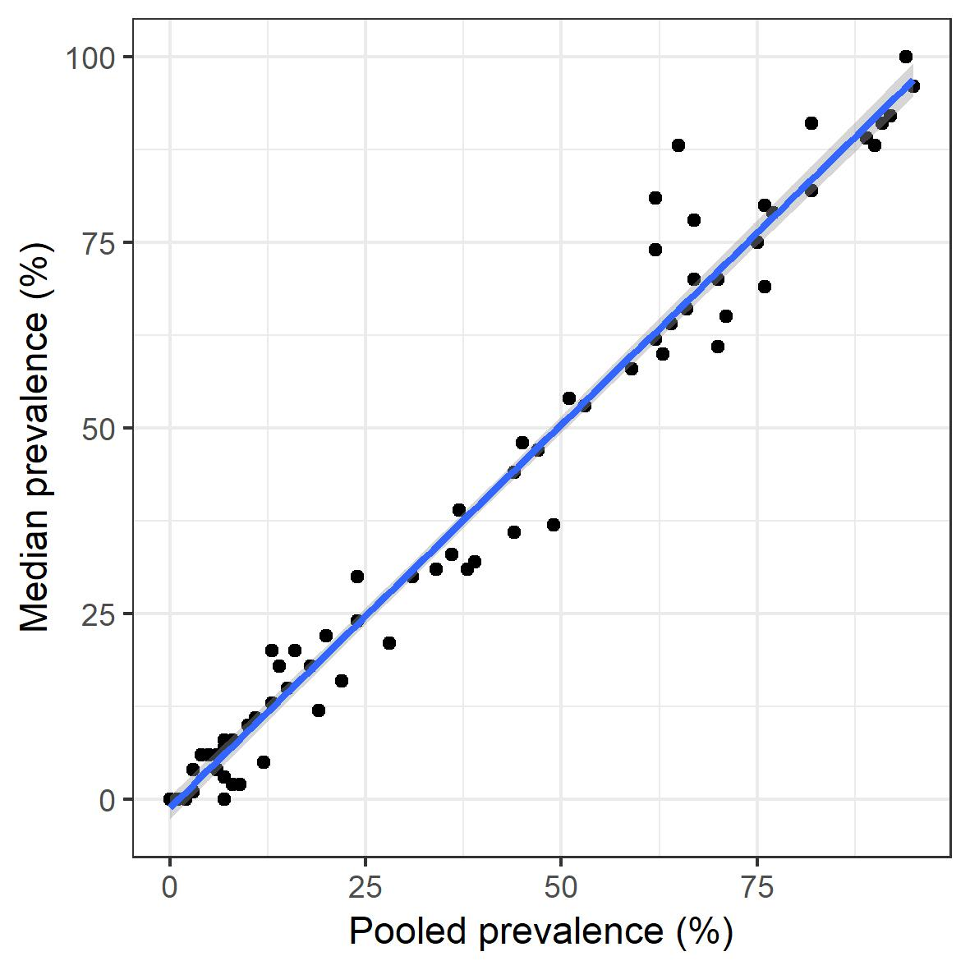

Figure S2a. Sensitivity analysis: Random effects metaanalysis results for studies on MDR S. Typhi in South Asia, comparing results for all studies (red) with only those reporting AST methods used (olive); (c) internal control strain reported (green), and those on over 50 isolates of S. Typhi (blue), resistance breakpoints clearly stated (pink), grouped by 5-year period.

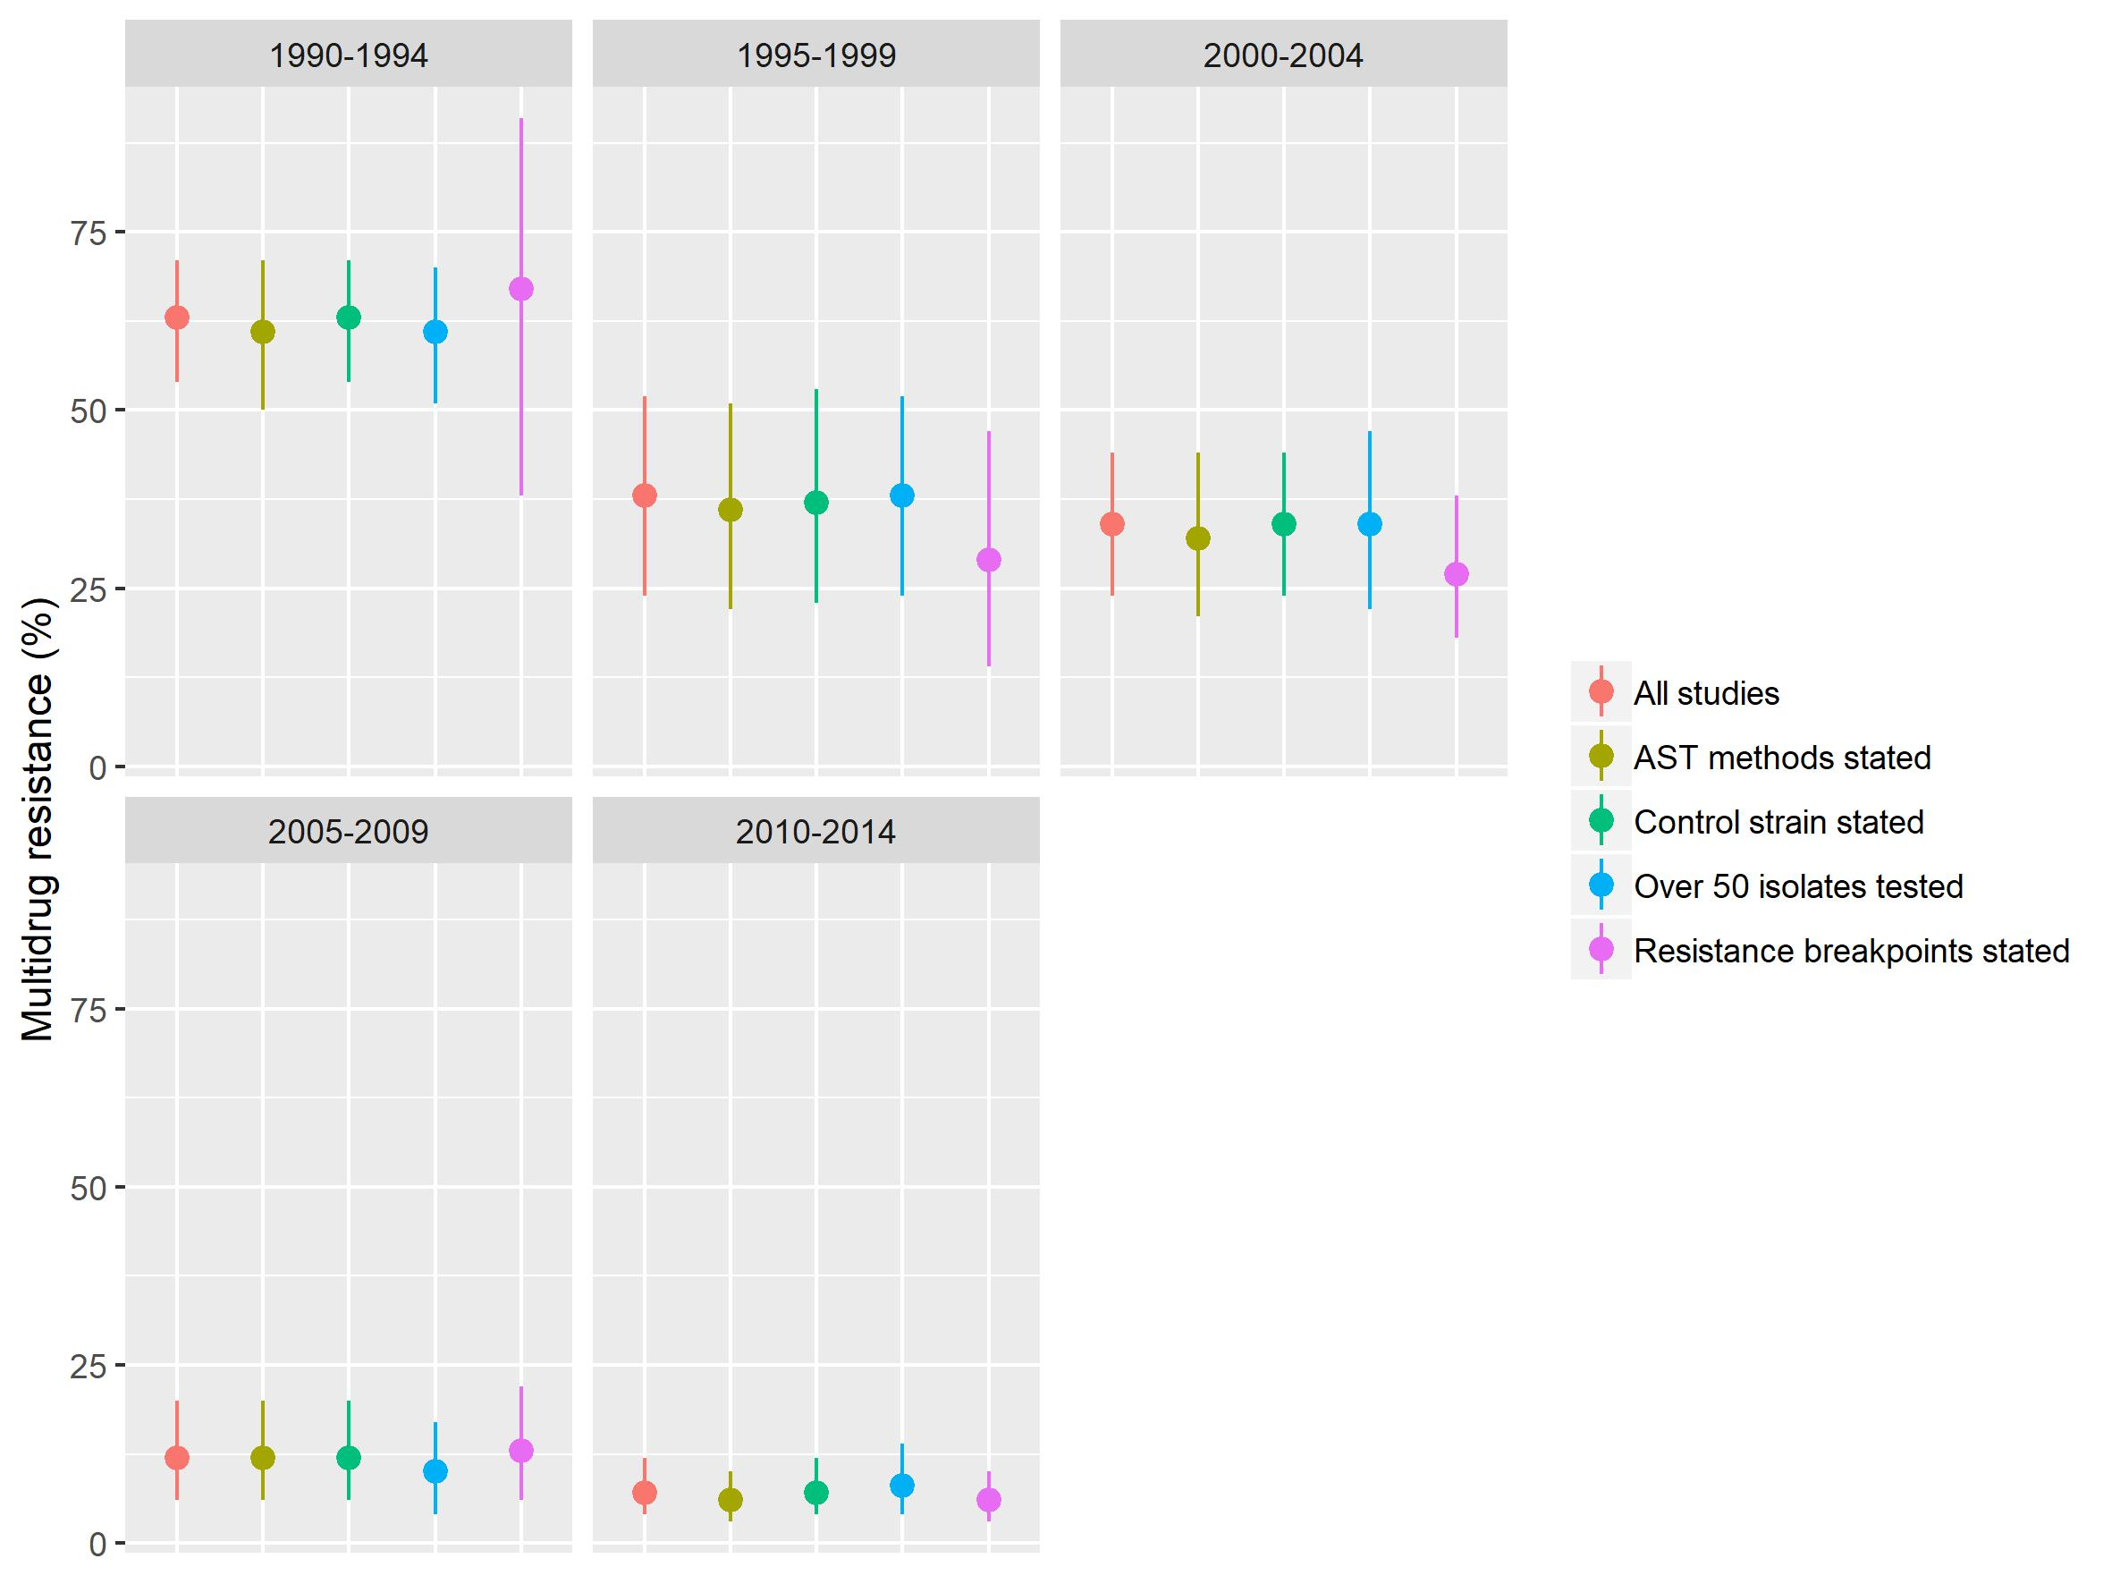

Figure S2b. Sensitivity analysis: Random effects metaanalysis results for studies on FQNS S. Typhi in South Asia, comparing results for all studies (red) with only those reporting AST methods used (olive); (c) internal control strain reported (green), and those on over 50 isolates of S. Typhi (blue), resistance breakpoints clearly stated (pink), grouped by 5-year period.

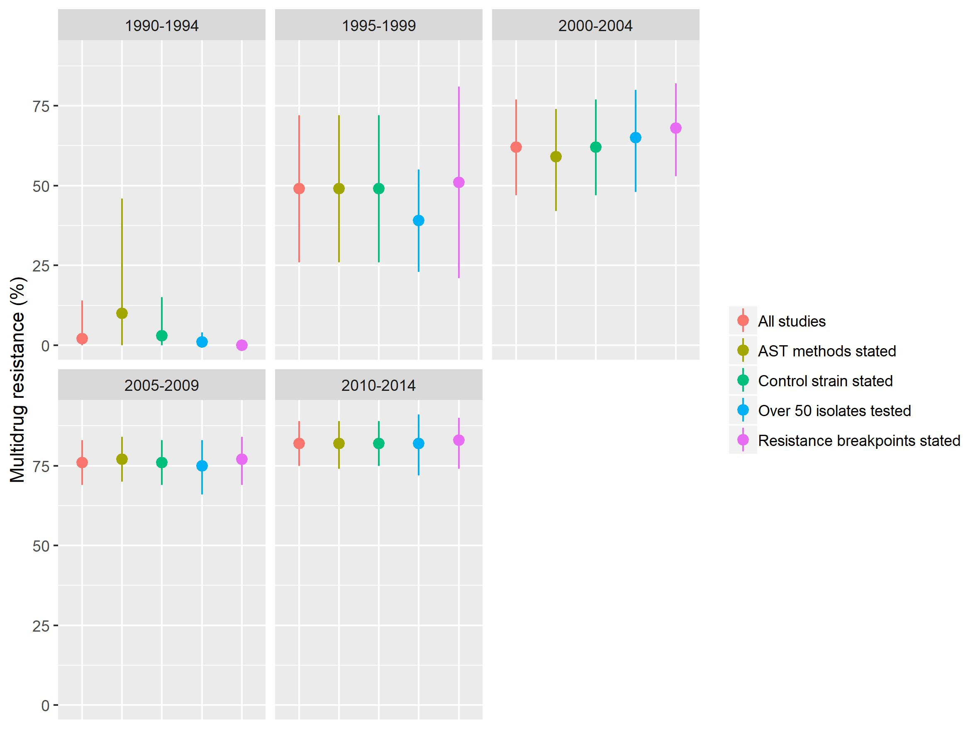

Figure S3. MDR S. Typhi in sub-Saharan Africa: Forest plots illustrating the prevalence of MDR amongst S. Typhi isolates in sub-Saharan Africa, grouped by five-year time-periods. Individual study results are displayed with 95% confidence intervals, the pooled prevalence [95%CI] for each subgroup is represented by the blue diamond: (a) Central sSA; (b) Eastern sSA; (c) Western sSA. Multidrug resistance is defined as concurrent resistance against ampicillin, chloramphenicol and co-trimoxazole. 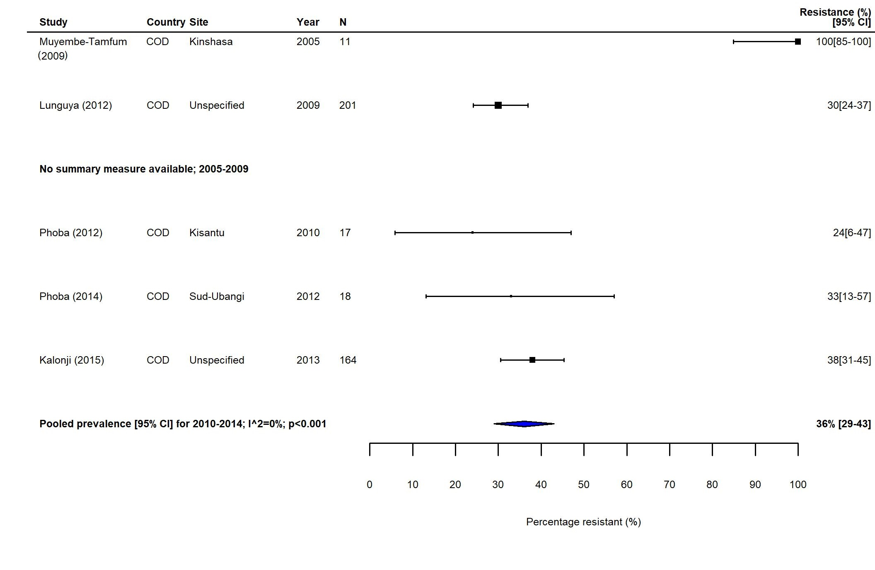
(a)
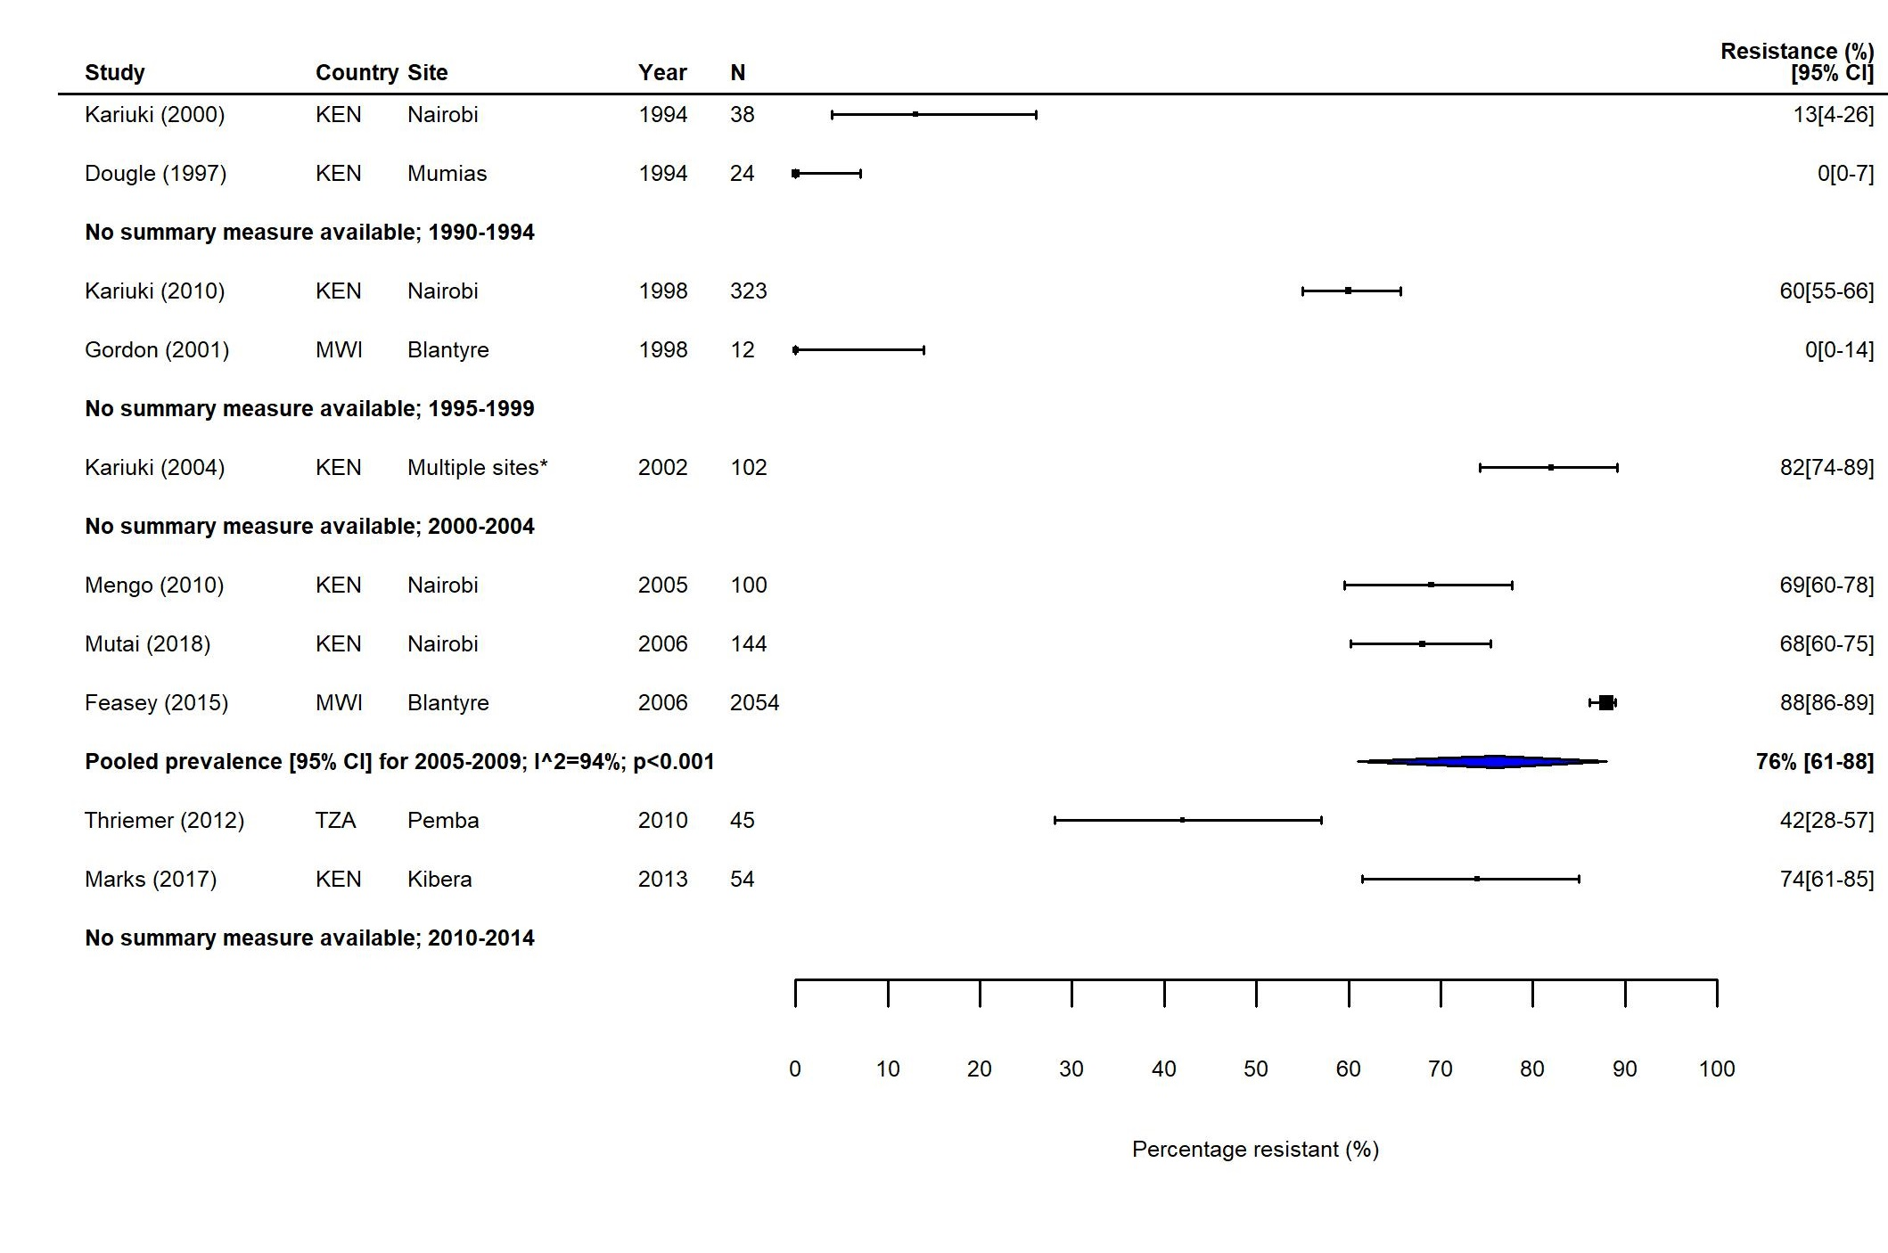
(b)

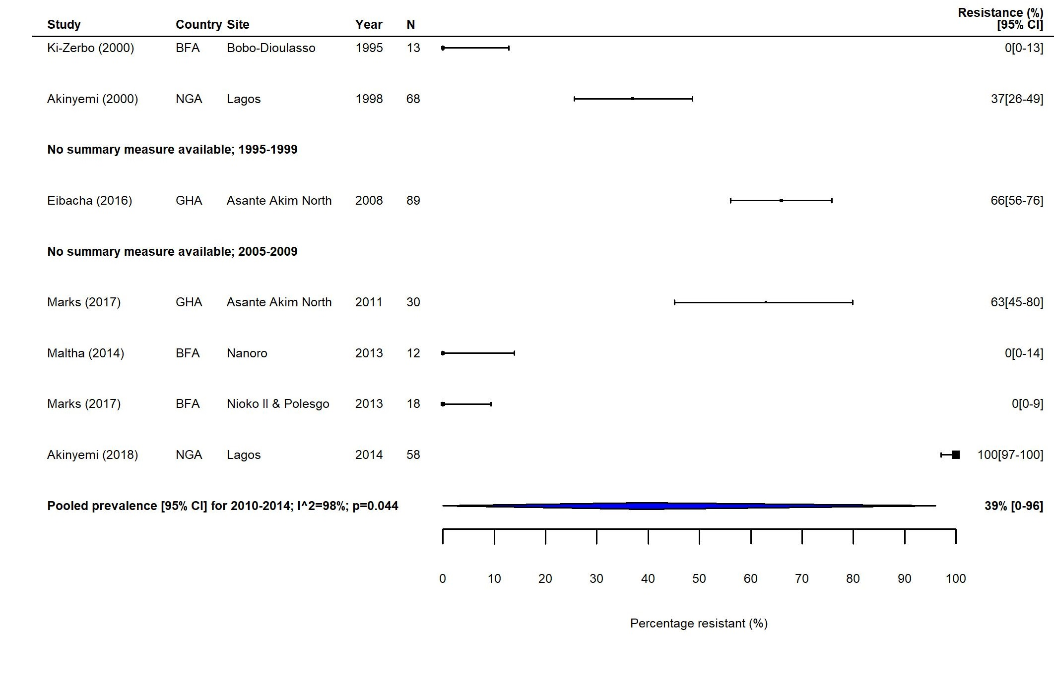

(c)
Figure S4. MDR S. Typhi in North Africa and the Middle East (NAME): Forest plots illustrating the prevalence of MDR amongst S. Typhi isolates in NAME, grouped by five-year time-periods. Individual study results are displayed with 95% confidence intervals, the pooled prevalence [95%CI] for each subgroup is represented by the blue diamond. Multidrug resistance is defined as concurrent resistance against ampicillin, chloramphenicol and co-trimoxazole.

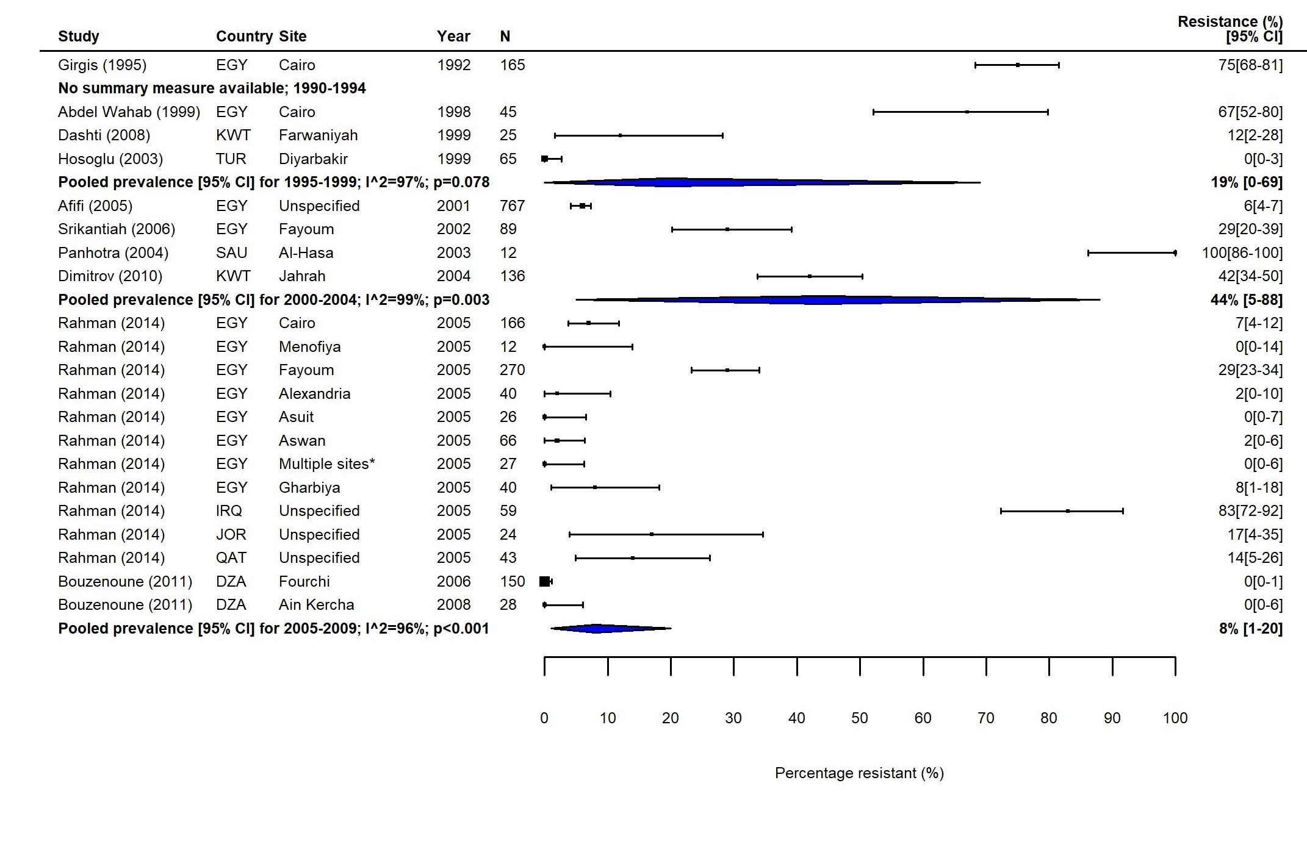

Figure S5. MDR S. Typhi in East Asia: Forest plots illustrating the prevalence of MDR amongst S. Typhi isolates in East Asia, grouped by five-year time-periods. Individual study results are displayed with 95% confidence intervals, the pooled prevalence [95%CI] for each subgroup is represented by the blue diamond. Multidrug resistance is defined as concurrent resistance against ampicillin, chloramphenicol and co-trimoxazole. 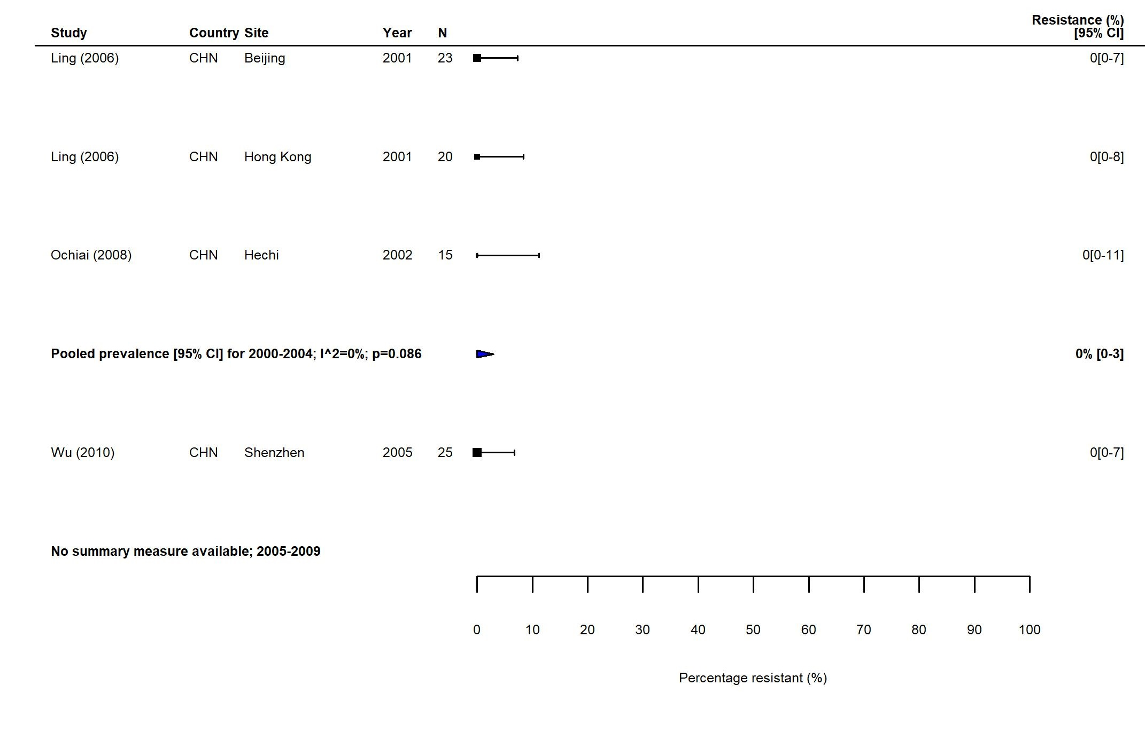

Figure S6. FQNS S. Typhi in sub-Saharan Africa: Forest plots illustrating the prevalence of FQNS amongst S. Typhi in sub-Saharan Africa, grouped by five-year time-periods. Individual study results are displayed with 95% confidence intervals, the pooled prevalence [95%CI] for each subgroup are represented by the blue diamonds: (a) Central sSA; (b) Eastern sSA; (c) Western sSA.
To allow the analysis of resistance trends over time despite typhoid-specific breakpoint changes for ciprofloxacin (CLSI, 2012) coming into effect during our study (1990-2018), we categorised intermediate (ciprofloxacin MIC 0.12–0.5 μg/ml) and resistant isolates (≥ 1 μg/ml) according to the updated breakpoints, as well as isolates with 'decreased ciprofloxacin (or fluoroquinolone) susceptibility' (ciprofloxacin MIC 0.125–1.0 μg/ml) and nalidixic acid resistant isolates (as proxy marker for 'decreased ciprofloxacin (or fluoroquinolone) susceptibility') as fluoroquinolone non-susceptible (FQNS).
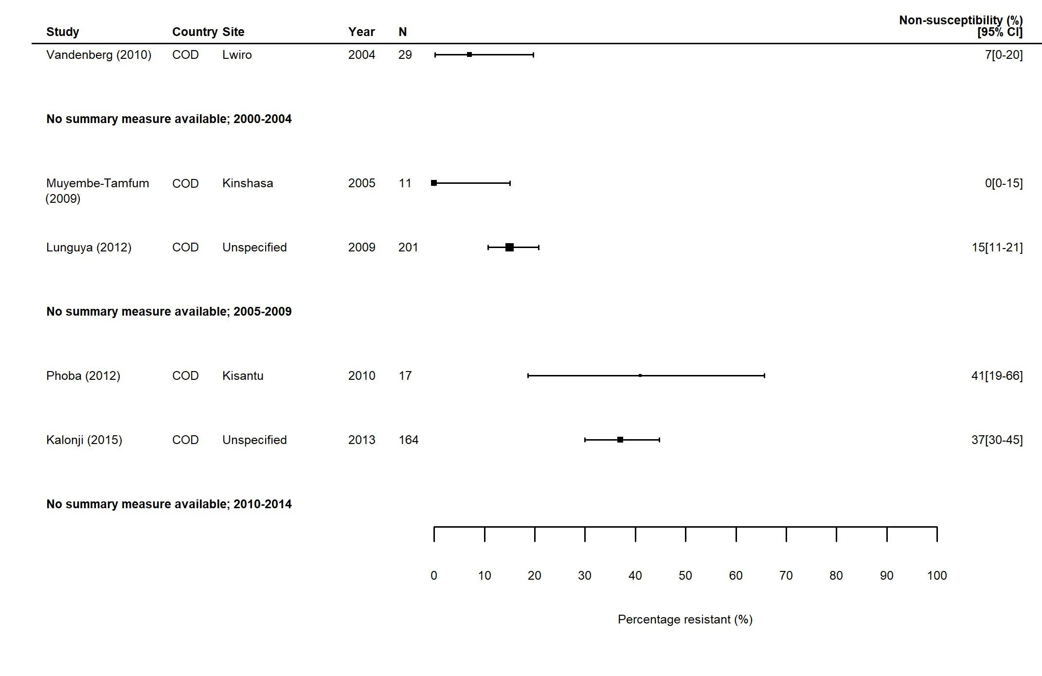
(a)

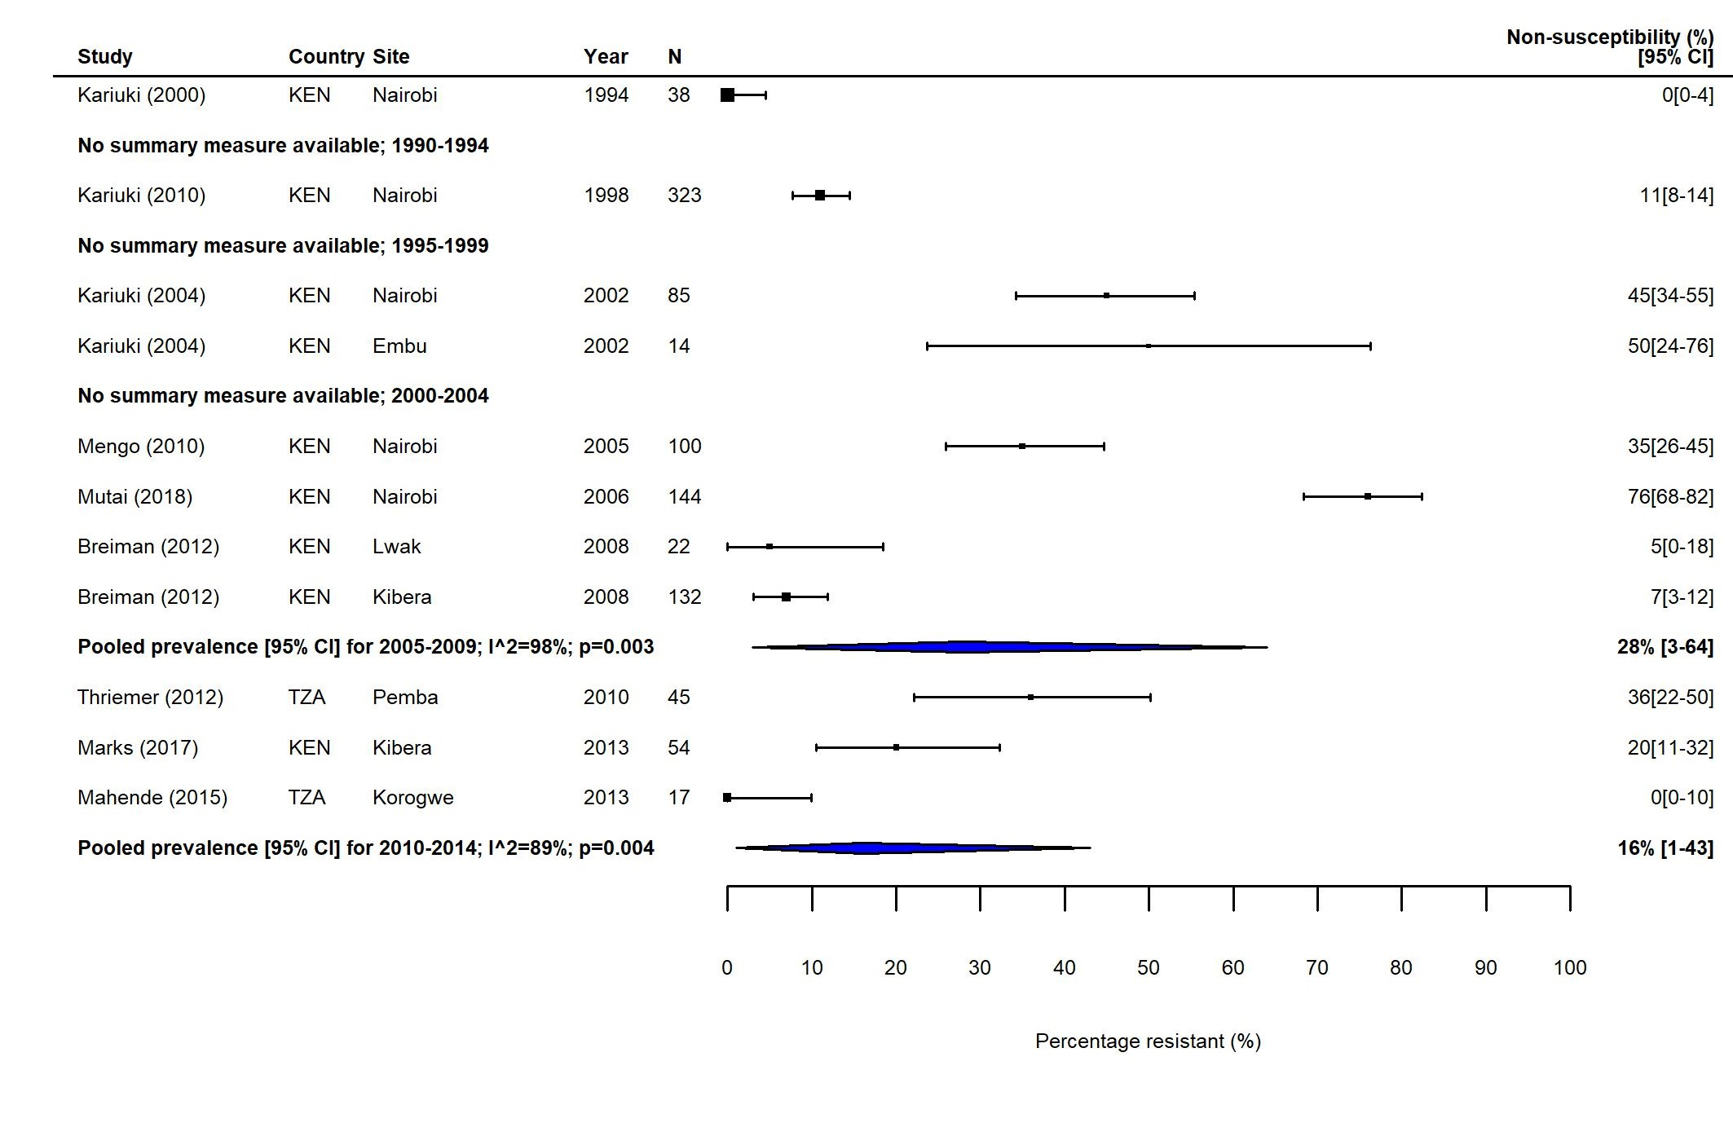
(b)
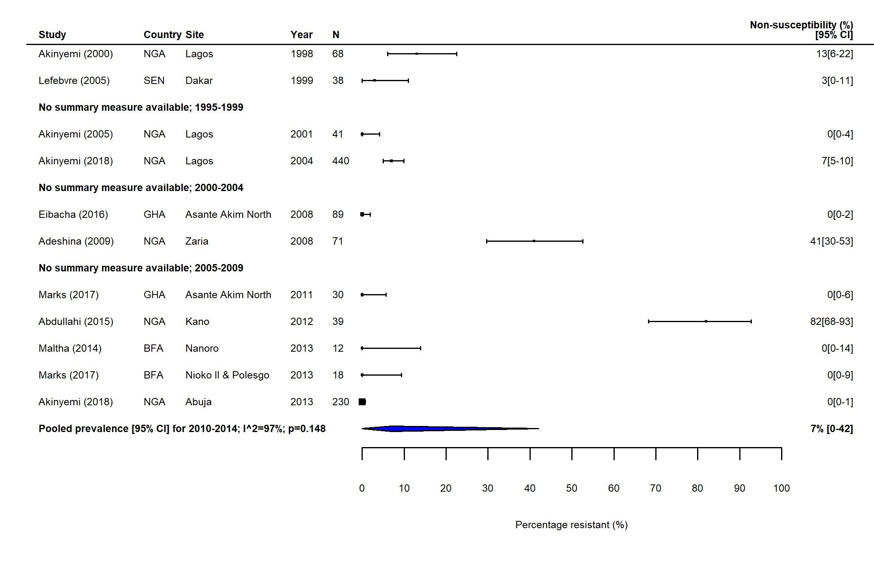
(c)

Figure S7. FQNS S. Typhi in North Africa and the Middle East (NAME): Forest plots illustrating the prevalence of FQNS amongst S. Typhi in NAME, grouped by five-year time-periods. Individual study results are displayed with 95% confidence intervals, the pooled prevalence [95%CI] for each subgroup are represented by the blue diamonds.
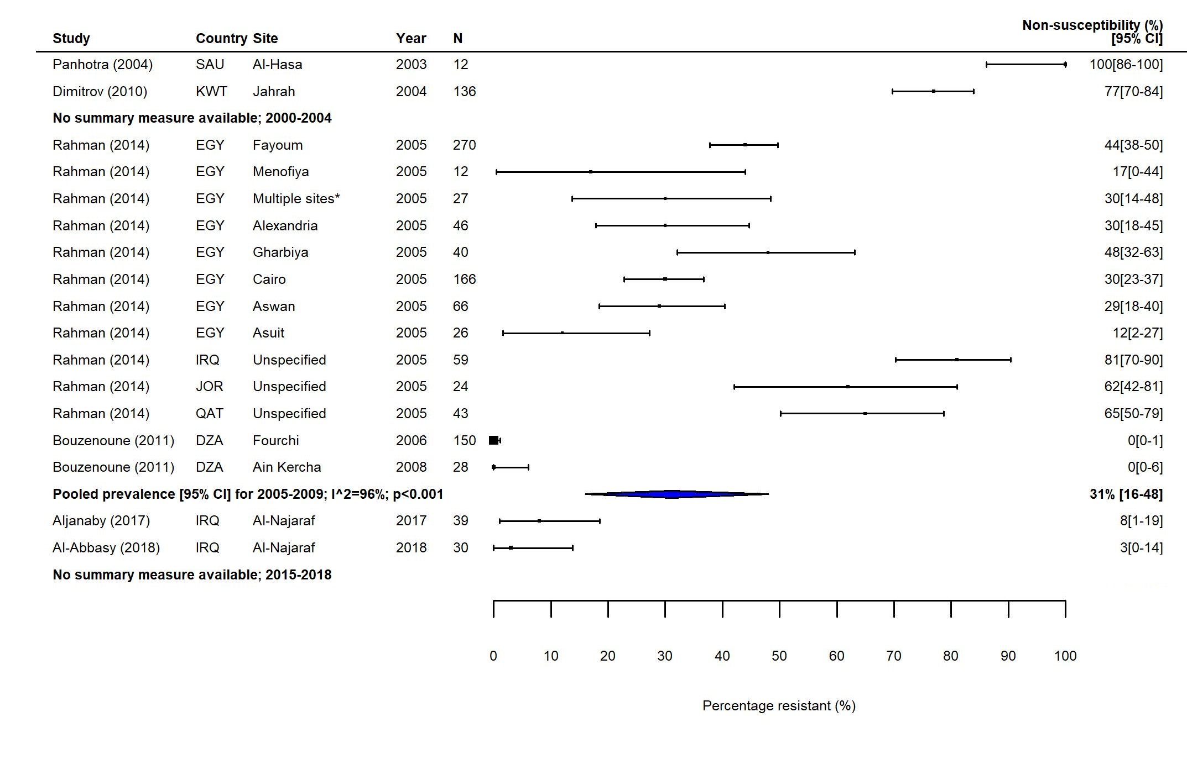

Figure S8. FQNS S. Typhi in East Asia: Forest plots illustrating the prevalence of FQNS amongst S. Typhi in East Asia, grouped by five-year time-periods. Individual study results are displayed with 95% confidence intervals, the pooled prevalence [95%CI] for each subgroup are represented by the blue diamonds.
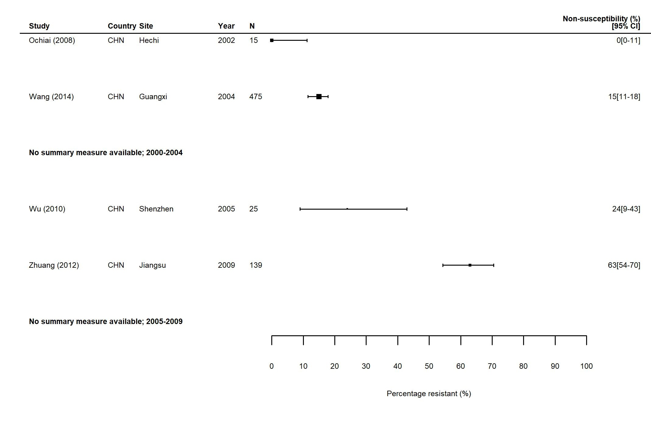

Figure S9. MDR S. Paratyphi in South Asia: Forest plots illustrating the prevalence of MDR amongst S. Paratyphi isolates in South Asia, grouped by five-year time-periods. Individual study results are displayed with 95% confidence intervals, the pooled prevalence [95%CI] for each subgroup is represented by the blue diamond: (a) 1990-1999; (b) 2000-2009; (c) 2010-2018. Multidrug resistance is defined as concurrent resistance against ampicillin, chloramphenicol and co-trimoxazole. 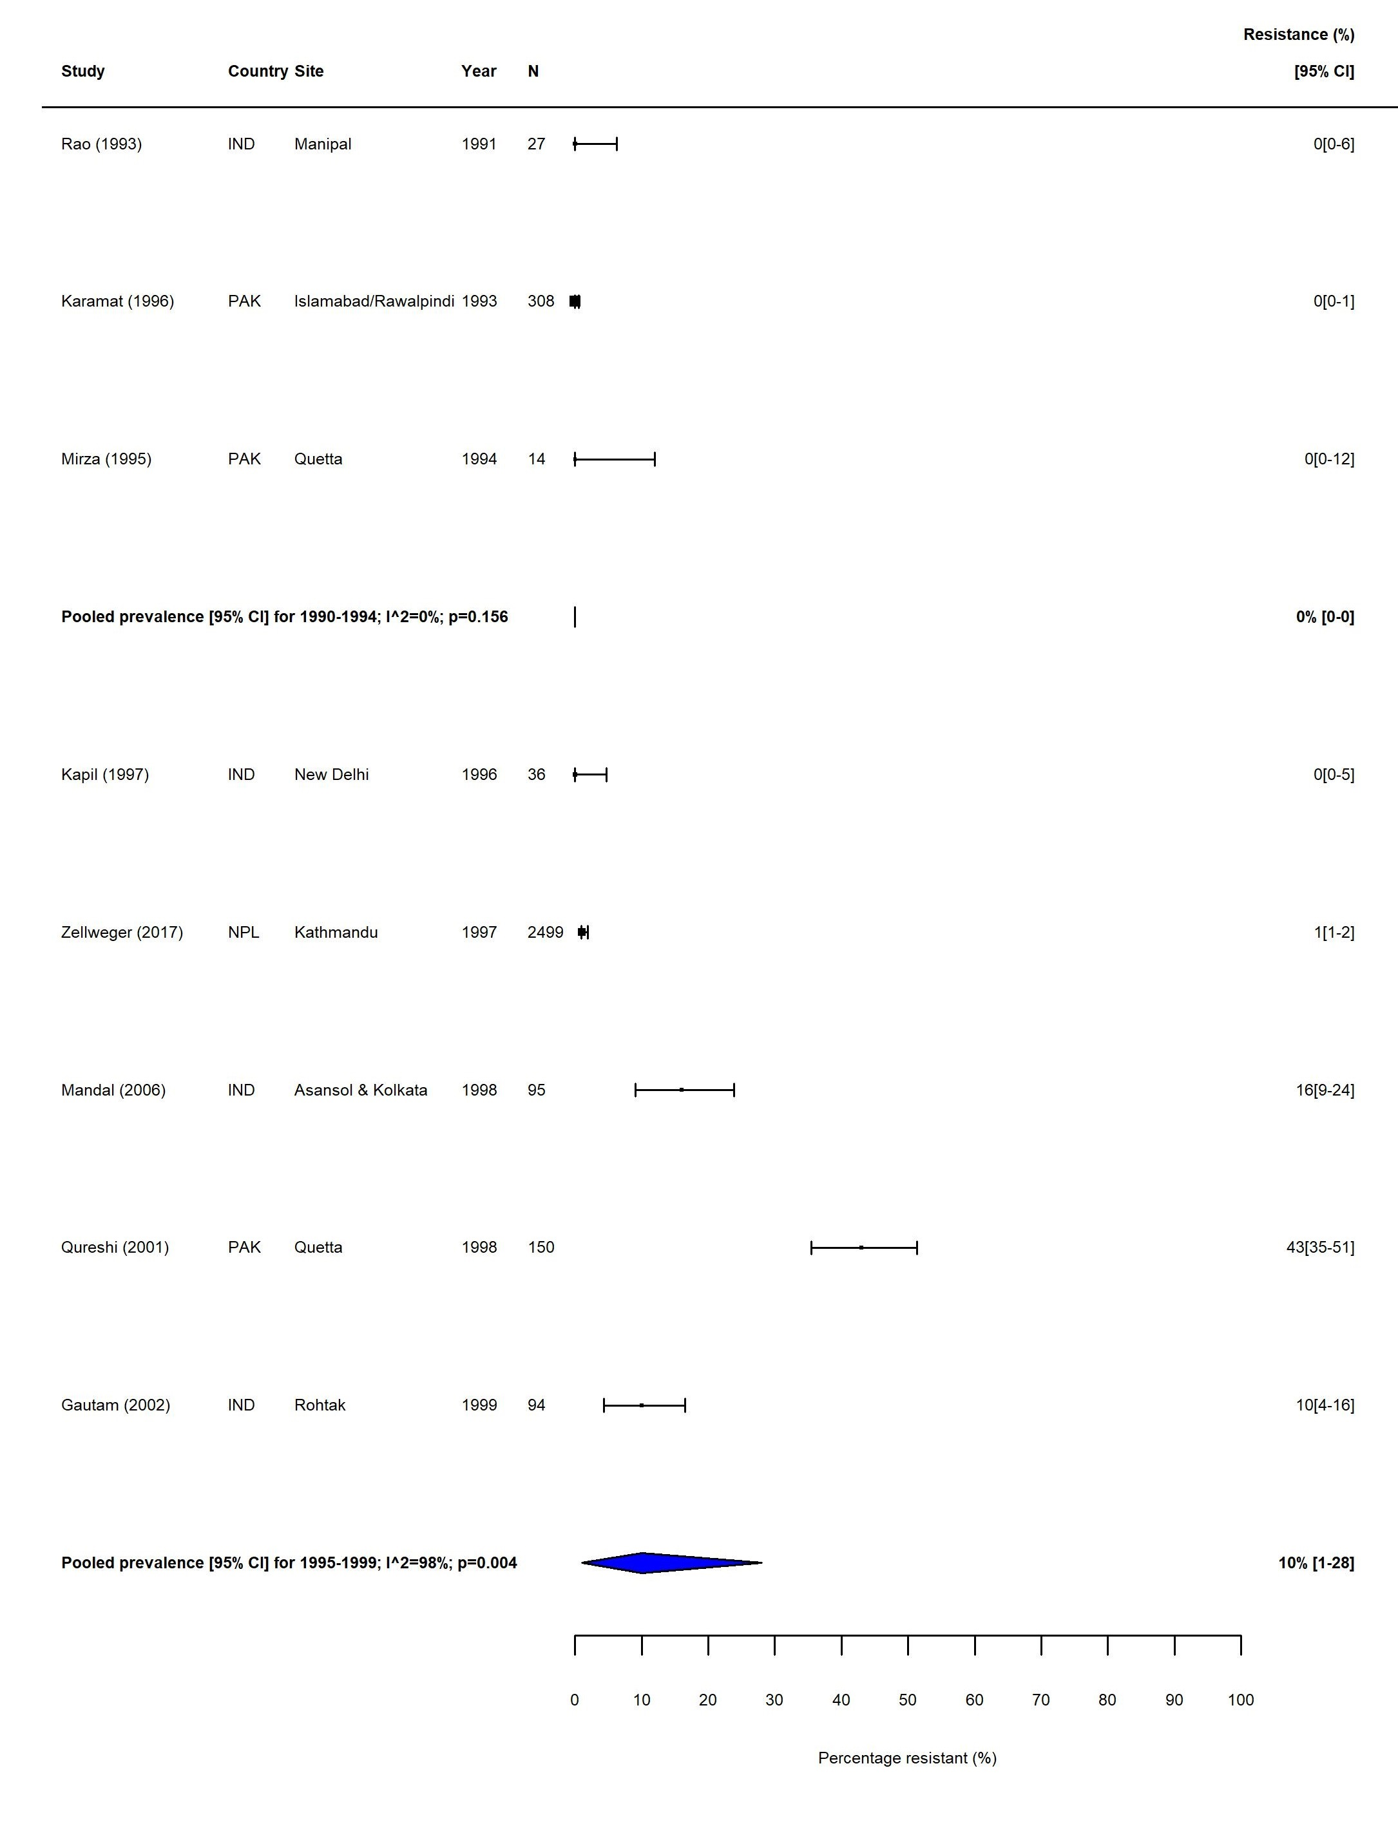 (a) 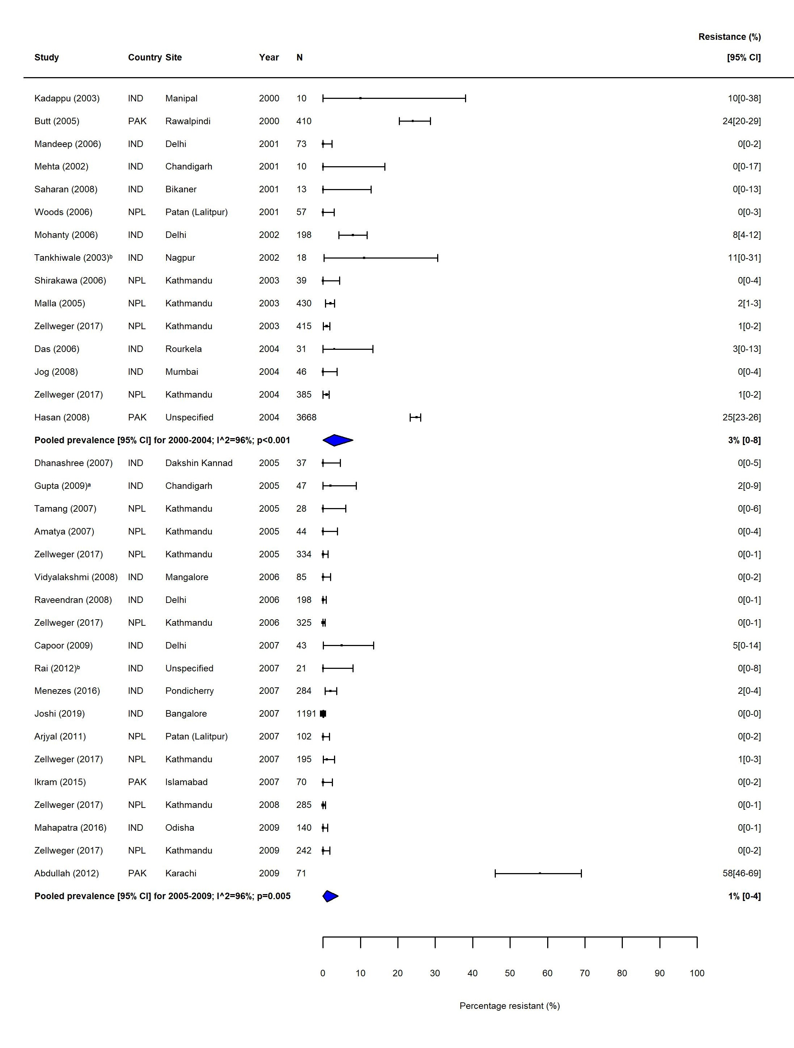
(b)

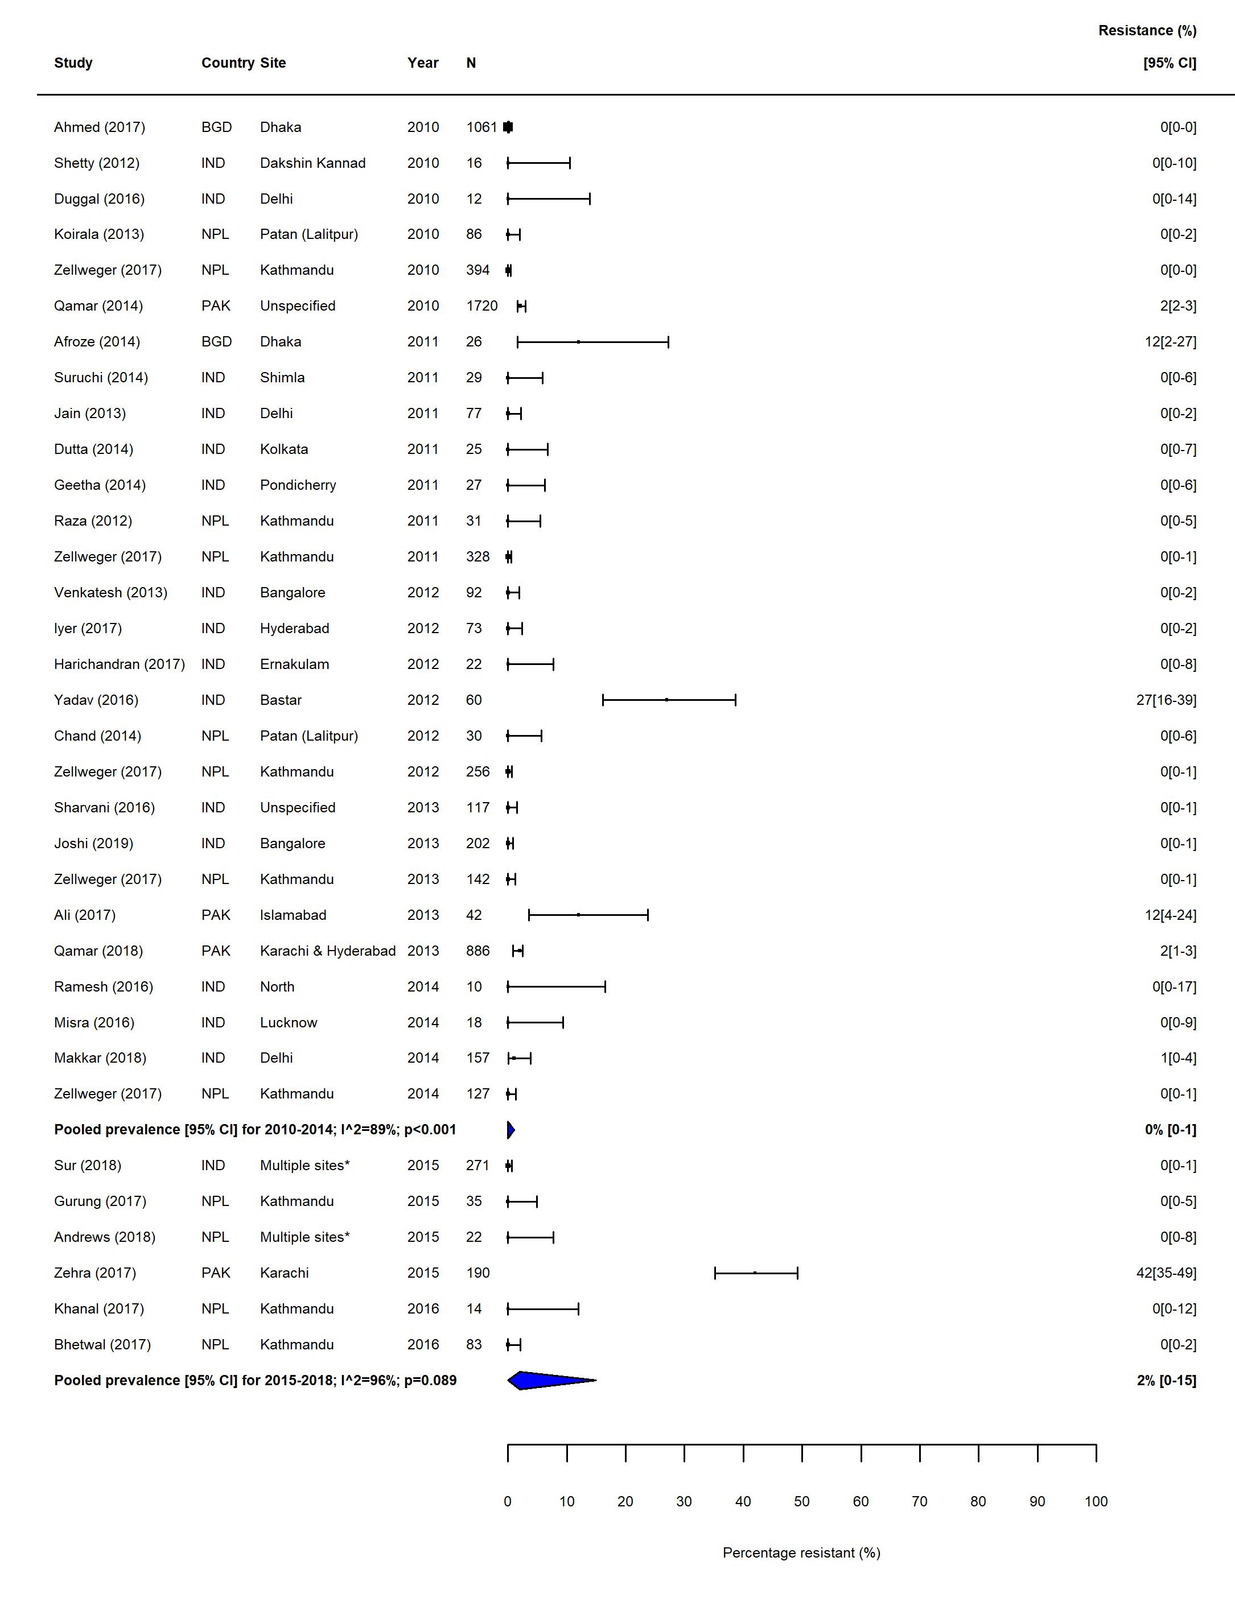

(c)

Figure S10. MDR S. Paratyphi in Southeast Asia: Forest plots illustrating the prevalence of MDR amongst S. Paratyphi isolates in Southeast Asia, grouped by five-year time-periods. Individual study results are displayed with 95% confidence intervals, the pooled prevalence [95%CI] for each subgroup is represented by the blue diamond. Multidrug resistance is defined as concurrent resistance against ampicillin, chloramphenicol and co-trimoxazole.

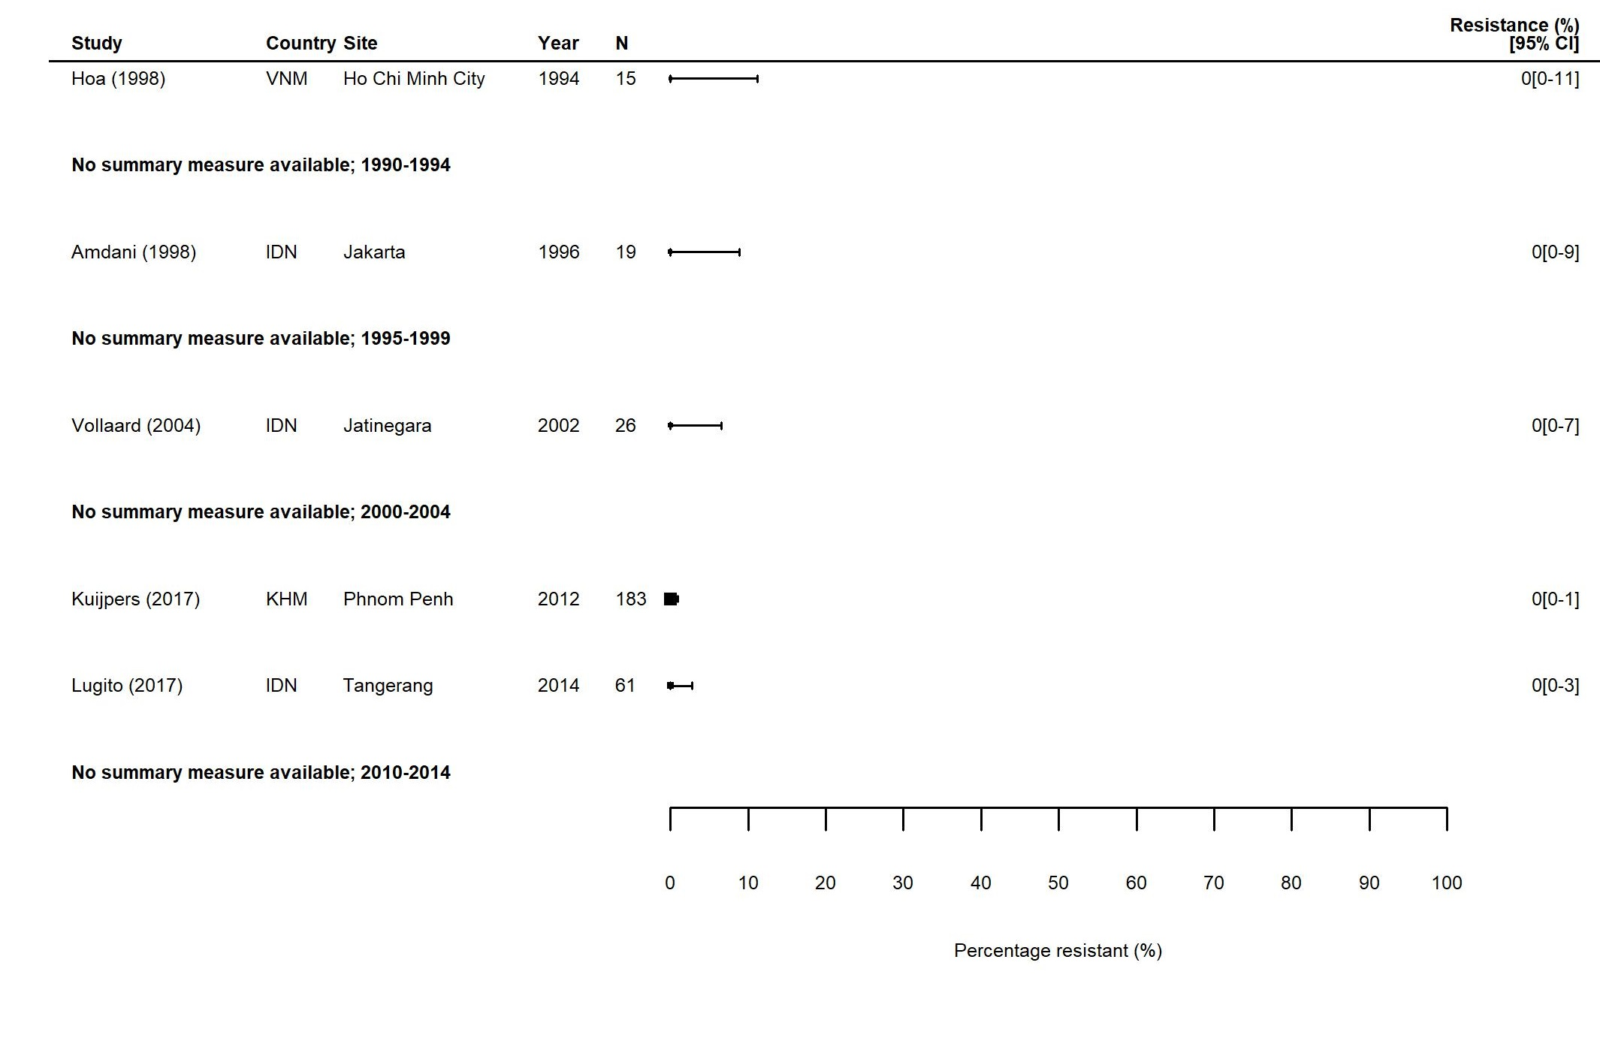

Figure S11. MDR S. Paratyphi in East Asia: Forest plots illustrating the prevalence of MDR amongst S. Paratyphi isolates in East Asia, grouped by five-year time-periods. Individual study results are displayed with 95% confidence intervals, the pooled prevalence [95%CI] for each subgroup is represented by the blue diamond. Multidrug resistance is defined as concurrent resistance against ampicillin, chloramphenicol and co-trimoxazole.

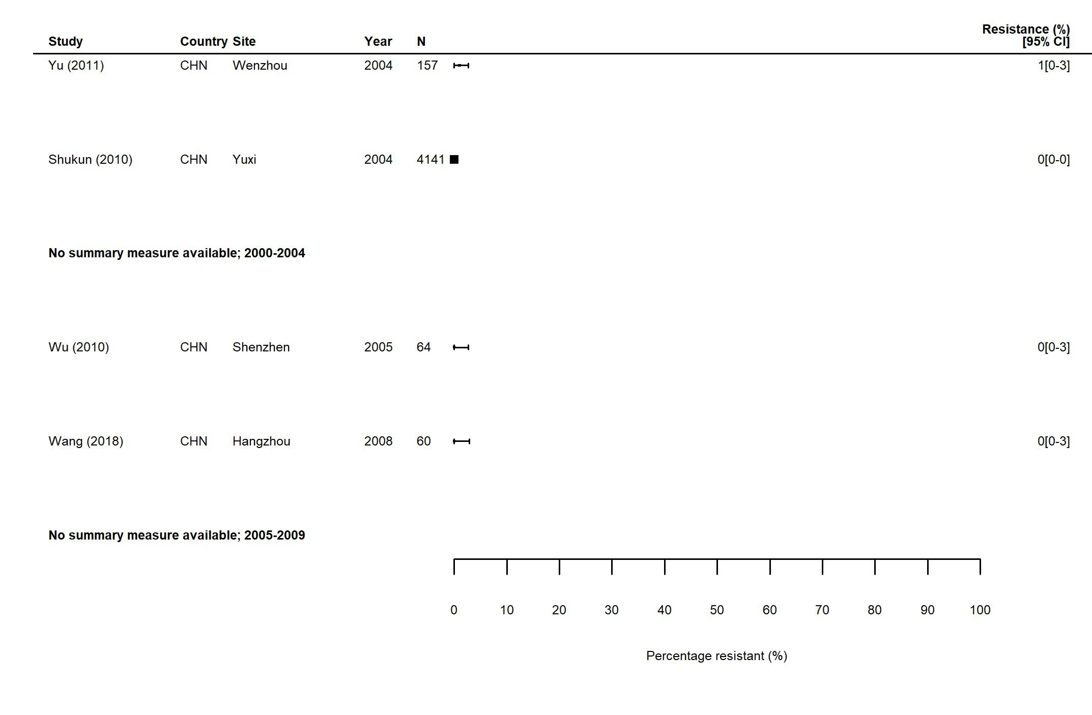

Figure S12. FQNS S. Paratyphi in South Asia: Forest plots illustrating the prevalence of FQNS amongst S. Paratyphi in South Asia, grouped by five-year time-periods. Individual study results are displayed with 95% confidence intervals, the pooled prevalence [95%CI] for each subgroup are represented by the blue diamonds.: (a) 1990-2009; (b) 2010-2018.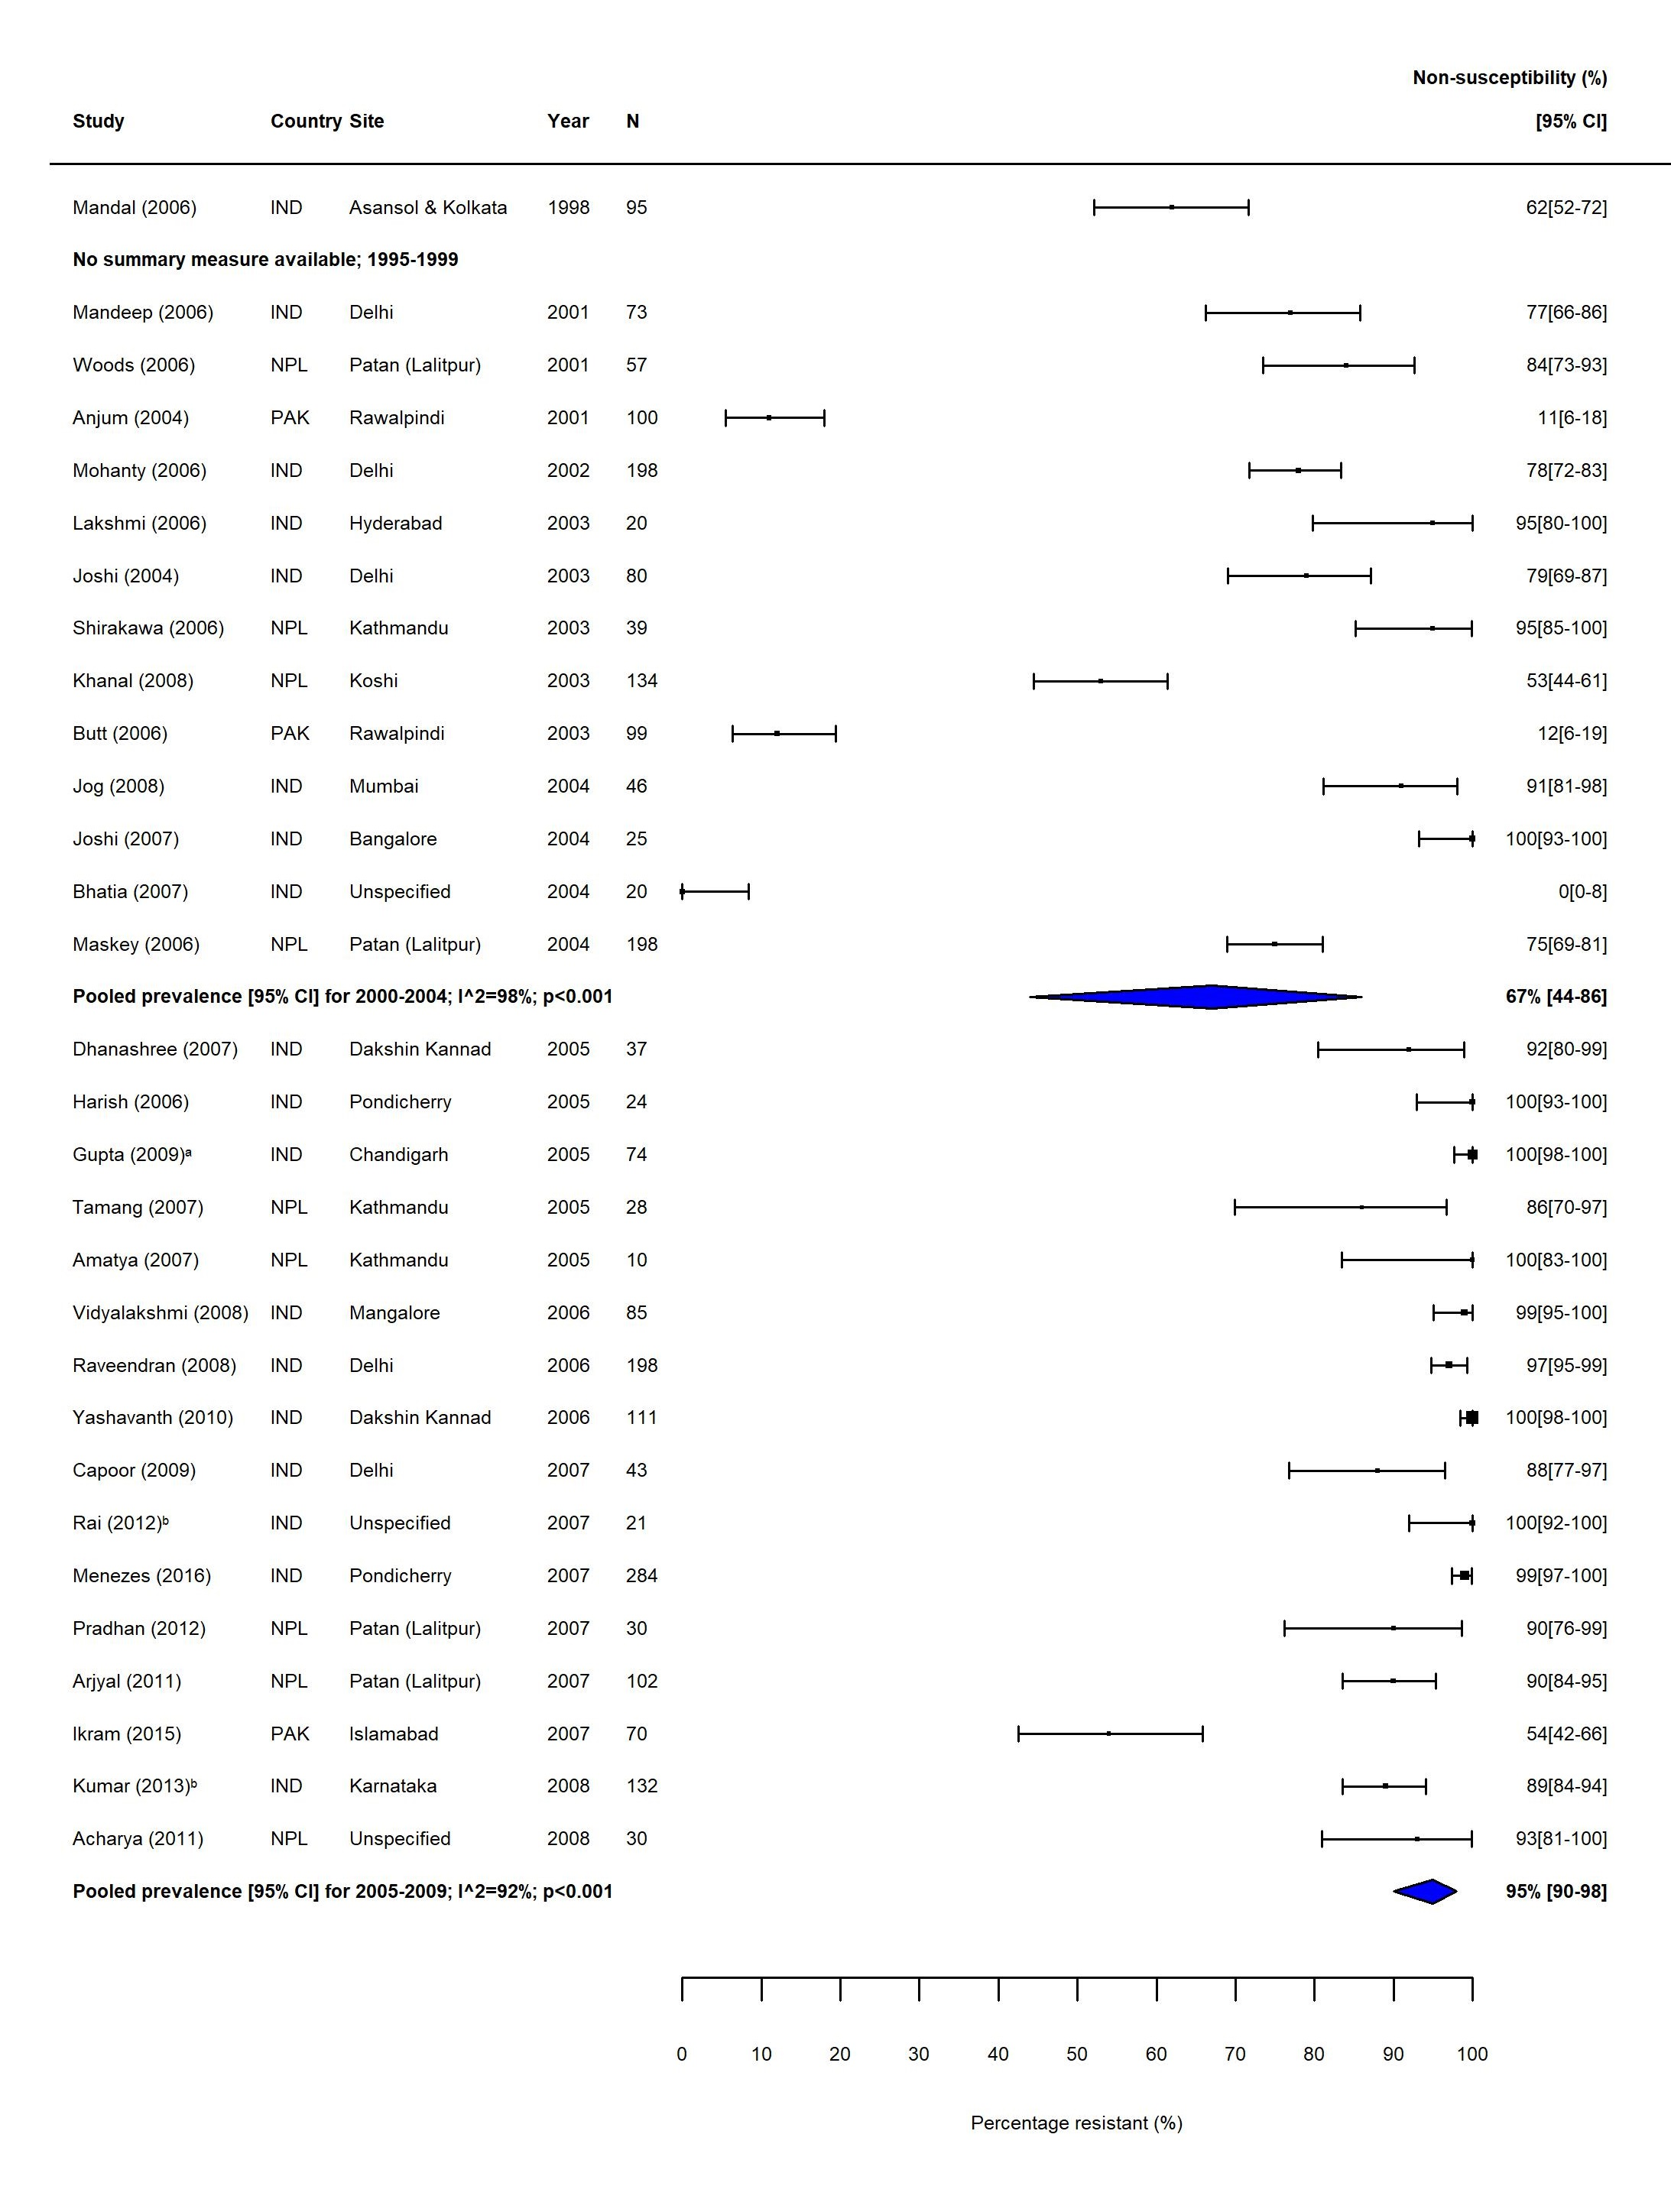
(a)
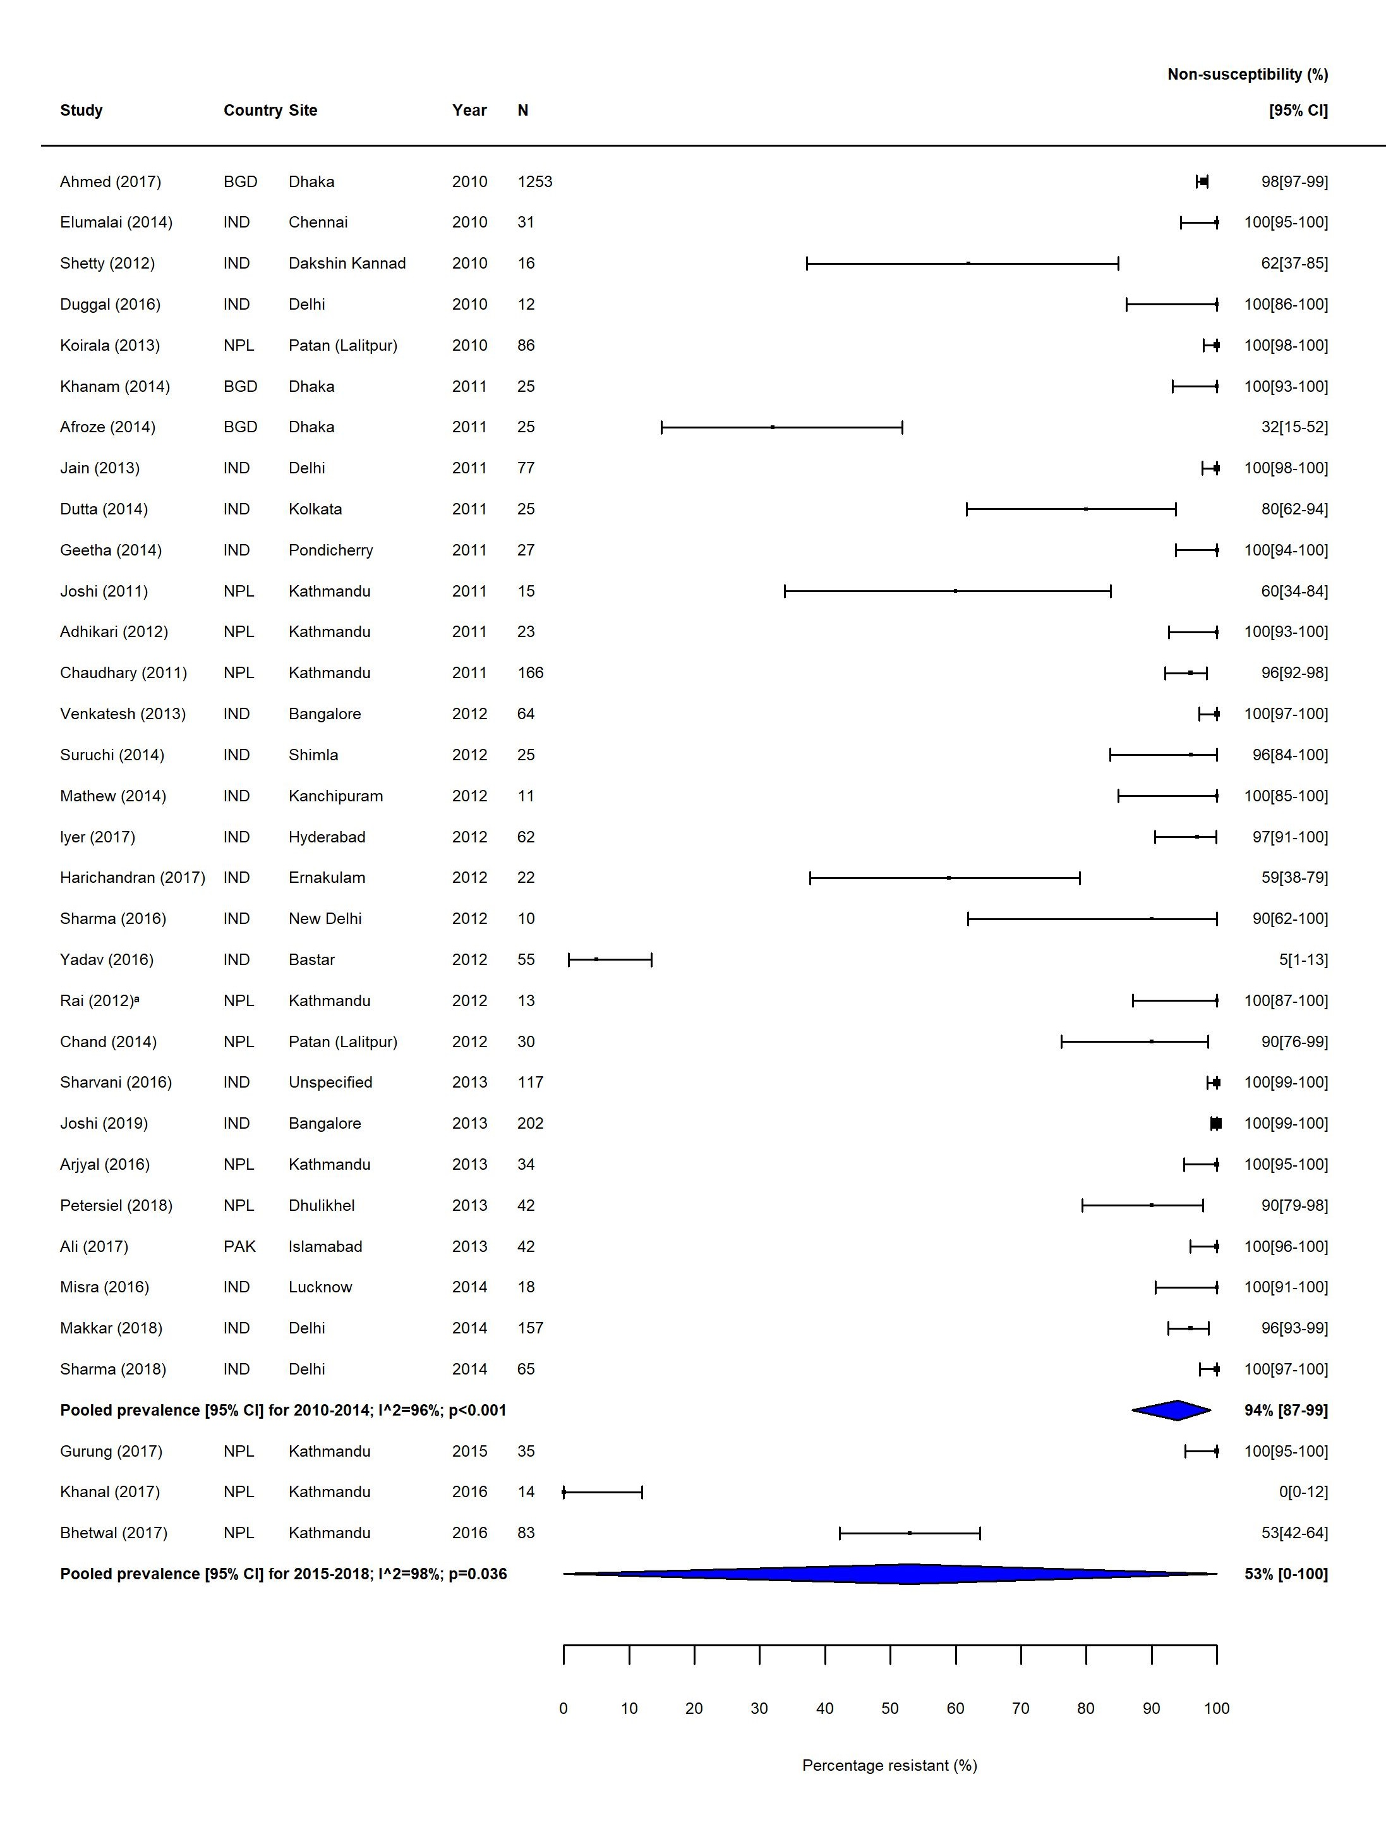
(b)

Figure S13. FQNS S. Paratyphi in Southeast Asia: Forest plots illustrating the prevalence of FQNS amongst S. Paratyphi in Southeast Asia, grouped by five-year time-periods. Individual study results are displayed with 95% confidence intervals, the pooled prevalence [95%CI] for each subgroup are represented by the blue diamonds.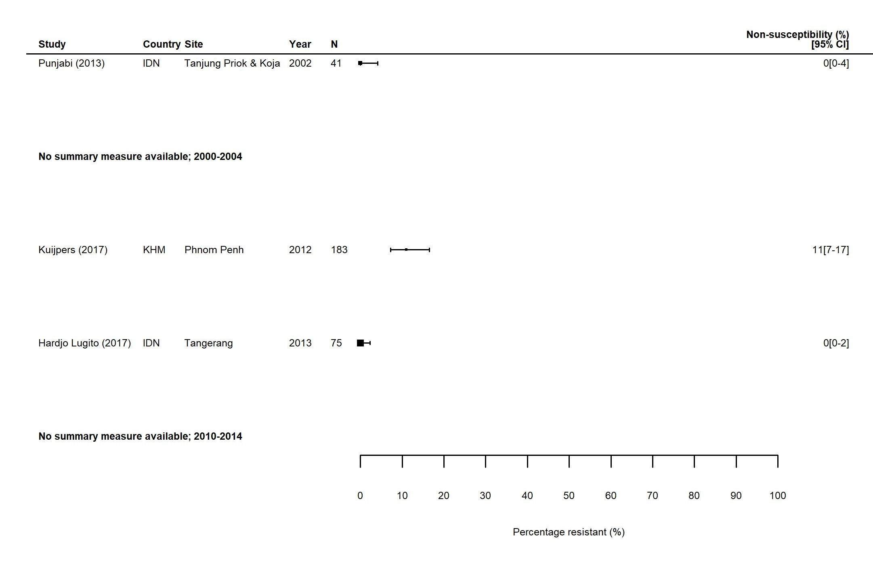

Figure S14. FQNS S. Paratyphi in East Asia: Forest plots illustrating the prevalence of FQNS amongst S. Paratyphi in East Asia, grouped by five-year time-periods. Individual study results are displayed with 95% confidence intervals, the pooled prevalence [95%CI] for each subgroup are represented by the blue diamonds. 