Healing of disrupted perineal wounds after vaginal delivery: A poorly understood condition
- Nicola Adanna Okeahialam, MBChB
Urogynaecology Clinical Research Fellow
Croydon University Hospital
nicola.okeahialam@nhs.net

- Ranee Thakar, MD, FRCOG
Consultant Obstetrician and Urogynaecologist
Croydon University Hospital
Honorary Senior Lecturer, St George’s University of London
ranee.thakar@nhs.net

- Abdul H Sultan, MD, FRCOG
Consultant Obstetrician and Urogynaecologist
Croydon University Hospital
Honorary Reader, St. George’s University of London
abdulsultan@nhs.net

Corresponding Author:
Mr Abdul H Sultan, MD, FRCOG
Consultant Obstetrician and Urogynaecologist
Croydon University Hospital
530 London Rd, Thornton Heath CR7 7YE
02084014395
abdulsultan@nhs.net
Abstract:
Perineal injury following childbirth can result in complications such as wound infection and dehiscence. The reported incidence of these complications in the literature range between 0.1- 23.6% and 0.2% -24.6% respectively. However, the healing of disrupted perineal wounds is poorly understood. In addition, despite the incidence of perineal wound complications, with respect to maternity services, inadequate priority is given to the postpartum management of perineal morbidity (Bick 2009). In this review, we explore the normal process of wound healing in the context of infected perineal wounds following childbirth. In addition, we describe the management of complications including hypergranulation, perineal pain, dyspareunia and obstetric fistula.

Keywords:
Perineal trauma, Wound healing, Wound infection, Wound dehiscence, Perineal hygiene

Key Points:
- Perineal wound infection and dehiscence can affect up to a quarter of women following vaginal delivery
- The perineum is susceptible to wound healing complications as it is an area of high moisture, high surface temperature and in close proximity to the complex microflora of the genitourinary and gastrointestinal tract.
- Perineal wound infection can occur in the absence of wound infection due to factors such as surgical repair technique, mechanical stress as a result of external trauma, local oedema (a normal result of the inflammatory phase of wound healing) or bleeding/haematoma
- Complications as a result of disrupted perineal wound healing including excessive granulation or scar tissue formation can be managed in the outpatient setting

Reflective questions:
- Can you name potential complications women may face with the healing of their perineal wound?
- How can you use this new knowledge to support women with perineal wound healing concerns?
- How can we better inform women on perineal care and potential problems they may face with regards to the healing of their perineal wound?

Main Text
Introduction:
A wound may be defined as any disruption of tissue integrity; including the skin, mucous membranes or organs (Kujath and Michelsen 2008). This also includes clean surgical wounds closed with sutures (Li et al. 2007). In the context of perineal wounds following childbirth, approximately 63% are spontaneous and 17% are iatrogenic following an episiotomy. However, 20% of women will not sustain any perineal trauma (Smith et al. 2013). Overall, 69% of perineal wounds will require suturing (Royal College of Obstetricians and Gynaecologists (RCOG) 2004). The healing of perineal wounds following childbirth can be disrupted from complications such as wound infection and dehiscence. The reported incidence of these complications in the literature range between 0.1- 23.6% and 0.2% -24.6% respectively (Jones et al. 2019). Despite the incidence of perineal wound healing complications, disrupted perineal wound healing is poorly understood. Also, with respect to maternity services, inadequate priority is given to the postpartum management of perineal complications (Bick 2009). The aims of this review is to explore the process of normal wound healing and disrupted wound healing in the context of perineal wounds following childbirth. Additionally, the management of perineal complications will also be reviewed. Written consent was obtained for publication of the images included in this review as per the recruitment for the PERINEAL study (A Prospective observational study evaluating the sonographic appearance of the anal sphincter in women with wound infection following vaginal delivery: ClinicalTrials.gov Identifier: NCT04480684)

Pathophysiology of wound healing:
Wound healing can be categorised as either primary, secondary or tertiary (delayed primary closure) (Singh et al. 2017). Healing by primary intention occurs when wound edges are approximated by sutures and healing by secondary intention occurs when the wound edges are separated: this process of healing takes longer as wound contraction and filling of the tissue defect needs to occur. With tertiary healing, closure of the wound is delayed, for example, in cases of heavily contaminated wounds when wound irrigation and debridement is required to reduce the risk of subsequent wound infection and abscess formation.

Wounds are stimulated to heal in four overlapping, synchronised phases; this includes haemostasis, inflammation, proliferation (formation of granulation tissue) and remodelling (scar formation) (Figure 1) (Singer and Clark 1999; Li et al. 2007). The process of haemostasis starts immediately following tissue injury and lasts for several hours (Reinke and Sorg 2012). Vasoconstriction occurs to stem the blood loss from the injured blood vessels, platelets are then activated and aggregate to fill the wound with a fibrin clot (Robson et al. 2001; Li et al. 2007; Reinke and Sorg 2012). Once the bleeding has stopped, blood vessels dilate, facilitating the entry of blood, fluid and inflammatory cells into the wound (Robson et al. 2001; Li et al. 2007). This increase in blood vessel permeability causes local erythema, heat and oedema of the wound (Reinke and Sorg 2012). These signs may also be seen in the presence of perineal wound infection (Webb et al. 2014).

The inflammation stage lasts for one to three days (Reinke and Sorg 2012) whereby, inflammatory cells such as neutrophils, monocytes and macrophages degrade necrotic tissue, debris and local bacteria (Robson et al. 2001; Reinke and Sorg 2012). In the proliferative phase (3-10 days in length), there is a shift from a fibrin filled wound surface to collagen based granulation tissue, accompanied by neovascularisation and angiogenesis (Robson et al. 2001; Reinke and Sorg 2012). As this tissue is highly vascular, it has a very red appearance, and if friable, may bleed on contact (Reinke and Sorg 2012).

The time taken to transition from the inflammatory to the proliferative phase is crucial in the normal process of wound healing (Landén et al. 2016). If this transition process is prolonged, for example due to infection, excess and persistent granulation tissue may form (Singer and Clark 1999; Kornhaber et al. 2016). Excess granulation tissue inhibits the movement of epithelial cells across the wound surface and consequently further delays wound healing (Kornhaber et al. 2016). Granulation tissue formation is a transitional step in the wound healing cascade, and therefore, when over production and maturation occurs, wound healing is prolonged and associated with a wide based scar (Robson et al. 2001).

The final phase of the wound healing cascade is remodelling and begins from day 21 following tissue injury and continues for up to 1 year (Reinke and Sorg 2012). The matured granulation tissue which has filled the wound undergoes remodelling and collagen maturation occurs (Robson et al. 2001; Reinke and Sorg 2012). Subsequently, neovascularisation and angiogenesis cease, and the mature wound becomes avascular and acellular leaving a scar (Gonzalez et al. 2016; Landén et al. 2016).

Wound infection pathophysiology:
The skin acts as a physical barrier against infection and regularly sheds its outermost layer: the epidermis, which aids in the removal of surface bacteria (Tortora et al. 2004). Therefore, in body areas where there is increased moisture and so less skin shedding, bacterial concentrations are higher (Tortora et al. 2004). Moreover, warm environments are also favourable for microbial proliferation (Bowler et al. 2001). An additional barrier to wound infection is the skin microflora. This microbial ecosystem is usually stable and consists of bacteria, viruses and fungi (Eyerich et al. 2018). These micro-organisms are protective against the overgrowth of potential pathogenic bacteria (Rashid et al. 2012). Therefore, wounds will contain bacteria and under normal conditions there is an intricate relationship between the defence ability of the skin and the number of micro-organisms that colonise the surface (Bowler 2002; Grice and Segre 2011).

With perineal wounds, organisms from the surrounding skin, endogenous mucosal surfaces (genitourinary tract, gastrointestinal tract) or the external environment can contaminate the wound and cause infection (Karsnitz 2013). Also, as the perineum is both an area of high moisture (from sweat, urine and faeces) and higher surface temperature, the protective barrier function of the overlying skin is weakened (Margesson 2004). All these factors increase the risk of infection and so prolonged wound healing.

Perineal wound infection:
The diagnosis of wound infection requires subjective review by healthcare professionals for associated signs and symptoms. Although, there is no agreed standardised definition of perineal wound infection following childbirth within the literature (Jones et al. 2019), signs and symptoms which may indicate infection include the presence of markers such as perineal pain, purulent discharge and wound dehiscence (Johnson et al. 2012). Microbiological analysis can also be used to help guide management (World Union of Wound Healing Societies (WUWHS). 2008). However, microorganisms can take between 2-5 days to grow on culture media (Bowler et al. 2001). Perineal wound infections are often polymicrobial due to the complex microflora of the surrounding genitourinary and gastrointestinal tract (Childs et al. 2020) and may include gram-negative bacilli, enterococci, group B streptococci and anaerobic bacteria (Lachiewicz et al. 2015) (Figure 2). However, any microbial swab taken, even in the absence of infection is likely to isolate a range of bacteria. Therefore, diagnosis of wound infection should be made clinically, and the culture and sensitivity of microbiological swabs should guide antibiotic choice (Healy and Freedman 2006). It is recommended that broad spectrum antibiotics are used as first-line (Webb et al. 2014). Table 1 highlights the pathogens most commonly identified in perineal wound infection from the literature.

Perineal wound dehiscence:
Wound dehiscence can be defined as complete or partial disruption of wound edges that were previously approximated (Wound International 2018). However, there is no standardised definition for perineal wound infection in literature (Jones et al. 2019). Although perineal wound dehiscence is often reported to occur concurrently with wound infection (Dudley et al. 2013) there are a number of other causes of wound dehiscence in the absence of infection. These include surgical technique, for example if sutures have been placed under too much tension and mechanical stress as a result of external trauma, local oedema (a normal result of the inflammatory phase of wound healing) or bleeding/haematoma and poor alignment of the wound edges. In addition, any factor which can potentially disrupt the wound healing phases such as smoking and chronic diseases such as diabetes and immunocompromised states can predispose to wound dehiscence (Wound International 2018).

Perineal wounds that have dehisced can either be managed conservatively (healing by secondary intention with antibiotic cover) or surgically. With wounds that are managed conservatively, healing occurs through growth of new tissue from the base of the wound to fill the space between the unopposed wound edges (Norman et al. 2016). Currently there is no agreed best practice recommendation for the management of perineal wound dehiscence due to a lack of robust evidence comparing conservative management and re-suturing (Figure 5) (Dudley L.M. et al. 2013). This means that in the United Kingdom (UK), healing by secondary intention is often advised. However, this can be a protracted process, during which regular patient review of wound healing progress is required (Figure 3). Figure 4 graphically depicts the wound healing trajectory of a dehisced perineal wound. The graphs show how the rate of wound depth/volume healing tends to be much faster than wound contraction which correlated with the rate of wound area/perimeter healing. In comparison to wound area, a decrease in the volume of a wound is a more important indicator of appropriate wound healing, as it corresponds with the rate of wound re-epithelialisation. Furthermore, during wound healing, the area can increase slightly in the initial phases (Sangwine et al. 1998). It has been argued that with re-suturing there is the additional risk of further wound infection and dehiscence (Webb et al. 2014).

Complications of disrupted perineal wound healing:
Excessive granulation tissue:
Granulation tissue forms during the proliferative wound stage to fill the wound defect from the base upwards. When the proliferative stage of wound healing is prolonged, hypergranulation can occur (Singer and Clark 1999; Kornhaber et al. 2016). Hypergranulation can be defined as excess granulation tissue which overfills the wound bed beyond normal surface height resulting in a raised mass of tissue (Vuolo 2010) (Figure 6A). Causes of hypergranulation include excessive moisture, prolonged periods of inflammation secondary to infection or irritation from foreign bodies (for example wound dressings) and wound dehiscence leading to healing by secondary intention (Vuolo 2010; Kornhaber et al. 2016). Therefore, in perineal wounds with disrupted healing, hypergranulation can occur due to infection/dehiscence, the high moisture levels of the perineum and potential irritation from maternity pads. As granulation tissue is highly vascular, women may also report bleeding and excessive discharge.

Hypergranulation can be managed in the outpatient setting with cautery using silver nitrate (Figure 6B & C) (Wan et al. 2020). However, there are no studies investigating the effectiveness of topical silver nitrate for the management of over-granulated perineal wounds following childbirth. Although, its use has been described for granulation tissue in other sites such as the umbilicus in neonates (Ogawa et al. 2018). As silver nitrate is caustic, application can be painful, and if not done with care, irritate surrounding healthy skin; therefore the patient should be pre-warned and care should be taken during application (Hampton 2007). Topical local anaesthetics such as 5% lidocaine ointment or Instillagel® can be applied prior to silver nitrate application to provide an analgesic effect and the application can be continued as and when necessary. In a small number of cases, surgical management under anaesthesia including diathermy and/or surgical excision may be required for persistent hypergranulation despite repeated treatment with silver nitrate (Webb et al. 2014).

Perineal pain/dyspareunia:
When normal wound healing is disrupted, the wound may heal with a hypertrophic scar due to excess collagen deposition (Martin and Nunan 2015). Disrupted perineal wound healing can lead to scar tissue formation or a web of skin at the posterior fourchette (Figure 7). This can lead to fissuring, bleeding and pain during sexual intercourse (Kettle et al. 2005).

In the outpatient setting, perineal pain secondary to scar tissue formation can be managed with perineal massage and/or vaginal dilators with topical 5% lidocaine ointment (Wan et al. 2020). However, the evidence supporting the use of topical anaesthetics for perineal pain following childbirth is limited (Hedayati et al. 2005). In cases of persistent pain, a combination of 10ml 0.5% bupivacaine, 1500IU hyaluronidase and 40mg methylprednisolone acetate can be infiltrated into the perineum at the site of maximal tenderness. In cases of persistent perineal scarring, perineoplasty may be required to surgically divide the band of scar tissue at the introitus (Wan et al. 2020).

Prevention of perineal wound healing complications:
Perineal wound infection and dehiscence can have a negative impact on the wellbeing of new mothers. These complications can significantly impact women physically and emotionally and subsequently lead to social isolation (Dudley et al. 2017). Moreover, a large retrospective study of 3254 women attending a dedicated perineal clinic at our unit showed that 670 (20.6 %) women experienced perineal complications including wound infection (n=236), dehiscence (n=209) or perineal pain/dyspareunia (n=225). Sixty-four (30.6%) women with wound dehiscence underwent secondary re-suturing. In those with perinea pain/dyspareunia, topical 5% lidocaine ointment or local perineal injections were used in 58 (25.8%) and 17 (7.6%) women respectively (Wan et al. 2020).

To minimise the maternal morbidity associated with perineal wound healing complications, preventative strategies should be prioritised. This can first start with the technique used to repair perineal wounds. A Cochrane systematic review reported that in comparison to an interrupted suturing technique, continuous suturing of the vagina, perineal muscles and skin is associated with less pain at 10 days and need for suture removal (Kettle et al. 2012). The exposed knots of interrupted sutures are a nidus for bacterial colonisation and can lead to perineal wound infection or dehiscence (Figure 8). Secondly, based on the risk factors (Table 2) for these complications obstetric practice can be modified. An example of this is the prophylactic antibiotic administration intraoperatively and following repair of OASI (Fernando et al. 2002). However, there is insufficient evidence to support the use of prophylactic antibiotics with other perineal tears such as episiotomies (Bonet et al. 2017). Prophylactic antibiotics after operative vaginal delivery have been shown to reduce the risk of maternal infection, as found in the ANODE trial (a randomised controlled trial of prophylactic ANtibiotics to investigate the prevention of infection following Operative vaginal DElivery) (Knight et al. 2019). However, it is important to note that antimicrobial stewardship is a significant health priority and the overuse of antibiotic is associated with anti-microbial resistance (National Institute for Health and Care Excellence 2015). Therefore, alternative methods to tackle perineal wound complications have been investigated.

Firstly, good perineal hygiene is important in order to keep the perineum clean and dry. This includes hand hygiene, regular changing of maternity pads and daily washing of the perineum with water followed by gentle drying (National Institute for Health and Care Excellence 2006). A randomised control trial (RCT) investigating the use of copper-impregnated maternity pads following vaginal delivery showed a significant reduction in superficial and deep perineal wound infection by 75% and 85% respectively (Arendsen et al. 2020).

Advanced wound care technology:
Advances have been made in wound care to aid clinicians in managing wound complications. This includes imaging devices which allow point-of care diagnosis of wound infection and accurate three-dimensional measurement of wound size. The MolecuLight i:X imaging device (MolecuLight, Toronto, Canada) uses bacterial fluorescence imaging technology to evaluate bacterial loads within and surrounding wounds (Ottolino-Perry et al. 2017; Rennie et al. 2019). This device has been used in addition to microbiological culture and to assist with the dressing changes of chronic leg ulcers, surgical wounds, burns, skin grafts and traumatic wounds (Hurley et al. 2019). The Silhouette® camera uses the laser assisted scanning technology in order to obtain accurate 3D measurements of wounds (Jørgensen et al. 2016) and has been described to aid prediction of wound healing in chronic leg ulcers and surgical wounds (Romanelli et al. 2008; Hammond and Nixon 2011). However, to our knowledge the use of advance wound care technologies has never previously been described for the management of perineal wounds complications.

Conclusion:
Perineal wound infection and dehiscence can affect up to a quarter of women following vaginal delivery (Jones et al. 2019). Women should be given clear information on perineal care and potential problems they may face with regards to the healing of their perineal wound. It is important clinicians are aware of how these complications may present and their management in order to improve the quality of postnatal care. However, at present there is a paucity of research into the natural history of perineal wound healing, therefore we are currently undertaking research to address this.

References:

Ajibade F, De la Horra A, Street P, Motara K. 2013. Surveillance of perineal breakdown during childbirth : essential audit. BJOG Int J Obst Gynaecol Confer RCOG World Congr 2013.:476–7.
Almarzouqi F, Grieb G, Klink C, Bauerschlag D, Fuchs PC, Alharbi Z, Vasku M, Pallua N. 2015. Fatal Necrotizing Fasciitis following Episiotomy. Case Reports in Surgery. 2015:1–4. doi:10.1155/2015/562810.
Arendsen LP, Thakar R, Bassett P, Sultan AH. 2020. A double blind randomized controlled trial using copper impregnated maternity sanitary towels to reduce perineal wound infection. Midwifery. 92:102858. doi:10.1016/j.midw.2020.102858.
Bick D. 2009. Postpartum management of the perineum. British Journal of Midwifery. 17(9):571–577. doi:10.12968/bjom.2009.17.9.43890.
Bonet M, Ota E, Chibueze CE, Oladapo OT. 2017. Antibiotic prophylaxis for episiotomy repair following vaginal birth. Cochrane Pregnancy and Childbirth Group, editor. Cochrane Database of Systematic Reviews. doi:10.1002/14651858.CD012136.pub2. [accessed 2021 Apr 12]. http://doi.wiley.com/10.1002/14651858.CD012136.pub2.
Bowler PG. 2002. Wound pathophysiology, infection and therapeutic options. Annals of Medicine. 34(6):419–427. doi:10.1080/078538902321012360.
Bowler PG, Duerden BI, Armstrong DG. 2001. Wound Microbiology and Associated Approaches to Wound Management. Clinical Microbiology Reviews. 14(2):244–269. doi:10.1128/CMR.14.2.244-269.2001.
Childs C, Sandy-Hodgetts K, Broad C, Cooper R, Manresa M, Verdú-Soriano J. 2020. Risk, Prevention and Management of Complications After Vaginal and Caesarean Section Birth. J Wound Care. 29(Sup11a):S1–S48. doi:10.12968/jowc.2020.29.Sup11a.S1.
Chua WC, Mazlan MZ, Ali S, Che Omar S, Wan Hassan WMN, Seevaunnantum SP, Mohd Zaini RH, Hassan MH, Muhd Besari A, Abd Rahman Z, et al. 2017. Post-partum streptococcal toxic shock syndrome associated with necrotizing fasciitis. IDCases. 9:91–94. doi:10.1016/j.idcr.2017.05.002.
Dudley L, Kettle C, Ismail K. 2013. Prevalence, pathophysiology and current management of dehisced perineal wounds following childbirth. Br J Midwifery. 21(3):160–171. doi:10.12968/bjom.2013.21.3.160.
Dudley L, Kettle C, Waterfield J, Ismail KMK. 2017. Perineal resuturing versus expectant management following vaginal delivery complicated by a dehisced wound (PREVIEW): a nested qualitative study. BMJ Open. 7(2):e013008. doi:10.1136/bmjopen-2016-013008.
Dudley L.M., Kettle C., Ismail K.M.K. 2013. Secondary suturing compared to non-suturing for broken down perineal wounds following childbirth. Cochrane Database Syst Rev. 2013(9):CD008977. doi:10.1002/14651858.CD008977.pub2.
Eyerich S, Eyerich K, Traidl-Hoffmann C, Biedermann T. 2018. Cutaneous Barriers and Skin Immunity: Differentiating A Connected Network. Trends in Immunology. 39(4):315–327. doi:10.1016/j.it.2018.02.004.
Fernando RJ, Sultan AH, Radley S, Jones PW, Johanson RB. 2002. Management of obstetric anal sphincter injury: a systematic review & national practice survey. BMC Health Serv Res. 2(1):9. doi:10.1186/1472-6963-2-9.
Fox A. 2011. Challenges: perineal wound care in the community. World of Irish Nursing & Midwifery. 19(5):48–50.
Gommesen D, Nohr EA, Drue HC, Qvist N, Rasch V. 2019. Obstetric perineal tears: risk factors, wound infection and dehiscence: a prospective cohort study. Arch Gynecol Obstet. 300(1):67–77. doi:10.1007/s00404-019-05165-1.
Gonzalez AC de O, Costa TF, Andrade Z de A, Medrado ARAP. 2016. Wound healing - A literature review. An Bras Dermatol. 91(5):614–620. doi:10.1590/abd1806-4841.20164741.
Grice EA, Segre JA. 2011. The skin microbiome. Nat Rev Microbiol. 9(4):244–253. doi:10.1038/nrmicro2537.
Hammond CE, Nixon MA. 2011. The Reliability of a Handheld Wound Measurement and Documentation Device in Clinical Practice: Journal of Wound, Ostomy and Continence Nursing. 38(3):260–264. doi:10.1097/WON.0b013e318215fc60.
Hampton S. 2007. Understanding overgranulation in tissue viability practice. British Journal of Community Nursing. 12(Sup4):S24–S30. doi:10.12968/bjcn.2007.12.Sup4.43000.
Häusler G, Hanzal E, Dadak C, Gruber W. 1994. Necrotizing fasciitis arising from episiotomy. Arch Gynecol Obstet. 255(3):153–155. doi:10.1007/BF02390943.
Healy B, Freedman A. 2006. ABC of wound healing: Infections. BMJ. 332(838).
Hedayati H, Parsons J, Crowther C. 2005. Topically applied anaesthetics for treating perineal pain after childbirth. Cochrane Database of Systematic Reviews.(2). doi:10.1002/14651858.CD004223.pub2. http://dx.doi.org/10.1002/14651858.CD004223.pub2.
Hurley CM, McClusky P, Sugrue RM, Clover JA, Kelly JE. 2019. Efficacy of a bacterial fluorescence imaging device in an outpatient wound care clinic: a pilot study. J Wound Care. 28(7):438–443. doi:10.12968/jowc.2019.28.7.438.
Jallad K, Steele SE, Barber MD. 2016. Breakdown of Perineal Laceration Repair After Vaginal Delivery: A Case-Control Study. Female Pelvic Medicine & Reconstructive Surgery. 22(4):276–279. doi:10.1097/SPV.0000000000000274.
Johnson A, Thakar R, Sultan AH. 2012. Obstetric perineal wound infection: is there underreporting? British Journal of Nursing. 21(Sup5):S28–S35. doi:10.12968/bjon.2012.21.Sup5.S28.
Jones K, Webb S, Manresa M, Hodgetts-Morton V, Morris RK. 2019. The incidence of wound infection and dehiscence following childbirth-related perineal trauma: A systematic review of the evidence. European Journal of Obstetrics and Gynecology and Reproductive Biology. 240:1–8. doi:10.1016/j.ejogrb.2019.05.038.
Jørgensen LB, Sørensen JA, Jemec GB, Yderstraede KB. 2016. Methods to assess area and volume of wounds - a systematic review: Review of methods to assess wound size. Int Wound J. 13(4):540–553. doi:10.1111/iwj.12472.
Karsnitz DB. 2013. Puerperal Infections of the Genital Tract: A Clinical Review. Journal of Midwifery & Women’s Health. 58(6):632–642. doi:10.1111/jmwh.12119.
Kettle C, Dowswell T, Ismail K. 2012. Continuous and interrupted suturing techniques for repair of episiotomy or second‐degree tears. Cochrane Database of Systematic Reviews.(11). doi:10.1002/14651858.CD000947.pub3. http://dx.doi.org/10.1002/14651858.CD000947.pub3.
Kettle C, Ismail KM, O’Mahony F. 2005. Dyspareunia following childbirth. The Obstetrician & Gynaecologist. 7(4):245–249. doi:10.1576/toag.7.4.245.27119.
Knight M, Chiocchia V, Partlett C, Rivero-Arias O, Hua X, Hinshaw K, Tuffnell D, Linsell L, Juszczak E, Knight M, et al. 2019. Prophylactic antibiotics in the prevention of infection after operative vaginal delivery (ANODE): a multicentre randomised controlled trial. The Lancet. 393(10189):2395–2403. doi:10.1016/S0140-6736(19)30773-1.
Kornhaber R, Jaeger M, Harats M, Aviv U, Zerach A, Haik J. 2016. Treatment of hypergranulation tissue in burn wounds with topical steroid dressings: a case series. IMCRJ. Volume 9:241–245. doi:10.2147/IMCRJ.S113182.
Kujath P, Michelsen A. 2008. Wounds – From Physiology to Wound Dressing. Deutsches Aerzteblatt Online. doi:10.3238/arztebl.2008.0239. [accessed 2020 May 4]. https://www.aerzteblatt.de/10.3238/arztebl.2008.0239.
Lachiewicz MP, Moulton LJ, Jaiyeoba O. 2015. Pelvic Surgical Site Infections in Gynecologic Surgery. Mardh PA, editor. Infectious Diseases in Obstetrics and Gynecology. 2015:614950. doi:10.1155/2015/614950.
Landén NX, Li D, Ståhle M. 2016. Transition from inflammation to proliferation: a critical step during wound healing. Cell Mol Life Sci. 73(20):3861–3885. doi:10.1007/s00018-016-2268-0.
Lewicky-Gaupp C, Leader-Cramer A, Johnson LL, Kenton K, Gossett DR. 2015. Wound Complications After Obstetric Anal Sphincter Injuries: Obstetrics & Gynecology. 125(5):1088–1093. doi:10.1097/AOG.0000000000000833.
Li J, Chen J, Kirsner R. 2007. Pathophysiology of acute wound healing. Clinics in Dermatology. 25(1):9–18. doi:10.1016/j.clindermatol.2006.09.007.
Margesson LJ. 2004. Contact dermatitis of the vulva. Dermatol Ther. 17(1):20–27. doi:10.1111/j.1396-0296.2004.04003.x.
Martin P, Nunan R. 2015. Cellular and molecular mechanisms of repair in acute and chronic wound healing. Br J Dermatol. 173(2):370–378. doi:10.1111/bjd.13954.
National Institute for Health and Care Excellence. 2006. Postnatal care up to 8 weeks after birth (CG37). [accessed 2021 Mar 21]. https://www.nice.org.uk/guidance/cg37.
National Institute for Health and Care Excellence. 2015. Antimicrobial stewardship: systems and processes for effective antimicrobial medicine use. NICE guideline [NG15]. https://www.nice.org.uk/guidance/ng15.
Norman G, Dumville JC, Mohapatra DP, Owens GL, Crosbie EJ. 2016. Antibiotics and antiseptics for surgical wounds healing by secondary intention. Cochrane Wounds Group, editor. Cochrane Database of Systematic Reviews. doi:10.1002/14651858.CD011712.pub2. [accessed 2021 Mar 18]. http://doi.wiley.com/10.1002/14651858.CD011712.pub2.
Ogawa C, Sato Y, Suzuki C, Mano A, Tashiro A, Niwa T, Hamazaki S, Tanahashi Y, Suzumura M, Hayano S, et al. 2018. Treatment with silver nitrate versus topical steroid treatment for umbilical granuloma: A non-inferiority randomized control trial. Glod JW, editor. PLoS ONE. 13(2):e0192688. doi:10.1371/journal.pone.0192688.
Ottolino-Perry K, Chamma E, Blackmore KM, Lindvere-Teene L, Starr D, Tapang K, Rosen CF, Pitcher B, Panzarella T, Linden R, et al. 2017. Improved detection of clinically relevant wound bacteria using autofluorescence image-guided sampling in diabetic foot ulcers: Autofluorescence image-guided wound sampling. Int Wound J. 14(5):833–841. doi:10.1111/iwj.12717.
Rai S, Medhi R, Das A, Ahmed M, Das B. 2015. Necrotizing fasciitis &ndash; a rare complication following common obstetric operative procedures: report of two cases. IJWH.:357. doi:10.2147/IJWH.S76516.
Rashid M-U, Weintraub A, Nord CE. 2012. Effect of new antimicrobial agents on the ecological balance of human microflora. Anaerobe. 18(2):249–253. doi:10.1016/j.anaerobe.2011.11.005.
Reinke JM, Sorg H. 2012. Wound Repair and Regeneration. Eur Surg Res. 49(1):35–43. doi:10.1159/000339613.
Rennie M, Dunham D, Lindvere-Teene L, Raizman R, Hill R, Linden R. 2019. Understanding Real-Time Fluorescence Signals from Bacteria and Wound Tissues Observed with the MolecuLight i:XTM. Diagnostics. 9(1):22. doi:10.3390/diagnostics9010022.
Robson MC, Steed DL, Franz MG. 2001. Wound healing: Biologic features and approaches to maximize healing trajectories. Current Problems in Surgery. 38(2):A1-140. doi:10.1067/msg.2001.111167.
Romanelli M, Dini V, Rogers LC, Hammond CE, Nixon MA. 2008. Clinical evaluation of a wound measurement and documentation system. Wounds. 20(9):258–264.
Rotas M, McCalla S, Liu C, Minkoff H. 2007. Methicillin-Resistant Staphylococcus aureus Necrotizing Pneumonia Arising From an Infected Episiotomy Site: Obstetrics & Gynecology. 109(Supplement):533–536. doi:10.1097/01.AOG.0000241100.70410.9e.
Royal College of Obstetricians and Gynaecologists (RCOG). 2004. Methods and Materials used in Perineal repair, Guideline No 23. London: Royal College of Obstetricians and Gynaecologists Press.
Sangwine SJ, Sangwine SJ, Horne REN. 1998. Wound Metrics- The background and motivation. In: The Colour Image Processing Handbook. Boston, MA: Springer US : Imprint : Springer. p. 359–360. [accessed 2020 May 14]. http://public.eblib.com/choice/publicfullrecord.aspx?p=3081201.
Shy KK, Eschenbach DA. 1979. Fatal Perineal Cellulitis from an Episiotomy Site. Obstetrics & Gynecology. 54(3). https://journals.lww.com/greenjournal/Fulltext/1979/09000/Fatal_Perineal_Cellulitis_from_an_Episiotomy_Site.5.aspx.
Singer AJ, Clark RAF. 1999. Cutaneous Wound Healing. N Engl J Med. 341(10):738–746. doi:10.1056/NEJM199909023411006.
Singh S, Young A, McNaught C-E. 2017. The physiology of wound healing. Surgery (Oxford). 35(9):473–477. doi:10.1016/j.mpsur.2017.06.004.
Smith LA, Price N, Simonite V, Burns EE. 2013. Incidence of and risk factors for perineal trauma: a prospective observational study. BMC Pregnancy Childbirth. 13(1):59. doi:10.1186/1471-2393-13-59.
Stock L, Basham E, Gossett DR, Lewicky-Gaupp C. 2013. Factors associated with wound complications in women with obstetric anal sphincter injuries (OASIS). American Journal of Obstetrics and Gynecology. 208(4):327.e1-327.e6. doi:10.1016/j.ajog.2012.12.025.
Sule S, Shittu S. 2004. Puerperal complications of episiotomies at Ahmadu Bello University Teaching Hospital, Zaria, Nigeria. E Af Med Jrnl. 80(7):351–356. doi:10.4314/eamj.v80i7.8717.
Tortora GJ, Funke BR, Case CL. 2004. Nonspecific Defenses of the Host. In: Microbiology an introduction. 8th ed. San Francisco: Pearson Cummings.
Tsenov D, Shopova E, Chamova M, Garnizov T, Ganeva G, Diakova D. 2001. [Microbiology of open surgical wounds after delivery--episiotomy and cesarean section]. Akush Ginekol (Sofiia). 40 Suppl 5:19–21.
Vuolo J. 2010. Hypergranulation: exploring possible management options. British Journal of Nursing. 19(Sup2):S4–S8. doi:10.12968/bjon.2010.19.Sup2.47244.
Wan OYK, Taithongchai A, Veiga SI, Sultan AH, Thakar R. 2020. A one-stop perineal clinic: our eleven-year experience. Int Urogynecol J. 31:2317–2326. doi:10.1007/s00192-020-04405-2.
Webb S, Sherburn M, Ismail KMK. 2014. Managing perineal trauma after childbirth. BMJ. 349(nov25 27):g6829–g6829. doi:10.1136/bmj.g6829.
Wilkie GL, Saadeh M, Robinson JN, Little SE. 2018. Risk factors for poor perineal outcome after operative vaginal delivery. J Perinatol. 38(12):1625–1630. doi:10.1038/s41372-018-0252-2.
Wiseman O, Rafferty AM, Stockley J, Murrells T, Bick D. 2019. Infection and wound breakdown in spontaneous second-degree perineal tears: An exploratory mixed methods study. Birth. 46(1):80–89. doi:10.1111/birt.12389.
World Union of Wound Healing Societies (WUWHS). 2008. Principles of best practice: Wound infection in clinical practice. An international consensus. www.mepltd.co.uk.
Wound International. 2018. World Union of Wound Healing Societies (WUWHS).Consensus Document. Surgical wound dehiscence: improving prevention and outcomes.
Zhang H, Han S. 2017. Risk factors and preventive measures for postoperative infection in episiotomy of puerperal. Biomedical Research. 28(20):8857–8861.
Figure Legend:

Figure 1: A graph demonstrating the overlapping phases of wound healing- (Gonzalez et al. 2016)
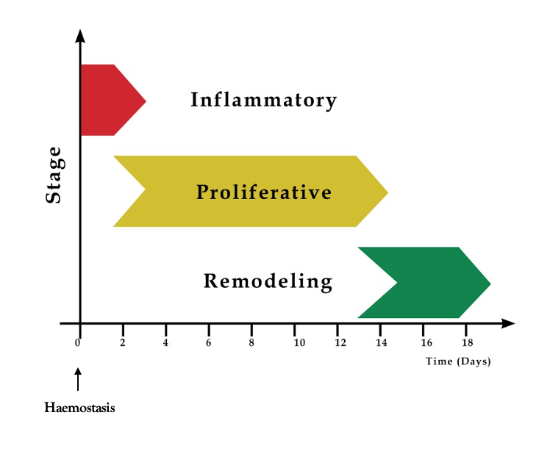

Figure 2 : Bacterial fluorescence images of infected perineal wounds taken using the MolecuLight i:X imaging device. Wounds showing red (A, B) or white (C) fluorescence (arrows) with microbiological culture results below
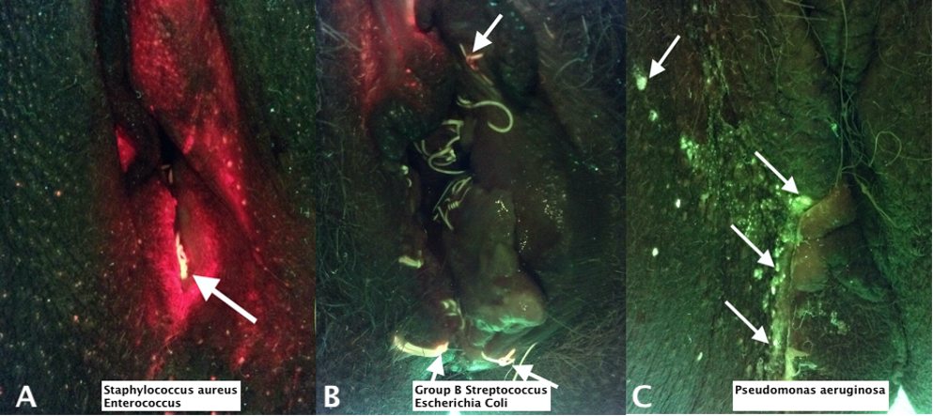

Figure 3: Wound healing of a dehisced episiotomy, two (A), three (B), four (C), five (D), six (E), and seven weeks (F) where the wound has healed with a wide based scar. Corresponding wound measurements taken using the Silhouette® camera are shown below (length x width x depth).
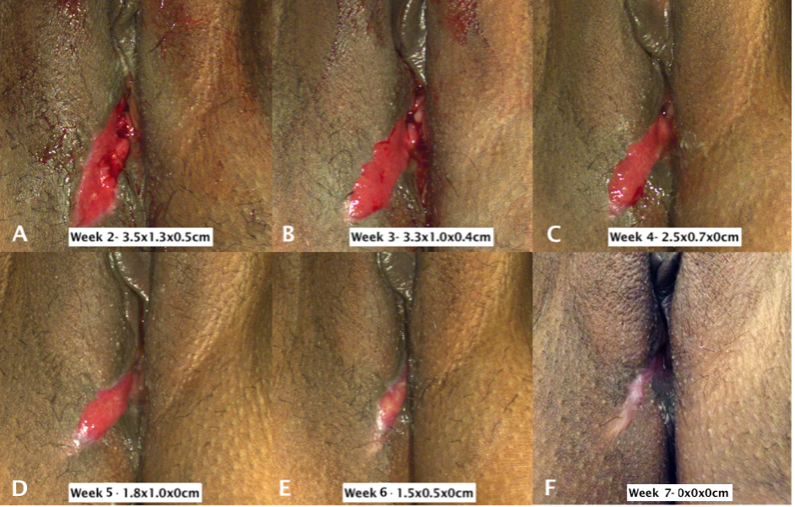

Figure 4: Wound healing trajectory of a dehisced episiotomy using the Silhouette® camera. The graphs show the rate of area (cm²) (A), perimeter (mm) (B), depth (mm) (C) and volume (cm³) (D) change over time
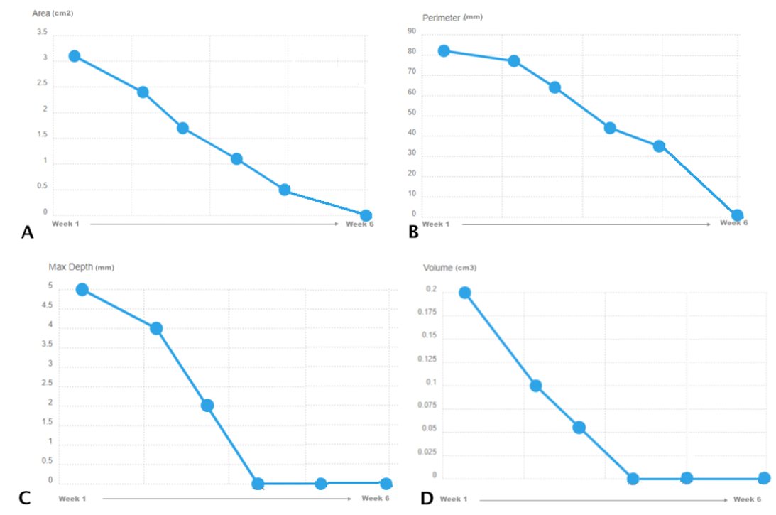

Figure 5: A dehisced episiotomy diagnosed week 1 (A) following a ventouse and forceps delivery. The patient opted for surgical resuturing which was perfomed 2 weeks following delivery. The images show the uncomplicated healing of the wound two (B), three (C) and four (D) weeks following delivery

Figure 6: Excessive granulation tissue formation at seven-week postnatal following healing of a dehisced perineal wound healing by secondary intention (A). The area was treated with silver nitrate (B). The area of granulation tissue 2 weeks after treatment (C)
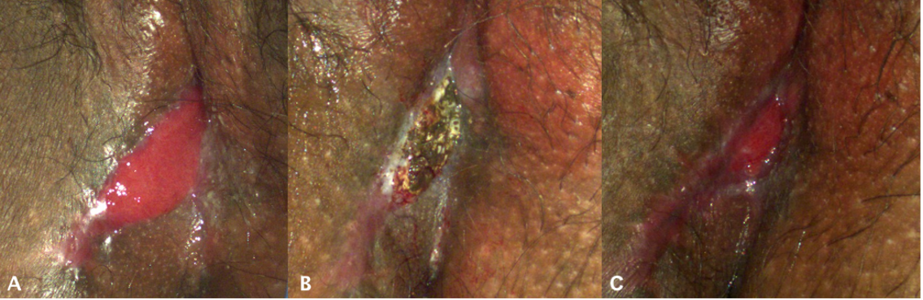

Figure 7: A vaginal examination being performed to show a perineal web at the posterior fourchette (A). The perineum after surgical division of the perineal web (B)
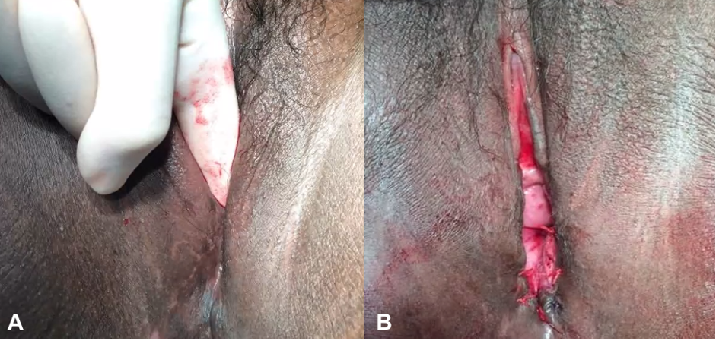

Figure 8: At one week following diagnosis and treatment with oral antibiotics, there was no bacterial fluorescence in wounds closed with sub-cuticular sutures (A). However, red fluorescence (arrows) in the knots of interrupted sutures of wounds that had dehisced (B) and remained approximated (C). Microbiological culture results from wound swabs above and loose sutures below
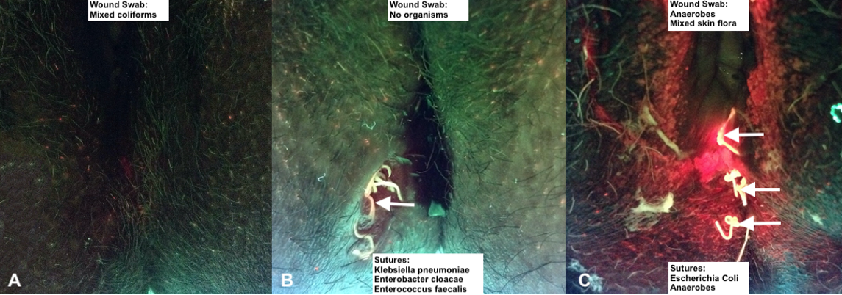

Table 1: Microorganisms causing perineal wound infection following childbirth
Organisms | Reference
Gram positive cocci
Staphylococcus spp. | (Ajibade et al. 2013), (Arendsen et al. 2020), (Fox 2011), (Rotas et al. 2007), (Sule and Shittu 2004), (Zhang and Han 2017)
Streptococcus spp. | (Ajibade et al. 2013), (Almarzouqi et al. 2015), (Arendsen et al. 2020), (Chua et al. 2017), (Fox 2011), (Shy and Eschenbach 1979), (Wiseman et al. 2019),
Enterococcus spp. | (Ajibade et al. 2013), (Häusler et al. 1994), (Tsenov et al. 2001)
Gram positive rods
Escherichia spp. | (Almarzouqi et al. 2015), (Fox 2011), (Häusler et al. 1994), (Shy and Eschenbach 1979), (Sule and Shittu 2004), (Tsenov et al. 2001), (Zhang and Han 2017)
Gram negative aerobic
Acinetobacter spp. | (Zhang and Han 2017)
Pseudomonas spp. | (Ajibade et al. 2013), (Zhang and Han 2017)
Enterobacter spp. | (Zhang and Han 2017)
Proteus spp. | (Rai et al. 2015)
Mixed anaerobes | (Arendsen et al. 2020), (Fox 2011)
Gram negative rods
Bacteroides spp. | (Almarzouqi et al. 2015), (Fox 2011), (Shy and Eschenbach 1979),
Gardnerella spp. | (Fox 2011)
Coliforms | (Ajibade et al. 2013), (Arendsen et al. 2020)
Anaerobic
Klebsiella spp. | (Fox 2011), (Rai et al. 2015), (Shy and Eschenbach 1979)
Clostridium spp. | (Shy and Eschenbach 1979)
Fungi
Candida spp. | (Ajibade et al. 2013), (Fox 2011), (Zhang and Han 2017)
Saccharomyces spp. | (Zhang and Han 2017)

Table 2: Risk factors for perineal wound complications (infection/dehiscence) following childbirth

Risk Factors | Reference
Obesity | (Edwards et al. 1978), (Stock et al. 2013), (Zhang and Han 2017), (Gommesen et al. 2019)
Smoking | Jallad et al. 2016), (Stock et al. 2013)
Co-morbidities e.g. Diabetes | (Zhang and Han 2017)
Prolonged rupture of membranes | (Johnson et al. 2012)
Premature rupture of membranes | (Zhang and Han 2017)
Puerperal reproductive tract infection | (Zhang and Han 2017)
Number of vaginal examinations >3 | (Zhang and Han 2017)
Instrumental delivery | (Jallad et al. 2016), (Johnson et al. 2012), (Lewicky-Gaupp et al. 2015), (Stock et al. 2013), (Wilkie et al. 2018)
Episiotomy | (Gommesen et al. 2019), (Jallad et al. 2016), (Johnson et al. 2012), (Wilkie et al. 2018)
Obstetric anal sphincter injury | (Jallad et al. 2016)

