Supplementary appendix

Responder analysis of improvement in six-minute walk test with ferric carboxymaltose in iron- deficient heart failure with reduced ejection fraction patients
Stefan D. Anker, MD PHD; Piotr Ponikowski, MD; Muhammad Shahzeb Khan, MD MSc; Tim Friede, PhD; Ewa A. Jankowska, MD; Vincent Fabien, PHD; Udo-Michael Goehring, MD;
Marco Metra, MD; Ileana L Piña, MD, MPH; Andrew JS Coats, MD, PHD; Giuseppe Rosano, MD, PHD; Fabio Dorigotti, MD; Josep Comin-Colet, MD PHD;
Dirk J Van Veldhuisen MD; Gerasimos S. Filippatos, MD; Javed Butler, MD MPH MBA

Contents:
Supplementary Table 1: Key characteristics of the two included randomized controlled trials in iron- deficient HFrEF patients .2
Supplementary Table 2: Proportion of patients with 6MWT data available at weeks 12 and 24 in both treatment arms…………………………………………………………………………………………
Supplementary Table 3: NNT to achieve defined change vs baseline in 6MWT at weeks 12 and 24 (random-effects model)..4

Supplementary Table 4: Changes in KCCQ-OSS score according to 6MWT responder categories from baseline to week 12 and 24 in the FCM and placebo arms……………………………………………....5

Supplementary Table 5: Changes in KCCQ-CSS score according to 6MWT responder categories from baseline to week 12 and 24 in the FCM and placebo arms……………………………………………....6

Supplementary Table 6: Changes in EQ-5D Health State (VAS) score according to 6MWT responder categories from baseline to week 12 and 24 in the FCM and placebo arms……………………………..7

Supplementary Table 7: Changes in EQ-5D index score according to 6MWT responder categories from baseline to week 12 and 24 in the FCM and placebo arms……………………………………………....8

Supplementary Table 8: Changes in NYHA score according to 6MWT responder categories from baseline to week 12 and 24 in the FCM and placebo arms……………………………………………………......9

Supplementary Figure 1: Mean change from baseline in 6MWT with FCM vs placebo at weeks 12 and 24 – random-effects model …………………………………………………………………………………. 10
Supplementary Figure 2: Responder analyses across MCID thresholds for 6MWT 11
References 12
Supplementary Table 1: Key Characteristics of the two included randomized controlled trials in iron-deficient HFrEF patients

 | FAIR-HF^{1,2} | CONFIRM-HF^{3,4}
Randomization | 2:1 (FCM:placebo) | 1:1 (FCM:placebo)
Number of patients | 459 (FCM: 304; placebo: 155) | 301* (FCM: 150; placebo: 151)
Study duration | 24 weeks | 52 weeks
Patient population and HF details | Ambulatory patients with optimally  treated CHF (NYHA class II/III) and iron deficiency | Ambulatory patients with optimally  treated CHF (NYHA class II/III) and iron deficiency
Hemoglobin | ≥9.5 and ≤13.5 g/dL | <15 g/dL
Primary endpoint | Change in PGA score and NYHA  class from baseline to week 24 | Change in 6MWT distance from  baseline to week 24
Legend: *304 patients were randomized but only 301 received study treatment and had any post-baseline assessment. 6MWT, 6-minute walk test; CHF, chronic heart failure; CONFIRM-HF, Ferric CarboxymaltOse evaluatioN on perFormance in patients with IRon deficiency in coMbination with chronic Heart Failure; FAIR- HF, Ferinject Assessment in Patients with Iron Deficiency and Chronic Heart Failure; FCM, ferric carboxymaltose; HF, heart failure; NYHA, New York Heart Association; PGA, Patient Global Assessment.

Supplementary Table 2: Proportion of patients with 6MWT data available at weeks 12 and 24 in FCM and placebo arms

Number of Patients (%) | FCM(N=454) | Placebo(N=306)
At week 12
Patient with data available | 408(89.9) | 276(90.2)
Patients imputed for death | 6(1.3) | 5(1.6)
Patients imputed for hospitalization | 4(0.9) | 8(2.6)
Alive and non-hospitalized patients with missing data | 36(7.9) | 17(5.6)
At week 24
Patients with data available | 396(87.2) | 264(86.3)
Patients imputed for death | 12(2.6) | 9(2.9)
Patients imputed for hospitalization | 6(1.3) | 10(3.3)
Alive and non-hospitalized patients with missing data | 40(8.8) | 23(7.5)

Legend: 6MWT, 6-minute walk test; FCM, ferric carboxymaltose

Supplementary Table 3: NNT to achieve defined change vs baseline in 6MWT at weeks 12 and 24 (random-effects model)

 | Week 12 | Week 24
Improvement
≥20 m | 6 | 6
≥30 m | 8 | 7
≥40 m | 9 | 8
Deterioration
≥10 m | 7 | 6
Legend: ORs from the random-effects responder analysis were converted into NNT using the formula described in Hutton et al.⁵ and the placebo control response/deterioration proportion.
6MWT, 6-minute walk test; NNT, number needed to treat; OR, odds ratio

Supplementary Table 4: Changes in KCCQ-OSS score according to 6MWT responder categories from baseline to week 12 and 24 in the FCM and placebo arms.

6-Minute Walk Test (6MWT) Responder Categories | Mean(SD) Changes in KCCQ-OSS score from Baseline
 | FCM | Placebo
At week 12
Improvement ≥ 20 | 14.2(18.9) | 5.4(11.3)
Improvement ≥ 30 | 15.6(19.8) | 4.5(10.2)
Improvement ≥ 40 | 17.0(20.2) | 5.0(11.1)
Deterioration ≥ 10 | 0.80(14.9) | 1.8(16.2)
At week 24
Improvement ≥ 20 | 15.6(19.1) | 8.7(14.5)
Improvement ≥ 30 | 16.9(19.5) | 9.0(14.7)
Improvement ≥ 40 | 17.5(20.2) | 9.5(13.2)
Deterioration ≥ 10 | -0.56(15.1) | -0.2(16.1)

Legend: 6MWT, 6-minute walk test; NNT, FCM, Ferric carboxymaltose; KCCQ-OSS, Kansas City Cardiomyopathy Questionnaire Overall Summary Score; SD, Standard deviation

Supplementary Table 5: Changes in KCCQ-CSS score according to 6MWT responder categories from baseline to week 12 and 24 in the FCM and placebo arms.

6-Minute Walk Test (6MWT) Responder Categories | Mean(SD) Changes in KCCQ-CSS score from Baseline
 | FCM | Placebo
At week 12
Improvement ≥ 20 | 13.5(18.5) | 5.4(10.6)
Improvement ≥ 30 | 14.8(19.5) | 4.6(10.1)
Improvement ≥ 40 | 15.6(19.3) | 5.1(11.3)
Deterioration ≥ 10 | -0.66(16.4) | 3.0(16.5)
At week 24
Improvement ≥ 20 | 14.4(18.7) | 7.6(15.3)
Improvement ≥ 30 | 15.4(19.0) | 8.1(15.3)
Improvement ≥ 40 | 15.7(19.7) | 9.0(14.2)
Deterioration ≥ 10 | -1.0(15.0) | 0.5(15.7)

Legend: 6MWT, 6-minute walk test; NNT, FCM, Ferric carboxymaltose; KCCQ-CSS, Kansas City Cardiomyopathy Questionnaire Clinical Summary Score; SD, Standard deviation

Supplementary Table 6: Changes in EQ-5D Health State (VAS) score according to 6MWT responder categories from baseline to week 12 and 24 in the FCM and placebo arms.

6-Minute Walk Test (6MWT) Responder Categories | Mean(SD) Changes in EQ-5D Health State (VAS) score from Baseline
 | FCM | Placebo
At week 12
Improvement ≥ 20 | 8.6(13.9) | 5.3(13.7)
Improvement ≥ 30 | 9.0(14.2) | 5.1(12.7)
Improvement ≥ 40 | 8.7(14.0) | 4.8(12.9)
Deterioration ≥ 10 | -0.4(12.9) | -0.1(13.5)
At week 24
Improvement ≥ 20 | 10.6(14.4) | 8.3(13.8)
Improvement ≥ 30 | 11.2(14.6) | 6.9(12.9)
Improvement ≥ 40 | 11.6(14.8) | 6.0(12.5)
Deterioration ≥ 10 | 2.9(12.5) | -1.5(14.3)

Legend: 6MWT, 6-minute walk test; NNT, FCM, Ferric carboxymaltose; VAS, Visual analogue scale; SD, Standard deviation

Supplementary Table 7: Changes in EQ-5D index score according to 6MWT responder categories from baseline to week 12 and 24 in the FCM and placebo arms.
6-Minute Walk Test (6MWT) Responder Categories | Mean (SD) Changes in EQ-5D index score from Baseline
 | FCM | Placebo
At week 12
Improvement ≥ 20 | 0.13(0.23) | 0.06(0.17)
Improvement ≥ 30 | 0.13(0.23) | 0.04(0.15)
Improvement ≥ 40 | 0.14(0.23) | 0.04(0.16)
Deterioration ≥ 10 | -0.05(0.21) | -0.02(0.24)
At week 24
Improvement ≥ 20 | 0.13(0.23) | 0.07(0.21)
Improvement ≥ 30 | 0.15(0.23) | 0.06(0.21)
Improvement ≥ 40 | 0.16(0.23) | 0.04(0.19)
Deterioration ≥ 10 | 0.03(0.22) | -0.01(0.21)

Legend: 6MWT, 6-minute walk test; NNT, FCM, Ferric carboxymaltose; SD, Standard deviation

Supplementary Table 8: Changes in NYHA Score according to 6MWT responder categories from baseline to week 12 and 24 in the FCM and placebo arms.

6-Minute Walk Test (6MWT) Responder Categories | Mean (SD) Changes in NYHA Score from Baseline
 | FCM | Placebo
At week 12
Improvement ≥ 20 | -0.4(0.6) | -0.1(0.3)
Improvement ≥ 30 | -0.4(0.6) | 0.0(0.3)
Improvement ≥ 40 | -0.5(0.7) | -0.1(0.4)
Deterioration ≥ 10 | 0.2(0.7) | 0.3(0.7)
At week 24
Improvement ≥ 20 | -0.4(0.6) | -0.2(0.4)
Improvement ≥ 30 | -0.5(0.6) | -0.2(0.5)
Improvement ≥ 40 | -0.5(0.7) | -0.2(0.5)
Deterioration ≥ 10 | 0.4(0.9) | 0.4(0.8)
Legend: 6MWT, 6-minute walk test; NNT, FCM, Ferric carboxymaltose; NYHA, New York Heart Association; SD, Standard deviation

Supplementary Figure 1: Mean change from baseline in 6MWT with FCM vs placebo at weeks 12 and 24 – random-effects model
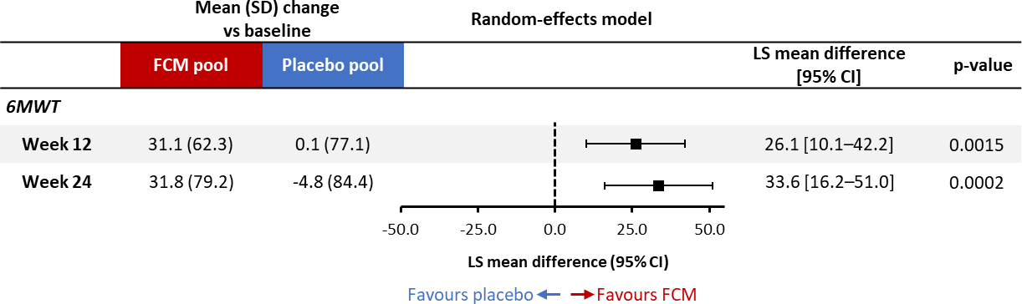

Legend: LS mean difference based on a random-effects MMRM analysis adjusted for study, baseline 6MWT score, age, estimated glomerular filtration rate, diabetes status, sex, and left ventricular ejection fraction. The random-effects model was an expanded version of the fixed-effects model, including random treatment-by-study interactions. Since only 6 patients are from Latin America and the remainder are from Europe, region was not included in the model. In FCM and placebo groups, patient numbers were 418 and 289, respectively, at week 12 and 415 and 283, respectively, at week 24. 6MWT, 6-minute walk test; CI, confidence interval; FCM, ferric carboxymaltose; LS, least-squares; MMRM, mixed model for repeated measures; SD, standard deviation.

Supplementary Figure 2: Responder analyses across MCID thresholds for 6MWT

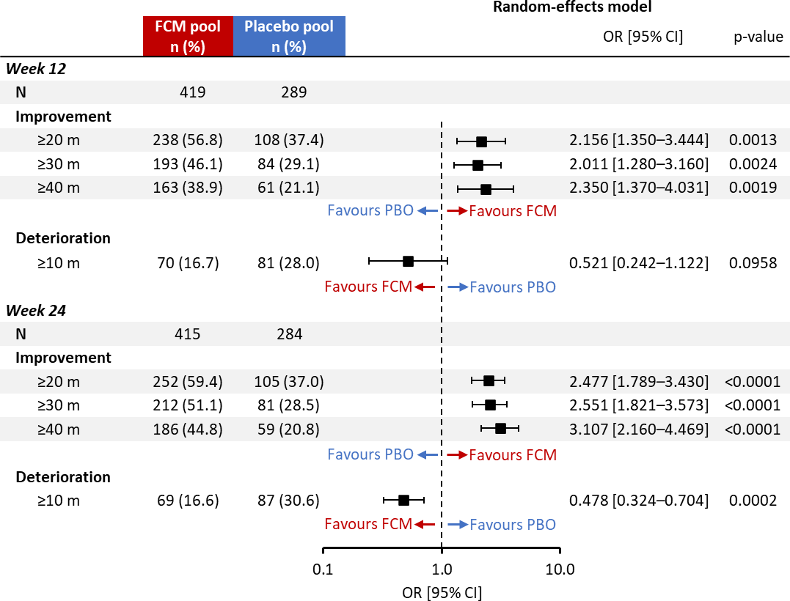

Legend: ORs with CIs and p-values were obtained from logistic regression models, including treatment group, study, and the following baseline factors: 6MWT distance, age, eGFR, diabetes status, sex, and left ventricular ejection fraction. The random-effects model was an expanded version of the fixed-effects model, including random treatment-by-study interactions. Furthermore, the covariate effects were allowed to vary across studies by introducing appropriate interactions. Patients were from Europe and Latin America, but since only six patients were from Latin America, region was not included in the model. Patients who had died or were hospitalised at week 12 and 24 were counted as deteriorated/non-responder at the respective time point. 6MWT, 6-minute walk test; CI, confidence interval; eGFR, estimated glomerular filtration rate; FCM, ferric carboxymaltose; MCID, minimal clinically important difference; OR, odds ratio; PBO, placebo.

- Anker SD, Colet JC, Filippatos G, Willenheimer R, Dickstein K, Drexler H, Lüscher TF, Mori C, von Eisenhart Rothe B, Pocock S, Poole-Wilson PA, Ponikowski P. Rationale and design of Ferinject assessment in patients with IRon deficiency and chronic Heart Failure (FAIR-HF) study: a randomized, placebo-controlled study of intravenous iron supplementation in patients with and without anaemia. Eur J Heart Fail 2009;11:1084-1091.

- Anker SD, Comin Colet J, Filippatos G, Willenheimer R, Dickstein K, Drexler H, Lüscher TF, Bart B, Banasiak W, Niegowska J, Kirwan B-A, Mori C, von Eisenhart Rothe B, Pocock SJ, Poole-Wilson PA, Ponikowski P. Ferric carboxymaltose in patients with heart failure and iron deficiency. N Engl J Med 2009;361:2436-2448.

- Ponikowski P, van Veldhuisen DJ, Comin-Colet J, Ertl G, Komajda M, Mareev V, McDonagh T, Parkhomenko A, Tavazzi L, Levesque V, Mori C, Roubert B, Filippatos G, Ruschitzka F, Anker SD. Beneficial effects of long-term intravenous iron therapy with ferric carboxymaltose in patients with symptomatic heart failure and iron deficiency. Eur Heart J 2015;36:657-668.

- Ponikowski P, van Veldhuisen DJ, Comin-Colet J, Ertl G, Komajda M, Mareev V, McDonagh TA, Parkhomenko A, Tavazzi L, Levesque V, Mori C, Roubert B, Filippatos G, Ruschitzka F, Anker SD. Rationale and design of the CONFIRM-HF study: a double-blind, randomized, placebo-controlled study to assess the effects of intravenous ferric carboxymaltose on functional capacity in patients with chronic heart failure and iron deficiency. ESC Heart Fail 2014;1:52-58.

- Hutton JL. Number needed to treat: properties and problems. Journal of the Royal Statistical Society: Series A (Statistics in Society) 2000;163:381-402.

