Supplementary material
PRISMA checklist for systematic reviews (2020)
Section and Topic | Item # | Checklist item | Location where item is reported
TITLE
Title | 1 | Identify the report as a systematic review. | P1
ABSTRACT
Abstract | 2 | See the PRISMA 2020 for Abstracts checklist. | P3
INTRODUCTION
Rationale | 3 | Describe the rationale for the review in the context of existing knowledge. | P4
Objectives | 4 | Provide an explicit statement of the objective(s) or question(s) the review addresses. | P4
METHODS
Eligibility criteria | 5 | Specify the inclusion and exclusion criteria for the review and how studies were grouped for the syntheses. | P5
Information sources | 6 | Specify all databases, registers, websites, organisations, reference lists and other sources searched or consulted to identify studies. Specify the date when each source was last searched or consulted. | P4-5 +Table S1
Search strategy | 7 | Present the full search strategies for all databases, registers and websites, including any filters and limits used. | P4-5 +Table S1
Selection process | 8 | Specify the methods used to decide whether a study met the inclusion criteria of the review, including how many reviewers screened each record and each report retrieved, whether they worked independently, and if applicable, details of automation tools used in the process. | P5
Data collection process | 9 | Specify the methods used to collect data from reports, including how many reviewers collected data from each report, whether they worked independently, any processes for obtaining or confirming data from study investigators, and if applicable, details of automation tools used in the process. | P5-6
Data items | 10a | List and define all outcomes for which data were sought. Specify whether all results that were compatible with each outcome domain in each study were sought (e.g. for all measures, time points, analyses), and if not, the methods used to decide which results to collect. | P6
 | 10b | List and define all other variables for which data were sought (e.g. participant and intervention characteristics, funding sources). Describe any assumptions made about any missing or unclear information. | P6
Study risk of bias assessment | 11 | Specify the methods used to assess risk of bias in the included studies, including details of the tool(s) used, how many reviewers assessed each study and whether they worked independently, and if applicable, details of automation tools used in the process. | P6+Table S2
Effect measures | 12 | Specify for each outcome the effect measure(s) (e.g. risk ratio, mean difference) used in the synthesis or presentation of results. | P6
Synthesis methods | 13a | Describe the processes used to decide which studies were eligible for each synthesis (e.g. tabulating the study intervention characteristics and comparing against the planned groups for each synthesis (item #5)). | P7
 | 13b | Describe any methods required to prepare the data for presentation or synthesis, such as handling of missing summary statistics, or data conversions. | P7
 | 13c | Describe any methods used to tabulate or visually display results of individual studies and syntheses. | P7
 | 13d | Describe any methods used to synthesize results and provide a rationale for the choice(s). If meta-analysis was performed, describe the model(s), method(s) to identify the presence and extent of statistical heterogeneity, and software package(s) used. | P7
 | 13e | Describe any methods used to explore possible causes of heterogeneity among study results (e.g. subgroup analysis, meta-regression). | P7
 | 13f | Describe any sensitivity analyses conducted to assess robustness of the synthesized results. | P7
Reporting bias assessment | 14 | Describe any methods used to assess risk of bias due to missing results in a synthesis (arising from reporting biases). | P7
Certainty assessment | 15 | Describe any methods used to assess certainty (or confidence) in the body of evidence for an outcome. | NA
RESULTS
Study selection | 16a | Describe the results of the search and selection process, from the number of records identified in the search to the number of studies included in the review, ideally using a flow diagram. | P7+Figure 1
 | 16b | Cite studies that might appear to meet the inclusion criteria, but which were excluded, and explain why they were excluded. | Figure 1
Study characteristics | 17 | Cite each included study and present its characteristics. | P8+Table 1+ Table S3
Risk of bias in studies | 18 | Present assessments of risk of bias for each included study. | Table S4
Results of individual studies | 19 | For all outcomes, present, for each study: (a) summary statistics for each group (where appropriate) and (b) an effect estimate and its precision (e.g. confidence/credible interval), ideally using structured tables or plots. | Figures 2-5+Figures S2-S5
Results of syntheses | 20a | For each synthesis, briefly summarise the characteristics and risk of bias among contributing studies. | NA
 | 20b | Present results of all statistical syntheses conducted. If meta-analysis was done, present for each the summary estimate and its precision (e.g. confidence/credible interval) and measures of statistical heterogeneity. If comparing groups, describe the direction of the effect. | P8-9+ Figures 2-5+Figures S1-S5
 | 20c | Present results of all investigations of possible causes of heterogeneity among study results. | P9+Table S3
 | 20d | Present results of all sensitivity analyses conducted to assess the robustness of the synthesized results. | P9
Reporting biases | 21 | Present assessments of risk of bias due to missing results (arising from reporting biases) for each synthesis assessed. | P10+Figure S6
Certainty of evidence | 22 | Present assessments of certainty (or confidence) in the body of evidence for each outcome assessed. | NA
DISCUSSION
Discussion | 23a | Provide a general interpretation of the results in the context of other evidence. | P10-13
 | 23b | Discuss any limitations of the evidence included in the review. | P12-13
 | 23c | Discuss any limitations of the review processes used. | P12-13
 | 23d | Discuss implications of the results for practice, policy, and future research. | P11-13
OTHER INFORMATION
Registration and protocol | 24a | Provide registration information for the review, including register name and registration number, or state that the review was not registered. | P4
 | 24b | Indicate where the review protocol can be accessed, or state that a protocol was not prepared. | P4
 | 24c | Describe and explain any amendments to information provided at registration or in the protocol. | NA
Support | 25 | Describe sources of financial or non-financial support for the review, and the role of the funders or sponsors in the review. | P14
Competing interests | 26 | Declare any competing interests of review authors. | P14
Availability of data, code and other materials | 27 | Report which of the following are publicly available and where they can be found: template data collection forms; data extracted from included studies; data used for all analyses; analytic code; any other materials used in the review. | NA

Table S1. Full Search strategy

Date of search performed:
1st December 2020.

Databases searched:
Medline, Embase and Cochrane Library databases using the OvidSP interface.

Search terms:
"Streptococcus agalactiae" [Mesh] OR "Streptococcus agalactiae" OR "group B adj3 strep"
AND
"Meningitis" [Mesh] OR "meningit*" OR "Infections" [Mesh] OR "infection*" OR "Pneumonia" [Mesh] OR "pneumonia*" OR "Sepsis" [Mesh] OR "septic?emia" OR "Bacteremia" [Mesh] OR "bacter?emia"

Restrictions:
None.

Footnotes
- The adj3 operator finds terms in any order with two words (or fewer) between them.
- The question mark (?) inside a word is used to replace one character.

Table S2. Modified Newcastle – Ottawa Quality Assessment Scale (NOS) ª

CASE CONTROL STUDIES

Selection
1) Is the case definition adequate?
- yes, with some independent validation (e.g. >1 person/record/time/process to extract information, or reference to primary record source such as x-rays or medical/hospital records) *
- yes, e.g., record linkage (e.g. ICD codes in database) or self-report with no reference to primary record
- no description
2) Representativeness of the cases
- all eligible cases with outcome of interest over a defined period of time, all cases in a defined catchment area, all cases in a defined hospital or clinic, group of hospitals, health maintenance organisation, or an appropriate sample of those cases (e.g. random sample) *
- not satisfying requirements in part (a), or not stated
3) Selection of controls
- community controls (i.e. same community as cases and would be cases if had outcome) *
- hospital controls, within same community as cases (i.e. not another city) but derived from a hospitalised population
- no description
4) Definition of controls
- it must explicitly state that controls have no history of this outcome *
- no description

Comparability
1) Comparability of cases and controls on the basis of the design or analysis
- study controls for one factor *
- study controls for any additional factor *

Exposure
1) Ascertainment of exposure
- secure record (e.g., medical records) *
- structured interview where blind to case/control status *
- interview not blinded to case/control status
- written self report or medical record only
- no description
2) Same method of ascertainment for cases and controls
- yes *
- no
3) Non-Response rate
- same rate for both groups *
- non respondents described
- rate different and no designation

COHORT STUDIES

Selection
1) Representativeness of the exposed cohort
- truly representative of the average in the community (>75% catchment population) *
- somewhat representative of the average in the community (<75% catchment population) *
- selected group of users e.g., nurses, volunteers
- no description of the derivation of the cohort
2) Selection of the non exposed cohort
- drawn from the same community as the exposed cohort *
- drawn from a different source
- no description of the derivation of the non exposed cohort
3) Ascertainment of exposure
- secure record (eg medical records) *
- structured interview *
- written self report
- no description
4) Demonstration that outcome of interest was not present at start of study
- yes *
- no

Comparability
1) Comparability of cohorts on the basis of the design or analysis
- study controls for one factor *
- study controls for additional factors *

Outcome
1) Assessment of outcome
- capture- recapture *
- clinical or laboratory record linkage *
- self report
- no description
2) Was follow-up long enough for outcomes to occur
- yes *
- no
3) Adequacy of follow up of cohorts
- all cases reported *
- cases not reported unlikely to introduce bias- > 75% cases reported *
- < 75% cases reported
- no statement

Note: A study can be awarded a maximum of one star for each numbered item within the Selection and Outcome categories. A maximum of two stars can be given for Comparability
ª http://www.ohri.ca/programs/clinical_epidemiology/oxford.asp

Table S3. Characteristics of included studies (extended version)

Reference | Cases | Controls | Preterm births rate population | <34 rate population | LBW rate population | Male ratio population | National GBS colonisation rate | Multiple-gestation pregnancies rate population | Maternal age <20 years rate population
Berardi et al. 2013 [18] | 100 | Regional Population | 7.4% [18] | 1.9% [18] | NA | NA | 23.2% [14] | NA | NA
Dangor et al. 2015 [3] | 46 | Study | NA | NA | NA | NA | NA | NA | NA
Dangor et al. 2016 [19] | 373 | Regional Population | 18.0% ^{a⁠} | NA | 18.0% ª | 50.8% [13] | NA | NA | NA
Fluegge et al. 2006 [20] | 136 | National Population | 8.4% [10] | NA | 6.5% [12] | NA | 18.4% [14] | NA | NA
Frigati et al. 2015 [21] | 19 | Regional Population | NA | NA | 41.3% ^{b} | 50.8% [13] | NA | NA | NA
Giannoni et al. 2016 [22] | 46 | National Population | 7.2% [10] | NA | NA | 51.4% [13] | 16.00% ^{c} | NA | NA
Guan et al. 2018 [23] | 21 | Regional Population | 5.7% ^{d} | NA | 5.0% [12] | 54.0% [13] | NA | NA | NA
Heath et al. 2004 [24] | 191 | National Population | NA | NA | 6.2% [24] | NA | NA | NA | NA
Ireland et al. 2014 [25] | 14 | Study | NA | NA | NA | NA | NA | NA | NA
Jordan et al. 2008 [26] | 468 | Regional Population | 12.4% [10] | NA | 8.1% ^{e} | 51.2% [13] | 24.7% [14] | NA | NA
Joubrel et al. 2015 [27] | 264 | National Population | 6.6% [10] | NA | 7.4% [12] | 51.1% [13] | 15.6% [14] | NA | NA
Juncosa-Morros et al. 2014 [28] | 143 | Regional Population | 7.5% ^{f} | NA | NA | NA | 15.5% [14] | 1.8% [11] | NA
Ko et al. 2015 [29] | 62 | National Population | 7.6% [10] | NA | 6.3% [12] | 51.1% [13] | 23.8% [14] | 1.5% [11] | NA
Lin et al. 2003 [30] | 122 | Study | NA | NA | NA | NA | NA | NA | NA
Matsubara et al. 2013 [31] | 162 | National Population | 5.8% [10] | 1.0% ^{g} | 9.5% [12] | 51.4% [13] | NA | 1.1% [11] | 1.4%
Matsubara et al. 2017 [32] | 274 | National Population | 5.7% [10] | 1.1% ^{g} | 9.5% [12] | 51.4% [13] | 16.2% [14] | 1.0% [11] | NA
Mynarek et al. 2020 [33] | 199 | National Population | 6.7% [33] | NA | 4.8% [33] | 51.3% [33] | NA | 3.4% [33] | NA
Nanduri et al. 2019 [2] | 1,387 | Regional Population | 12.0% [10] | NA | NA | 51.2% [13] | NA | NA | NA
Neto et al. 2007 [34] | 48 | National Population | 6.0% [34] | NA | NA | NA | NA | NA | NA
O'Sullivan et al. 2019 [5] | 339 | National Population | 6.4-7.4% [10] ^{h} | NA | 7.0% [12] | NA | NA | 1.6% [11] | NA
Óladóttir et al. 2011 [35] | 34 | National Population | 5.3% ^{i} | NA | NA | 51.3% [13] | NA | 1.0% [11] | NA
Pintye et al. 2016 [36] | 138 | Study | NA | NA | NA | NA | NA | NA | NA
Romain et al. 2018 [6] | 597 | National Population | 6.6% [10] | NA | NA | 51.1% [13] | 15.6% [14] | NA | NA
Schuchat et al. 1990 [37] | 37 | Regional Population | 10.0% [37] | NA | 8.0% [37] | NA | NA | NA | 14.0% [37]
Trijbels-Smeulders et al. 2007 [38] | 77 | National Population | 7.6% [38] | NA | NA | 51.1% [38] | NA | 3.5% [38] | NA
Vergadi et al. 2018 [39] | 9 | Regional Population | 7.4% ^{j} | NA | 7.7% j | 51.5% [13] | NA | NA | NA
Ying et al. 2019 [40] | 9 | Study | NA | NA | NA | NA | NA | NA | NA
Abbreviations: LBW, Low-birth weight; GBS, Group G Streptococcus; NA, Not Applicable
ª Cutland CL, Schrag SJ, Thigpen MC, et al. Increased Risk for Group B Streptococcus Sepsis in Young Infants Exposed to HIV, Soweto, South Africa, 2004–20081. Emerg Infect Dis 2015; 21:638–645
^{b} Personal communication
^{c} Capannaa F, Emonet SP, Cherkaoui A, Irion O, Schrenzel J, De Tejada BM. Antibiotic resistance patterns among group B Streptococcus isolates: Implications for antibiotic prophylaxis for early-onset neonatal sepsis. Swiss Med Wkly 2013;143:w13778
^{d} Lu J, Wei D, Shen S, et al. Increasing trends in incidence of preterm birth among 2.5 million newborns in Guangzhou, China, 2001 to 2016: an age-period-cohort analysis. BMC Public Health 2020; 20
^{e} https://www.cdc.gov/nchs/data/hestat/prelimbirths04/prelimbirths04health_tables.pdf#x2013;3%20%5BPDF%20-%2030%20KB%5D%3C/a%3E%20
^{f} https://canalsalut.gencat.cat/web/.content/_Professionals/Vigilancia_epidemiologica/documents/arxius/indicadors-salut-pernatal-informe-complet-2019-en.pdf
^{g} Sakata S, Konishi S, Ng CFS, Watanabe C. Preterm birth rates in Japan from 1979 to 2014: Analysis of national vital statistics. J Obstet Gynaecol Res 2018; 44:390–396. Available at: http://doi.wiley.com/10.1111/jog.13460
^{h} Differs between UK and ROI
^{i} Grétarsdóttir ÁS, Aspelund T, Steingrímsdóttir Þ, Bjarnadóttir RI, Einarsdóttir K. Preterm births in Iceland 1997-2016: Preterm birth rates by gestational age groups and type of preterm birth. Birth 2020; 47:105–114
^{j} http://www.statistics.gr/en/statistics/- /publication/SPO03

Table S4. Newcastle-Ottawa Scale score: A. Cohort studies B. Case-control studies

A. Cohort studies

Reference | Selection score | Comparability score | Outcome score | Total score
Berardi et al. 2013 [13] | 4 | 2 | 3 | 9
Dangor et al. 2016 [14] | 4 | 0 | 3 | 7
Fluegge et al. 2006 [15] | 4 | 0 | 2 | 6
Frigati et al. 2015 [16] | 4 | 0 | 2 | 6
Giannoni et al. 2016 [17] | 4 | 0 | 3 | 7
Guan et al. 2018 [18] | 4 | 0 | 2 | 6
Heath et al. 2004 [19] | 4 | 0 | 3 | 7
Jordan et al. 2008 [21] | 4 | 0 | 3 | 7
Joubrel et al. 2015 [22] | 4 | 0 | 2 | 6
Juncosa-Morros et al. 2014 [23] | 4 | 0 | 2 | 6
Ko et al. 2015 [24] | 4 | 0 | 3 | 7
Matsubara et al. 2013 [26] | 4 | 0 | 2 | 6
Matsubara et al. 2017 [27] | 4 | 0 | 2 | 6
Mynarek et al. 2020 [28] | 4 | 2 | 3 | 9
Nanduri et al. 2019 [2] | 4 | 0 | 3 | 7
Neto et al. 2007 [29] | 4 | 0 | 2 | 6
O'Sullivan et al. 2019 [4] | 4 | 0 | 3 | 7
Óladóttir et al. 2011 [30] | 4 | 0 | 3 | 7
Romain et al. 2018 [5] | 4 | 0 | 2 | 6
Schuchat et al. 1990 [32] | 4 | 2 | 2 | 9
Trijbels-Smeulders et al. 2007 [33] | 4 | 0 | 3 | 7
Vergadi et al. 2018 [34] | 4 | 0 | 3 | 7

B. Case-control studies

Reference | Selection score | Comparability score | Exposure score | Total score
Dangor et al. 2015 [3] | 4 | 2 | 3 | 9
Ireland et al. 2014 [20] | 3 | 1 | 3 | 7
Lin et al. 2003 [25] | 4 | 2 | 3 | 9
Pintye et al. 2016 [31] | 3 | 1 | 3 | 7
Ying et al. 2019 [35] | 3 | 1 | 3 | 7

Table S5. Subgroup Analysis of risk of LOGBS for A. Prematurity B. LBW

A. Prematurity

 | Number of studies | OR | 95% CI | I² | P subgroup
Region |  |  |  |  | < 0.0001
Africa | 1 | 1.33 | 1.04; 1.70
Americas | 5 | 5.15 | 3.82; 6.94 | 79%
Europe | 11 | 6.65 | 4.91; 8.99 | 87%
Western Pacific | 5 | 7.30 | 5.25; 10.16 | 49%
Resources |  |  |  |  | < 0.0001
HIC | 21 | 6.30 | 5.29; 7.50 | 81%
LMIC | 1 | 1.33 | 1.04; 1.70
Setting |  |  |  |  | < 0.0001
Single centre | 2 | 1.35 | 1.05; 1.72 | 0%
Multi-centre | 12 | 5.98 | 5.14; 6.93 | 49%
National surveillance | 8 | 7.34 | 4.96; 10.85 | 92%
Design |  |  |  |  | 0.3058
Case control studies | 3 | 4.15 | 2.82; 6.08 | 0%
Retrospective cohort studies | 7 | 6.17 | 4.11; 9.23 | 81%
Prospective cohort studies | 12 | 5.77 | 4.18; 7.95 | 94%
IAP Policy |  |  |  |  | 0.1879
Yes ª | 18 | 6.00 | 4.62; 7.80 | 93%
No | 4 | 3.69 | 1.88; 7.24 | 53%
ª Risk based: 4 studies; Universal screening: 3 studies; Both strategies: 5 studies; Policy changed during study: 6 studies

B. LBW

 |  | Number of studies | OR | 95% CI | I² | P subgroup
Region |  |  |  |  |  | < 0.0001
Africa |  | 2 | 2.28 | 1.16; 4.49 | 52%
Americas |  | 2 | 5.89 | 2.01; 17.25 | 84%
Europe |  | 5 | 10.52 | 7.34; 15.07 | 85%
Western Pacific |  | 5 | 6.18 | 3.53; 10.79 | 80%
Resources |  |  |  |  |  | 0.0011
HIC |  | 12 | 8.01 | 5.76; 11.14 | 88%
LMIC |  | 2 | 2.28 | 1.16; 4.49 | 52%
Setting |  |  |  |  |  | < 0.0001
Single centre |  | 2 | 1.89 | 1.24; 2.86 | 0%
Multi-centre |  | 6 | 5.33 | 3.78; 7.50 | 84%
National surveillance |  | 6 | 11.19 | 8.04; 15.56 | 83%
Design |  |  |  |  |  | 0.6127
Case control studies |  | 1 | 3.57 | 0.42; 30.10 | -
Retrospective cohort studies |  | 6 | 5.70 | 3.29; 9.87 | 93%
Prospective cohort studies |  | 7 | 7.80 | 4.60; 13.21 | 97%
IAP Policy |  |  |  |  |  | 0.7461
Yes ^{b} |  | 10 | 6.97 | 4.51; 10.79 | 96%
No |  | 4 | 6.06 | 2.94; 12.50 | 74%
 | ^{b} Risk based: 5 studies; Universal screening: 1 study; Both strategies: 2 studies; Policy changed during study: 2 studies

C. Maternal Colonisation

 |  | Number of studies | OR | 95% CI | I² | P subgroup
Region |  |  |  |  |  | 0.2120
Africa |  | 1 | 4.63 | 2.28; 9.36 | -
Americas |  | 3 | 2.48 | 1.88; 3.27 | 0%
Europe |  | 6 | 2.80 | 1.80; 4.36 | 81%
Western Pacific |  | 2 | 2.07 | 1.50; 2.85 | 0%
Resources |  |  |  |  |  | 0.1260
HIC |  | 11 | 2.57 | 1.99; 3.33 | 67%
LMIC |  | 1 | 4.63 | 2.28; 9.36 | -
Setting |  |  |  |  |  | 0.4113
Multi-centre |  | 8 | 2.86 | 1.98; 4.14 | 78%
National surveillance |  | 4 | 2.40 | 1.97; 2.93 | 0%
Design |  |  |  |  |  | 0.5937
Case control studies |  | 3 | 2.95 | 1.76; 4.92 | 39%
Retrospective cohort studies |  | 2 | 3.59 | 1.27; 10.13 | 94%
Prospective cohort studies |  | 7 | 2.36 | 1.27; 10.13 | 36%
IAP Policy |  |  |  |  |  | -
Yes ^{c} |  | 12 | 2.67 | 2.07; 3.45 | 66%
 | ^{c} Risk based: 3 studies; Universal screening: 2 studies; Both strategies: 4 studies; Policy changed during study: 3 studies

D. Multiple births

 |  | Number of studies | OR | 95% CI | I² | P subgroup
Region |  |  |  |  |  | 0.5325
Americas |  | 1 | 6.55 | 1.43; 29.90 | -
Europe |  | 5 | 6.60 | 3.85; 11.30 | 62%
Western Pacific |  | 4 | 11.21 | 5.16; 24.33 | 76%
Resources |  |  |  |  |  | -
HIC |  | 10 | 8.01 | 5.19; 12.38 | 72%
Setting |  |  |  |  |  | 0.3822
Multi-centre |  | 5 | 6.45 | 3.72; 11.18 | 46%
National surveillance |  | 5 | 9.47 | 4.88; 18.40 | 83%
Design |  |  |  |  |  | 0.9836
Case control studies |  | 2 | 7.64 | 1.27; 45.98 | 0%
Retrospective cohort studies |  | 5 | 7.70 | 4.55; 13.04 | 67%
Prospective cohort studies |  | 3 | 8.55 | 3.10; 23.59 | 90%
IAP Policy |  |  |  |  |  | -
Yes ^{d} |  | 10 | 8.01 | 5.19; 12.38 | 72%
 | ^{d} Risk based: 4 studies; Policy changed during study: 6 studies

FIGURES

Figure S1. Forest Plot of Meta-analysis of risk of LOGBS for gestation <34 weeks.
Figure S2. Forest Plot of Meta-analysis of risk of LOGBS for PROM.

Figure S3. Forest Plot of Meta-analysis of risk of LOGBS for intrapartum fever.

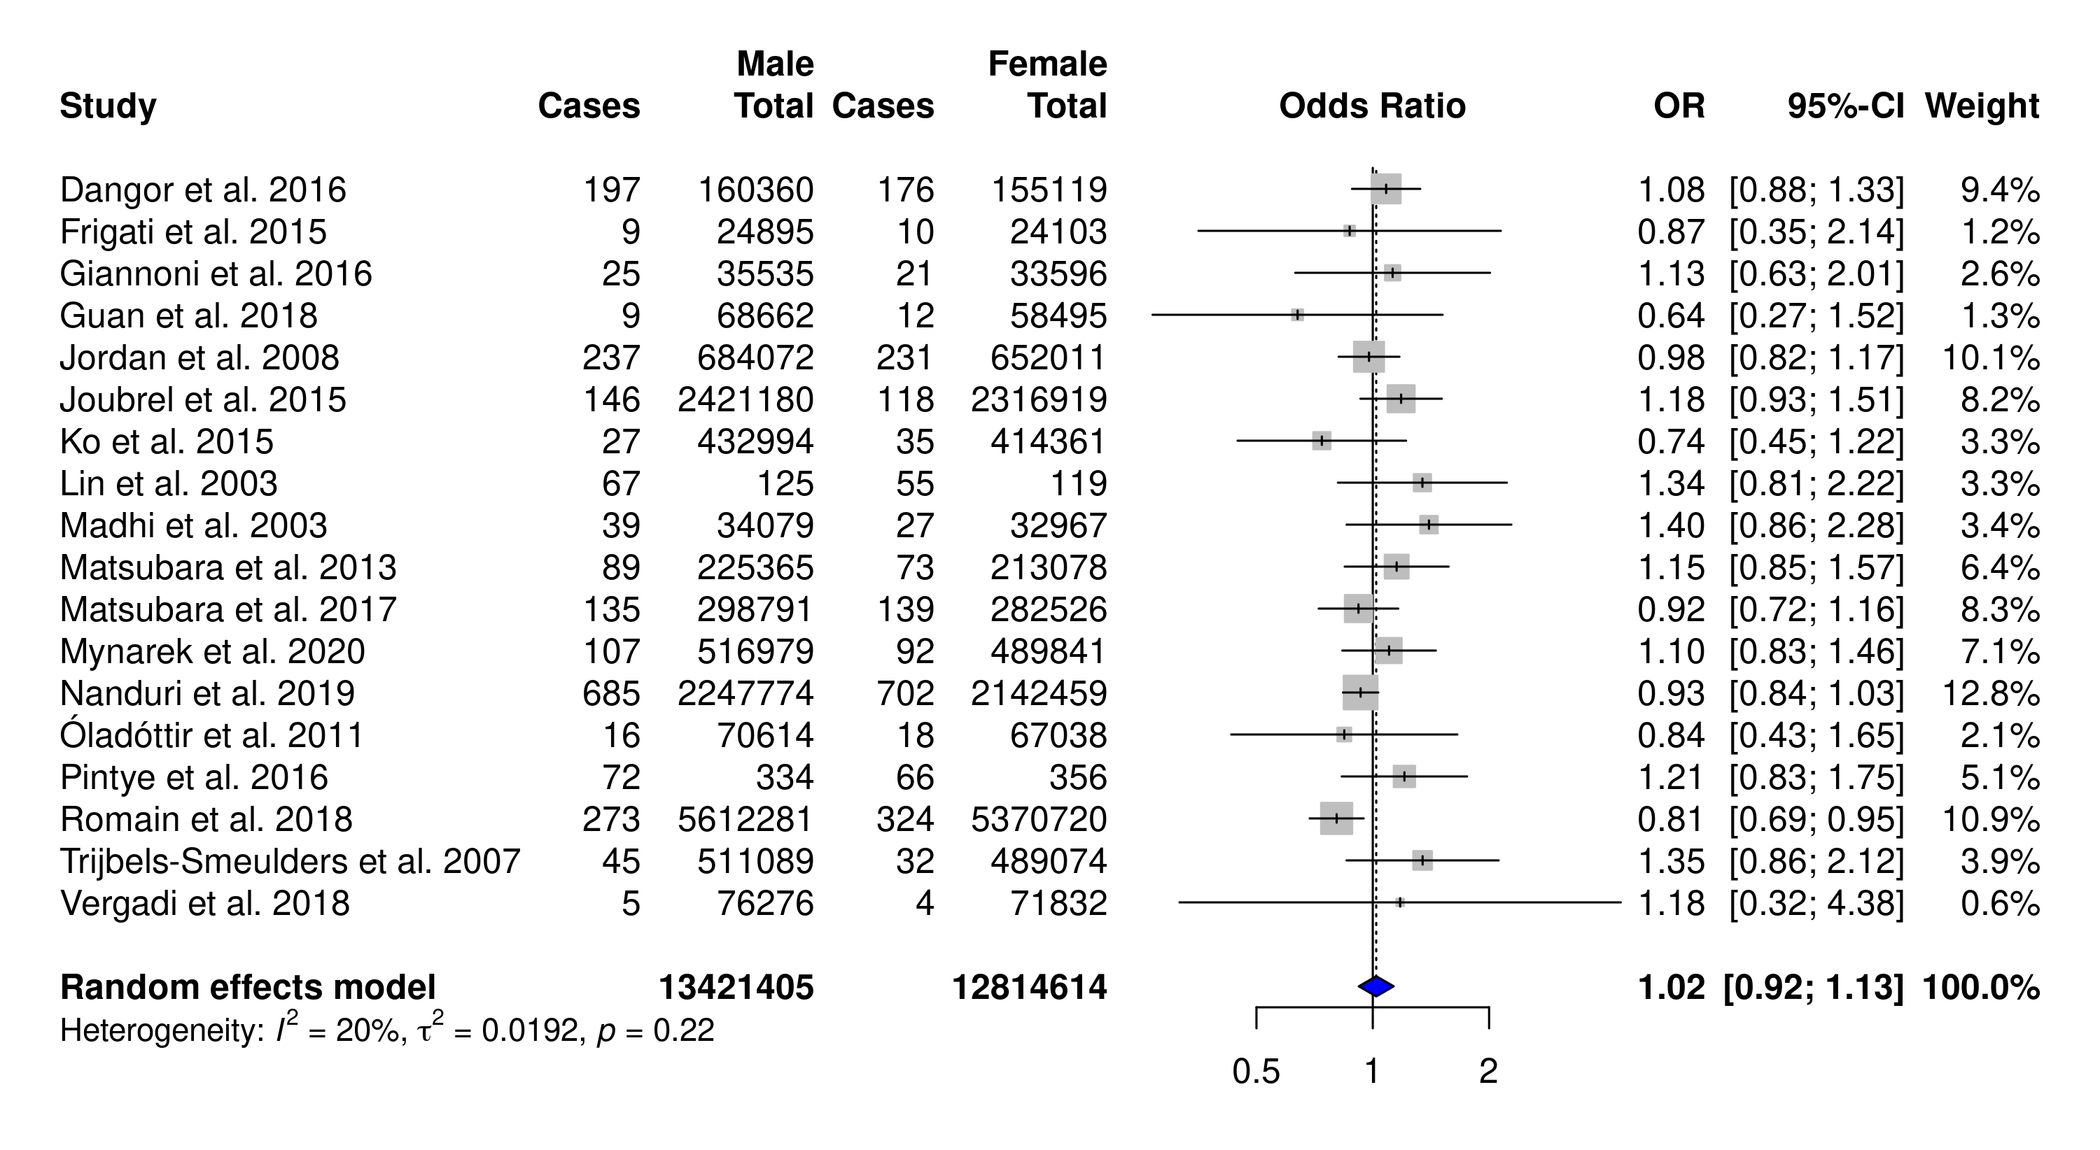

Figure S4. Forest Plot of Meta-analysis of risk of LOGBS for infant sex.

Figure S5. Forest Plot of Meta-analysis of risk of LOGBS for maternal age.

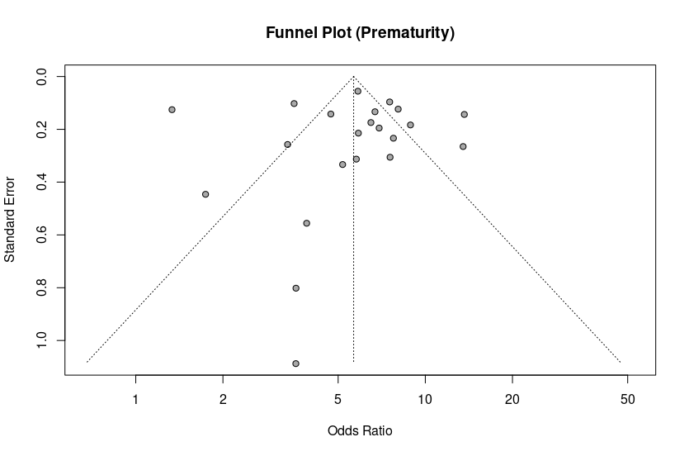
Eggers' test of the intercept
=============================
intercept 95% CI t p
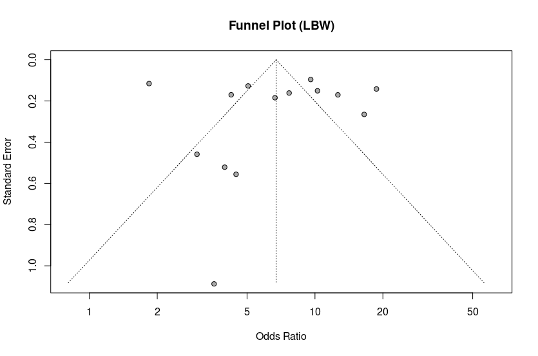
-0.009 -2.66 - 2.65 -0.007 0.9947592

Eggers' test of the intercept
=============================
intercept 95% CI t p
-0.006 -5.15 - 5.13 -0.002 0.9982186
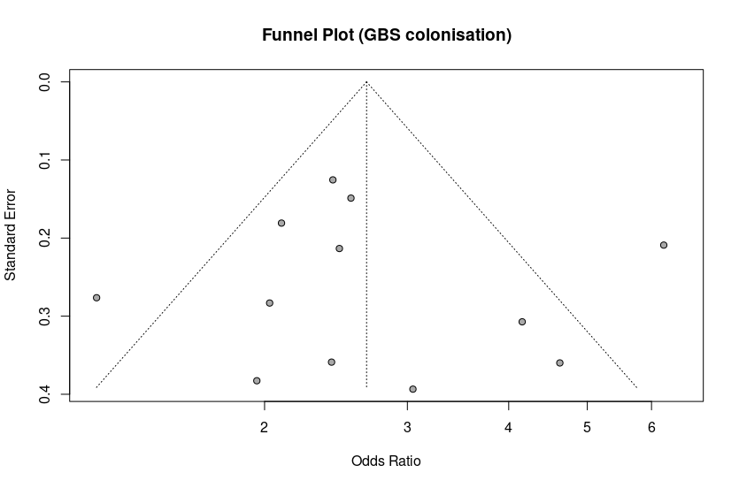
Eggers' test of the intercept
=============================
intercept 95% CI t p
0.396 -2.37 - 3.16 0.281 0.7843591

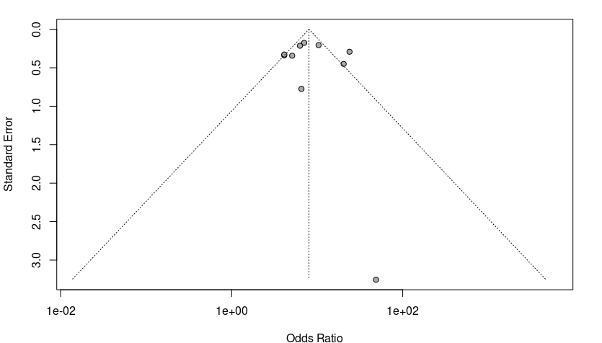
Funnel Plot (Multiple Gestation Pregnancies)
Eggers' test of the intercept
=============================
intercept 95% CI t p
0.345 -2.43 - 3.12 0.244 0.8133503

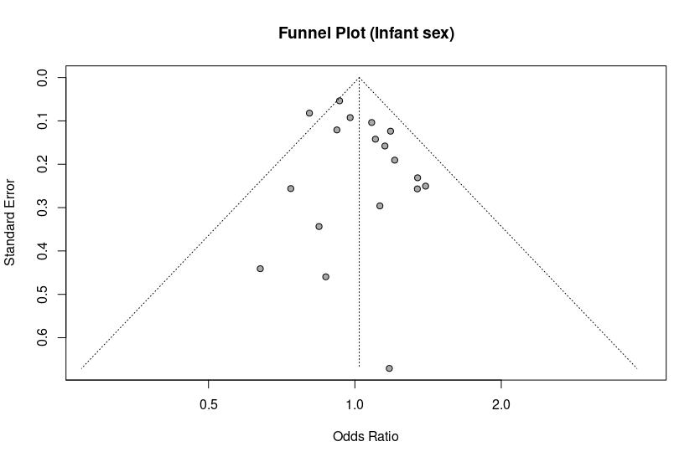

Eggers' test of the intercept
=============================
intercept 95% CI t p
0.677 -0.22 - 1.58 1.474 0.1598711

Figure S6. Funnel plots and Egger’s regression test.

