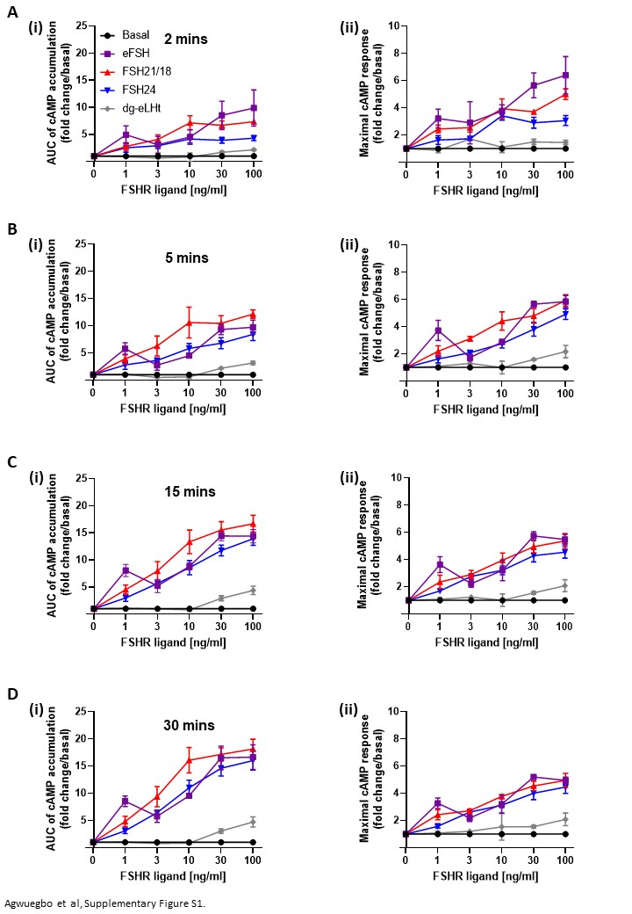
Supplementary Figure S1. Concentration-dependent effects of FSH ligands on cAMP production. HEK293 cells transiently co-expressing the HA-tagged FSHR and pGloSensorTM-20F plasmid were pre-equilibrated for 2 hours at 37°C and then treated for up to 30 minutes with increasing concentrations (0-100 ng/ml) of eFSH, FSH21, FSH24 or dg-eLHt. At (A) 2 minutes, (B) 5 minutes, (C) 15 minutes and (D) 30 minutes, measurements of the (i) AUC and (ii) maximal response were taken. Data represented as fold change/basal and analyzed using ordinary one-way ANOVA. All data represent mean ± SEM of 3-5 independent experiments conducted in triplicate. *p < 0.05; **p < 0.01; ***p < 0.001; ****p < 0.0001.

